 **MEMORANDUM**

**FROM:** Raiza Calderon, Load Research & Forecasting

**DATE:** June 29, 2022

**SUBJECT:** **Escalation Rates**

Please use the following escalation rates for this year’s budget process.



**Consumer Price Index (CPI):**  **Onetime Factors Boosting Inflation**

The CPI, the most widely used measure of inflation, is a guide to use when escalating O&M at Tampa Electric Company (TEC).

As anticipated by Moody’s Analytics forecast last year, inflation increased 4.7% in 2021, but they did not expect it to continue increasing. Moody’s is now projecting it to be 7.1% in 2022, returning to a long-term sustainable rate for the remainder of the forecast period.

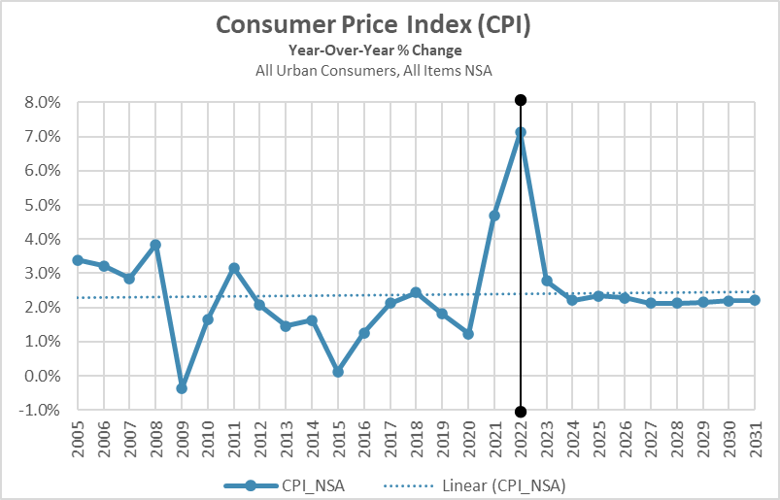

U.S. inflation is running at a 40-year high. Some draw comparisons between today and the high-inflation time of the 1970s and 1980s. The comparison is not apples-to-apples, since supply-chain issues are one reason inflation is high today. One similarity is higher energy prices. Energy has been adding around 2 percentage points to year-over-year growth in the CPI. The forecast anticipates that energy prices steadily decline in the second half of the year. Risks are weighted to the upside, but the assumption is that the supply response is strong enough to put downward pressure on global energy prices.

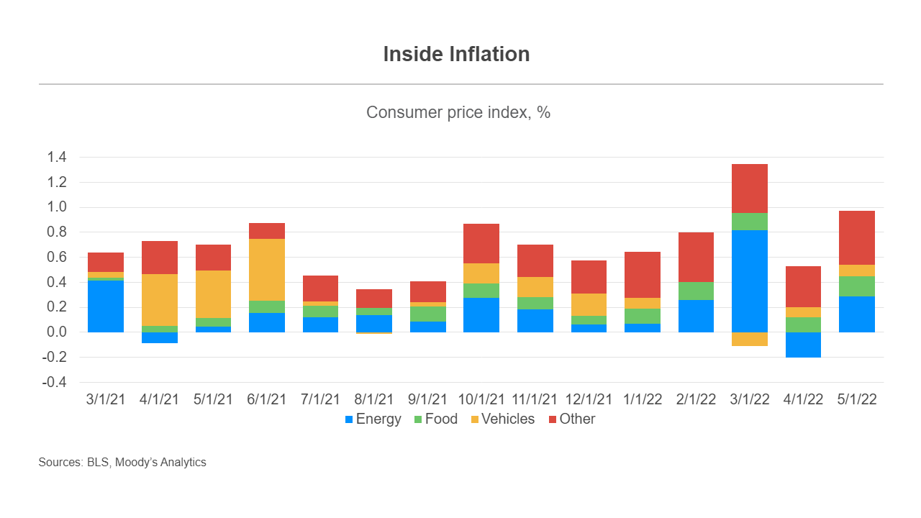

Energy and food prices added 0.4 percentage point to growth in the CPI from April to May. Gasoline prices have continued to jump, and relief at the pump is unlikely to occur soon. As retail gasoline prices soar to levels not seen in years, most consumers perceive a deterioration in their financial situation. However, some prices are showing signs of slowing. Supply-chain-constrained components of the CPI added 1.5 percentage points to year-over-year growth in the CPI in May, less than the 1.8-percentage point contribution in April. The Moody’s Analytics Used-Vehicle Price Index also indicated some signs of cooling. The year-over-year growth rate for used vehicles fell to 16% in May from 20.8% in April. Demand and supply factors have contributed to some easing in the used-vehicle market; higher interest rates have postponed purchasing plans for cars while the semiconductor chip shortage is helping backlogged producers.

Having a significantly high inflation on a year-ago basis compared with the 2.1% average growth in 2018 and 2019 is costing the average household over $350 per month more to purchase the same basket of goods and services as they did last year. Consequently, the share of households blaming higher prices for worse personal finances has surged since early 2021, and this discontent is unlikely to abate as long as the price of necessities—namely, food and energy—remains elevated.

**Handy-Whitman Index (HWI): Producer Price Indexes (PPI) drive HWI**

The HWI is a widely used utility cost index that tracks costs based on the Commission's Uniform System of Accounts for electric plant and related plant items. For the purposes of TEC, it is a guide to use when escalating projects associated to our plant assets.

TEC uses a weighted average between the cost trends of electric utility construction for Gas Turbogenerators and Steam Production Plants to calculate the HWI. There is currently no plan for Handy-Whitman to incorporate construction cost indices for renewables or solar.

The data used to forecast the HWI used Moody’s Analytics May 2022 delivery provided early June. Relative to last year’s HWI forecast, there was a drastic include in in 2022. The main drivers causing the spike in 2022 and then slowdown in 2023 and 2024 are the U.S. Industrial Commodities Produce Price Index (PPI) and PPI subcomponents such as Machinery and Equipment PPI and Metals and Metals Products PPI. Soaring inflation in 2022 is increasing input costs for producers, causing the large spike in 2022. The Federal Reserve System is aggressively increasing interest rates to lower inflation, which will help level off the PPIs in 2023 and 2024 (causing the jump down in growth rates). However, that aggressive monetary policy will slow the economy and weaken the labor market as well. This will reduce demand for commodities and cause a slowdown/slight dip in 2023/2024 in the Industrial Commodities PPIs, and by extension the Handy Whitman series.