Cost Estimating

VERSION 1.0

Approval: Helen Wesley Date: 9/21/2022

PROJECT CONTROLS
Corporate Engineering
TABLE OF CONTENTS

1.0 PURPOSE 3
2.0 APPLICABILITY 3
3.0 DEFINITIONS 3
4.0 ROLES & RESPONSIBILITIES 4
5.0 PROCESS DESCRIPTION 4
5.1 Estimating Inputs 4
5.1.1 Scope 4
5.1.2 Schedule 5
5.1.3 Risk Management 6
5.2 Cost Estimate Classification System 6
5.2.1 Cost Estimate Level Table 7
5.3 Cost Estimating 11
5.3.1 Cost Estimate Inputs 11
5.3.2 Application of the Estimate Classification to PGS Estimates 14
Appendix A – Project Charter 15
Appendix B – Project Scope Example 16
Appendix C – Project Schedule Example 17
Appendix D – Project Cost Estimate Worksheet 18

PURPOSE
The purpose of this procedure is to provide consistent guidance, methodologies, and best practices to ensure development of high-quality cost estimates for Peoples Gas (“PGS”) capital projects. Accurate cost estimating supports the execution of projects and programs and allows management to make critical expenditure decisions. The document is intended to guide the creation of cost estimates for projects with capital cost in excess of $5 million and provide some common considerations and applications for estimating a project throughout the different phases of project along its lifecycle.

APPLICABILITY
A strong cost estimating foundation is essential to achieving program and project success. Reliable cost estimates are necessary for responsible management at every stage of the project. This procedure is applicable to PGS’ natural gas distribution and transmission capital projects.

DEFINITIONS
- Asset – Any resource owned or controlled by a business. For the purposes of cost estimating, designs are comprised of assets, such as piping, gate stations, etc.
- Basis of Estimate Documentation – Documentation that should describe how an estimate, schedule or other plan component was developed, and defines the information used in support of development. A basis document should commonly include a description of the scope, methodologies, references and defining deliverables, assumptions and exclusions, clarifications, adjustments, and level of uncertainty.
- Contingency – Preparation in the event of unexpected or unknown results. Contingency should be included appropriately, based on apparent project risks or project risk analysis to the most possible extent. Contingency is an amount included in an estimate to cover costs that may result from incomplete design, unforeseen and unpredictable conditions, or uncertainties. Contingency is most significant and appropriate for long-term projects and most order of magnitude and preliminary estimate classes with significant size and complexity.
- Cost Estimate Documentation – Documents which support cost estimate development. Should be easily discernable, traceable, and consistent. Must be very thorough and maintained to assure technical/cost/schedule consistency, management focus, and ease of reference. Examples of cost estimating documentation include project scope, schedule, vendor parts quotes, proposals, bids, etc.
- Cost Estimate Techniques – Should be appropriately based on estimate class and purpose, available technical information, time constraints, and compliance with planning, project size and complexity. The chosen techniques should facilitate systematic cost estimate duplication or verification.
- Cost Estimate Updates – Potential changes to cost estimates to reflect new information. Changes could be due to scope/resources/budget, etc.
- Direct Costs – A price that can be directly tied to the production of specific goods or services. Examples of direct costs include materials, construction labor, land & easement purchases, engineering labor.
- Escalation – The provision in a cost estimate for increases in the cost of equipment, material, labor, etc. Escalation rates applied should have a documented basis. Escalation would typically be applied in situations where an estimate is being developed in current dollars but may not be constructed for several years, or to bring historical costs to the present. Escalation factors include evaluating current inflation rates when developing estimates for future projects, or based on project location, i.e., if building in an urban setting vs. a rural setting. An example escalation percentage is 3% annually.
- Indirect Costs – Costs that are not directly tied to the production of specific goods or services. May be either fixed or variable. Examples of indirect costs include overhead labor from corporate functions, allocations from fixed assets, administration costs, etc.
- PowerPlan – Property and accounting software that serves as a data repository for all project costs at the transaction level and is the source for budgets, actuals, and forecasts.
- Scope of Work – A full description of project specifics. Should be commensurate with the planning, phase, size, and complexity of the project and should be activity based to most practical extent.
- Work Breakdown Structure (WBS) – The WBS is a deliverable-oriented breakdown of the project into smaller tasks to be executed by the project team, creating a logical and manageable method to estimate and track costs, schedule, project objectives, and deliverables.

ROLES & RESPONSIBILITIES
Role | Responsibility
Cost Estimator | Prepares costs estimates in accordance with this procedure  - May be the Project Engineer or other personnel with specifically assigned duties including project cost estimation
Project Engineer | - Prepares design in accordance with Scope of Work  - Completes cost estimate
Project Manager | - Provides direction and oversight to the Project Controls Team  - Works with Project Engineer to ensure timely development of costs estimates at the different gates of a project’s lifecycle  - Develops project schedule
Finance Team | - Reviews and approves prepared cost estimate using financial model  - Calculates applicable rates based on cost estimates.
Business Development Team | - Reviews cost estimate for accuracy  - Originates & coordinates cost estimation throughout the process  - Identifies cost of service rate
Manager – Project Management | - Provides direction and oversight to Project Controls Team  - Reviews and approves cost estimates at various gates throughout the lifecycle of a project

PROCESS DESCRIPTION

5.1 Estimating Inputs

5.1.1 Scope
The project scope is essential to preparing cost estimates and in executing a successful project. Without the appropriate definition of the project, any work that is estimated and planned may not reflect a true picture of what the project is intending to build. This can create scope creep, extended project schedule and project overruns.
Collecting requirements from the Project Charter (see Appendix A) allows scope to be defined. The resulting deliverables from this definition include Engineering, Permitting and Construction Scopes of Work. The Scope of Work should include the following:
- Overall project objective
- Project description providing the major elements or components
- Gas service requirements; including min/avg/max pressure and hourly flow rate
- Any key operating philosophy or objectives
- Key assumptions
At PGS, a SharePoint Project Scope form is used to enter project details, from which a conceptual cost estimate is created. This form may be generated by the Marketing team, Operations, Engineering, or other Project Owner. See Appendix B for an example.

5.1.2 Schedule
The Project Schedule is the timeline from start to finish, including engineering, procurement, construction, commissioning, and project close out. Collecting input from various groups, activity durations and resources are assigned. Sequence logic between activities is determined and this results in an overall schedule. Key items which make up the basis for the schedule should be communicated and understood. These items include:
- Schedule duration – Information on how and where the activity durations were estimated. Examples may include material deliveries from vendor quotations, construction schedule from contractor, permitting requirements, recently completed projects of similar scope, etc.
- Critical path – The longest sequence of activities which result in project completion. Any delay in project critical path tasks will result in extending the project. These activities should be well understood, and their durations should be verified.
- Execution plan and resource usage – Brief summary of how the project is planned to be executed with particular focus on factors affecting the schedule including specifying targeted construction start, resources and equipment availability and composition, use of overtime or double shifts.
- Risks and project unique factors – Summary of risks (schedule threats) with emphasis on items affecting the schedule, as well as listing project unique factors such as project location and geographic conditions including site access, labor availability, weather, time of year, previous experience with similar projects, complexity of project.
- Contributors – The individuals involved in the schedule development and/or review, roles they played, and data and assumptions they contributed.
At PGS, the project schedule is developed by the Project Manager, based on input from the project team and various departments. Together with the Project Scope form, the project schedule provides valuable guidance to the conceptual cost estimate. An example of a project schedule can be found in Appendix C of this document.

5.1.3 Risk Management
The risk management process should begin early in the project lifecycle, setting the stage and tone to identify and manage the risks and ensure critical decisions are documented, organized, communicated, and timely acted upon. The risk management process should also consider project objectives, assumptions, and customer/stakeholder expectations.
The risk management process starts with risk identification. Typically, these risks are those things that can impact the cost and schedule. These items can be project specific or more global. Examples of project risks include:
- Project start delayed increasing the construction costs and estimated time to complete construction
- Potential delays due to hurricanes during the season that may cause flooding, evacuations, etc.
- Delivery delays in long lead items that are on critical path
- Government policy changes – such as purchasing steel in US due to tariff structure will cause delays in project and increase project costs
- Landowner opposition to the project
- Environmental permitting and/or opposition
- Material and resource availability and cost impacts

A risk analysis should be conducted to evaluate the impact of the risks on the cost estimate. The simplest form of analysis is a cost/benefit analysis. This approach involves listing the presumed overall range of costs over the presumed range of costs for the projected benefits. Other qualitative or quantitative assessment methods can be considered. Regardless, understanding the assumptions, probabilities of the risk occurring, the consequence of the risk occurring, any triggering conditions, and which elements of the project are impacted, should be considered when evaluating risk.
Once the project’s risks are known and assessed, proper mitigation may be implemented to minimize the risk event.

5.2 Cost Estimate Classification System
The various parties that use cost estimates often misinterpret the quality and value of the information available to prepare cost estimates, the various methods employed during the estimating process, the accuracy level expected from estimates, and the level of risk associated with estimates. The Cost Estimate Classification applies the degree of project definition as the primary characteristic for determining an estimate’s classification.
The cost estimates are typically referred to by Class or Level. The Class ranking is based on the level of accuracy, ranging from a Class 5 (low) to a Class 1 (high); and the designated Level is based on the measure of project definition, ranging from Level 1 (low) to Level 5 (high). The level of accuracy of the estimate determines the amount of engineering and estimating required to determine the costs. The higher the accuracy level, the higher the level of effort and investment is required.

5.2.1 Cost Estimate Level Table
The American Association of Cost Engineering (AACE) has created a cost estimate classification system which provides guidelines and general principles of estimate classification to project cost estimates. Below is the summary table and further definition for the AACE types of cost estimates for reference.
 | Primary Characteristic | Secondary Characteristic
 | Level of Project Definition  Expressed as % of complete definition | END USAGE  Typical purpose of estimate | EXPECTED ACCURACY RANGE  Typical variation in low and high ranges | RECOMMENDED CONTINGENCY RANGE  Typical range based on type of estimate | PREPARATION EFFORT  Typical degree of engineering effort as a percent of total engineering
ESTIMATE CLASS
Class 5 | 0% - 2% | Concept Screening | L: -20% to -50%  H: +30% to +100% | 40%-50% | 1 - 3%
Class 4 | 1% - 15% | Study or Feasibility | L: -15% to -30%  H: +20% to +50% | 20%-40% | 5% - 15%
Class 3 | 10% - 40% | Budget, Authorization, or Control | L: -10% to -20%  H: +10% to +30% | 10%-20% | 20% - 30%
Class 2 | 30% - 70% | Control or Bid/ Tender | L: -5% to -15%  H: +5% to +20% | 5%-10% | 40% - 80%
Class 1 | 50% - 100% | Check Estimate or Bid/Tender | L: -3% to -10%  H: +3% to +15% | 0%-5% | 50% - 100%

Class 5: Capacity Factored Estimate: Class 5 estimates are generally prepared based on very limited information and consequently have wide accuracy ranges. These estimates are used to determine if the project economics are favorable to proceed in development. A Class 5 estimate would be appropriate for project planning 3-5 years out or at the initial stages of proposed project.
The amount of engineering to develop a Class 5 estimate is between 0-2% of the engineering design effort. At PGS, the accuracy range of a Class 5 estimate is between -30% to +50%, as reflected in the Corporate Cost Estimate template (Appendix D). This level of estimate is typically consistent with Gate 1 of the Project Gating process.
Information utilized in the development of a Class 5 estimate include, but are not limited to: Project Scope, Factored Estimate Values (i.e., cost per foot), Assumptions, Risks, and Milestone Schedule.
Best practices recommend developing costs estimates by obtaining budgetary quotes for major materials and equipment, average cost of installation for major equipment and estimates per foot of pipe. The level of estimate at Class 5 may also be based on historical actual costs for similar projects with an applied appropriate escalation factor.

Class 4: Equipment Factored Estimate: Class 4 estimates are generally prepared based on limited information. These are typically used for project screening, determination of feasibility, concept evaluation, and preliminary budget approval. A Class 4 estimate would be used for project planning 1-3 years out or for initial budget approval. A “conceptual” cost estimate would be considered a Class 4 estimate.
Engineering design is from 1% to 15% complete. At PGS, the accuracy range of a Class 4 estimate is between -20% to +30%, as reflected in the Corporate Cost Estimate template. This level of estimate is also typically consistent with Gate 1 of the Project Gating process.
Typical information utilized in the development of a Class 4 estimate include, but are not limited to: Project Scope, Capacities, Flow Rates and Pressures, Block Schematics, Site Layout, Preliminary Material and Equipment List, Factored Estimate Values, Assumptions, Risks, and Milestone Schedule.

Class 3: Budgetary Cost Estimate: Class 3 estimates are generally prepared to form the basis for budget authorization, appropriation, and/or funding. These estimates are typically the initial control estimate against which all actual costs and resources will be monitored. A Class 3 estimate may be required for ELT, CLT or Board project approval. A “preliminary” cost estimate would be considered a Class 3 estimate.
The engineering effort required to develop a Class 3 estimate ranges from 10% to 40% complete. At PGS, the accuracy range of a Class 3 estimate is between -10% to +30%, as reflected in the Corporate Cost Estimate template. This level of estimate is consistent with Gate 2 of the Project Gating process.
Typical deliverables developed and used in the creation of a Class 3 estimate include, but are not limited to: Process Flow Diagrams, Preliminary P&IDs, Preliminary Piping, Plot Plan, Hydraulics, Equipment and Material Lists with Quotes, Construction and Contracting Plan, Assumptions, Risks, Detailed Schedule.

Class 2: Control Budget Estimate: Class 2 estimates are generally prepared to form a detailed control baseline estimate against which all project work is monitored in terms of cost and progress control. For contractors, this class estimate is often used as a “bid” estimate to establish contract value. A “detailed” estimate would be considered a Class 2 estimate.
Generally, engineering is from 30% to 70% complete for a Class 2 estimate. At PGS, the accuracy range of a Class 2 estimate is between -10% and +15%, as reflected in the corporate cost estimating template. This level of estimate is consistent with Gate 3 of the Project Gating process.
Typical minimum deliverables include but are not limited to: Budgetary or committed costs from bidders, contractors, sub-contractors, including materials, equipment, land, permitting, and construction direct costs.
Class 1: Detailed Estimate: This estimate is generally prepared for discrete parts or sections of the total project rather than generating this level for the entire project. The parts of the project estimated at this level of detail will typically be used by subcontractors for bids. The updated estimate is often referred to as the current control estimate and becomes the new baseline estimate for cost/schedule/forecasting control of the project.
Engineering work is typically 50% to 100% complete. At PGS, the accuracy range of a Class 1 estimate is between -5% to +5% in the corporate cost estimating template.

5.2.2 Estimate Input Checklist and Maturity Matrix
The table below provides guidelines of the maturity of estimate deliverables against the five estimate classification levels. This checklist of deliverables serves as a guide and not a checklist that must be followed rigidly. The maturity level approximates the degree of completion of the deliverable. The degree of completion is indicated by the following letters.
- None (blank): development of the deliverable has not begun.
- Started (S): work on the deliverable has begun. Development is typically limited to sketches, rough outlines, or similar levels of early completion.
- Preliminary (P): work on the deliverable is advanced. Interim, cross-functional reviews have usually been conducted. Development may be near completion except for final reviews and approvals.
- Complete (C): the deliverable has been reviewed and approved as appropriate.
- Defined (D): Project definition is advanced, and reviews have been conducted. Development may be near completion except for final approvals.
- Not Required (NR): May not be required for all estimates of the specific class, but specific project estimates may require at least preliminary development.

 | ESTIMATE CLASSIFICATION
General Project Data: | CLASS 5 | CLASS 4 | CLASS 3 | CLASS 2 | CLASS 1
Project Scope Description | General | Preliminary | Defined | Defined | Defined
Pipeline/Facility Capacity | Assumed | Preliminary | Defined | Defined | Defined
Pipeline/Facility Location | General | Approximate | Specific | Specific | Specific
Land/Easements | None | Preliminary | Defined | Defined | Defined
Integrated Project Plan | None | Preliminary | Defined | Defined | Defined
Project Master Schedule | None | Preliminary | Defined | Defined | Defined
Escalation Strategy | None | Preliminary | Defined | Defined | Defined
Work Breakdown Structure | None | Preliminary | Defined | Defined | Defined
Project Code of Accounts | None | Preliminary | Defined | Defined | Defined
Contracting Strategy | Assumed | Assumed | Preliminary | Defined | Defined
Scope:
Project Scope of Work Description | P | P | D | D | D
Site Infrastructure (Access, Construction Power, Camp, etc.) | NR | P | D | D | D
Capacity:
Flow and Commodity Characteristics | P | P | D | D | D
Electrical Power Requirements (when not the primary capacity driver) | NR | P | D | D | D
Project Location:
Station, Termina and Tie-in | P | P | D | D | D
Requirements:
Codes and/or Standards | NR | P | D | D | D
Communication Systems | NR | P | D | D | D
Environmental Monitoring | NR | NR | P | P | D
Strategy:
Right-of-Way (ROW) | P | P | D | D | D
Contracting/Sourcing | NR | P | D | D | D
Escalation | NR | P | D | D | D
Planning:
Logistics Plan | P | P | P | D | D
Integrated Project Plan | NR | P | D | D | D
Project Code of Accounts | NR | P | D | D | D
Project Master Schedule | NR | P | D | D | D
Regulatory Approval & Permitting | NR | P | D | D | D
Risk Register | NR | P | D | D | D
Stakeholder Consultation/Engagement/  Management Plan | NR | P | D | D | D
Utility Coordination/Agreements | NR | P | D | D | D
Work Breakdown Structure | NR | P | D | D | D
Startup and Commissioning Plan | NR | P | P/D | D | D
Studies:
Routing Options | P | P | D | D | D
Topography and/or Bathymetry | P | P | P/D | D | D
Environmental impact/Sustainability Assessment | NR | P | D | D | D
Environmental/Existing Conditions | NR | P | D | D | D
Meteorology and/or Oceanographic/Subsea | NR | P | D | D | D
Soils and Hydrology | NR | P | D | D | D
Technical Deliverables:
Hydraulic Design | S | P | C | C | C
Piping Discipline Drawings | S | P | P | C | C
Piping Schedules | S | P | P | C | C
Route Alignment Sheets | S/P | P/C | C | C | C
Route Mapping/Survey | S/P | P/C | C | C | C
Design Specifications | NR | S/P | C | C | C
Electrical & Cathodic Protection (CP) One-Line Drawings | NR | S/P | C | C | C
Instrument List | NR | S/P | C | C | C
Utilities Systems Plans Including Relocation | NR | S/P | C | C | C
Construction Permits | NR | S/P | P/C | C | C
Geometric Layout, Alignment, Profile, Cross Section | NR | S/P | P/C | C | C
Land/ROW Title Negotiation | NR | S/P | P/C | C | C
Civil/Site/Structural/Architectural/  Discipline Drawings | NR | S/P | P | C | C
Crossings and Borings Designs and Drawings | NR | S/P | P | C | C
Demolition Plan and Drawings | NR | S/P | P | C | C
Erosion Control Plan and Drawings | NR | S/P | P | C | C
Station/Terminal Interface Design | NR | S | P | C | C
Electrical & CP Schedules | NR | NR/S | P | P/C | C
Instrument and Control Schedules | NR | NR/S | P | P/C | C
Instrument Datasheets | NR | NR/S | P | P/C | C
Electrical & CP Discipline Drawings | NR | NR | S/P | P/C | C
Instrumentation/Control System Discipline Drawings | NR | NR | S/P | P/C | C

5.3 Cost Estimating
The cost estimate is an approximation or anticipated cost for specified project scope, that is the process of predicting the cost of a facility through quantitative analysis of the work required by the design documents to evaluate a single total value and may have identifiable component values. An underestimation of resources and costs is one of the most common contributors to project failure. Reliable cost estimates are necessary for responsible management at every stage of the project. Main uses of the cost estimate include a feasibility decision, obtaining funding, and going for bid or contract. An accuracy of an estimate is dependent on the details of input information.
In putting together the cost estimate, it is important to understand that it is an estimate of the Total Installed Cost (TIC), and that the overall cost is correct and not that each line item is precisely correct. Accordingly, more time and effort should be dedicated to the items with the biggest impact to the total project costs and less should be dedicated to items with low impact and risk to the TIC.

5.3.1 Cost Estimate Inputs
Cost estimate line items should be based on available project information or documentation, such as the following examples:
Construction costs – Define how the construction costs were developed. Examples would include:
- Contractor estimates or bids
- Internal estimates based on databases and previously completed projects
- Unit pricing for welding, lay price per foot, concrete per cubic yard, steel per pound, fill per cubic yard, bore vs. open lay, dewatering etc.
- Major equipment (meter/reg. skids, RNG process equipment, etc.)
- Estimating man-days, crew days, equipment days to complete a task
- Allocation for small items such as small diameter pipe, valves, fittings, nuts & bolts, etc.
- Construction and safety inspection costs

Materials and Equipment costs – Identify the material costs need to build the pipeline system and associated facilities. Costs may be obtained in the following way:
- Budgetary quotes
- Purchase quotes
- Storeroom materials and standard items
- PGS database from previous projects
Land and Right-of-way costs – Identify the costs associated with purchasing land or easement rights and any associated damages or restoration requirements as a result of construction activities. Other items to consider are:
- Easement acquisition costs from ROW Agents
- Temporary easement usage
- Damage assumptions – costs for crops
- Restoration costs – pavement, backfill material, hard surface vs soft surface, flowable fill
- Environmentally sensitive areas
- Permitting costs
Environmental costs - Define how the environmental costs were determined and the assumptions and costs included in the estimate.
- Permitting costs
- Restoration or remediation costs
- Environmentally sensitive areas
- Public and community impacts
Engineering & Project Management costs - Define how the engineering costs were estimated.
- Percentage of total installed costs
- Actual estimated costs based on project scope and schedule, similar to bid quality estimate.
- Percentage of total project cost (particularly at Class 5 estimate levels)
- Historical averages
- Outside services
Escalation % – Similar to contingency, account for escalations that may occur as a result of due to project delays, execution timelines, inflationary pressures and indicators. Escalations are typically applied to adjust costs estimated in current year dollars to the expected project year’s dollar values, and for any year-over-year cost or price increases due to inflation or other factors for multi-year projects. Cost estimates are typically provided in current year dollars. For example, the project may be estimated in 2022 dollars, however the project may not begin until 2025 or later. For this reason, the costs are adjusted for inflation utilizing an escalation percentage. Other factors that should be considered when applying an escalation factor is the environment in which a project will be constructed. Urban and rural environments will have substantially different impacts on costs. This may be achieved through an escalation or through pre-determined factor values used during the preliminary cost estimating phases.

AFUDC % - Allowance for Funds Used During Construction. This is the carrying cost of money from the time capital expenditures for the project have begun until the project is in service. This typically ranges between 5-7% and will increase or decrease as the interest rates increase or decrease and is applied to projects lasting more than one year in duration.
Contingency % - Contingency covers undefined project costs and risks. The amount of the contingency is determined by the level, effort, and details in preparation of the cost estimate. The contingency percentage is the estimation of future expenditures which are possible but cannot be accurately predicted. It is important not to add contingency upon contingency. This means do not inflate the estimate numbers for unknowns and then add contingency on top of inflated numbers.

Typically, the higher the level of accuracy of the cost estimate, the smaller the contingency number. Contingency ranges from 5-50% for projects. It is typical that Class 5 estimates can have a contingency in the range of 40-50%, where a Class 3 estimate can have a contingency ranging from 10-20%, and so forth.

Contingency can be placed on the overall project costs or individual WBS categories. The advantage of placing individual contingency on WBS is the contingency can be adjusted for each WBS based on the confidence of the accuracy of the category. Items with firm quotations would have low contingency (5%) while WBS with low certainty of price may have higher contingencies of (15-20%).
Assumptions - It is important to list the items included or excluded from the project estimate. Knowing the assumptions and potential cost of the exclusions will help track changes in the original estimate and the final project costs. Some examples of assumptions include:
- There is sufficient power at the site for the additional loads.
- Directional drill will be in clay not rock
- The existing infrastructure is in good condition and will meet the new operating parameters
- Project construction will be outside of the winter season
- There are no known environmental concerns on a brownfield site

When the project specific information has been obtained, the cost estimate can be created. Appendix D contains an example of a PGS cost estimate worksheet.

5.3.2 Application of the Estimate Classification to PGS Estimates
Once all estimate inputs have been captured within PGS’s estimating template, the Estimate Summary worksheet is updated. Presented in this sheet are the baseline costs and maximum case costs.
- Baseline costs are those calculated with no accuracy, capex escalator, or contingency adjustments.
- Minimum case costs are calculated by subtracting a percentage from the baseline costs, depending on Estimate Level. At PGS, the Estimate Minimum percentage applied is as follows:
    - Class 5 Estimate: -30%
    - Class 4 Estimate: -20%
    - Class 3 Estimate: -10%
    - Class 2 Estimate: -10%
    - Class 1 Estimate: -5%
Note: Minimum case costs are not presented in PGS’s cost estimating template.
- Maximum case costs are calculated based on the baseline costs by applying multiple factors, such as contingency, accuracy, Capex escalation, etc. Maximum contingency factors per class at PGS are as follows:

    - Class 5 Estimate: +40%
    - Class 4 Estimate: +25%
    - Class 3 Estimate: +20%
    - Class 2 Estimate: +15%
    - Class 1 Estimate: +5%
Examples of the application of these values can be seen on the Project Cost Estimate form in Appendix D.

Appendix A – Project Charter

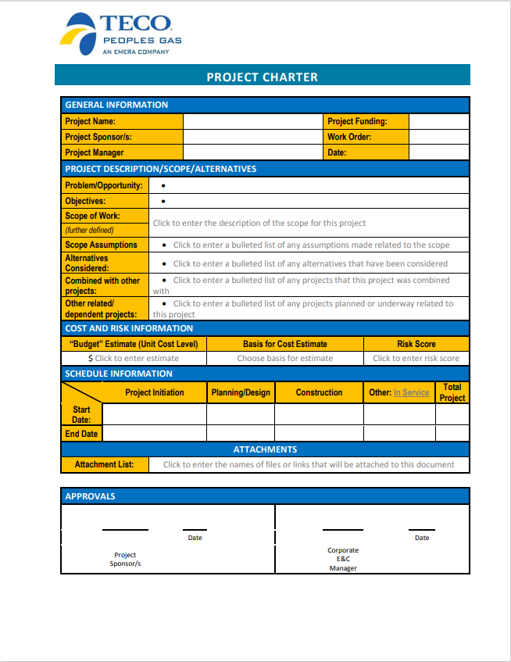

Appendix B – Project Scope Example

Example of Project Scope
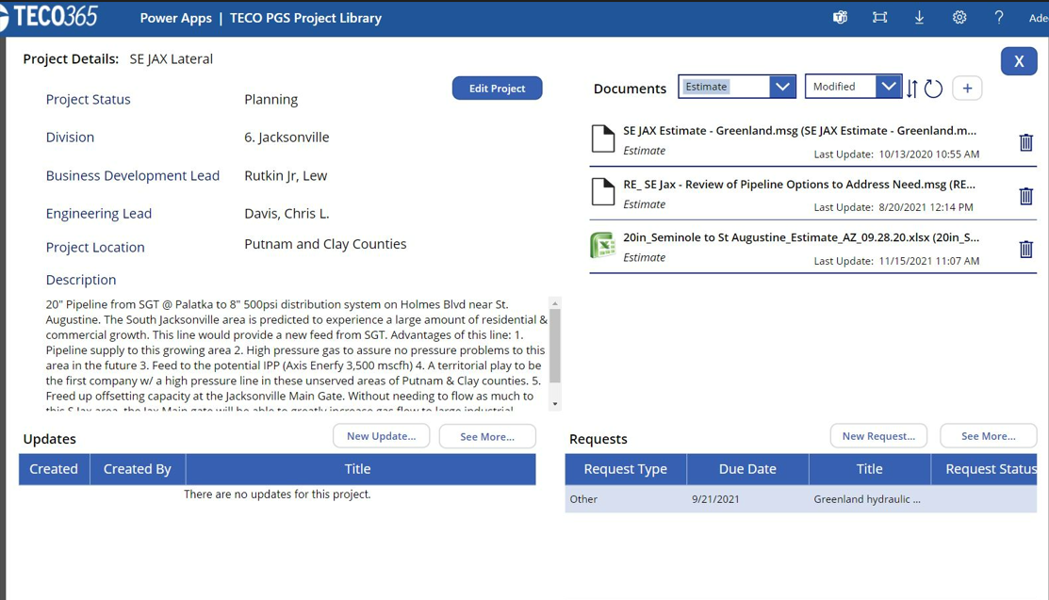

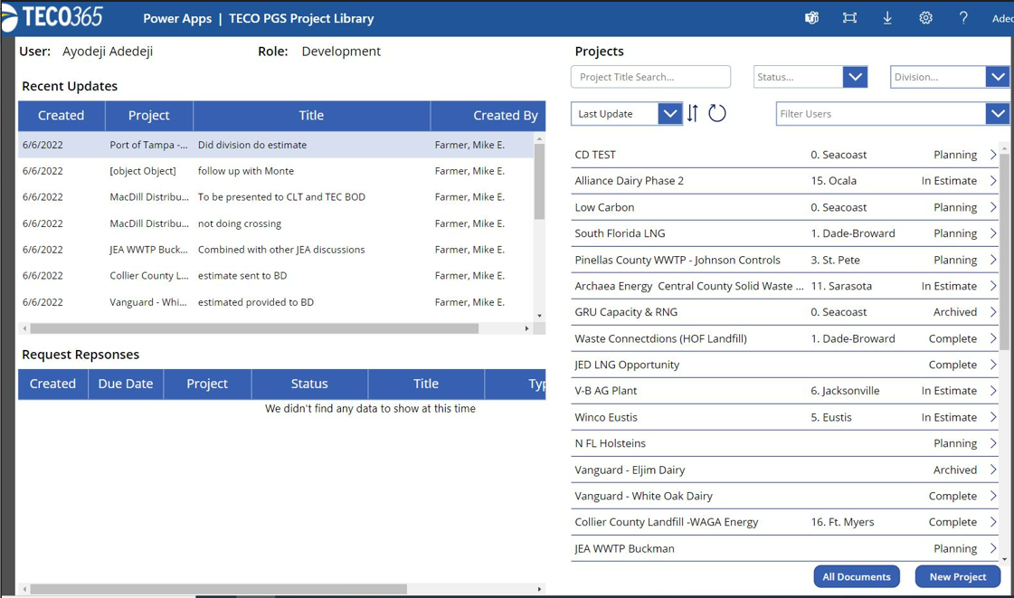

Appendix C – Project Schedule Example
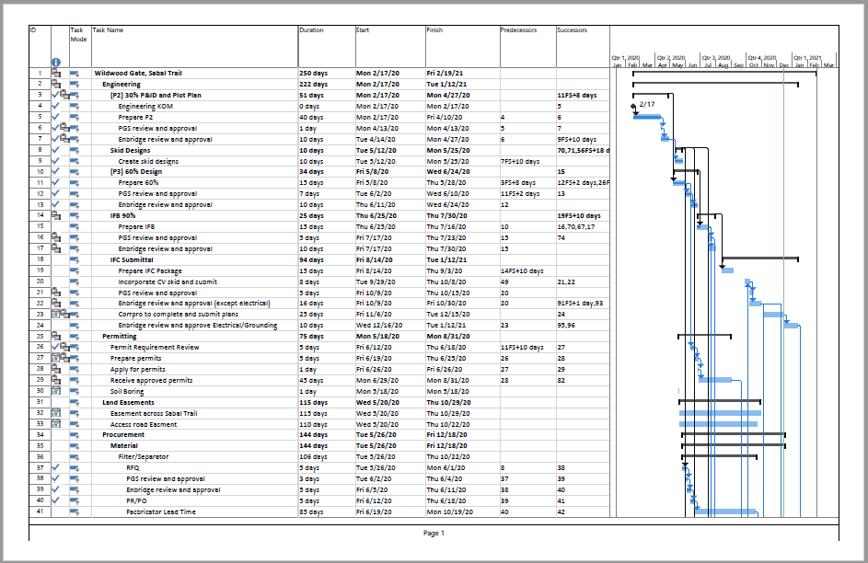
Example of Project Schedule

Appendix D – Project Cost Estimate Worksheet
Cost estimate summary worksheet.
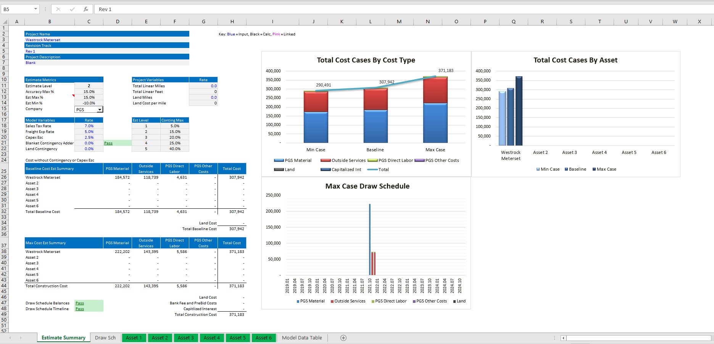
To populate the Executive Summary page, enter information for each Asset on the “Asset” worksheets tabbed at the bottom of the main spreadsheet.
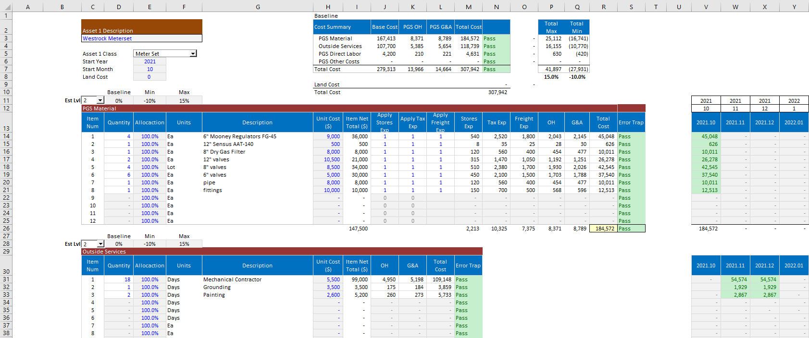
Every Asset should have its own worksheet, and the following key inputs should be identified:

Estimate variables such as asset types, facility types, and estimate levels are defined within the estimating template.
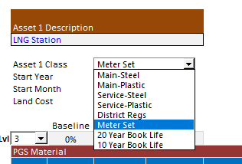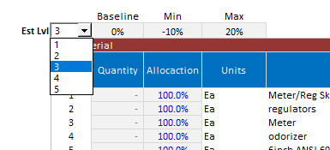

Estimate inputs such as material quantities, outside services, direct labor, other costs, and unit costs are input into the estimating template.

Materials
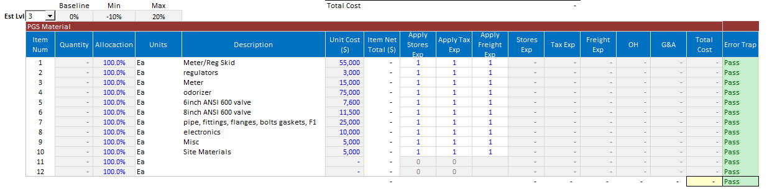

Contract Labor
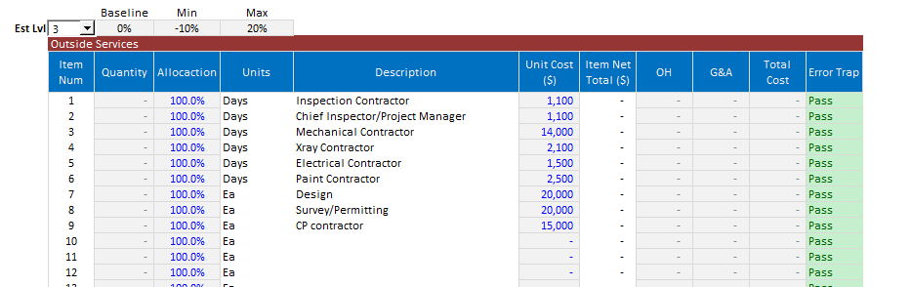

Direct Labor & Overheads
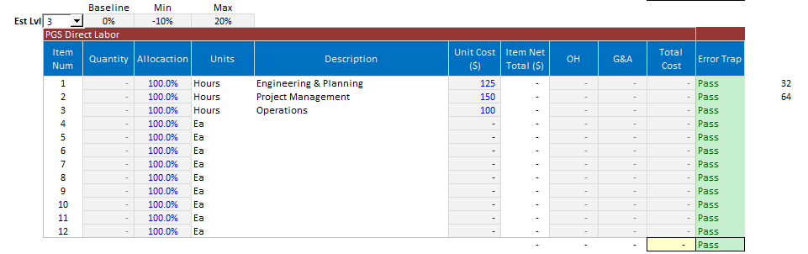

Other Costs
