

**Project Forecasting**

VERSION 1.0

Approval: Helen Wesley Date: 9/21/2022

PROJECT CONTROLS

Corporate Engineering

**TABLE OF CONTENTS**

1.0 PURPOSE 3

2.0 APPLICABILITY 3

3.0 DEFINITIONS & TERMS 4

4.0 ROLES & RESPONSIBILITIES 4

5.0 PROCESS DESCRIPTION 5

6.0 COST MANAGEMENT TIMELINE 7

7.0 REVISION HISTORY 7

APPENDIX A – Corporate Cost & Forecast Excel Templates 8

# 1.0 PURPOSE

The purpose of cost analysis and forecasting is to periodically assess the project costs and related scope to accurately report on budget adherence to-date, to quantify future expected costs, and to validate the costs against the schedule and progress. Analysis and forecasting of cost are integral parts of the project control system.

The objectives of cost analysis are as follows:

* Ensure that costs recorded by the accounting process are accurate, appropriate, and coded correctly.
* Evaluate variances between budget, actual cost and forecast.
* Provide credibility to internal cost reporting.

The objectives of a project forecast are as follows:

* Forecast the total project cost based on costs incurred to date and an Estimate to Complete (ETC) based on known scope and project schedule. Provide documentation to support the basis of this forecast.
* Determine likely areas of cost variances and opportunities for potential cost savings and direct management attention appropriately.
* Support project management and overall cost management with relaying accurate information in cash flow models and monthly reporting.

While forecasts can never be 100% accurate, due to fluctuation in costs or many other factors that influence projects, it is always best to provide the most accurate forecast possible. Doing so allows you to gain invaluable insight and creates a habit of looking at past and real-time data to predict future demand.

# 2.0 APPLICABILITY

Cost analysis and forecasting enables the cost controls team to measure the status of the project relative to the budget and to explain and report variances monthly. Internal cost reporting facilitates awareness of the issues causing the variances, which enables Project Management to take appropriate action to maintain cost-effective methods for completing the assigned scope of work. Additionally, cost analysis and forecasting ensures appropriate review and approval of project costs, through the lifecycle of the project, meet the capital management requirements of PGS (“the Company”) in accordance with PGS Policy **- TECO-LEG-POL-02-6 Contract Signature Authority & Procurement Requirements.**

The preparation of an effective project forecast includes the collection, estimation, analysis, and consolidation of cost data through joint efforts of the cost controls team, project management and accounting. These efforts are accomplished monthly to provide accurate and usable budgeting information.

# 3.0 DEFINITIONS & TERMS

* **Accrual –** A journal entry that is used to recognize revenues or expenses that have been earned or consumed for which related cash amounts have not yet been received or paid out.
* **Actual Costs (AC)** – The amount of money paid to acquire an asset, product, or service.
* **Actuals to Date (ATD)** – The amount of money that has been realized between a specified start time and the present.
* **Allowance for Funds During Construction (AFUDC)** – Federal Energy Regulatory Commission’s (FERC) long-standing regulation that permits a regulated electric or gas utility to earn a return on the construction costs of utility plant during the period of construction.
* **Estimate at Completion (EAC)** – An estimate of the total costs an activity or group of activities will accumulate upon final completion. (ATD + ETC = EAC)
* **Estimate to Complete (ETC)** – The current expectation of total costs at the end of a project. the estimated resources that are work hours, costs, time, and/or materials required to complete a scope of work.
* **Integrated Project Schedule (IPS)** - Initial project schedule breaks the project into broad activities, to provide essential information to those assembling the contractor's cost estimates.
* **Overheads** – All costs that cannot be directly attributed to a specific activity, product, or service (i.e., legal expenses, admin salaries, depreciation, insurance, licenses, fees, etc.)
* **PowerPlan** – Project planning, management and tracking tool used during the life cycle of the project for planning, budgeting, and scheduling.
* **Project Managers** – Responsible for the execution and review of designated funding projects.
* **SAP** – Repository for actuals; also used for invoice management.
* **Variance** – The difference between the planned amount and actual amount. Variance analysis is an evaluation as to why the variance may have occurred. The purpose of variance analysis is to determine what factors are driving the variances and accurately adjust the project plan moving forward.

# 4.0 ROLES & RESPONSIBILITIES

|  |  |
| --- | --- |
| **Role** | **Responsibility** |
| **Executive Leadership Team (ELT)** | * Approves all projects exceeding $5M * Reviews monthly reporting package; distributed by Business Planning |
| **Business Planning** | * Analyzes/Reviews and updates forecast models with previous months actuals * Sends out forecast files to Project Managers for updates and variance explanations * Synthesizes all information received from Project Managers into high level view for monthly reporting package * Distributes monthly reporting package to ELT |
| **Project Managers** | * Breaks down cost estimate into monthly cash flow in accordance with the IPS * Tracks project commitments as incurred * Maintains project commitments and projections in cost worksheets in PowerPlan * Submits forecast updates to Project Controls * Provides monthly variance explanations to Project Controls for all variances +/- $100K * Submits monthly accruals to Accounting |
| **Project Controls** | * Collects forecast updates and variance explanations from Project managers * Submits updates and variance explanations to Business Planning monthly * Maintains history of financial records (monthly reports, etc.) |
| **Manager – Project Management** | * Provides direction and oversight to Project Controls Team * Reviews the quality and accuracy of monthly cost analysis, forecasting, and deliverables * Ensures all costs are captured correctly and forecasted in the correct month in accordance with the IPS * Engage other project team members, as needed, to develop the Initial Budget and Cash Flow |

# 5.0 PROCESS DESCRIPTION

Business Planning analyzes and forecasts monthly project costs to meet the project cost control and reporting requirements. Once actuals are posted, the month end close process occurs; usually within the first 4-5 business days of the month. Any accruals should be processed either just prior to the end of the month or within 1-2 days following the first business day of the month so that they can be included in the cost analysis process. (See Cost Management Timeline for an example of more specific monthly timelines). Best practice is to accrue alloutstanding charges and expenses for the month, but, at a minimum, all accruals exceeding $10K must be submitted.

*Note: Project Managers should be aware of all charges incurred throughout the month and should consider updating the monthly forecast in PowerPlan prior to the month close process, particularly if the actual charges incurred will result in a variance from the monthly budget and will require an explanation.*

Business Planning sends out the forecast files to the assigned Project Managers requesting updates to monthly and project total forecasts and variance explanations on a project-by-project basis. Variance explanations are required for all funding projects that have a monthly variance that is +/- $100K from the monthly budget for the project. Variance explanations should consider impacts from material costs, contract labor, land and environmental costs, impacts from overhead rates, and costs associated with any changes in scope or risks experienced on the project. Variance explanations should be detailed and consistent to allow Business Planning to effectively analyze variance themes and develop reports.

Once the forecast files are received from Business Planning, the Project Managers then:

* Update PGS PowerPlan/Excel file.
* Update the monthly forecast, the forecast for the current year, and the project’s forecasted total incurred costs in the PGS PowerPlan/Excel file.
* Update the estimated in-service date column in PGS PowerPlan/Excel file, if needed.
* Upload values from the original cost estimate into the Corporate Cost & Forecast Excel Template (see Appendix A).
* Update the current month’s cost forecast based on any price changes and/or known delays.
* Schedule meeting with Manager of Project Management to review variance explanations.
* Send all forecast updates and variance explanations to Project Controls, via email.

*Note: Project Controls updates PowerPlan any time there is a project being managed by a third party Project Manager or whenever a project exceeds $5M.*

Project Managers should update forecasts when project estimates are updated, when material prices change if additional labor will be required to complete a project, and/or when funds for executing construction through close-out (including any additional permit requirements, on-going environmental monitoring, AFUDC, the as-built process, etc.) are released upon approval of Gate 3. **(see Project Gating procedure - PROJECT GATE 3)**.

If the forecast exceeds the approved amount or if there is a large increase in the forecast within a month or year of the life of the project, the Project Manager will need to review the forecast change with the Manager of Project Management. When the forecast change and explanation have been confirmed, it is documented in the monthly or bi-weekly report. The Manager of Project Management reviews the report with executive management to request approval for extra funding (See **Project Gating procedure – PROJECT GATE 1** for project approval requirements).

*Note: PowerPlan collects data at the G/L level. Throughout the month, the project is collecting actual costs via invoices processed through SAP which then feeds into PowerPlan. The only additional costs entered at* *month end are the application of overheads and accruals. As a good rule, Project Managers should review overhead rates and actuals throughout the month and update the forecast ahead of the request from Business Planning.*

Once all forecast updates have been finalized/submitted into PowerPlan and variance explanations have been received, Business Planning synthesizes the variance explanations from all funding projects by project category/ABM level.

The monthly reporting package is compiled and distributed to the project stakeholders and ELT, which then reviews variances, explanations, and the overall forecast.

*Note: Monthly reporting package reports current month actuals vs. budget, current month actuals vs. forecast, YTD actuals vs. YTD budget, YTD actuals vs. YTD forecast, and variance explanations for capital projects.*

# 6.0 COST MANAGEMENT TIMELINE

The PGS Business Planning table reflects the dates and times for the various stages of the monthly forecasting process. Business Planning distributes the annual calendar outlining the monthly due dates via e-mail.

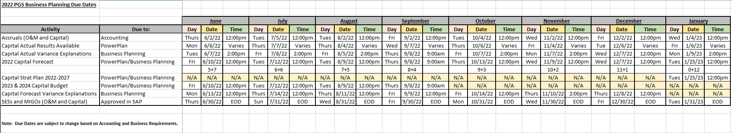

*\*Table is provided for example purposes only.*

# 7.0 REVISION HISTORY

|  |  |  |
| --- | --- | --- |
| Description of Change | Date | Version |
| Working Draft | 06/15/2022 | 0.0 |
| Issued Final |  | 1.0 |
| Revision 2 |  | 2.0 |
| Revision 3 |  | 3.0 |

# APPENDIX A – Corporate Cost & Forecast Excel Templates

Summary tab – This worksheet is automatically populated. The user should only update Project Name, Work Order, and Funding Project Year fields.

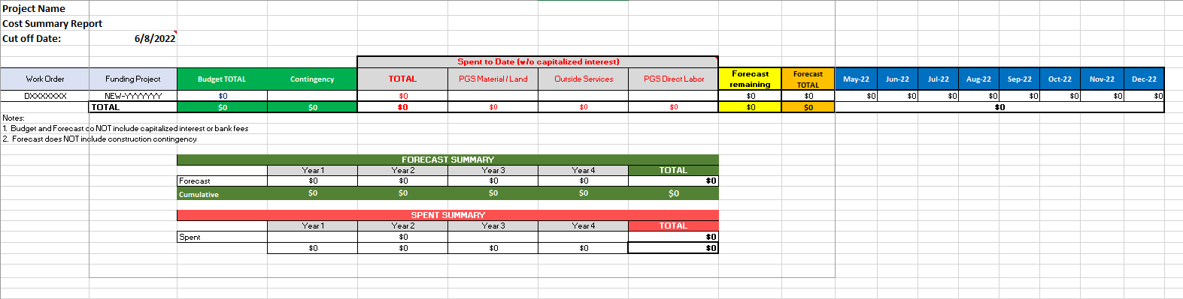

Forecast tab – Project Managers enter forecast per category in corresponding month

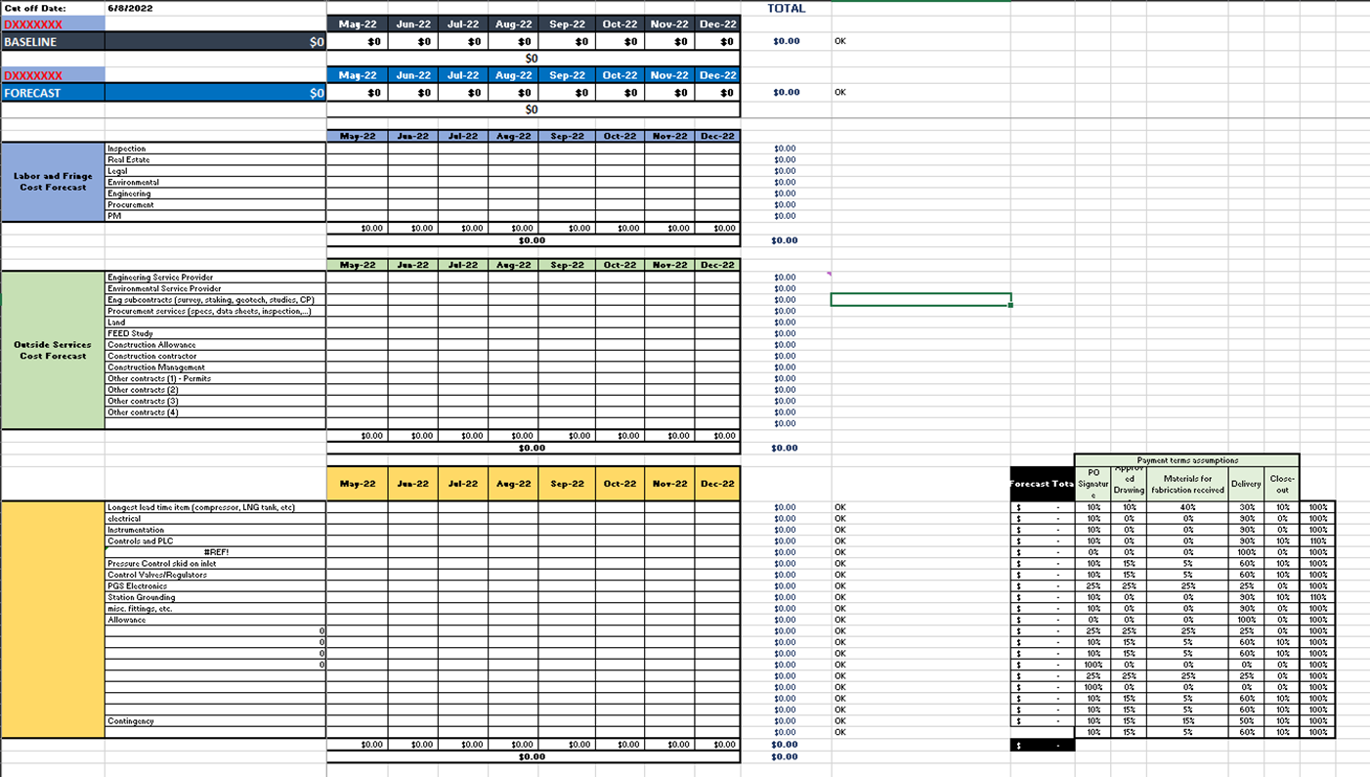(Continuation of templates on next pages)

Materials tab

Budget Table - enter Total Baseline Cost

Forecast Table – User should update Qty, Size, Location, Unit Price, and Category fields.

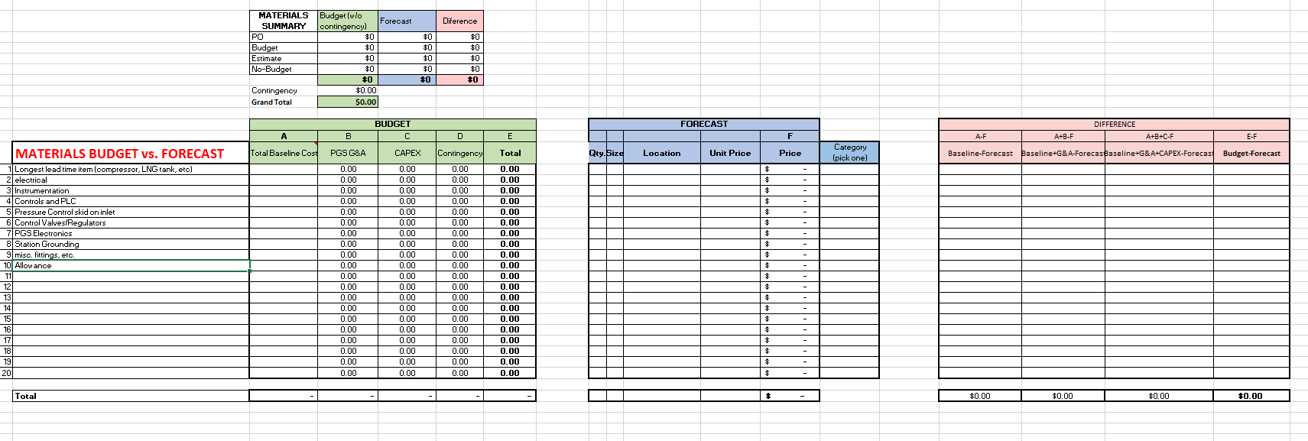

Baseline Transposed tab

The data that comes from the budget used to get the funded project broken down by category, that establishes the baseline of the project against which forecast performance is measured

