

**Project Gating**

VERSION 1.0

Approval: Helen Wesley Date: 9/21/2022

PROJECT CONTROLS

Corporate Engineering

**TABLE OF CONTENTS**

1.0 PURPOSE 3

2.0 APPLICABILITY 5

3.0 DEFINITIONS & TERMS 5

4.0 ROLES & RESPONSIBILITIES 6

5.0 GATE 1 – INITIATION GATE 7

6.0 GATE 2 – 30% PROJECT REVIEW 9

7.0 GATE 3 – PROJECT AUTHORIZATION 11

8.0 GATE 4 – CLOSE-OUT 12

9.0 REVISION HISTORY 13

Appendix A – Capital Funding Project Setup 14

Appendix B – Work Order Setup 15

Appendix C – Transmission Asset Record Process Flow 17

# 1.0 PURPOSE

The Project Phase Gate process is used widely across utilities. It is considered a “Leading Practice” directly related with reducing cost over runs, schedule delays, and scope misalignment.

This document provides a standard guideline for the various phases in the project gating process relating to the origination, development, planning, design, execution, and closeout of PGS Peoples Gas (“PGS”) capital projects.

The project gating process provides management specific points in the project lifecycle when further progress entails higher investment and commitment.

The purpose of project gating is to provide project status information, resolve issues encountered, review potential risks, review cost and schedule performance, and provide communication amongst the project team members and project stakeholders

Project Phase Gate Benefits:

* Increases consistency and predictability of project delivery
* Improves engagement, accountability, and alignment across key stakeholder groups
* Defining and executing on the right scope. Reducing or eliminating rework and scope creep
* Confirming expected deliverables at each phase before proceeding to the next phase
* Enabling earlier critical decision-making
* Better cost visibility and control

Each Phase Gate has specific deliverables that are reviewed, and a decision is made to fund to the next gate. By increasing the visibility if a Phase Gate is not approved, it escalates issues earlier in the project lifecycle and allows for more awareness and time to address issues such as scope definition, realistic schedules (e.g. for design, permitting, clearances, construction) and resource management.

GATES:

The Project Phase gates align with key milestones in the project lifecycle. Each gate requires an approval by key stakeholders based on deliverables and delegation of authority.

**Initiation/ Planning**

**Design**

**Construction**

**Close Out**





**GATE 1: DESIGN BASIS**

* Approval: design basis
* TIC: Class 4 or 5
* Decision: proceed to detailed **design?**

**GATE 2: 30% PROJECT REVIEW**

* Approval: project scope, execution strategy, schedule
* TIC: Class 3 or 4
* Decision: proceed to final **design and procurement?**

**GATE 3: PROJECT AUTHORIZATION**

* Approval: project design and delivery strategy
* TIC: Class 2 or 3
* Decision: proceed to **construction?**

**GATE 4: PROJECT CLOSE OUT**

* Approval: Records and Accounting
* Decision: proceed to **close-out?**

# 2.0 APPLICABILITY

Project Gates are applicable to major expansion pipeline, RNG, CNG, and LNG projects valued at $5 million or more. This process provides key points in a project where a formal review of the project's current state is performed. Most often they appear at the phase transitions of projects and represent a point in the project where the sponsor and stakeholders will incur increased risk, expense, and reward. When a project gate is encountered, a Gate Review is held to determine if the project should proceed or not and under what conditions. Although the Gate Review may appear like a project status meeting, it is much more important. Project meetings tend to be periodic (weekly, monthly, etc.) and are generally led by the project manager and attended by project staff.

Gate Reviews occur at various defined phases within the project. Therefore, Gate Reviews are paced by the rate of progress and complexity of the project. During Gate Reviews, progress to-date, scope, detail for the next gate, sponsor recommitment, and authorization to proceed into the next phase, are some of the matters that are addressed.

# 3.0 DEFINITIONS & TERMS

* **Board of Directors –** The team that approves all projects that are $10M or more from a cost perspective in value.
* **Capital Leadership Team** – The team that approves all projects that are $5M or more from a cost perspective in value.
* **Change Management** – The management of a change in resources, process, budget and people involved in a project.
* **Cost Estimates** – Preliminary stage for any project, operation, or program wherein a reasonable calculation of all the project costs is done and, therefore, involves precise judgment, experience, and accuracy.
* **Executive Leadership Team** – The team that approves all projects less than $5M from a cost perspective in value.
* **Gate Keeper** – A member of the project team who oversees and monitors the outcome of the project through a gate.
* **Gate Review -** Provides formal review meeting to ensure all deliverables of the specific gate are completed. It provides management with the information required at specific phases in the project life cycle to decide whether or not to proceed to the next gate when further progress in as the project requires higher investment and commitment of resources.
* **PowerPlan** – Project planning, management and tracking cost control tool used during the life cycle of the project for planning, budgeting, and scheduling.
* **Preliminary Project Schedule –** Initial project schedule that breaks the project into relatively few broad activities, to provide essential information to those assembling the contractor's cost estimates.
* **Project Gate –** A concept that provides key communication opportunities as a project moves through the processes while elaborating on specific steps.
* **Project Team -** A group of people responsible for the completion of the project. This includes planning, execution, monitoring and controlling, and closing, as well as decision making or any other activity that is related to the project.

# 4.0 ROLES & RESPONSIBILITIES

|  |  |
| --- | --- |
| **Role** | **Responsibility** |
| **Executive Leadership Team (ELT)** | * Approves all projects * For projects less than $5M, will be the final approval level |
| **Capital Leadership Team (CLT)** | * Approves all projects over $5M once the ELT has approved * For projects ranging from $5M to $10M, will be the final approval level |
| **Board of Directors** | * Approves all projects over $10M once the CLT has approved |
| **Project Manager** | * Manages the project from its planning to closeout phases and acts as a liaison, while maintaining constant communication between all functional teams, contractors, and stakeholder(s) * Obtains stakeholder feedback and scope changes * Obtains material cost estimates * Identifies project risks * Submits project budget change authorization for funding * Freezes Project Scope * Issues request to acquire land and easements * Issues request to purchase or order materials * Obtains permits * Prepares Construction Plan and obtains bids, if needed * Oversees Construction * Prepares documentation for Work Order initiation and closeout * Ensures all paperwork and as-built documentation to ensure compliance requirements are met and systems are complete and updated * Reconciles materials * Reviews/revises funding approval if necessary * Archives project documentation |
| **Project Engineer** | * Completes conceptual design (may require several iterations based on new information or feedback) * Completes detailed design * Develops cost estimates |
| **Project Controls** | * Monitors project costs and progress * Updates PowerPlan with current project information * Manages external Project Managers and analyzes variances for projects over $5M |
| **Business Development** | * Initiates new project requests and captures project scope and other pertinent information used in estimating, design, planning and execution * Creates Project Charter * Reviews project with key stakeholders * Presents project for economic feasibility and funding approval, including requesting Funding Project number * Serves as liaison between customer and company to communicate cost information, customer responsibilities, and status |
| **Business Planning** | * Creates funding project in PowerPlan * Updates budget forecast with project information |

# 5.0 GATE 1 – INITIATION GATE

The phase leading to Gate 1 is initiated at the conceptual stage of a project. Requests for a project and a preliminary cost estimate come from a variety of sources. New customer or additional growth opportunities will be initiated by Business Development or TECO Partners. System Planning will identify projects necessary to support native growth and system reliability. Estimates for new projects may include new pipelines, associated equipment, facilities or upgrades to existing facilities, upstream facilities, land, and operation & maintenance costs.

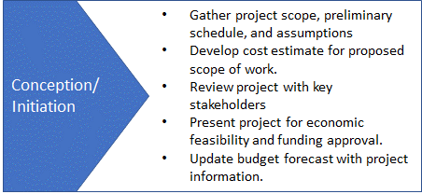The project initiator (Business Development or System Planning) will guide the project through this stage, creating a project request, managing the project development, and planning team, obtaining a high-level preliminary estimate & design from the engineering construction team, drafting a project plan, and documenting the project requests in PGS’s BD Portal (SharePoint site). A preliminary scope of work should capture high-level parameters of the project that will impact the preliminary estimate. Scope should include items such as customer information, load/demand requirements, project assumptions, pressure requirements, usage requirements and processes, service location, and schedule. Key milestones, such as engineering design, land acquisition, construction start, and desired completion, should be identified as early in the process as practicable.

Engineering will develop a high-level estimate consistent with the Cost Estimating Process. A “Budgetary Estimate” should be completed to an Estimating Class 4 or 5. **Refer to estimate levels 4 & 5 of the Cost Estimating procedure for estimate details and requirements.** Field visits are usually not needed to develop the preliminary estimate. However, there may be some preliminary survey work to gather feedback from different stakeholders (i.e., engineering, system planning, operations, and measurement) that may be needed to identify the high-level equipment and sizes needed. Additionally, as a preliminary route is considered, understanding some of the key environmental cost drivers (road crossing, railroad crossing, rivers, etc.) may impact the preliminary cost estimate. A preliminary identification of risks to the project should be generated early in the process. Project risks and environmental factors should be considered when evaluating contingency. Some consideration of known details within the preliminary estimate would increase confidence around the preliminary estimate. Deliverables will be used in the budgeting process for future years and evaluating and ranking projects against other planned projects.

The project scope of work and preliminary estimate will be provided to the financial analytics team to provide a rate using cost-of-service methodology. The rate is compared to tariff rate to ensure it is in compliance. It is also reviewed for rate impact, competitive rate adjustment (CRA) impact for CIS tariff projects, and bill impact for reliability projects. If the customer or internal teams would like to proceed based on preliminary estimate, then, project is prepared for advancement to the next stage. The =budgetary estimate is further refined based on feedback from customers and/or internal teams (site visit, pipeline route assessment, tariff compliance, financial feasibility). The revised budgetary estimate is prepared by engineering and used by business development to negotiate an agreement with a potential customer or used for further analysis to determine the prudency of a reliability project. There is a back and forth at this stage to refine the estimate based on customer or internal team feedback. The customer may be offered different options and terms at this stage. A funding number is created, and the budget is shared with the Business Planning team for inclusion in the company budget. At this stage, an upstream review is conducted to determine the cost of upstream improvements required. The budget is incorporated into a financial model by financial analytics to prepare project-specific financial statements and analysis to support approval. The customer enters into a conditionally binding agreement and budget estimate used to price customer rate is used to seek approval. Budgetary estimate is used to seek project approval following favorable evaluation by internal teams. Due to budgetary constraints, the budgetary estimate is not further refined to definitive estimates. The budgetary estimate includes contingency which is determined by the risk level of the project. The budget amount approved is included in the company budget and formally included in all planning activities. The monthly spend profile is included in quarterly forecasts and monitored by finance team for variance. Depending on the forecasted cost of the project, a financial approval is required by the various leadership teams: the Executive Leadership Team (ELT), Capital Leadership Team (CLT), or the Board of Directors (BOD). Below, are the project cost levels of approval by its required leadership team:

|  |  |  |  |
| --- | --- | --- | --- |
|  | **Projects < $5M** | **Projects ranging from $5M-$10M** | **Projects >$10M** |
| **Executive Leadership Team (ELT)** |  |  |  |
| **Capital Leadership Team (CLT)** |  |  |  |
| **Board of Directors (BOD)** |  |  |  |

The Business Development team passes on approved budget to finance and engineering for execution into the next Gate. The Business Development team also provides project oversight and leads customer interface. **Gate 1 Deliverables include:**

* Ensure financial align with tariffs and justification for customers, regulators, and shareholders
* Signed Gas Service Agreement from customer including project terms, scope, and schedule (for customer backed project).
* Complete appropriate reviews and corporate approvals for business case and associated agreements
* Project Charter – including but not limited to:
  + Scope
  + Schedule
  + Cost estimate summary
* Detailed Cost Estimate (level 4 or 5)
* Project Assumptions
* Potential Risks
* Milestone Schedule
* Estimated cost to reach Gate 2

# 6.0 GATE 2 – 30% PROJECT REVIEW

After the project Design Basis is approved and authorization to move to Gate 2 is documented, the project responsibility moves from the originator and development team to the assigned Project Manager. Business Development, Business Planning, Engineering and the assigned Project Manager should work together to ensure a complete and detailed turnover of project information. Other stakeholders should be engaged as needed. Outputs from Gate 1, Project Scope, Cost Estimate, Assumptions, Potential Risks, and the Milestone Schedule should be reviewed in detail to ensure a common understanding and continuity of the project into the design phase. The intent is to give the Project Manager and Engineering team an opportunity to review in detail the scope of the work, get answers to any questions they have, and review the schedule. The entire project team will discuss the preliminary construction plan, review risks, identify critical path items (such as long lead materials), and discuss communication needs and change management.

The estimate and schedule from Gate 1 will be used by the Project Manager/Controller to initiate the funding process by completing the **Capital Funding Project Setup Form** (See Appendix A for example project funding form). The form will be kept in the project folder records.

Business Planning sets up the project in PowerPlan using the information provided by the Project Manager on the project funding form. Once the Funding Project is created, the Project Manager will create Work Order(s) in PowerPlan.

The Project Manager will revise the Project Charter as needed for sign off by the project sponsors (Vice President of Engineering & Construction and the Vice President of Business Development). The Project Charter is used throughout the project life cycle. (See Appendix B for a high-level description of the project setup in PowerPlan and the Project Charter form).

Going forward, project forecasts are updated monthly per the Project **Forecasting** **Procedure**.

During initial design, if land is required for the project, and it has not previously been obtained, Real Estate Services will start the route assessment and land acquisition process. Project alternatives should be explored, and scope additions evaluated. Rework or rescoping may be required either due to land issues or technical issues that arise. The project should be reviewed to ensure that there are no other service delivery options to the identified project.

After the 30% design step is completed, the Project Manager will conduct a preliminary review and planning meeting following the Corporate Engineering and Construction Design Review Guidelines. The goal for this meeting is to ensure the different stakeholders have a common understanding of the project scope, schedule, milestones, and resource needs. This meeting will offer an opportunity for each of the stakeholders to provide input into the project, including the identification of risk. The Project Manager will prepare a Risk Management Plan with input from the project team to identify possible risks and mitigations.

The assigned engineer will use the updated project details and 30% design to develop the initial detailed estimate including the engineering, materials, land, construction labor, other labor, and overheads. The estimate should be completed to an Estimating Class 3 level at a minimum, as described in the Cost Estimating Procedure. **Please refer to estimate level 3 of the Cost Estimating procedure for required details and criteria.**  The Project Manager and Engineer will review the project details and updated cost estimate with Corporate Engineering & Construction management.

If the cost estimate increases to a level that exceeds prior approval, additional approval will need to be received prior to the Gate 2 review meeting per company policy.

**Gate 2 Deliverables include:**

* Updated Project Charter
* 30% Design
* Risk Management Plan
* List of long lead materials
* Cost Estimate level 3 or 4
* Schedule (WBS level 4 or more)
* Land Acquisition Plan
* Estimated costs to reach Gate 3

# 7.0 GATE 3 – PROJECT AUTHORIZATION

Gate 3 should be performed prior to the mobilization of the construction crews. Land acquisition should be coming to a completion. As Real Estate Services group acquires property, it should communicate a release so that project management and construction team members know that they may begin work on that site. Permit applications need to be submitted after design work is completed but prior to commencing construction.

The Project Manager will work with Engineering to complete the detailed design, including updating all changes impacted by the land acquisition process. Cost estimates are updated to reflect updated material costs, contractor bids, land and easement acquisition costs, permitting fees, restoration costs, contingencies, and escalations. The estimate should be completed to an Estimating Class 2 or 3 level as described in the Cost Estimating Procedure. **Refer to estimate level 2 or 3 of the Cost Estimating procedure for required details and criteria.**  The cost estimate should be updated in PowerPlan to reflect the updated forecast. If the cost estimate increases to a level that exceeds prior approval, additional approval levels are required commensurate with the approval table in Gate 1.

The Project Manager is responsible for ensuring materials are ordered on time and issuing bid packages for construction resources. Additional labor resources (inspection, x-ray, in-line inspection, etc.) will need to be acquired to support project execution. Some long lead time items may need to be ordered well ahead of the completion of detailed design to meet the construction schedule or customer requirements. Follow procurement requirements for funding long lead time items.

The Project Manager will update the project plan and construction schedule to reflect all known variables. Regular planning and progress meetings should occur throughout the duration of the execution phase of the project. Additionally, project schedules, forecasts, and risks should be updated throughout the project. See the **Project** **Forecasting Procedure** for requirements related to monthly variance explanations and updating of project forecasts in PowerPlan. Any impacts to schedule or cost should be documented and communicated to management and Business Development if it may impact delivery to the customer as this can lead to losses in project revenue.

**Gate 3 Deliverables include:**

* Updated Detailed Design
* Work Order Approval
* Bill of Materials
* Contractor bid summary
* Updated Risk Management Plan
* Updated Cost Estimate
* Updated Schedule
* Updated Construction Plan
* Updated Land Acquisition Plan
* Submitted Permit applications

# 8.0 GATE 4 – CLOSE-OUT

Construction will return materials and do any cleanup to restore the land along the route and at any facility sites. Right-of-way restoration may take many months depending on the time of year that the project is completed. Seeding, landscaping, gravel spreading are examples of activities that can take place well after the project has been completed and the new assets are in service. Surplus materials should be returned to the warehouses and reconciled against the purchased materials.

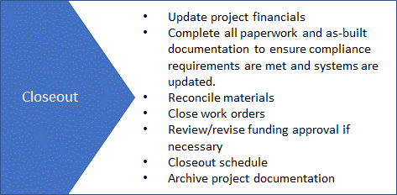Construction will complete all required paperwork and as-built documentation to ensure compliance requirements are met and systems (ex. GIS, SAP, OpenText, PowerPlan) are updated. It is recommended that a quality control check of documentation is completed before any records are posted to the system of record or filed. See Appendix C: Transmission Asset Record Process Flow for more details on the record keeping requirements.

Engineering will complete all as-built drawings based on the documentation received from construction. The Project Manager will evaluate the Total Installed Cost (TIC), update PowerPlan as needed, per the **Project Forecasting Procedure**, and provide an explanation for any variance. A final review of the project to evaluate lessons learned and improvement opportunities is recommended. Work order records will be filed accordingly.

Project Manager will update PowerPlan to reflect the assets installed and to ensure property accounting records are accurate. The project will be closed in the system by Business Planning. Trailing charges should be expected to reflect the restoration activities described above and the forecast should be updated to reflect these costs unless the costs are marginal.

# 9.0 REVISION HISTORY

|  |  |  |
| --- | --- | --- |
| Description of Change | Date | Version |
| Working Draft | 06/15/2022 | 0.0 |
| Issued Final |  | 1.0 |
| Revision 2 |  | 2.0 |
| Revision 3 |  | 3.0 |

# Appendix A – Capital Funding Project Setup

**Capital Funding Project Setup Form**

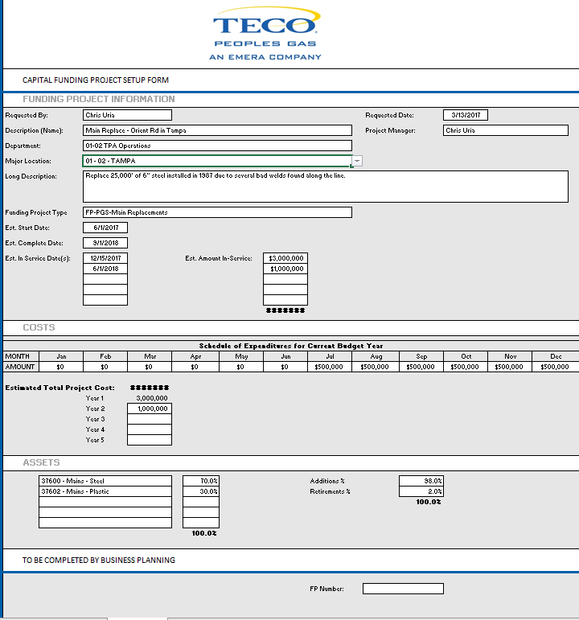

# Appendix B – Work Order Setup

**Work Order Setup Process**

When initiating a new work order, the Project Manager must assign the budget Project Funding Number to the Work Order within PowerPlan. The second step is to assign the “type” of Work Order or what asset is being constructed, for example, mains or stations.

By design, a Funding Project can have one or many Work Orders to post actual costs and build an asset. A Work Order must be cost estimated and approved. However, these ***Work Order cost estimates are NOT systematically displayed in the Funding Project estimates (forecast, budget).***

Once the Work Order has been created and approved in PowerPlan, the Project Manager is responsible for creating the Project Charter for sign off by the project sponsors (Vice President of Engineering & Construction and the Vice President of Business Development). The Project Charter is used throughout the project life cycle.

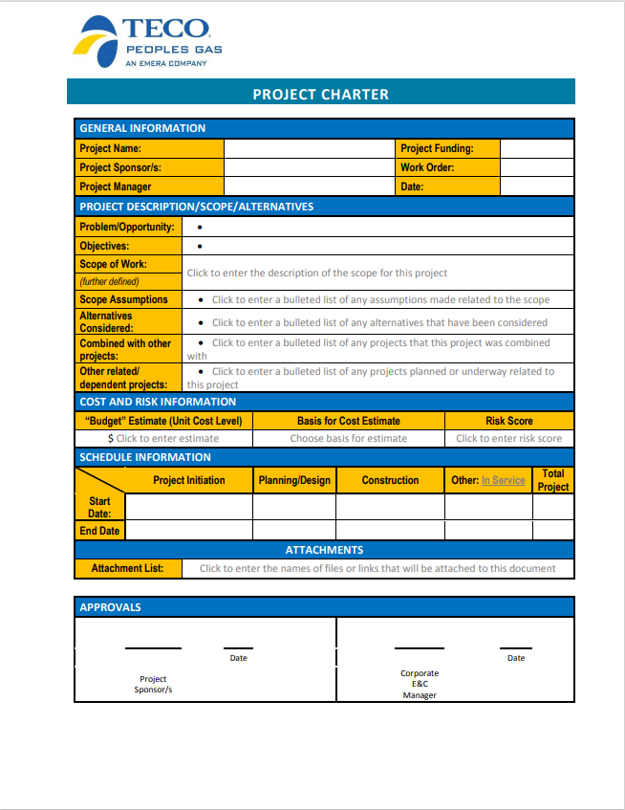

# Appendix C – Transmission Asset Record Process Flow

Gas Transmission project recording keeping process flow diagram

