|  |  |  |  |
| --- | --- | --- | --- |
| State of Florida  pscSEAL | | Public Service Commission  Capital Circle Office Center ● 2540 Shumard Oak Boulevard Tallahassee, Florida 32399-0850  -M-E-M-O-R-A-N-D-U-M- | |
| DATE: | October 27, 2023 | | |
| TO: | Office of Commission Clerk (Teitzman) | | |
| FROM: | Division of Economics (Barrett)  Division Of Engineering (Ellis)  Office of the General Counsel (Stiller) | | |
| RE: | Docket No. 20230072-EI – Petition for approval of shared solar tariff change, by Tampa Electric Company. | | |
| AGENDA: | 11/09/23 – Regular Agenda – Tariff Filing – Interested Persons May Participate | | |
| COMMISSIONERS ASSIGNED: | | | All Commissioners |
| PREHEARING OFFICER: | | | Administrative |
| CRITICAL DATES: | | | 1/31/2024 (8-month Effective Date) |
| SPECIAL INSTRUCTIONS: | | | None |

Case Background

On May 31, 2023, Tampa Electric Company (TECO or utility) filed a petition for approval of changes to its Shared Solar Rider Tariff (SSR-1 Tariff or Tariff). The SSR-1 Tariff pertains to an optional program that is marketed by TECO as its “Sun Select” program. The utility’s current SSR-1 Tariff was approved by the Commission in Order No. PSC-2019-0215-TRF-EI (Tariff Approval Order) and offers residential and commercial customers the option to purchase all or a portion of their monthly energy consumption from an allocation of 17.5 megawatts (MWs) of dedicated capacity from the utility’s Lake Hancock solar facility.[1] In its petition, the utility seeks approval of several modifications designed to attract more participants to subscribe to the optional Tariff. TECO also states that it hopes to learn more about customer adoption of community solar programs and engage with its customers to help them reach decarbonization goals.

In Order No. PSC-2023-0214-PCO-EI, the Commission suspended the proposed modified tariff in order to allow staff sufficient time to review the proposed modifications and gather pertinent information.[2] Subsequently, staff issued two data requests to the utility, and conducted two informal meetings with utility representatives on August 17, 2023, and September 7, 2023.

On September 15, 2023, TECO filed revisions to the proposed SSR-1 Tariff based on feedback provided by staff. TECO’s proposed SSR-1 Tariff, as amended, is shown in Attachment A.

The Commission has jurisdiction over this matter pursuant to Sections 366.03, 366.04, 366.05, and 366.06, Florida Statutes (F.S.).

Discussion of Issues

Issue :

 Should the Commission approve the proposed changes to TECO’s Shared Solar Rider Tariff?

Recommendation:

 Yes, the Commission should approve the proposed changes to TECO’s Shared Solar Rider Tariff, as shown in Attachment A, contingent upon TECO’s compliance with certain program implementation provisions and reporting requirements described below.

First, incremental revenues from this program that exceed the Sun Select revenue credits approved in the 2021 Settlement should be recorded as a credit to the Fuel and Purchased Power Cost Recovery Clause (Fuel Clause) to offset expenditures for fuel.

Second, TECO should manage its SSR-1 Tariff program subscriptions to ensure that the proportion of energy sales of residential and commercial customers in the RS and GS classes to total energy sales (all classes) is, in the aggregate, no lower than thirty percent.

Third, in its marketing of the revised program, TECO should not claim or imply that program revenues are earmarked for or contribute to the construction of new solar resources.

Finally, TECO should submit annual reports in March of 2024, 2025, 2026, and 2027 with data for the prior calendar year, detailing the following: 1) the number of revised SSR-1 Tariff program participants, amount of energy sales, waiting list levels, and revenues collected, by subscription level and by rate class; 2) the incremental revenue, above the Sun Select revenue currently included in base rates, credited to the Fuel Clause; 3) a summary of TECO’s key findings regarding customer adoption of community solar programs and its customers’ desire to reach decarbonization goals; and 4) a detailed description of whether and how the results of the program have impacted TECO’s generation planning. (Barrett, Ellis)

Staff Analysis:

 As set forth in the Tariff Approval Order, the utility’s current SSR-1 Tariff offers customers an opportunity to support the construction of a 17.5 MW portion of the Lake Hancock solar project, a 49.5 MW solar facility constructed by TECO that came fully on-line in 2019. The remaining 32 MWs of the Lake Hancock solar project were included in base rate charges through a solar generation base rate adjustment (SoBRA) mechanism.[3]

Customers taking service under the current SSR-1 Tariff pay a levelized energy rate of 6.3 cents/kWh, which recovers the anticipated revenue requirement of the capital and operating and maintenance (O&M) costs of 17.5 MWs of this solar facility over the 30-year projected life, plus program administrative costs. Under the SSR-1 Tariff, residential customers can opt to purchase solar energy on the basis of 25, 50, or 100 percent of their monthly energy usage, and commercial/industrial customers are eligible to purchase in 1,000 kWh blocks. In exchange, such customers are exempted from having to pay fuel costs via the Fuel Clause for the portion of their bills under SSR-1 Tariff subscription. While this exemption decreased revenues in the Fuel Clause, the general body of ratepayers received the benefit of an additional 17.5 MW of solar capacity that was not funded by the general body of ratepayers at the time the original proposal was approved.

The Tariff Approval Order provided that the 17.5 MW portion of the Lake Hancock unit would be included in TECO’s revenue requirement as an addition to base rates in a future rate case proceeding. Accordingly, in the 2021 Settlement, TECO included the cost associated with the 17.5 MW portion of Lake Hancock in its base rates.[4] The projected SSR-1 Tariff revenues will continue to be included as a credit to the revenue requirement when calculating base rates. Staff confirmed that TECO included the SSR-1 Tariff revenues as an offset when calculating base rates in Docket No. 20210034-EI, thereby putting downward pressure on base rates and avoiding double recovery.

**Proposed Changes to SSR-1 Tariff and Sun Select Program**

As shown in Attachment A, TECO proposes the following notable changes to its SSR-1 Tariff:

1. The Tariff rate decreases from 6.3 cents/kWh to 4.9 cents/kWh.
2. The program capacity increases from 17.5 MW of incremental capacity to 30 MW of existing capacity.
3. New customer enrollments and re-enrollments will not be allowed to exceed 10 million kWh per year for GSD, GSLDPR, and GSLDSU customers.
4. Re-enrollments are prohibited for 12 months after an account’s cancellation from the program.
5. The SSR-1 Tariff’s “Monthly Rate” is renamed “Rate.”

The utility explained that it seeks approval of changes to the Sun Select program for the purpose of elevating participation levels. Participation in the program has been modest, with only 35 percent of the available capacity currently subscribed and a churn rate of 44 percent.[5] Additionally, the utility states it hopes to learn more about customer adoption of community solar programs and engage with its customers to help them reach decarbonization goals.

In order to achieve these objectives, TECO proposes two primary changes to the program. First, the utility proposes to reduce the monthly rate under the SSR-1 Tariff from 6.3 cents/kWh to 4.9 cents/kWh based on a revised pricing model. The reduction of 1.4 cents/kWh is intended for current and future program participants. Second, TECO proposes to expand the available capacity of the Sun Select program from 17.5 MWs to 30.0 MWs.

TECO’s proposal to reduce the monthly SSR-1 Tariff rate is based on a complete change in its pricing model. Exhibit B to the petition, the “Waterfall Chart,” proposes that increased incremental costs under the proposed program are offset by decreased incremental costs, resulting in the proposed SSR-1 Tariff rate of 4.9 cents/kWh.[6] TECO states it used a marginal cost of service analysis to arrive at its calculation of levelized costs, including energy and generation capacity. TECO then used various cost/credit assumptions that, when summed, equal the proposed SSR-1 rate. These cost considerations are more fully described below.

While TECO has historically based Sun Select program costs on the actual capital and O&M costs of the eligible 17.5 MW of the Lake Hancock facility, the proposed changes are based upon the capital and O&M expenses of TECO’s entire solar fleet, plus added credits and expenses associated with the facility’s energy and capacity. TECO proposes a program price in part based on the average installed costs of TECO’s entire solar generation portfolio, which is lower than the installed cost of the Lake Hancock solar facility under which the Sun Select program price was originally established. In addition, the utility’s pricing model adjusted the depreciable life of solar assets by five years (from 30 years to 35 years).[7] Unlike the original program, no new incremental capacity will be constructed as a result of this increase in amount of eligible solar capacity in the Sun Select participation from 17.5 MW to 30.0 MW,[8] or approximately 0.3 percent of TECO’s net energy for load in 2023.[9] TECO states that the portfolio approach enables it to make available to customers the entire capacity limit of the program, rather than having a small portion reserved as a buffer.[10]

Regarding the proposed capacity credit, TECO specifies that it includes the capacity credit as an offset to ensure customers are not paying for capacity twice, using the next avoidable unit instead of the system’s costs. TECO includes a 1.5 cents/kWh credit for capacity based on the installed cost information for the 2023 Standard Offer Contract avoided unit, a 2030 natural gas-fired internal combustion engine. However, no new generation will be constructed, and the existing capacity is solar, which TECO considers non-firm for its winter system peak and only partially firm for its summer system peak. As a result, the resulting 4.9 cents/kWh rate is not cost based. While the program is voluntary, the Commission should consider whether it has an undue impact on the general body of ratepayers.

In addition to the proposed rate change, a proposed wording change in the tariff renames the term “Monthly Rate” to “Rate” in reference to the SSR-1 rate, designed to avoid the appearance of a flat fee.

In response to staff concerns, TECO updated its original tariff filing to include two other proposed changes to its SSR-1 Tariff. First, the proposed tariff would limit new customer enrollments and re-enrollments to 10 million kWh per year for the customers in the GSD, GSLDPR, and GSLDSU rate classes, to address staff concerns that a small number of customers could prohibit more widespread adoption of the program. Second, TECO proposed tariff changes that would prohibit re-enrollments for 12 months after an account’s cancellation from the program. TECO offered this change in response to staff’s concern that some customers may seek to enter and exit the program frequently, based on what they perceive is or will be a favorable relationship between TECO’s fuel factor and the SSR-1 Tariff rate.

***SSR-1 Tariff Customer Impacts***

TECO claims that the proposed program provides Sun Select participants a pricing option to facilitate their efforts to decarbonize their operations or homes by using renewable power. TECO also indicated that it provides participants with an opportunity to mitigate bill changes due to fuel price fluctuations (hedge).[11] Staff considered several customer impacts, as discussed below.

**Pricing Impact**

When a subscriber enrolls in this optional program, they continue to receive electric service from TECO’s mix of fossil and renewable generating resources. The fixed Sun Select tariff rate effectively replaces a portion or all of the Fuel Clause charges that customer would ordinarily be assessed. Staff notes this is somewhat similar to a customer installing rooftop solar panels, in that such a customer voluntarily pays a premium (for their rooftop solar panels), with the expectation of having lower Fuel Clause charges as the result of paying the premium. Fuel Clause charges are ordinarily reset on an annual basis, or perhaps more often depending on actions the utility takes in responding to external (market) conditions or as required by the Commission. TECO’s marketing materials for this program state:

Sun Select participants lock in a solar rate. While this rate is slightly higher, your fuel charge is waived for that portion of your electricity use.[12]

Staff compared the proposed SSR-1 Tariff and TECO’s Projected System Average Fuel Costs (for 2024 through 2030). As shown in Table 1-1, the proposed Tariff rate (4.9 cents per kWh) is higher than TECO’s Projected System Average Fuel Costs (for 2024 through 2030).

**Table 1-1**

**Proposed Tariff Rate and Projected Fuel Cost Comparison (cents/kWh)**

|  |  |  |  |
| --- | --- | --- | --- |
| Year  (A) | Proposed SSR-1 Tariff Rate  (B) | Projected System Average Fuel Cost  (C)* | Difference between Proposed SSR-1 Tariff Rate and Projected Average System Fuel Costs  (B – C) |
| 2024 | 4.9 | 3.8 | 1.4 |
| 2025 | 4.9 | 3.3 | 1.6 |
| 2026 | 4.9 | 3.2 | 1.7 |
| 2027 | 4.9 | 3.2 | 1.7 |
| 2028 | 4.9 | 3.2 | 1.7 |
| 2029 | 4.9 | 3.2 | 1.7 |
| 2030 | 4.9 | 3.2 | 1.7 |

Source: *TECO’s Response to Staff’s 1st Data Request, No. 3.b and FPSC Document No. 04517-2023, and FPSC Document No. 05265-2023.

Based on 2024 through 2030 rate comparisons, Sun Select participants appear to continue the history of paying more for electric service than they otherwise would, assuming the nominal fuel price projections provided by TECO.[13] Staff further notes that fuel prices are inherently volatile, and believes it is plausible that in some future periods Sun Select participants may pay less than the fuel factor for the volume of energy they purchase under the program.

Additionally, as is the case under the existing tariff, the proposed SSR-Tariff rate serves as a hedge of fuel prices. By paying a flat rate for Sun Select rather than the variable fuel factor, participants may perceive a benefit of the program in more stable bills.

**Access and Marketing**

Staff has identified two areas of concern regarding customer impacts that can be addressed by staff’s recommendation, as discussed below. First, TECO’s petition does not address the potential for one or more rate classes to be excluded for participation at the levels they have been able to in the past. If TECO’s proposal to reduce the rate for this optional program is approved, and fuel prices rise, staff believes that the residential and general service rate classes should be in a position to participate in proportions somewhat similar to their level of participation to date.[14] In Table 1-2, staff presents the level of sales participation in numbers and percent for the applicable rate classes as of June 2023. The Residential Class has accounted for 43 percent of total sales (all classes), and the General Services Class has participated at a much lower rate, about 1 percent of total sales, for a total participation rate between the two classes of 44 percent. Staff believes TECO should manage its SSR-1 Tariff program subscriptions to ensure that the proportion of energy sales of the Residential class (RS) and General Services class (GS), in the aggregate, to total sales are no lower than thirty percent. This reservation threshold will ensure the RS and GS classes have the opportunity to subscribe to a minimum of 30 percent of sales. Staff notes that the current tariff language supports subscription management by the utility.

**Table 1-2**

**SSR-1 Tariff Participation by Rate Class (June 2023)**

|  |  |  |  |  |
| --- | --- | --- | --- | --- |
| Usage | Residential | Small Commercial | Commercial and Industrial | Total |
| MW | 4.96 | 0.11 | 6.73 | 11.8 |
| kWh | 11,524,305 | 308,985 | 14,855,328 | 26,688,618 |
| Percent (%) | 43.18 | 0.93 | 55.66 | 100 |

Source: TECO’s Response to Staff’s 1st Data Request, FPSC Document No. 04715-2023.

Second, if the proposed SSR-1 Tariff is approved, staff believes TECO should carefully review all marketing efforts and materials to ensure that they contain no claim or implication that Sun Select program revenues are earmarked for constructing new solar resources. In corresponding with staff, the utility emphasized that no new solar construction is planned.

***SSR-1 Tariff Impacts, Non-Participant Customers***

TECO reports that increasing program participation in the SSR-1 program to 30 MW will have no effect on base rates, fuel, or other charges to non-participants in 2024.

Staff’s primary concern related to non-participant impacts is the potential for Fuel Clause factor increases. If the utility’s proposal is approved, staff believes participation and revenues derived from this program, based on the attractive lower rate and higher program capacity, will likely both increase. Concurrently, fuel clause collections would decrease as more customers avoid the fuel clause factor on their bills. Such decreases in fuel revenue could impose an added burden on the other customers that continue to pay fuel clause charges at a potentially higher rate. While previously the Sun Select program offered additional solar generation that offset fuel and capacity prices, the proposed program expansion to 30 MWs uses existing solar capacity, which offers no additional avoided system savings.

However, staff believes the Commission could address this concern by requiring TECO to record incremental revenue collected from this program (i.e., revenue exceeding the authorized Shared Solar Tariff revenue credits approved in the 2021 Agreement) as an offset to expenditures for fuel in the fuel cost recovery clause docket. Projected Shared Solar Tariff revenue amounts in 2021 Settlement Agreement were credited to base rates.[15] Staff believes excess revenues generated under the proposed revisions to TECO’s Shared Solar Tariff can and should be used to reduce the potential of unfavorable impacts on TECO’s fuel factor which would otherwise be borne by non-participants. The Commission approved a similar approach in Order No. PSC-2023-0191-TRF-EI, which addressed Duke Energy Florida, LLC’s (Duke) optional Clean Energy Impact program and associated tariff.[16] The Commission required Duke to include program revenues, net of expenses, in Duke’s Fuel Clause filings to ensure that program benefits for the general body of ratepayers are reflected in rates on a more timely basis.

***Reporting Requirements***

The utility stated that it seeks to learn about customer adoption of community solar programs and its customers’ desire to reach decarbonization goals. However, because the utility has not clearly expressed how additional generation now or in the future may or may not materialize as a result of this program, staff is uncertain as to what degree the proposed pricing option facilitates decarbonization. A utility representative indicated that TECO will be reviewing the ongoing results of the program to evaluate its options for accelerating decarbonization efforts in the future, but no specific plans are in place at this time. As such, staff believes a reporting requirement would give TECO the opportunity to share its key findings with the Commission.

If the petition is approved, the utility should be required to submit an annual report on the progress of this program for the years 2024-2027. Specifically, staff believes the utility should submit an annual report in March of 2024, 2025, 2026, and 2027, for the prior year, detailing the following: 1) the number of revised SSR-1 Tariff program participants, amount of energy sales, waiting list levels, and revenues collected, by subscription level and by rate class; 2) the incremental revenue, above the Sun Select revenue currently included in base rates, credited to the fuel clause; 3) a summary of TECO’s key findings regarding customer adoption of community solar programs and its customers’ desire to reach decarbonization goals; and 4) a detailed description of whether and how the results of the program has impacted TECO’s generation planning.

**Conclusion**

Staff agrees with TECO that a lower price, if approved, should assist the utility in increasing subscriptions to this program. Additionally, staff notes that higher participation up to the proposed limit of 30 MWs would give TECO the opportunity to learn more about customer adoption of community solar program and their customer’s desire to reach climate change oriented goals. Further, staff notes that the Commission has a history of generally being supportive of optional renewable energy programs by the investor-owned electric utilities operating in Florida when the pricing of such services are not expected to result in harm to the general body of ratepayers.

Staff believes the Commission should approve the proposed changes to TECO’s Shared Solar Rider Tariff, as shown in Attachment A, contingent upon TECO’s compliance with certain program implementation provisions and reporting requirements described below.

First, incremental revenues from this program that exceed the Sun Select revenue credits approved in the 2021 Settlement should be recorded as a credit to the Fuel and Purchased Power Cost Recovery Clause (Fuel Clause) to offset expenditures for fuel. While TECO’s proposed Shared Solar Rider Tariff charge of 4.9 cents/kWh is not cost based, this voluntary program is not expected to have an undue impact on the general body of ratepayers, assuming such incremental revenues are credited to the Fuel Clause.

Second, TECO should manage its SSR-1 Tariff program subscriptions to ensure that the proportion of energy sales of residential and commercial customers in the RS and GS classes to total energy sales (all classes) are, in the aggregate, no lower than thirty percent.

Third, in its marketing of the revised program, TECO should not claim or imply that program revenues are earmarked for or contribute to the construction of new solar resources.

Finally, TECO should submit annual reports in March of 2024, 2025, 2026, and 2027 with data for the prior calendar year, detailing the following: 1) the number of revised SSR-1 Tariff program participants, amount of energy sales, waiting list levels, and revenues collected, by subscription level and by rate class; 2) the incremental revenue, above the Sun Select revenue currently included in base rates, credited to the Fuel Clause; 3) a summary of TECO’s key findings regarding customer adoption of community solar programs and its customers’ desire to reach decarbonization goals; and 4) a detailed description of whether and how the results of the program has impacted TECO’s generation planning.

Issue :

 Should this docket be closed?

Recommendation:

 If Issue 1 is approved and a protest is filed within 21 days of the issuance of the order, the tariff, in effect at that time, should remain in effect, with any revenue held subject to refund, pending resolution of the protest. If no timely protest is filed, this docket should be closed upon the issuance of the consummating order. (Stiller)

Staff Analysis:

 If Issue 1 is approved and a protest is filed within 21 days of the issuance of the order, the tariff, in effect at that time, should remain in effect, with any revenue held subject to refund, pending resolution of the protest. If no timely protest is filed, this docket should be closed upon the issuance of the consummating order.

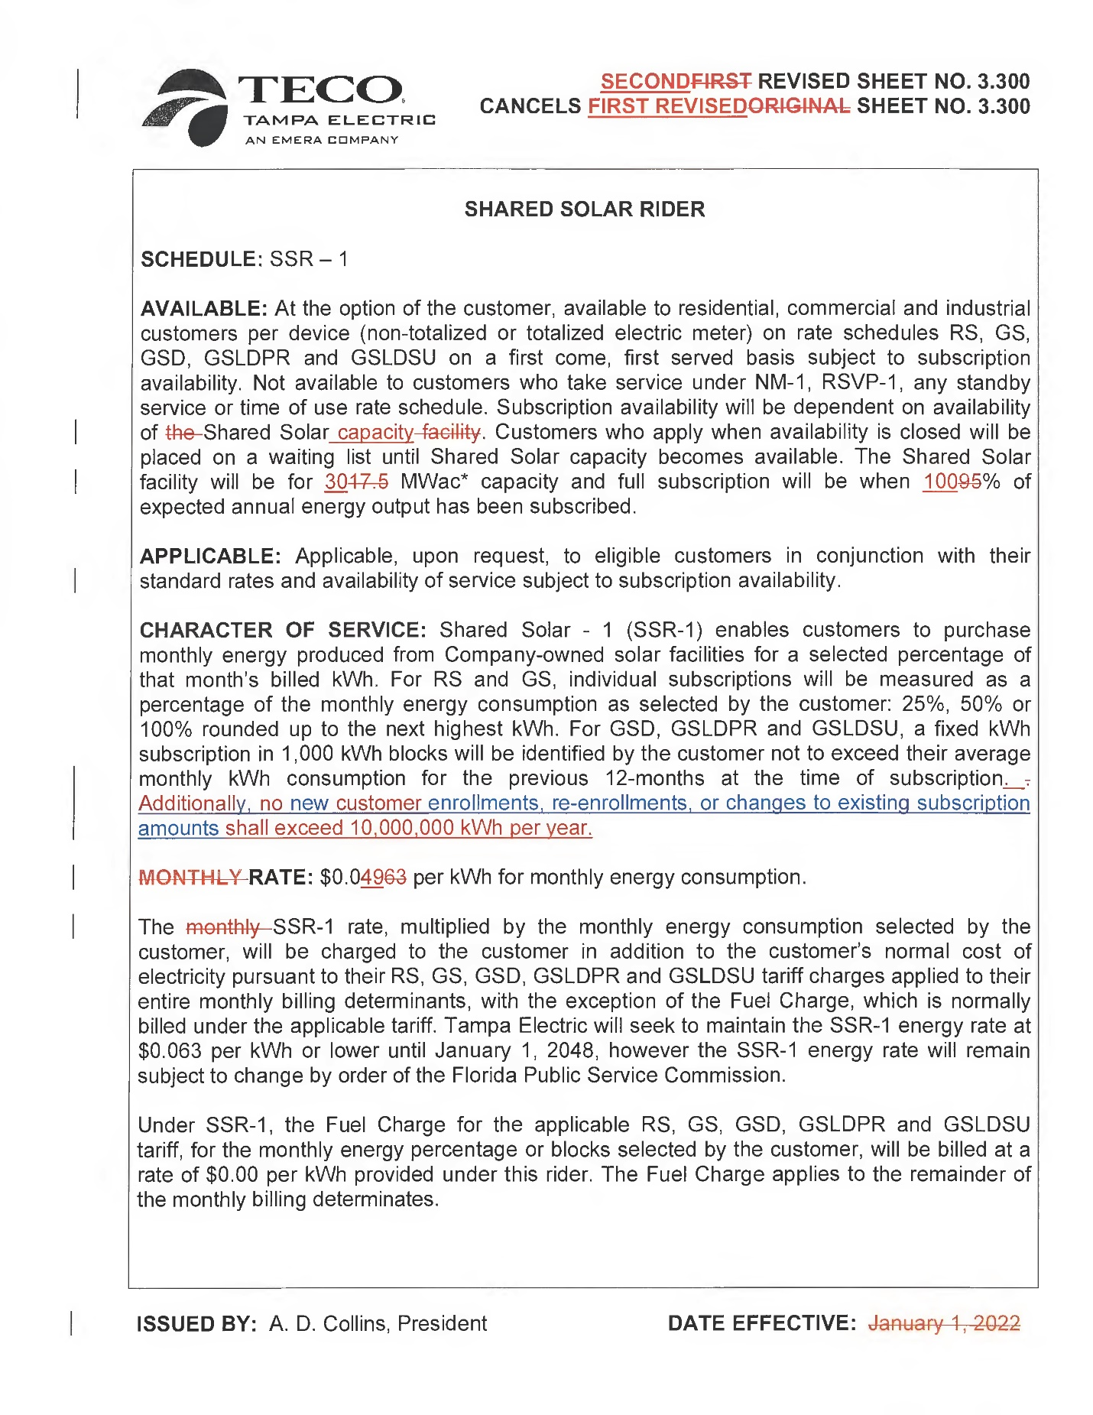

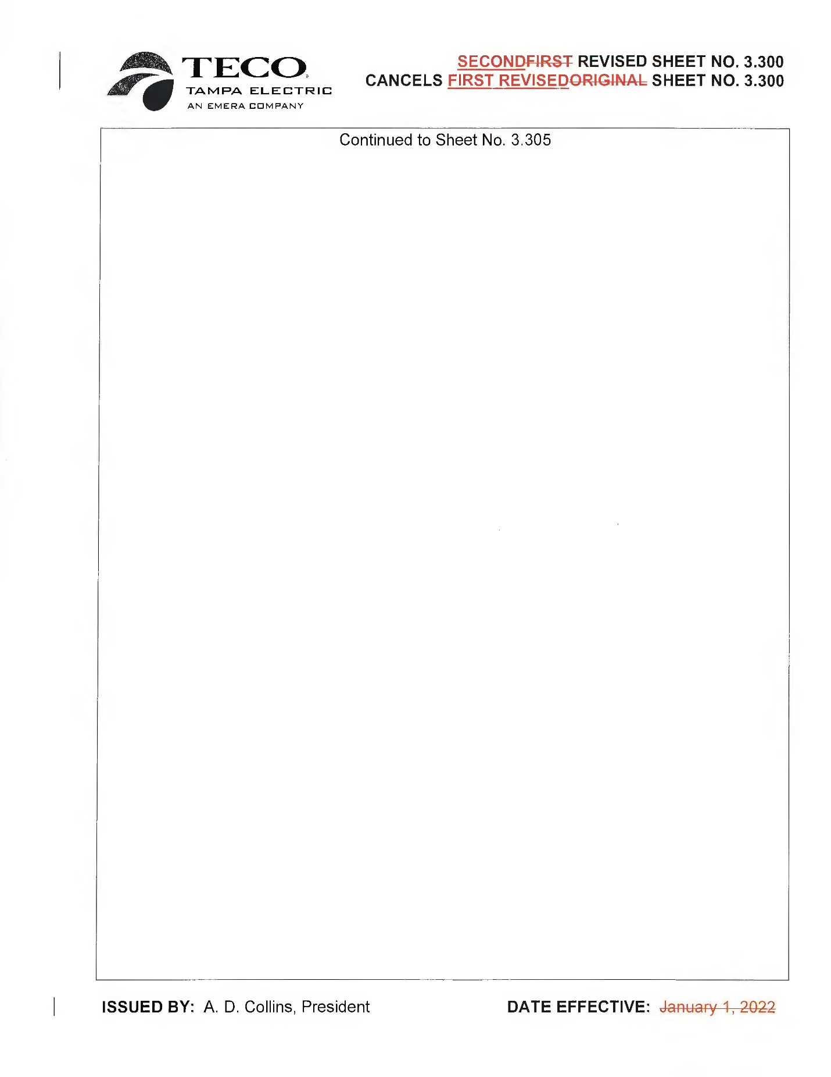

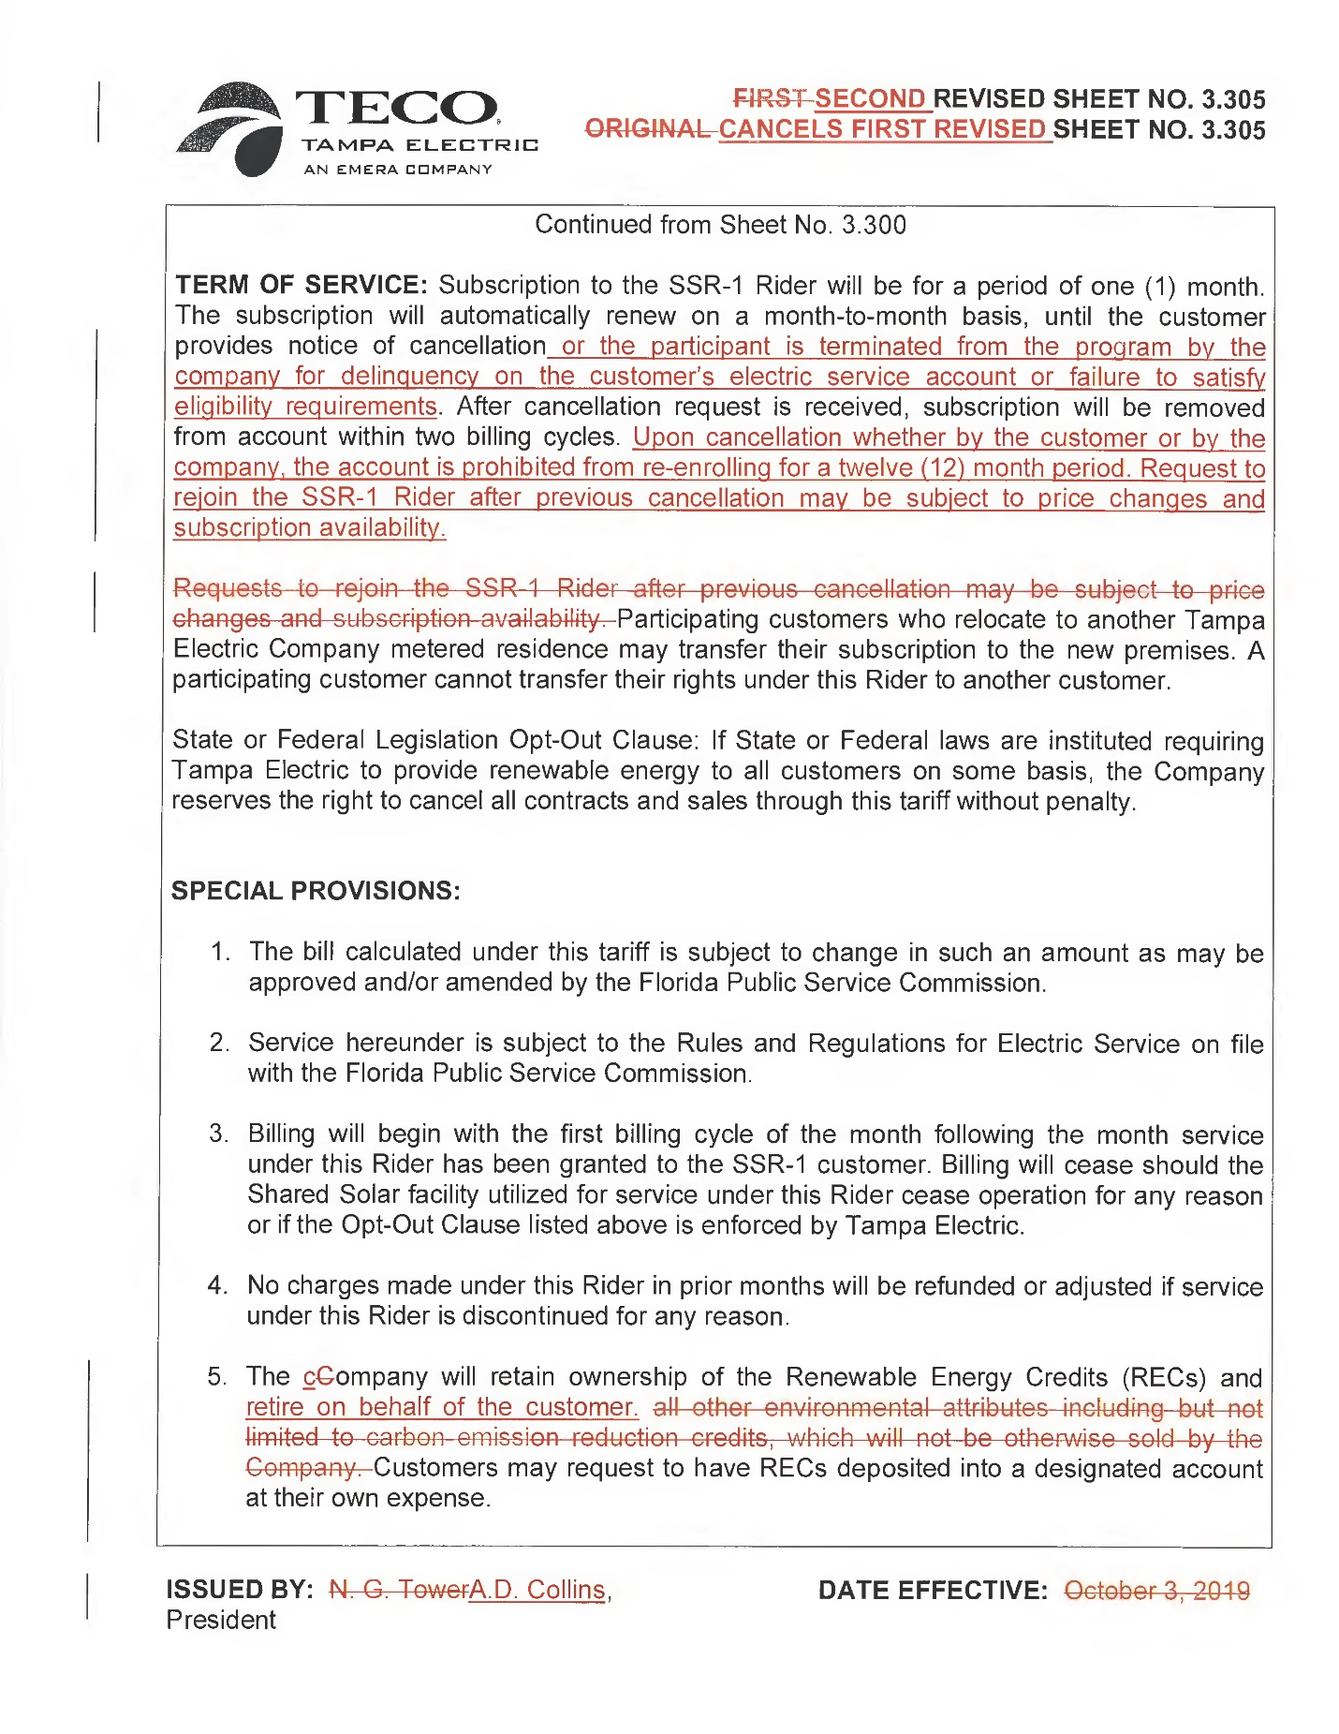

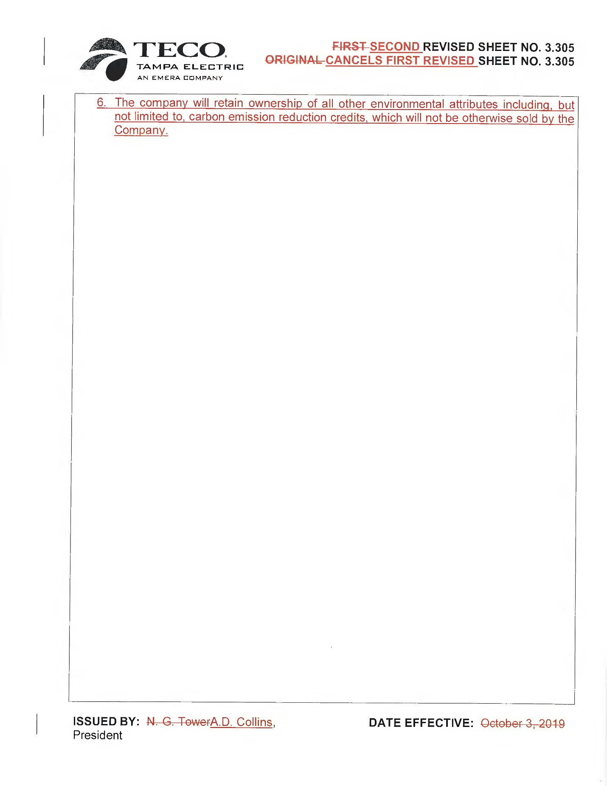

1. Order No. PSC-2019-0215-TRF-EI, Order Approving Tampa Electric Company’s Shared Solar Tariff, issued June 3, 2019, in Docket No. 20180204-EI, *In re: Petition for approval of shared solar tariff, by Tampa Electric Company.* In 2021, the Commission reaffirmed its approval of the SSR-1 Tariff when it approved a stipulation and settlement agreement that resolved TECO’s last general rate case. *See* Order No. PSC-2021-0423-S-EI, issued November 10, 2021, in Docket No. 20210034-EI, *In re: Petition for rate increase by Tampa Electric Company* (2021 Settlement).
2. Order No. PSC-2023-0214-PCO-EI, issued July 26, 2023, in Docket No. 20230072-EI, *In re: Petition for approval of shared solar tariff change, by Tampa Electric Company.*
3. Order No. PSC-2018-0571-FOF-EI, issued December 7, 2018, in Docket No. 20180133-EI, *In re: Petition for limited proceeding to approve second Solar Base Rate Adjustment (SoBRA), effective January 1, 2019, by Tampa Electric Company.*
4. Order No. PSC-2021-0423-S-EI, issued November 10, 2021, Docket No. 20210034-EI, *In re: Petition for rate increase by Tampa Electric Company.*
5. Exhibit A to the petition (“Sun Select De-enrollment Reasons”) summarizes de-enrollment data reflecting that about 51 percent of customers that enrolled and later dropped out of the program cited high participation costs as their reason for exiting.
6. Exhibit B to Petition, FPSC Document No. 03449-2023.
7. The price support for the current (6.3 cents per kWh) rate used a depreciable life of 30 years for the Lake Hancock facility. In the 2021 Agreement, the utility agreed to extend the life of solar assets to 35 years for depreciation purposes. TECO proposes to use this Commission-approved 35-year life in calculating the SSR-1 rate. This change puts additional downward pressure on the rate.
8. TECO’s response to Staff Data Request 2, No. 16.a.
9. Based on 30 MW operating at a 25.8% capacity factor, which produces approximately 67.8 gigawatt-hours (GWh) annually, versus TECO’s net energy for load of 20,977 GWh.
10. In its current form, the Sun Select program features a 5 percent buffer, which results in the program having a maximum expected annual energy output of 95 percent.
11. TECO’s Response to Staff’s First Data Request, Nos. 5 and 6, FPSC Document No. 04517-2023.
12. The utility provided staff the website link promoting their optional Sun Select program. *See* [https://www.tampaelectric.com/company/solar-energy/sun-select/](https://linkprotect.cudasvc.com/url?a=https%3a%2f%2fwww.tampaelectric.com%2fcompany%2fsolar-energy%2fsun-select%2f&c=E,1,dhZoKmcI9Xie8KZ4jZZQ2LASiPeFs3jYhC8c9W9zeJ7qv_v9VDLh5xpe-w-axHCwJTQVC6hRS1UYbQzOut4HGaL9cRYomidh-IFZnIqjz9TmHSISMA,,&typo=1)
13. TECO provided staff a projection of nominal System Average Fuel Costs to 2030, FPSC Document No. 05265-2023.
14. TECO’s Response to Staff’s First Data Request, No. 4.a., FPSC Document No. 04517-2023.
15. *See* Order No. PSC-2021-0423-S-EI, issued November 10, 2021, in Docket No. 20210034-EI, *In re: Petition for rate increase by Tampa Electric Company.* At Page 5 of that Order, the revenue requirement of the 17.5 MW portion of Lake Hancock Generating Station was required to be included in the revenue requirements of future rate proceedings, as an addition to base rates, and the revenues under the tariff were to be credited to the revenue requirement as an offset. This was implemented in the 2021 Settlement Agreement in revised MFR Schedule E-13c in Docket No. 20210034-EI (Document No. 03510-2021, Pages 2, 3, and 5. This credit to revenue amounted to $723,807 for the RS rate class, $6,691 for the GS class, and $15,120 for the GSD and GSDT.
16. Oder No. PSC-2023-0191-TRF-EI, issued June 29, 2023, in Docket No. 20220202-EI, *In re: Petition for approval of new clean energy impact program, a new renewable certificates (REC) buying program, by Duke Energy Florida, LLC.* An appeal of this Order is currently pending before the Florida Supreme Court, Case No. SC21-303.