BEFORE THE FLORIDA PUBLIC SERVICE COMMISSION

Notice of DEVELOPMENT OF RULEMAKING

TO

ALL WATER AND WASTEWATER UTILITIES

OFFICE OF PUBLIC COUNSEL

AND

ALL OTHER INTERESTED PERSONS

Docket No.: 20230123-ws

IN RE: PROPOSED RULE 25-30.0372, FLORIDA ADMINISTRATIVE CODE,
ALTERNATIVE PROCEDURE FOR ESTABLISHING RATE BASE VALUE
OF ACQUIRED UTILITY SYSTEM

ISSUED: October 31, 2023

NOTICE is hereby given pursuant to Section 120.54, Florida Statutes, that the Florida Public Service Commission staff has initiated rulemaking to adopt new Rule 25-30.0372, Florida Administrative Code, pertaining to Alternative Procedure for Establishing Rate Base Value of Acquired Utility System.

A staff rule development workshop will be held at the following time and place:

November 14, 2023, at 9:30 a.m.
Betty Easley Conference Center, Room 148
4075 Esplanade Way
Tallahassee, FL 32399-0850

The draft rule and the agenda for the workshop are attached. One or more Commissioners may be in attendance and participate in the workshop. The person to be contacted regarding the rule development is Susan Sapoznikoff, Office of the General Counsel, 2540 Shumard Oak Boulevard, Tallahassee, FL 32399-0850; Susan.Sapoznikoff@psc.state.fl.us, (850) 413-6630.

In accordance with the Americans with Disabilities Act, persons needing a special accommodation to participate at this workshop should contact the Office of Commission Clerk no later than five days prior to the workshop at 2540 Shumard Oak Boulevard, Tallahassee, Florida 32399-0850 or 850-413-6770 (Florida Relay Service, 1-800-955-8770 Voice or 1-800-955-8771 TDD). Assisted Listening Devices are available upon request from the Office of Commission Clerk, Gerald L. Gunter Building, Room 152.

EMERGENCY CANCELLATION OF THE WORKSHOP

If a named storm or other disaster requires cancellation of the workshop, notice of cancellation will be provided on the Commission’s website (http://www.psc.state.fl.us) under the Hot Topics link found on the home page. Cancellation can also be confirmed by calling the Office of the General Counsel at (850) 413-6199.

By DIRECTION of the Florida Public Service Commission this31st day of October, 2023.

/s/ Adam J. Teitzman
ADAM J. TEITZMAN
Commission Clerk
Florida Public Service Commission
2540 Shumard Oak Boulevard
Tallahassee, Florida 32399
(850) 413-6770
www.floridapsc.com

Copies furnished: A copy of this document is provided to the parties of record at the time of issuance and, if applicable, interested persons.

SS
25-30.0372 Alternative Procedure for Establishing Rate Base Value of Acquired Utility System.
(1) Definitions. For the purposes of this rule, the following definitions apply:
(a) “Licensed Appraiser,” as referenced in Section 367.0811(4)(a), F.S., means a person who meets all the following criteria:
1. Has certification as an Accredited Senior Appraiser by the American Society of Appraisers, designation as a Certified Valuation Analyst by the National Association of Certified Valuators and Analysts, or designation as a Member of the Appraisal Institute by the Appraisal Institute; and
2. Has a current license in good standing from any state as an appraiser, engineer, or certified public accountant.
(b) “Price Index” means the most recent annual price increase or decrease index of major categories of operating costs incurred by water and wastewater utilities established by the Commission by order entered pursuant to Section 367.081(4)(a), F.S.
(2) Appraisals.
(a) Each appraisal must assess the value of the utility system being acquired according to its intended use.
(b) The acquiring utility will select one licensed appraiser, the utility being acquired will select one licensed appraiser, and those two utilities will jointly select the third licensed appraiser.
(c) The list of licensed appraisers required by Section 367.0811(4)(a), F.S., can be found at www.floridapsc.com/appraiserlist or obtained from the Office of the Commission Clerk, Florida Public Service Commission, 2540 Shumard Oak Boulevard, Tallahassee, Florida 32399-0850.
(d) A licensed appraiser will be included on the Commission’s list of approved licensed appraisers by submitting all of the following to appaiserlist@psc.state.fl.us or the Office of the Commission Clerk, Florida Public Service Commission, 2540 Shumard Oak Boulevard, Tallahassee, FL 32399-0850:
1. The licensed appraiser’s name, mailing address, telephone number, and email address;
2. The name of any company with which the licensed appraiser is employed or associated; and
3. Proof of the information required by paragraph (1)(a) above.
(e) It is the responsibility of the licensed appraiser to ensure that correct and updated information remains on file with the Commission. The licensed appraiser must submit updated information to appraiserlist@psc.state.fl.us within 30 days of any change of information. If the Commission determines that a person no longer meets the requirements to be a licensed appraiser on the Commission’s list, that person will be removed from the list. Upon request and upon providing proof that the requirements listed in paragraph (1)(a) above are met, a person will be added back to the list.
(f) The licensed appraiser can be removed from the list by submitting a request for removal in writing to appraiserlist@psc.state.fl.us.
(3) Engineering Assessment.
(a) In assessing the impact on quality of service, the assessment of the tangible assets of the utility system being acquired required by Section 367.0811(4)(b), F.S., must include impacts to the quality of product.
(b) The licensed engineer who performs the engineering assessment required by Section 367.0811(4)(b), F.S., may not also serve as a licensed appraiser on the same acquisition transaction.
(4) Petition. Section 367.0811(5), F.S., sets forth the filing requirements a petition to establish the rate base value must contain.
(a) The petition must be filed within 6 months of the issuance of the final order approving the transfer of the certificate(s) of authorization or the closing date of the sale, whichever is later. Commission staff will review the petition and within 30 days of receipt of the petition will notify the acquiring utility whether the petition is complete or identify the information missing from the petition under the requirements of Section 367.0811(5), F.S. The date the petition is complete under Section 367.0811(6), F.S., is the date that Commission staff notifies the acquiring utility that the petition meets the filing requirements of Section 367.0811(5), F.S.
(b) Form PSC XXX (XX/23), entitled “Water and/or Wastewater Cumulative Present Value of the Revenue Requirement for Alternate Rate Base Worksheet” (“CPVRR”), which is incorporated by reference in this rule and may be obtained from [hyperlink], must be included in the petition to show the 5-year projected rate impact required by Section 367.0811(5)(e), F.S. The form can also be found at www.floridapsc.com, or obtained from the Office of the Commission Clerk, Florida Public Service Commission, 2540 Shumard Oak Boulevard, Tallahassee, Florida 32399-0850.
(c) The 5-year rate impact required by Section 367.0811(5)(e), F.S., must also include the following for each year for residential and general service customers, and the CPVRR must support the projections for these charges:
1. Base facility charge,
2. Gallonage charge, and
3. Billing determinants.
(d) The information filed under Section 367.0811(5)(e), F.S., must include the acquiring utility’s proposed journal entries anticipated to result from the acquisition, including tax entries and account numbers in conformance with the 1996 NARUC Uniform System of Accounts, which is incorporated by reference in Rule 25-30.115, F.A.C.
(e) For purposes of determining whether the petition must include a rate stabilization plan under Section 367.0811(5)(h), F.S., “significant individual increase in rates” means a rate increase during any twelve consecutive months of the 5-year projected rate impact period in excess of price index over the current rates of the utility system being acquired. A copy of the most recent Commission order establishing the price index can be obtained from the Public Service Commission, Division of Accounting & Finance, 2540 Shumard Oak Boulevard, Tallahassee, Florida 32399-0850.
Rulemaking Authority 367.0811(11), FS. Law Implemented 367.0811, FS., History–New___
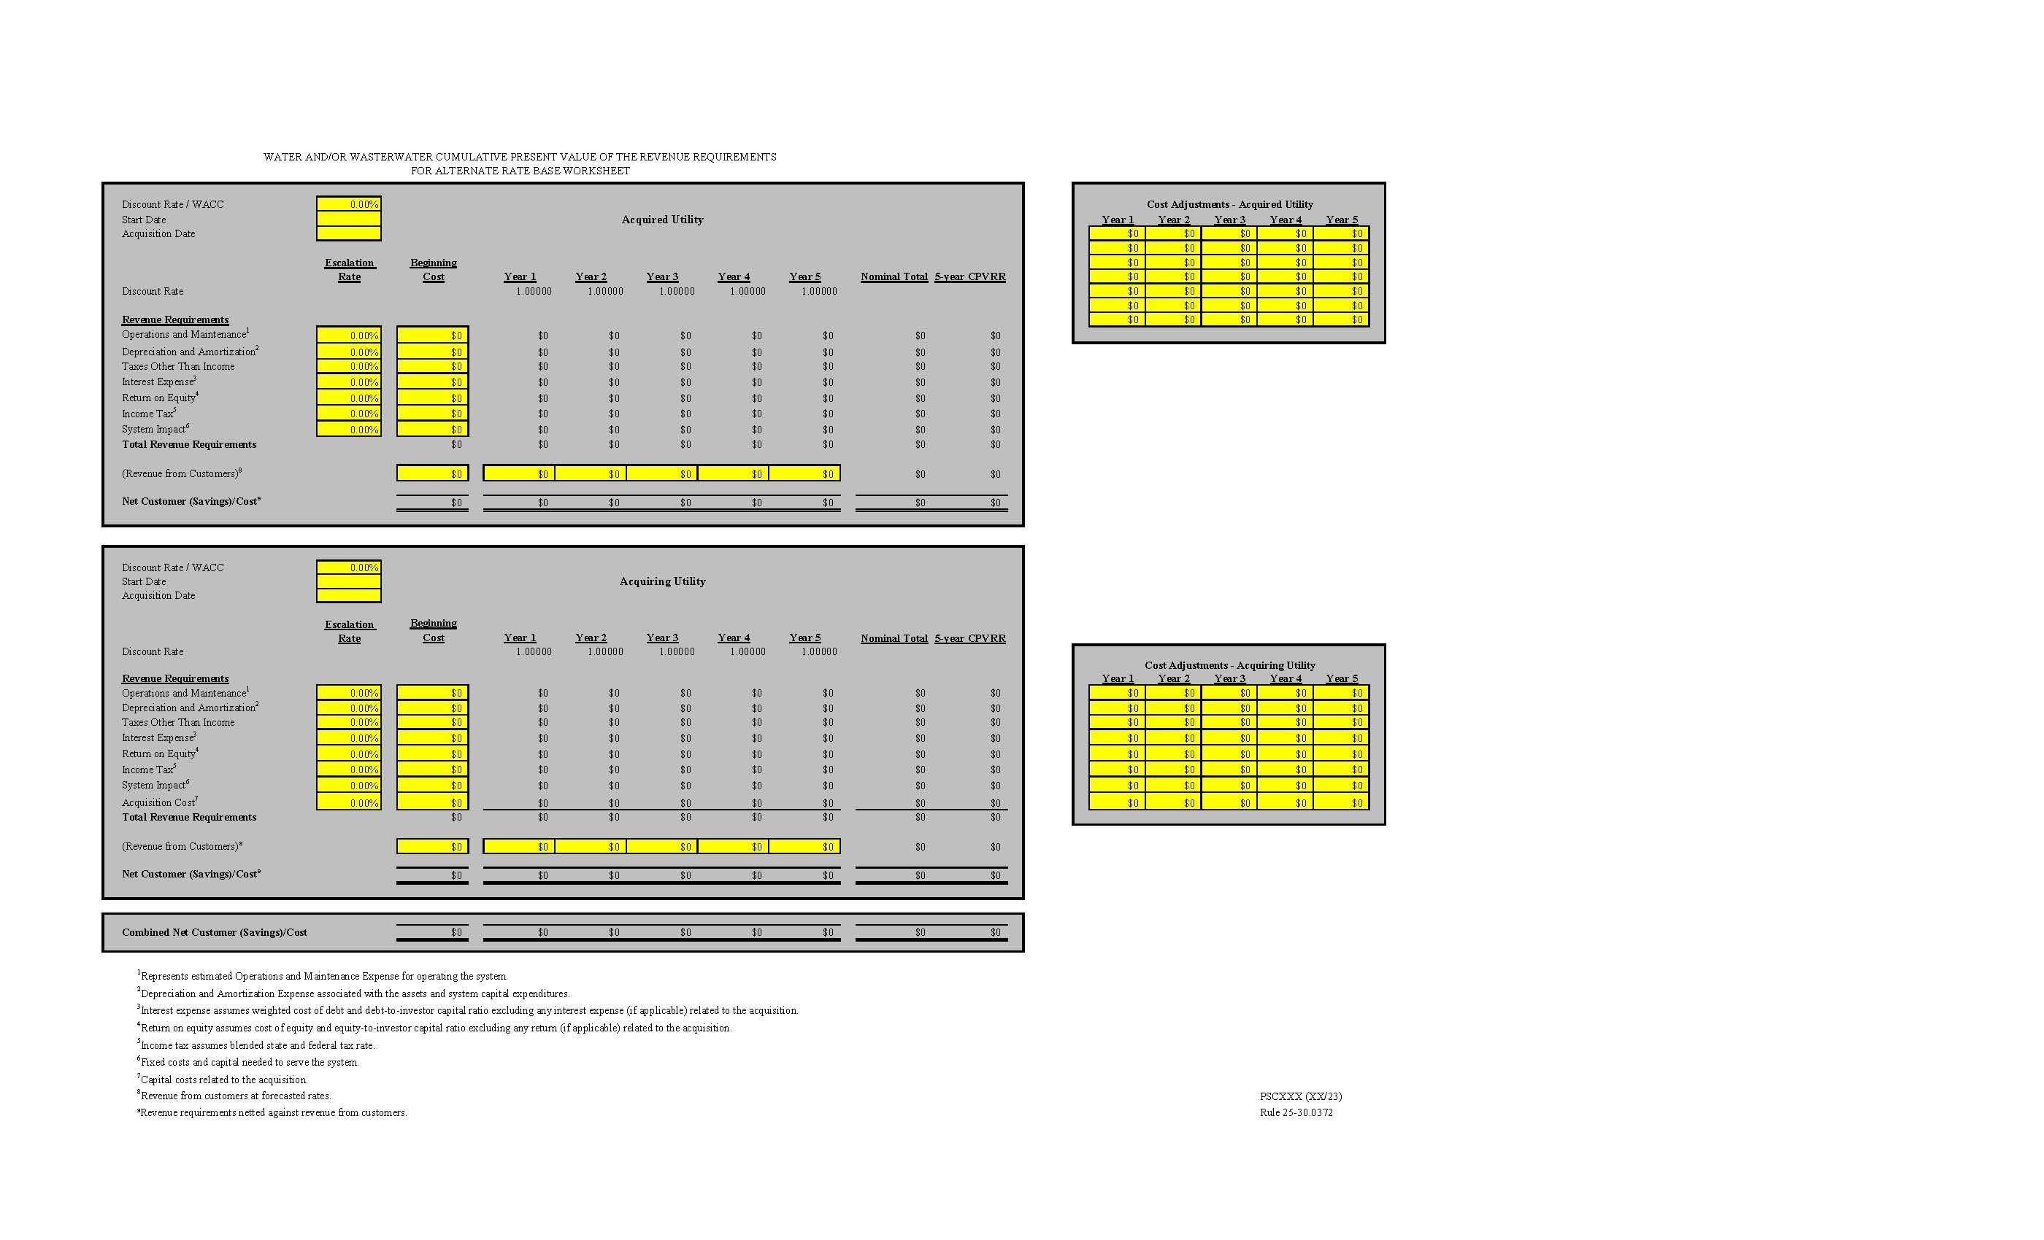

WORKSHOP AGENDA

1. STAFF WELCOME AND OVERVIEW OF DRAFT RULE
2. STAKEHOLDER COMMENTS ON DRAFT RULE
3. DISCUSSION OF NEXT STEPS
4. ADJOURN

