BEFORE THE FLORIDA PUBLIC SERVICE COMMISSION

|  |  |
| --- | --- |
| In re: Petition for approval of safety, access, and facility enhancement program true-up and 2024 cost recovery factors, by Florida City Gas. | DOCKET NO. 20230097-GU  ORDER NO. PSC-2023-0345-TRF-GU  ISSUED: November 16, 2023 |

The following Commissioners participated in the disposition of this matter:

ANDREW GILES FAY, Chairman

ART GRAHAM

GARY F. CLARK

MIKE LA ROSA

GABRIELLA PASSIDOMO

ORDER APPROVING SAFETY, ACCESS, AND FACILITY ENHANCEMENT (SAFE) PROGRAM TRUE-UP AND 2024 COST RECOVERY FACTORS

BY THE COMMISSION:

Background

On August 31, 2023, Florida City Gas (FCG or utility) filed a petition for approval of its safety, access, and facility enhancement program (SAFE) true-up and 2024 cost recovery factors. We originally approved the SAFE program in Order No. PSC-15-0390-TRF-GU (2015 Order) to recover the cost of relocating on an expedited basis certain existing gas mains and associated facilities from rear lot easements to the street front.[1] In the 2015 Order, we found that the relocation of mains and services to the street front provides for more direct access to the facilities and will enhance the level of service provided to all customers through improved safety and reliability. The SAFE factor is a surcharge on customers’ bills.

In the 2015 Order, we required the utility to file an annual petition, beginning in 2016, for review and resetting of the SAFE factors to true-up any prior over-or under-recovery and to set the surcharge for the coming year. The SAFE program was originally approved as a 10-year program and was planned to finish in 2025.

During the utility’s 2022 rate case, we approved a stipulation for the expansion of the SAFE program in Order No. PSC-2023-0177-FOF-GU (Rate Case Order).[2] The parties agreed and we found that the continuation of the SAFE program beyond its original 2025 expiration date and the relocation of an additional approximately 150 miles of mains and 13,874 services was reasonable.[3]

In the Rate Case Order, we further approved a stipulation for the replacement of approximately 160 miles and 8,059 associated services of “orange pipe,” through the SAFE program.[4] All parties to the rate case agreed that orange pipe is a specific plastic material that was used in the 1970s and 1980s that has been studied by the United States Department of Transportation Pipeline and Hazardous Materials Safety Administration and shown through industry research to exhibit premature failure in the form of cracking.

In addition, as part of its rate case, FCG moved the SAFE investment and related expenses as of December 31, 2022, from clause recovery to base rates, in compliance with the 2015 Order.[5] Specifically, the 2015 Order stated that “…if FCG files a base rate case prior to 2025, the then-current SAFE surcharge program would be folded into any newly approved rate base, and the surcharge would begin anew.”[6] We approved FCG’s proposal to move the SAFE surcharge into base rates in the Rate Case Order.[7] The rate case decision was effective May 1, 2023.

The current 2023 SAFE factors were approved by Order No. PSC-2022-0403-TRF-GU (2022 Order).[8] The SAFE factors effective January 2023 were calculated based on the assumption that we would approve the request to roll SAFE investments into rate base in the rate case docket and therefore decreased compared to the 2022 SAFE factors. Since the rate case decision became effective May 1, 2023 (as opposed to January 2023), FCG did not collect the full SAFE revenue requirement in 2023, resulting in a 2023 under-recovery. The 2022 Order provided that if we had not made a decision in the 2022 rate case prior to the January 1, 2023 effective date, then any SAFE revenue requirement not collected in 2023 would be trued-up in the next SAFE filing. Accordingly, FCG has included the 2023 under-recovery with the proposed 2024 SAFE factors.

Finally, in the Rate Case Order we required FCG to propose a new investment/construction schedule and term for the SAFE program in its next applicable annual SAFE filing. Subsequently, FCG now proposes in this petition to extend the SAFE program for an additional 10-year period through 2035 for the replacement of orange pipe and relocation of rear lot mains and services to the street front. The utility proposes to begin the replacement of orange pipe in 2024 and continue through 2033. FCG also proposes to begin the relocation of mains and services in 2026 and continue through 2035.

In Order No. PSC-2023-0302-PCO-GU, we suspended the proposed tariffs to allow staff sufficient time to analyze the utility’s filing, pursuant to Section 366.06(3), Florida Statue (F.S.). Our staff issued their first data request to FCG on September 13, 2023, for which FCG provided a response on September 19, 2023. Staff issued a second data request on September 22, 2023 for which responses were received September 28, 2023.

FCG’s annual progress in the SAFE program is shown in Attachment A to this order. The proposed 2024 SAFE factors are shown in Attachment B on Tariff Sheet No. 79. We have jurisdiction over this matter pursuant to Sections 366.04, 366.041, 366.05, and 366.06, F.S.

Decision

Under the SAFE program originally approved in 2015, FCG was ordered to relocate or replace 254.3 miles of mains and 11,443 associated service lines from rear property easements to the street over a 10-year period, ending in 2025. The utility began its mains and services replacements at the end of 2015. The surcharges have been in effect since January 2016. During 2023, the utility has replaced 26 miles of mains and 1,399 services, as shown in Attachment B to the order.[9]

Proposed SAFE Timeline

FCG proposes a 10-year investment and construction schedule for the continuation and expansion of the SAFE program projects, as approved in the Rate Case Order. FCG stated in response to staff’s data request that the 10-year schedule aligns similarly with the original approval for the 2015 SAFE program, which had a 10-year period.[10] FCG also explained that delaying projects would prevent customers and communities from safe access to natural gas in the form of declining pipe integrity. FCG further stated that accelerating the respective 10-year timeline would have a negative impact on customers’ billing and could potentially require FCG to engage additional outside resources.[11] We find that the proposed 10-year investment and construction schedule for the SAFE program projects is reasonable, based on FCG’s provided arguments and our previous approval of similar timelines for investments made through a surcharge.[12] FCG shall be required to file a final true-up of the actual SAFE program costs at the end of the 10-year period, once all program costs are known.

Prioritization of SAFE Relocation and Replacement Projects

The utility stated that prioritization of the SAFE relocation and replacement projects was determined by FCG’s risk assessment model, the Distribution, Integrity, and Management Program (DIMP). Based on FCG’s DIMP, the utility has prioritized future SAFE projects based on the location of the pipelines, material of the pipelines, leak incident rates, maintenance access complications, and customer encroachments.

True-ups by Year

As required by the 2015 Order, the utility’s calculations for the 2024 revenue requirement and SAFE factors include a final true-up for 2022, and an estimated/actual true-up for 2023, and projected costs for 2024.

Final True-up for 2022

FCG stated that the revenues collected for 2022 were $4,562,635, compared to a revenue requirement of $4,305,208 resulting in an over-recovery of $257,427. Adding the 2021 final under-recovery of $326,212 and the $257,427 over-recovery of 2022, including interest, results in a final 2022 under-recovery of $35,929.[13]

Actual/Estimated 2023 True-up

FCG provided actual revenues for January through June and forecasted revenues for July through

December 2023, totaling $674,737 as compared to a projected revenue requirement of $2,506,526, resulting in an under-recovery of $1,831,789. Adding the 2022 under-recovery of $35,929 to the 2023 under-recovery of $1,831,789, the resulting total 2023 true-up, including interest, is an under-recovery of $1,935,339.[14]

Projected 2024 Costs

The utility’s projected investment for 2024 is $29,851,712 for its projects located in Miami-Dade and Brevard County. The revenue requirement, which includes a return on investment, depreciation, and taxes is $2,682,570. The return on investment calculation includes federal income taxes, regulatory assessment fees, and bad debt. After adding the 2023 under-recovery of $1,935,339, the total 2024 revenue requirement is $4,647,910. Table 1 displays the projected 2024 revenue requirement calculation.

Table 0

2024 Revenue Requirements Calculation

|  |
| --- |
| 2024 Projected Investment $29,851,712 |
| Return on Investment $1,861,231  Depreciation Expense $441,201  Property Tax Expense $380,138  2024 Revenue Requirement $2,682,570  Plus 2023 Under-recovery $1,965,339  Total 2024 Revenue Requirement $4,647,910 |

Source: Page 6 of Attachment D of the petition and Attachment 2 in response to Staff’s First Data Request No. 1

Proposed 2024 SAFE Factors

The SAFE factors are fixed monthly charges. FCG’s cost allocation methodology was approved in the 2015 Order and was used in the instant filing. The approved methodology allocates the current cost of a 2-inch pipe to all customers on a per customer basis and allocates the incremental cost of replacing a 4-inch pipe to customers who use over 6,000 therms per year. For customers who require 4-inch pipes, the cost takes into account that the minimum pipe is insufficient to serve their demand, and therefore, allocates an incremental per foot cost in addition to the all-customer cost. The resulting allocation factors are applied to the 2024 total revenue requirement to develop the monthly SAFE factors.

The proposed fixed monthly SAFE factor is $3.17 for customers using less than 6,000 therms per year (current factor is $0.44). The proposed fixed monthly SAFE factor for customers using more than 6,000 therms per year is $5.44 (the current factor is $0.98). We note that the current 2023 SAFE factors decreased from 2022 since we approved moving SAFE investments into rate base in the Rate Case Order, resulting in a lower SAFE factor.

Conclusion

We hereby approve FCG’s proposed SAFE tariff for the period January through December 2024. After reviewing FCG’s filings and supporting documentation, the calculations of the 2024 SAFE factors appear consistent with the methodology approved in the 2015 Order and are reasonable and accurate. Furthermore, we approve FCG’s proposed 10-year SAFE investment and construction schedule. The proposed tariffs, provided in Attachment B to this order, shall be effective for the first billing cycle in January 2024 through the last billing cycle of December 2024.

Based on the foregoing, it is

ORDERED by the Florida Public Service Commission that Florida City Gas’s proposed safety, access, and facility enhancement program tariff for the period January through December 2024 is approved. Furthermore, we approve FCG’s proposed 10-year SAFE investment and construction schedule. The proposed tariffs, provided in Attachment B to this order, shall be effective for the first billing cycle in January 2024 through the last billing cycle of December 2024. It is further

ORDERED that if a protest is filed within 21 days of issuance of the Order, the tariff shall remain in effect with any charges held subject to refund pending resolution of the protest. It is further

ORDERED that if no timely protest is filed, this docket shall be closed upon the issuance of a Consummating Order.

By ORDER of the Florida Public Service Commission this 16th day of November, 2023.

|  |  |
| --- | --- |
|  | /s/ Adam J. Teitzman |
|  | ADAM J. TEITZMAN  Commission Clerk |

Florida Public Service Commission

2540 Shumard Oak Boulevard

Tallahassee, Florida 32399

(850) 413‑6770

www.floridapsc.com

Copies furnished: A copy of this document is provided to the parties of record at the time of issuance and, if applicable, interested persons.

MRT

NOTICE OF FURTHER PROCEEDINGS

The Florida Public Service Commission is required by Section 120.569(1), Florida Statutes, to notify parties of any administrative hearing or judicial review of Commission orders that is available under Sections 120.57 or 120.68, Florida Statutes, as well as the procedures and time limits that apply. This notice should not be construed to mean all requests for an administrative hearing or judicial review will be granted or result in the relief sought.

Mediation may be available on a case-by-case basis. If mediation is conducted, it does not affect a substantially interested person's right to a hearing.

The Commission's decision on this tariff is interim in nature and will become final, unless a person whose substantial interests are affected by the proposed action files a petition for a formal proceeding, in the form provided by Rule 28-106.201, Florida Administrative Code. This petition must be received by the Office of Commission Clerk, 2540 Shumard Oak Boulevard, Tallahassee, Florida 32399-0850, by the close of business on December 7, 2023.

In the absence of such a petition, this Order shall become final and effective upon the issuance of a Consummating Order.

Any objection or protest filed in this docket before the issuance date of this order is considered abandoned unless it satisfies the foregoing conditions and is renewed within the specified protest period.

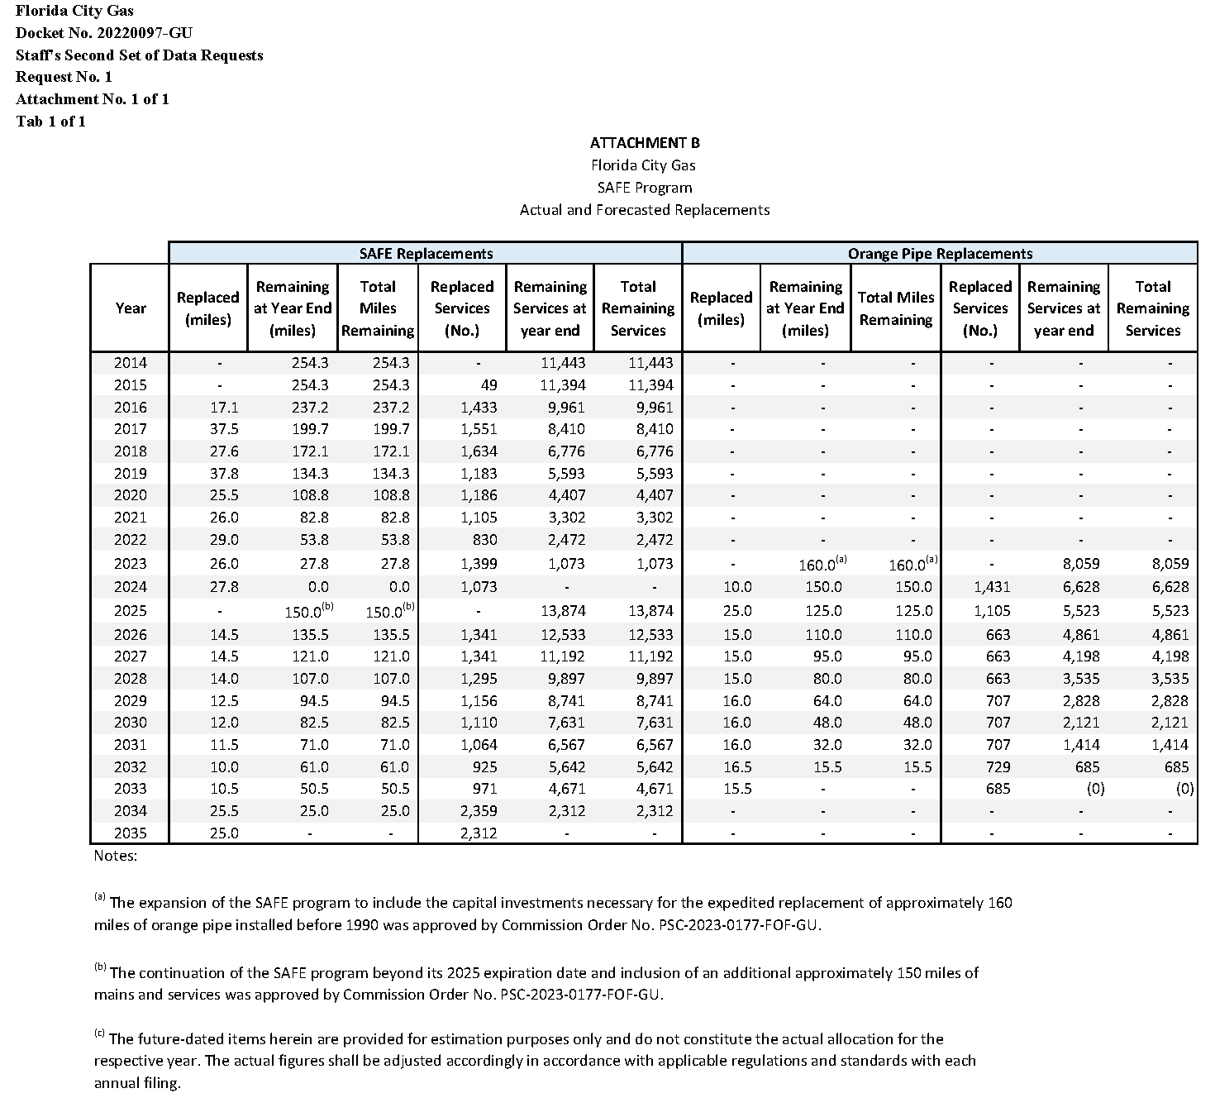

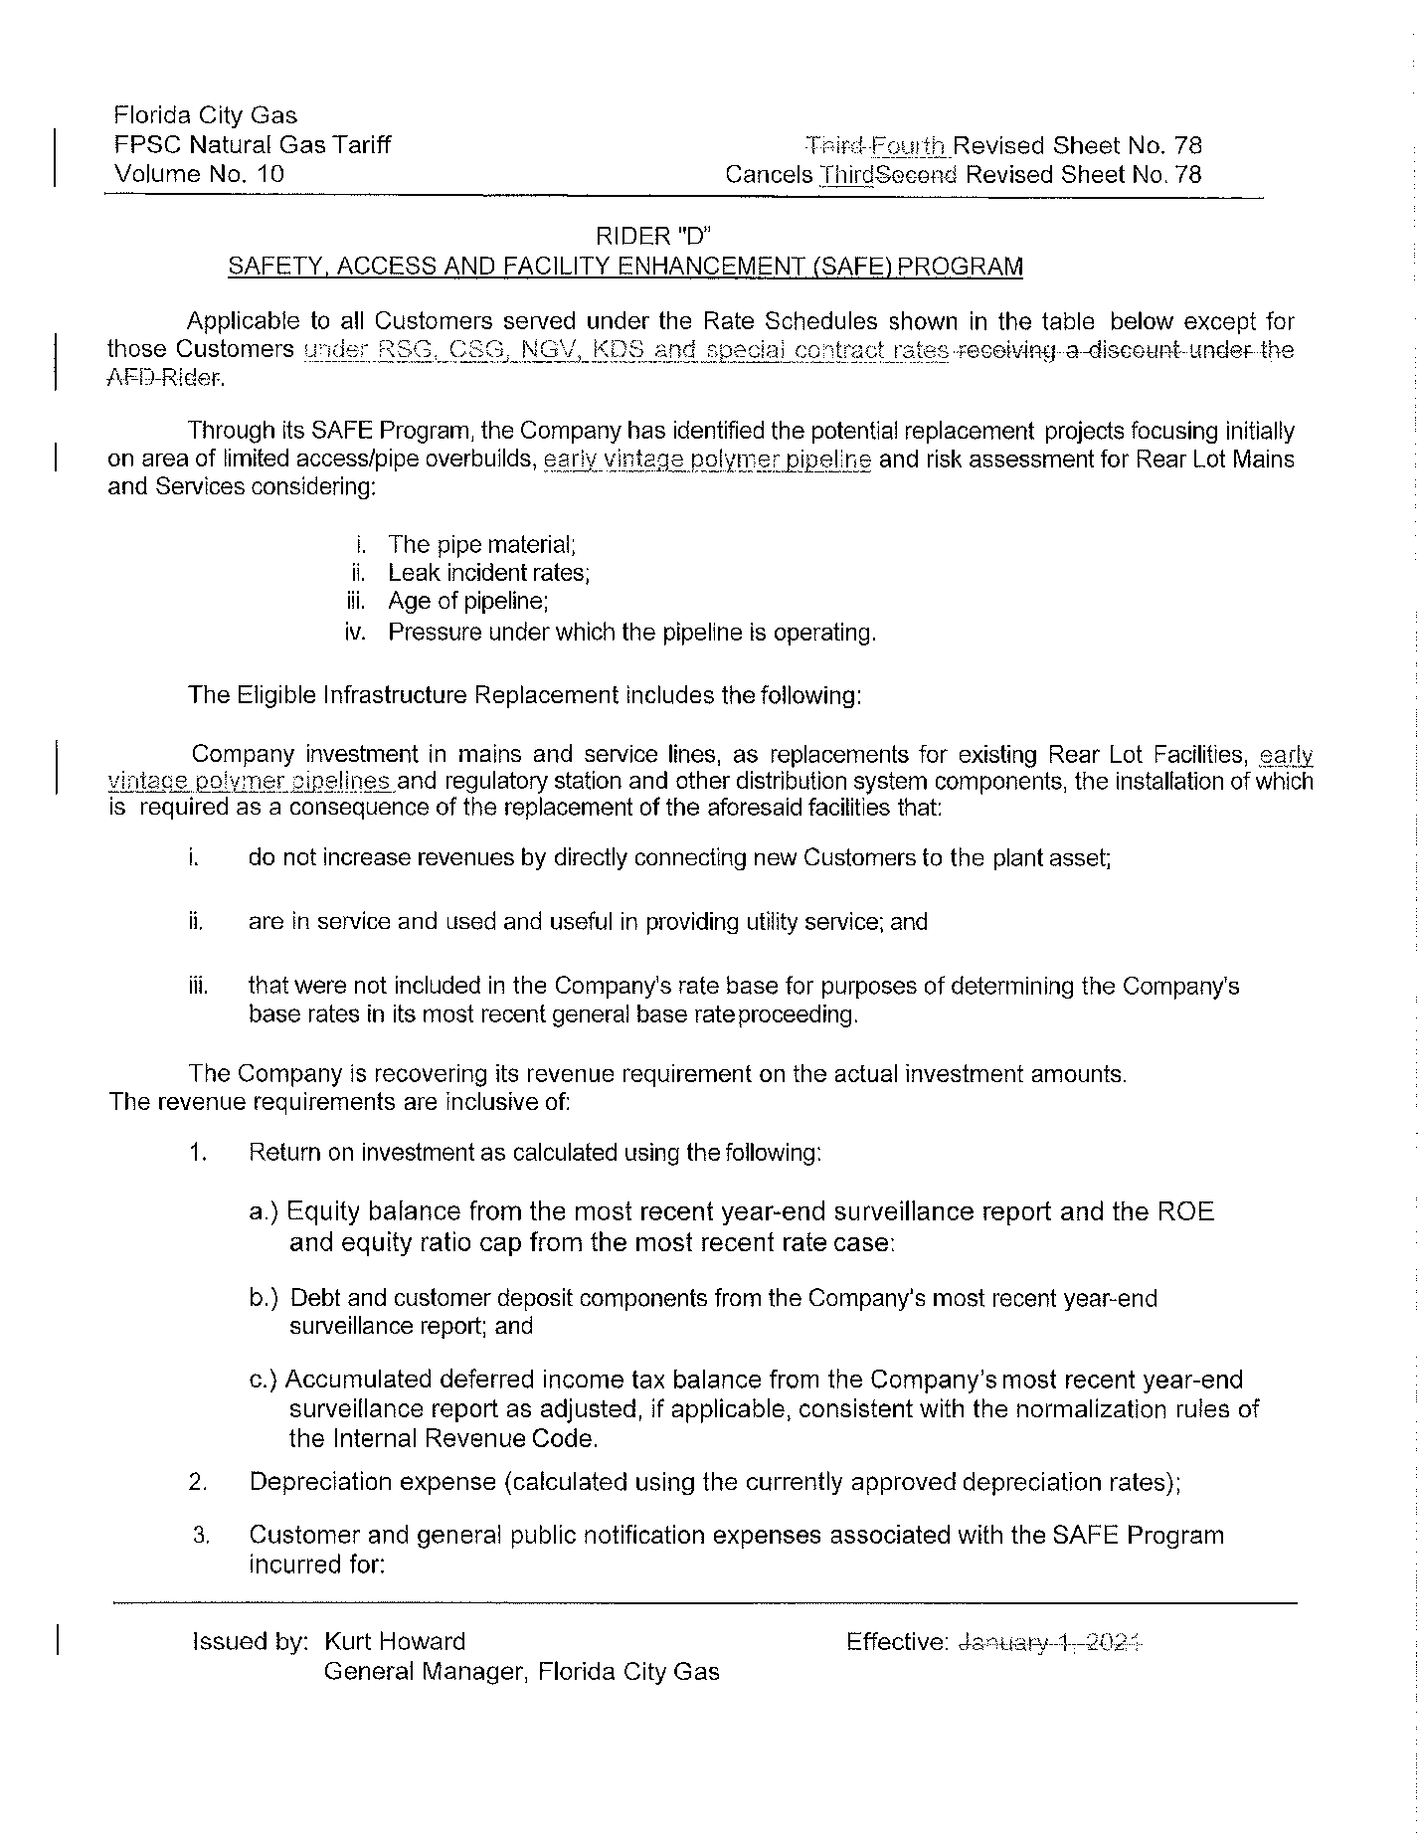

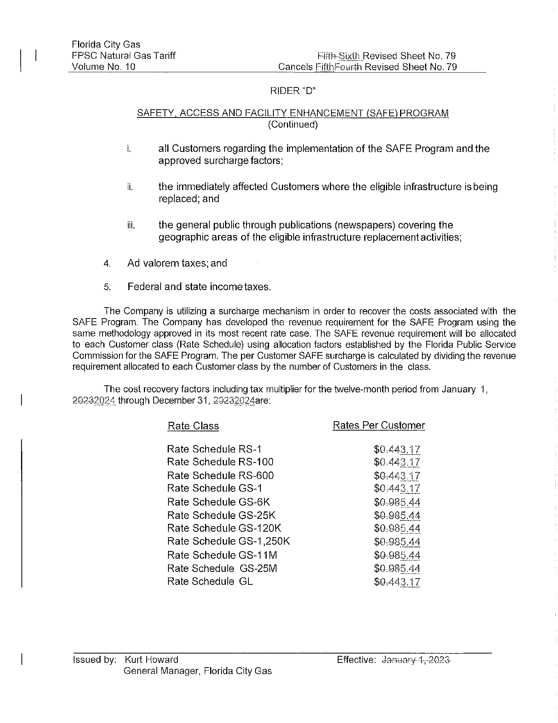

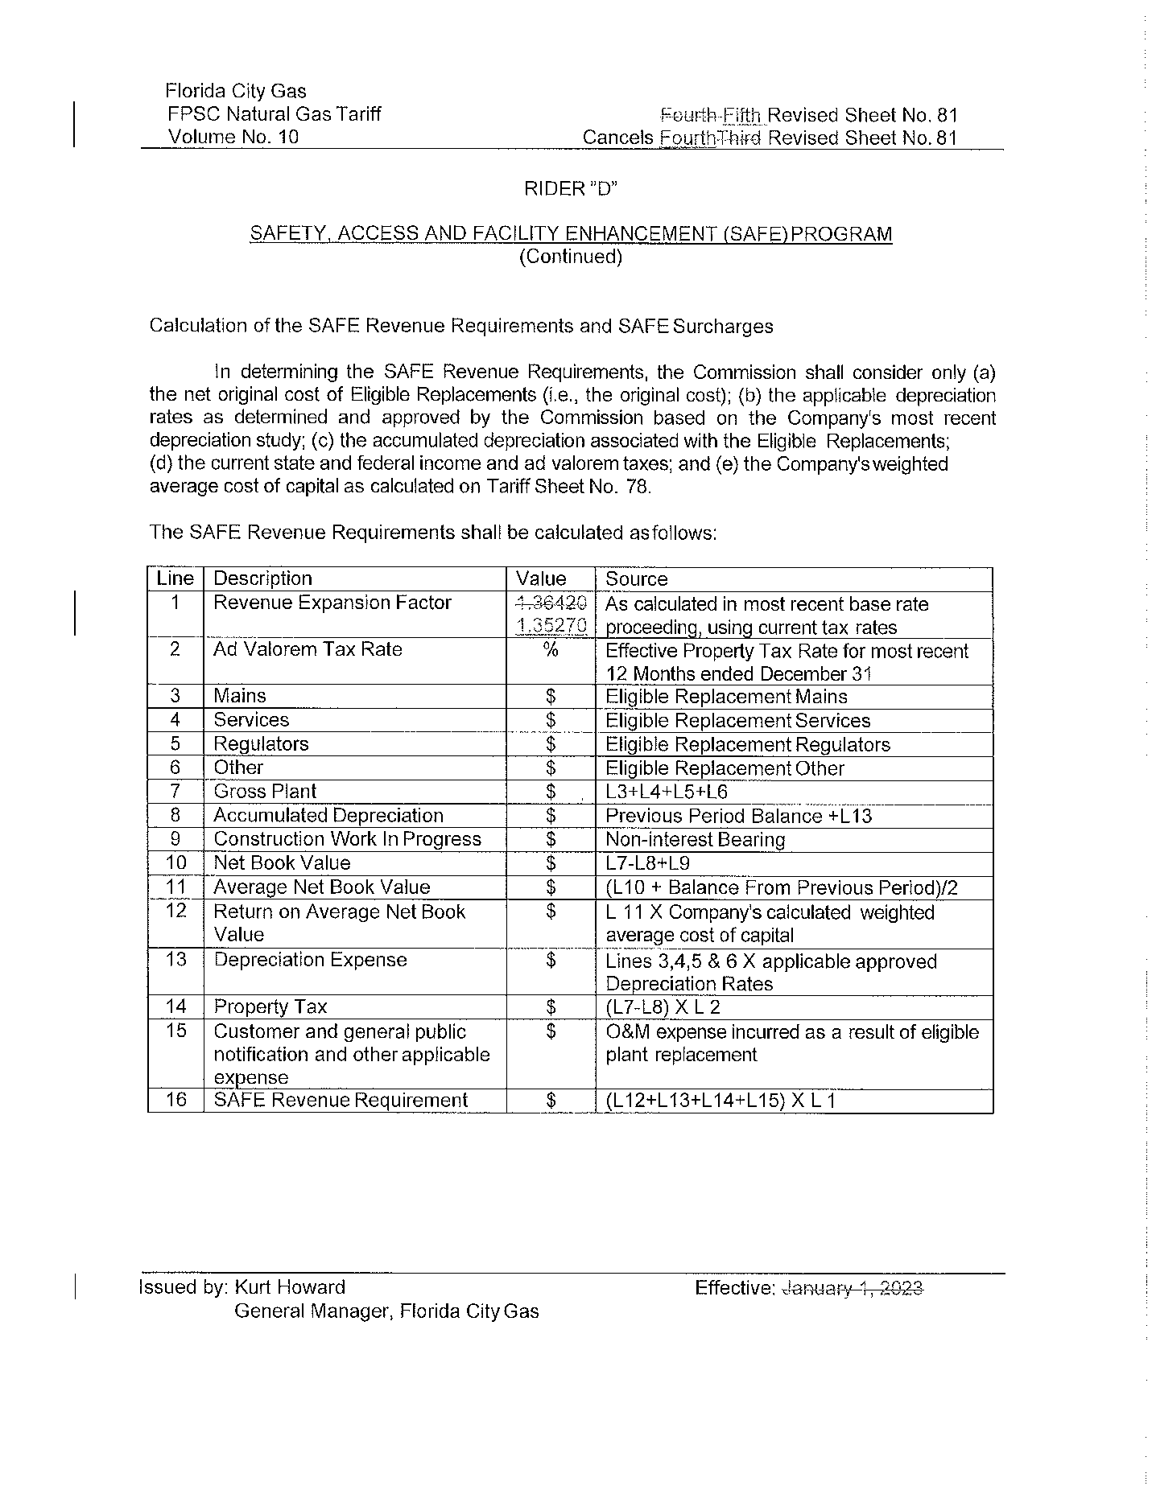

1. Order No. PSC-15-0390-TRF-GU, issued September 15, 2015, in Docket No. 20150116-GU, *In re: Petition for approval of safety, access, and facility enhancement program and associated cost recovery methodology, by Florida City Gas.*
2. Order No. PSC-2023-0177-FOF-GU, issued June 9, 2023, in Docket No. 20220069-GU, *In re: Petition for rate increase by Florida City Gas.*
3. See page 72, Section X, B. of Order No. PSC-2023-0177-FOF-GU.
4. See page 72, Section X, C. of Order No. PSC-2023-0177-FOF-GU.
5. Docket No. 20220069-EI, *In re: Petition for approval of rate increase and request for approval of depreciation rates*, filed May 31, 2022.
6. See page 4 of Order No. PSC-15-0390-TRF-GU.
7. See page 18 of Order No. PSC-2023-0177-FOF-GU.
8. Order No. PSC-2022-0403-TRF-GU, issued November 21, 2022, in Docket No. 20220153-GU, *In re: Petition for approval of safety, access, and facility enhancement program true-up and 2023 cost recovery factors, by Florida City Gas.*
9. DN 05438-2023, data response No. 1.
10. DN 05277-2023, data response No. 5.
11. DN 05438-2023, data response No. 4.
12. Order No. PSC-2023-0235-PAA-GU, issued August 15, 2023, in Docket No. 20230029-GU, *In re: Petition for approval of gas utility access and replacement directive, by Florida Public Utilities Company.* Order No. PSC-12-0490-TRF-GU, issued September 24, 2012, in Docket No. 120036-GU, *In re: Joint petition for approval of Gas Reliability Infrastructure Program (GRIP) by Florida Public Utilities Company and the Florida Division of Chesapeake Utilities Corporation.* Order No. PSC-12-0476-TRF-GU, issued September 18, 2012, in Docket No. 110320-GU, *In re: Petition for approval of Cast Iron/Bare Steel Pipe Replacement Rider (Rider CI/BSR), by Peoples Gas System.*
13. The calculation also includes a December 2021 true-up of $7,799 booked in January 2022. The petition shows $37,226 as the final 2022 true-up as a result of a cell error, the correct number is $35,929. The error does not impact the final rates.
14. The calculation also includes a December 2022 true-up of $26,525 booked in January 2023.