BEFORE THE FLORIDA PUBLIC SERVICE COMMISSION

|  |  |
| --- | --- |
| In re: Petition for approval of smart outdoor lighting services pilot program by Duke Energy Florida, LLC. | DOCKET NO. 20230068-EI  ORDER NO. PSC-2023-0353-TRF-EI  ISSUED: November 20, 2023 |

The following Commissioners participated in the disposition of this matter:

ANDREW GILES FAY, Chairman

ART GRAHAM

GARY F. CLARK

MIKE LA ROSA

GABRIELLA PASSIDOMO

ORDER APPROVING TARIFF

BY THE COMMISSION:

BACKGROUND

On May 15, 2023, Duke Energy Florida, LLC (Duke or utility) filed a petition for approval of the smart outdoor lighting services pilot program (pilot program). Specifically, Duke is proposing to make modifications to Tariff Sheet Nos. 6.280 and 6.281 to allow certain customers taking service under the existing LS-1 lighting tariff to set their own personal lighting schedule and to dim the lights. Currently, all lights offered under the tariff operate from dusk to dawn.

In Order No. PSC-2023-0182-PCO-EI, we suspended Duke’s proposed modifications to Tariff Sheet Nos. 6.280 and 6.281 to allow our staff time to gather additional data.[1] On June 26, 2023, staff issued its first data request, to which Duke responded on July 17, 2023. Staff issued a second data request on July 28, 2023, to which Duke responded on August 11, 2023. Staff noticed a scrivener’s error in the tariff sheets filed with the petition, and Duke included updated legislative and clean versions of the tariff sheets in response to staff’s first data request. The proposed legislative tariffs are Attachment A to this order. This order addresses the proposed smart outdoor lighting services pilot program. We have jurisdiction over this matter pursuant to Sections 366.03, 366.04, 366.05, and 366.06, Florida Statutes (F.S.).

DECISION

Rate Schedule LS-1

Rate schedule LS-1, Lighting Service, is available to any customer for the sole purpose of lighting roadways or other land use areas. Currently, the energy rates for the LS-1 tariff are set for all customers based on the same lighting schedule (dusk to dawn), with no option to dim the lights. Customers taking service under the LS-1 tariff pay a fixed monthly customer charge, a non-fuel energy charge based on per kWh usage, cost recovery factors, as well as per unit fixture and maintenance charges. Service is available to both metered and unmetered customers.

Proposed Pilot Program

Under the proposed pilot program, Duke would offer certain customers taking service under rate schedule LS-1 the option to set their own lighting schedules and dim the lights. The rates offered under the current tariff would remain the same. Customers would be able to schedule lighting service during the time period from 30 minutes prior to dusk until 30 minutes after dawn. The terms and conditions of the pilot program state that customers would be able to request brightness between 50 and 100 percent of the standard output of the fixture. Additionally, the terms and conditions state that participating customers would be able to request changes to their lighting schedules during the pilot program. The processing time for normal schedule changes would be five business days and the processing time for “emergent special events” would be three business days. Examples of these special events include turning off desired lights for a fireworks show, community concerts, or outdoor movie events.

If approved, the pilot would run for a period of 18 months beginning on the date of the final Commission order approving the petition. The utility has stated that customers would be enrolled in the pilot program for a period of 12 consecutive months, with enrollment ending after the sixth month of the pilot program. In its petition, the utility stated that it would file an amendment to its LS-1 tariff to remove references to the pilot program no less than sixty days before its expiration.

Pilot Program Participation and Availability

In its petition, Duke stated that customers would be able to participate if they take service for at least five light-emitting diode (LED) lights with company installed smart nodes. Further, Duke has stated that it has begun installing the smart nodes on all compatible LEDs through its typical installation and maintenance work and that there are no incremental costs associated with the installation of a smart node. Additionally, the utility asserted that, as of July 2023, 250 customers have LED light fixtures with smart nodes installed. The utility estimates that approximately 25 to 50 customers would participate in the pilot program. Duke proposes to limit participation in the pilot program to 10,000 lights, while also reserving the right to allow additional participation.

The pilot program would be available to both metered and unmetered customers. Additionally, pilot program participants on LS-1 with metered accounts would be charged based on their actual kWh usage, so their actual energy consumption would be charged based on their energy usage (which may be higher or lower). The utility intends to measure the impact of the program on unmetered customers by utilizing vendor provided software that tracks street light usage based on being on/off or dimmed and compare that to data from a normal streetlight that turns the light on from dusk to dawn.

In its petition, Duke stated that the purpose of the pilot program is to gather data on energy usage changes from participating customers so that it can develop a future permanent program that is appropriately priced. Examples of customers who might participate in the pilot include a sporting arena that may only need lights on until the late evening or a parking lot that may need to light the lot for slightly longer than dusk to dawn.

Pilot Program Costs

Duke stated that the marketing cost of the pilot program is estimated to be between $3,320 and $5,320. These costs include the one time cost for the development of a customer website and the one time cost for 500 color printouts of a pilot program factsheet. These costs are not included in rate base and would be included in future rate cases if applicable.

Having reviewed the petition and the utility’s data request responses, we hereby approve Duke’s proposed smart outdoor lighting services pilot program and associated revised Tariff Sheet Nos. 6.280 and 6.281, contained in Attachment A, effective the date of our final order approving the pilot. The proposed pilot program will allow Duke to gather data on energy usage changes from participating customers so that it may develop a permanent future program that is appropriately priced. Participating customers would be able to customize the operating and dimming schedules of their lights.

Based on the foregoing, it is

ORDERED by the Florida Public Service Commission that Duke Energy Florida, LLC’s petition for approval of a smart outdoor lighting service pilot program, contained in Attachment A, is hereby granted. It is further

ORDERED that this program shall become effective on the date of our final order approving the pilot. It is further

ORDERED that if a protest is filed within 21 days of issuance of the order, the tariffs shall not go into effect pending resolution of the protest. If no timely protest is filed, this docket shall be closed upon the issuance of a consummating order.

By ORDER of the Florida Public Service Commission this 20th day of November, 2023.

|  |  |
| --- | --- |
|  | /s/ Adam J. Teitzman |
|  | ADAM J. TEITZMAN  Commission Clerk |

Florida Public Service Commission

2540 Shumard Oak Boulevard

Tallahassee, Florida 32399

(850) 413‑6770

www.floridapsc.com

Copies furnished: A copy of this document is provided to the parties of record at the time of issuance and, if applicable, interested persons.

SBr

NOTICE OF FURTHER PROCEEDINGS

The Florida Public Service Commission is required by Section 120.569(1), Florida Statutes, to notify parties of any administrative hearing or judicial review of Commission orders that is available under Sections 120.57 or 120.68, Florida Statutes, as well as the procedures and time limits that apply. This notice should not be construed to mean all requests for an administrative hearing or judicial review will be granted or result in the relief sought.

Mediation may be available on a case-by-case basis. If mediation is conducted, it does not affect a substantially interested person's right to a hearing.

The Commission's decision on this tariff is interim in nature and will become final, unless a person whose substantial interests are affected by the proposed action files a petition for a formal proceeding, in the form provided by Rule 28-106.201, Florida Administrative Code. This petition must be received by the Office of Commission Clerk, 2540 Shumard Oak Boulevard, Tallahassee, Florida 32399-0850, by the close of business on December 11, 2023.

In the absence of such a petition, this Order shall become final and effective upon the issuance of a Consummating Order.

Any objection or protest filed in this docket before the issuance date of this order is considered abandoned unless it satisfies the foregoing conditions and is renewed within the specified protest period.

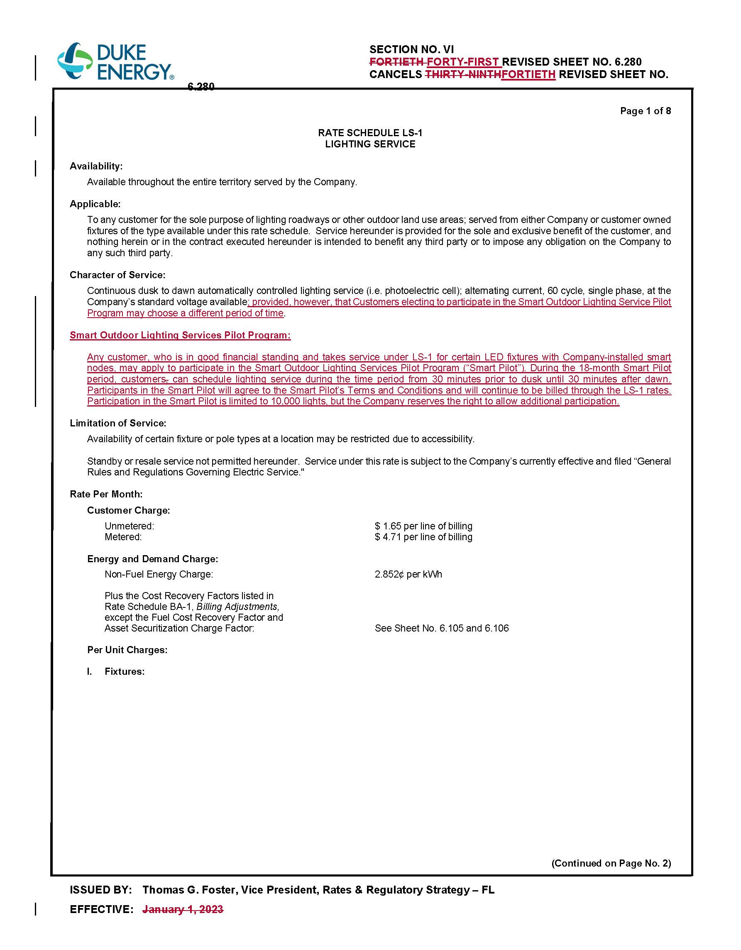

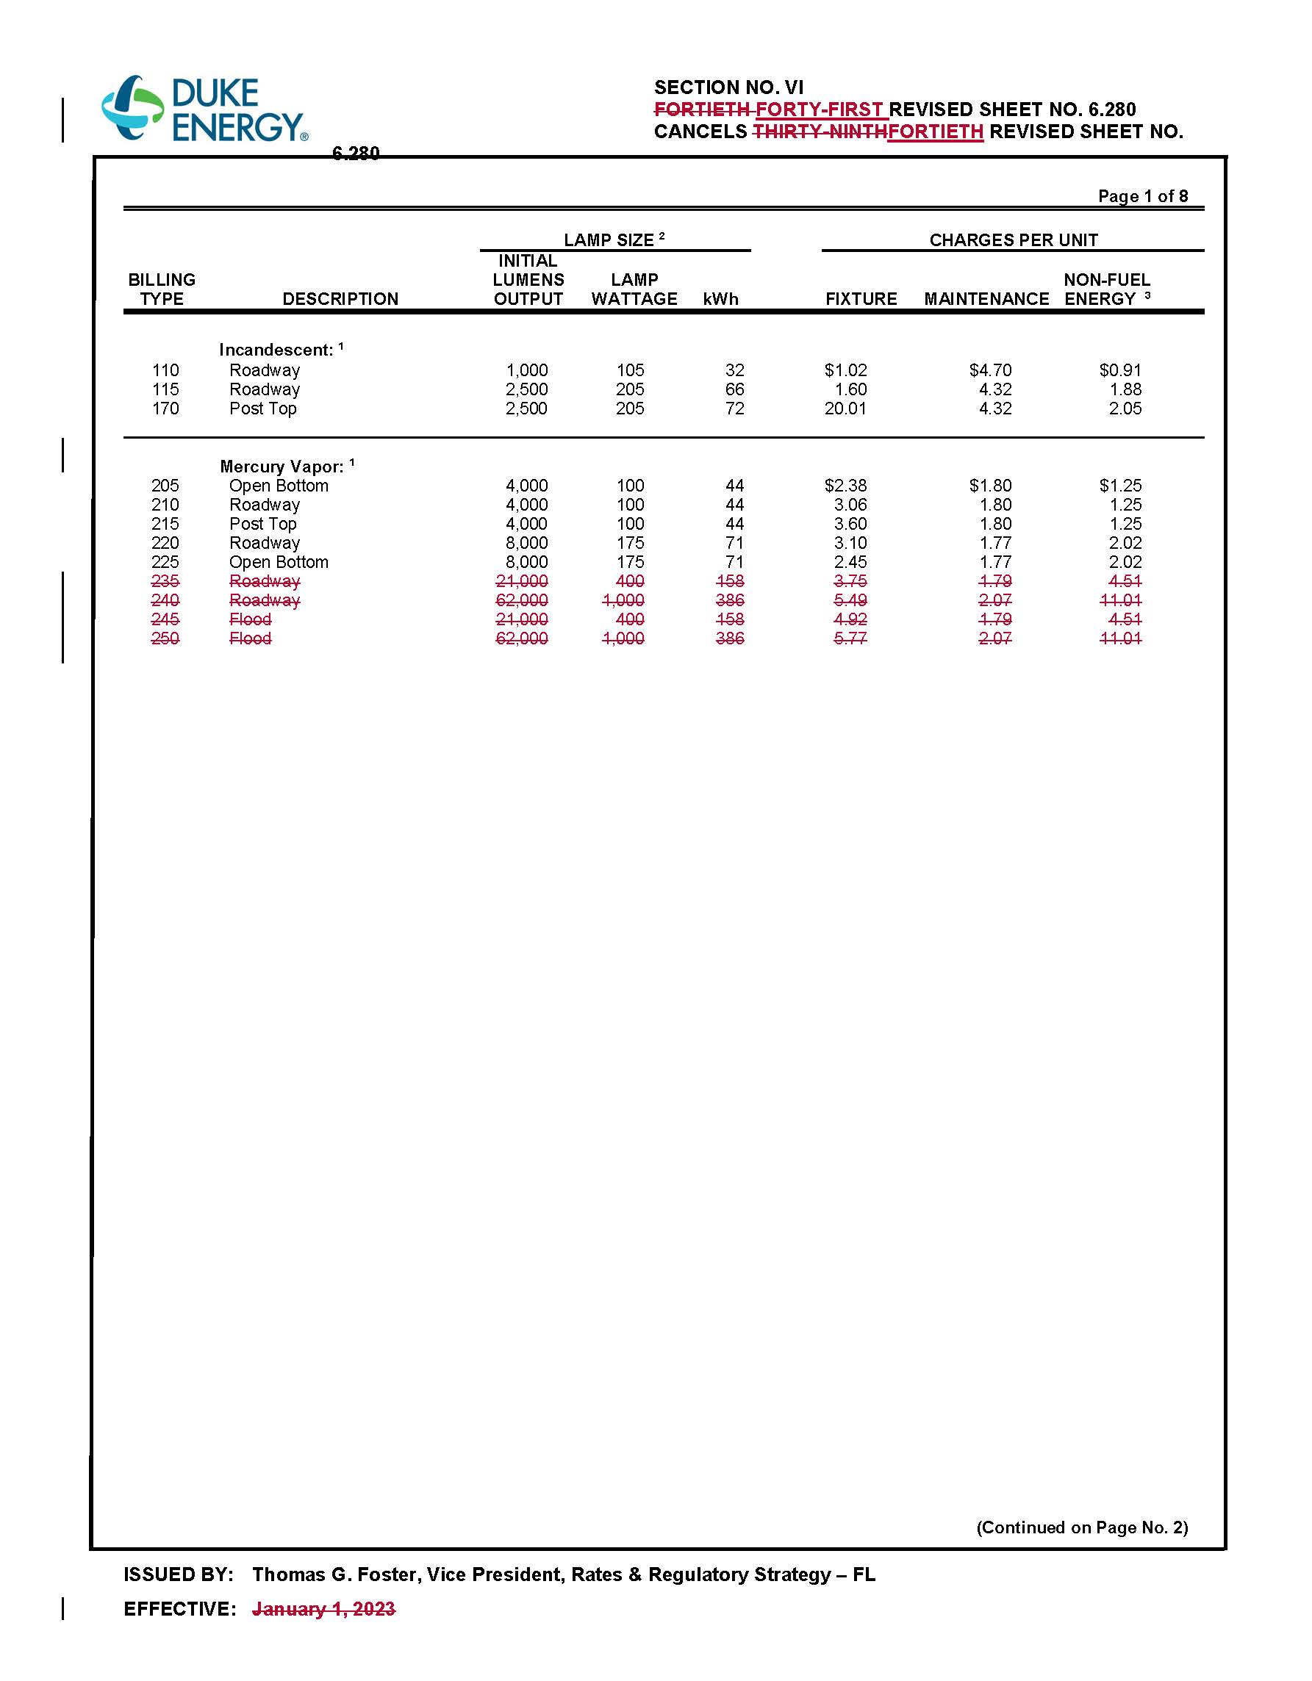

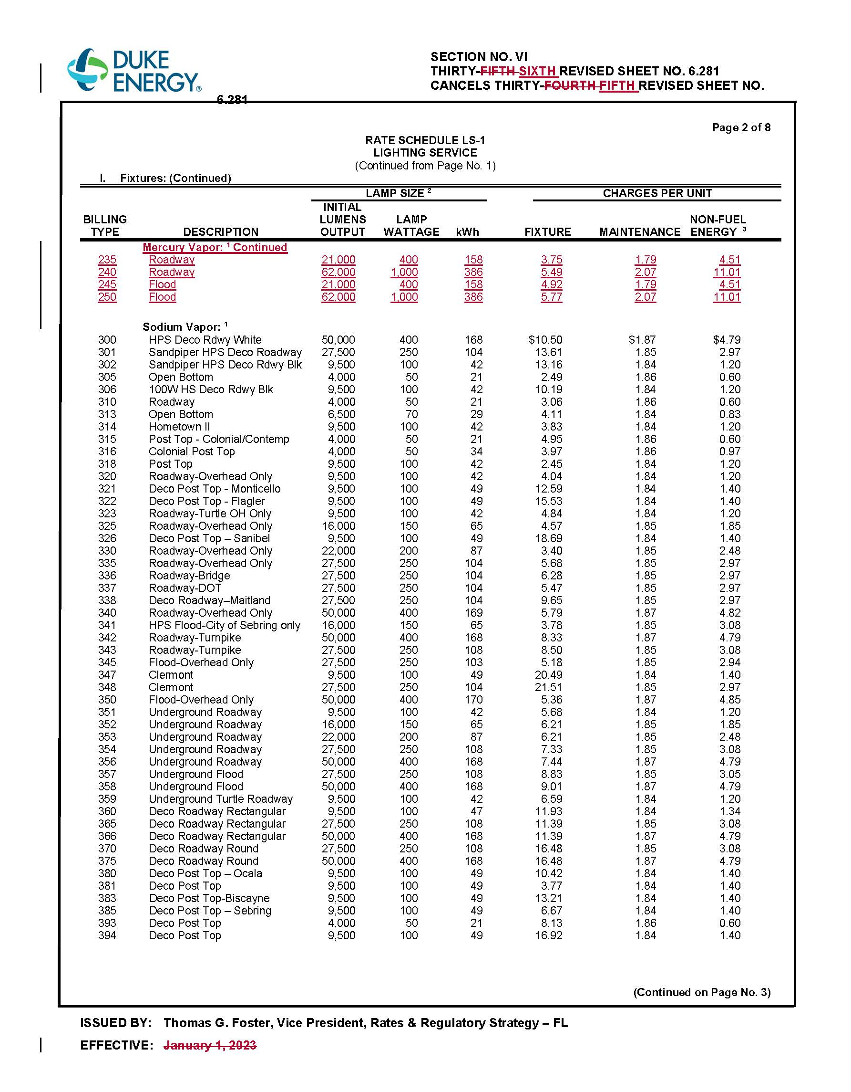

1. Order No. PSC-2023-0182-PCO-EI, issued June 26, 2023, in Docket No. 20230068-EI, *In re: Petition for approval of smart outdoor lighting services pilot program by Duke Energy Florida, LLC*.