BEFORE THE FLORIDA PUBLIC SERVICE COMMISSION

|  |  |
| --- | --- |
| In re: Petition for limited proceeding for recovery of incremental storm restoration costs related to Hurricanes Ian and Nicole, by Florida Power & Light Company. | DOCKET NO. 20230017-EI  ORDER NO. PSC-2023-0354-PCO-EI  ISSUED: November 27, 2023 |

The following Commissioners participated in the disposition of this matter:

ANDREW GILES FAY, Chairman

ART GRAHAM

GARY F. CLARK

MIKE LA ROSA

GABRIELLA PASSIDOMO

ORDER GRANTING SUPPLEMENTAL PETITION

TO MODIFY INTERIM STORM SURCHARGE

BY THE COMMISSION:

Background

By Order issued March 23, 2023, we approved Florida Power & Light Company’s (FPL or Company) petition for a limited proceeding seeking authority to implement an interim storm restoration recovery charge to recover $1.3 billion for the incremental restoration costs related to Hurricanes Ian and Nicole and to replenish the storm reserve.[1] This amount included $18.8 million in interest.

We also approved the alternate storm charge calculation FPL proposed in its petition, which combined the recovery of incremental storm costs associated with Hurricanes Ian and Nicole with the remaining amounts to be collected for Hurricanes Michael, Sally, and Zeta, which we have previously approved for Gulf Power Company.[2] This alternate calculation estimated a total of $1.5 billion for incremental restoration costs related to Hurricanes Michael, Sally, Zeta, Ian, and Nicole, to replenish the storm reserve, and included $21.6 million in interest. FPL filed its petition pursuant to the provisions of the 2021 Settlement Agreement (2021 Settlement) we approved in Order No. PSC-2021-0446-S-EI.[3]

On September 5, 2023, FPL filed a supplemental petition to reduce the interim storm surcharge based on its internal review and finalization of the invoices and storm costs associated with Hurricanes Ian and Nicole. As a result of this internal process, the estimated incremental storm restoration cost related to the two storms decreased from the original estimate of $1.3 billion to $1.1 billion. Thus, the total estimate reflected in the alternative storm charge calculation decreased from $1.5 billion to $1.3 billion. FPL has proposed amended reduced interim storm restoration charges applicable to all rate classes, effective with the first billing cycle of January 2024 and continuing through March 2024, subject to a final true-up.

We have jurisdiction over this matter pursuant to Sections 366.04, 366.05, 366.06, and 366.076, Florida Statutes.

Decision

FPL filed a supplemental petition to reduce the interim storm surcharge based on its internal review and finalization of the invoices and storm costs associated with Hurricanes Ian and Nicole. As a result of this internal process, the estimated incremental storm restoration cost related to the two storms decreased from the original estimate of $1.3 billion to $1.1 billion. Thus, the estimate of total costs reflected in the alternative storm charge calculation decreased from $1.5 billion to $1.3 billion. Included in that total is FPL’s request to replenish the storm reserve to the pre-storm level of $219.9 million.

The initial interim petition was filed pursuant to the provisions of the 2021 Settlement we approved in Order No. PSC-2021-0446-S-EI. Storm restoration costs for Ian and Nicole were incurred during the term of the 2021 Settlement. Based on the updated estimates for the two storms, the current interim storm surcharge would result in an over-recovery of approximately $200 million if allowed to remain effective through March 2024.

The approval of an interim storm restoration recovery charge is preliminary in nature and is subject to refund pending further review once the total actual storm restoration costs are known. After the actual costs are reviewed for prudence and reasonableness, and are compared to the actual amount recovered through the interim storm restoration recovery charge, a determination will be made whether any over/under recovery has occurred. The disposition of any over/under recovery, and associated interest, will be considered by us at a later date. However, we find it appropriate to amend the interim storm surcharge to reflect the known and measurable changes identified by the Company in advance of the final disposition.

Based on a review of the information provided by FPL in its supplemental petition, we authorize the Company to implement an amended interim storm restoration recovery charge subject to refund. Not later than December 31, 2023, FPL shall file documentation of the storm costs for Commission review and true-up of any excess or shortfall.[4]

FPL has proposed to decrease the currently effective interim storm restoration recovery surcharges based on the Company’s internal review of storm costs, as discussed immediately above. In paragraph 10 of the petition, FPL states that the updated surcharges are allocated to the rate classes consistent with the rate design approved in FPL’s most recent rate case.[5] We have reviewed the allocation to rate classes and find that the allocations provided in Appendix D to the petition are consistent with those approved in FPL’s most recent rate case. Furthermore, we have reviewed the derivation of the surcharges provided in Appendix D to the petition, and find that the surcharges have been calculated correctly, using projected kilowatt hour (kWh) sales for January through March 2024. The proposed interim storm restoration recovery factors shall remain in effect until we approve a final true-up.

The proposed interim storm restoration surcharges are shown on First Revised Tariff Sheet No. 8.030.7, provided in Appendix F to the petition. For residential customers the proposed surcharge will be 0.665 cents per kWh, which equates to a total surcharge of $6.65 for a 1,000 kWh monthly bill. The current surcharge is 1.53 cents per kWh, which equates to a total surcharge of $15.30 for a 1,000 kWh monthly bill. The storm cost recovery surcharge shall be included in the non-fuel energy charge on customer bills.

Based on the foregoing, it is

ORDERED by the Florida Public Service Commission that the Supplemental Petition to Modify the Interim Storm Surcharge Related to Hurricanes Ian and Nicole filed by Florida Power & Light Company is approved. It is further

ORDERED that FPL’s revised interim storm restoration recovery surcharges and associated tariff, as shown in Attachment A to this Order, are approved and shall become effective the first billing cycle of January 2024. It is further

ORDERED that the revised interim storm restoration recovery factors shall remain in effect until we approve a final true-up. It is further

ORDERED that this docket shall remain open pending final reconciliation of actual recoverable storm costs with the amount collected pursuant to the modified consolidated interim storm restoration recovery charge, and the calculation of a refund or additional charge if warranted.

By ORDER of the Florida Public Service Commission this 27th day of November, 2023.

|  |  |
| --- | --- |
|  |  |
|  | ADAM J. TEITZMAN  Commission Clerk |

Florida Public Service Commission

2540 Shumard Oak Boulevard

Tallahassee, Florida 32399

(850) 413‑6770

www.floridapsc.com

Copies furnished: A copy of this document is provided to the parties of record at the time of issuance and, if applicable, interested persons.

SPS

NOTICE OF FURTHER PROCEEDINGS OR JUDICIAL REVIEW

The Florida Public Service Commission is required by Section 120.569(1), Florida Statutes, to notify parties of any administrative hearing or judicial review of Commission orders that is available under Sections 120.57 or 120.68, Florida Statutes, as well as the procedures and time limits that apply. This notice should not be construed to mean all requests for an administrative hearing or judicial review will be granted or result in the relief sought.

Mediation may be available on a case-by-case basis. If mediation is conducted, it does not affect a substantially interested person's right to a hearing.

Any party adversely affected by this order, which is preliminary, procedural or intermediate in nature, may request: (1) reconsideration within 10 days pursuant to Rule 25-22.0376, Florida Administrative Code; or (2) judicial review by the Florida Supreme Court, in the case of an electric, gas or telephone utility, or the First District Court of Appeal, in the case of a water or wastewater utility. A motion for reconsideration shall be filed with the Office of Commission Clerk, in the form prescribed by Rule 25-22.0376, Florida Administrative Code. Judicial review of a preliminary, procedural or intermediate ruling or order is available if review of the final action will not provide an adequate remedy. Such review may be requested from the appropriate court, as described above, pursuant to Rule 9.100, Florida Rules of Appellate Procedure.

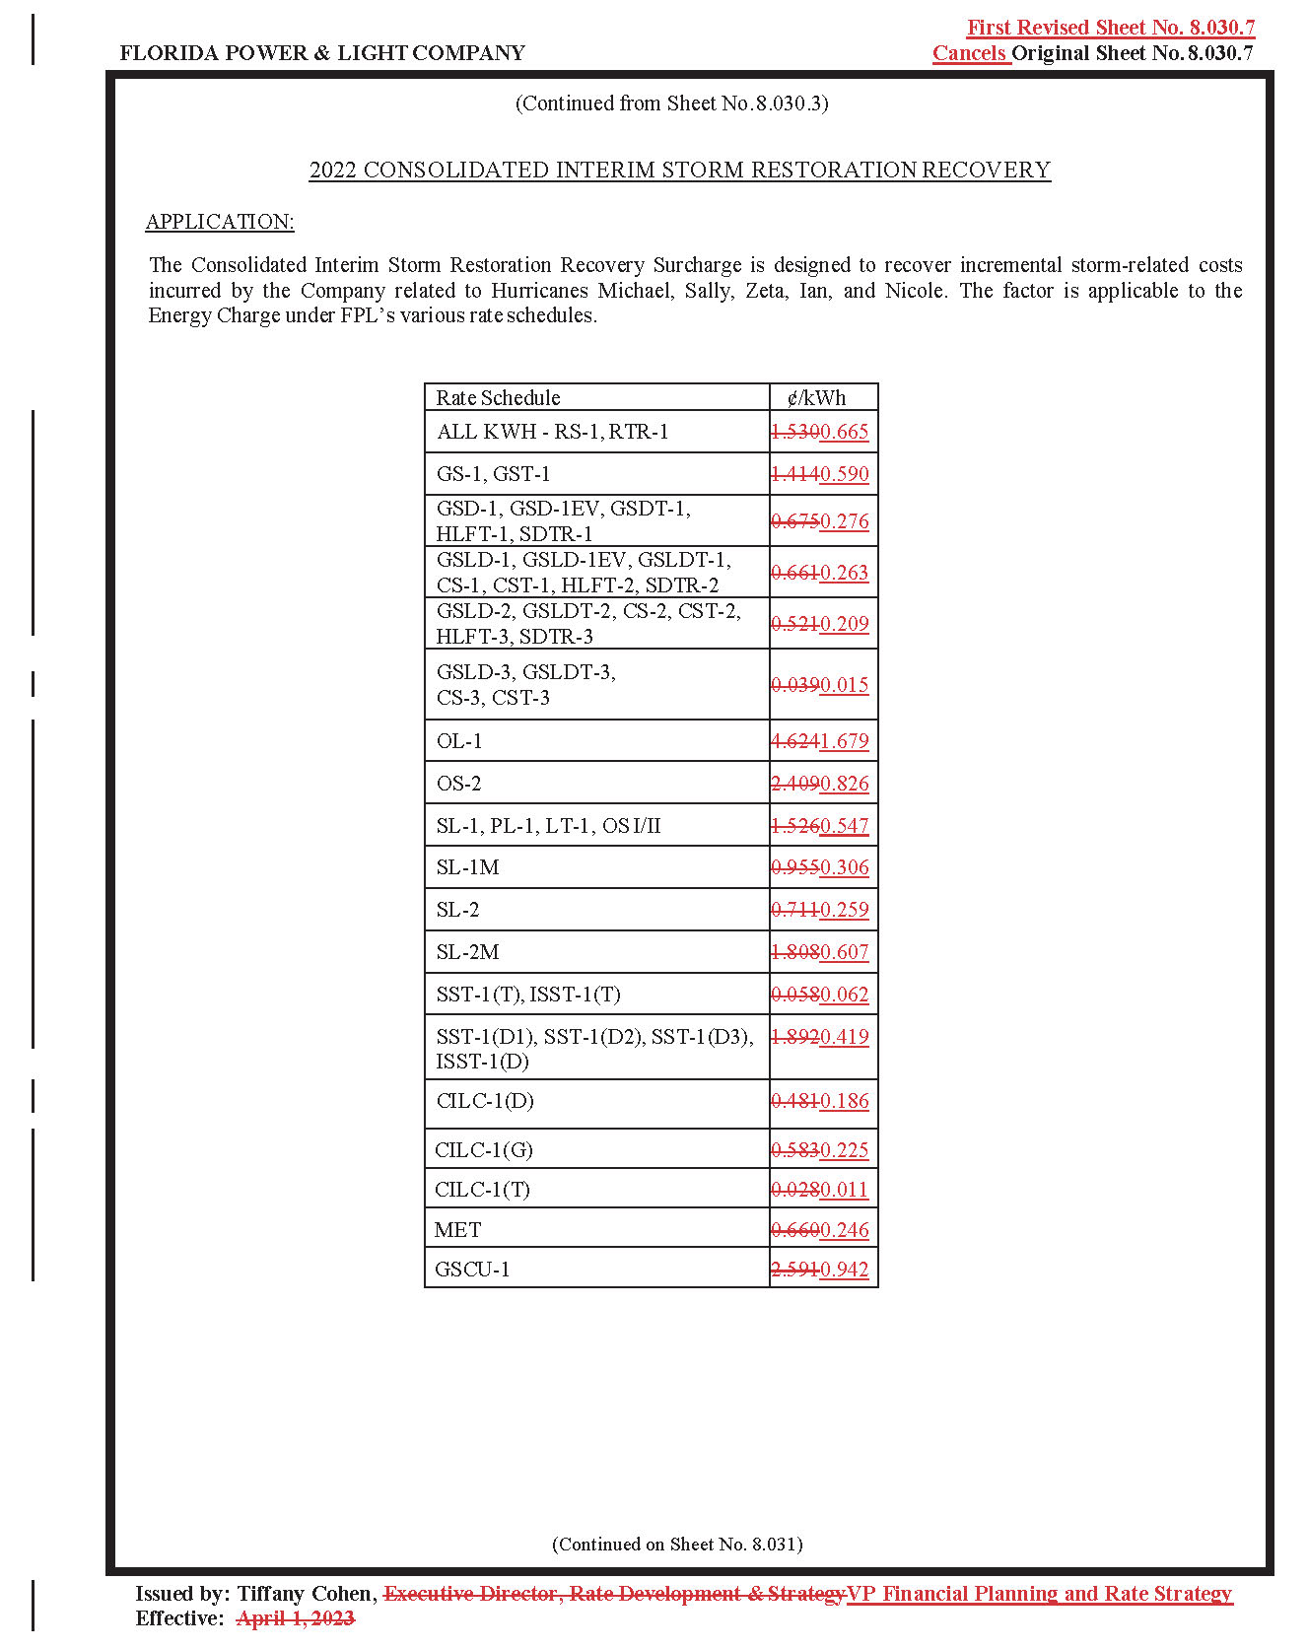

1. Order No. PSC-2023-0110-PCO-EI, issued March 23, 2023, in Docket No. 20230017-EI, *In re: Petition for limited proceeding for recovery of incremental storm restoration costs related to Hurricanes Ian and Nicole, by Florida Power & Light Company*.
2. Order No. PSC-2019-0221-PCO-EI, issued June 3, 2019, in Docket No. 20190038-EI, *In re: Petition for limited proceeding for recovery of incremental storm restoration costs related to Hurricane Michael, by Gulf Power Company*; and Order No. PSC-2022-0406-FOF-EI, issued November 21, 2022, in Docket No. 20200041-EI, *In re: Petition for limited proceeding for recovery of incremental storm restoration costs related to Hurricane Sally, by Gulf Power Company*.
3. Order No. PSC-2021-0446-S-EI, issued December 2, 2021, in Docket No. 20210015-EI, *In re: Petition for rate increase by Florida Power & Light Company*.
4. *See* Order No. PSC-2023-0298-PAA-EI, issued October 2, 2023, in Docket No. 20230017-EI, *In re: Petition for limited proceeding for recovery of incremental storm restoration costs related to Hurricanes Ian and Nicole, by Florida Power & Light Company*.
5. Order No. PSC-2021-0446-S-EI.