State of Florida   |  | Public Service Commission  Capital Circle Office Center ● 2540 Shumard Oak Boulevard  Tallahassee, Florida 32399-0850  -M-E-M-O-R-A-N-D-U-M-
DATE: | November 28, 2023
TO: | Office of Commission Clerk (Teitzman)
FROM: | Division of Economics (Hampson, Kelley)  Division of Accounting and Finance (Norris)  Office of the General Counsel (Thompson, Dose, Sandy, Watrous)
RE: | Docket No. 20230023-GU – Petition for rate increase by Peoples Gas System, Inc.
AGENDA: | 12/05/23 – Special Agenda – Post-Hearing Decision – Participation is Limited to Commissioners and Staff
COMMISSIONERS ASSIGNED: |  |  | All Commissioners
PREHEARING OFFICER: |  |  | Passidomo
CRITICAL DATES: |  |  | 04/04/24 (12-Month Effective Date)
SPECIAL INSTRUCTIONS: |  |  | None

Case Background
On April 4, 2023, Peoples Gas System, Inc. (PGS or Company) filed a petition seeking the Commission’s approval of a rate increase and associated depreciation rates. PGS is a natural gas distribution company providing sales and transportation of natural gas, and is a public utility subject to this Commission’s regulatory jurisdiction under Chapter 366, Florida Statutes (F.S.). PGS is a wholly owned subsidiary of TECO Gas Operations, Inc. and provides service to approximately 470,000 customers in 39 of Florida’s 67 counties.
An administrative hearing was held September 12-15, 2023. At the hearing, the Commission approved Type 1 stipulations for the following issues: 16, 17, 18, 20, 25, 30, 39, 44, 46, and 56. The Commission also approved Type 2 stipulations for the following issues: 2, 3, 5, 8, 11, 12, 14, 24, 26, 37, 40, 45, 48, 58, 59, 62, 64, 65, 66, 67, and 68. At the November 9, 2023 Special Agenda Conference, the Commission approved an incremental increase in operating revenues of $106,682,569. The total Company target revenues, including other operating revenues, is $458,180,488. The staff-calculated final revenue requirement calculation that reflect the Commission-approved increase to operating revenues is contained in Attachment A to the recommendation.
At the hearing, the Commission approved the stipulations regarding the Company’s cost of service study in Issue 58 and the revenue increase allocation to the rate classes in Issue 59. This recommendation addresses the issues that were not addressed at the November 9, 2023 Special Agenda Conference: Issue 60 (customer charges), Issue 61 (distribution charges), Issue 69 (approval of tariffs), Issue 70 (effective date), and Issue 75 (close docket).

On November 14, 2023, the Company filed a revised cost of service study and associated tariffs reflecting the final Commission-approved revenue requirement. The proposed customer and per therm distribution charges are calculated in the revised cost of service study and shown in the attached tariffs. The tariffs are included in Attachment B to the recommendation. The Commission has jurisdiction over this matter pursuant to Chapter 366, F.S., including Sections 366.06 and 366.071, F.S.

Discussion of Issues

Issue 60:
What customer charges should be approved?

Recommendation:
The proposed customer charges as provided in the tariffs in Attachment B to the recommendation should be approved. (P. Kelley, Hampson, Norris)

Position of the Parties

PGS:
This is a fallout issue based on the revenue requirement approved by the Commission and its decisions on issues that impact the inputs to the company’s stipulated cost of service methodology.

OPC:
OPC did not address this issue in its post-hearing brief.

FIPUG:
FIPUG did not address this issue in its post-hearing brief.

Staff Analysis:

PARTIES’ ARGUMENTS

PGS
PGS did not provide an argument. (PGS BR 41)

OPC
OPC did not address this issue in its post-hearing brief.

FIPUG
FIPUG did not address this issue in its post-hearing brief.

ANALYSIS

The customer charges, in combination with the per therm distribution charges shown in Issue 61, are designed to allow the Company to recover the total Commission-approved revenue requirement. Further, the Commission approved the Company’s proposed cost of service methodology in Issue 58 and the allocation of the revenue increase to rate classes in Issue 59 at the November 9, 2023 Special Agenda Conference. The proposed customer charges reflect the approved revenue requirements and cost of service methodology; therefore, the proposed charges provided in the tariffs in Attachment B to the recommendation should be approved.

Issue 61:
What per therm distribution charges should be approved?

Recommendation:
The proposed per therm distribution charges as provided in the tariffs in Attachment B to the recommendation should be approved. (P. Kelley, Hampson, Norris)

Position of the Parties

PGS:
This is a fallout issue based on the revenue requirement approved by the Commission and its decisions on issues that impact the inputs to the company’s stipulated cost of service methodology.

OPC:
OPC did not address this issue in its post-hearing brief.

FIPUG:
FIPUG did not address this issue in its post-hearing brief.

Staff Analysis:

PARTIES’ ARGUMENTS

PGS
PGS did not provide an argument. (PGS BR 42)

OPC
OPC did not address this issue in its post-hearing brief.

FIPUG
FIPUG did not address this issue in its post-hearing brief.

ANALYSIS

Staff has reviewed the Company’s revised cost of service filing and it reflects the Commission-approved total Company revenue requirement. Further, the Commission approved the Company’s proposed cost of service methodology in Issue 58 and the allocation of the revenue increase to rate classes in Issue 59 at the November 9, 2023 Special Agenda Conference. The proposed customer charges reflect the approved revenue requirements and cost of service methodology; therefore, the proposed per therm charges provided in the tariffs in Attachment B to the recommendation should be approved.

Issue 69:
Should the Commission approve PGS’s proposed tariffs reflecting the Commission-approved target revenues?

Recommendation:
Yes, the Commission should approve PGS’s proposed tariffs reflecting the Commission-approved target revenues, as provided in Attachment B to the recommendation. (P. Kelley, Hampson, Norris)

Position of the Parties

PGS:
Yes. Once the Commission approves the company’s customer and per therm charges, the company should submit updated tariff sheets reflecting the new rates and charges, including those approved by stipulation, and the Staff of the Commission should be given administrative authority to approve the update tariff pages.

OPC:
OPC did not address this issue in its post-hearing brief.

FIPUG:
FIPUG did not address this issue in its post-hearing brief.

Staff Analysis:

PARTIES’ ARGUMENTS

PGS
PGS did not provide an argument. (PGS BR 42)

OPC
OPC did not address this issue in its post-hearing brief.

FIPUG
FIPUG did not address this issue in its post-hearing brief.

ANALYSIS

Staff has reviewed the revised cost of service study and associated tariffs, which were revised to reflect the final Commission-approved revenue requirement. Reviewing the documentation provided by PGS, staff believes that the revised cost of service study and associated tariffs are in accordance with the Commission vote from the November 9, 2023 Special Agenda Conference. The Commission should approve the proposed tariffs as provided in Attachment B to the recommendation.

Issue 70:
What is the effective date for PGS's revised rates and charges?

Recommendation:
The rates and charges approved by the Commission should become effective the first billing cycle in January 2024. (P. Kelley, Hampson, Norris)

Position of the Parties

PGS:
The revised base rates and charges approved in this case should be effective with the first billing cycle in January 2024

OPC:
OPC did not address this issue in its post-hearing brief.

FIPUG:
FIPUG did not address this issue in its post-hearing brief.

Staff Analysis:

PARTIES’ ARGUMENTS

PGS
The appropriate effective date for Peoples’ revised rates and charges should be the first billing cycle in January 2024. (PGS BR 42)

OPC
OPC did not address this issue in its post-hearing brief.

FIPUG
FIPUG did not address this issue in its post-hearing brief.

ANALYSIS
PGS provided a notification of the proposed rate increase to its customers during the month of June 2023, and also posted notice of the rate increase on its website. The notification included a comparison between current and proposed rates, and that the rates ultimately approved by the Commission will not exceed those identified in the notice. PGS will also provide a direct notice to customers during January 2024, which will identify the final, Commission-approved rates and charges.
Staff has reviewed the direct notice and believes the notice reflects the rates and charges approved by the Commission. Staff recommends that the rates and charges approved by the Commission should become effective the first billing cycle in January 2024.

Issue 75:
Should this docket be closed?

Recommendation:
After the final order is issued, this docket should be closed. (Thompson, Sandy)

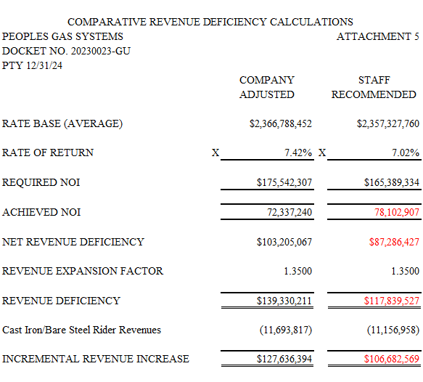
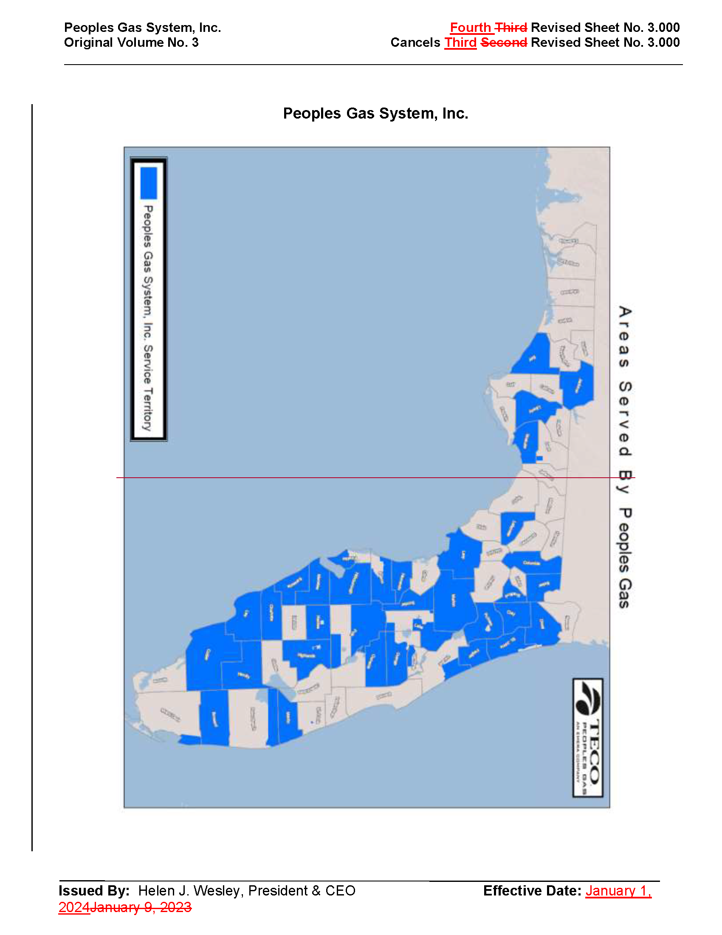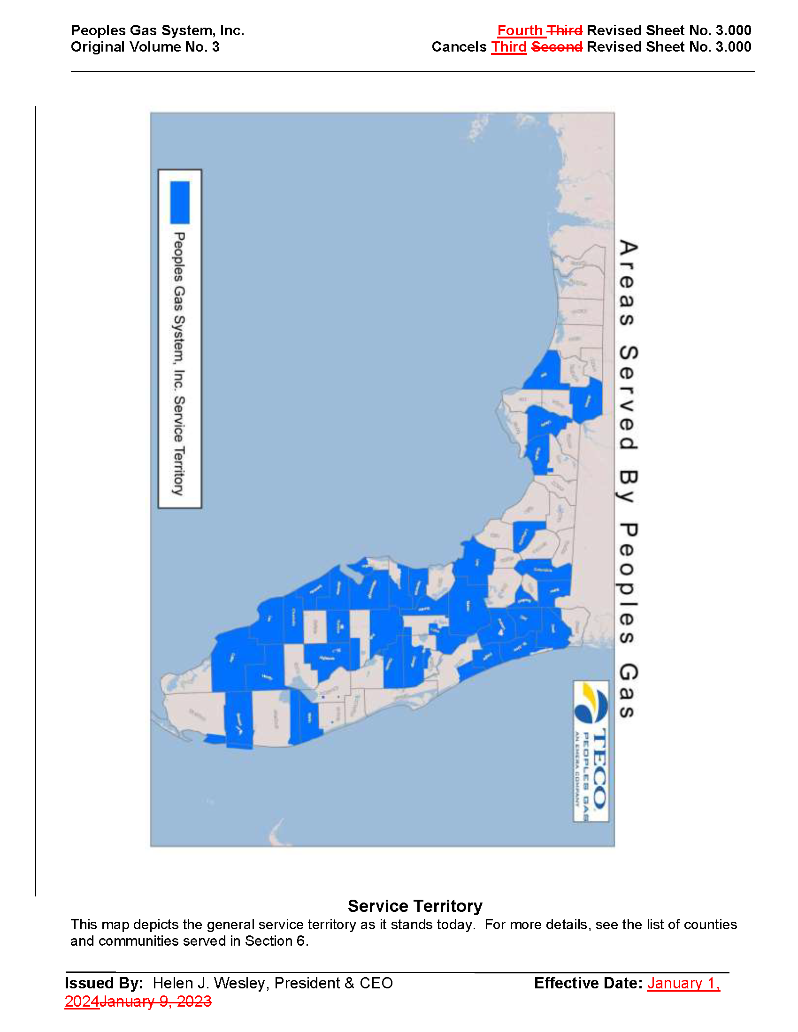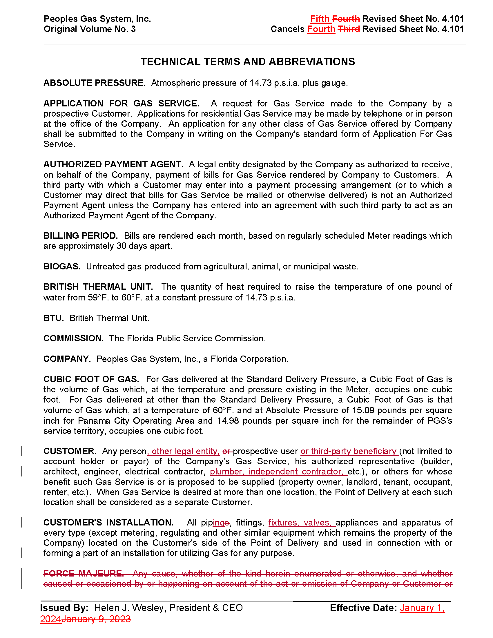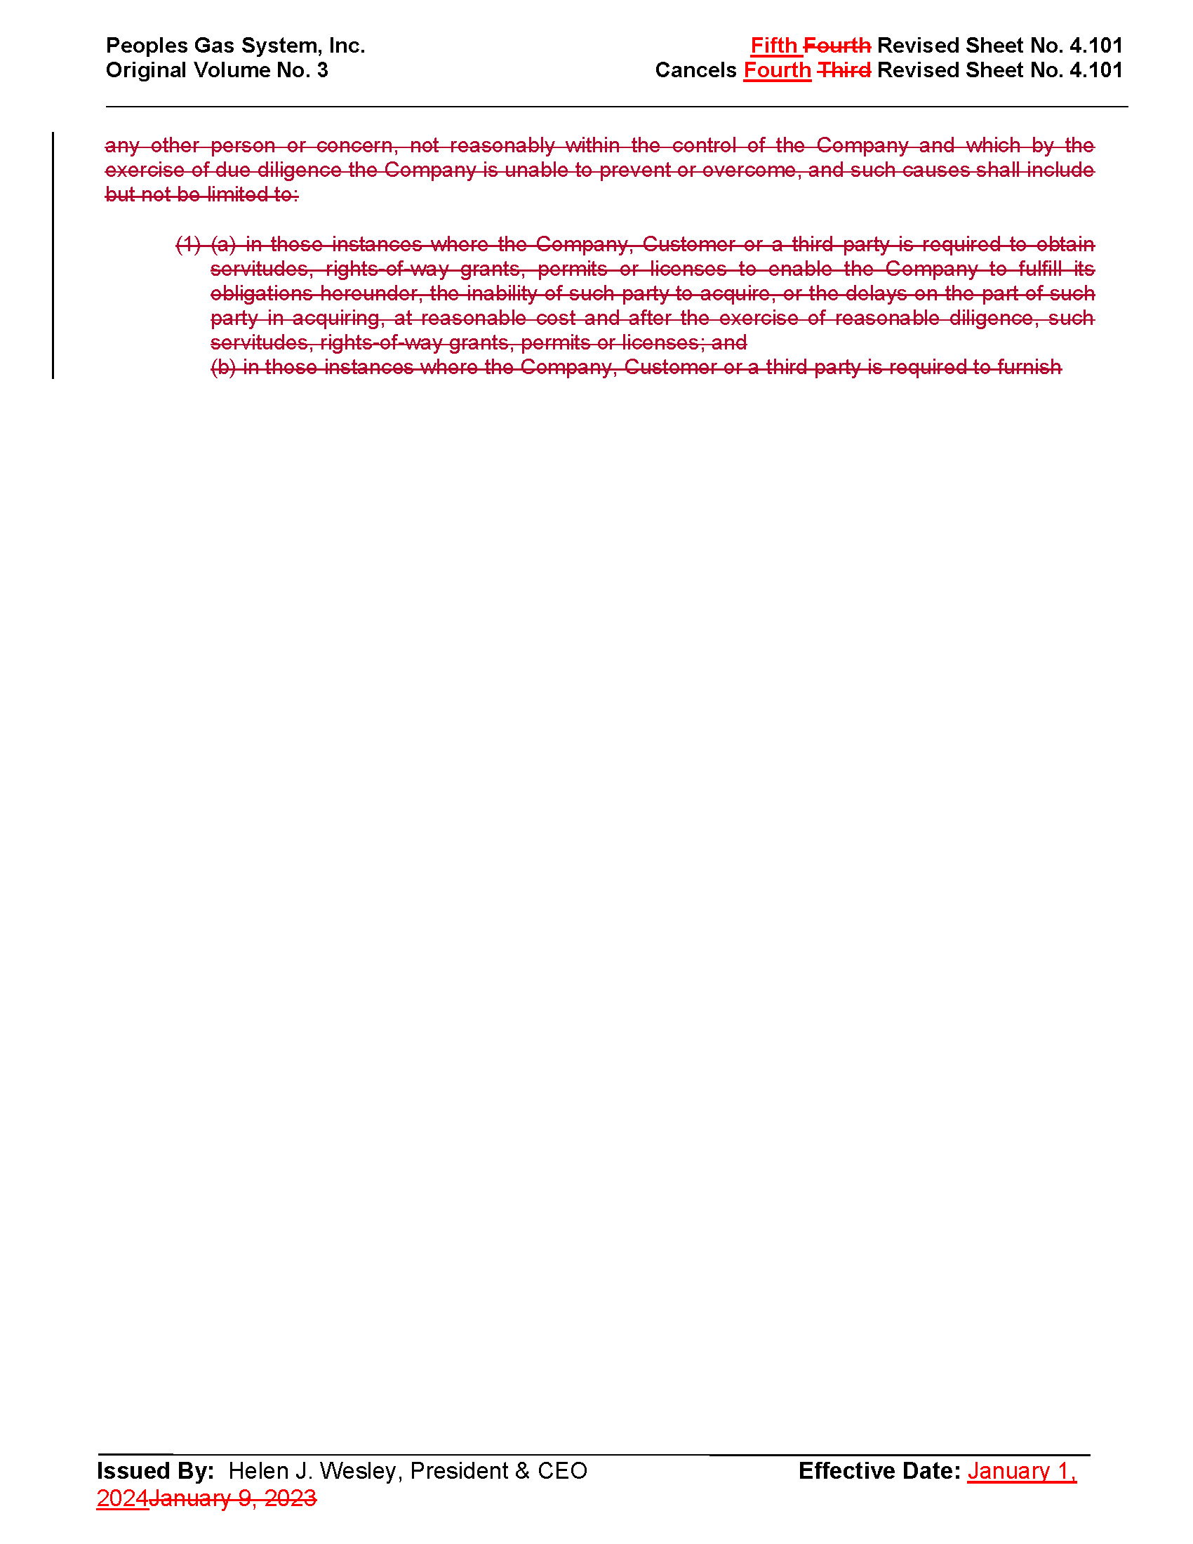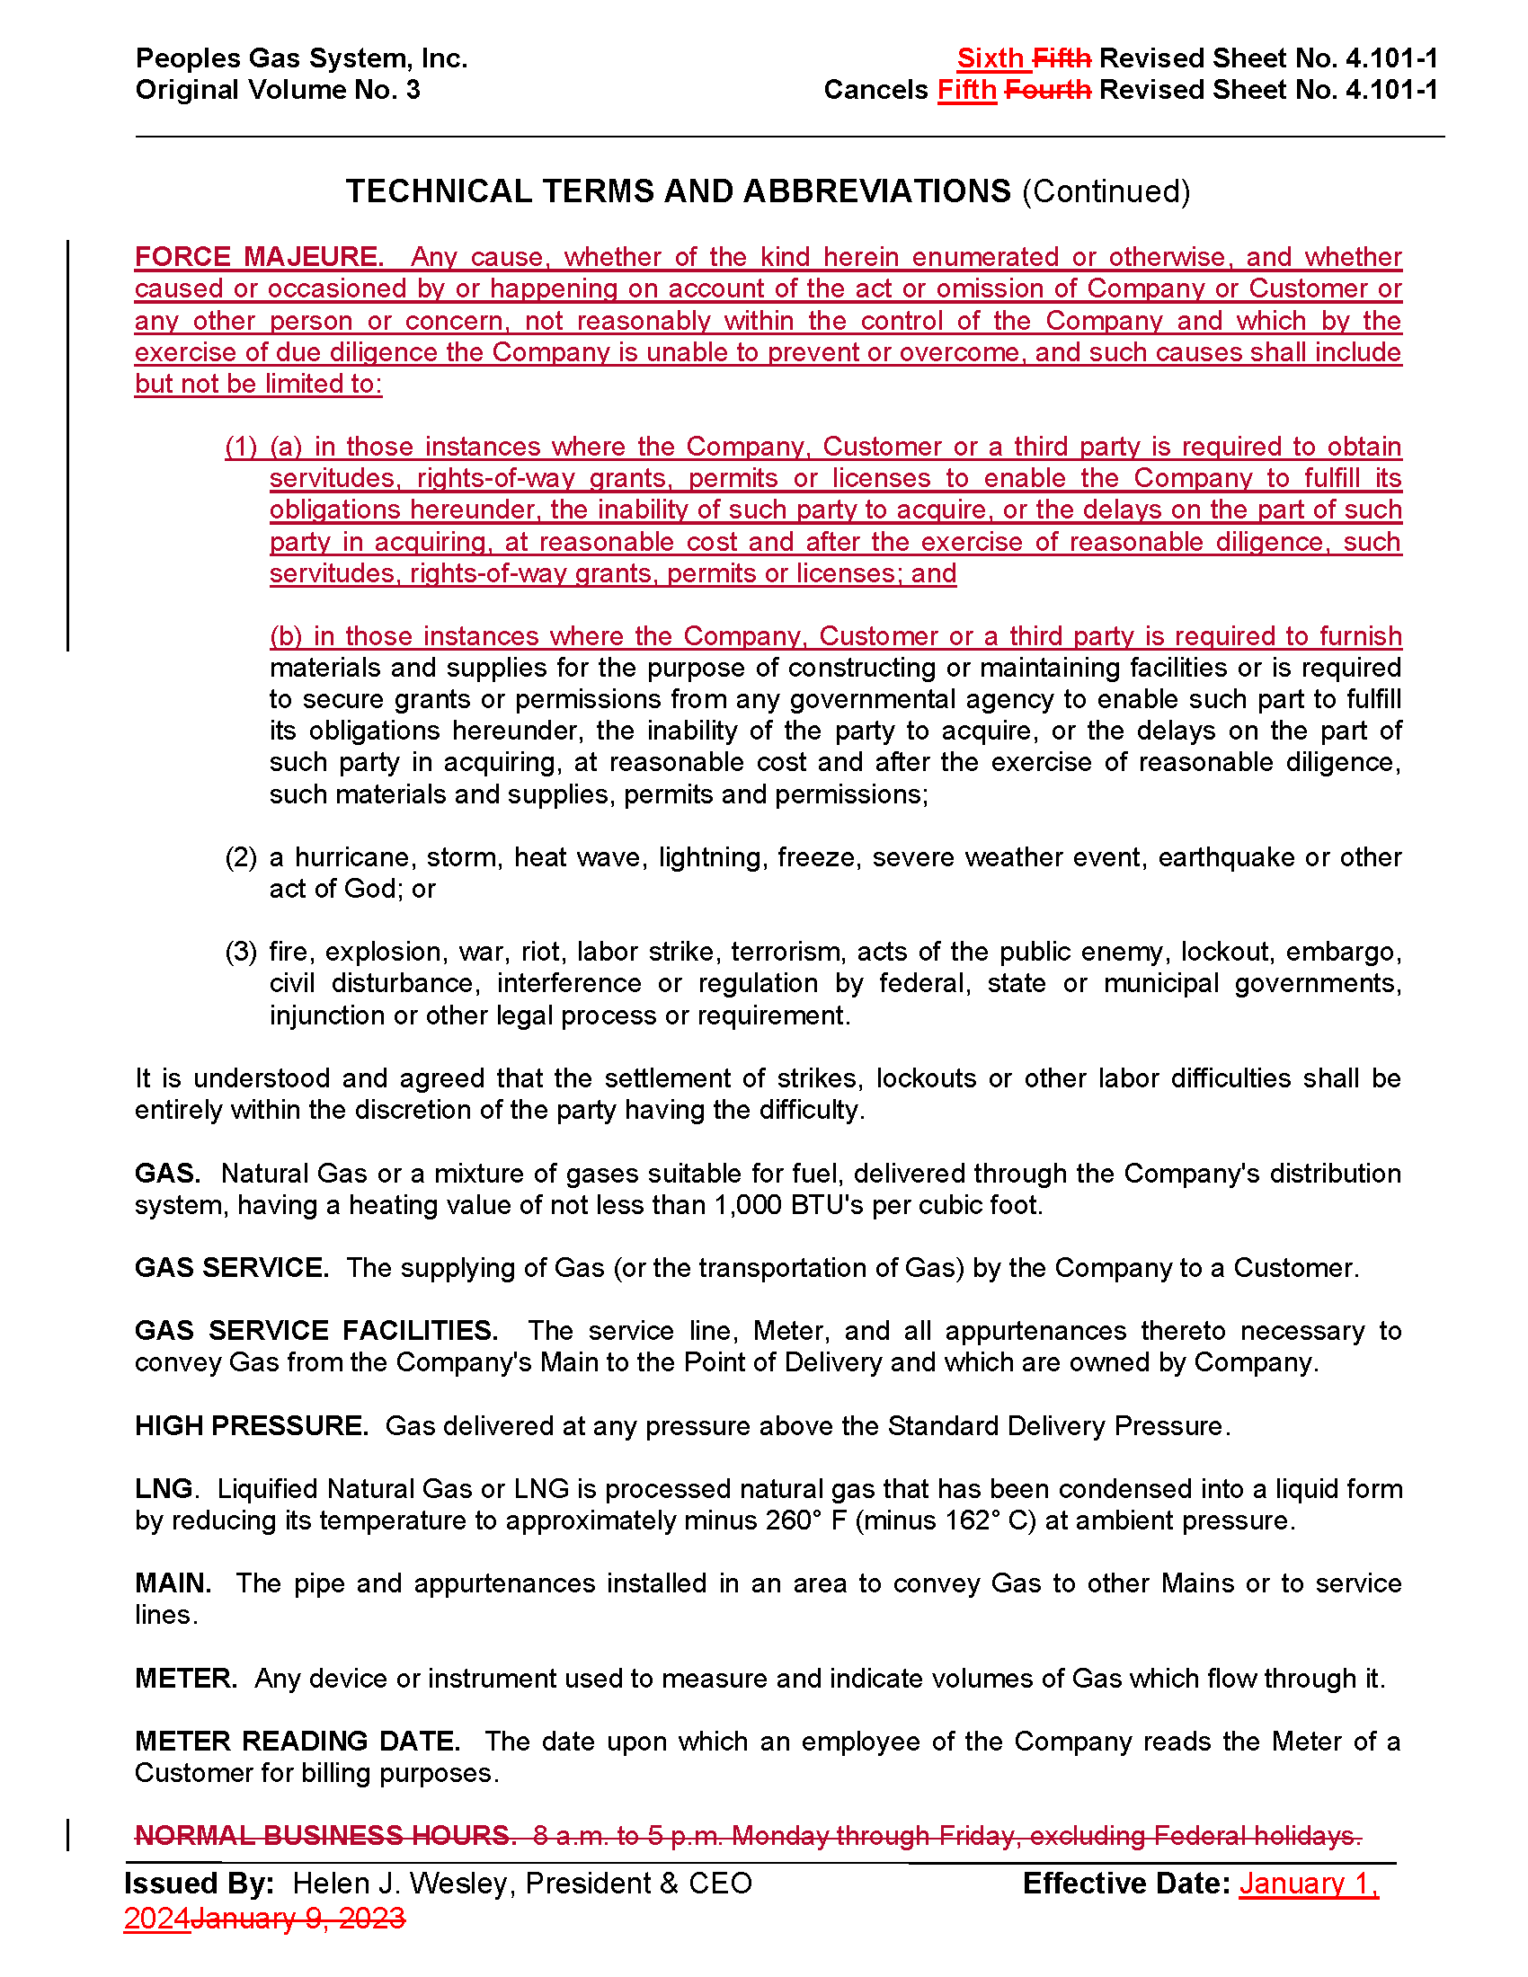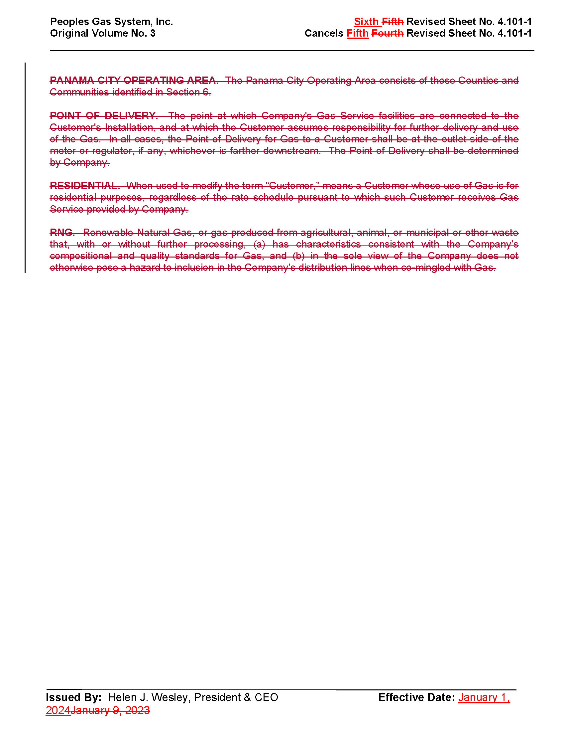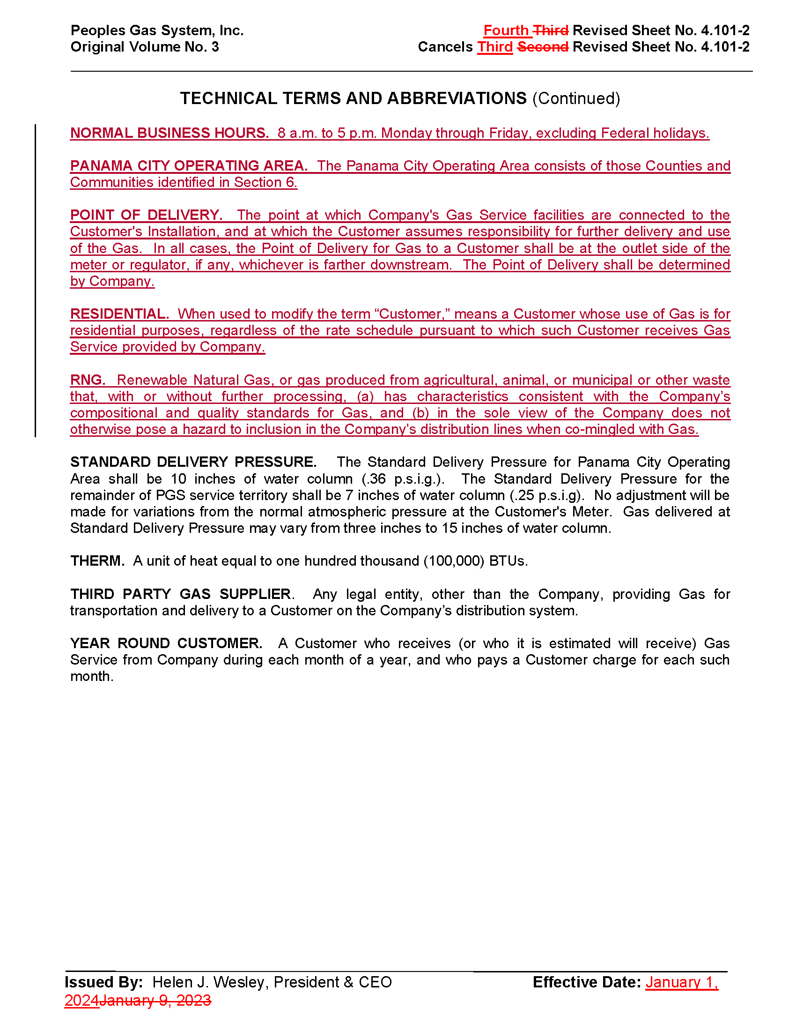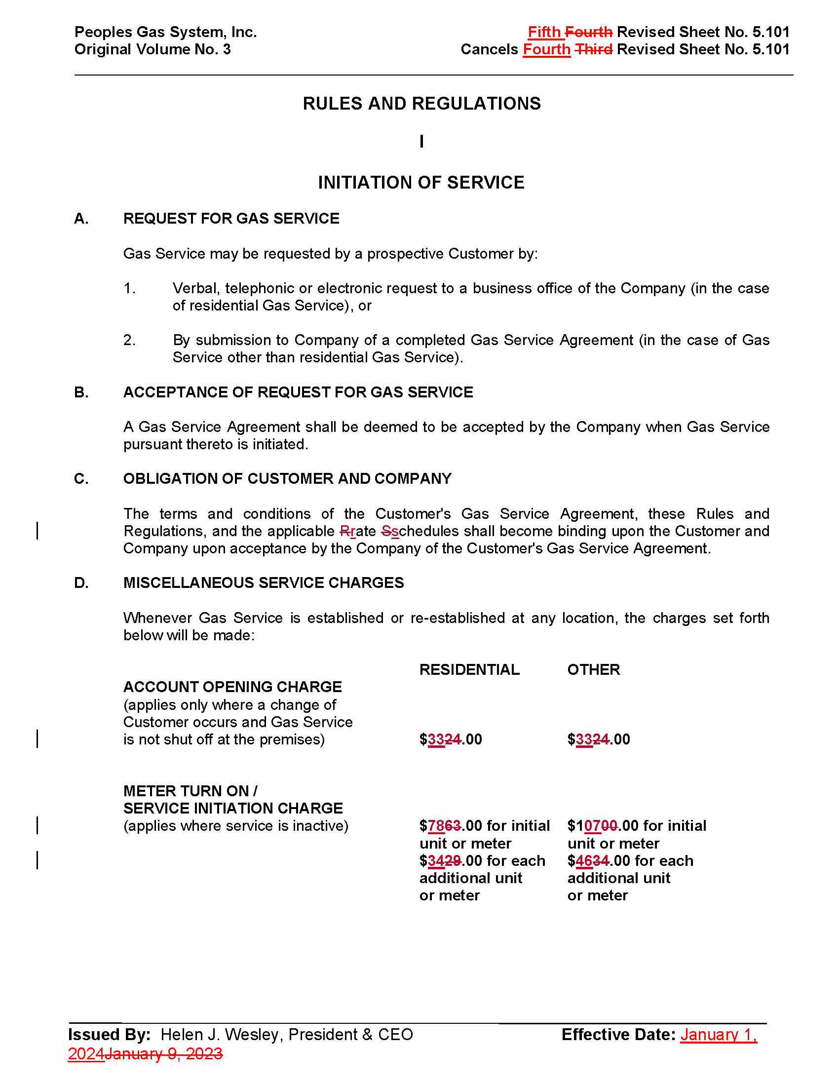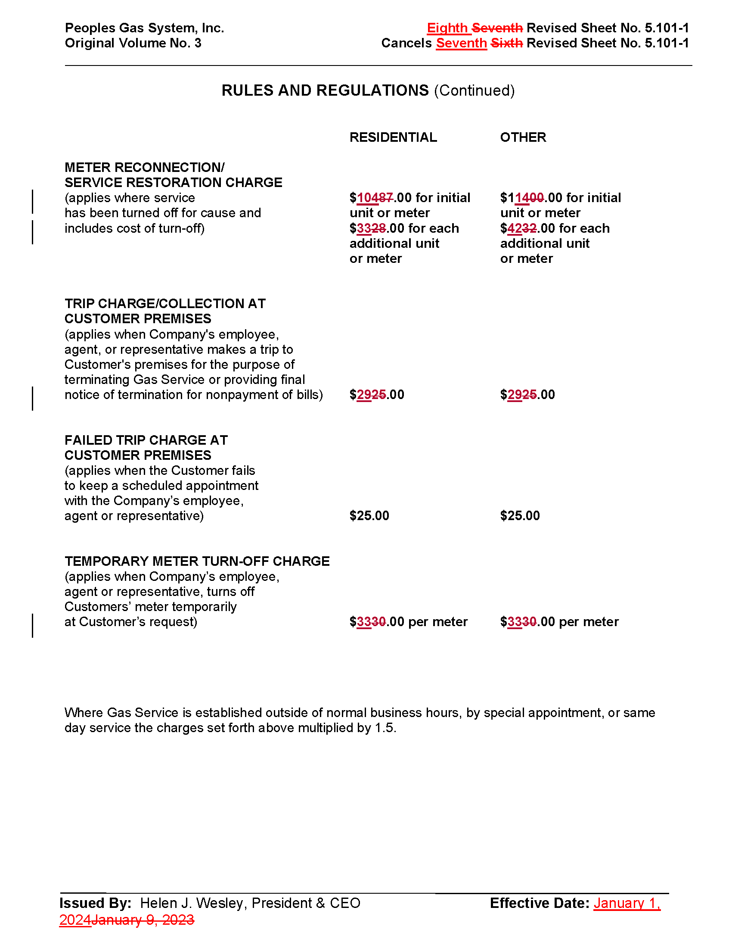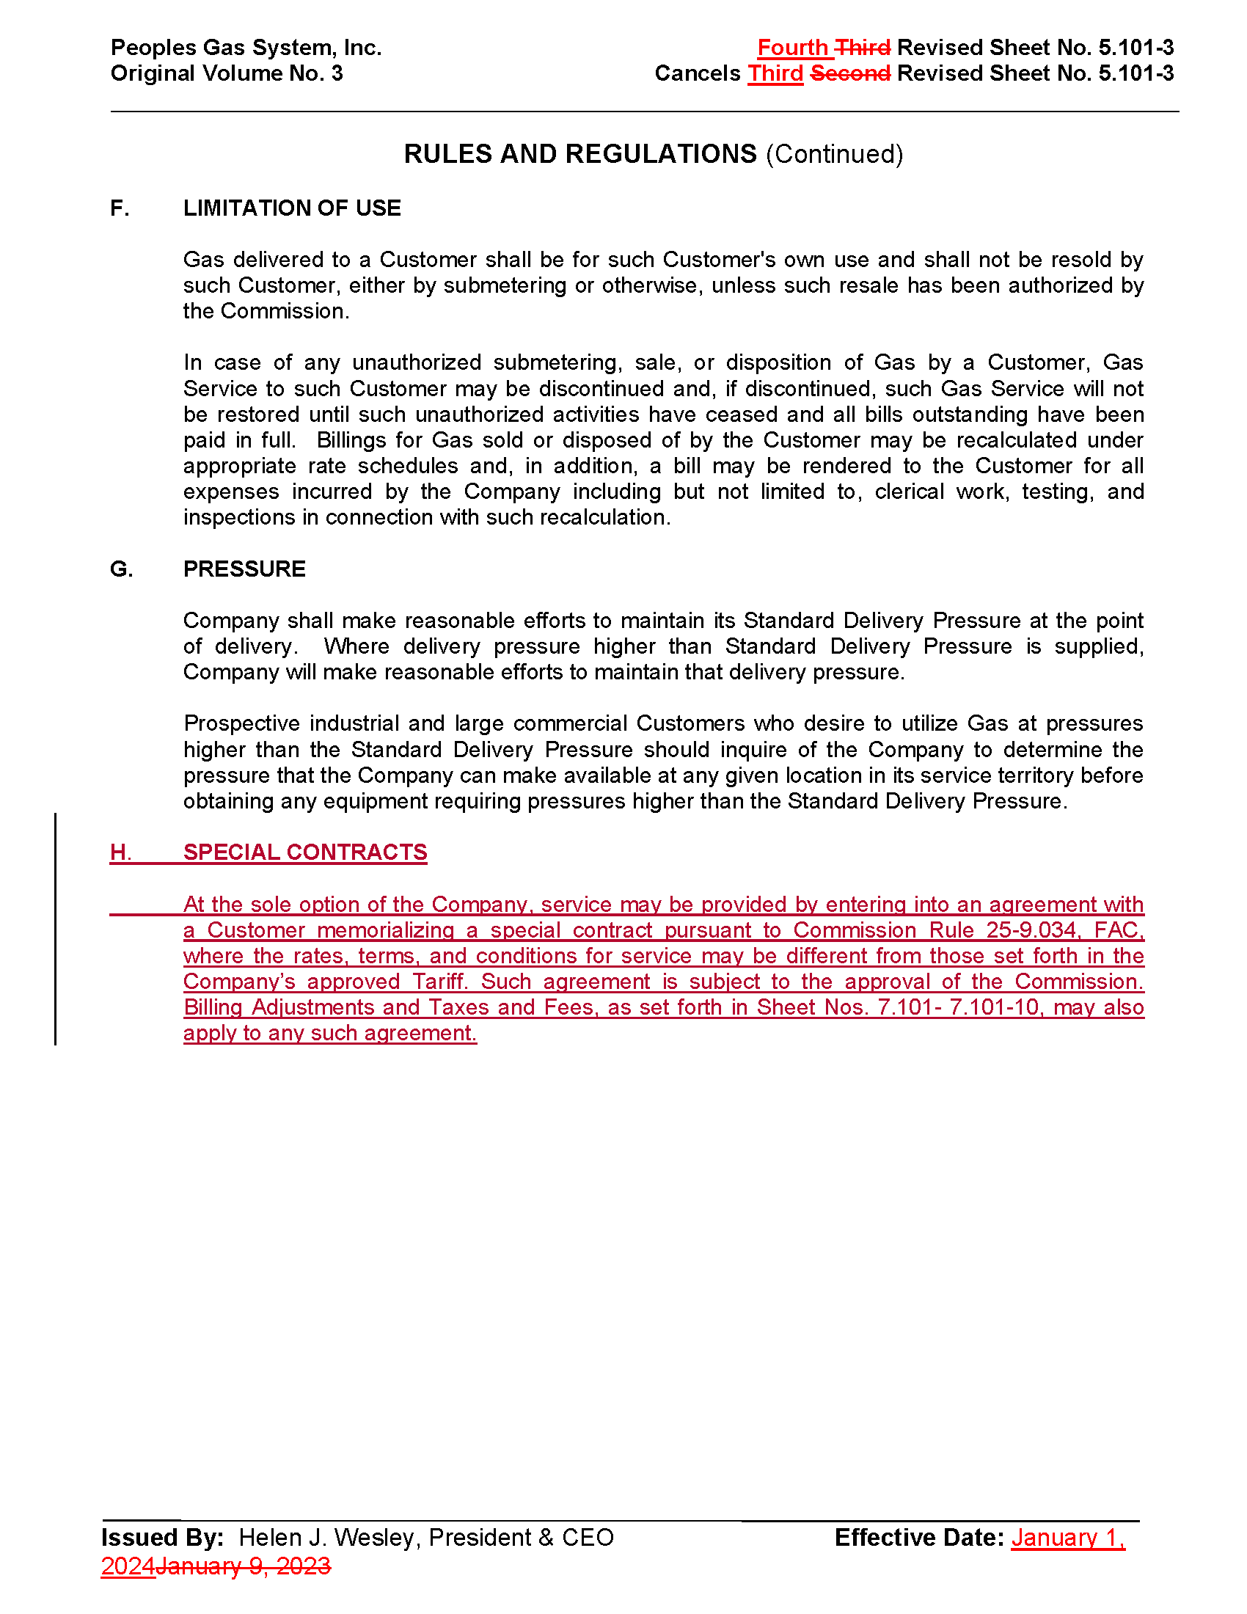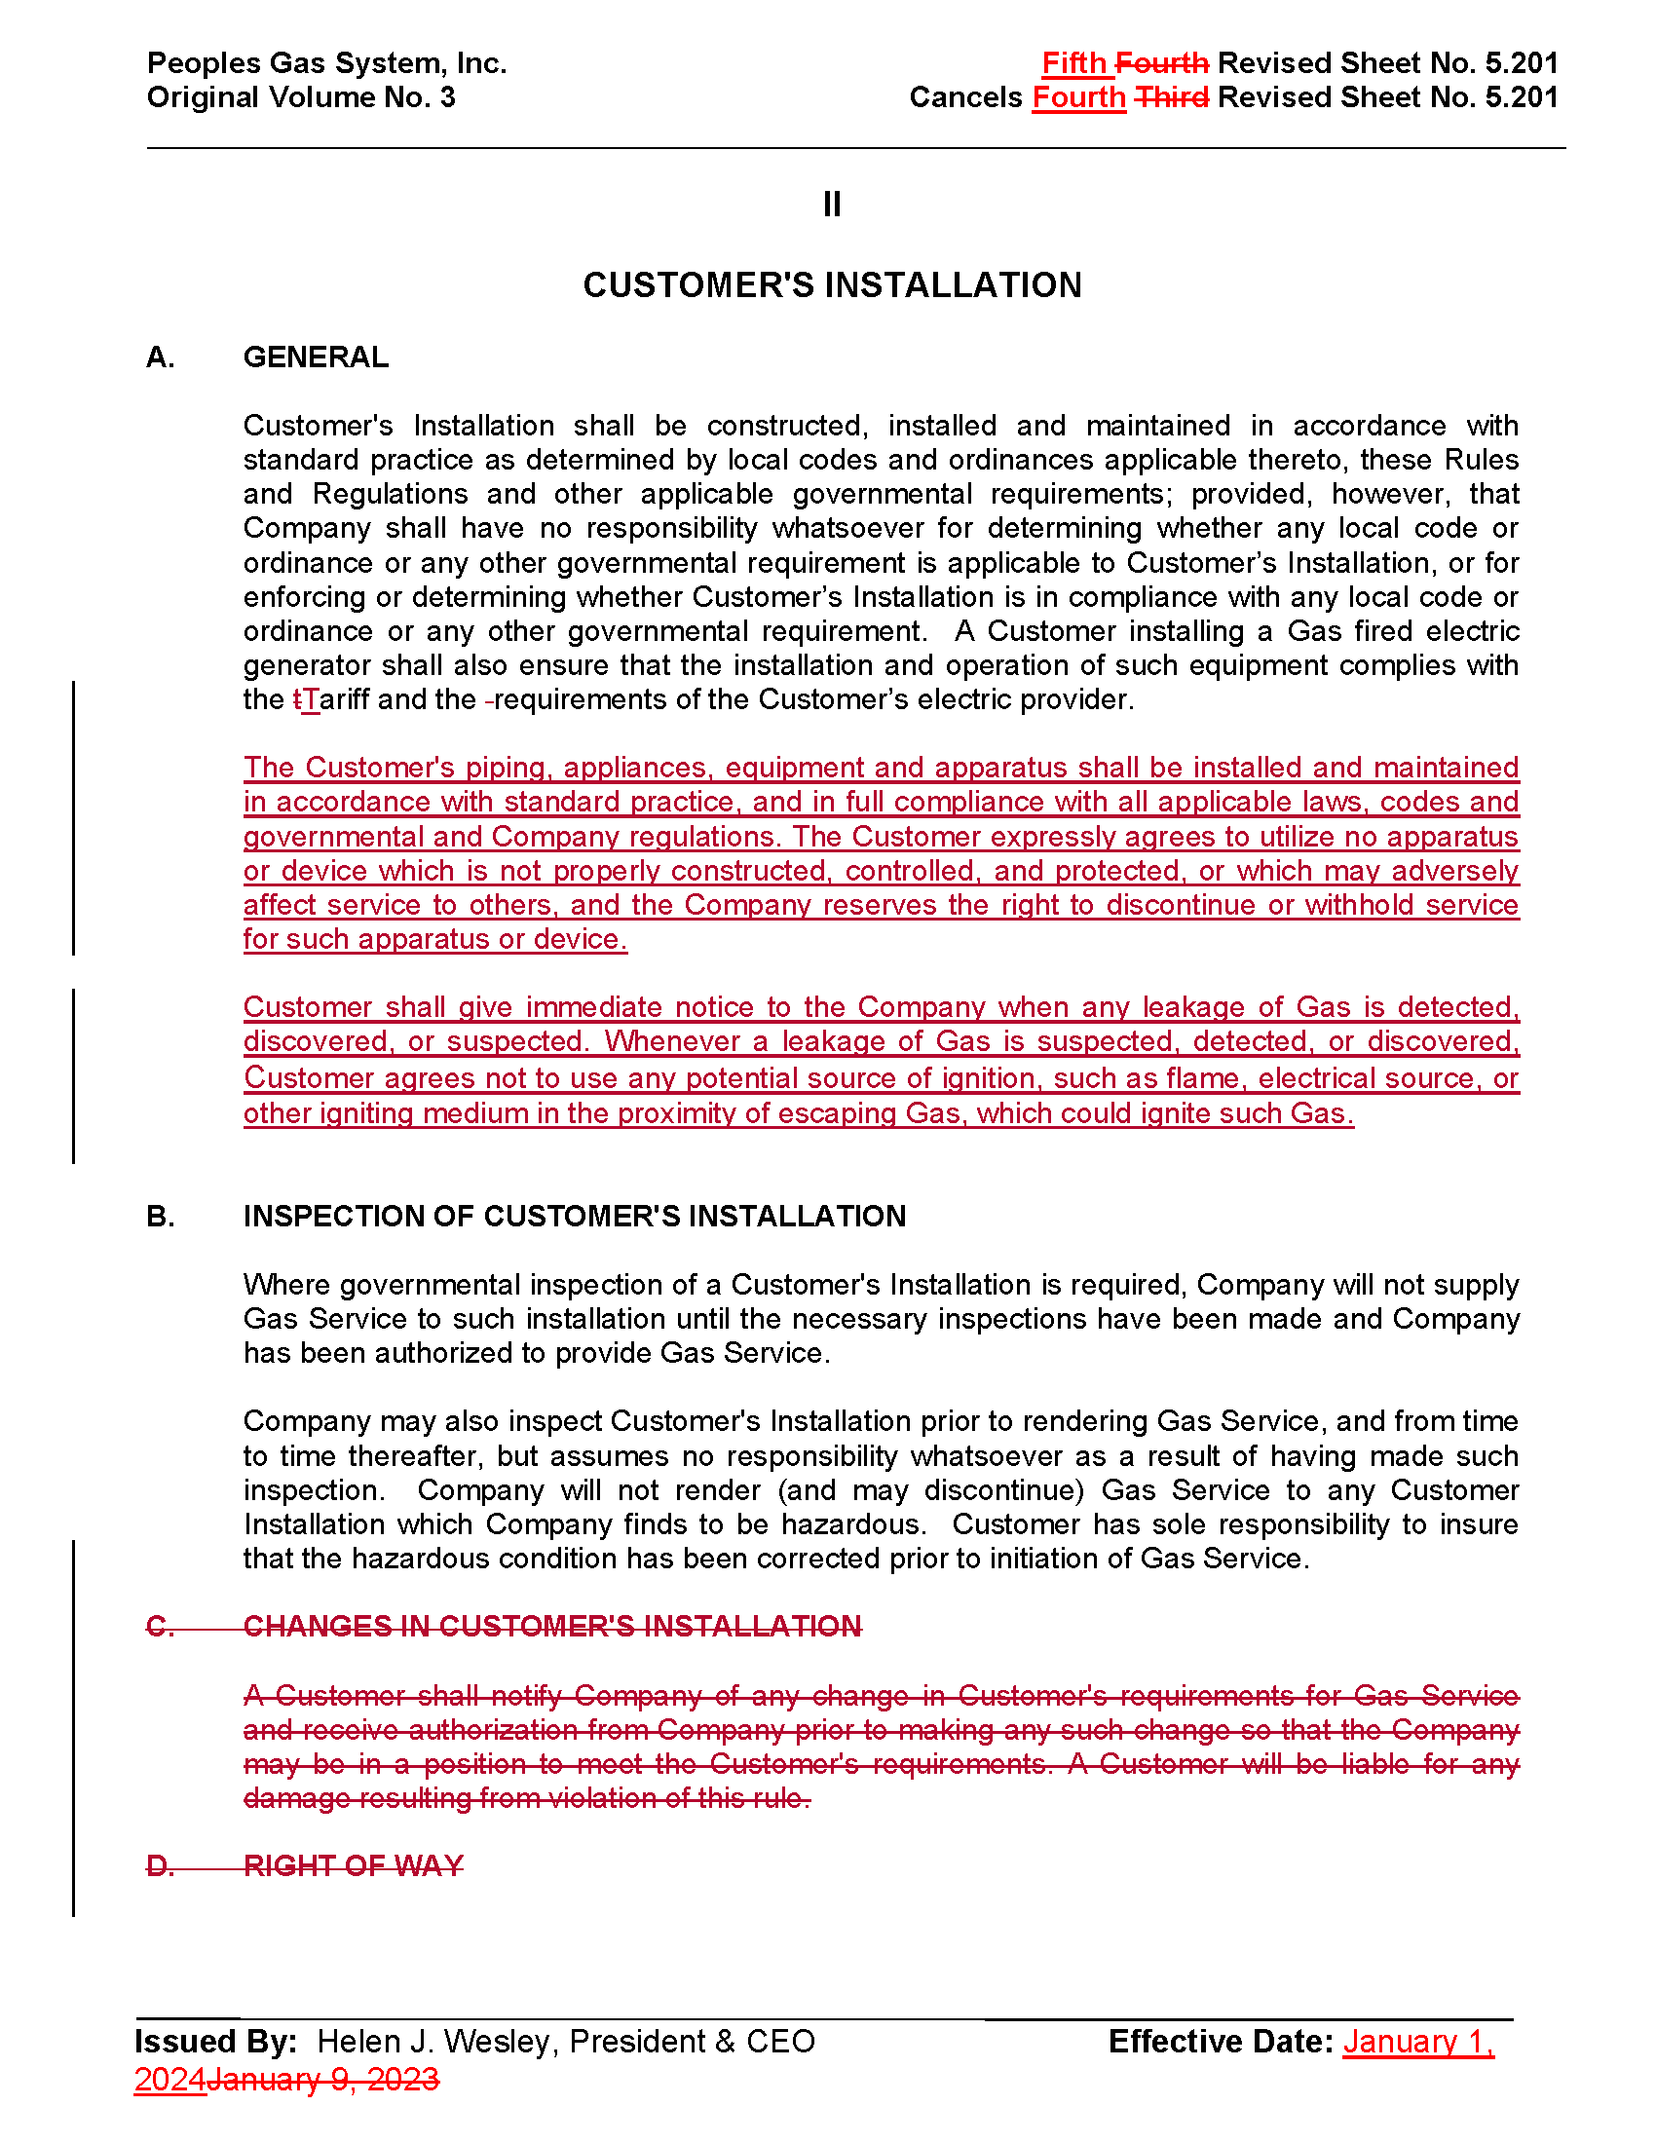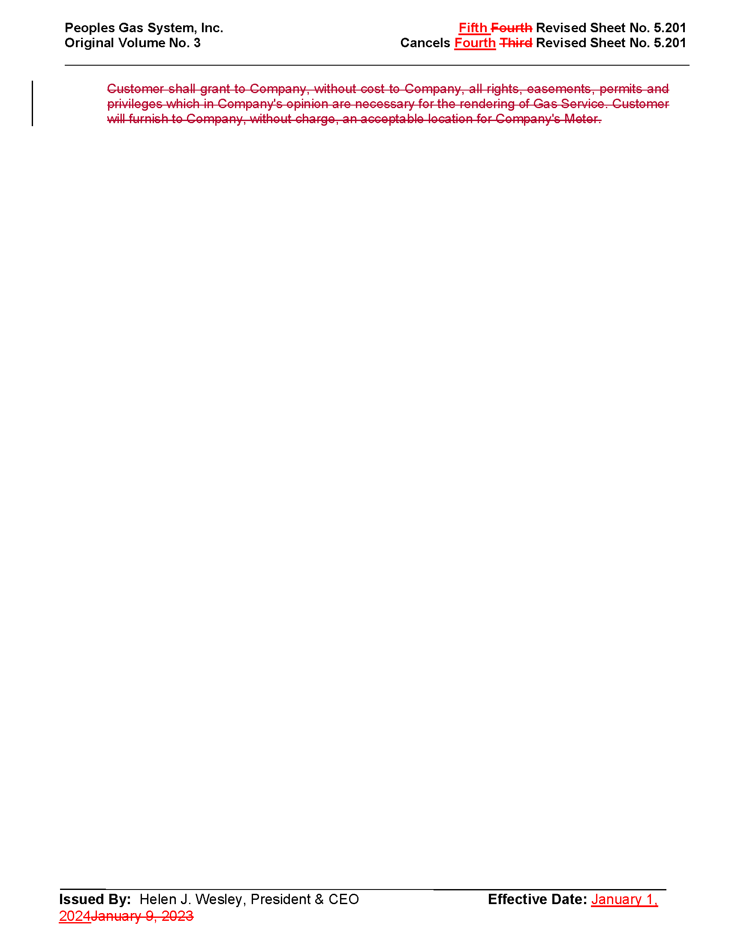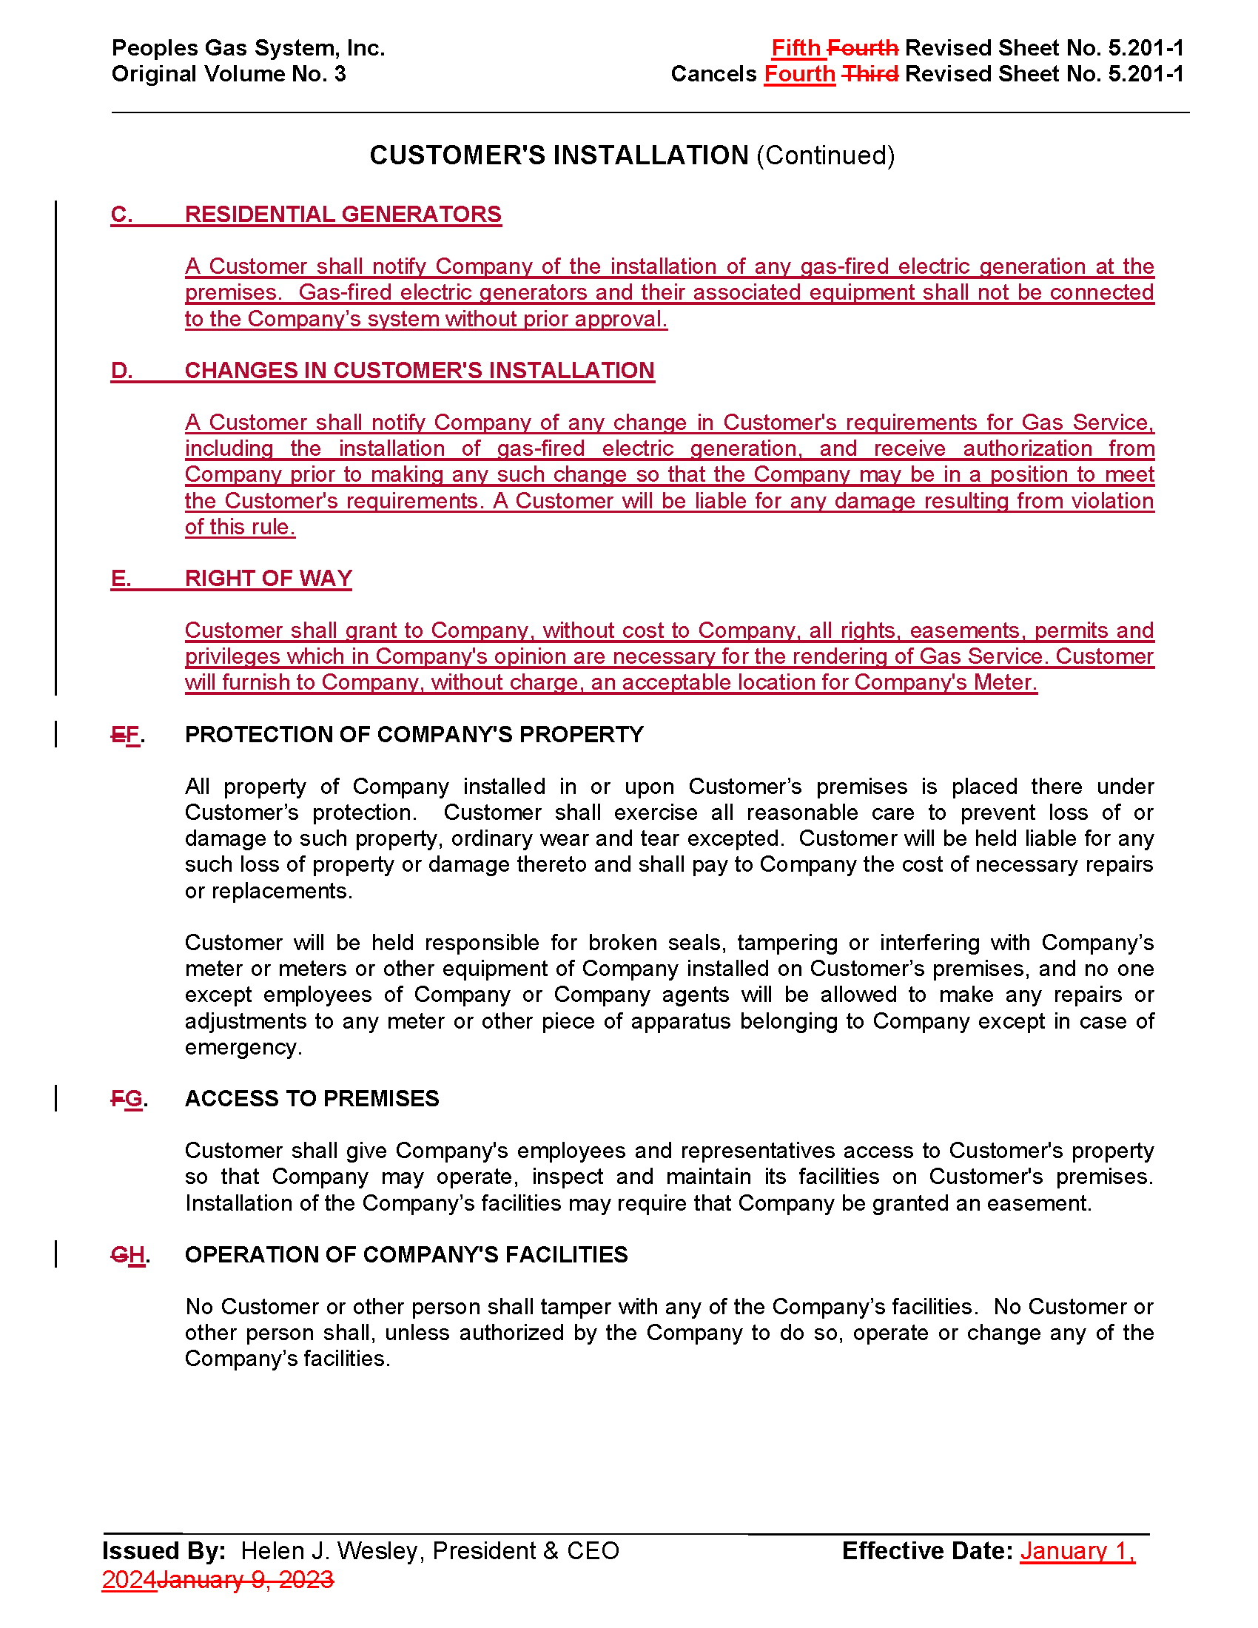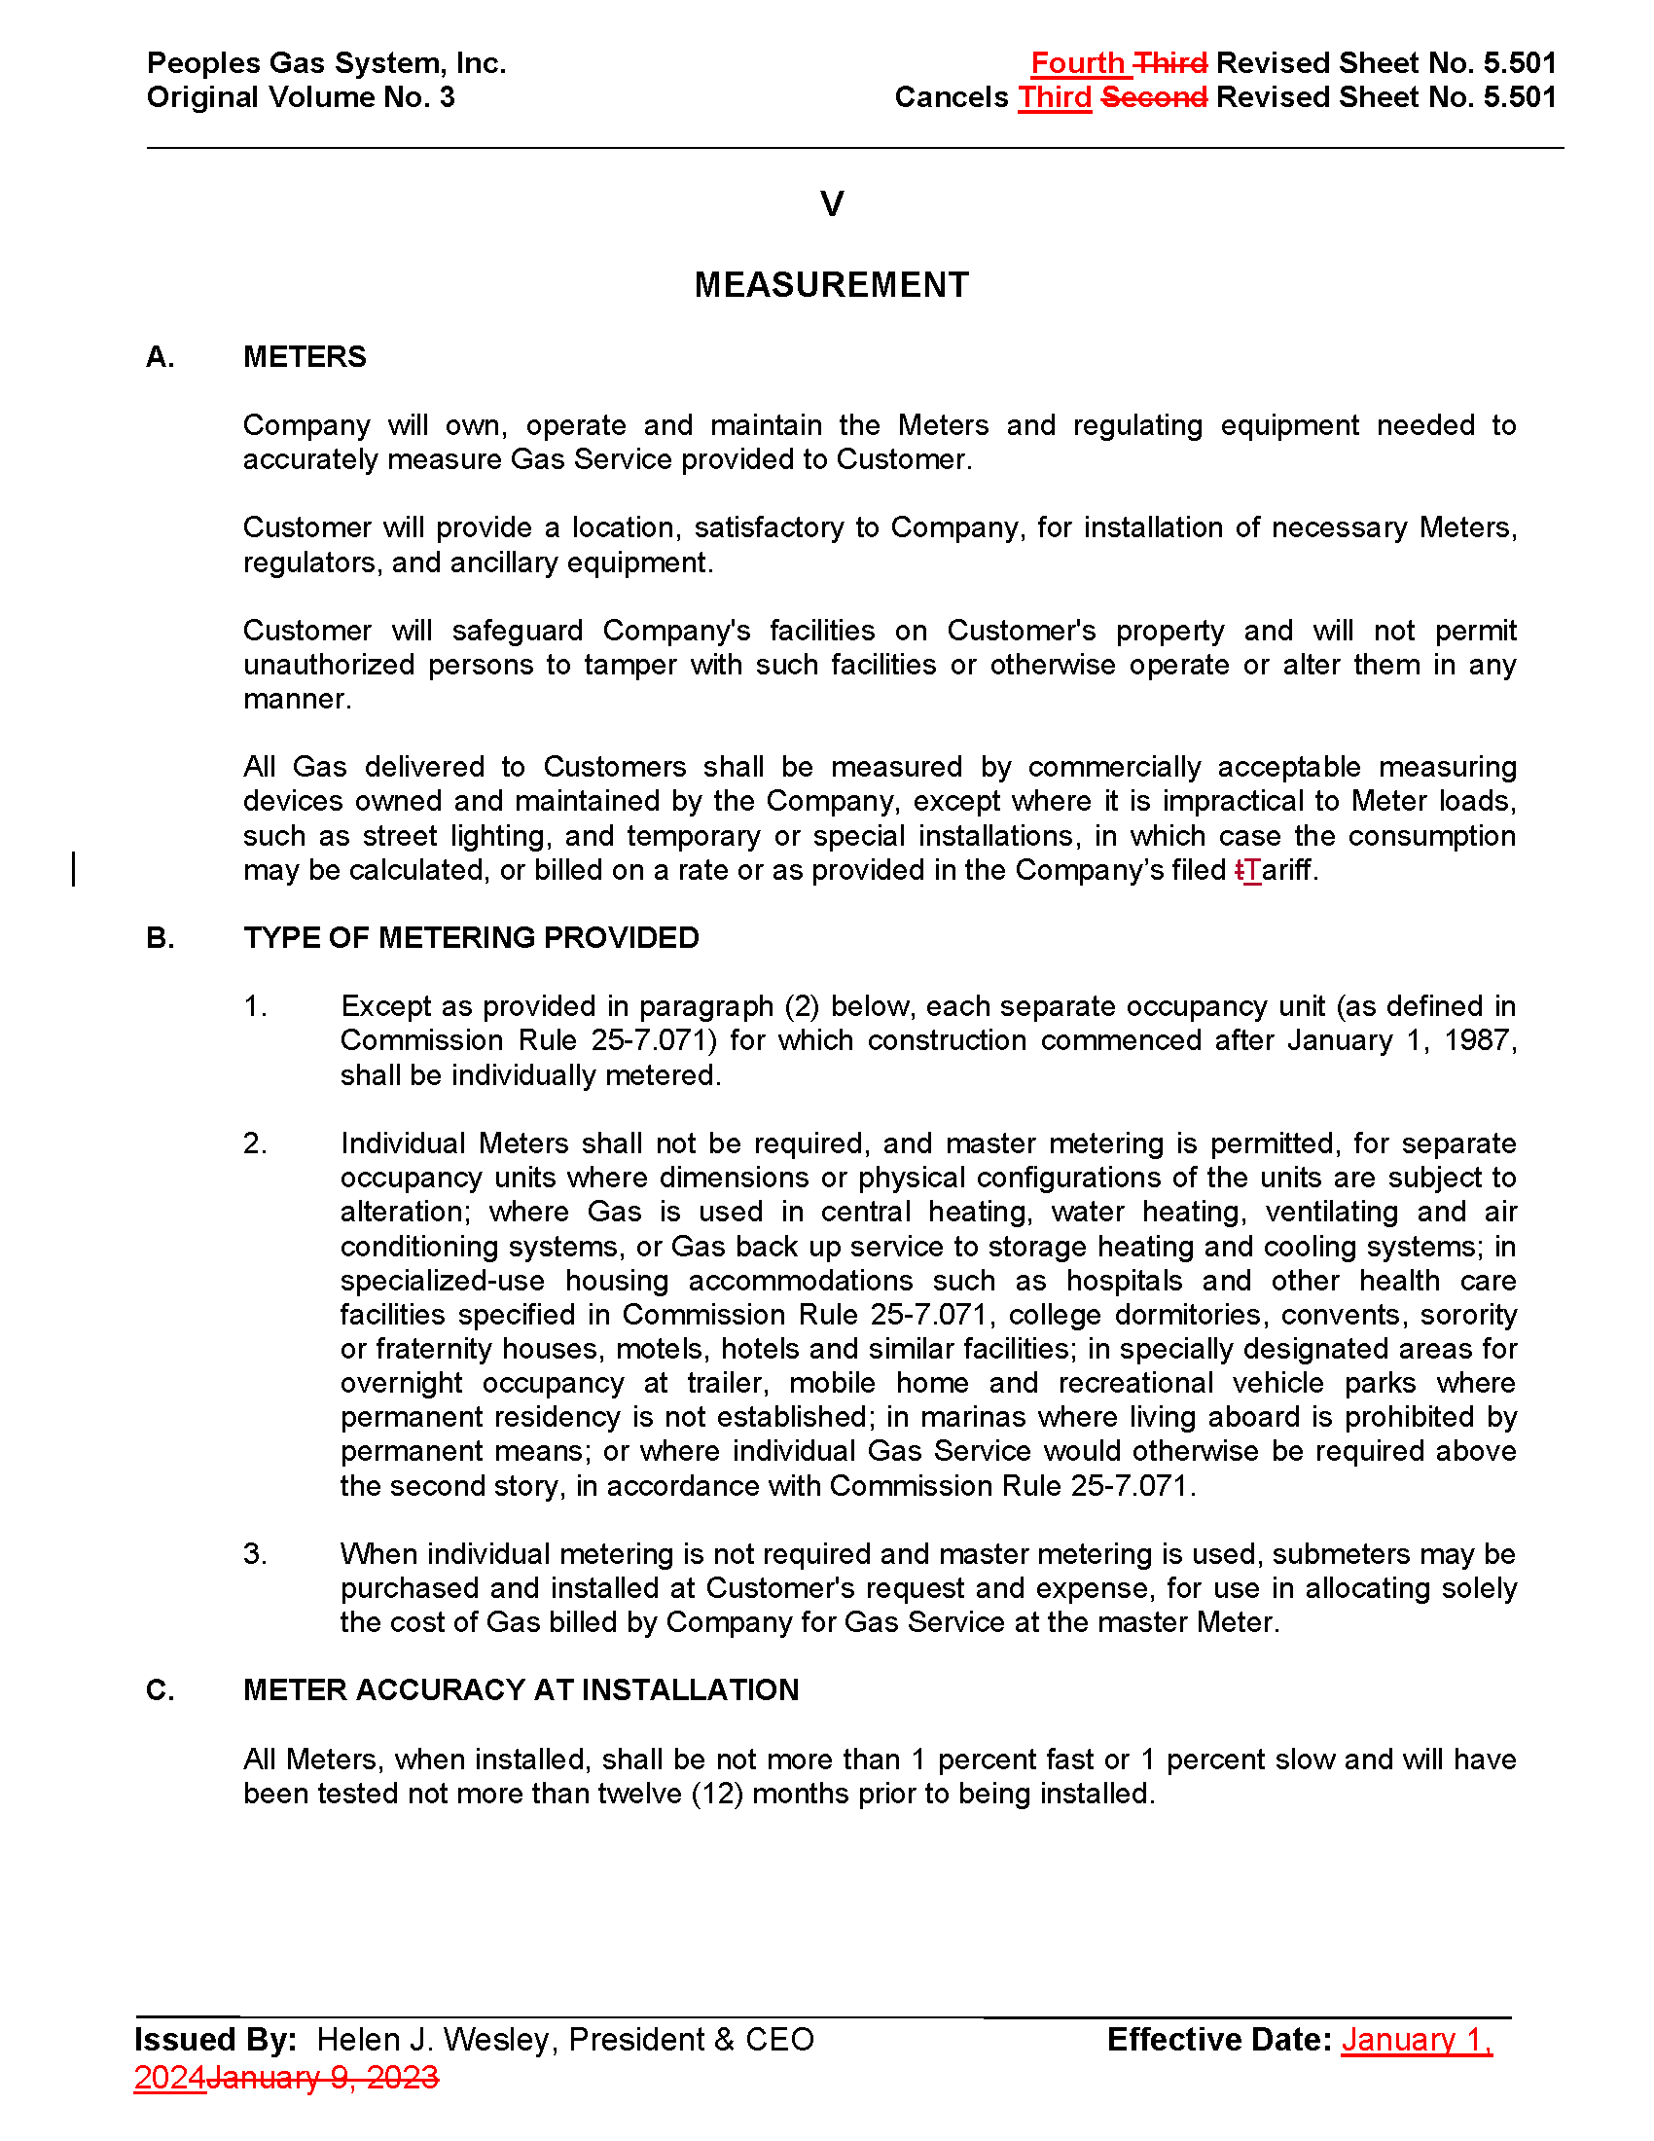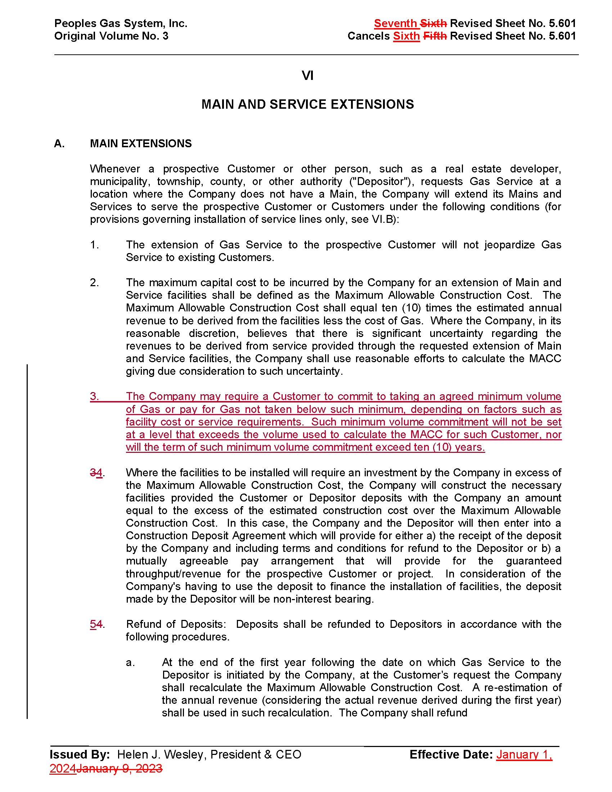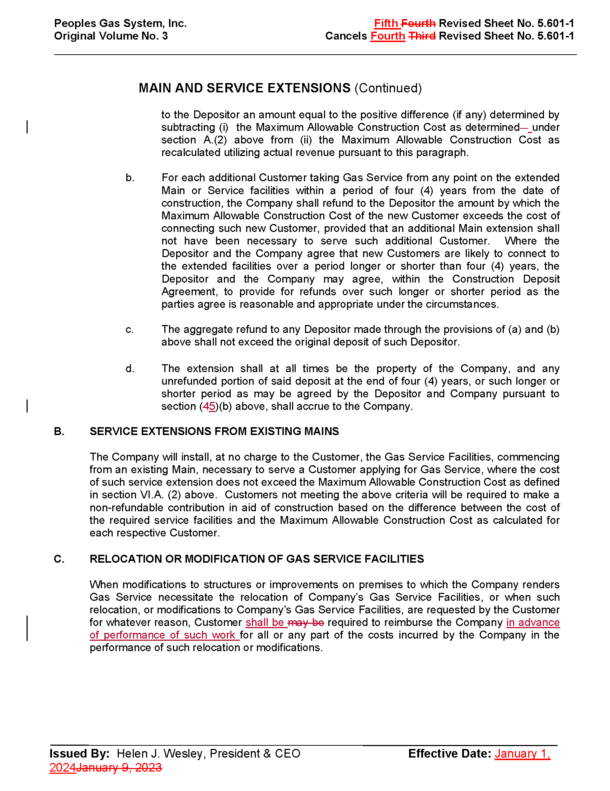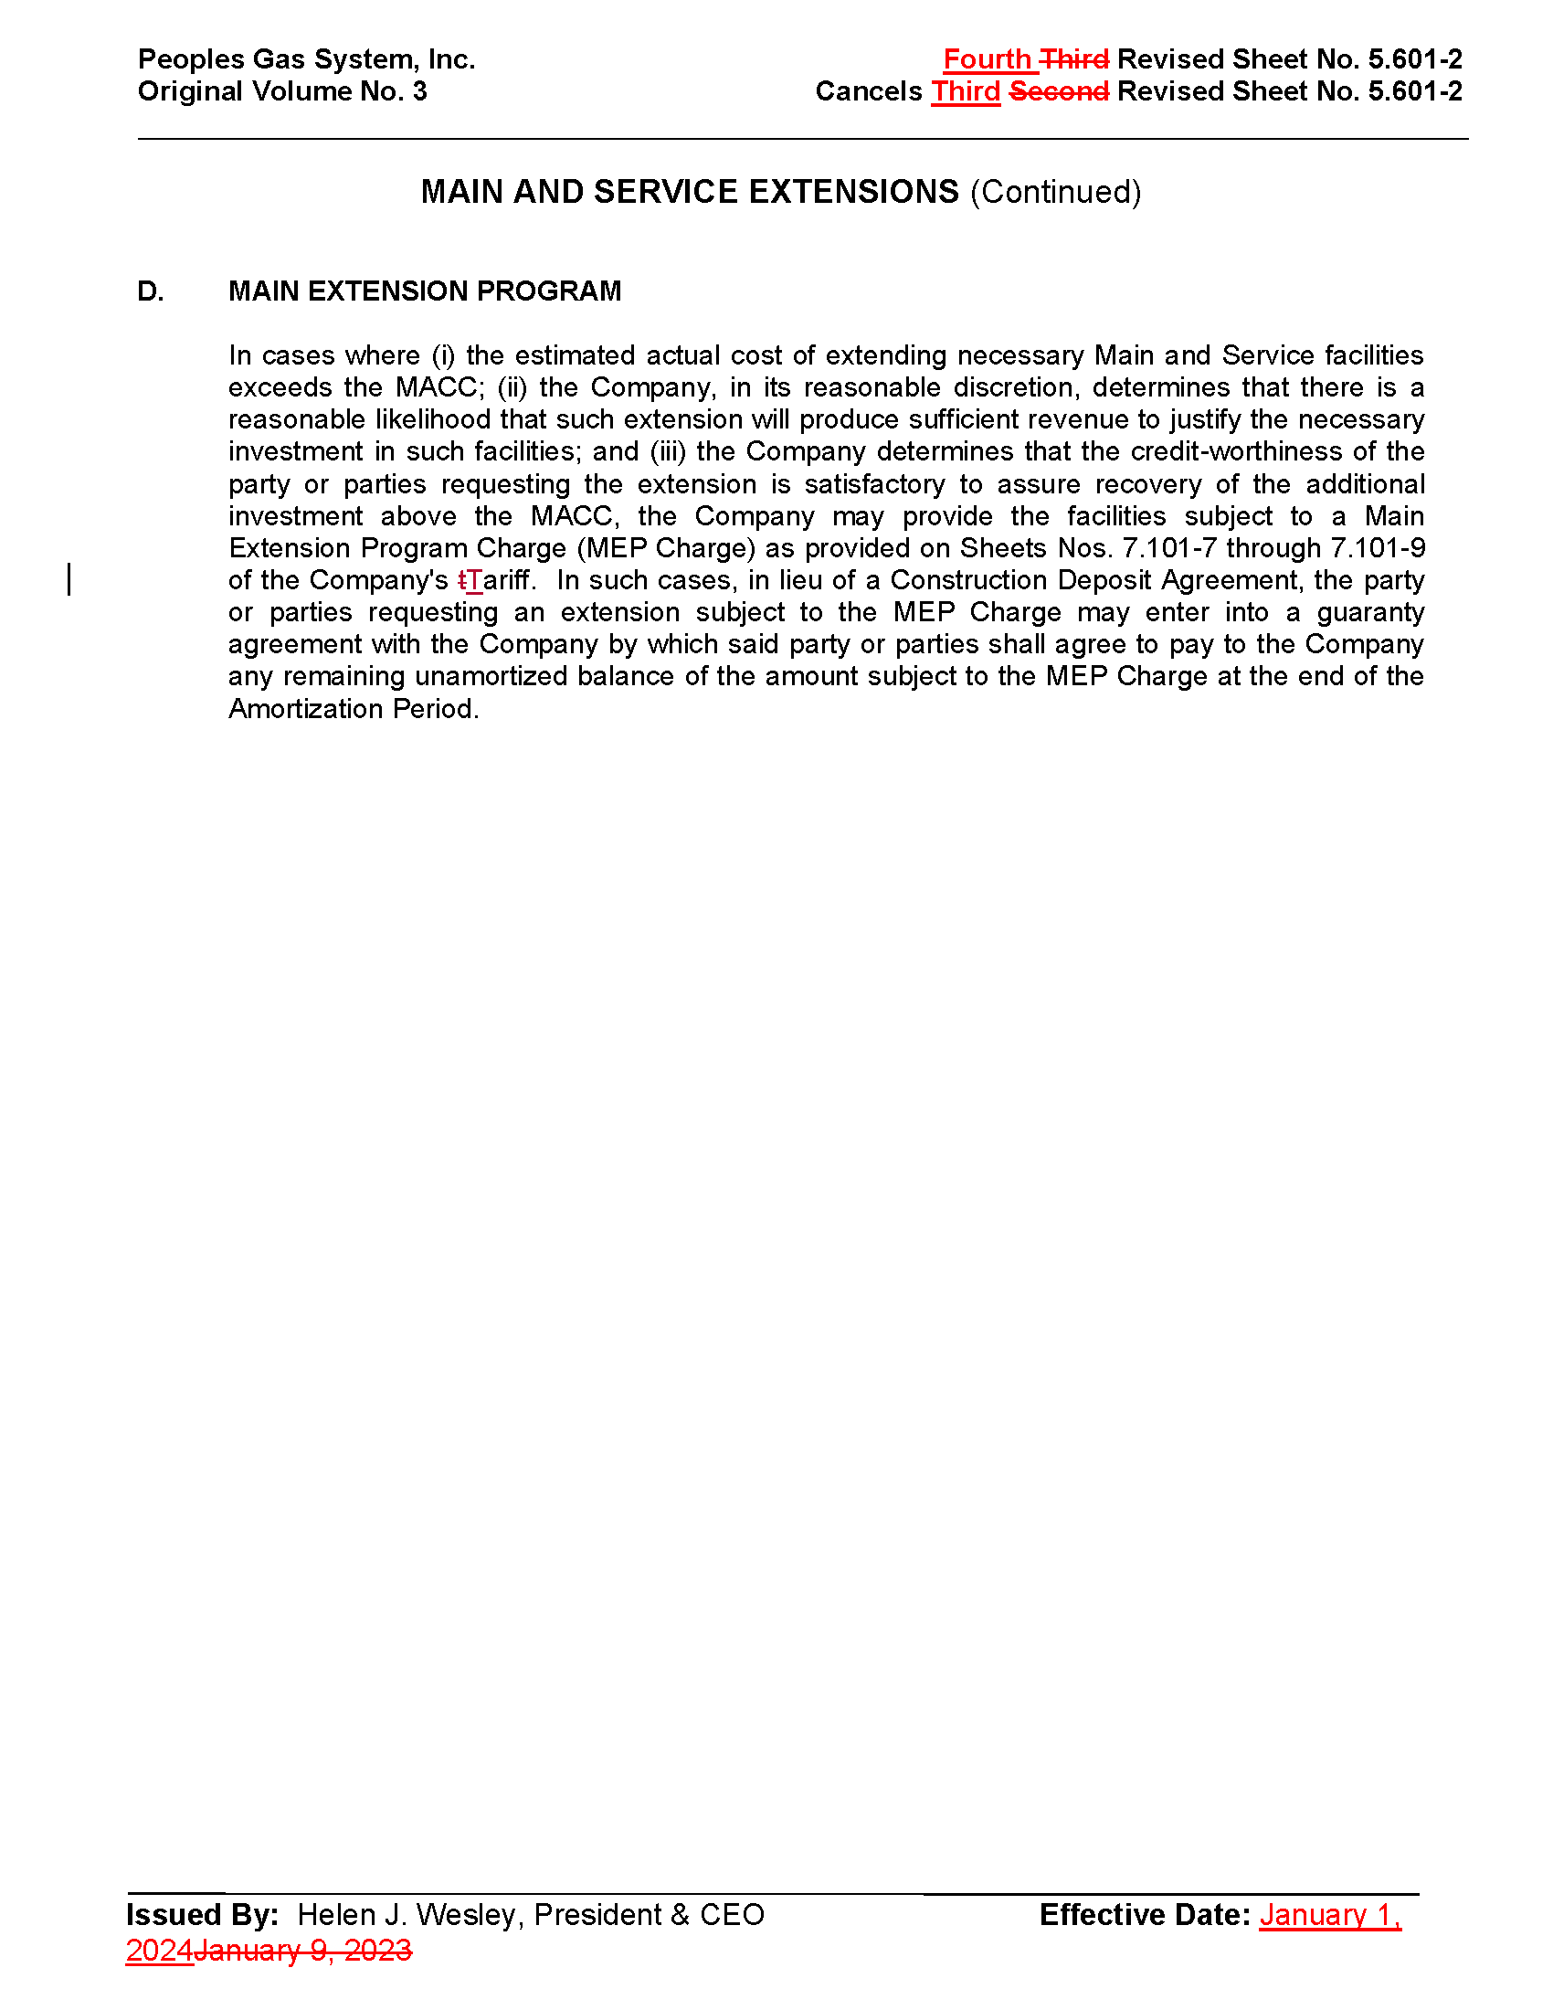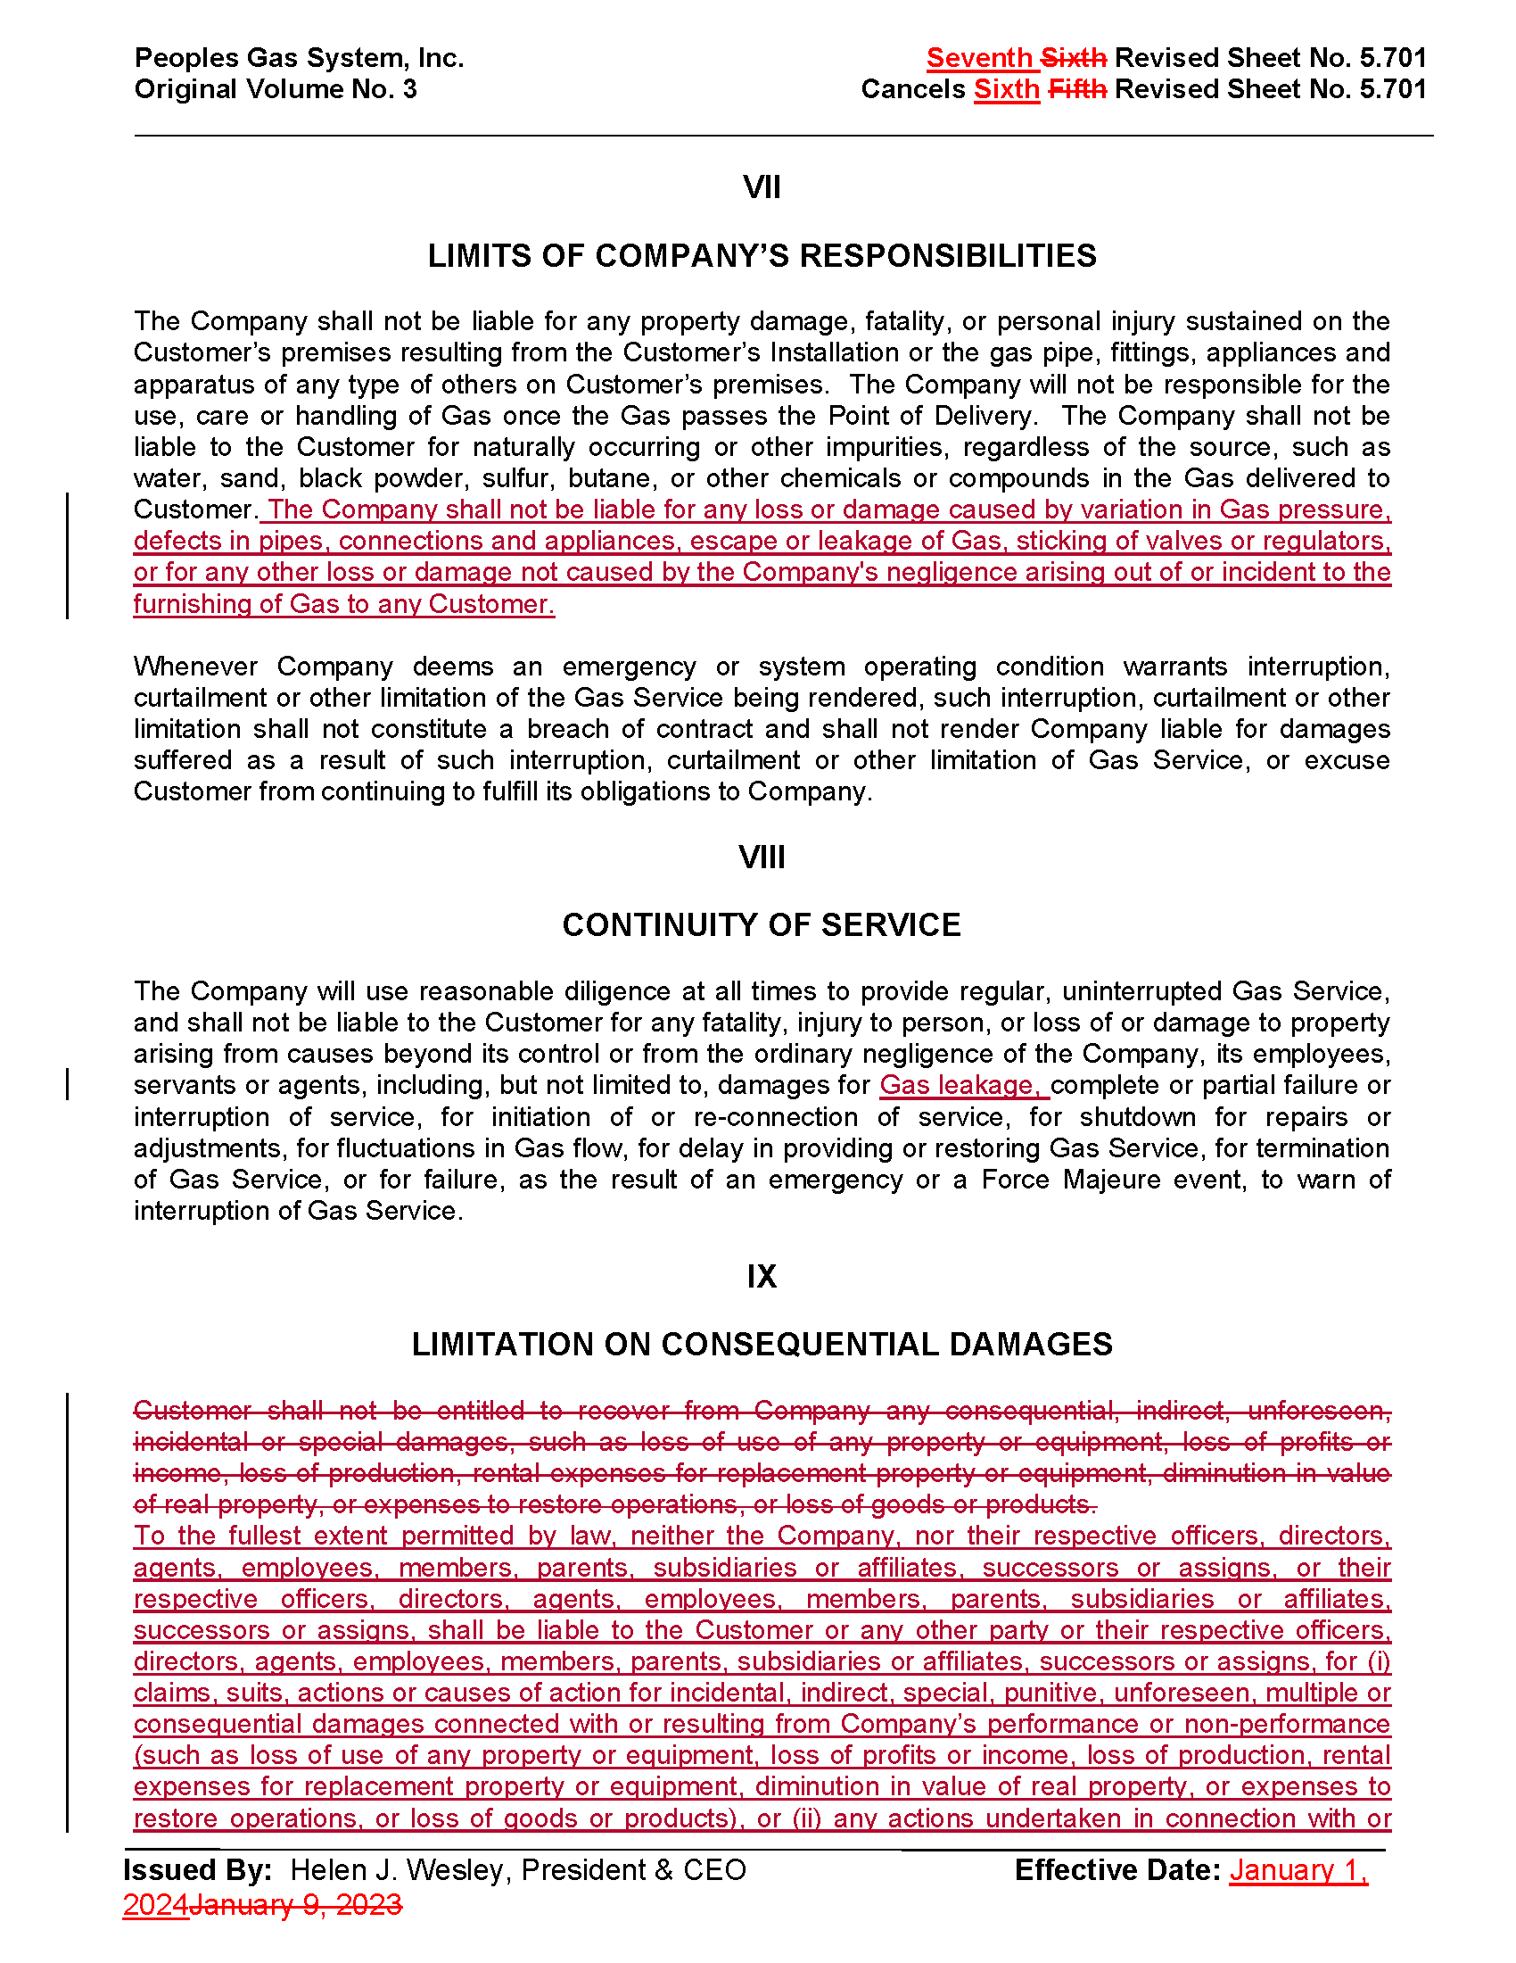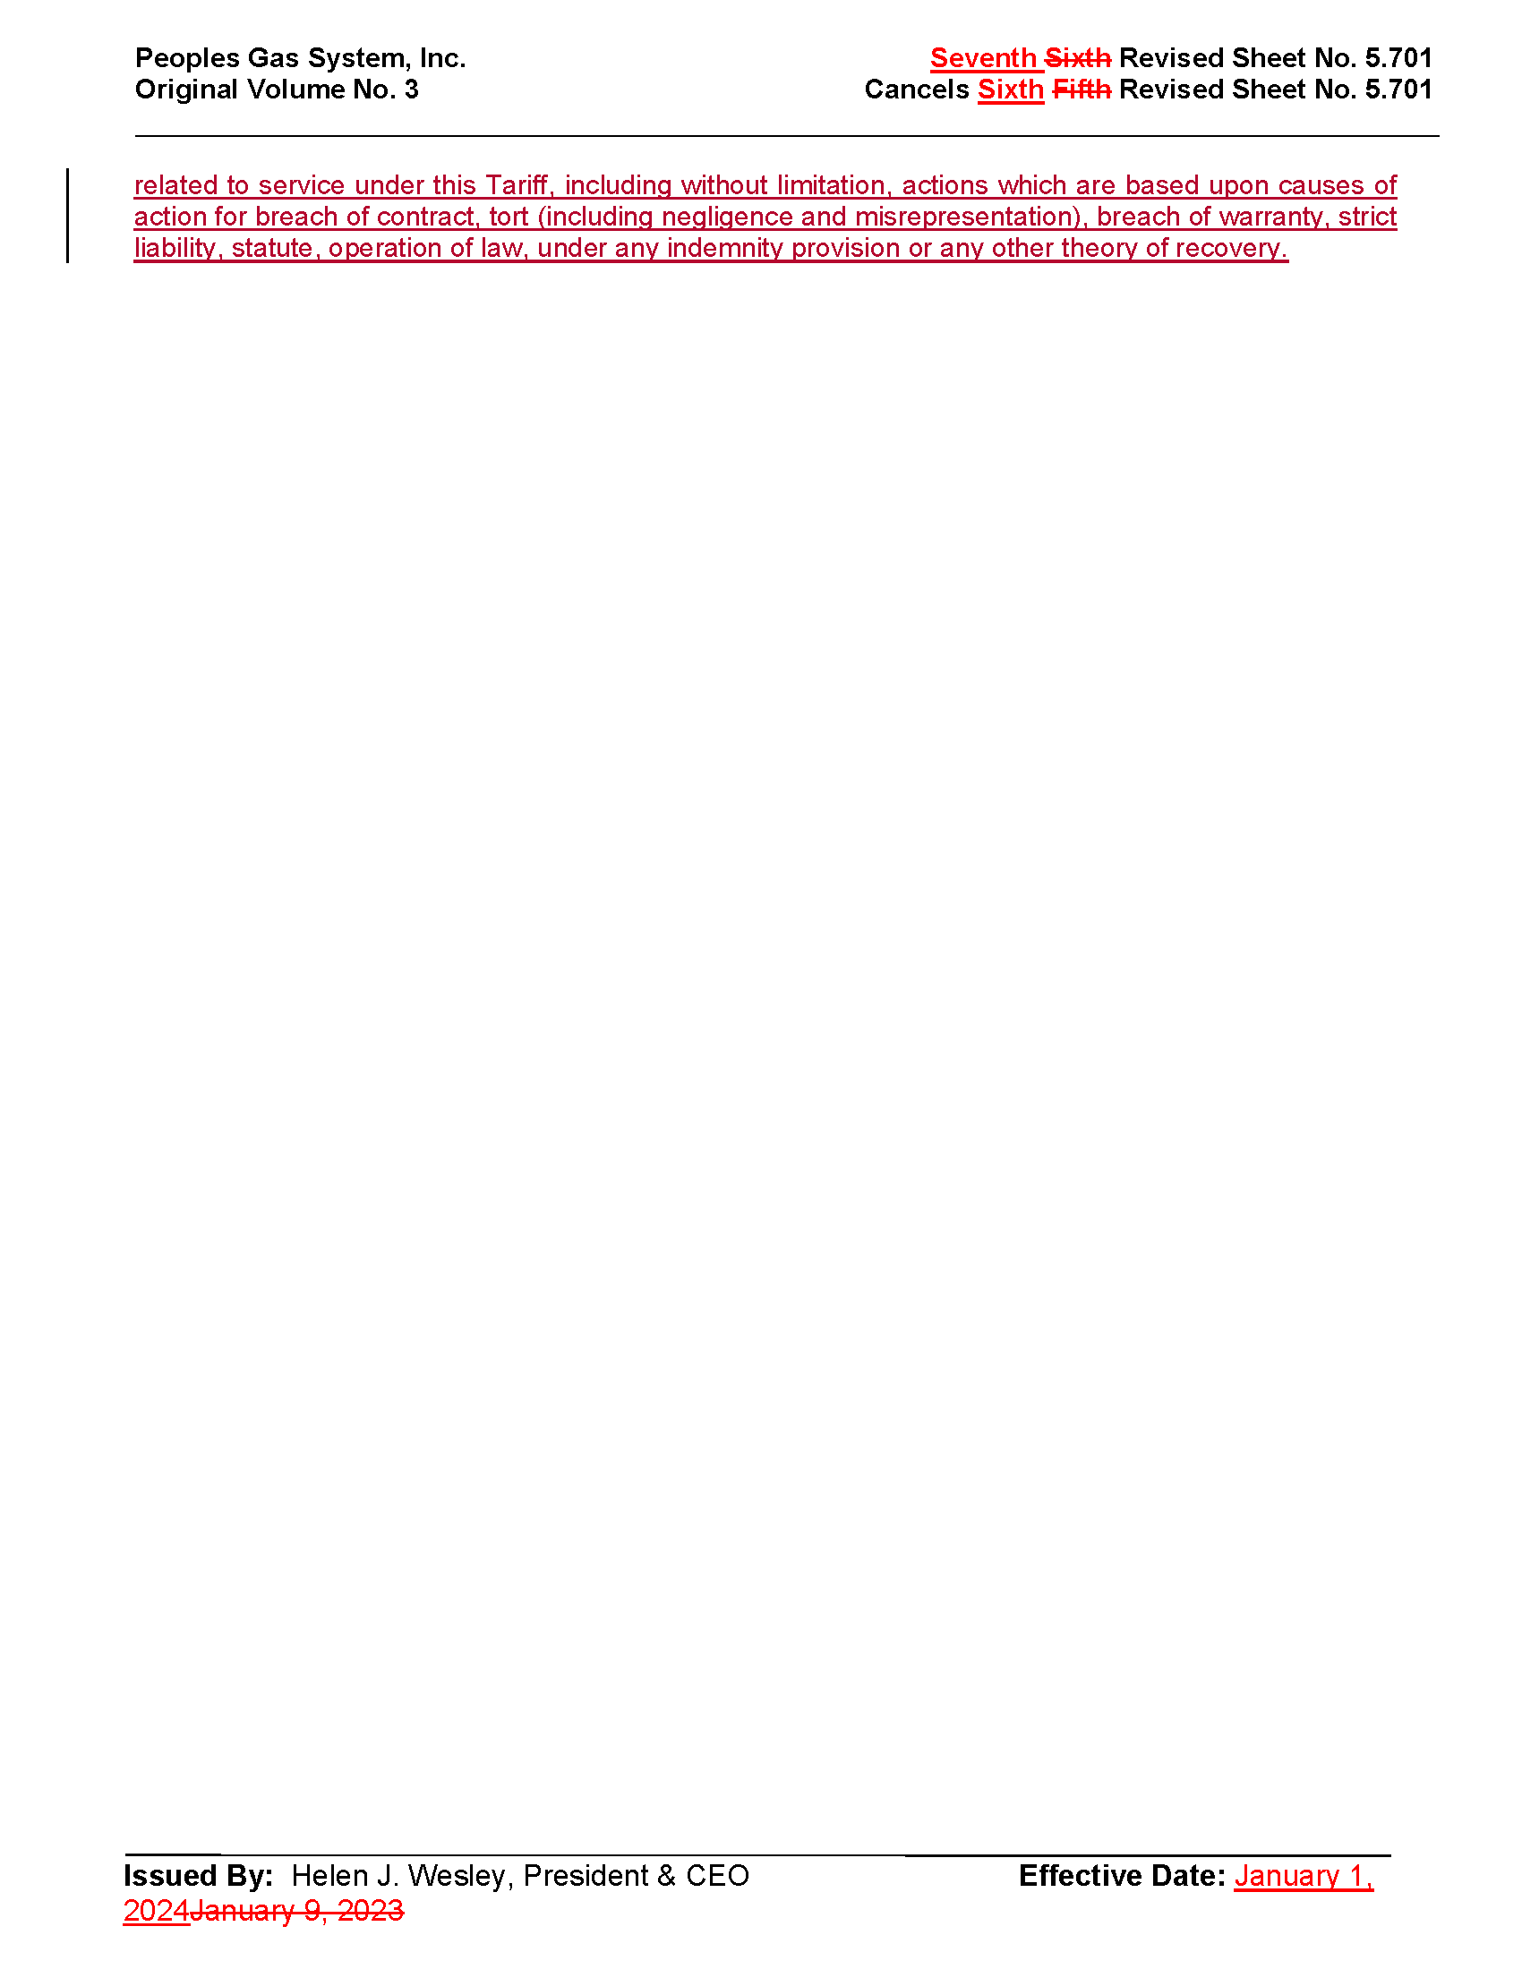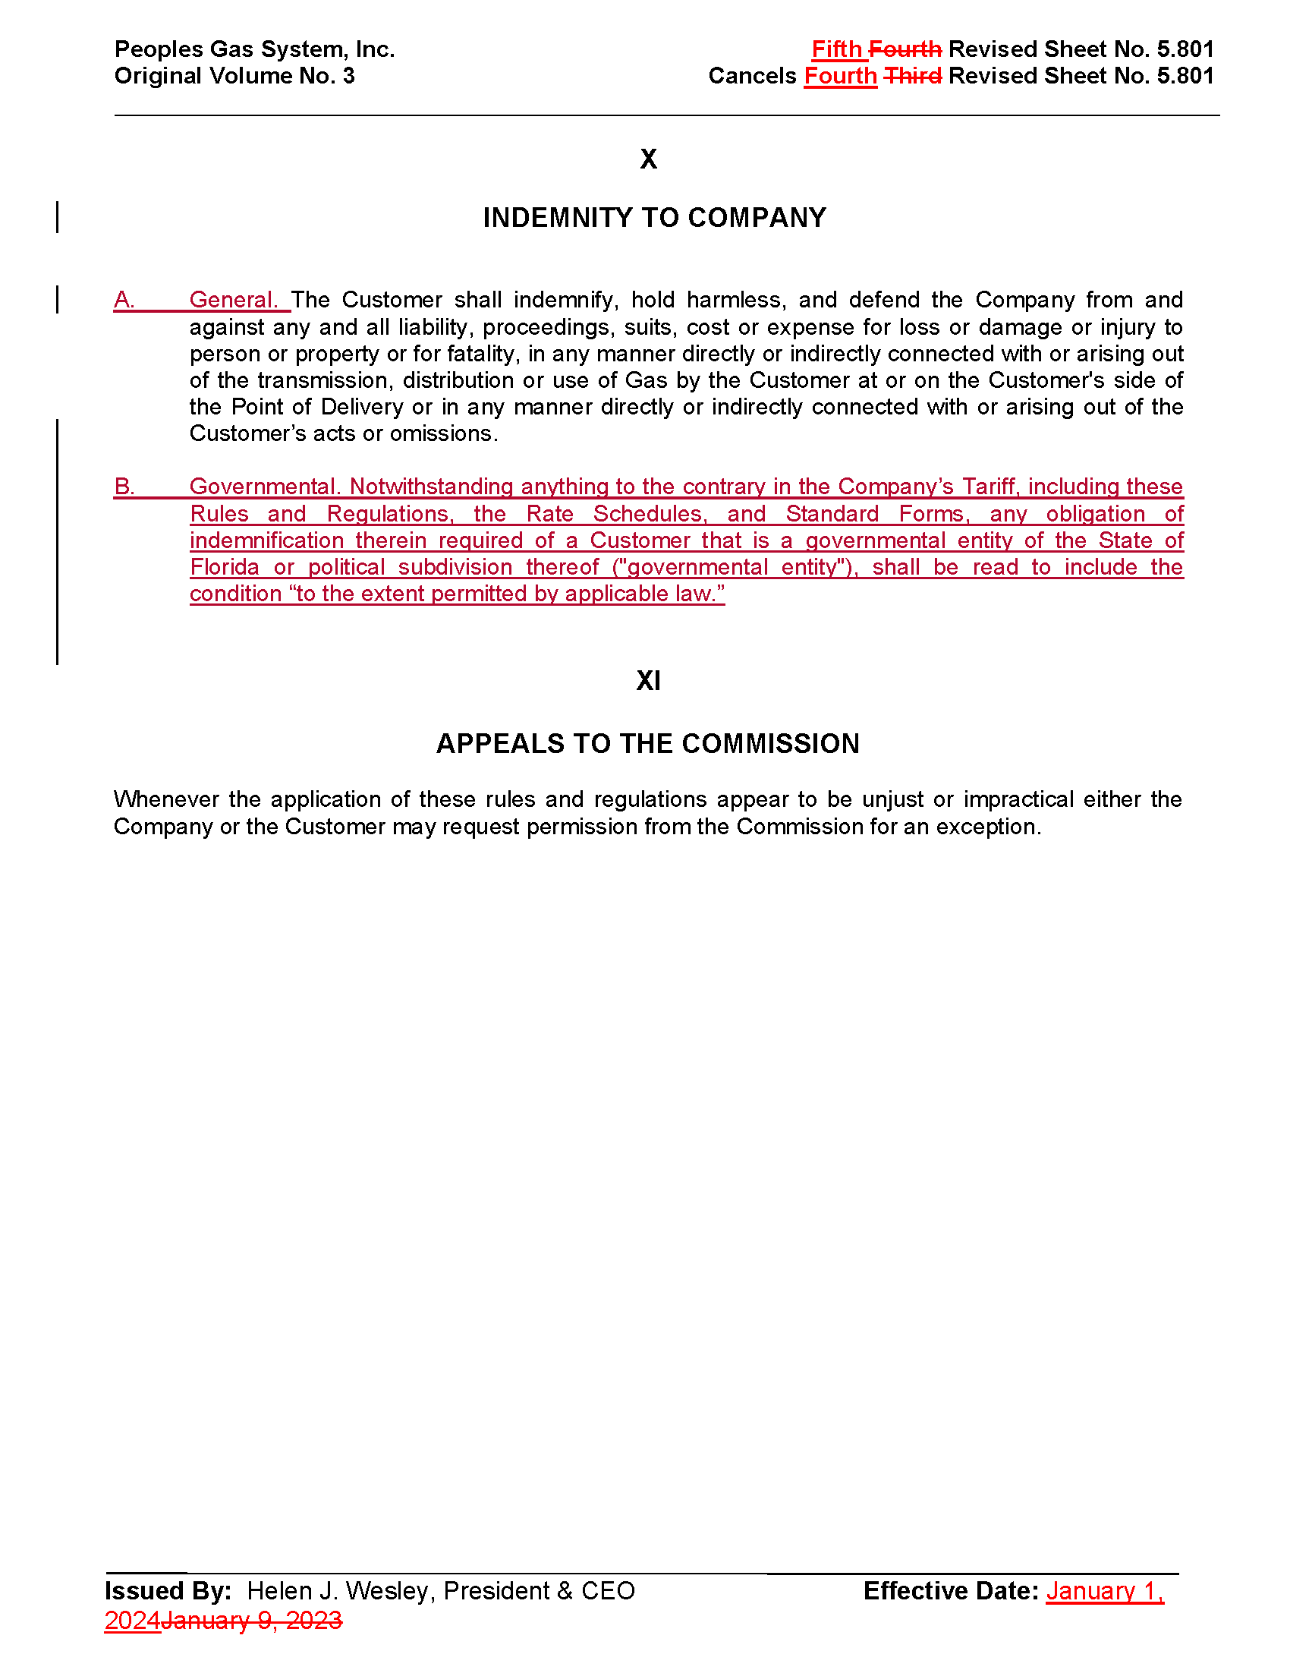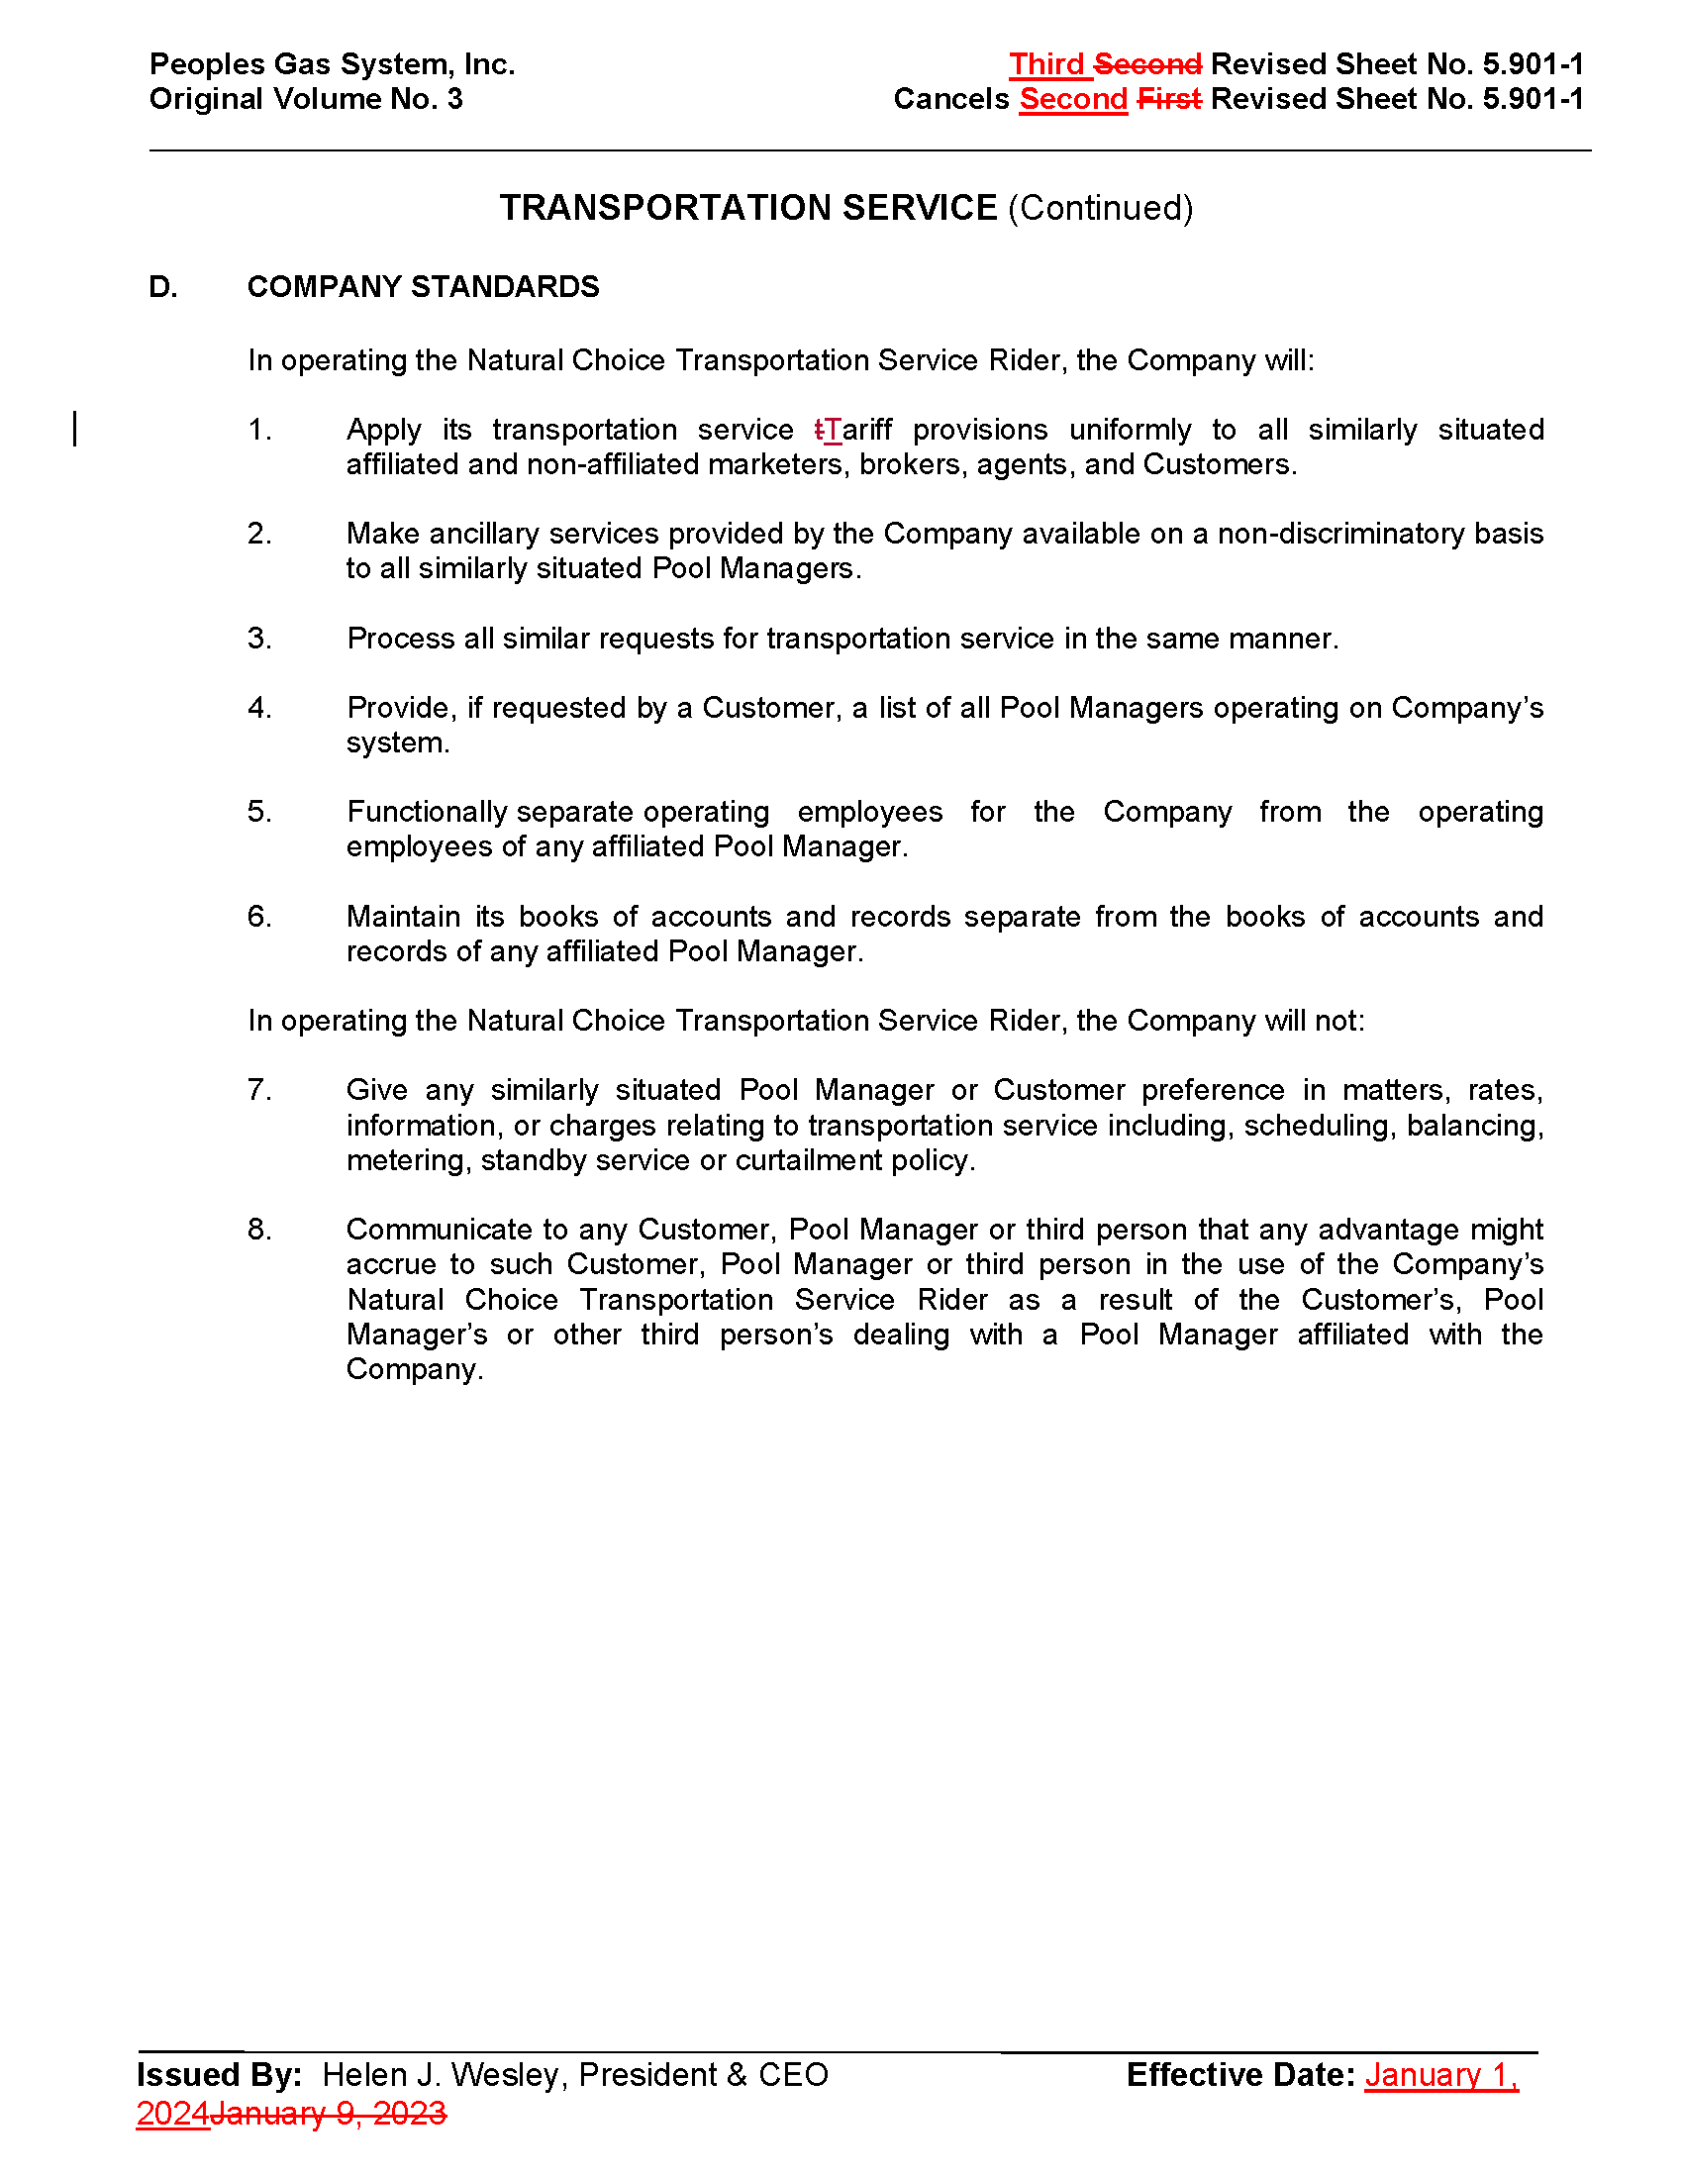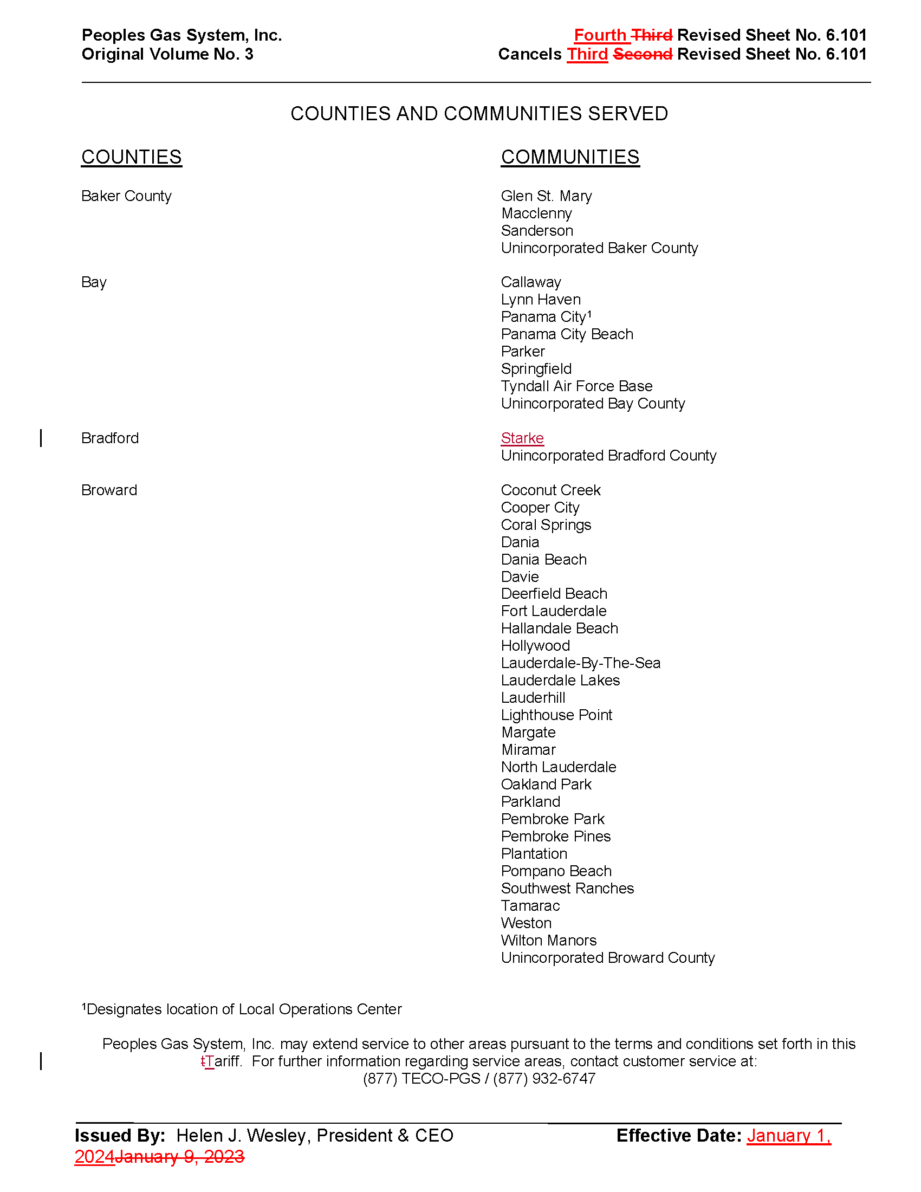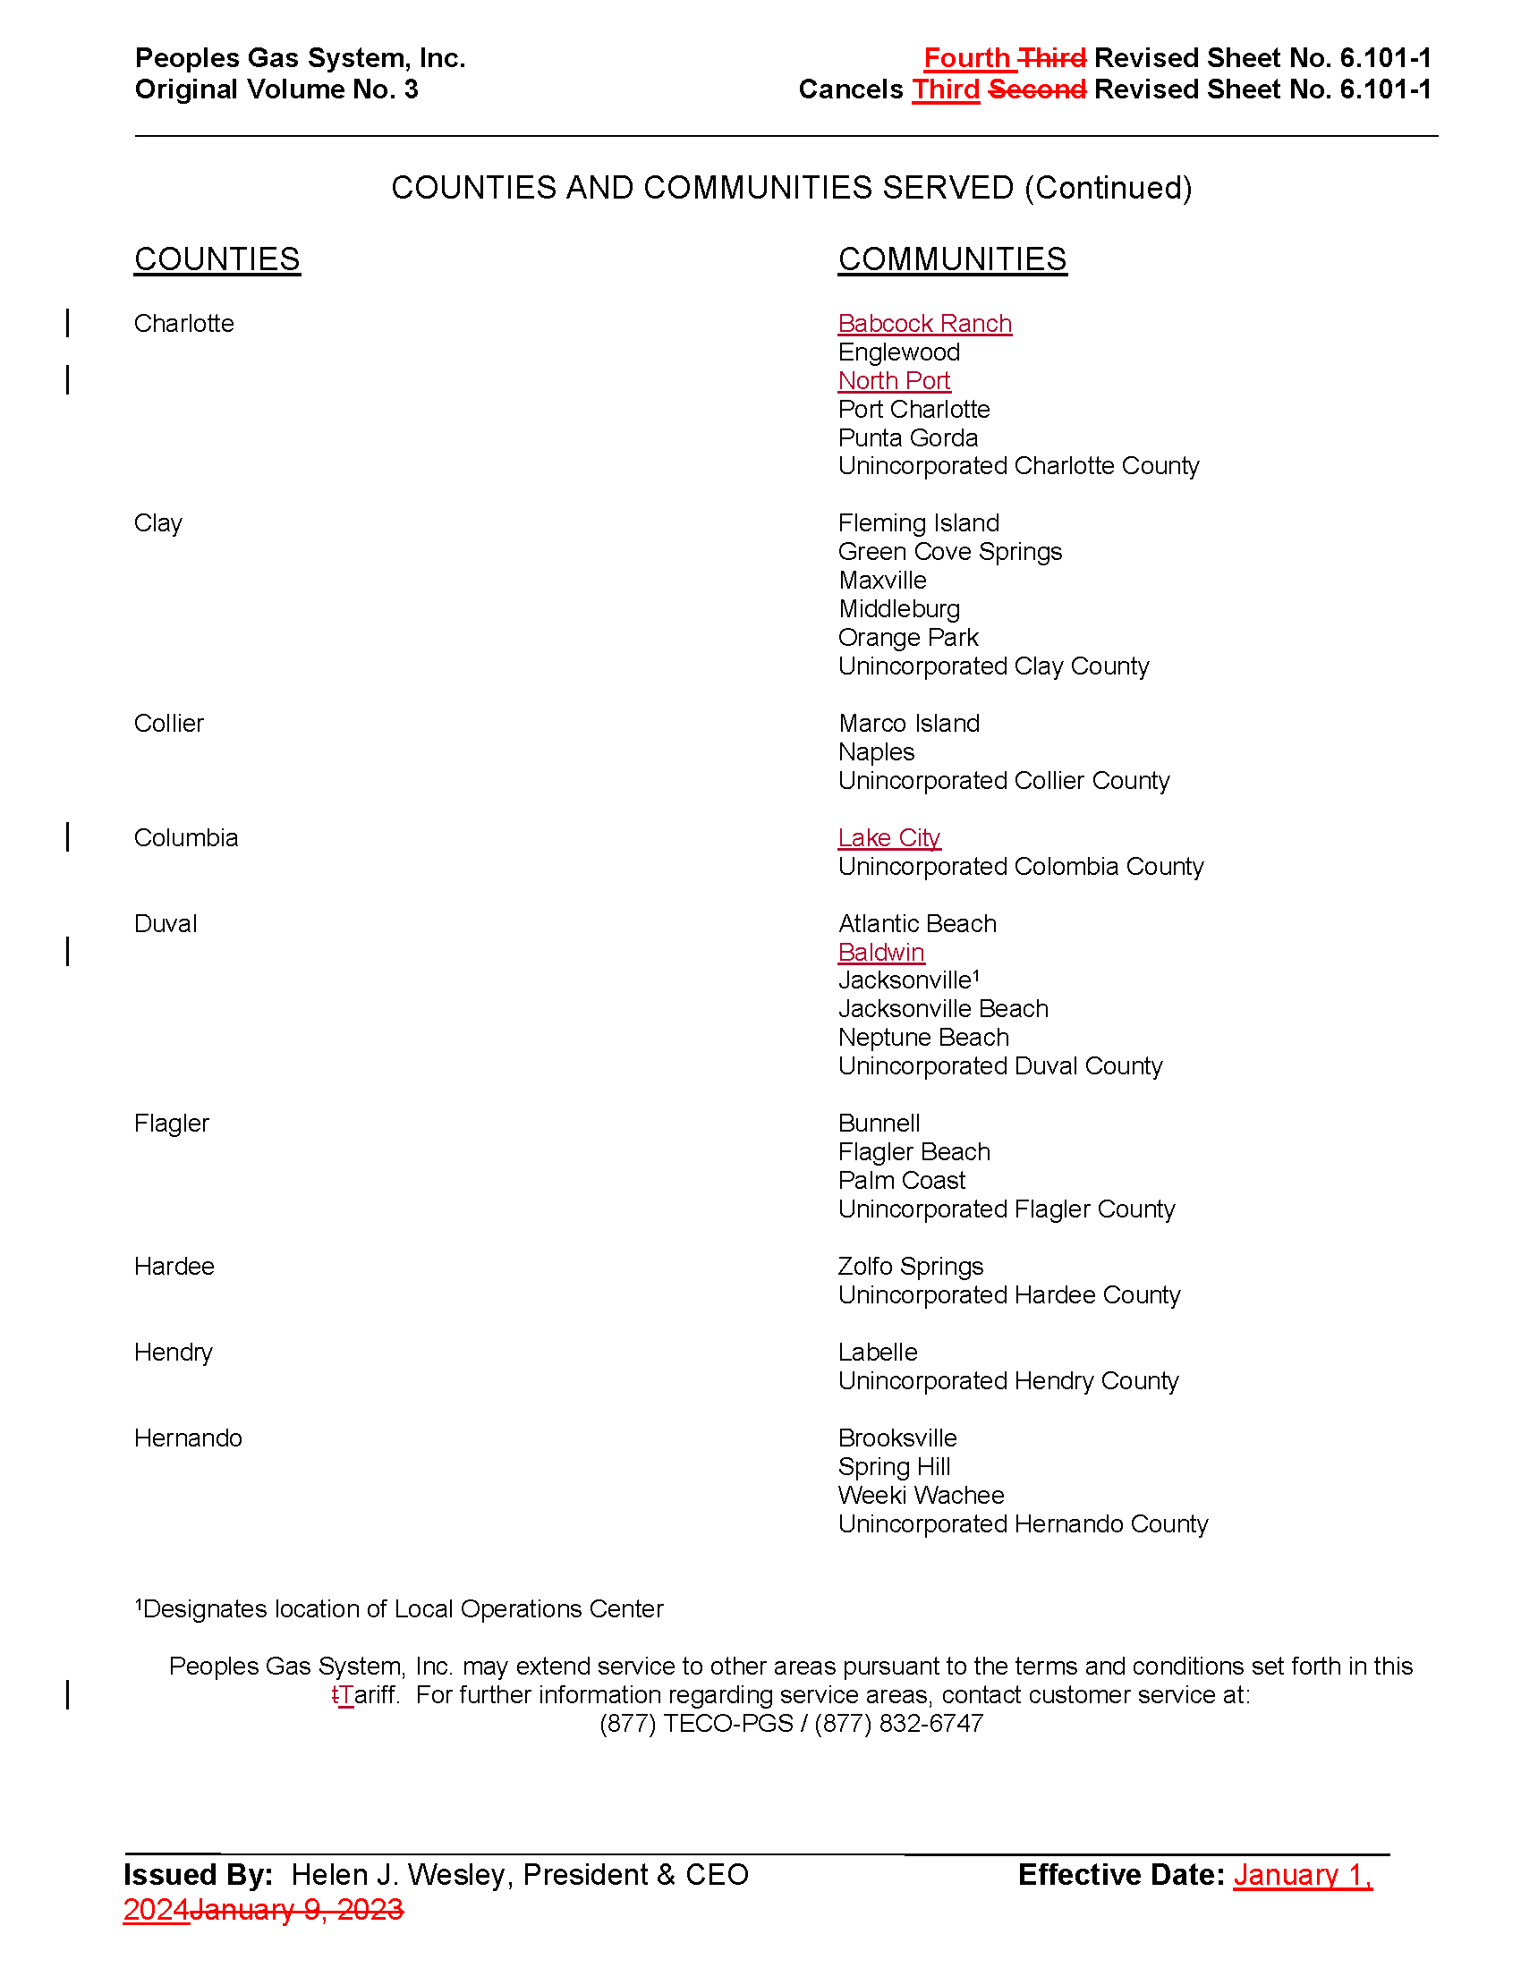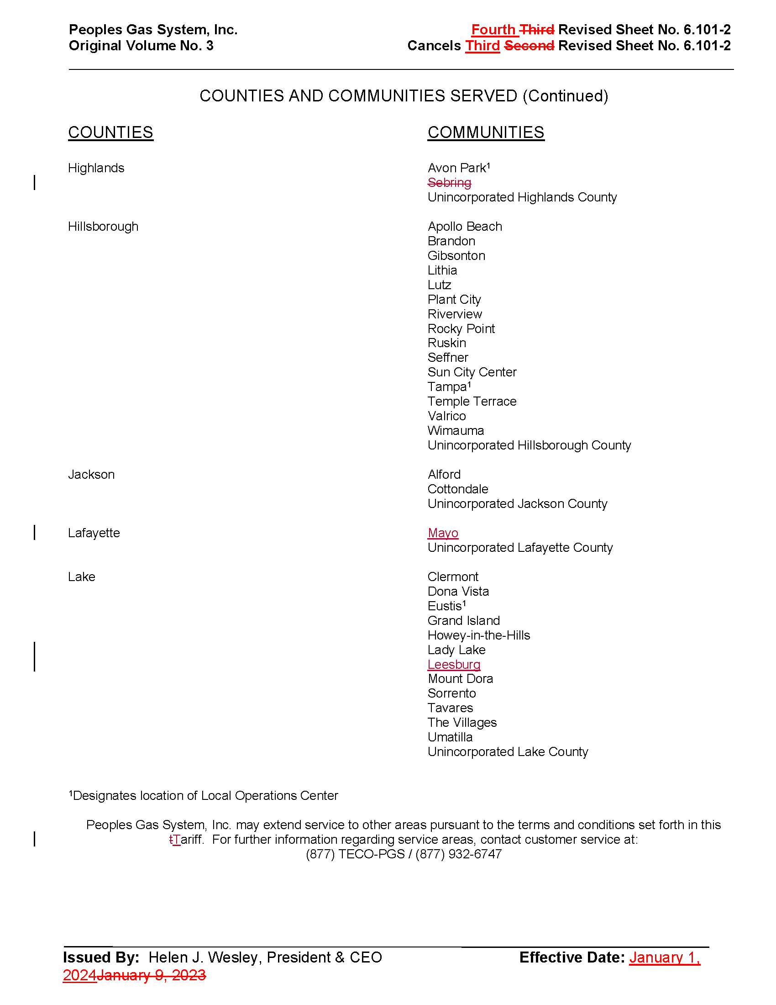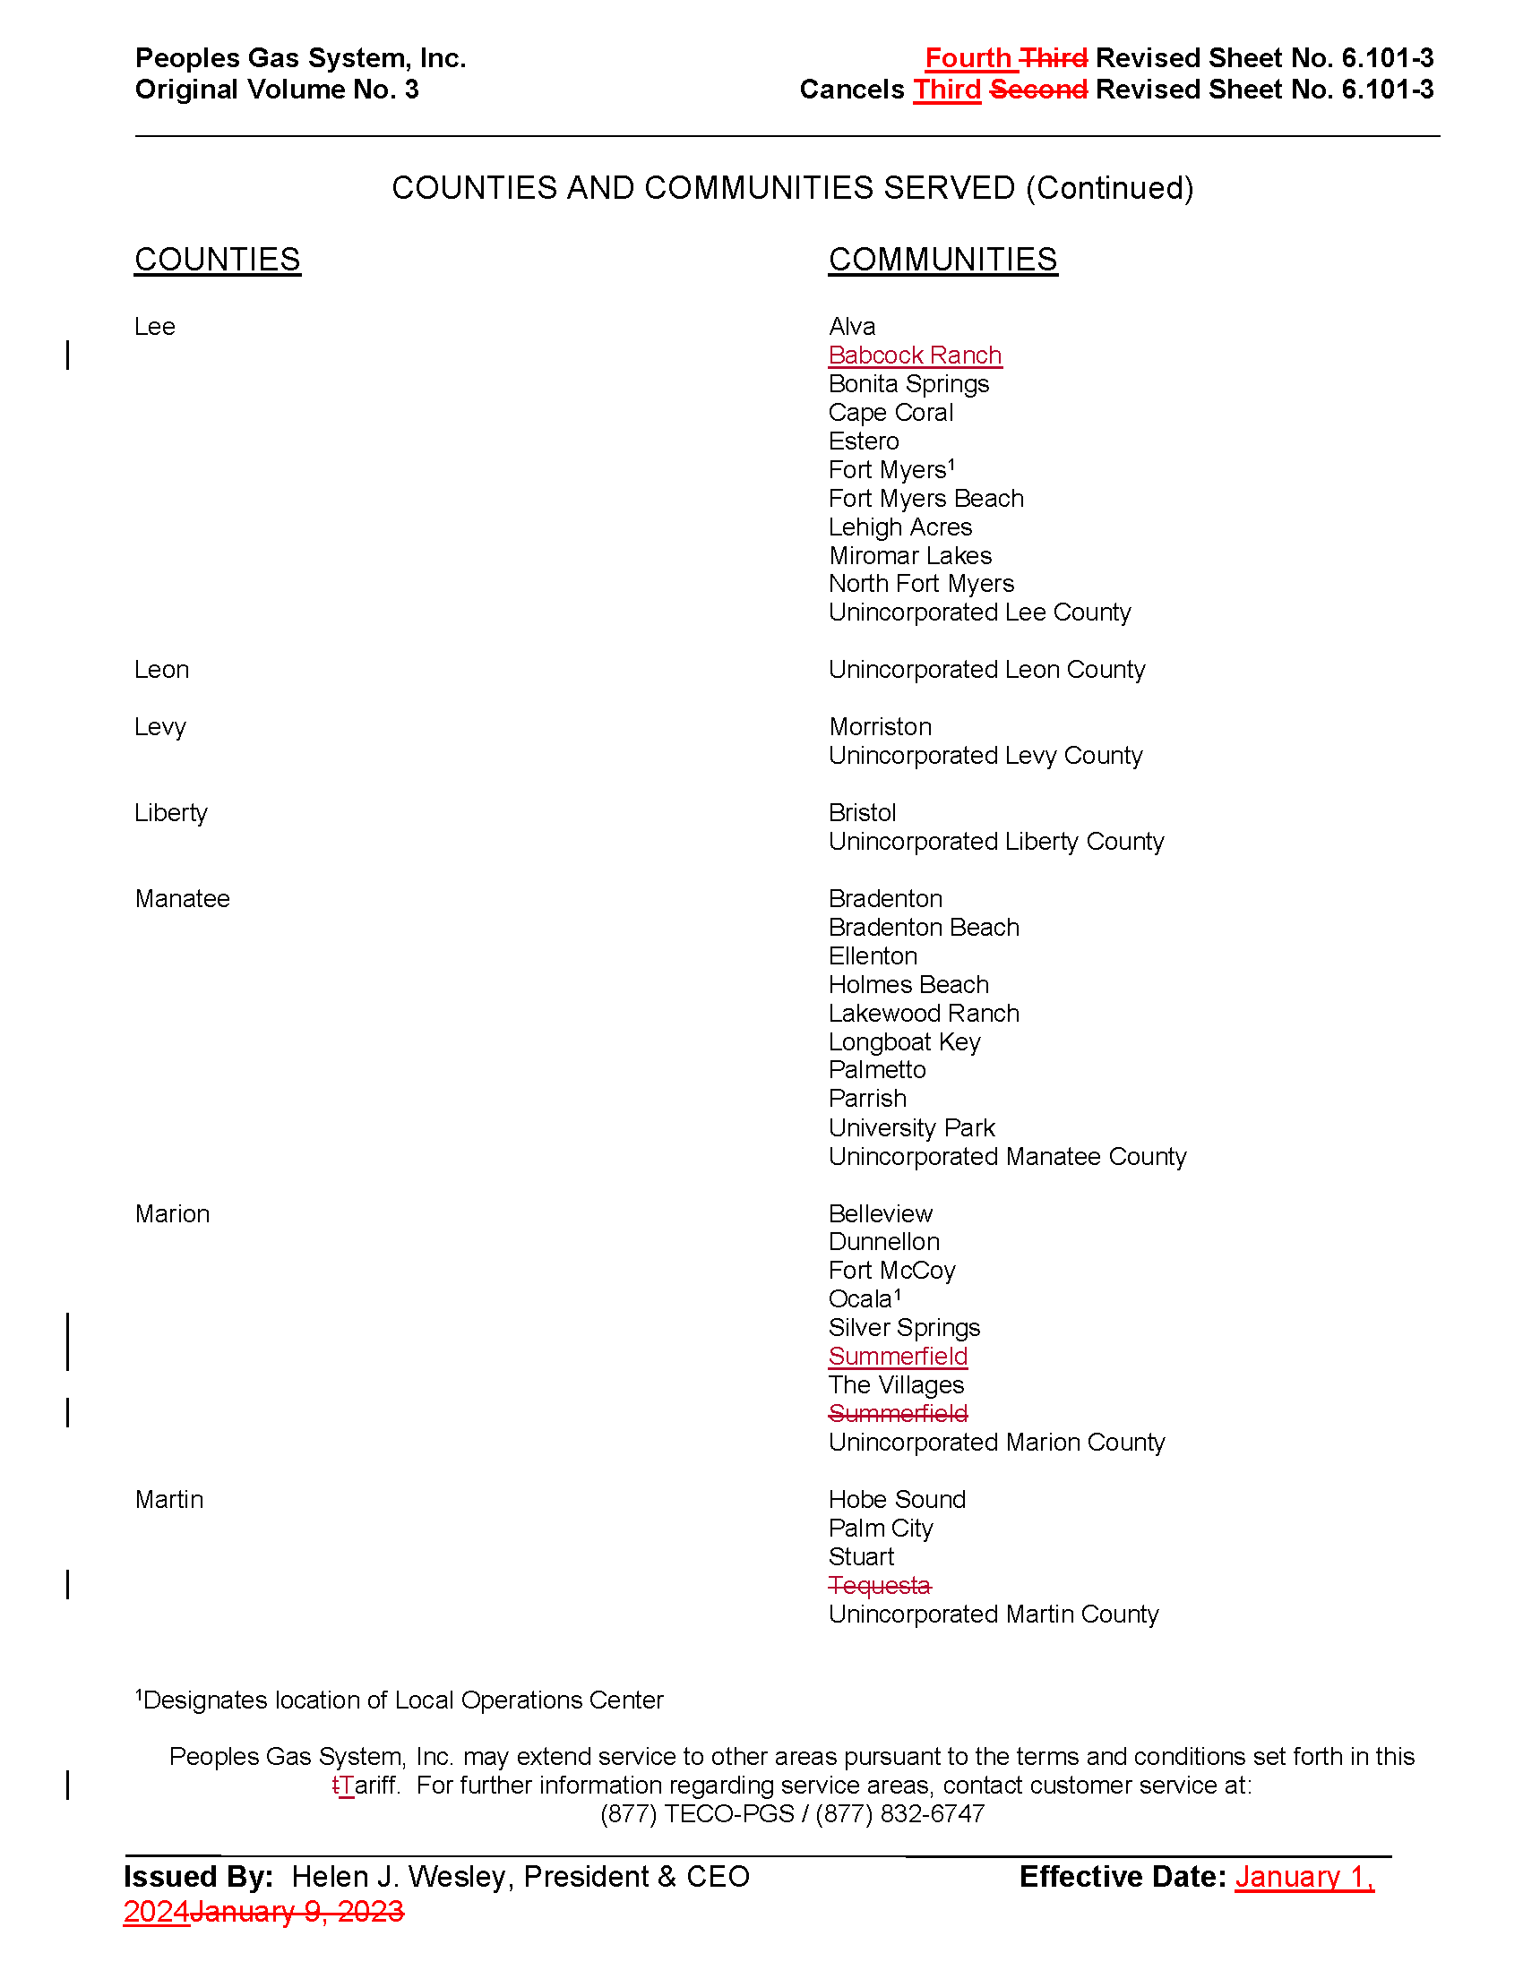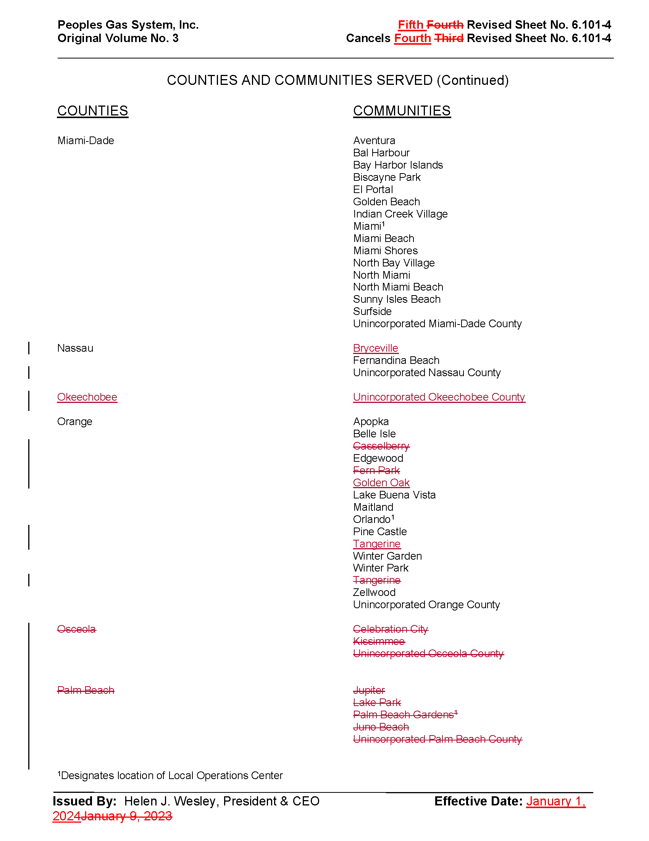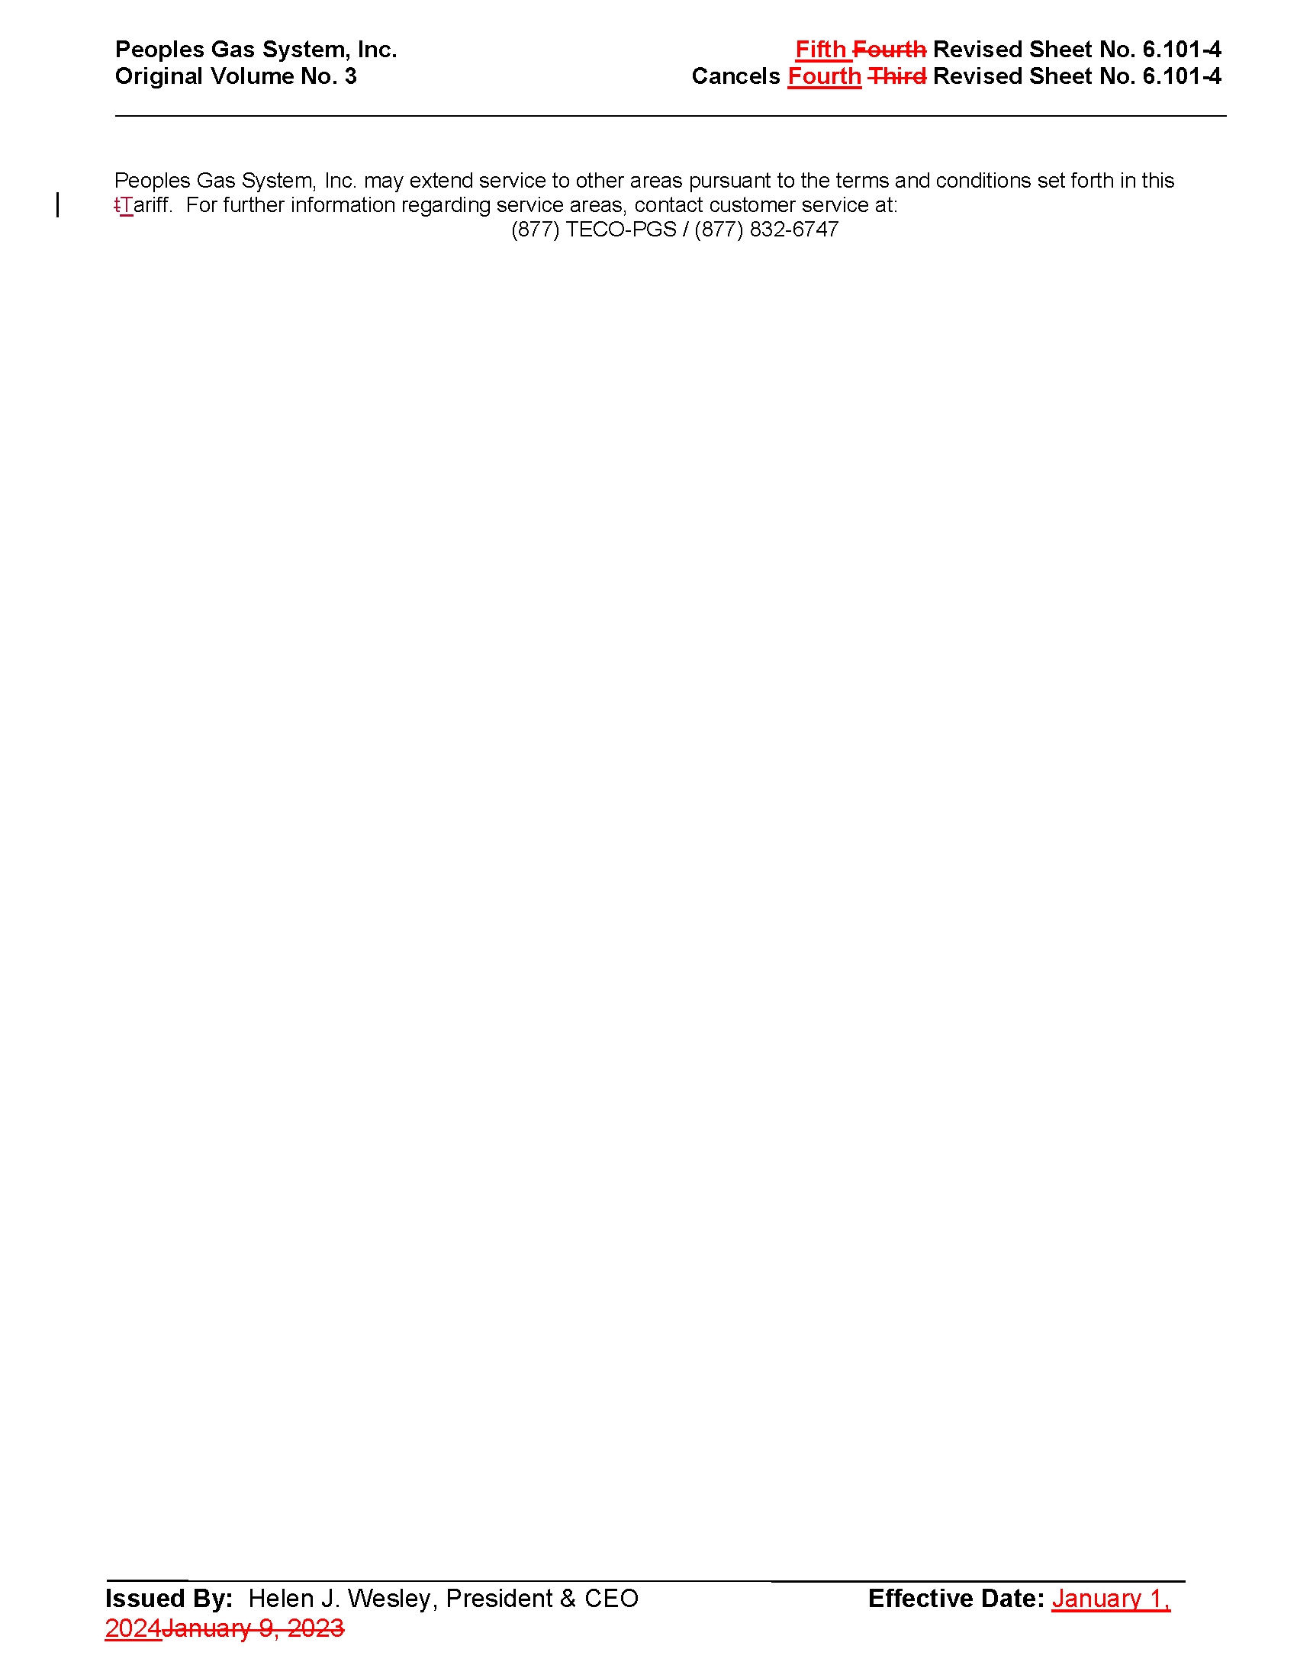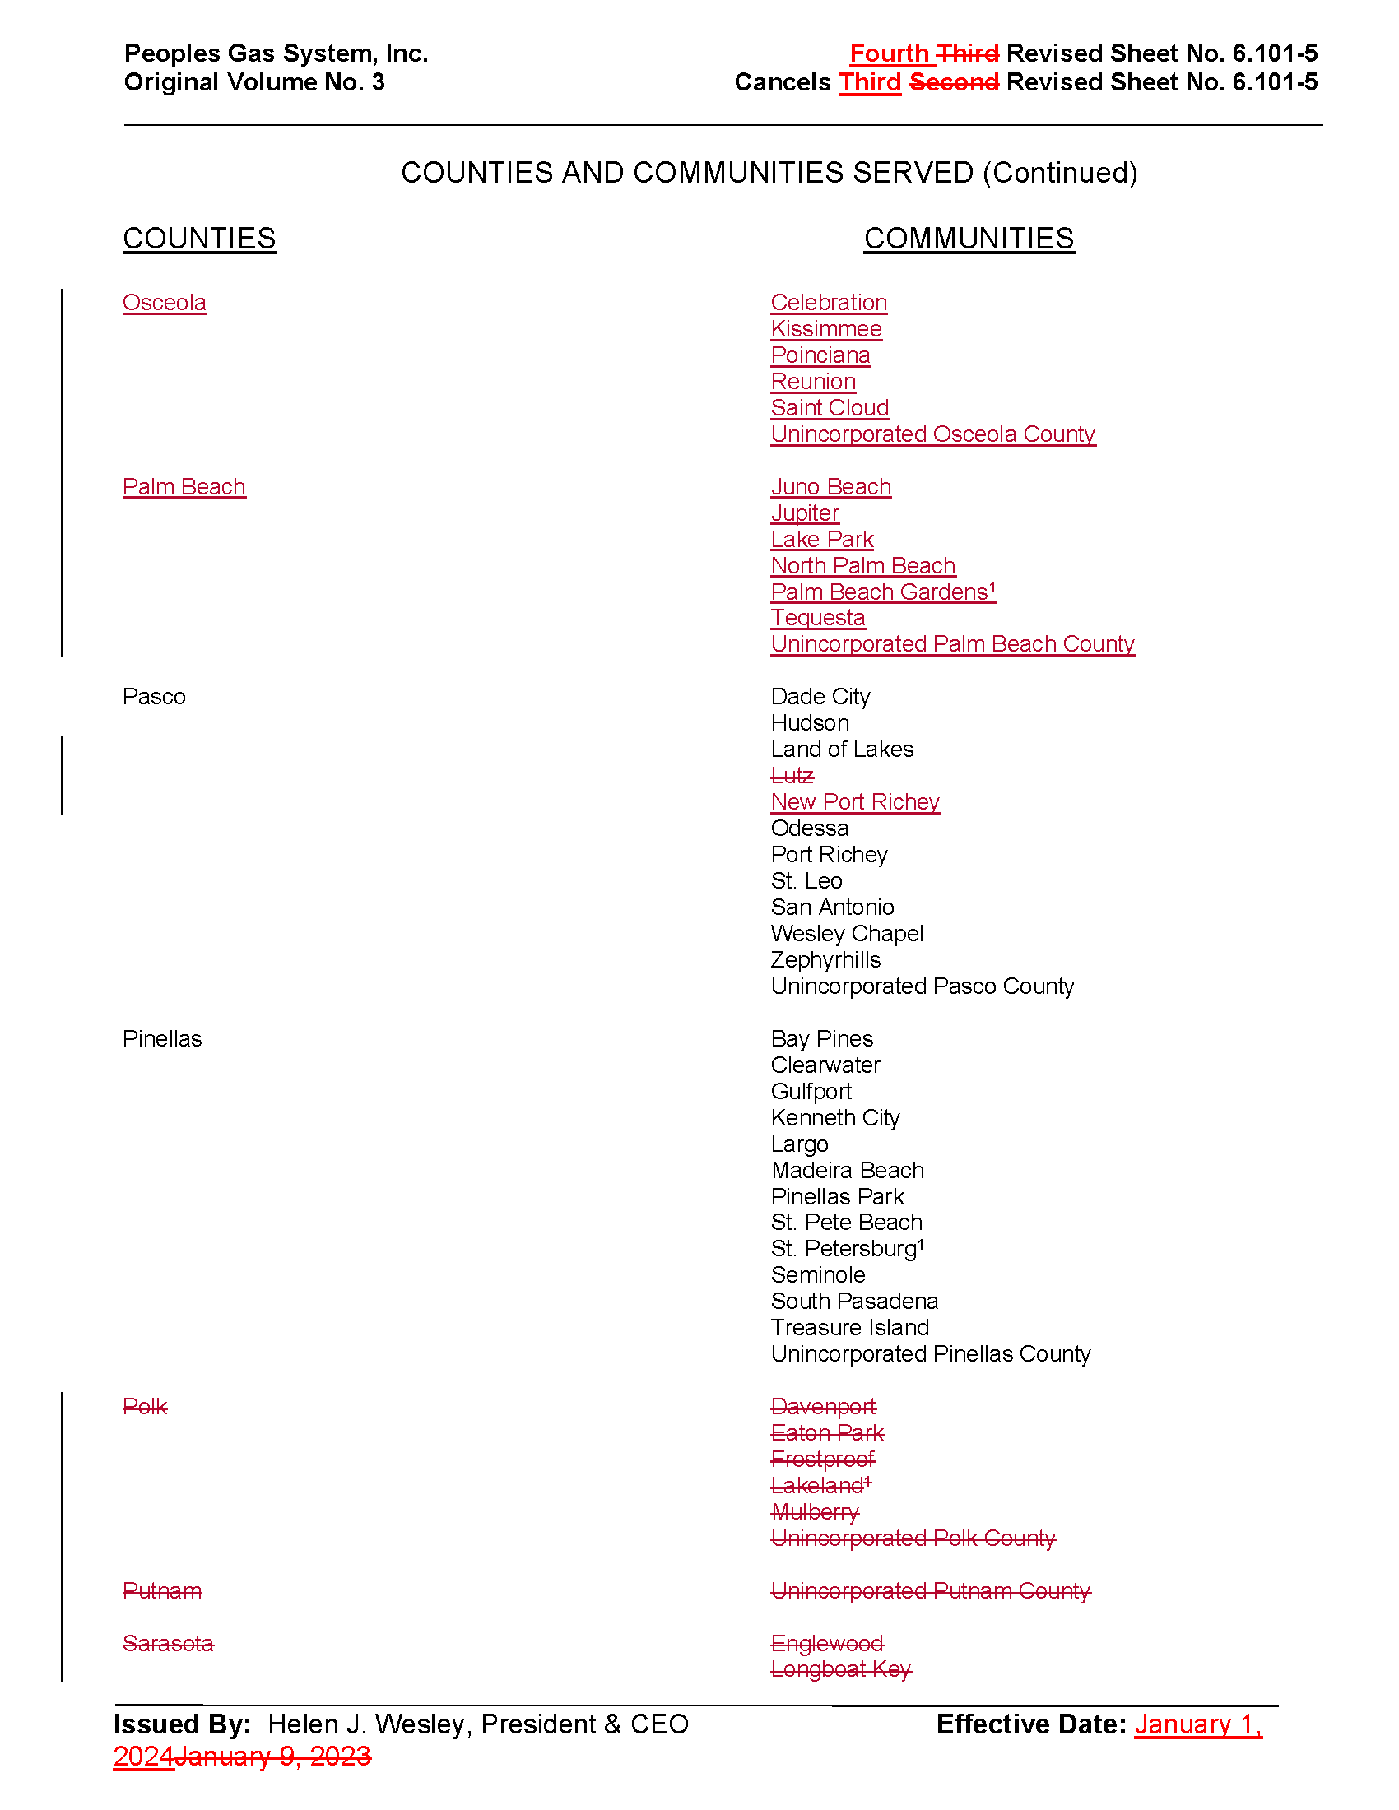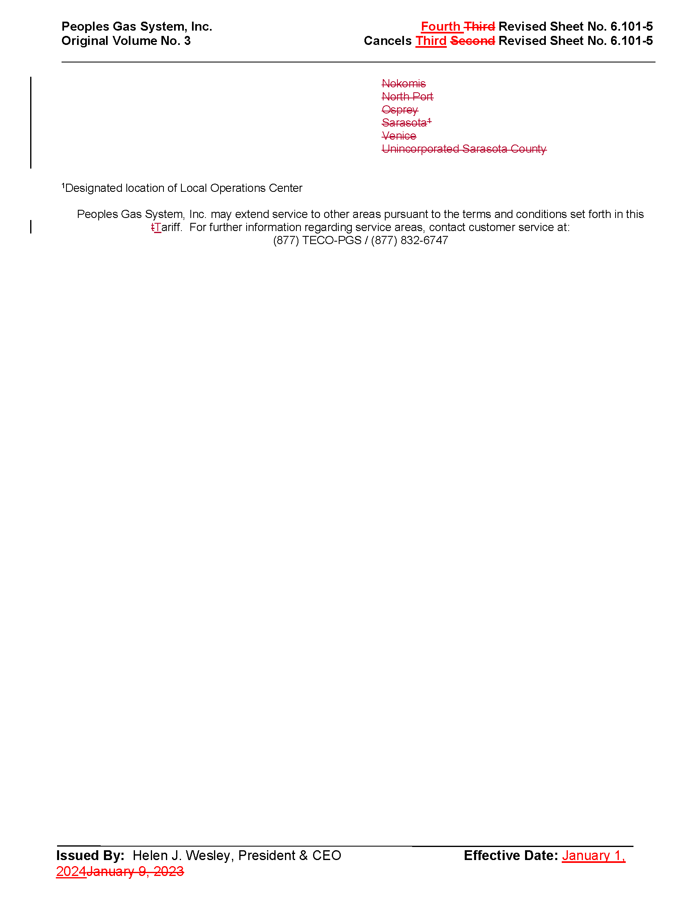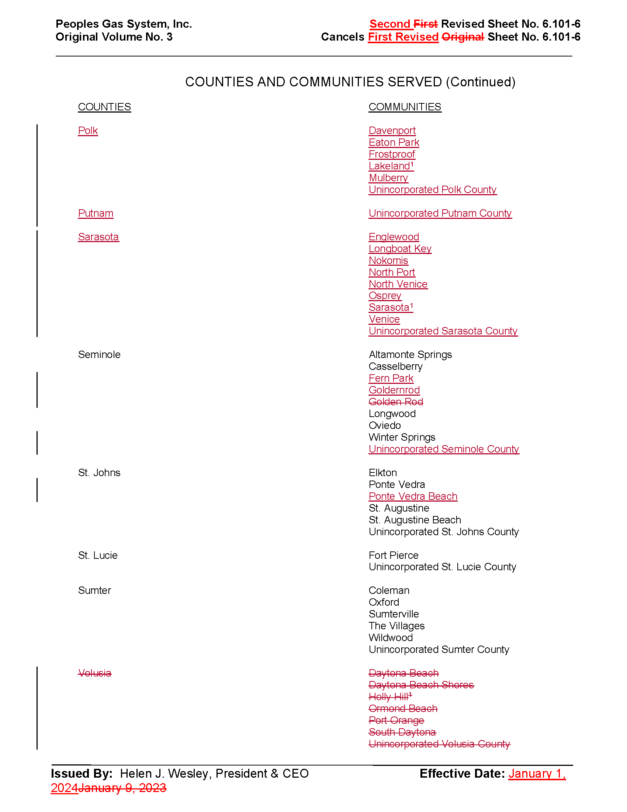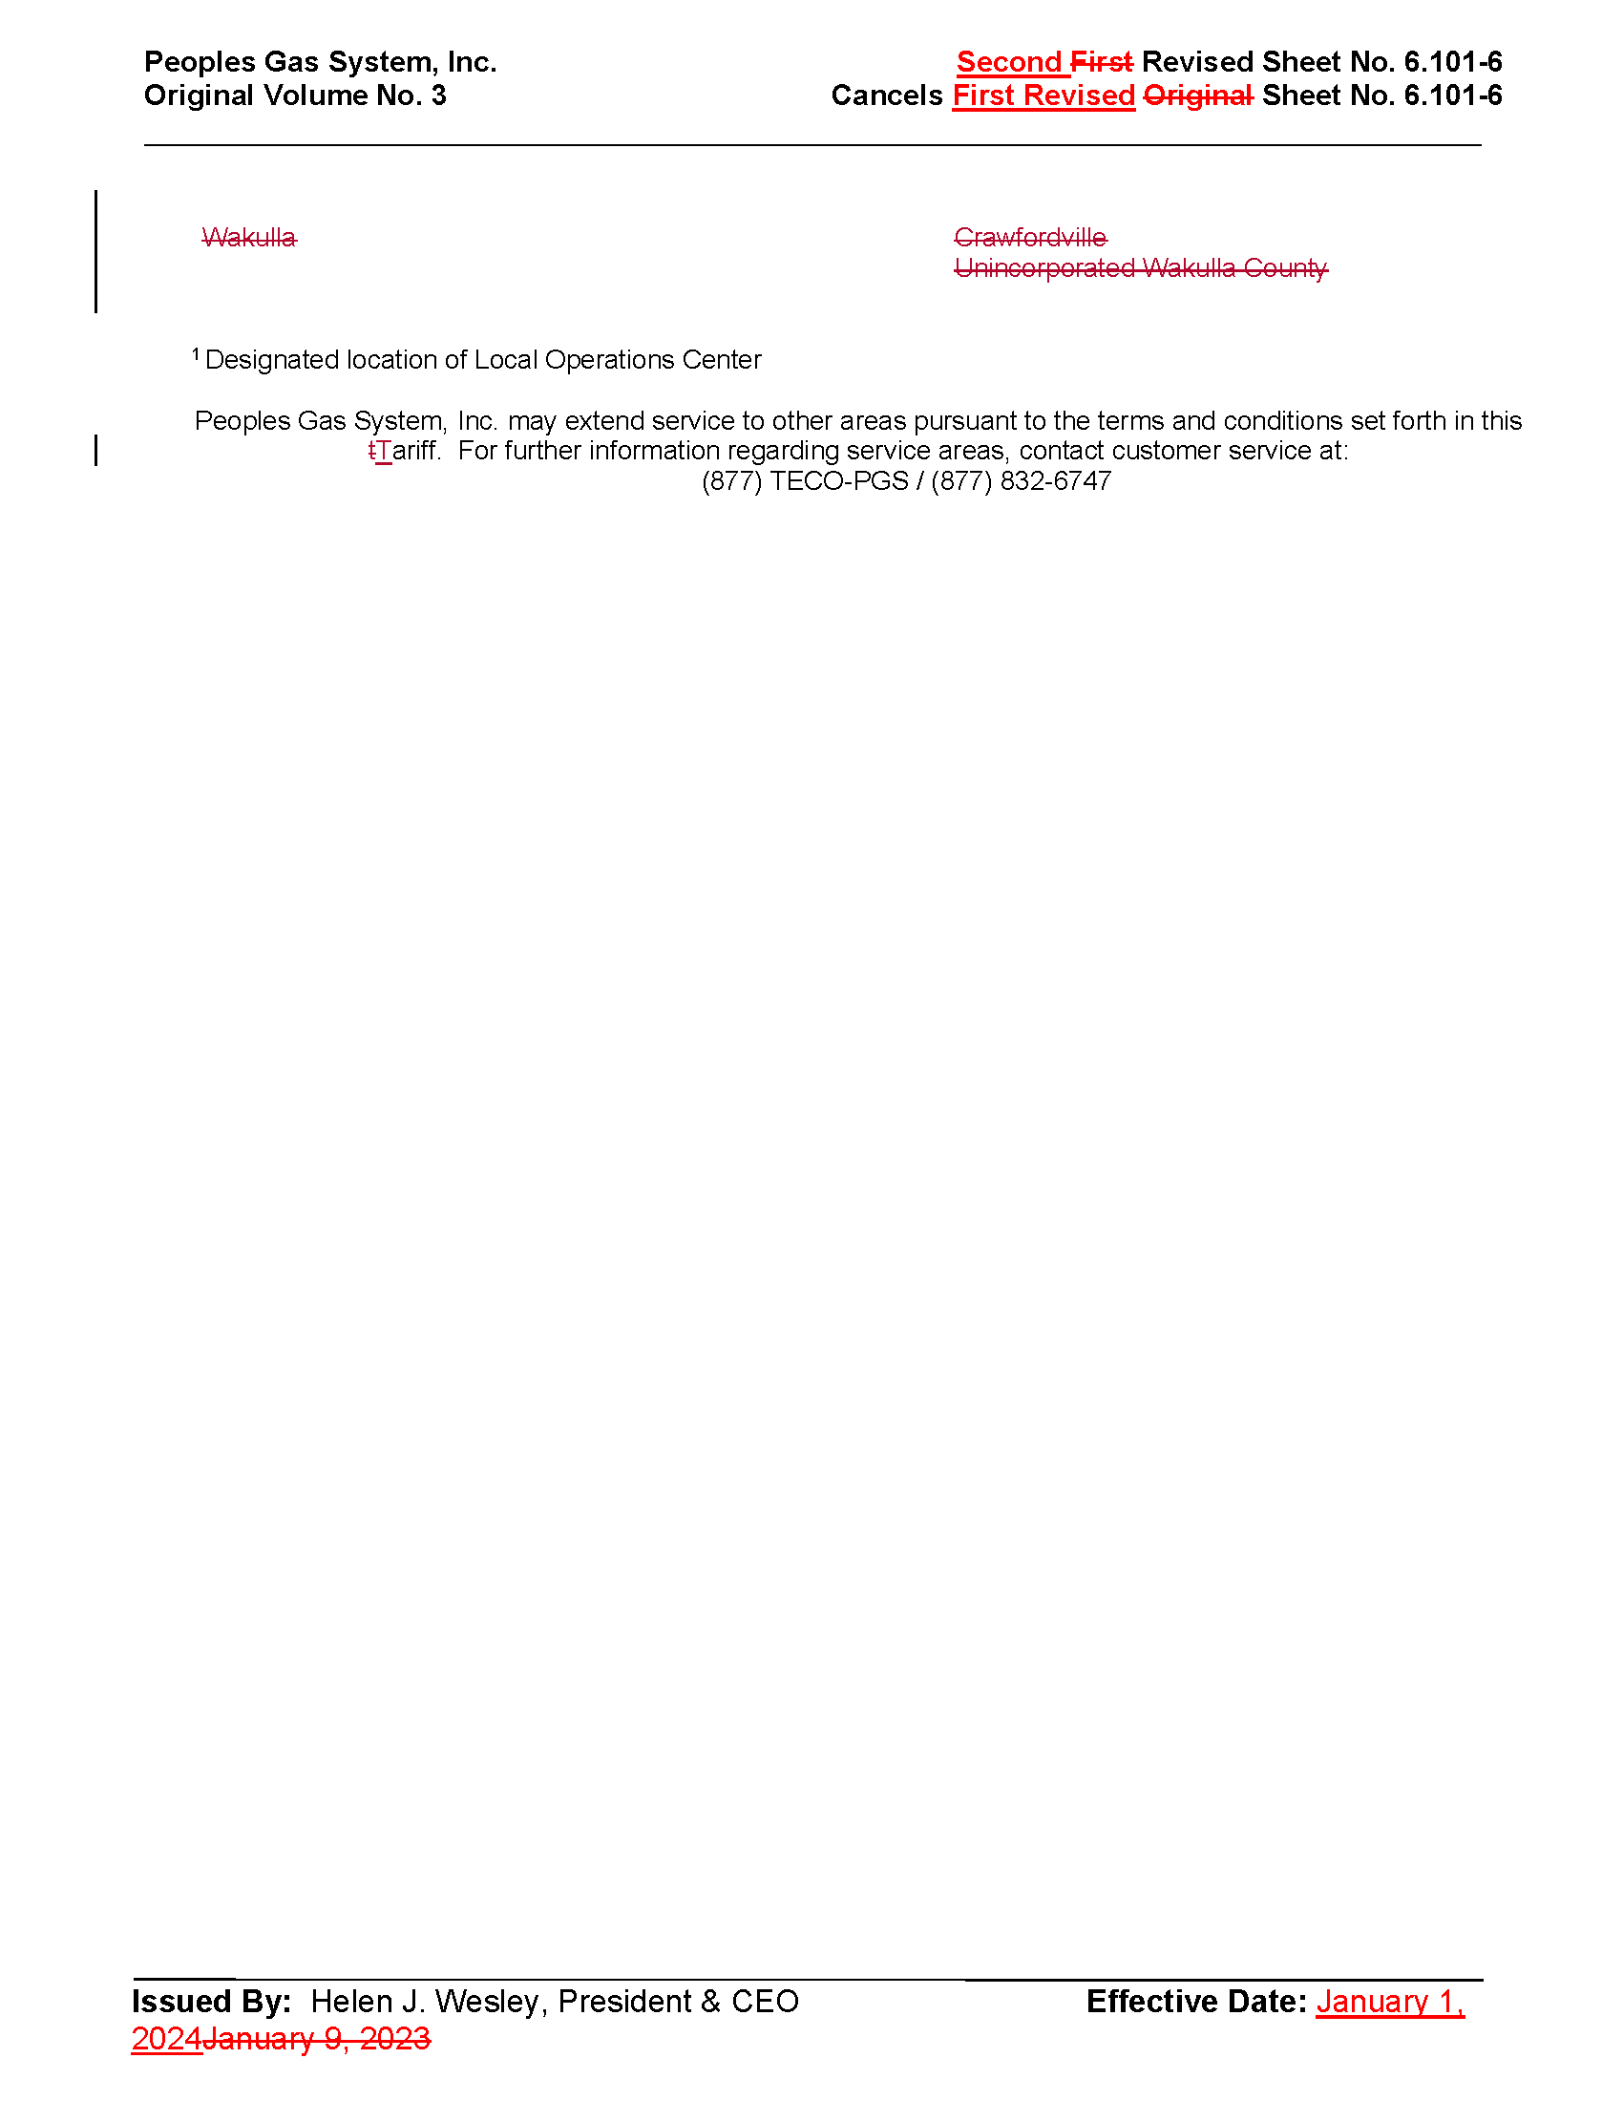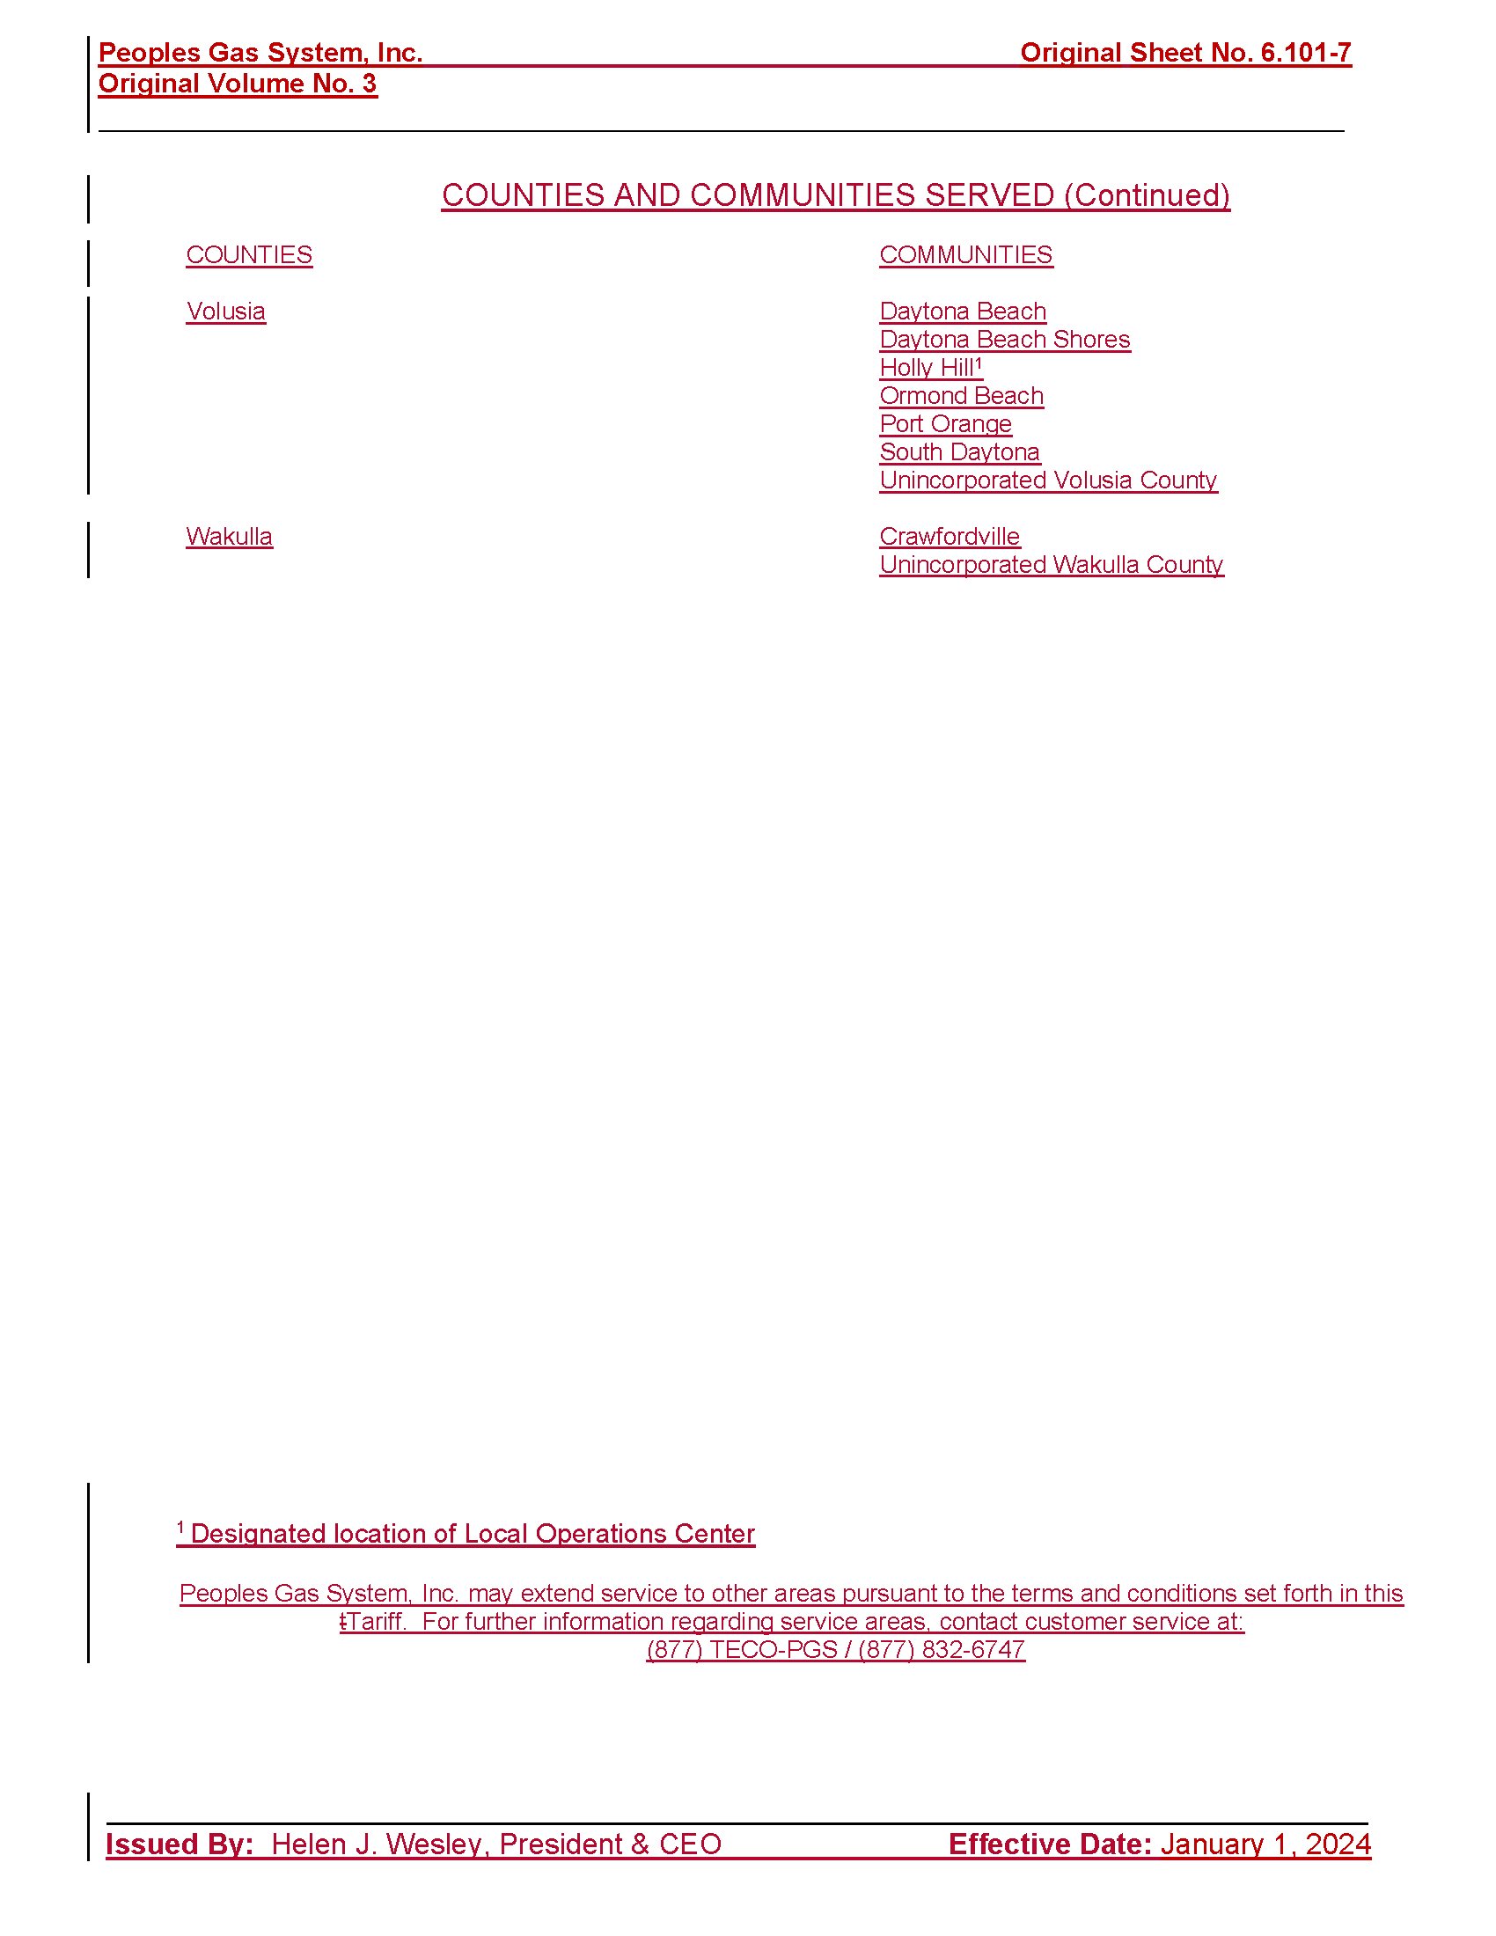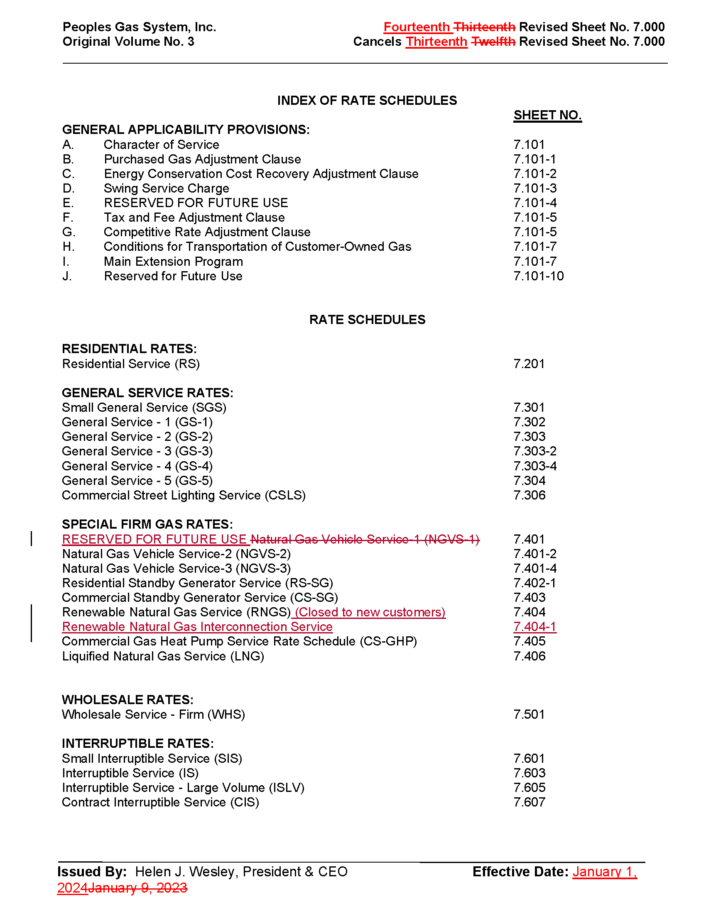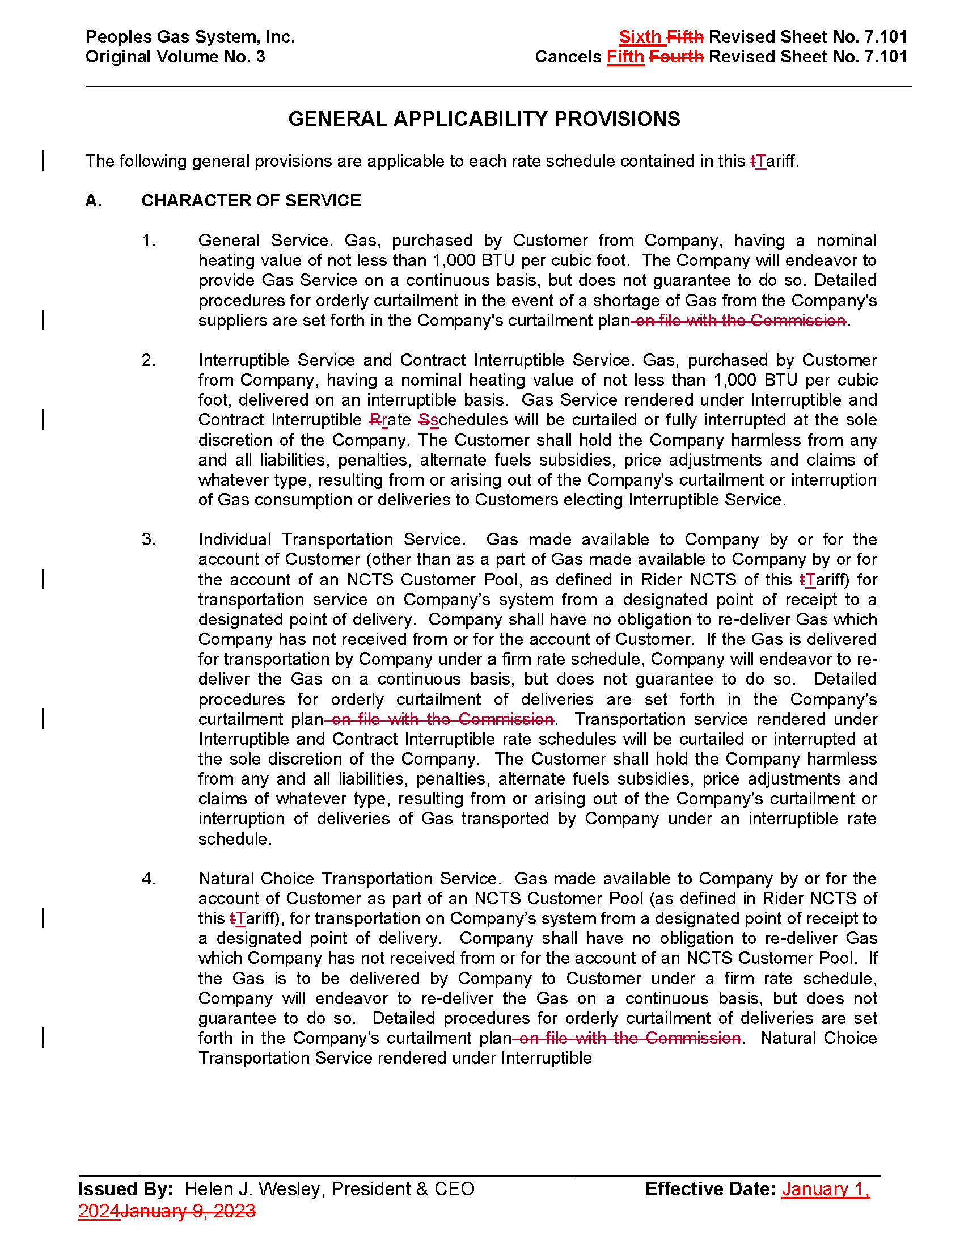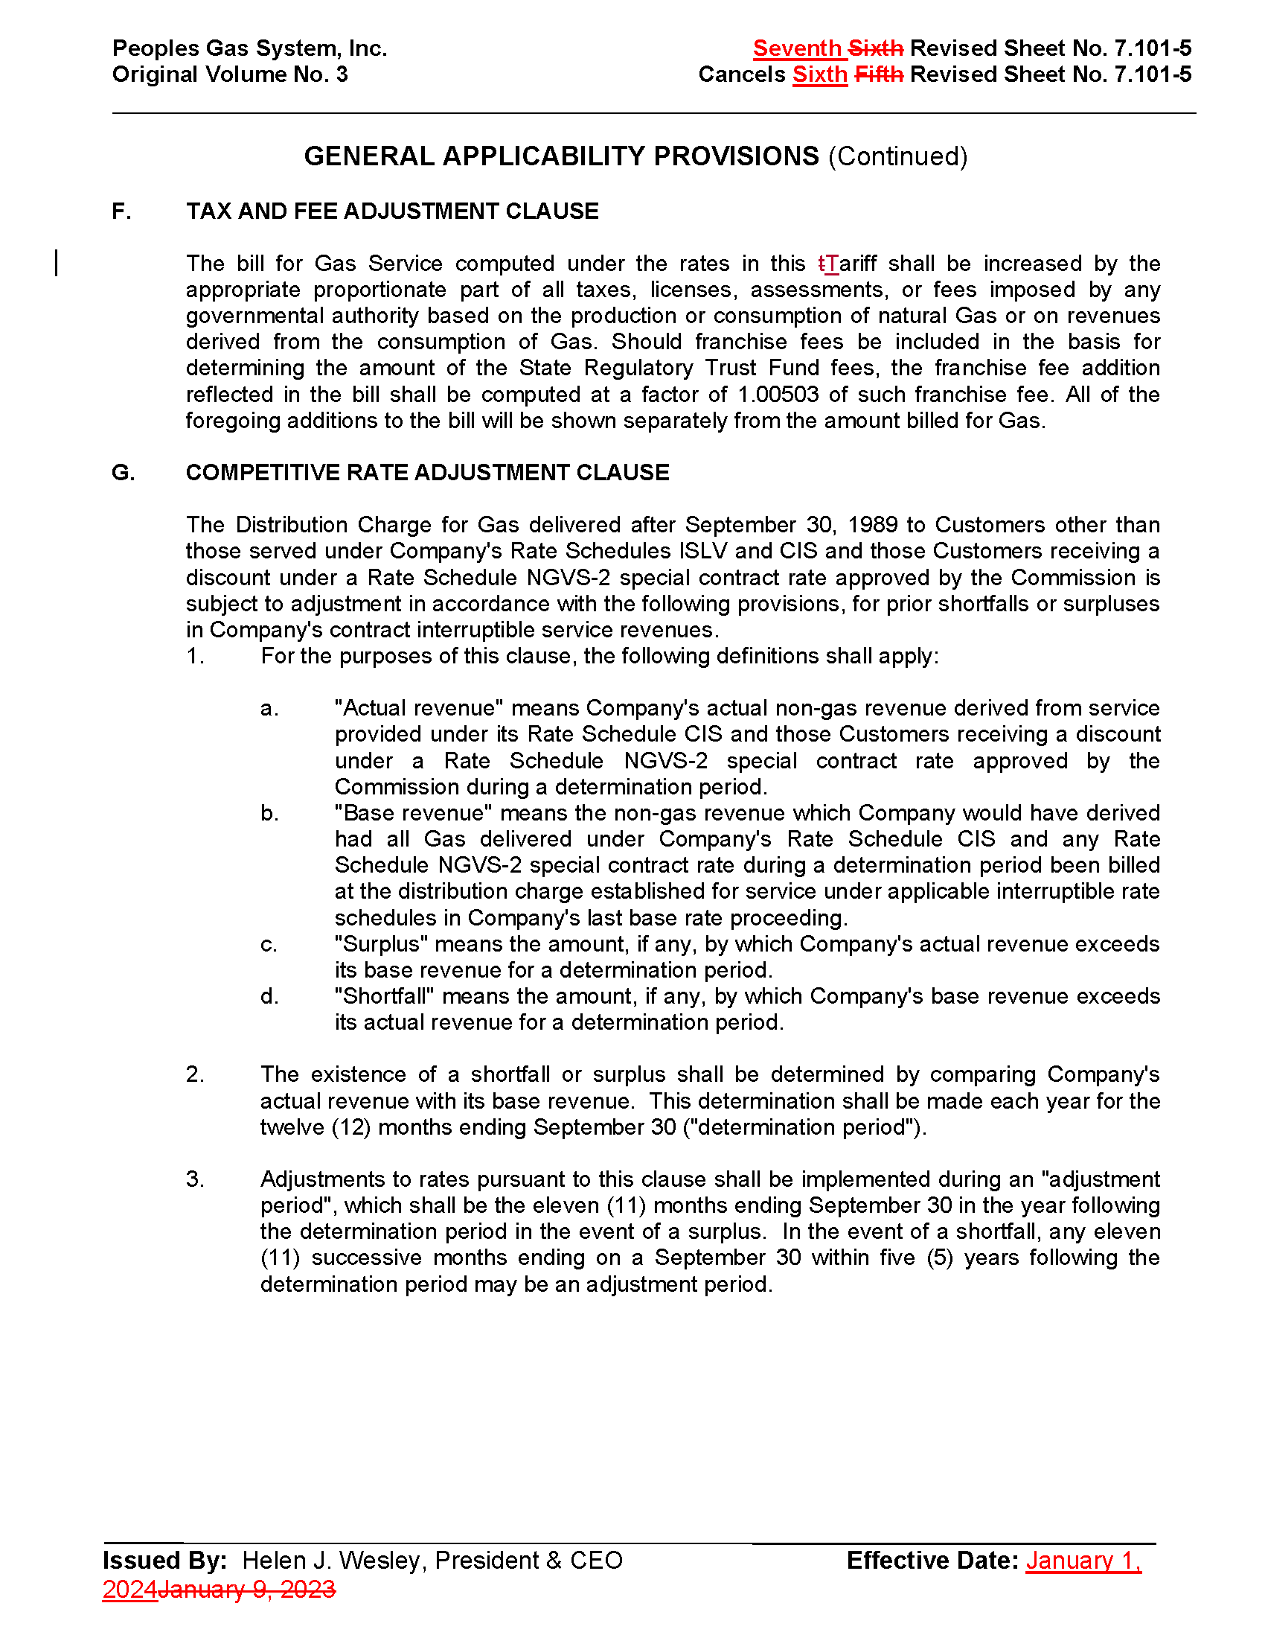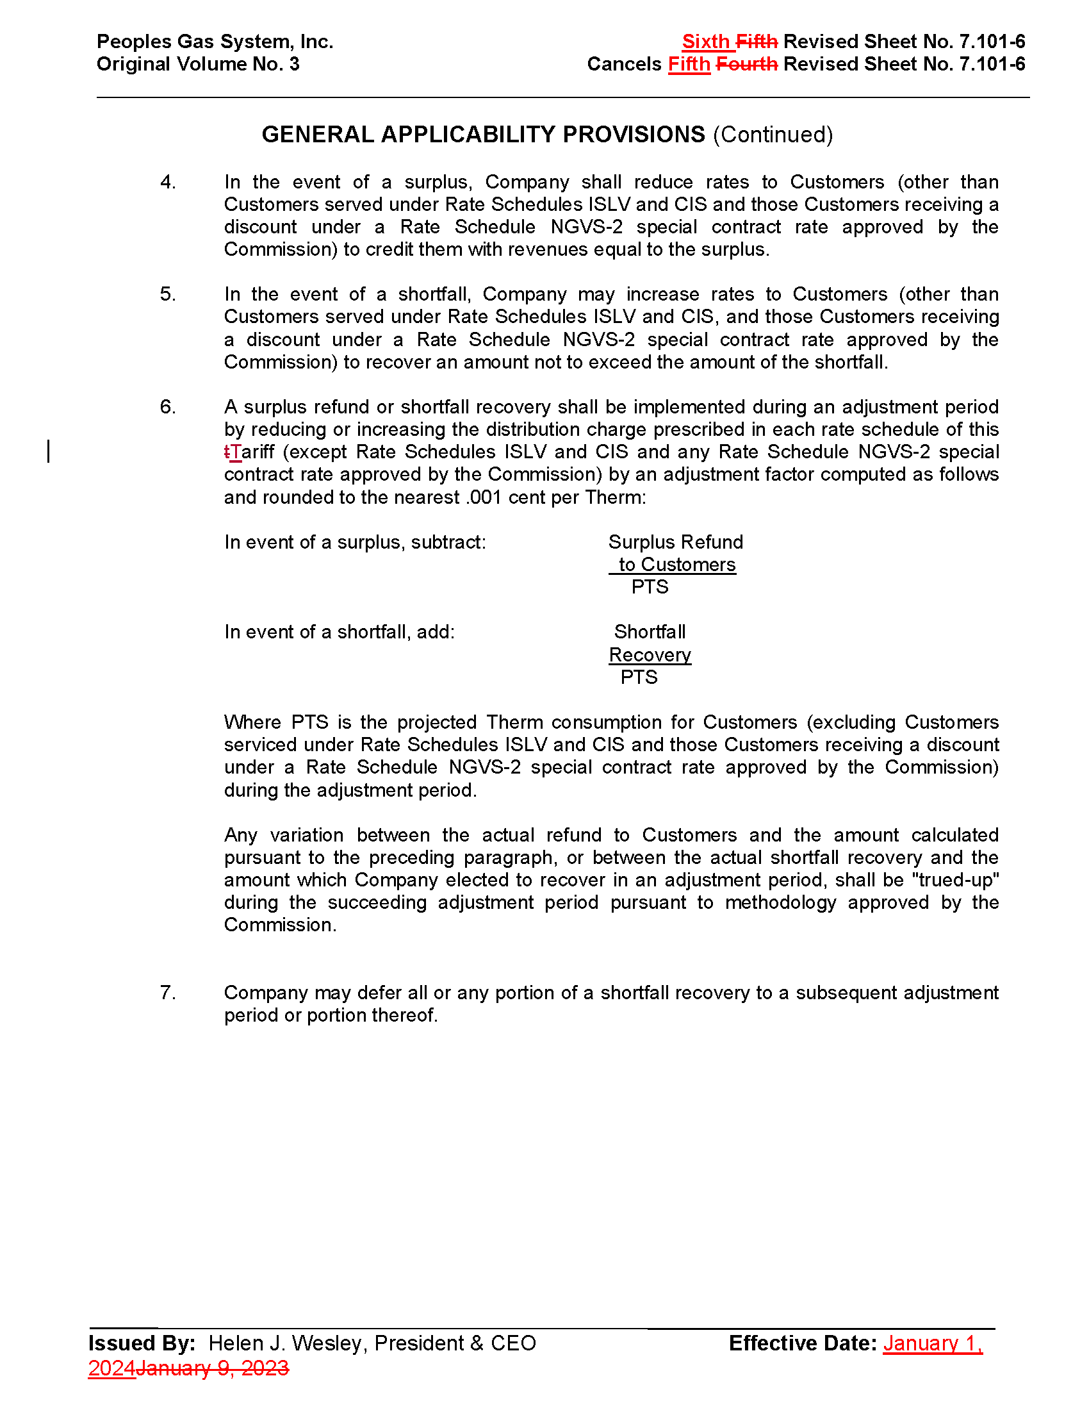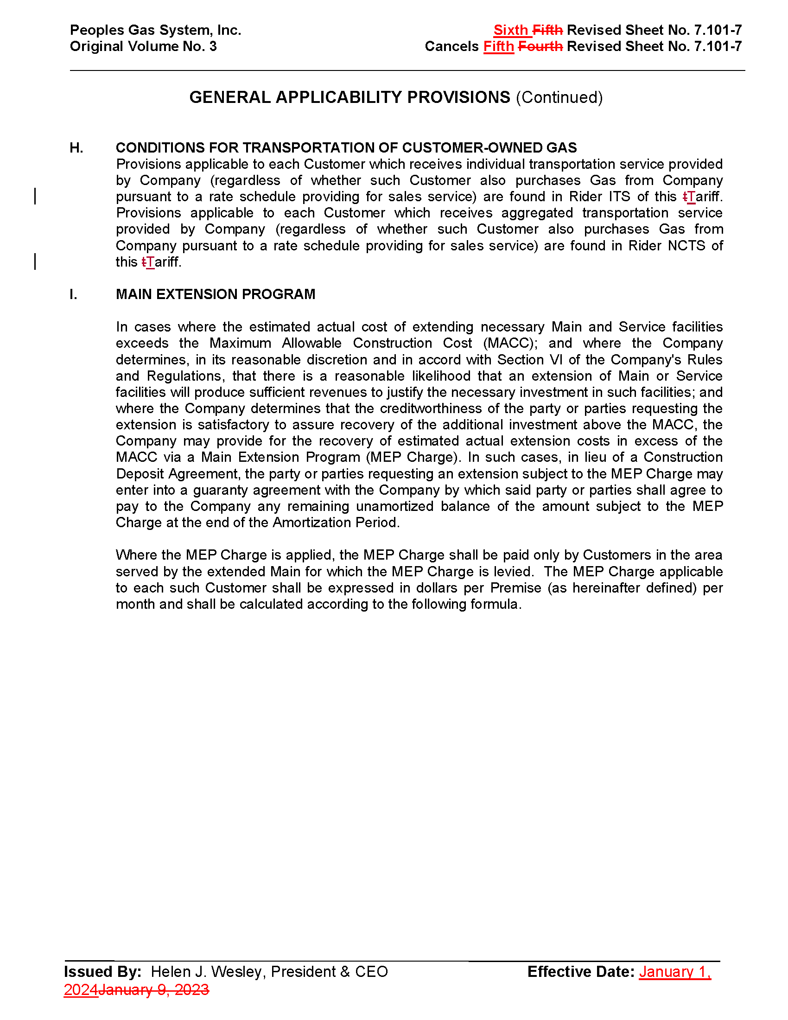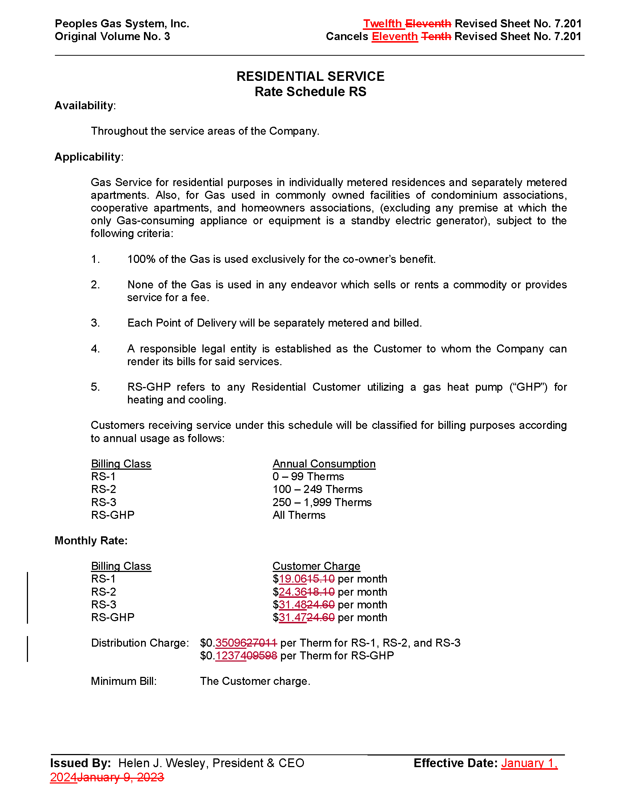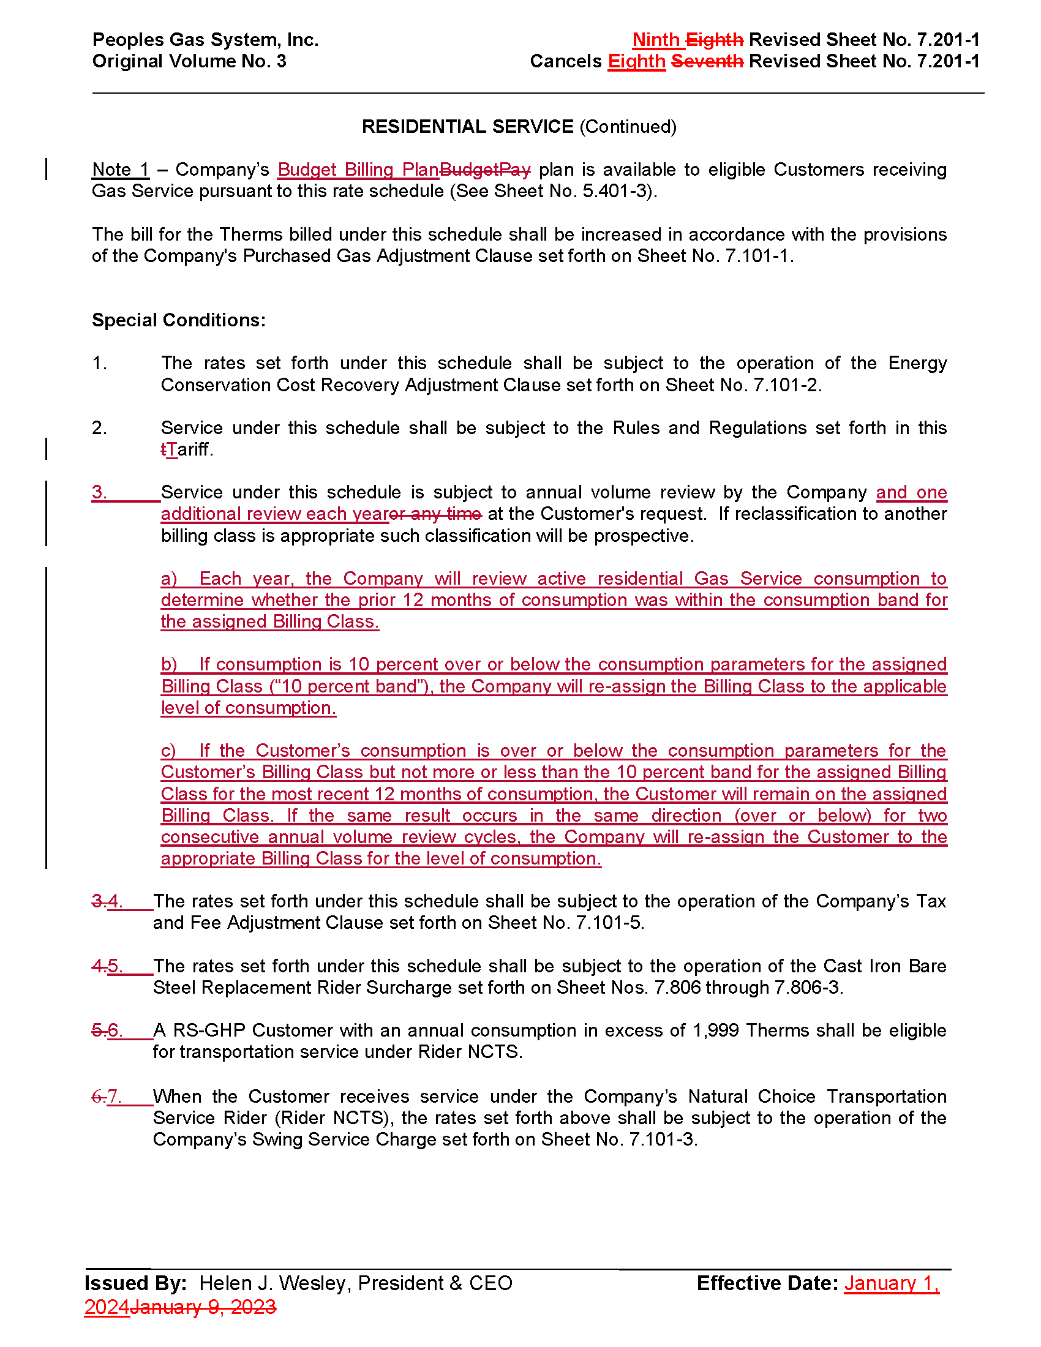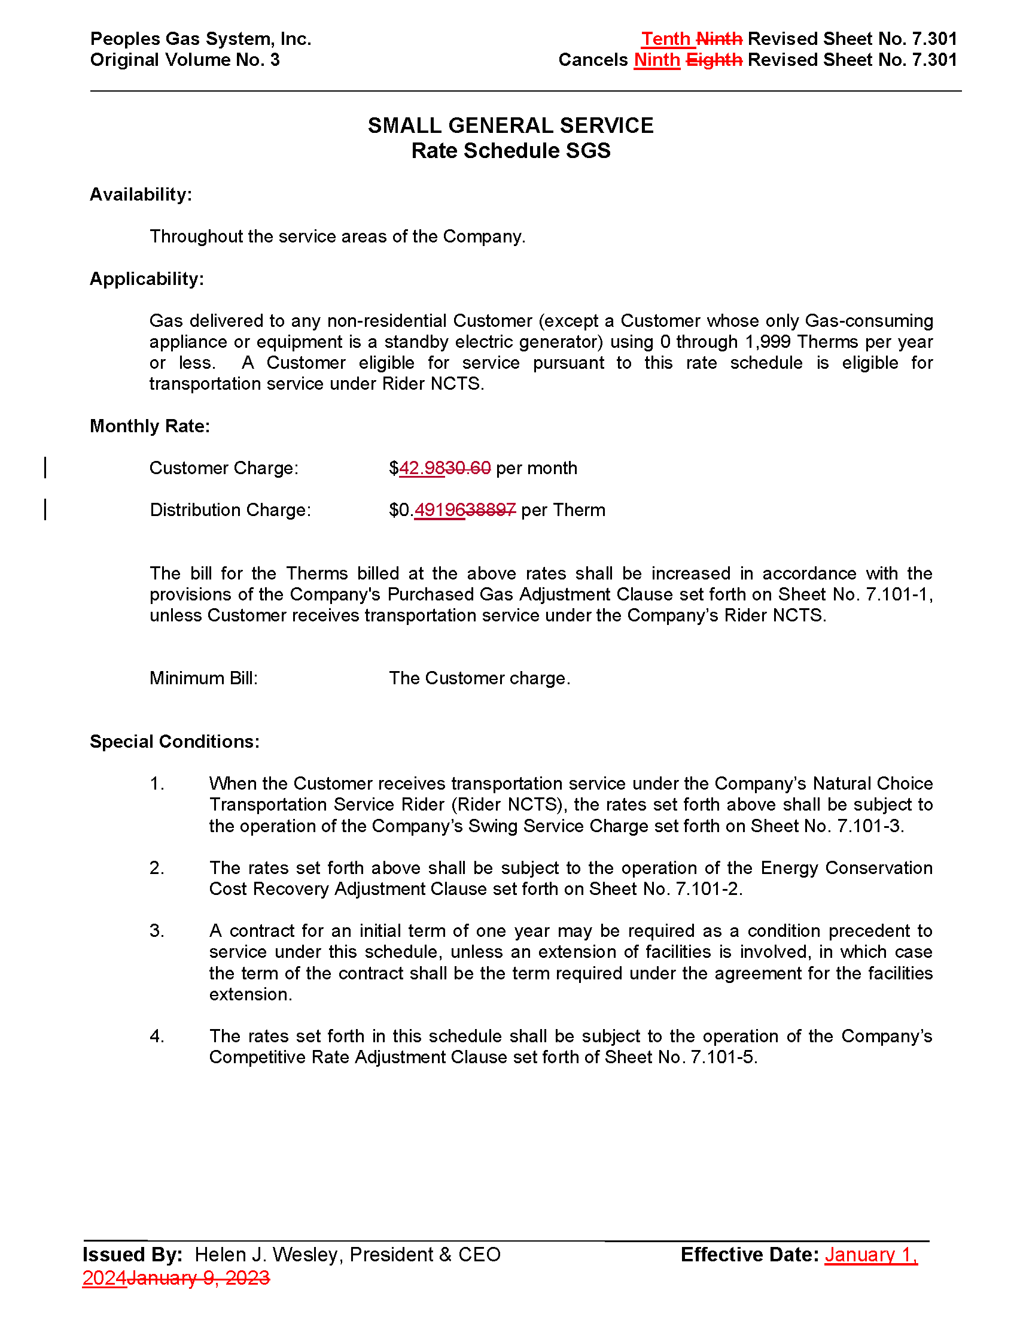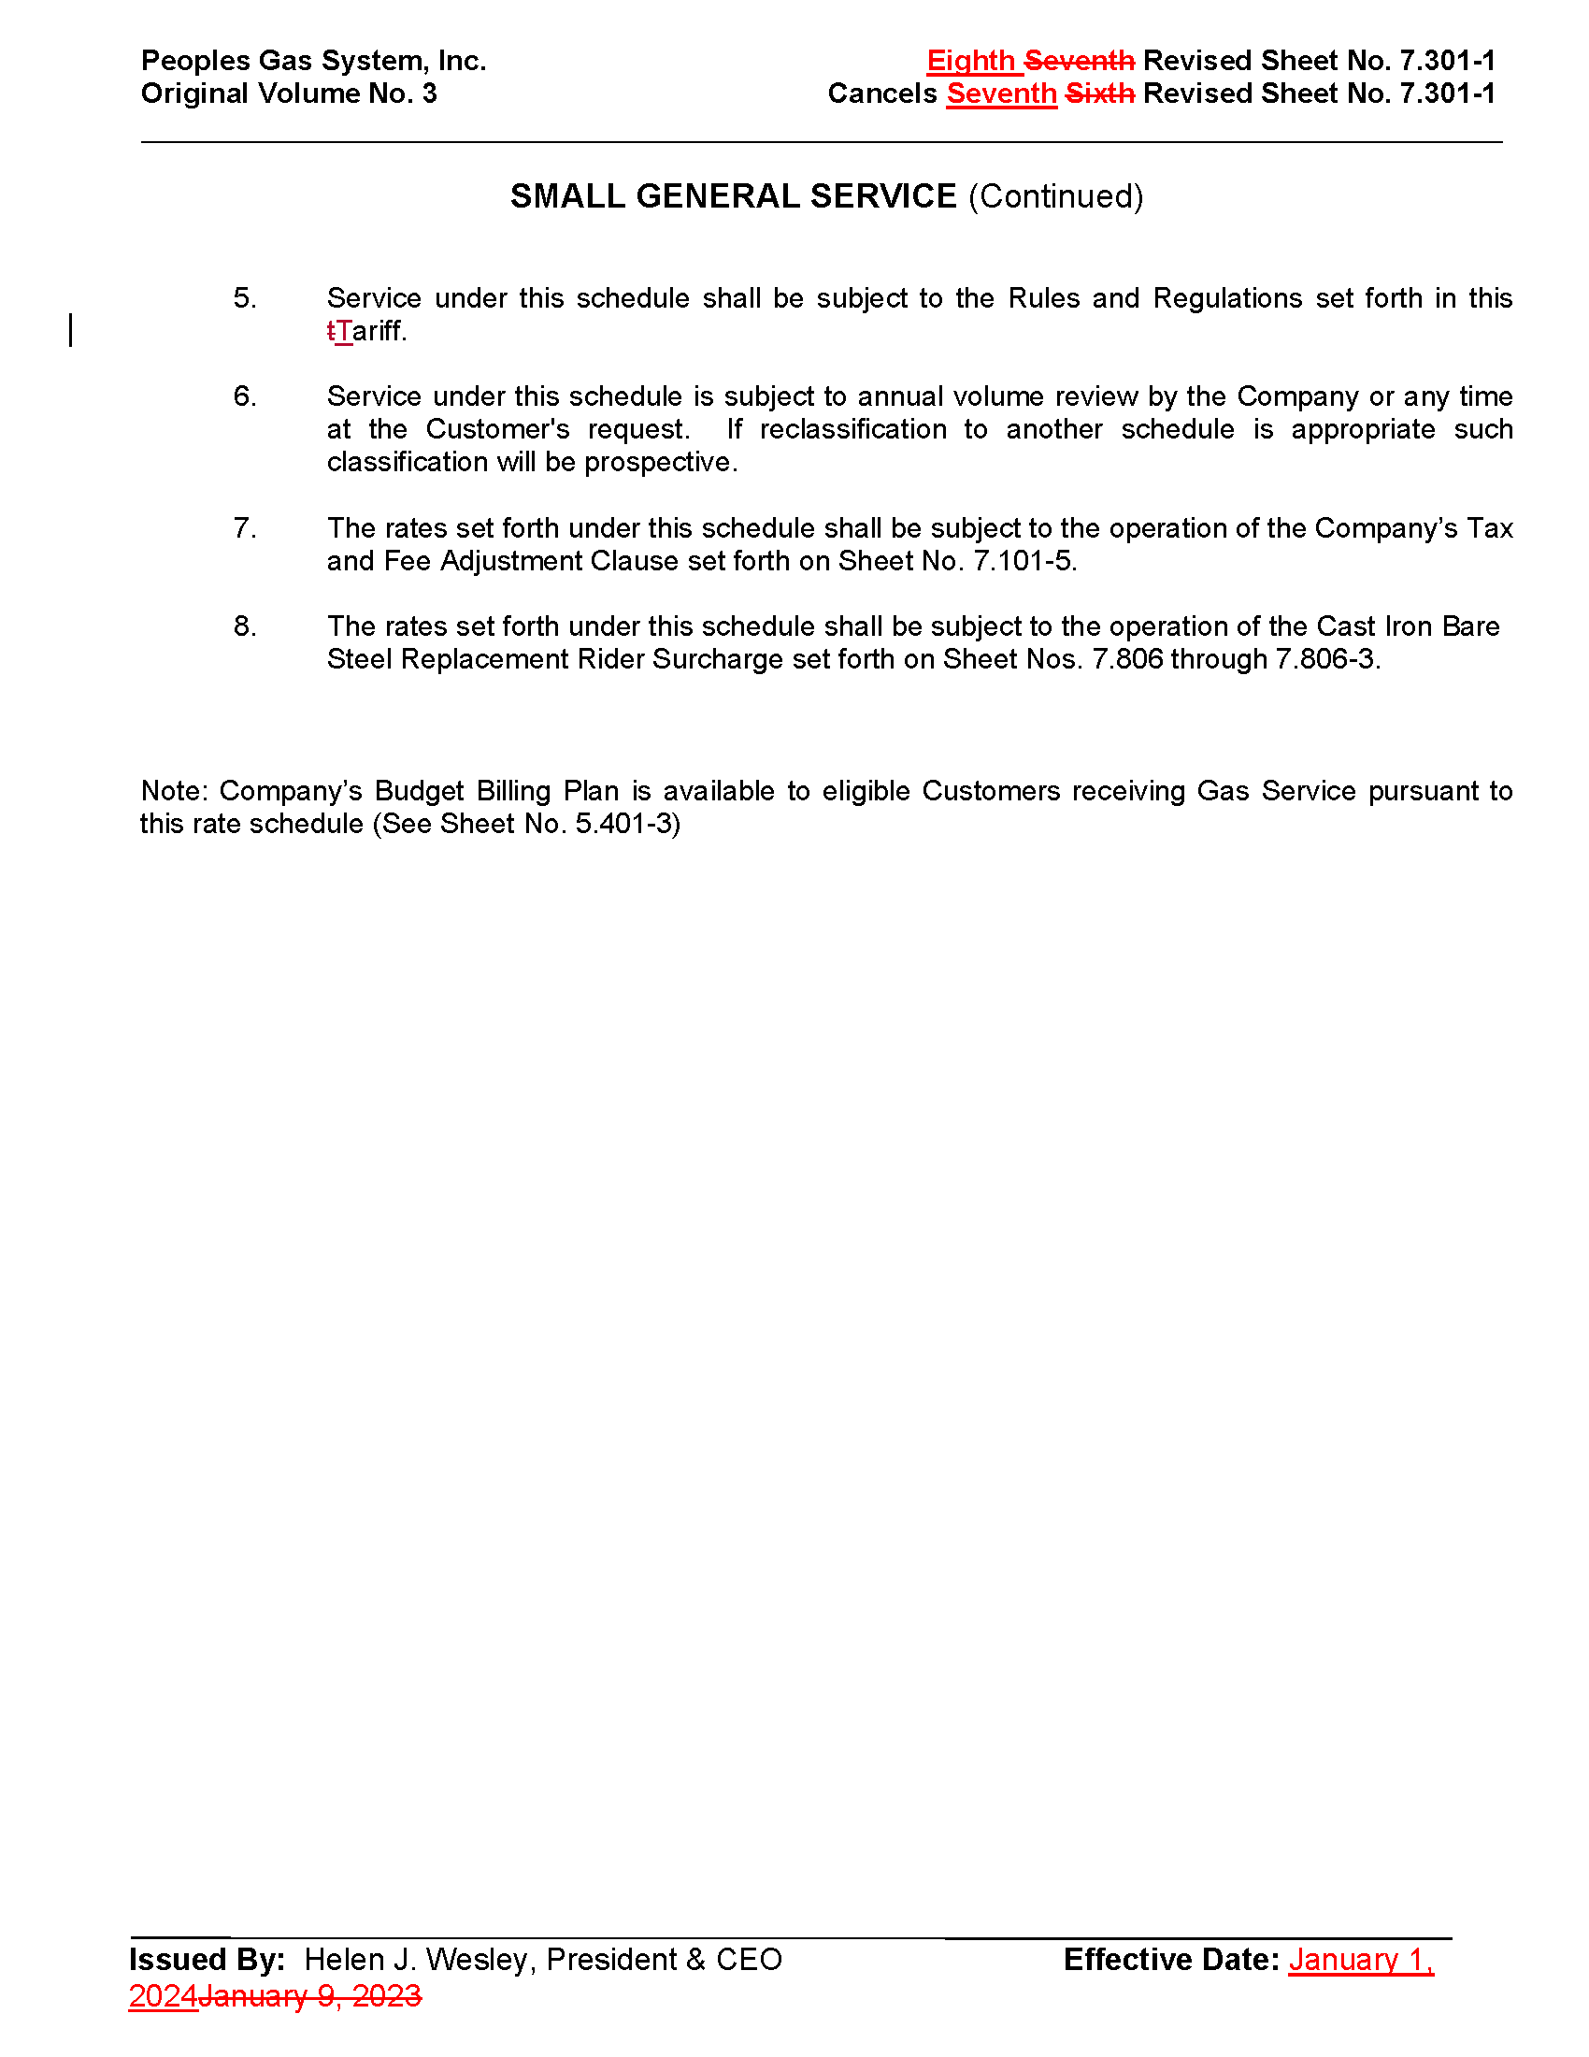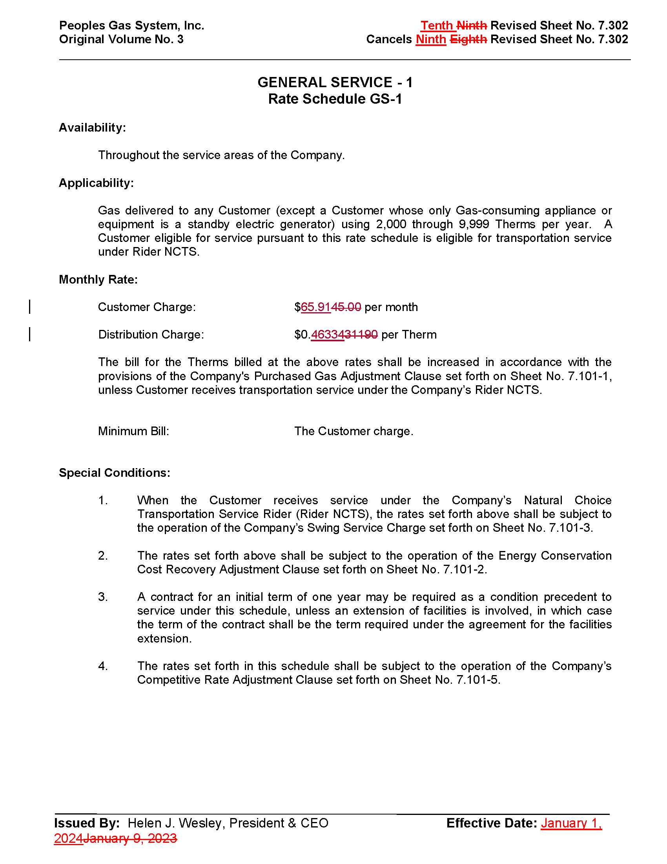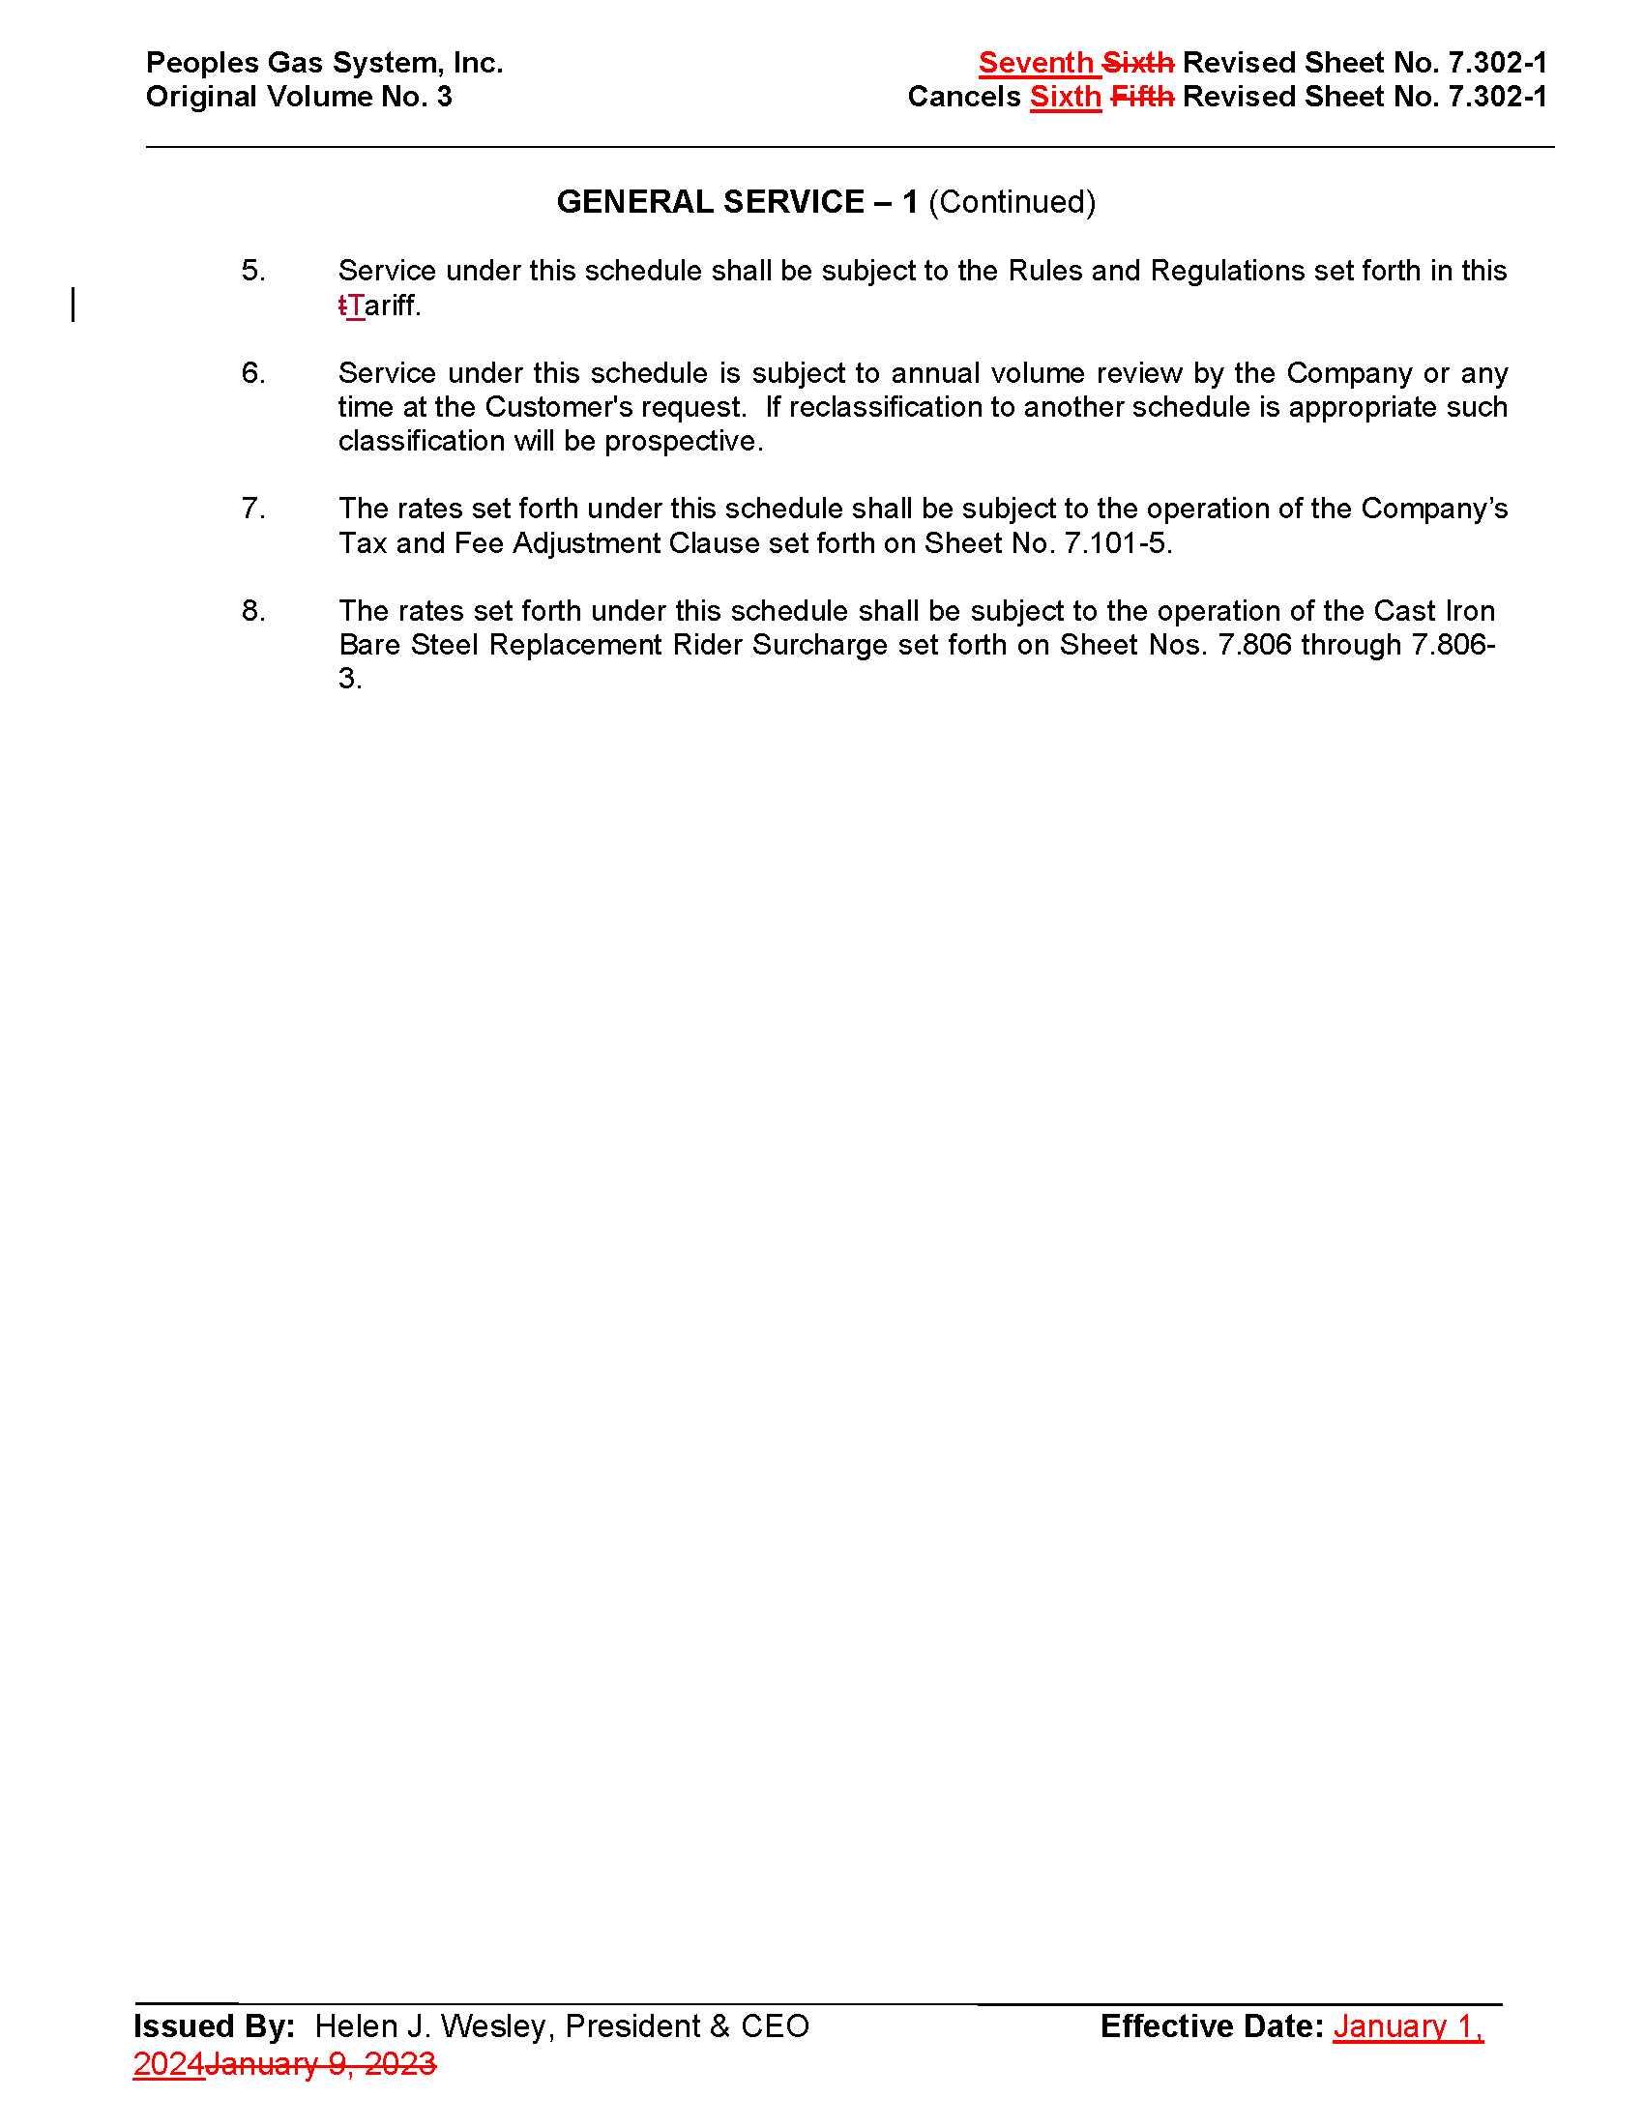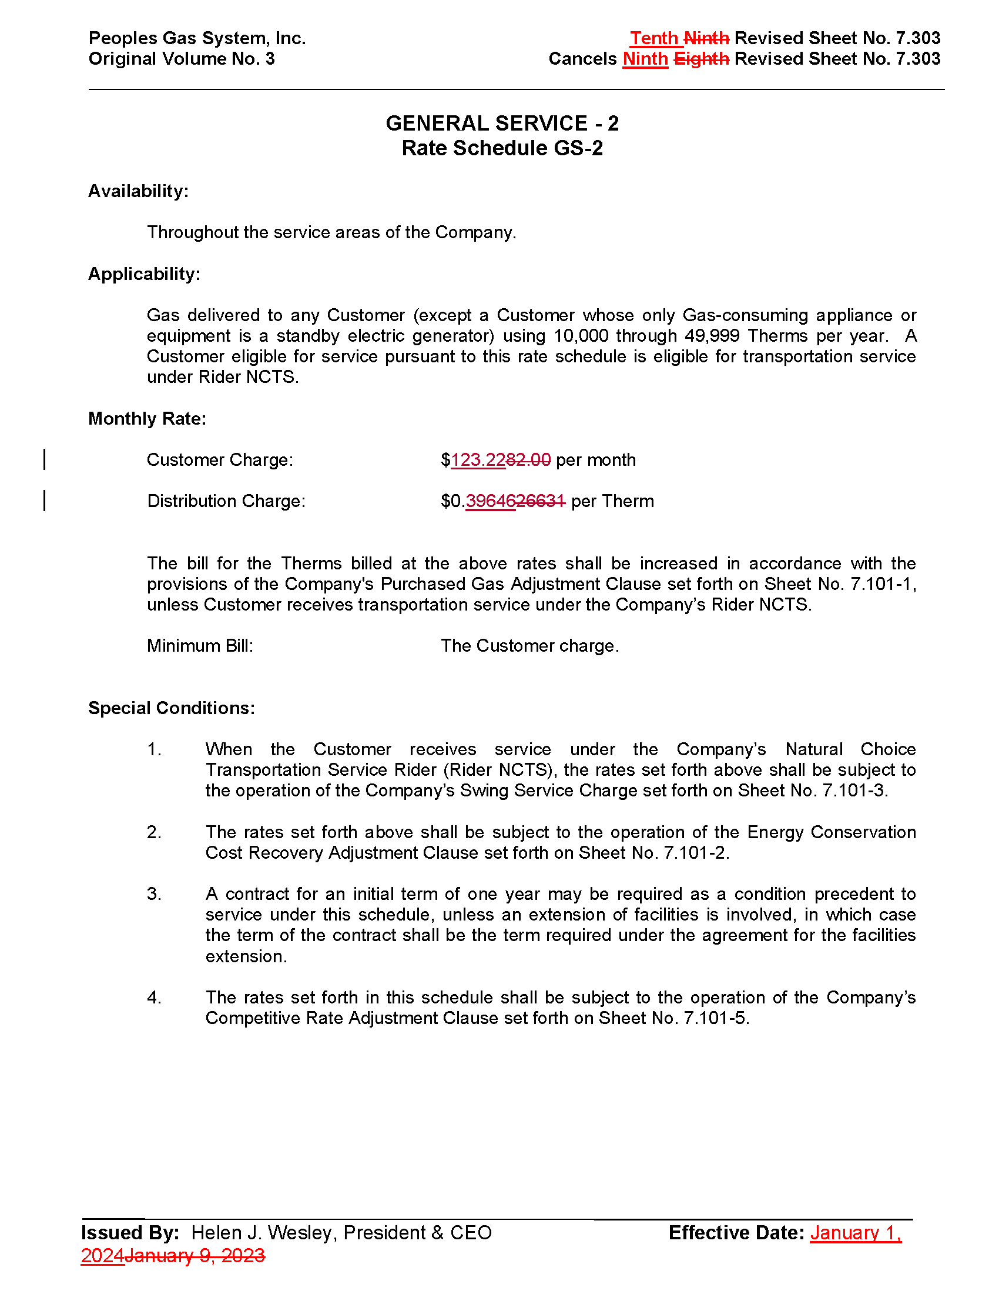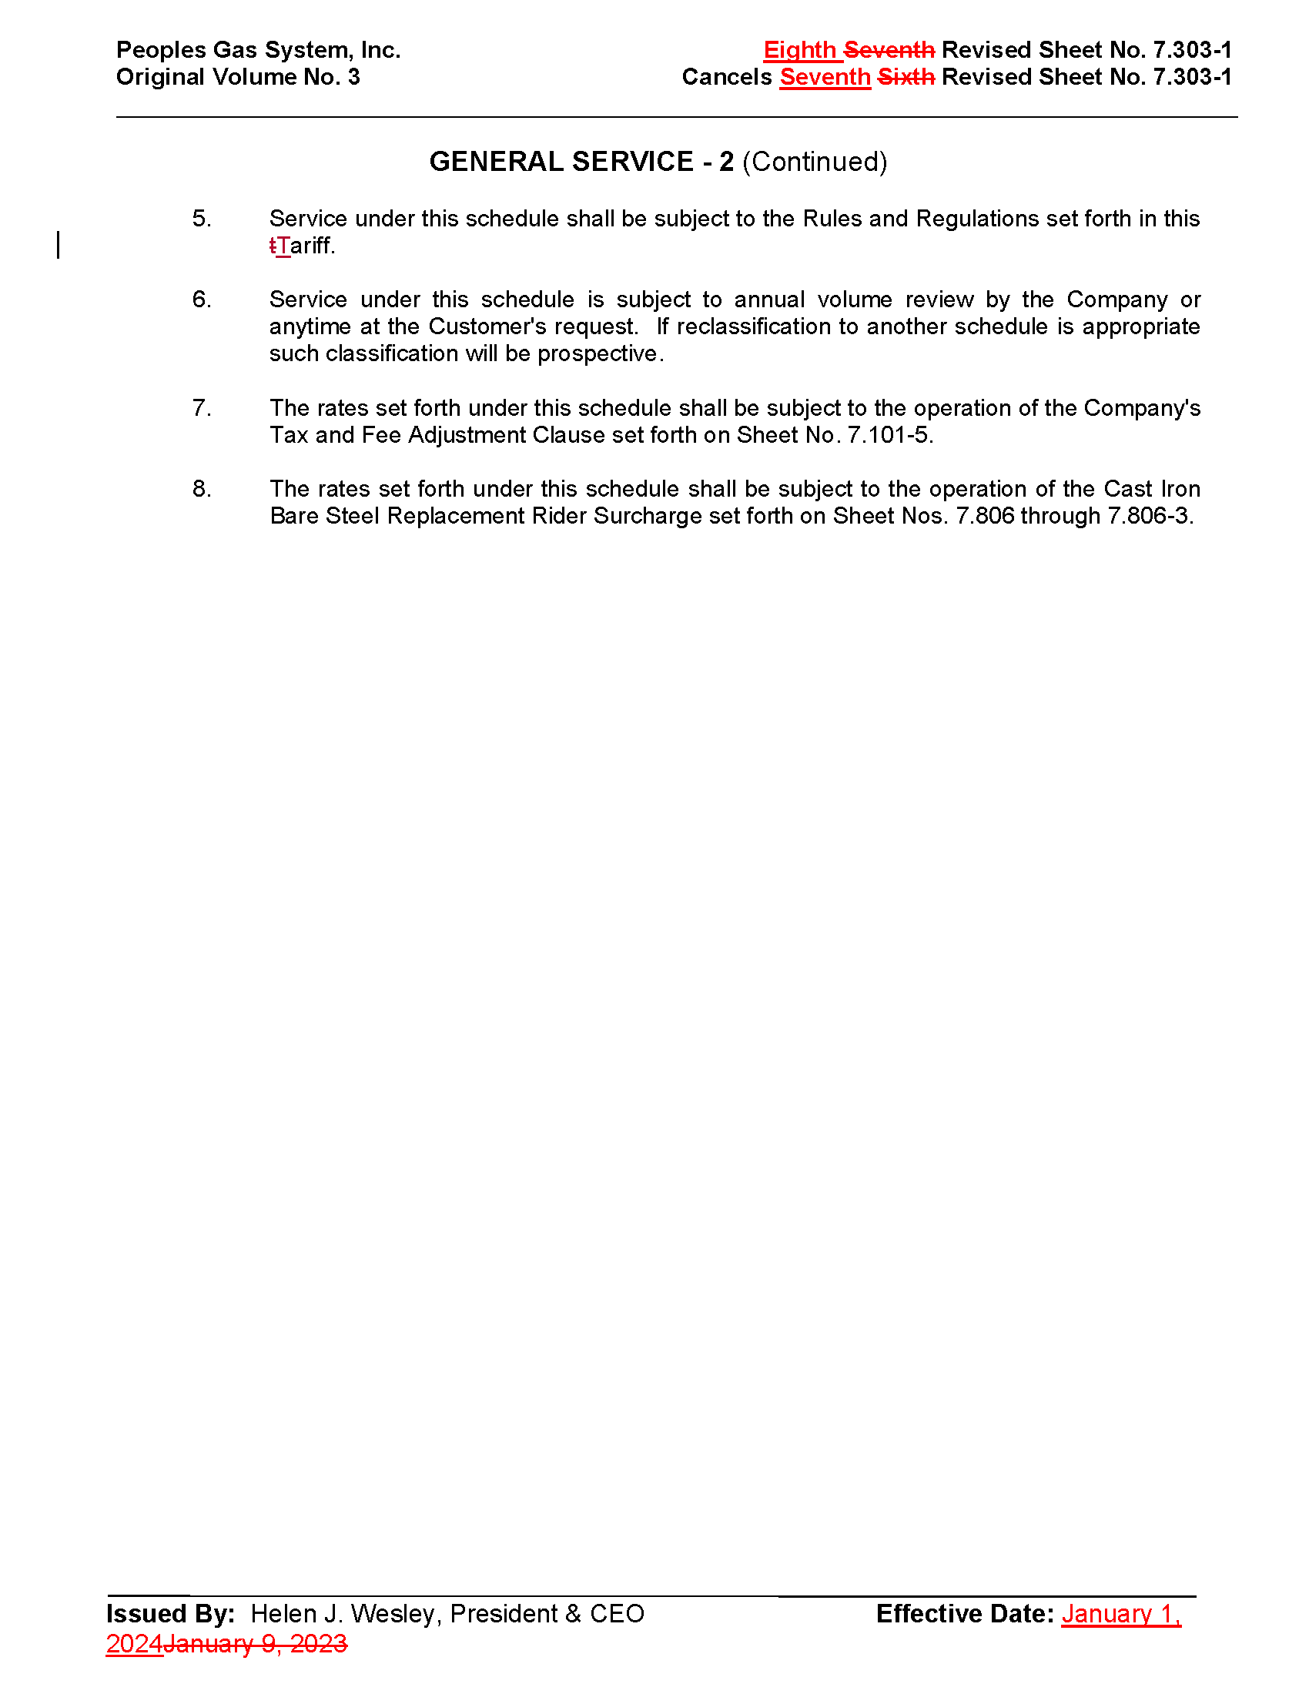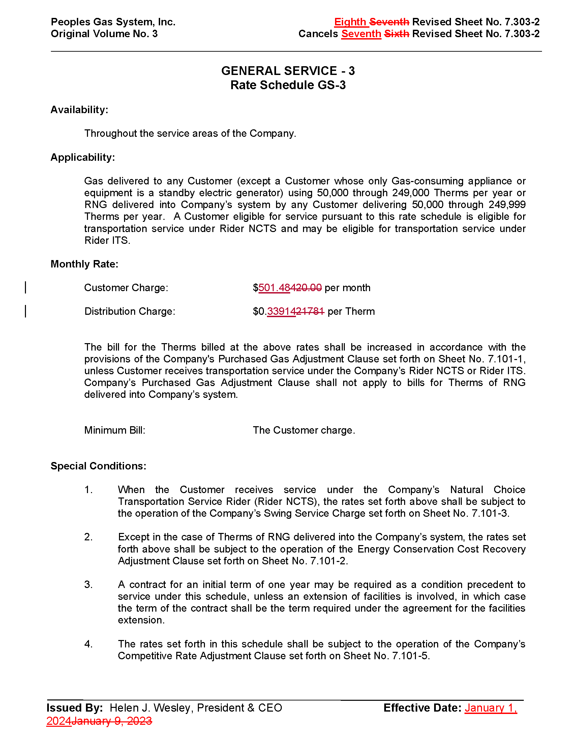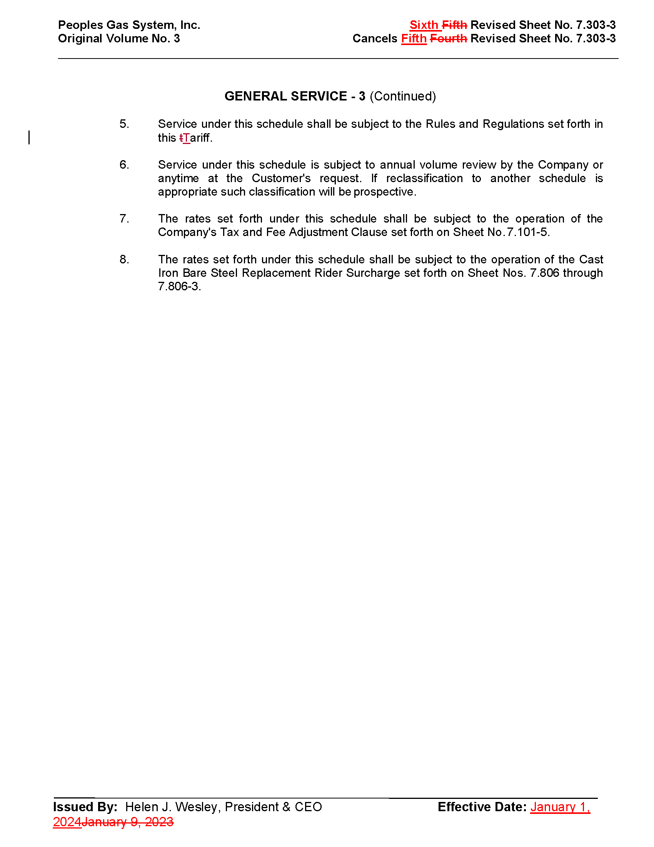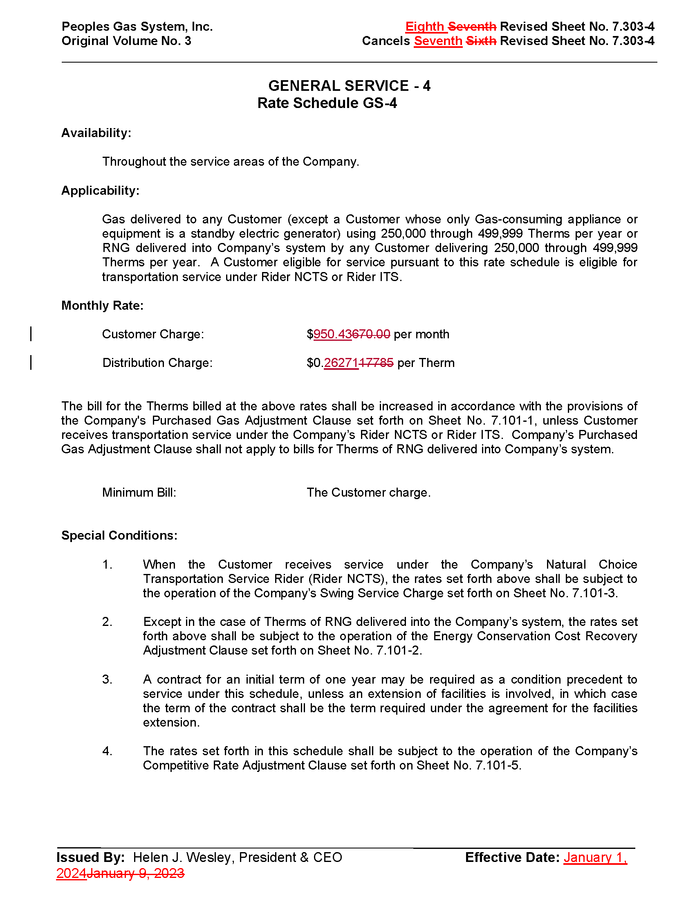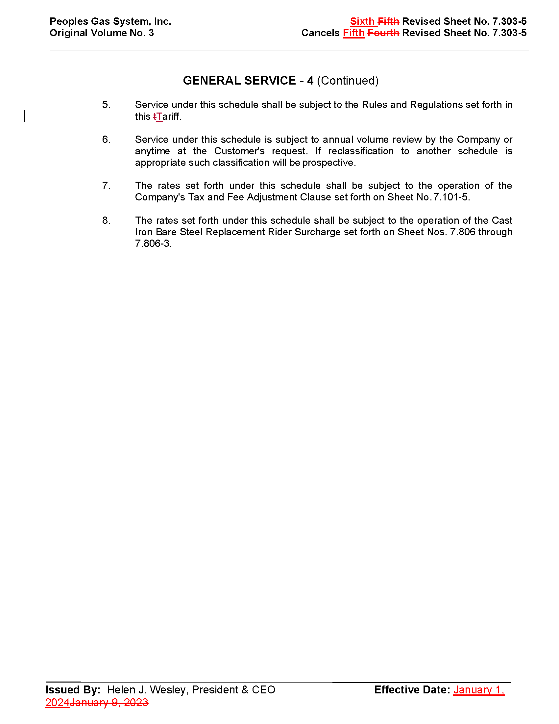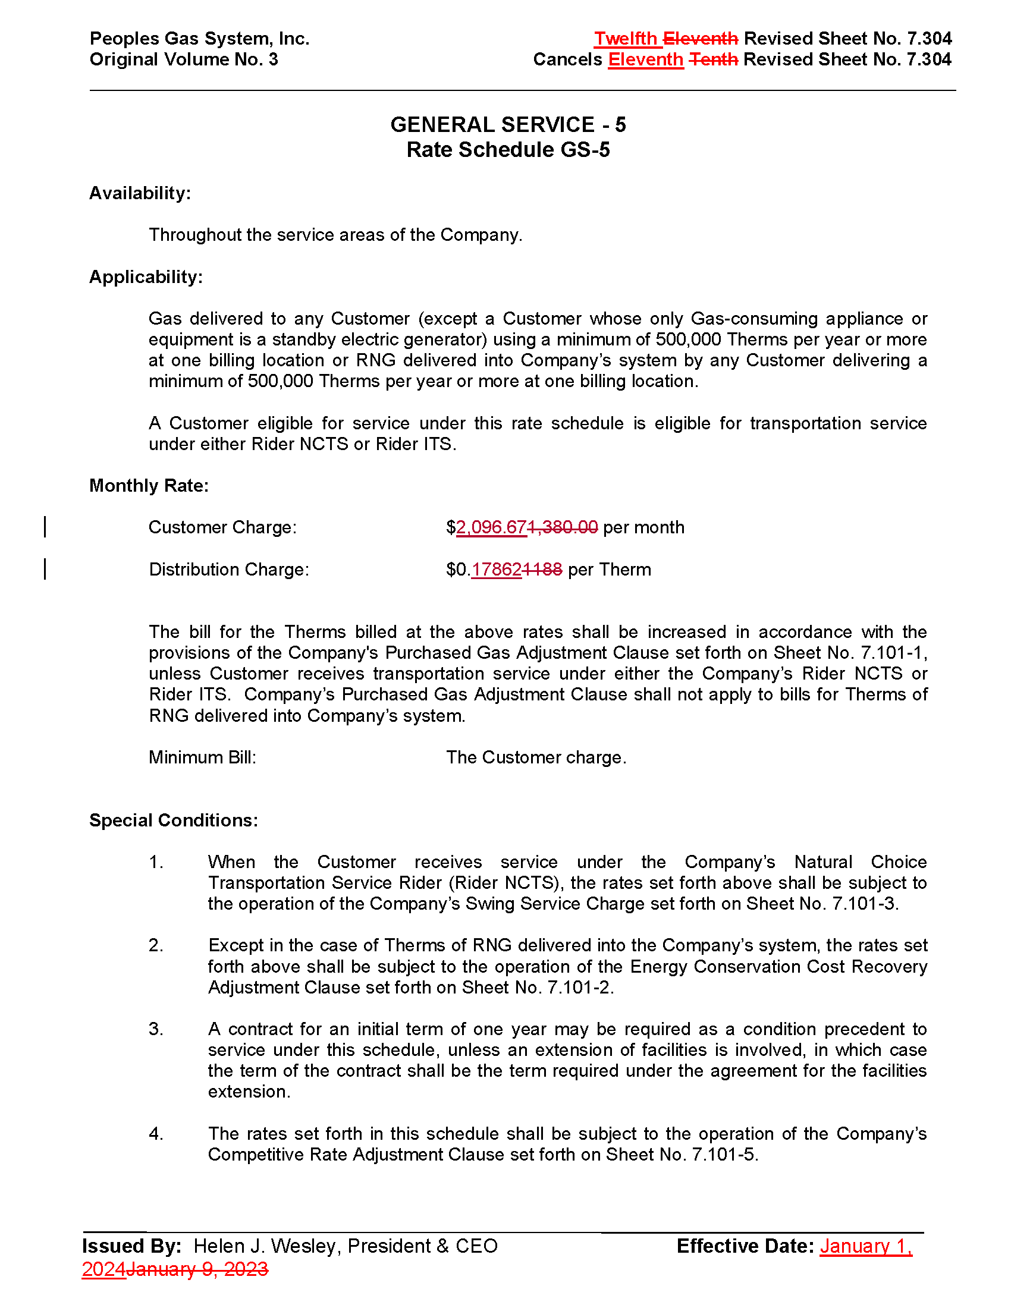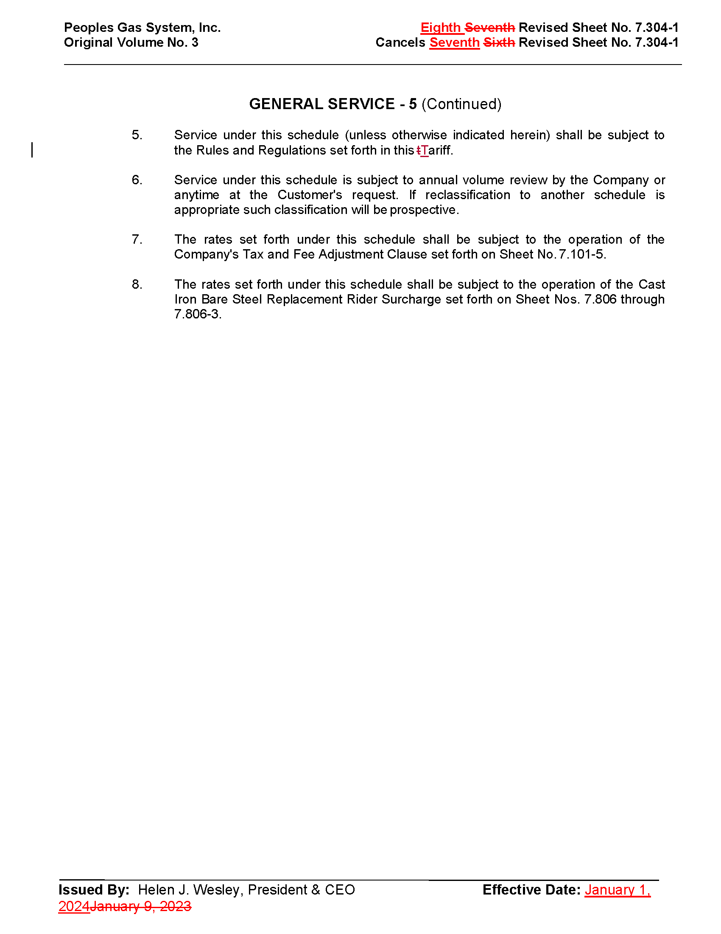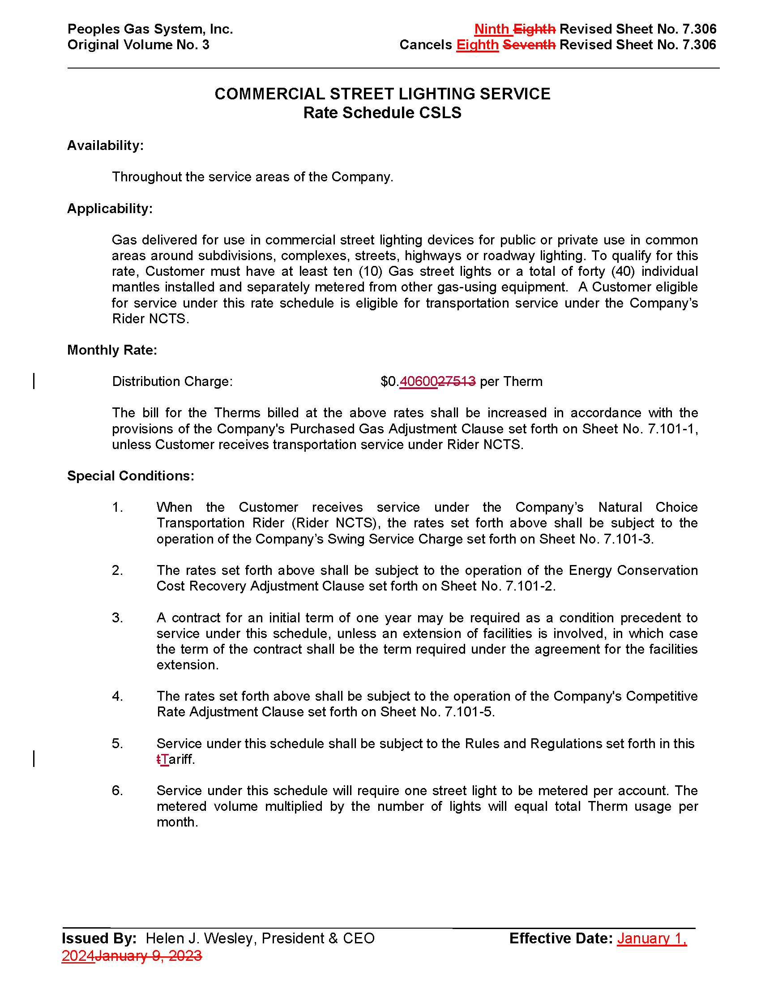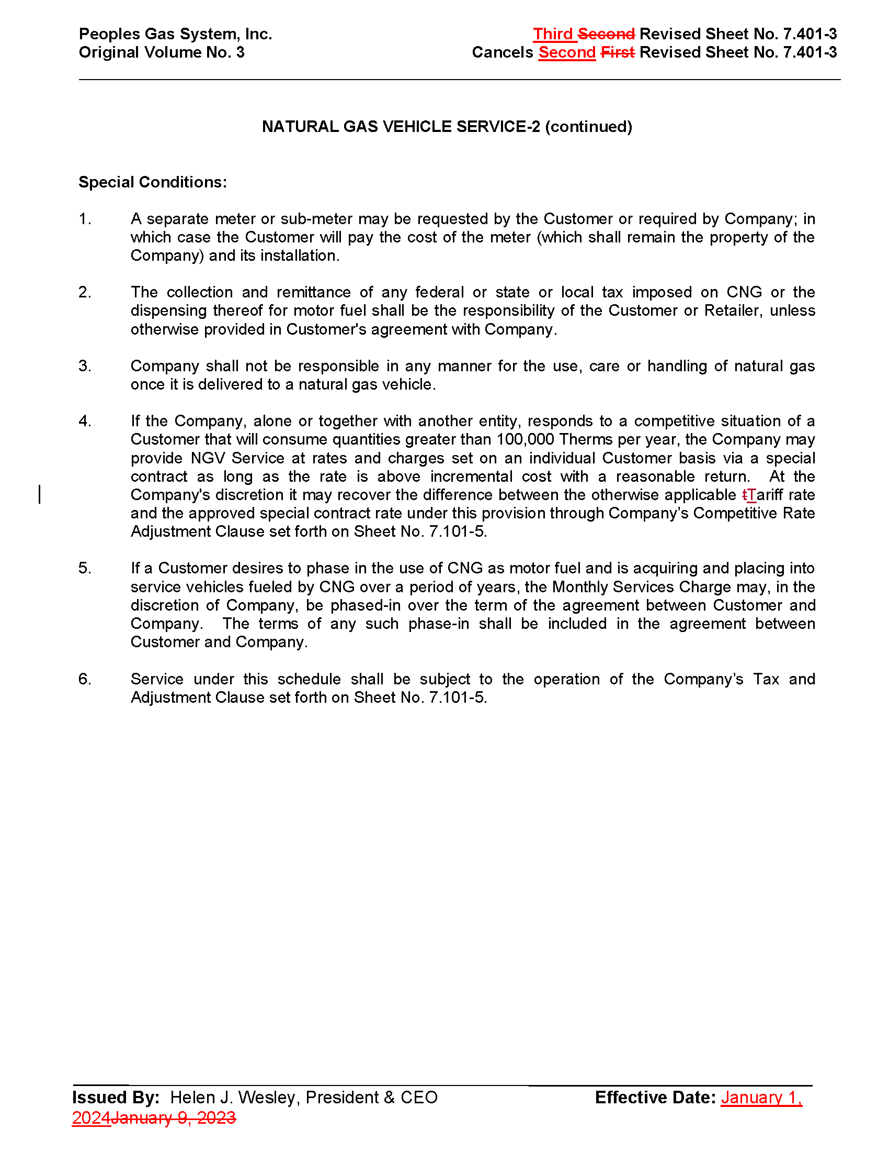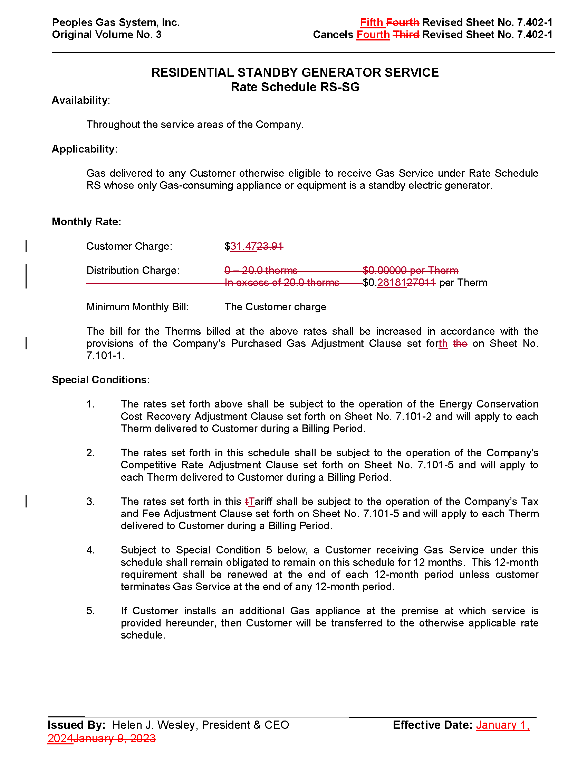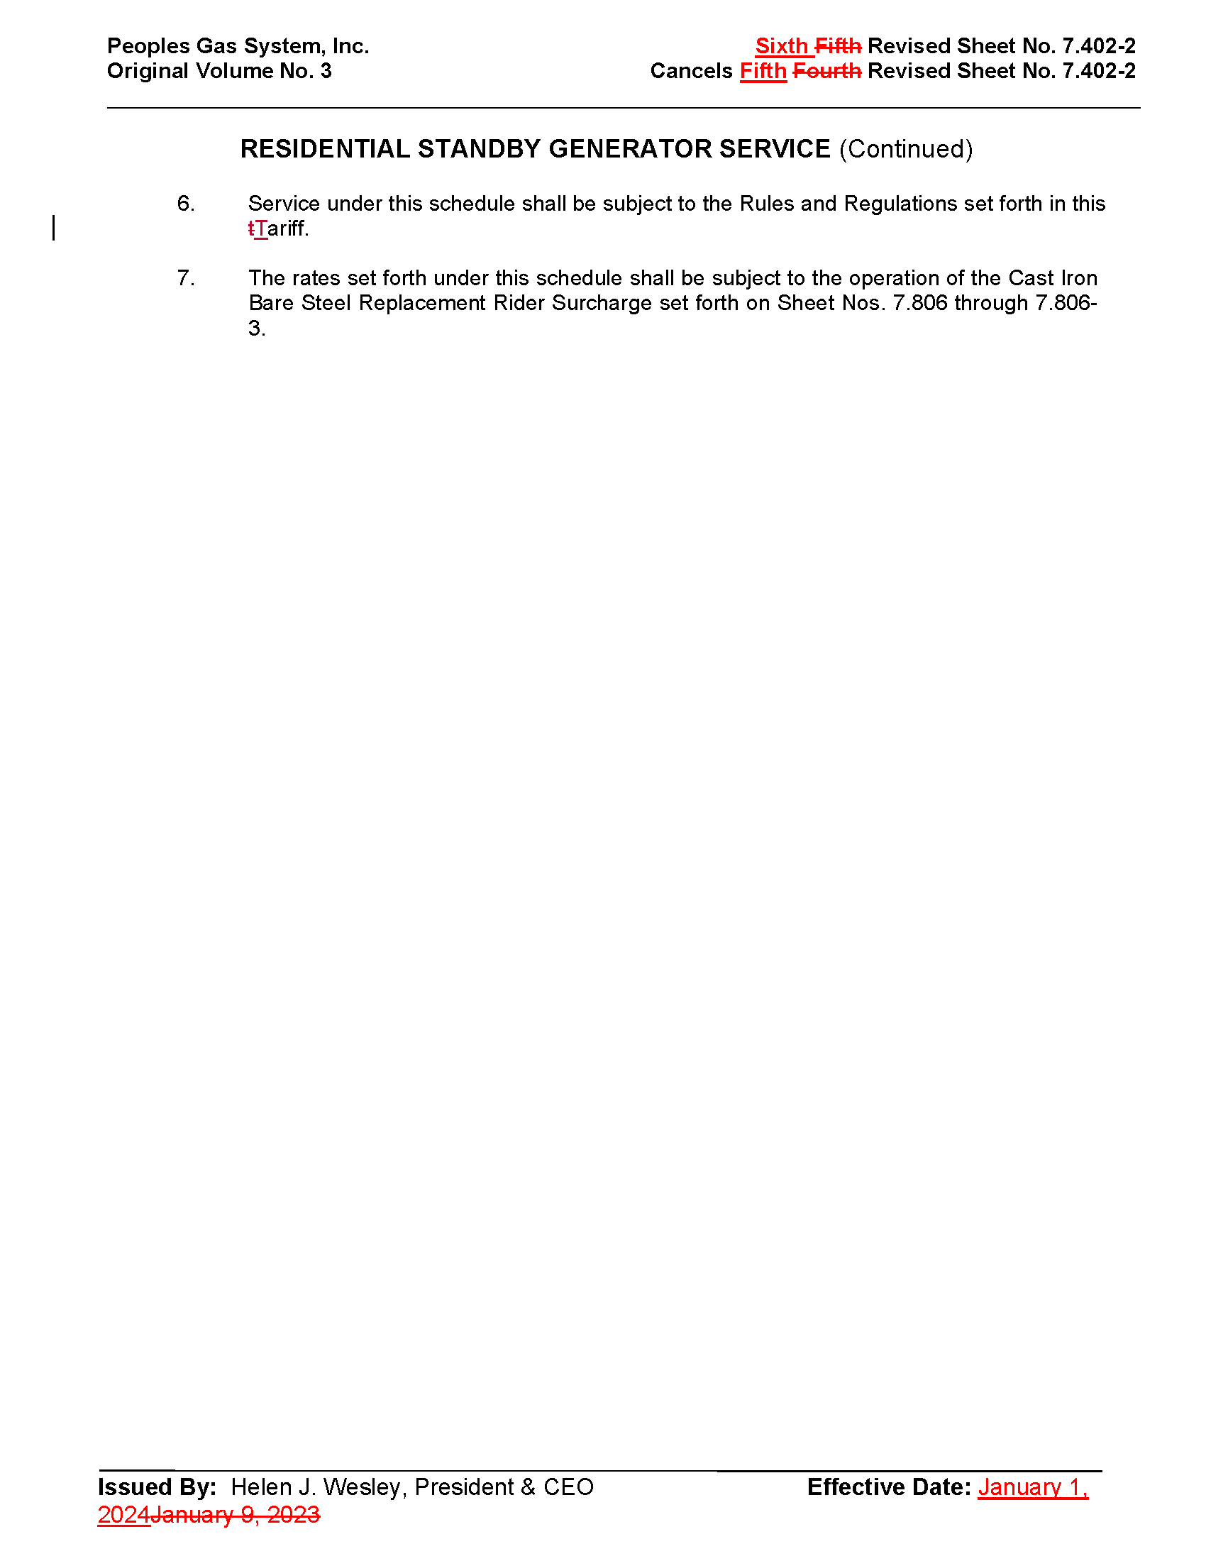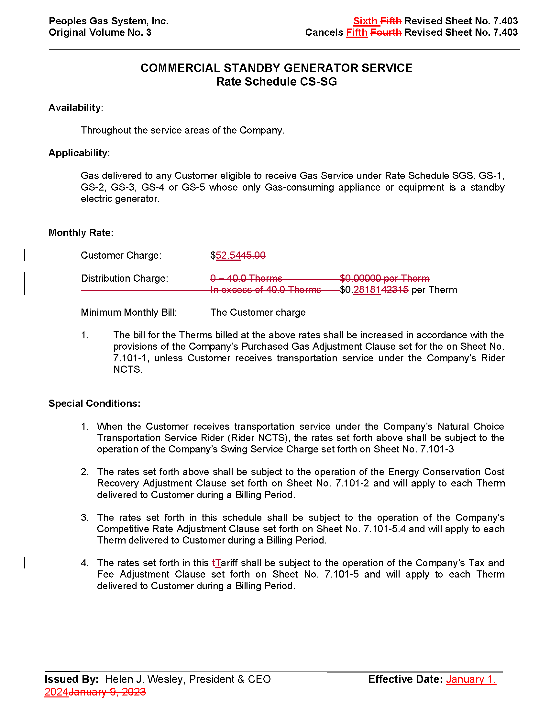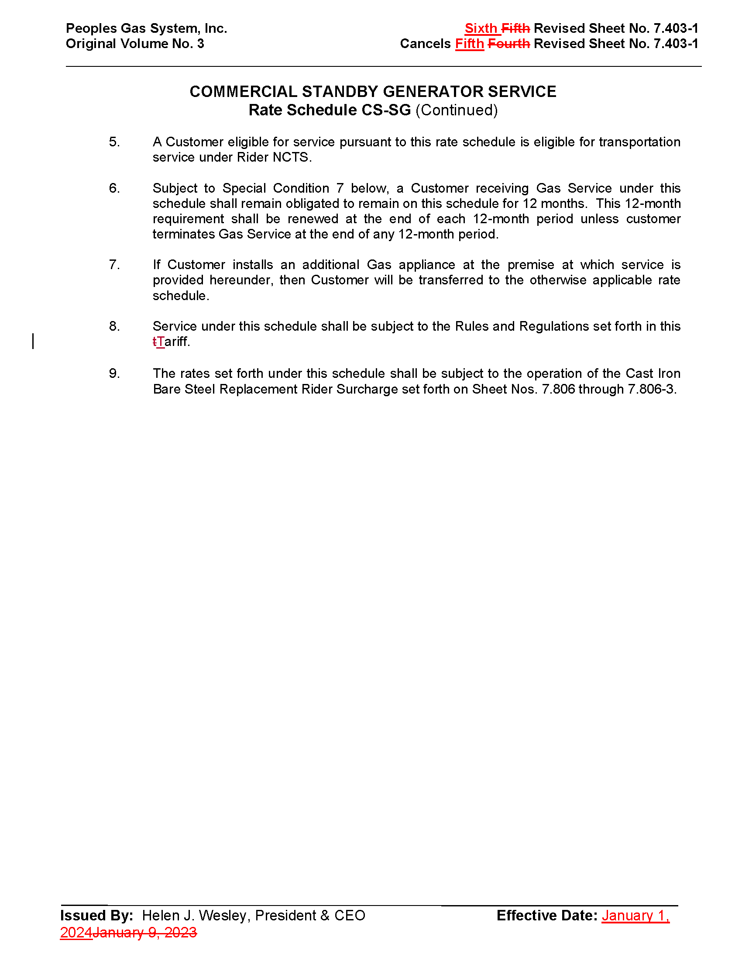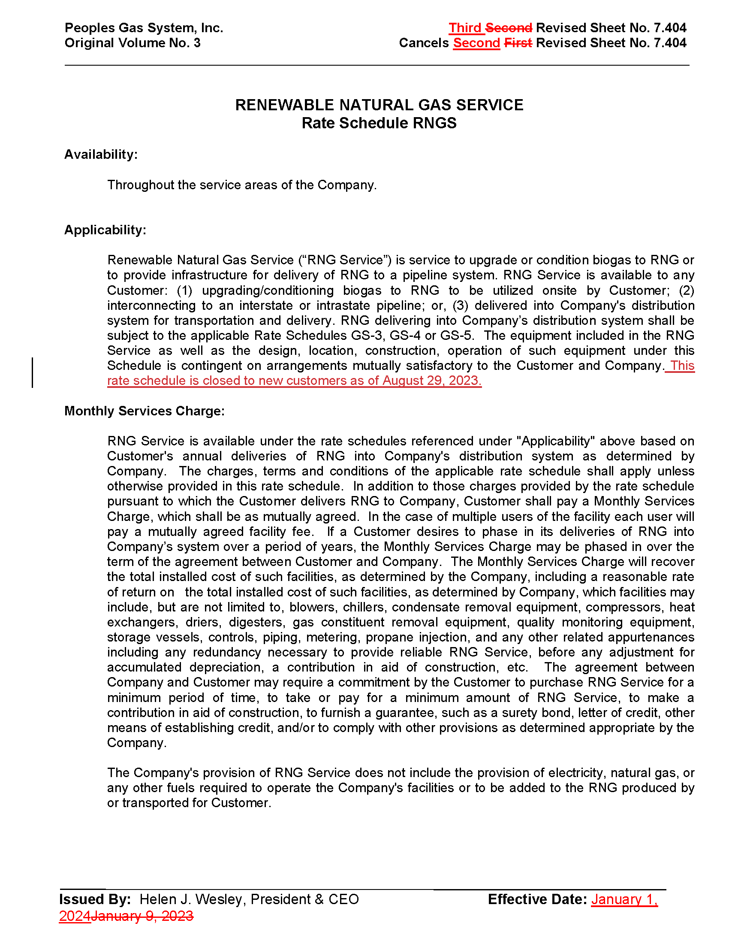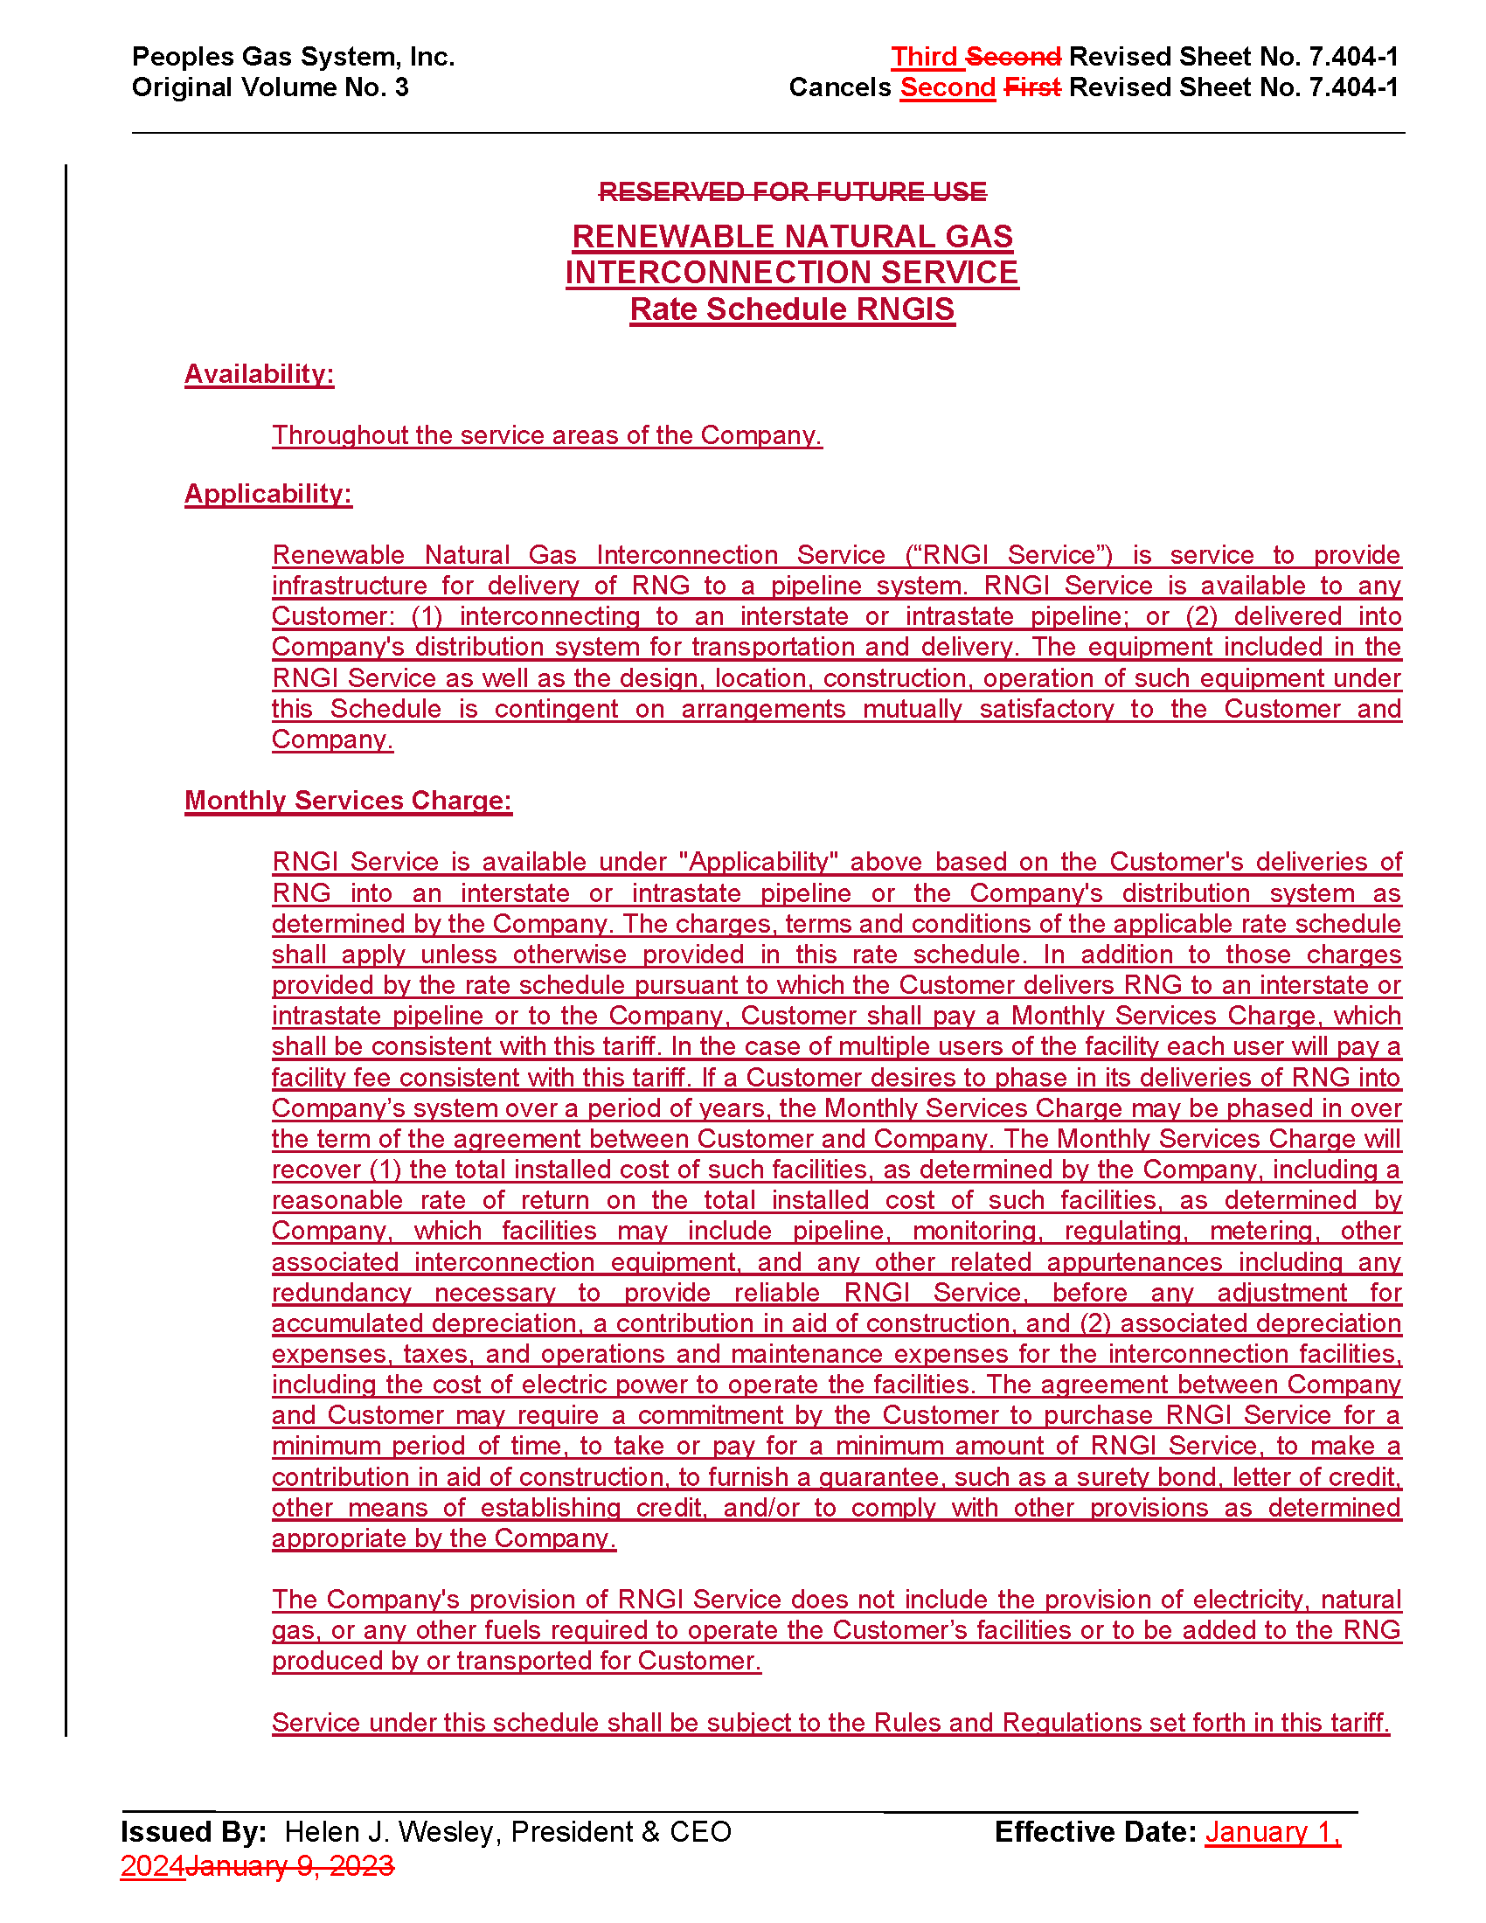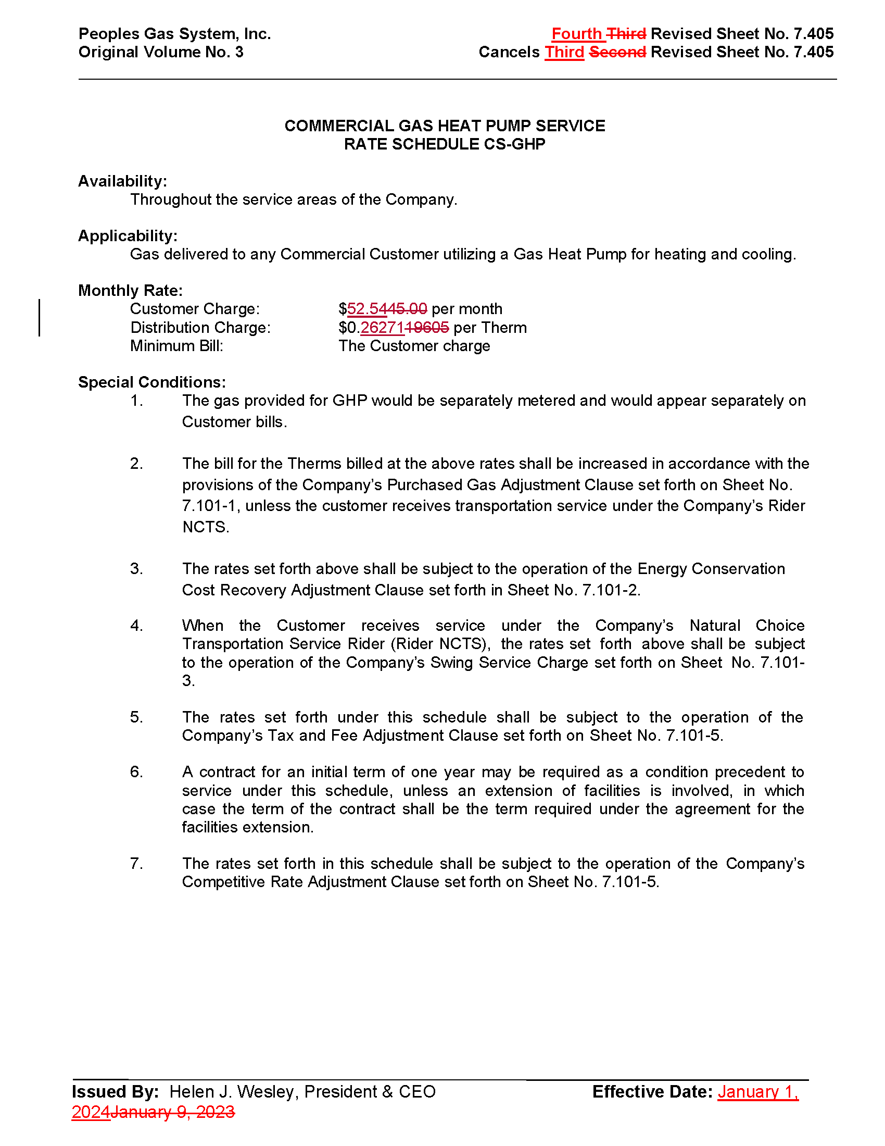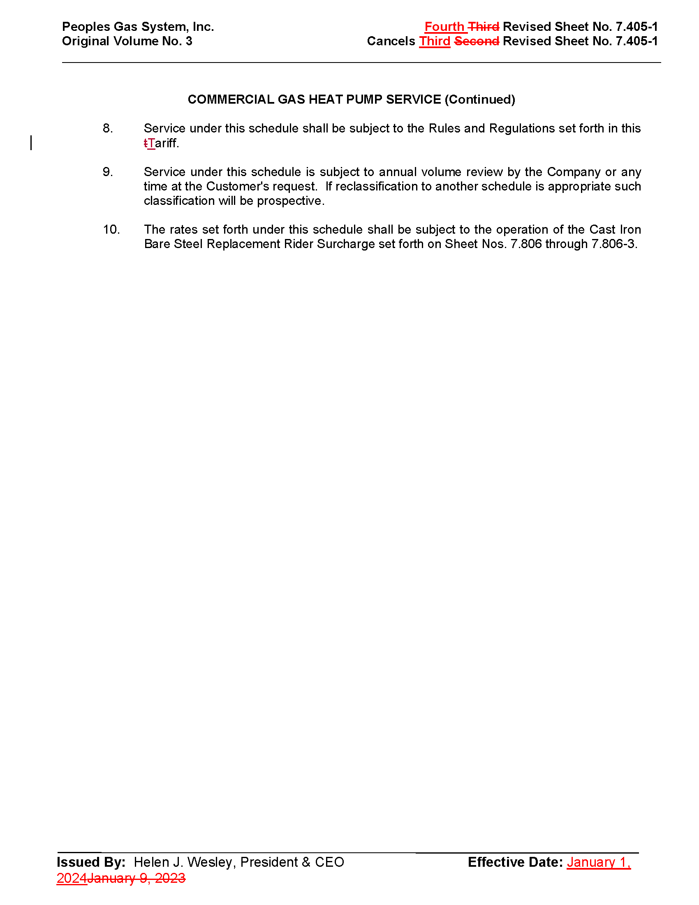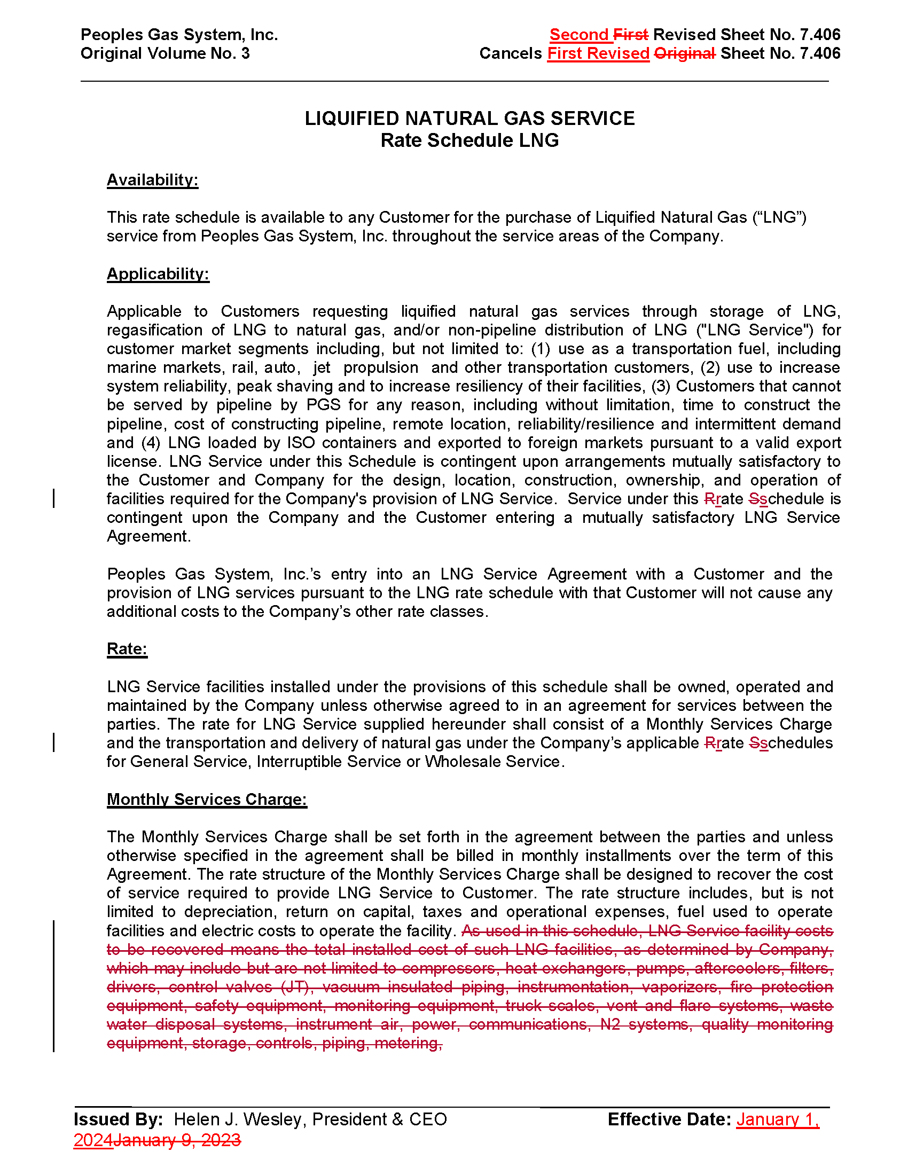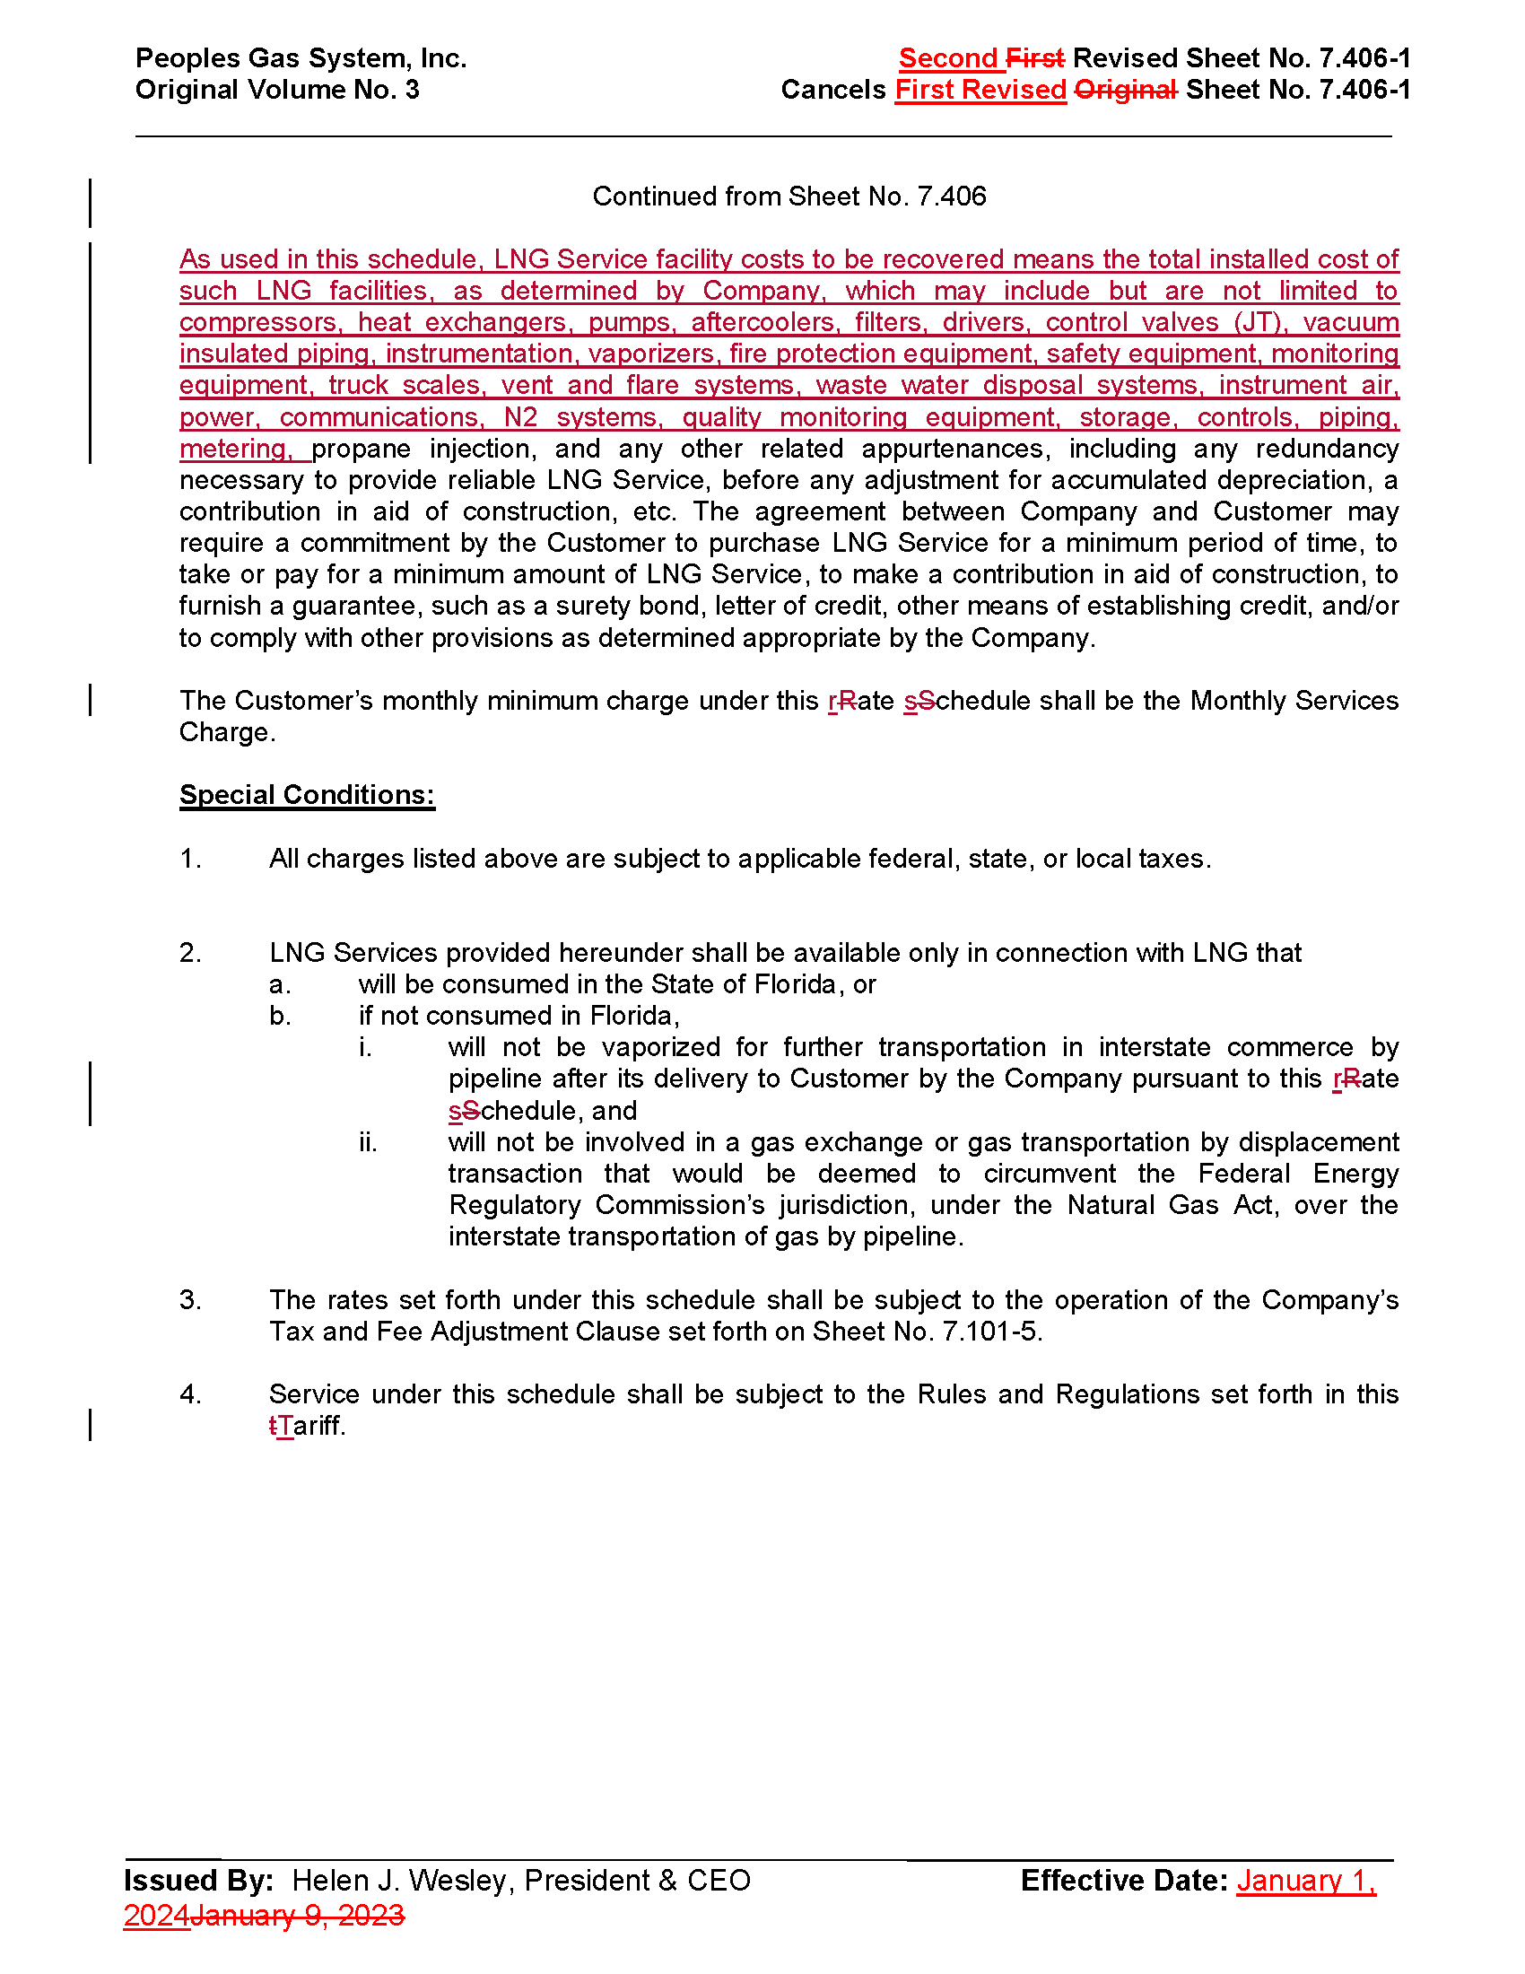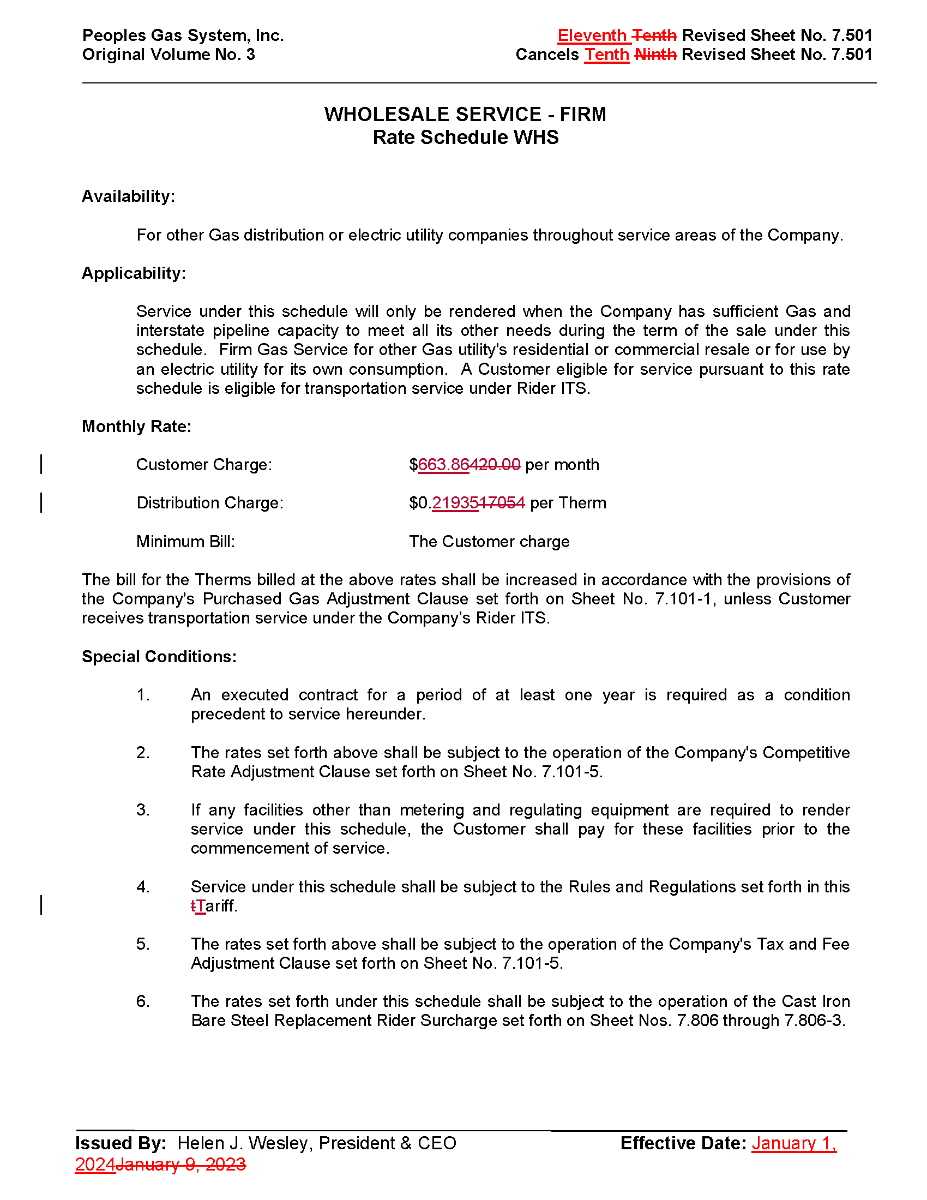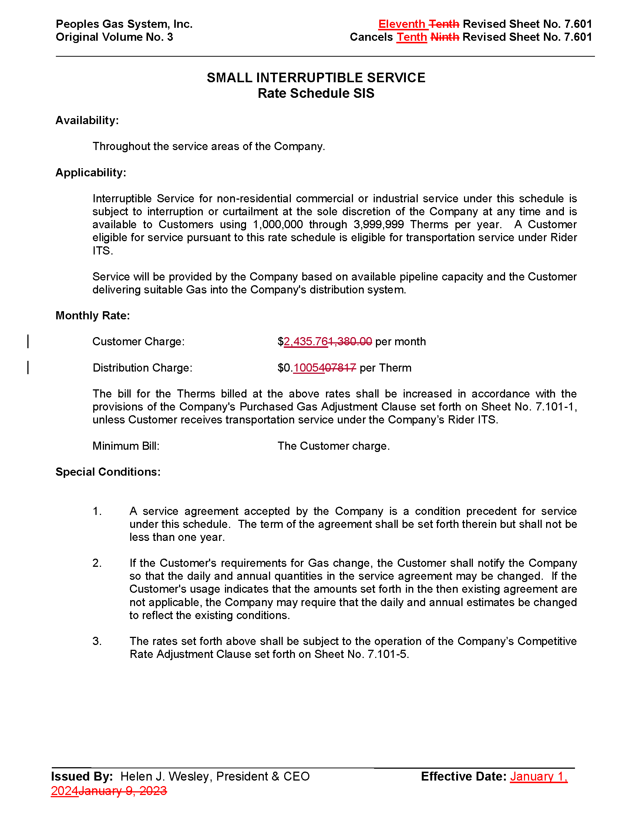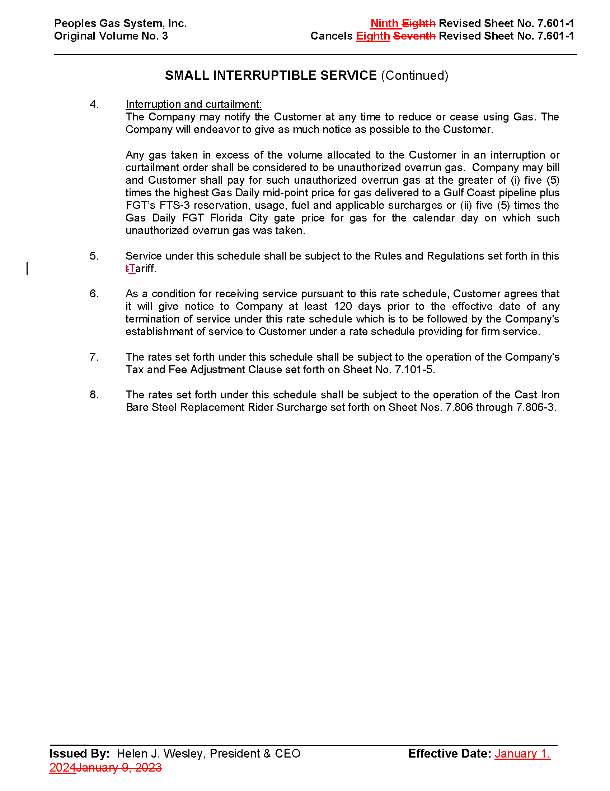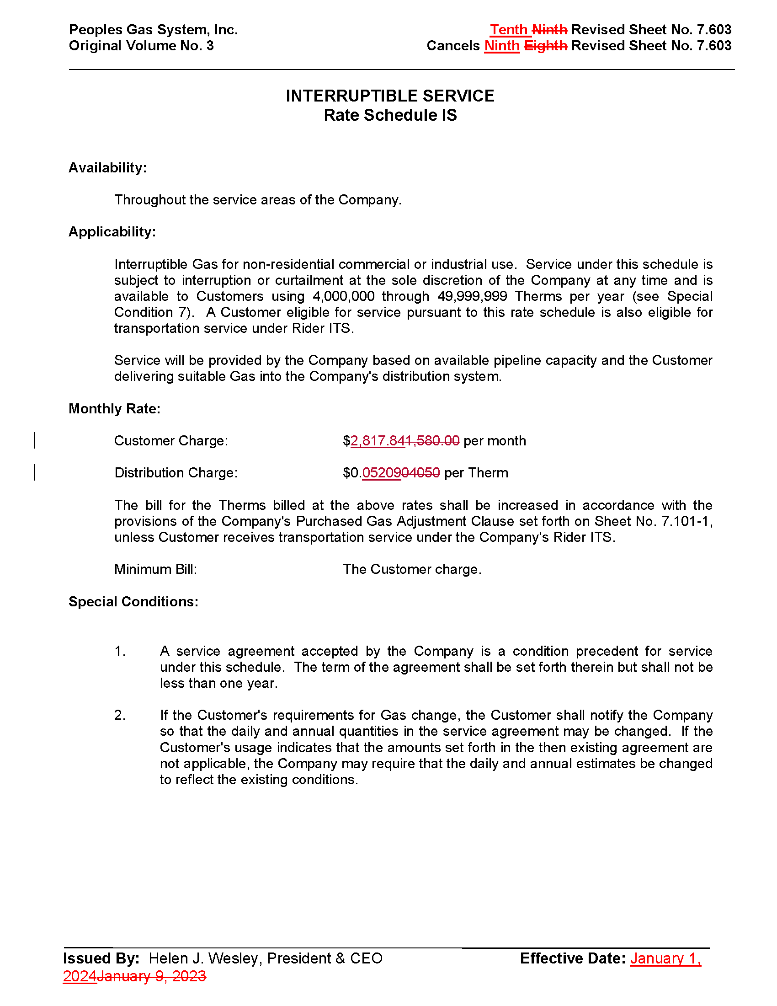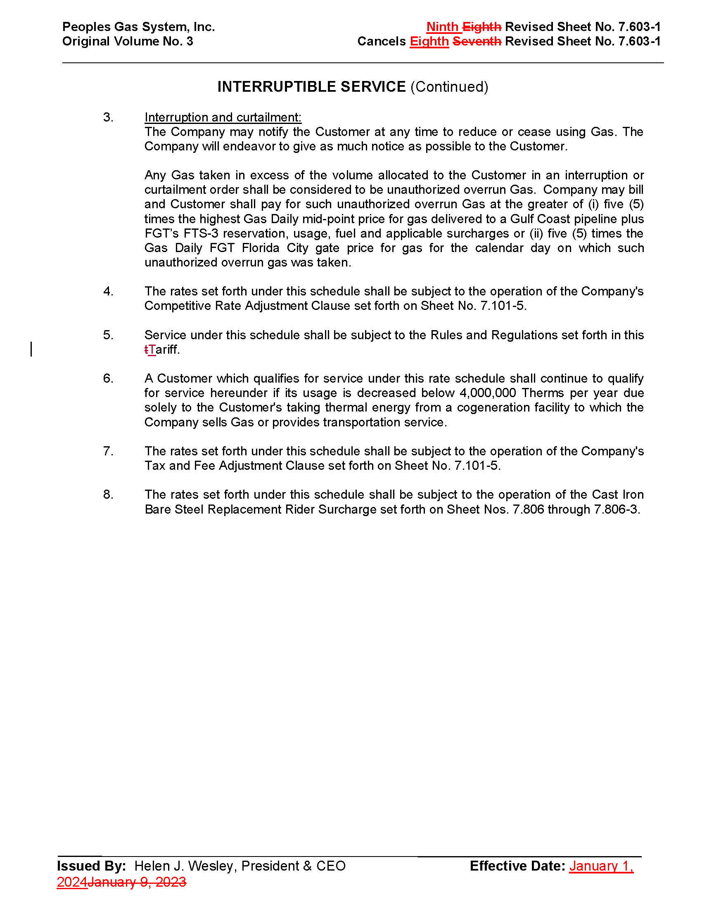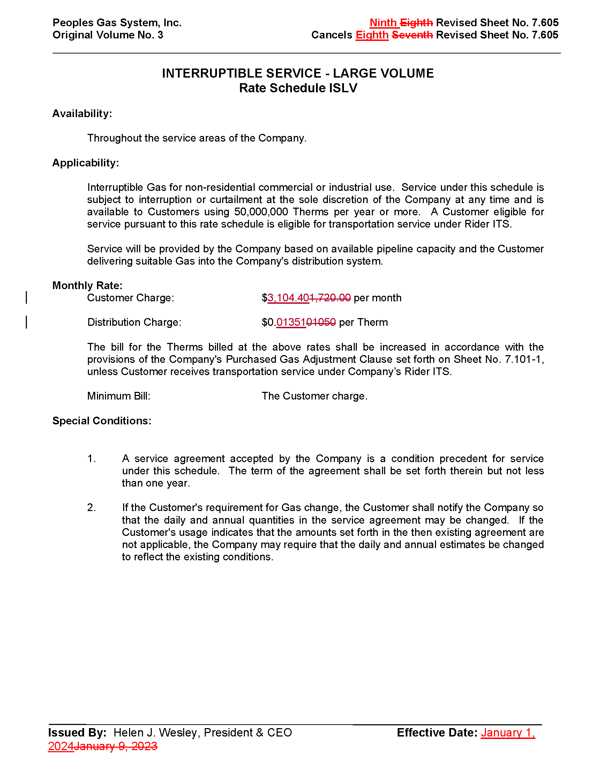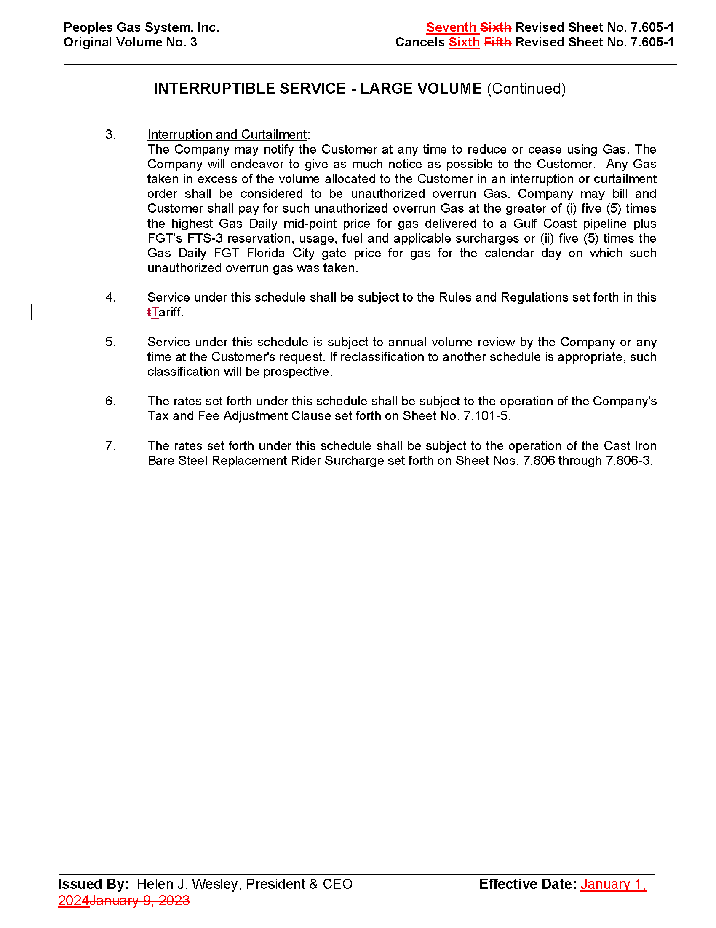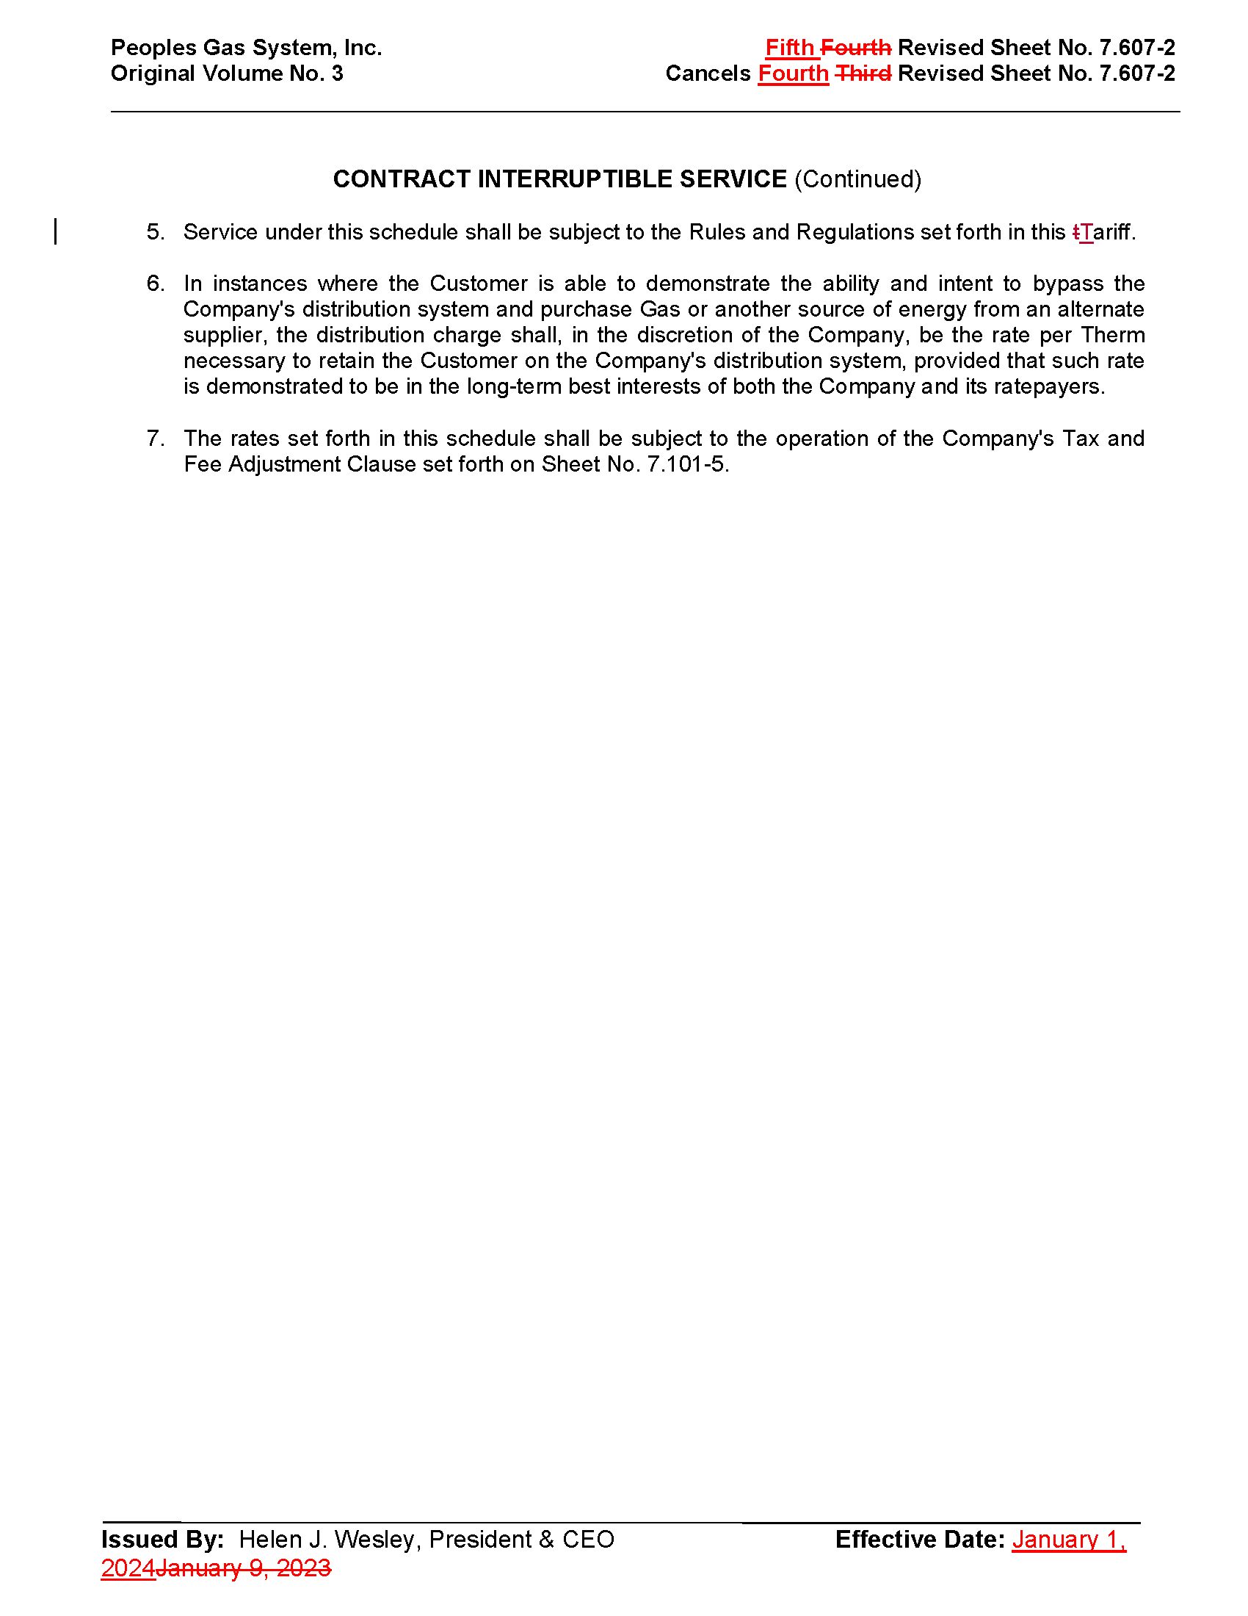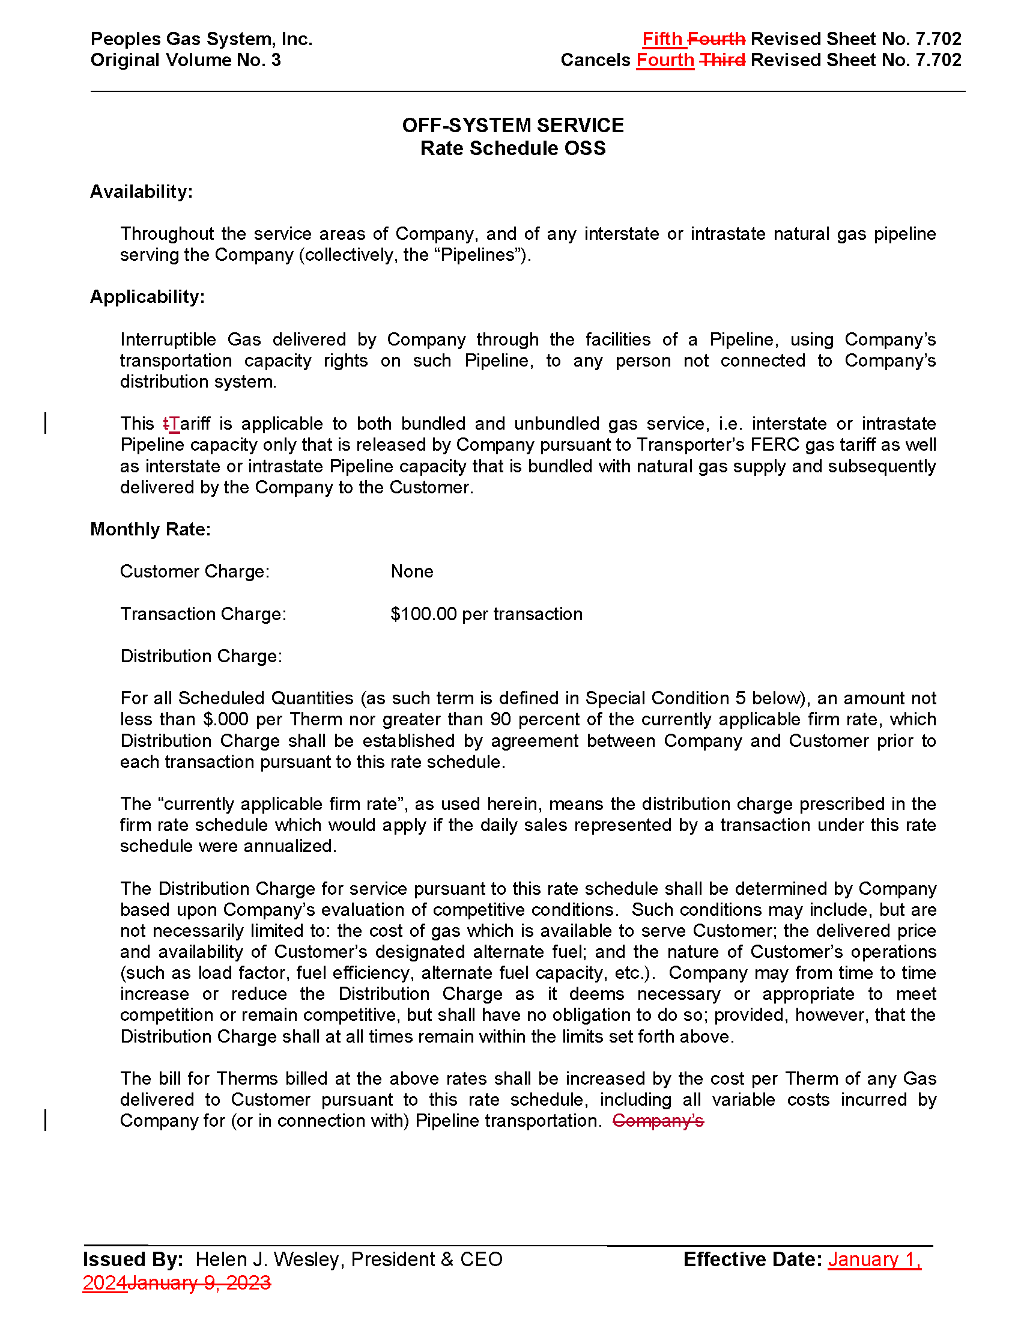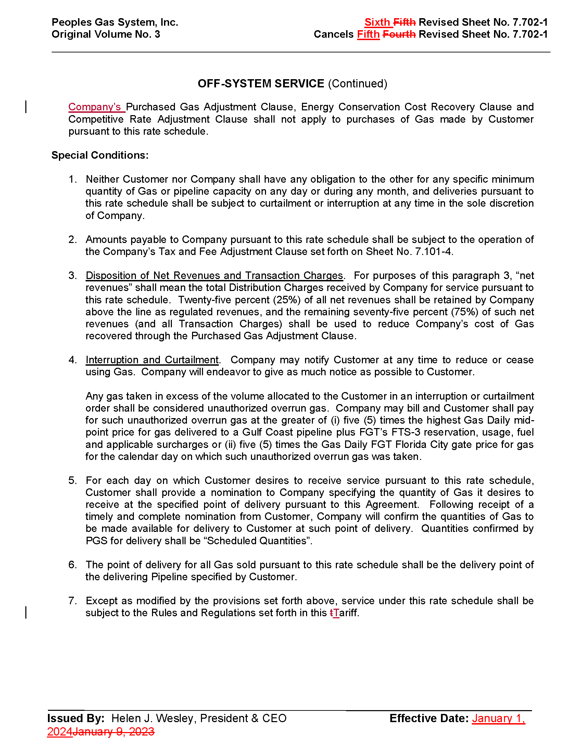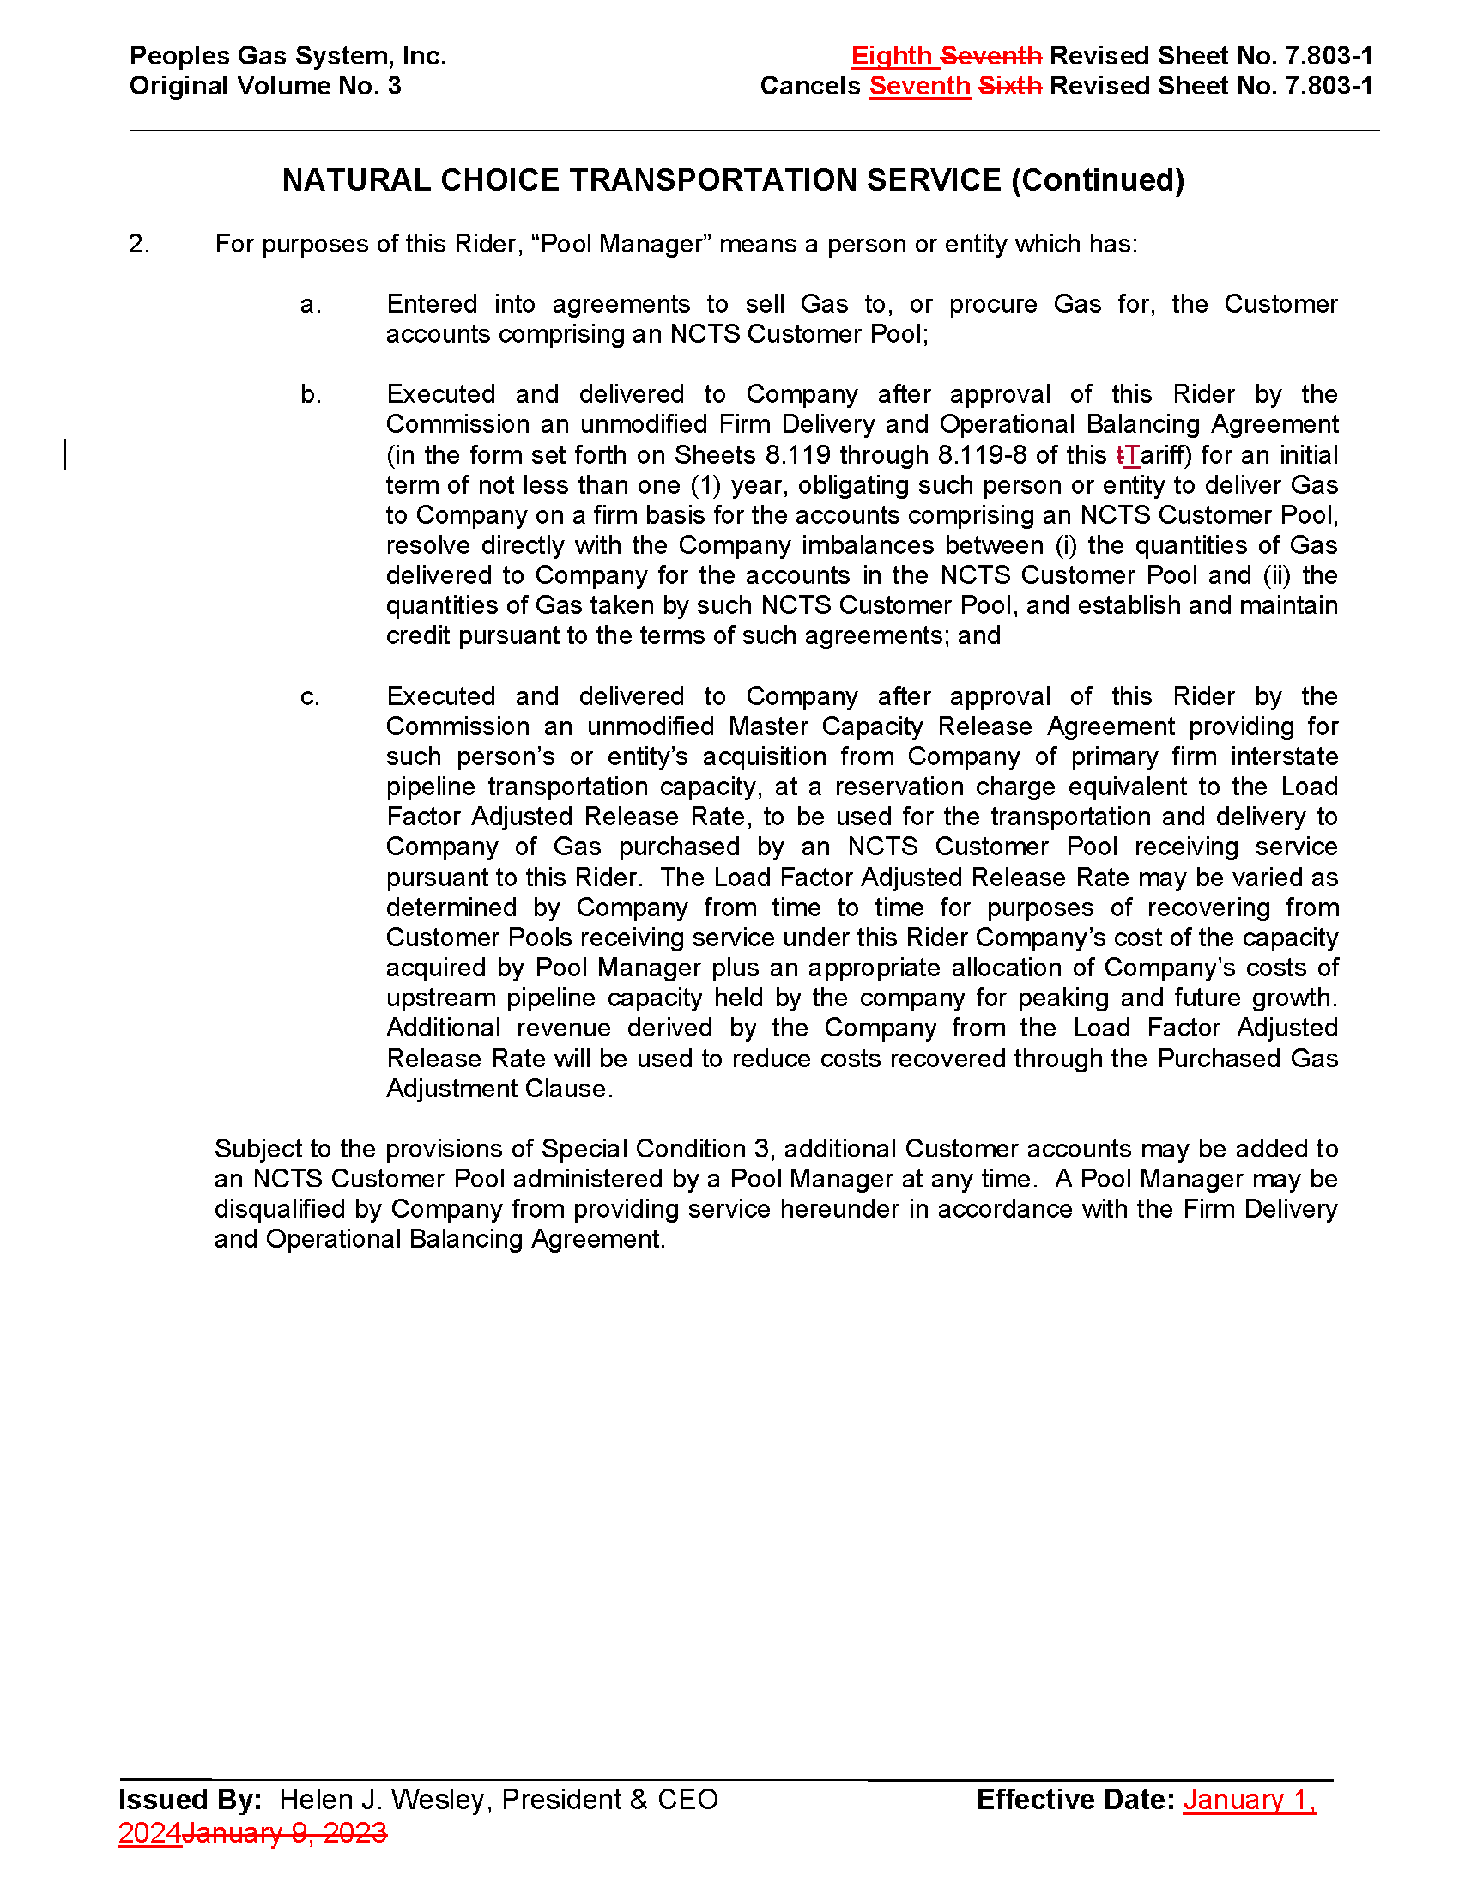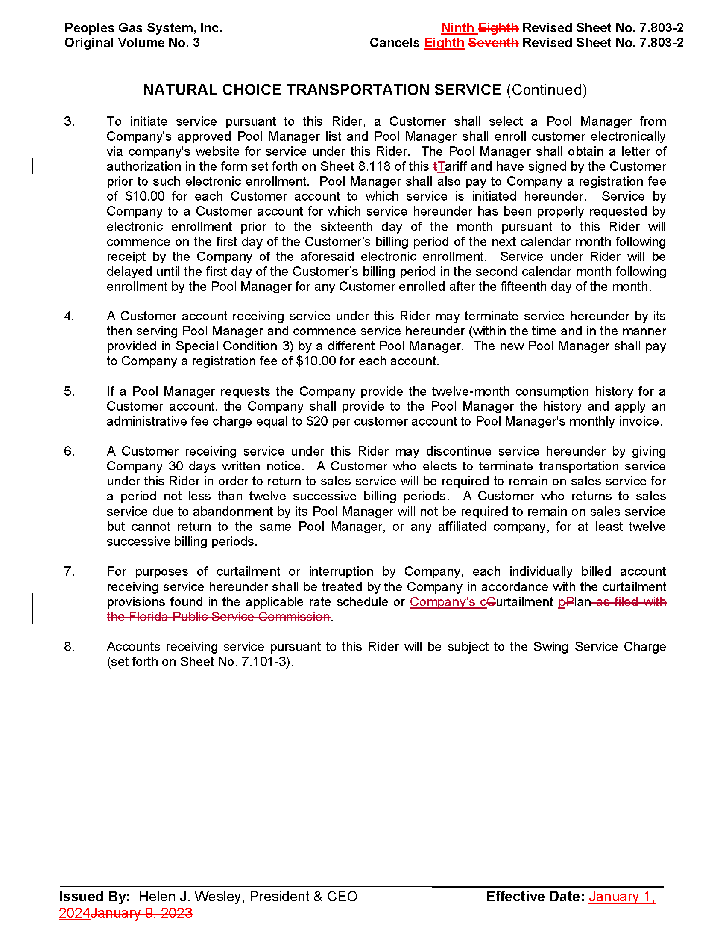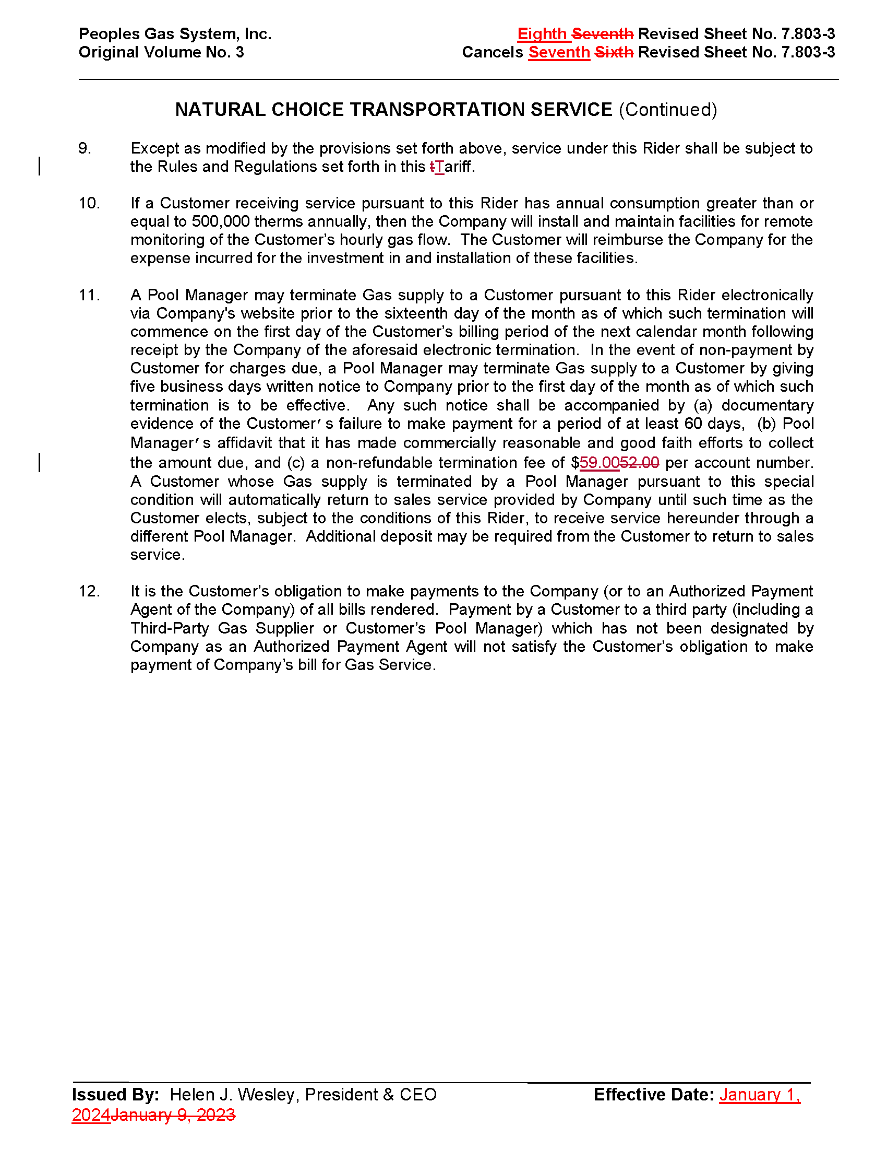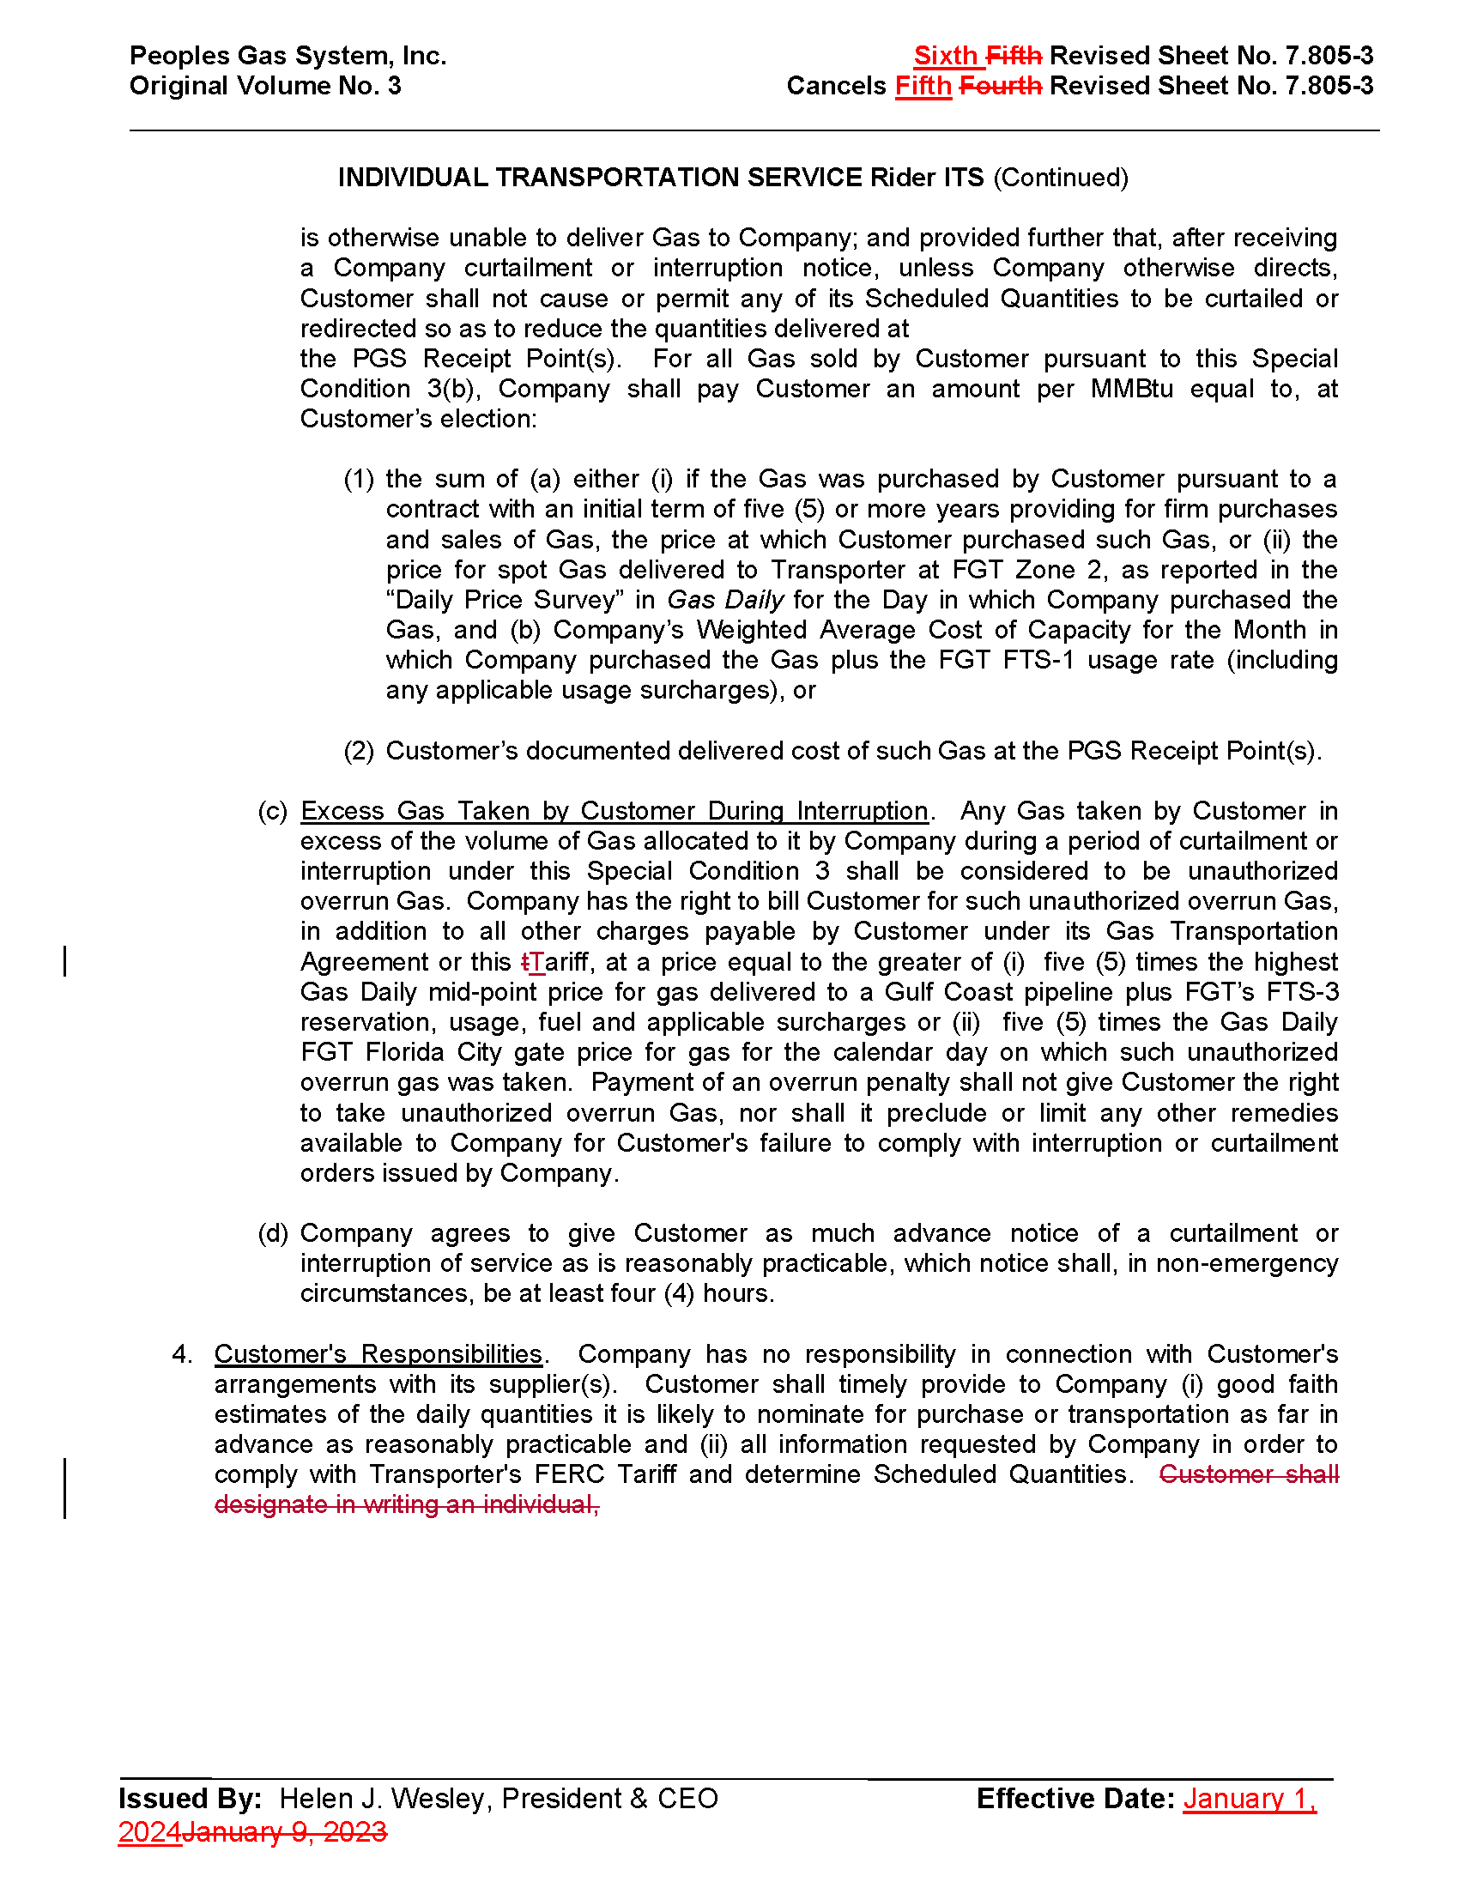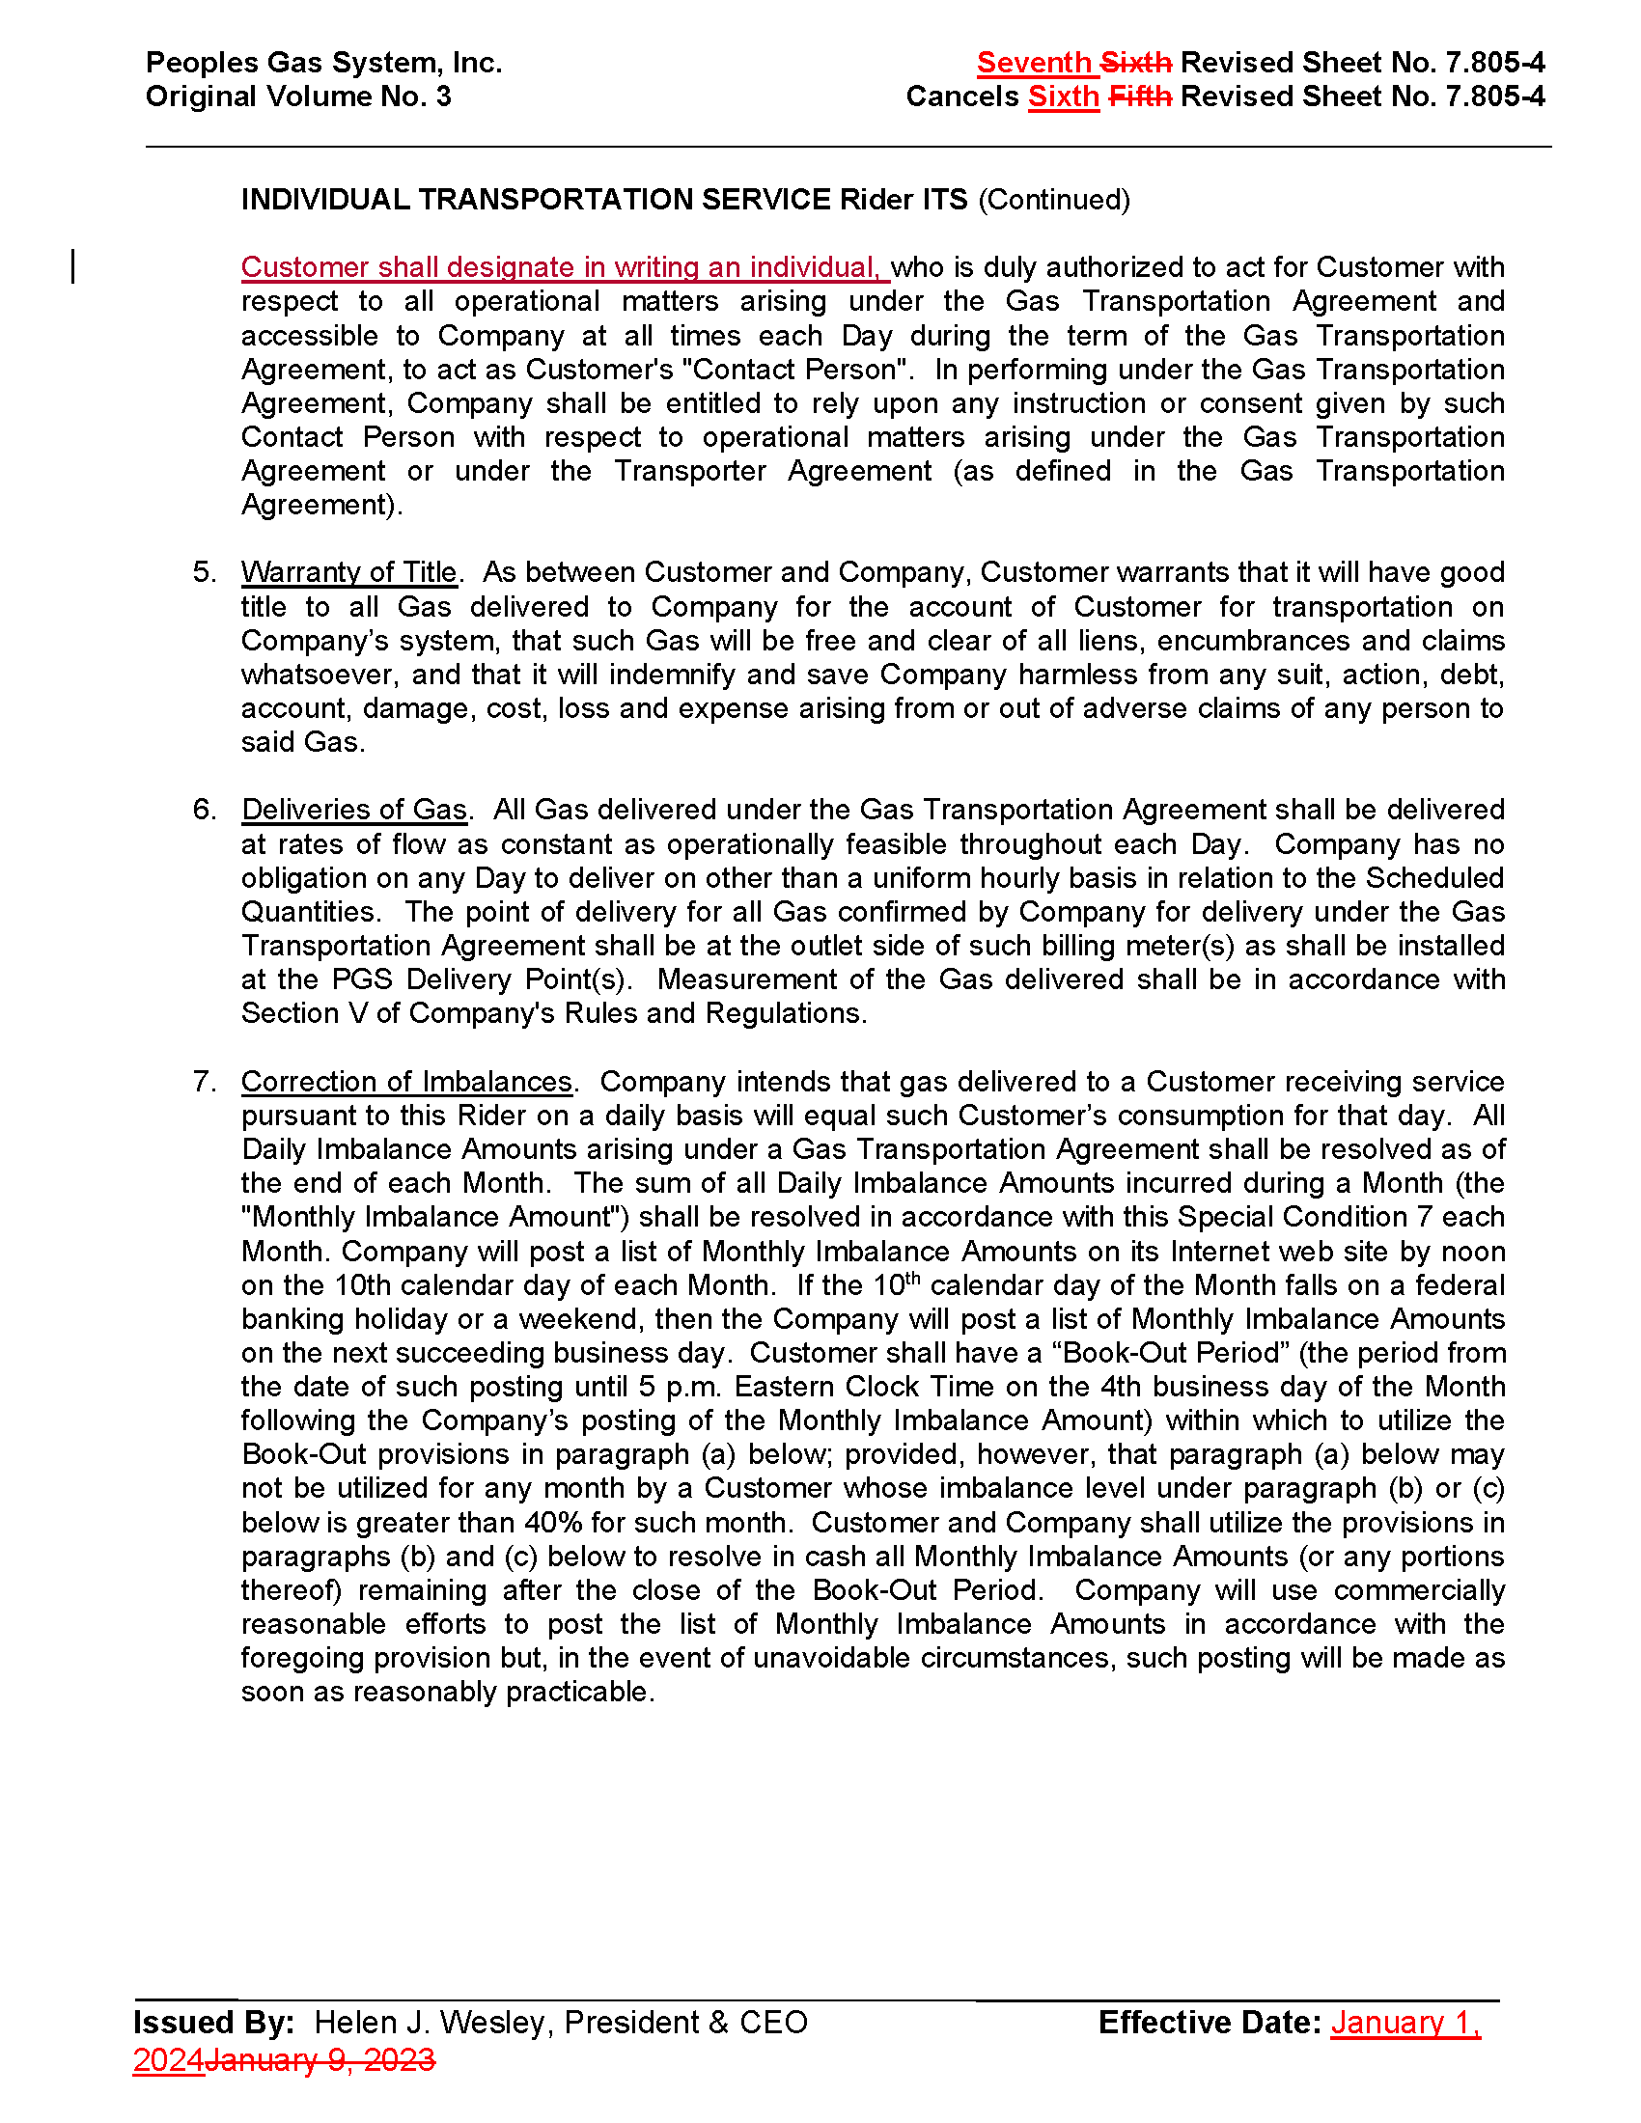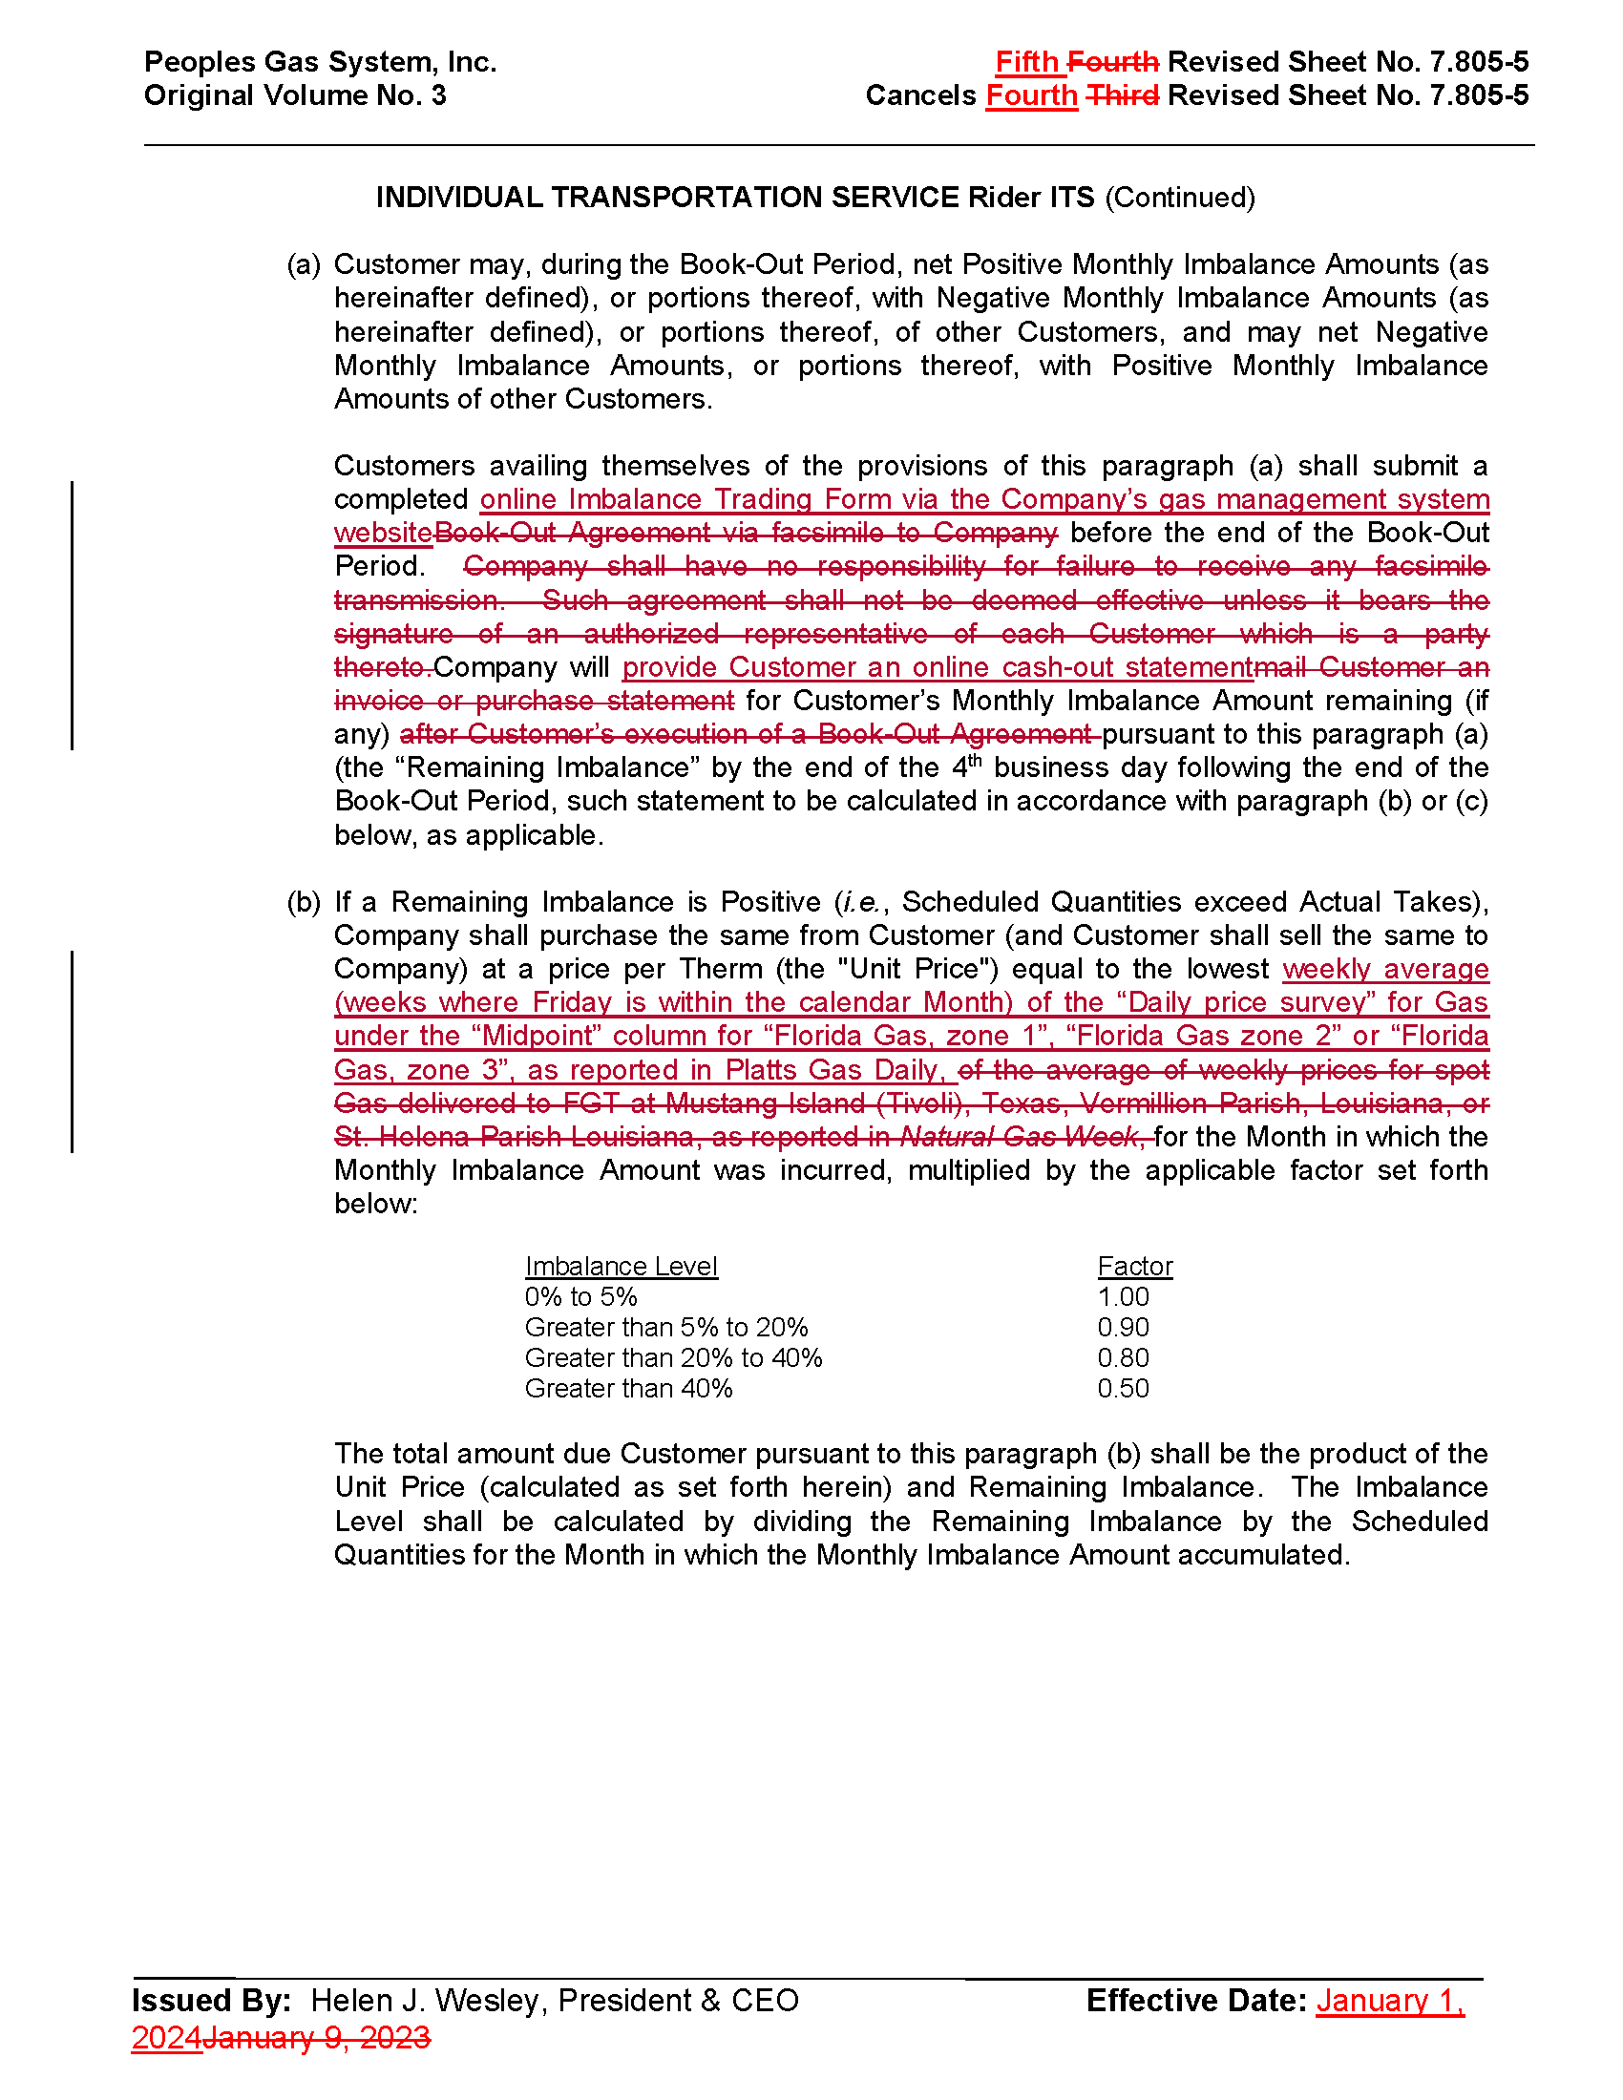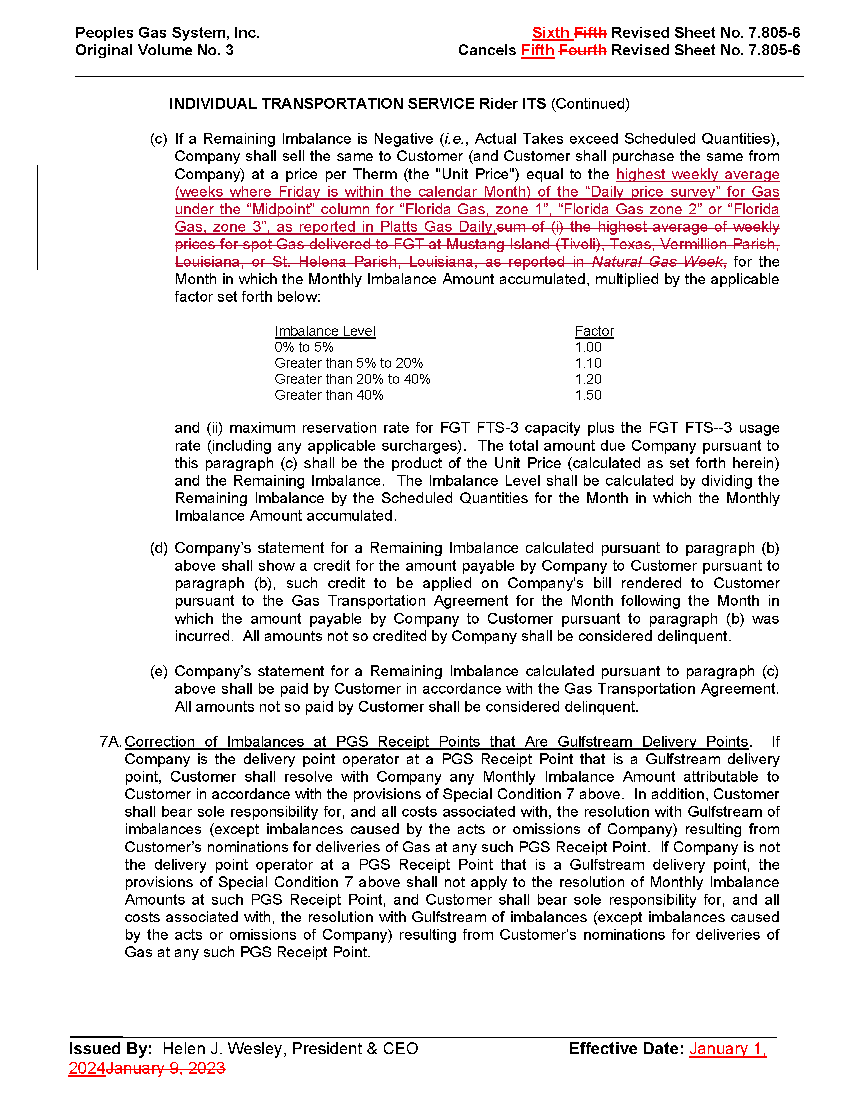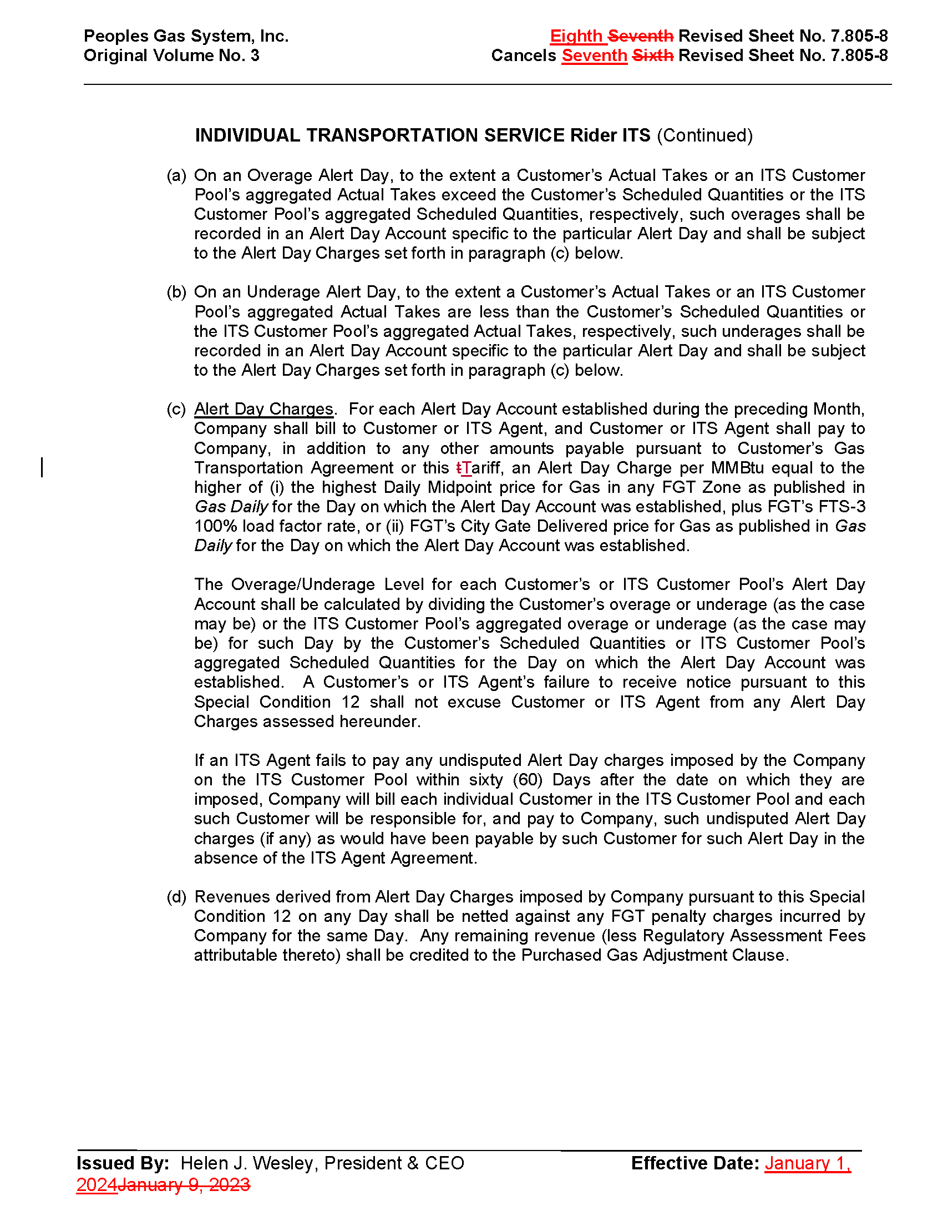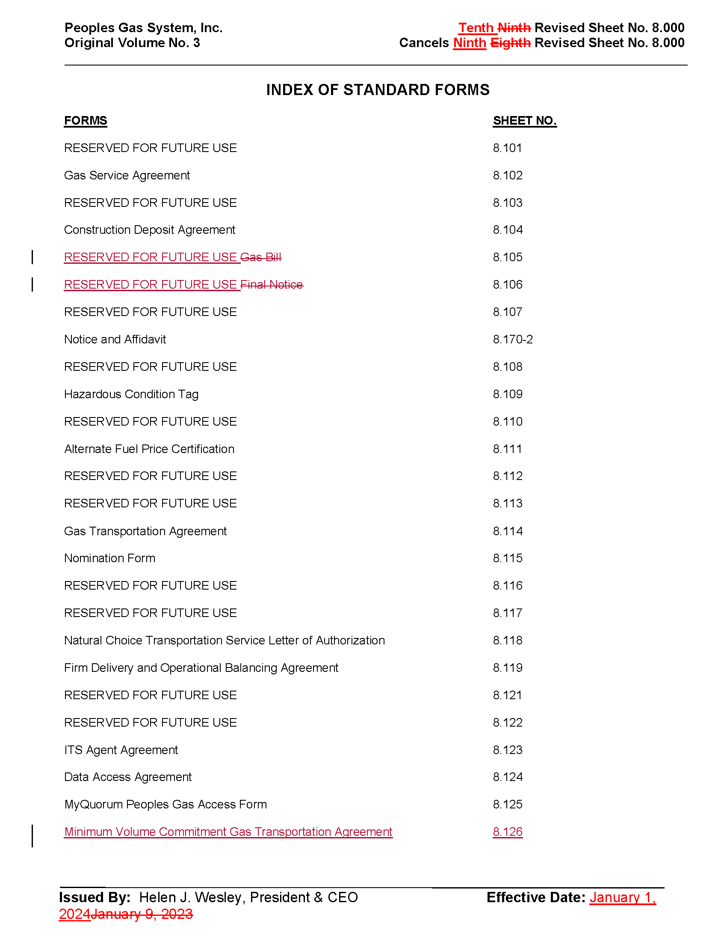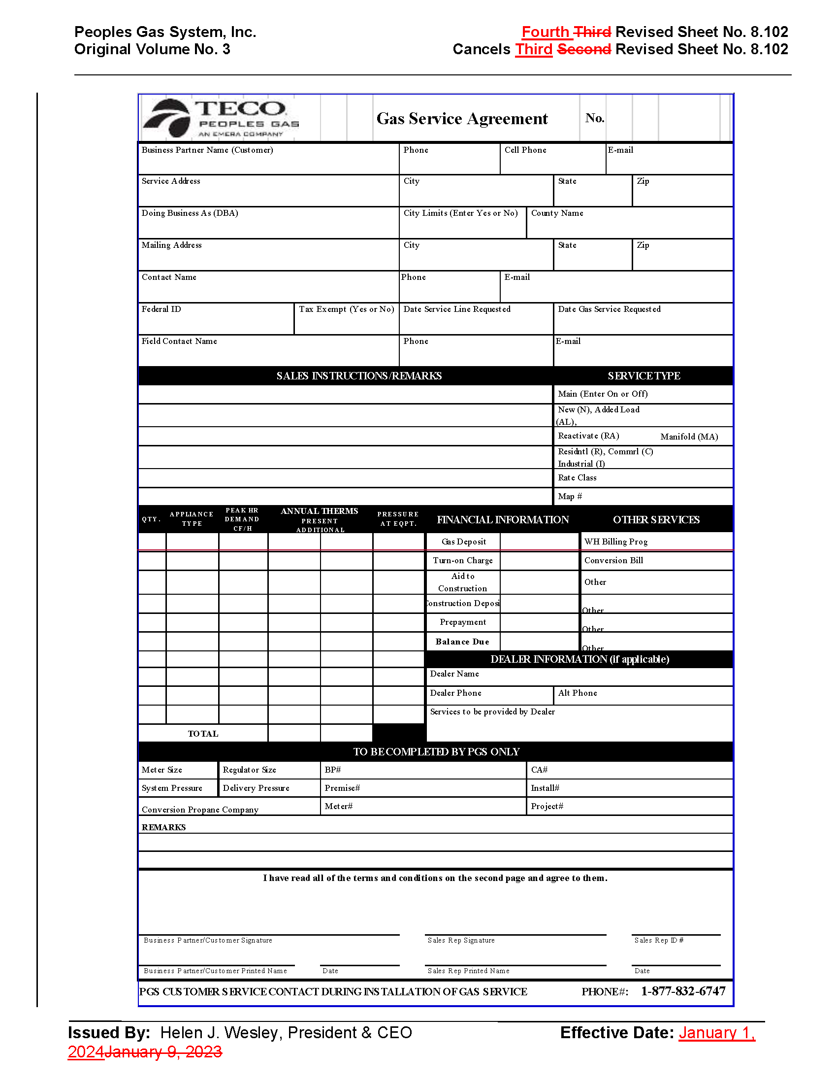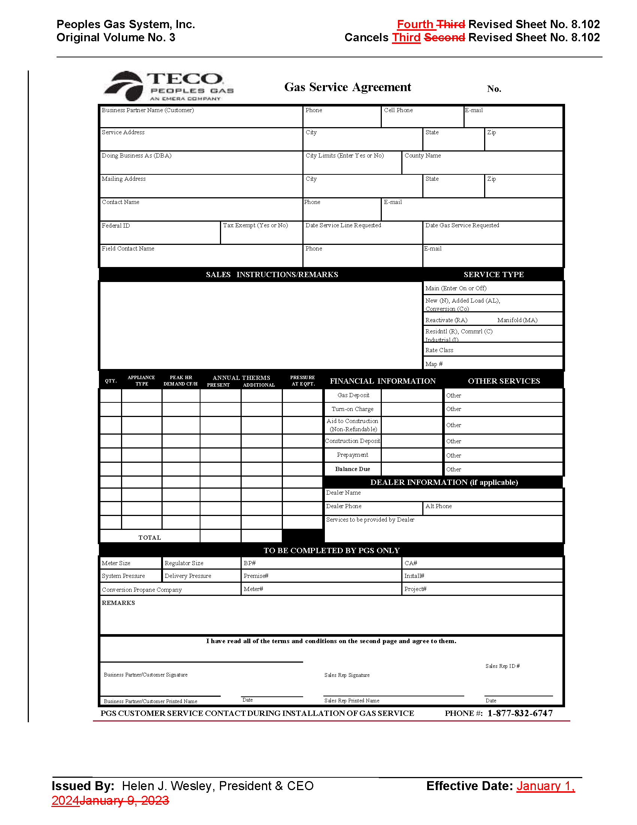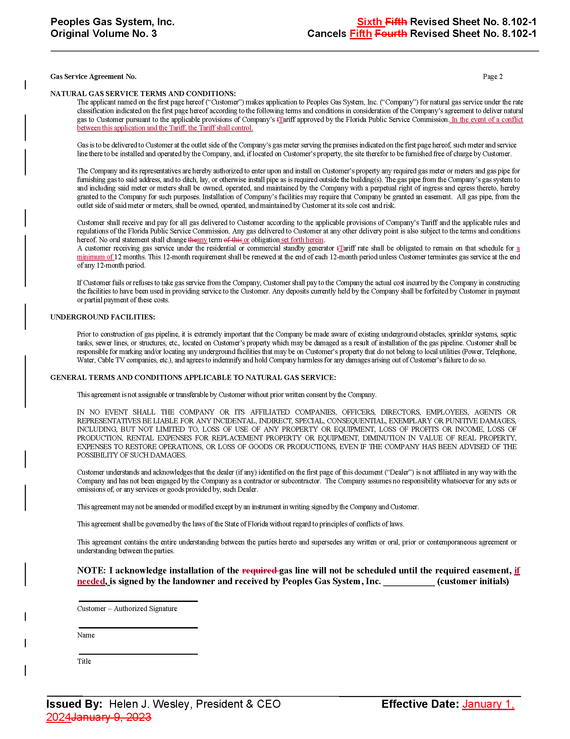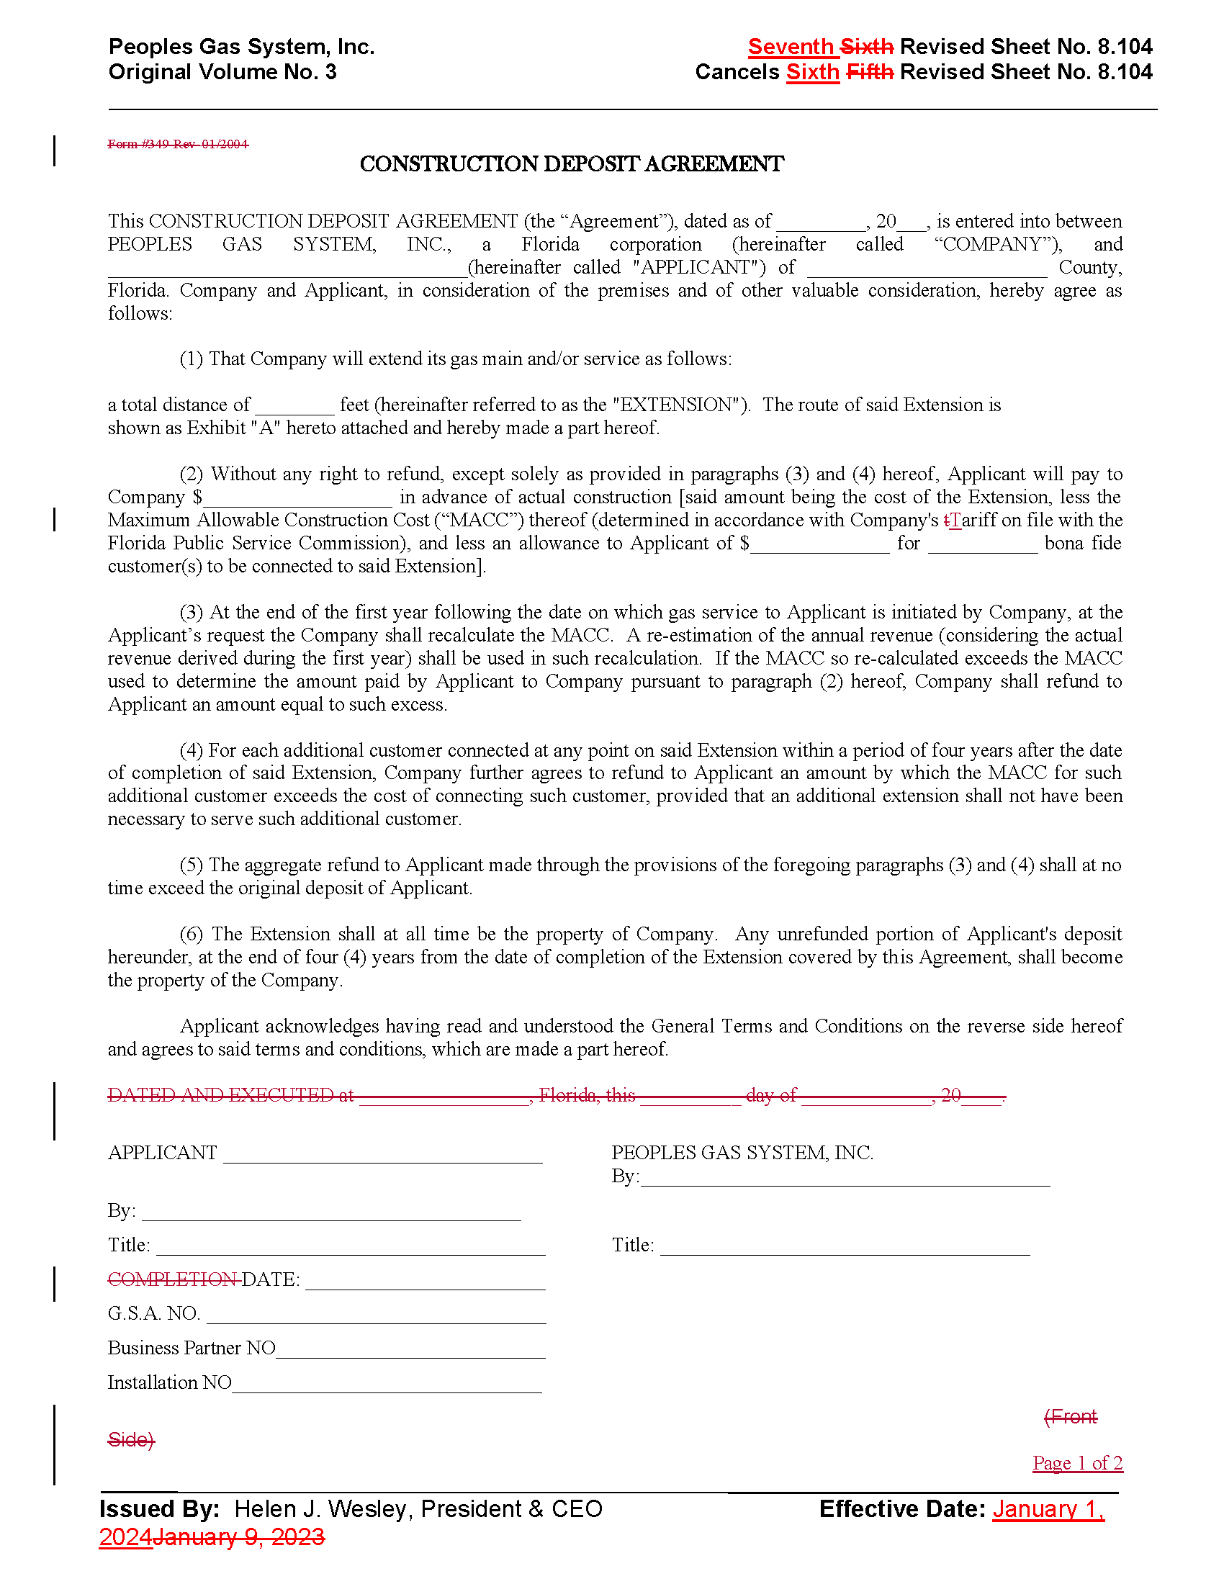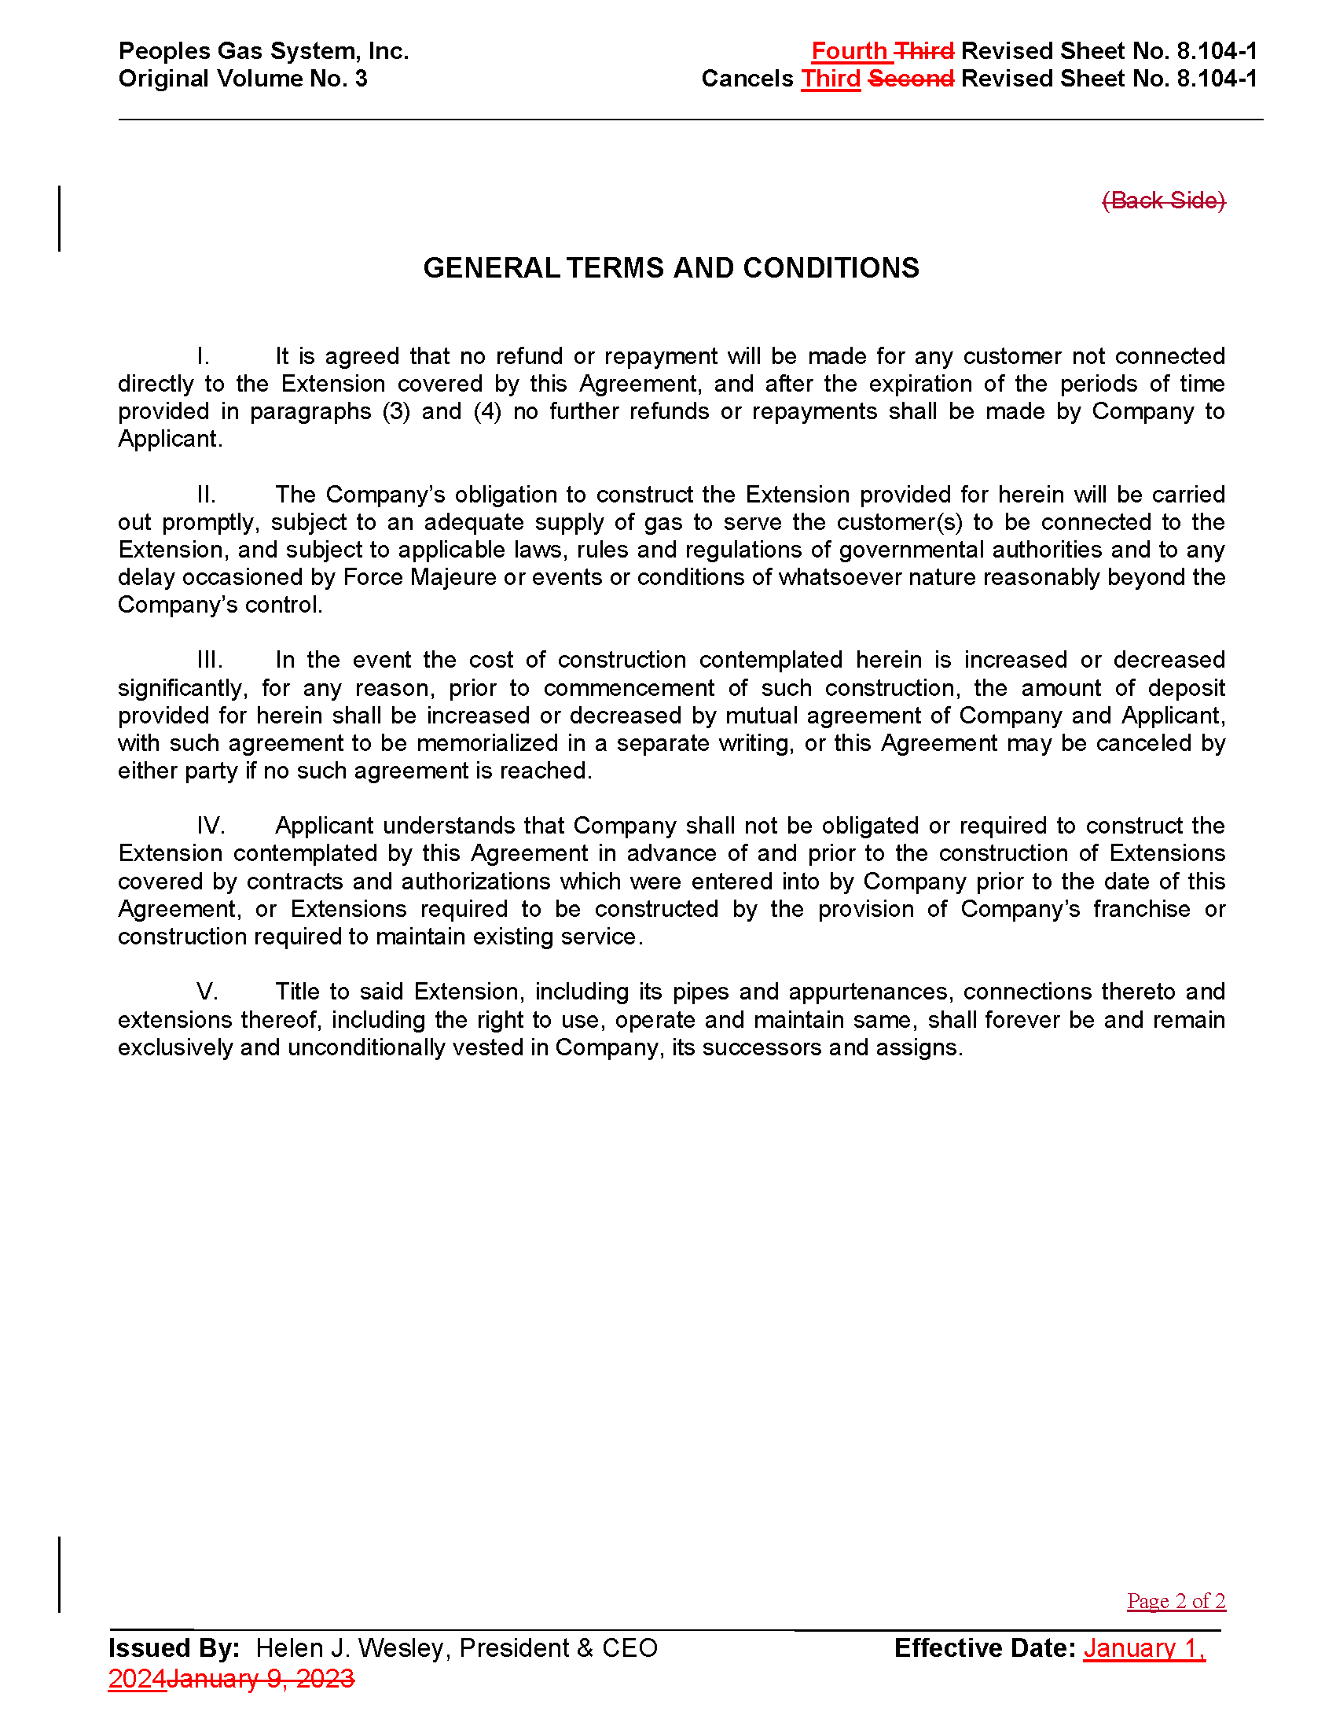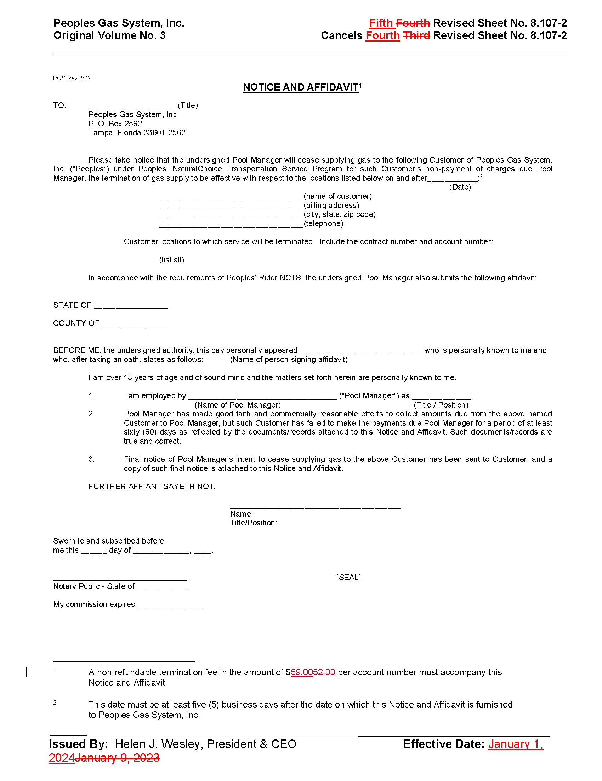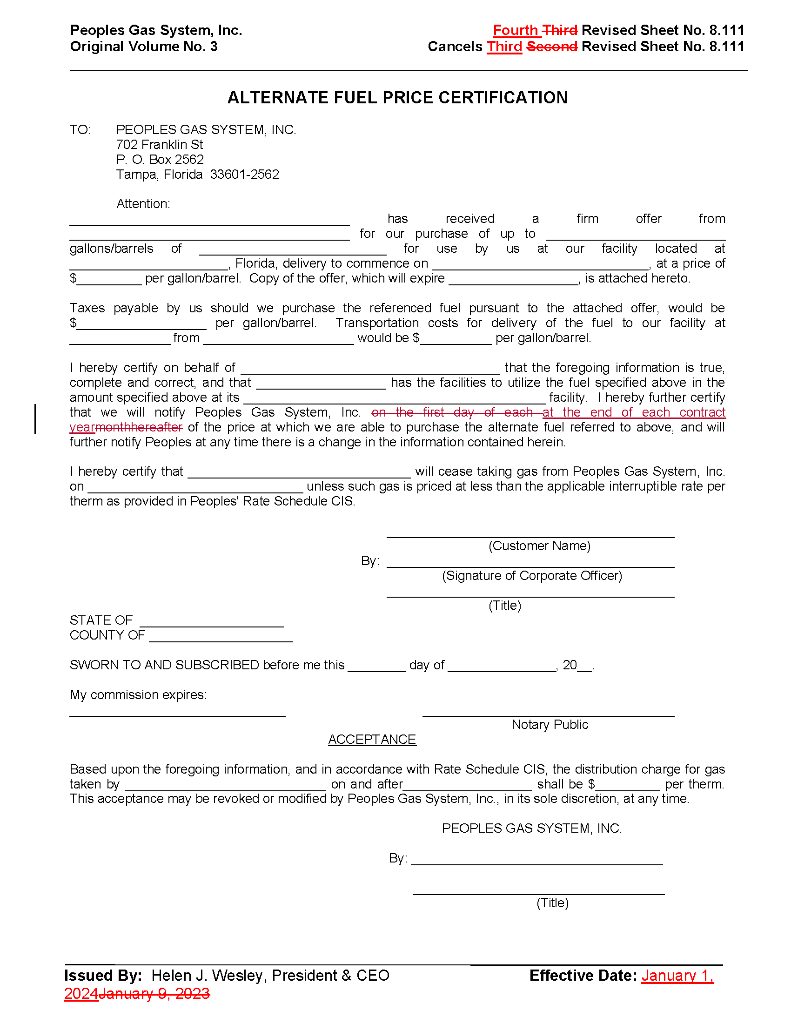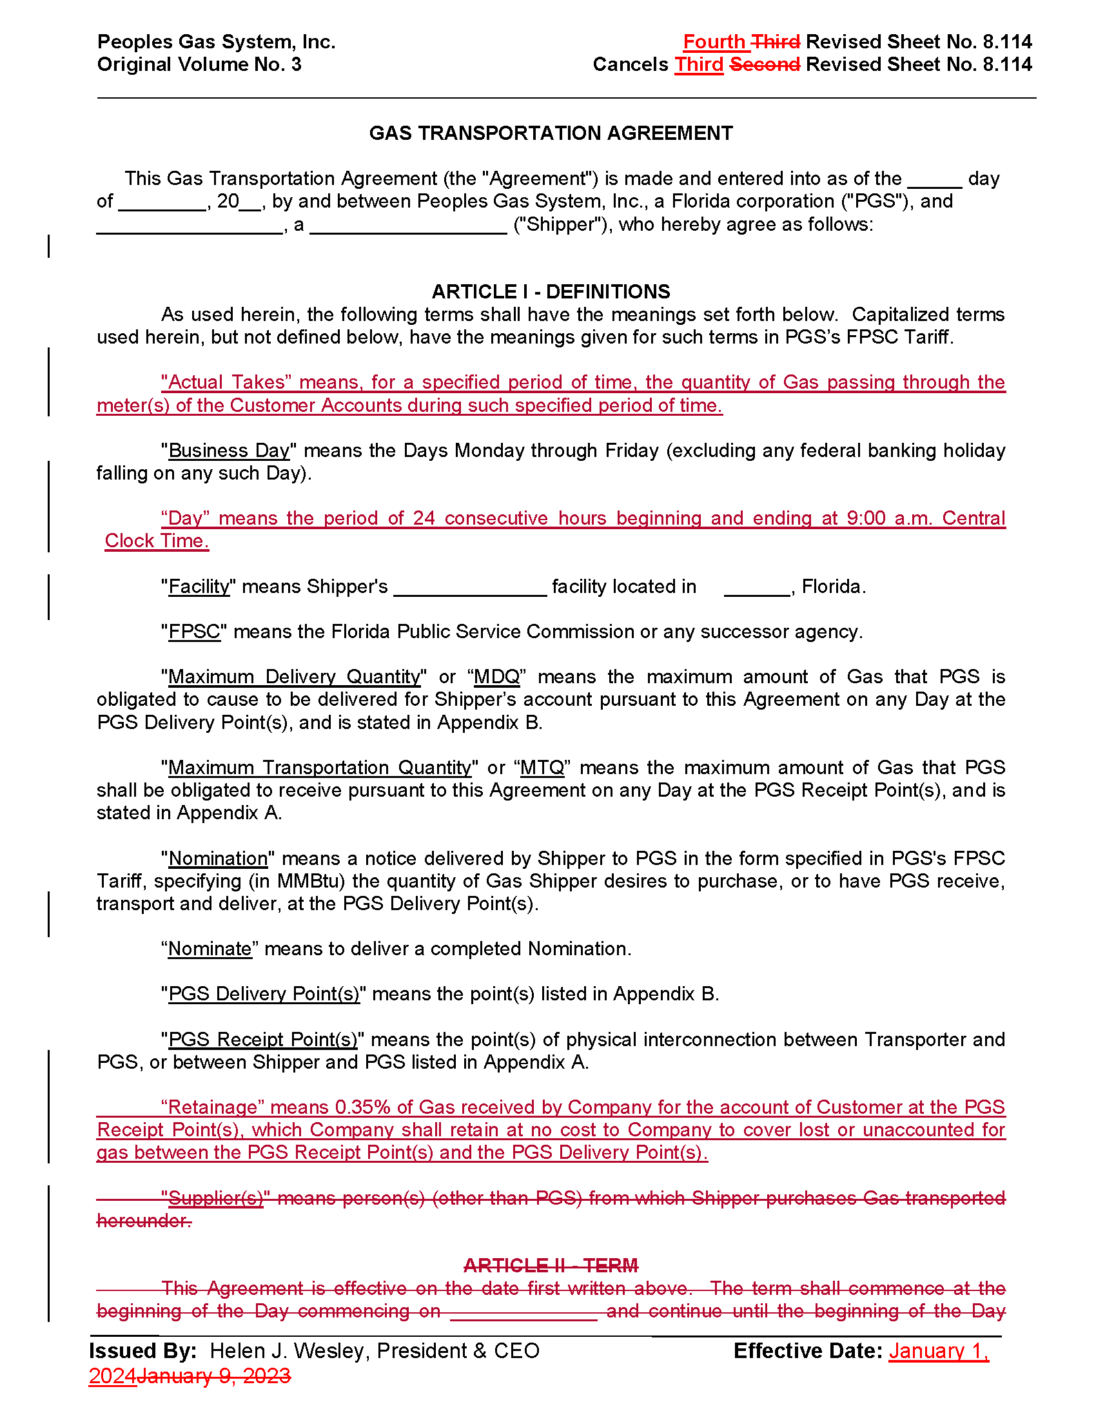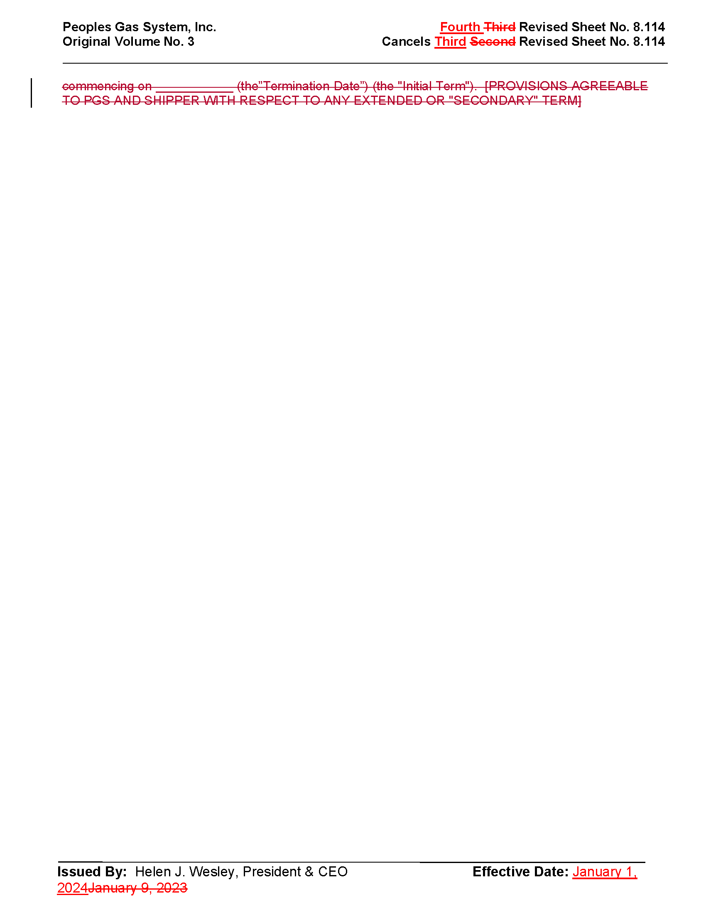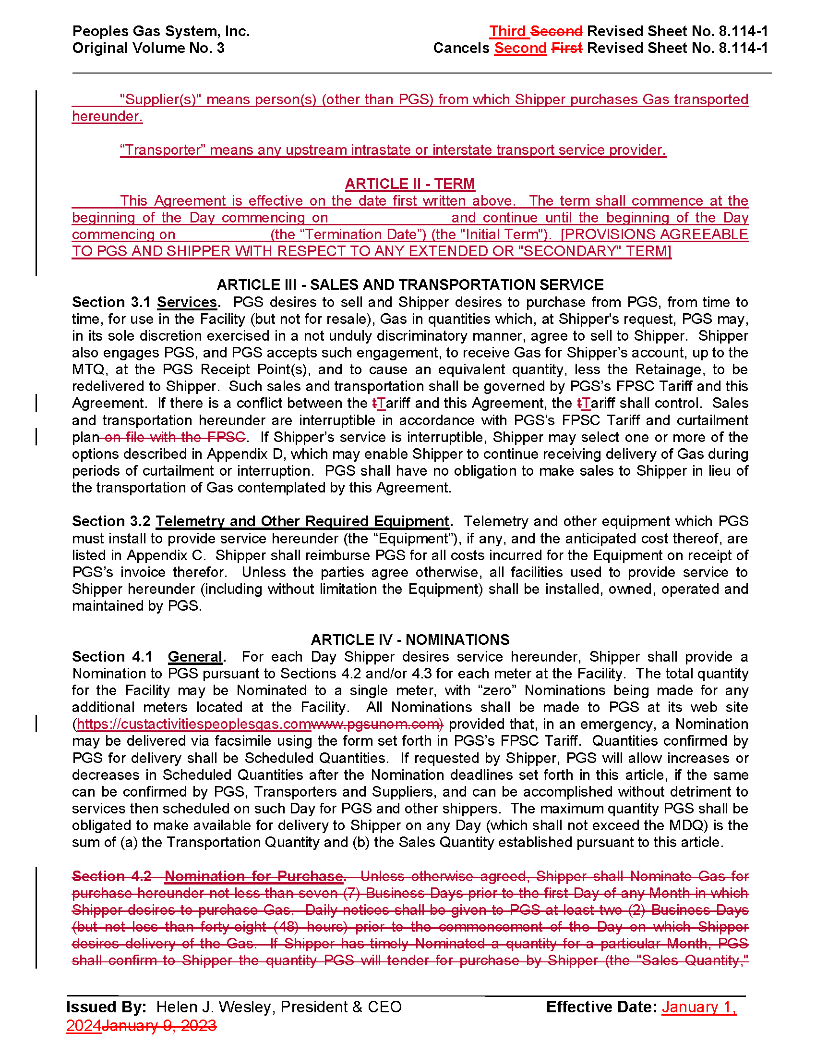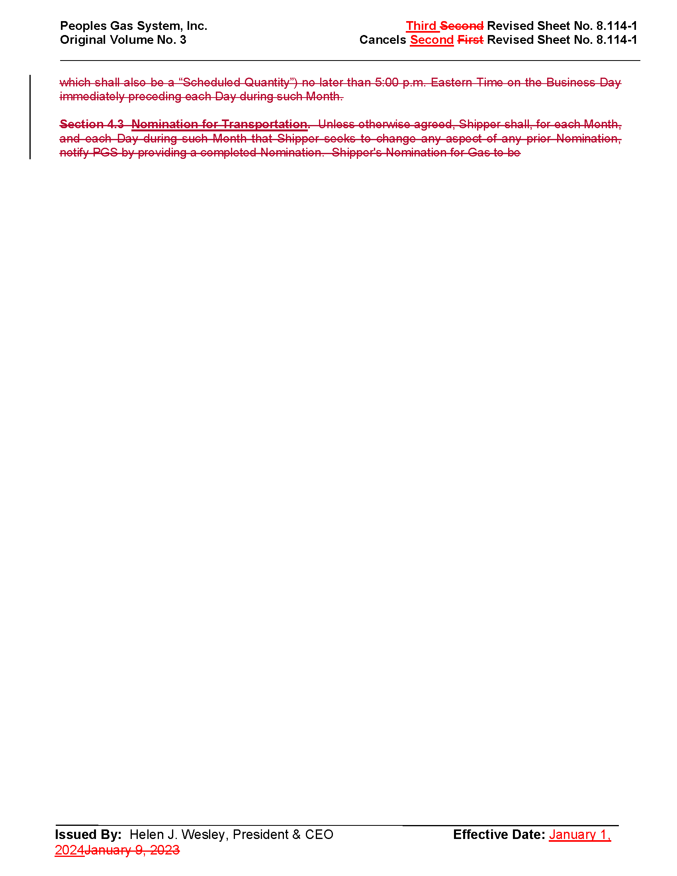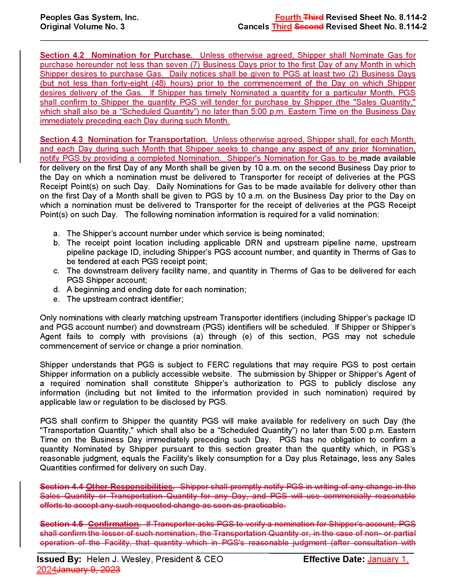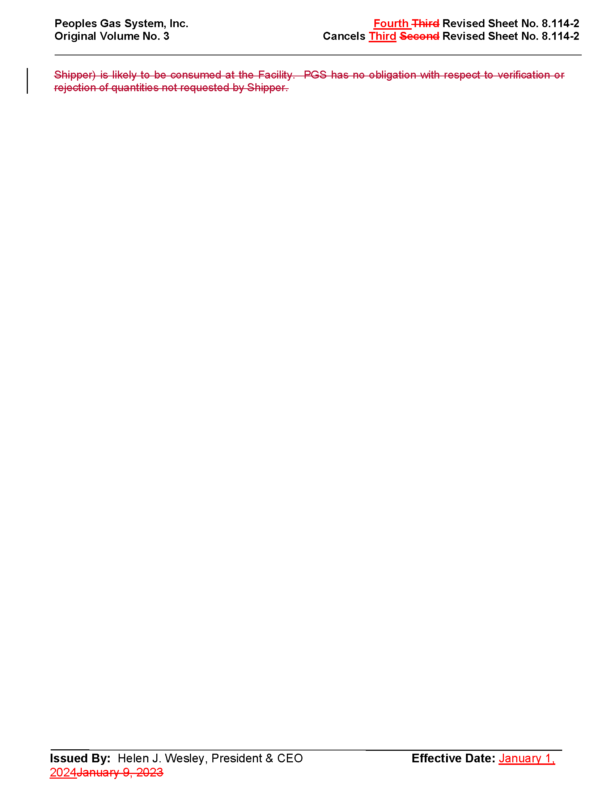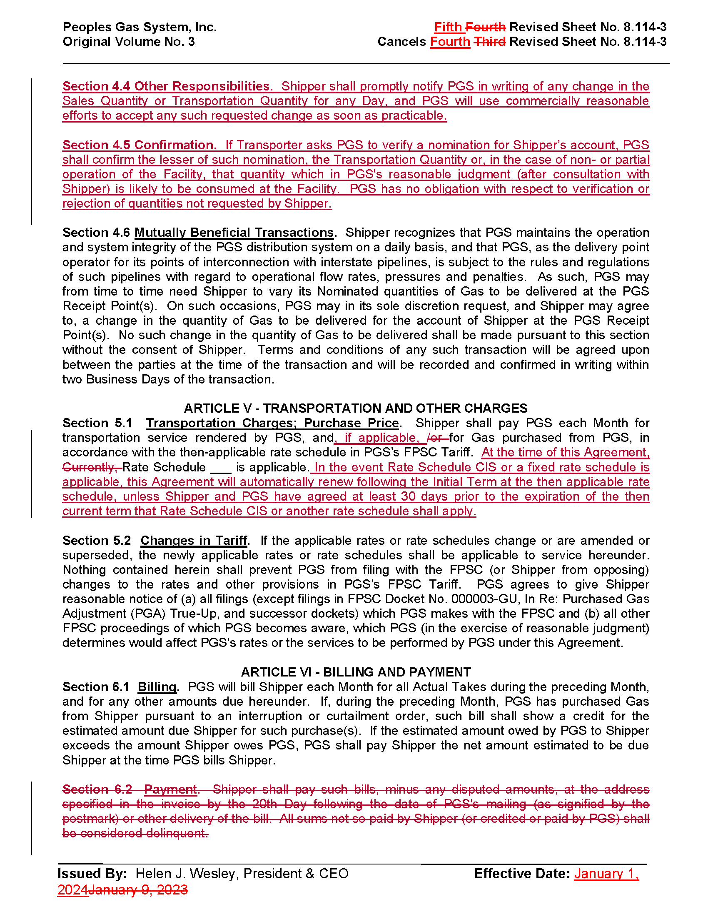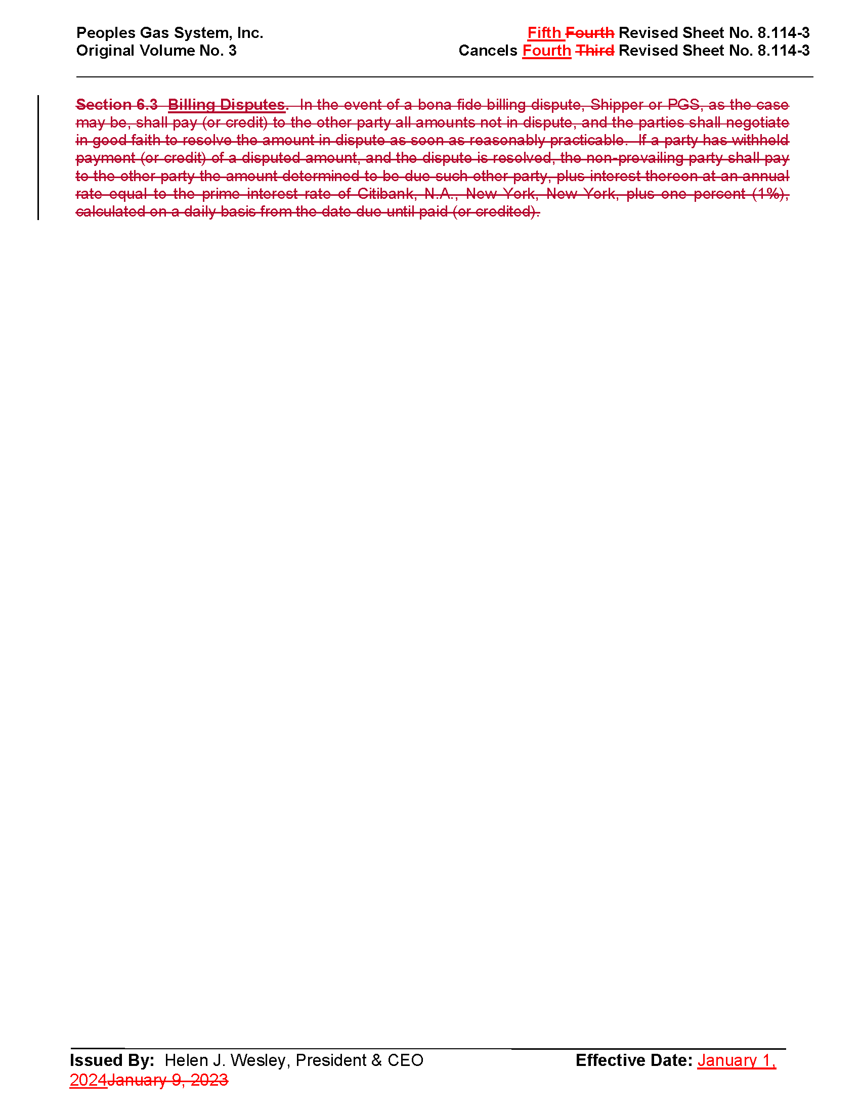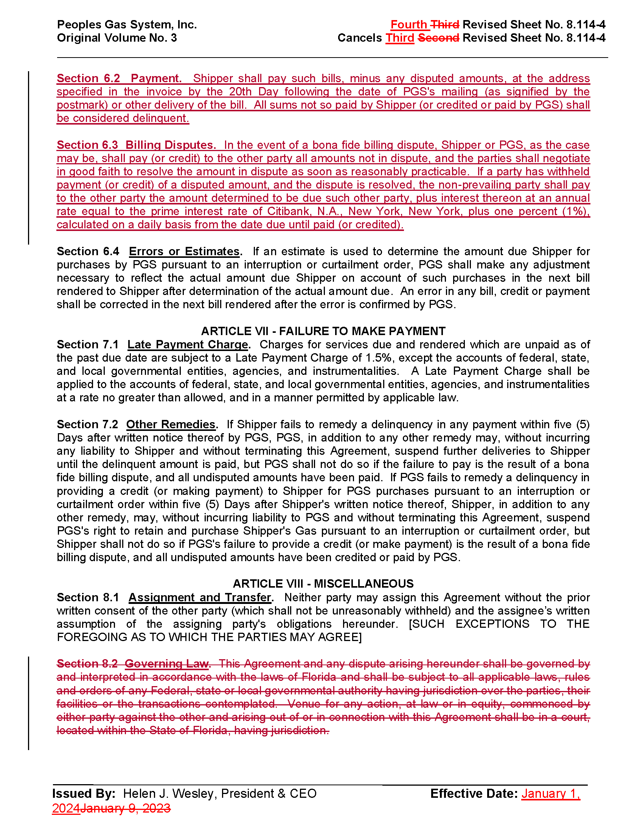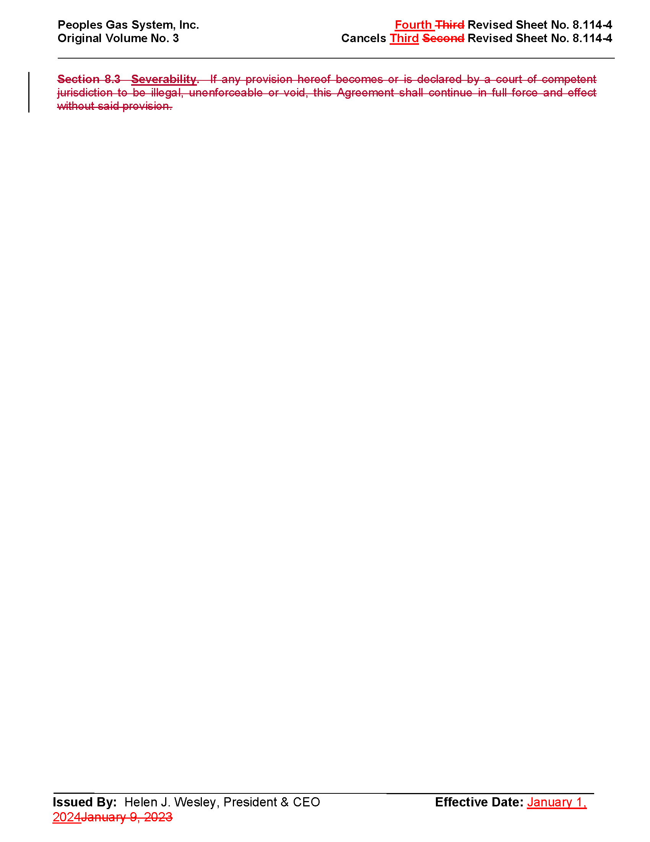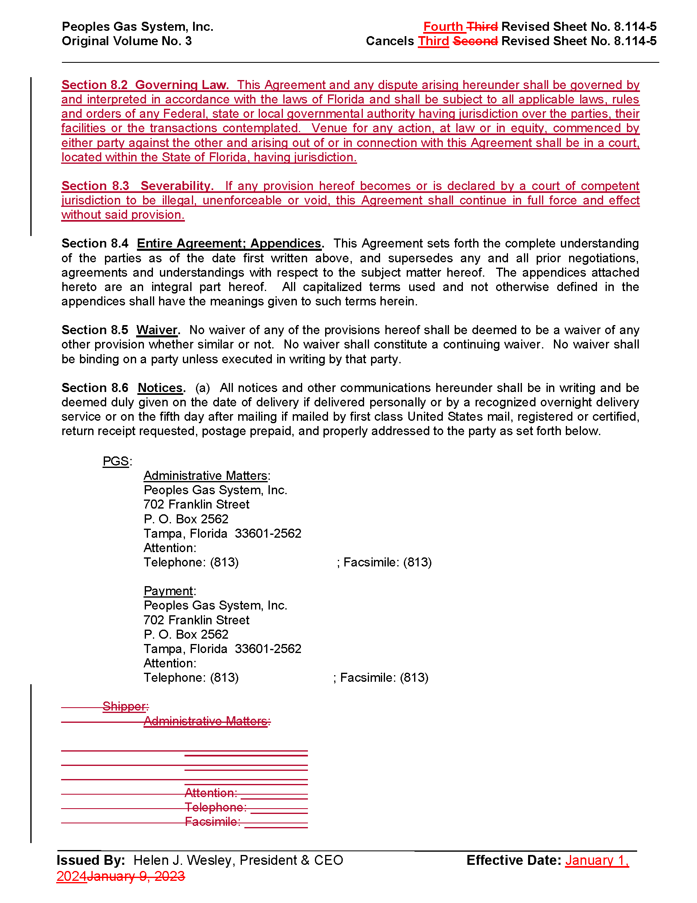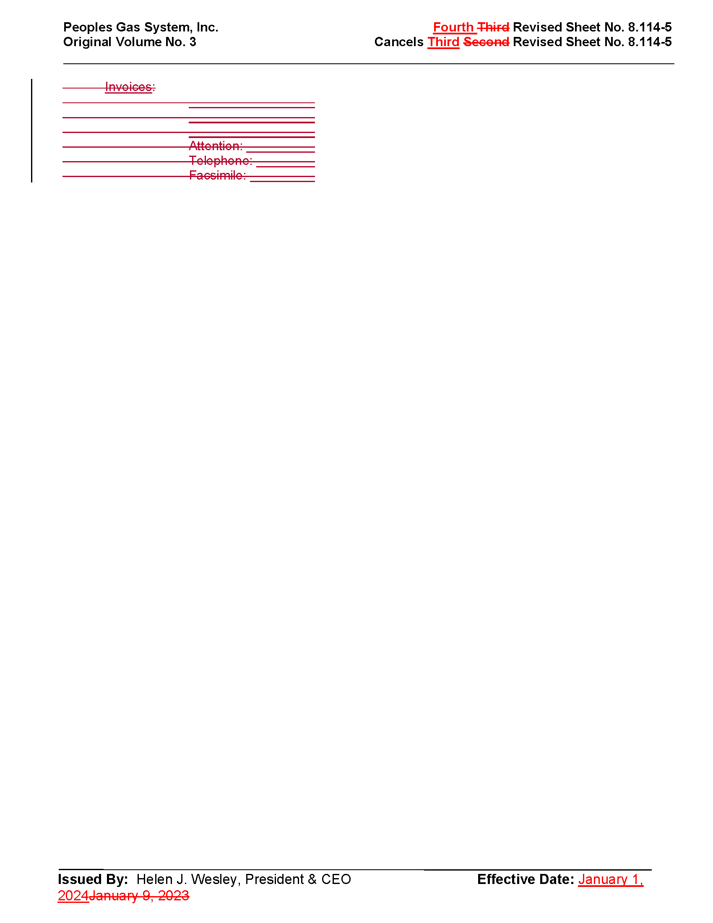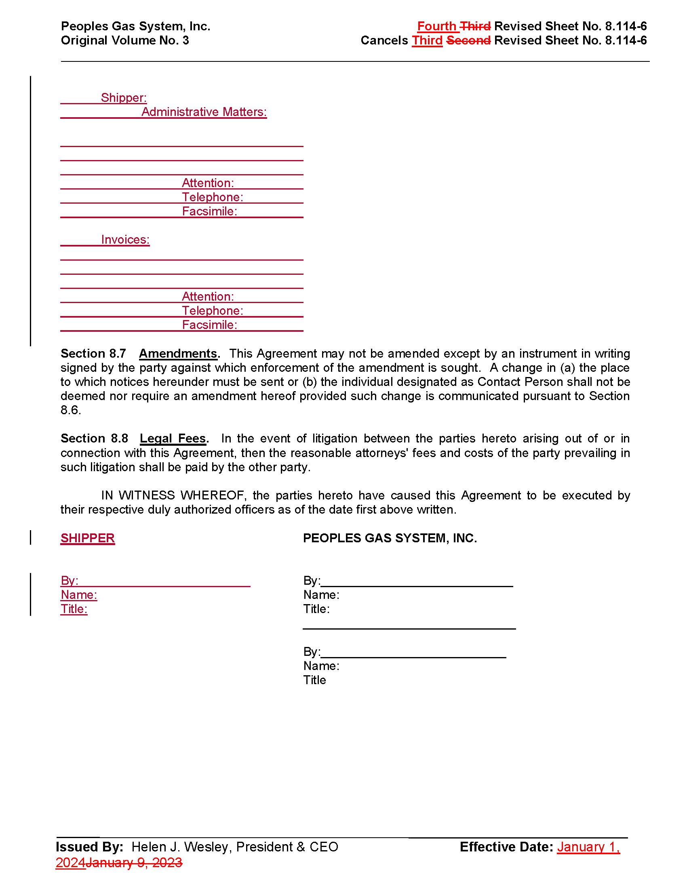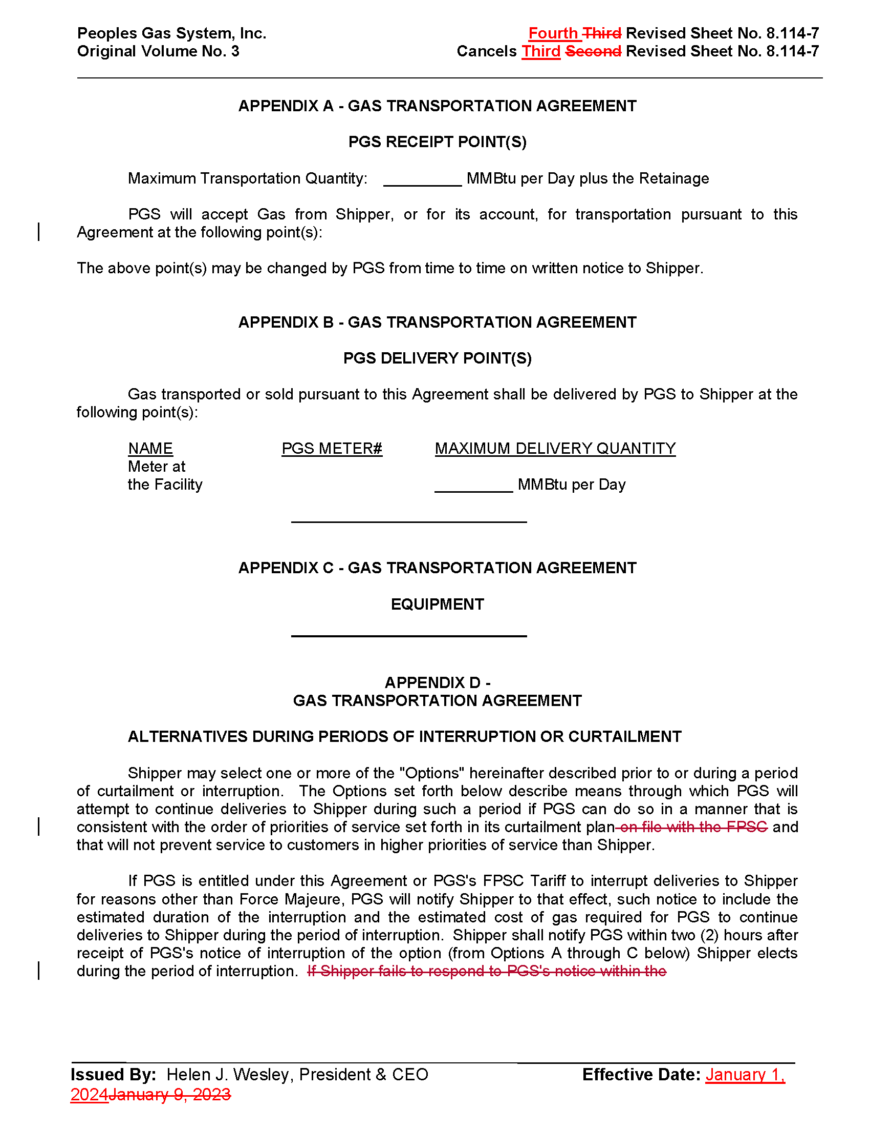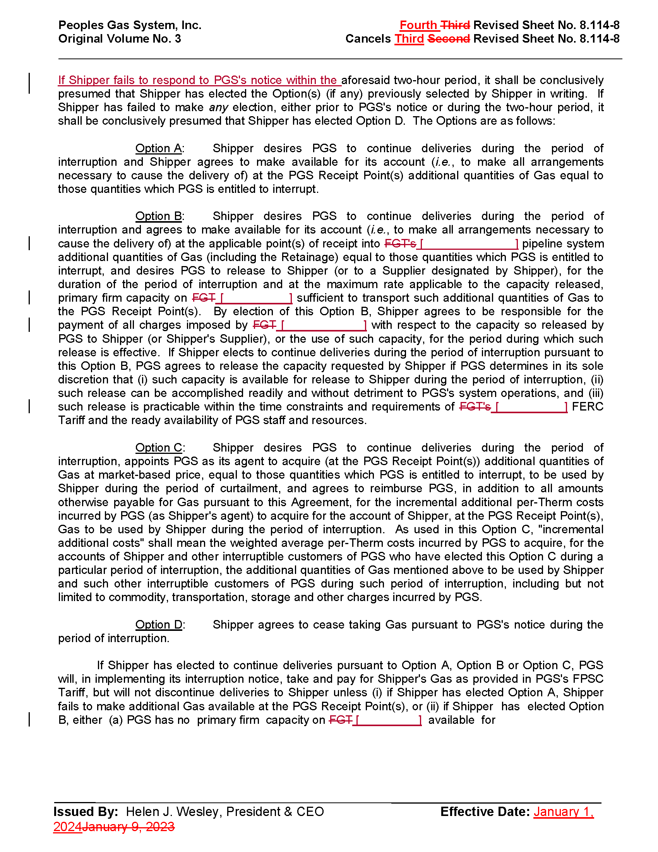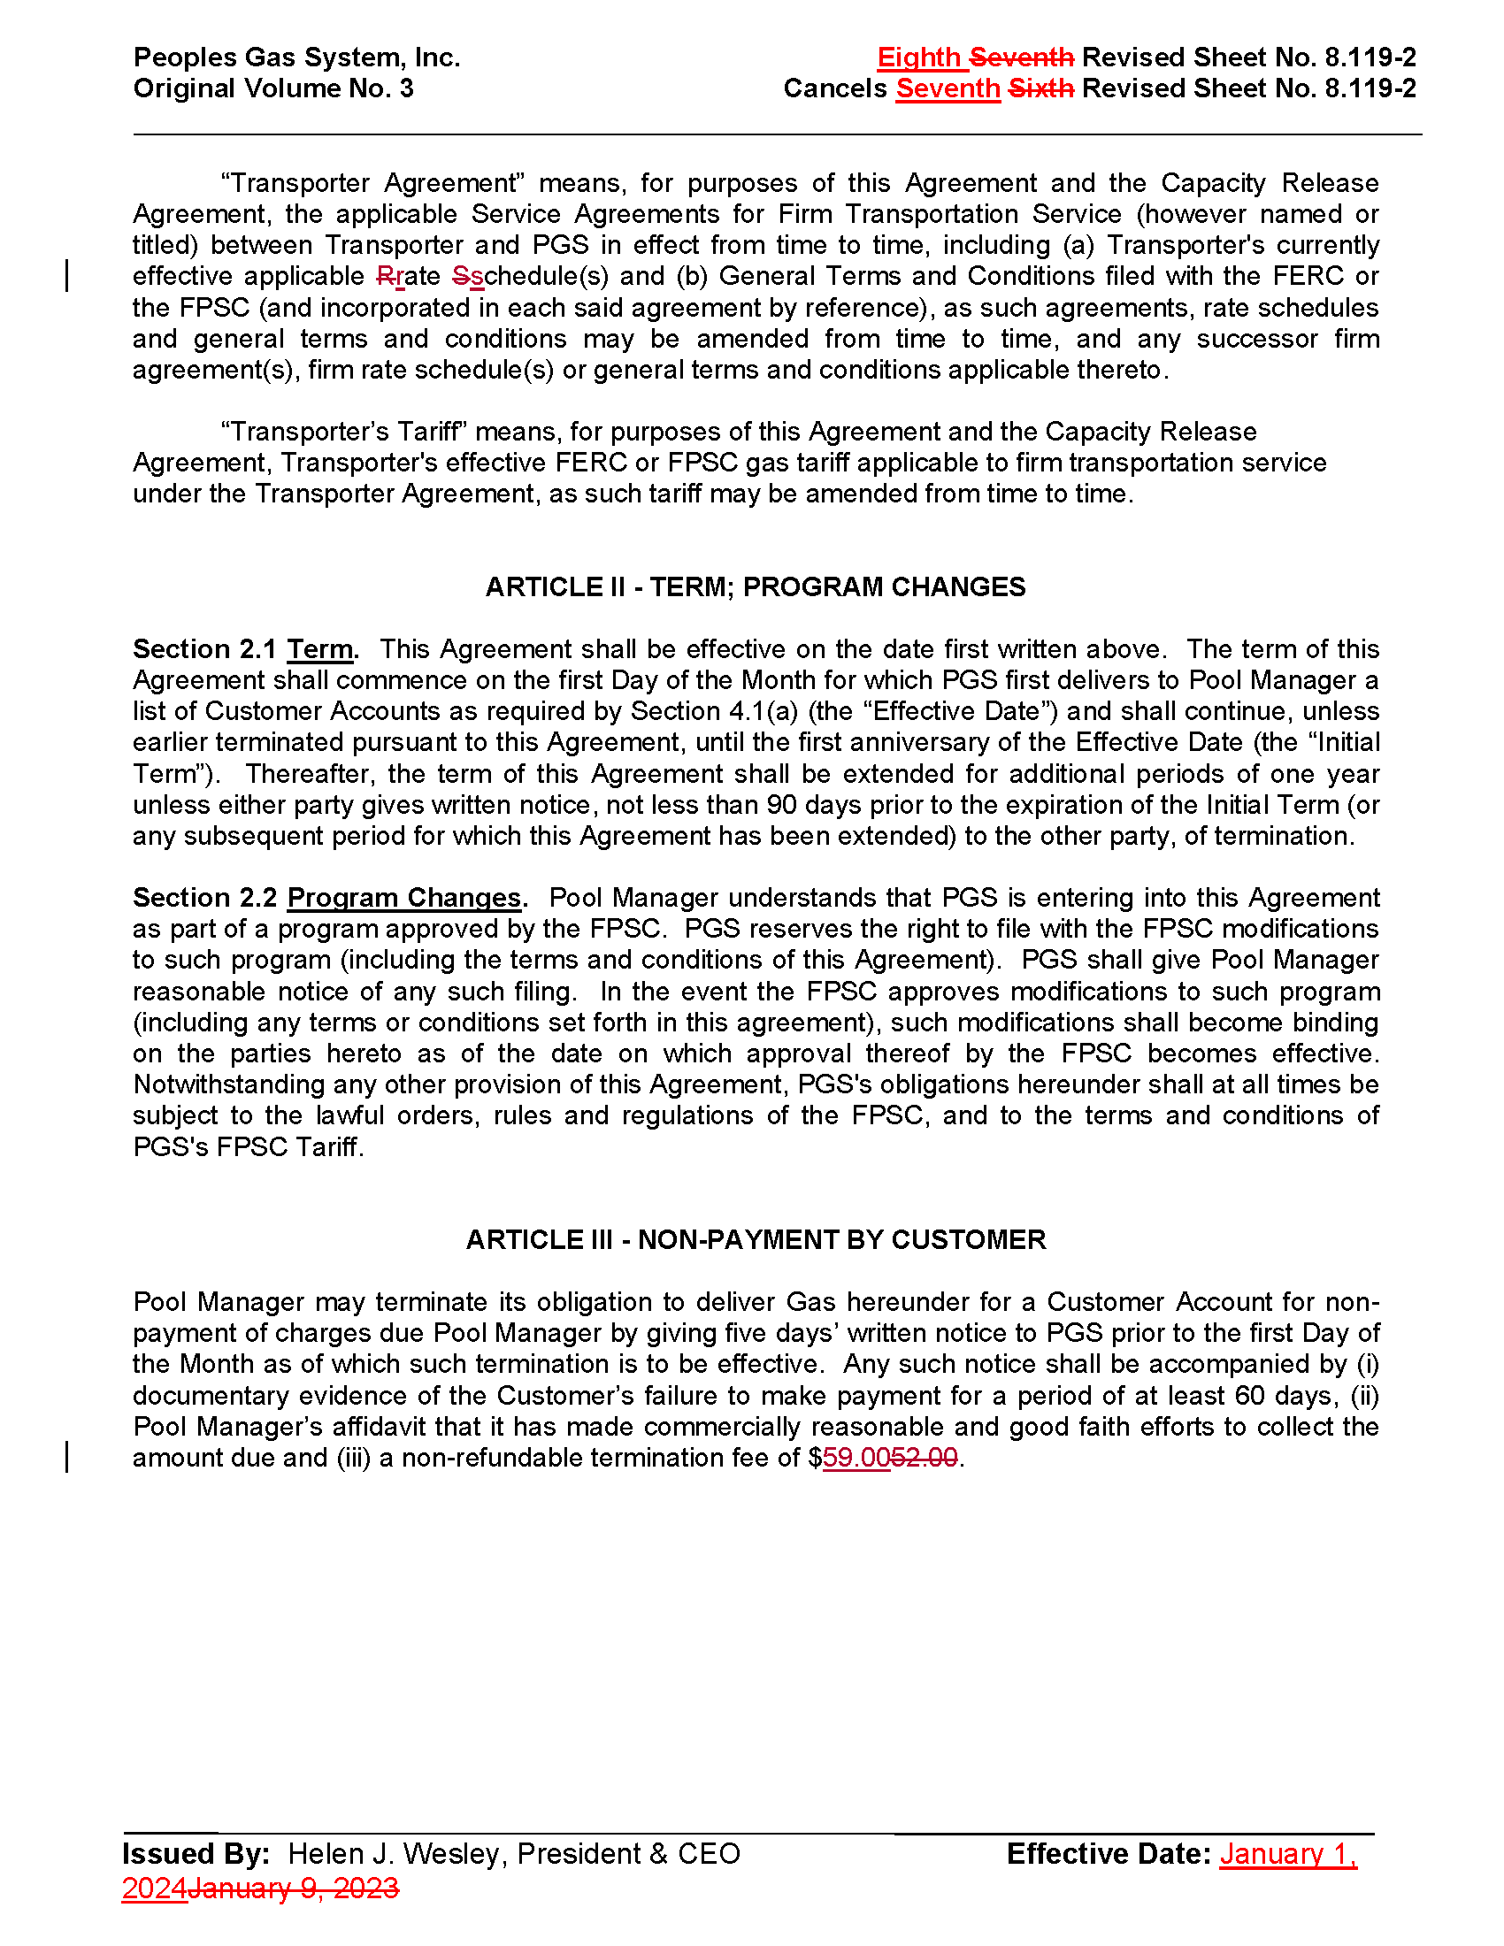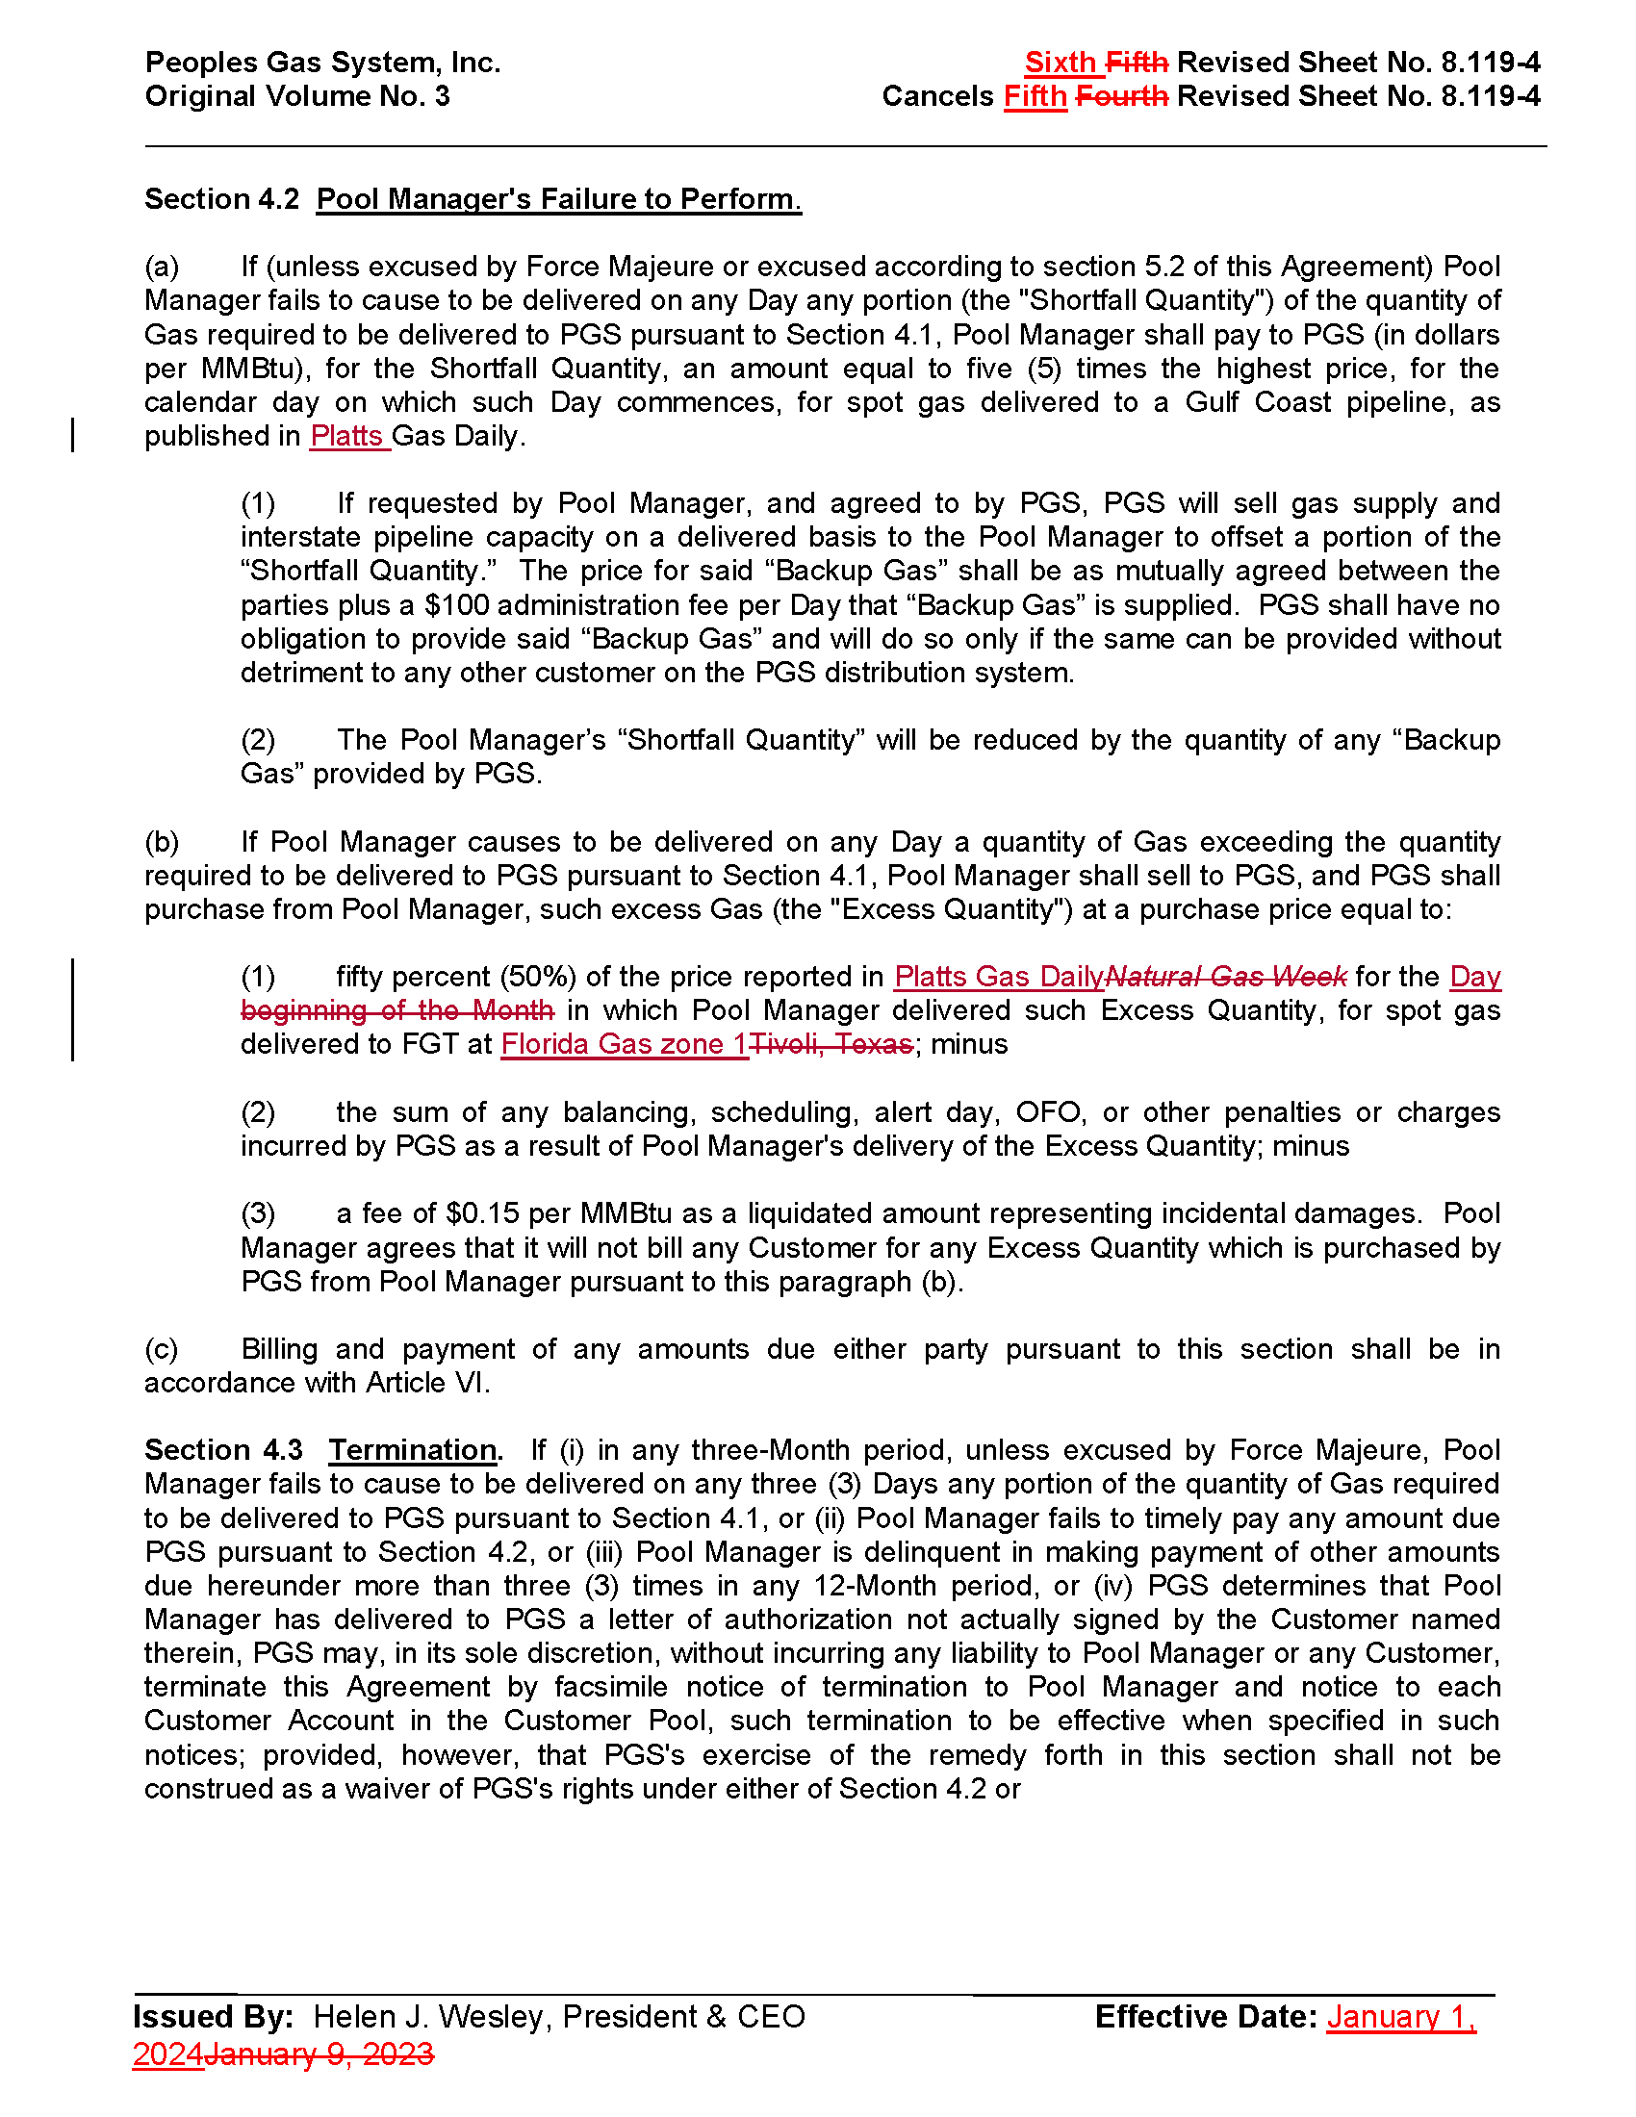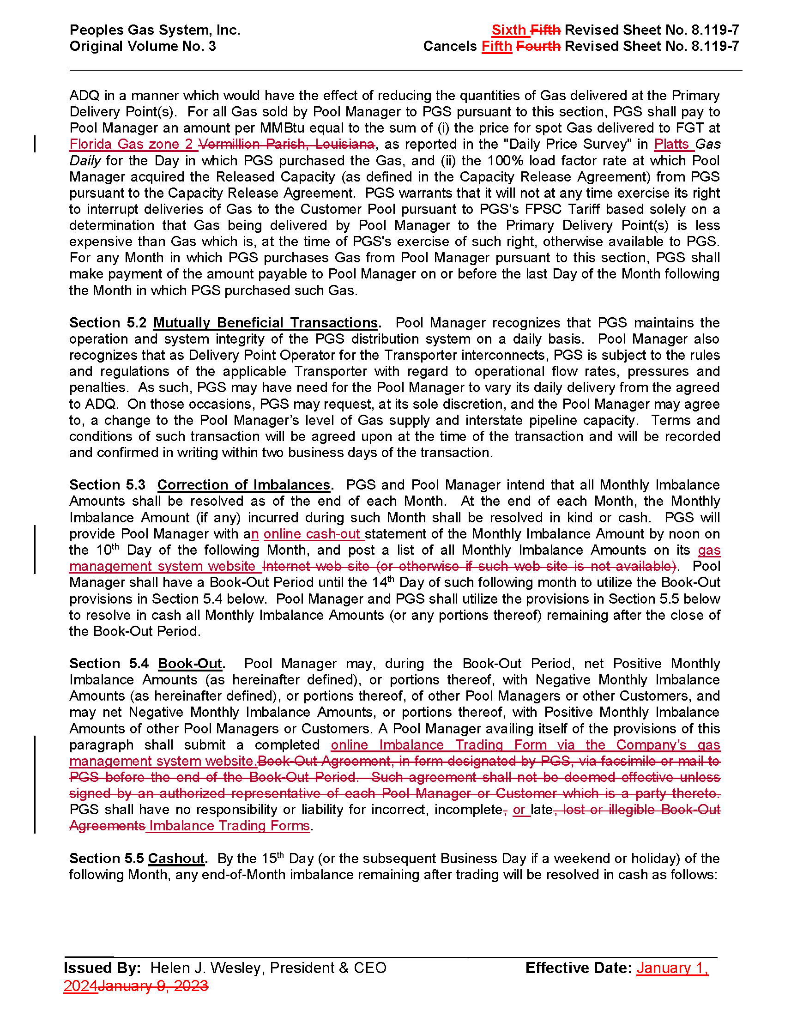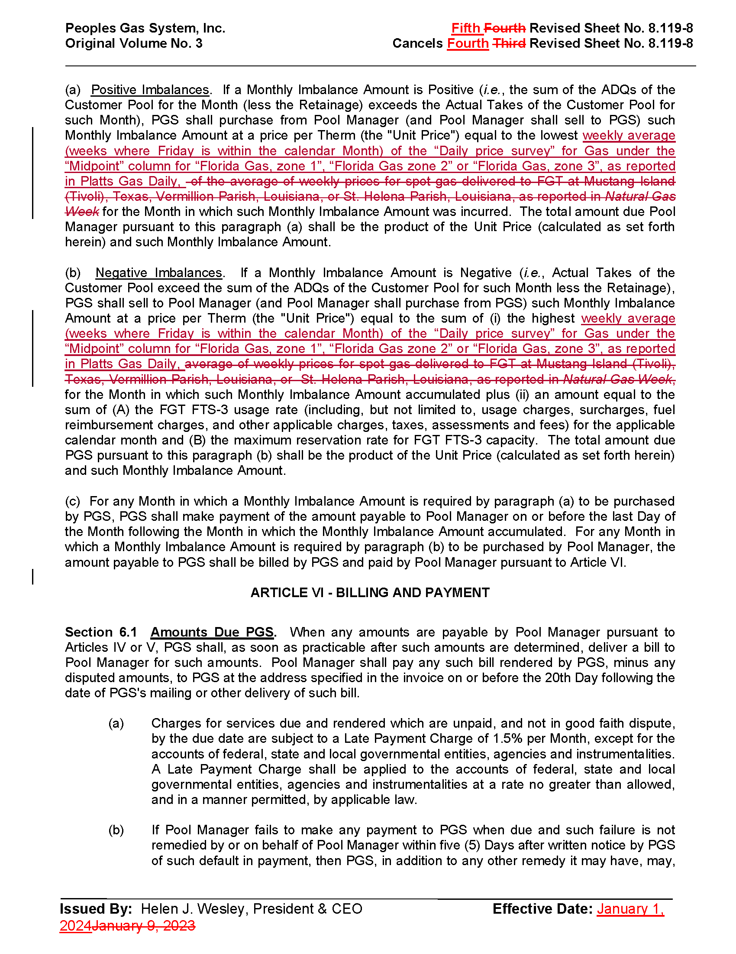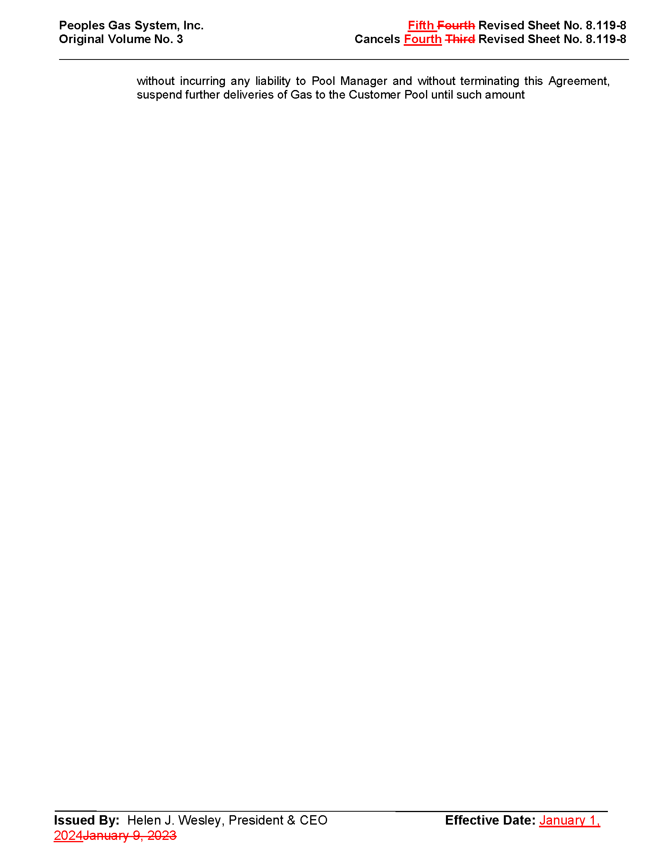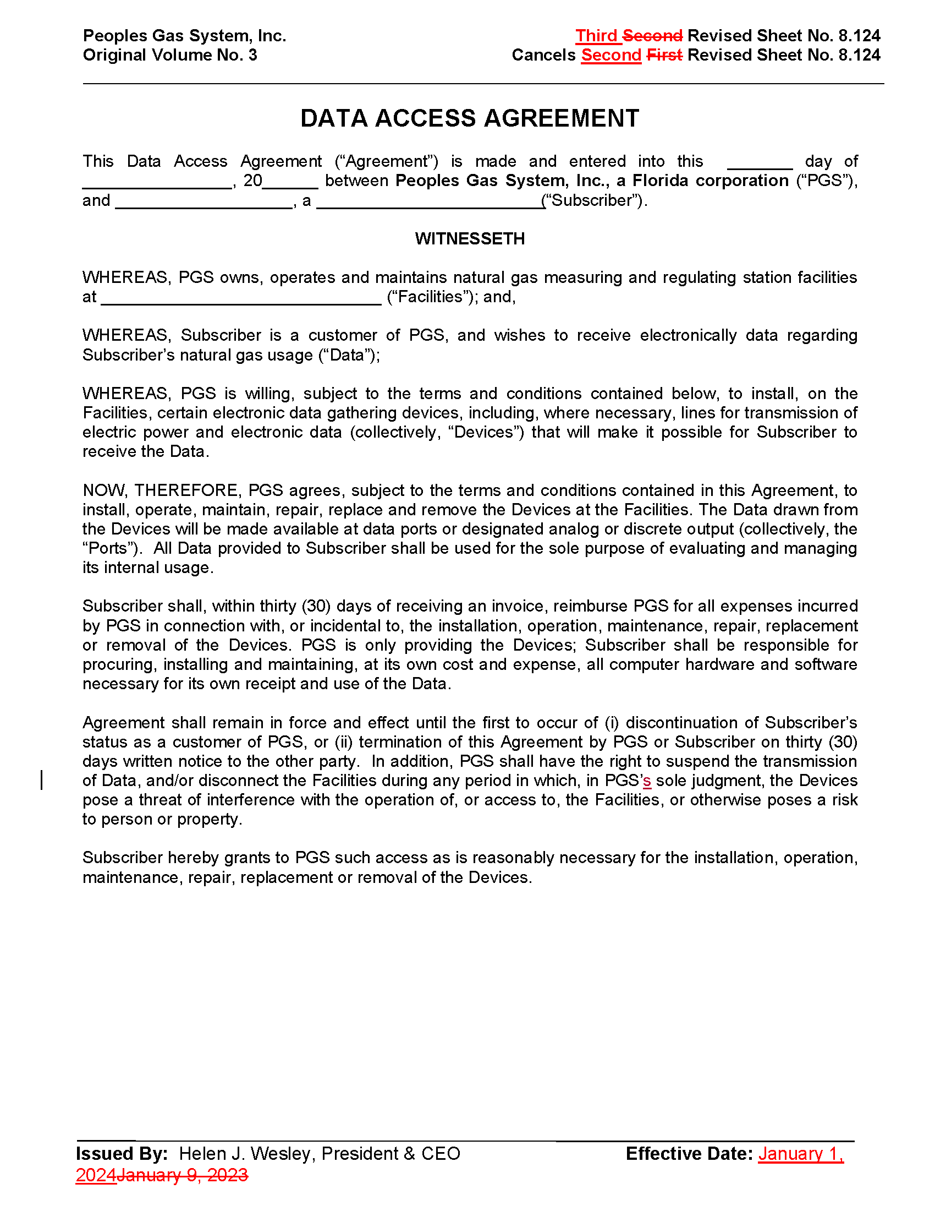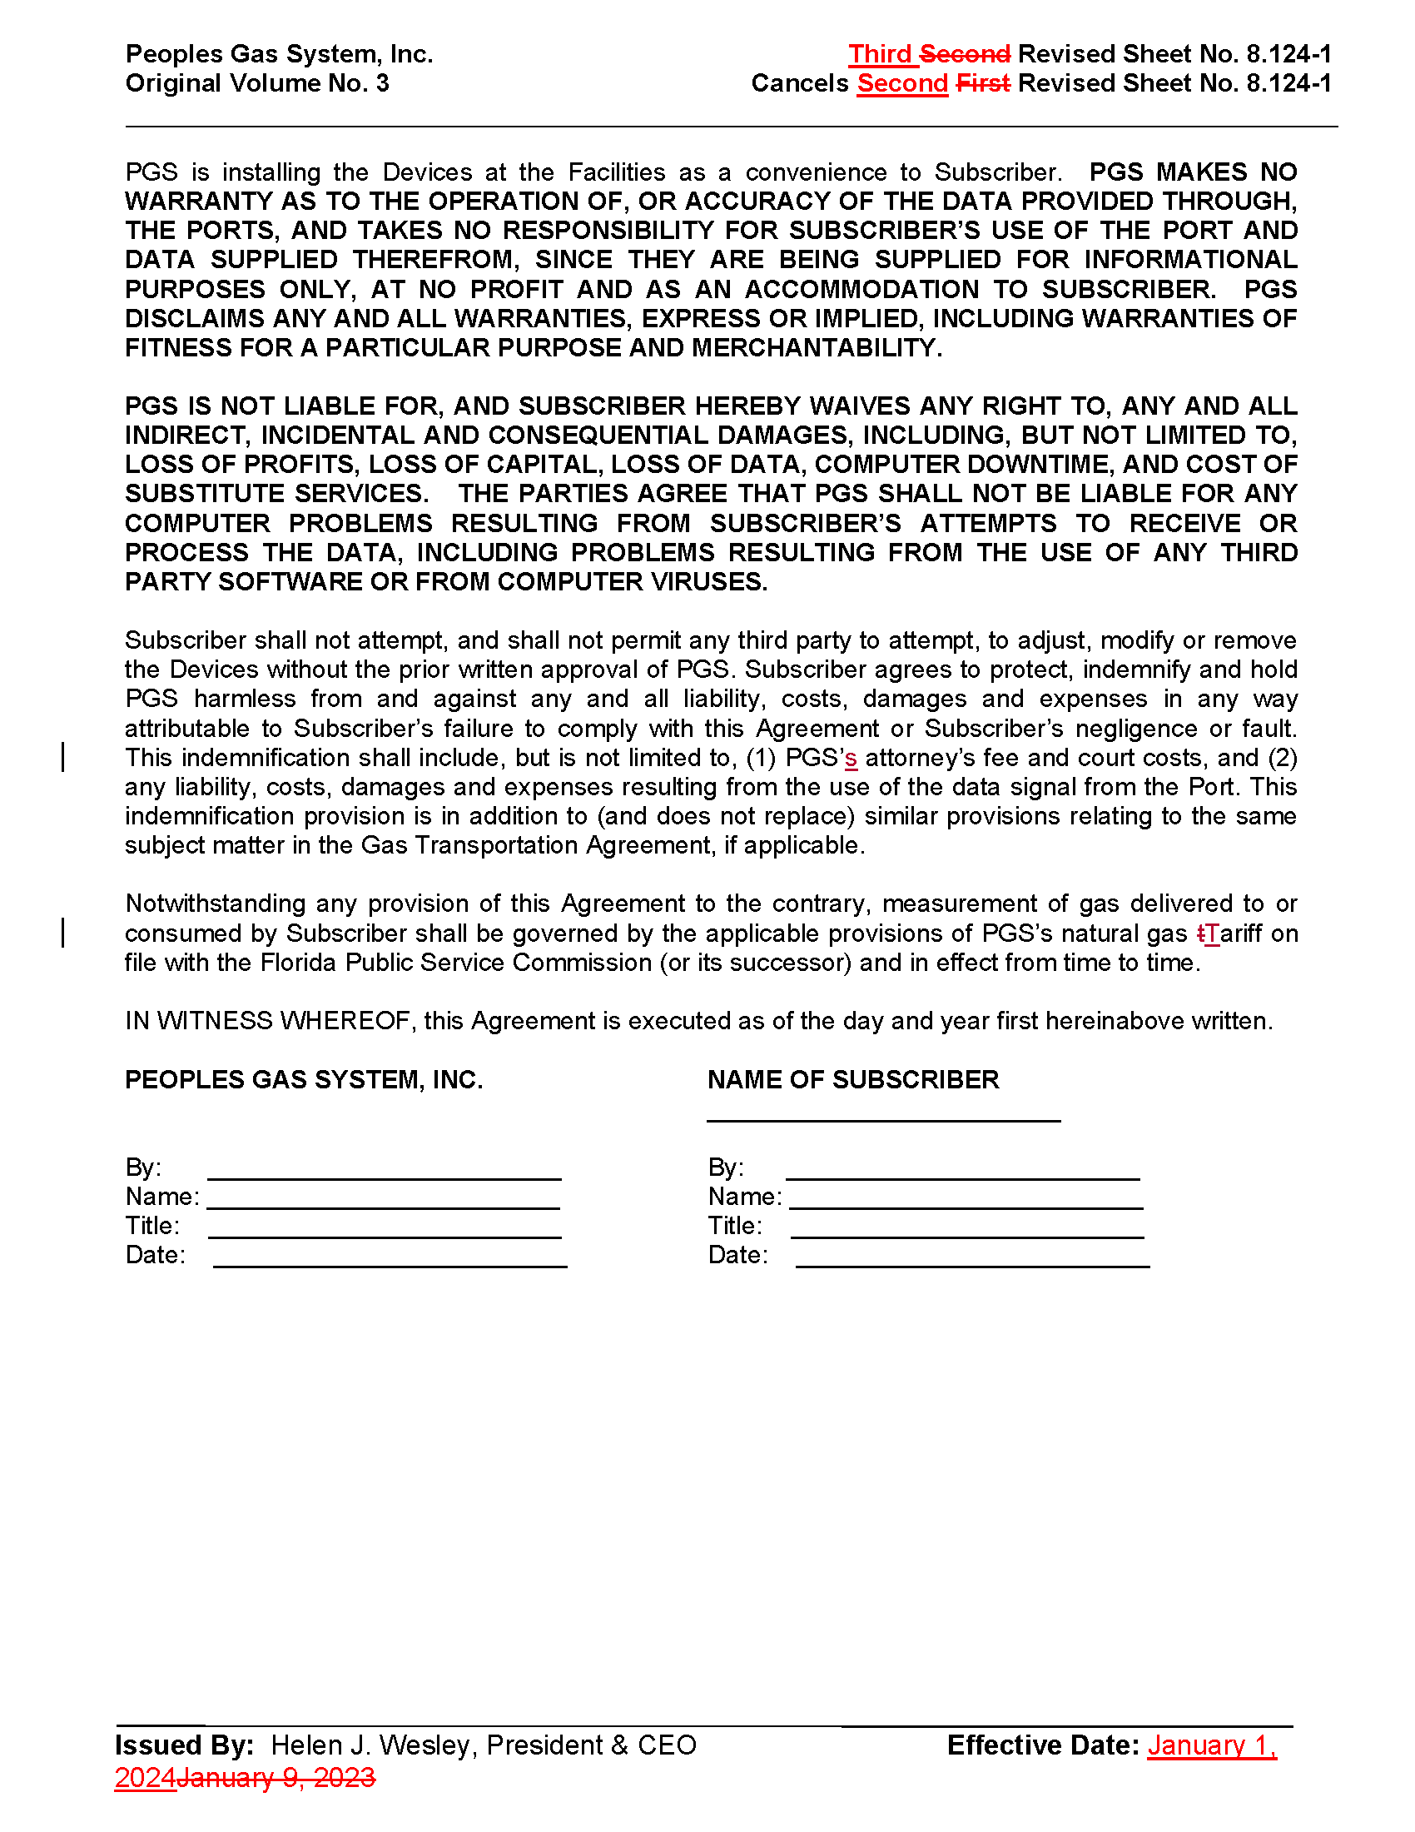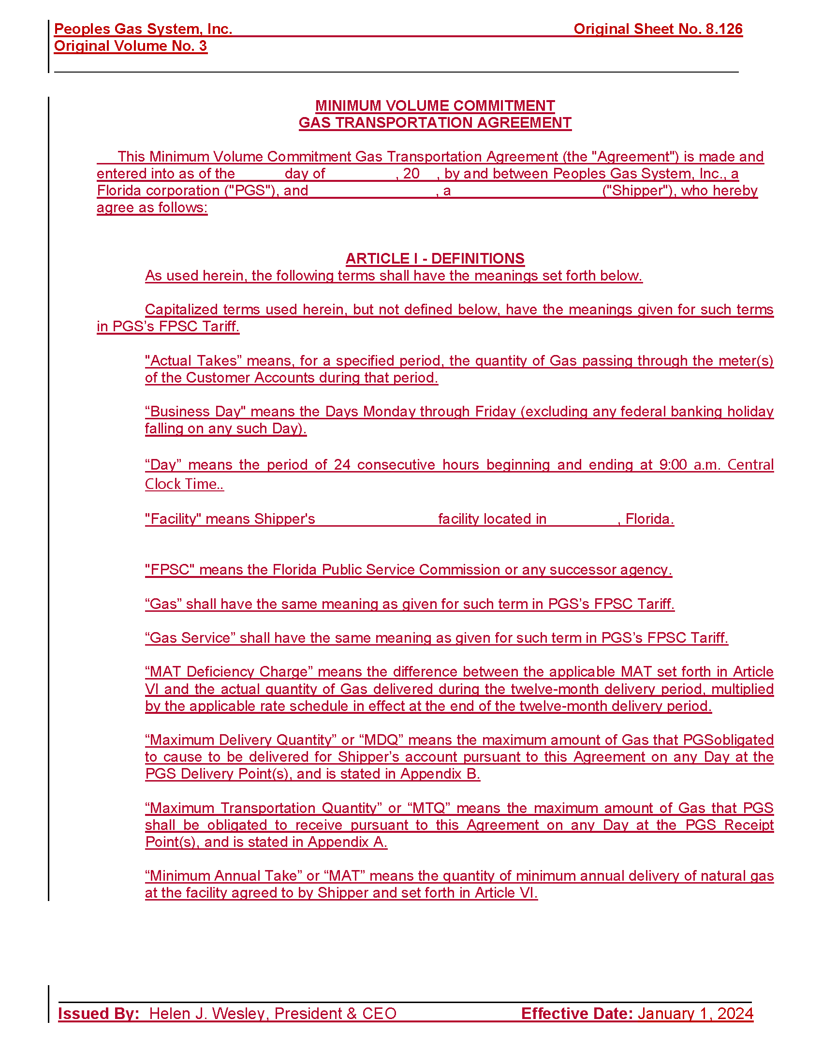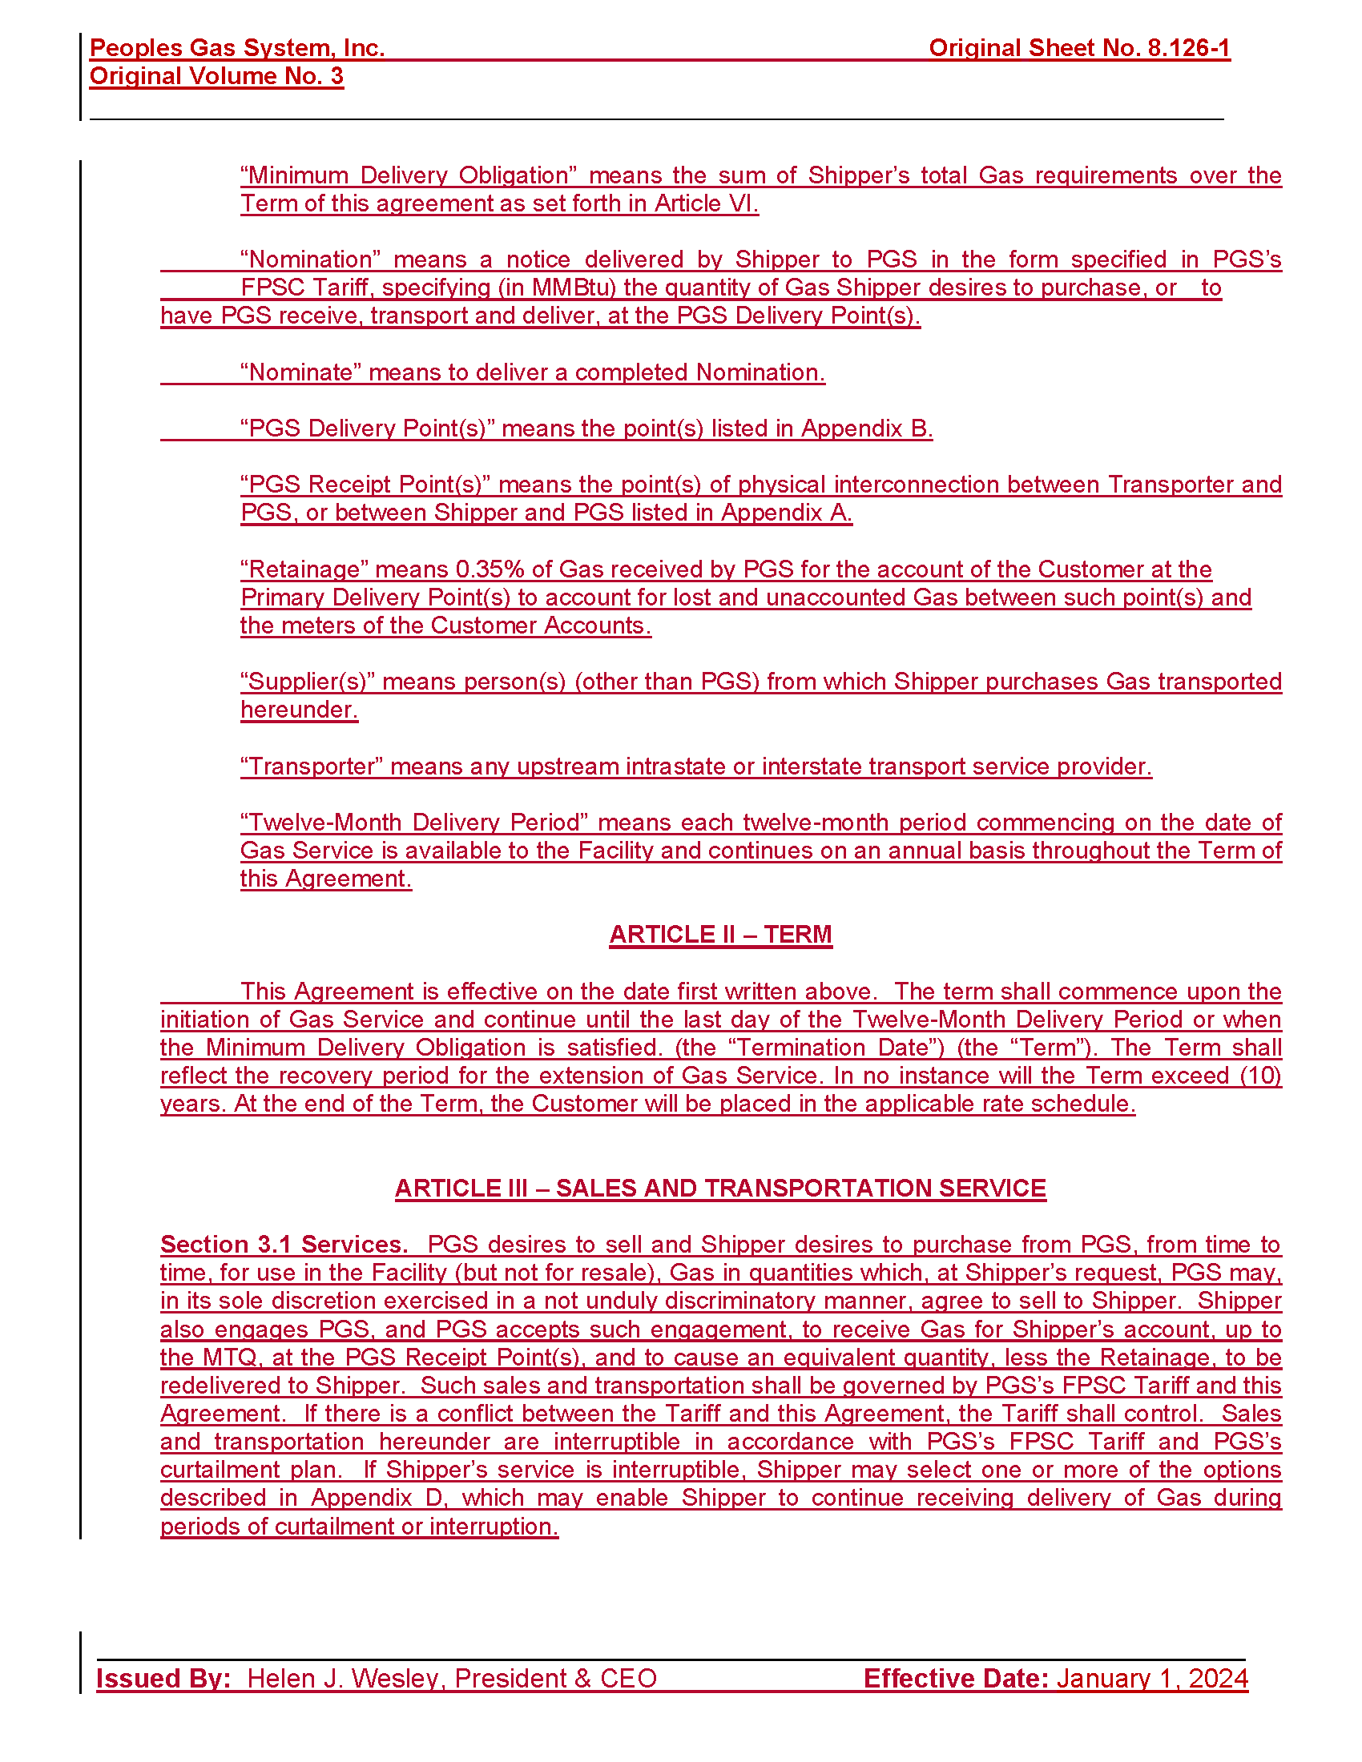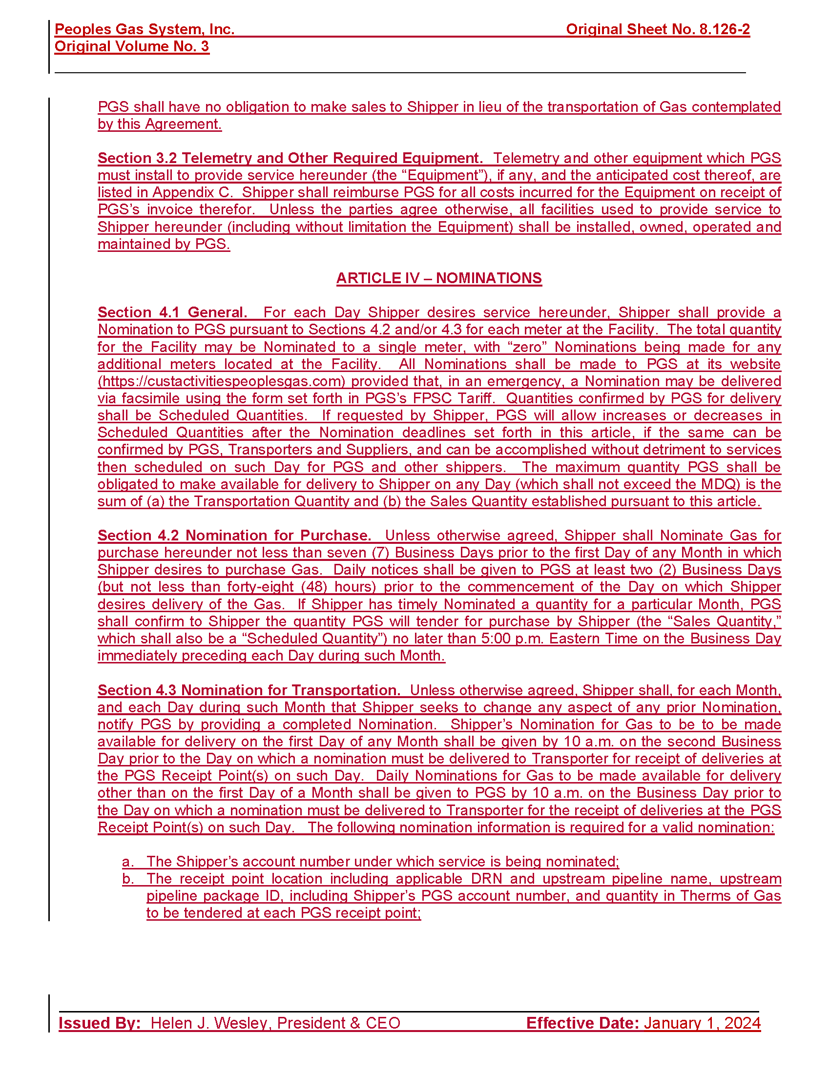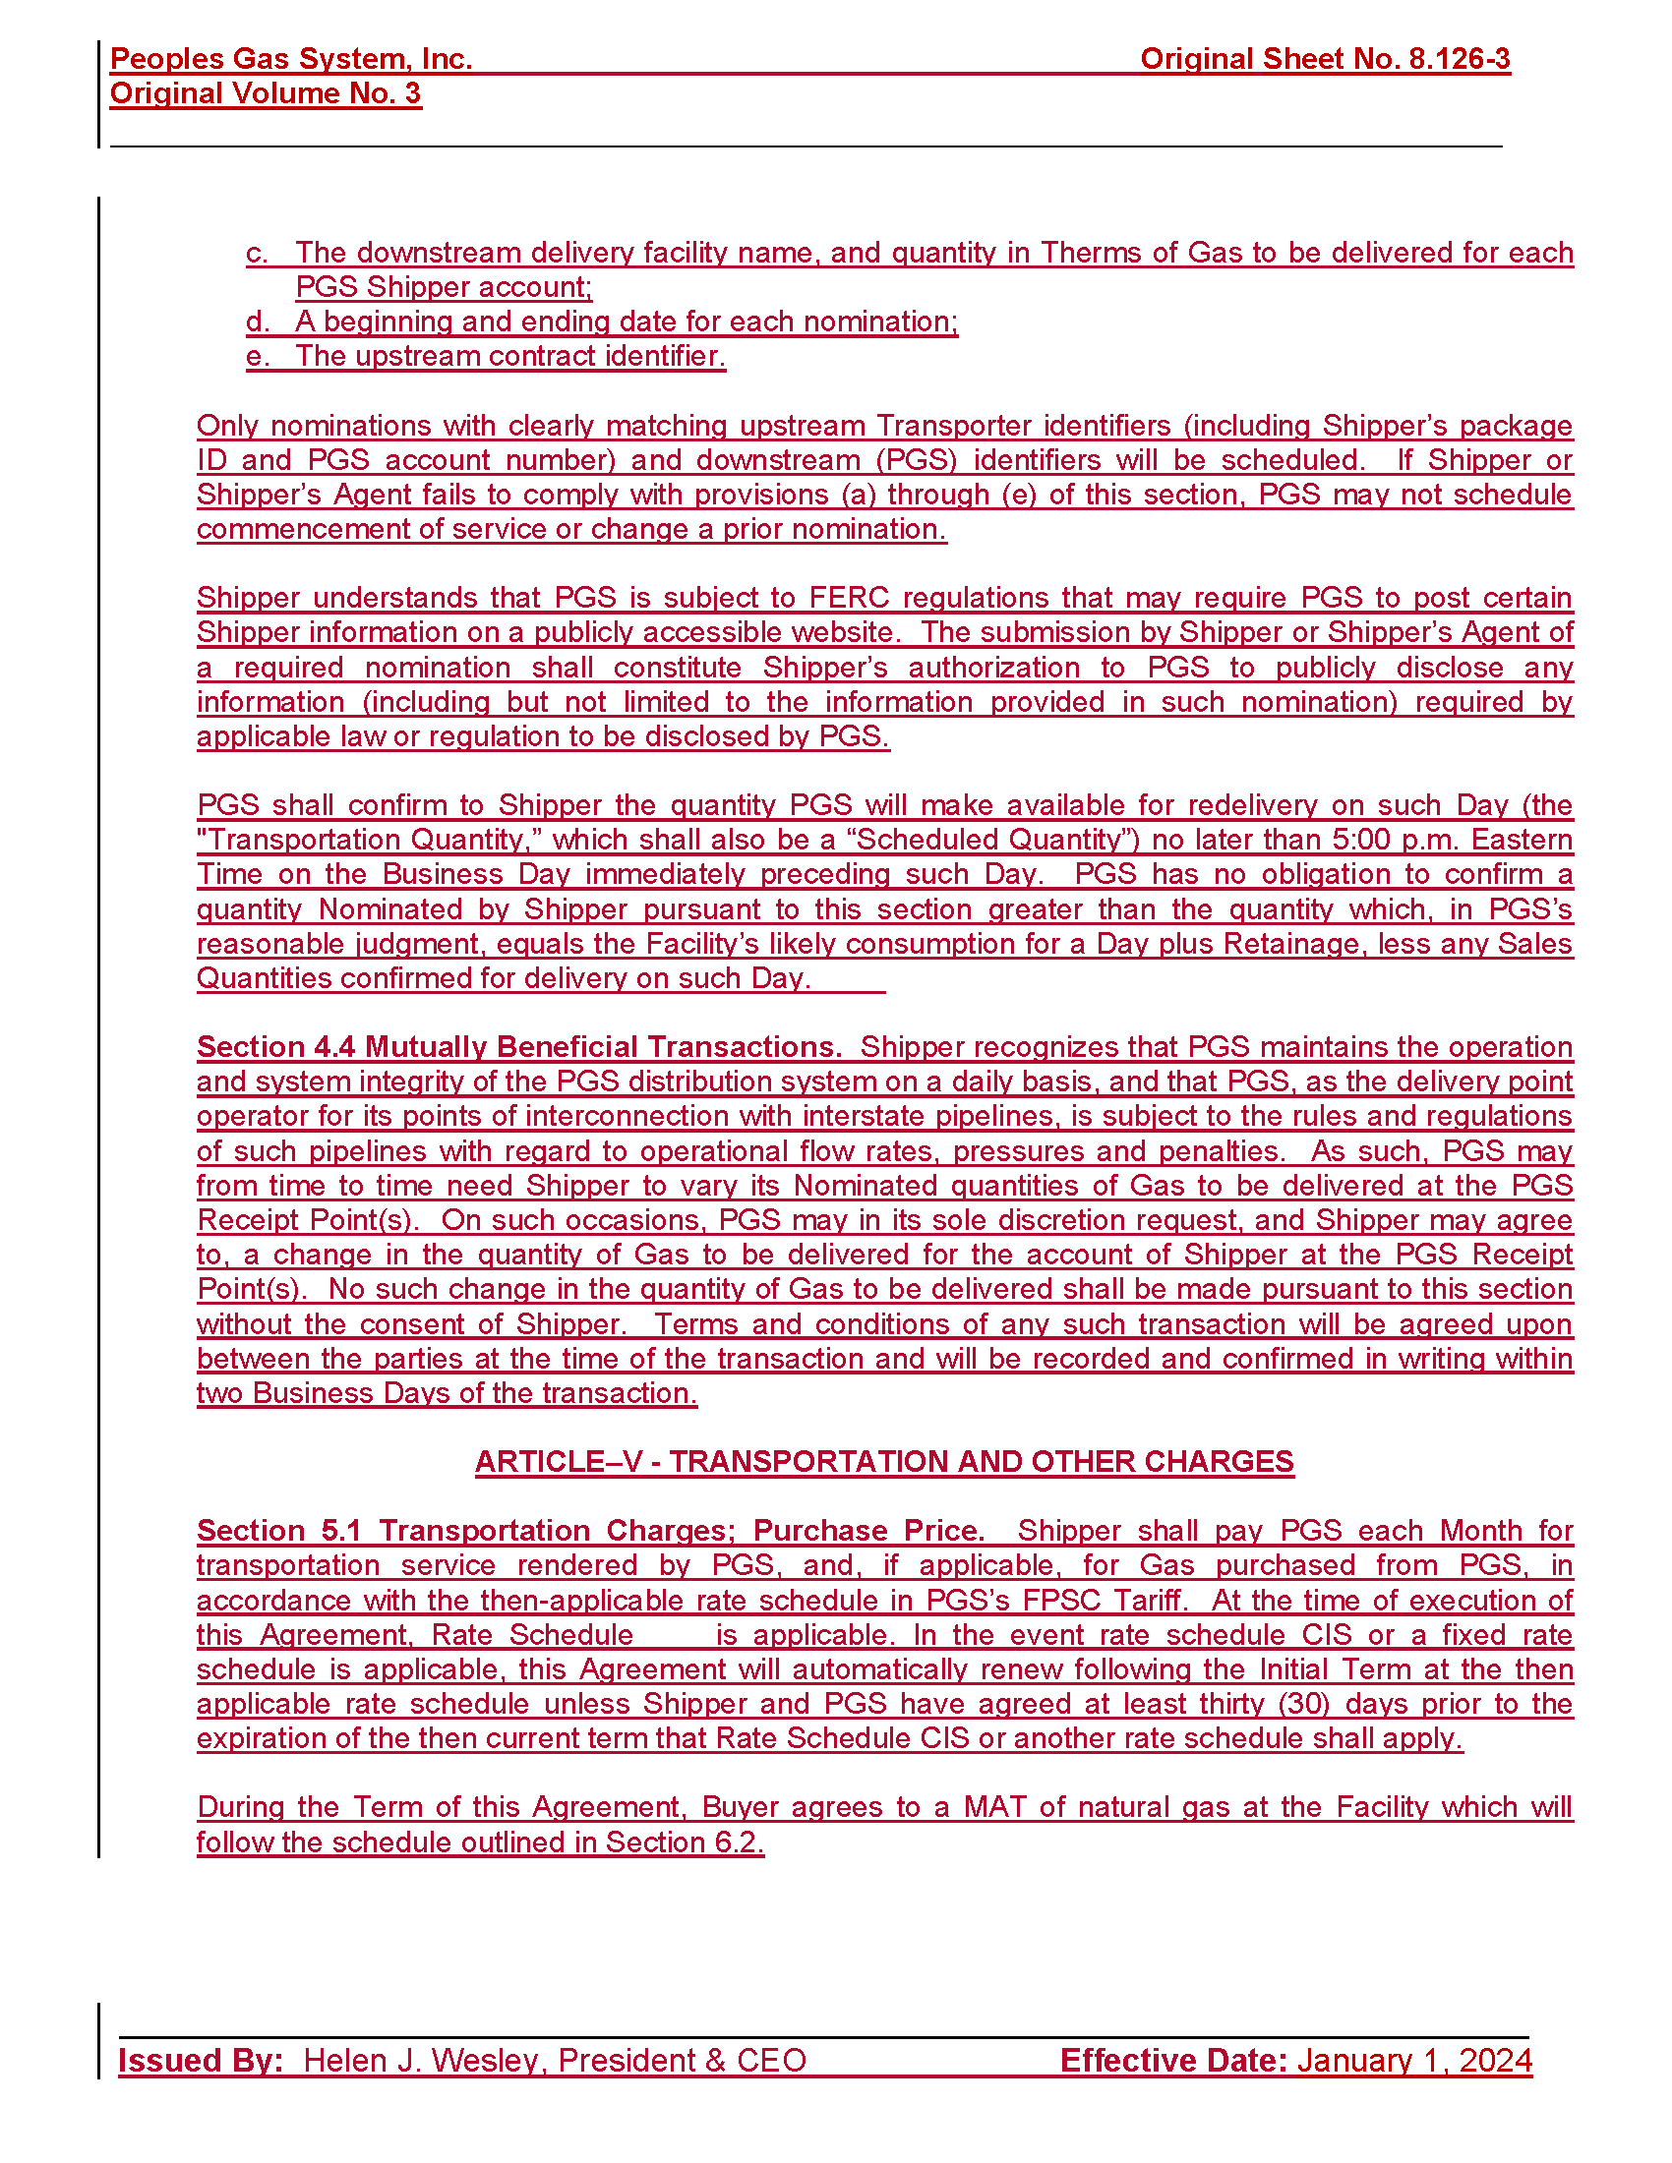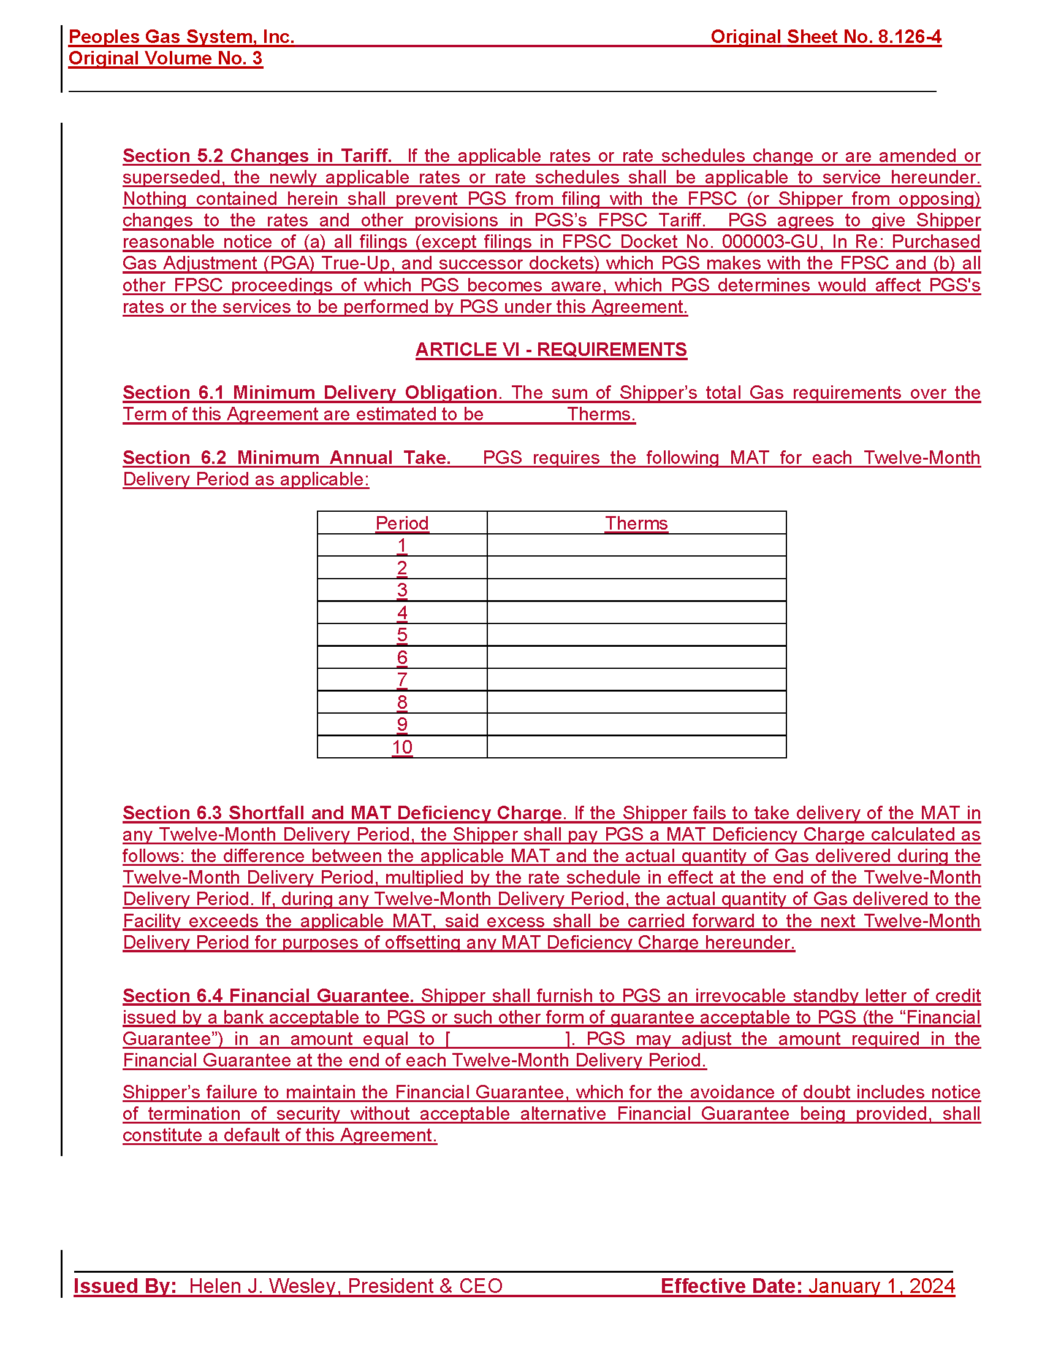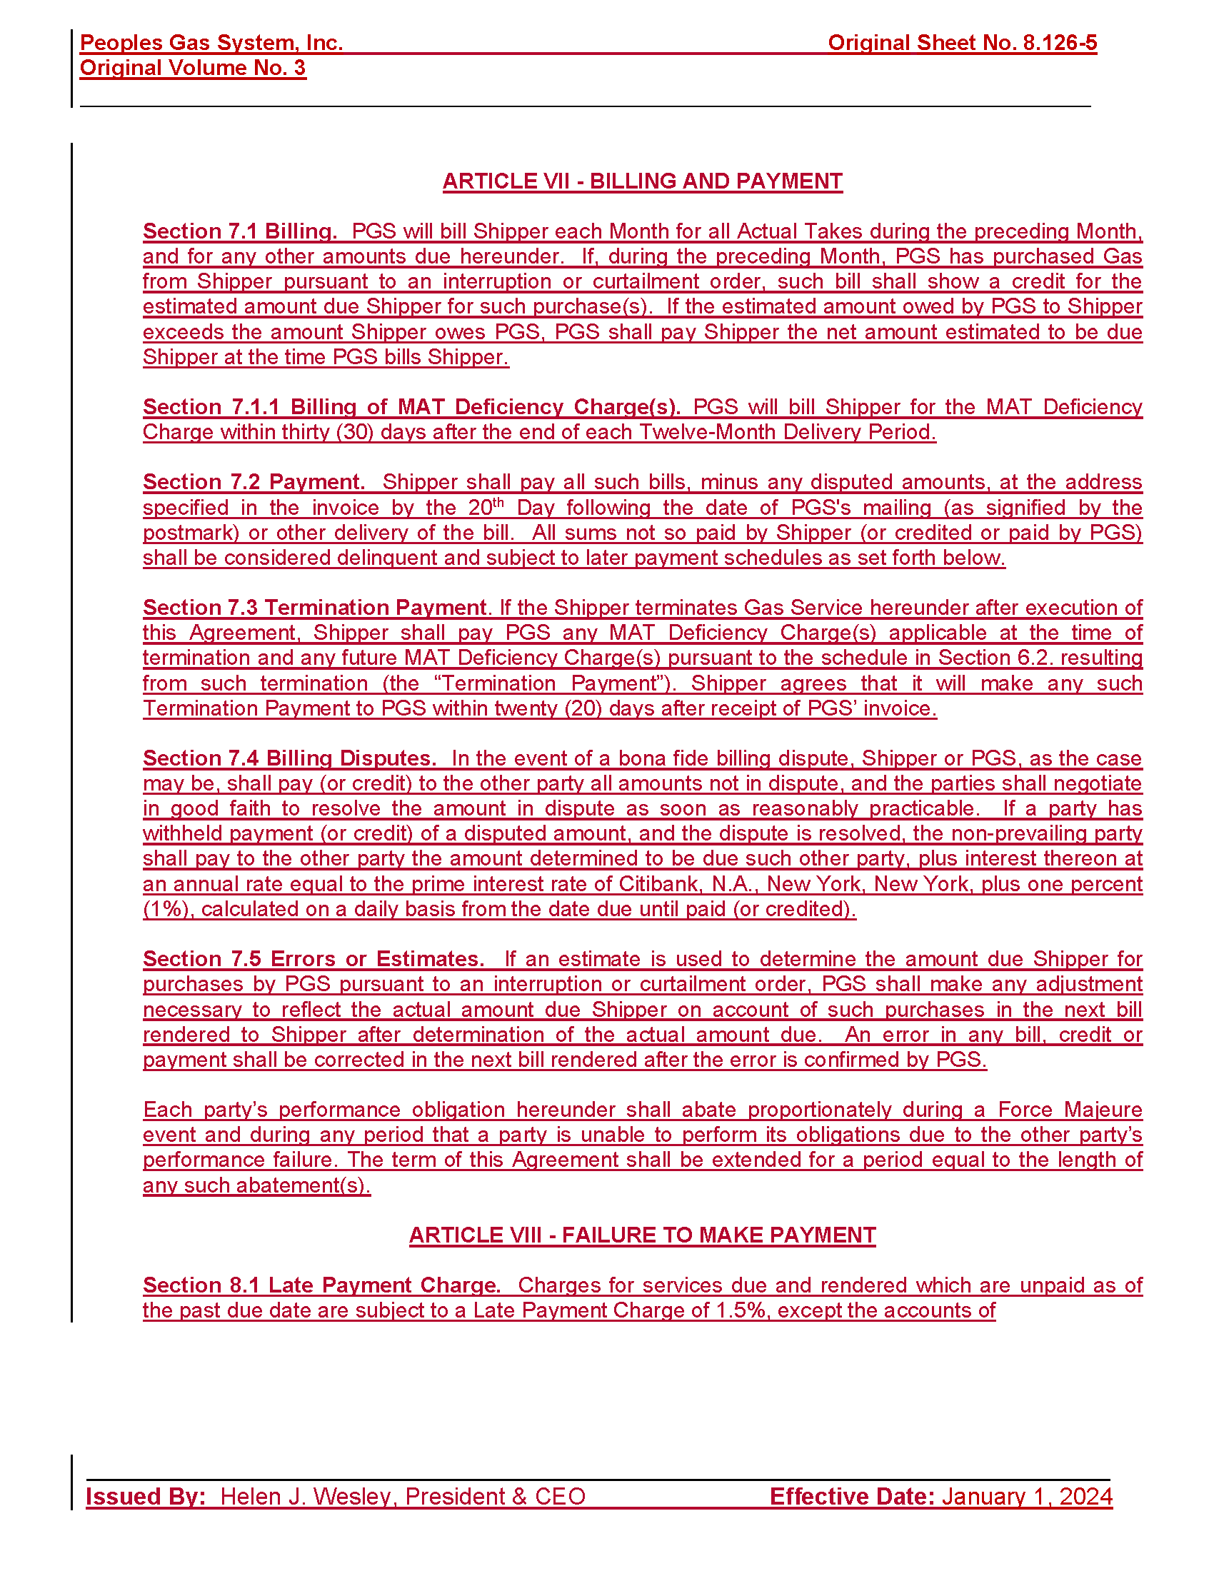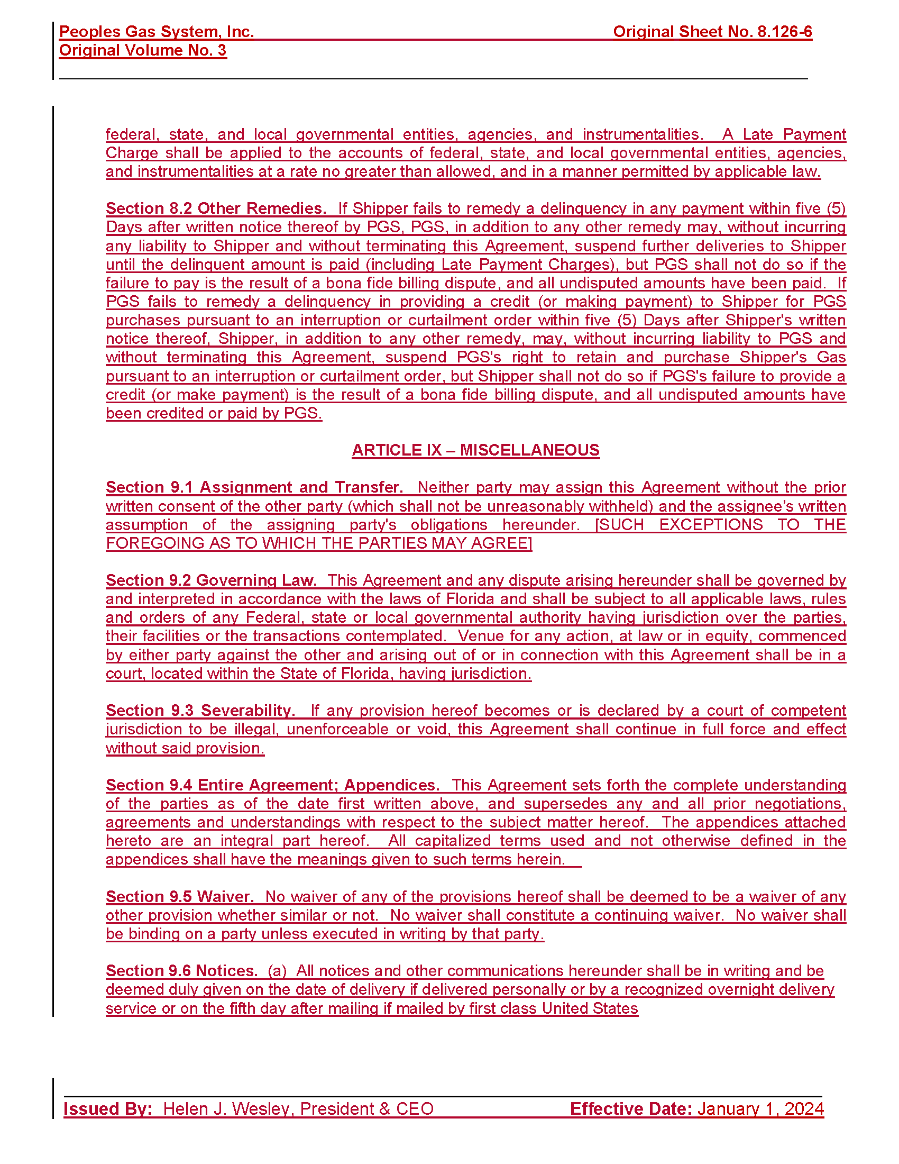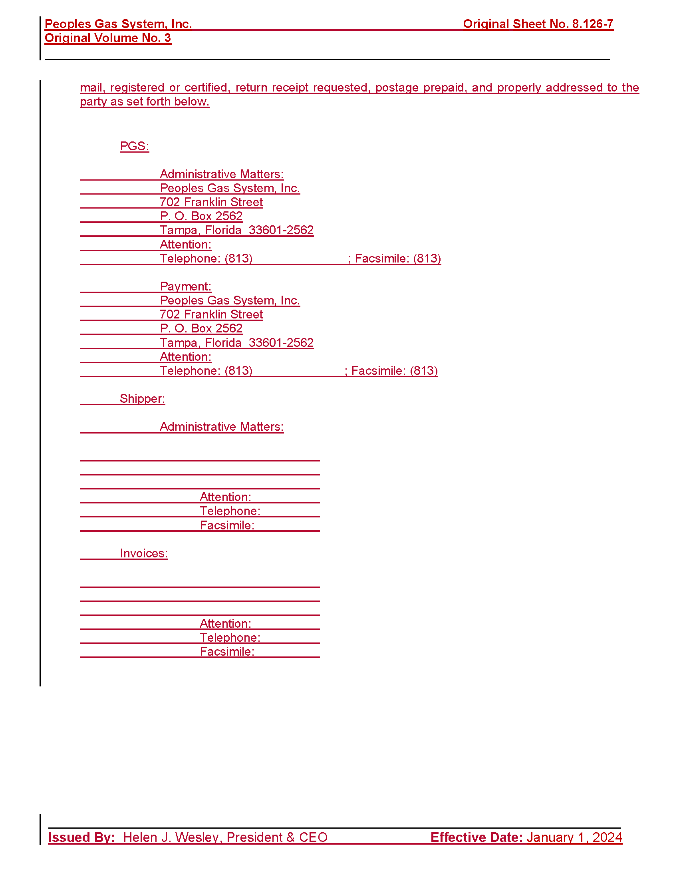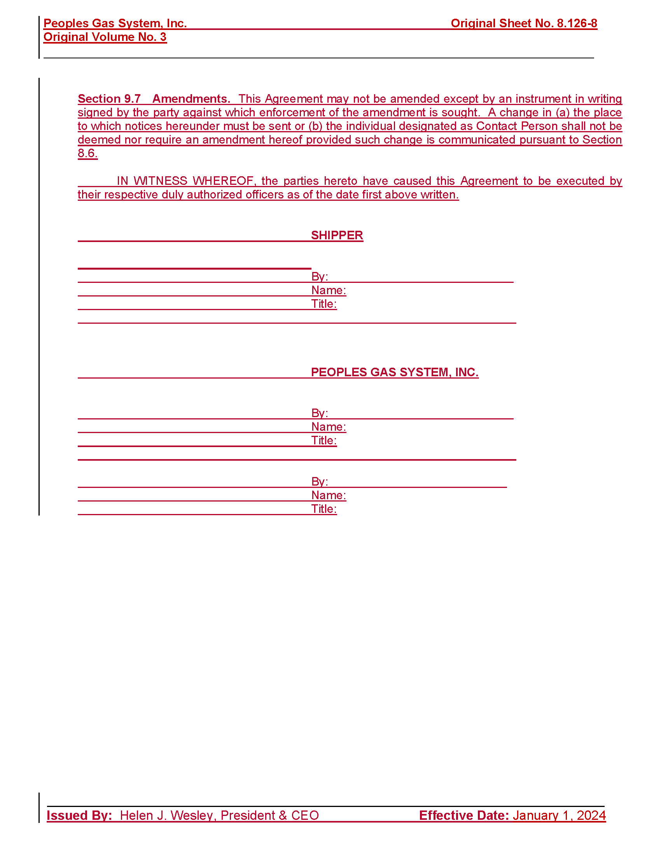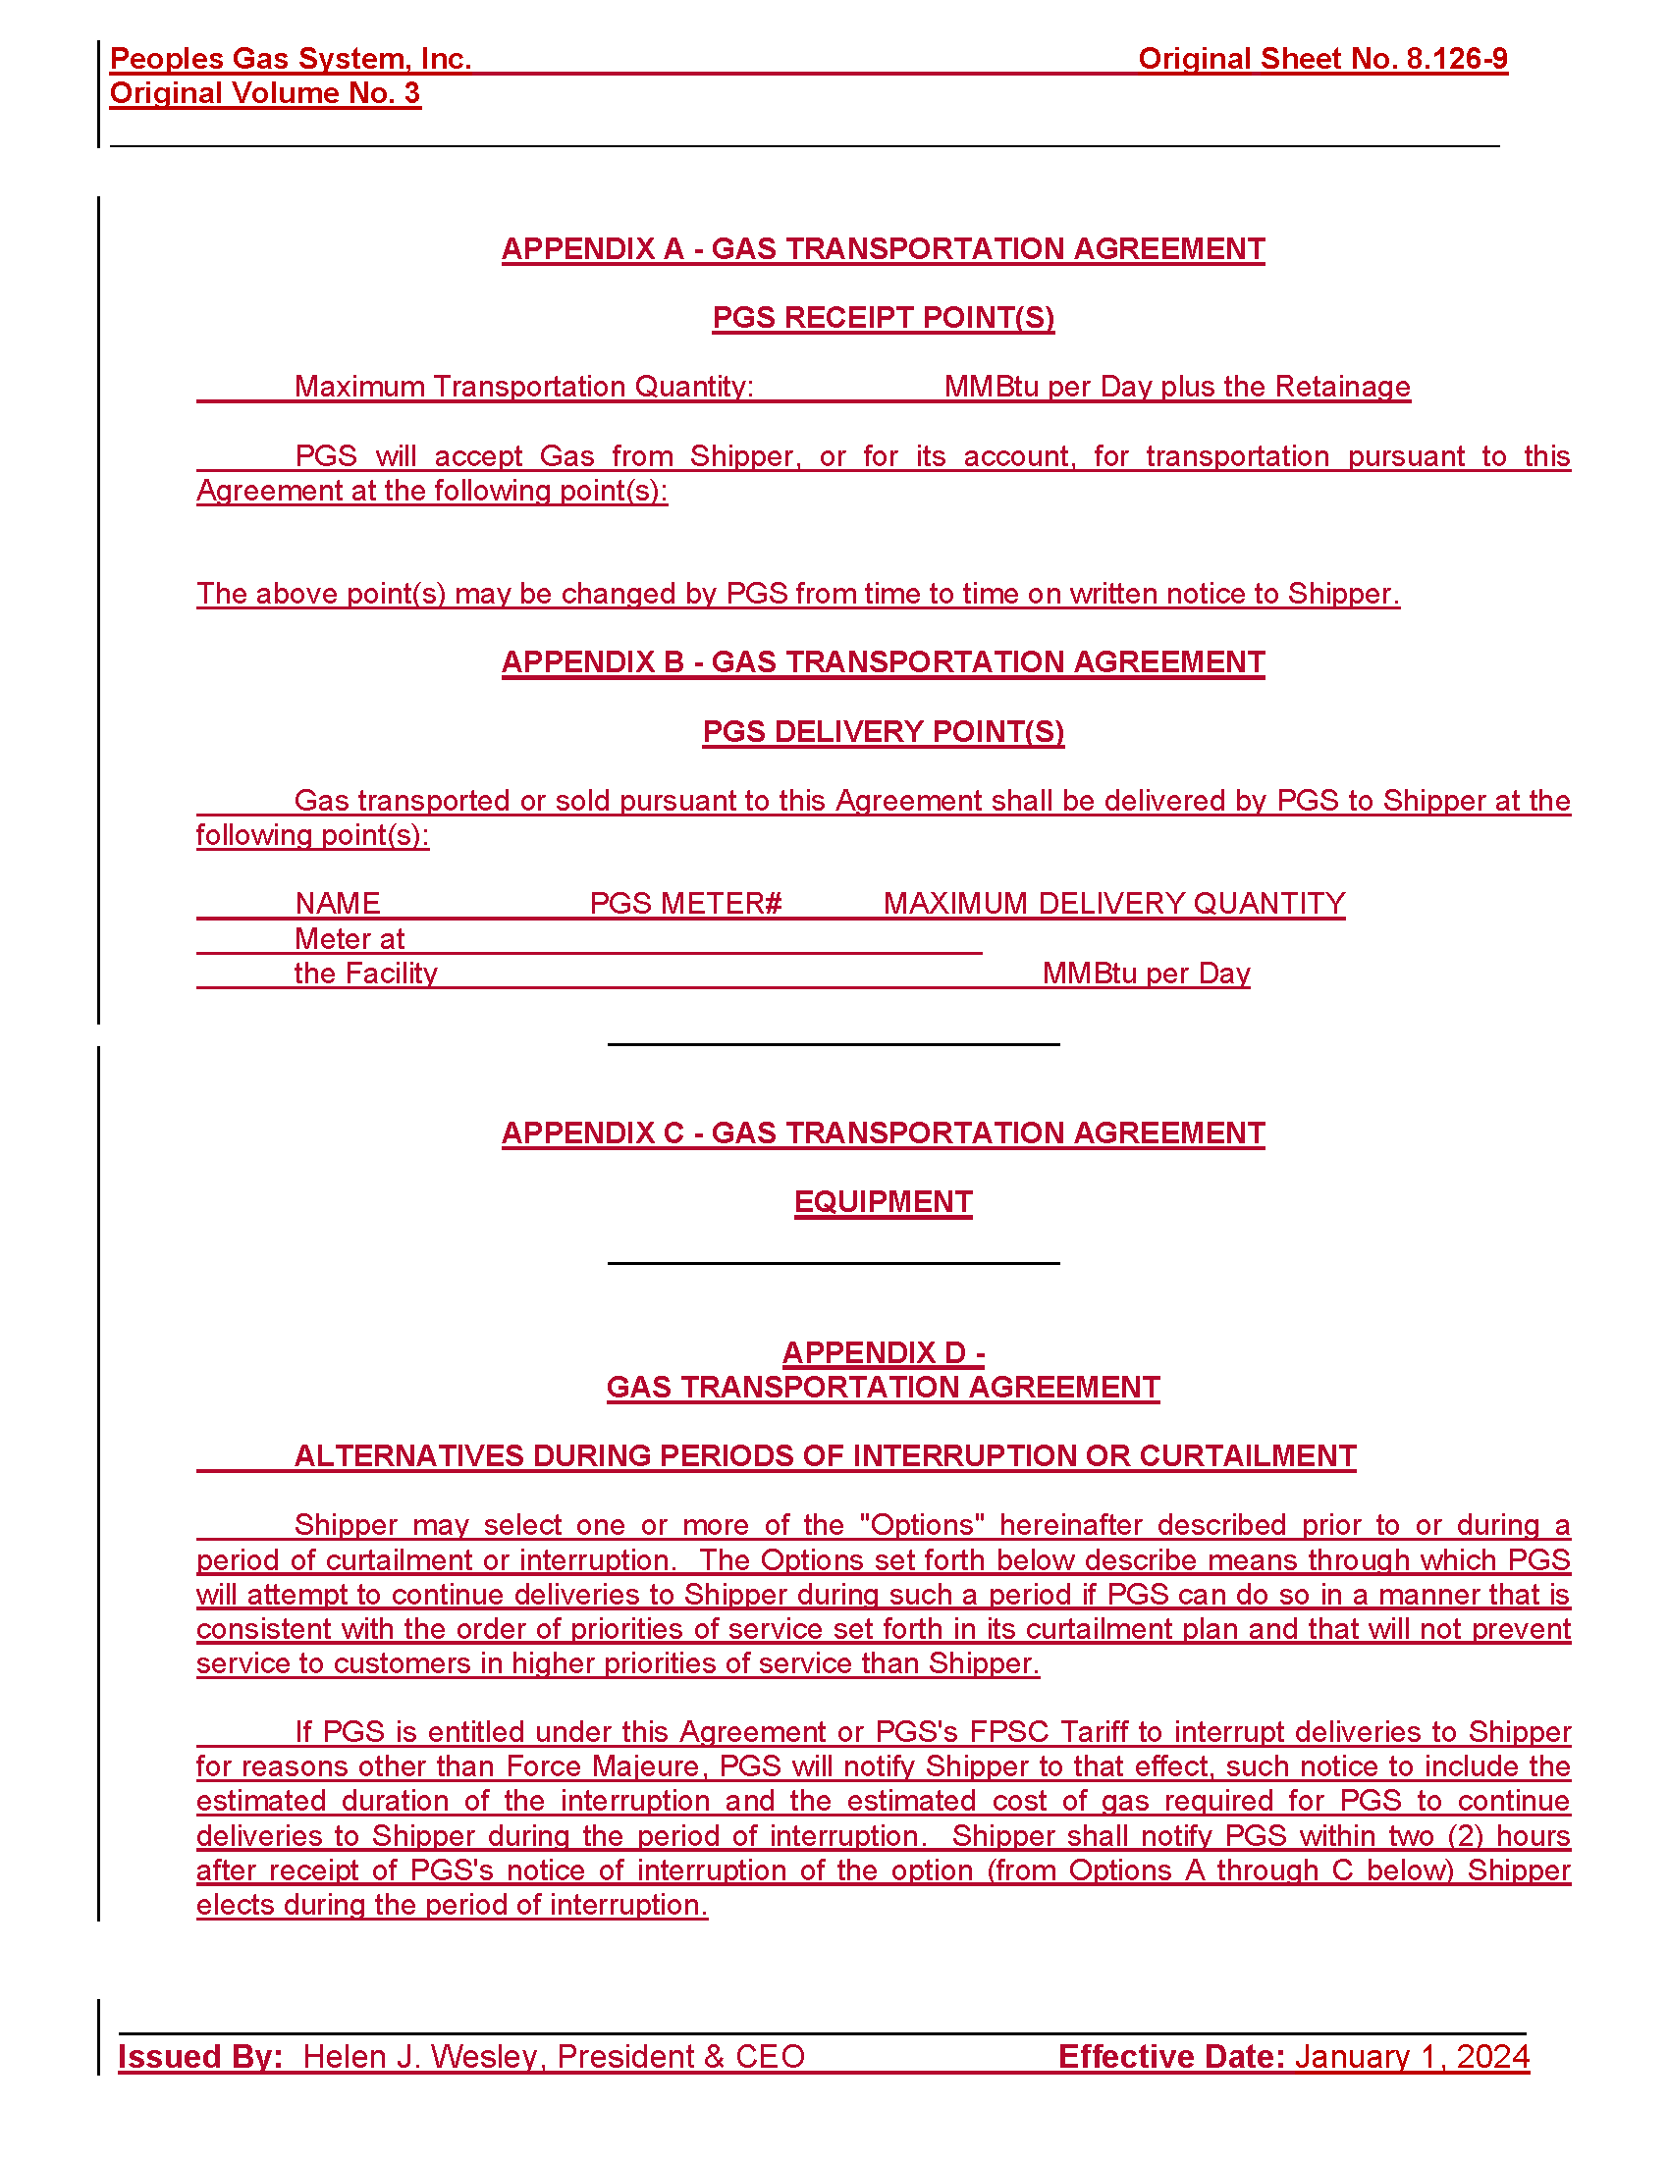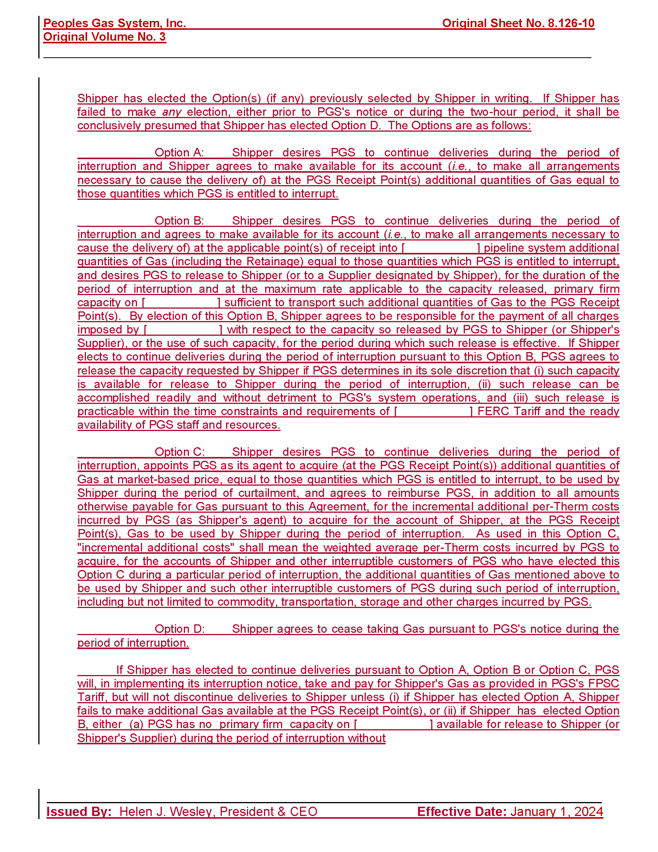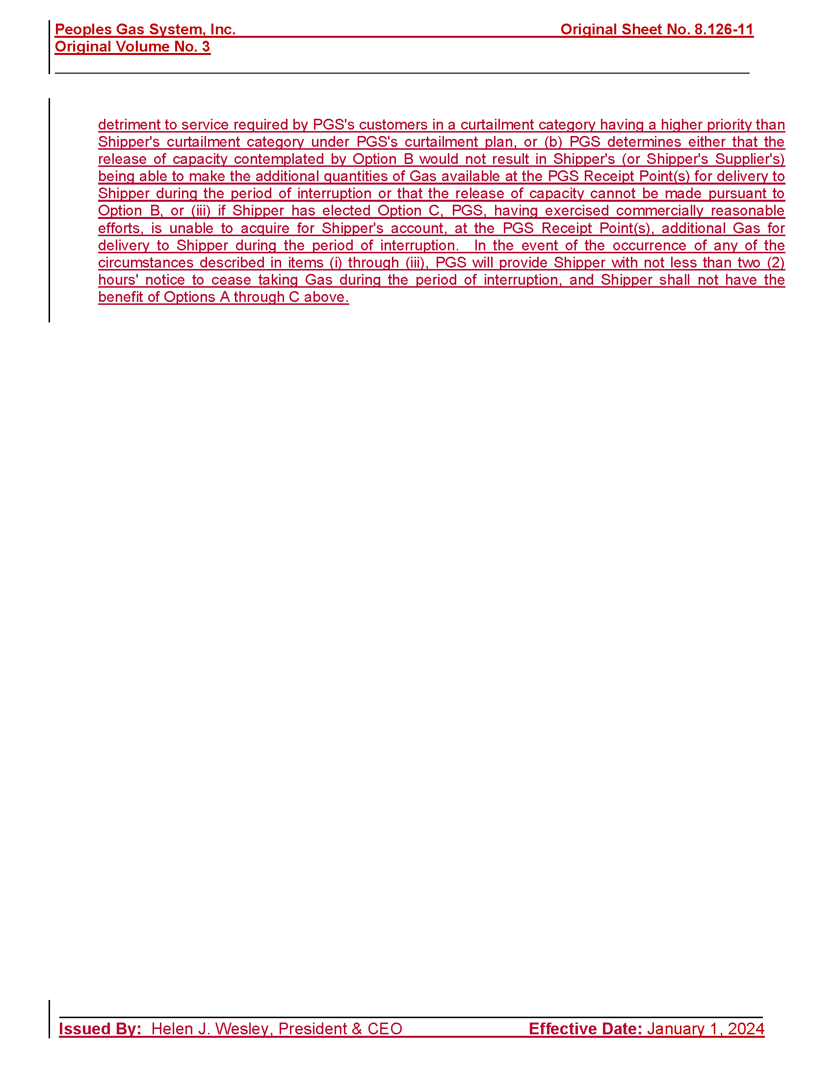

A Type 1 stipulation occurs on an Issue where the utility and intervenors agree on the resolution of the issue.
A Type 2 stipulation occurs when the utility and staff, or the utility and at least one party adversarial to the utility, agree on the resolution of the issue and the remaining parties (including staff if they do not join in the agreement) do not object to the Commission relying on the agreed language to resolve that issue in a final order.
The incremental operating revenue increase shown does not include the revenues associated with the transfer of Cast Iron/Bare Steel Rider investments, as approved in Issue 14 by the Commission. As provided on Attachment A, the total increase to base rates is $117,839,527 when the Cast Iron/Bare Steel Rider revenue of $11,156,958 is included.
See Schedule H-1, page 11 of 13, line 1, of the revised cost of service study (Document No. 06067-2023).
Document No. 06067-2023.
Document No. 06067-2023.

