State of Florida |  | Public Service Commission  Capital Circle Office Center ● 2540 Shumard Oak Boulevard  Tallahassee, Florida 32399-0850  -M-E-M-O-R-A-N-D-U-M-
DATE: | January 25, 2024
TO: | Office of Commission Clerk (Teitzman)
FROM: | Division of Economics (Kaymak, Barrett, Guffey)  Office of the General Counsel (Dose)
RE: | Docket No. 20230125-GU – Joint petition for approval of amendment to territorial agreement in Pasco County, by Florida Public Utilities Company and Peoples Gas System, Inc.
AGENDA: | 02/06/24 – Regular Agenda – Proposed Agency Action – Interested Persons May Participate
COMMISSIONERS ASSIGNED: |  |  | All Commissioners
PREHEARING OFFICER: |  |  | La Rosa
CRITICAL DATES: |  |  | None
SPECIAL INSTRUCTIONS: |  |  | None

Case Background
On November 3, 2023, Florida Public Utilities Company (FPUC) and Peoples Gas System, Inc. (Peoples), collectively the joint petitioners, filed a petition seeking Commission approval of a first amendment (Amendment No. 1) to the Amended and Restated Territorial Agreement – Pasco County (Pasco Agreement). In November 2007, the Commission approved the Pasco Agreement, along with a Master Territorial Agreement (Master Agreement) and a gas transportation agreement between the Florida Division of Chesapeake Utilities Corporation and Peoples. This Master Agreement contains terms and conditions that govern all territorial agreements entered into by Peoples and Chesapeake. The joint petitioners, through Amendment No. 1, seek the Commission’s approval to adjust the utilities’ shared service boundary.

Staff issued a data request to the joint petitioners on November 17, 2023, for which responses were received on December 13, 2023.
On January 10, 2024, the parties filed a corrected version of Amendment No. 1. The corrected version, initialed by counsel, contains the date that the amendment was entered into by the parties (October 31, 2023), which was inadvertently omitted in the original version submitted with the petition. No other changes were made to the corrected version of Amendment No. 1. Amendment No. 1 is shown as Attachment A to this recommendation.
The Commission has jurisdiction over this matter pursuant to Section 366.04, Florida Statutes (F.S.).

Discussion of Issues

Issue 1:
Should the Commission approve the proposed Amendment No. 1 to the Pasco Agreement between FPUC and Peoples in Pasco County?

Recommendation:
Yes, the Commission should approve the proposed Amendment No. 1, which transfers a portion of FPUC’s service territory to Peoples. The proposed Amendment No. 1 would facilitate the provision of economical and reliable natural gas service by Peoples to prospective residential and business customers in the proposed transfer area identified as Service Area B in Amendment No. 1 – Exhibit A, thereby avoiding duplication of facilities and services. (Kaymak, Barrett, Guffey)
Staff Analysis: Pursuant to Section 366.04(3)(a), F.S., and Rule 25-7.0471, Florida Administrative Code (F.A.C.), the Commission has the jurisdiction to approve territorial agreements between natural gas utilities. Unless the Commission determines that the proposed Amendment No. 1 will cause a detriment to the public interest, the proposed amendment should be approved.

Proposed Amendment to Territorial Agreement
FPUC and Peoples began territorial agreement discussions after a developer announced plans for a commercial complex in Service Area B. The previously undeveloped parcel of land in FPUC’s service territory is located geographically a considerable distance from the company’s existing natural gas facilities, but very close to existing facilities operated by Peoples. The proposed Amendment No. 1 will facilitate serving the new commercial development within the geographic area described in Amendment No. 1 – Exhibit A as Service Area B (Attachment A). Service Area B is about 12,212 acres in size, and the new commercial development is projected to include a grocery store and other retail outparcels totaling about 60,000 square feet. The joint petitioners assert that in the next 5 to 10 years, further development within the Service Area B could result in up to 1,000 new residential and commercial customers.

FPUC determined that its nearest facilities to Service Area B are approximately 24 miles away in Plant City. The utility asserted that construction of new facilities from its existing facilities in Plant City to Service Area B would cost several million dollars. Although a specific estimate was not developed, FPUC determined it was unable to extend service to the development economically, and thus pursued the territorial modifications set forth in this petition.

Peoples, on the other hand, has natural gas facilities about 320 feet away from Service Area B on County Road 577 (Curley Road). To provide natural gas services to Service Area B, Peoples would need to construct 170 linear feet of main lines, 150 linear feet of service lines, and a distinct regulator station, which Peoples estimate would cost $105,000. Based on the comparative difference in the amount of required infrastructure, Peoples can more economically serve the commercial development than FPUC and is willing to do so.

Pursuant to Paragraphs 3.D. and 3.E. of the Master Agreement, the joint petitioners have entered into Amendment No. 1 which, if approved, would transfer Service Area B from FPUC to Peoples. Pursuant to Paragraph 5 of Amendment No. 1, the terms and conditions of the Pasco Agreement would remain unchanged going forward. Prior to the second anniversary of the Commission’s approval of Amendment No. 1, and no more frequently than every five years thereafter, Peoples and FPUC will confer regarding the status of the amendment.

The joint petitioners state that the approval and implementation of Amendment No. 1 will not cause a decrease in the availability or reliability of natural gas service provided by either entity, or to the existing or future ratepayers of either entity, consistent with the standards set forth in Section 366.04, F.S., and Rule 25-7.0471(2)(c), F.A.C.. As stated in paragraph 6 of the petition, approval of Amendment No. 1 will enable as many residential and business customers in Pasco County as possible to receive economical and reliable natural gas service and will not necessitate the transfer of any existing customers or facilities between the joint petitioners. Moreover, as stated in paragraph 6, absent the subject amendment, certain customers in Pasco County would be unable to obtain natural gas service; thus, the approval of Amendment No. 1 would be in the public interest.

Rule Considerations
Rule 25-7.0471(2), F.A.C., addresses the standards the Commission should consider for approving territorial agreements for natural gas utilities. The Rule states:

(2) Standards for Approval. In approving territorial agreements, the Commission shall consider:
(a) The reasonableness of the purchase price of any facilities being transferred;
(b) The reasonable likelihood that the agreement, in and of itself, will not cause a decrease in the reliability of natural gas service to the existing or future ratepayers of any utility party to the agreement, and
(c) The reasonable likelihood that the agreement will eliminate existing or potential uneconomic duplication of facilities.
(d) Other relevant factors that may arise from the circumstances of a particular case.

In its review, staff considered each component of Rule 25-7.0471(2), F.A.C. Regarding paragraph (2)(a), staff notes that FPUC agreed to transfer the pertinent area to Peoples without compensation, which staff believes is reasonable because no facilities are being transferred. Regarding paragraph (2)(b), the joint petitioners’ have confirmed that the availability and reliability of service to existing or future customers will not be decreased for either petitioner. The joint petitioners verified that there are no natural gas facilities in Service Area B, and that construction would be necessary to service that geographic area. Paragraph (2)(c) has been appropriately considered because, under the proposed territorial agreement, staff believes uneconomic duplication of facilities would not occur because Peoples facilities are better positioned to serve the area economically and efficiently. Staff believe paragraph(2)(d) gives the Commission the flexibility to address any other relevant concerns that are case-specific. The joint petitioners assert that there are none.

Under Rule 25-7.0471(1)(e), F.A.C., a proposed territorial agreement must provide information regarding the degree of acceptance by affected customers. Staff notes, however, that in the instant case, there are no current customers and under this proposed territorial agreement, no facility transfers are contemplated. In addition, representatives from FPUC and Peoples have notified staff that the developer is aware of, and has no objection to, the proposed territorial agreement.

Conclusion
Staff recommends that the Commission approve the proposed Amendment No. 1, which transfers a portion of FPUC’s service territory to Peoples. The proposed Amendment No. 1 would facilitate the provision of economical and reliable natural gas service by Peoples to residential and business customers in the proposed transfer area identified as Service Area B in Amendment No. 1 – Exhibit A, thereby avoiding duplication of facilities and services.

Issue 2:
Should this docket be closed?

Recommendation:
If no protest is filed by a person whose substantial interests are affected within 21 days of the issuance of the Order, this docket should be closed upon the issuance of a Consummating Order. (Dose)

Staff Analysis:
If no protest is filed by a person whose substantial interests are affected within 21 days of the issuance of the Order, this docket should be closed upon the issuance of a Consummating Order.
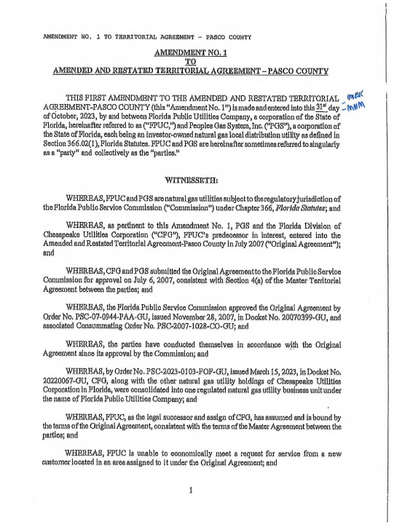

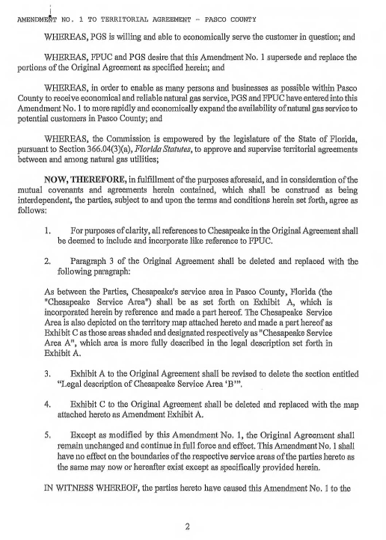

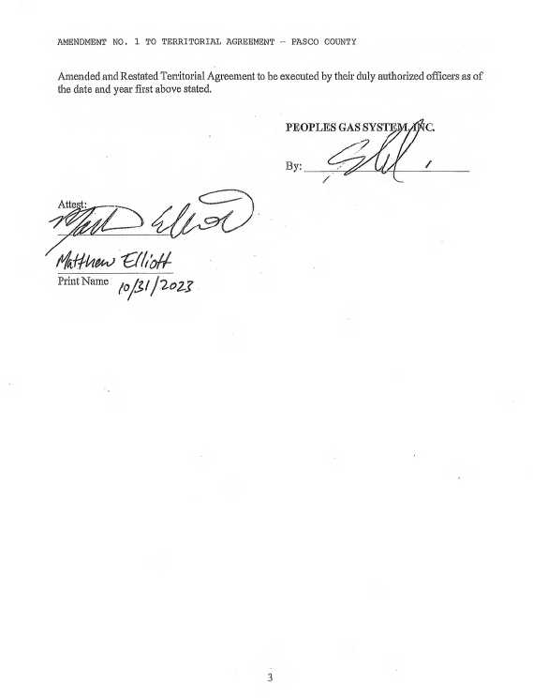

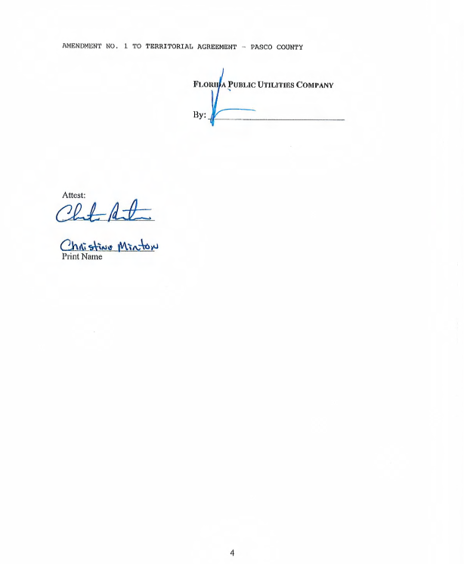

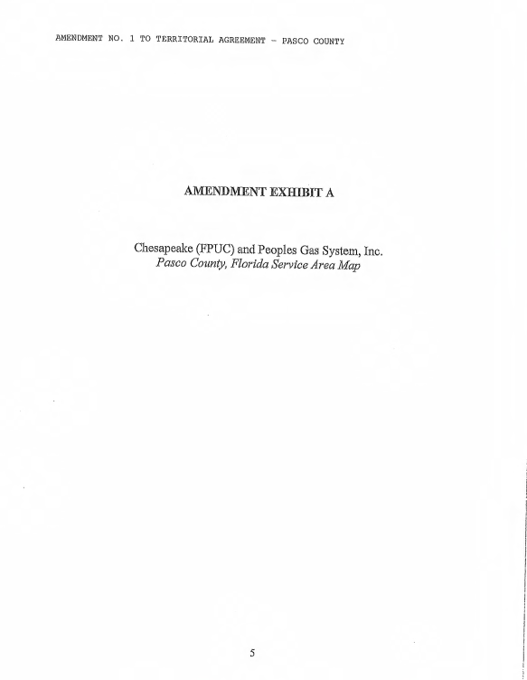

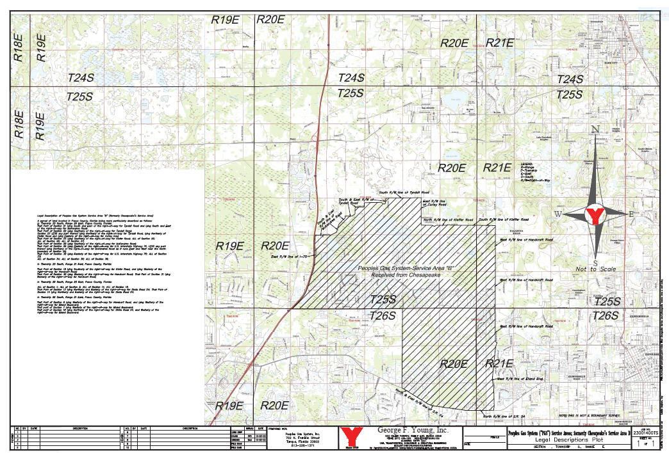

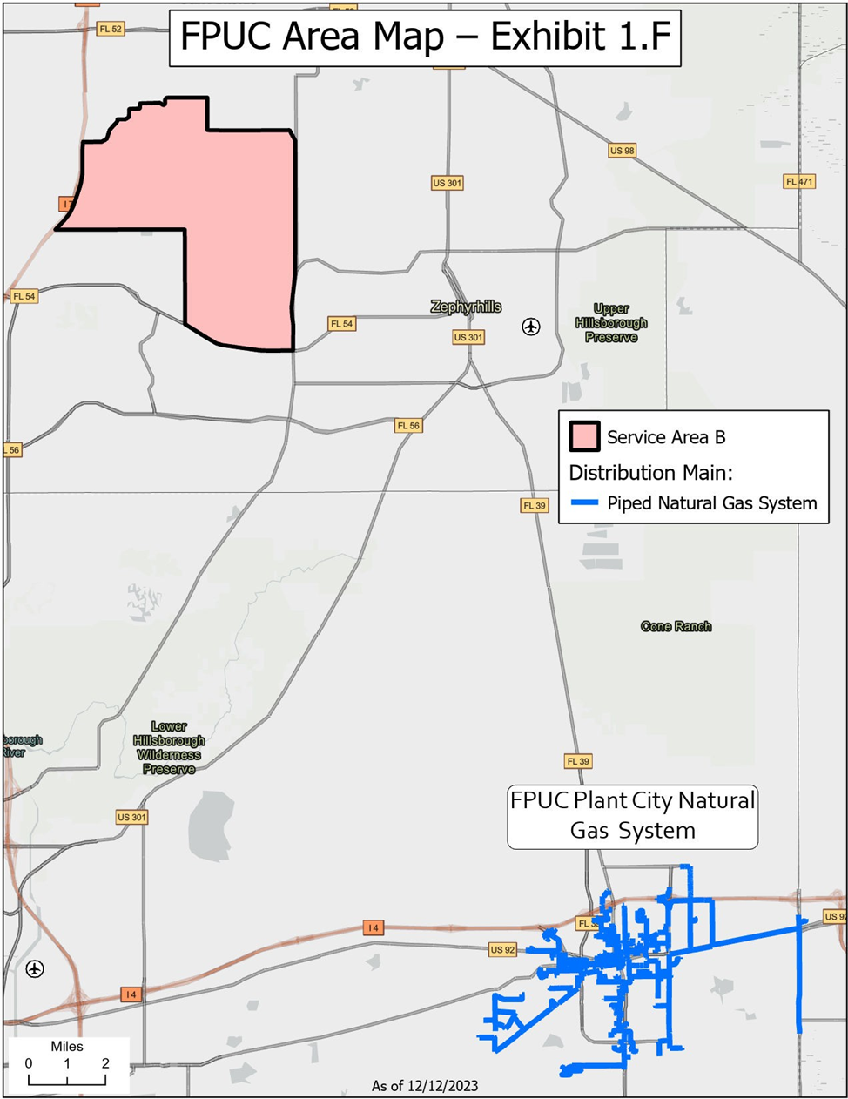

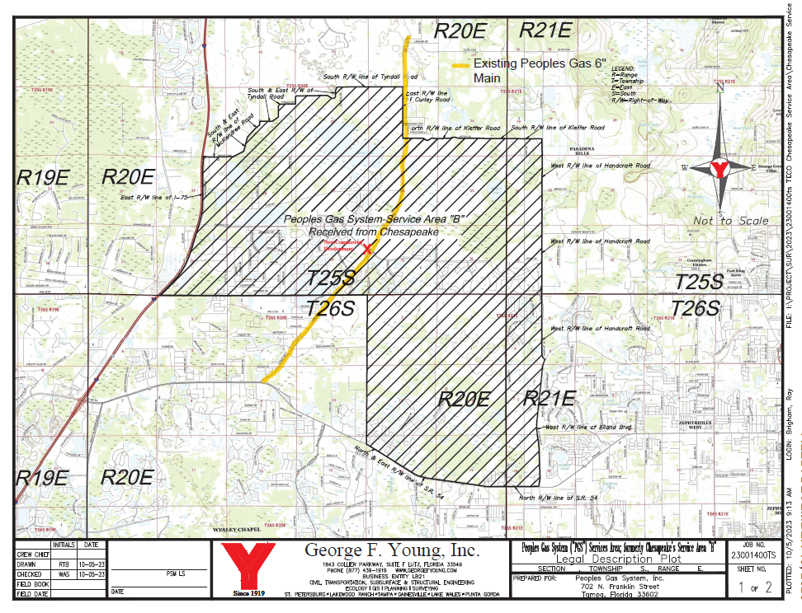

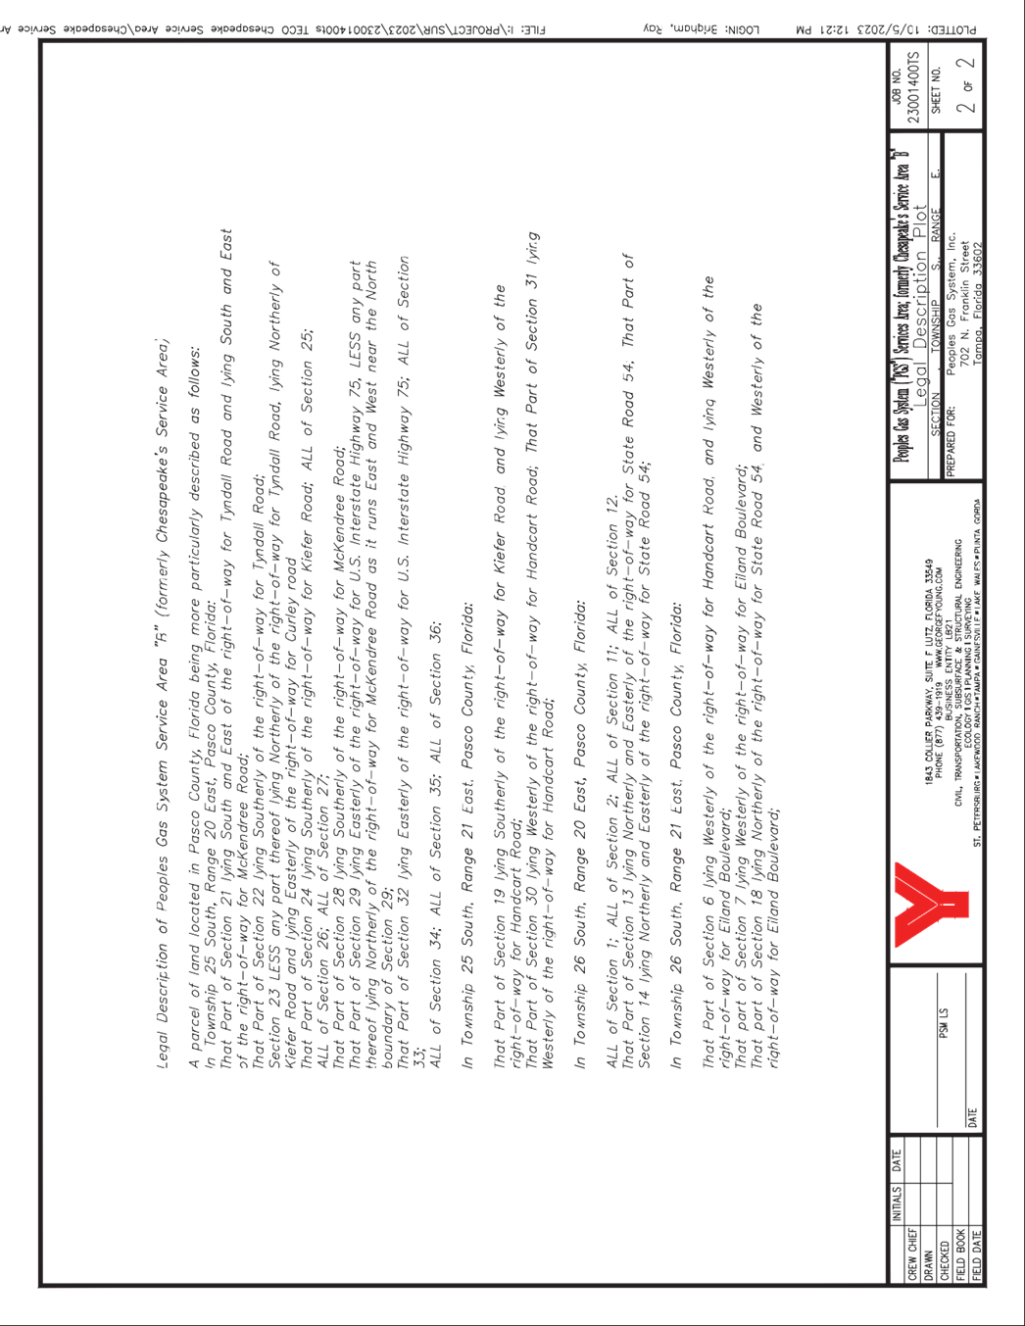
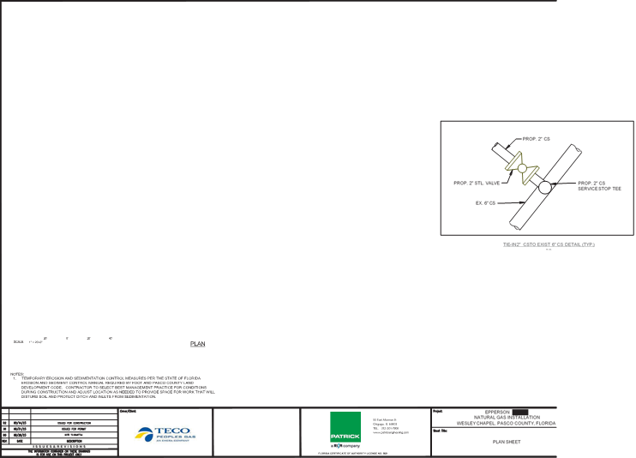
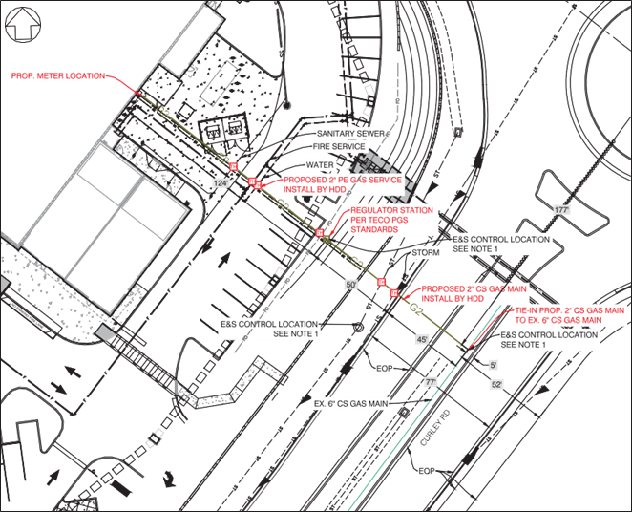

By Order No. PSC-2023-0103-FOF-GU, issued March 15, 2023, in Docket No. 20220067-GU, the Florida Division of Chesapeake Utilities Corporation, as well as FPUC’s Indiantown Division and Fort Meade Division, were consolidated with Florida Public Utilities Corporation, under the name of Florida Public Utilities Company. FPUC has assumed the rights and responsibilities under all pertinent agreements entered into by its predecessor, the Florida Division of Chesapeake Utilities Corporation, also known as CFG.
Order No. PSC-2007-0944-PAA-GU, issued November 28, 2007, in Docket No. 20070399-GU, In re: Joint Petition for approval of territorial agreement in Pasco County, master territorial agreement, and gas transportation agreement, by Peoples Gas System and the Florida Division of Chesapeake Utilities Corporation.
Id.
See Document No. 00141-2024.
Utilities Commission of the City of New Smyrna Beach v. Florida Public Service Commission, 469 So. 2d 731 (Fla.1985).
Document No. 06579-2023, Staff’s First Data Request, No. 5.
Document No. 06579-2023, Staff’s First Data Request, No. 1.
Id.
See Footnote 2, citing the Master Agreement approved by Order No. PSC-2007-0944-PAA-GU.
Document No. 06579-2023, Staff’s First Data Request, No. 4.
Document No. 06579-2023, Staff’s First Data Request, No. 3.
Document No. 06579-2023, Staff’s First Data Request, No. 4.
Id.
Id.

