BEFORE THE FLORIDA PUBLIC SERVICE COMMISSION

In re: Petition for approval of revised purchased power agreement with Pasco County, by Tampa Electric Company. | DOCKET NO. 20230129-EI  ORDER NO. PSC-2024-0064-PAA-EI  ISSUED: March 12, 2024

The following Commissioners participated in the disposition of this matter:

MIKE LA ROSA, Chairman
ART GRAHAM
GARY F. CLARK
ANDREW GILES FAY
GABRIELLA PASSIDOMO

NOTICE OF PROPOSED AGENCY ACTION
ORDER APPROVING TAMPA ELECTRIC COMPANY’S PETITION OF REVISED PURCHASE POWER AGREEMENT WITH PASCO COUNTY

BY THE COMMISSION:

NOTICE is hereby given by the Florida Public Service Commission that the action discussed herein is preliminary in nature and will become final unless a person whose interests are substantially affected files a petition for a formal proceeding, pursuant to Rule 25-22.029, Florida Administrative Code (F.A.C.).

Background
On April 4, 2023, the Florida Public Service Commission (Commission) approved Tampa Electric Company’s (TECO or Company) Purchase Power Agreement (PPA or Contract) for the Pasco County (Pasco) Waste-To-Energy Facility (WTE Facility), with restrictions on TECO’s cost recovery for transmission costs and renewable energy credits (RECs). The PPA was based on Pasco owning and operating a WTE Facility, located in Spring Hill, Florida. Pasco’s WTE Facility is within Duke Energy Florida, LLC’s (DEF’s) service territory and would require access to DEF’s transmission capacity to deliver electricity to TECO. The transmission costs disallowed for cost recovery were related to a contract provision that could have shifted some of transmission costs from Pasco to TECO above a set threshold. The REC costs were not approved for cost recovery at that time, but TECO could still purchase them, provided it demonstrated the need for any purchases in a future proceeding. After our decision, the PPA was canceled by both parties, pursuant to the terms of the PPA, because cost recovery of all terms was not granted.

On November 17, 2023, TECO filed a petition for approval of a negotiated PPA for the purchase of firm capacity and energy with Pasco. A copy of the PPA is attached (Attachment A). Pasco proposes to sell 18 megawatts (MW) of firm capacity and energy for ten years, from January 1, 2025, through December 31, 2034. Unlike the prior PPA, this PPA does not contain a transmission cost sharing threshold, and includes RECs as part of the initial energy purchase.

We have jurisdiction over this matter pursuant to Sections 366.051, 366.81, and 366.91, Florida Statutes (F.S.).

Review and Decision
Pasco proposes to sell 18 MW of firm capacity and energy from its WTE Facility to TECO for ten years from January 1, 2025, through December 31, 2034. The WTE Facility uses municipal solid waste as its primary fuel, a source of renewable energy pursuant to Section 366.91(2)(b), F.S. The price structure in the Contract has no capacity payment, but an “all-in” confidential dollars per megawatt-hour (MWh) energy rate payment that escalates annually.

Rule 25-17.0832(3), Florida Administrative Code (F.A.C.), states that in reviewing negotiated firm capacity and energy contracts for the purposes of cost recovery, we shall consider factors relating to the contract that would impact the utility’s customers, including: need for power by the purchasing utility and/or Florida utilities statewide, the cost-effectiveness of the contract, security provisions for early payment, and performance guarantees associated with the facility. These factors are evaluated below.

Need For Power

Based on TECO’s 2023 Ten-Year Site Plan (TYSP), the next planned capacity addition that could be avoided is an 18.7 MW natural gas-fired reciprocating engine with an in-service date of January 2030. Therefore, the PPA’s firm capacity of 18 MW would help avoid or defer the construction of future generation for the duration of the PPA until 2035. In addition to firm capacity, the PPA would improve the Company’s fuel diversity by increasing the contribution of renewable resources. TECO is forecast to rely upon natural gas for up to 82.8 percent of its energy during the Contract period, according to its 2023 TYSP. Therefore, we find the proposed PPA will enhance TECO’s system reliability and increase its fuel diversity.
Cost-Effectiveness

Rule 25-17.0832(3)(b), F.A.C., states in part that we should consider whether the cumulative present worth of a payment to the Qualifying Facility (QF) is not greater than the cumulative present worth of purchasing utility’s avoided cost of capacity and energy. This cost-effectiveness evaluation was based on the differential between TECO’s internal system costs versus the proposed payments under the PPA in two scenarios, with and without the PPA. In response to our data request, TECO provided its cost-effectiveness analysis that estimated the net cumulative benefits of the PPA at $7.3 million on an NPV basis. System savings are primarily associated with reduced fuel and fuel transportation costs, in addition to some deferred generation costs. Using the base fuel and emission price forecasts, the PPA is anticipated to be cost-effective on a cumulative basis for every year of the period, starting with the first year. The Company also performed high and low fuel sensitivities, in which the PPA was also cost-effective on a cumulative NPV basis over the term of the Contract. In addition, TECO will receive any Renewable Energy Credits (RECs) generated by the WTE Facility from its associated energy at no cost. In response to our data request, TECO states if it sells any of the RECs it will pass on any revenue to ratepayers. These potential revenues are not included in the economic evaluation of the PPA.

The PPA includes fixed energy rate payment, and therefore the rates are not allowed to float with changes to TECO’s system fuel cost. This allocates the risk of fuel price fluctuation from the Pasco WTE Facility to TECO’s ratepayers. For example, if fuel costs do not escalate as quickly as projected in the cost-effectiveness analyses, it may result in a loss to customers. Conversely, if fuel costs escalate faster, customers would see an increased benefit. Regardless, TECO would remain obligated to pay the contracted rate and may seek to recover the costs from the ratepayers through the Fuel Clause, subject to our review. In Order No. PSC-11-0439-PAA-EQ, we expressed concerns regarding fixed price contracts and noted that utilities are responsible for including terms and conditions that minimize risk to the company’s general body of ratepayers, and encouraged utilities to strive to avoid fixed price contracts.

Security Capacity Payment

Rule 25-18.032(3)(c), F.A.C., requires us to consider security factors relating to the contract for early capacity payments. Security guarantees included in the contract are provisions to ensure repayment of firm capacity and energy payment in the event that the QF fails to deliver firm capacity and energy to adhere to the terms and conditions of the contract. The Contract begins in the year 2025, and the avoided unit is scheduled to be in-service in 2030. If the QF defaults during this time, the Contract includes a termination security table for determining compensation to TECO. We reviewed the security terms and conditions contained in the negotiated Contract and found them adequate to protect ratepayers.

Performance Guarantees

Rule 25-17.0832(3)(d), F.A.C., requires us to consider whether the utility’s ratepayers will be protected by the contract’s terms. Performance guarantees, as included in this contract, detail how the QF is to operate and require financial penalties or other remedies should it fail to do so within the contract’s terms and conditions. The protections include a lower energy rate if Pasco does not provide a monthly energy availability of at least 92 percent. Also, if the Pasco WTE Facility has availability of less than 70 percent for any 6 months in a calendar year during the Contract, this failure will be considered default, which means that TECO can recover the cost of obtaining replacement power from Pasco. We reviewed the performance guarantees contained in the negotiated Contract and found them adequate to protect ratepayers.

Other Considerations

The proposed PPA includes additional risks relating to transmission costs. In a typical purchase power contract, the QF is assumed to be responsible for transmission-related costs. For example, in TECO’s current Standard Offer Contract, the QF is solely responsible for all costs to provide transmission to the interconnection point with the Company. As the Pasco WTE Facility is located in DEF’s service territory, the Seller requires the use of a part of DEF’s transmission capacity to deliver energy to the delivery point with TECO. Normally, Pasco would request this service and pay DEF for the transmission service, due to being the QF pursuant to Rule 25-17.0889, F.A.C. However, in this case, Section 5 of the PPA makes TECO responsible for requesting and securing the required transmission service from DEF, and for paying transmission capacity fees based on DEF’s Open Access Transmission Tariff (OATT). TECO’s monthly payments to Pasco would then be reduced by the amount of the transmission capacity fees paid to DEF. This contractual mechanism appears to have a net zero effect on ratepayers.

In addition, Section 5 of the PPA also makes TECO responsible for potential transmission studies and possible upgrades, if needed, to secure DEF’s transmission capacity for Pasco’s WTE Facility. TECO has stated, consistent with Order No. PSC- 2023-0132-PAA-EI, that it will not seek cost recovery of any transmission costs related to transmission studies or potential upgrades.

Conclusion

Based on our review, the negotiated PPA improves TECO’s fuel diversity with the addition of renewable energy and is cost-effective based on current forecasts, saving a projected $7.3 million in NPV, with savings beginning the first year of the PPA. The Contract has adequate security and performance guarantees to protect ratepayers in the event of a default or non-performance by Pasco. In addition, consistent with Order No. PSC-2023-0132-PAA-EI, the Company will not seek cost recovery for any transmission studies or upgrades.

Based on the foregoing, it is

ORDERED that the negotiated Purchased Power Agreement improves Tampa Electric Company’s fuel diversity with the addition of renewable energy and is cost-effective based on current forecasts, saving a projected $7.3 million in Net Present Value (NPV), with savings beginning the first year of the Purchase Power Agreement. The Contract has adequate security and performance guarantees to protect ratepayers in the event of a default or non-performance by Pasco. In addition, consistent with Order No. PSC-2023-0132-PAA-EI, Tampa Electric Company will not seek cost recovery for any transmission studies or upgrades. It is further

ORDERED that the provisions of this Order, issued as proposed agency action, shall become final and effective upon the issuance of a Consummating Order unless an appropriate petition, in the form provided by Rule 28-106.201, Florida Administrative Code, is received by the Commission Clerk, 2540 Shumard Oak Boulevard, Tallahassee, Florida 32399-0850, by the close of business on the date set forth in the “Notice of Further Proceedings” attached hereto. It is further

ORDERED that in the event this Order becomes final, this docket shall be closed.

By ORDER of the Florida Public Service Commission this 12th day of March, 2024.

/s/ Adam J. Teitzman
ADAM J. TEITZMAN
Commission Clerk
Florida Public Service Commission
2540 Shumard Oak Boulevard
Tallahassee, Florida 32399
(850) 413-6770
www.floridapsc.com

Copies furnished: A copy of this document is provided to the parties of record at the time of issuance and, if applicable, interested persons.

JDI

NOTICE OF FURTHER PROCEEDINGS OR JUDICIAL REVIEW

The Florida Public Service Commission is required by Section 120.569(1), Florida Statutes, to notify parties of any administrative hearing or judicial review of Commission orders that is available under Sections 120.57 or 120.68, Florida Statutes, as well as the procedures and time limits that apply. This notice should not be construed to mean all requests for an administrative hearing or judicial review will be granted or result in the relief sought.

The action proposed herein is preliminary in nature. Any person whose substantial interests are affected by the action proposed by this order may file a petition for a formal proceeding, in the form provided by Rule 28-106.201, Florida Administrative Code. This petition must be received by the Office of Commission Clerk, at 2540 Shumard Oak Boulevard, Tallahassee, Florida 32399-0850, by the close of business on April 2, 2024. If such a petition is filed, mediation may be available on a case-by-case basis. If mediation is conducted, it does not affect a substantially interested person's right to a hearing. In the absence of such a petition, this order shall become effective and final upon the issuance of a Consummating Order.

Any objection or protest filed in this docket before the issuance date of this order is considered abandoned unless it satisfies the foregoing conditions and is renewed within the specified protest period.

Any party adversely affected by the Commission's final action in this matter may request: (1) reconsideration of the decision by filing a motion for reconsideration with the Office of Commission Clerk, within fifteen (15) days of the issuance of this order in the form prescribed by Rule 25-22.060, Florida Administrative Code; or (2) judicial review by the Florida Supreme Court in the case of an electric, gas or telephone utility or the First District Court of Appeal in the case of a water or wastewater utility by filing a notice of appeal with the Office of Commission Clerk and filing a copy of the notice of appeal and the filing fee with the appropriate court. This filing must be completed within thirty (30) days after the issuance of this order, pursuant to Rule 9.110, Florida Rules of Appellate Procedure. The notice of appeal must be in the form specified in Rule 9.900(a), Florida Rules of Appellate Procedure.

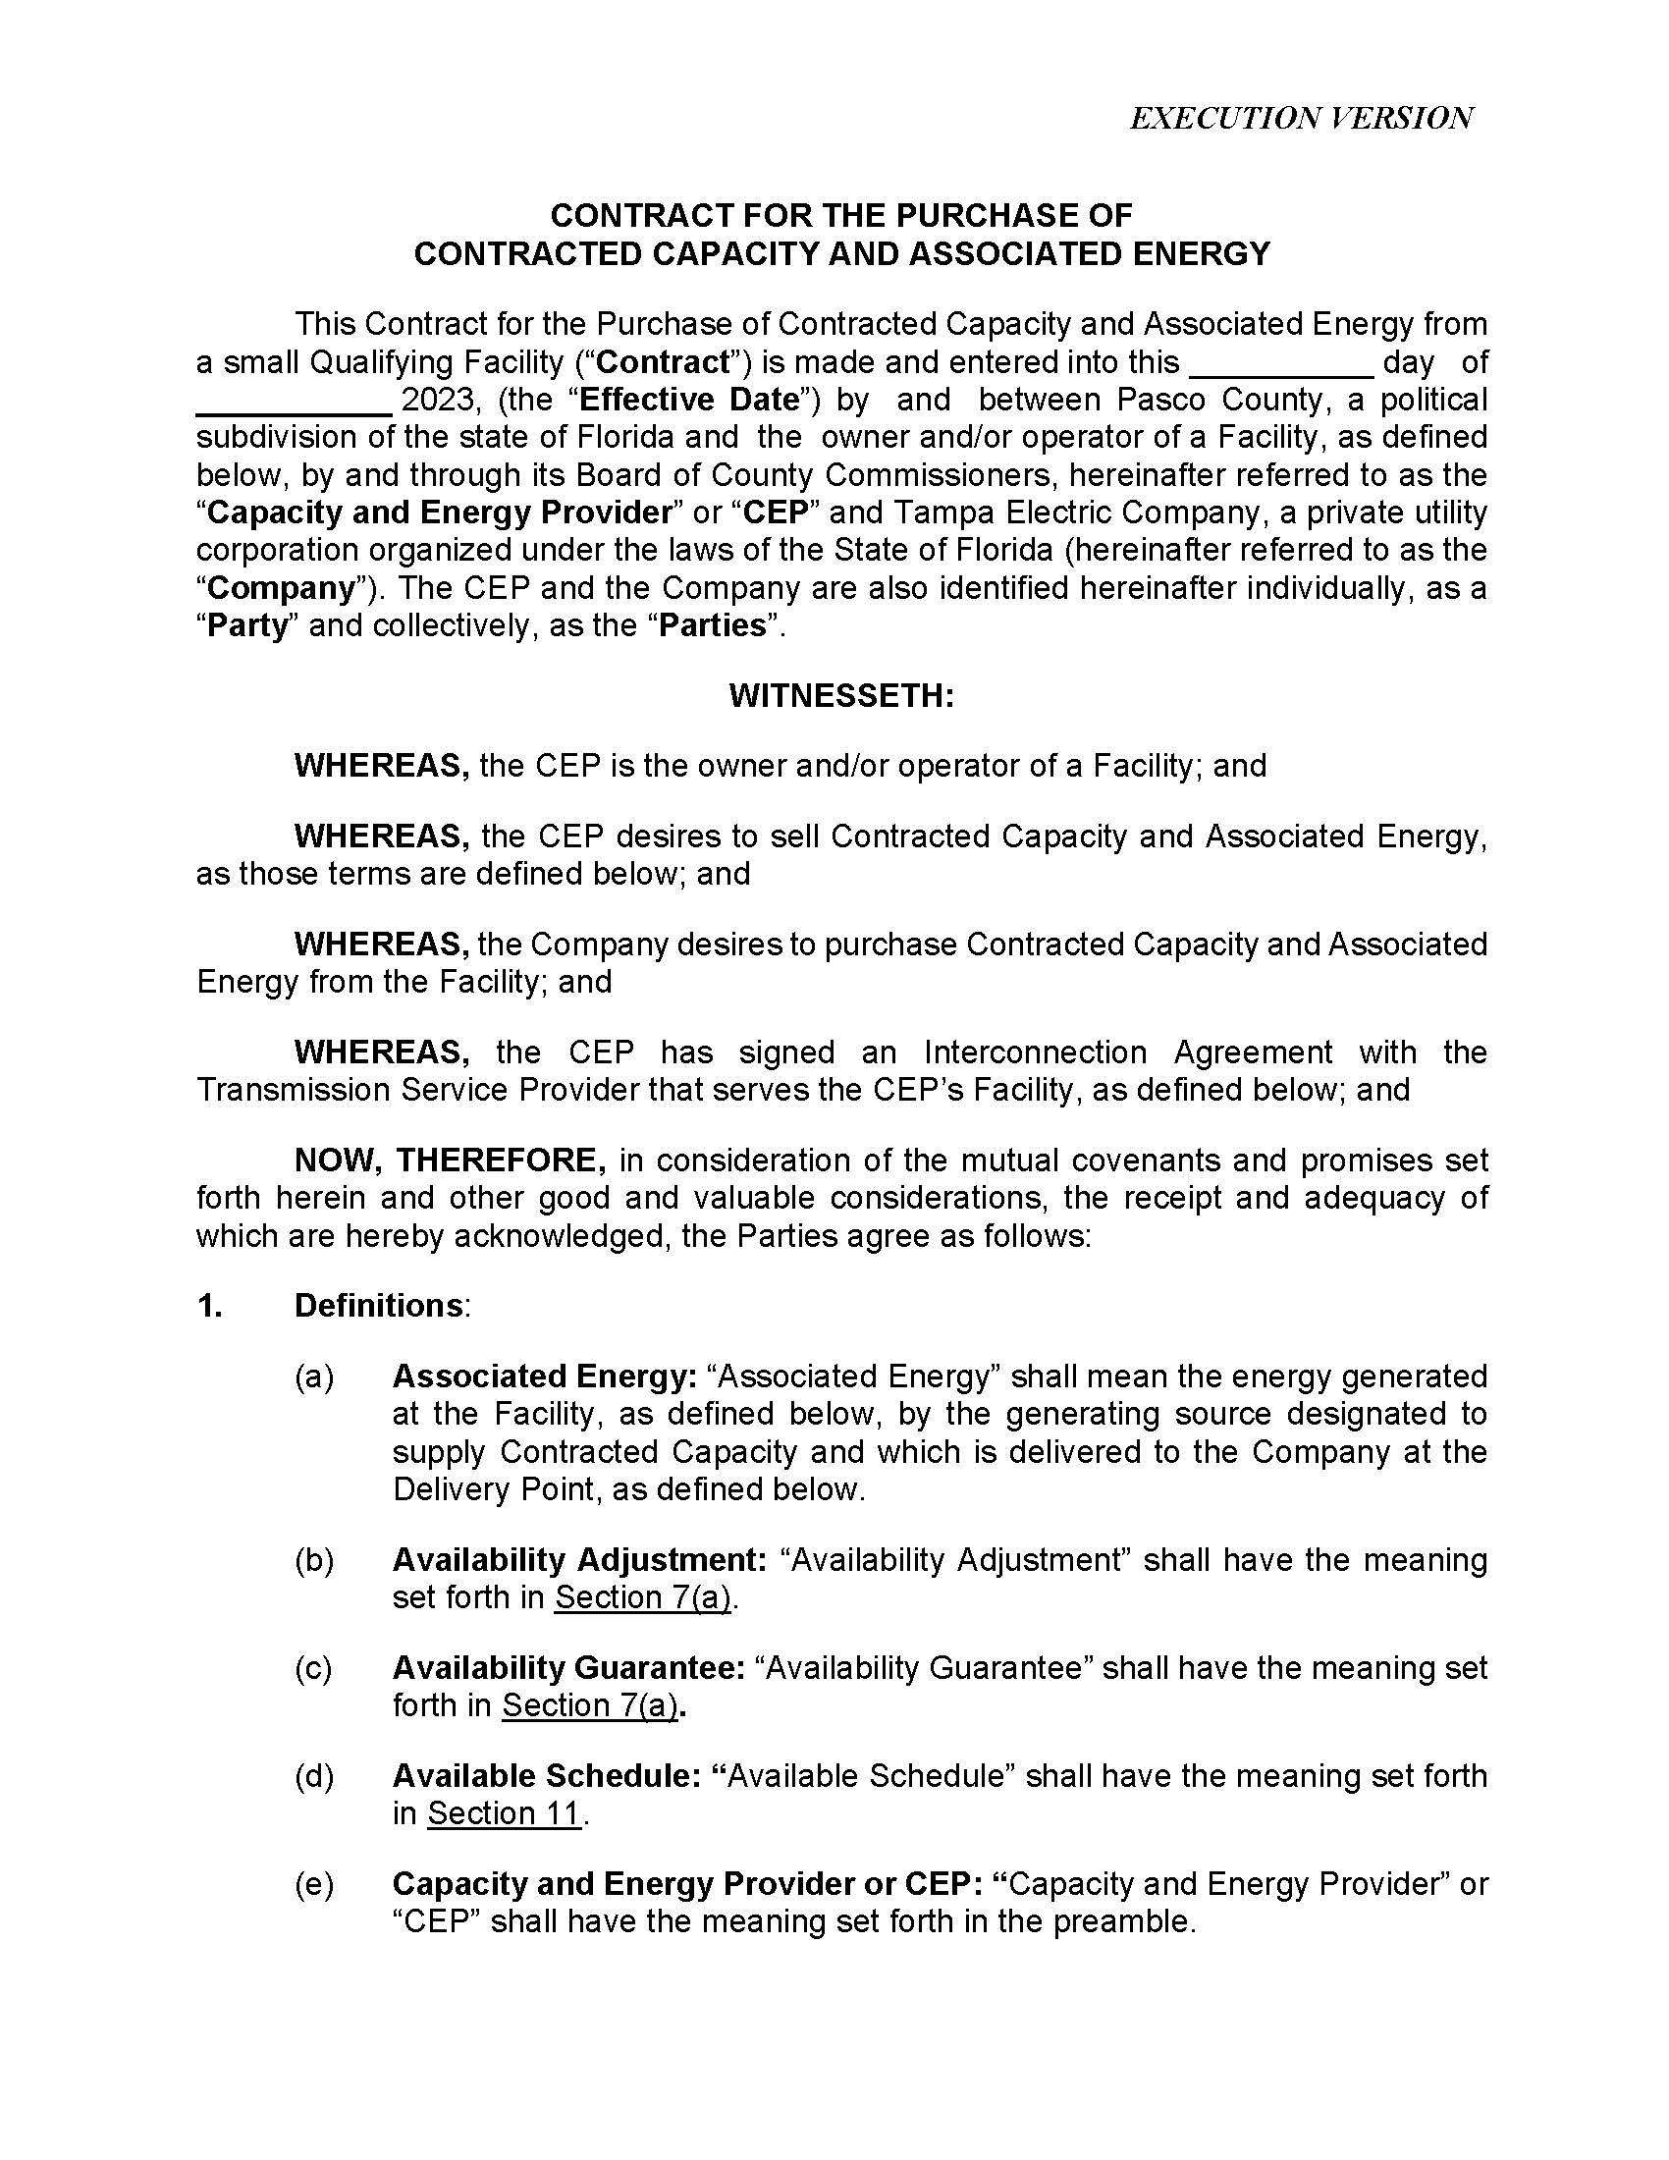

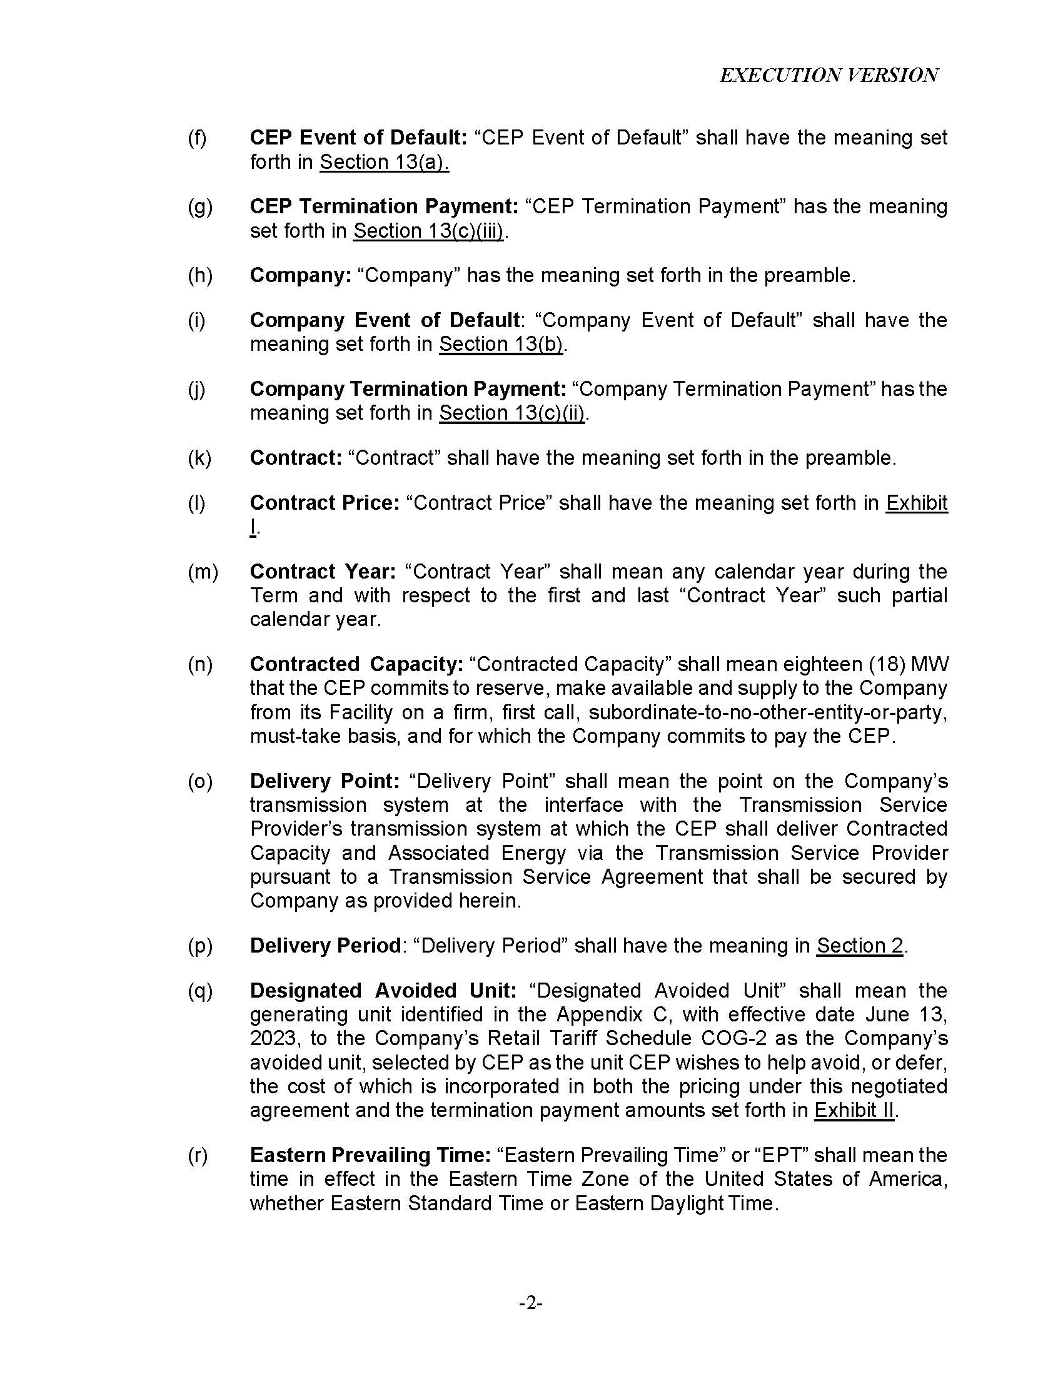
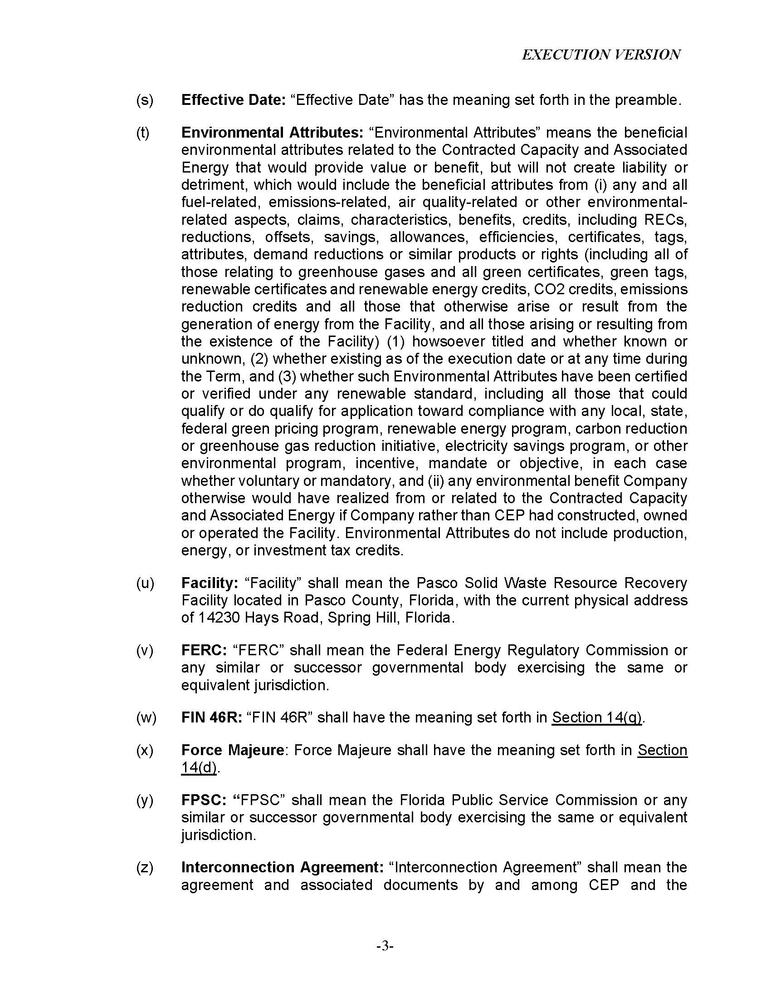

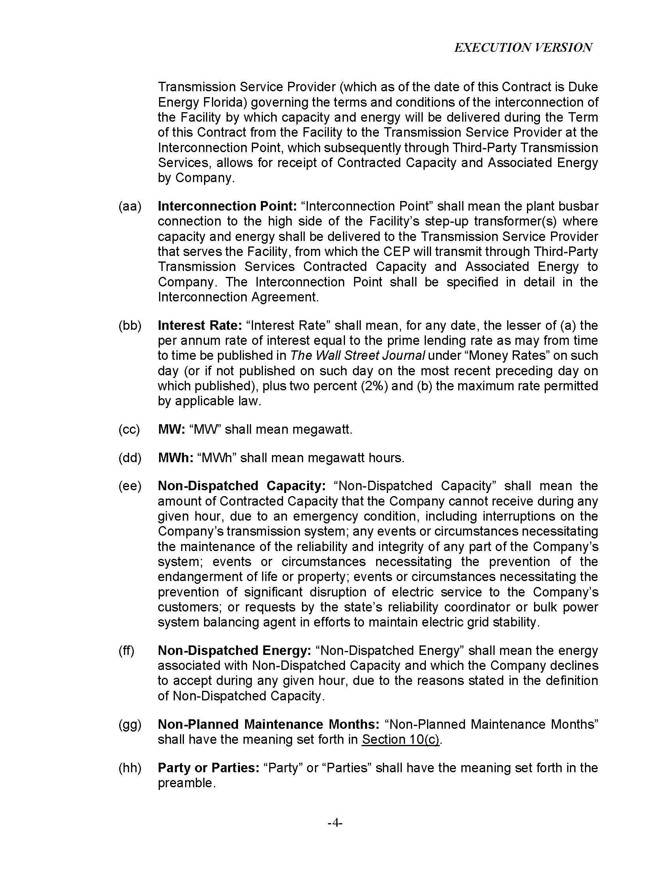

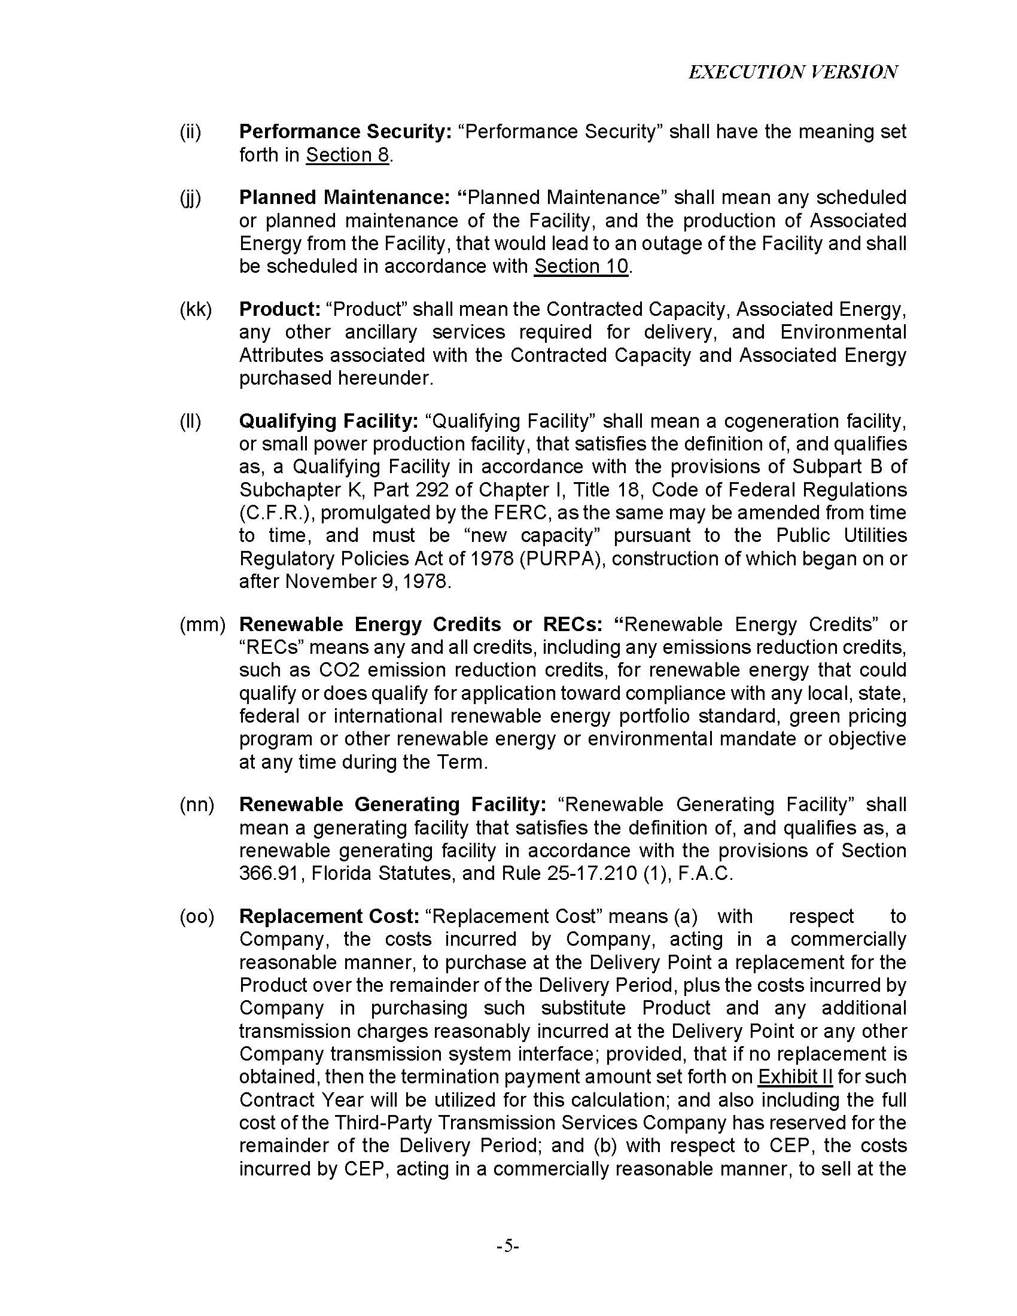

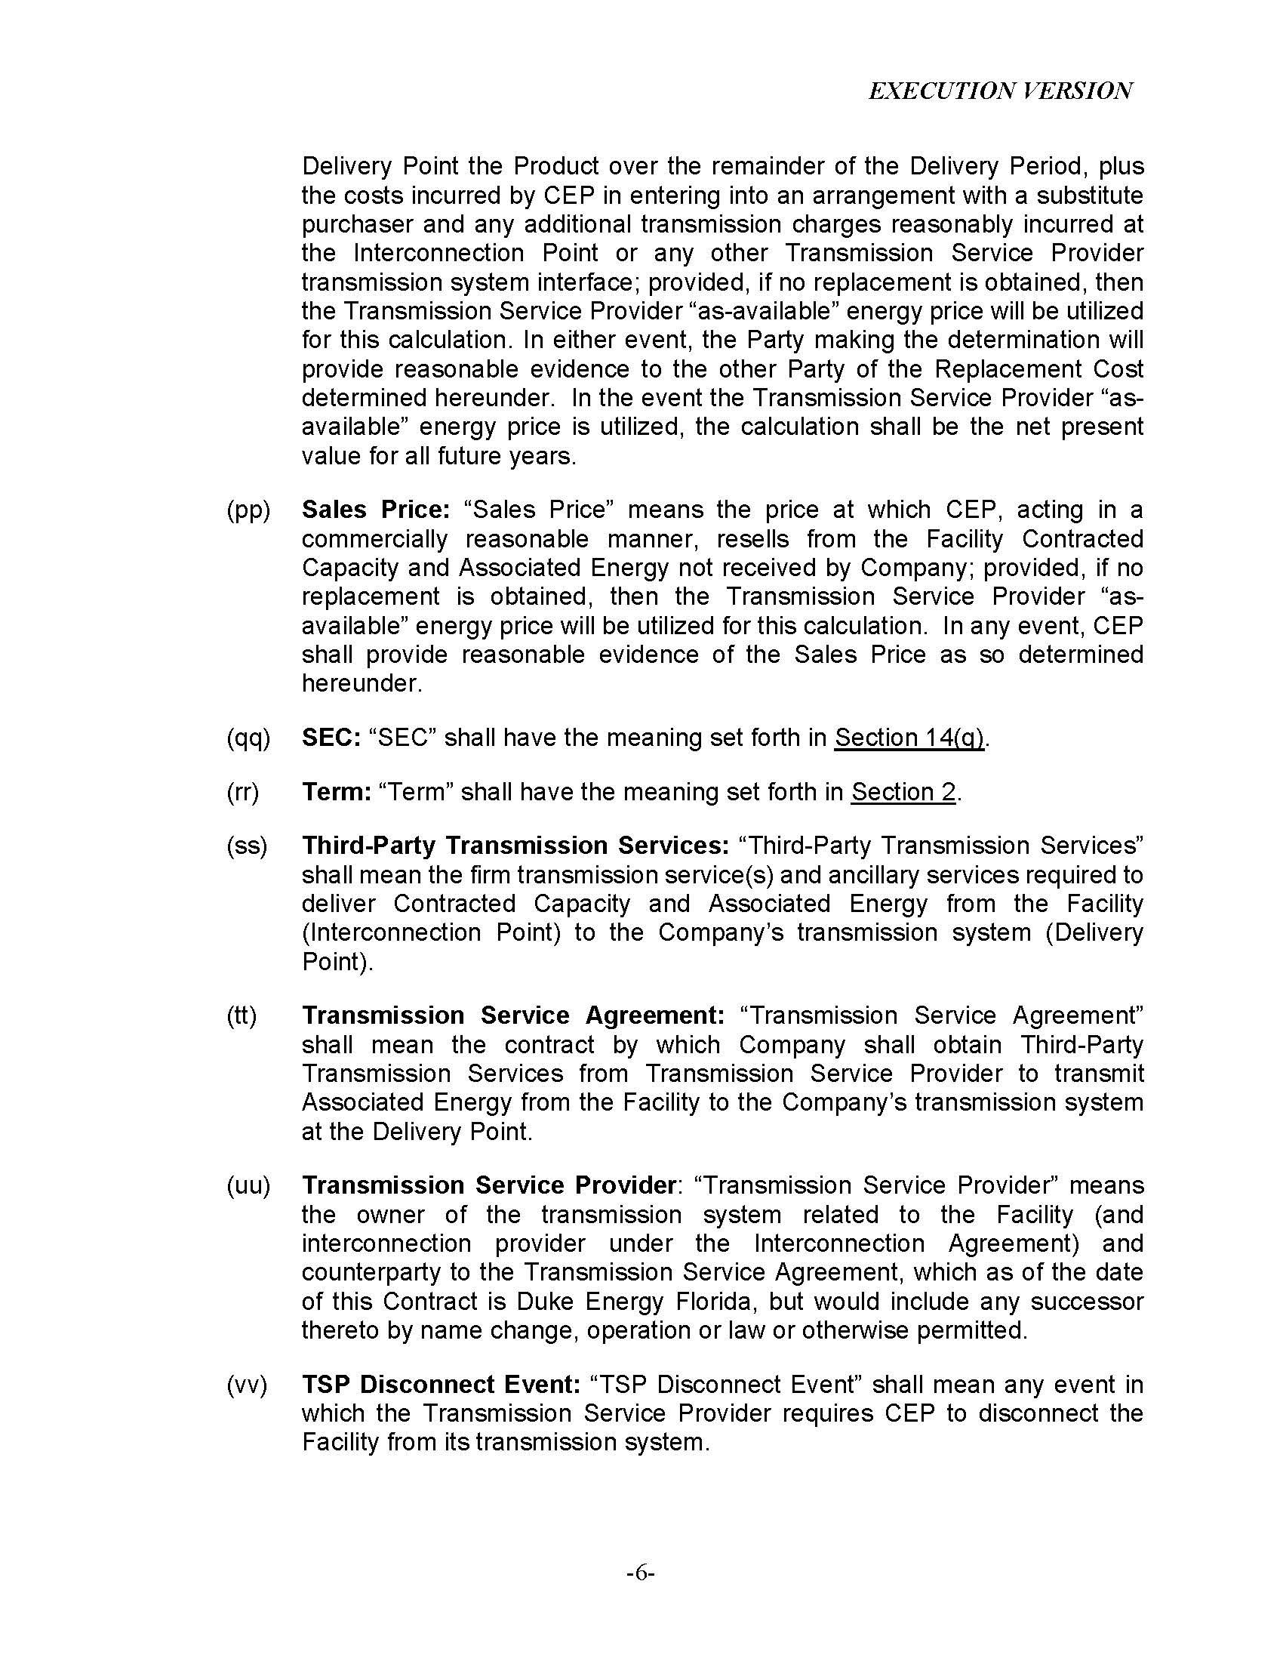

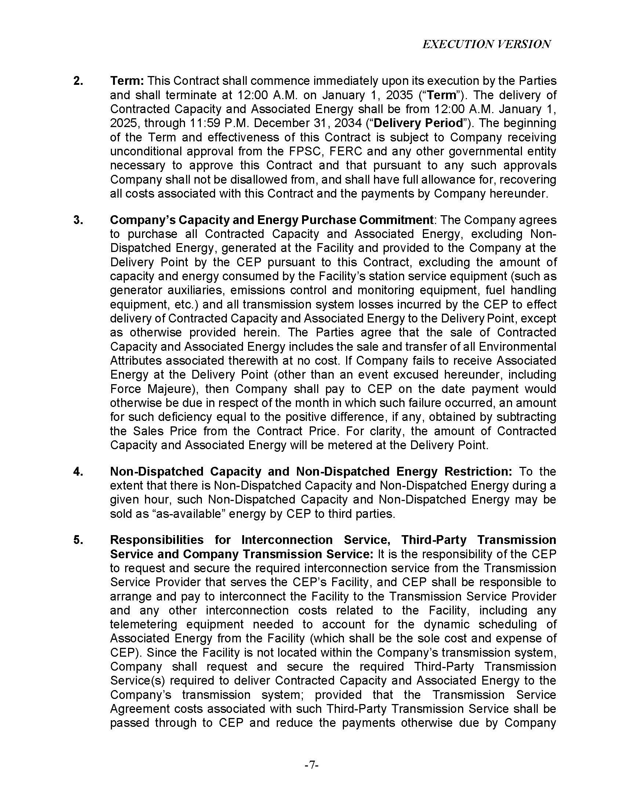

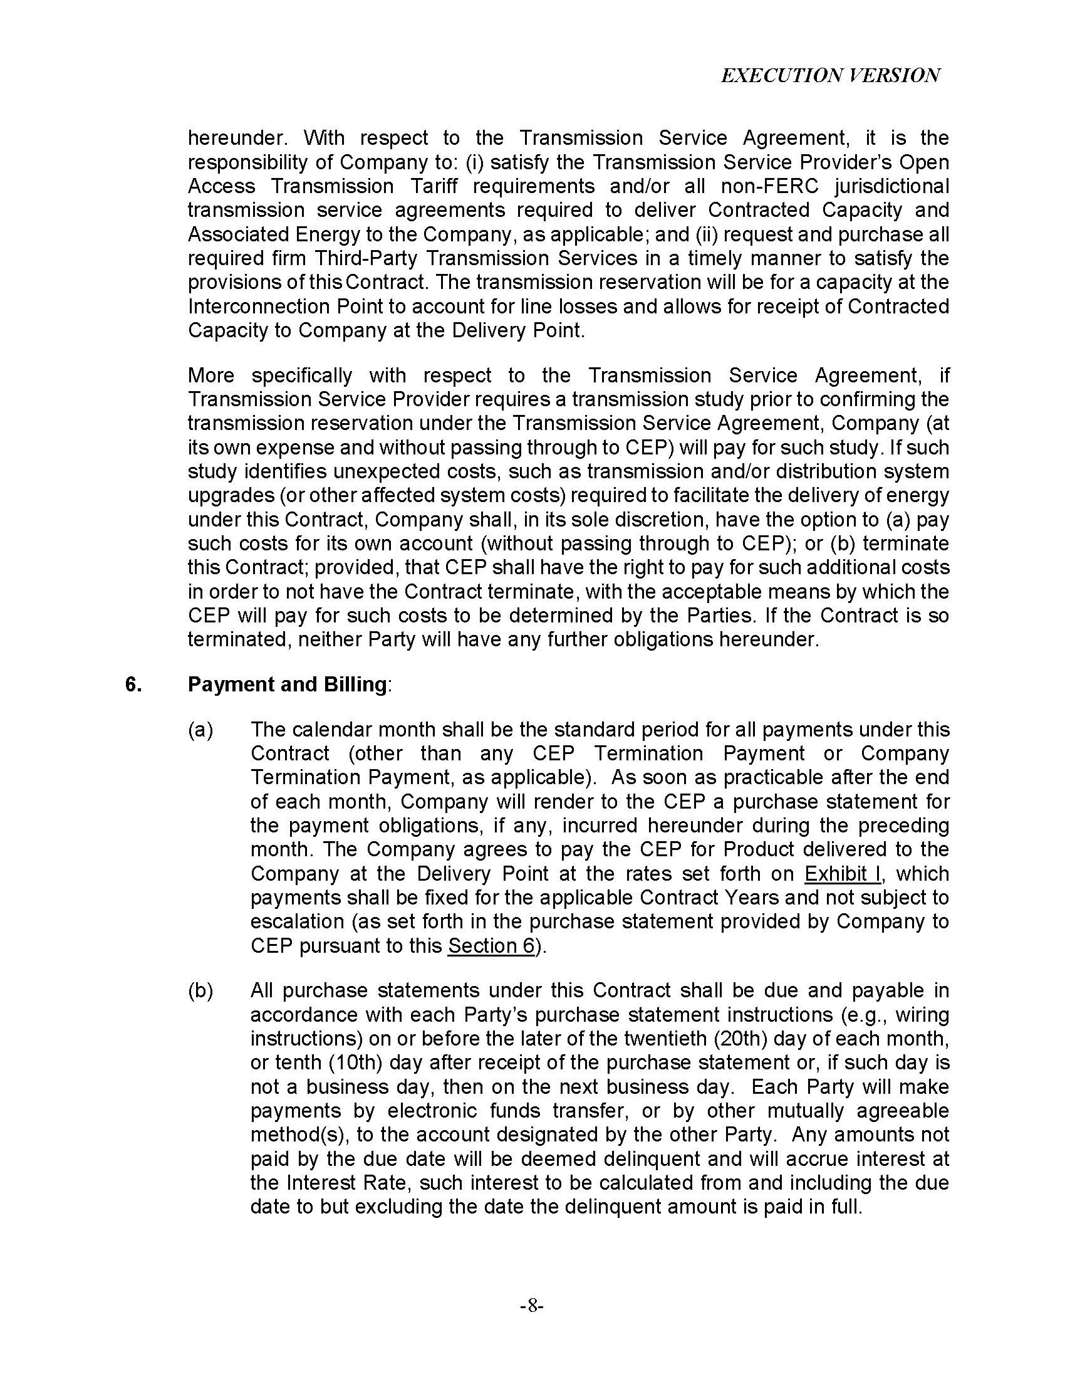

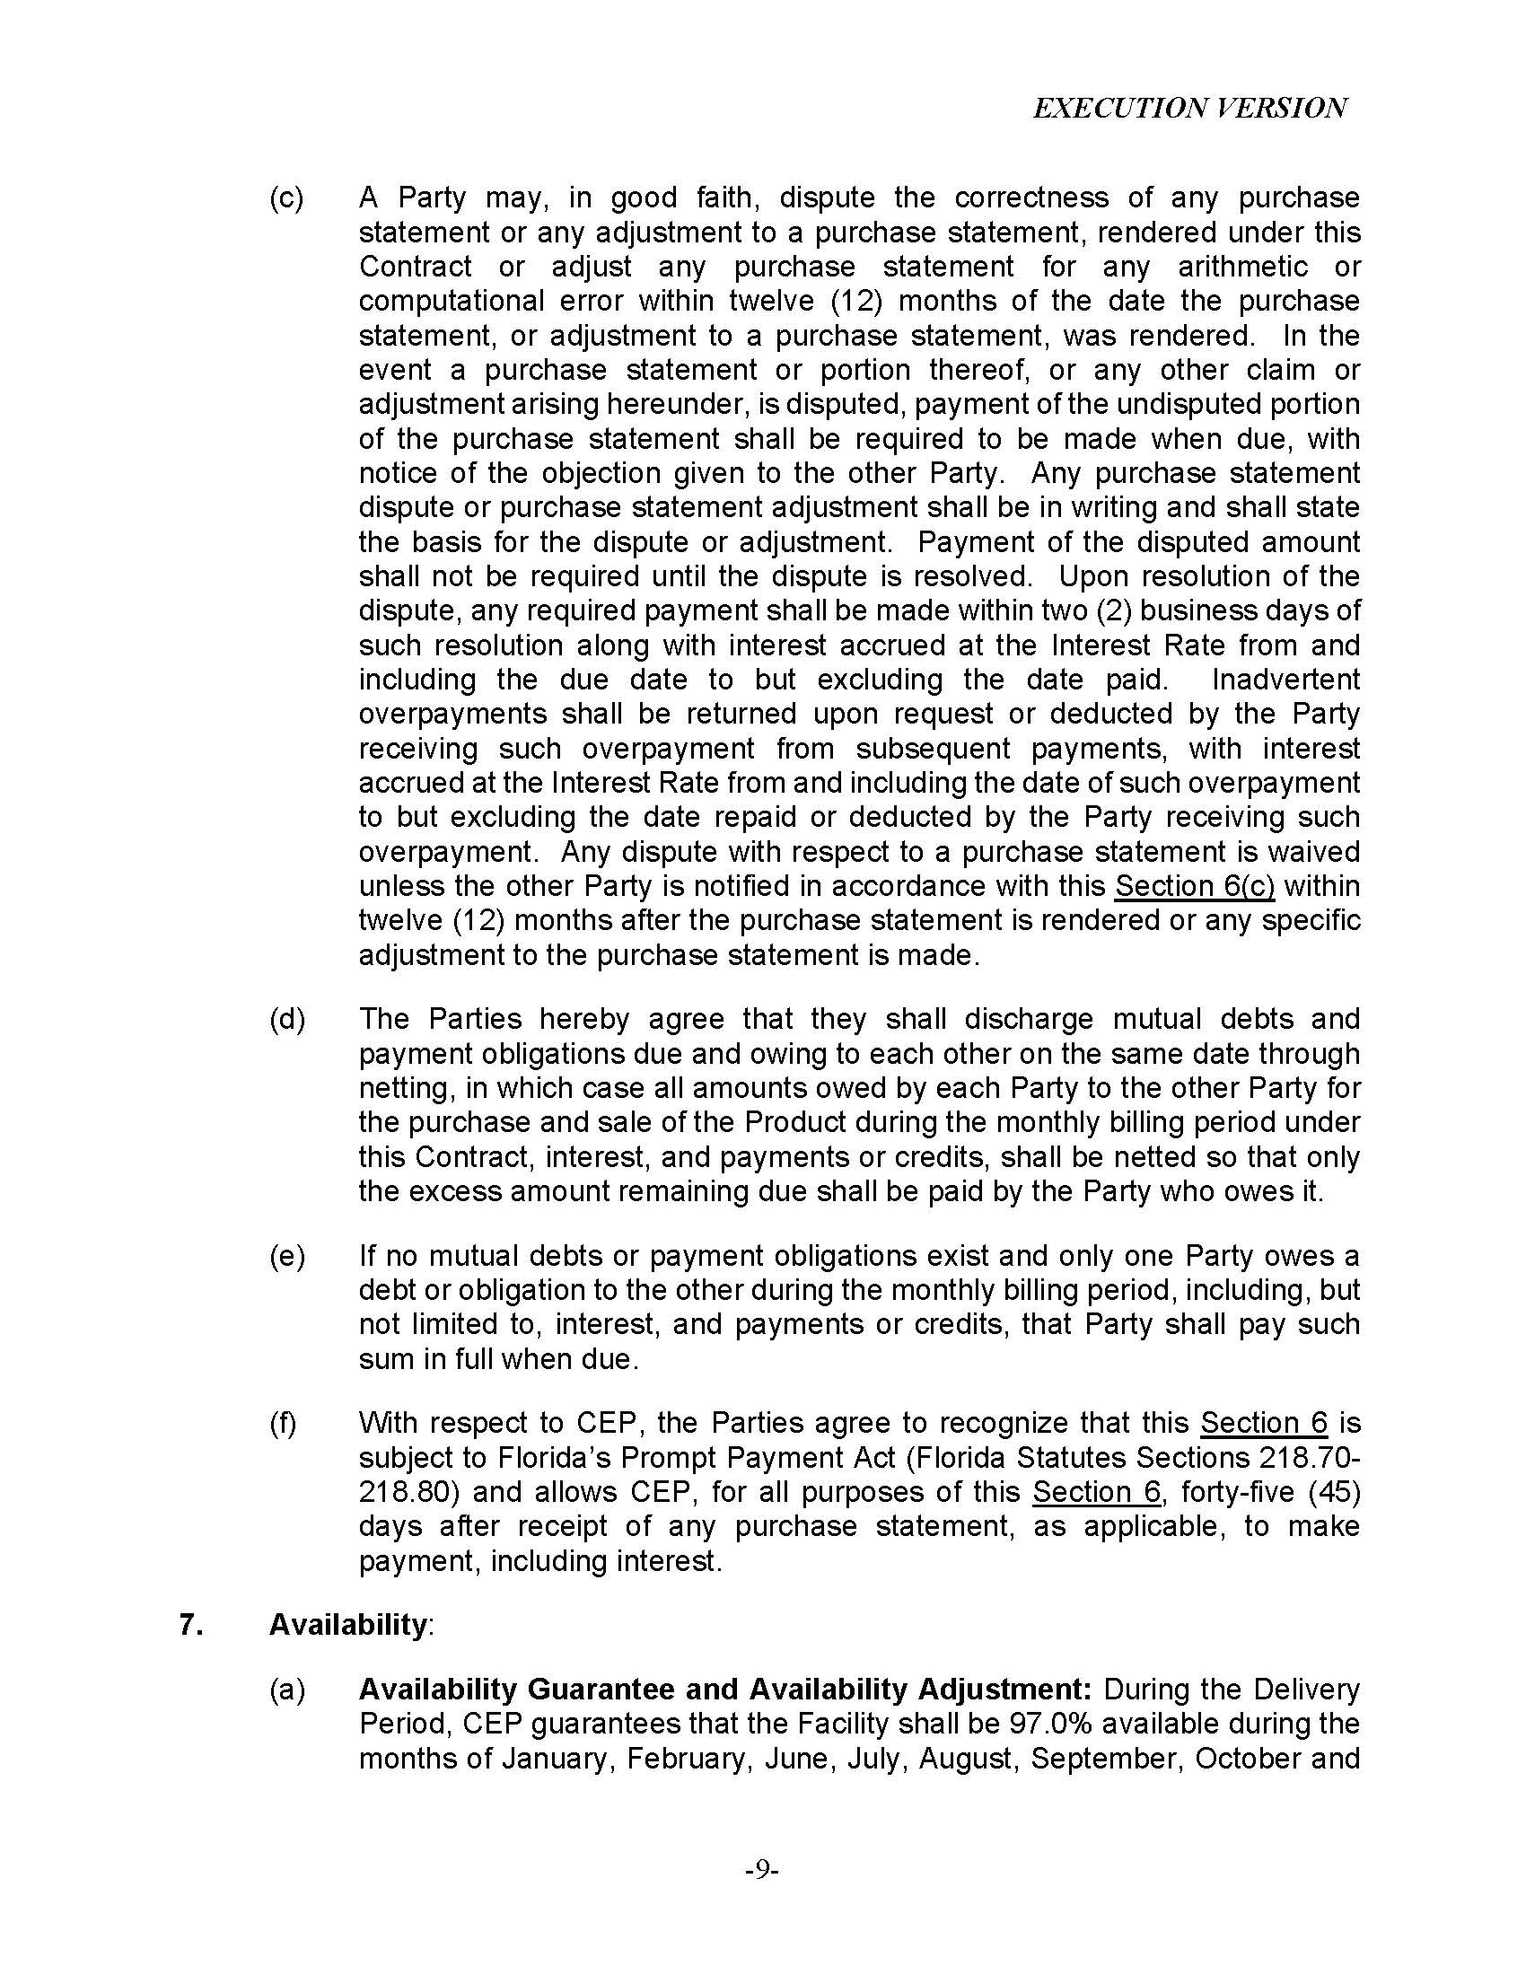

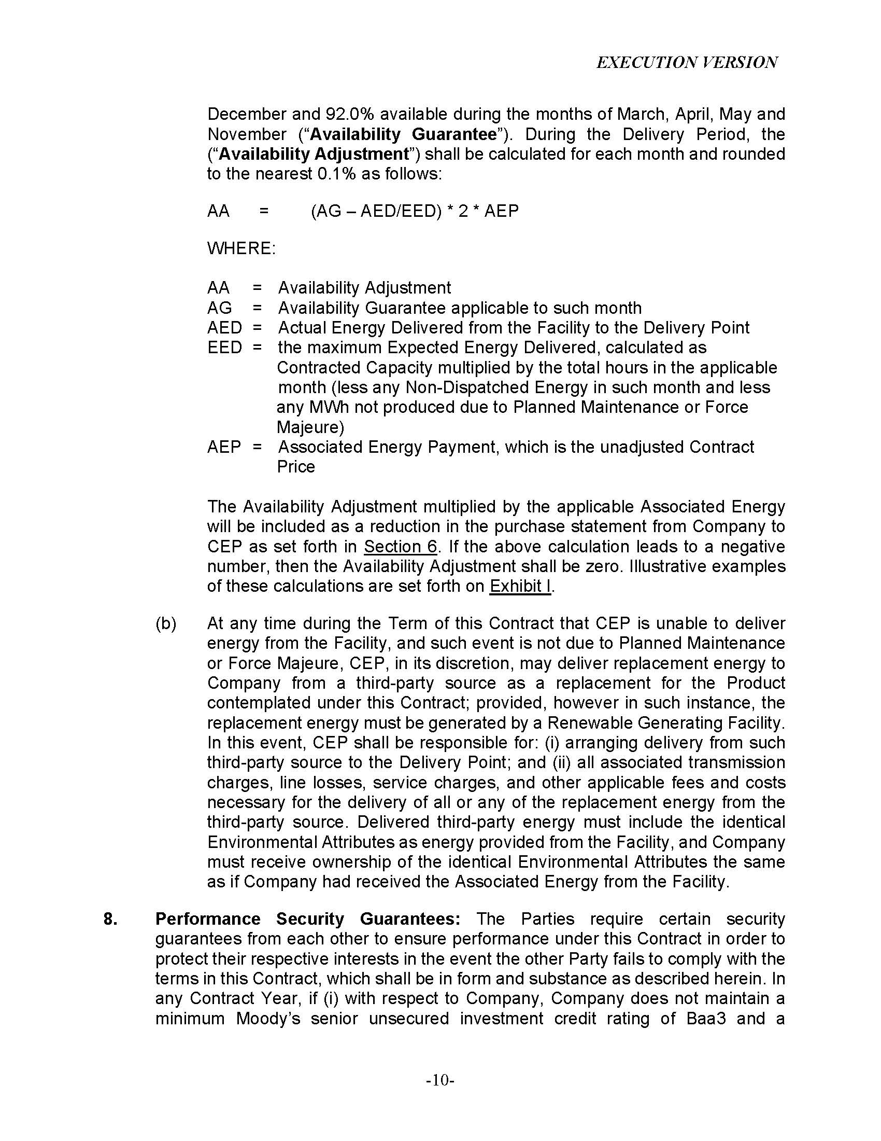

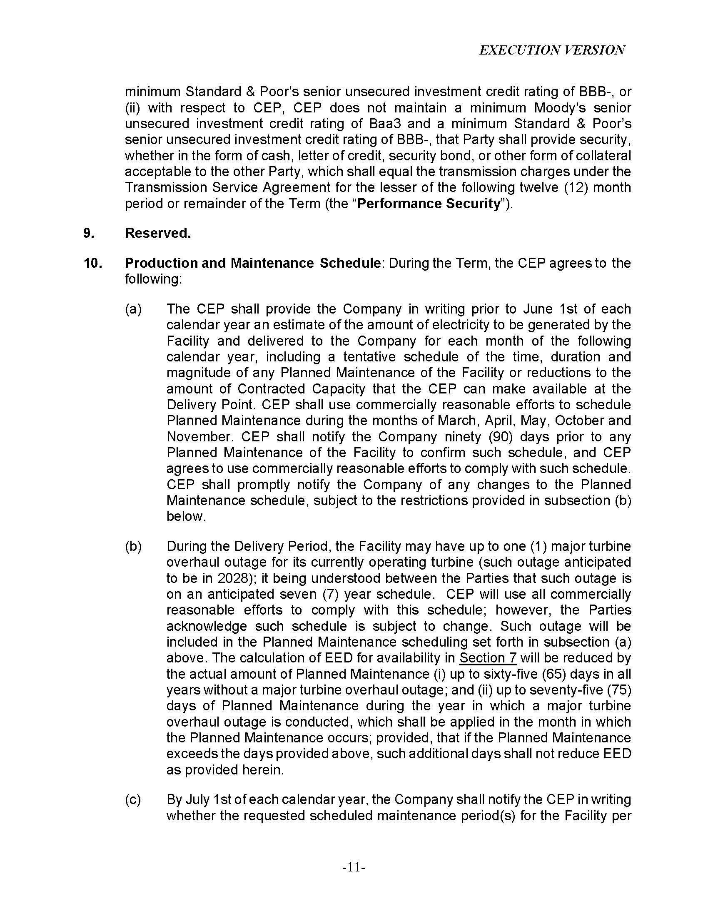

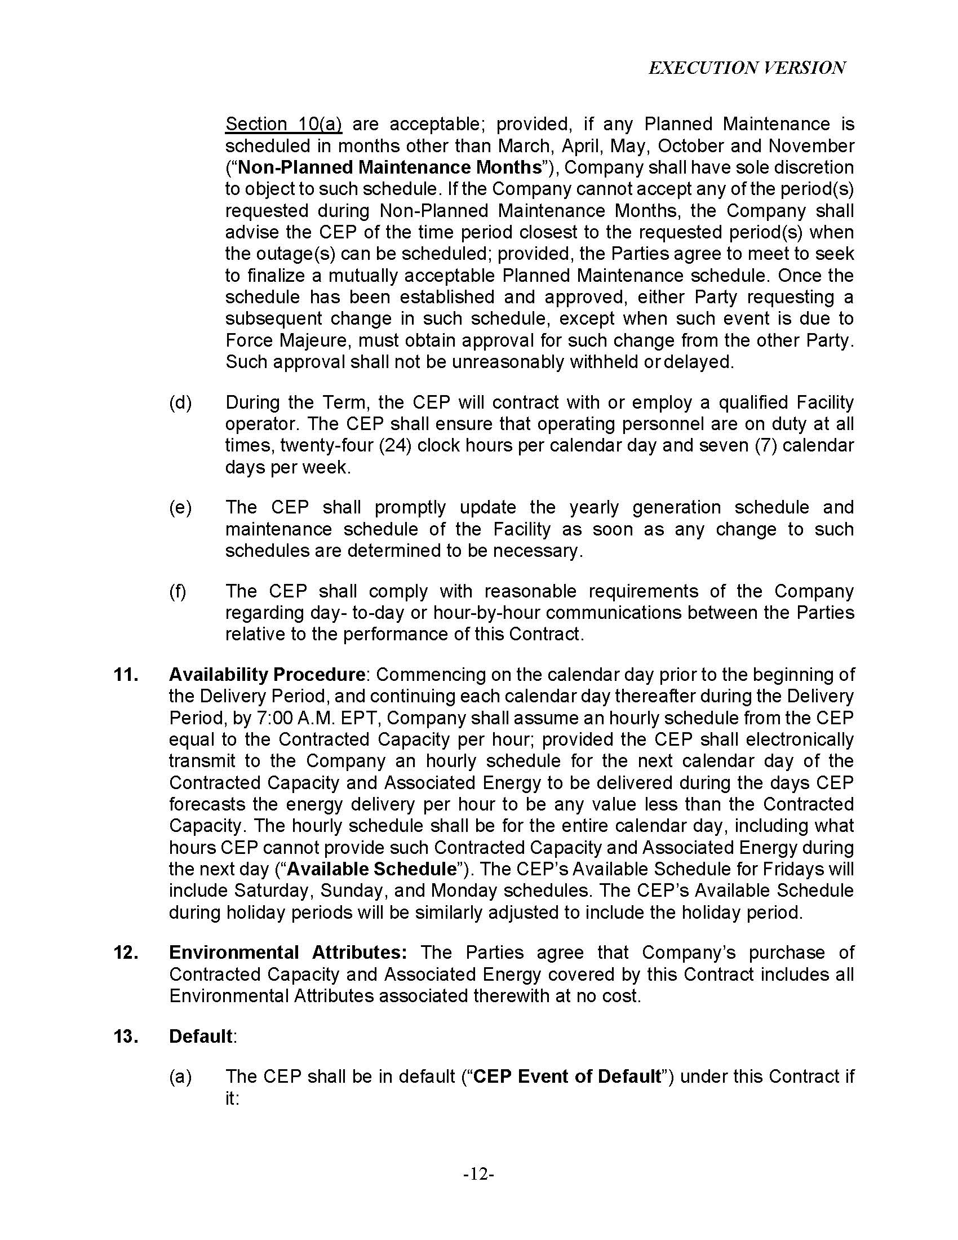

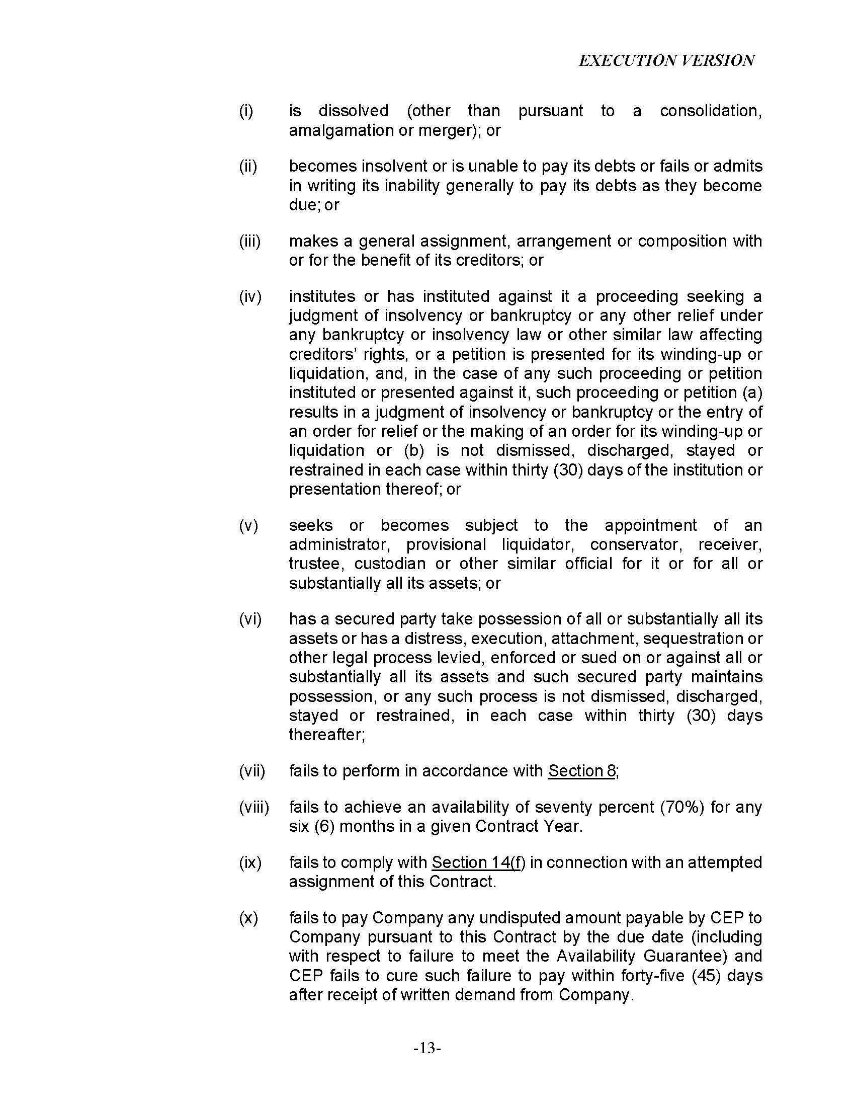

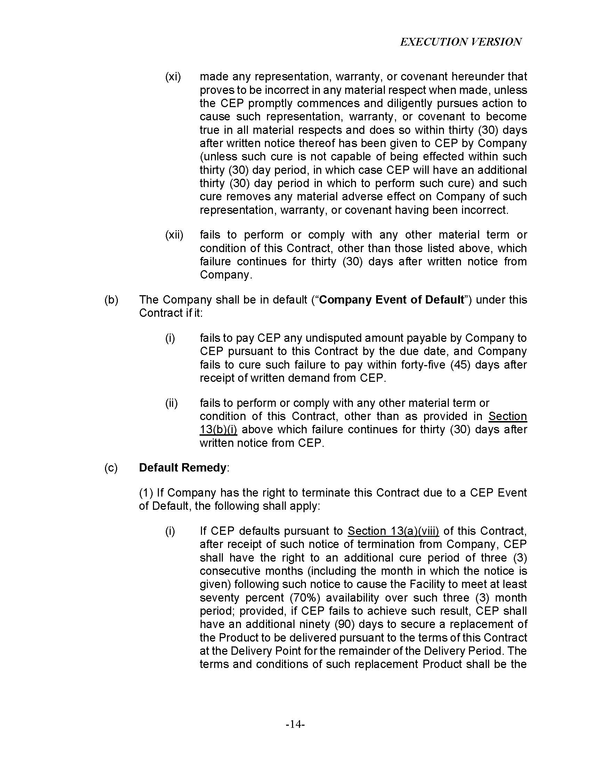

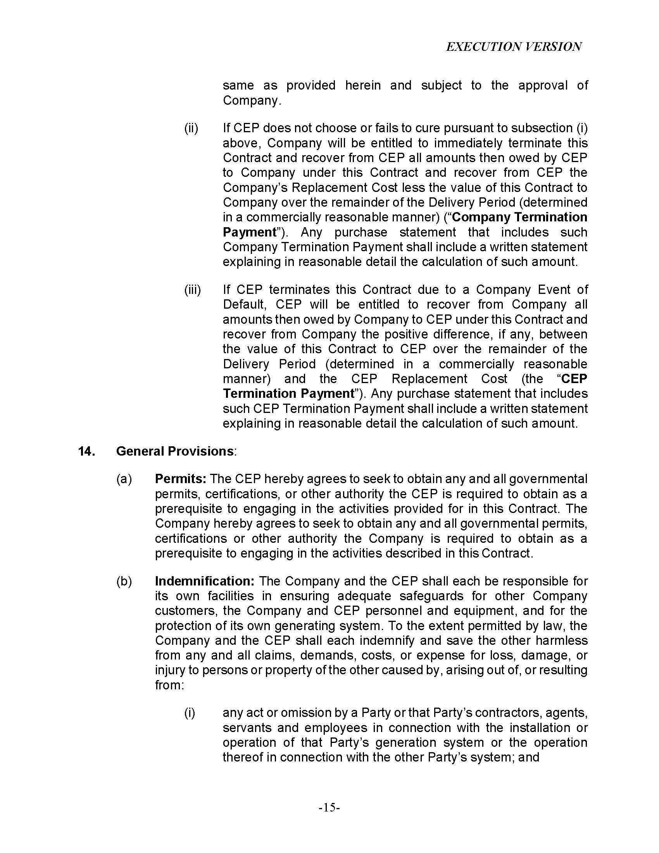

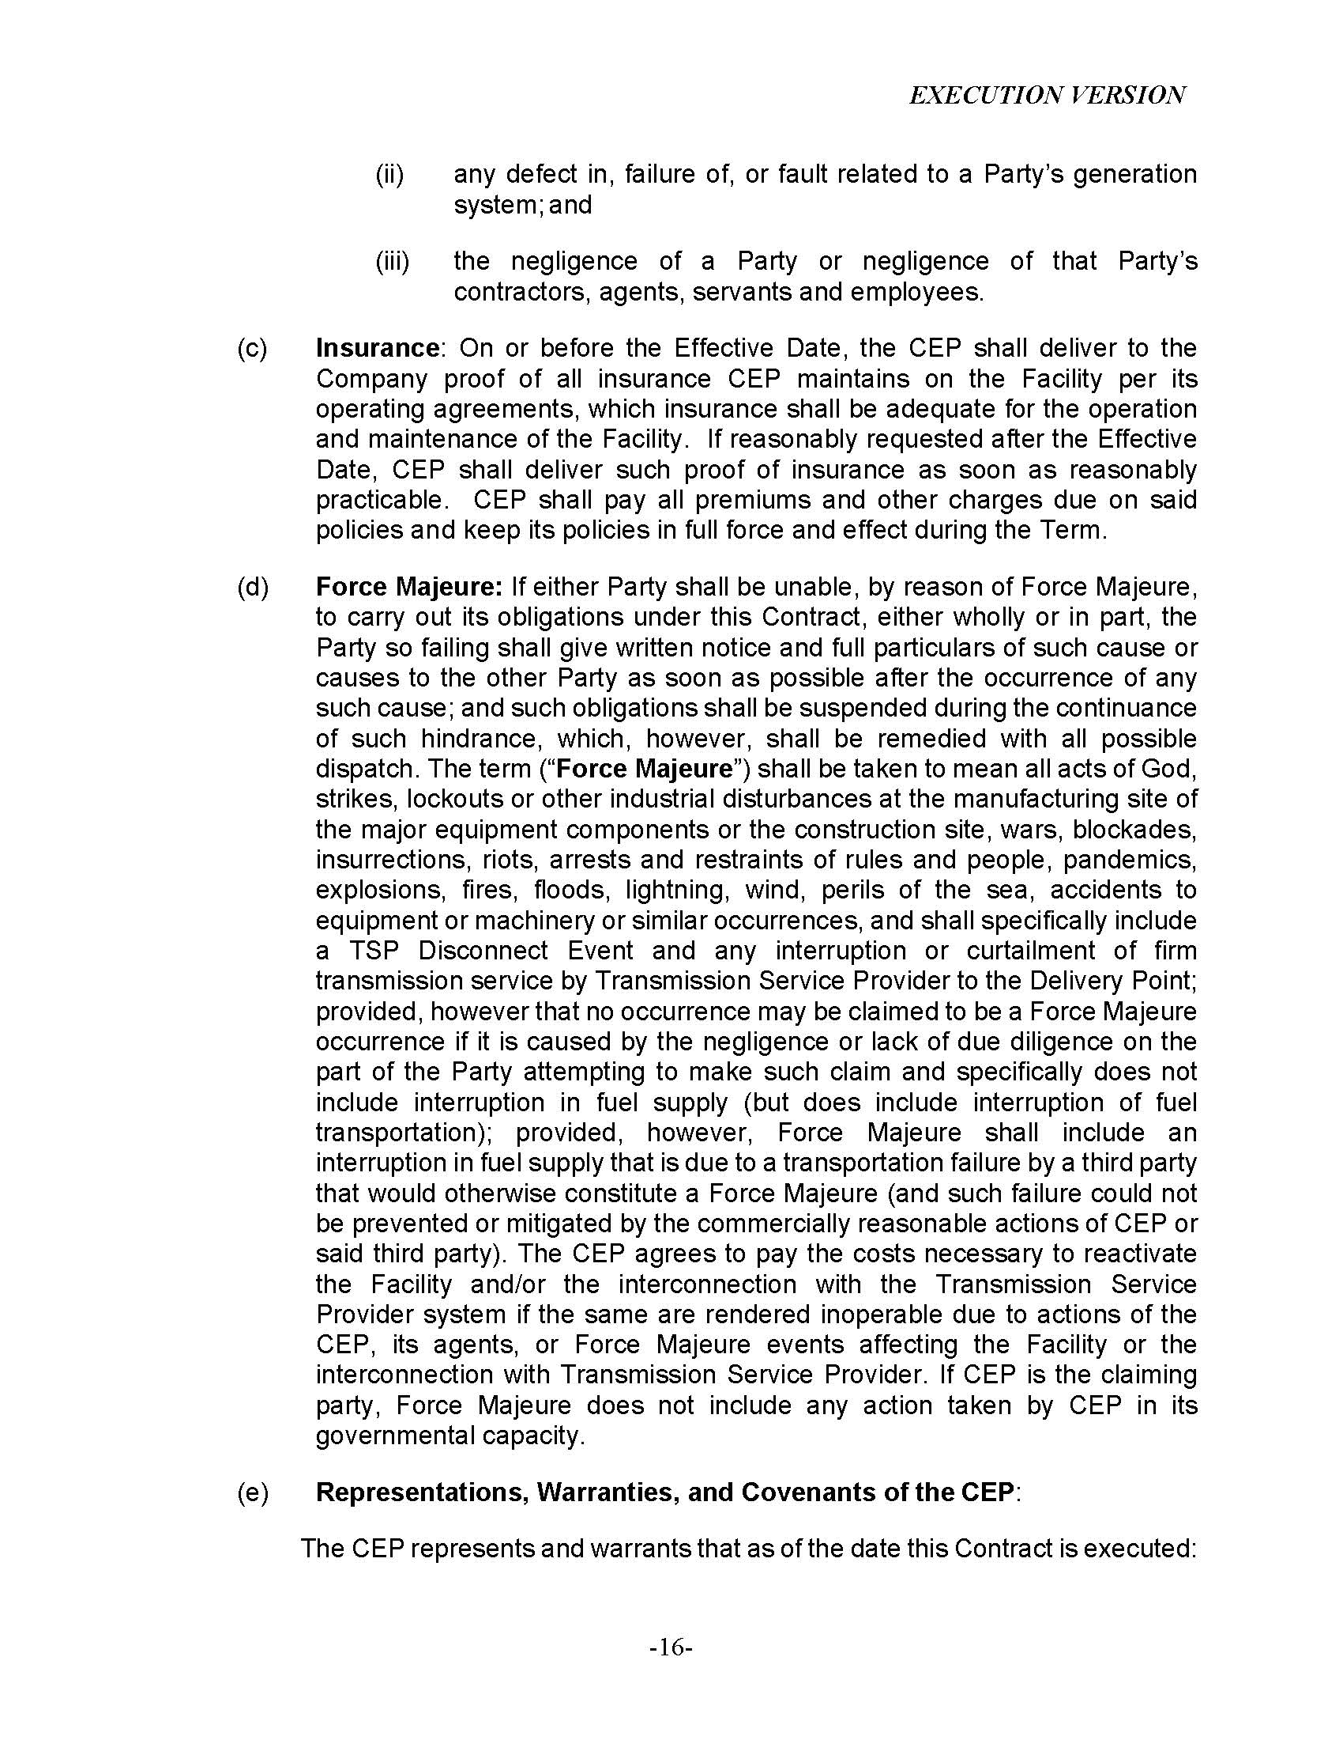

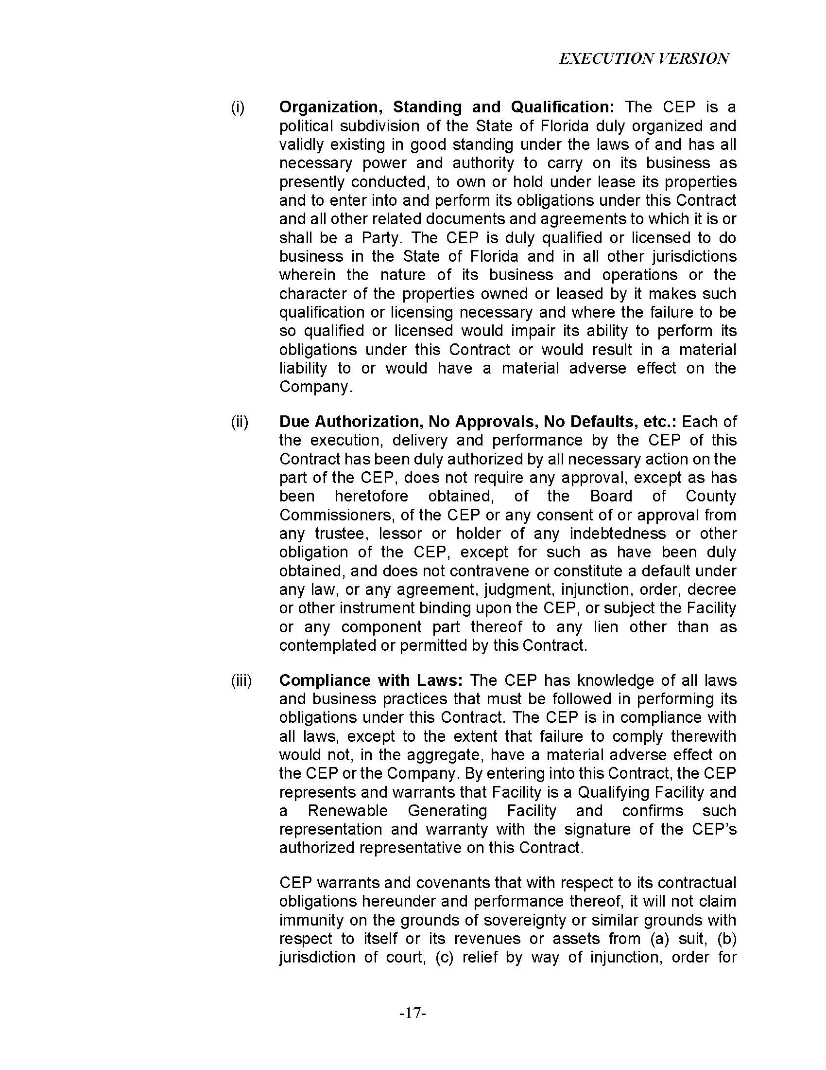

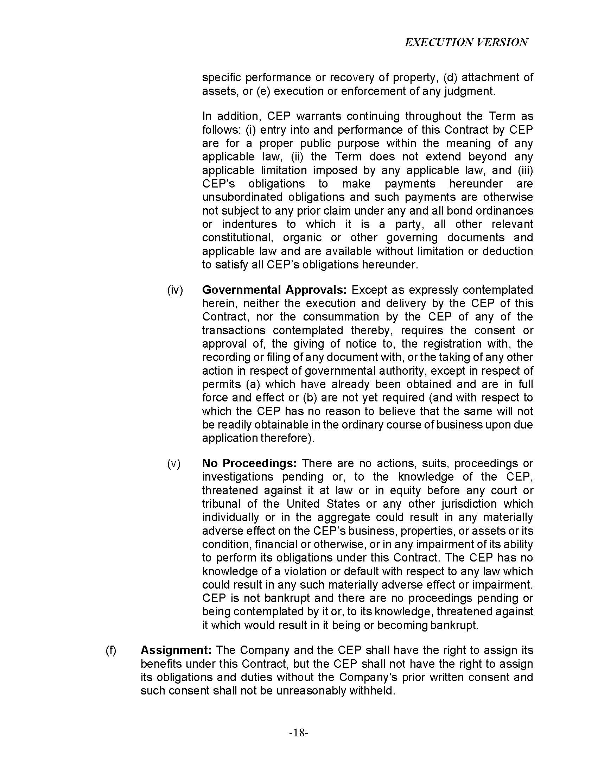

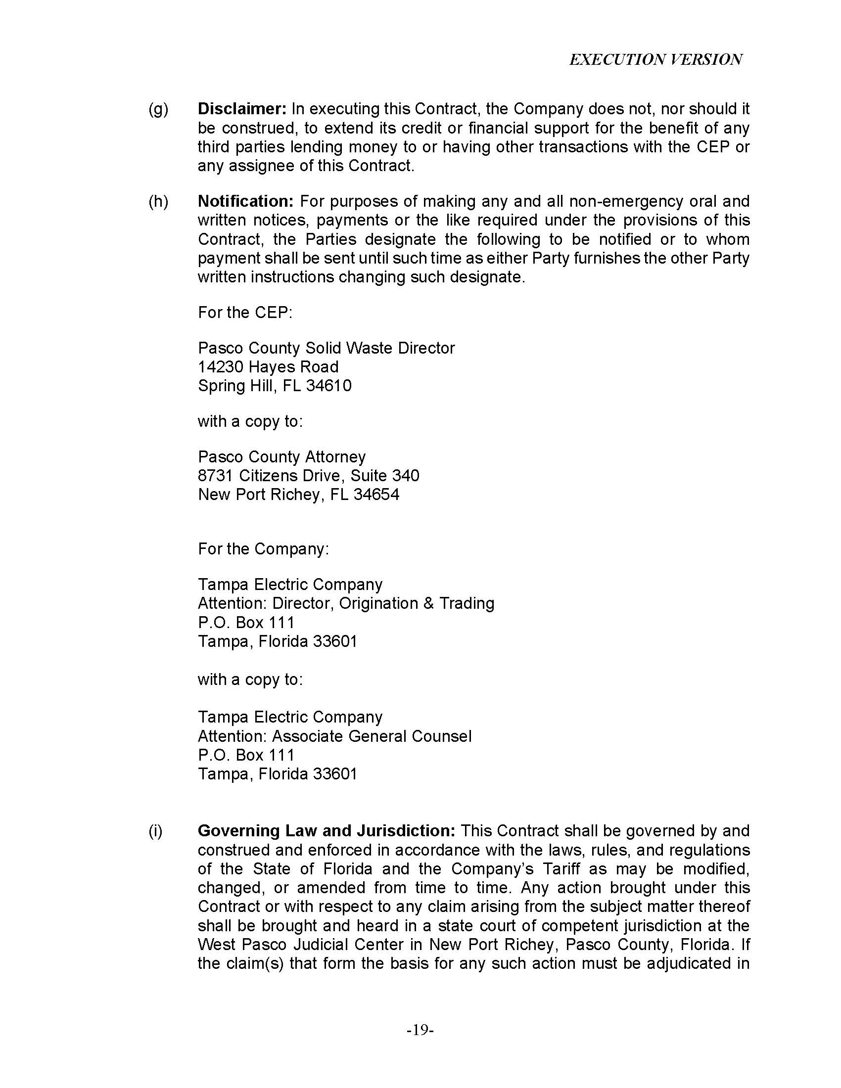

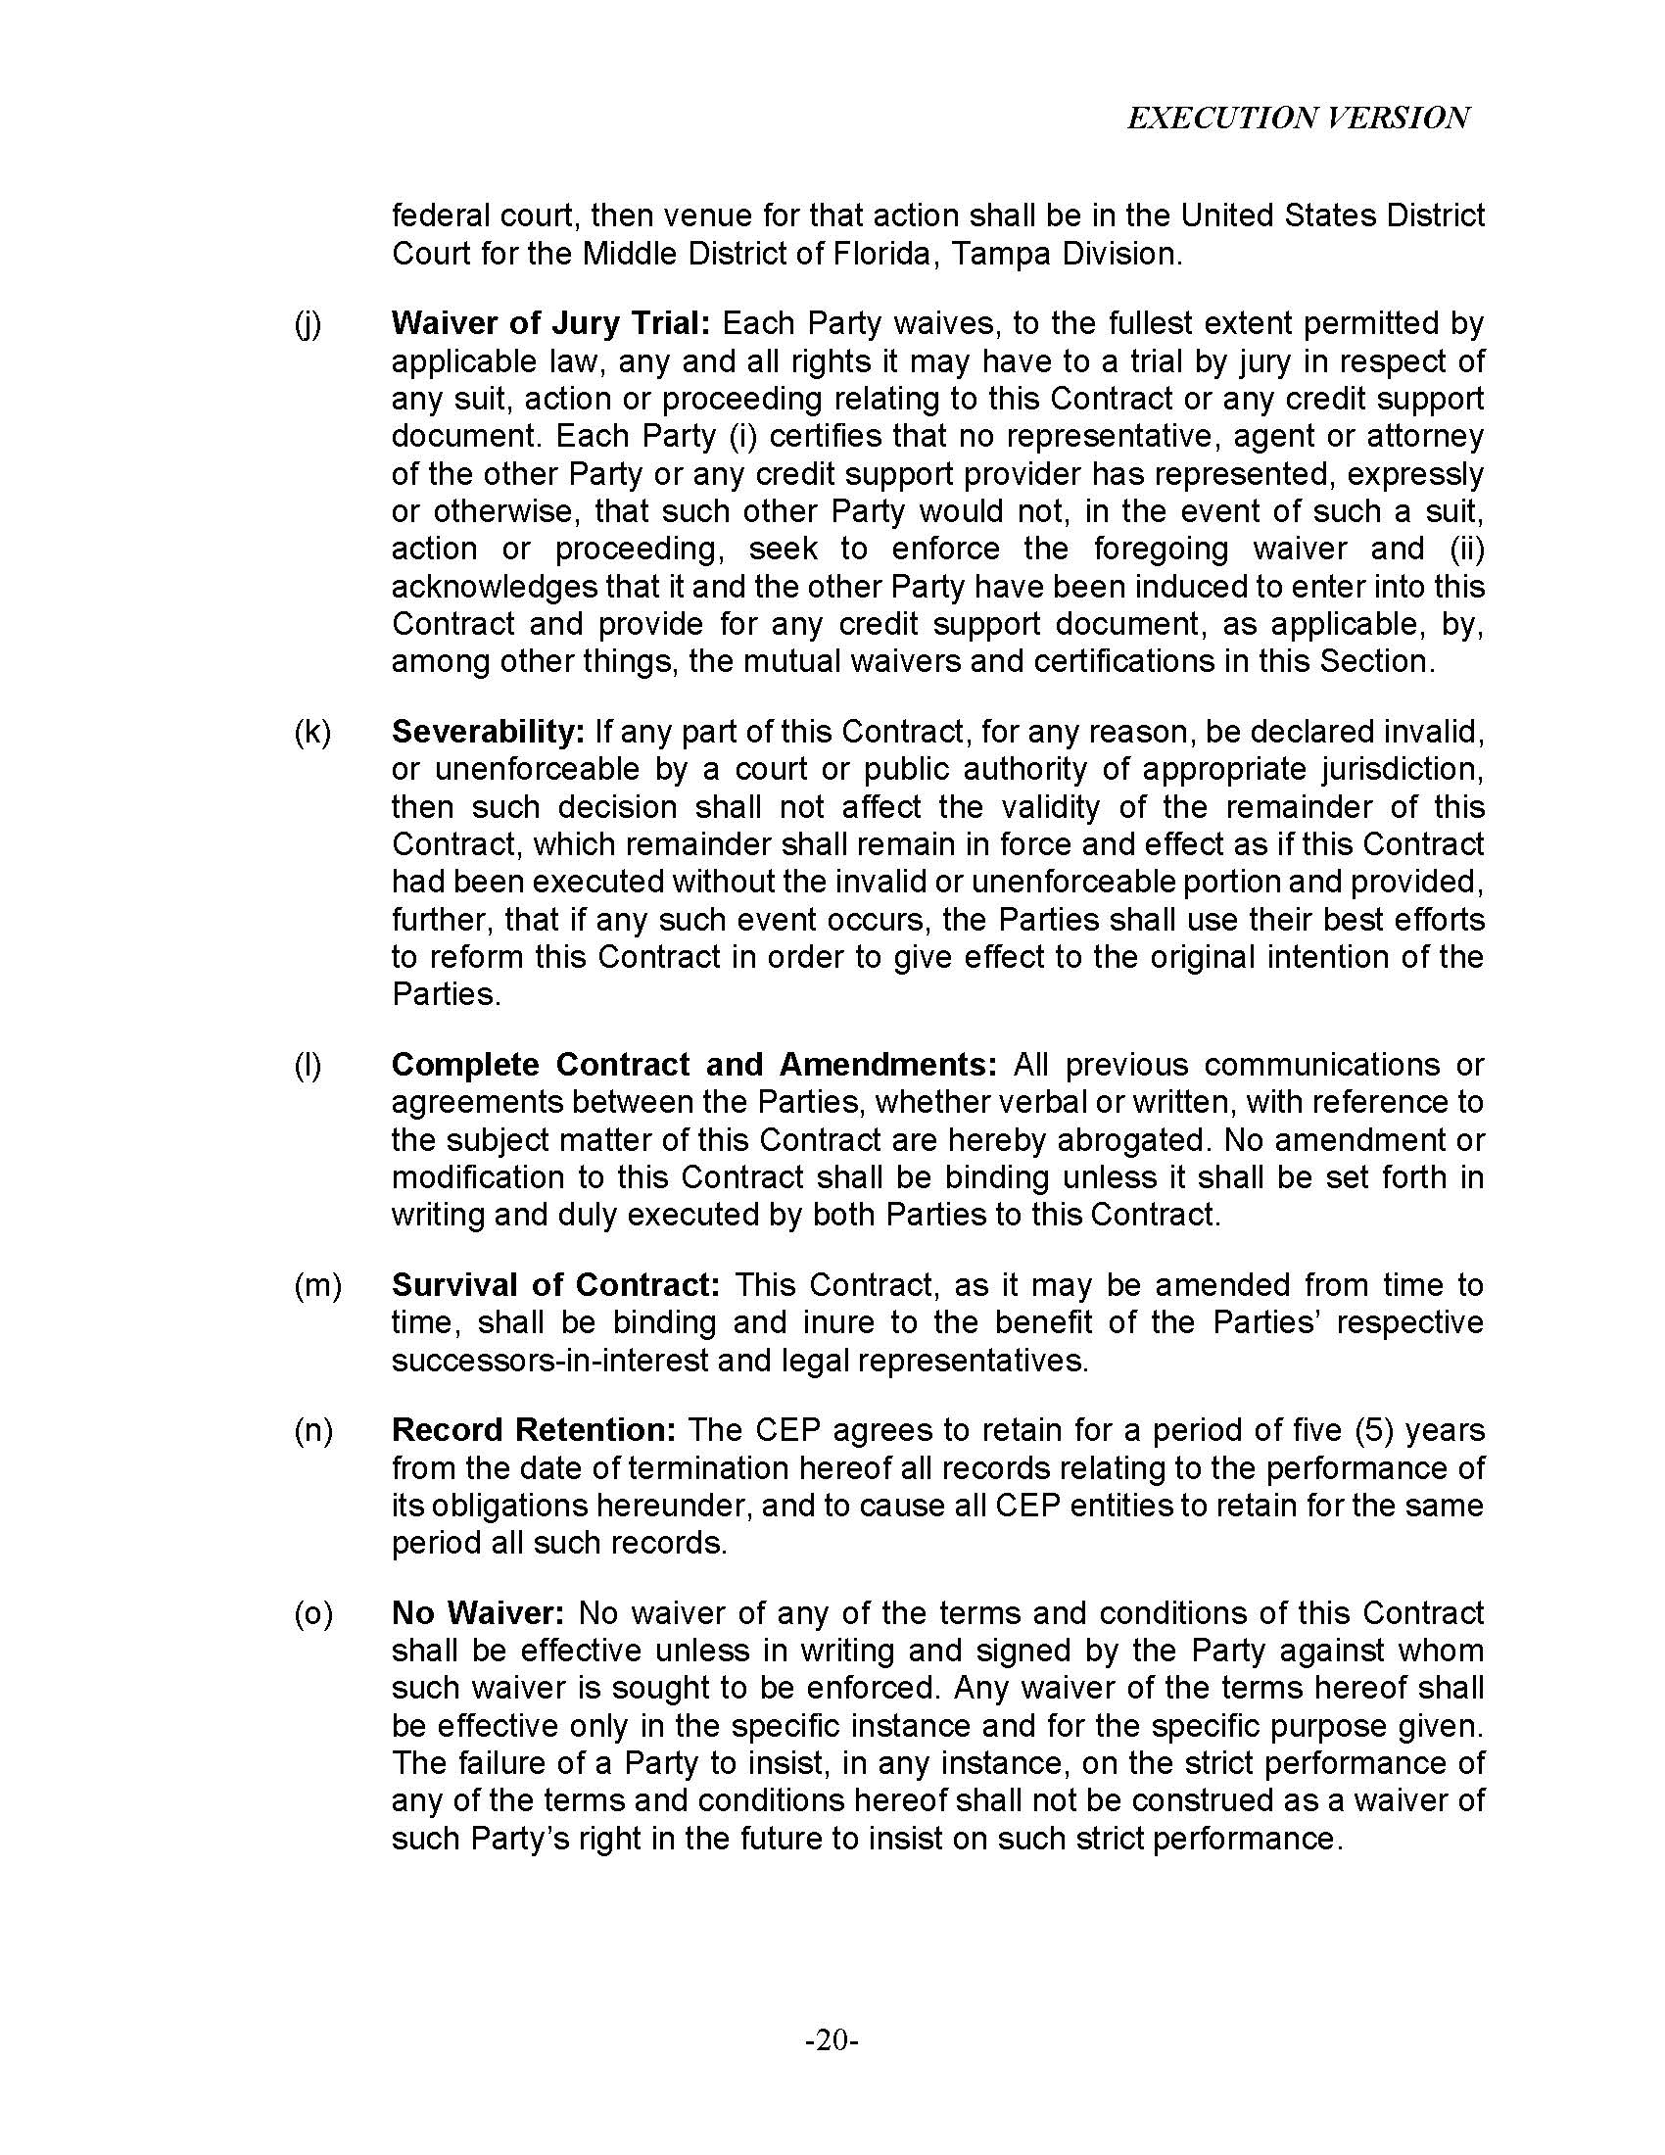

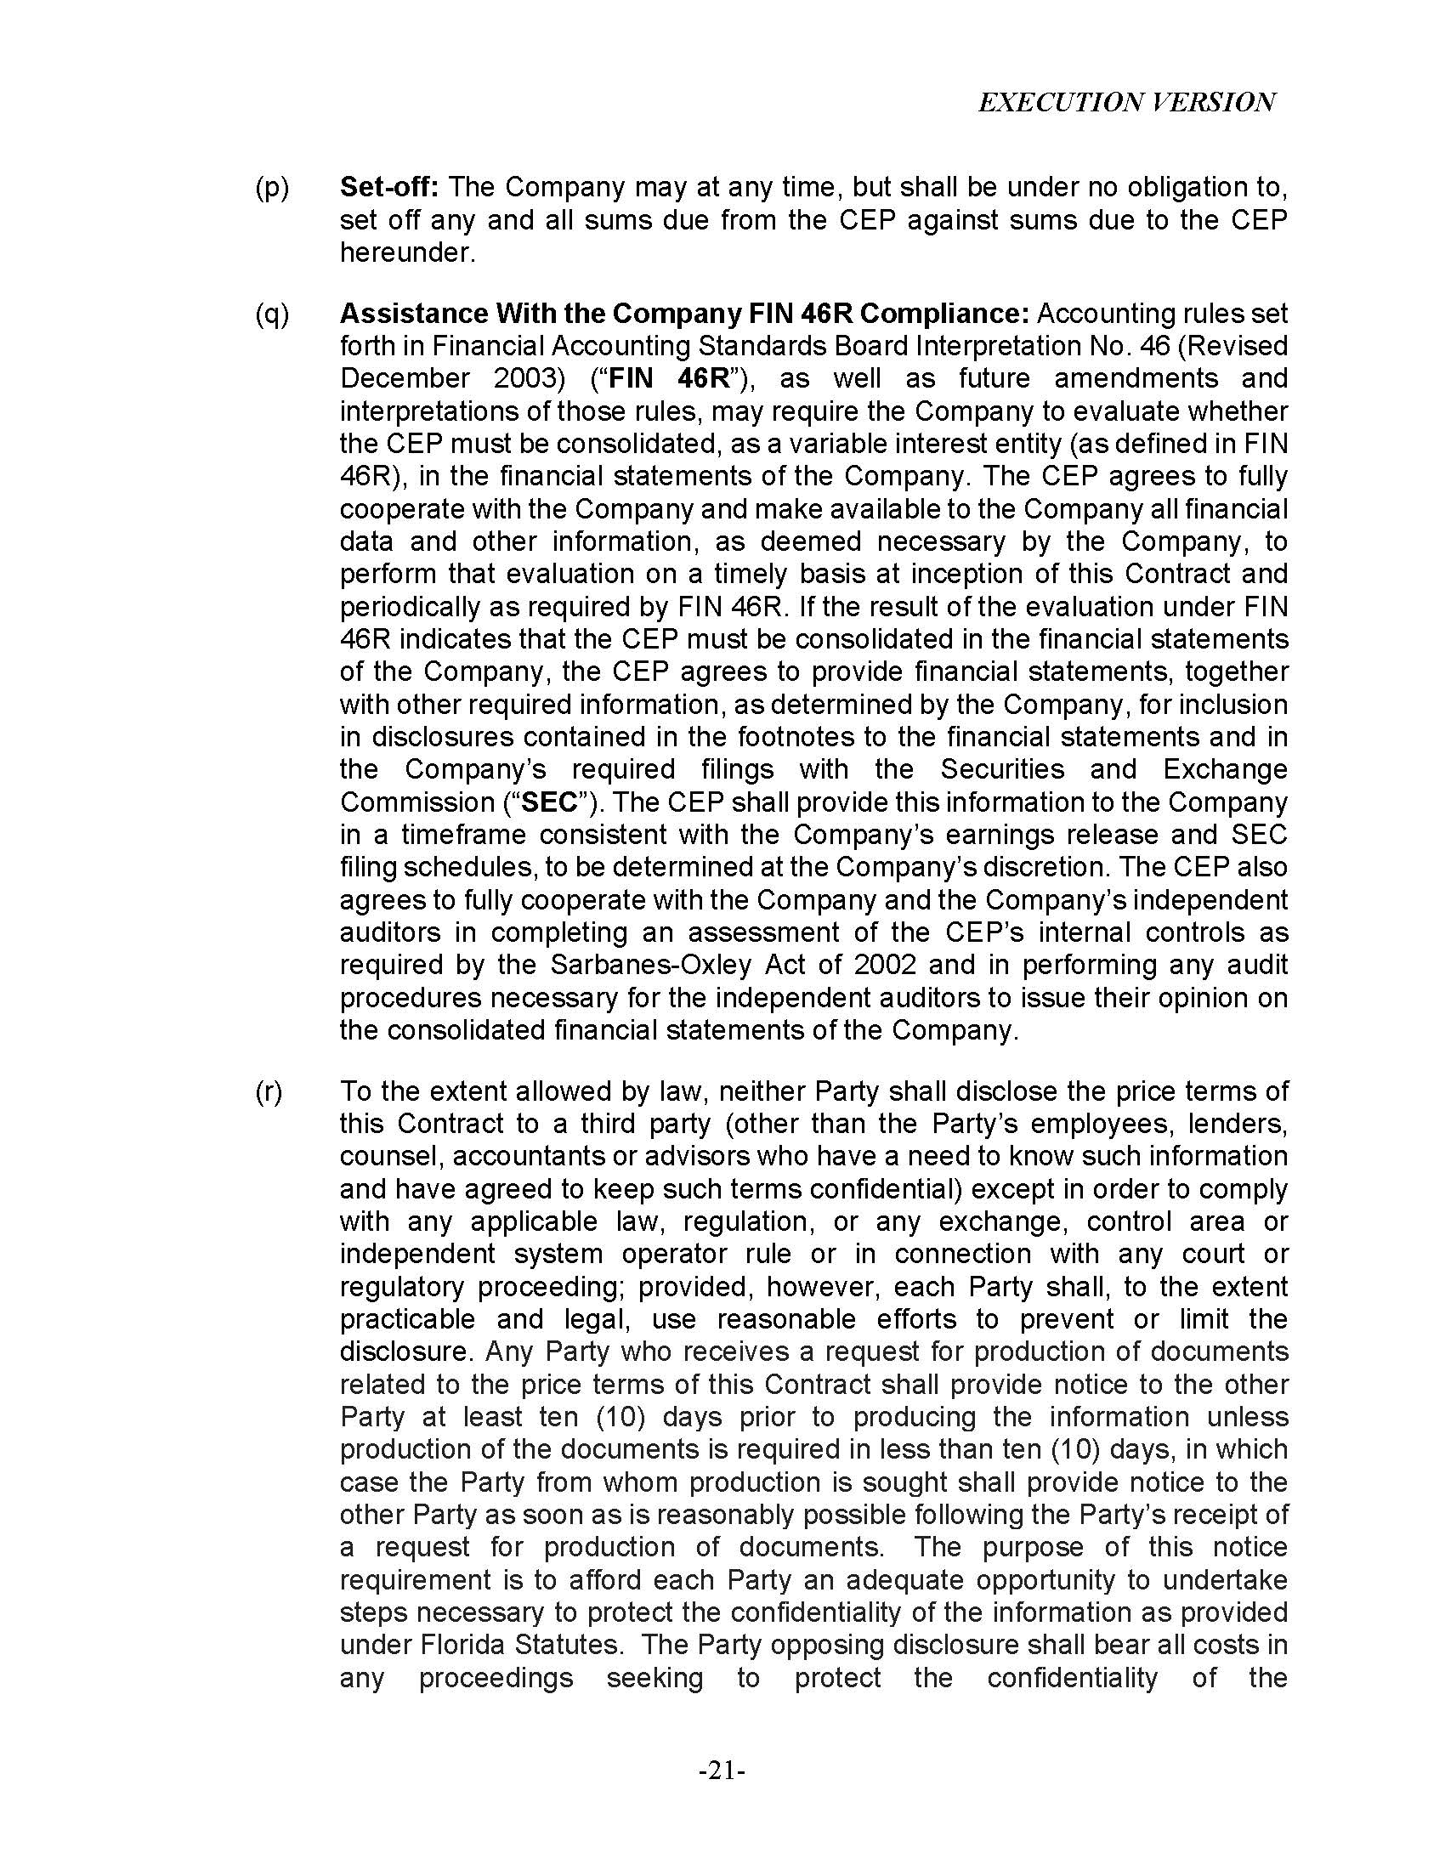

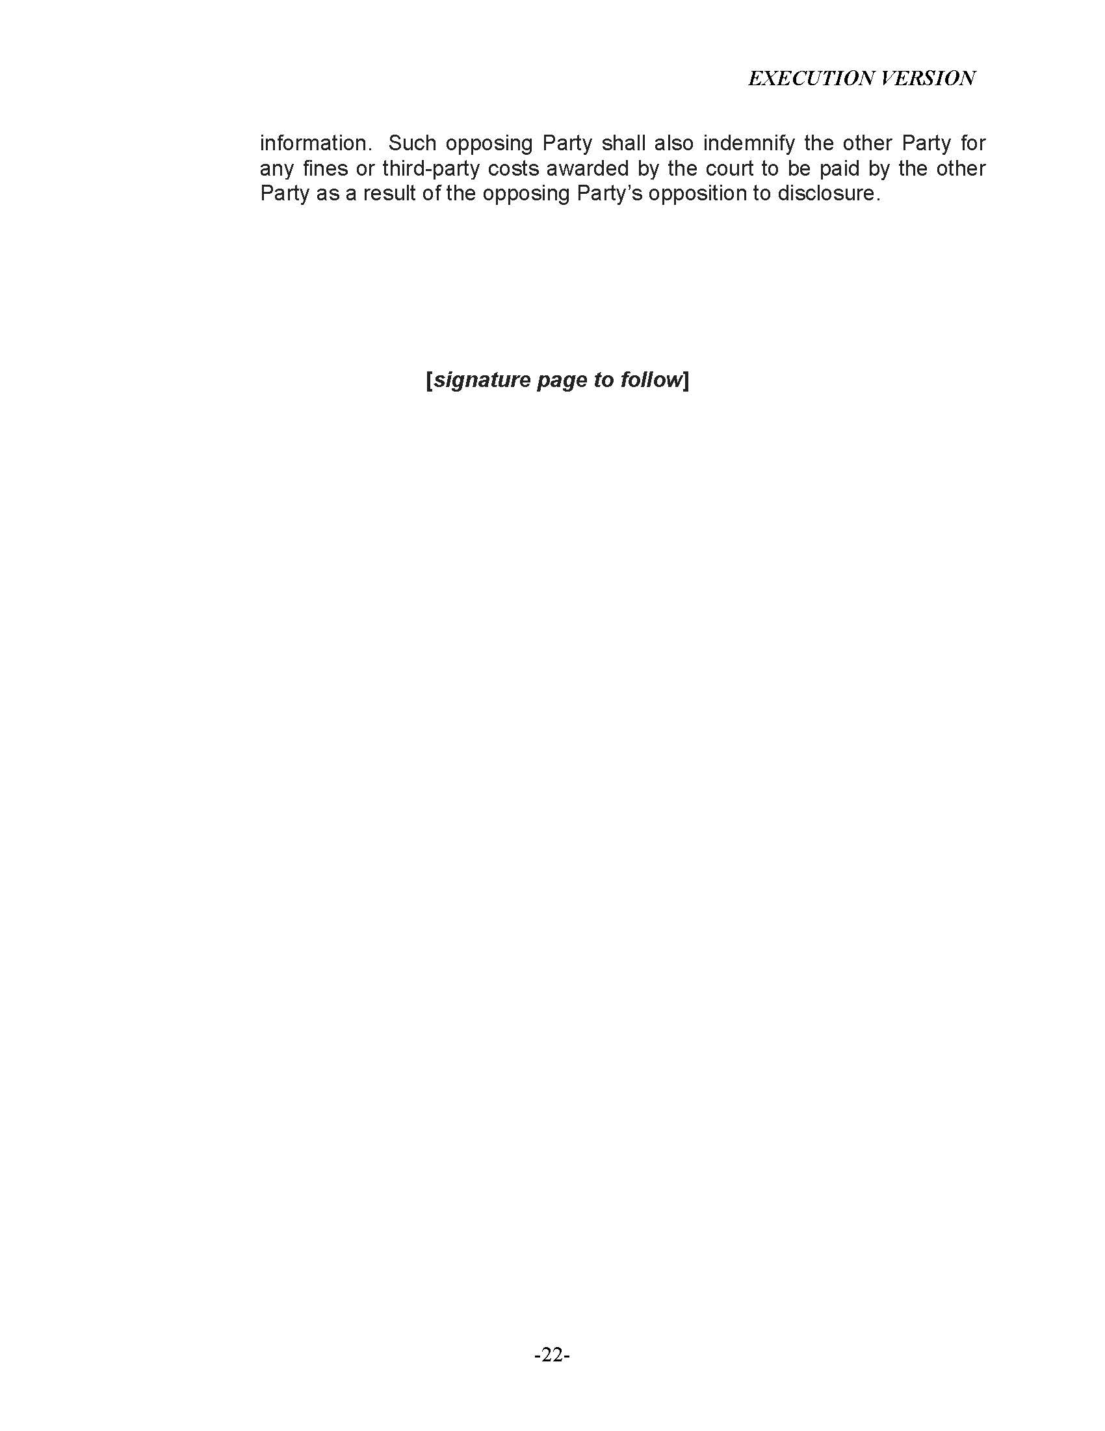

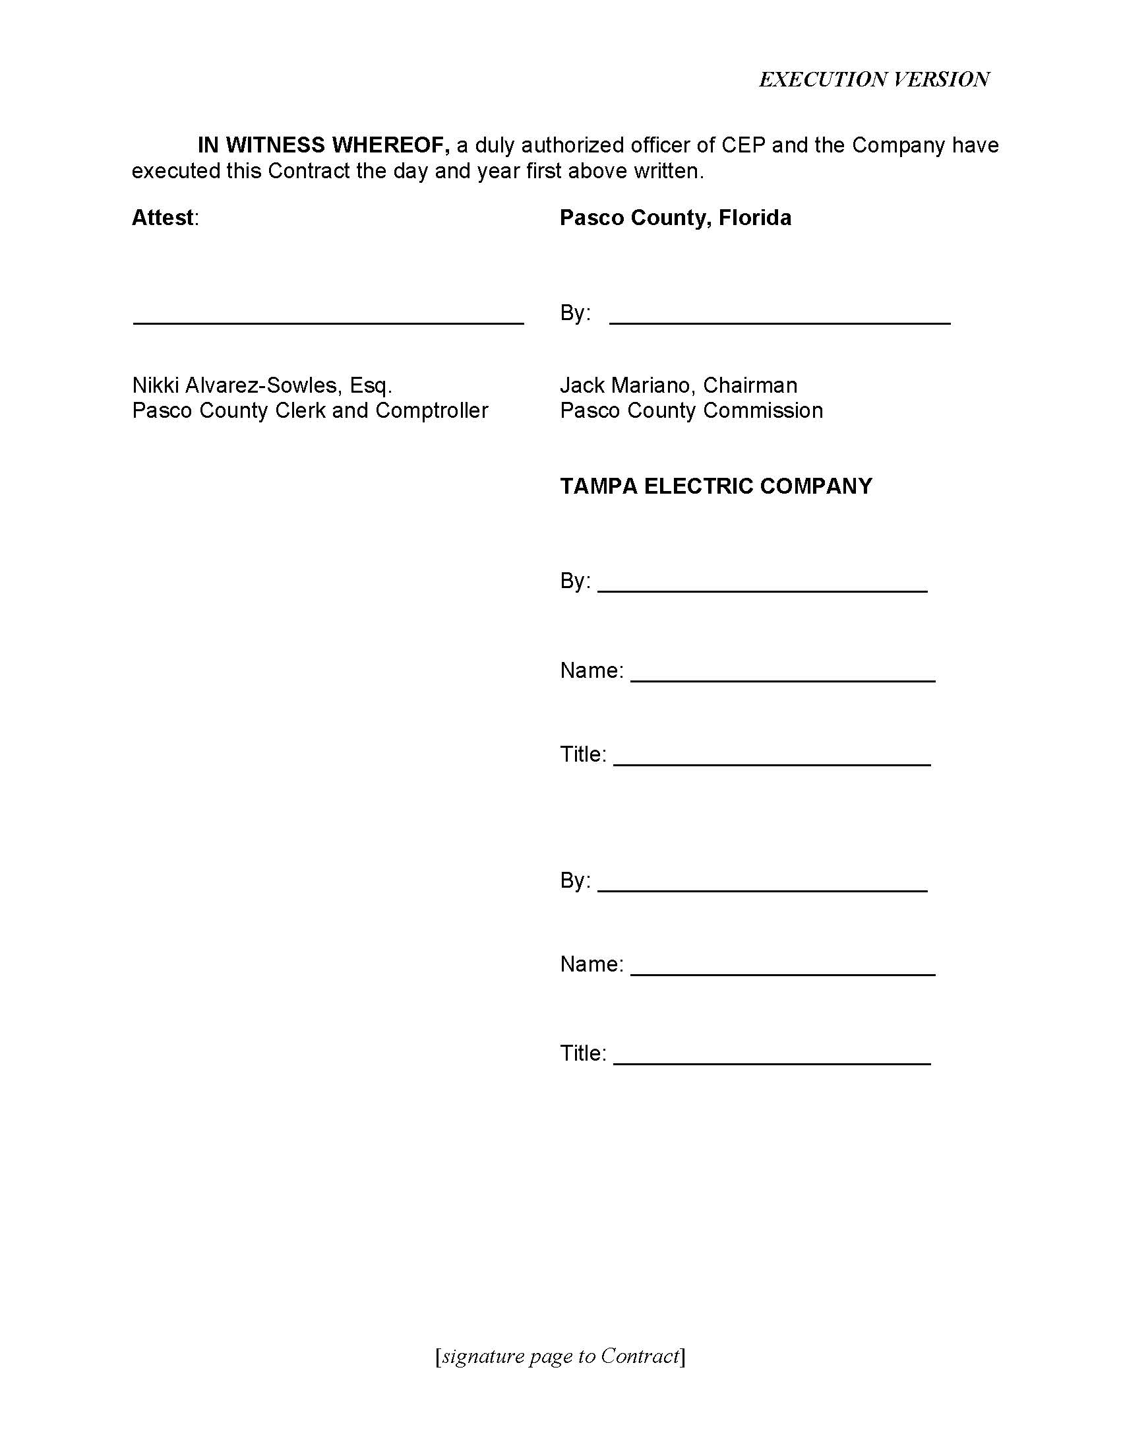

See Order No. PSC-2023-0132-PAA-EI, issued April 18, 2023, in Docket No. 20220186-EI, In re: Petition for approval of purchase power agreement between Tampa Electric Company and Pasco County.
Document No. 00219-2024, filed on January 18, 2024, in Docket No. 20230129-EI.
Document No. 00219-2024, filed on January 18, 2024, in Docket No. 20230129-EI.
See Order No. PSC-11-0439-PAA-EQ, issued October 11, 2011, in Docket No. 20110090-EQ, In re: Petition for Approving Negotiated Power Purchase Agreement between Progress Energy Florida, Inc. and U.S. Ecogen Polk, LLC.
See Order No. PSC-2023-0179-PAA-EQ, issued June 21, 2023, in Docket No. 20230041-EQ, In re: Petition for approval of revisions to standard offer contracts and rate schedule COG-2, by Tampa Electric Company.

