|  |  |  |  |
| --- | --- | --- | --- |
| State of Florida  pscSEAL | | Public Service Commission  Capital Circle Office Center ● 2540 Shumard Oak Boulevard Tallahassee, Florida 32399-0850  -M-E-M-O-R-A-N-D-U-M- | |
| DATE: | June 27, 2024 | | |
| TO: | Office of Commission Clerk (Teitzman) | | |
| FROM: | Division of Economics (Ward, Hampson)  Office of the General Counsel (Thompson) | | |
| RE: | Docket No. 20240051-GU – Petition for approval of transportation service agreement with Florida City Gas by Peninsula Pipeline Company, Inc. | | |
| AGENDA: | 07/09/24 – Regular Agenda – Proposed Agency Action – Interested Persons May Participate | | |
| COMMISSIONERS ASSIGNED: | | | All Commissioners |
| PREHEARING OFFICER: | | | Clark |
| CRITICAL DATES: | | | None |
| SPECIAL INSTRUCTIONS: | | | Place on the Agenda prior to Docket 20240050-GU |

Case Background

On March 28, 2024, Peninsula Pipeline Company, Inc. (Peninsula) filed a petition for approval of a transportation service agreement (Transportation Agreement) with Florida City Gas (FCG) (jointly, the parties). The purpose of the Transportation Agreement is to ensure continuance of gas service to FCG after the impending acquisition by Peninsula of certain pipeline facilities in the area in and around Palm Beach County. Peninsula operates as an intrastate natural gas transmission company as defined by Section 369.103(4), Florida Statutes (F.S.).[1] FCG is a local distribution company (LDC) subject to the regulatory jurisdiction of the Commission pursuant to Chapter 366, F.S.

By Order No. PSC-07-1012-TRF-GP, Peninsula received approval of an intrastate gas pipeline tariff that allows it to construct and operate intrastate pipeline facilities and to actively pursue agreements with natural gas customers.[2] Peninsula provides gas transportation service only; it does not engage in the sale of natural gas. Pursuant to Order No. PSC-07-1012-TRF-GP, Peninsula is allowed to enter into certain gas transmission agreements without prior Commission approval.[3] However, Peninsula is requesting Commission approval of this proposed Transportation Agreement as it does not fit any of the criteria enumerated in the tariff for which Commission approval would not be required.[4] The parties are subsidiaries of Chesapeake Utility Corporation, a Delaware corporation, and agreements between affiliated companies must be approved by the Commission pursuant to Section 368.105, F.S., and Order No. PSC-07-1012- TRF-GP.

The Pioneer Supply Header Pipeline (Pioneer Header) was constructed by FCG to provide itself and other local distribution companies (LDC) and industrial customers with gas supply from Florida Gas Transmission Company, LLC (FGT) in the area in and around Palm Beach County. The pipeline consists of 39.5 miles of 12-inch coated steel and runs from east to west through Palm Beach County. The pipeline interconnects with FGT at its east end and a pigging station at its west end near South Bay. The proposed Transportation Agreement has been necessitated by the transfer of the Pioneer Header from FCG to Peninsula. Pursuant to the proposed Transportation Agreement, Peninsula will provide transportation service to FCG, allowing FCG to continue to receive natural gas in Palm Beach County.

The proposed Transportation Agreement and project map are shown as Attachments A and B to the recommendation. During the evaluation of the petition, staff issued a data request for which responses were received on April 29, 2024. The Commission has jurisdiction over this matter pursuant to Sections 366.05(1), 366.06, and 368.105, F.S.

Discussion of Issues

Issue 1:

 Should the Commission approve Peninsula's Transportation Agreement with FCG?

Recommendation:

 Yes, the Commission should approve Peninsula’s Transportation Agreement with FCG dated March 18, 2024, included as Attachment A to the recommendation. The proposed Transportation Agreement is reasonable and meets the requirements of Section 368.105, F.S. Furthermore, the proposed Transportation Agreement benefits FCG’s current and potential future customers by ensuring that there is a continuous supply of natural gas to Palm Beach County. (Ward)

Staff Analysis:

Pioneer Header Acquisition

FCG originally constructed the Pioneer Header to provide service to itself and additional customers with gas supply from FGT. The Pioneer Header is being transferred to Peninsula at book value. Peninsula explained in its petition that it is the preferred owner-operator of this transmission asset because its core business is being a transmission grade pipeline owner and operator. Peninsula stated that the Pioneer Header is a natural fit for inclusion in its existing portfolio because it is a larger-diameter pipeline that interconnects directly with an interstate pipeline that would allow Peninsula to bring larger volumes of natural gas to LDCs or large volume industrial customers.

Peninsula further stated that the Pioneer Header will serve as the foundation for a larger-scale transmission project designed to reduce capacity constraints and improve deliverability of gas commodity to the southeastern portion of the state. Upon acquisition, Peninsula will undertake the costs associated with the ownership of the planned project protecting FCG’s general body of ratepayers. Peninsula asserts that the proposed Transportation Agreement will enable FCG to continue to obtain gas supply from FGT upon Peninsula’s acquisition of the Pioneer Header.

In response to staff’s first data request, Peninsula stated that the Purchase and Sale Agreement between FCG and Peninsula for the Pioneer Header will be signed upon approval of the Transportation Agreement (discussed below) by the Commission.[5] The purchase and sale agreement between FCG and Peninsula has been provided in responses to staff’s first data request; however, Commission approval is not required of the purchase and sale agreement. The purchase and sale agreement will be signed upon approval of the proposed Transportation Agreement.

Proposed Transportation Service Agreement

The parties have entered into the proposed Transportation Agreement to enable FCG to continue to serve natural gas customers in and around the area of Palm Beach County once Peninsula has acquired the Pioneer Header. The proposed Transportation Agreement specifies an initial term of 20 years and thereafter shall be extended on a year-to-year basis, unless either party gives no less than 90 days of written notification of termination. If either party desires to negotiate modifications to the rates or terms of this Transportation Agreement, they may do so no less than 120 days prior to the expiration of the current active term.

Pursuant to the proposed Transportation Agreement, Peninsula will provide 20,000 Dth/day of firm transportation service to FCG for a rate of $0.00 Dth/day for authorized transportation quantities. In response to staff’s first data request, Peninsula explained that the rate contained in the Transportation Agreement will prevent FCG ratepayers from additional rate impact because the cost of the Pioneer Header is currently included in base rates.[6] In its petition, Peninsula indicated that the agreement and rate are somewhat unique, recognizing the transfer of Pioneer Header.

In FCG’s next rate case, the pipeline will be removed from rate base. At that time, FCG and Peninsula will negotiate an appropriate transportation rate and petition the Commission for approval of an amended Transportation Agreement.

Conclusion

Based on the petition and the parties’ responses to staff’s data request, staff believes that the proposed Transportation Agreement is reasonable and meets the requirements of Section 368.105, F.S. Furthermore, the proposed Transportation Agreement benefits FCG’s current and potential future customers by ensuring that there is a continuous supply of natural gas to the area of Palm Beach County. Staff therefore recommends approval of the proposed Transportation Agreement between Peninsula and FCG dated March 18, 2024.

Issue 2:

 Should this docket be closed?

Recommendation:

 Yes. If no protest is filled by a person whose substantial interest are affected within 21 days of the issuance of the Order, this docket should be closed upon the issuance of a Consummating Order. (Thompson)

Staff Analysis:

 If no protest is filled by a person whose substantial interest are affected within 21 days of the issuance of the Order, this docket should be closed upon the issuance of a Consummating Order.

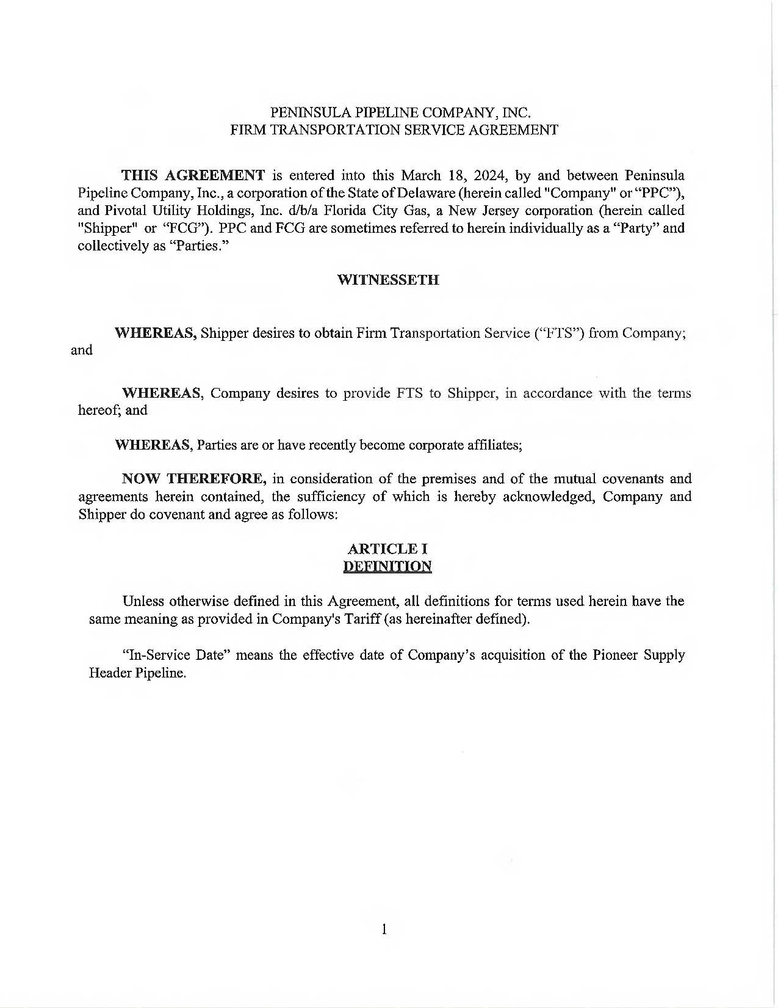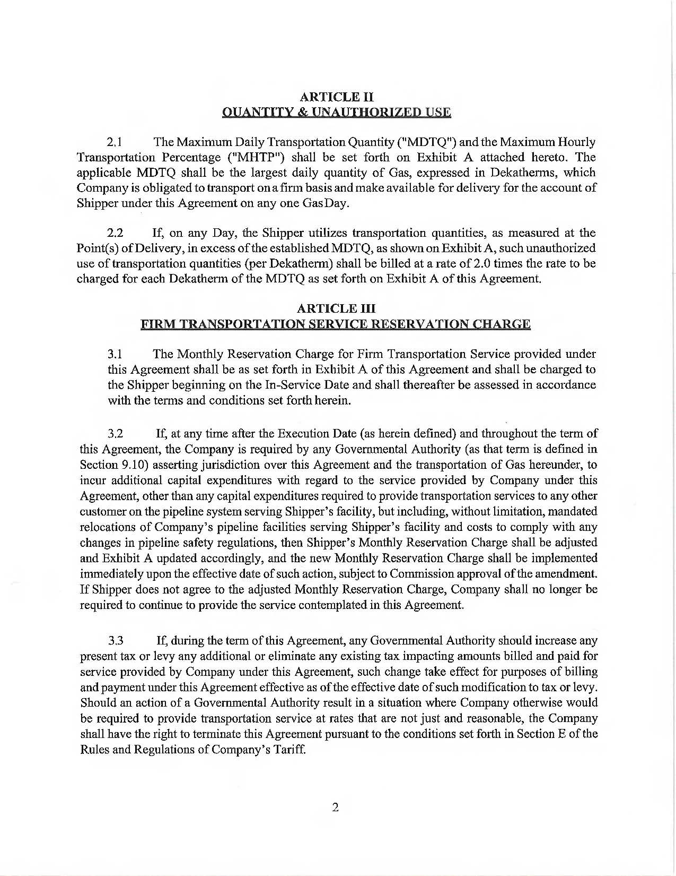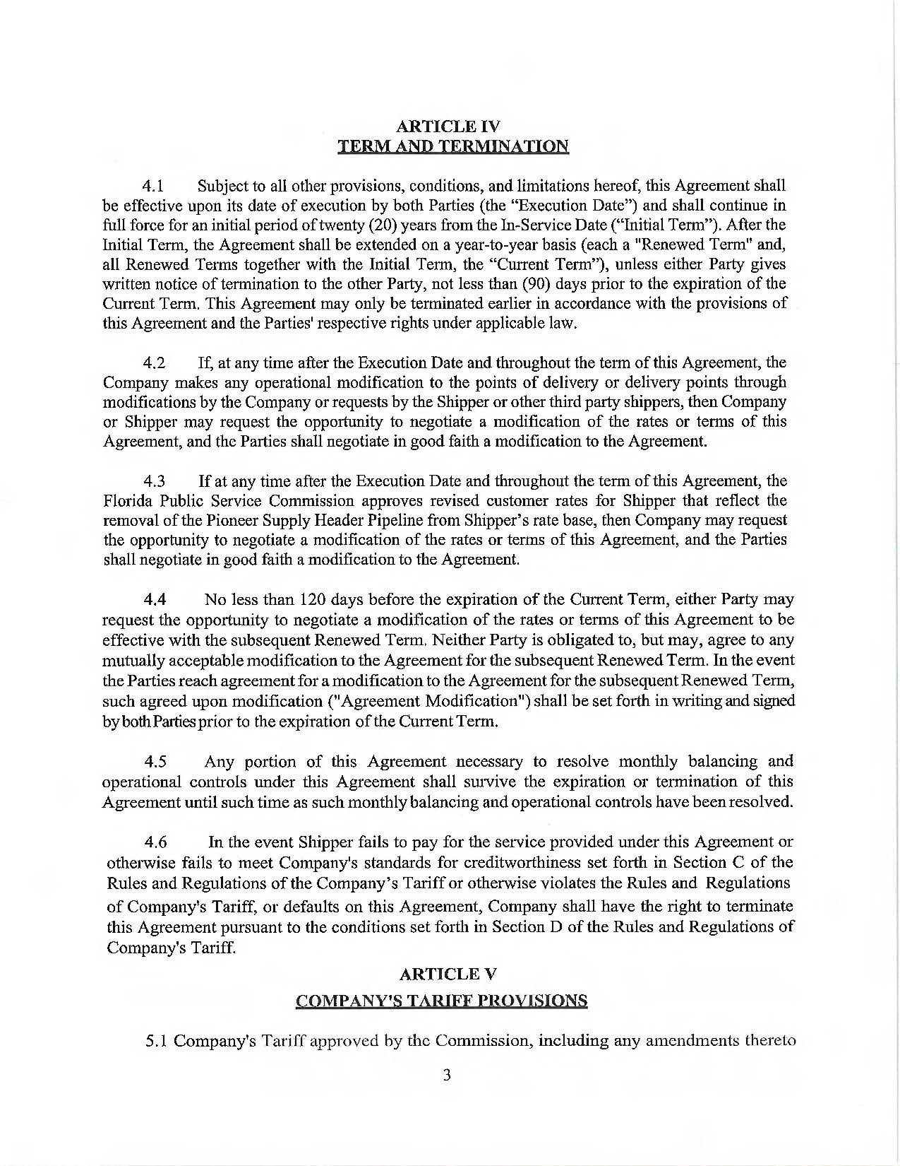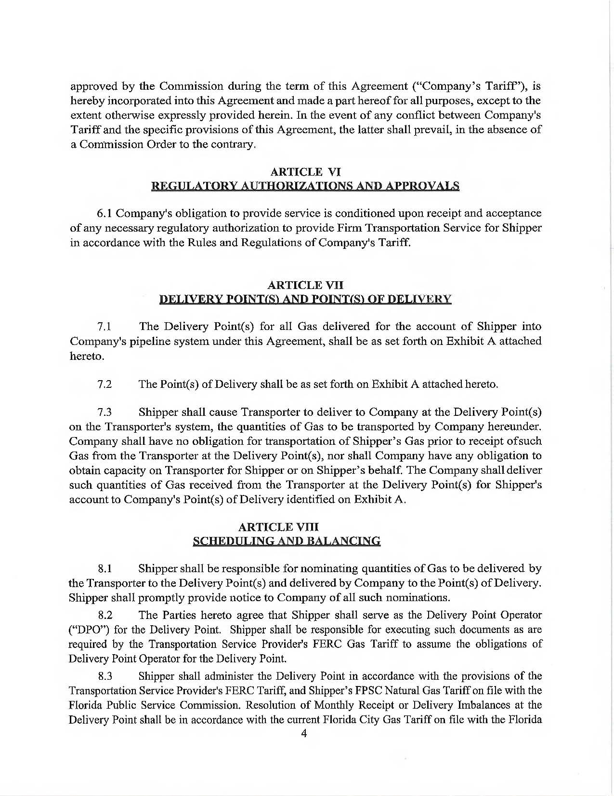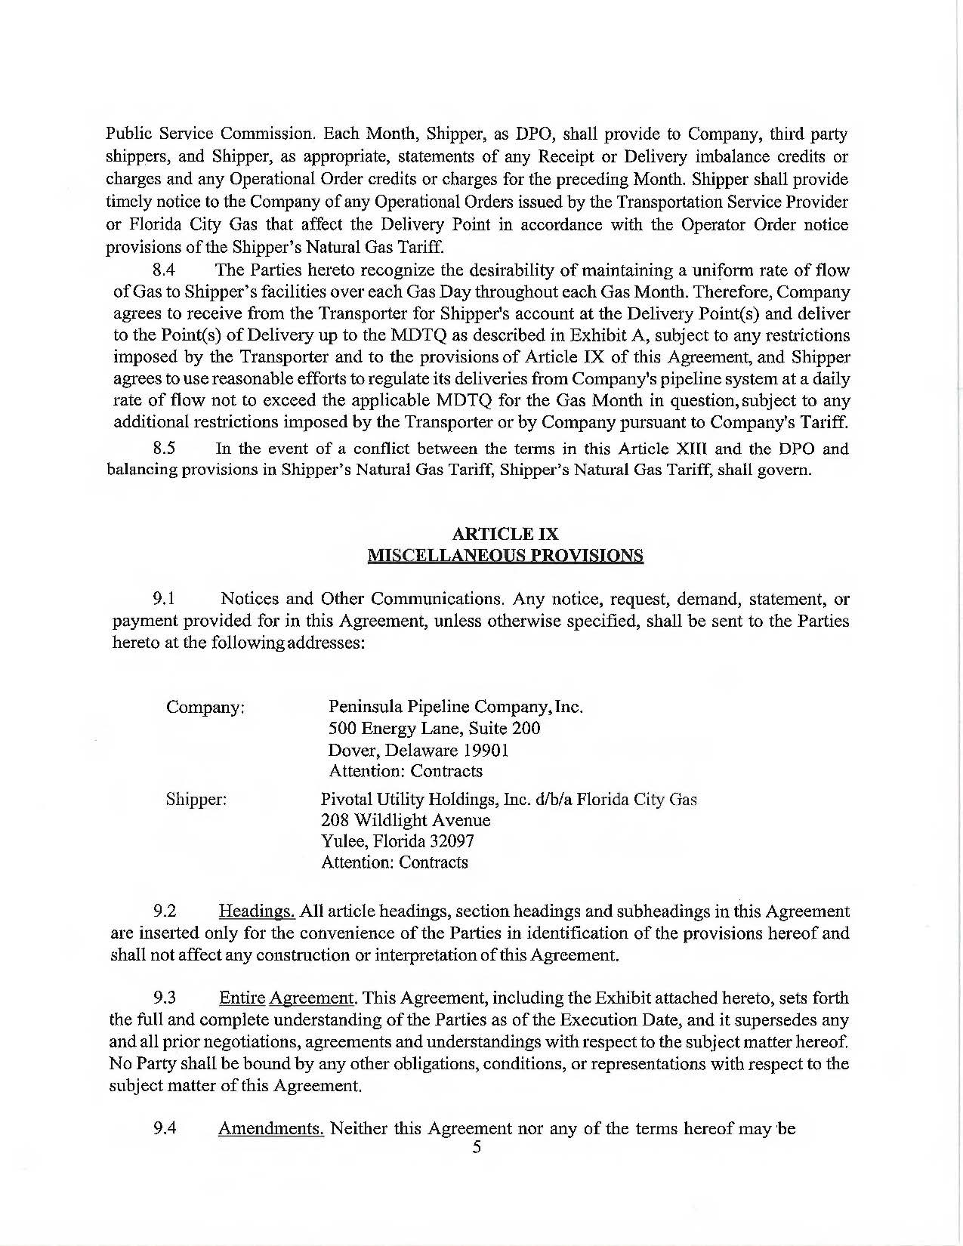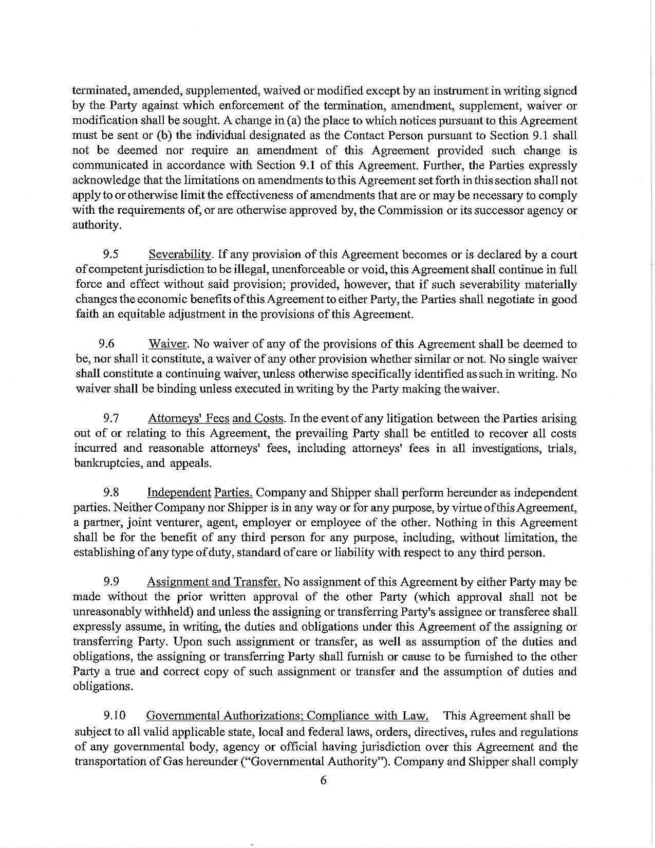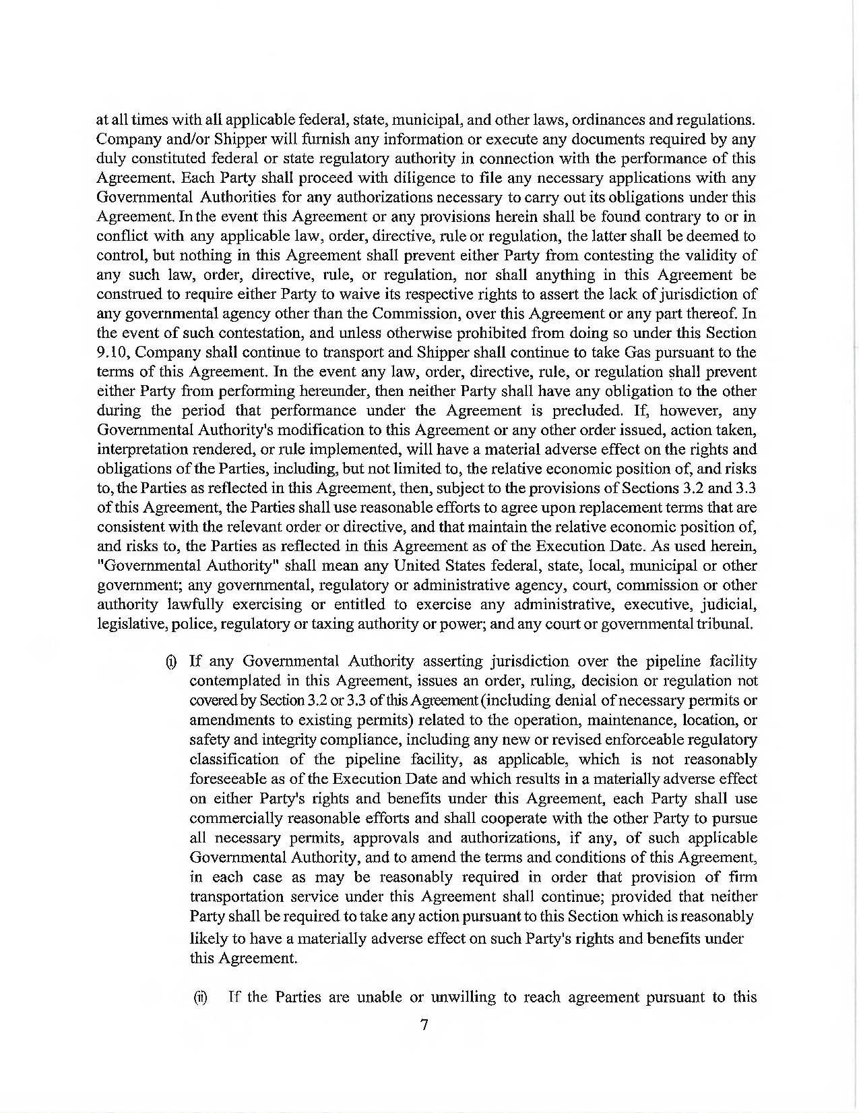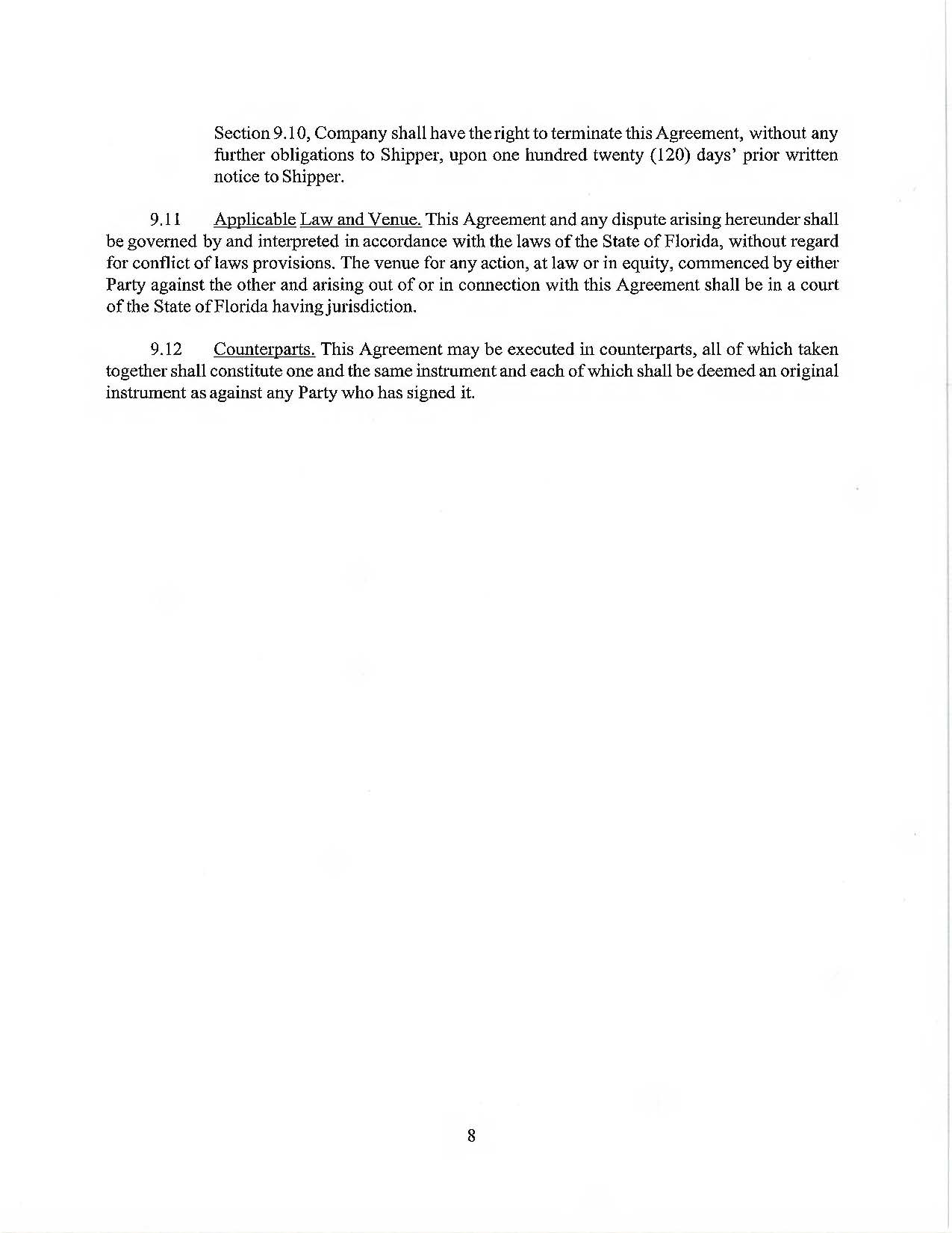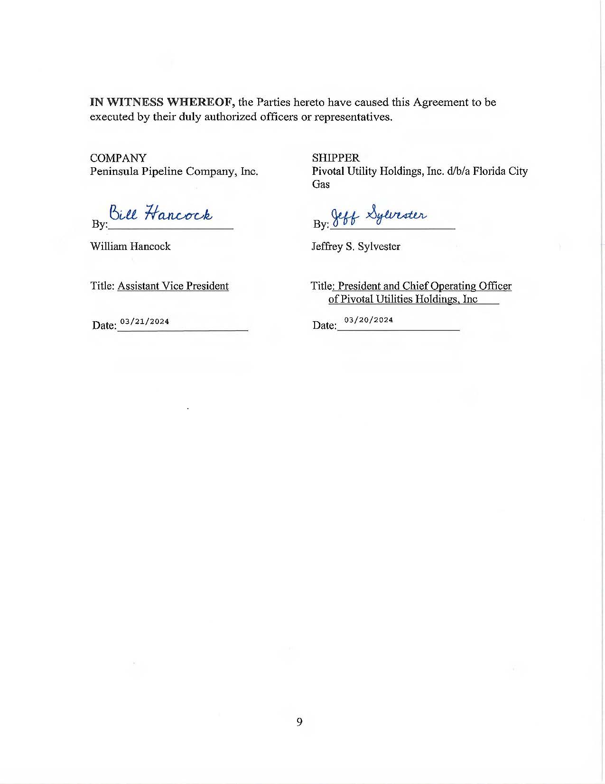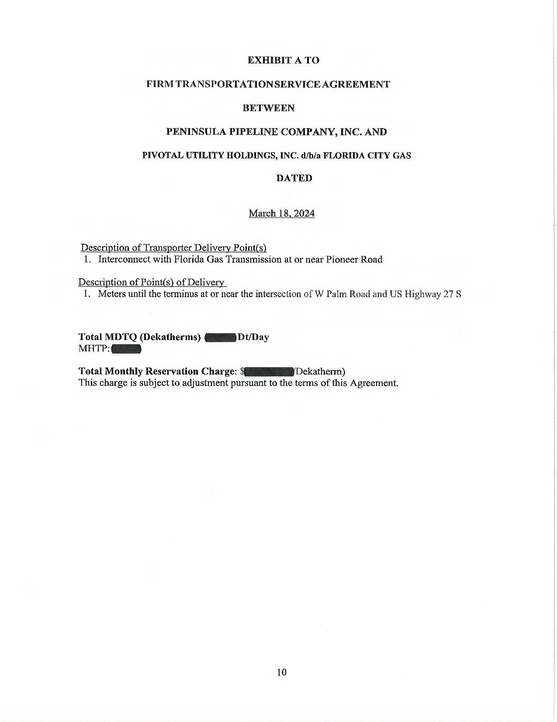

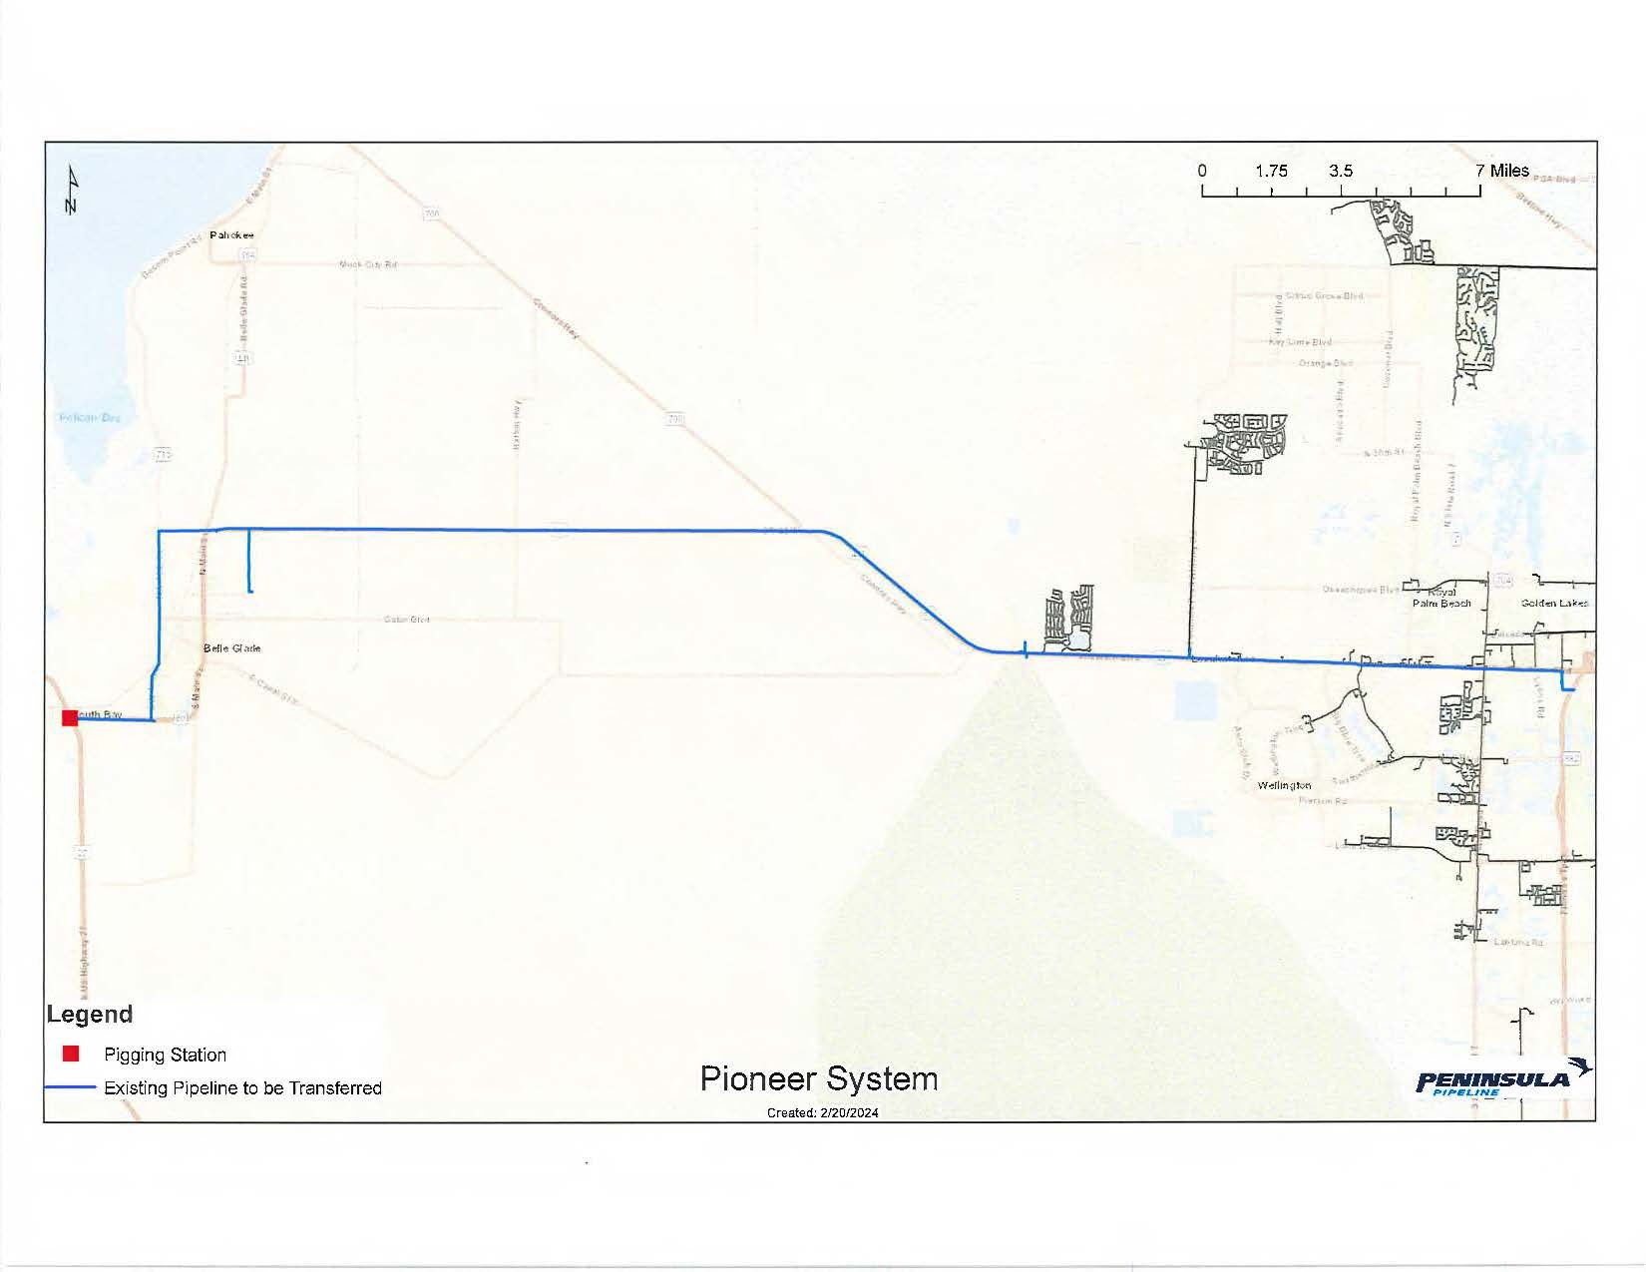

1. Order No. PSC-06-0023-DS-GP, issued January 9, 2006, in Docket No. 050584-GP, *In re: Petition for declaratory*

   *statement by Peninsula Pipeline Company, Inc. concerning recognition as a natural gas transmission company*

   *under Section 368.101, F.S., et seq.*
2. Order No. PSC-07-1012-TRF-GP, issued December 21, 2007, in Docket No. 070570-GP, *In re: Petition for*

   *approval of natural gas transmission pipeline tariff by Peninsula Pipeline Company, Inc.*
3. Peninsula Pipeline Company, Inc., Intrastate Pipeline Tariff, Original Sheet No. 11, Section 3.
4. Peninsula Pipeline Company, Inc., Intrastate Pipeline Tariff, Original Sheet No. 12, Section 4.
5. Responses to Staff’s First Data Request, Response No. 8.
6. Responses to Staff’s First Data Request, Response No. 9.