State of Florida   |  | Public Service Commission  Capital Circle Office Center ● 2540 Shumard Oak Boulevard  Tallahassee, Florida 32399-0850  -M-E-M-O-R-A-N-D-U-M-
DATE: | June 27, 2024
TO: | Office of Commission Clerk (Teitzman)
FROM: | Office of Industry Development and Market Analysis (Williams, Fogleman)  Office of the General Counsel (Imig, Farooqi, Harper)
RE: | Docket No. 20240043-TP – Request for submission of proposals for relay service, beginning in March 2025, for the deaf, hard of hearing, deaf/blind, or speech impaired, and other implementation matters in compliance with the Florida Telecommunications Access System Act of 1991.
AGENDA: | 07/09/24 – Regular Agenda – Interested Persons May Participate
COMMISSIONERS ASSIGNED: |  |  | All Commissioners
PREHEARING OFFICER: |  |  | Fay
CRITICAL DATES: |  |  | The current contract expires February 28, 2025. Significant time is needed to issue the RFP, evaluate proposals, and to set-up the system.
SPECIAL INSTRUCTIONS: |  |  | Anticipate the need for sign language interpreters and assisted listening devices. Please place near the beginning of the agenda to reduce interpreter costs.

Case Background
The existing Florida relay service provider contract expires February 28, 2025. On March 1, 2024, T-Mobile USA, Inc. (T-Mobile) provided written notice to the Florida Public Service Commission (Commission) that it does not intend to extend the relay provider contract an additional year past the expiration date, as permitted by the existing contract.

Attachment A to this recommendation contains a Draft Request for Proposals (RFP) to provide telecommunications relay service in Florida. If approved, the RFP will be issued no later than July 16, 2024, with the proposals due by August 19, 2024. The tentative schedule calls for the Commission to select a provider at the November 5, 2024 Agenda Conference, and for the provider to begin providing service on March 1, 2025.
Pursuant to Section 287.057(1)(b) Florida Statutes (F.S.), an agency is required to issue an RFP when it solicits commodities or contractual services that meet a certain threshold amount. See Section 287.017, F.S. In this case, the RFP is necessary in order for the Commission to offer relay service in compliance with:
- The Florida Telecommunications Access System Act (TASA), Chapter 427, Part II, F.S.;
- The Federal Americans with Disabilities Act of 1990, 42 USC §12101 et seq.; and
- The Federal Communications Commission (FCC) regulations on relay service, 47 CFR Part 64.
The RFP mandates many features for relay service, including 24 hour a day service every day of the year, answering time and blocking standards, confidentiality conditions, procedures for relaying a call giving substantial control to the user as to how the call is handled, Communications Assistant (CA) and provider requirements, and provisions for complaint resolution and consumer input. In addition, the RFP allows a bidder to provide unsolicited features as part of its basic relay service for which additional evaluation points may be awarded.
Pursuant to Chapter 287, F.S., the Commission must award the contract to the bidder whose proposal is the most advantageous to the state, taking into account the factors set forth in Section 427.704(3)(a), F.S:
- The appropriateness and accessibility of the proposed telecommunications relay service for the citizens of the state, including persons with hearing and/or speech loss;
- The overall quality of the proposed telecommunications relay service;
- The charges for the proposed telecommunications relay service;
- The ability and qualifications of the bidder to provide the proposed telecommunications relay service as outlined in the RFP;
- Any proposed service enhancements and technological enhancements which improve service without significantly increasing cost;
- Any proposed inclusion of provision of assistance to deaf persons with special needs to access the basic telecommunications system;
- The ability to meet the proposed commencement date for the Florida Relay Service; and
- All other factors listed in the RFP.
Each bidder will be required to submit its proposal on the basis of a charge per billable minute for a three-year contract with the option of four one-year extensions. The price proposal must be submitted in a sealed envelope separate from the technical proposal.
The RFP also provides for a point system for evaluating the proposals. A weight of 50% will be given to the technical aspect of the proposal and a weight of 50% will be given to the price aspect of the proposal.

A Bidders’ Conference was held on April 23, 2024. During the Conference, staff conducted a detailed walk-through of the Draft RFP and allowed participants to ask questions and present suggested changes. In addition, staff allowed Conference participants and all interested persons to submit written suggested changes to the Draft RFP for staff’s consideration. Staff has addressed suggested changes and has presented its recommended basis for acceptance or denial in Issue One of the recommendation.

The Commission has authority over TASA pursuant to Part II of Chapter 427, F.S., and issues this RFP pursuant to Chapter 287, F.S.

Discussion of Issues

Issue 1:
Should the Commission issue the RFP for telecommunications relay service?

Recommendation:
Yes. The Commission should issue the RFP, as set forth in Attachment A.

Staff Analysis:
The RFP was drafted to describe as specifically as possible the relay service that should be provided. The RFP includes traditional telecommunications relay service (TRS) and speech-to-speech (STS) service currently provided in Florida, and complies with FCC regulations. The RFP does not include analog captioned telephone service (CTS) that is offered under the current relay provider contract.
The RFP is substantially similar to the RFP issued by the Commission on May 11, 2021, with the exception of analog CTS. Based on analysis by staff, along with comments from Hamilton Relay, Inc. (Hamilton Relay) and T-Mobile, staff recommends selective revisions to the May 11, 2021 RFP. Staff’s review of suggested revisions to sections of the 2021 RFP is presented below.
Removal of analog CTS from the RFP
T-Mobile has requested the removal of analog CTS from the RFP. In support, T-Mobile cites the continued decline in analog CTS minutes of use, the absence of an FCC mandate, and the availability of viable alternatives. T-Mobile noted the number of analog CTS subscribers decreased from 137 to 89 during the twelve month period from April 2023 to March 2024.
Hamilton Relay supports the continuation of analog CTS in Florida to support traditional analog CTS users. Hamilton Relay presented some creditable information in support of the continued offering of analog CTS in Florida. However, based on declining minutes of use, viable alternatives, the potential impact on competition, along with statutory constraints, staff does not support Hamilton’s position.
As staff has previously reported to the Commission, analog CTS minutes of use continue to decline. This is driven in large part by the analog to digital transition in the telecommunications industry. This transition presents challenges for users reliant on analog forms of CTS, particularly those without access to broadband due to demographics or financial constraints. Historical data from the Commission’s three most recent Relay Reports is provided below with forecasted minutes of use by T-Mobile for the last two years:
 | Analog CTS Minutes of Use
July 2020 to June 2021 | 368,337
July 2021 to June 2022 | 236,044
July 2022 to June 2023 | 166,908
July 2023 to June 2024 | 153,345*
July 2024 to June 2025 | 84,435*
* Forecast provided by T-Mobile in associated FRTI budget dockets.

In response to this transformation, relay programs in other states are adjusting with reforms ranging from issuing separate contracts for traditional TRS and analog CTS, to discontinuing analog CTS altogether. Multiple contracts are not an option in Florida because TASA mandates that a single statewide relay service provider be awarded the contract. Staff notes that analog CTS is not a service mandated by the FCC for state relay program certification. Traditional TRS and STS are the only two mandated services required by the FCC for state certification.
It appears that issuing an RFP for only traditional TRS and STS will benefit Florida by providing the best opportunity for competition. To date, T-Mobile and Hamilton Relay are the only two potential bidders who have shown interest in submitting a proposal. T-Mobile has indicated to staff that it is not willing to continue offering analog CTS once the current contract expires. With T-Mobile ceasing the provision of analog CTS, requiring that service in Florida would result in a single bid in response to the RFP. This scenario has the potential to have adverse consequences on the price Florida Telecommunications Relay, Inc. (FTRI) pays for relay service and subsequently its relay service provider expense.
Staff acknowledges that issuing an RFP that does not include analog CTS is a significant change. However, staff is encouraged by the continued rapid advances in technology and the adoption of these advances by consumers. One of these advances will be offered by FTRI. It is an alternative to analog CTS that uses a new Caption Device that provides benefits to customers that are similar to analog CTS. The XLC8, when combined with the XLC8GLT Deluxe, offers the benefits of a CA assisted analog CTS call without the CA. The translation of voice to text is performed by the XLC8GLT Deluxe device. Other alternatives noted by T-Mobile include: use of a traditional CapTel phone with traditional relay Voice Carry-Over, Internet Protocol CTS for those customers who have internet access, and wireless service with free apps.
If the Commission approves staff’s recommendation to issue the RFP for traditional TRS and STS only, it will be important for FTRI, T-Mobile, and the winning bidder to educate consumers and the deaf and hard of hearing community about the change and alternative service offerings. FTRI’s continued outreach efforts, and specifically its marketing of the XLC8GLT Deluxe is important. T-Mobile, with input from staff, has already contacted consumers informing them that the CapTel service may be ending in the near future. T-Mobile also provided consumers with a method to learn more about alternative services.
Staff has deleted references to analog CTS that were included in the 2021 RFP. Staff recommends issuing the 2024 RFP for traditional TRS and STS only.
Section A.7. Key Dates
T-Mobile recommended extending the Clarifying Questions Submitted in Writing to the Proposal Review Committee Chairman date to at least two weeks from the date the RFP is released. Staff’s original schedule required clarifying questions to be submitted within one week.

Hamilton Relay did not comment on this section.

Staff supports T-Mobile’s request to extend the due date to two weeks from the RFP release date.

Section A.34. Liquidated Damages for Failure to Initiate Services on Time or to Provide
Contracted Services for the Life of the Contract

T-Mobile explained that as the industry has experienced significant declines in minutes of use, the liquidated damages for service level performance now far exceed the cost to provide the service. T-Mobile requests that the RFP reduce the amount of liquidated damages from $5,000 per day to $250 per day for Meet Answer Time Requirement and Meet Blockage Rate or Transmission Level Requirement.

Hamilton Relay suggests that due to shrinking relay usage, the liquidated damages contained in this section are stringent and increase costs. Hamilton asked that the Commission amend this section by adding the following language at the end of Section A.34: “Under no circumstance shall the liquidated damages exceed the revenue generated for the respective day.” Staff does not oppose this revision.

Staff does not oppose T-Mobile’s request to reduce the amount. However, staff does not support reducing the amount to $250 per day. In FTRI’s FY 2024/2025 Commission approved budget, total relay service provider expense is $921,793. This equates to a daily expense of $2,525. Staff believes $1,000 per day addresses the impact of declines in minutes of use and the resulting revenue decline, while providing continued incentive for the provider to deliver quality service. In addition, adoption of Hamilton Relay’s suggestion to cap liquidated damages further addresses T-Mobile’s concern.

Staff recommends the amount for liquidated damages for Meet Answer Time Requirement and Meet Blockage Rate or Transmission Level Requirement be reduced from $5,000 to $1,000 per day. Staff further recommends that liquidated damages not exceed the revenue generated for the respective day.

Section B.43. Performance Bond

This section requires the provider to furnish an acceptable performance bond, certified or cashier’s check, or bank money order equal to the estimated total first year price of the contract.

T-Mobile did not comment on this section.

Hamilton communicated that in light of decreasing minutes of use, “we respectfully request the Commission consider modifying this requirement to lower the amount to the estimated total for the first six months’ price of the contract.”

Staff agrees with Hamilton Relay that minutes of use continue to decline. FTRI’s relay service provider expense has continued to decline on an annual basis. Staff agrees that there is flexibility to lower the bond requirement as minutes and cost continue to decline. Staff supports Hamilton Relay’s request.

Section D. THE PRICE PROPOSAL FORMAT

This section requires that a bid price must be on a flat rate basis per billable minute for all billable minutes and not vary depending upon the volume of traffic. This section of the RFP has also been revised to reflect the discontinuance of analog CTS.

T-Mobile did not comment on this section.

In its written comments, Hamilton Relay proposed alternate pricing models. In response, Hamilton Relay submitted several alternative pricing models for consideration in its written comments which include a per minute rate with a monthly minimum and a monthly recurring charge with overages. Staff reviewed the alternative pricing models submitted by Hamilton Relay, but staff believes that the current flat rate billable minute methodology works well in Florida and should be retained.

In addition to the changes discussed above, the 2021 RFP has been edited for internal consistency with those changes. Staff recommends that the Commission issue the RFP as set forth in Attachment A.

Issue 2:
Should this docket be closed?

Recommendation:
No. (Imig)

Staff Analysis:
An RFP is issued pursuant to Chapter 287, F.S. Moreover, this RFP is specific to meet the requirements of Chapter 487, F.S., for TASA services. Accordingly, this docket should remain open throughout the life of the contract, and the provider should be selected at a future Commission Agenda Conference to begin providing service on March 1, 2025.

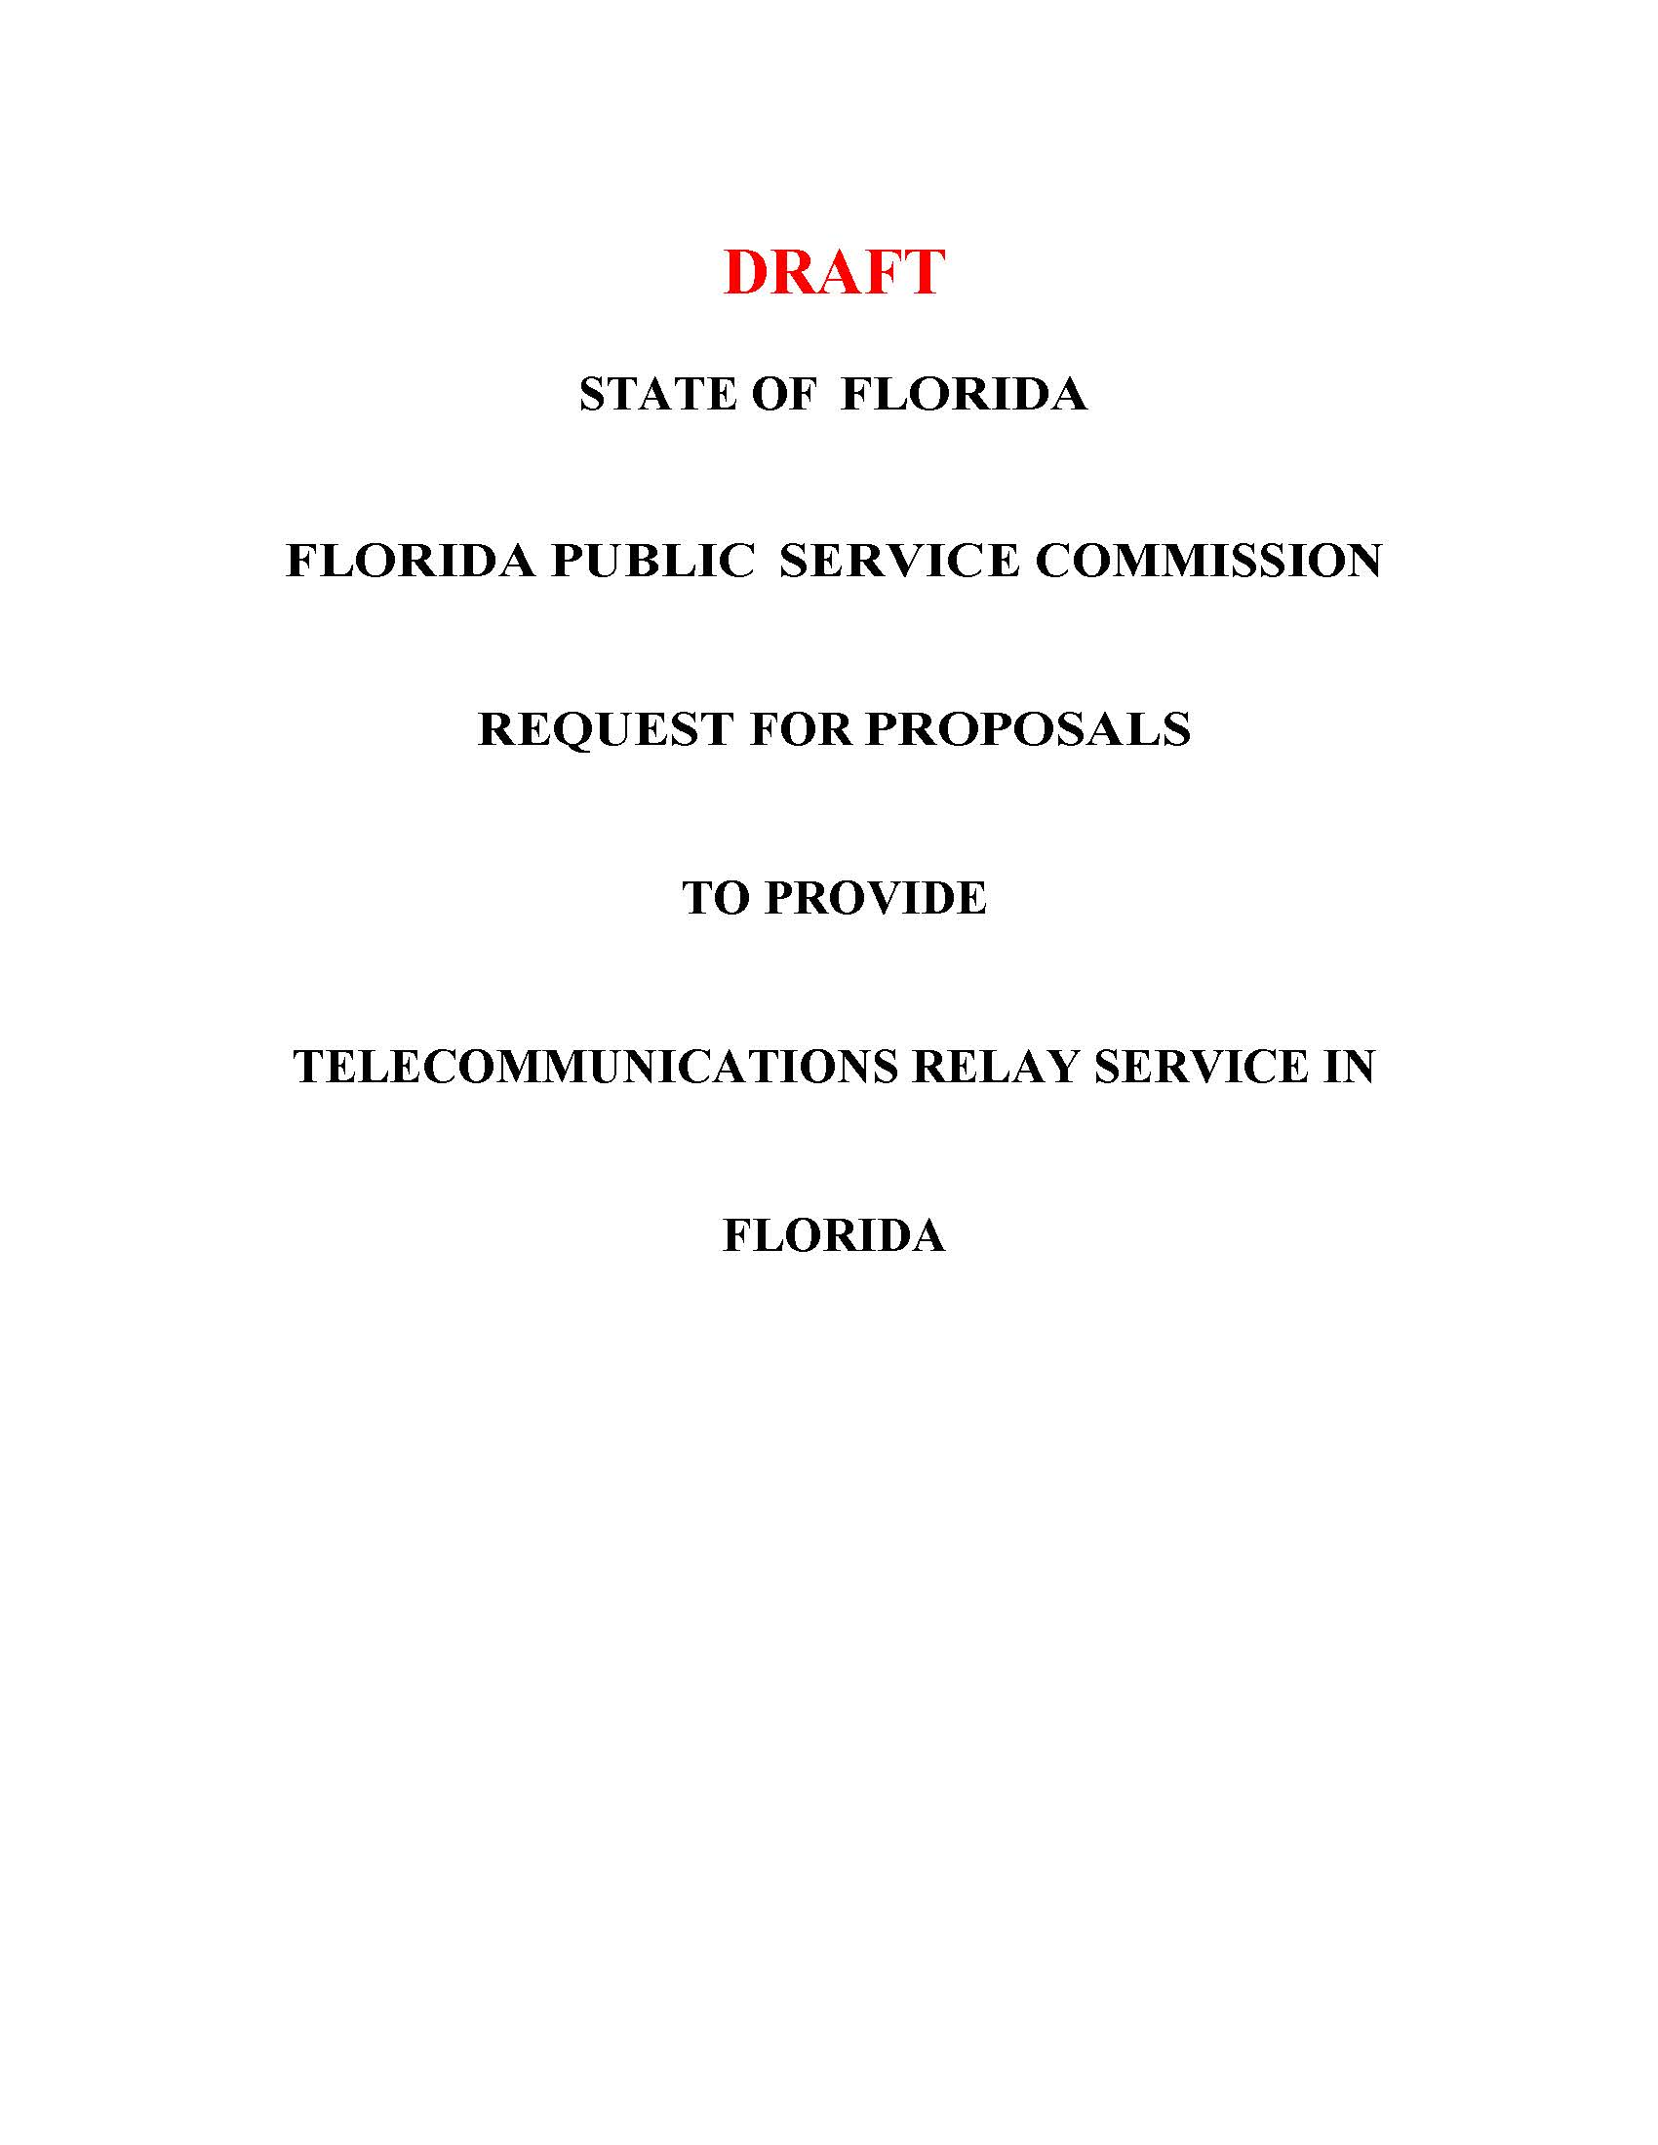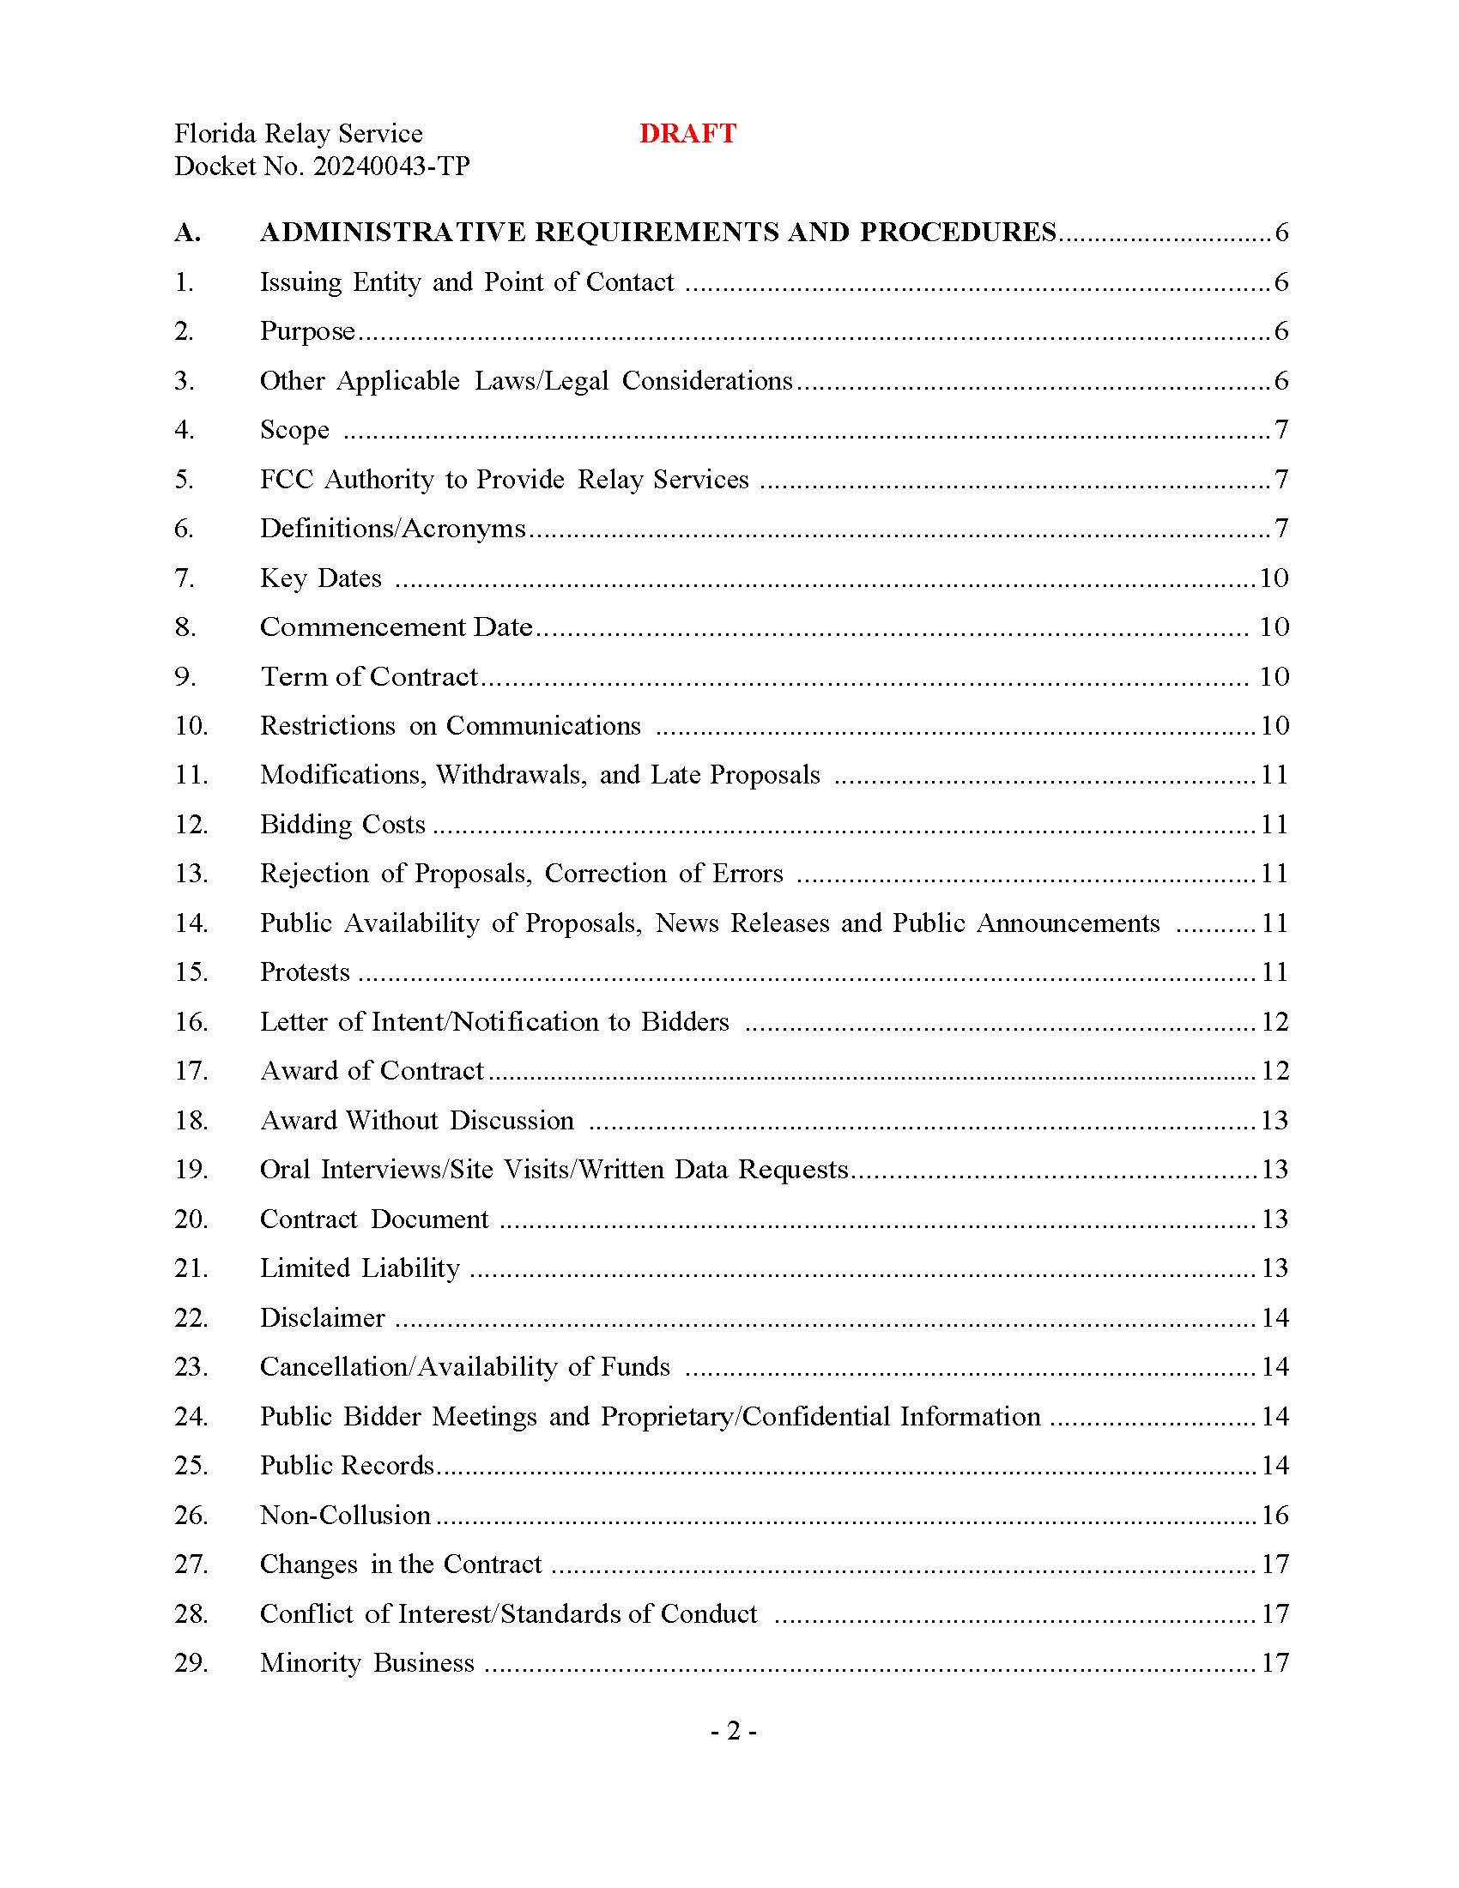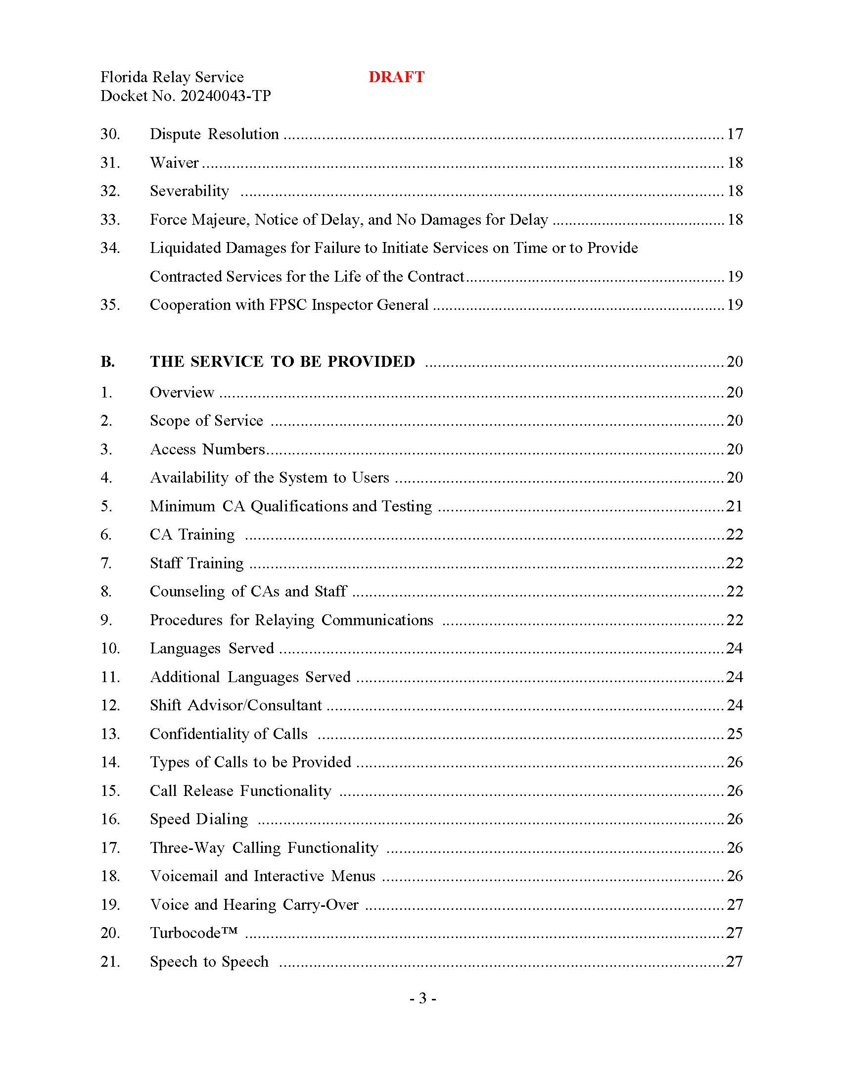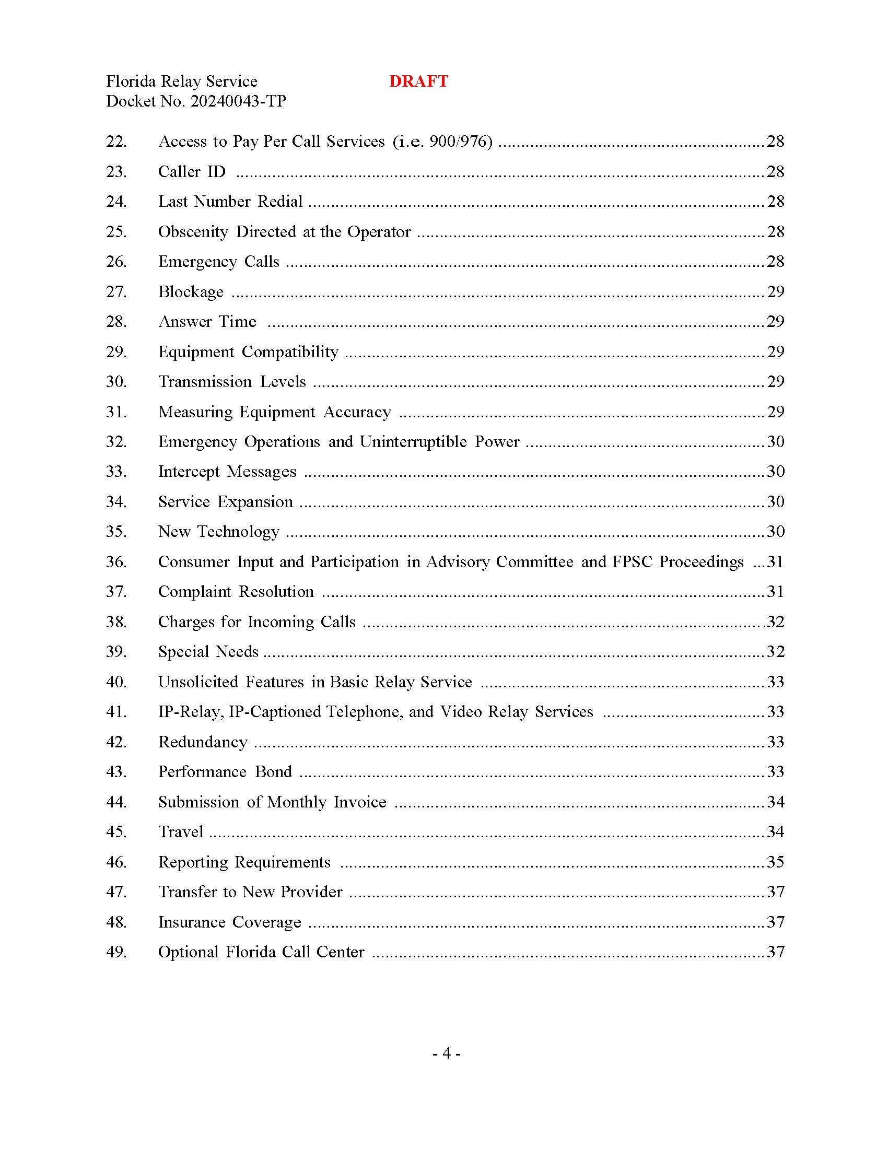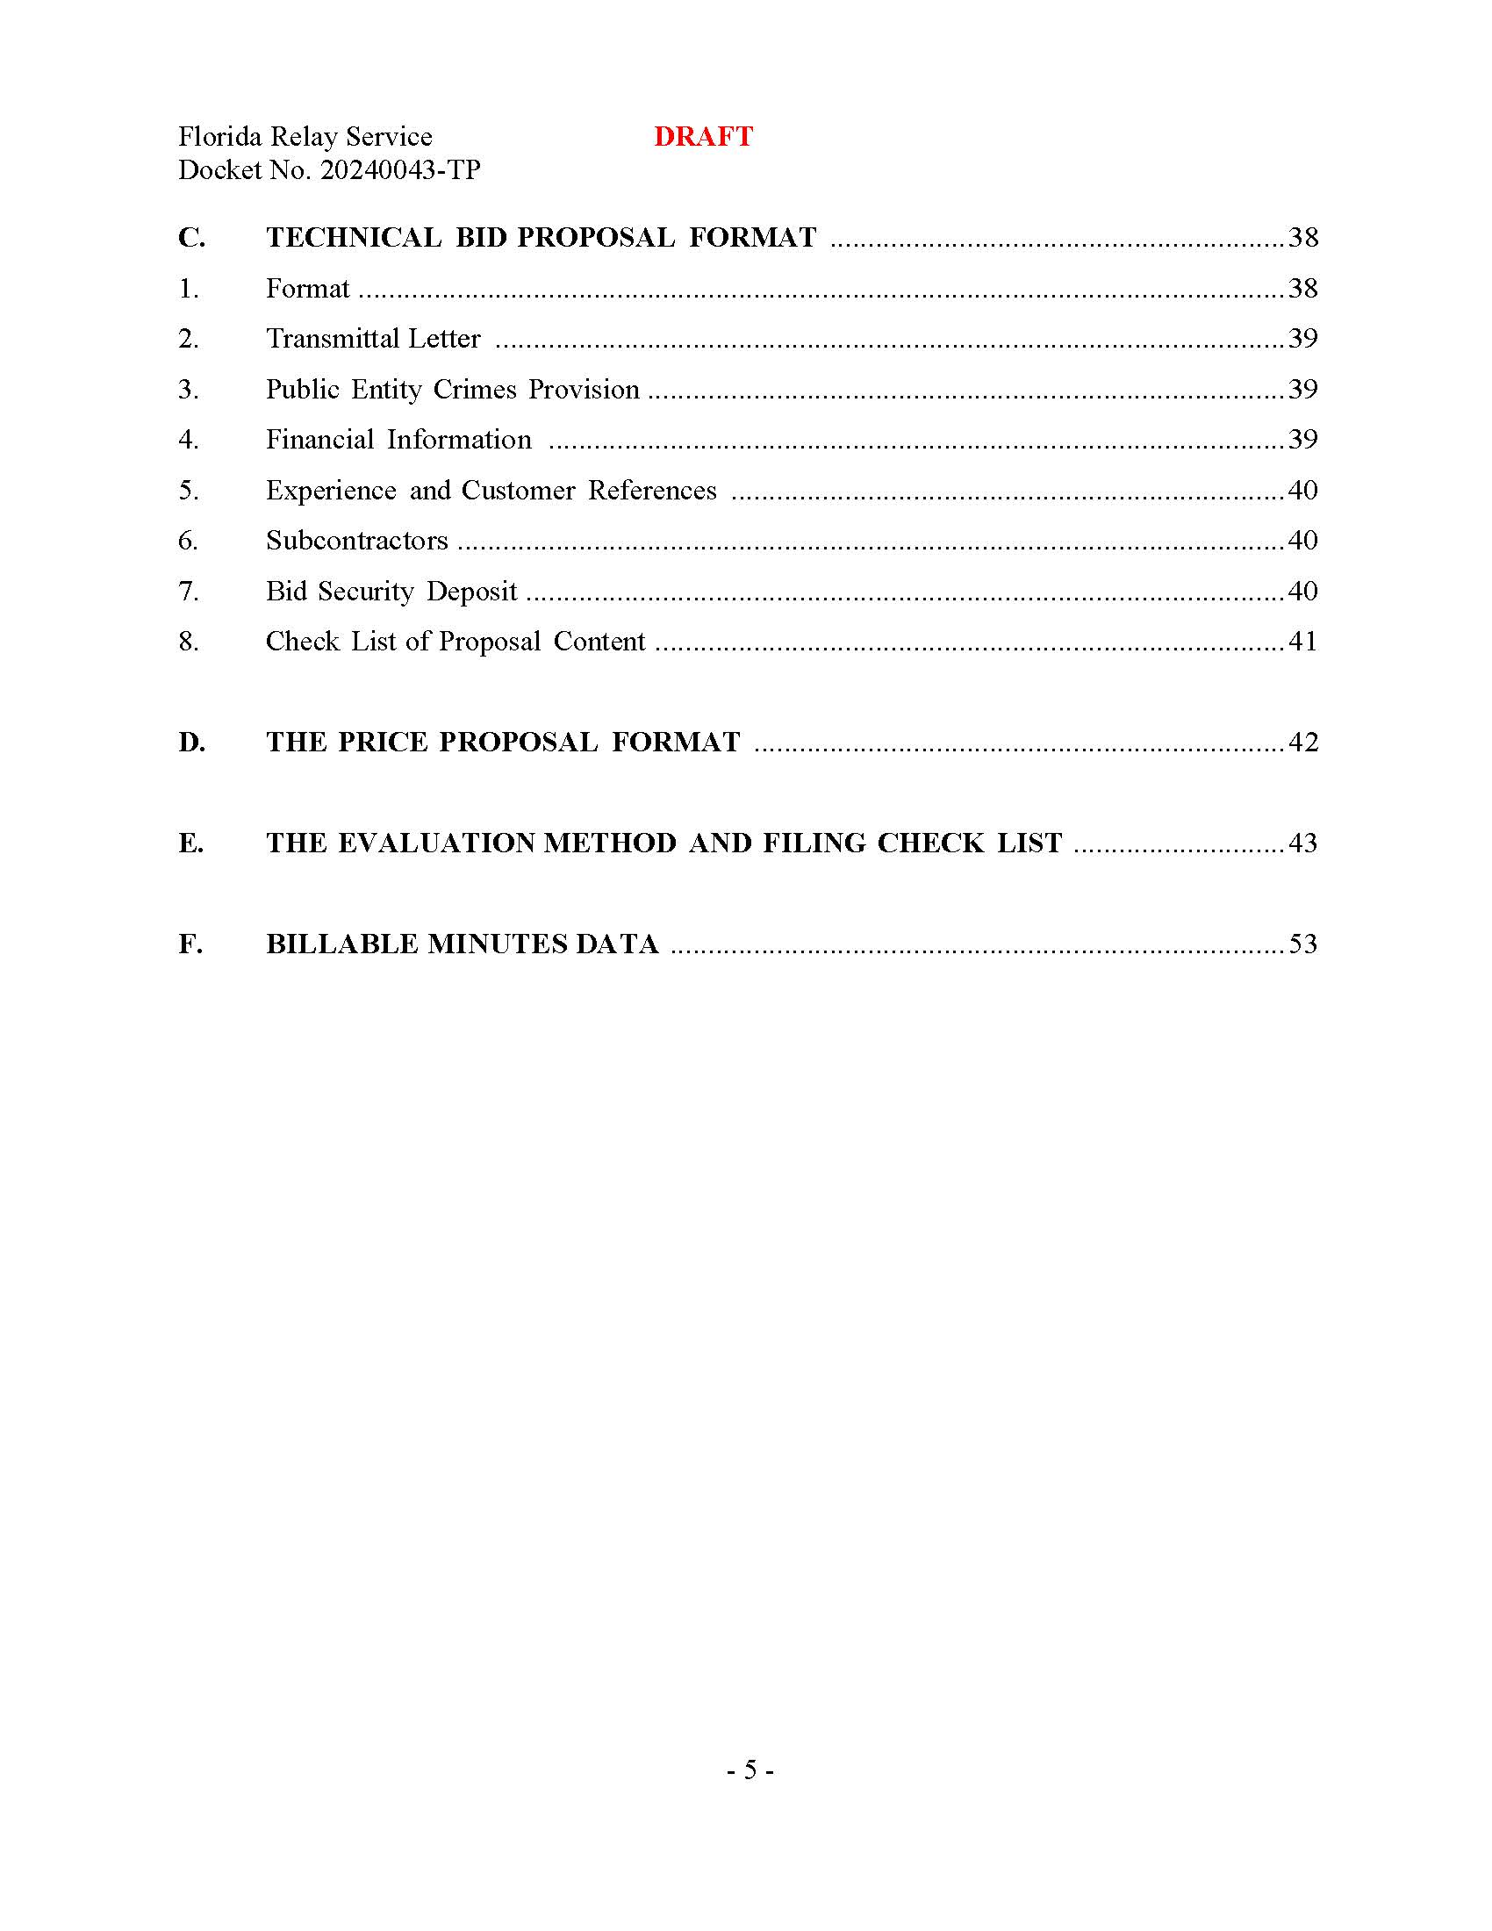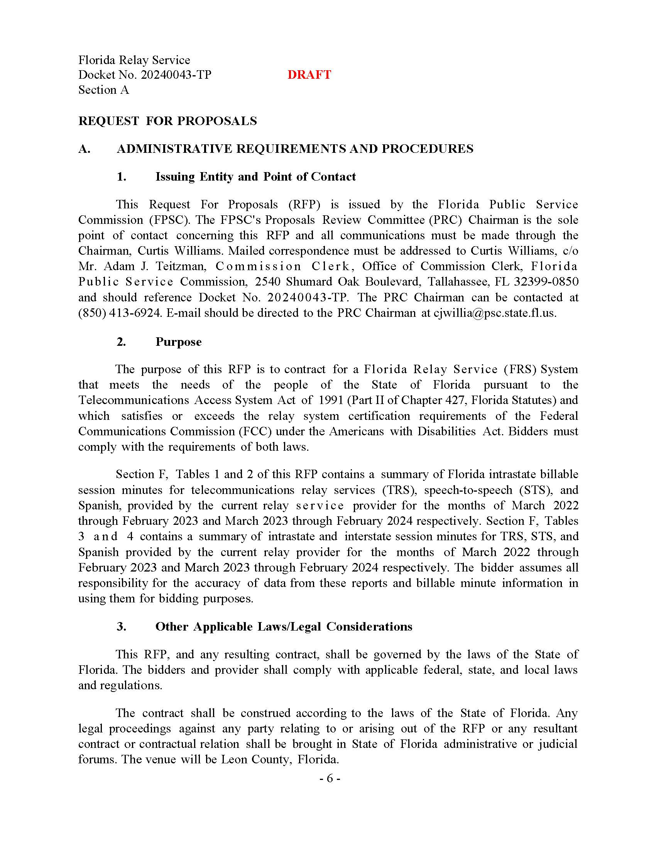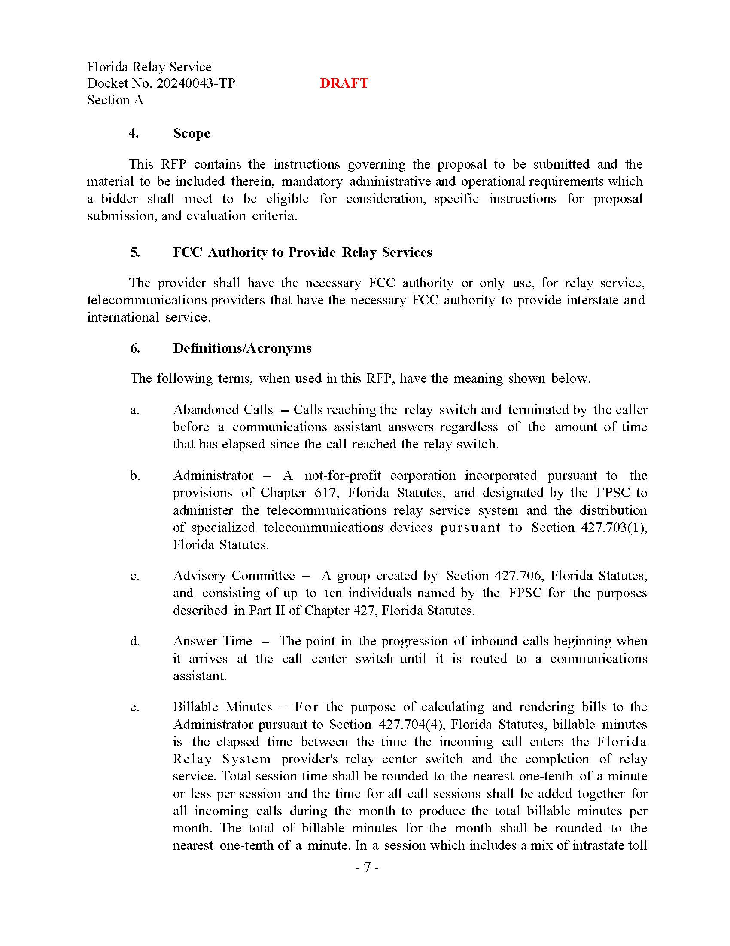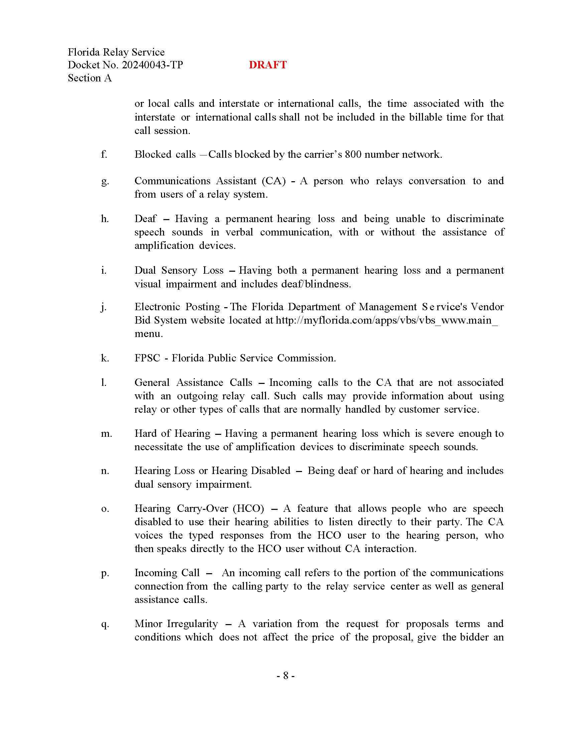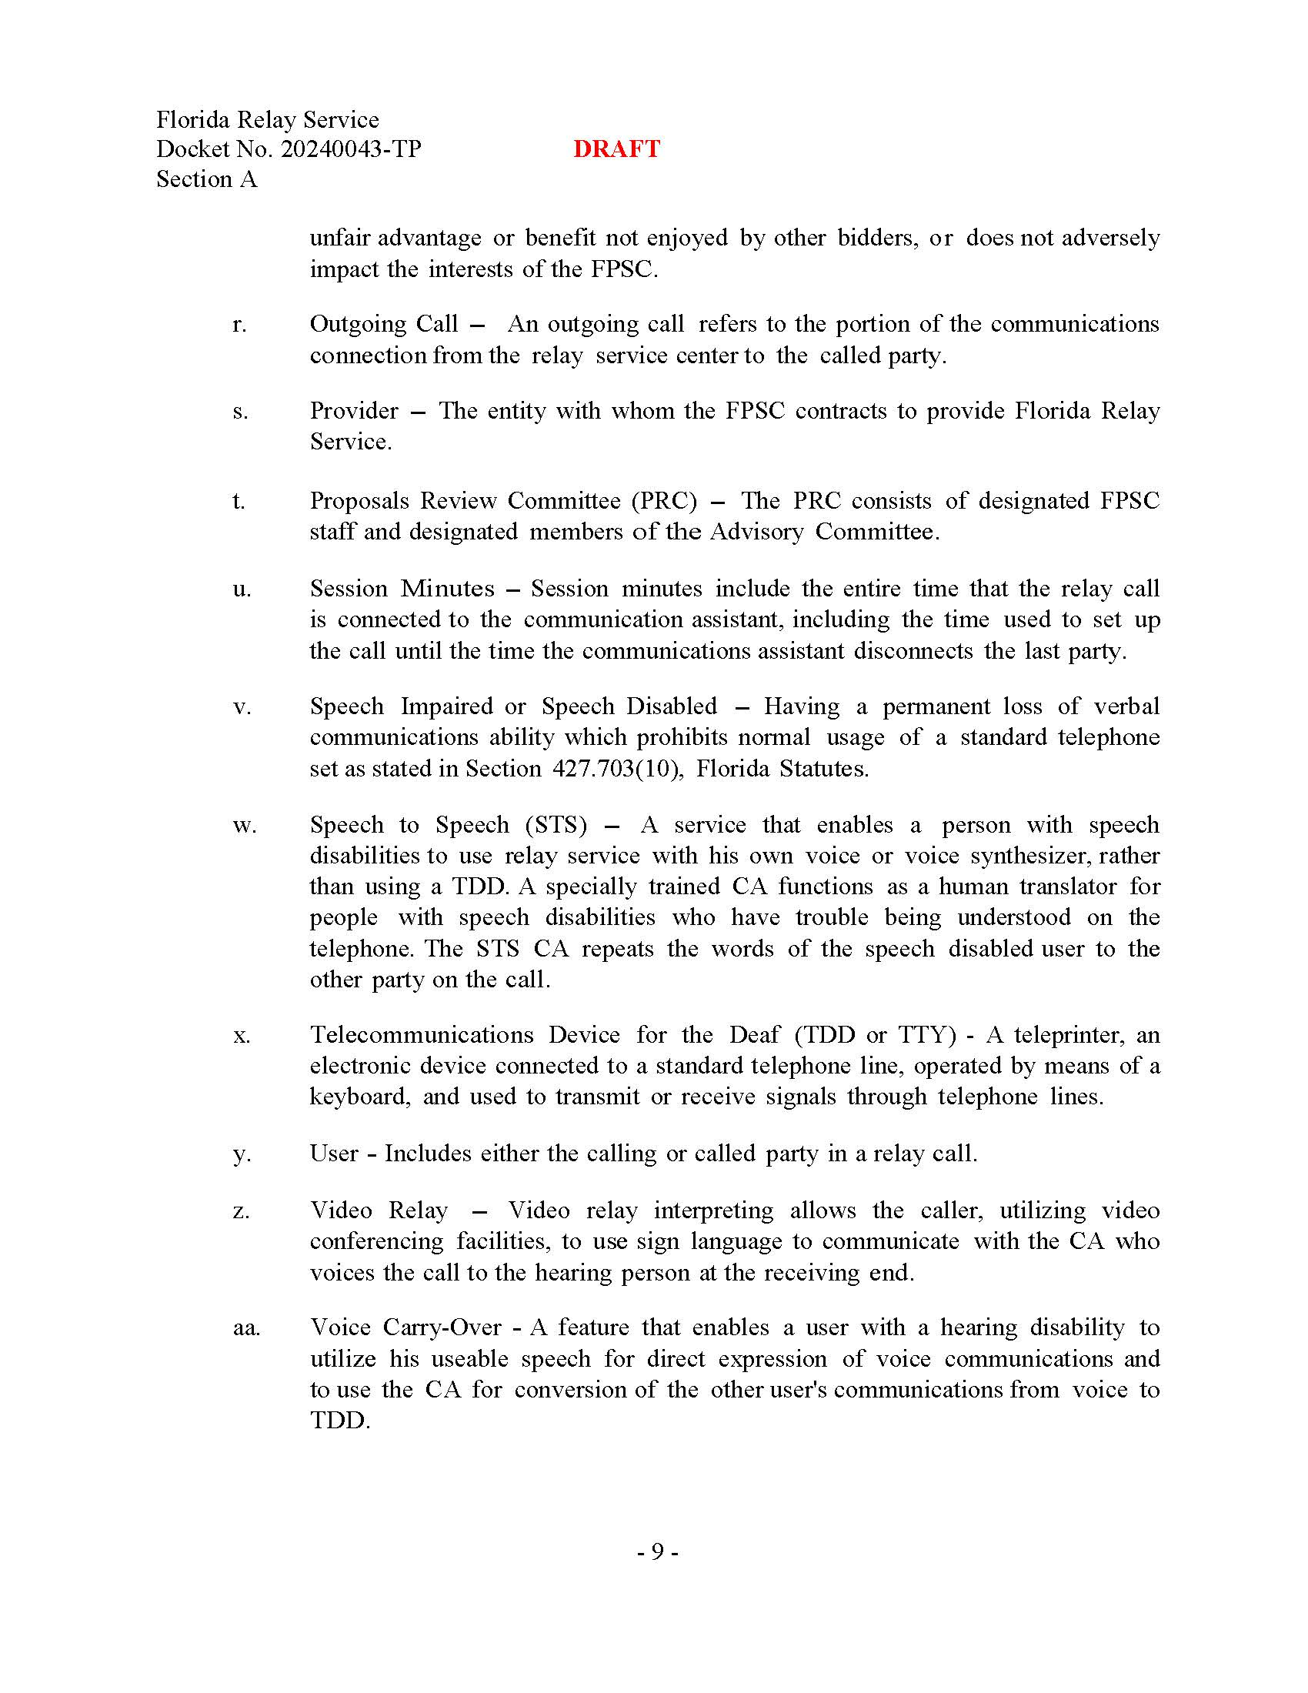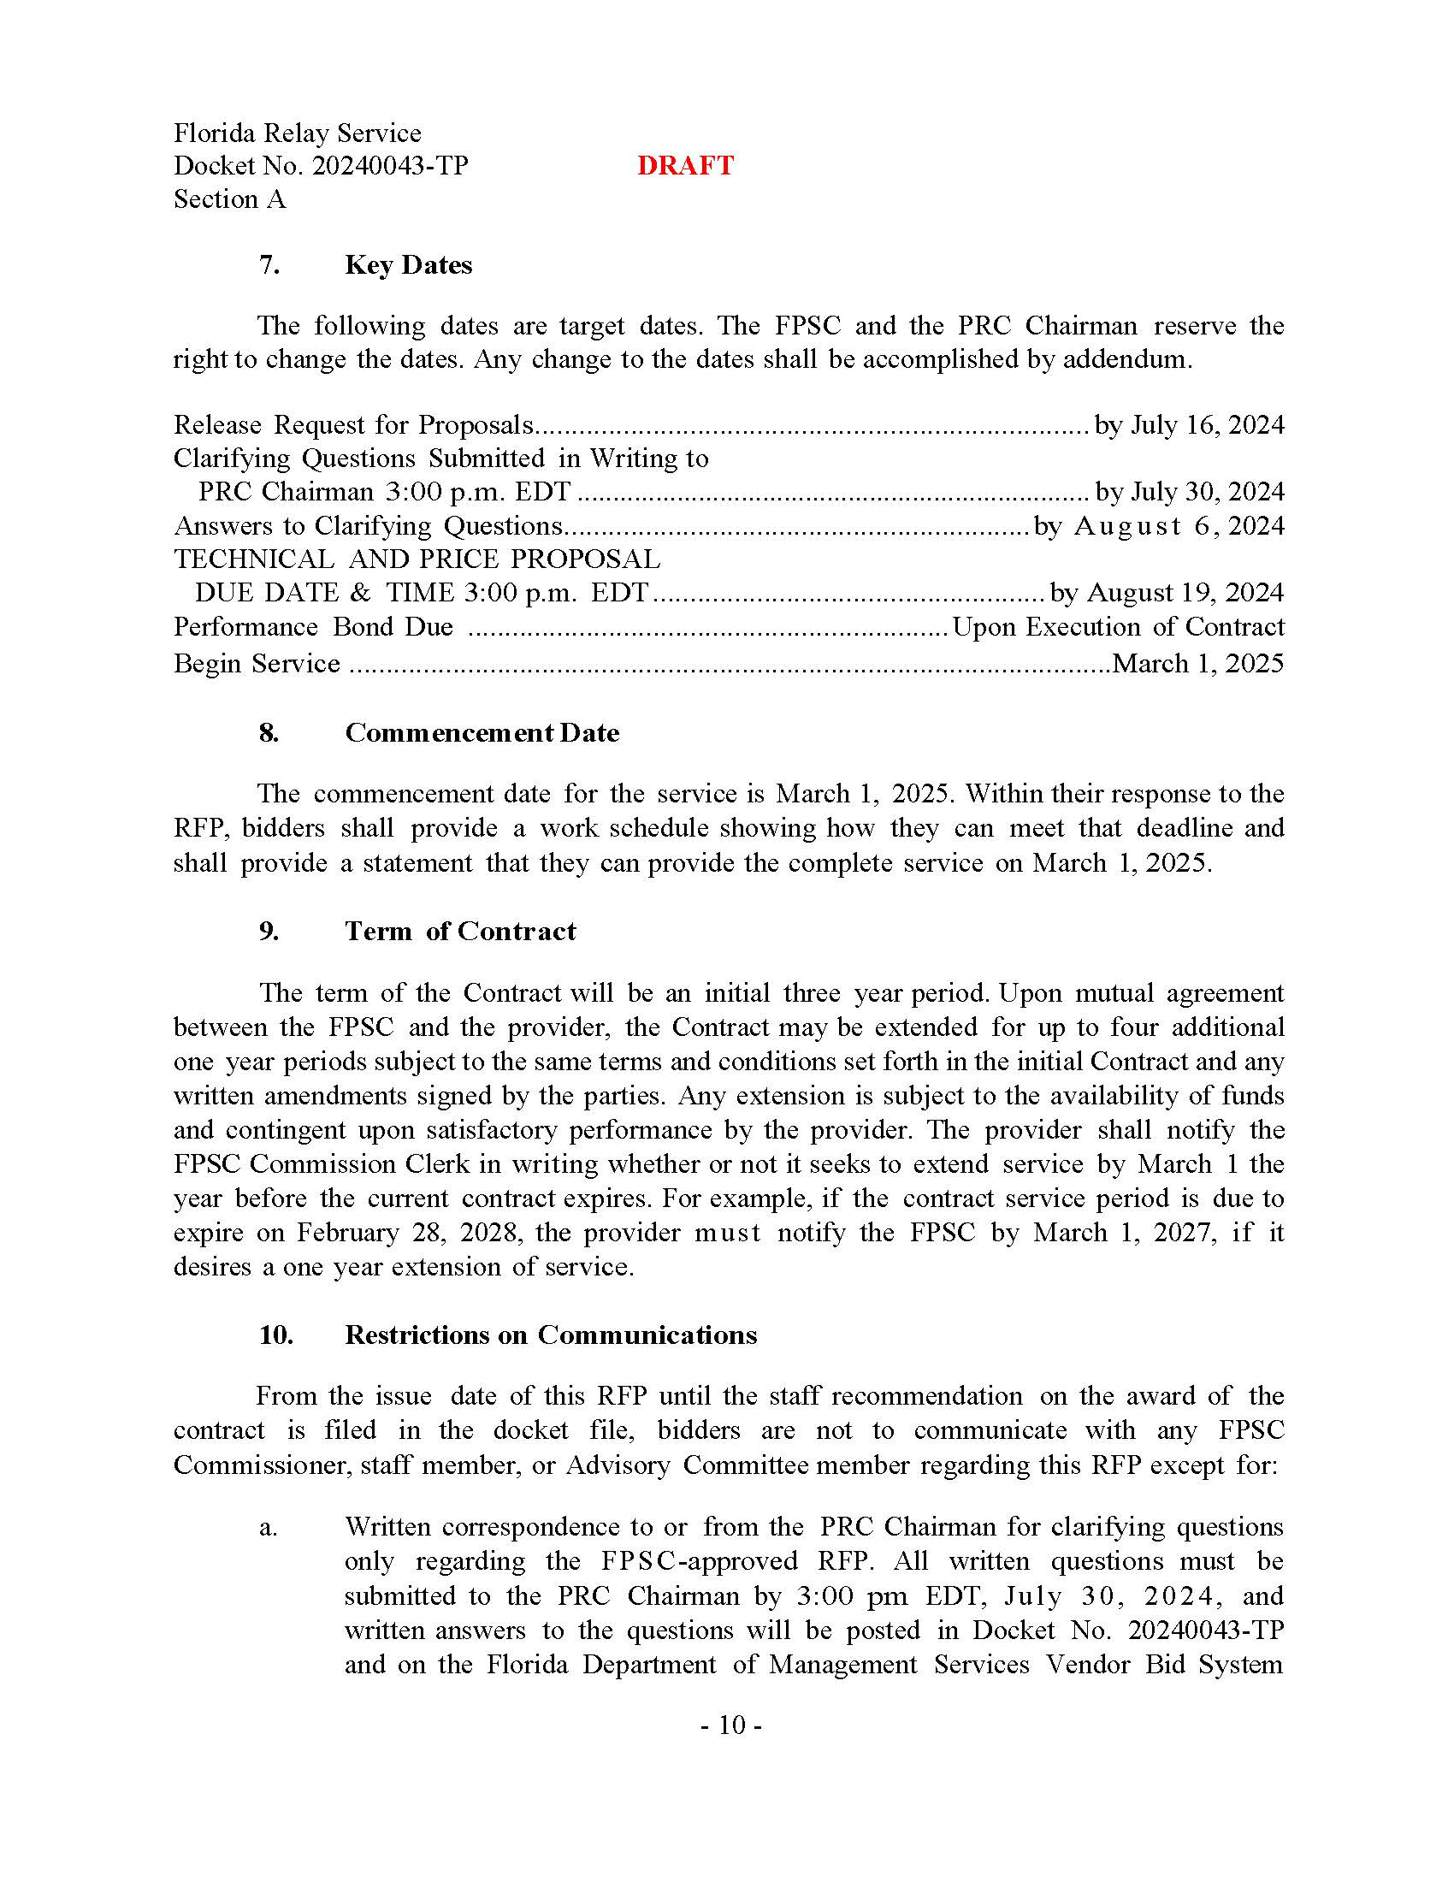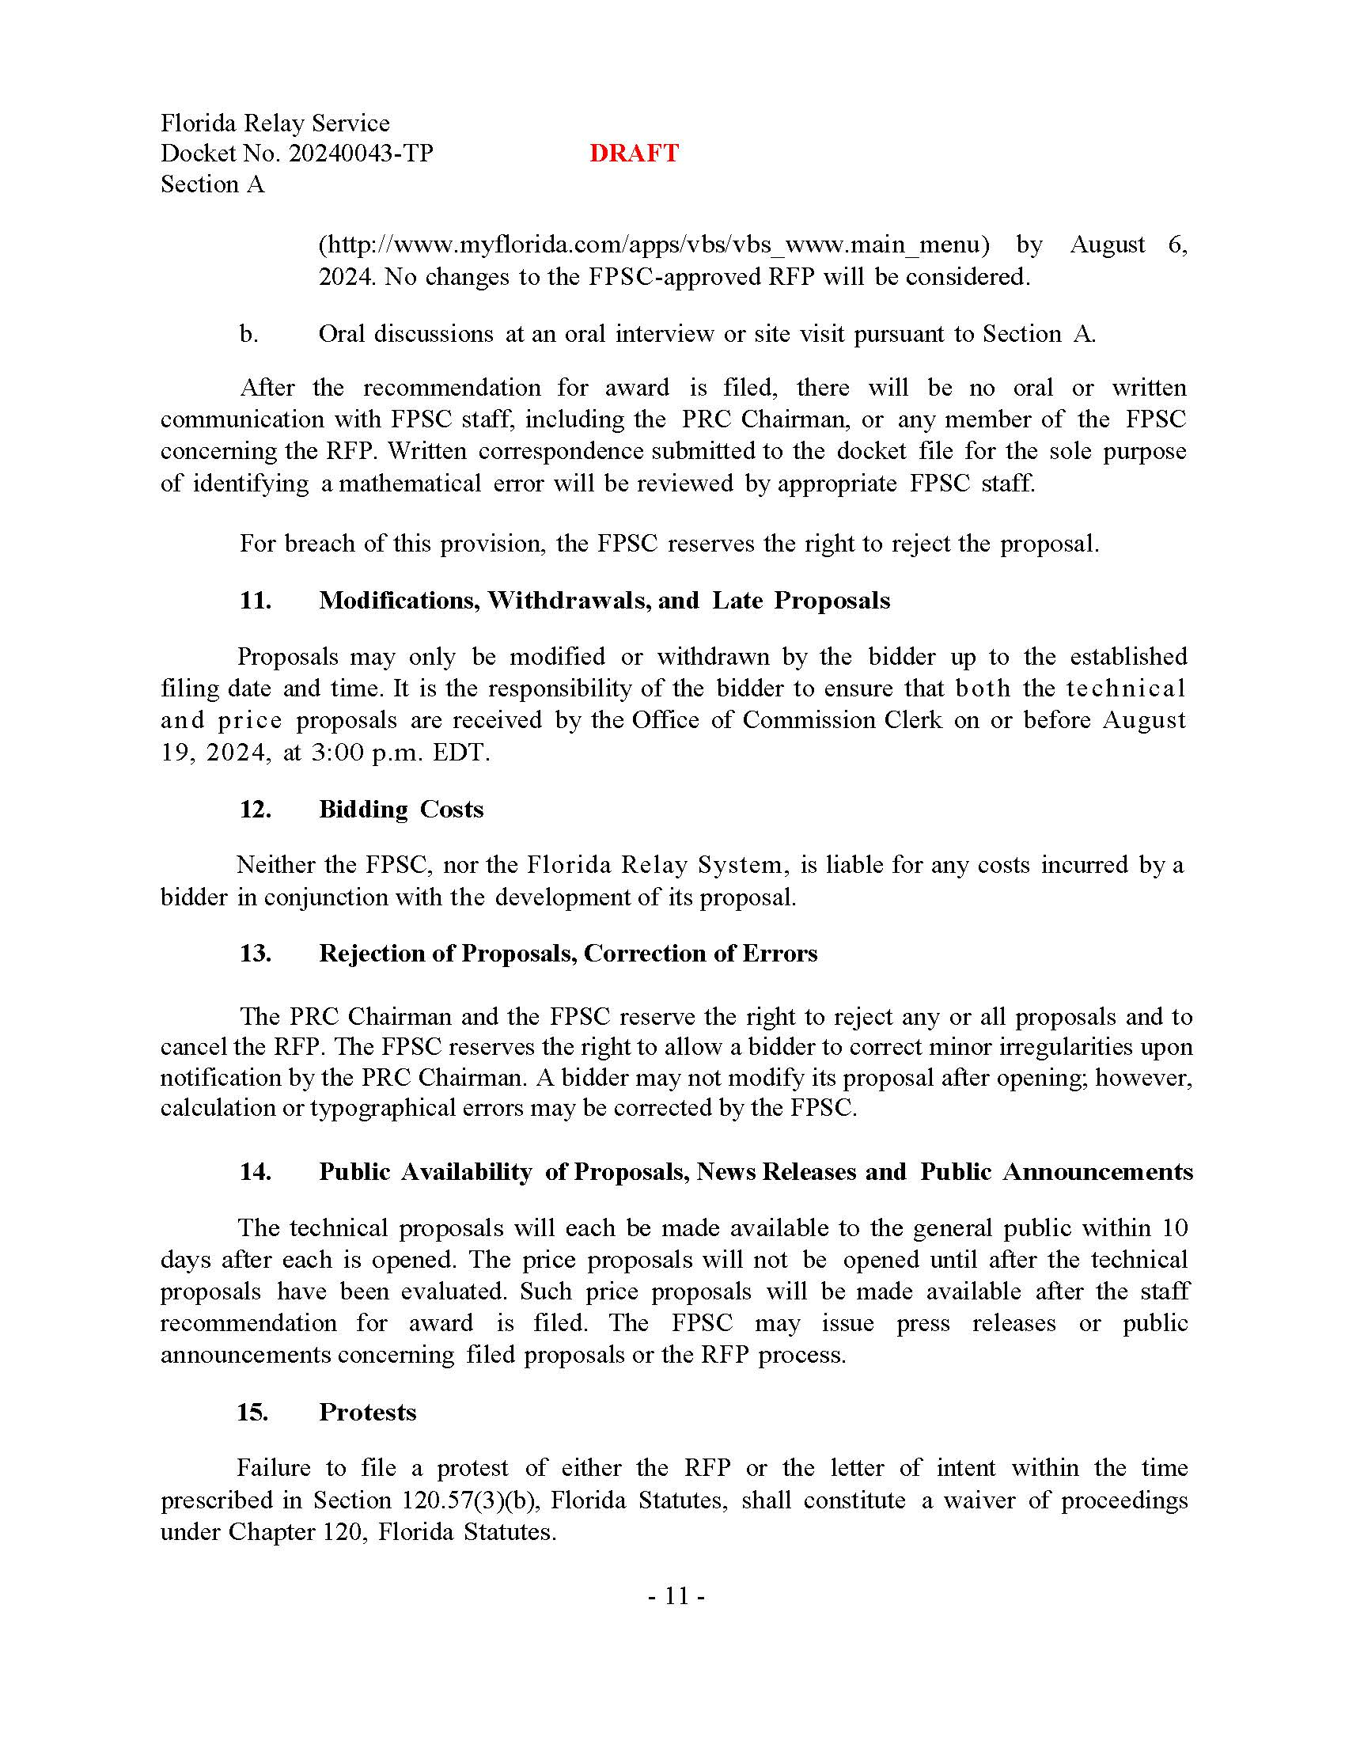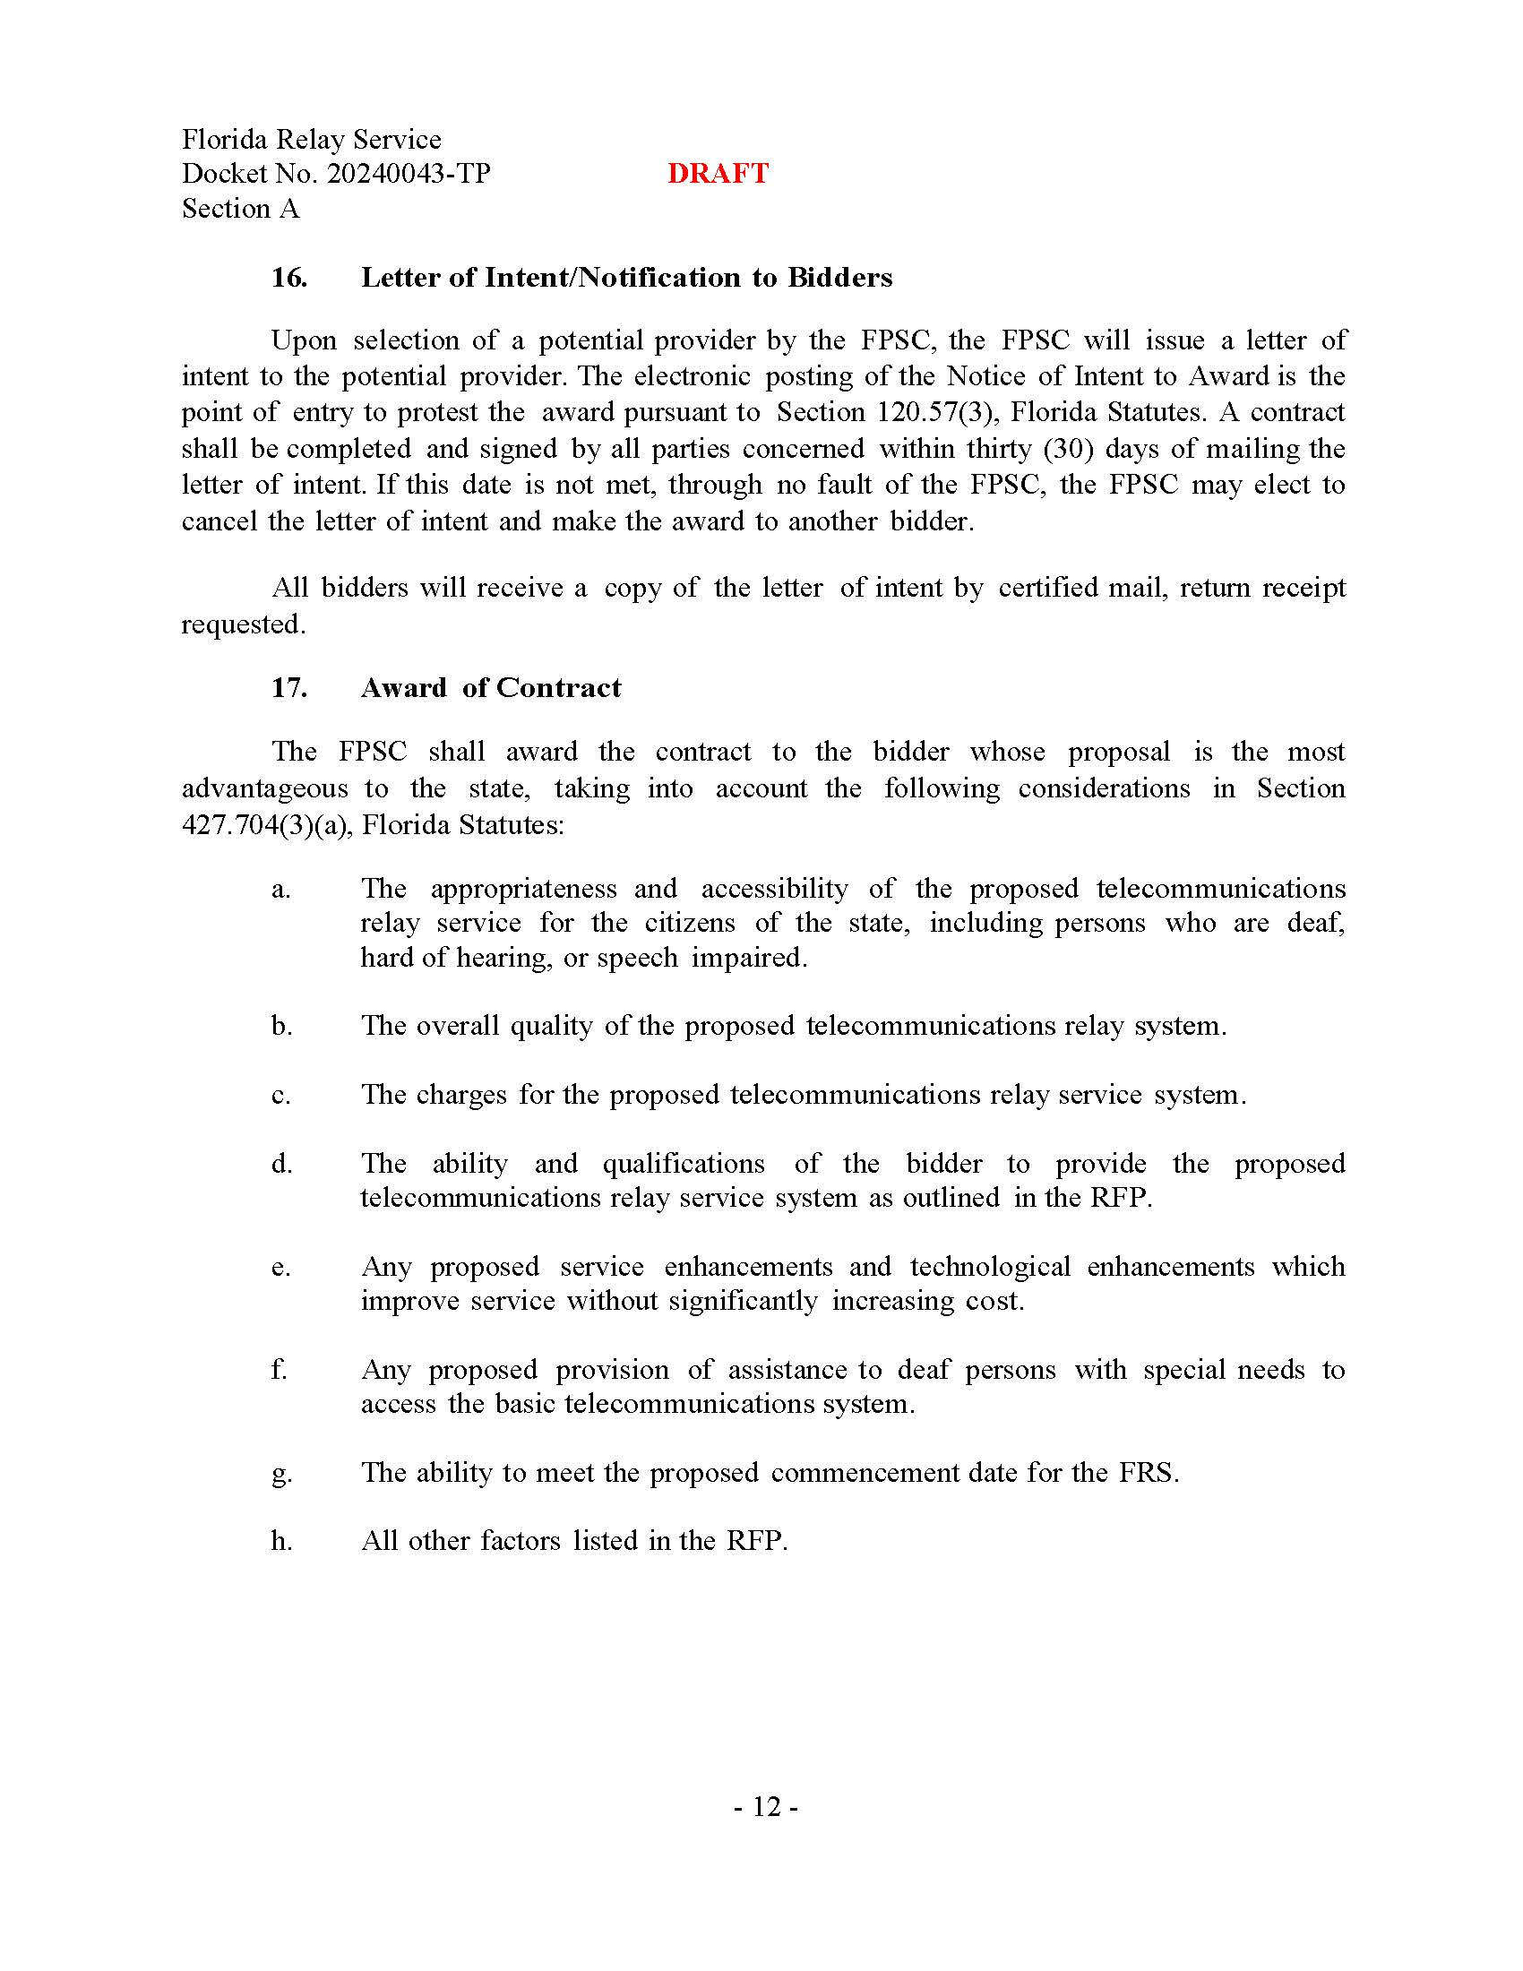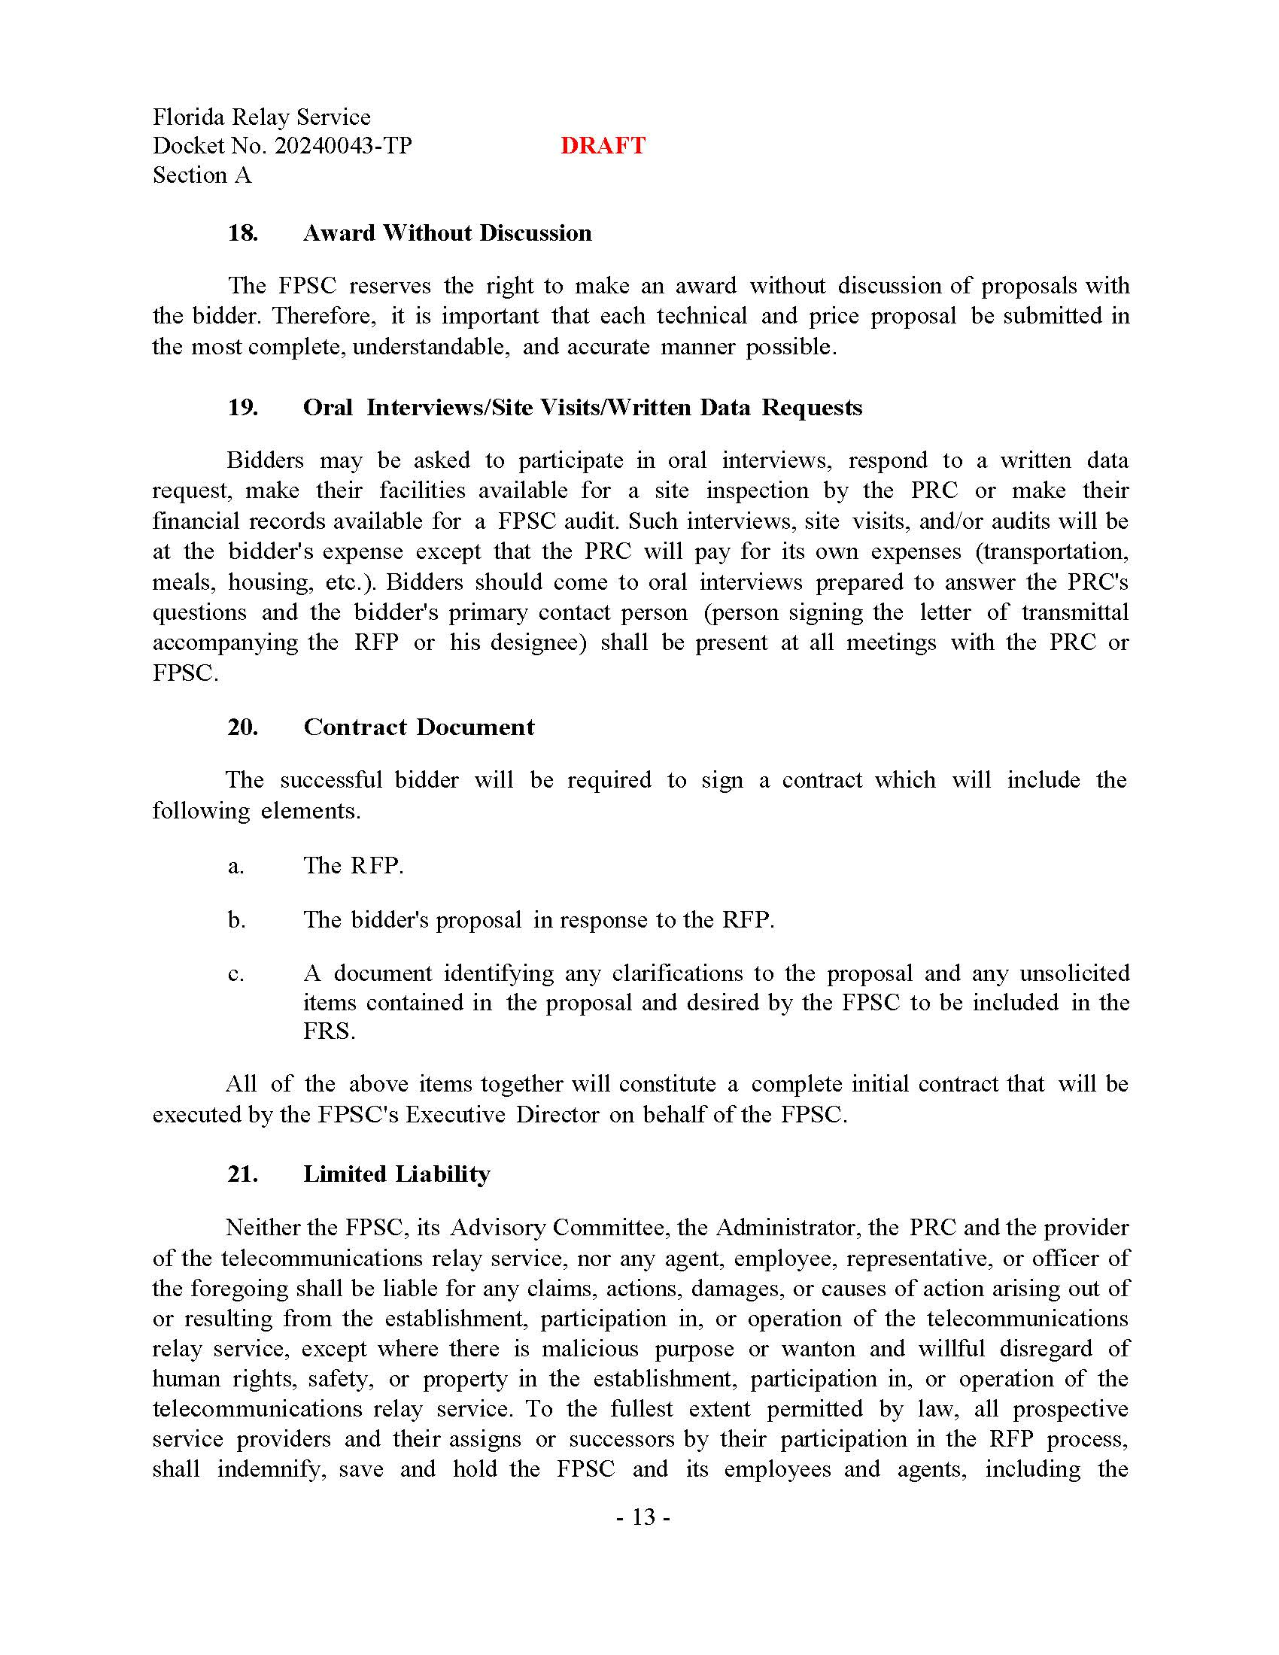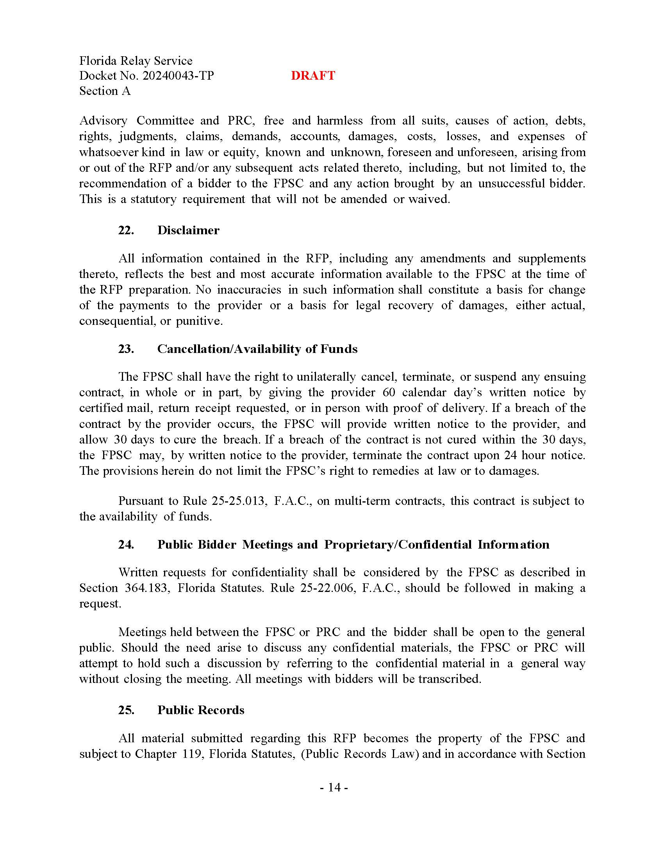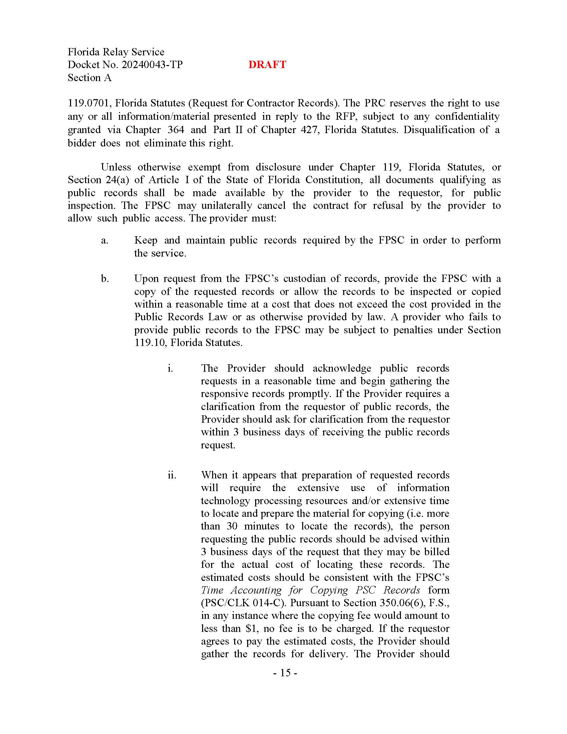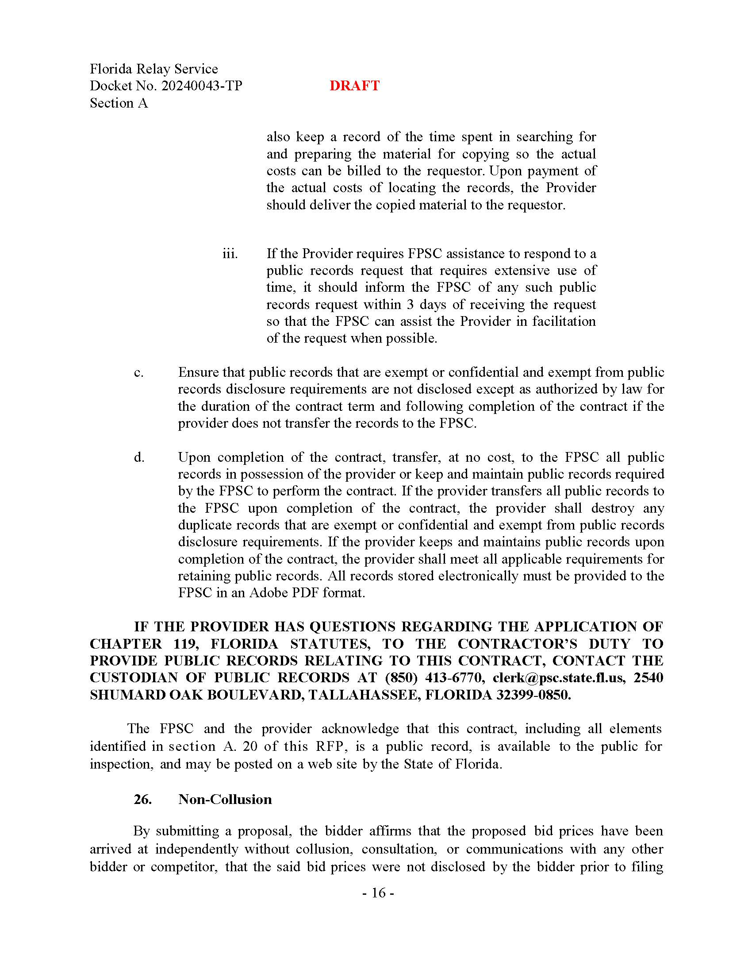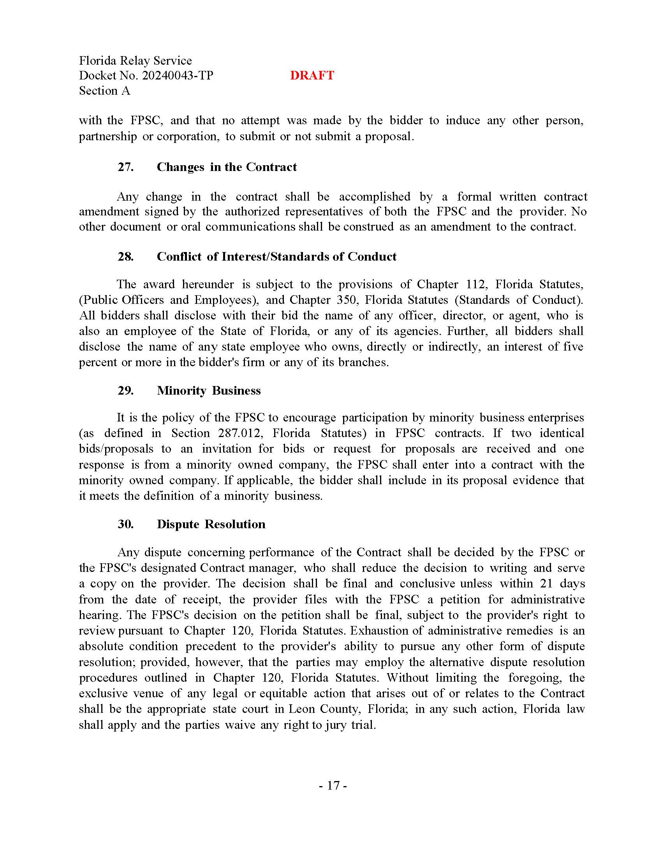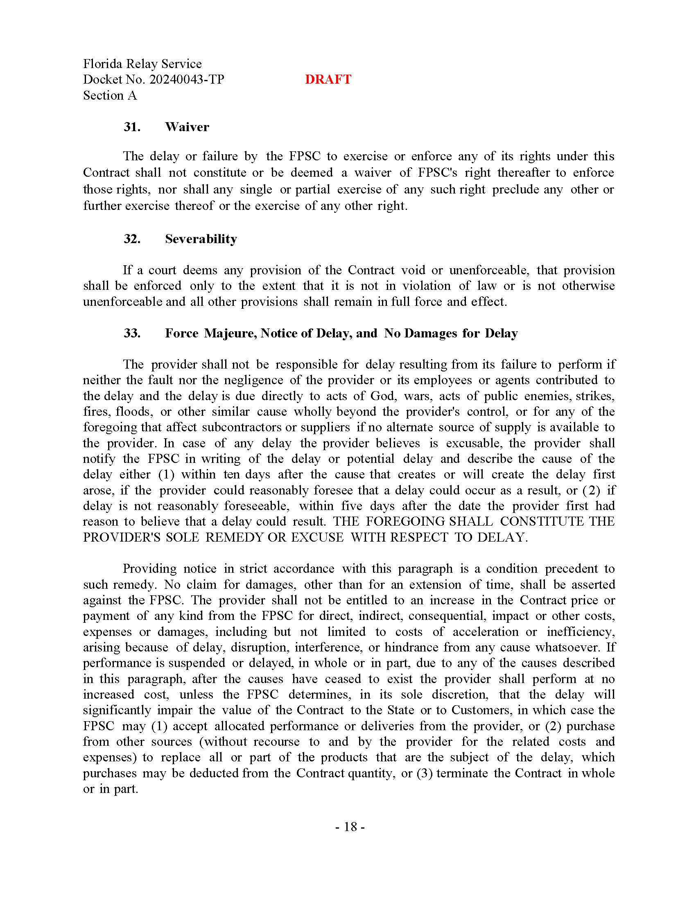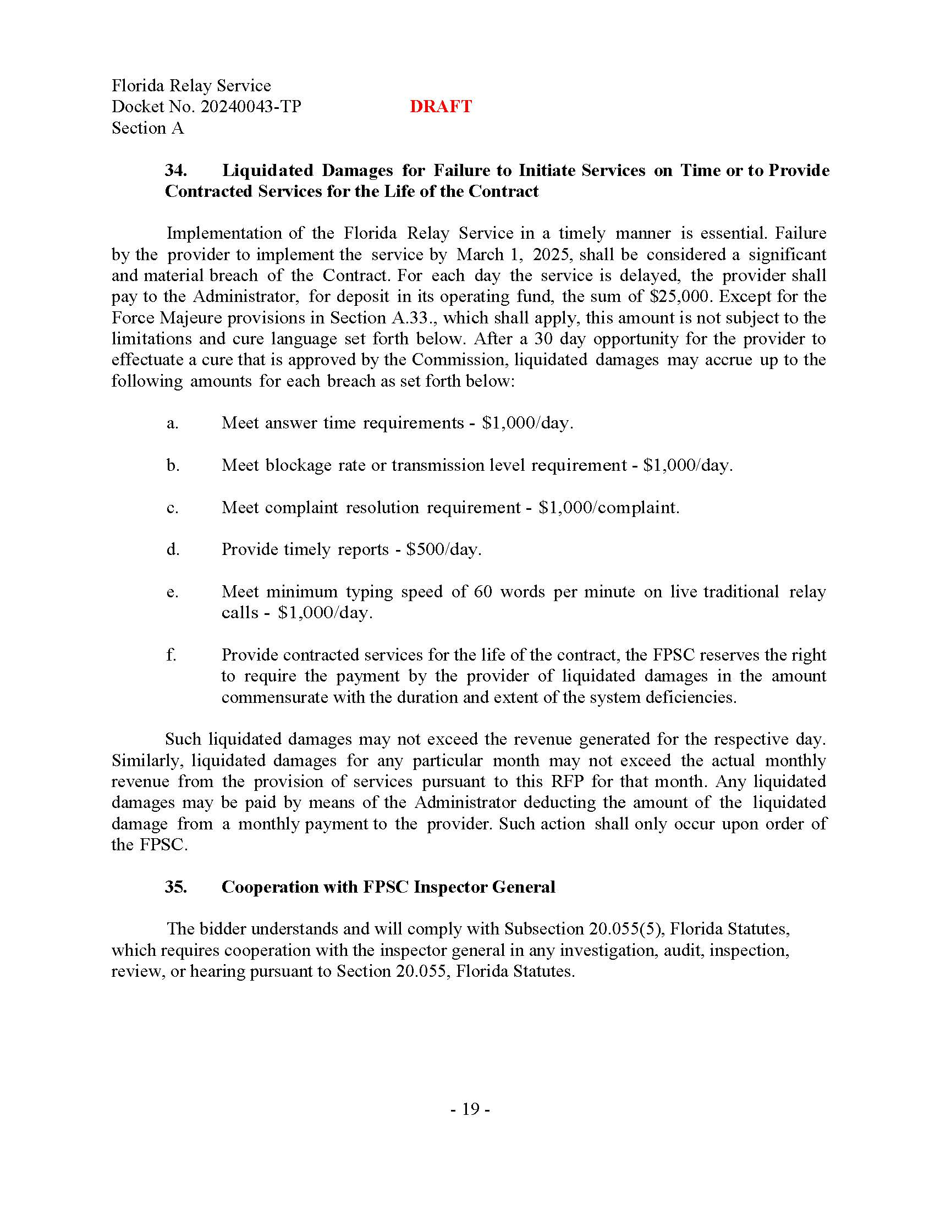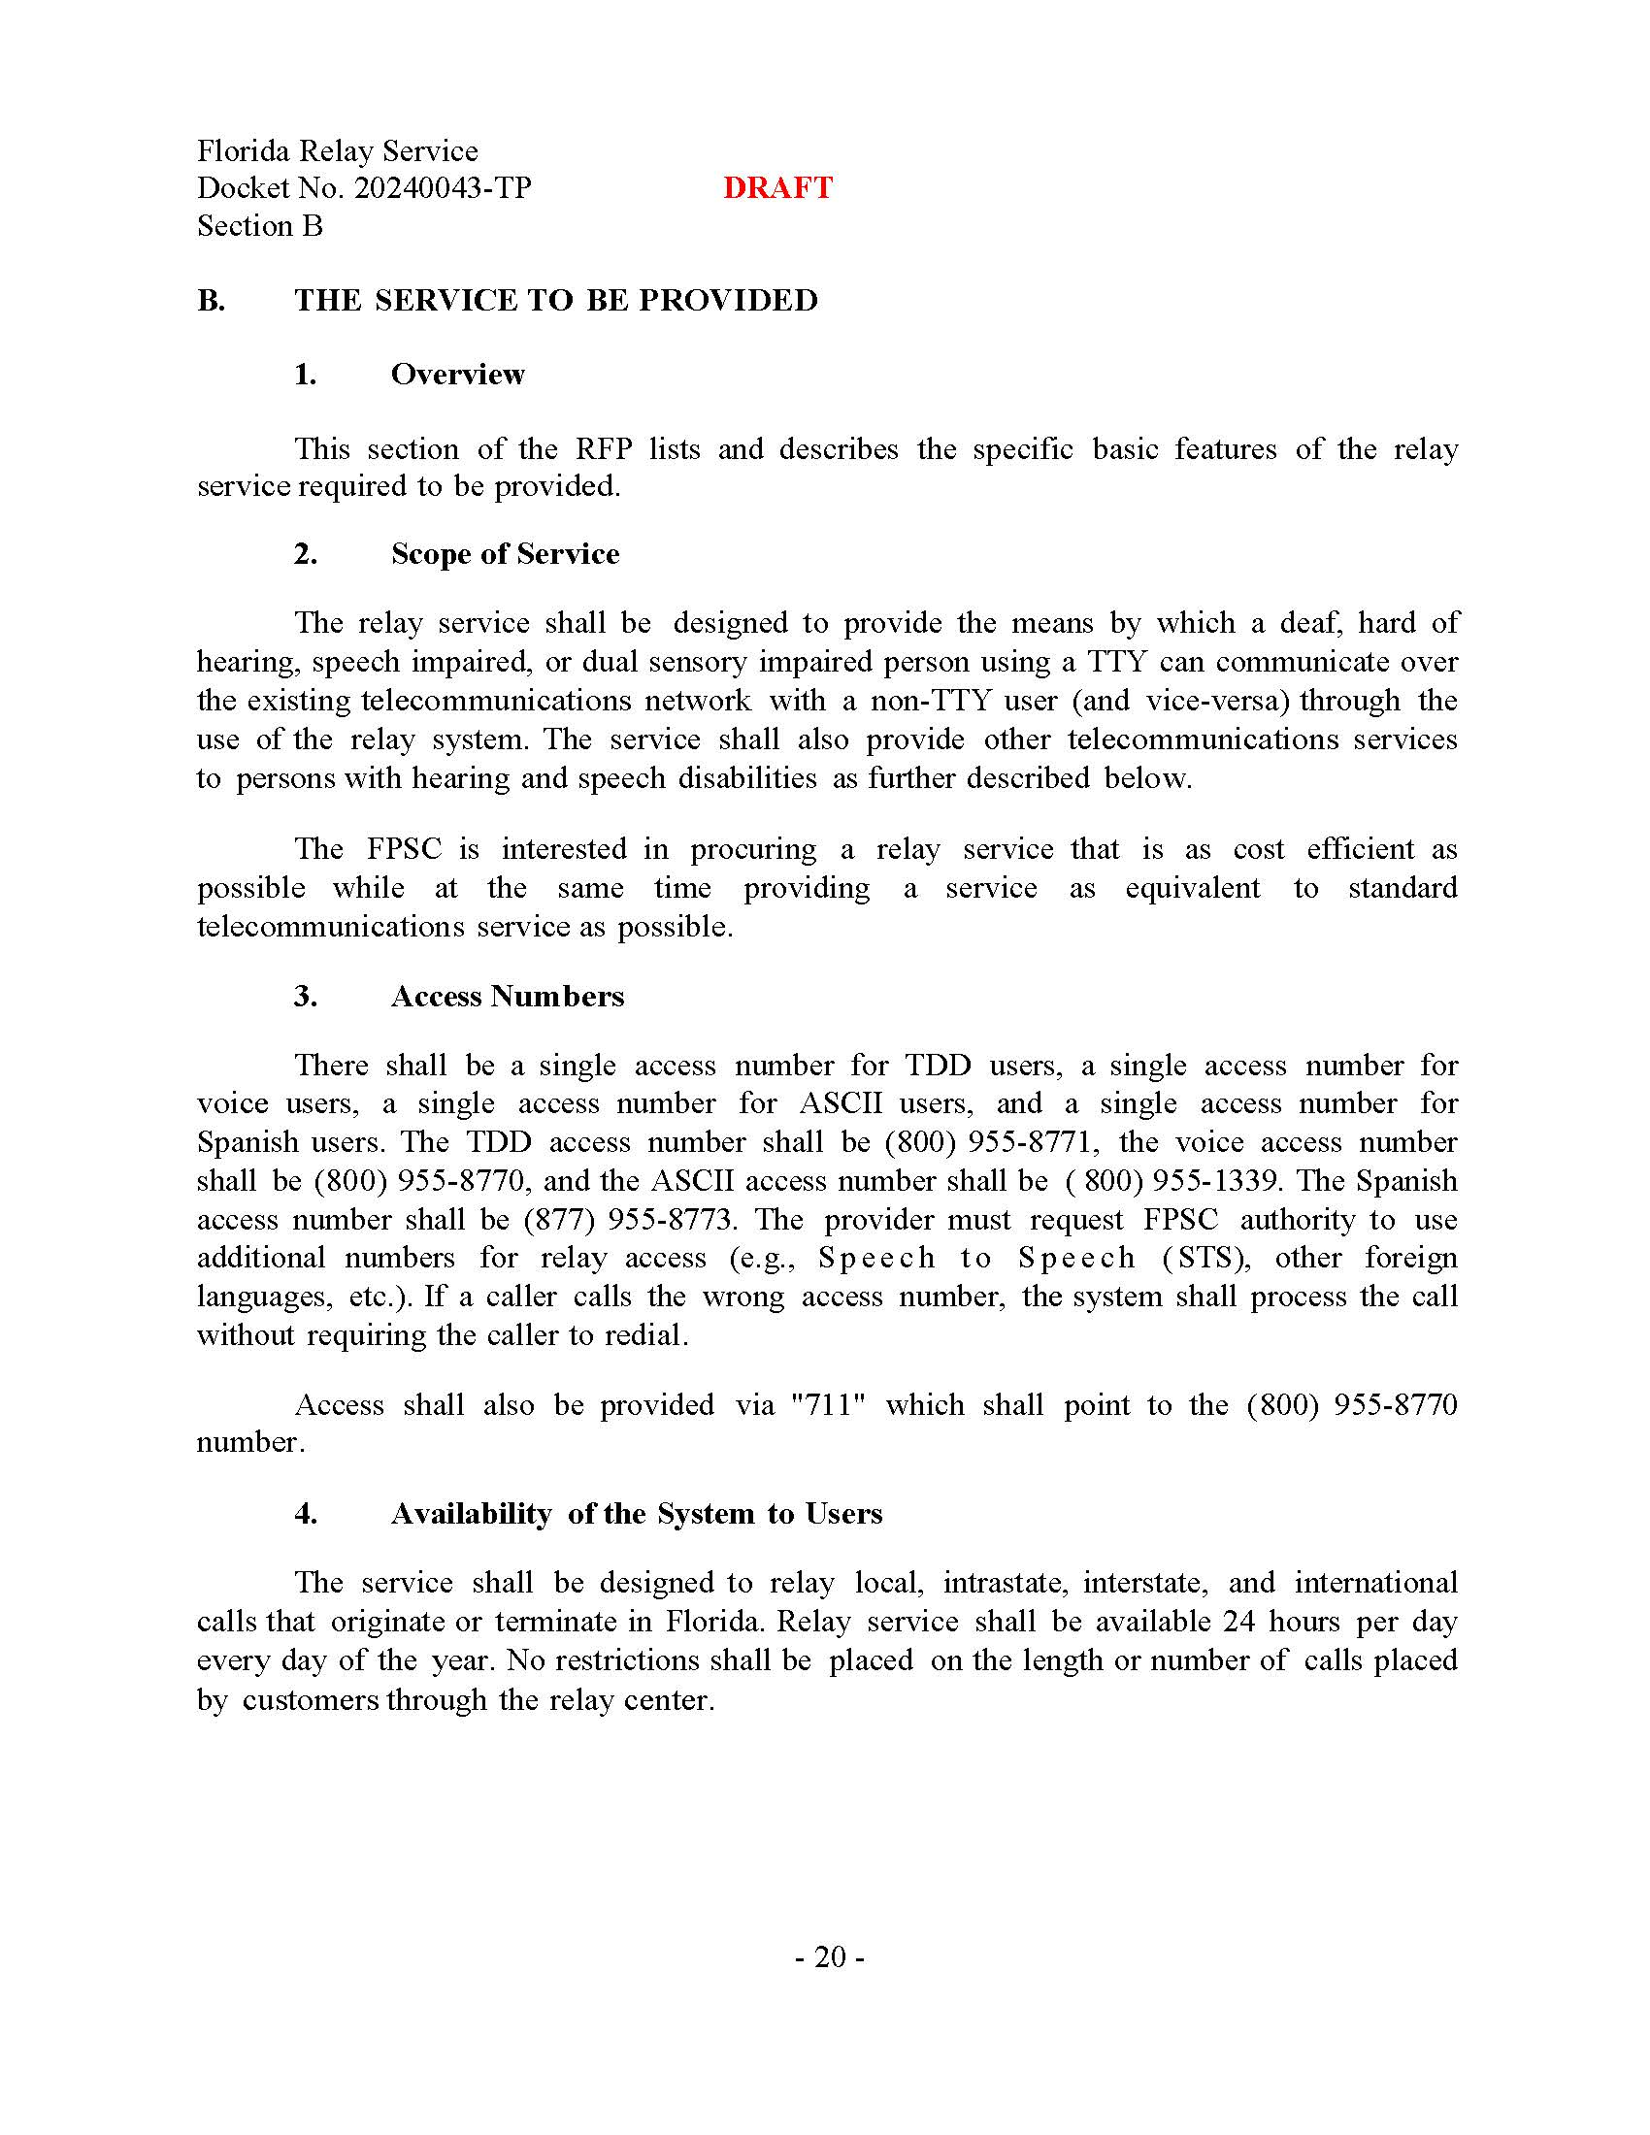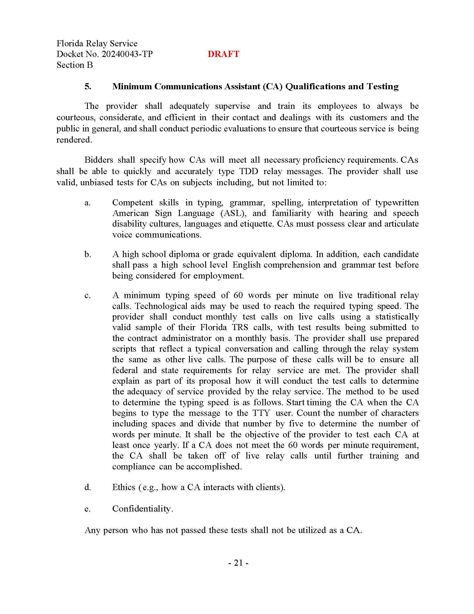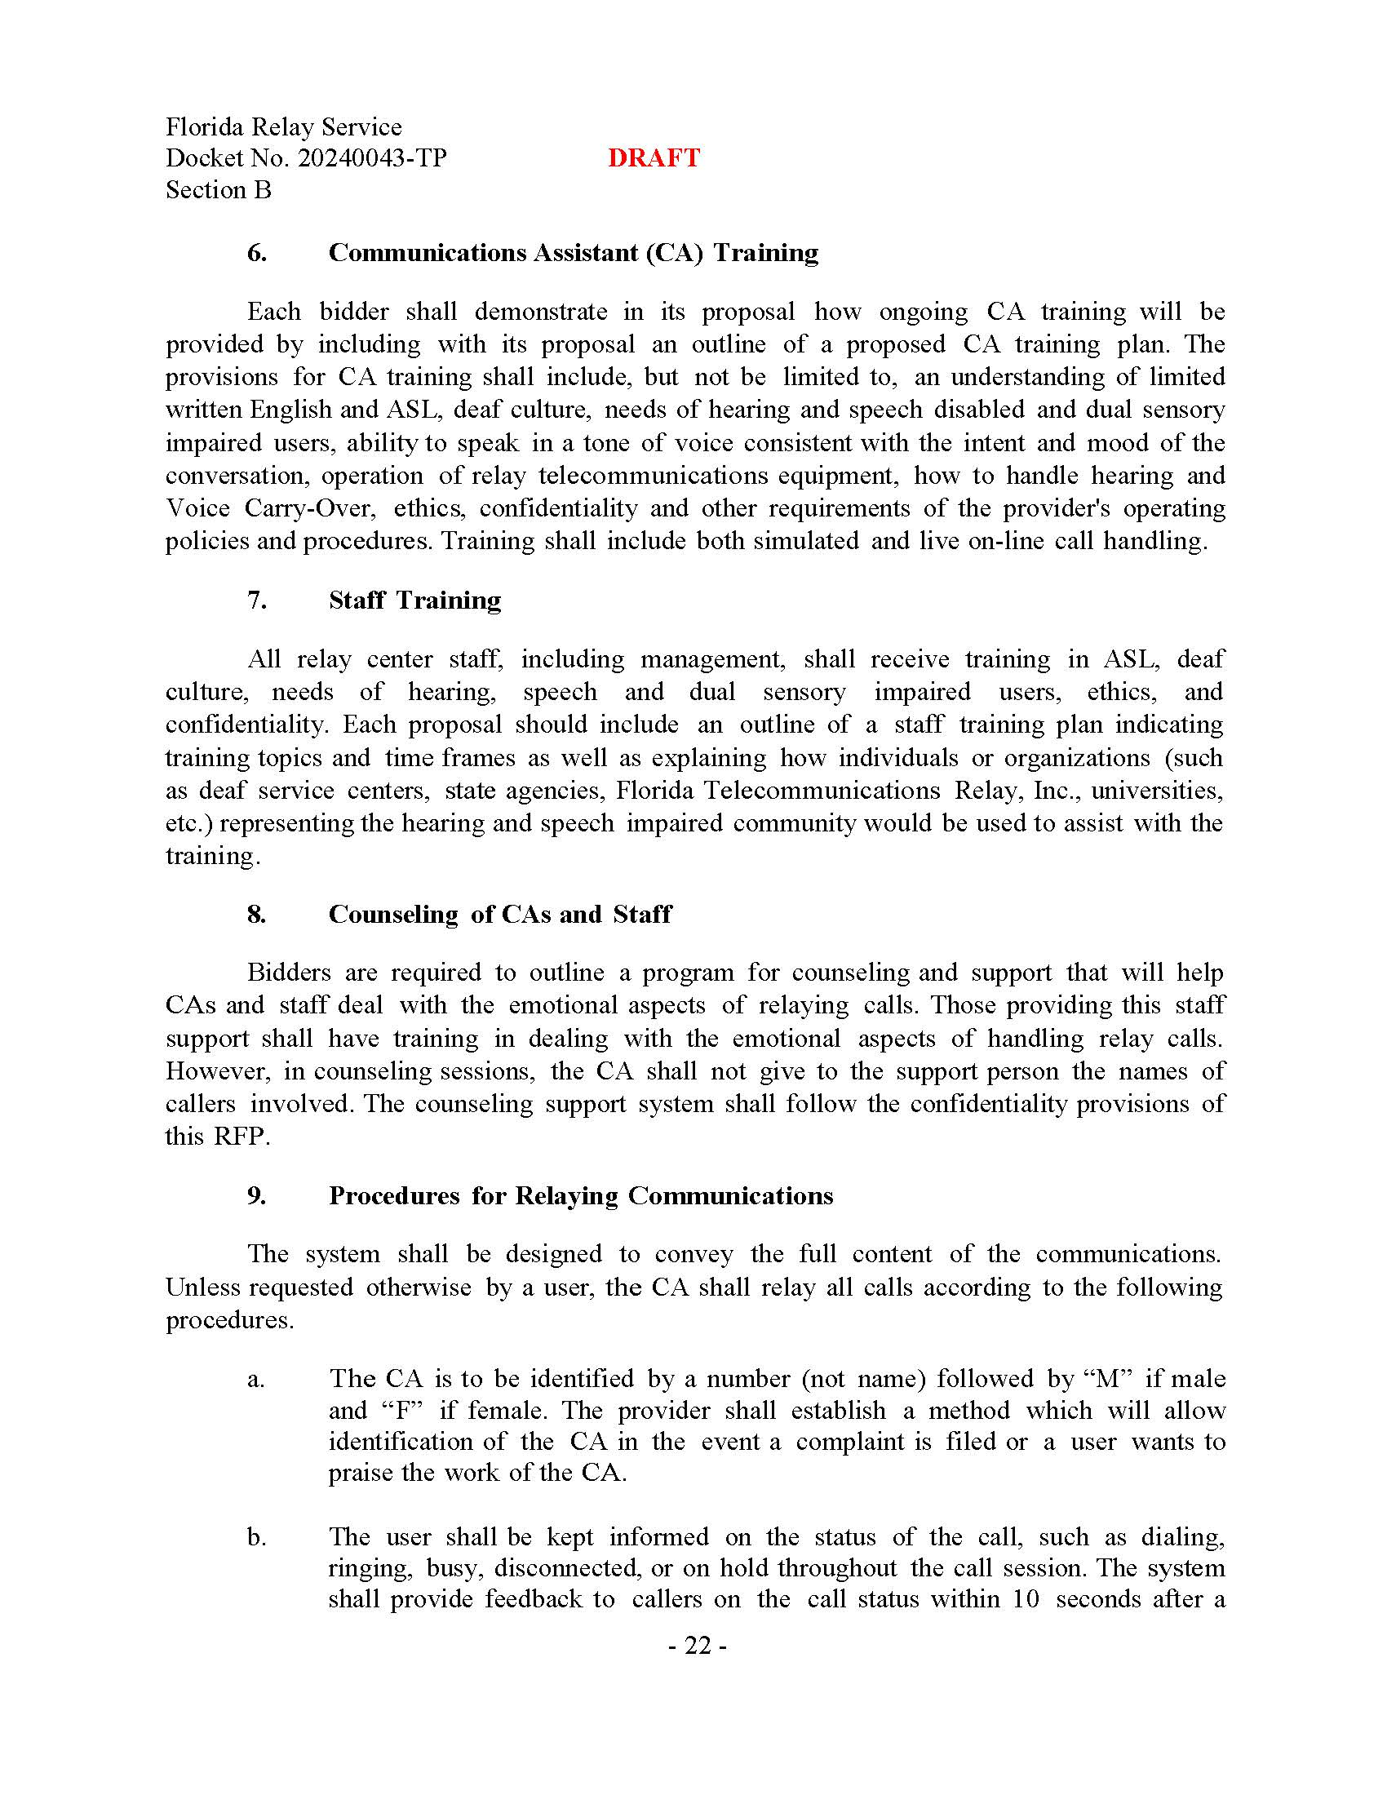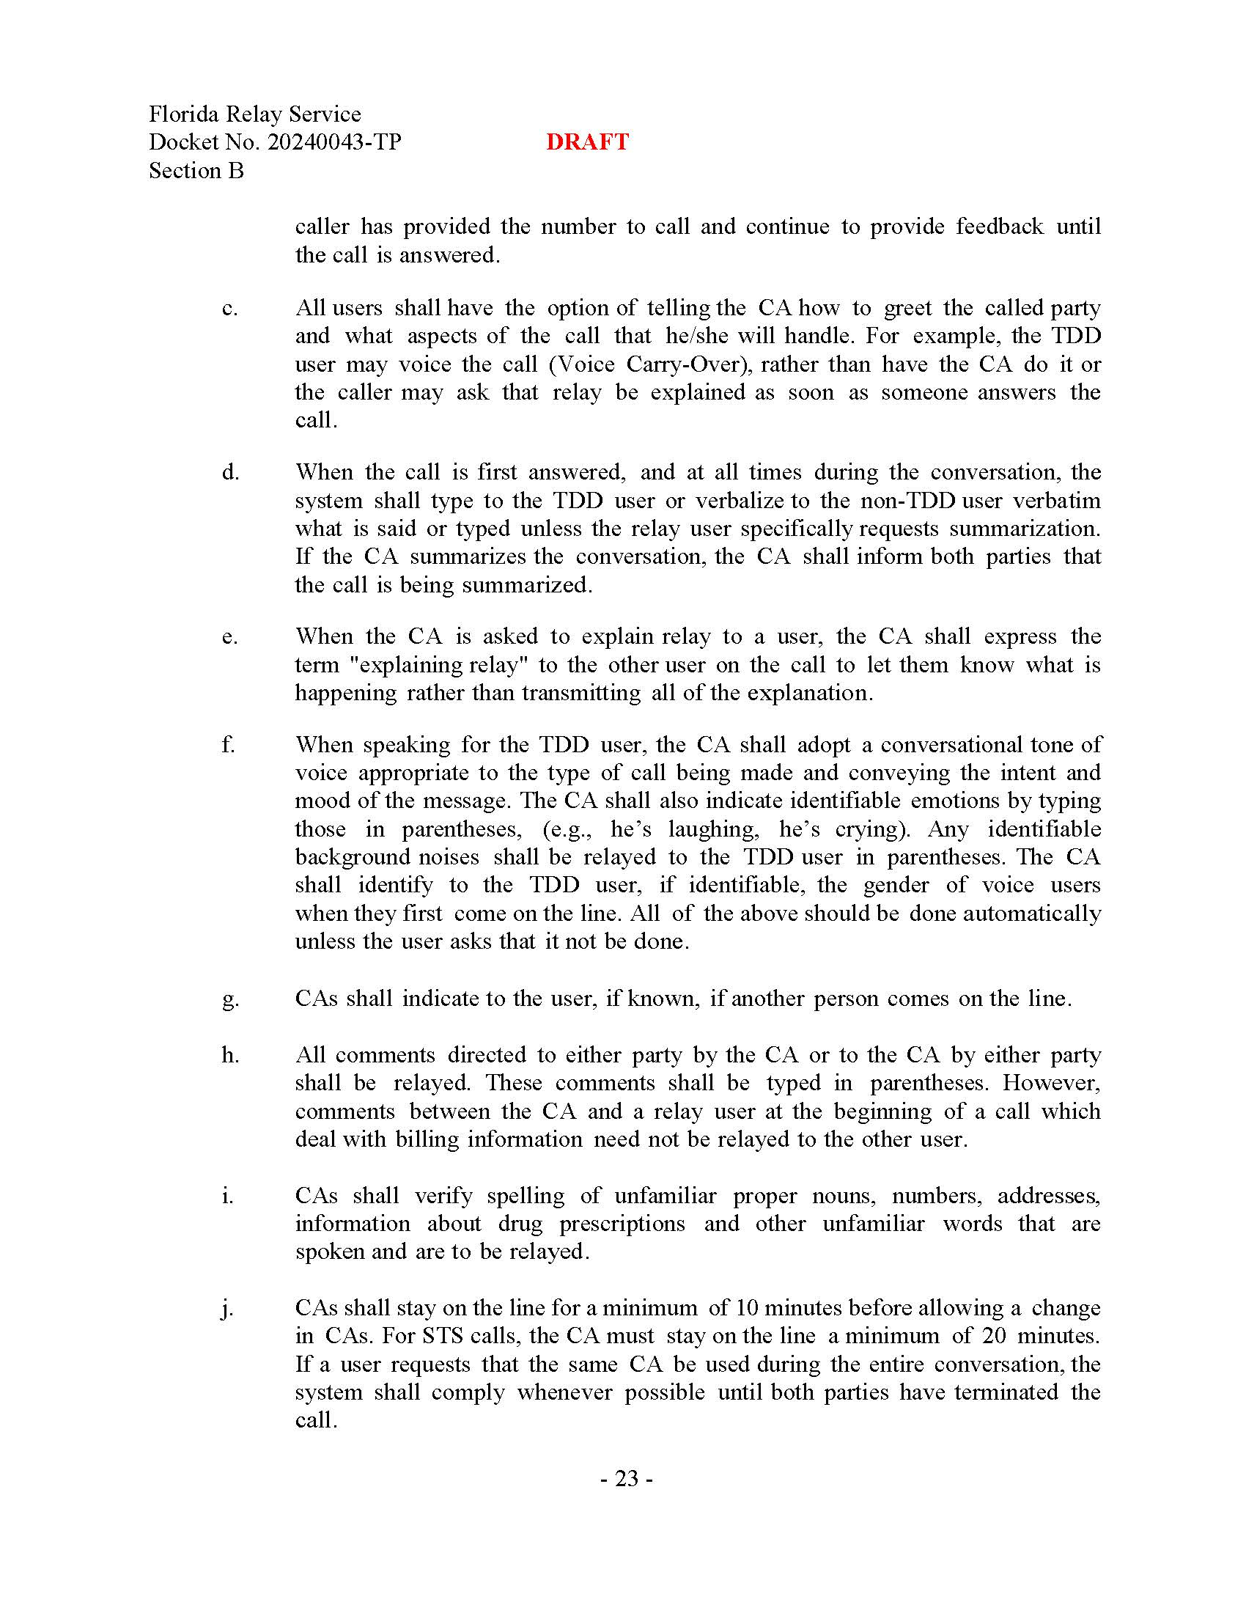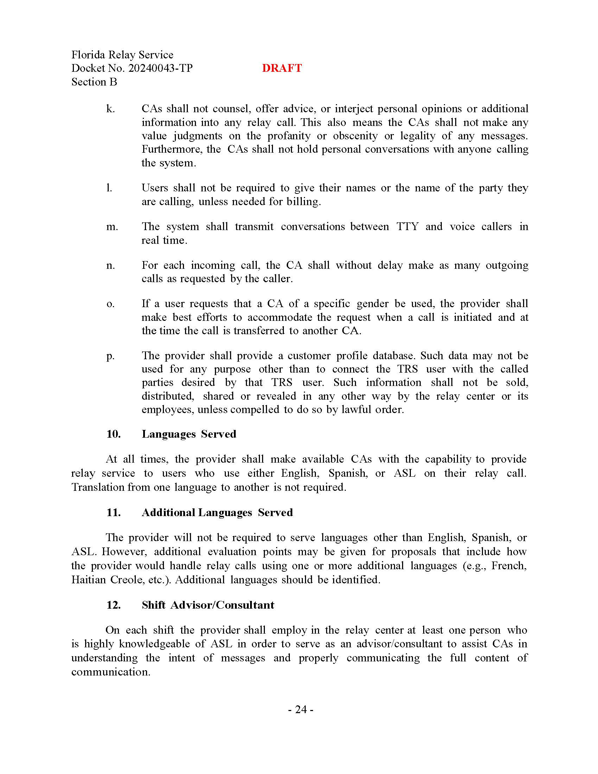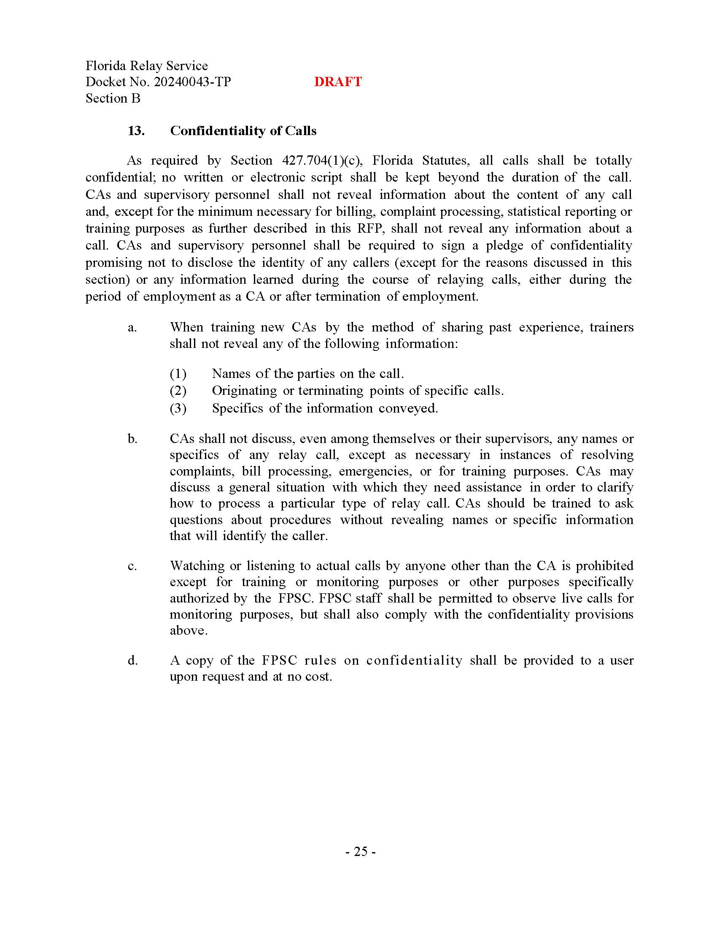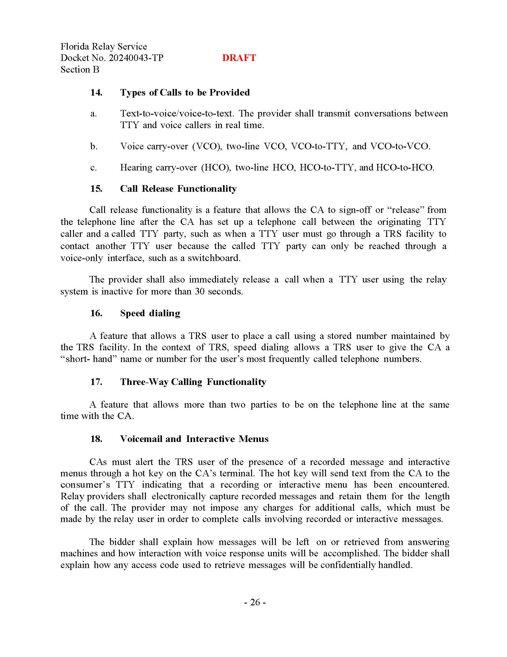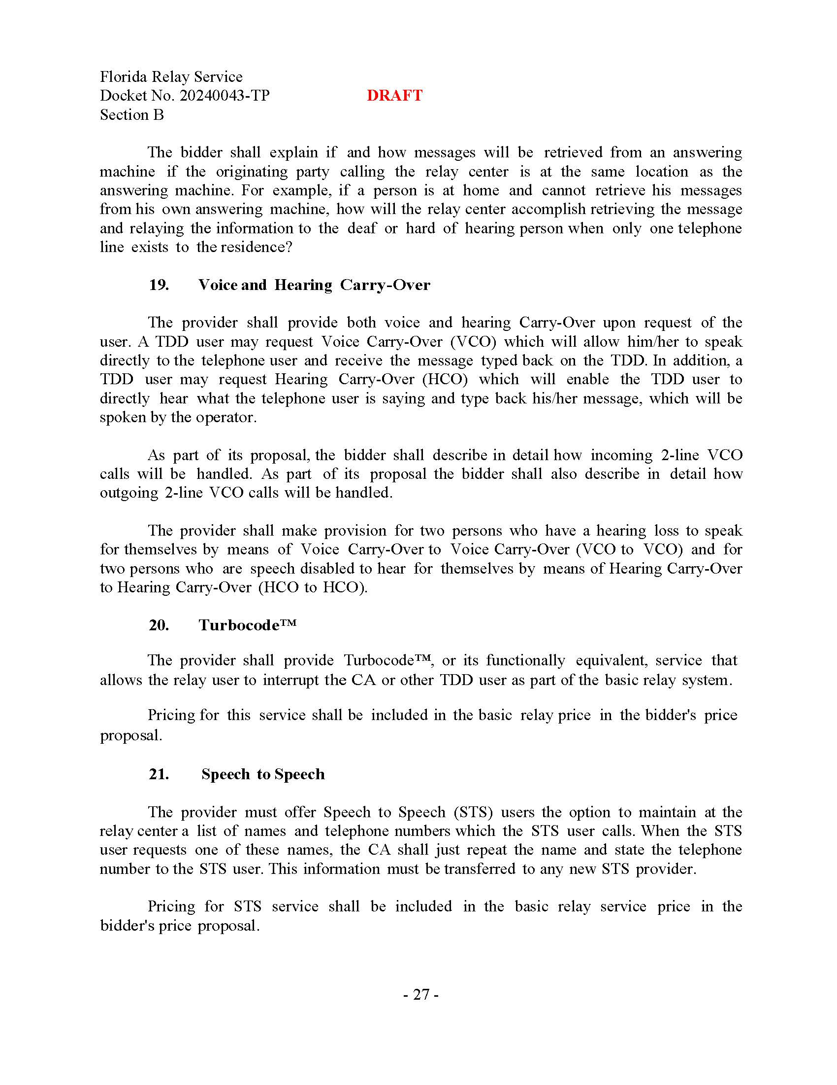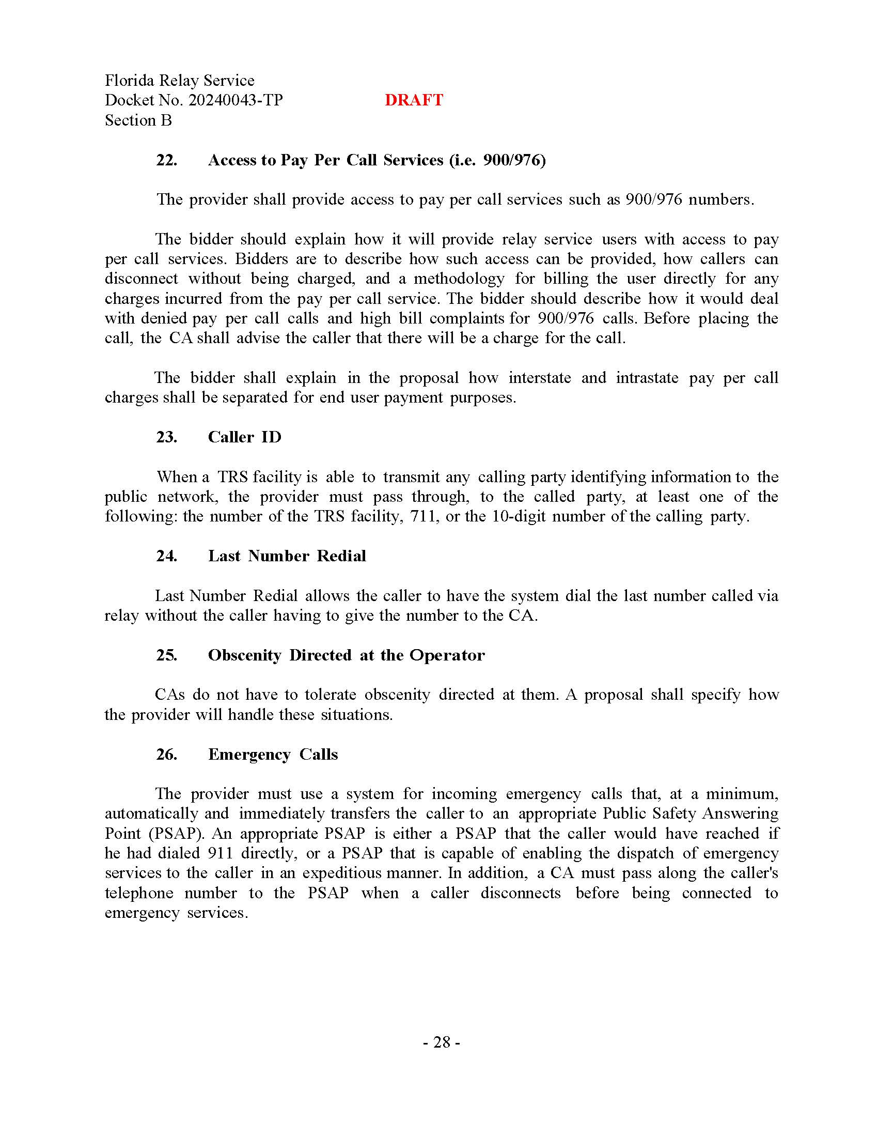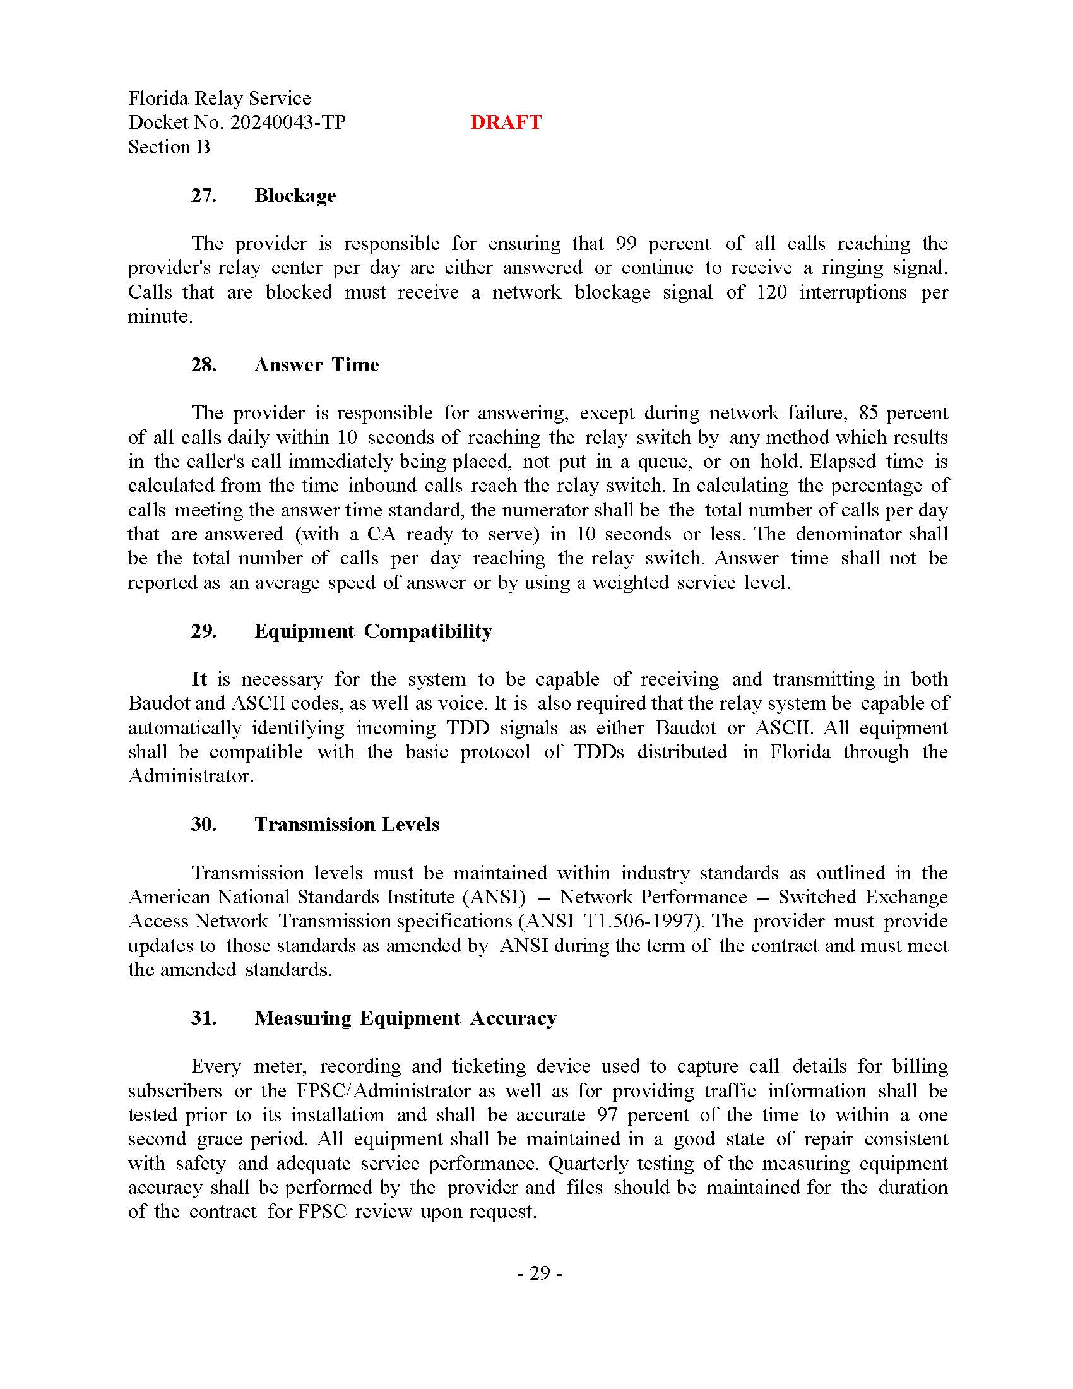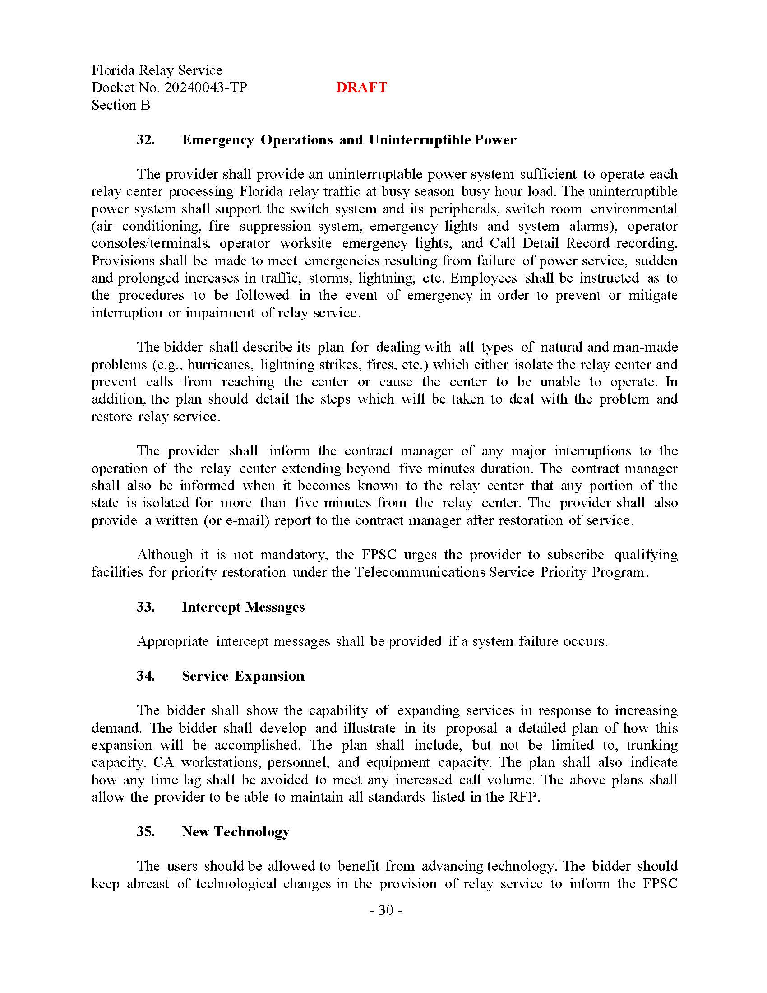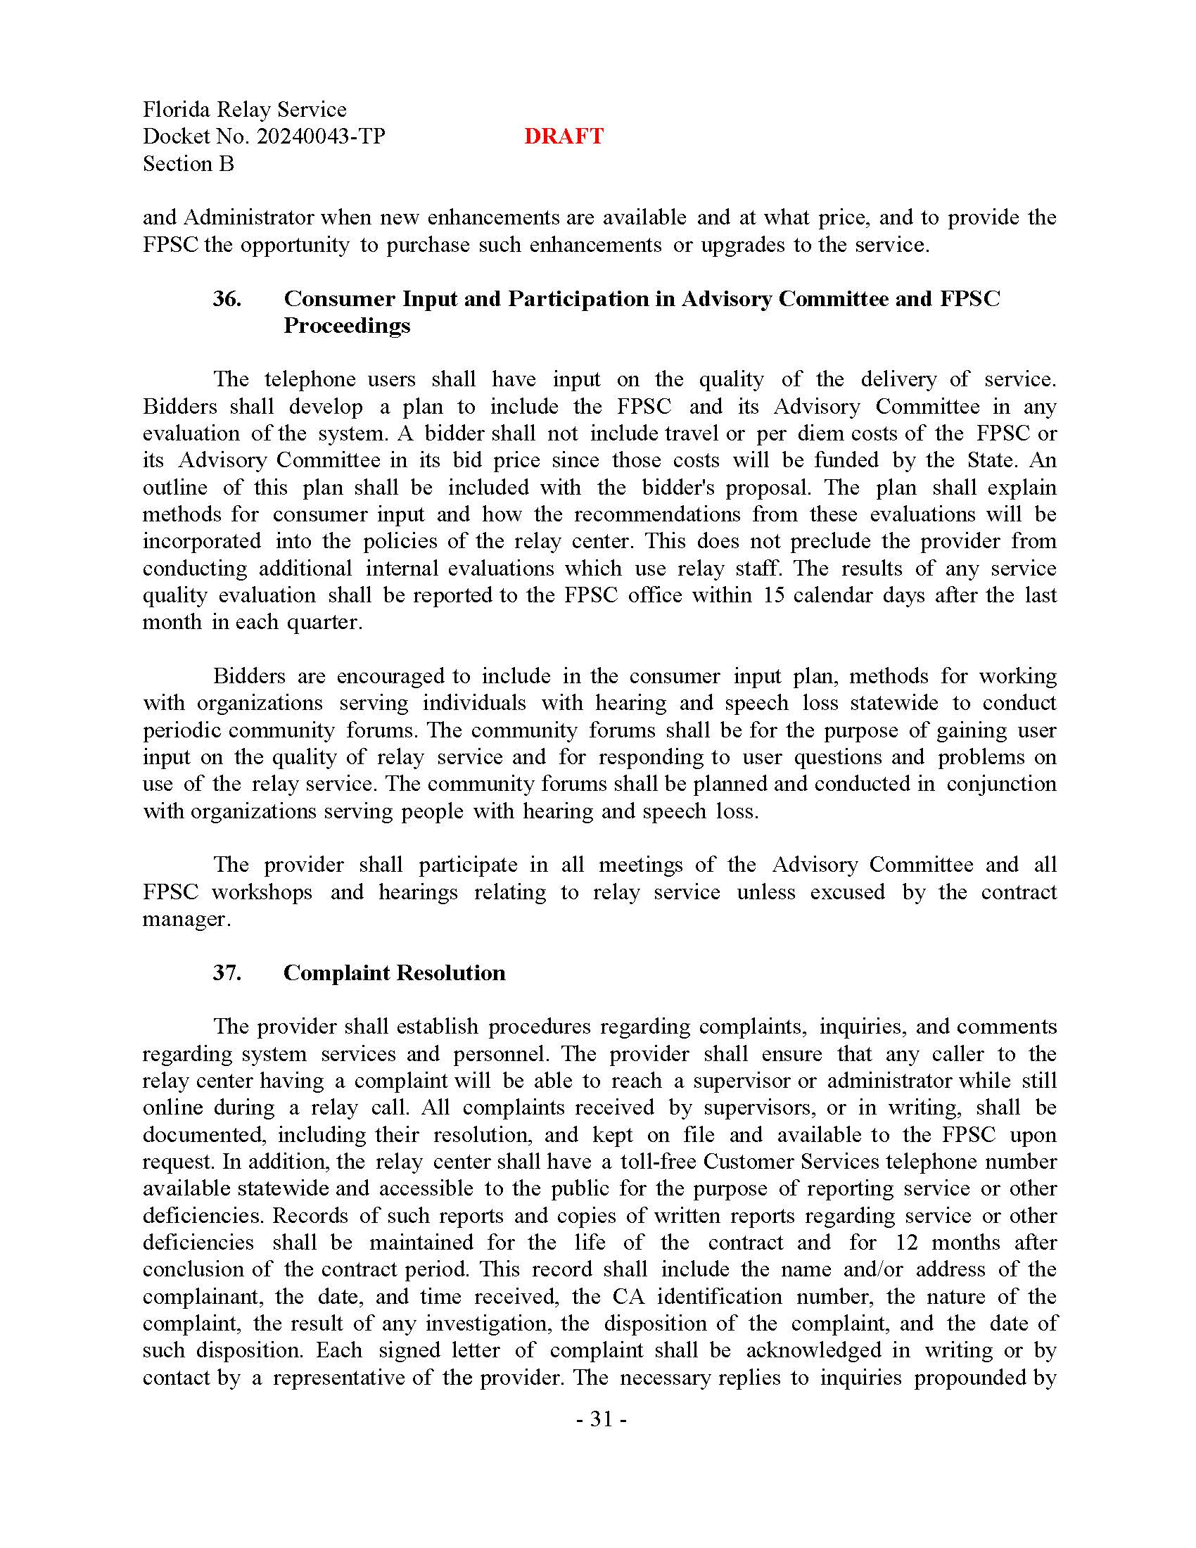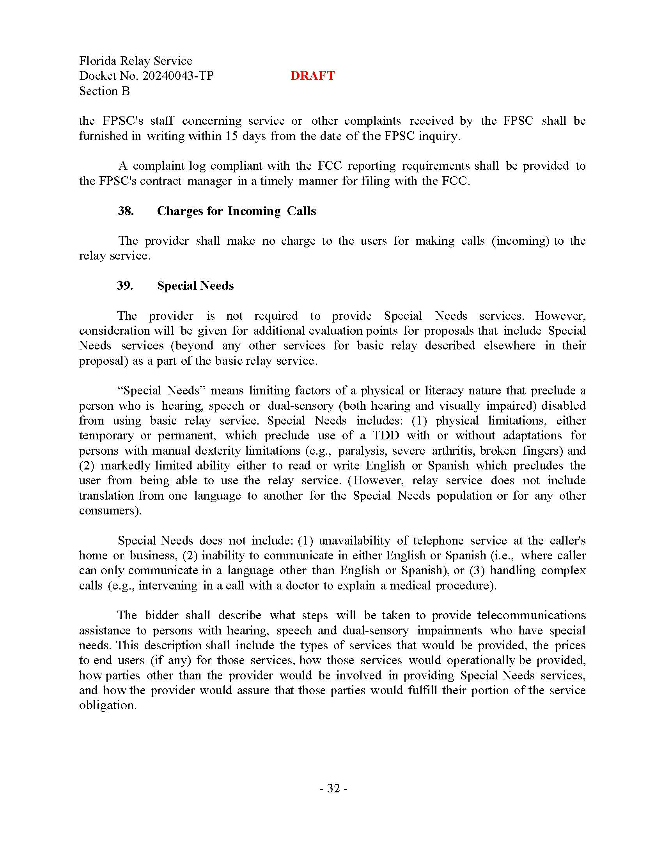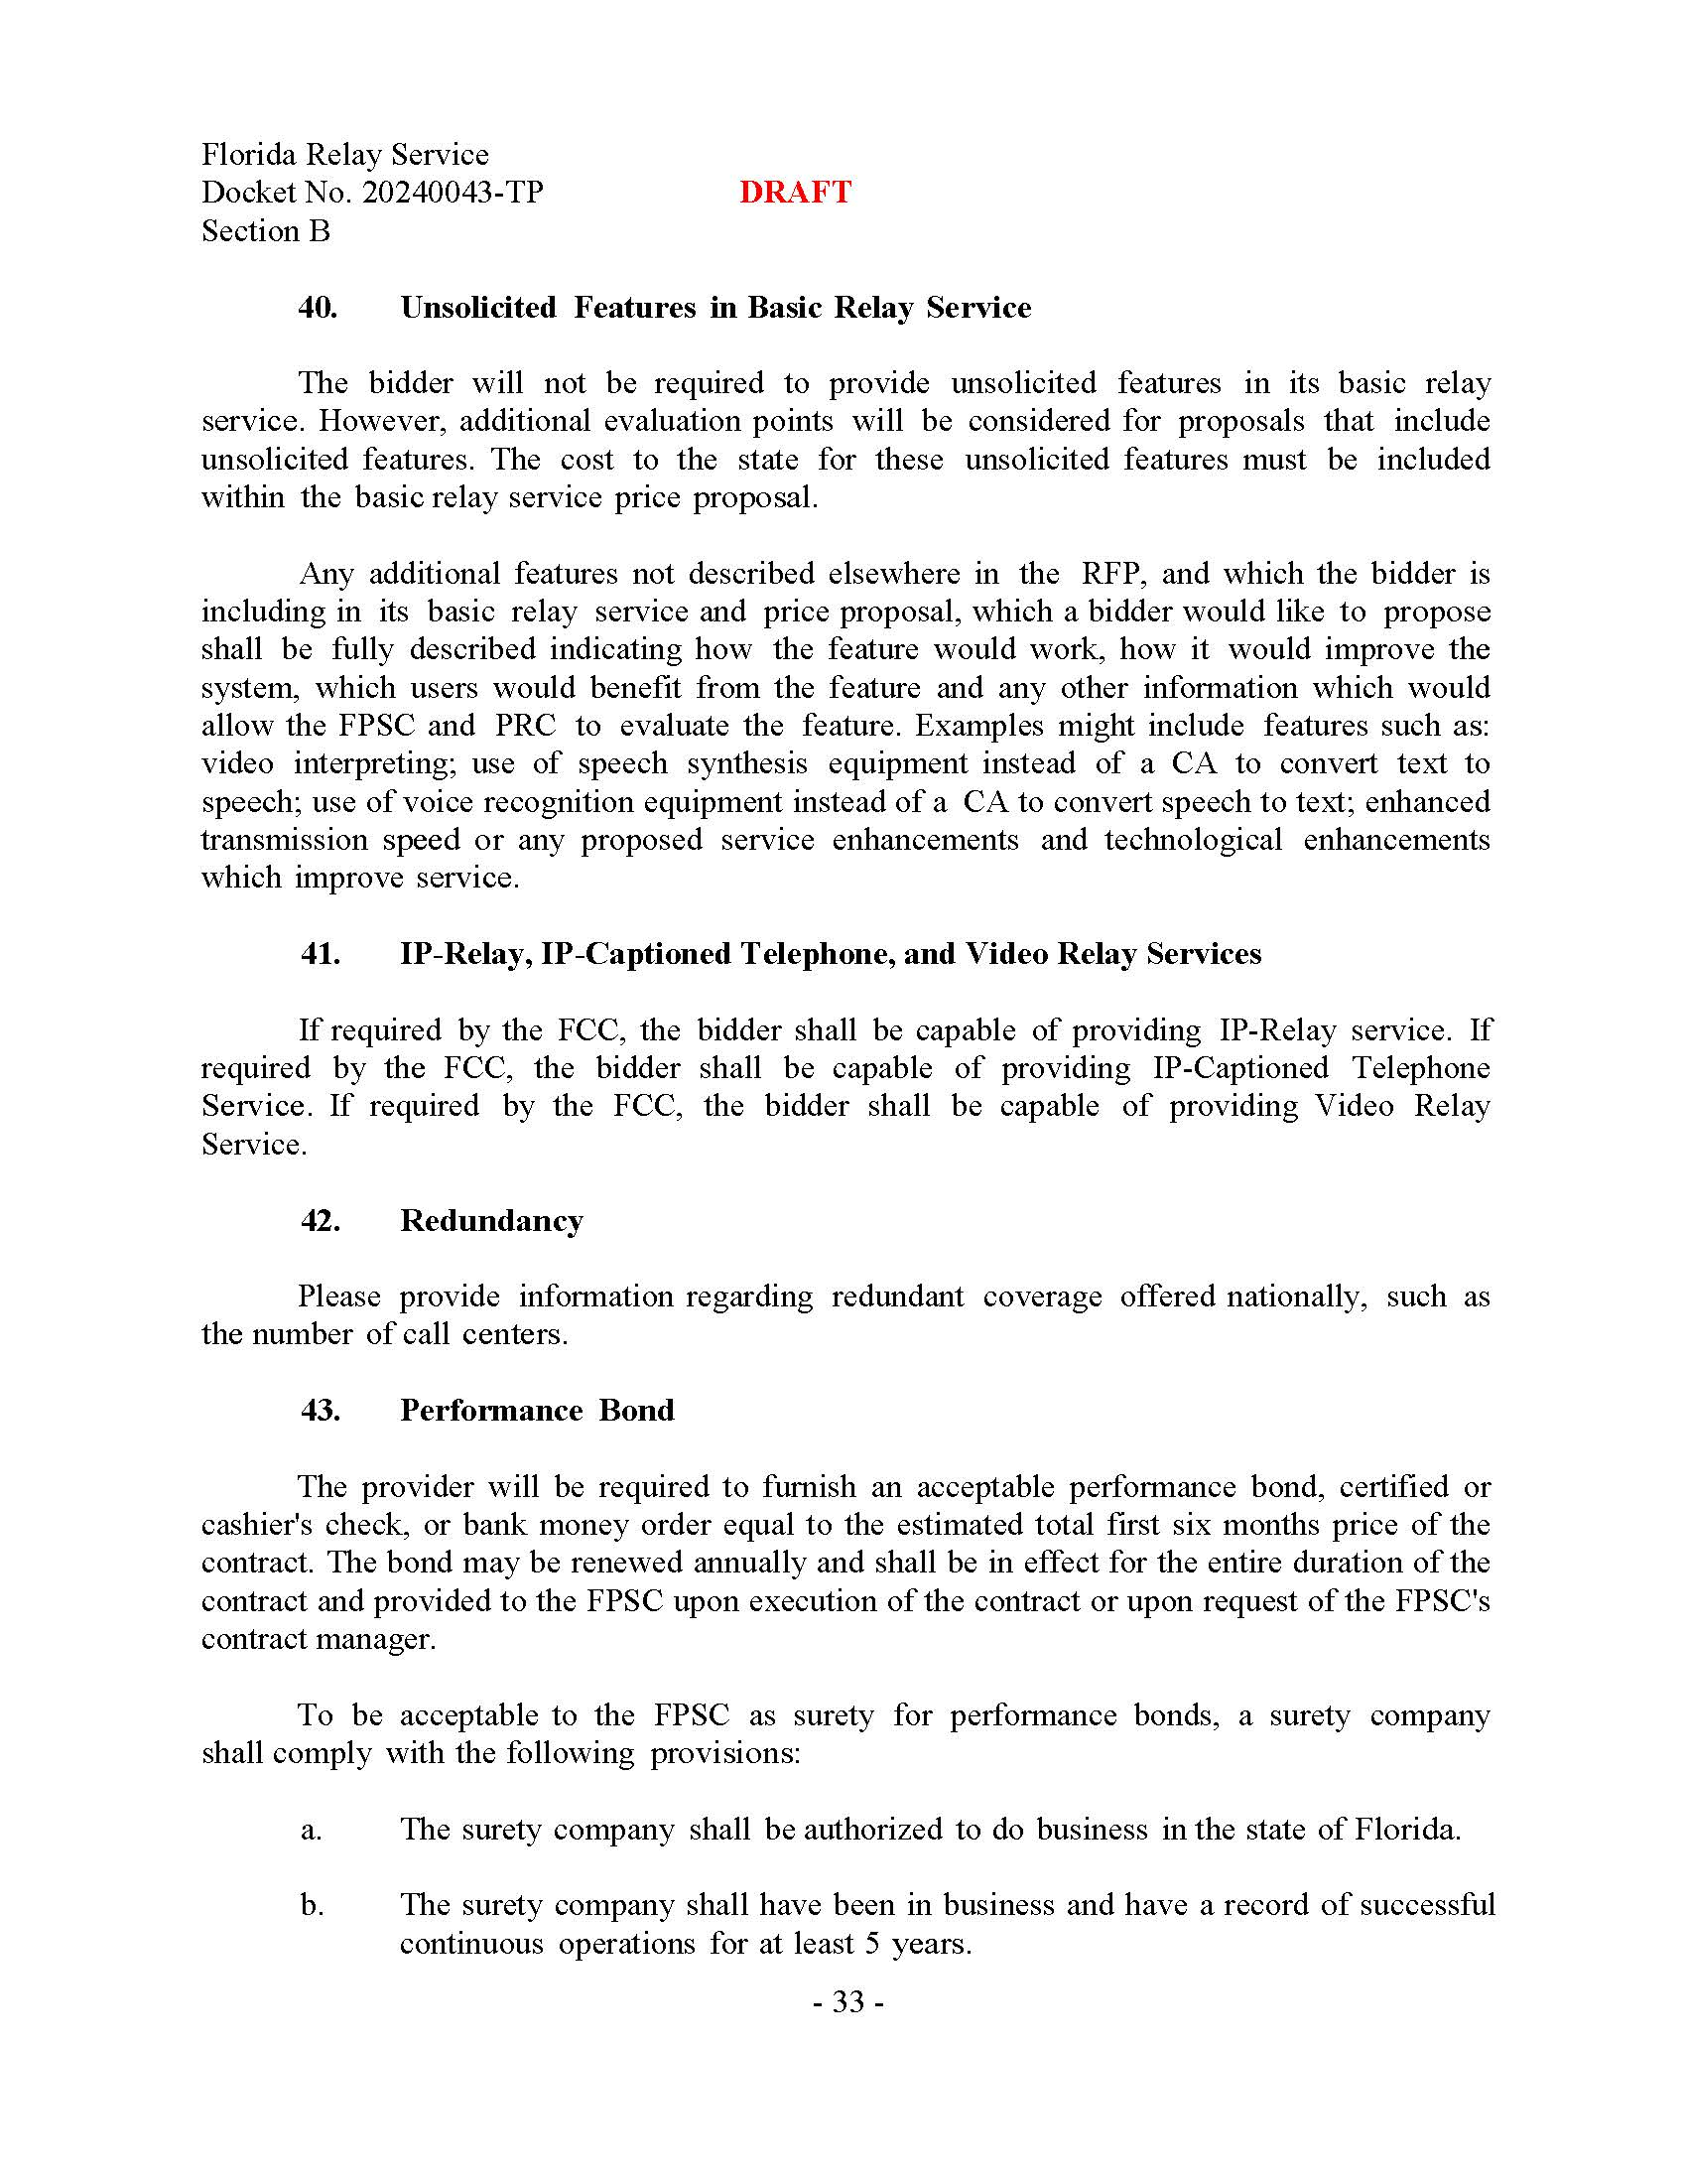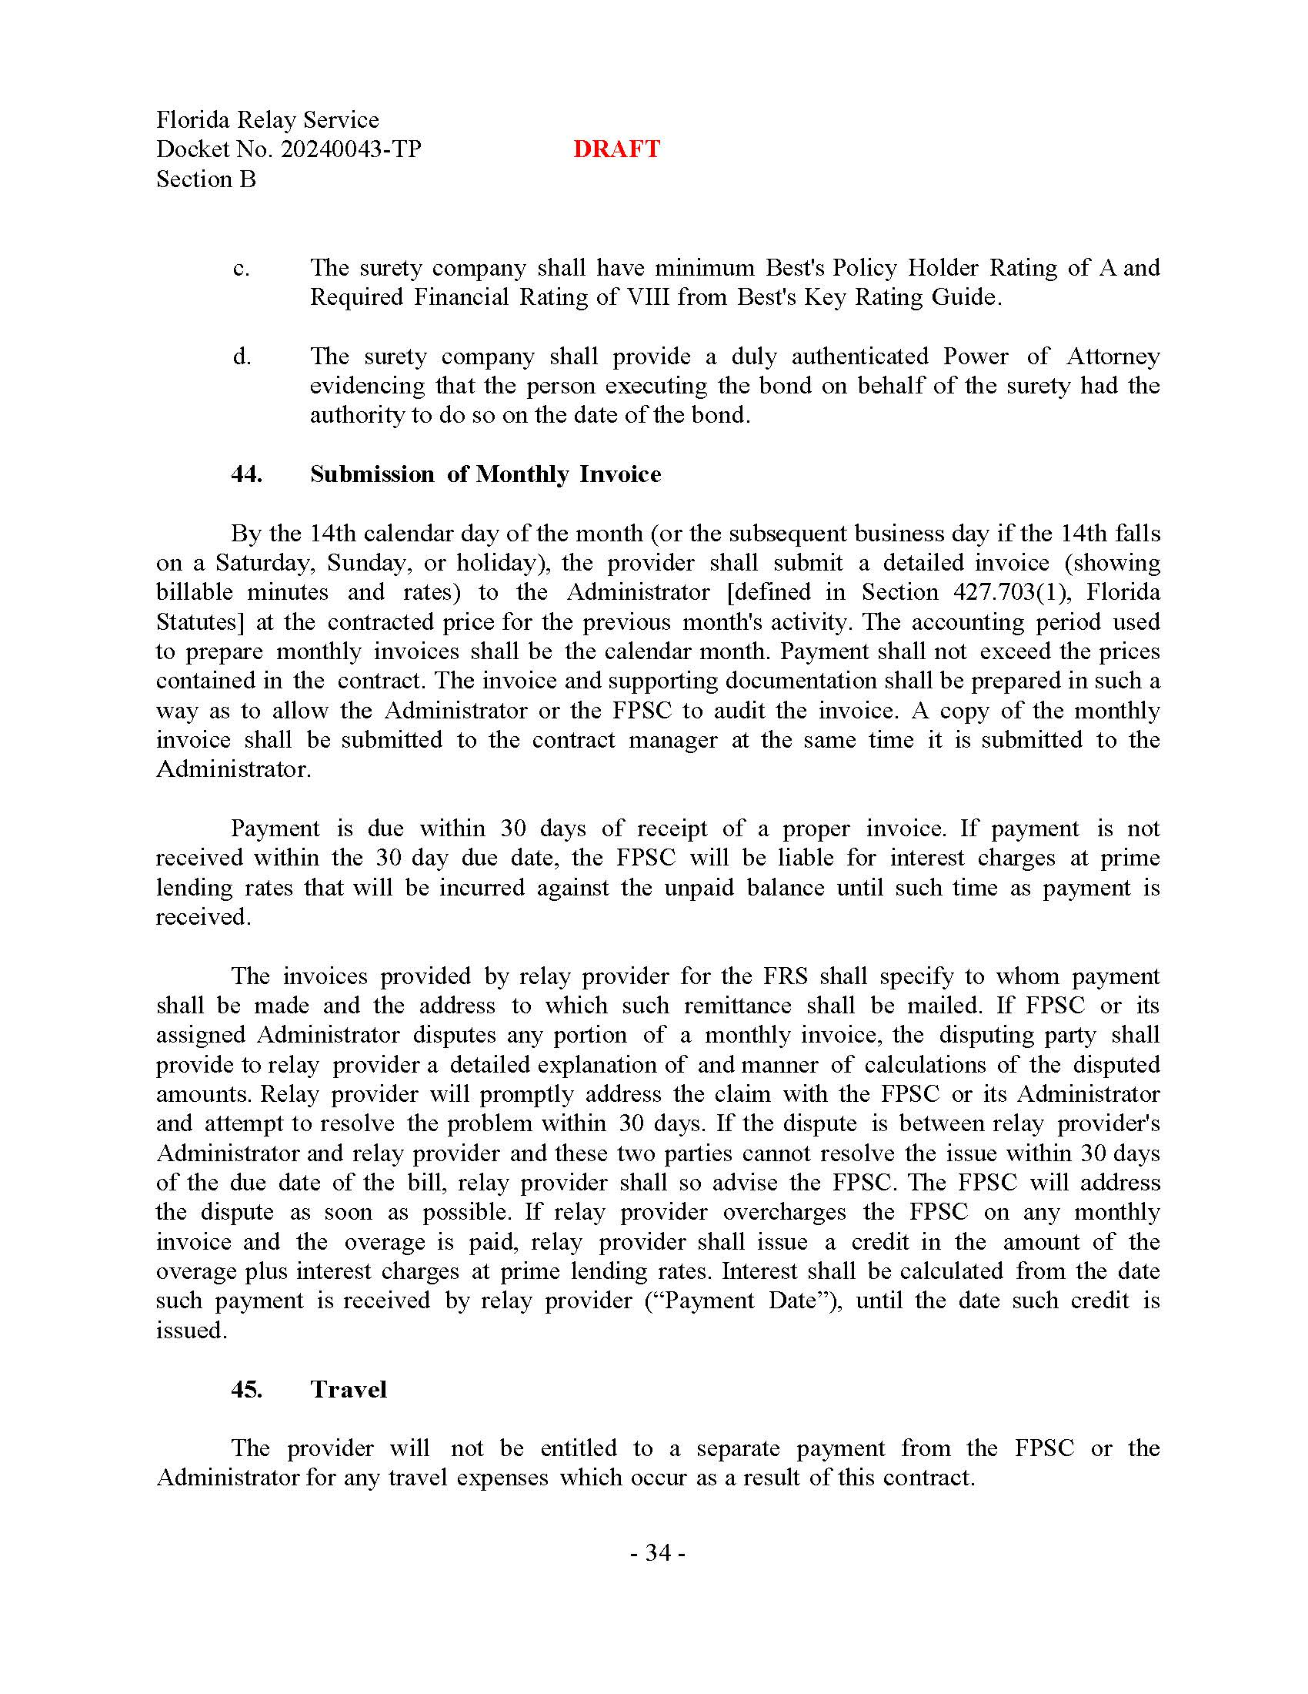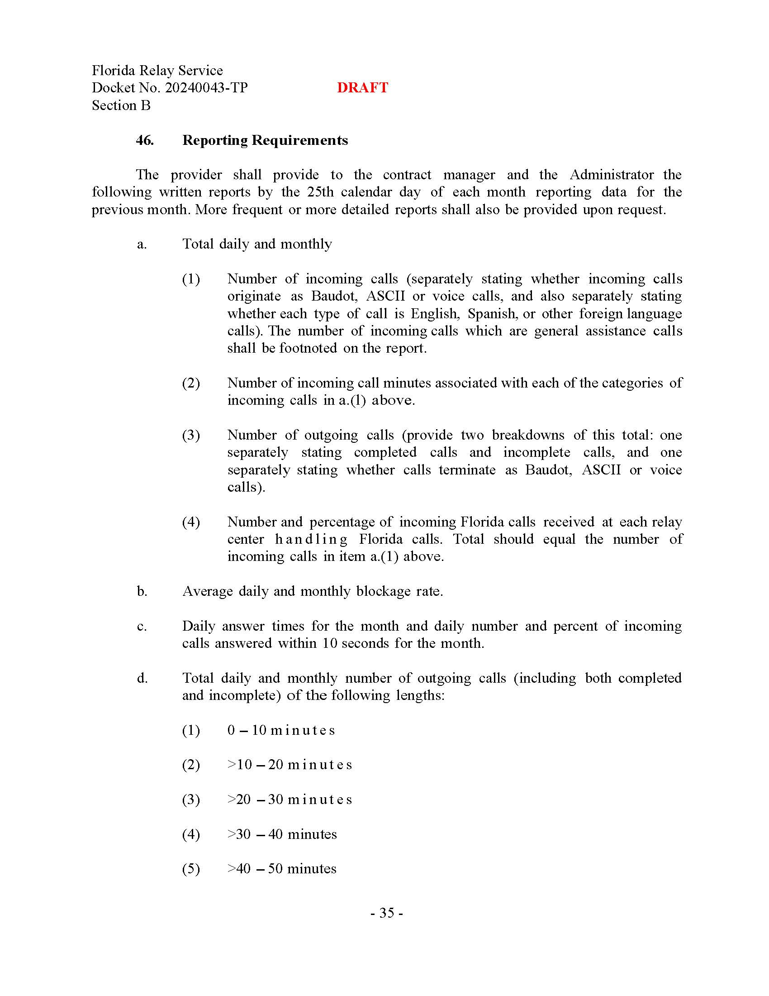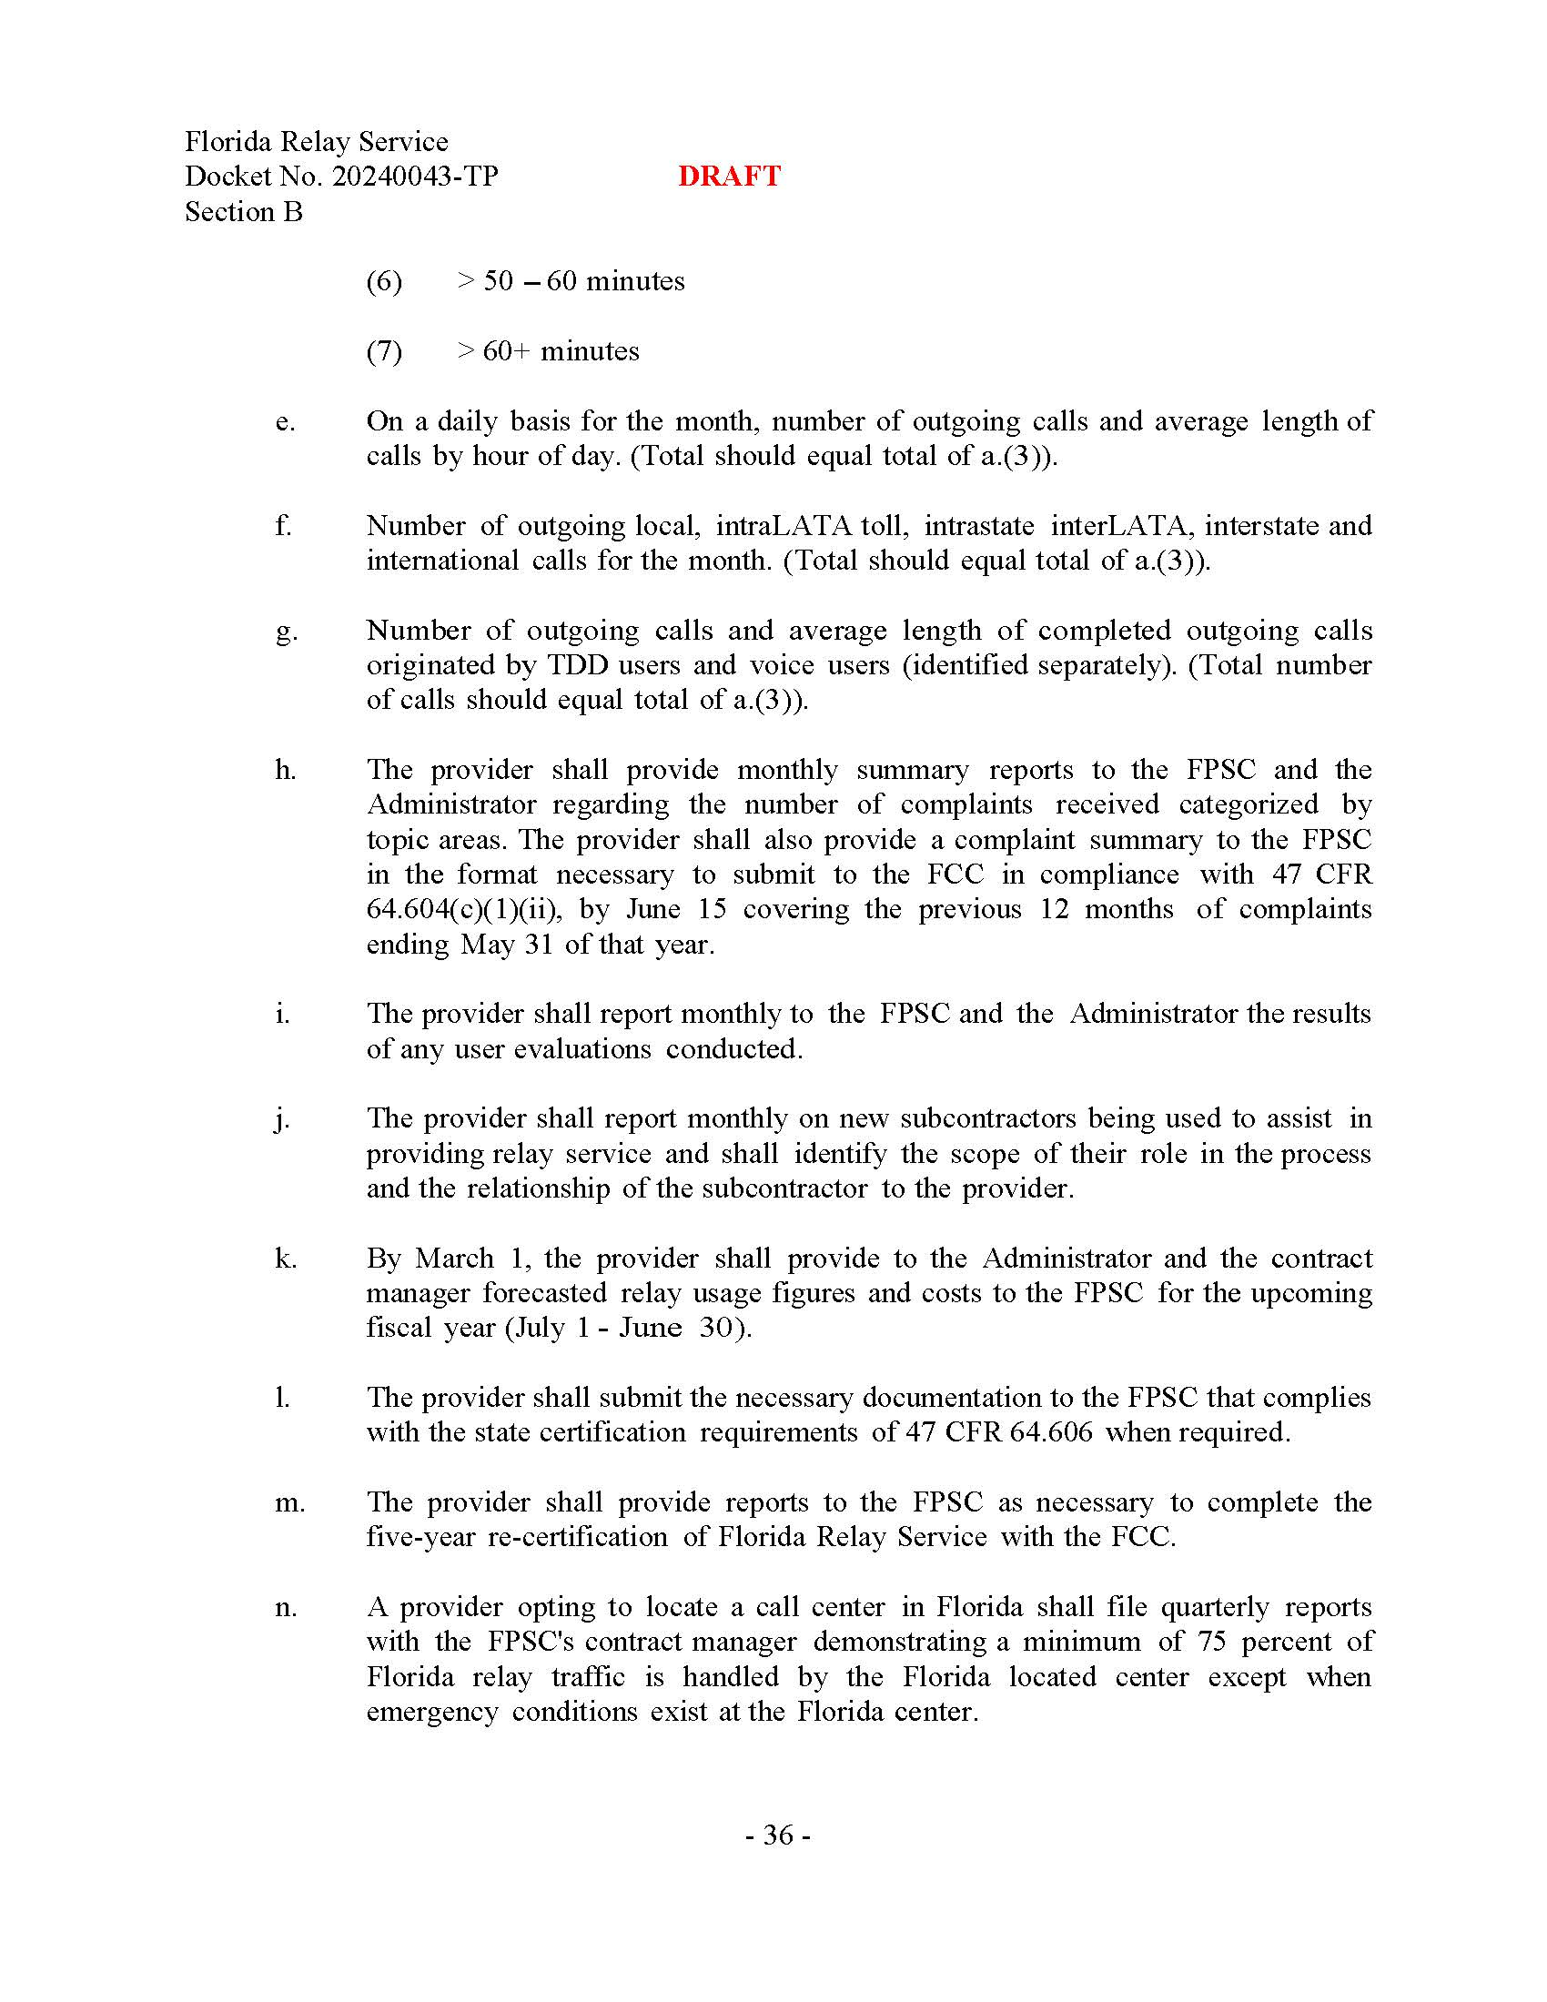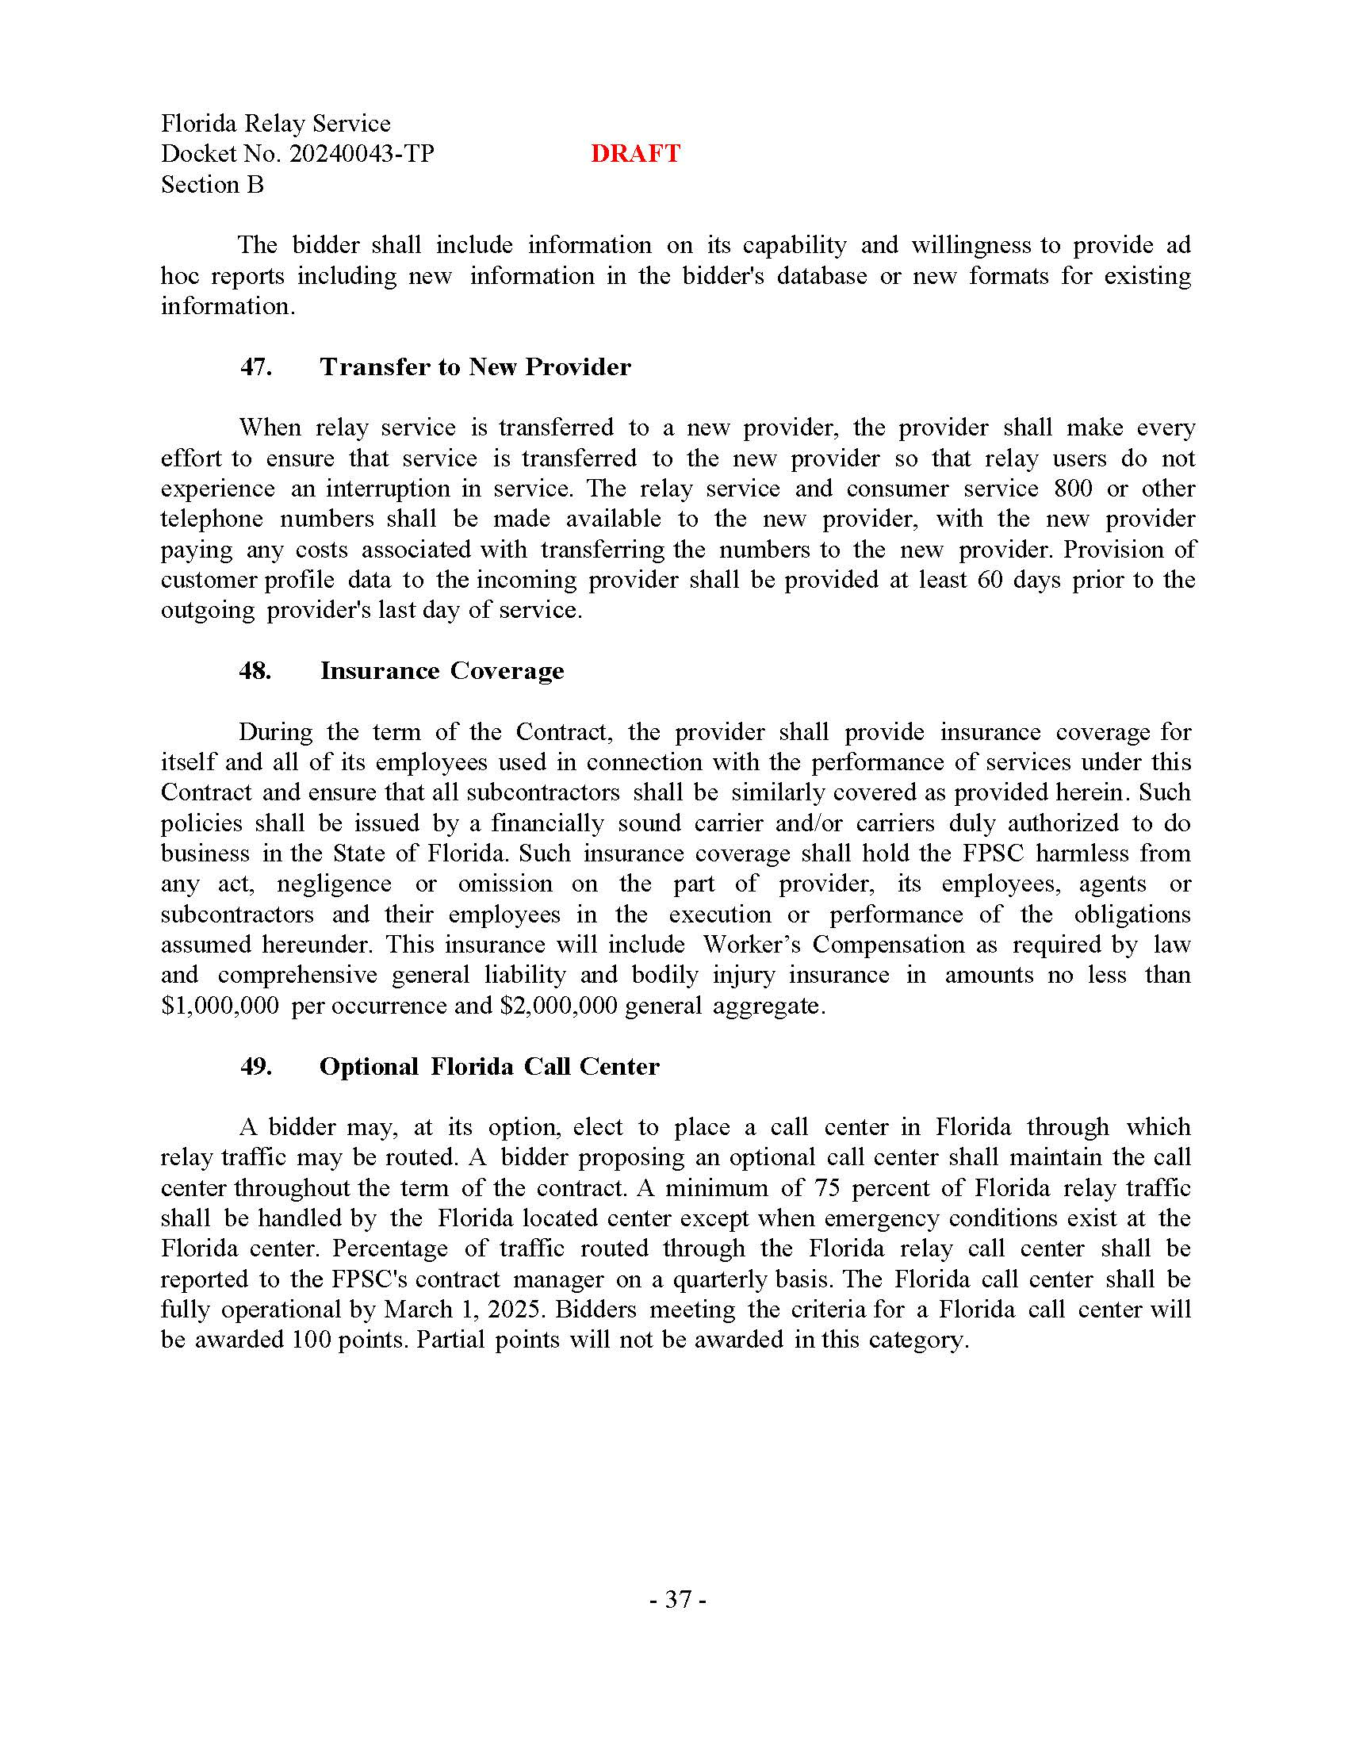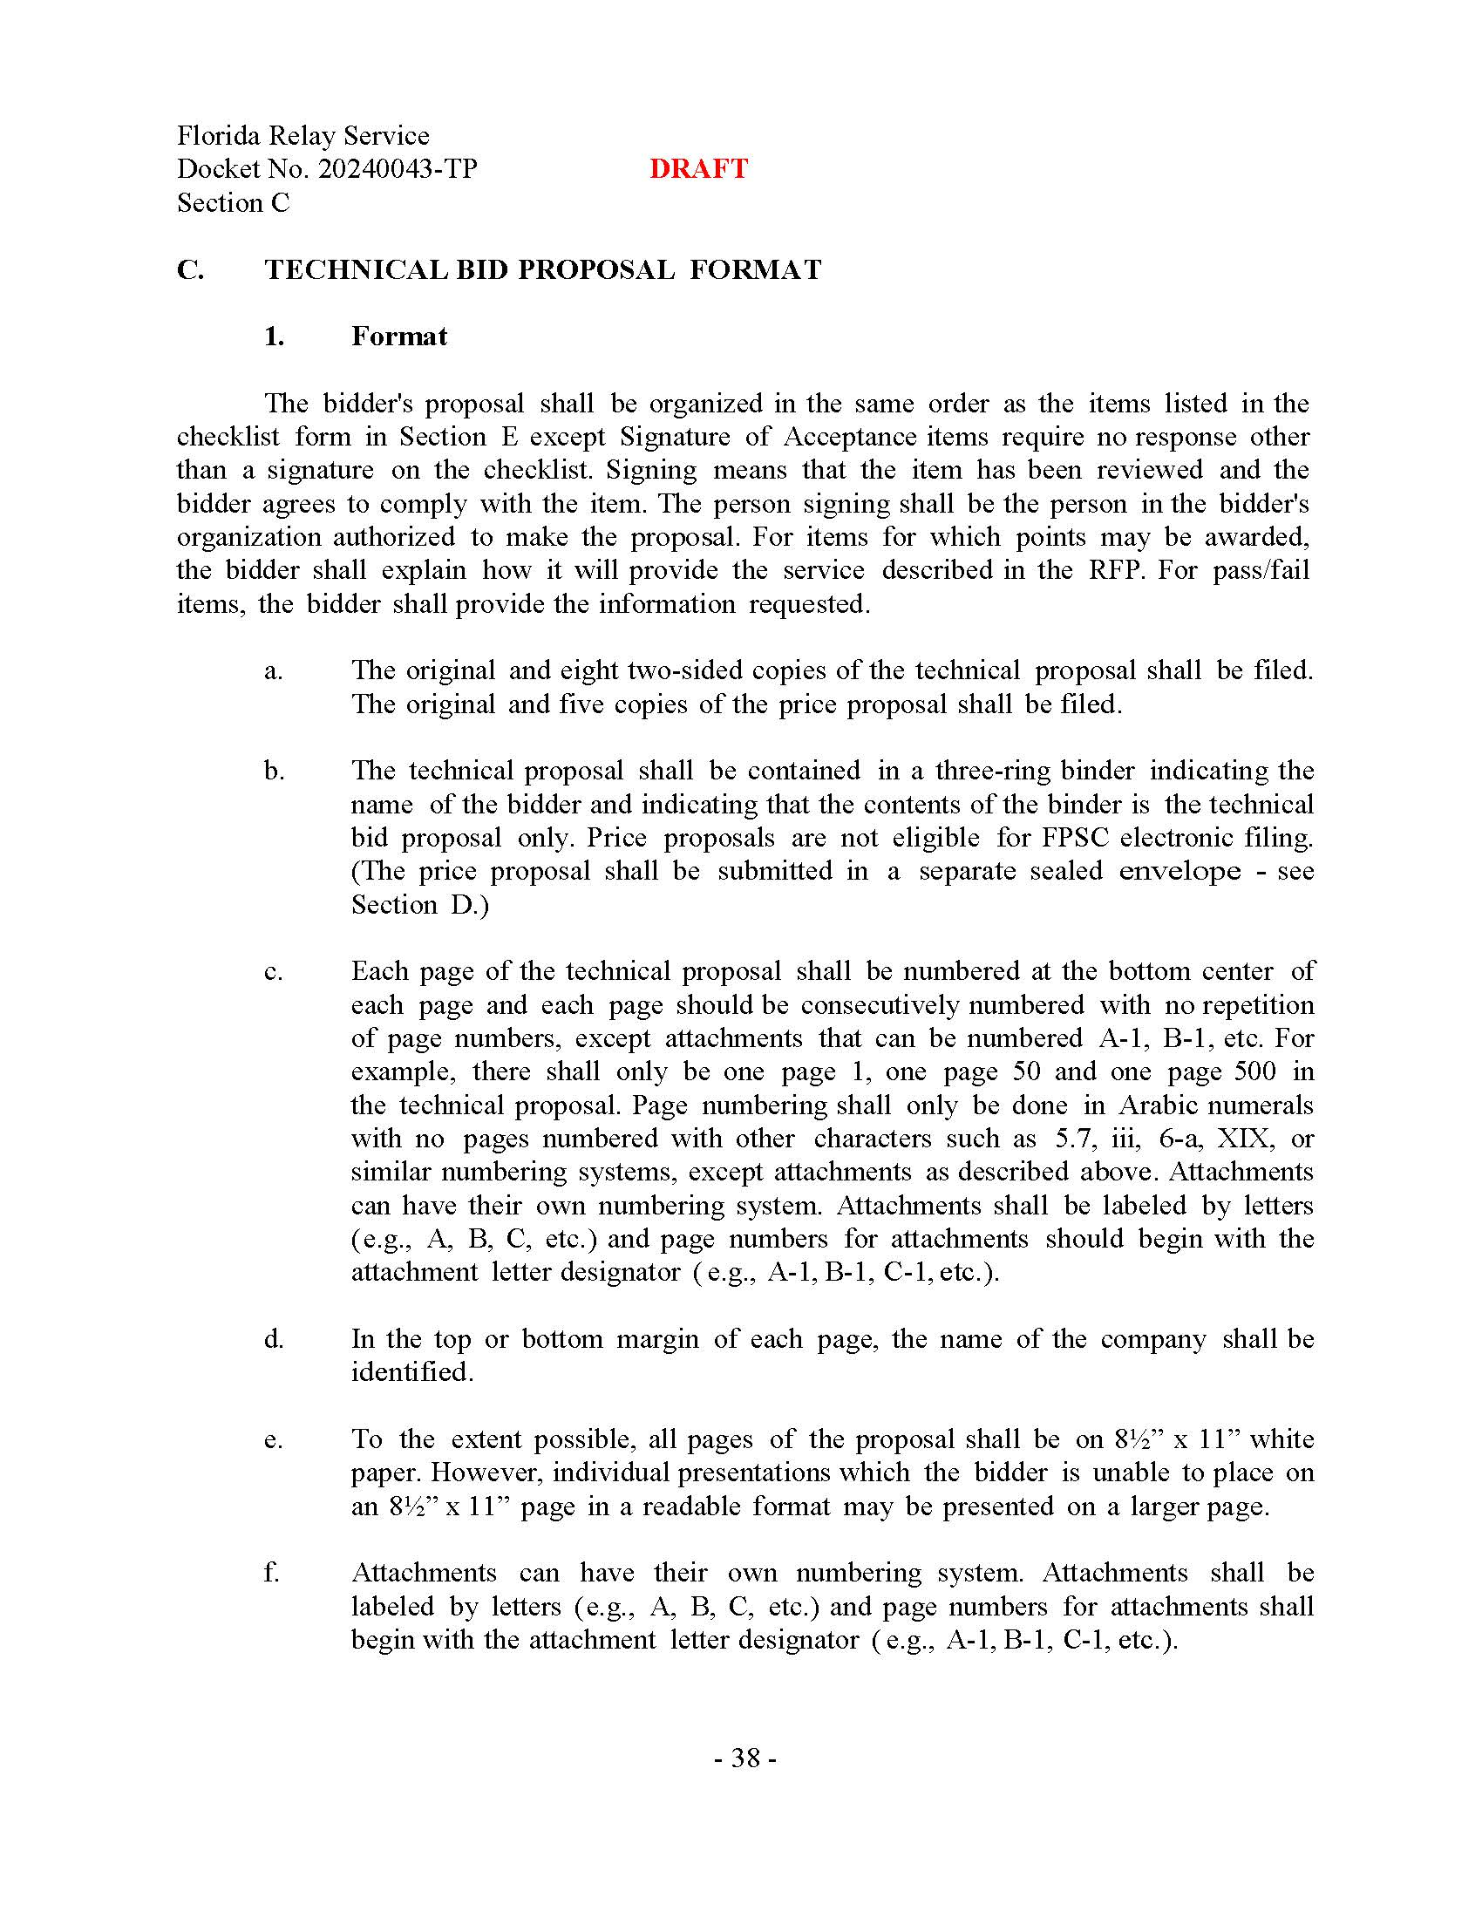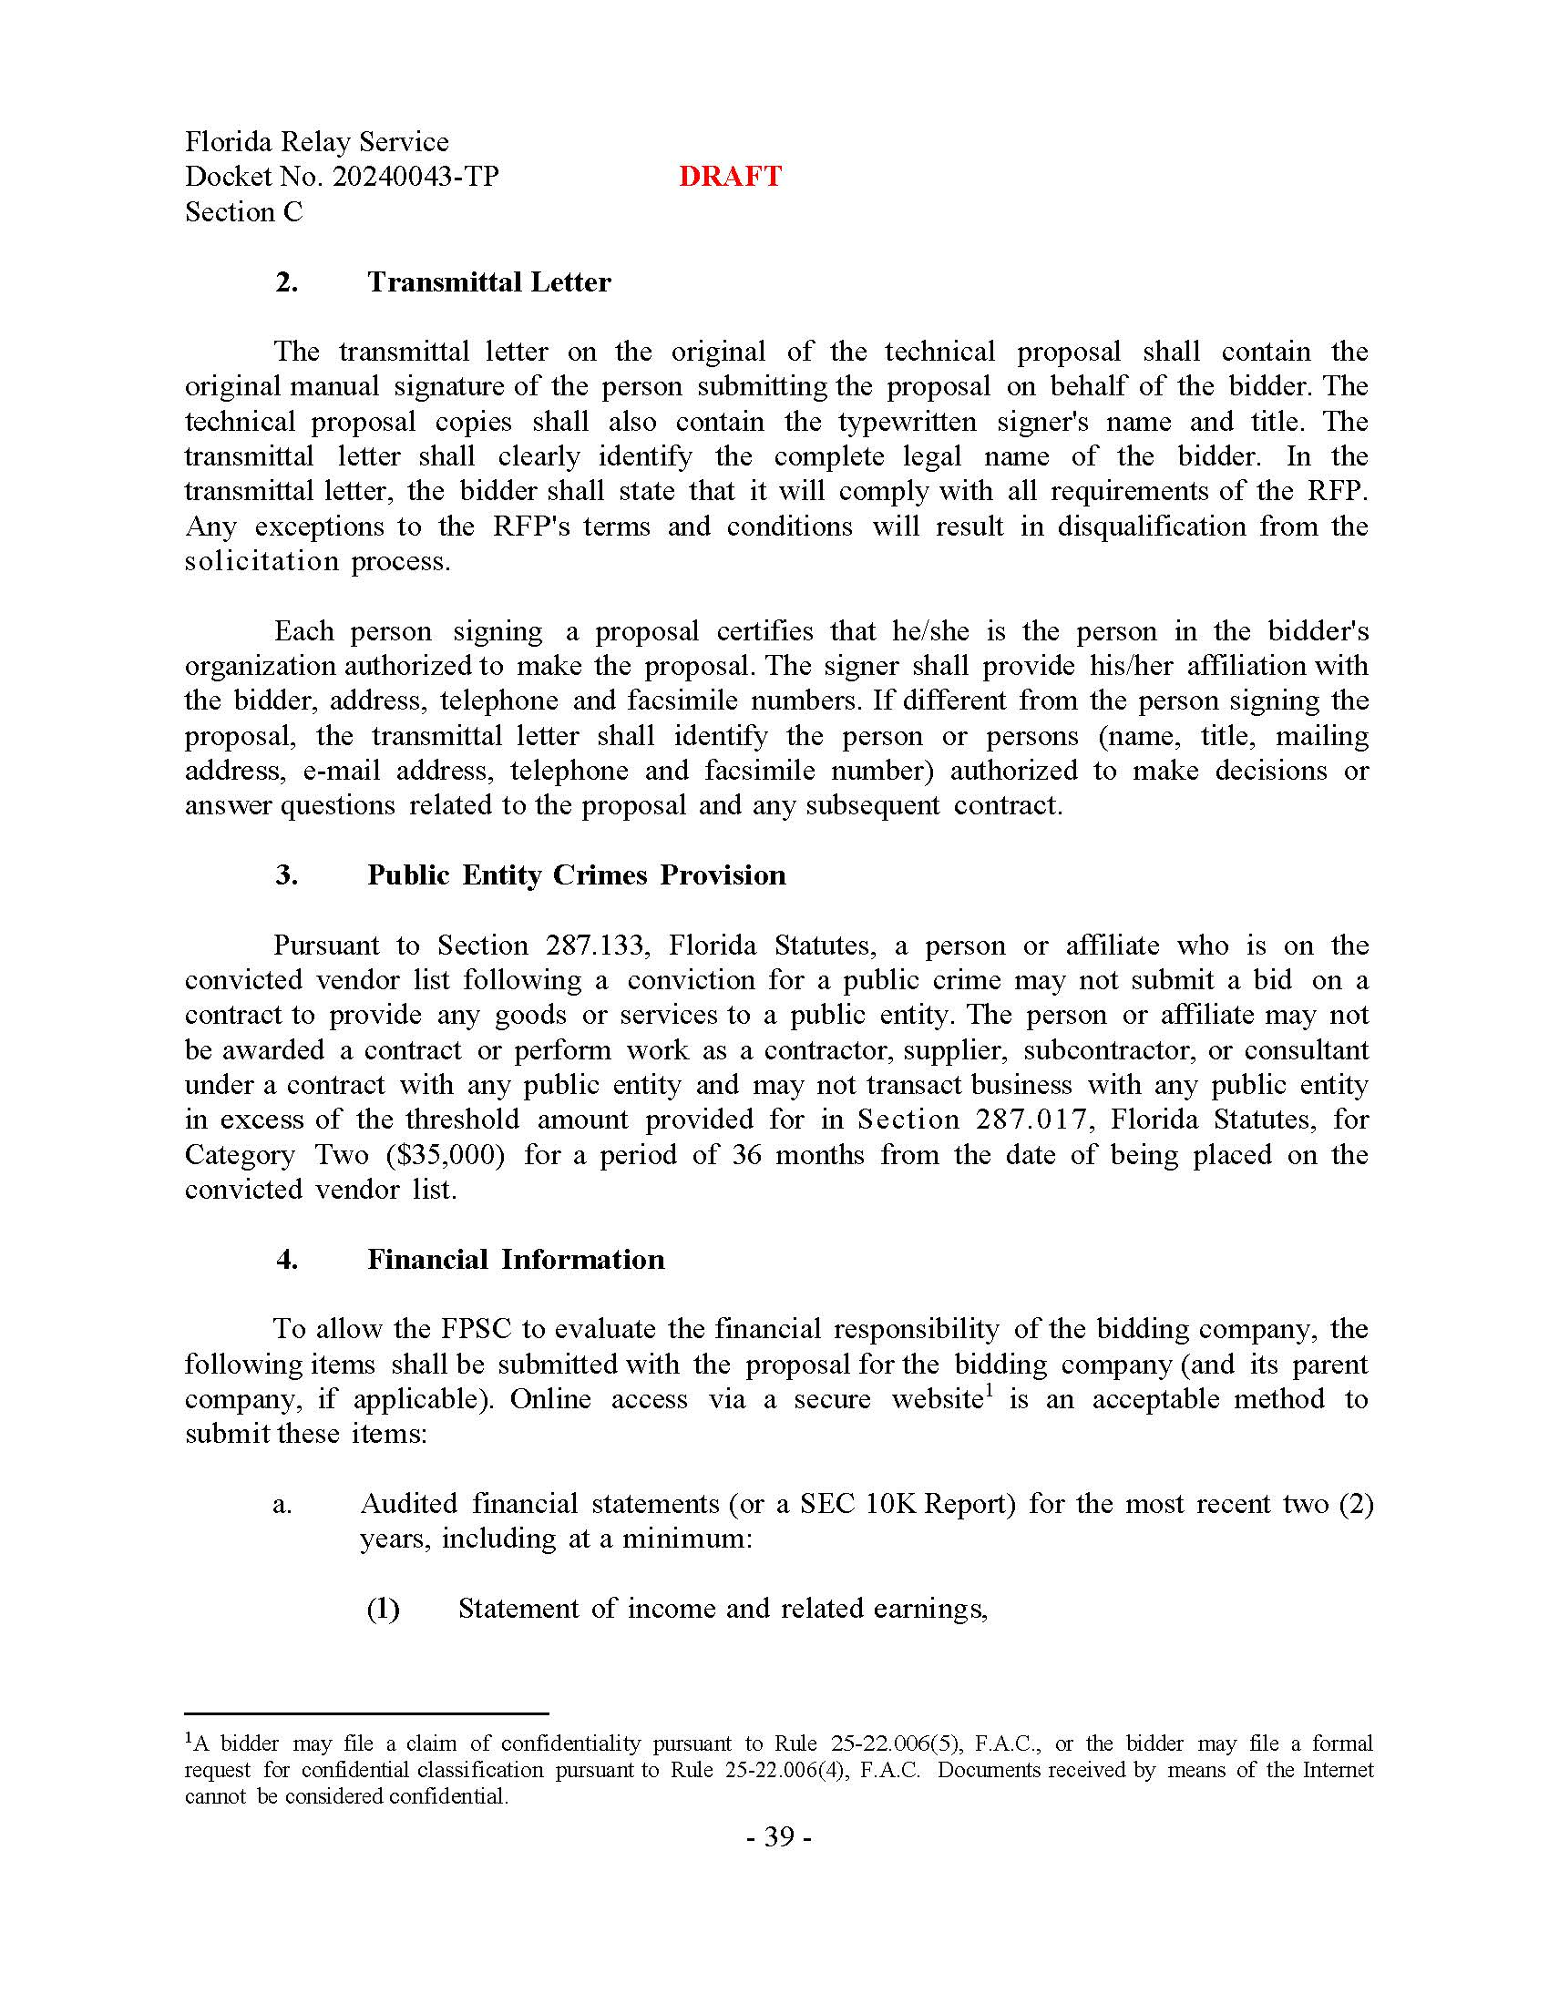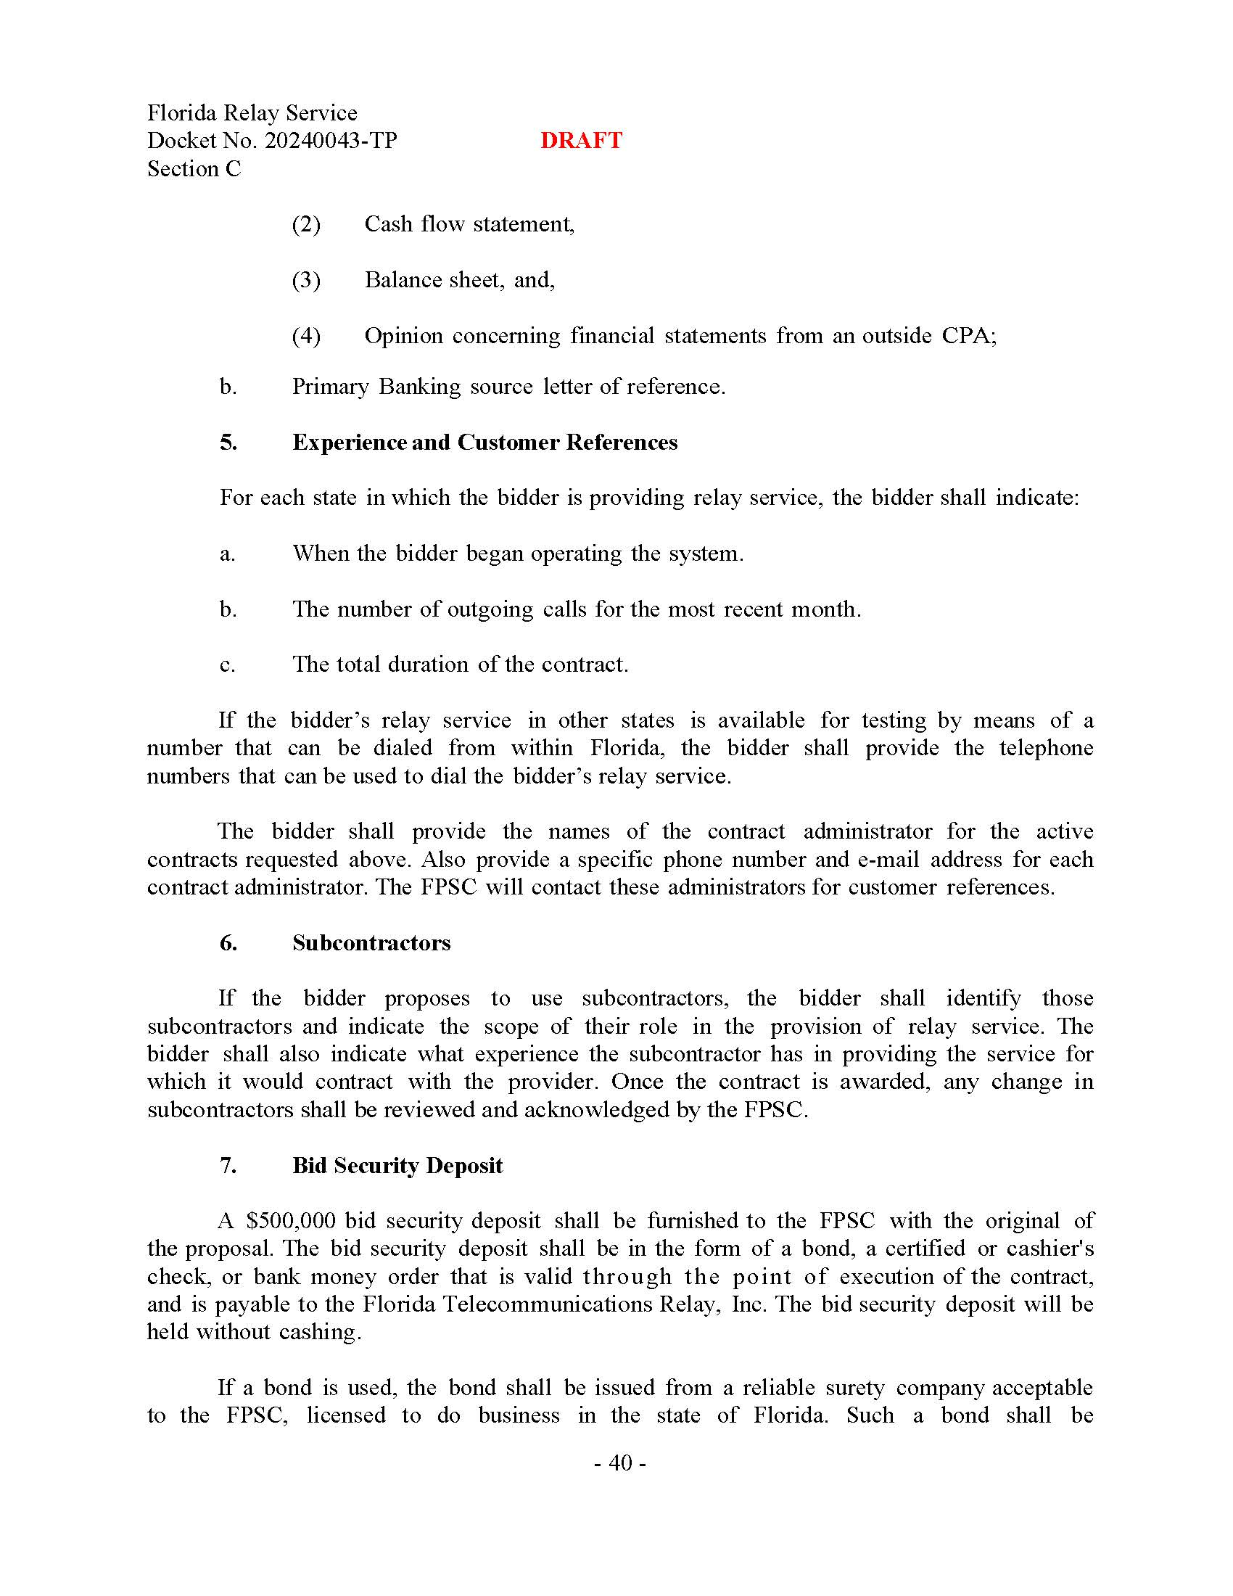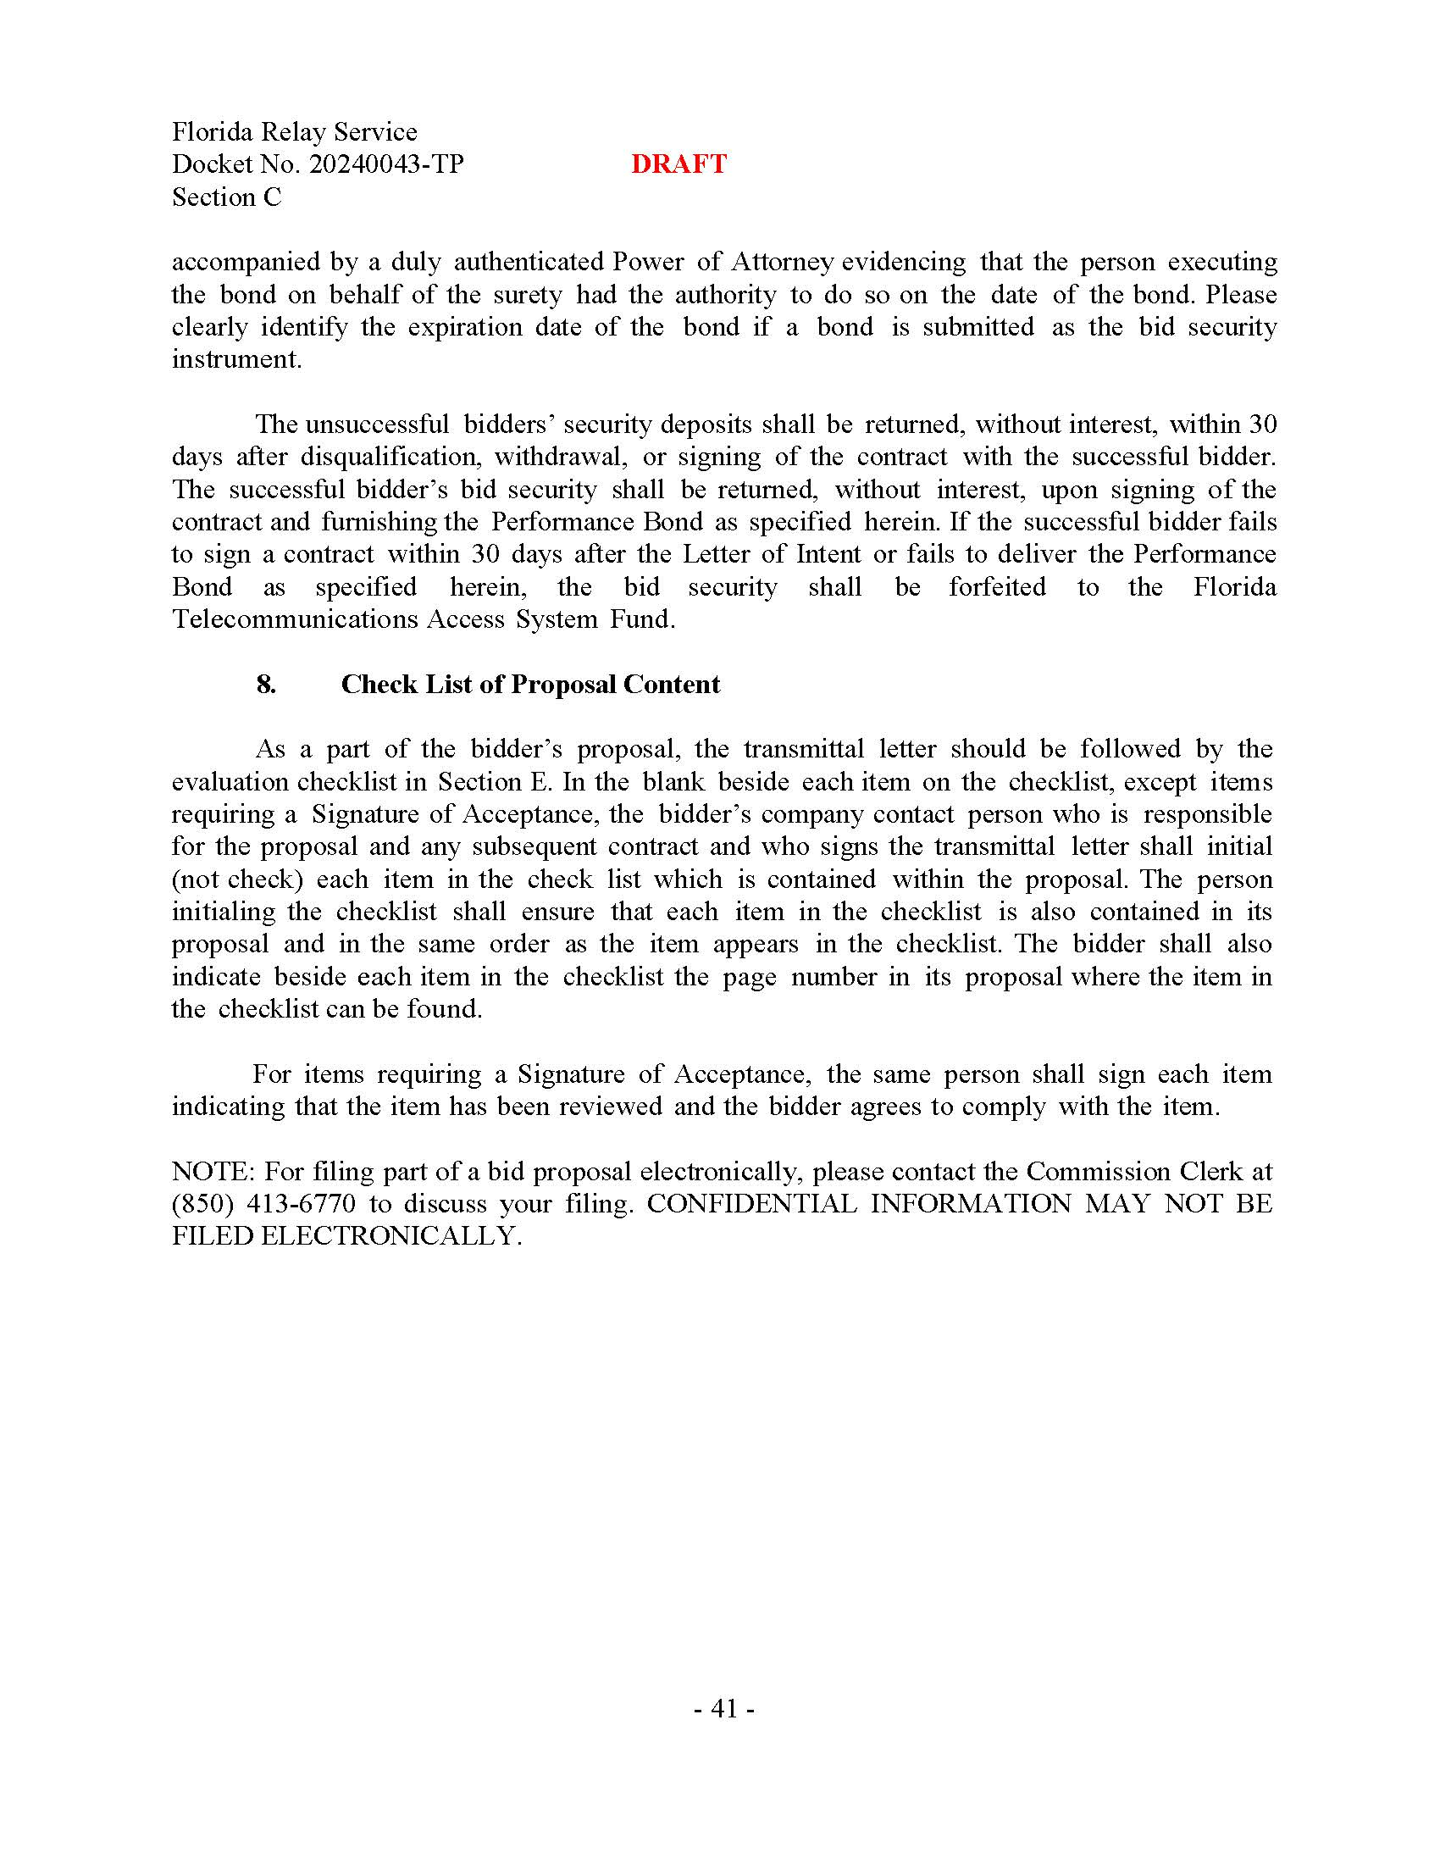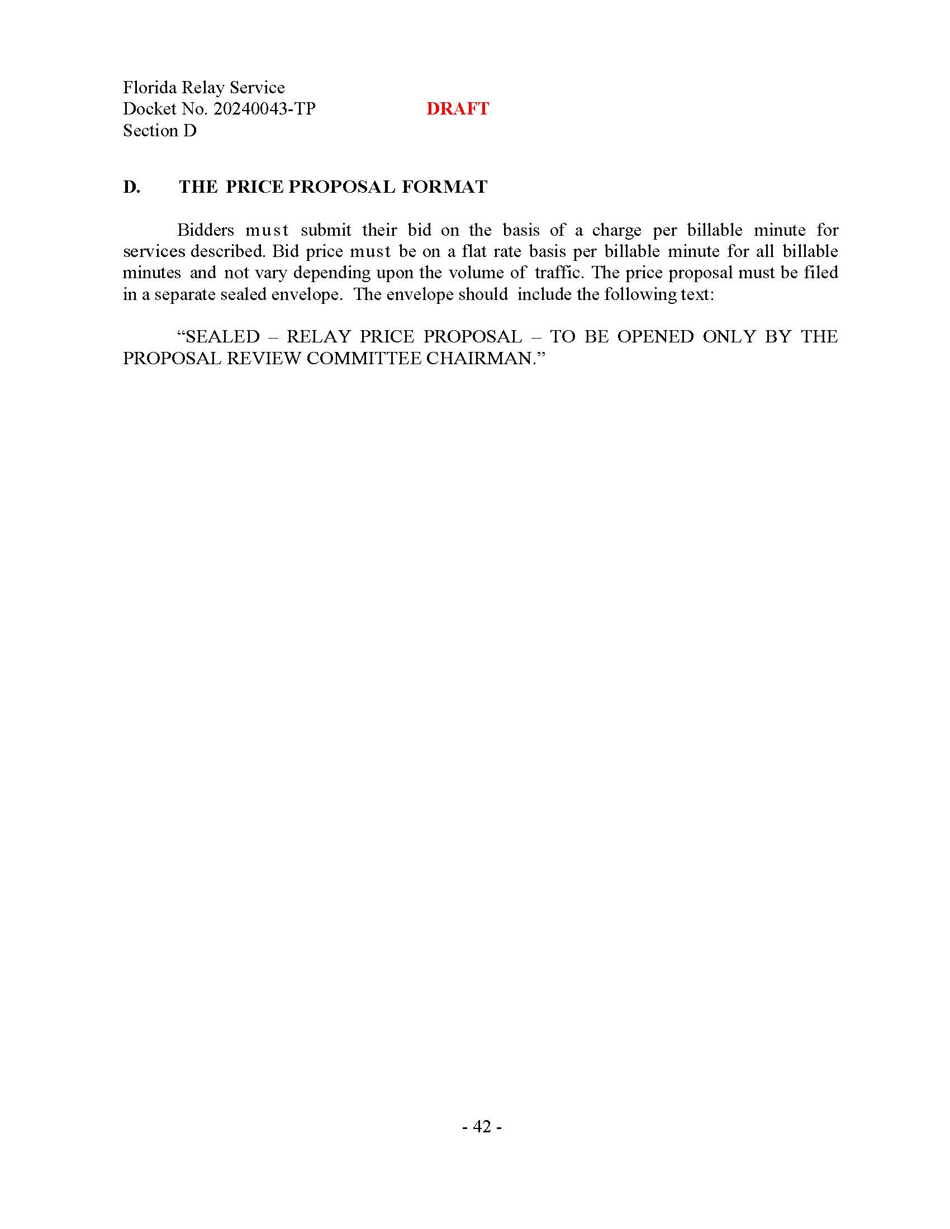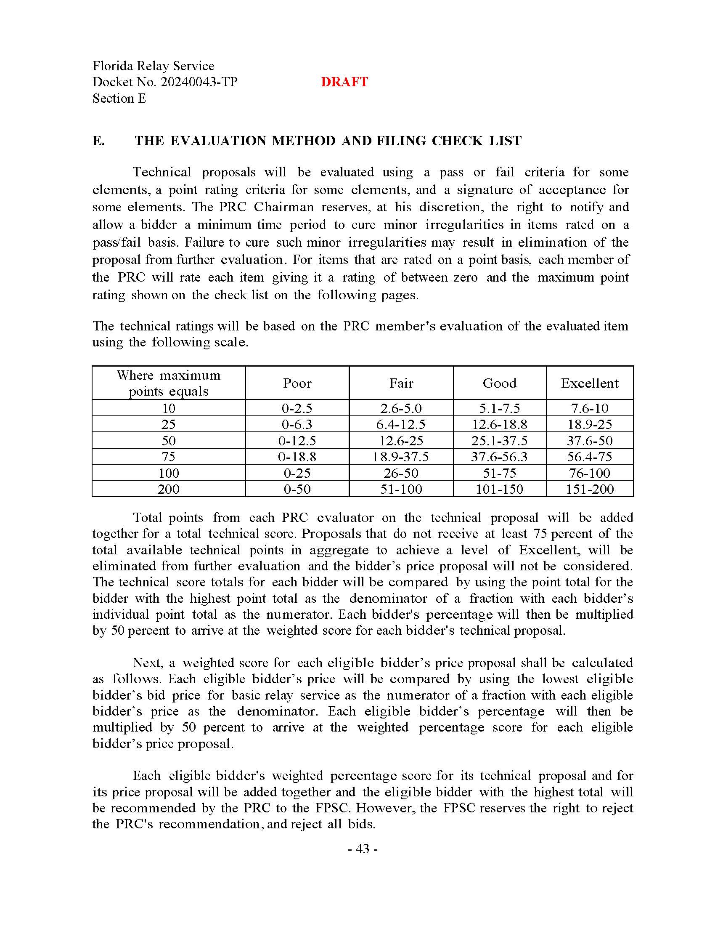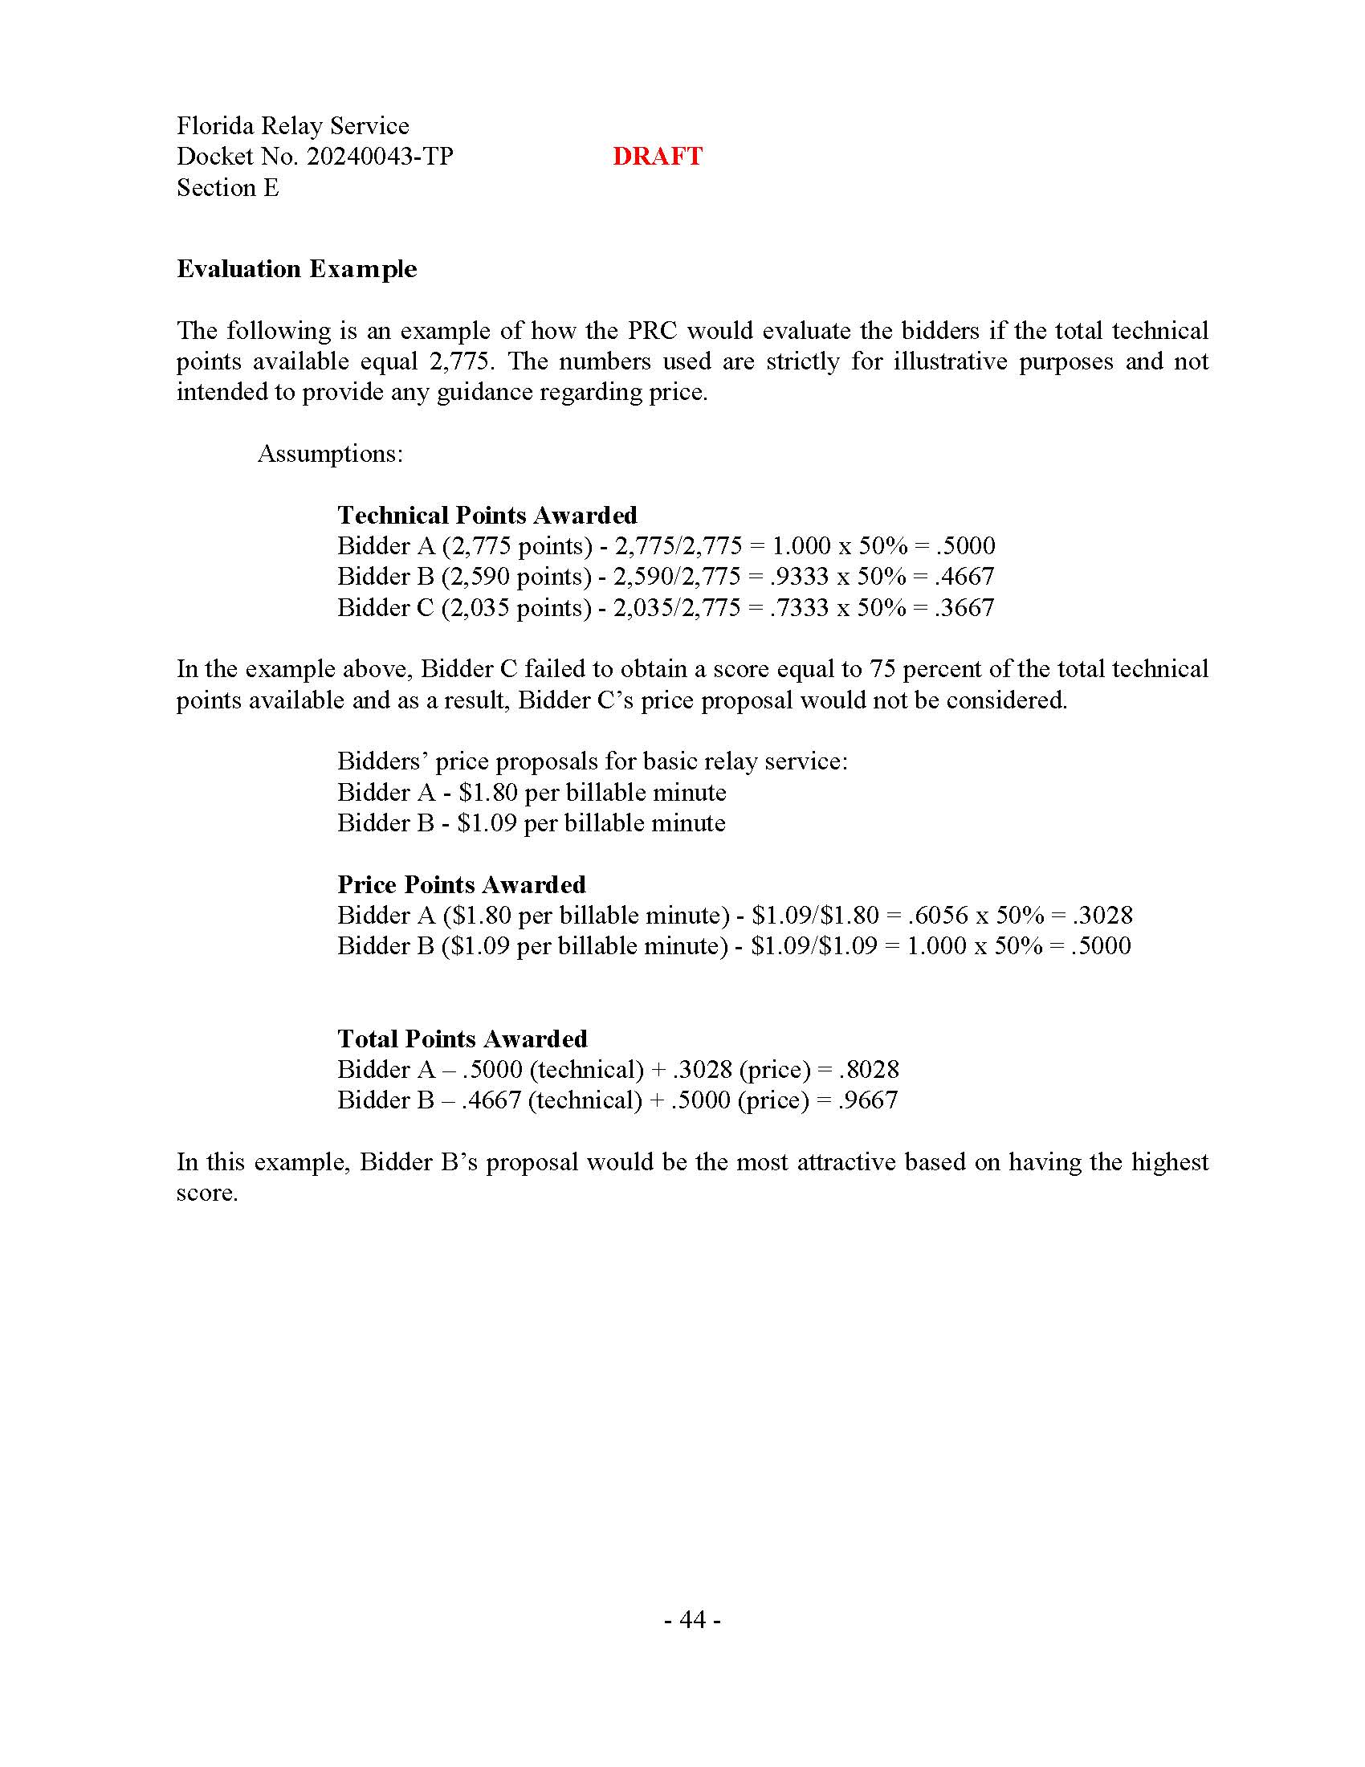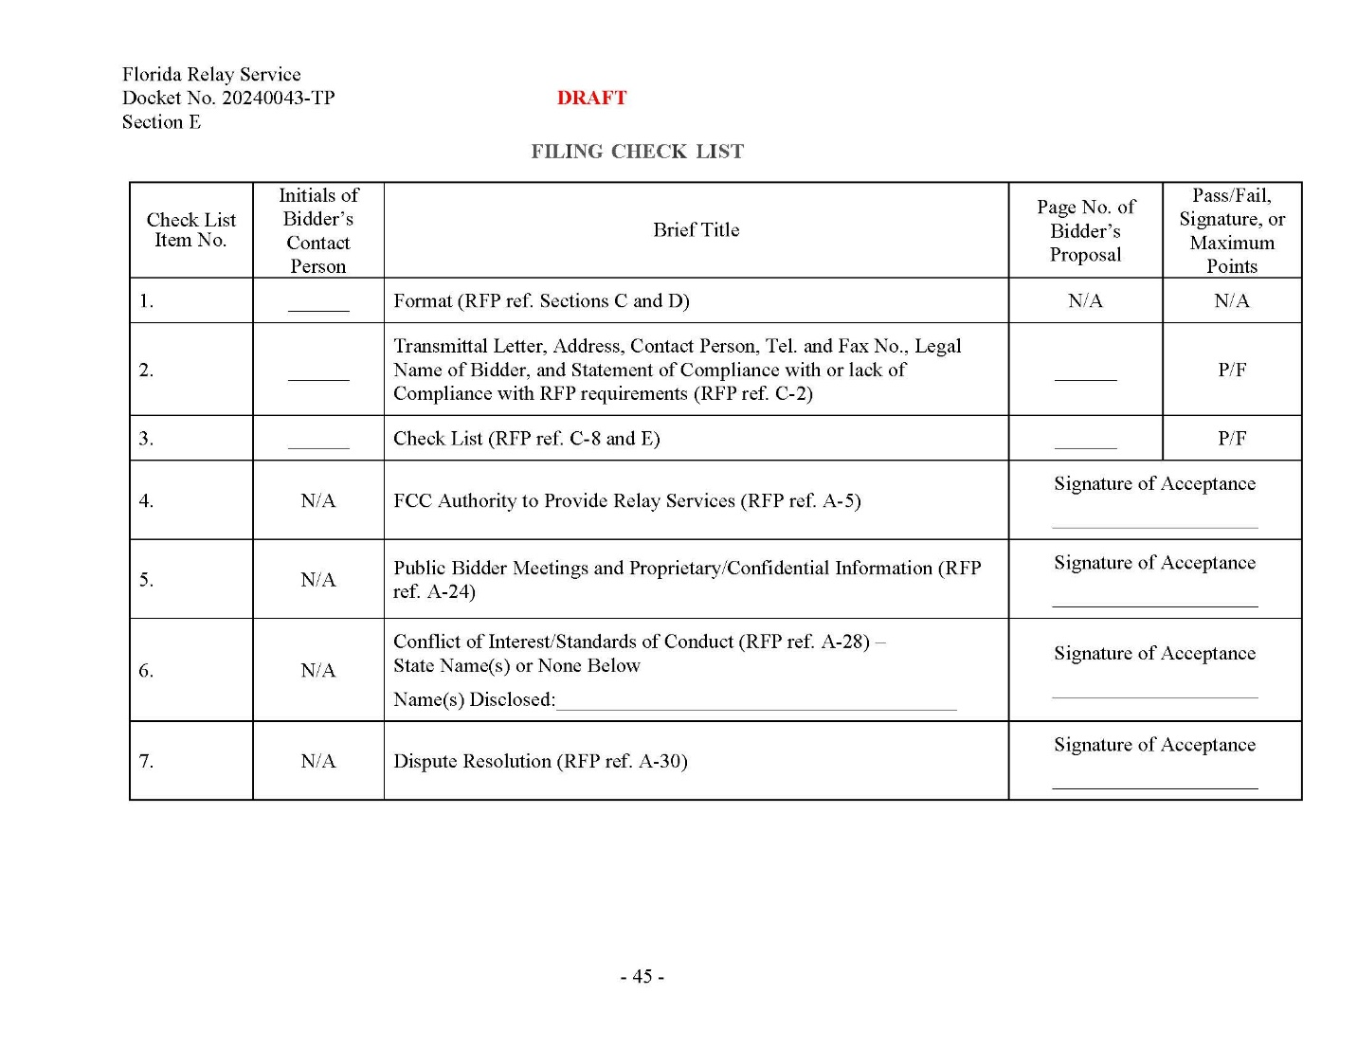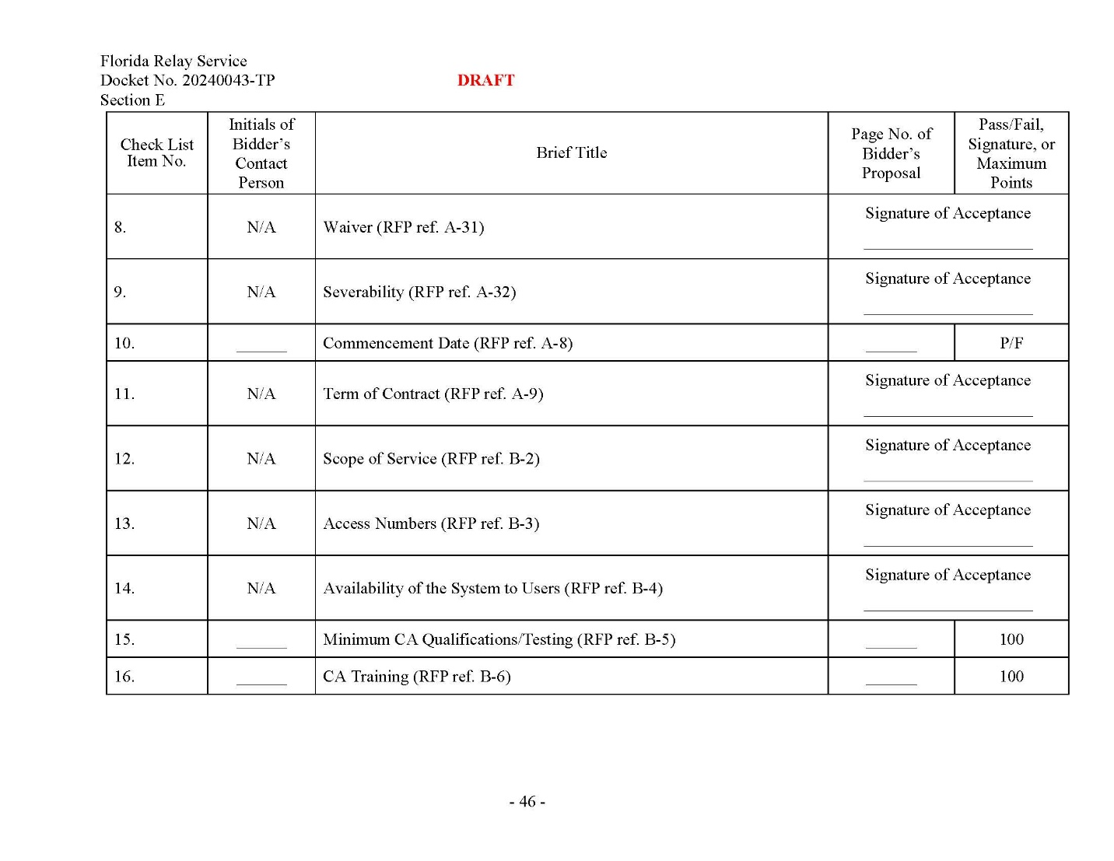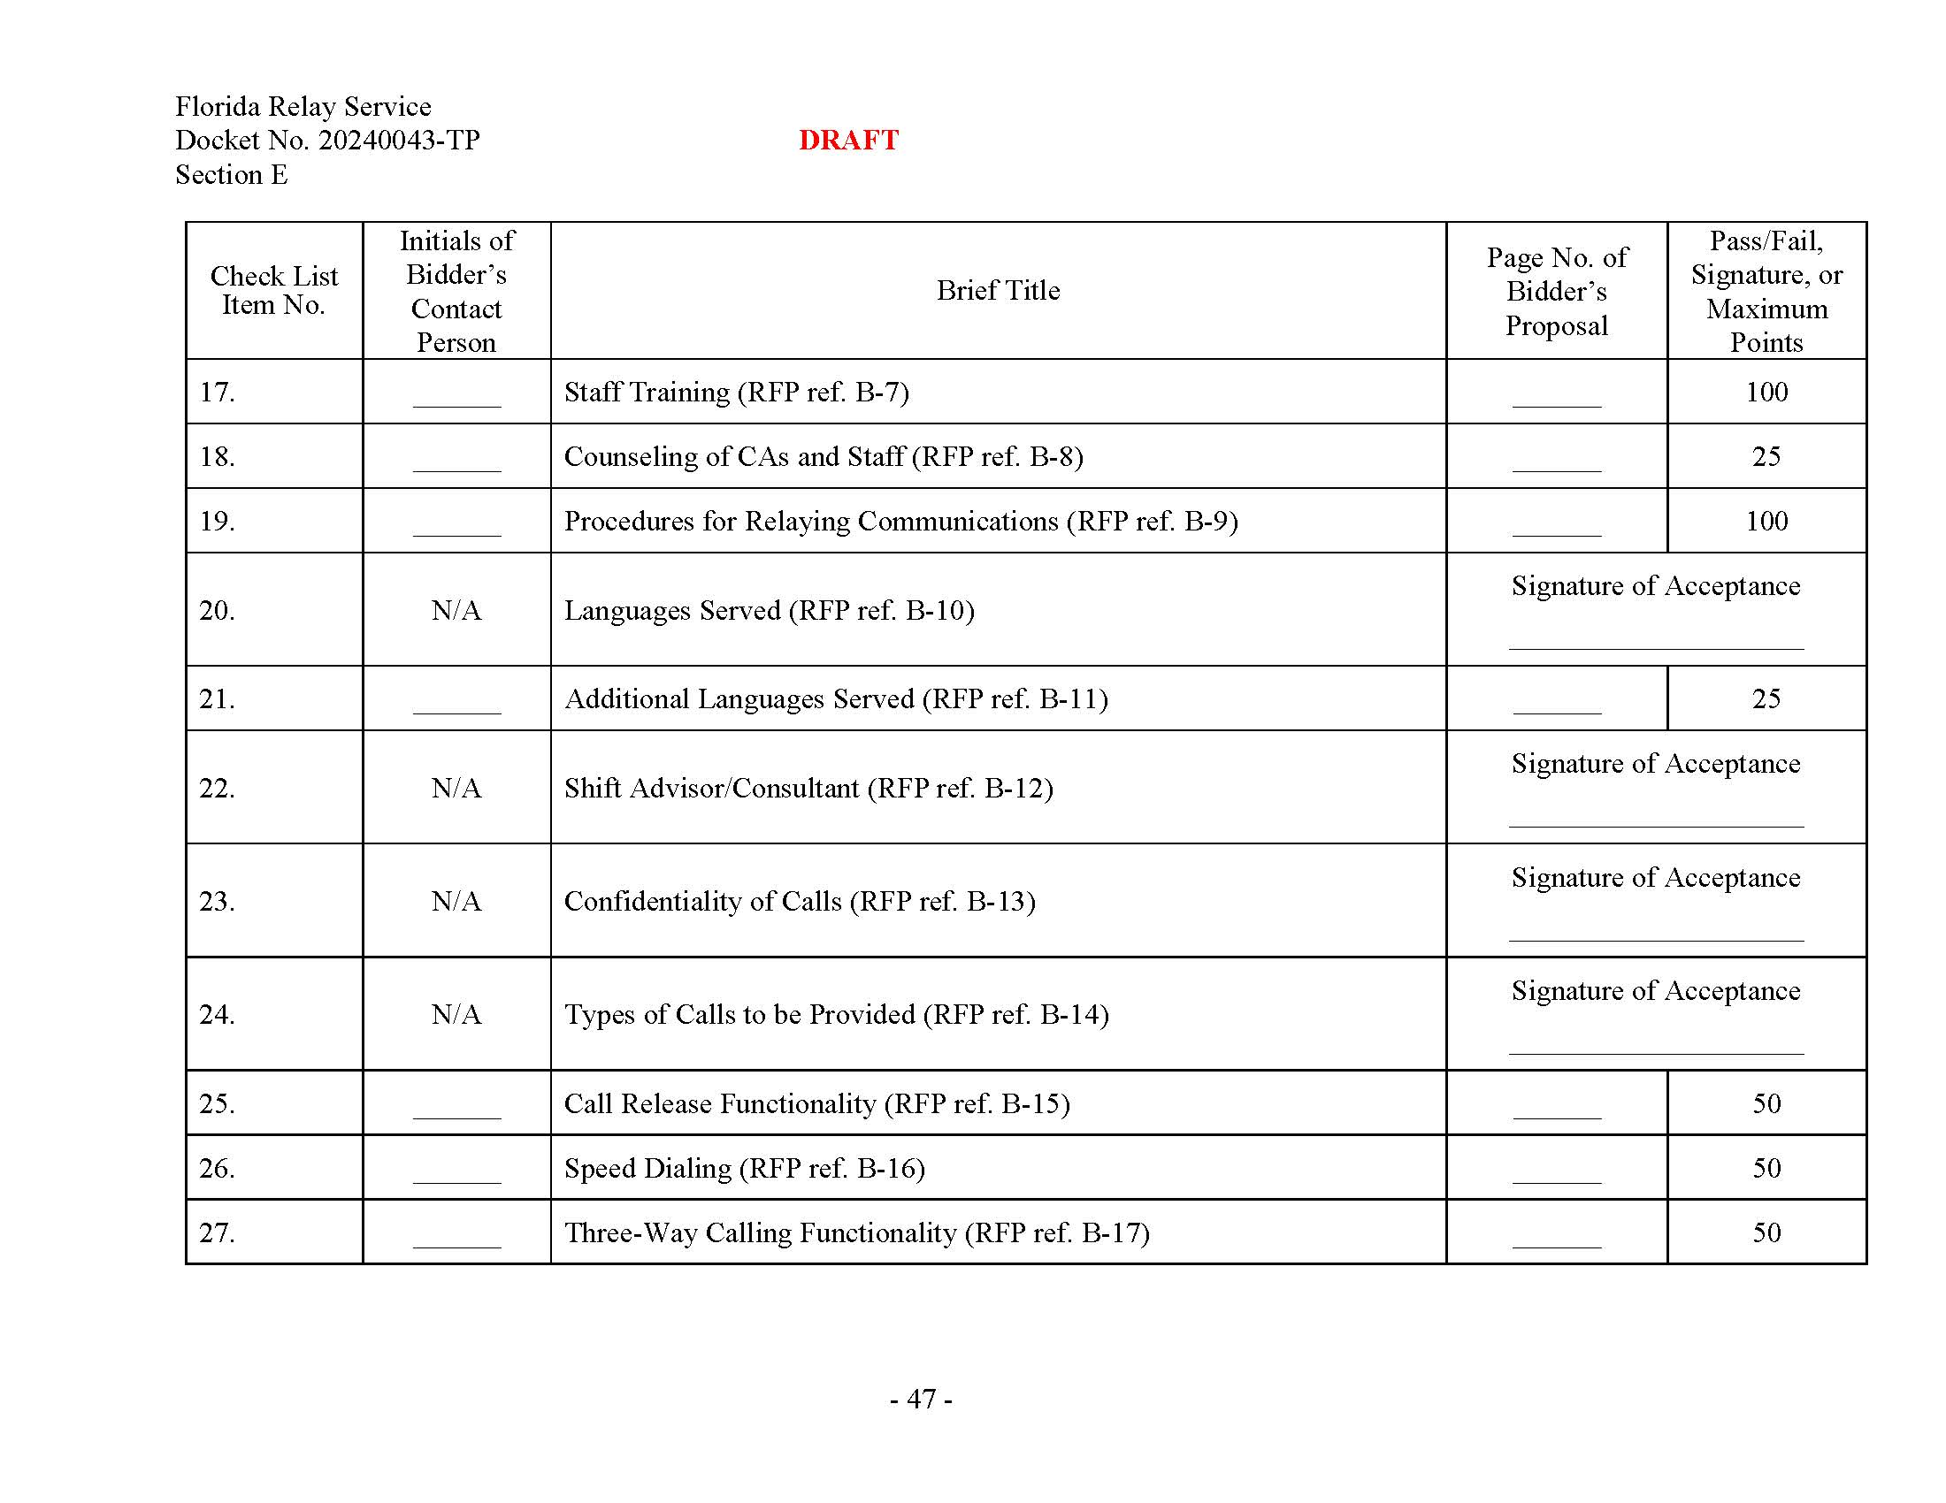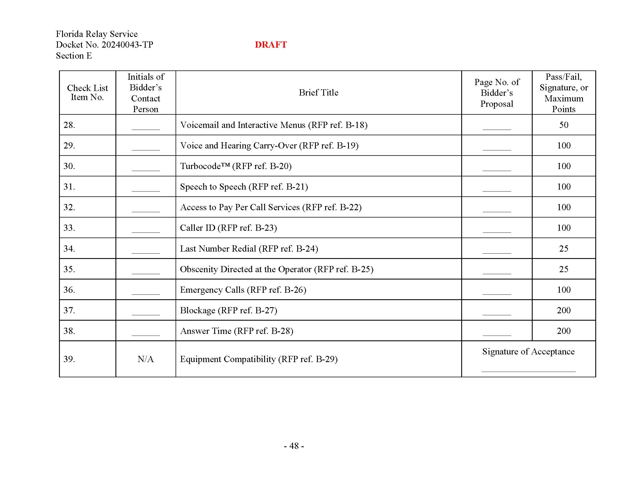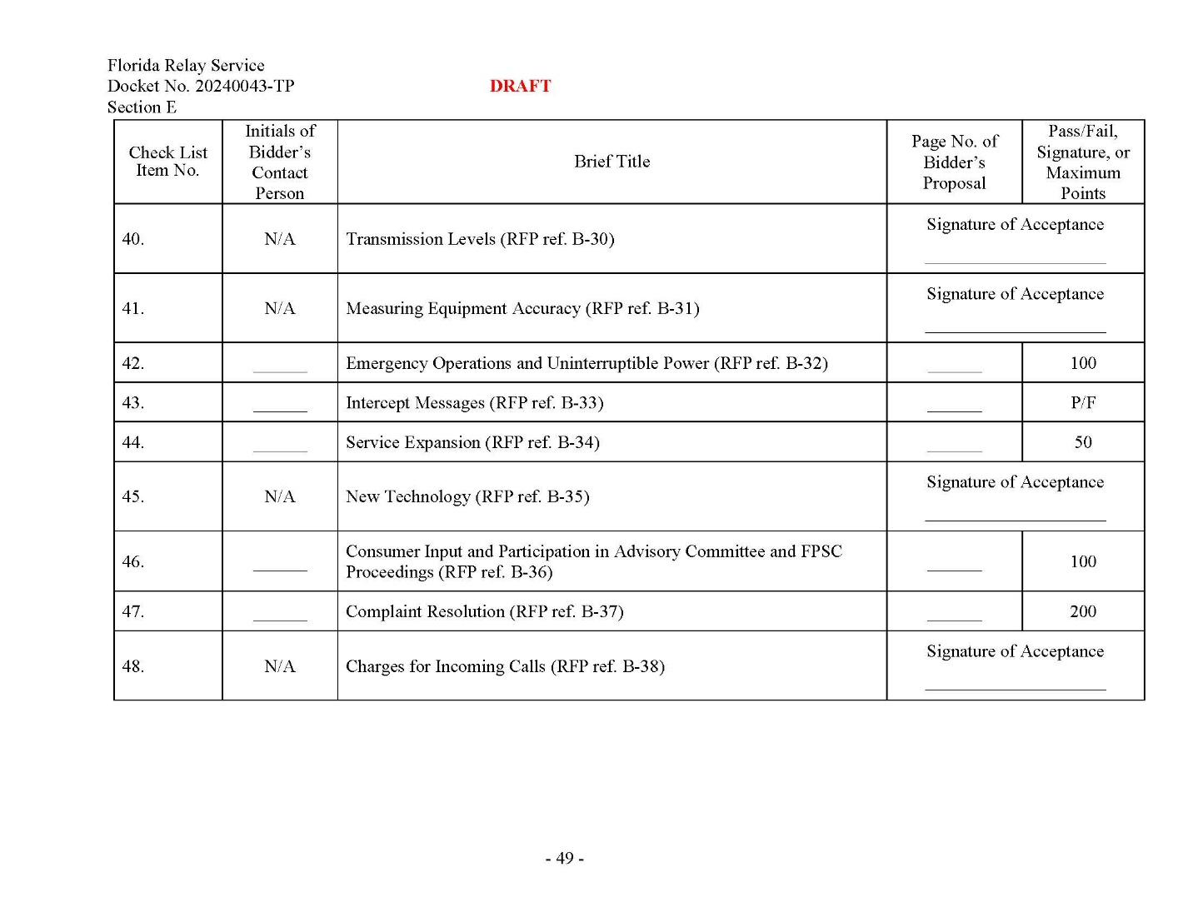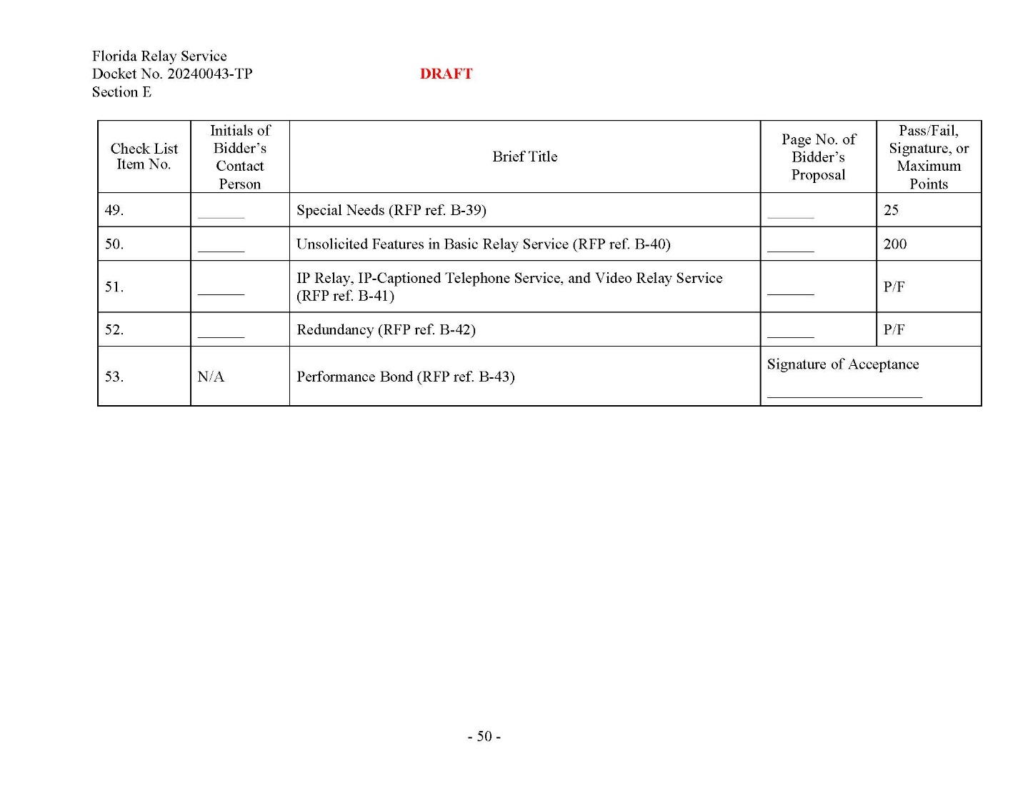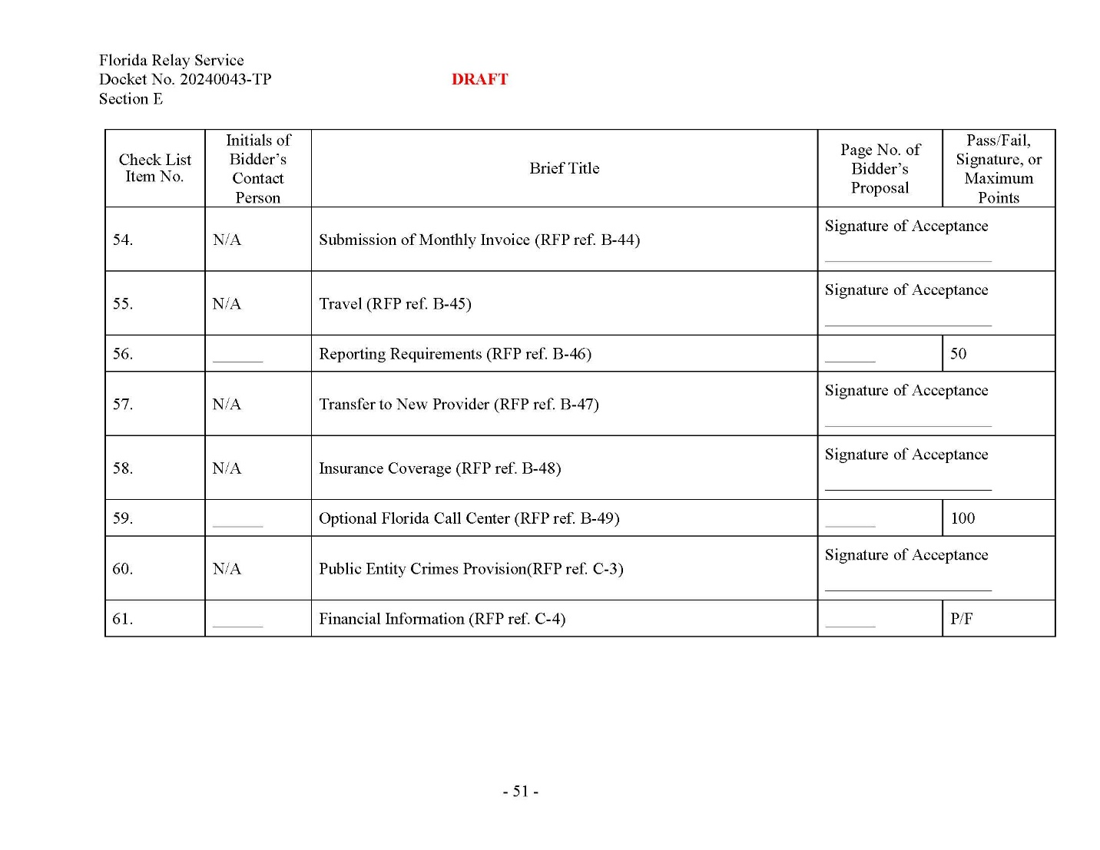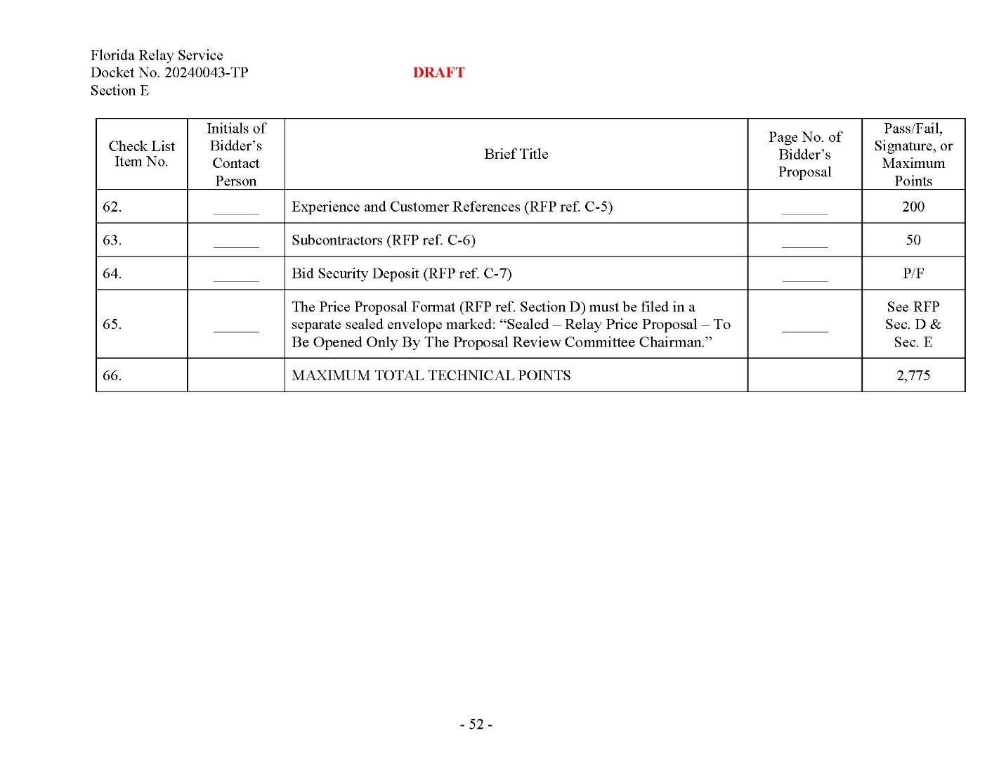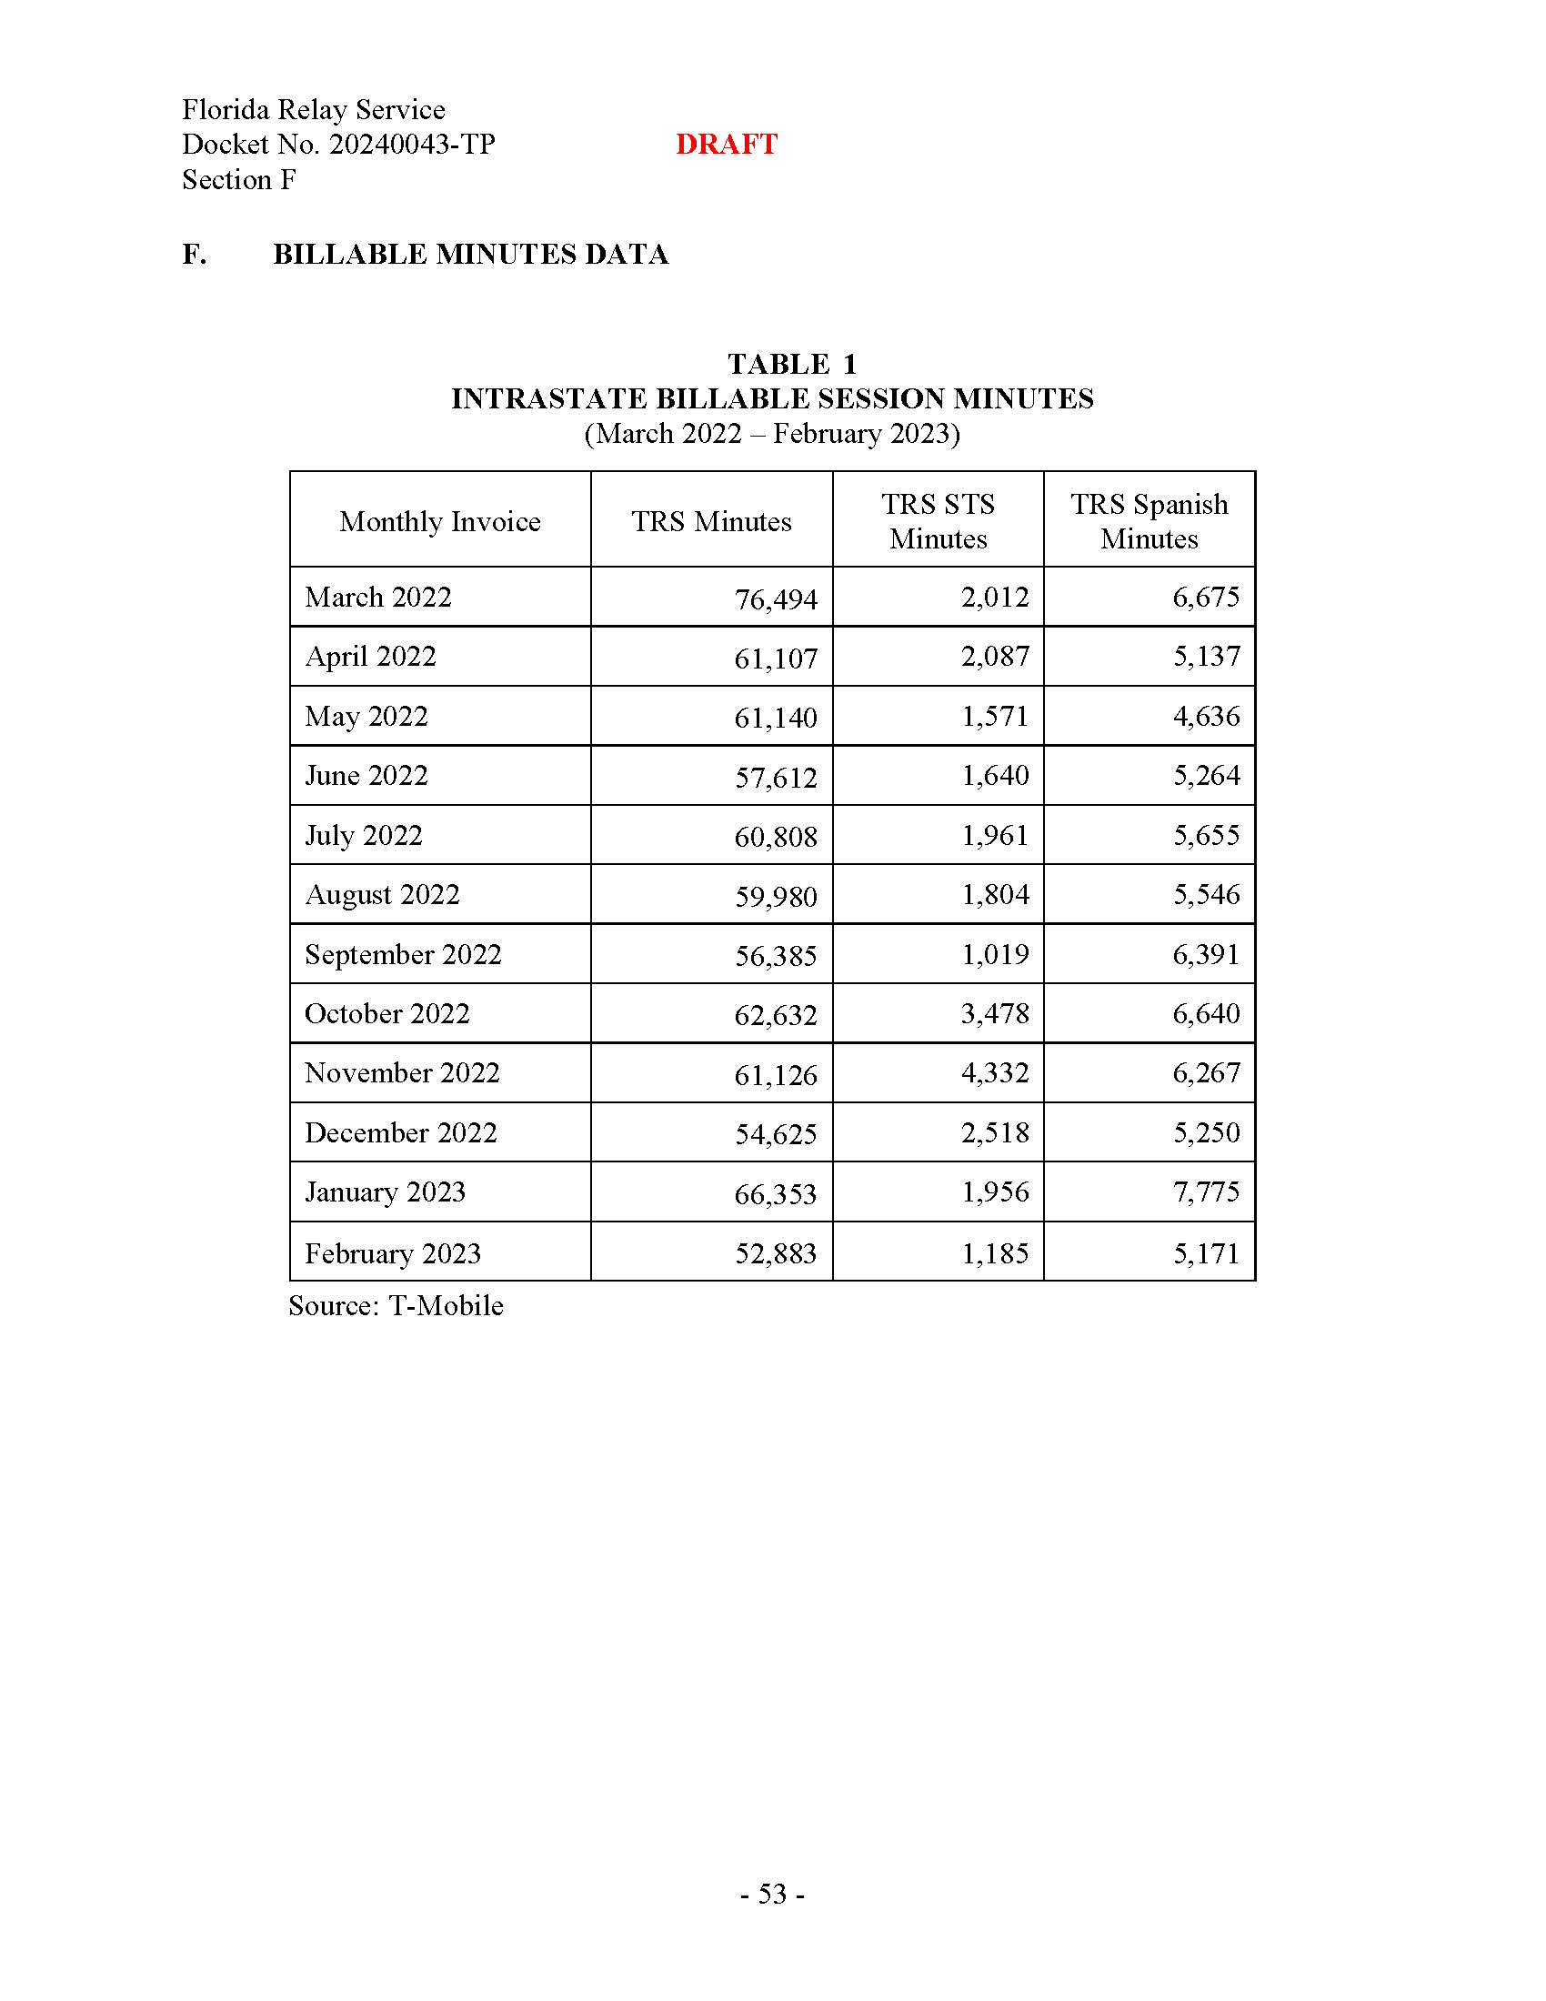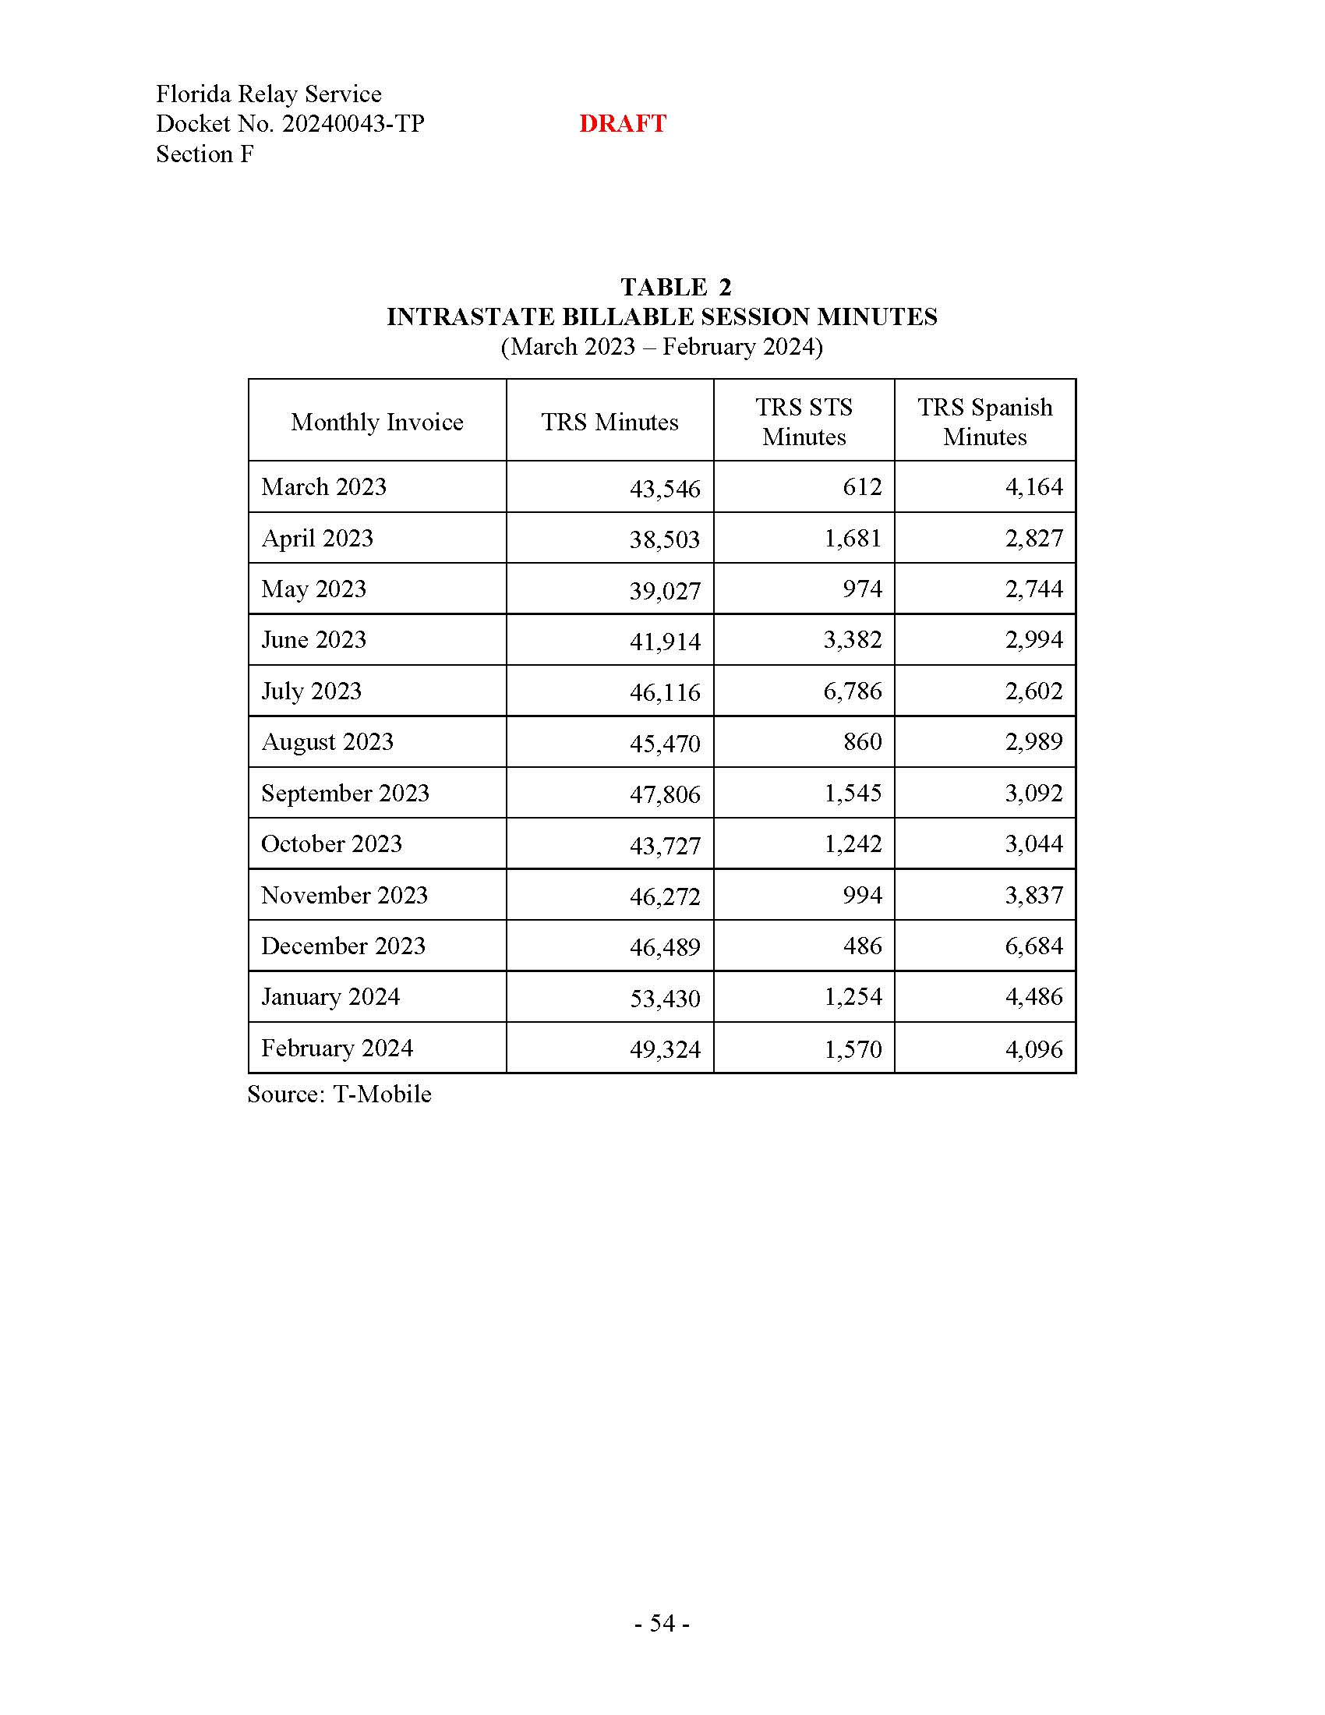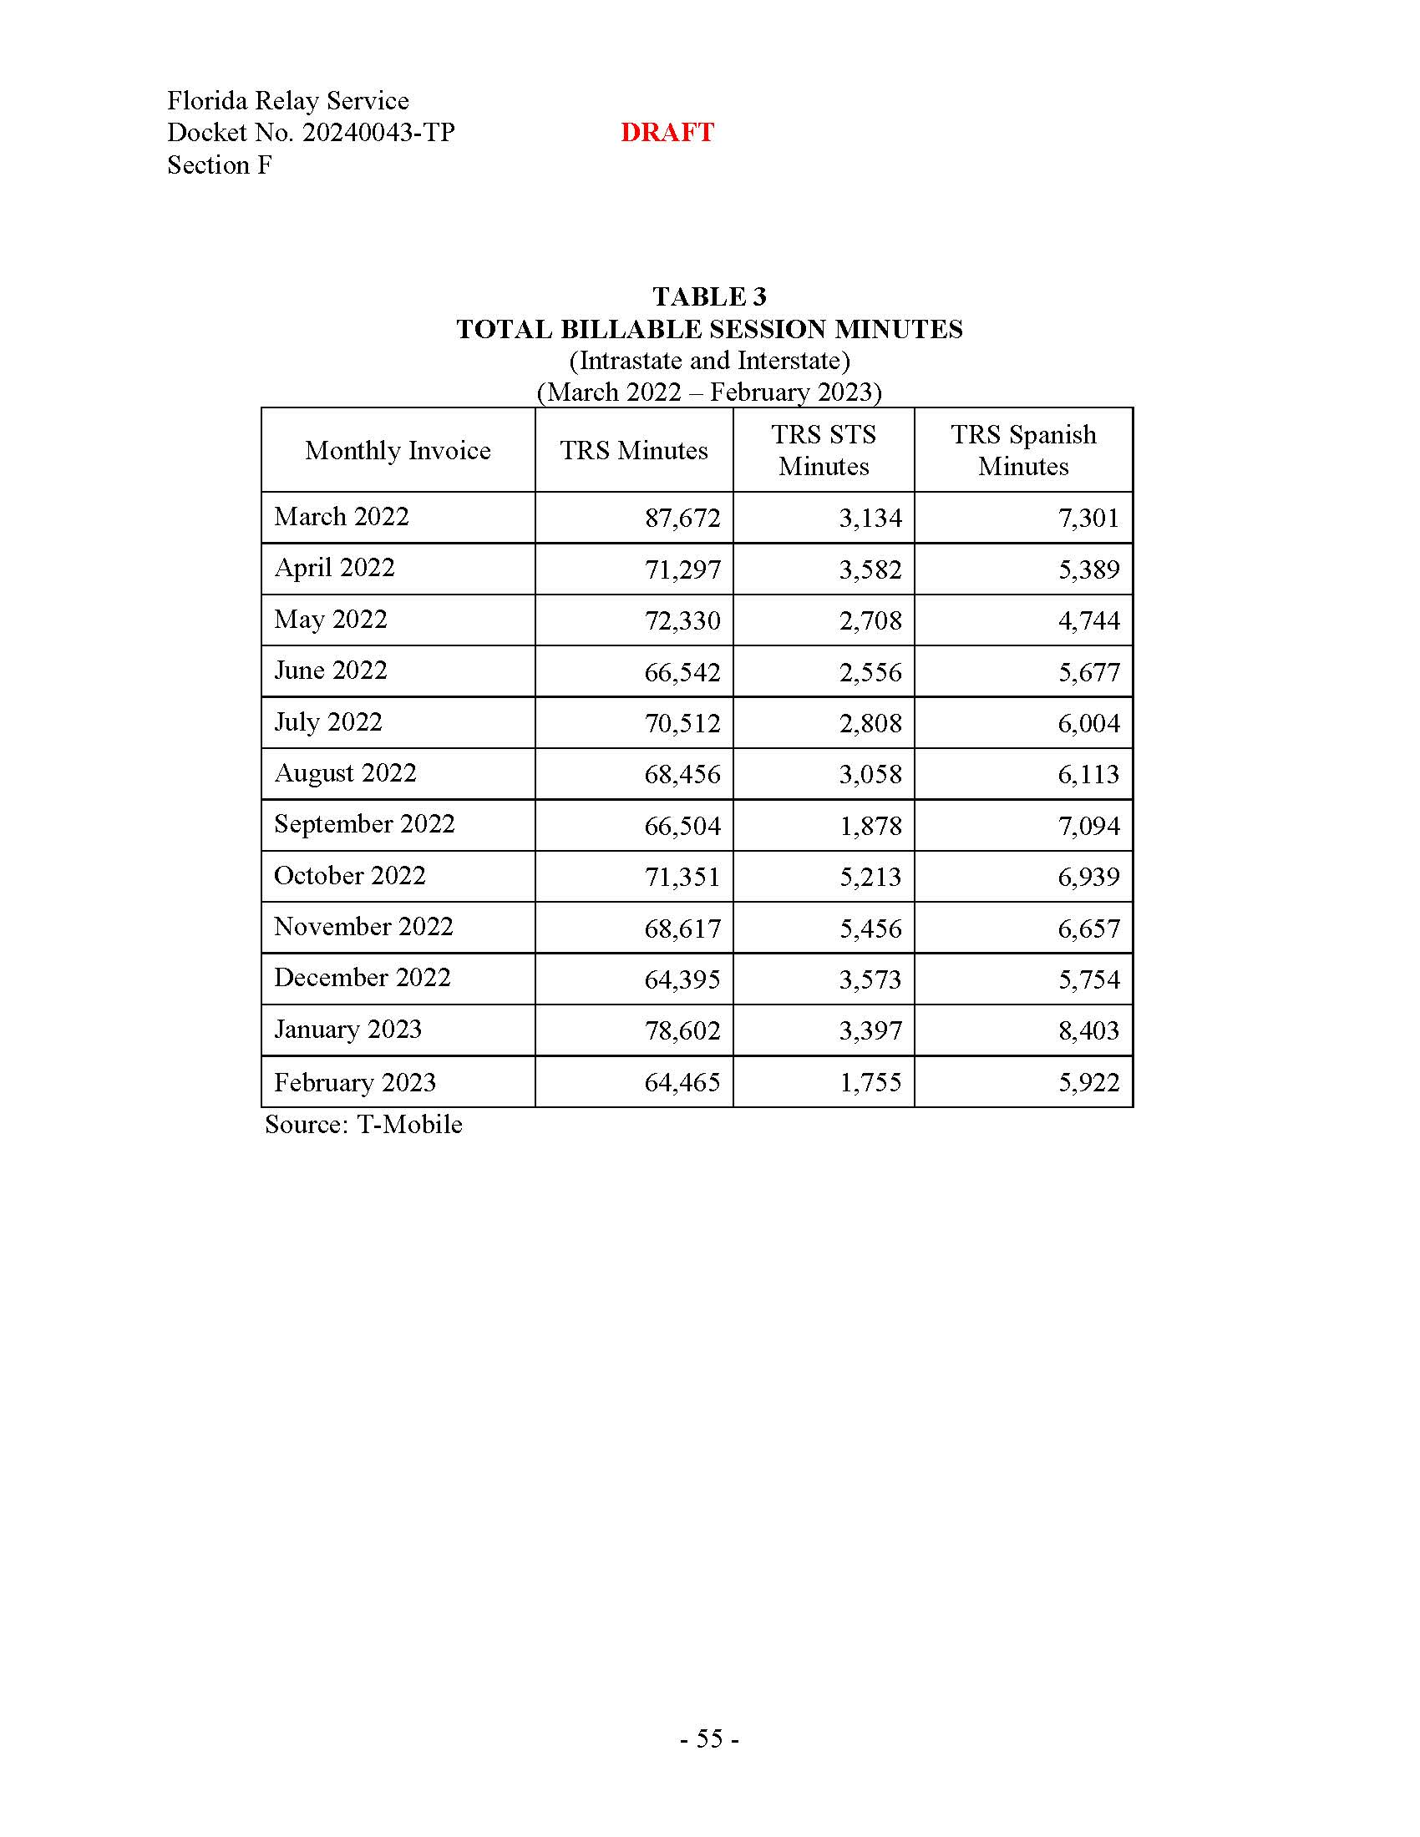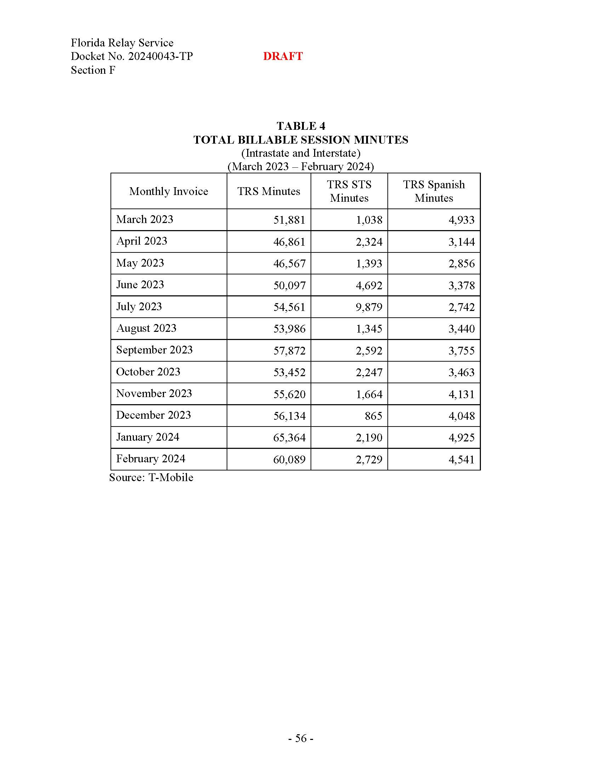

Section 427.704(1), Florida Statute.

