BEFORE THE FLORIDA PUBLIC SERVICE COMMISSION

In re: Petition for limited proceeding for recovery of incremental storm restoration costs related to Hurricanes Ian and Nicole, by Florida Power & Light Company. | DOCKET NO. 20230017-EI  ORDER NO. PSC-2024-0227-S-EI  ISSUED: July 8, 2024

The following Commissioners participated in the disposition of this matter:

MIKE LA ROSA, Chairman
ART GRAHAM
GARY F. CLARK
ANDREW GILES FAY
GABRIELLA PASSIDOMO

FINAL ORDER APPROVING STIPULATIONS

BY THE COMMISSION:

APPEARANCES:

CHRISTOPHER T. WRIGHT and JOEL T. BAKER, ESQUIRES, 700 Universe Blvd., Juno Beach, Florida 33408
On behalf of Florida Power & Light Company (FPL).

WALT TRIERWEILER, Public Counsel, CHARLES REHWINKEL, and PATRICIA A. CHRISTENSEN, ESQUIRES, Office of Public Counsel, c/o The Florida Legislature, 111 W. Madison Street, Room 812, Tallahassee, Florida 32399
On behalf of Office of Public Counsel (OPC).

STEPHANIE U. EATON, ESQUIRE, Spilman, Thomas & Battle, PLLC, 110 Oakwood Drive, Suite 500, Winston-Salem, North Carolina 27103
On behalf of Walmart, Inc. (Walmart).

DERRICK PRICE WILLIAMSON and STEVEN W. LEE, ESQUIRES, Spilman, Thomas & Battle, PLLC, 1100 Bent Creek Blvd., Suite 101, Mechanicsburg, Pennsylvania 17050
On behalf of Walmart, Inc. (Walmart).

SHAW STILLER and DANIEL DOSE, ESQUIRES, Florida Public Service Commission, 2540 Shumard Oak Boulevard, Tallahassee, Florida 32399-0850
On behalf of the Florida Public Service Commission (Staff).

MARY ANNE HELTON, ESQUIRE, Deputy General Counsel, Florida Public Service Commission, 2540 Shumard Oak Boulevard, Tallahassee, Florida 32399-0850
Advisor to the Florida Public Service Commission.

KEITH C. HETRICK, ESQUIRE, General Counsel, Florida Public Service Commission, 2540 Shumard Oak Boulevard, Tallahassee, Florida 32399-0850
Florida Public Service Commission General Counsel

Background

On January 23, 2023, Florida Power & Light Company (FPL of Company) filed a Petition for limited proceeding for recovery of incremental storm restoration costs related to Hurricanes Ian and Nicole. The petition was filed pursuant to the provisions of the Stipulation and Settlement Agreement approved by Final Order as a full resolution of FPL’s most recent base rate case. Under that Settlement and Final Order, FPL can begin recovery of storm costs 60 days following the filing of a petition for recovery.

In its petition, FPL sought authority to implement an interim storm restoration recovery surcharge to recover an estimated total of $1.3 billion for incremental restoration costs related to Hurricanes Ian and Nicole and to replenish the storm reserve to the pre-storm level of $219.9 million. FPL also prepared an alternate storm charge calculation seeking authority to implement an interim storm restoration recovery charge to recover an estimated total of $1.5 billion. This alternate calculation combines the incremental restoration costs related to Hurricanes Ian and Nicole with the remaining amounts to be collected for Hurricanes Michael, Sally, and Zeta, which we previously approved for recovery by Gulf Power Company, and to replenish the storm reserve. We granted FPL’s petition by Order No. PSC-2023-0110-PCO-EI, issued March 3, 2023, and approved a consolidated interim storm surcharge using FPL’s alternate storm charge calculation to cover restoration costs and to replenish the storm reserve. We ordered that this docket remain open pending final disposition (true-up) of storm costs.
On July 28, 2023, FPL filed in this docket a petition for a temporary waiver of or variance from Rule 25-6.0143(1)(g), Florida Administrative Code. FPL requested a waiver of the portion of this Rule that required it to file its petition and documentation concerning disposition of deferred storm costs related to Hurricanes Ian and Nicole not later than September 30, 2023. FPL requested that it be allowed until December 31, 2023, to file its petition and supporting documentation. By Order PSC-2023-0298-PAA-EI, issued October 2, 2023, we granted FPL’s petition and established December 31, 2023, as the Company’s filing deadline.
On September 5, 2023, FPL filed a supplemental petition to reduce the interim storm surcharge based on its internal review and finalization of the invoices and storm costs associated with Hurricanes Ian and Nicole. As a result of this internal process, the estimated incremental storm restoration cost related to the two storms decreased from the original estimate of $1.3 billion to $1.1 billion. Thus, the total estimate reflected in the alternative storm charge calculation decreased from $1.5 billion to $1.3 billion. FPL proposed amended (reduced) interim storm restoration charges applicable to all rate classes, effective with the first billing cycle of January 2024 and continuing through March 2024, subject to a final true-up. We approved FPL’s petition and reduced the interim storm surcharge by Order No. PSC-2023-0354-PAA-EI, issued November 27, 2023.

On November 17, 2023, FPL filed a petition for approval or actual incremental storm restoration costs association with Hurricanes Ian and Nicole and associated true-up process. On December 14, 2023, Order No. PSC-2023-0372-PCO-EI was issued, establishing controlling dates for this proceeding and scheduling an administrative hearing on this petition for June 18-20, 2024. We acknowledged intervention by the Office of Public Counsel (OPC) in this docket by Order No. PSC-2023-0081-FOF-EI, issued February 10, 2023. Intervention was granted to Walmart, Inc. (Walmart) by Order No. PSC-2023-0381-PCO-EI, issued December 20, 2023. We denied the petition for intervention by Jet Blast, Inc., filed May 8, 2024, by Order No. PSC-2023-0186-PCO-EI, issued June 7, 2024.

As part of its Prehearing Statement filed June 4, 2024, FPL submitted a set of Stipulations reached between the Company and OPC as a full and complete resolution of all disputed issues in this proceeding. OPC confirmed in its Prehearing Statement “that these stipulations are reasonable and prudent resolutions to the issues and are in the public interest.” A true and correct copy of the Stipulations is appended to this Order as Attachment A.

At the prehearing on June 11, 2024, Walmart stated that it joined in several of the Stipulations between OPC and FPL, and objected to none. Walmart, OPC, and FPL confirmed to the Prehearing Officer that Commission approval of the proposed Stipulations would constitute a full and complete resolution of all disputed issues in this proceeding, and that a separate vote on the fifteen issues identified in the Prehearing Statement would not be necessary. Walmart committed to submit an appropriate filing to memorialize in writing its position on the Stipulations. The Prehearing Officer then excused Walmart from attendance at the final hearing.

On June 12, 2024, a document titled “Walmart Acceptance of Certain Stipulations” was filed along with the Stipulations previously agreed to by FPL and OPC. Consistent with the representations at the Prehearing Conference, the stated purpose of the Acceptance is to evidence Walmart’s “acceptance and agreement with paragraphs 1-4 and 12-13 of the Stipulations.” Walmart further represented in the Acceptance that it does not object to and takes no position regarding paragraphs 5-11 and 14-16 of the Stipulations. A copy of Walmart’s Acceptance is appended to this Order as Attachment B.

On June 18, 2024, we conducted an administrative hearing for this docket. The prefiled testimony of FPL Witnesses Jarro, Ferguson, De Lucenay, and Cohen, and PSC staff Witness Ngo were admitted into the record. Exhibits 1-24 on the Comprehensive Exhibit list were also admitted into the record without objection. As set forth below, at the June 18, 2024 hearing, we voted to approve all of the stipulations set forth below, thereby resolving all outstanding issues for each party in this docket.

We have jurisdiction pursuant to Sections 366.04, 366.05, 366.06 and 366.076, Florida Statutes.

Decision

The parties proposed Type 1 or Type 2 stipulations to resolve all issues. A Type 1 stipulation occurs on an issue where the utility and intervenors agree on the resolution of the issue. A Type 2 stipulation occurs on an issue when the utility and staff, or the utility and at least one party adversarial to the utility, agree on the resolution of the issue and the remaining parties (including staff if they do not join in the agreement) do not object to the Commission relying on the agreed language to resolve that issue in a final order.

Paragraphs 1-4 and 12-13 of the Stipulations are subject to Type 1 stipulations among all three parties. Paragraphs 5-11 and 14-16 of the Stipulations are subject to Type 2 stipulations. All Stipulations are supported by the record and consistent with controlling law. The stipulations proposed by the parties are the result of negotiations between FPL, OPC, and Walmart and benefit FPL’s customers by establishing an ongoing, continuous storm restoration process improvement plan that results in current and future customers only paying for prudent, cost-effective storm restoration costs incurred due to extreme weather events. We find that approval of the stipulations is in the public interest and supported by the evidence entered at the hearing. Accordingly, we approve the Stipulations as listed in Attachment A and B to this Order as a full and complete resolution of this proceeding.

Consistent with the Stipulations, we grant our staff authority to review and approve FPL’s true-up compliance filing and revised tariff, and to administratively close this docket once these tasks are complete. We further grant our staff the administrative authority to cancel the tariff upon completion of the true-up process.

Based on the foregoing, it is

ORDERED by the Florida Public Service Commission that the stipulations, attached hereto as Attachment A and B, and all findings and rulings herein are hereby approved. It is further

ORDERED that each party to this docket shall abide by the stipulations, findings, and rulings herein which are applicable to it. It is further

ORDERED that Commission staff shall administratively cancel the tariff upon confirmation that the true-up process is complete. It is further

ORDERED that this docket shall be closed administratively once the true-up compliance filing and revised tariff have been received, reviewed, and approved by Commission staff.

By ORDER of the Florida Public Service Commission this 8th day of July, 2024.

/s/ Adam J. Teitzman
ADAM J. TEITZMAN
Commission Clerk
Florida Public Service Commission
2540 Shumard Oak Boulevard
Tallahassee, Florida 32399
(850) 413-6770
www.floridapsc.com

Copies furnished: A copy of this document is provided to the parties of record at the time of issuance and, if applicable, interested persons.

DD

NOTICE OF FURTHER PROCEEDINGS OR JUDICIAL REVIEW

The Florida Public Service Commission is required by Section 120.569(1), Florida Statutes, to notify parties of any administrative hearing or judicial review of Commission orders that is available under Sections 120.57 or 120.68, Florida Statutes, as well as the procedures and time limits that apply. This notice should not be construed to mean all requests for an administrative hearing or judicial review will be granted or result in the relief sought.

Any party adversely affected by the Commission's final action in this matter may request: 1) reconsideration of the decision by filing a motion for reconsideration with the Office of Commission Clerk, 2540 Shumard Oak Boulevard, Tallahassee, Florida 32399-0850, within fifteen (15) days of the issuance of this order in the form prescribed by Rule 25-22.060, Florida Administrative Code; or 2) judicial review by the Florida Supreme Court in the case of an electric, gas or telephone utility or the First District Court of Appeal in the case of a water and/or wastewater utility by filing a notice of appeal with the Office of Commission Clerk, and filing a copy of the notice of appeal and the filing fee with the appropriate court. This filing must be completed within thirty (30) days after the issuance of this order, pursuant to Rule 9.110, Florida Rules of Appellate Procedure. The notice of appeal must be in the form specified in Rule 9.900(a), Florida Rules of Appellate Procedure.

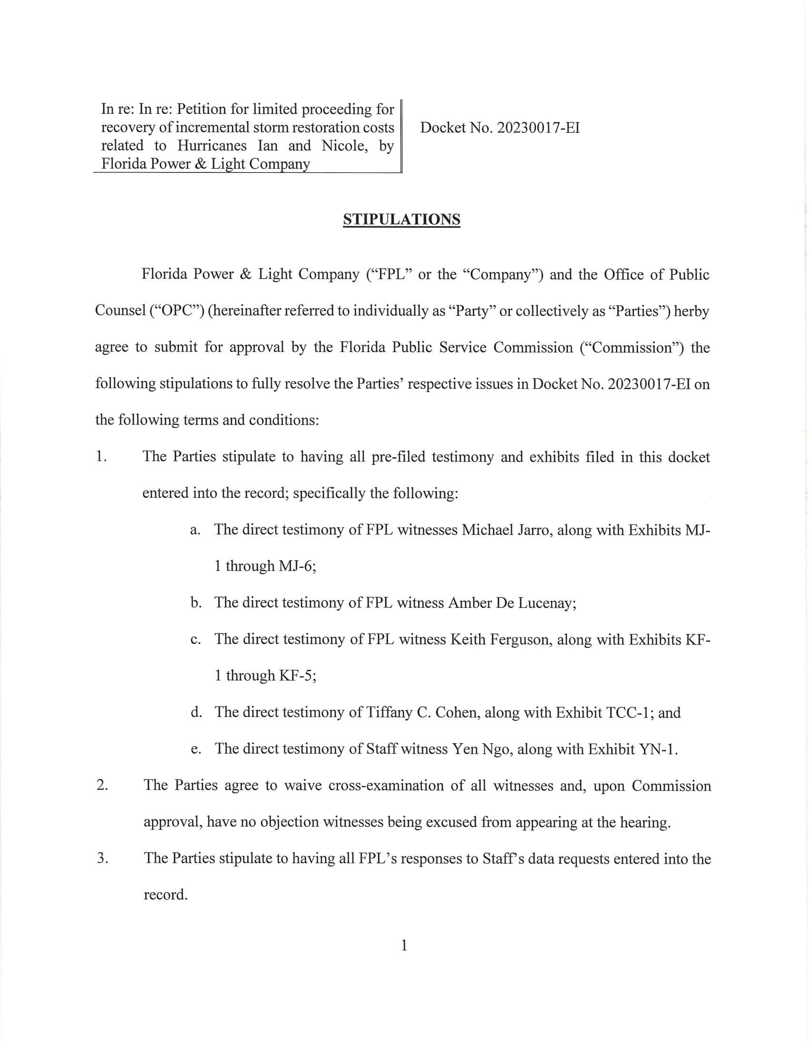

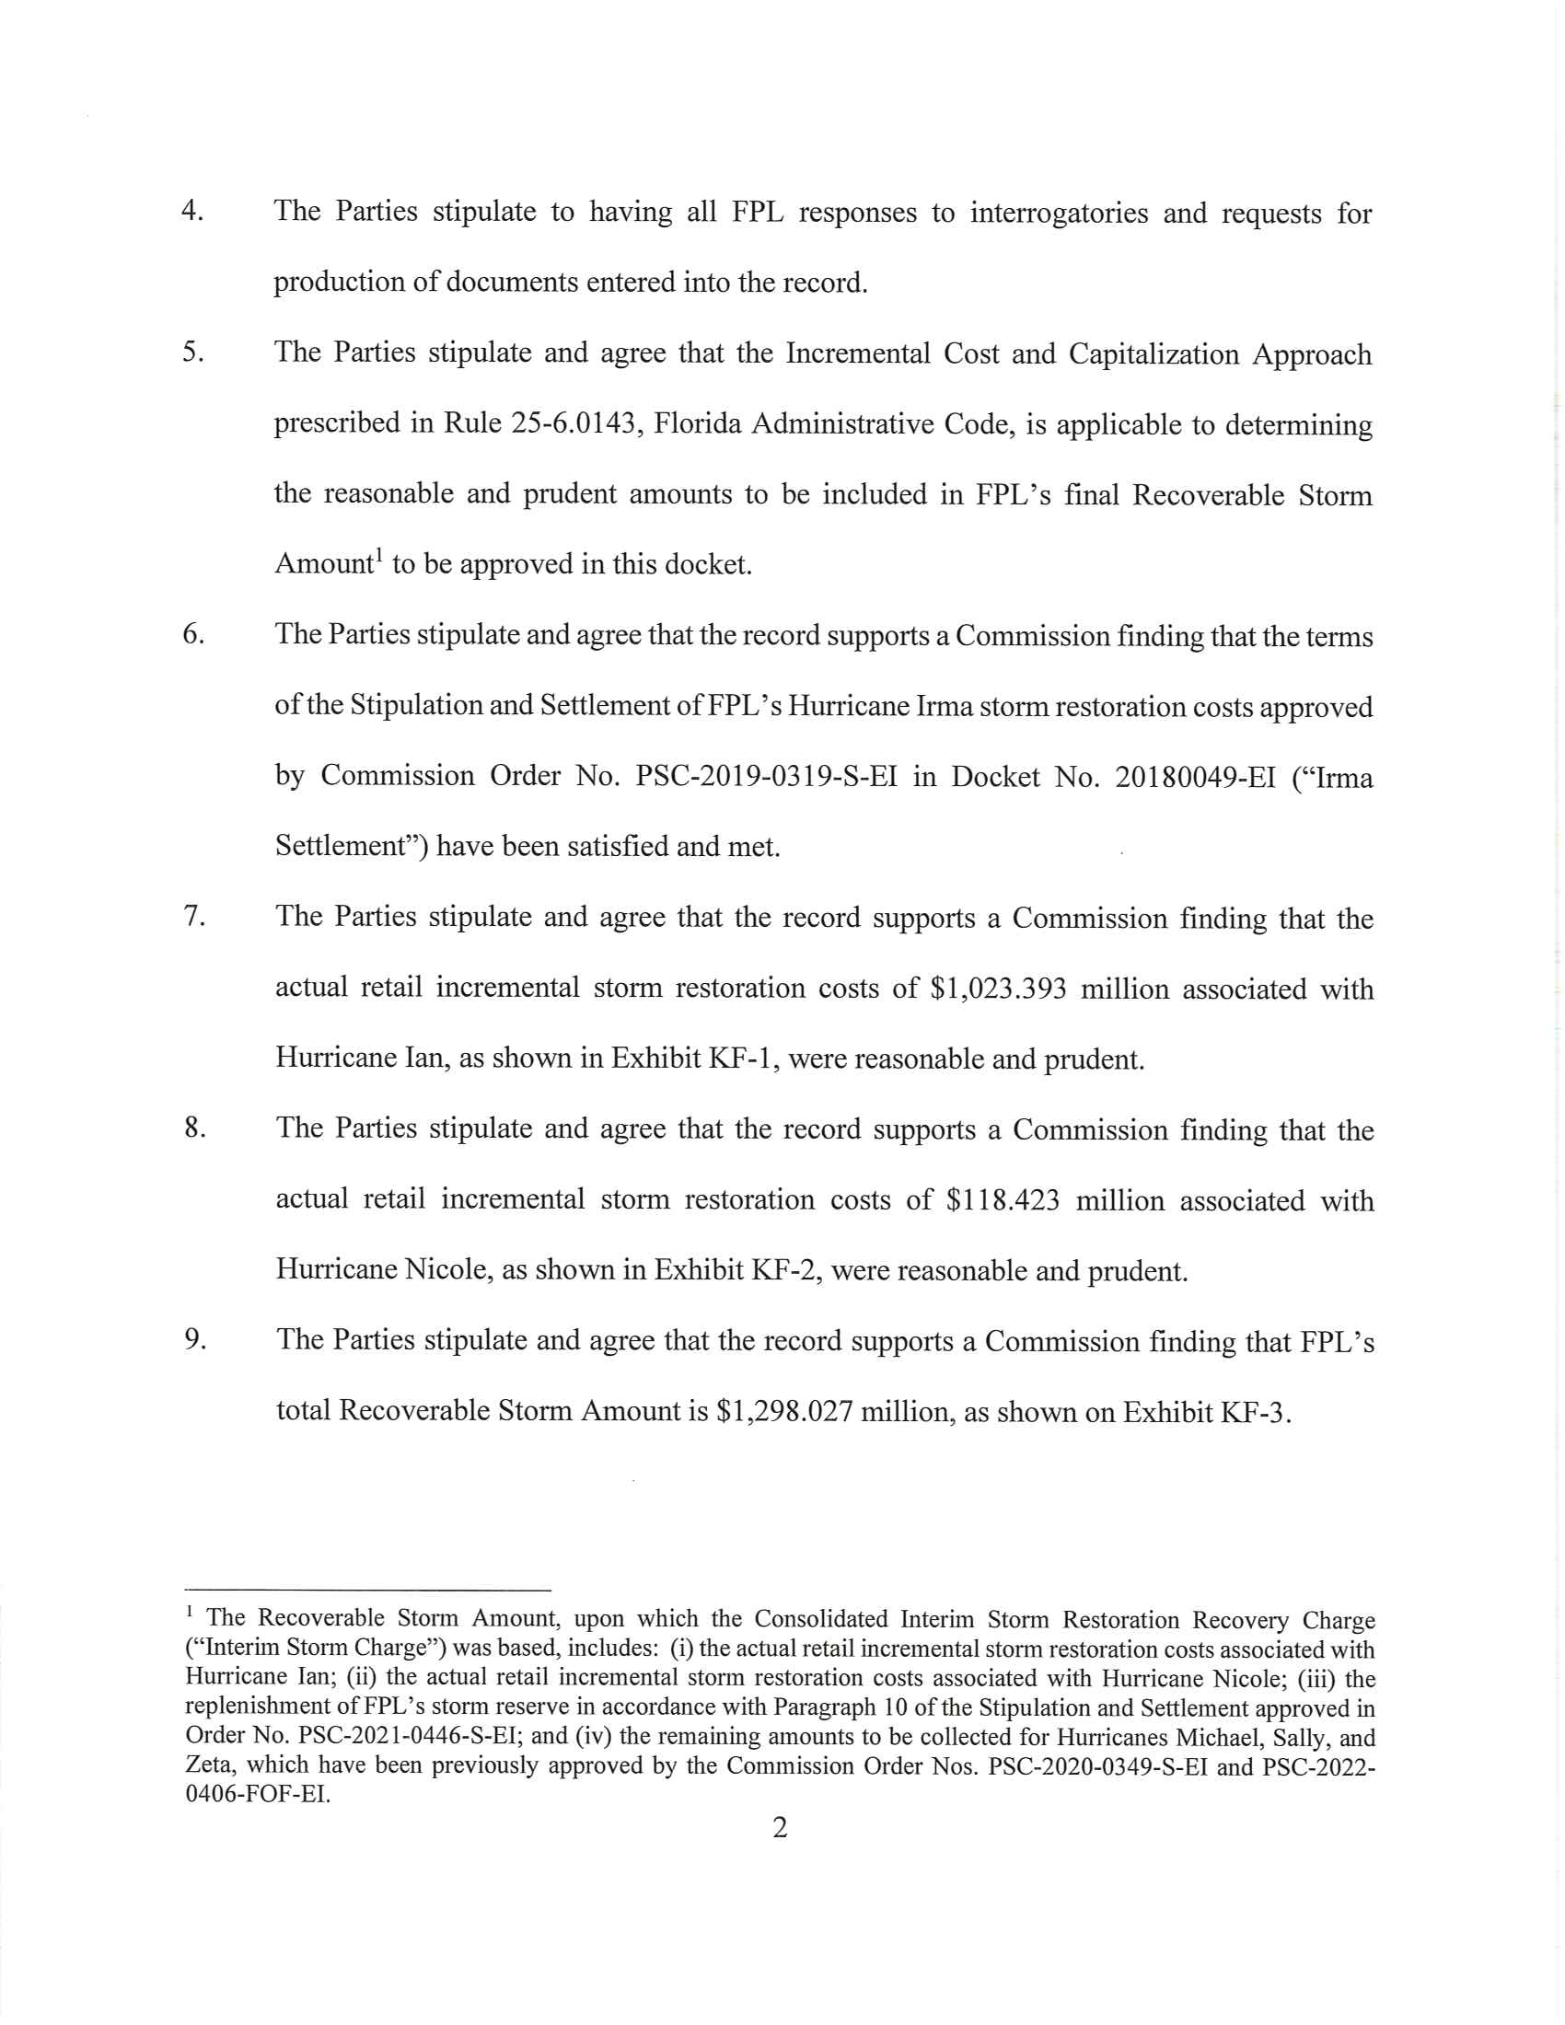

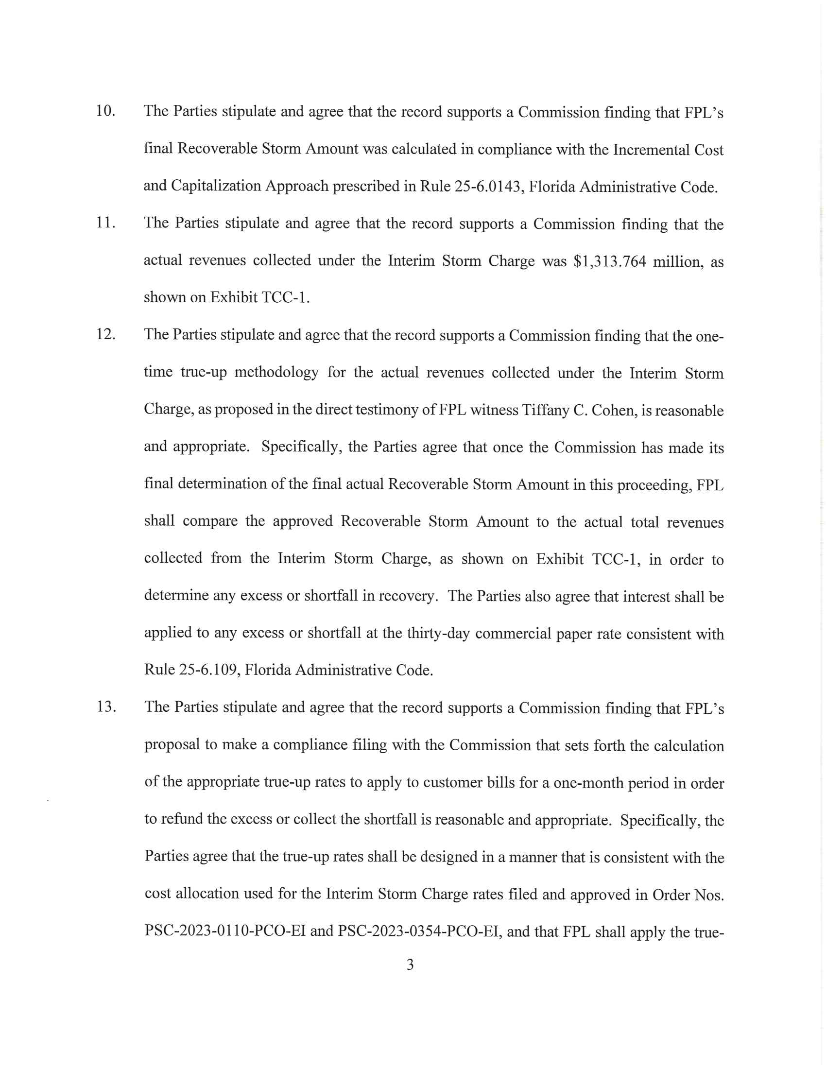

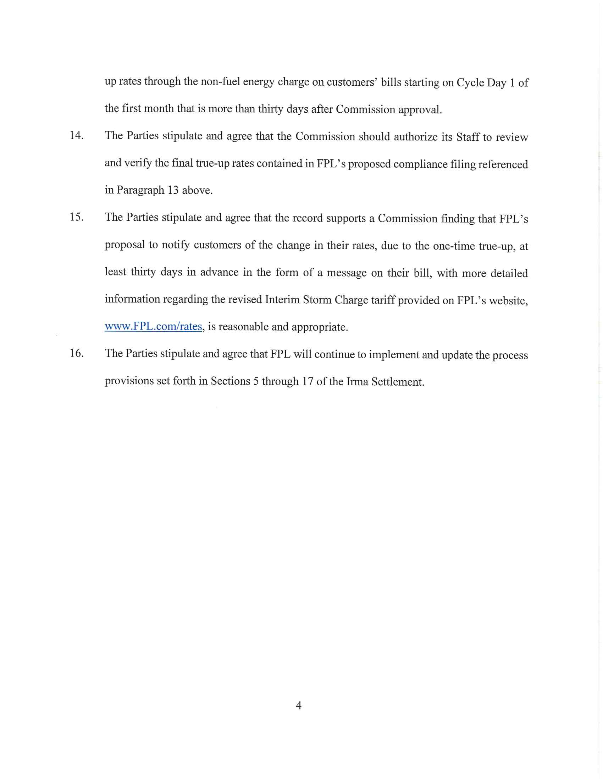

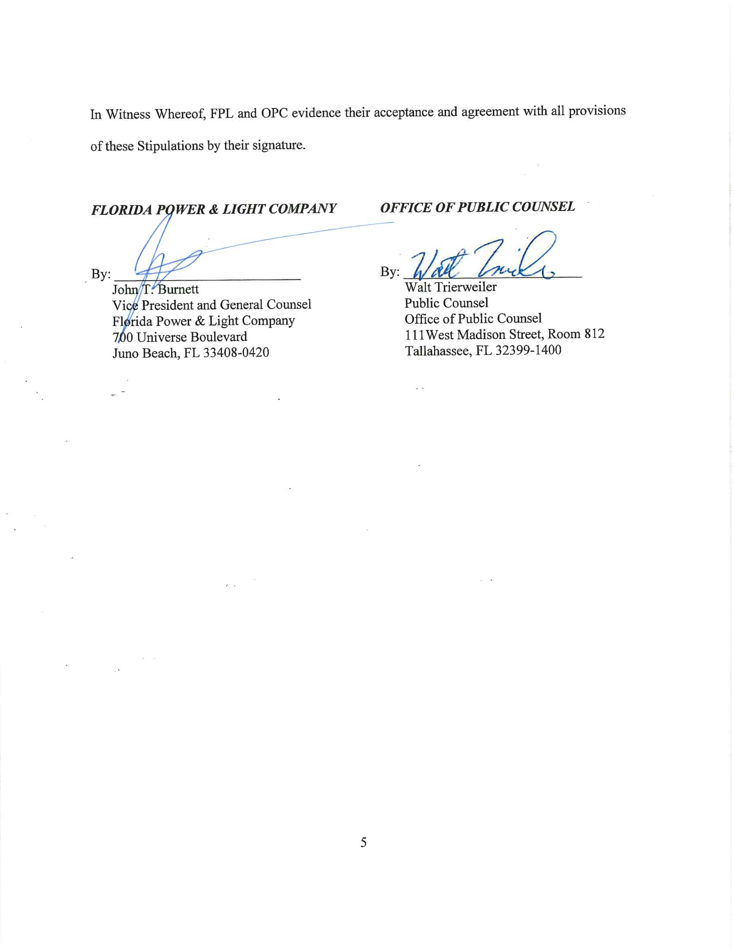
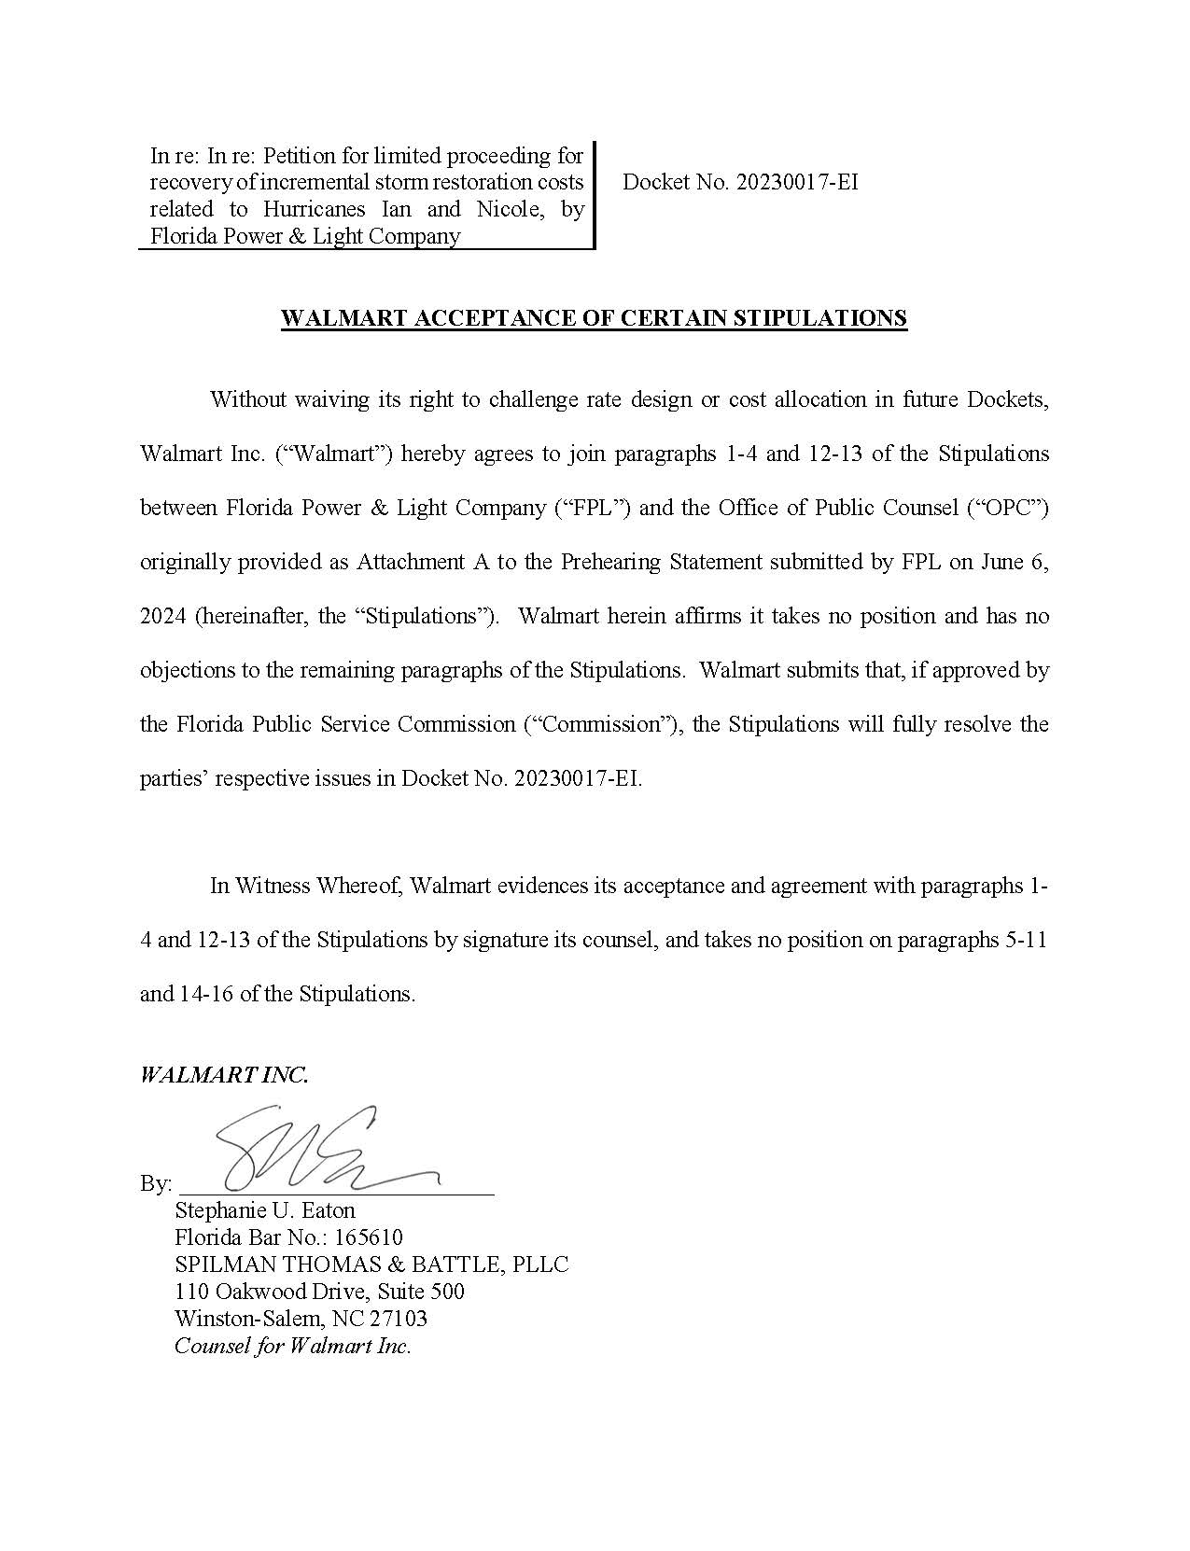

Order No. PSC-2021-0446-S-EI, issued December 2, 2021, in Docket No. 20210015-EI, In re: Petition for rate increase by Florida Power & Light Company.
Order Nos. PSC-2019-0221-PCO-EI and PSC-2022-0406-FOF-EI.

