BEFORE THE FLORIDA PUBLIC SERVICE COMMISSION

In re: Petition for approval of renewable energy tariff and standard offer contract, by Florida Power & Light Company. | DOCKET NO. 20240055-EQ  ORDER NO. PSC-2024-0231-PAA-EQ  ISSUED: July 8, 2024

The following Commissioners participated in the disposition of this matter:

MIKE LA ROSA, Chairman
ART GRAHAM
GARY F. CLARK
ANDREW GILES FAY
GABRIELLA PASSIDOMO

NOTICE OF PROPOSED AGENCY ACTION
ORDER APPROVING FLORIDA POWER & LIGHT COMPANY’S REVISED
RENEWABLE ENERGY TARIFF AND STANDARD OFFER CONTRACT

BY THE COMMISSION:

NOTICE is hereby given by the Florida Public Service Commission (Commission) that the action discussed herein is preliminary in nature and will become final unless a person whose interests are substantially affected files a petition for a formal proceeding, pursuant to Rule 25-22.029, Florida Administrative Code (F.A.C.).

Background

Section 366.91(3), Florida Statutes (F.S.), requires each investor-owned utility (IOU) to continuously offer to purchase capacity and energy from renewable generating facilities (RF) and small qualifying facilities (QF). Commission Rules 25-17.200 through 25-17.310, F.A.C., implement the statute and require each IOU to file with us, by April 1 of each year, a revised standard offer contract based on the next avoidable fossil-fueled generating unit of each technology type identified in the utility’s current Ten-Year Site Plan (TYSP). On April 1, 2024, Florida Power & Light Company (FPL) filed a petition for approval of its amended standard offer contract based on its 2024 TYSP. This Commission has jurisdiction over the amended standard offer contract, pursuant to Sections 366.04 through 366.055, and 366.91, F.S.

Analysis

Section 366.91(3), F.S., and Rule 25-17.250, F.A.C., require that an IOU continuously make available a standard offer contract for the purchase of firm capacity and energy from RFs and small QFs with design capacities of 100 kilowatts (kW) or less. Pursuant to Rules 25-17.250(1) and (3), F.A.C., the standard offer contract must provide a term of at least 10 years, and the payment terms must be based on the utility’s next avoidable fossil-fueled generating unit identified in its most recent TYSP or, if no avoided unit is identified, its next avoidable planned purchase. While FPL’s 2024 TYSP does not feature an avoidable fossil-fueled generating unit or planned purchases that could be deferred during the planning period, FPL has identified a 1,991 megawatt (MW) combined cycle unit with a projected in-service date of June 1, 2034, as the next avoidable planned generating unit based on its current planning process. In order to comply with the Rule, we have previously approved using a unit outside of the TYSP planning period as the avoided unit for standard offer contract purposes.

Under FPL’s standard offer contract, the RF/QF operator commits to certain minimum performance requirements based on the identified avoided unit, such as being operational and delivering an agreed upon amount of capacity by the in-service date of the avoided unit. In this way, the RF/QF thereby becomes eligible for capacity payments, in addition to payments received for energy. The standard offer contract may also serve as a starting point for negotiation of contract terms by providing payment information to an RF/QF operator in a situation where one or both parties desire particular contract terms other than those established in the standard offer.
In order to promote renewable generation, this Commission requires each IOU to offer multiple options for capacity payments, including the options to receive early or levelized payments. If the RF/QF operator elects to receive capacity payments under the normal or levelized contract options, it will receive as-available energy payments only until the in-service date of the avoided unit (in this case June 1, 2034). Thereafter, they begin receiving capacity payments in addition to firm energy payments. If either the early or early levelized option is selected, then the operator will begin receiving capacity payments earlier than the in-service date of the avoided unit. However, payments made under the early capacity payment options tend to be lower in the later years of the contract term, because the net present value (NPV) of the total payments must remain equal for all contract payment options.
Table 1 below contains FPL’s estimates of the annual payments for each payment option available under the revised standard offer contract to an operator with a 50 MW facility operating at a capacity factor of 94 percent, which is the minimum capacity factor required under the contract to qualify for full capacity payments. Normal and levelized capacity payments begin with the projected in-service date of the avoided unit (June 1, 2034) and continue for 10 years, while early and early levelized capacity payments begin four (4) years prior to the in-service date, or 2030 in this case.

Table 0 - Estimated Annual Payments to a 50 MW Renewable Facility
(94% Capacity Factor)
Year | Energy Payment | Capacity Payment
 |  | Normal | Levelized | Early | Early Levelized
 | $(000) | $(000) | $(000) | $(000) | $(000)
2025 | 12,342 | - | - | - | -
2026 | 14,585 | - | - | - | -
2027 | 15,291 | - | - | - | -
2028 | 15,058 | - | - | - | -
2029 | 17,741 | - | - | - | -
2030 | 15,811 | - | - | 1,779 | 1,989
2031 | 13,216 | - | - | 3,086 | 3,409
2032 | 13,126 | - | - | 3,151 | 3,409
2033 | 14,806 | - | - | 3,216 | 3,409
2034 | 15,877 | 3,075 | 3,336 | 3,283 | 3,409
2035 | 16,332 | 5,336 | 5,718 | 3,352 | 3,409
2036 | 15,161 | 5,447 | 5,718 | 3,421 | 3,409
2037 | 16,969 | 5,560 | 5,718 | 3,493 | 3,409
2038 | 18,061 | 5,676 | 5,718 | 3,565 | 3,409
2039 | 20,314 | 5,794 | 5,718 | 3,639 | 3,409
2040 | 20,694 | 5,915 | 5,718 | 3,715 | 3,409
2041 | 21,951 | 6,038 | 5,718 | 3,793 | 3,409
2042 | 22,091 | 6,164 | 5,718 | 3,872 | 3,409
2043 | 23,705 | 6,292 | 5,718 | 3,952 | 3,409
2044 | 26,567 | 2,644 | 2,383 | 1,661 | 1,420
Total | 349,700 | 57,944 | 57,183 | 48,978 | 47,728
Total (NPV) | 157,383 | 18,252 | 18,252 | 18,252 | 18,252
Source: FPL’s Response to Commission Staff’s First Data Request

FPL’s amended standard offer contract, in type-and-strike format, is included as Attachment A to this Order. The changes made to FPL’s tariff sheets are consistent with the updated avoided unit. Revisions include updates to calendar dates and payment information, which reflect the current economic and financial assumptions for the avoided unit.

Decision

We find that the provisions of FPL’s renewable energy tariff and amended standard offer contract conform to the requirements of Rules 25-17.200 through 25-17.310, F.A.C. The amended standard offer contract offers multiple payment options so that a developer of renewable generation may select the payment stream best suited to its financial needs. Therefore, we approve the renewable energy tariff and amended standard offer contract.
Based on the foregoing, it is

ORDERED by the Florida Public Service Commission that Florida Power & Light Company’s Petition for Approval of a Renewable Energy Tariff and Standard Offer Contract is GRANTED. The revised renewable energy tariff and amended standard offer contract are approved as set forth herein. It is further

ORDERED that the provisions of this Order, issued as proposed agency action, shall become final and effective upon the issuance of a Consummating Order unless an appropriate petition, in the form provided by Rule 28-106.201, F.A.C., is received by the Commission Clerk, 2540 Shumard Oak Boulevard, Tallahassee, Florida 32399-0850, by the close of business on the date set forth in the “Notice of Further Proceedings or Judicial Review” attached hereto. It is further

ORDERED that in the event this Order becomes final, this docket shall be closed.

By ORDER of the Florida Public Service Commission this 8th day of July, 2024.

/s/ Adam J. Teitzman
ADAM J. TEITZMAN
Commission Clerk
Florida Public Service Commission
2540 Shumard Oak Boulevard
Tallahassee, Florida 32399
(850) 413-6770
www.floridapsc.com

Copies furnished: A copy of this document is provided to the parties of record at the time of issuance and, if applicable, interested persons.

CMM

NOTICE OF FURTHER PROCEEDINGS OR JUDICIAL REVIEW

The Florida Public Service Commission is required by Section 120.569(1), Florida Statutes, to notify parties of any administrative hearing that is available under Section 120.57, Florida Statutes, as well as the procedures and time limits that apply. This notice should not be construed to mean all requests for an administrative hearing will be granted or result in the relief sought.

Mediation may be available on a case-by-case basis. If mediation is conducted, it does not affect a substantially interested person's right to a hearing.

The action proposed herein is preliminary in nature. Any person whose substantial interests are affected by the action proposed by this order may file a petition for a formal proceeding, in the form provided by Rule 28-106.201, Florida Administrative Code. This petition must be received by the Office of Commission Clerk, 2540 Shumard Oak Boulevard, Tallahassee, Florida 32399-0850, by the close of business on July 29, 2024.

In the absence of such a petition, this order shall become final and effective upon the issuance of a Consummating Order.

Any objection or protest filed in this docket before the issuance date of this order is considered abandoned unless it satisfies the foregoing conditions and is renewed within the specified protest period.

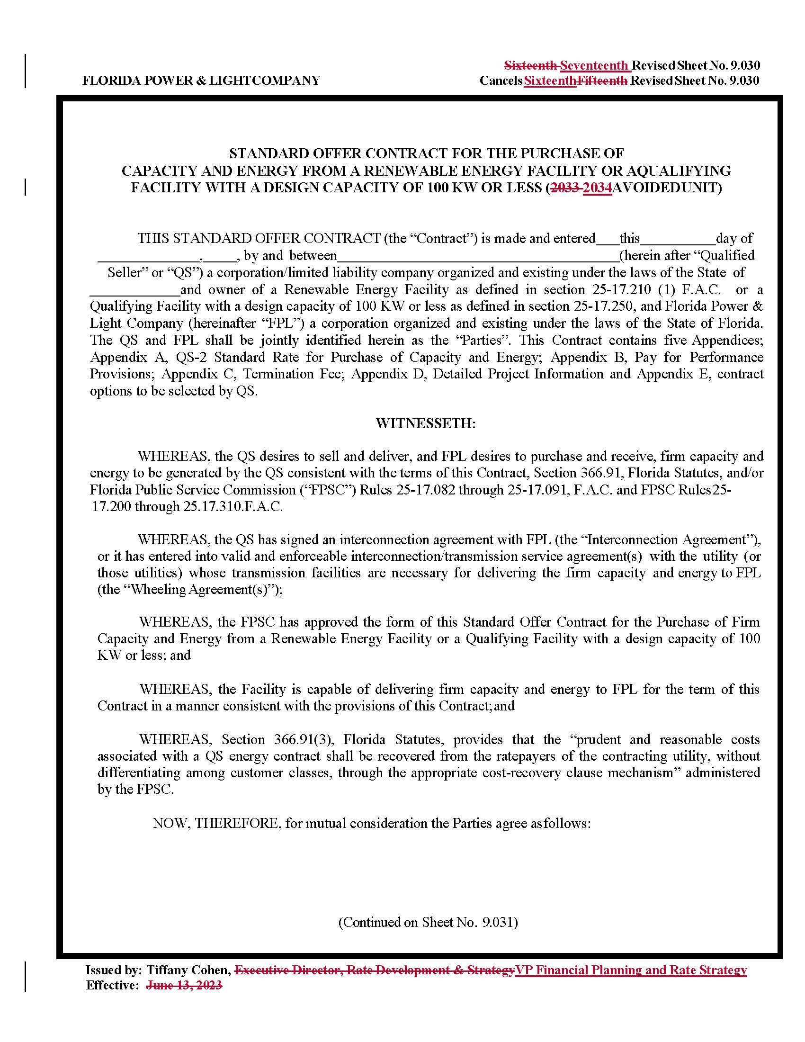
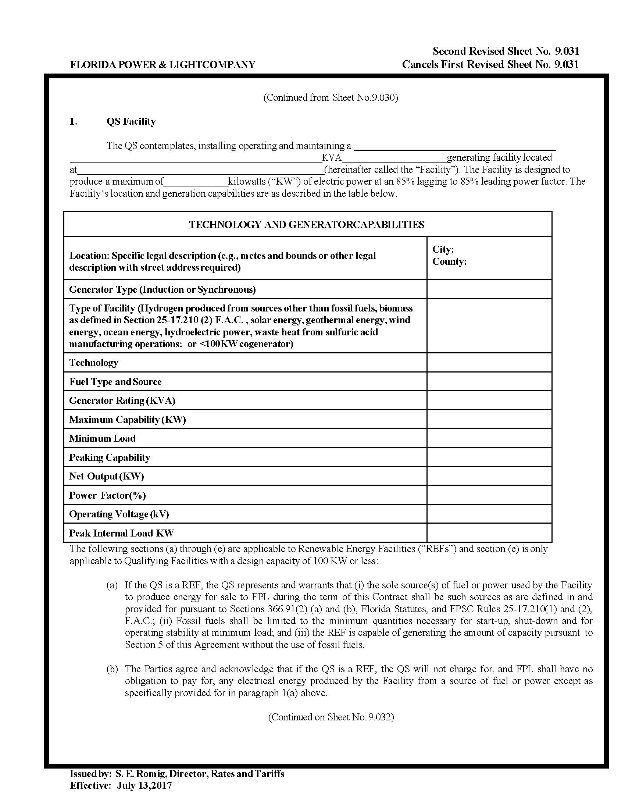
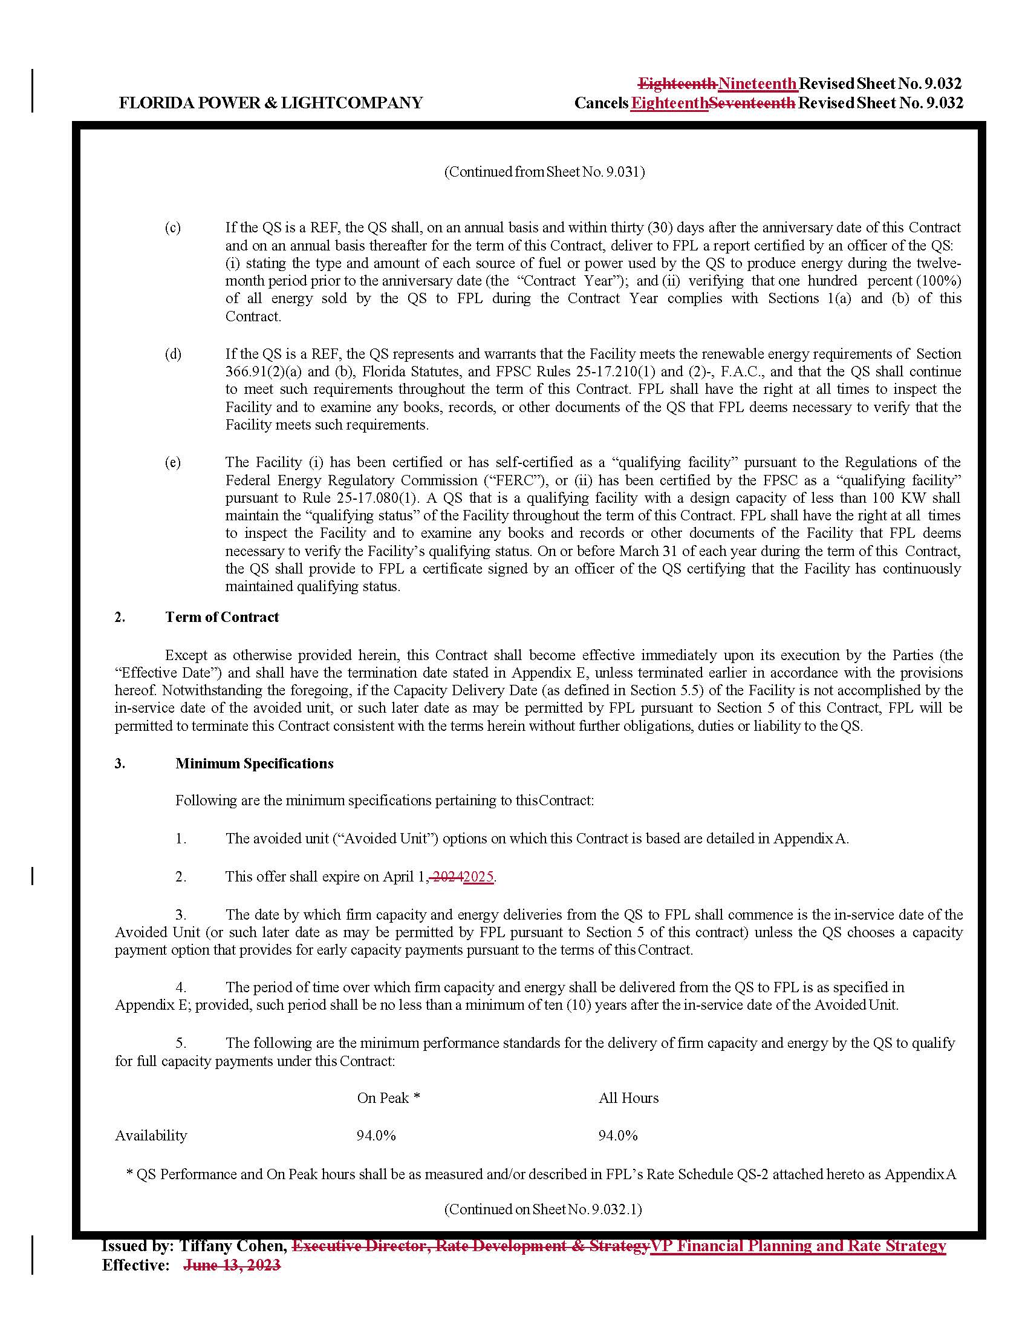
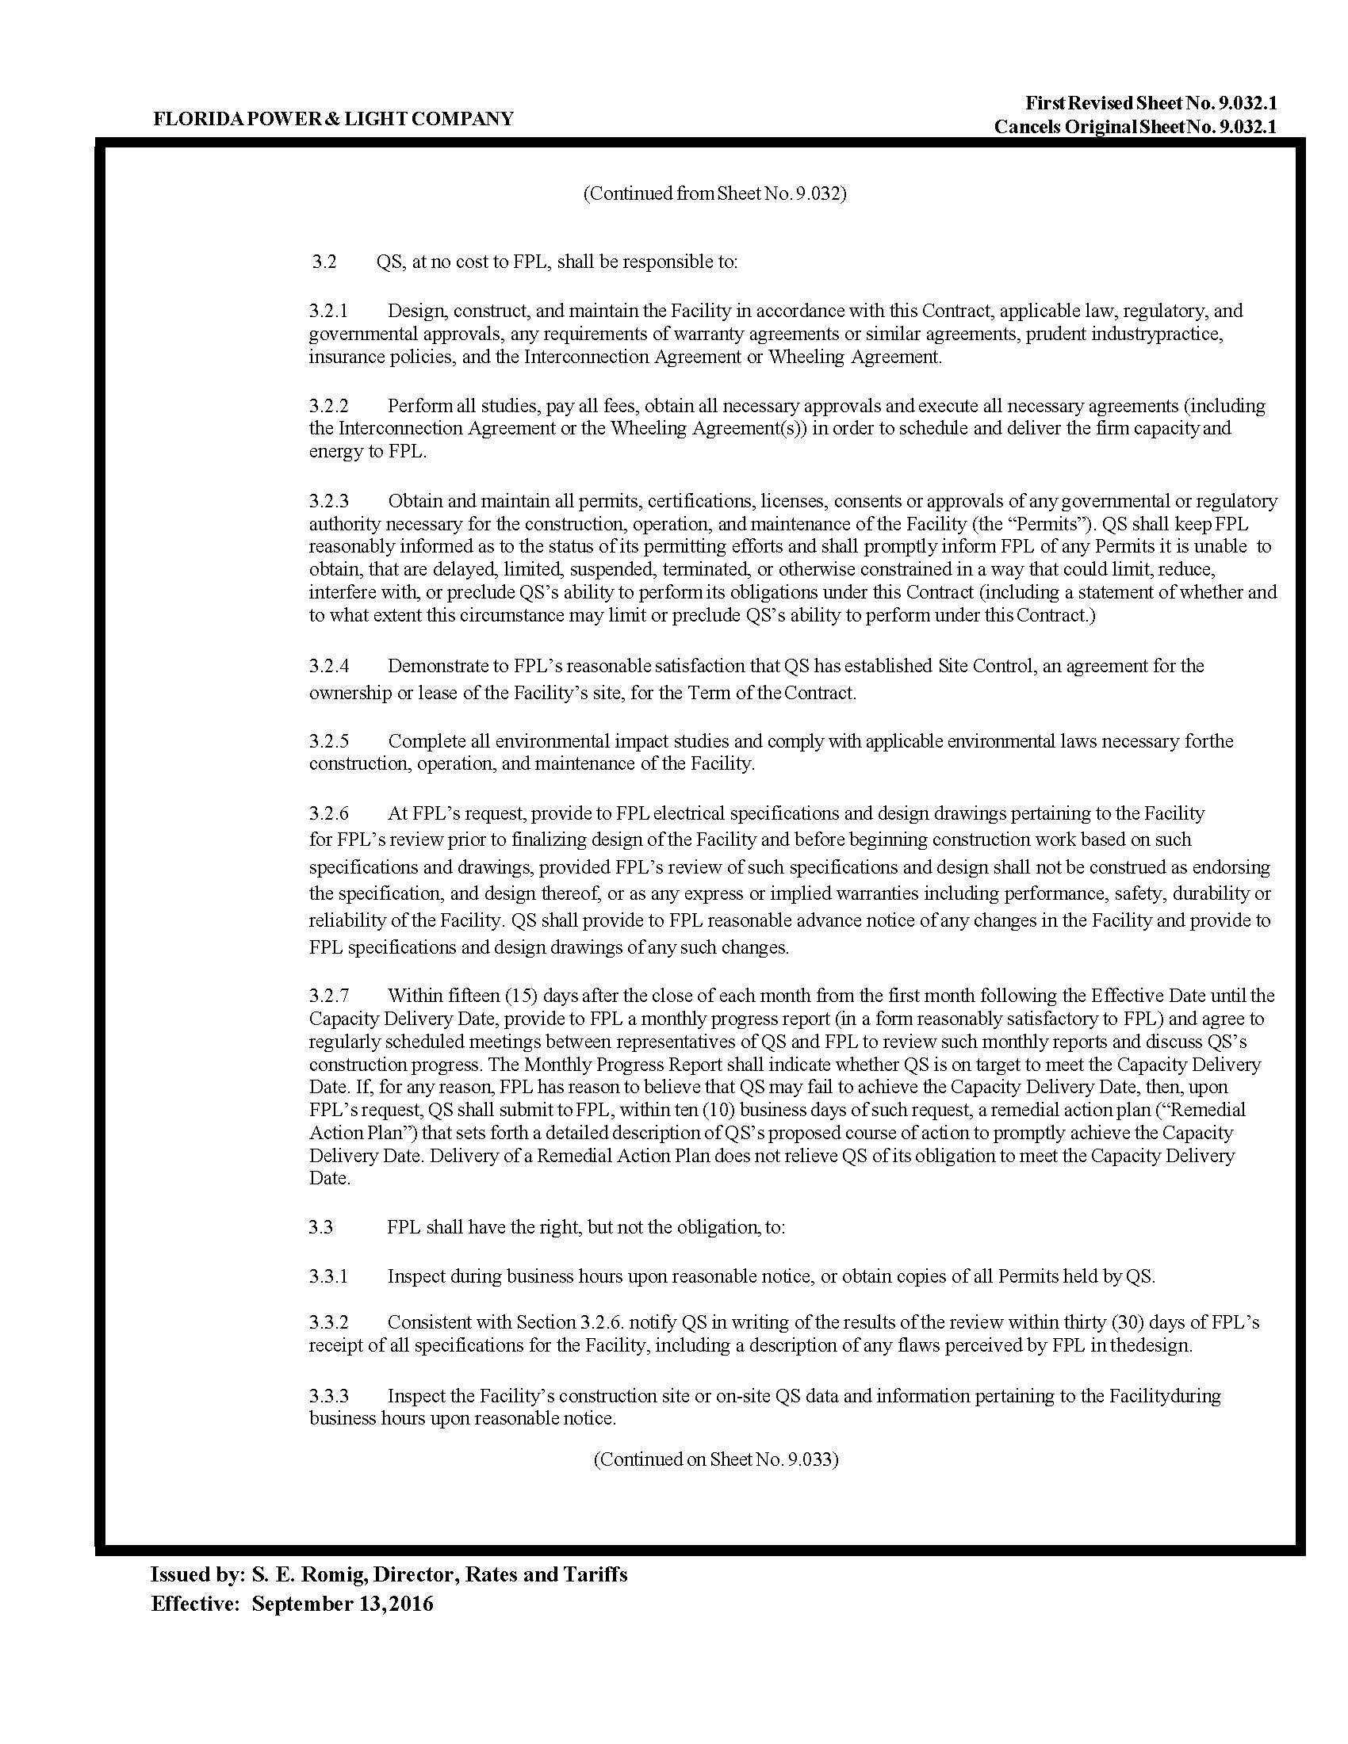
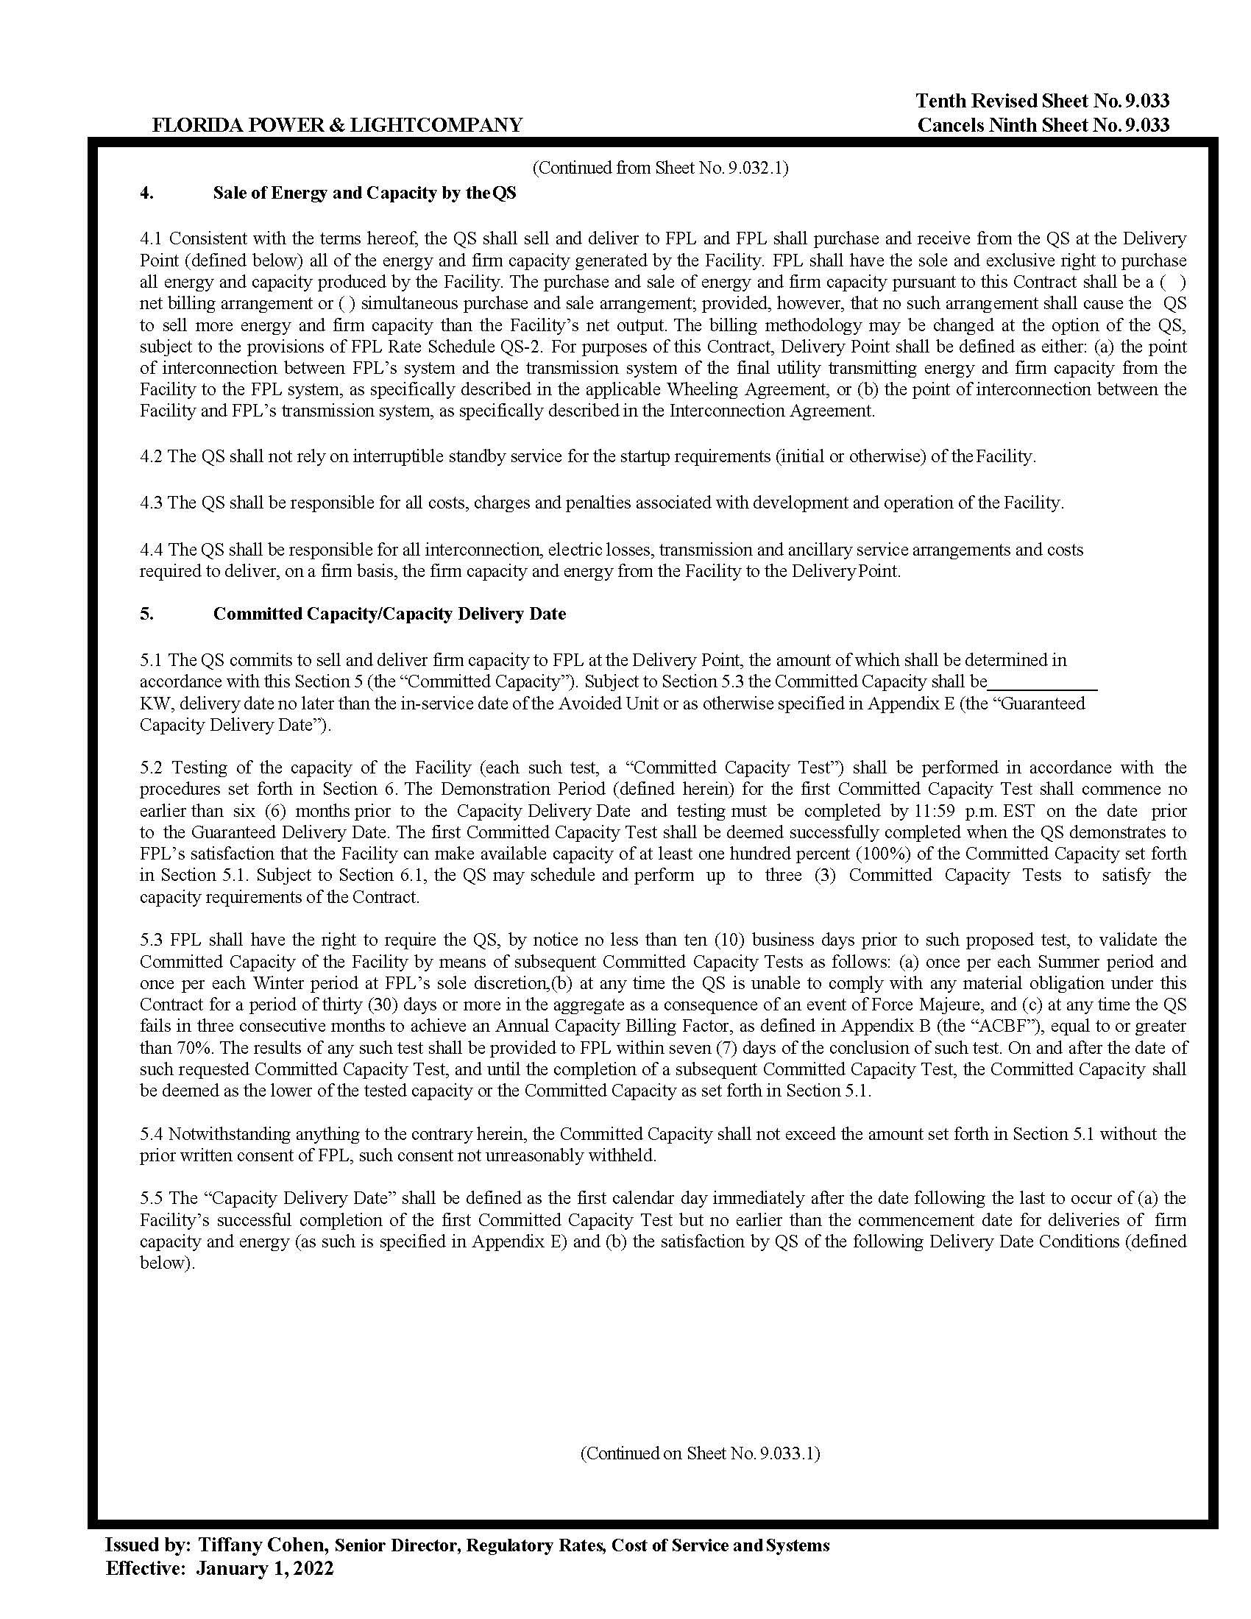
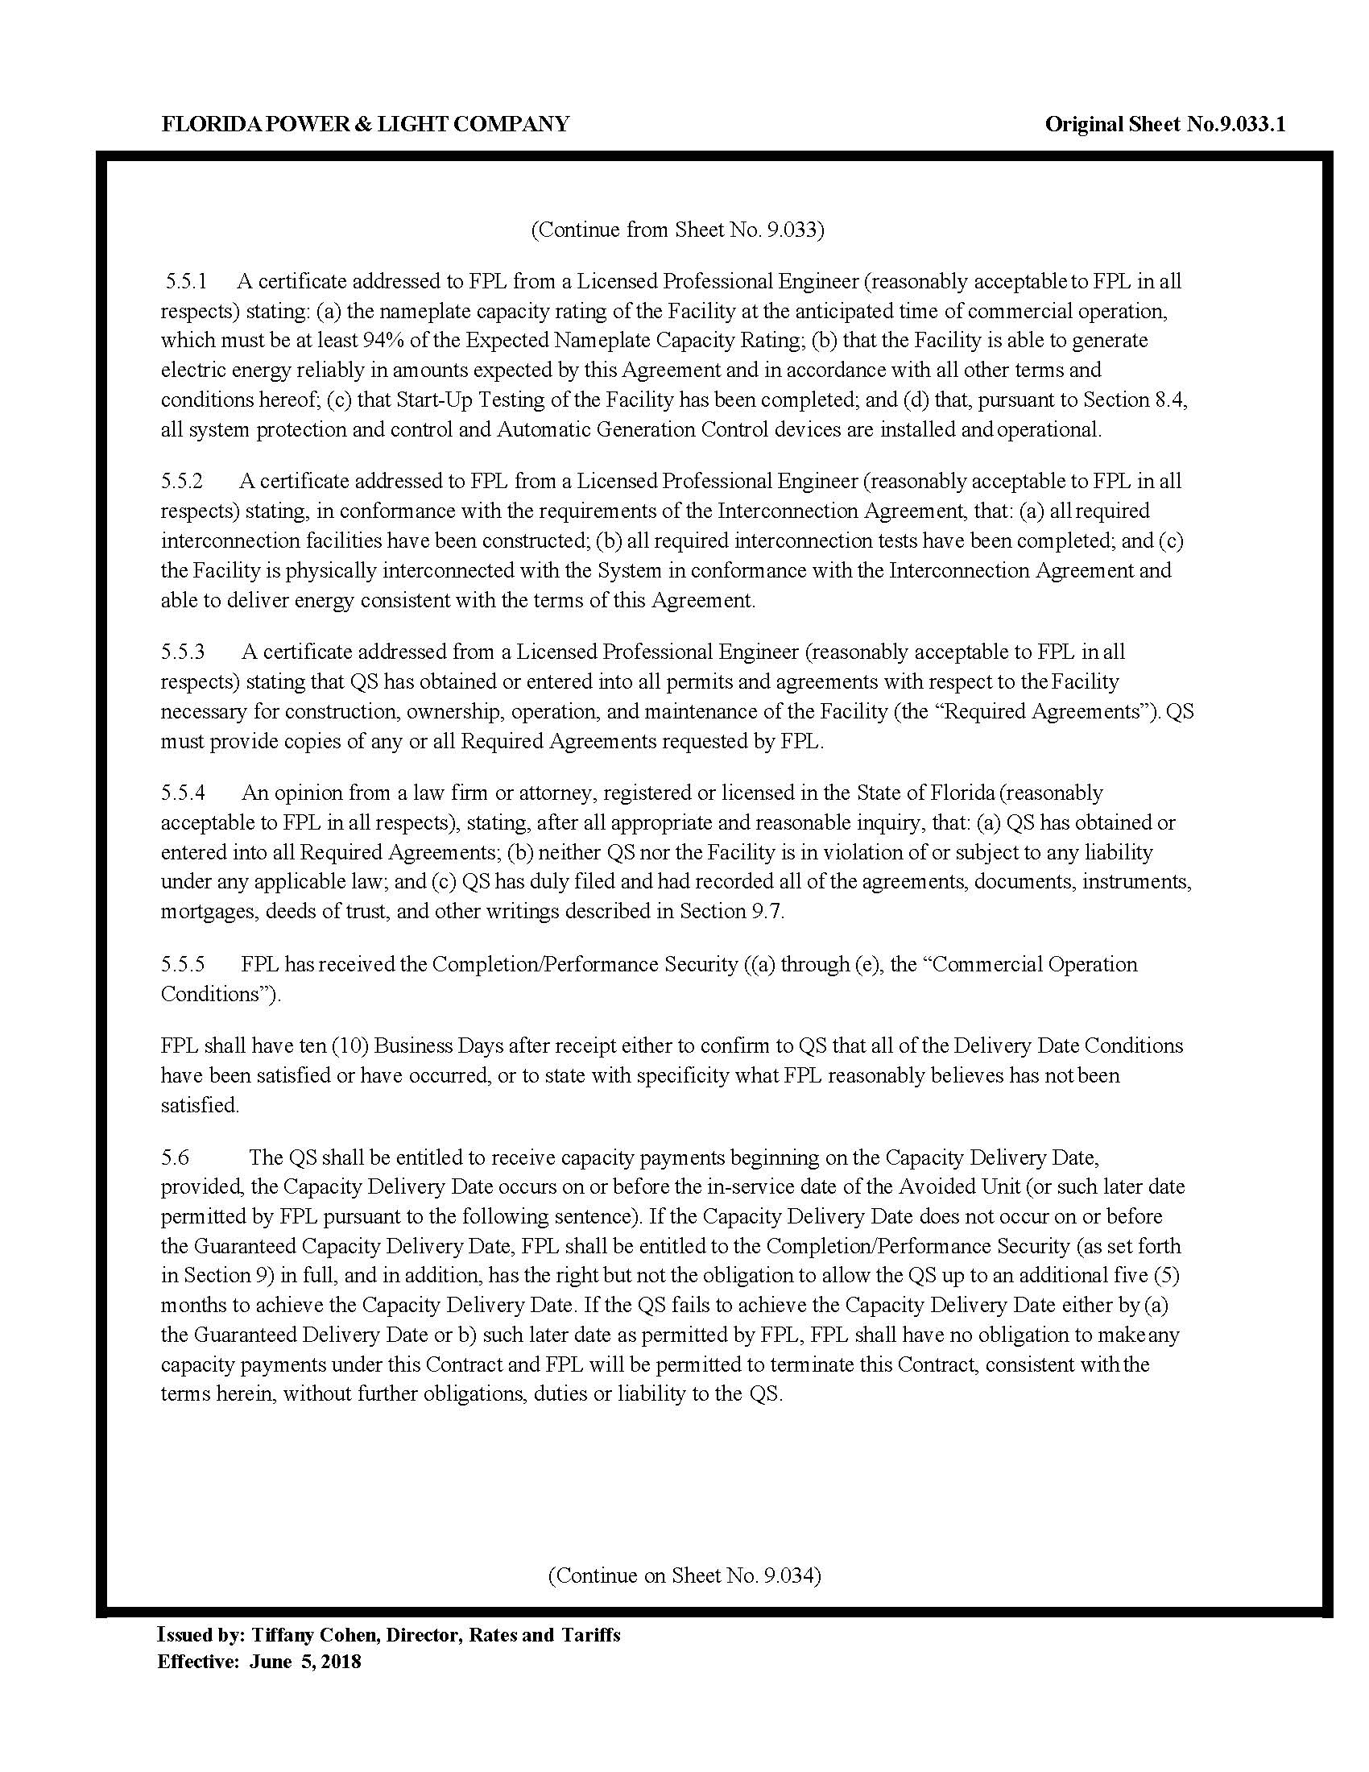
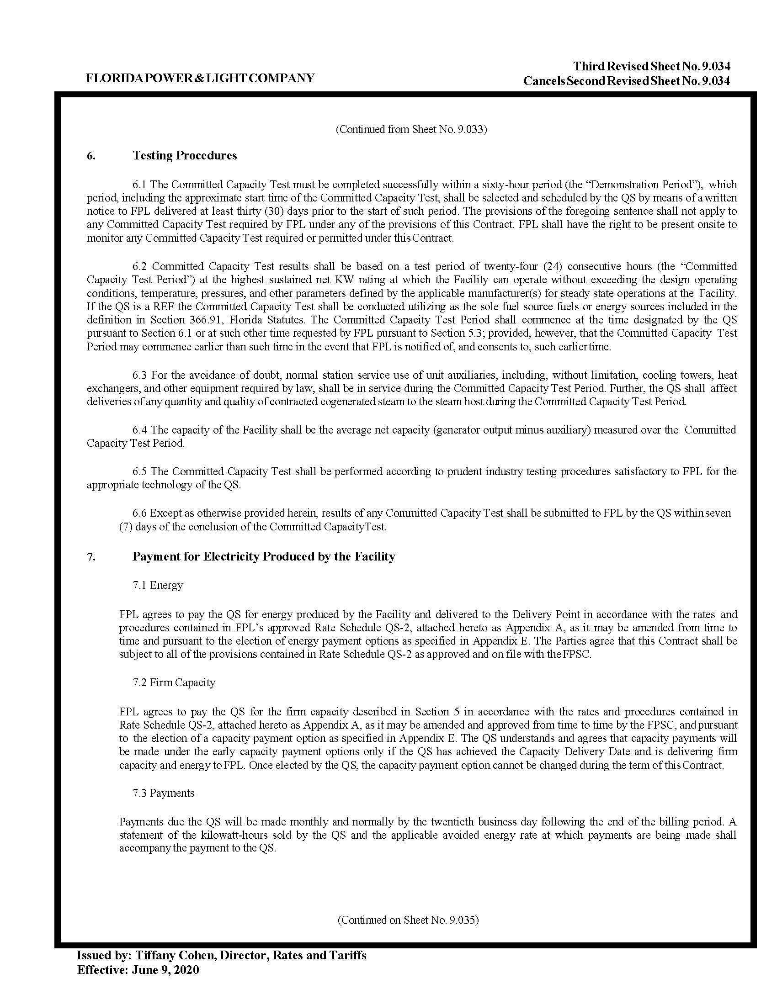
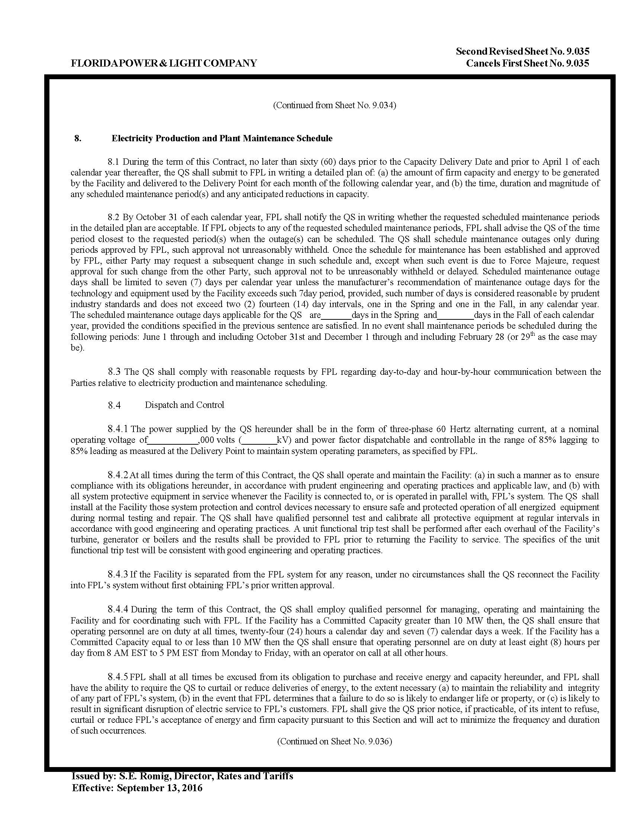
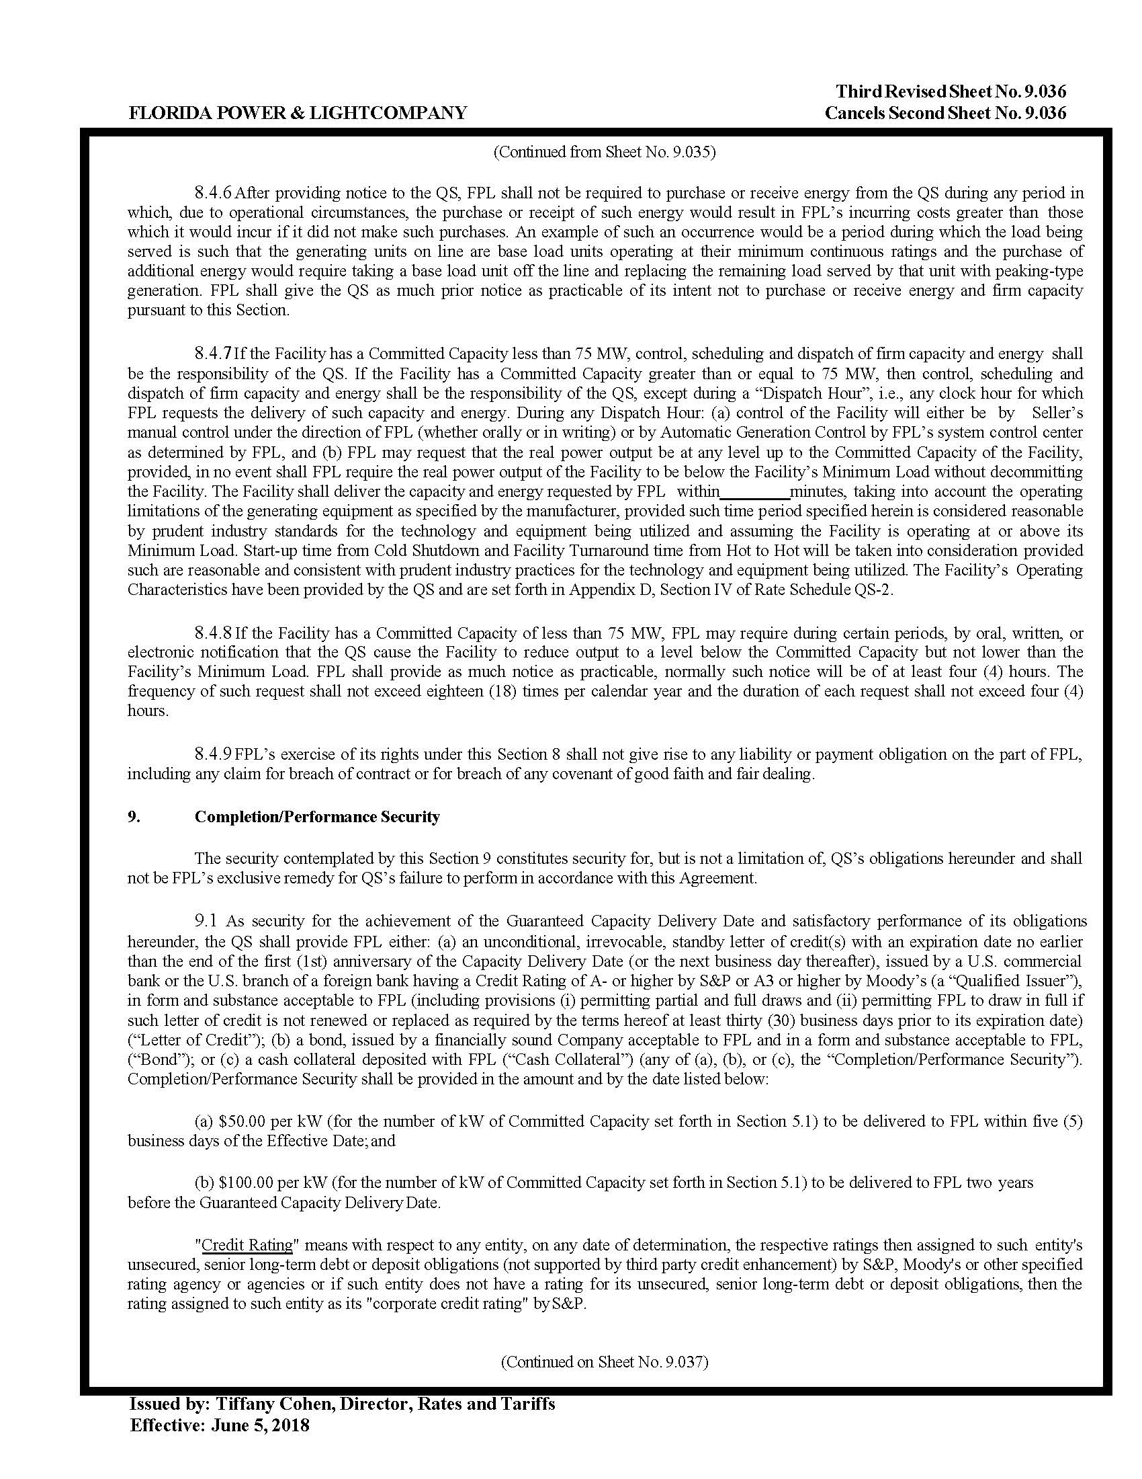
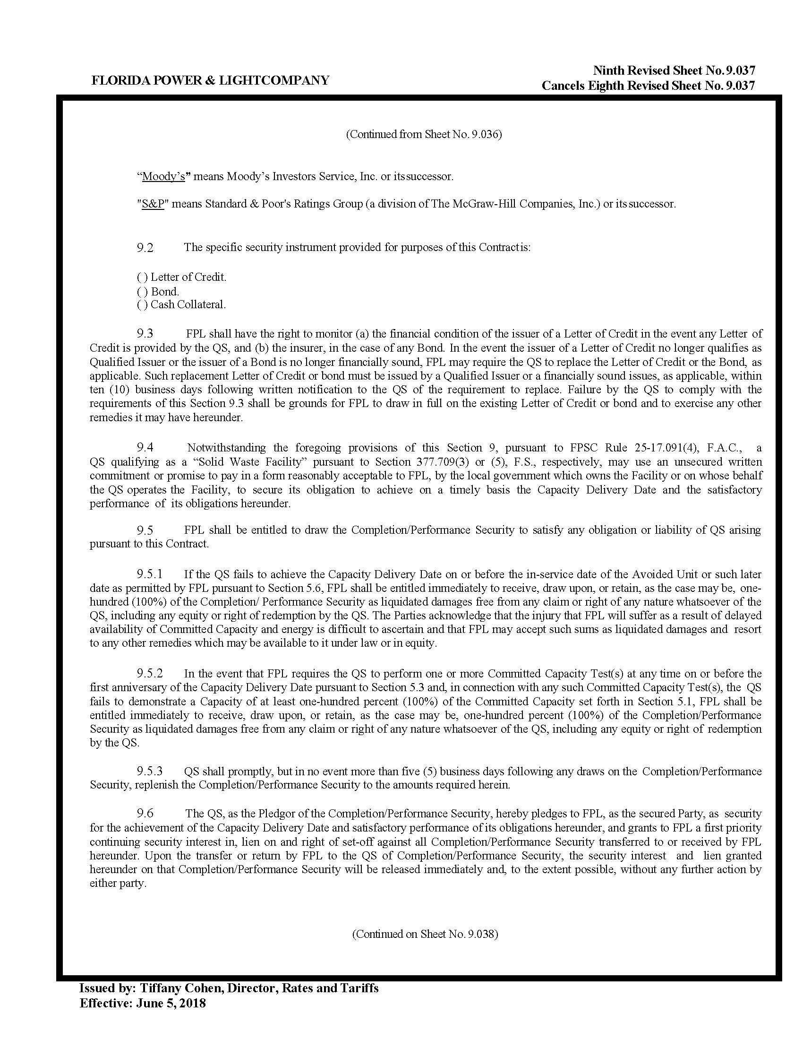
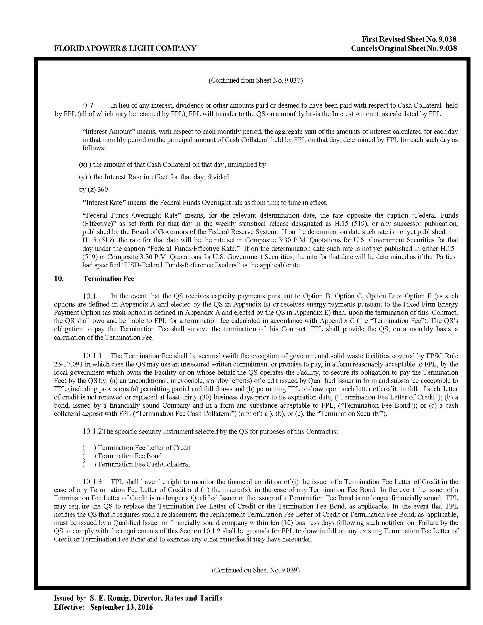
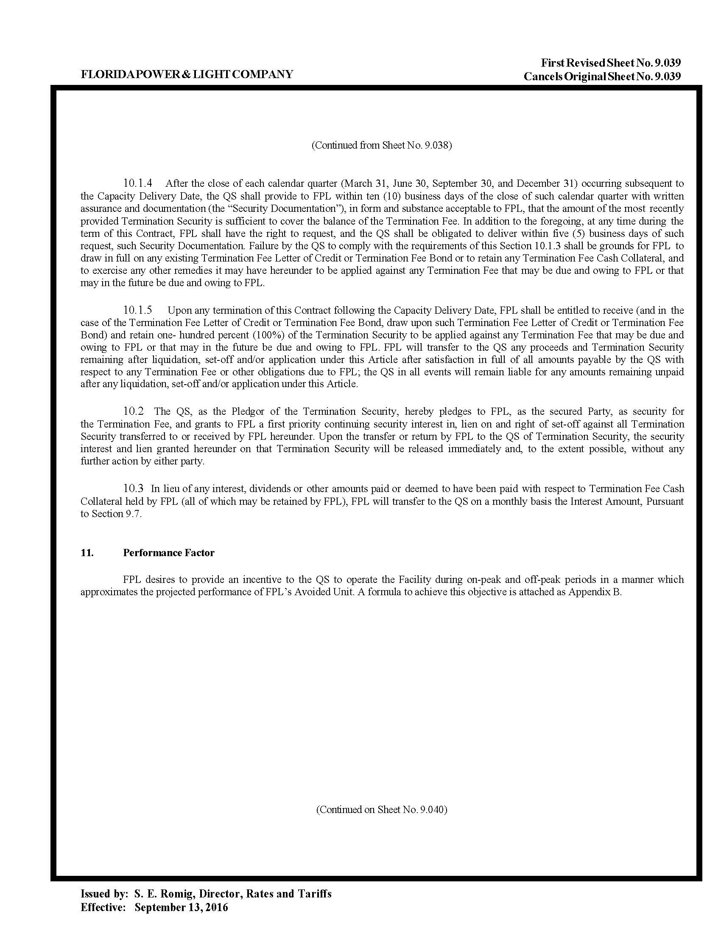
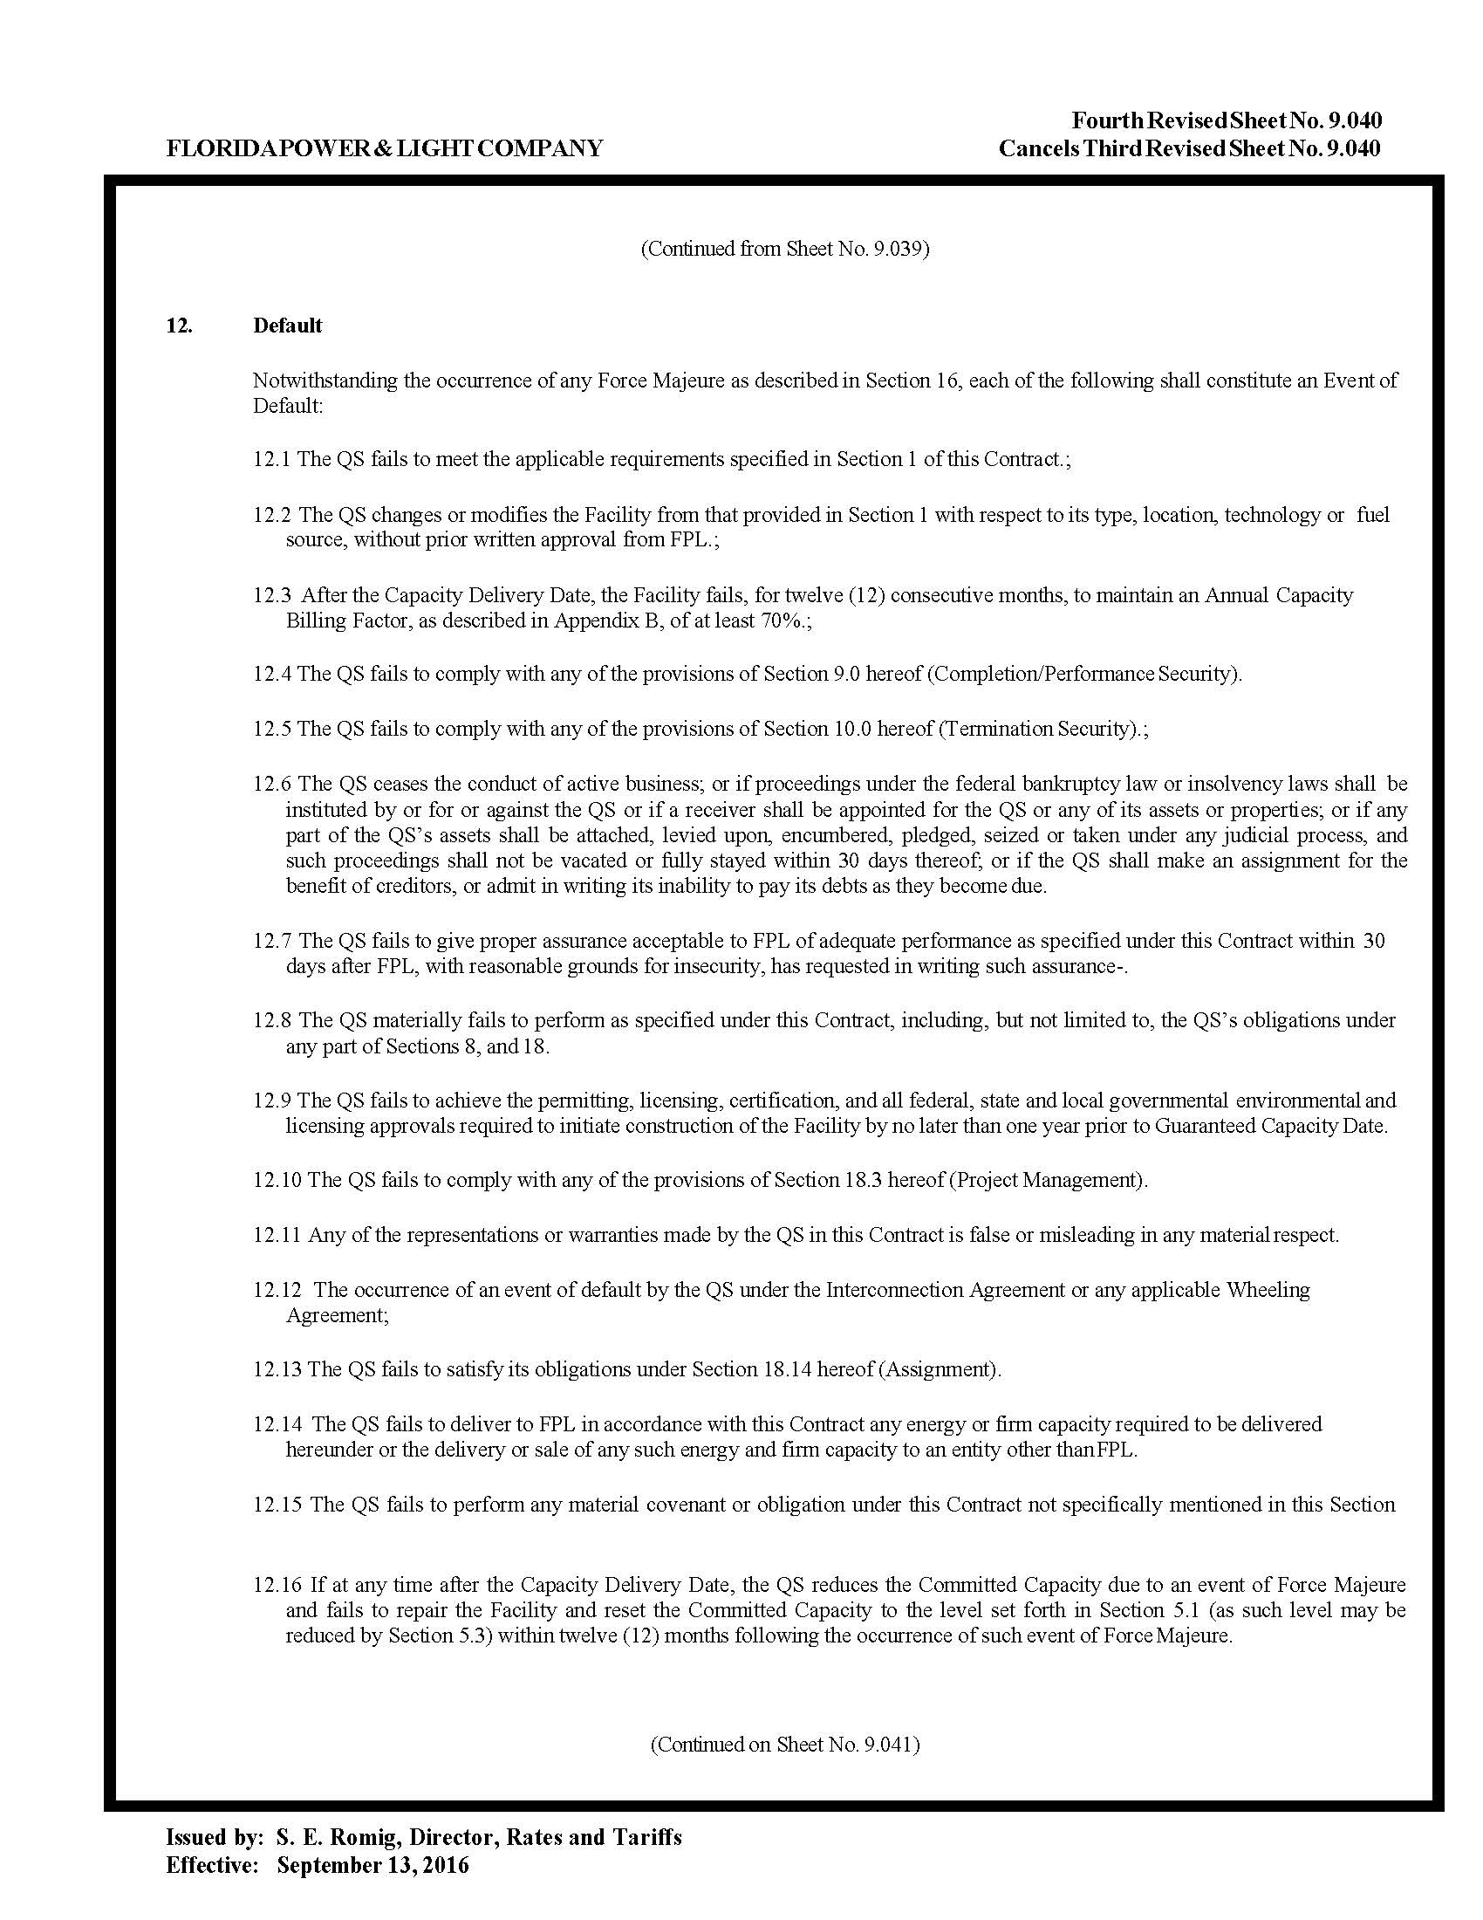
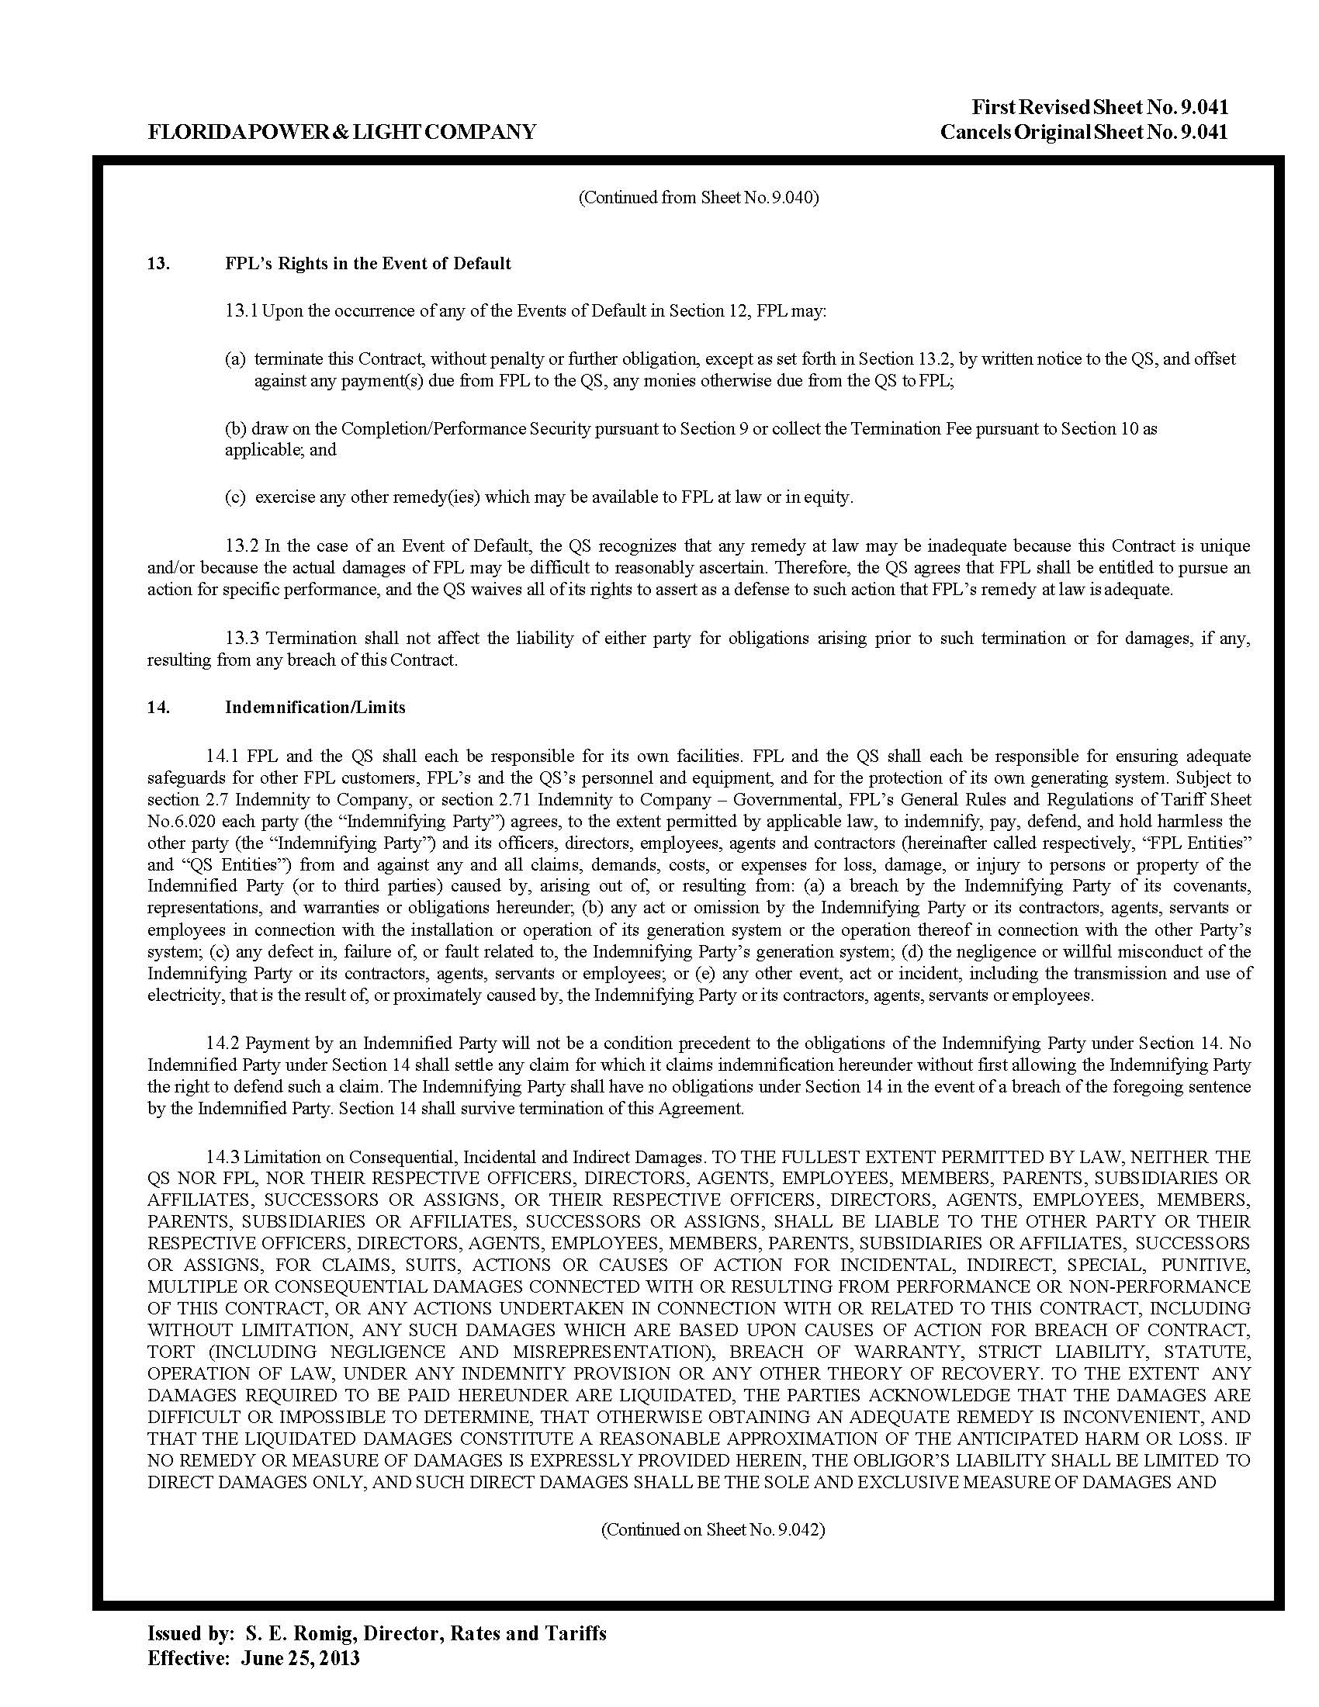
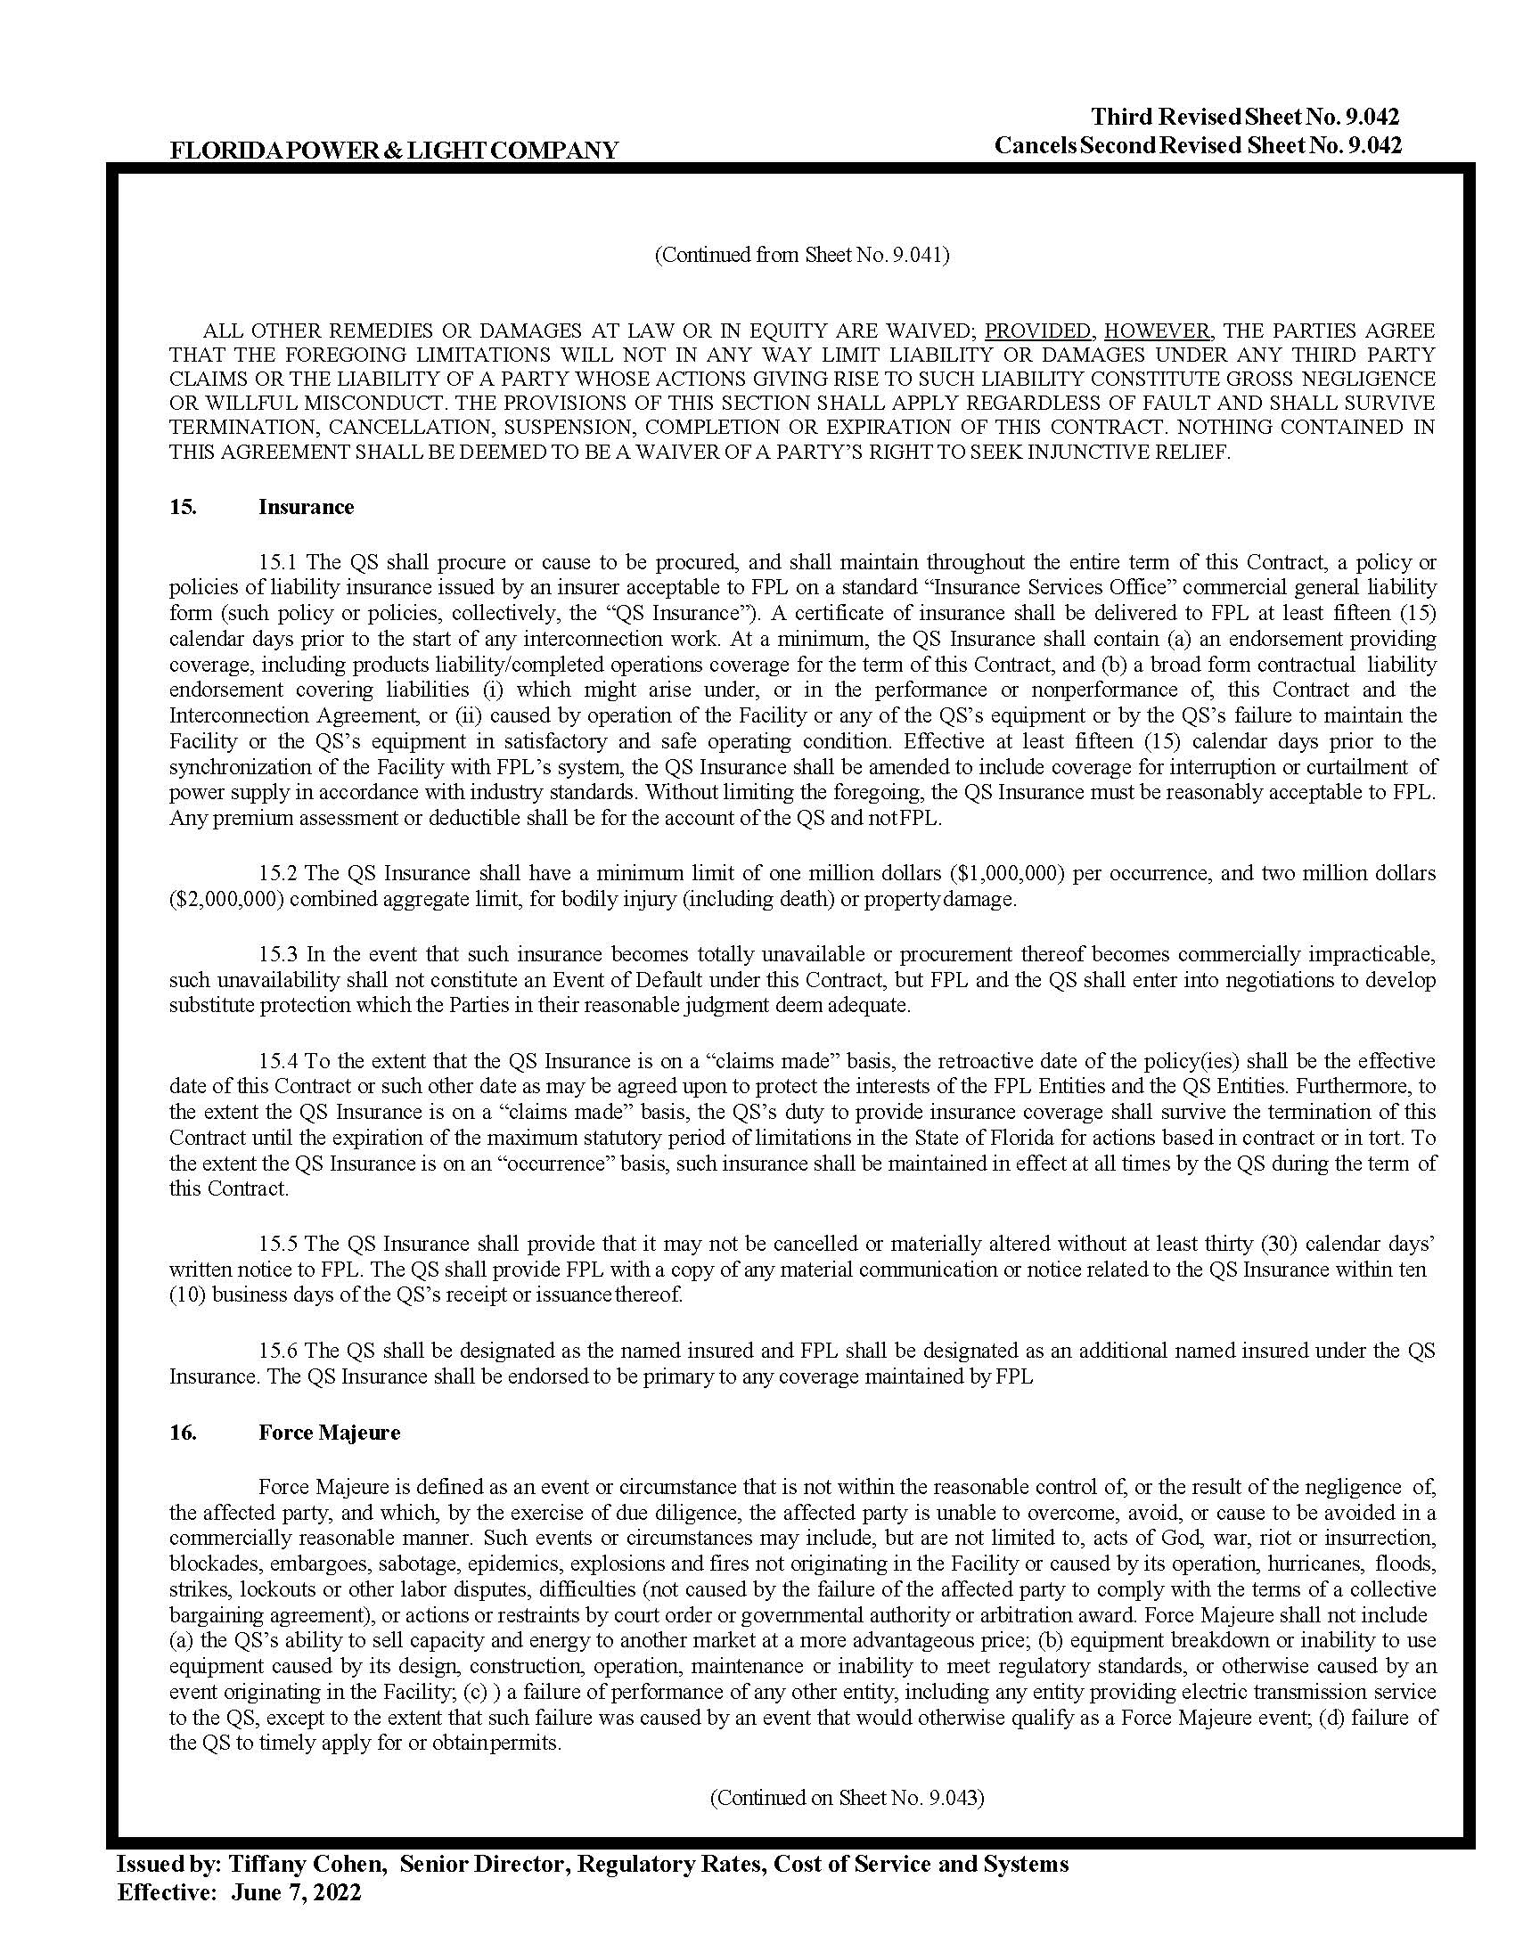
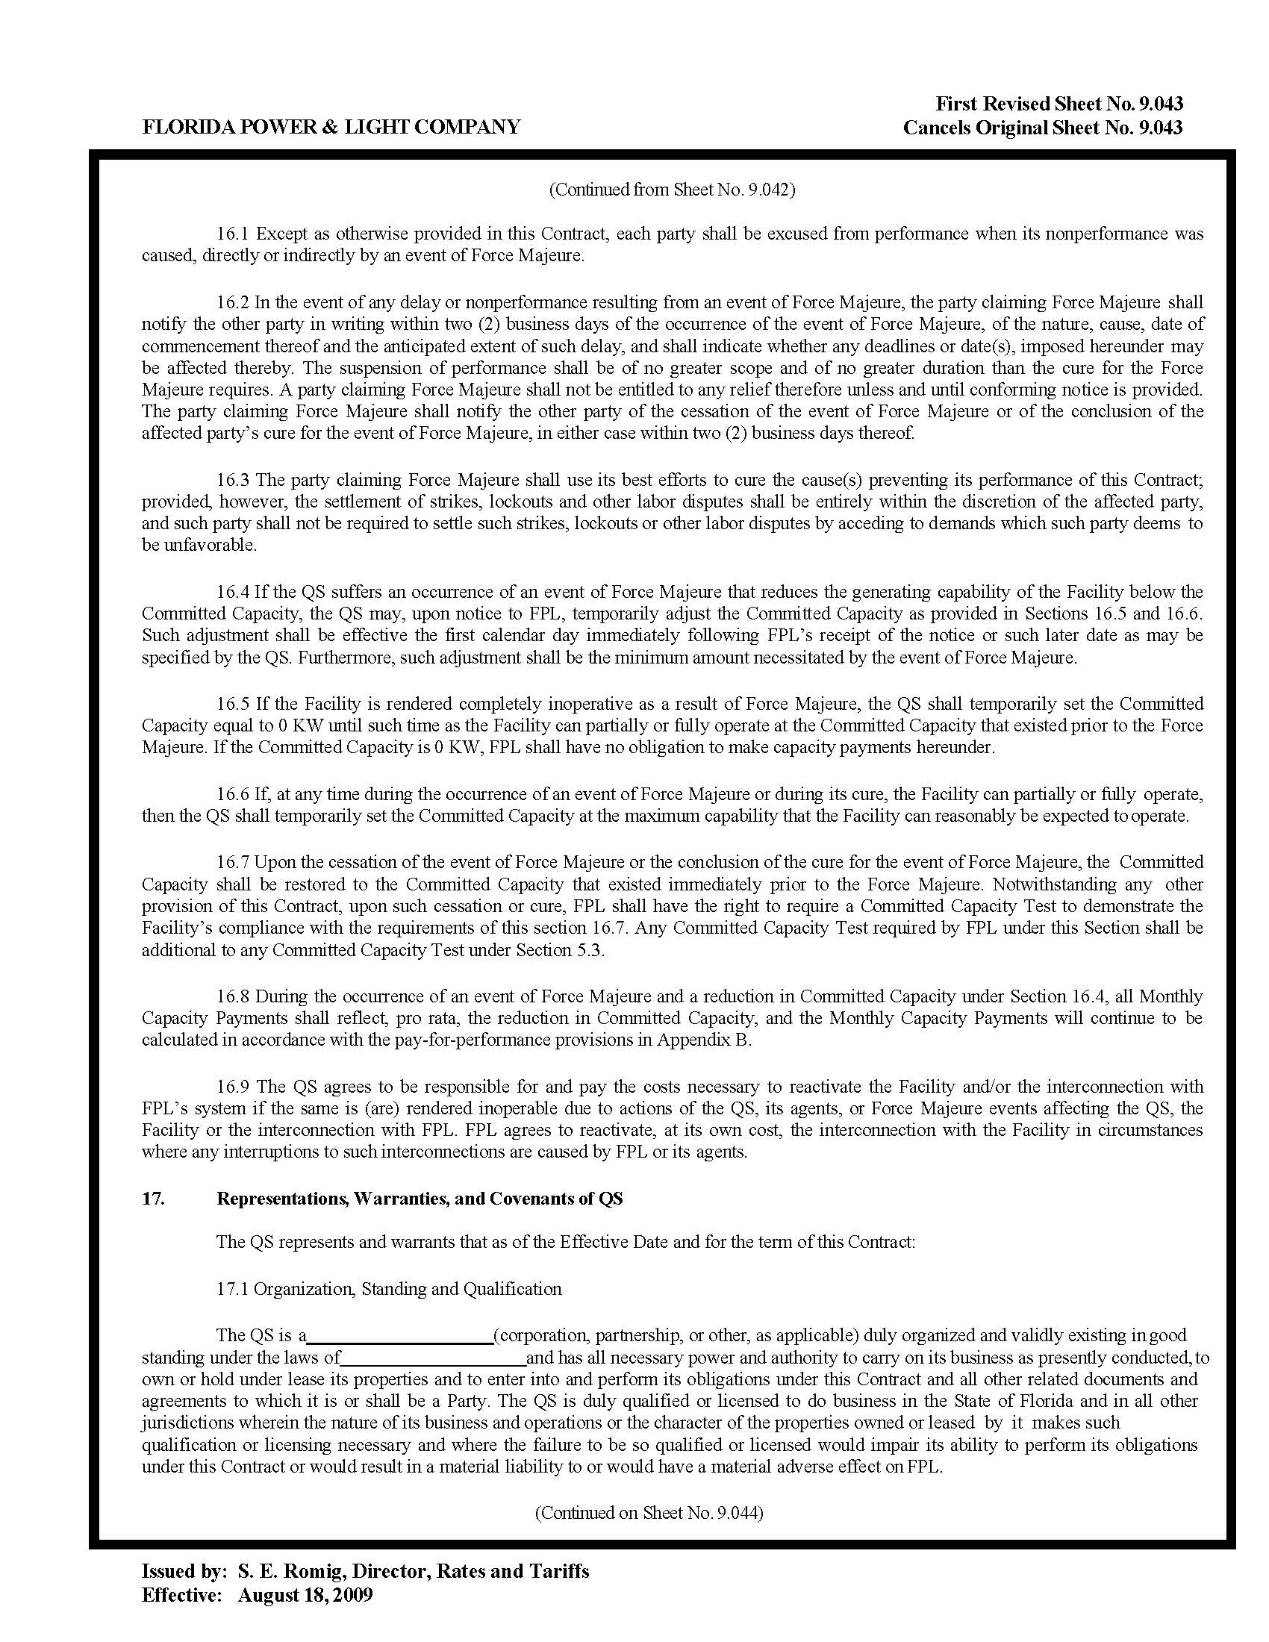
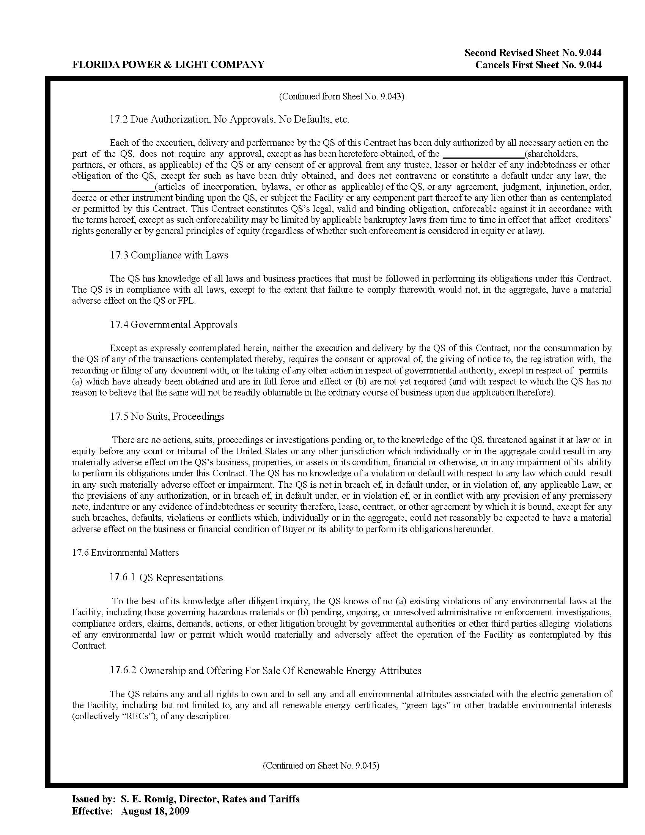
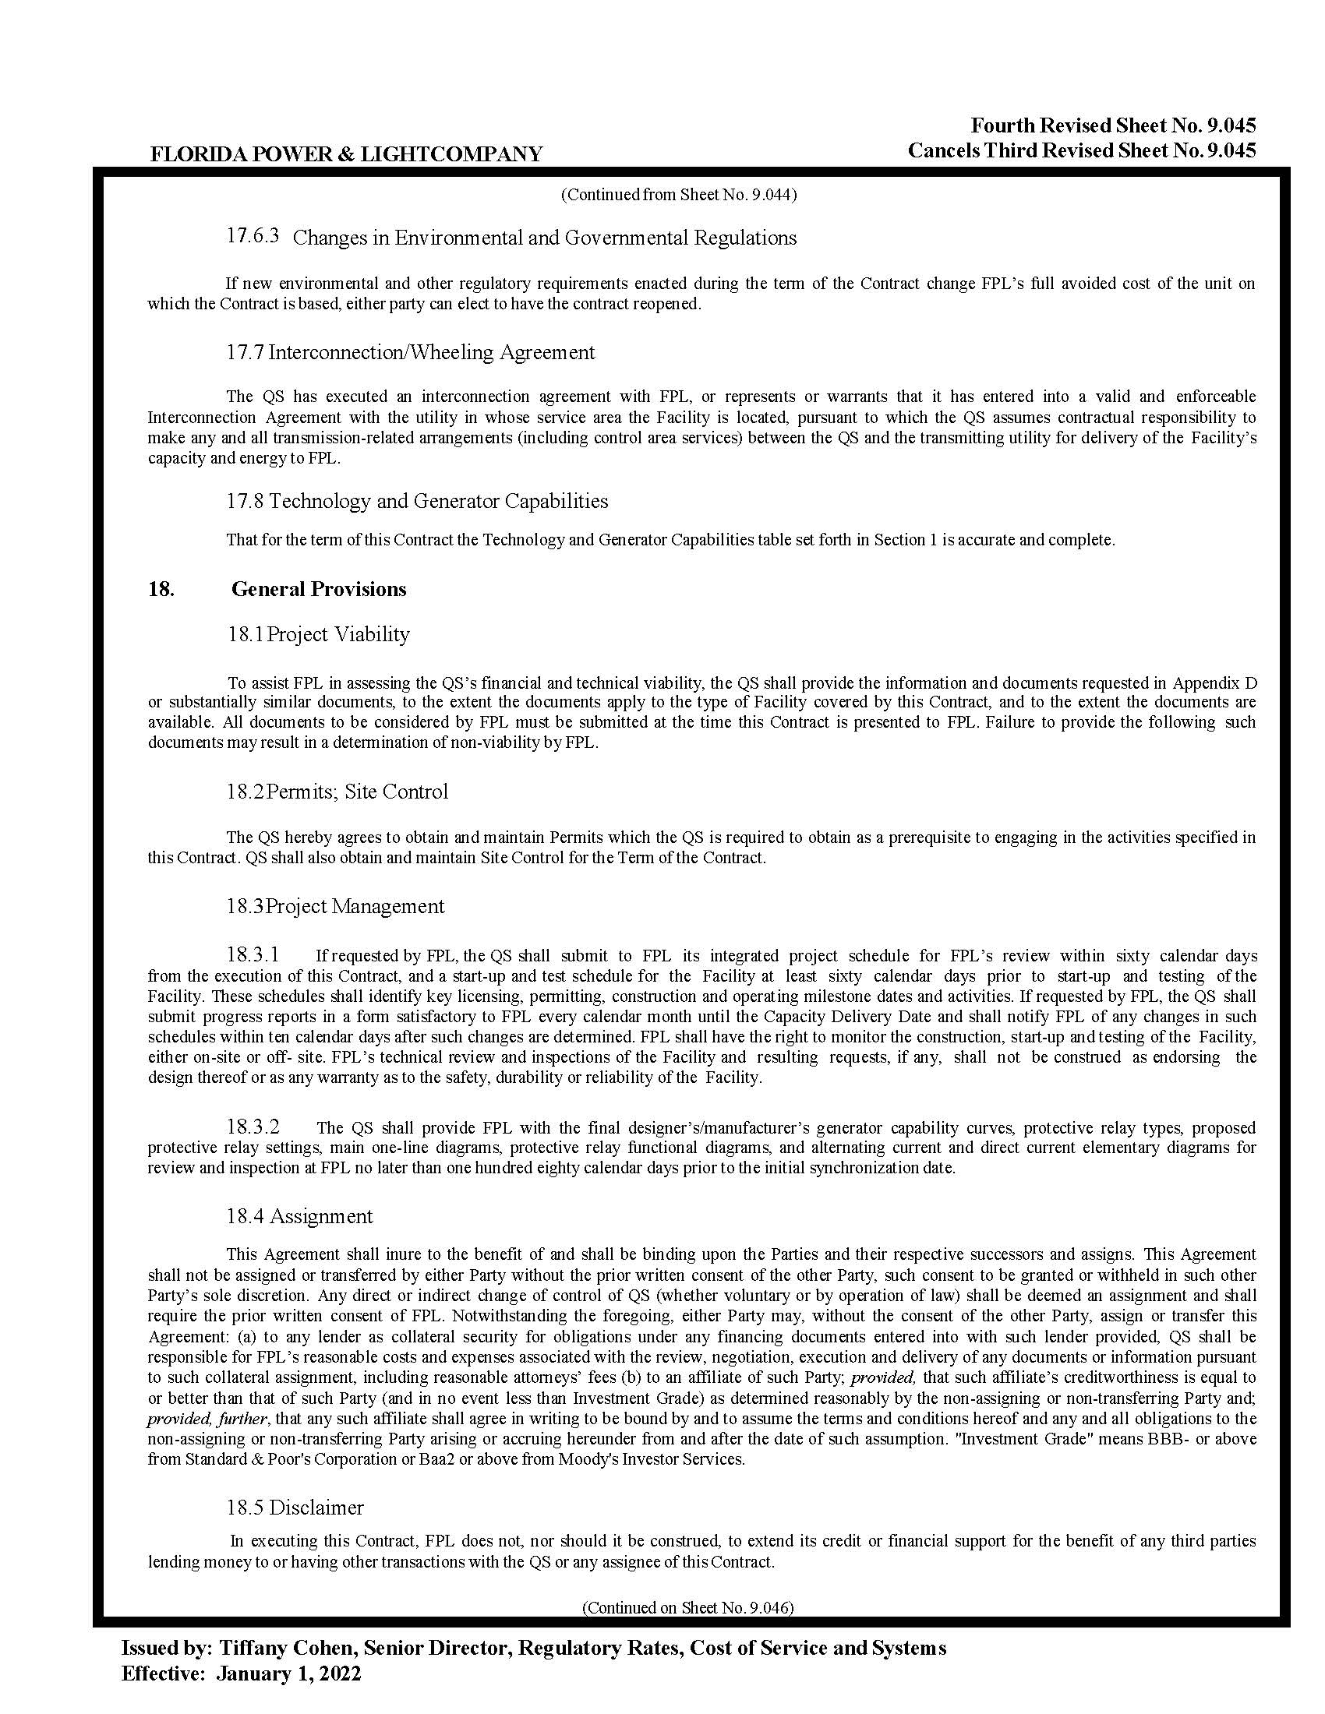
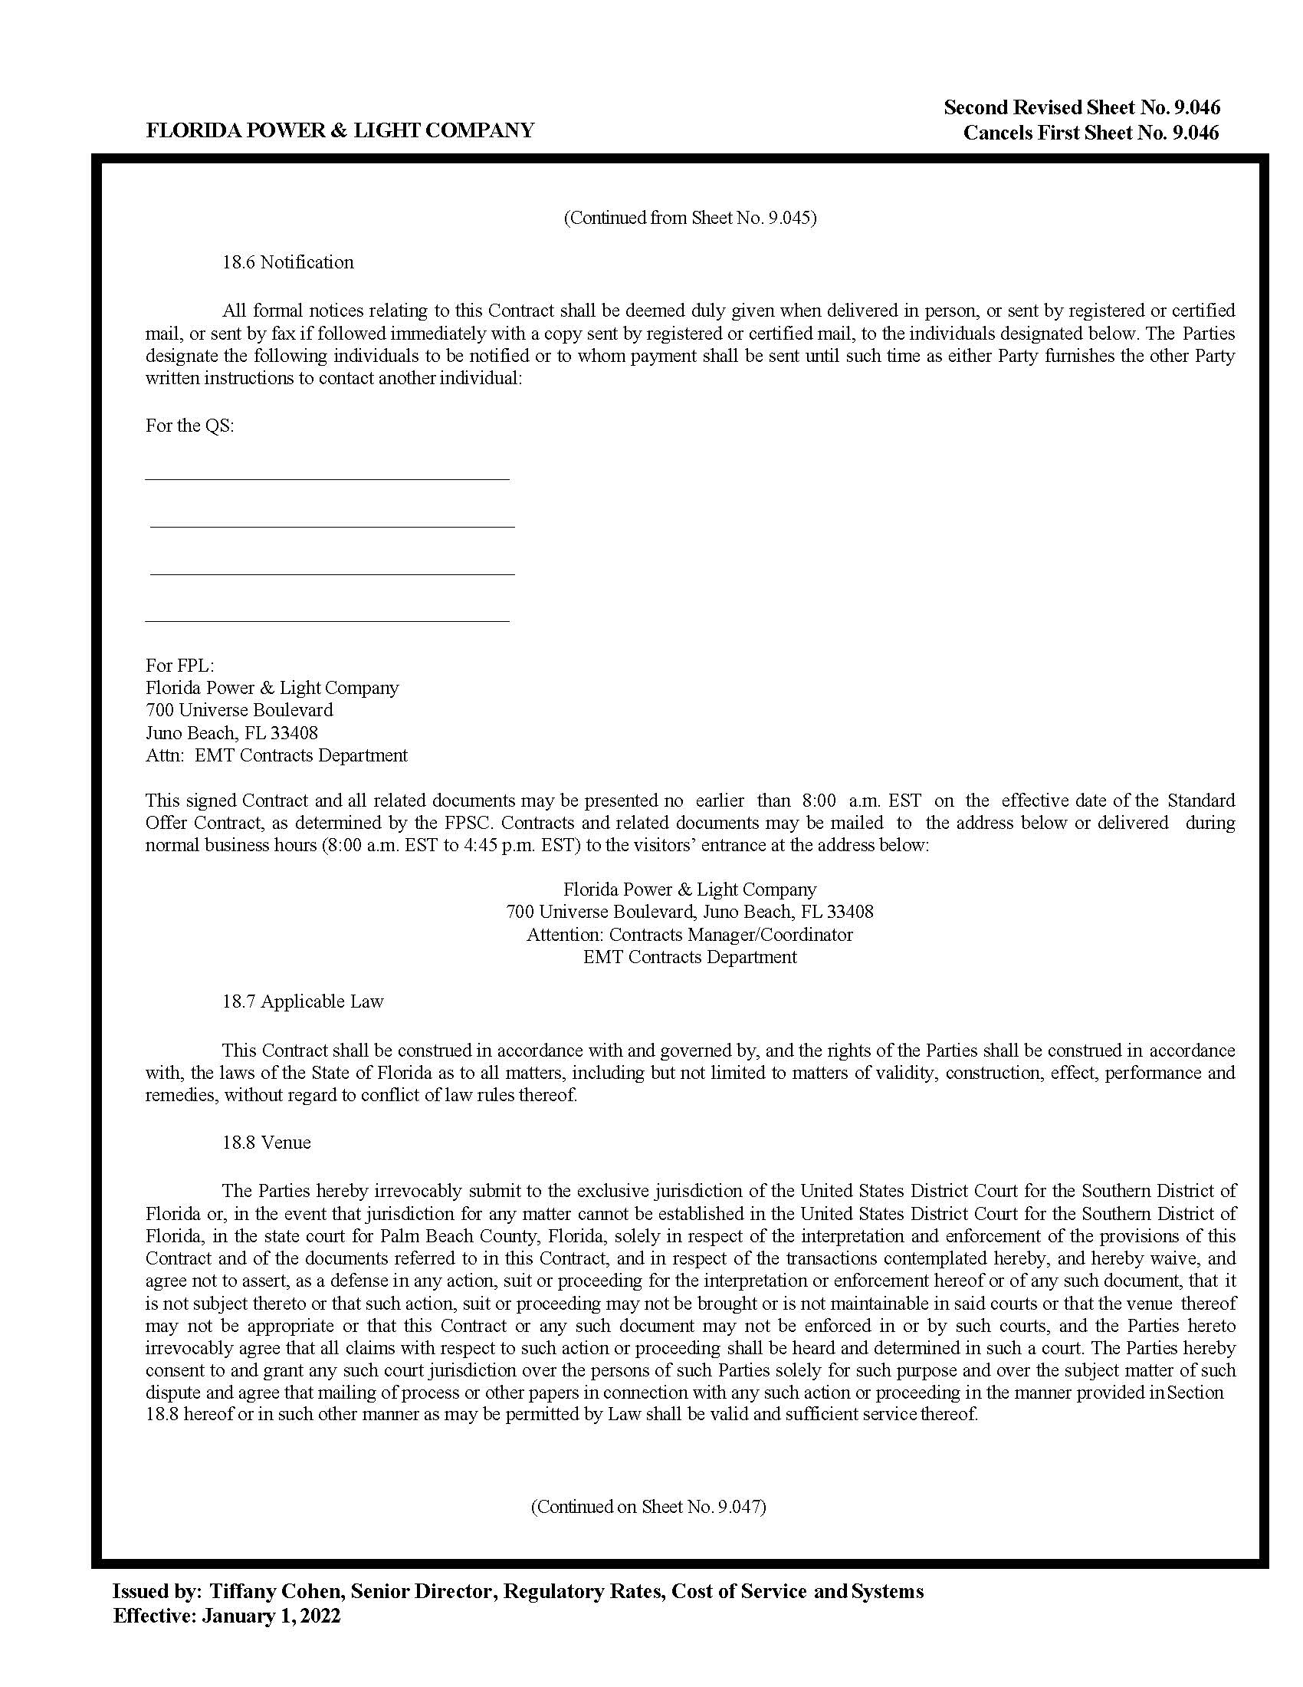
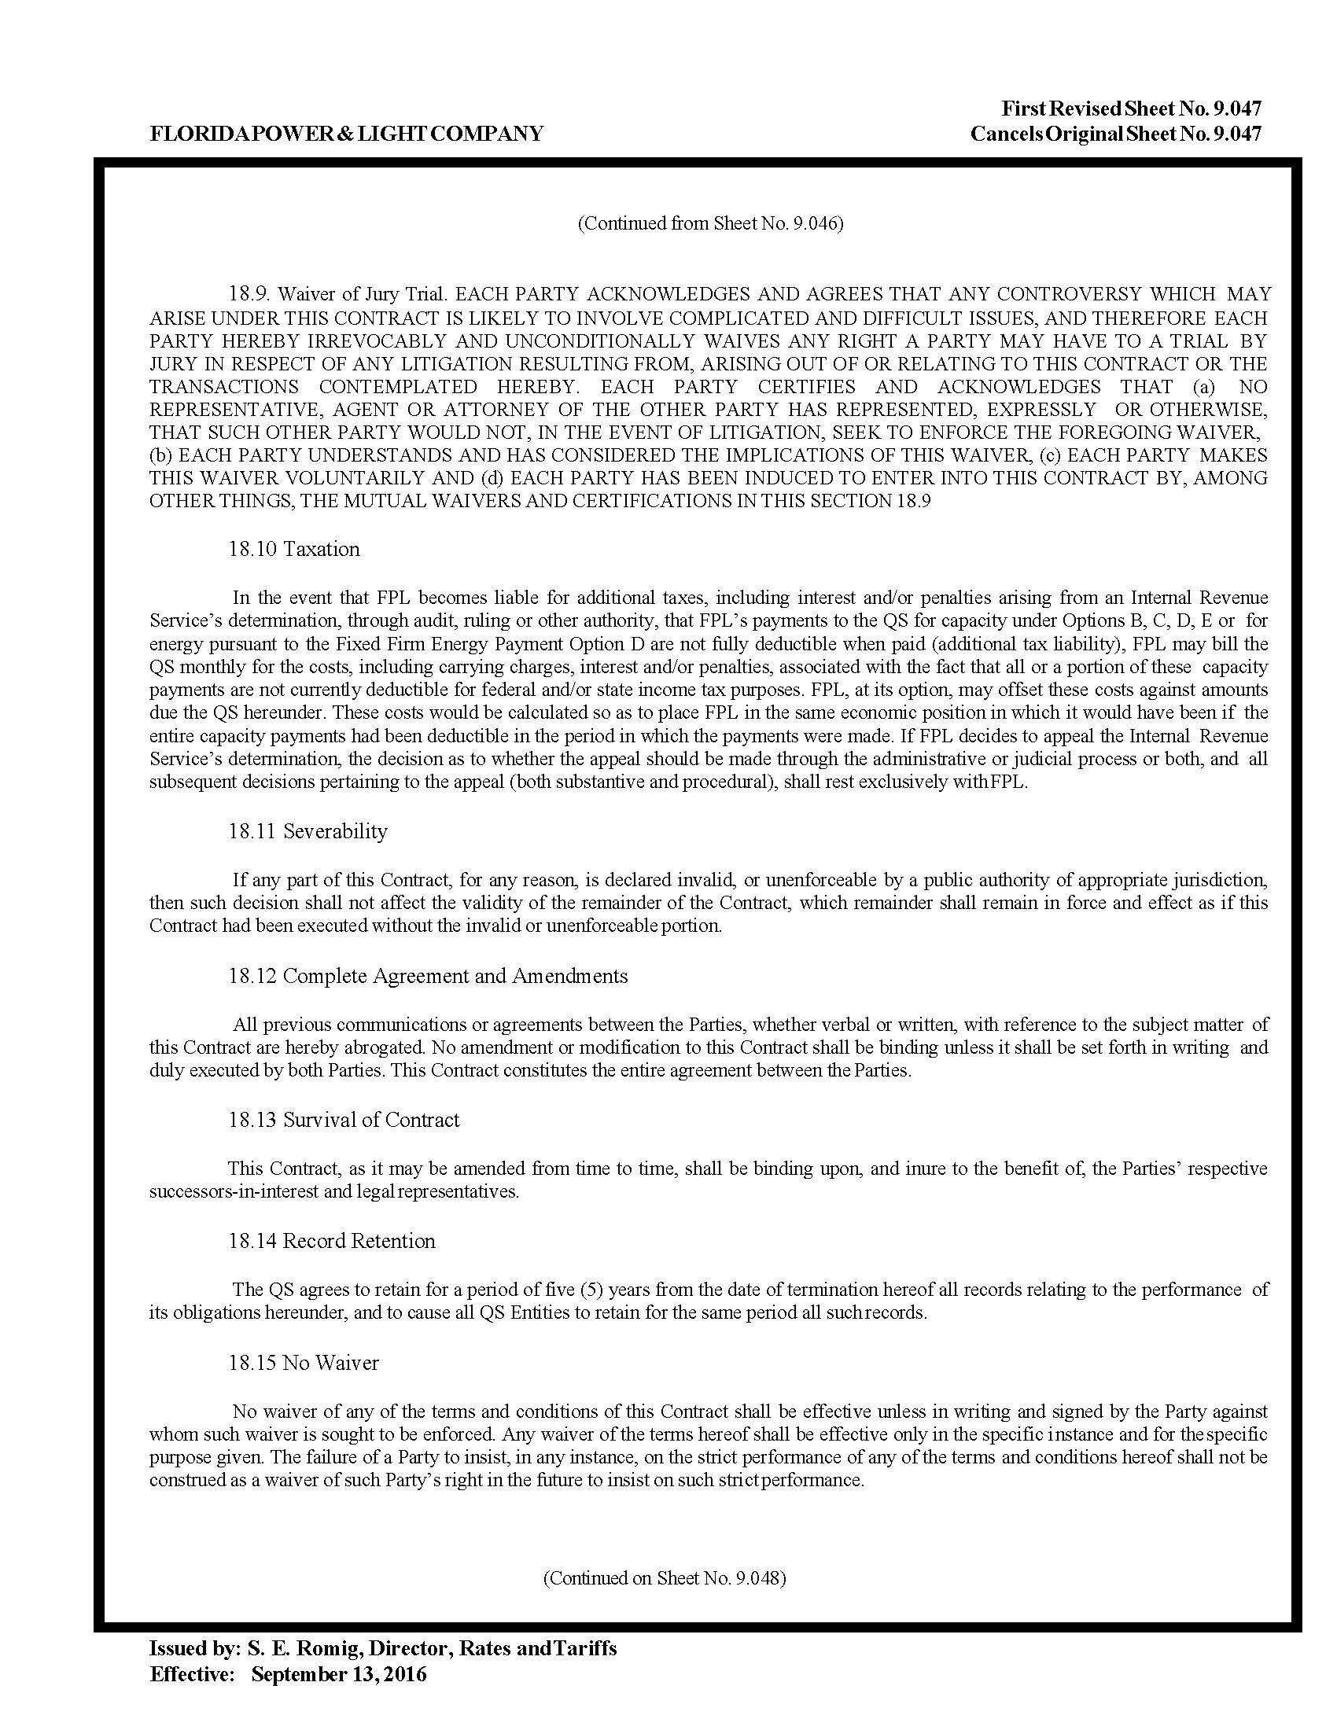
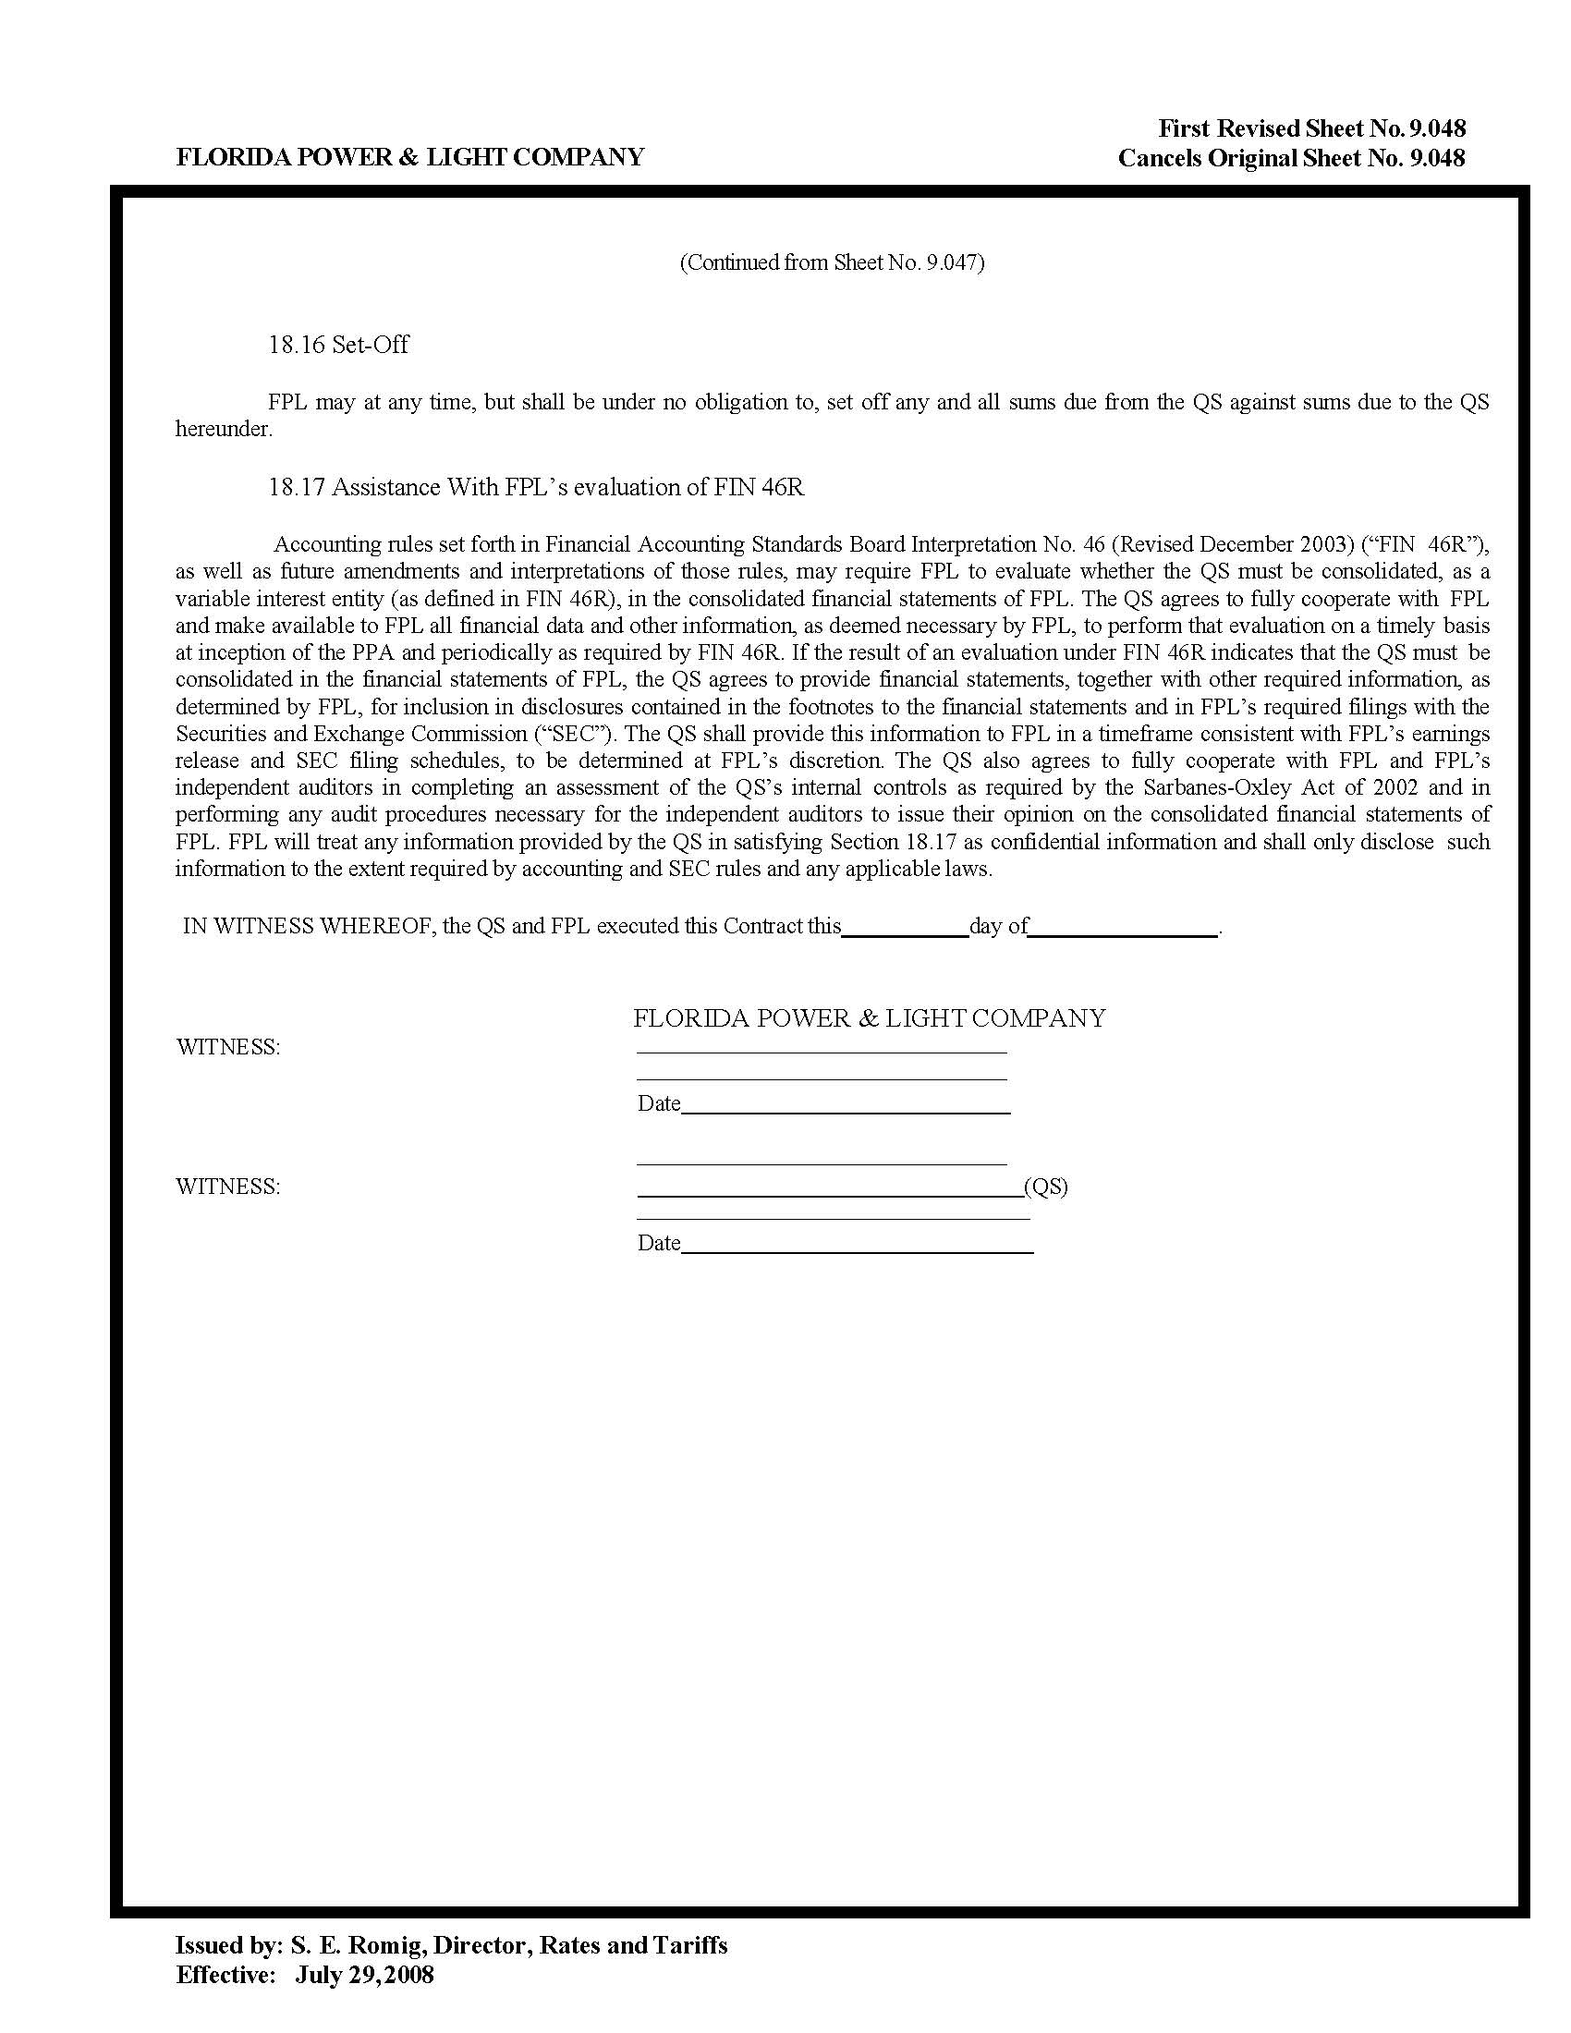
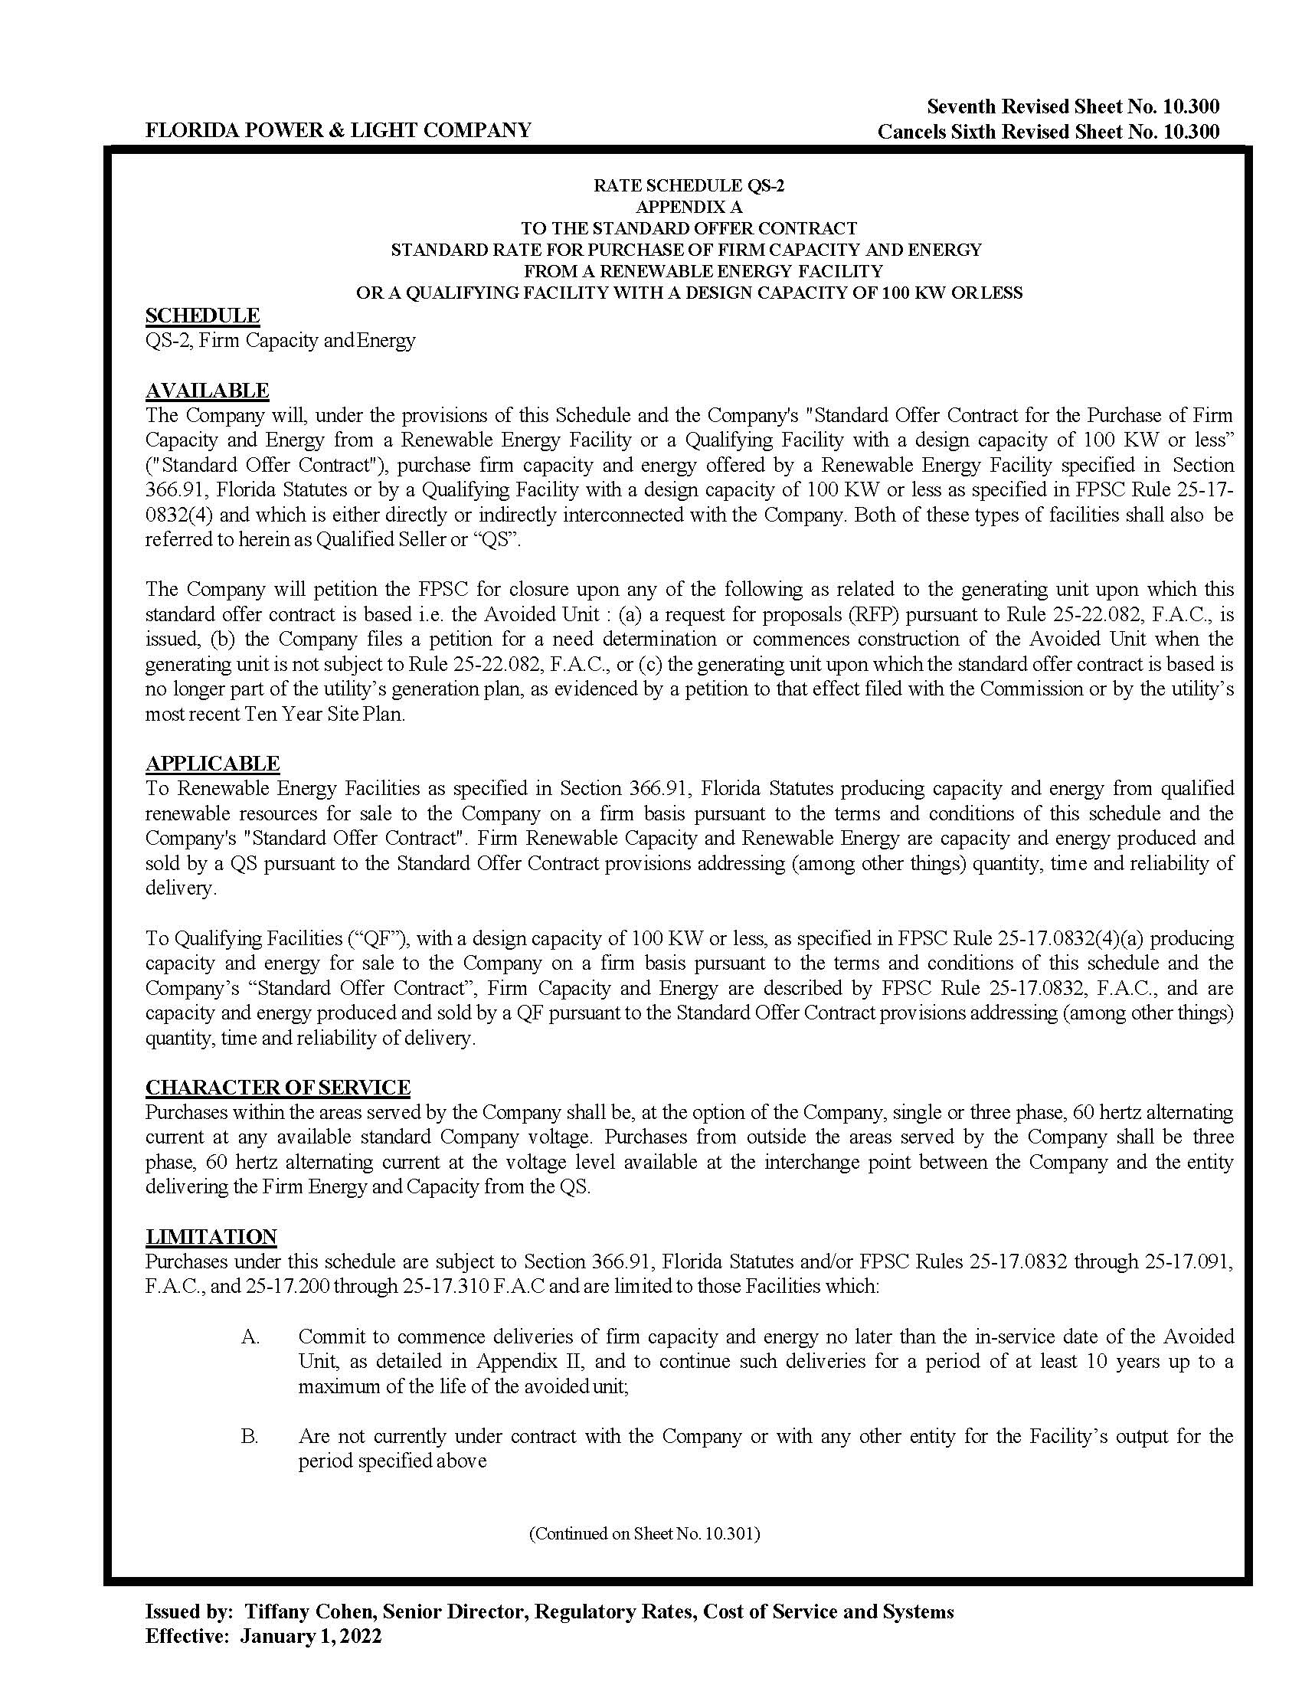
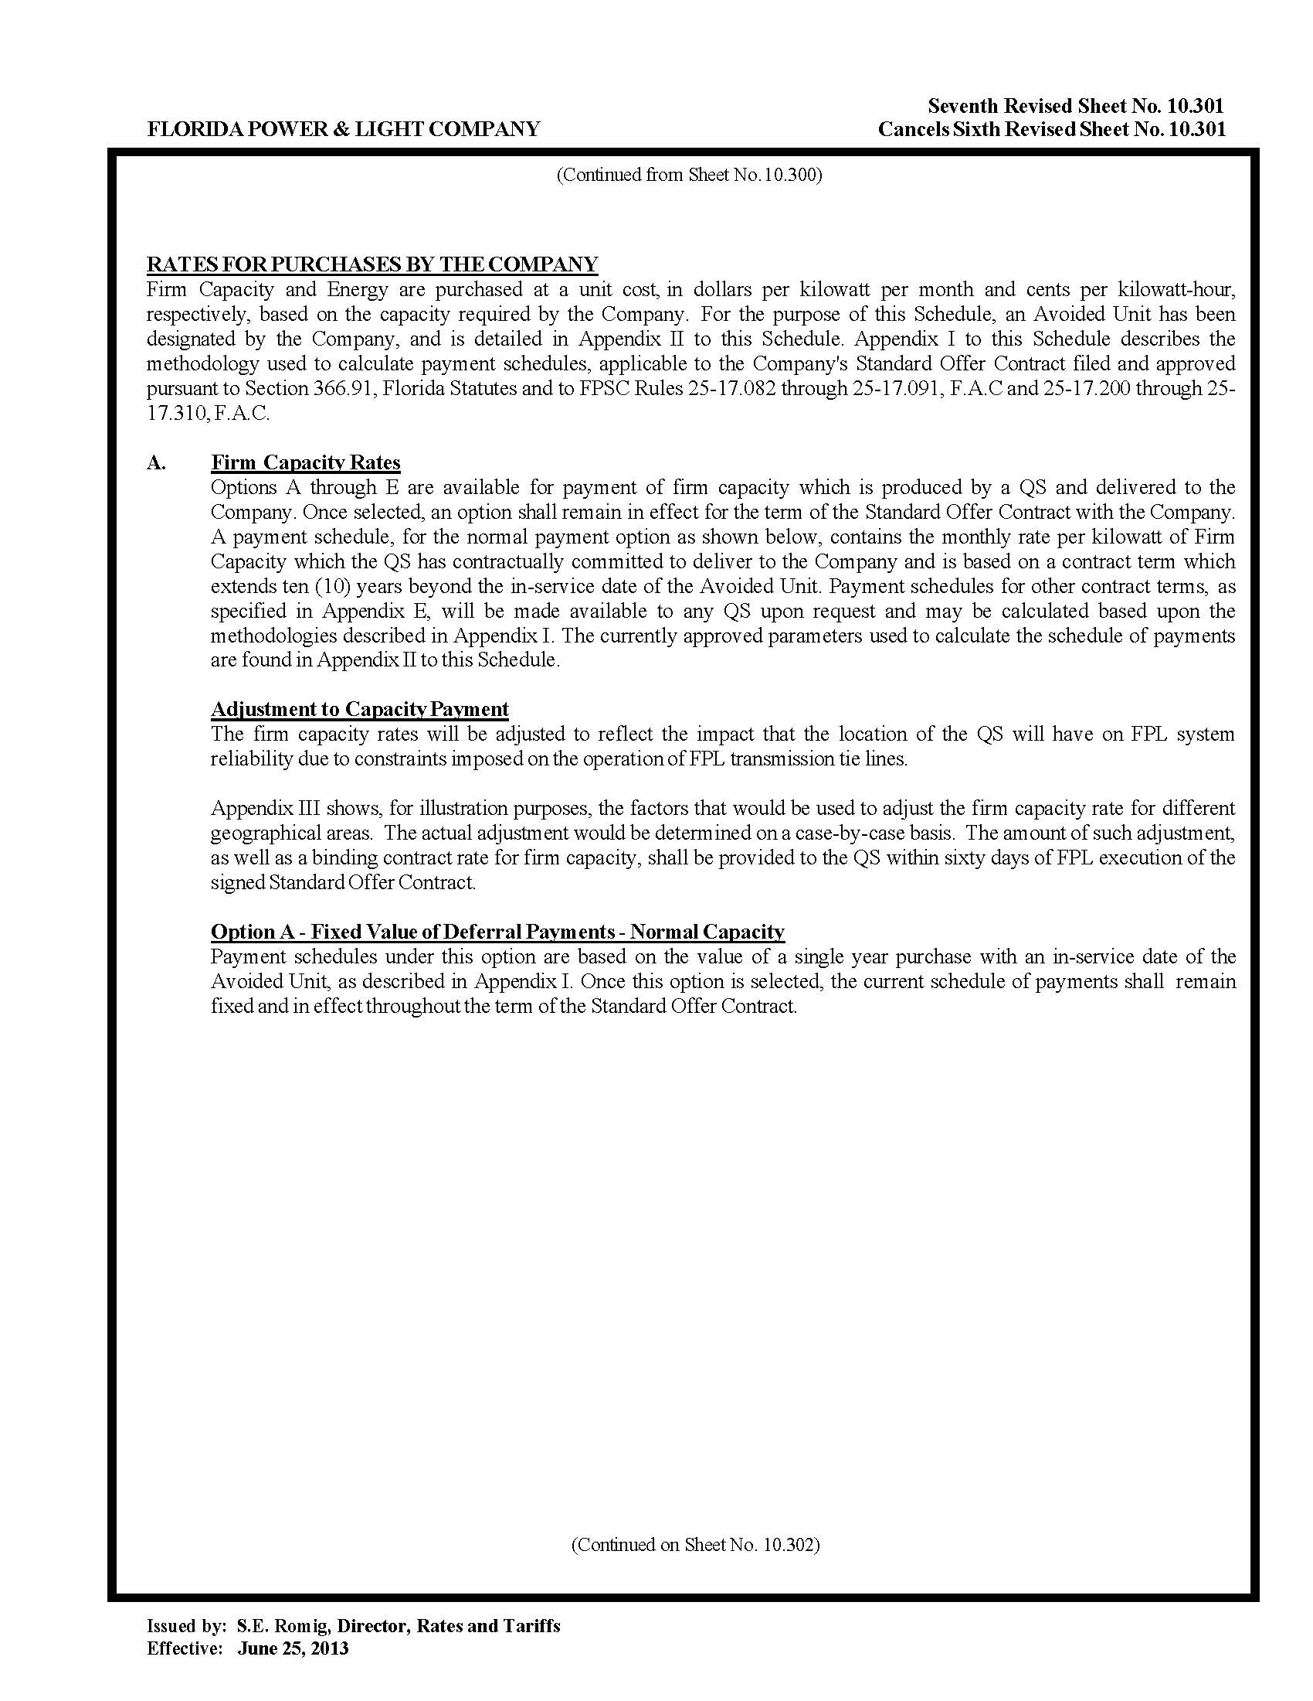
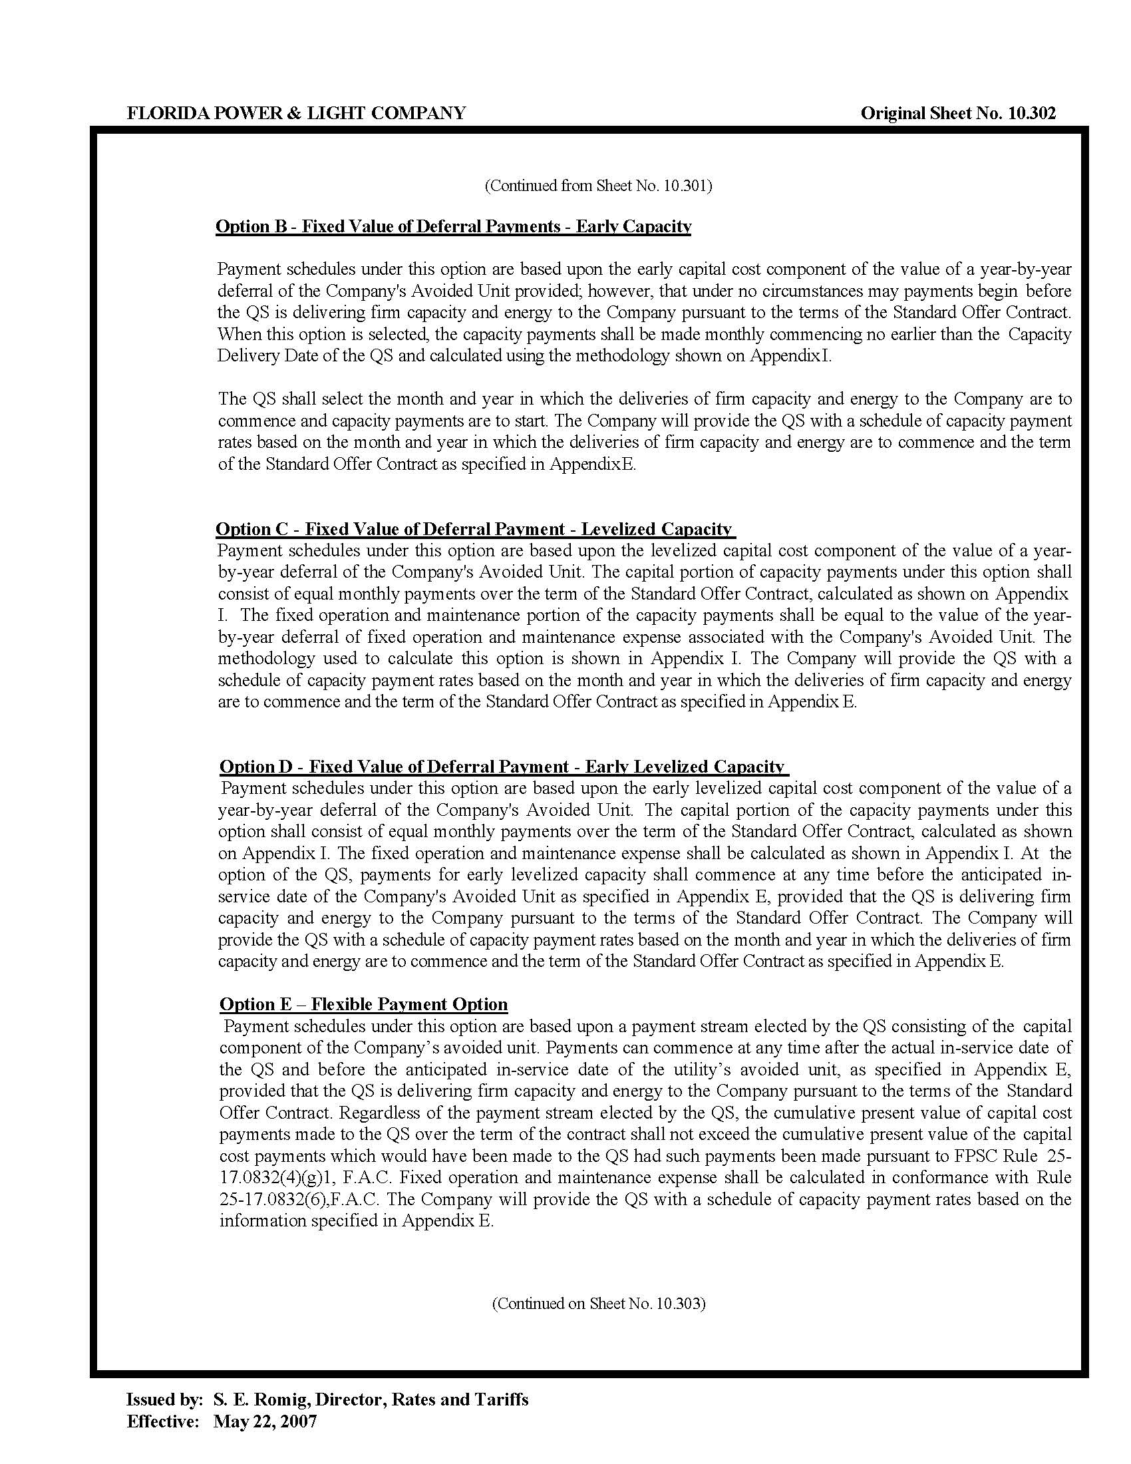
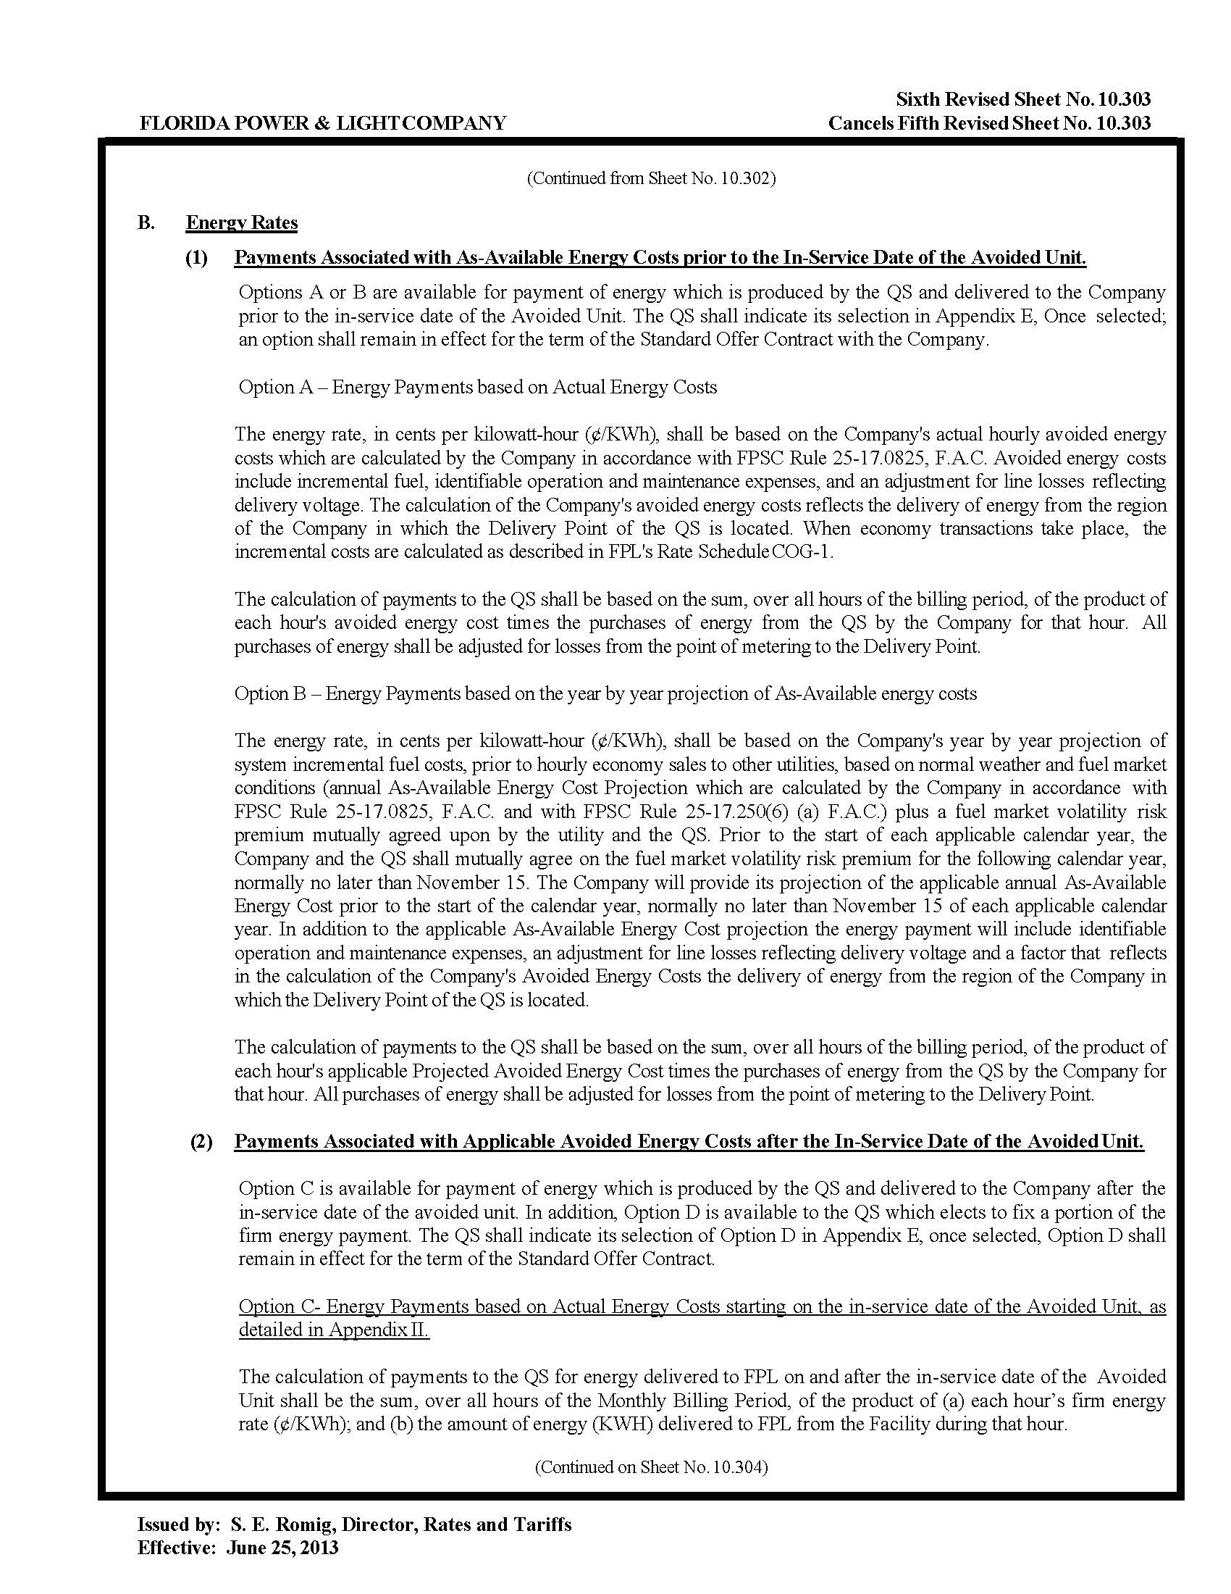
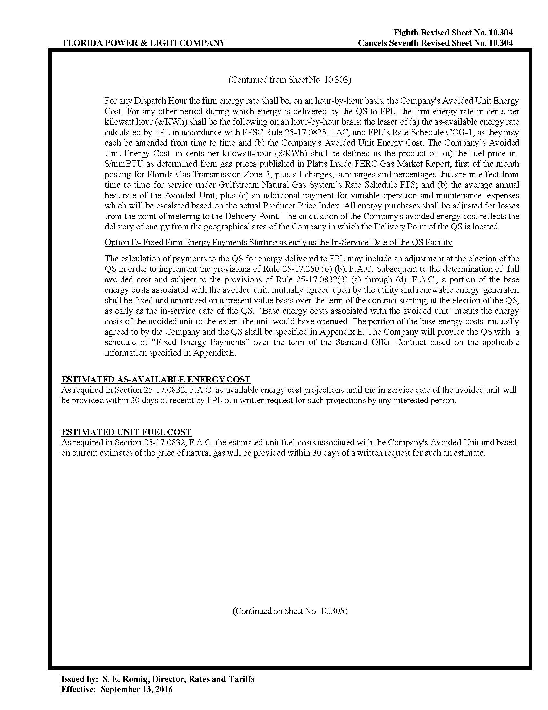
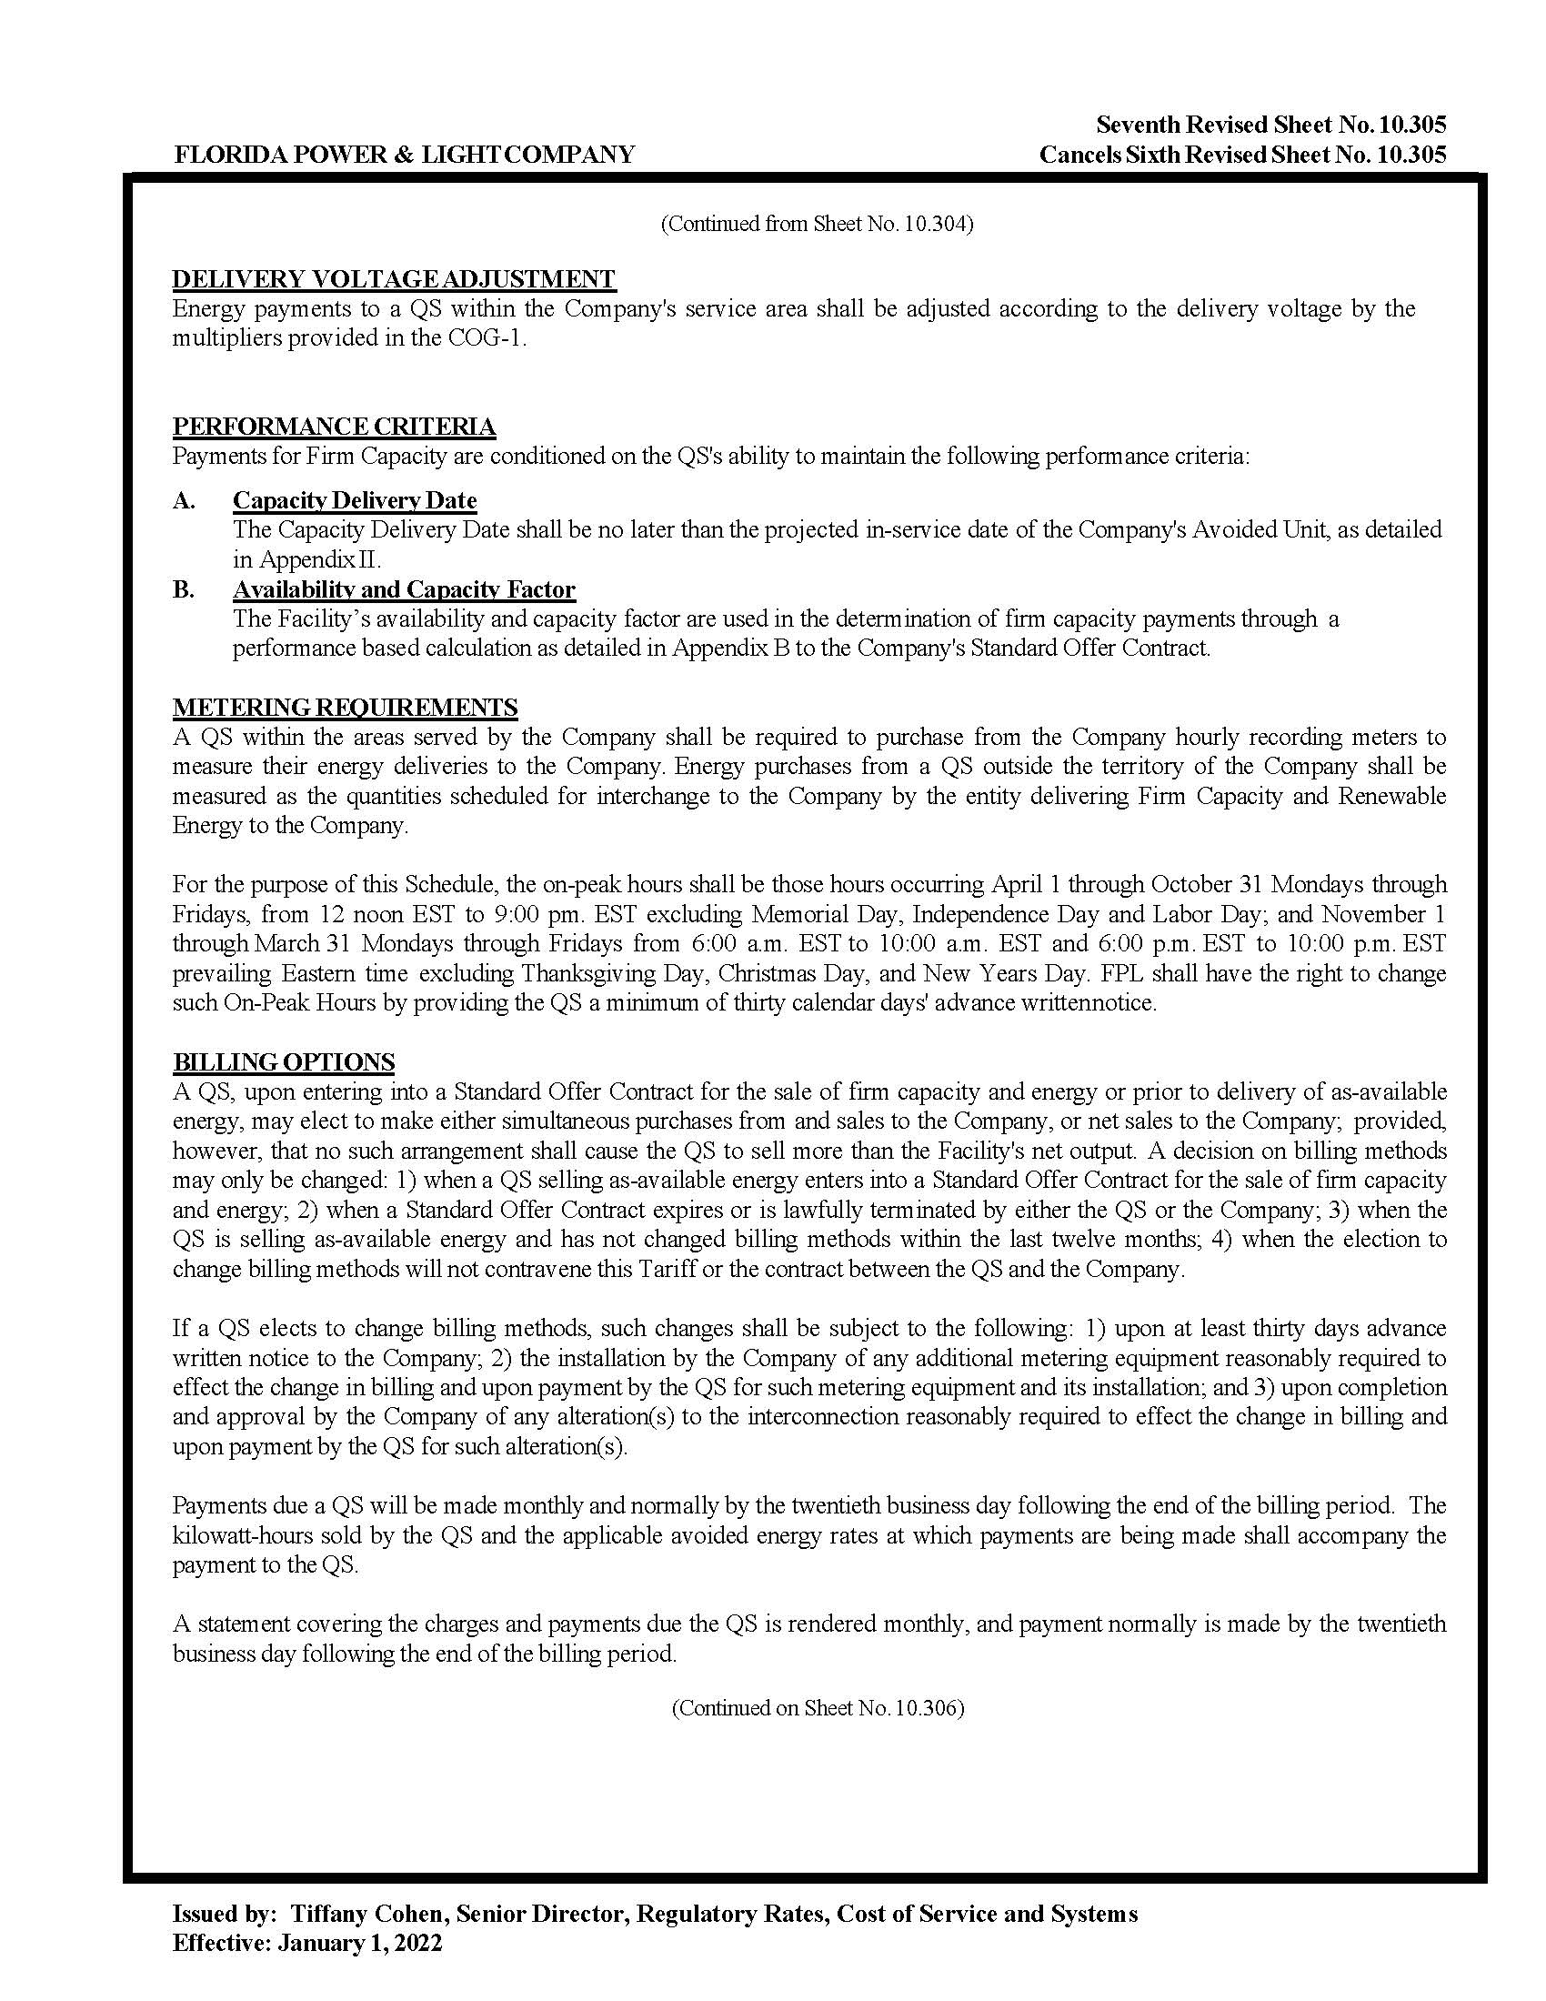
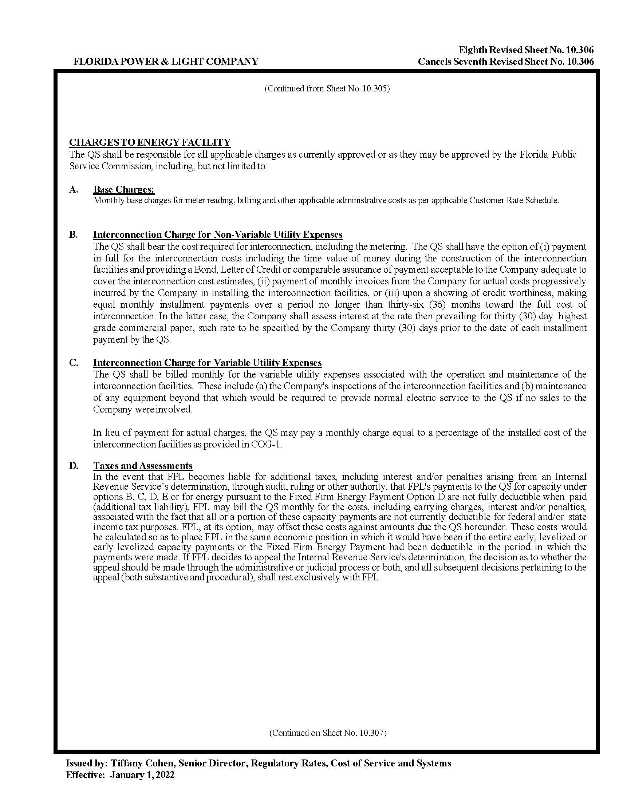
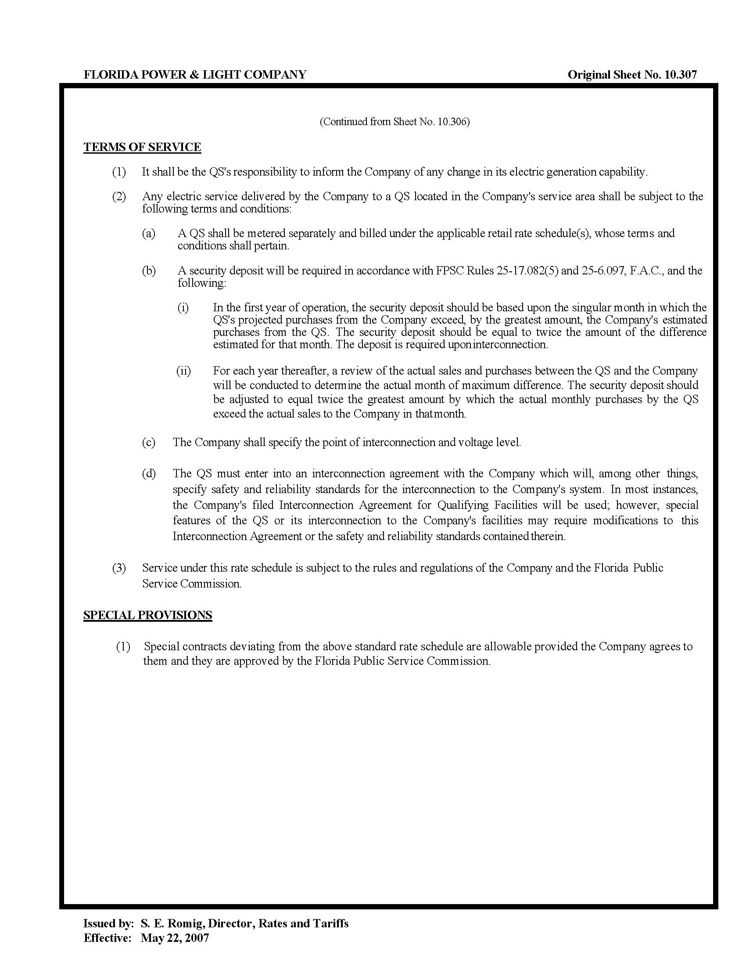
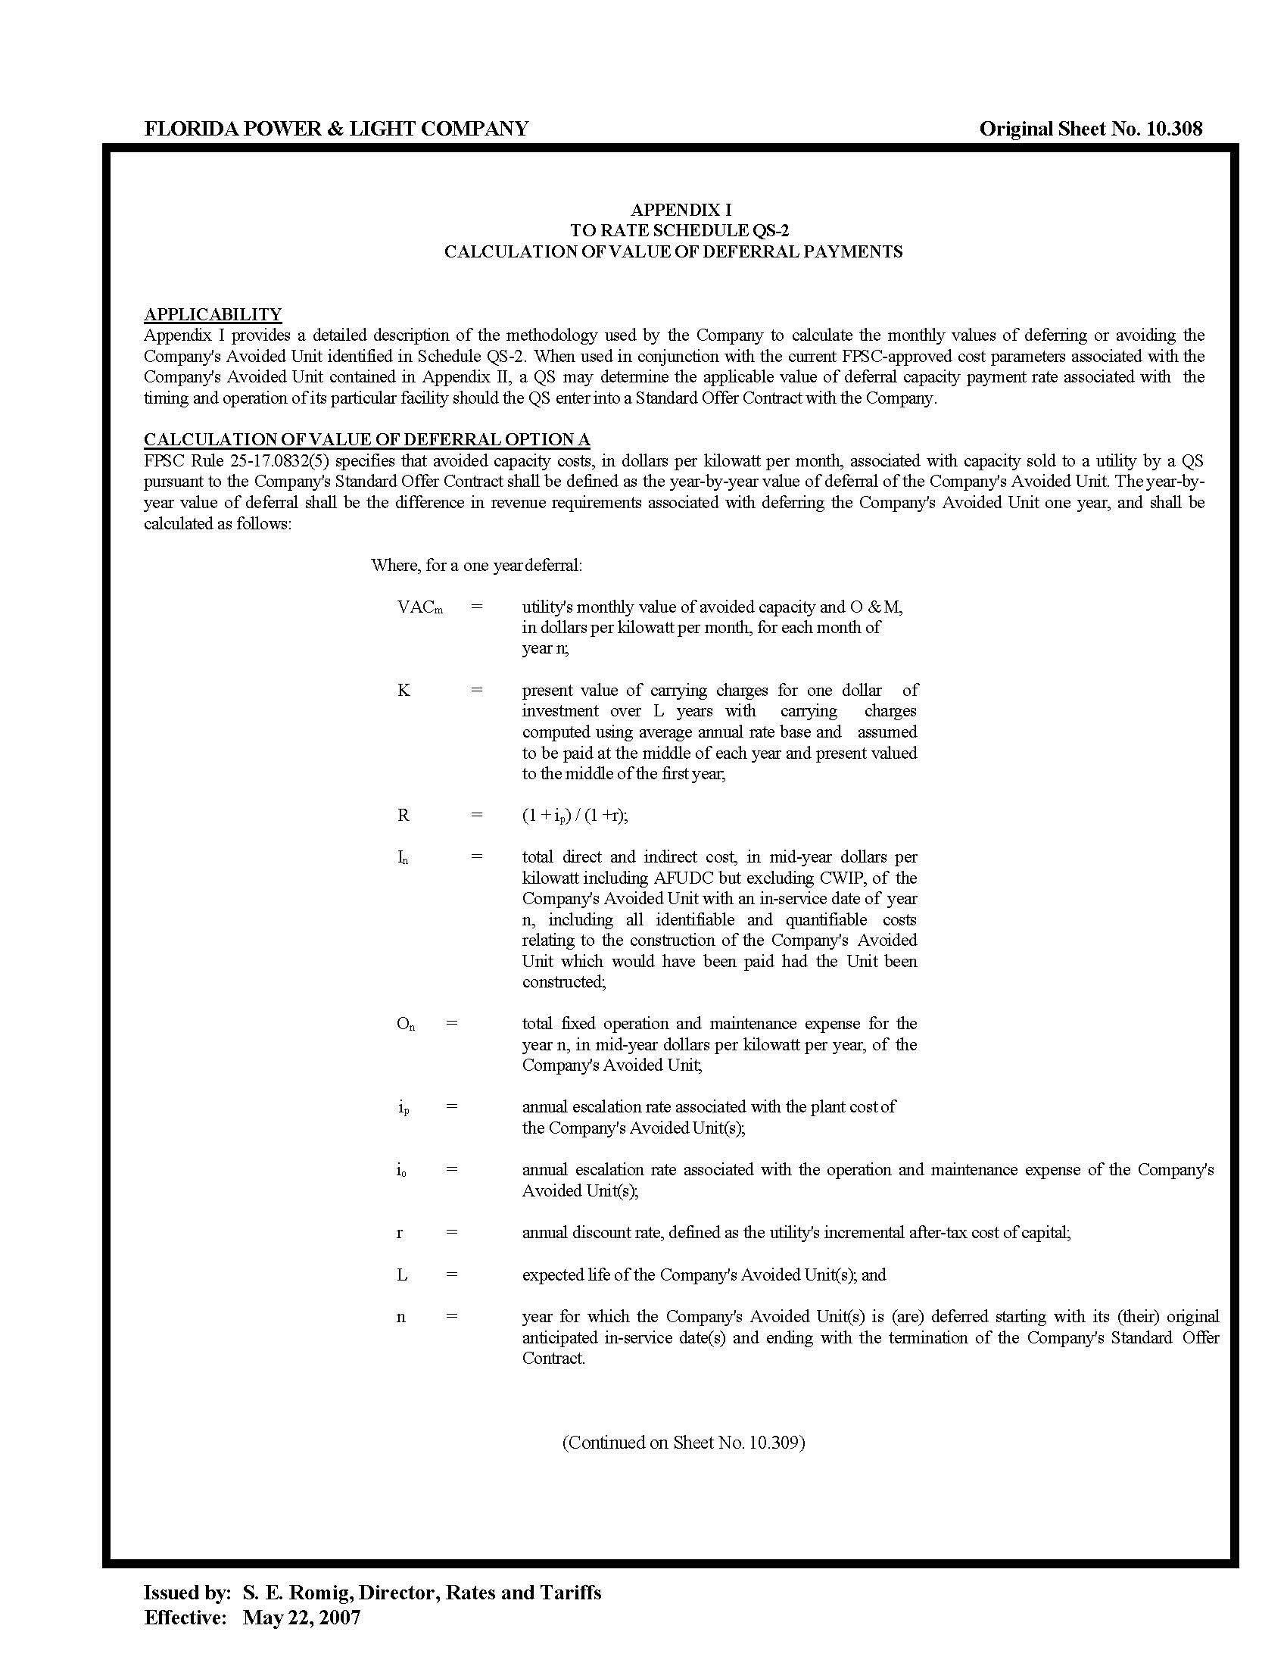
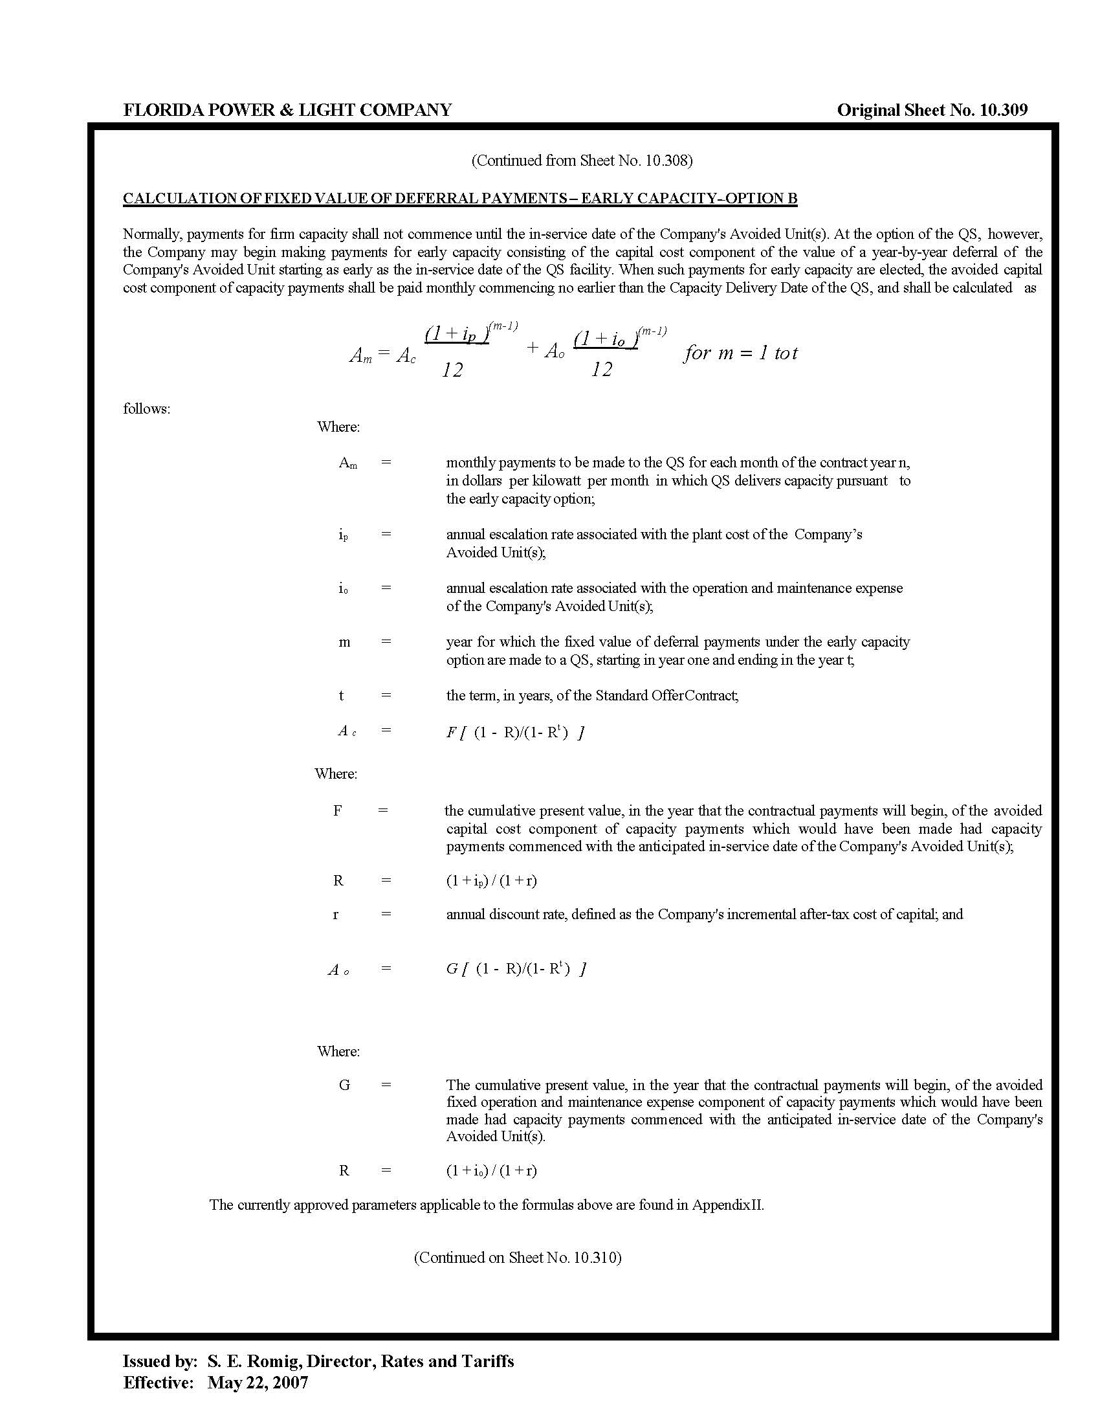
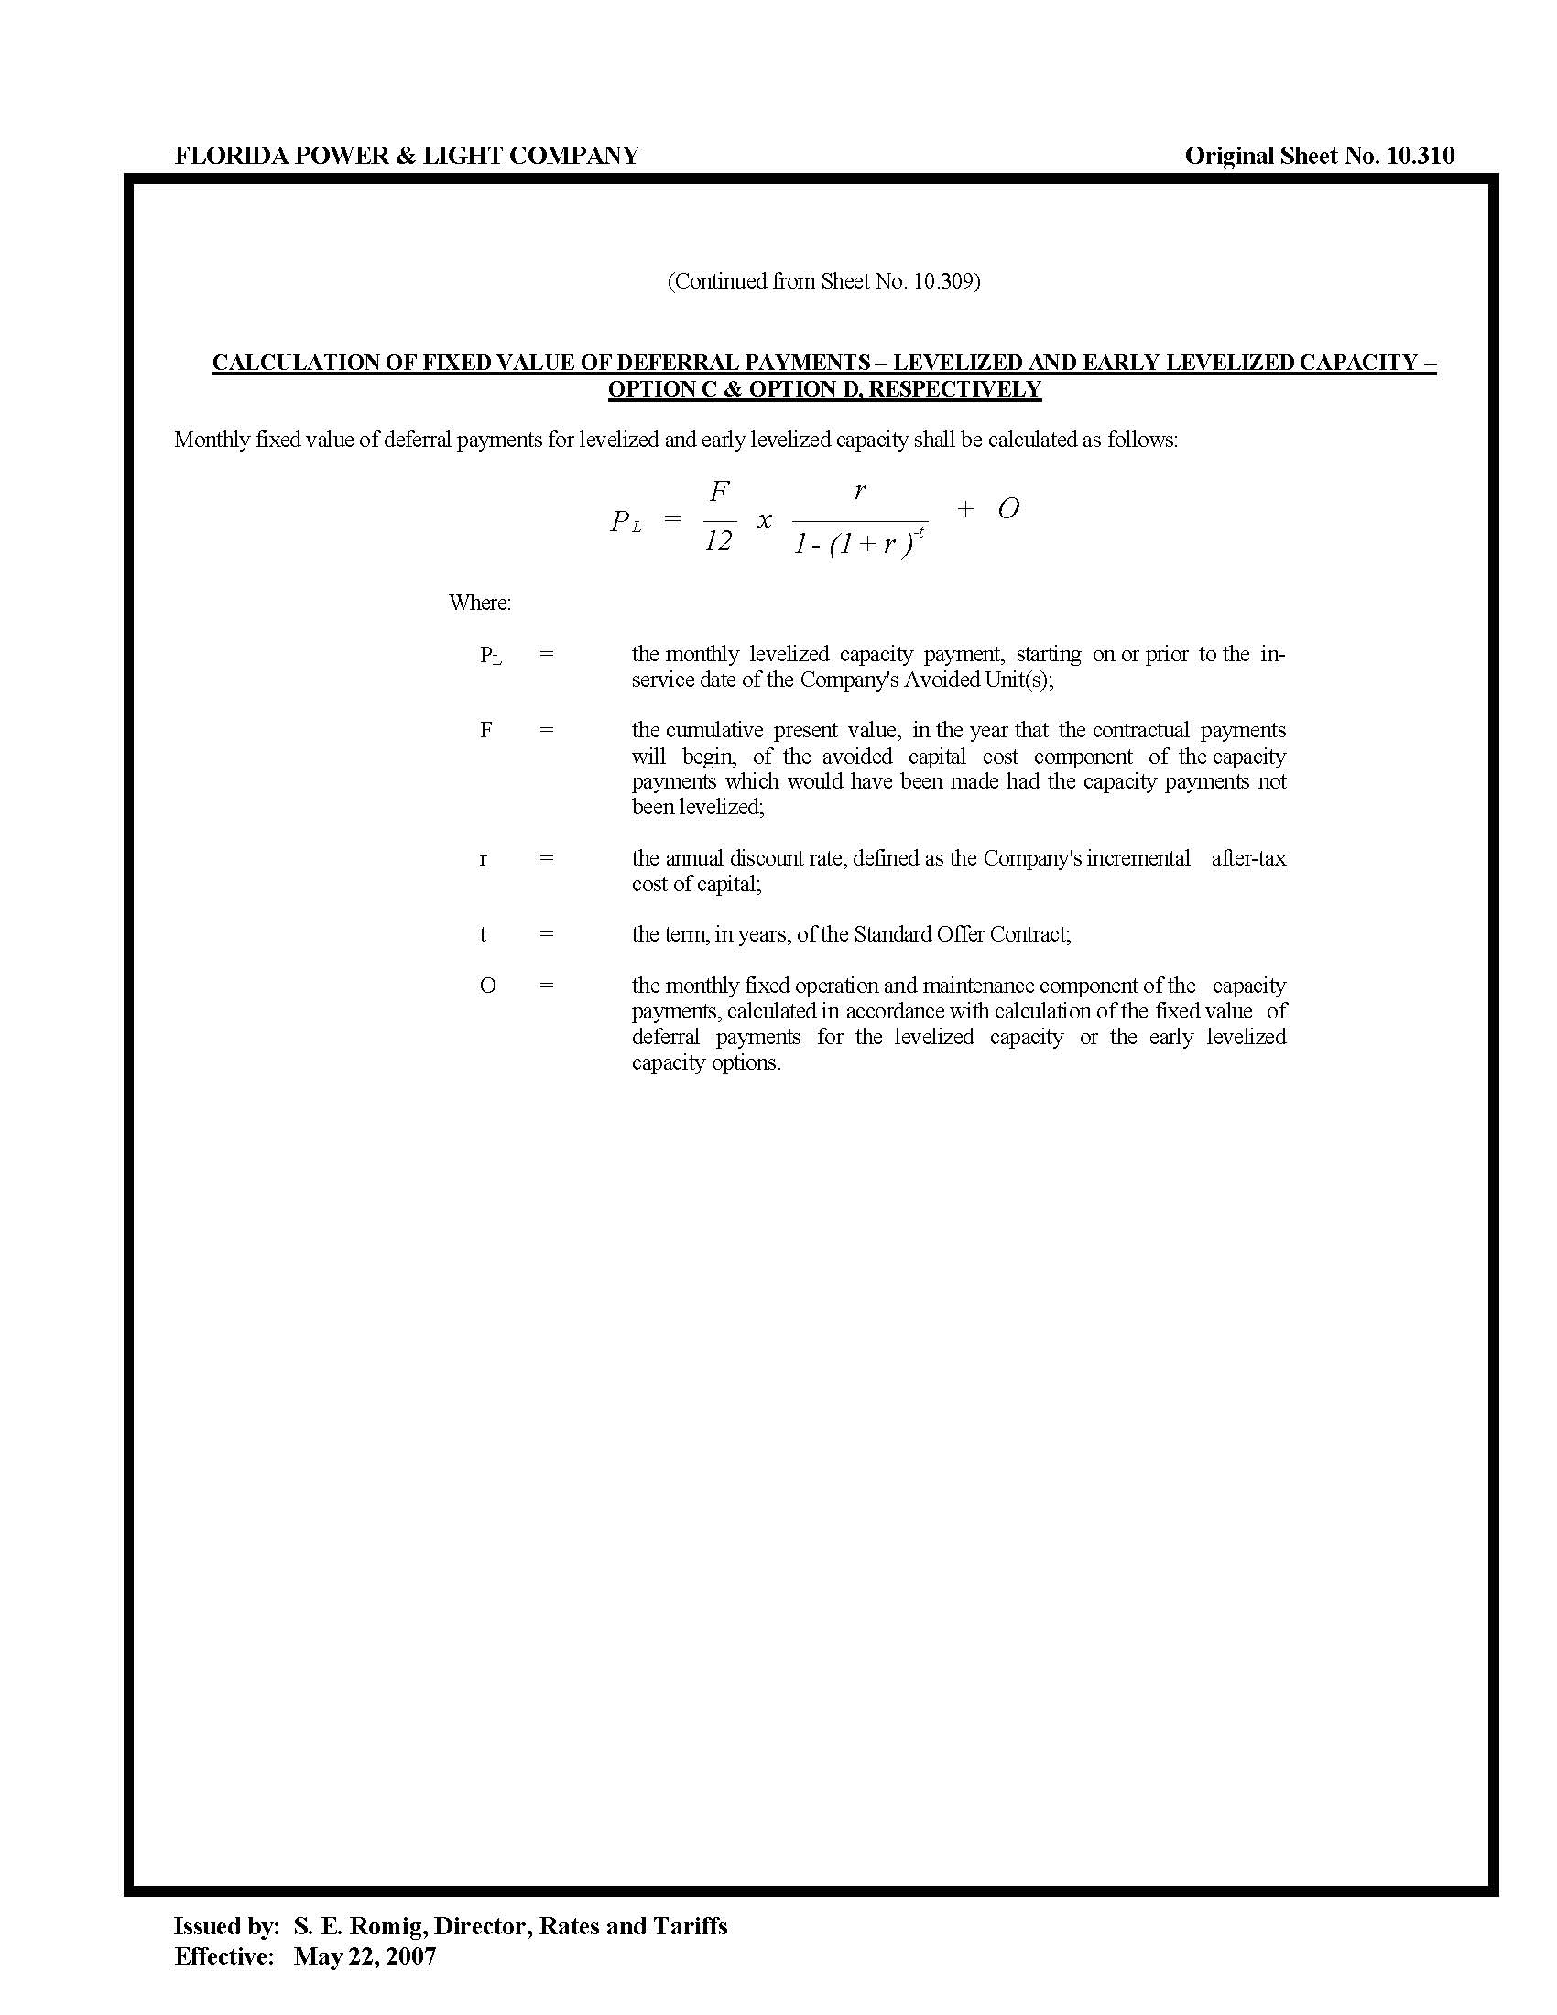
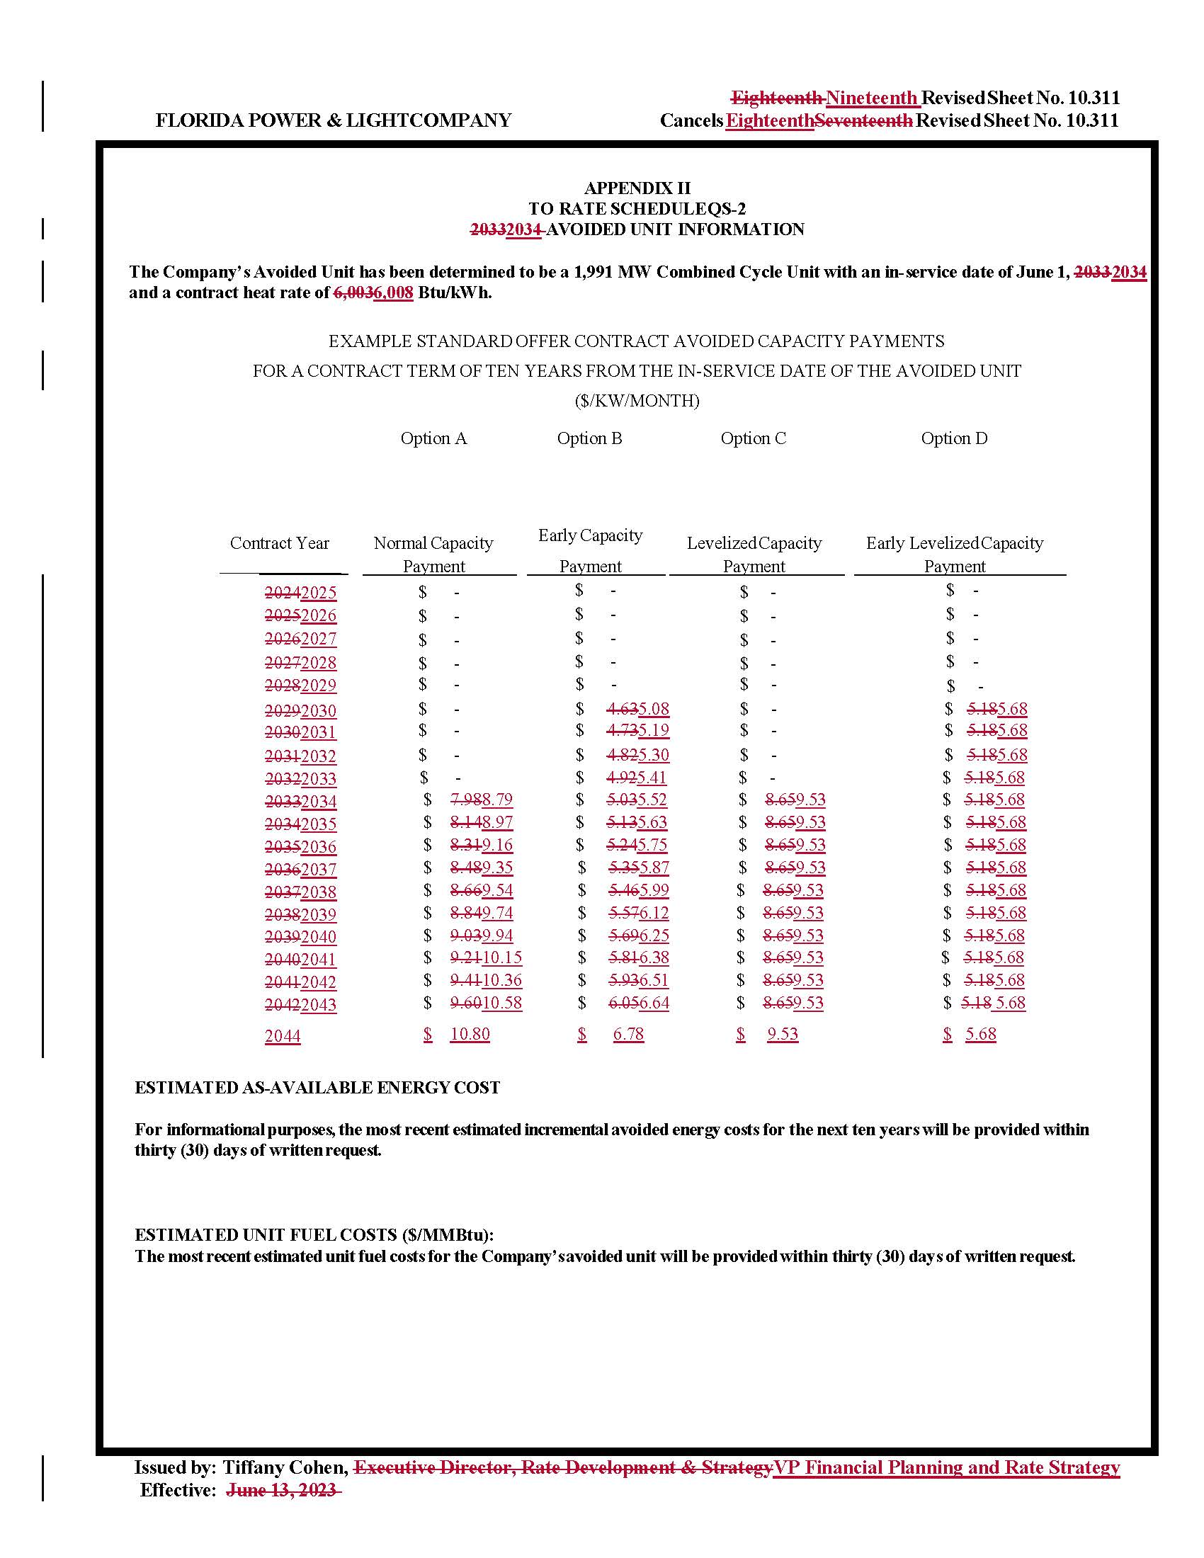
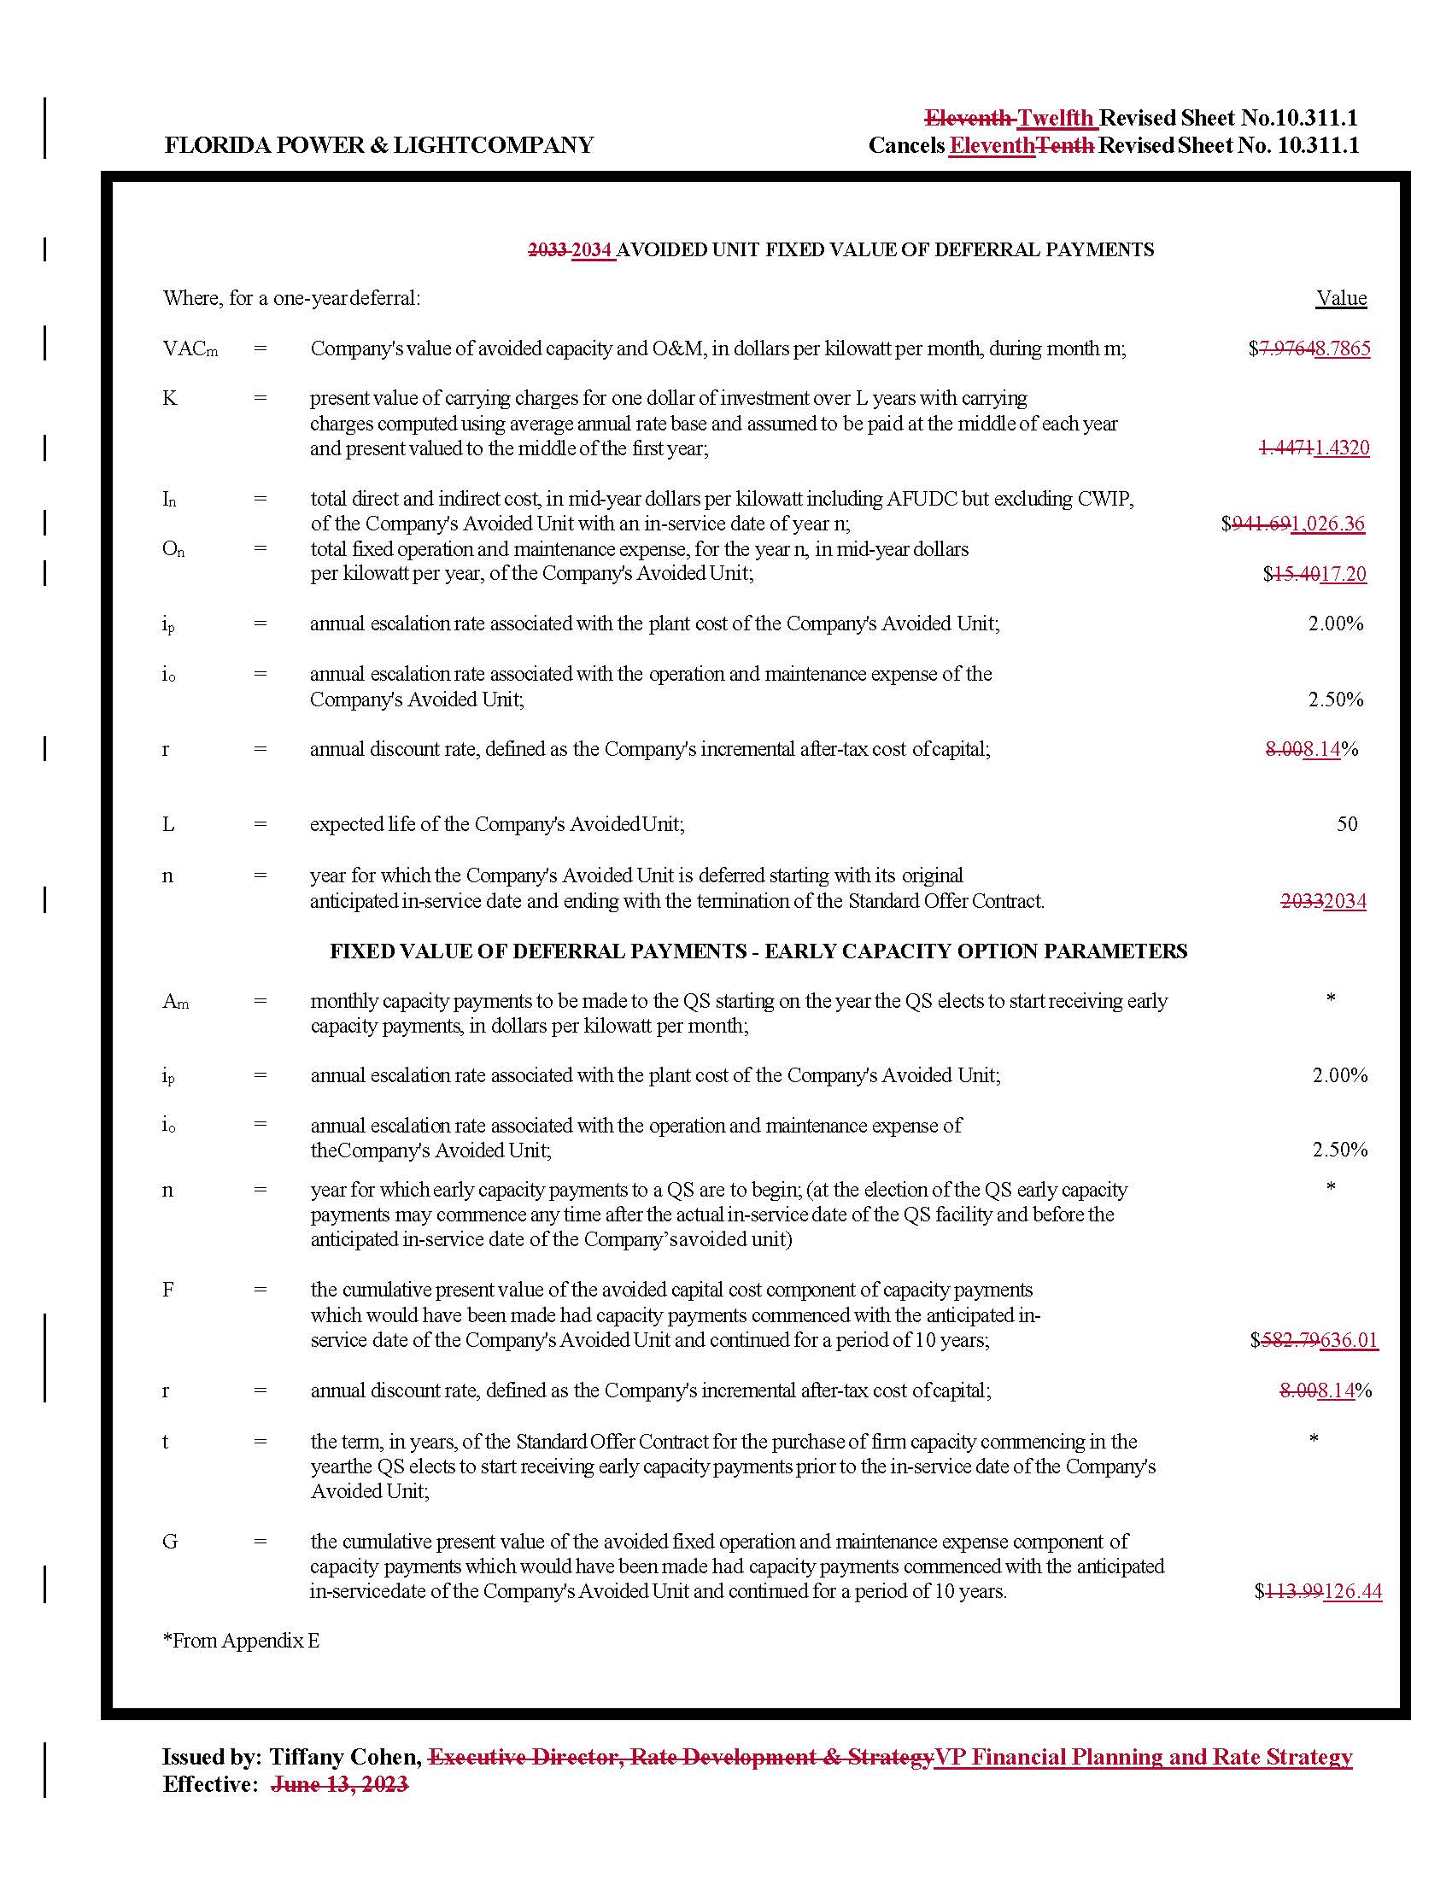
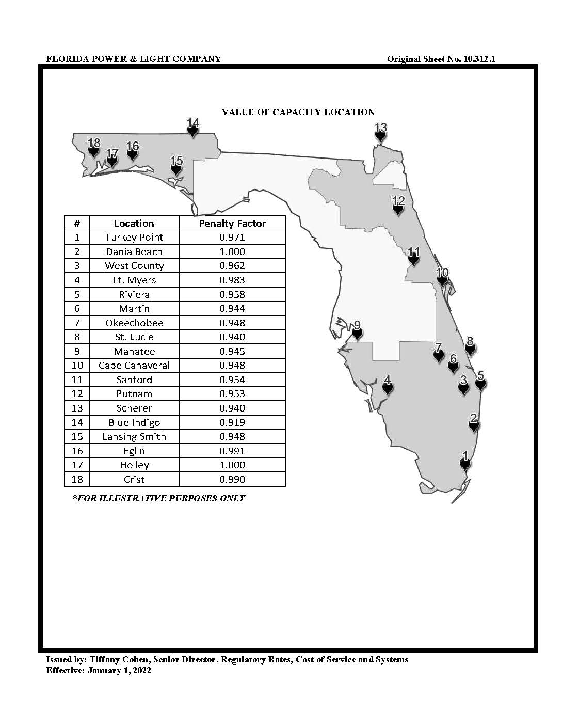
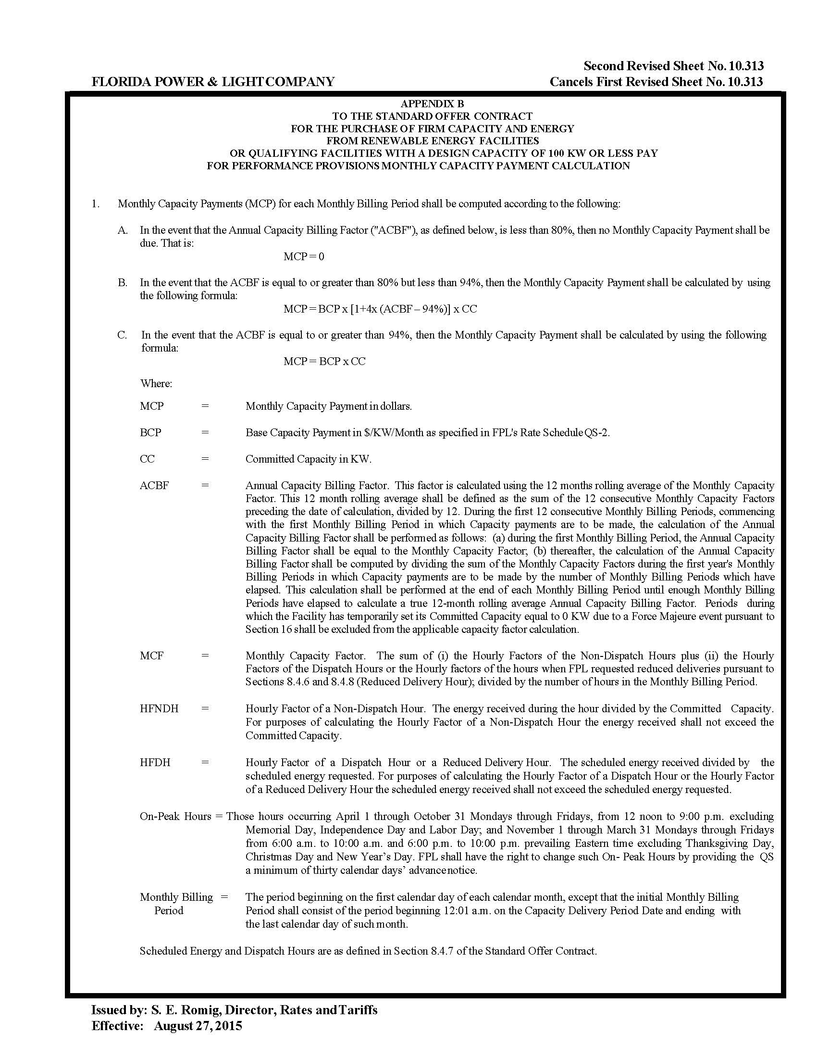
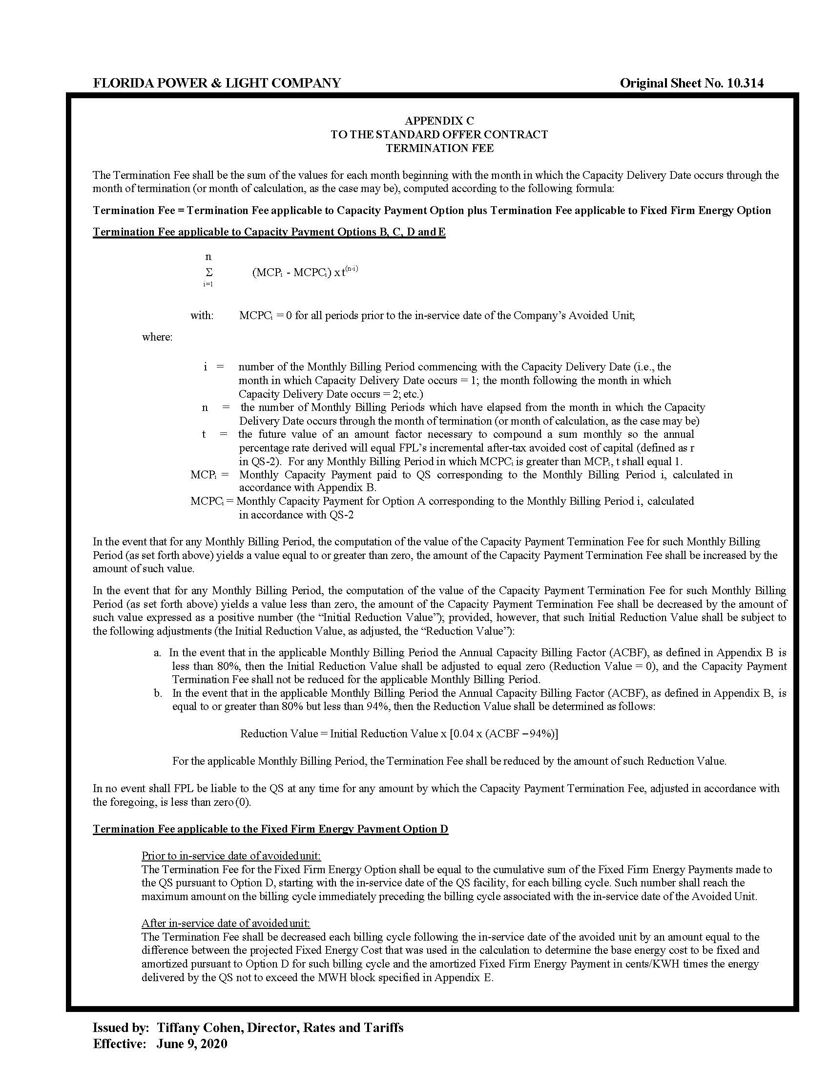
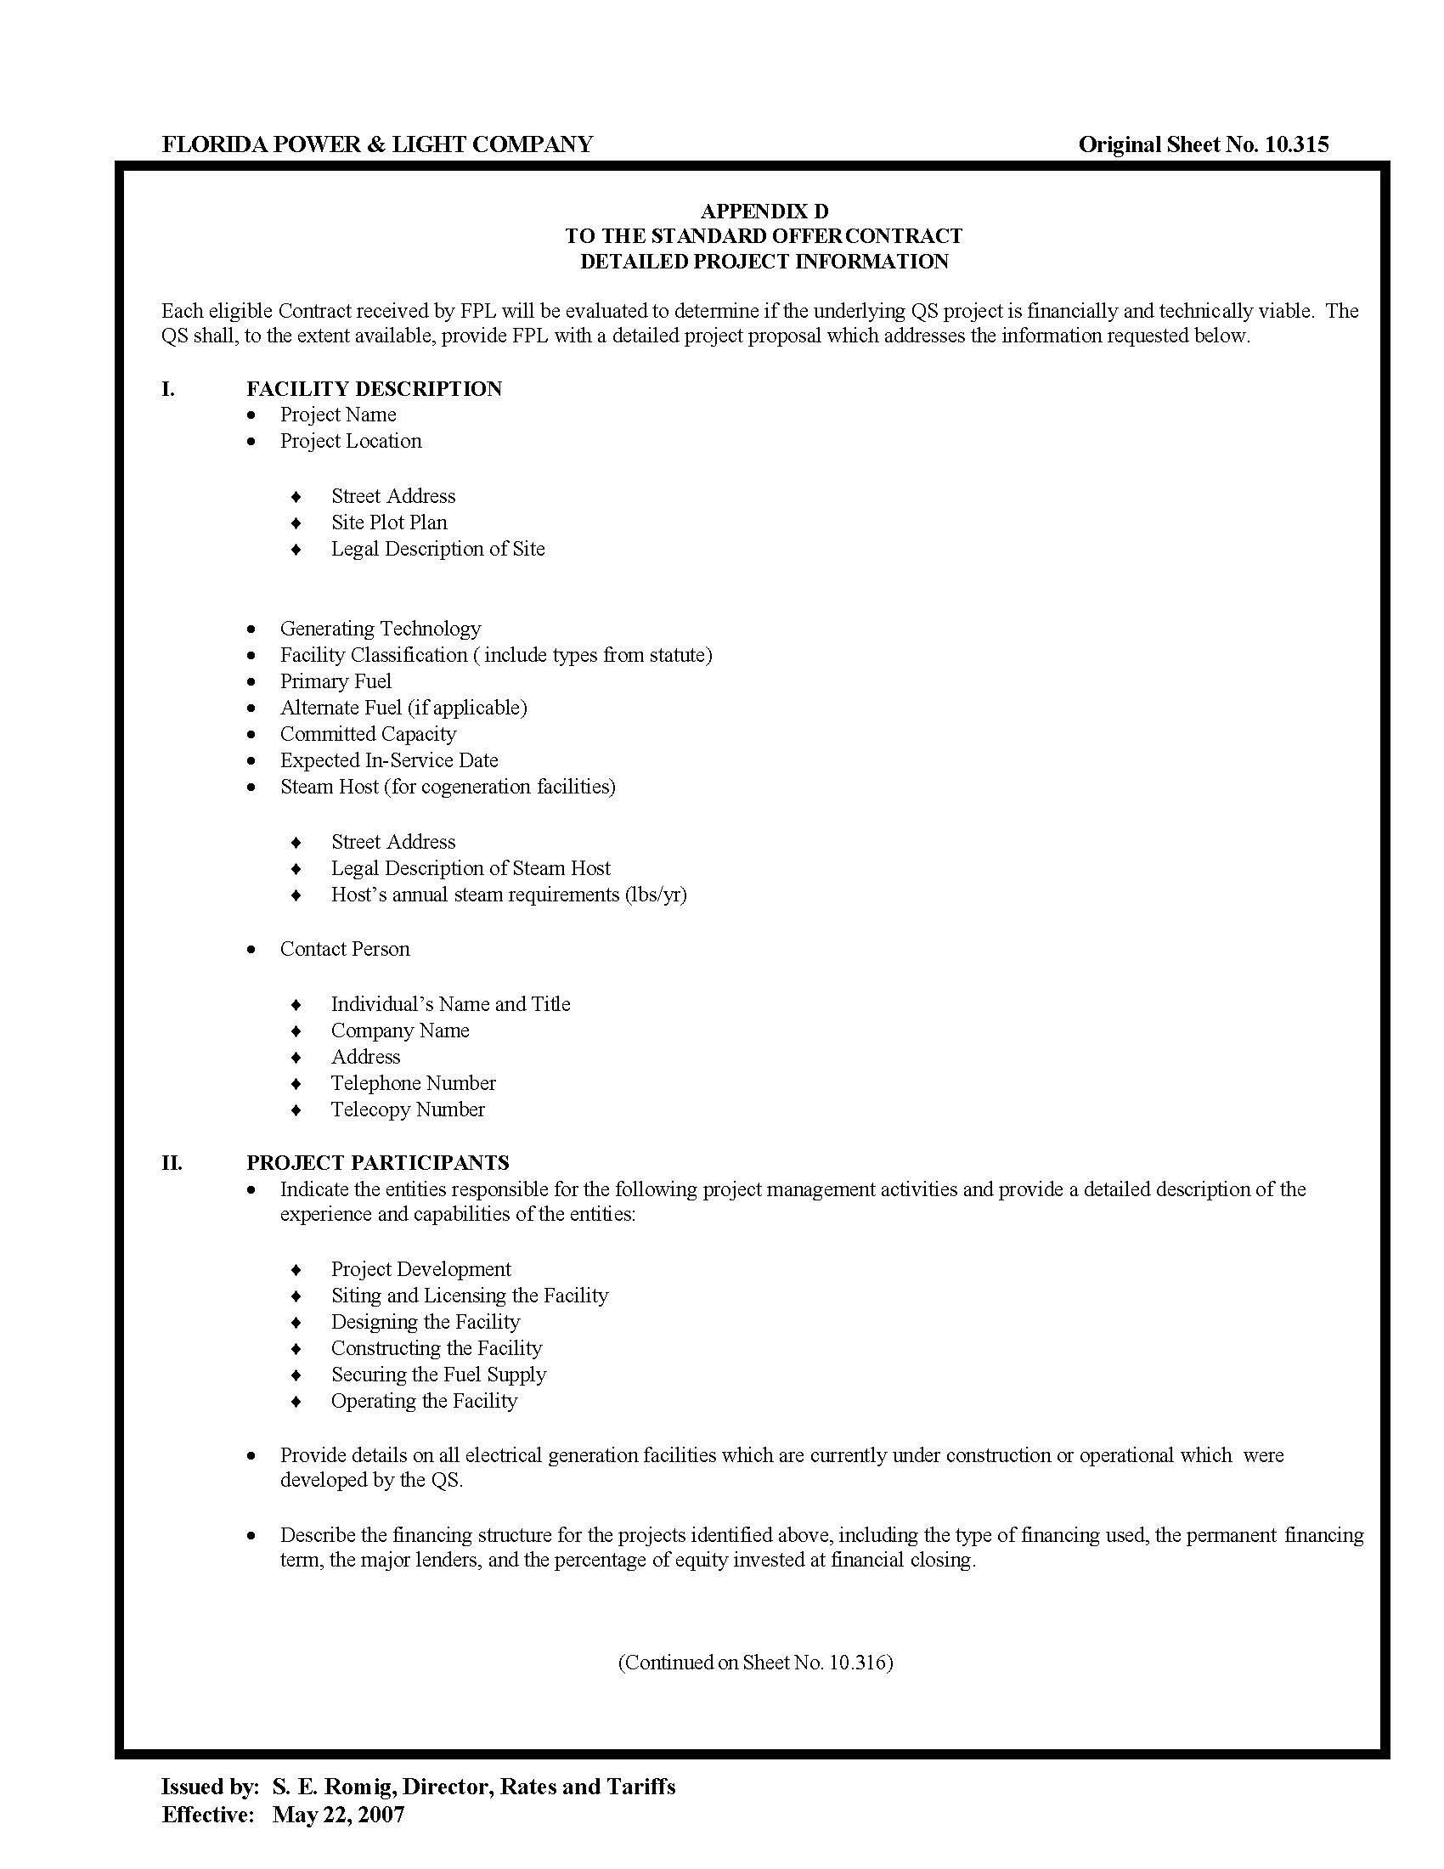
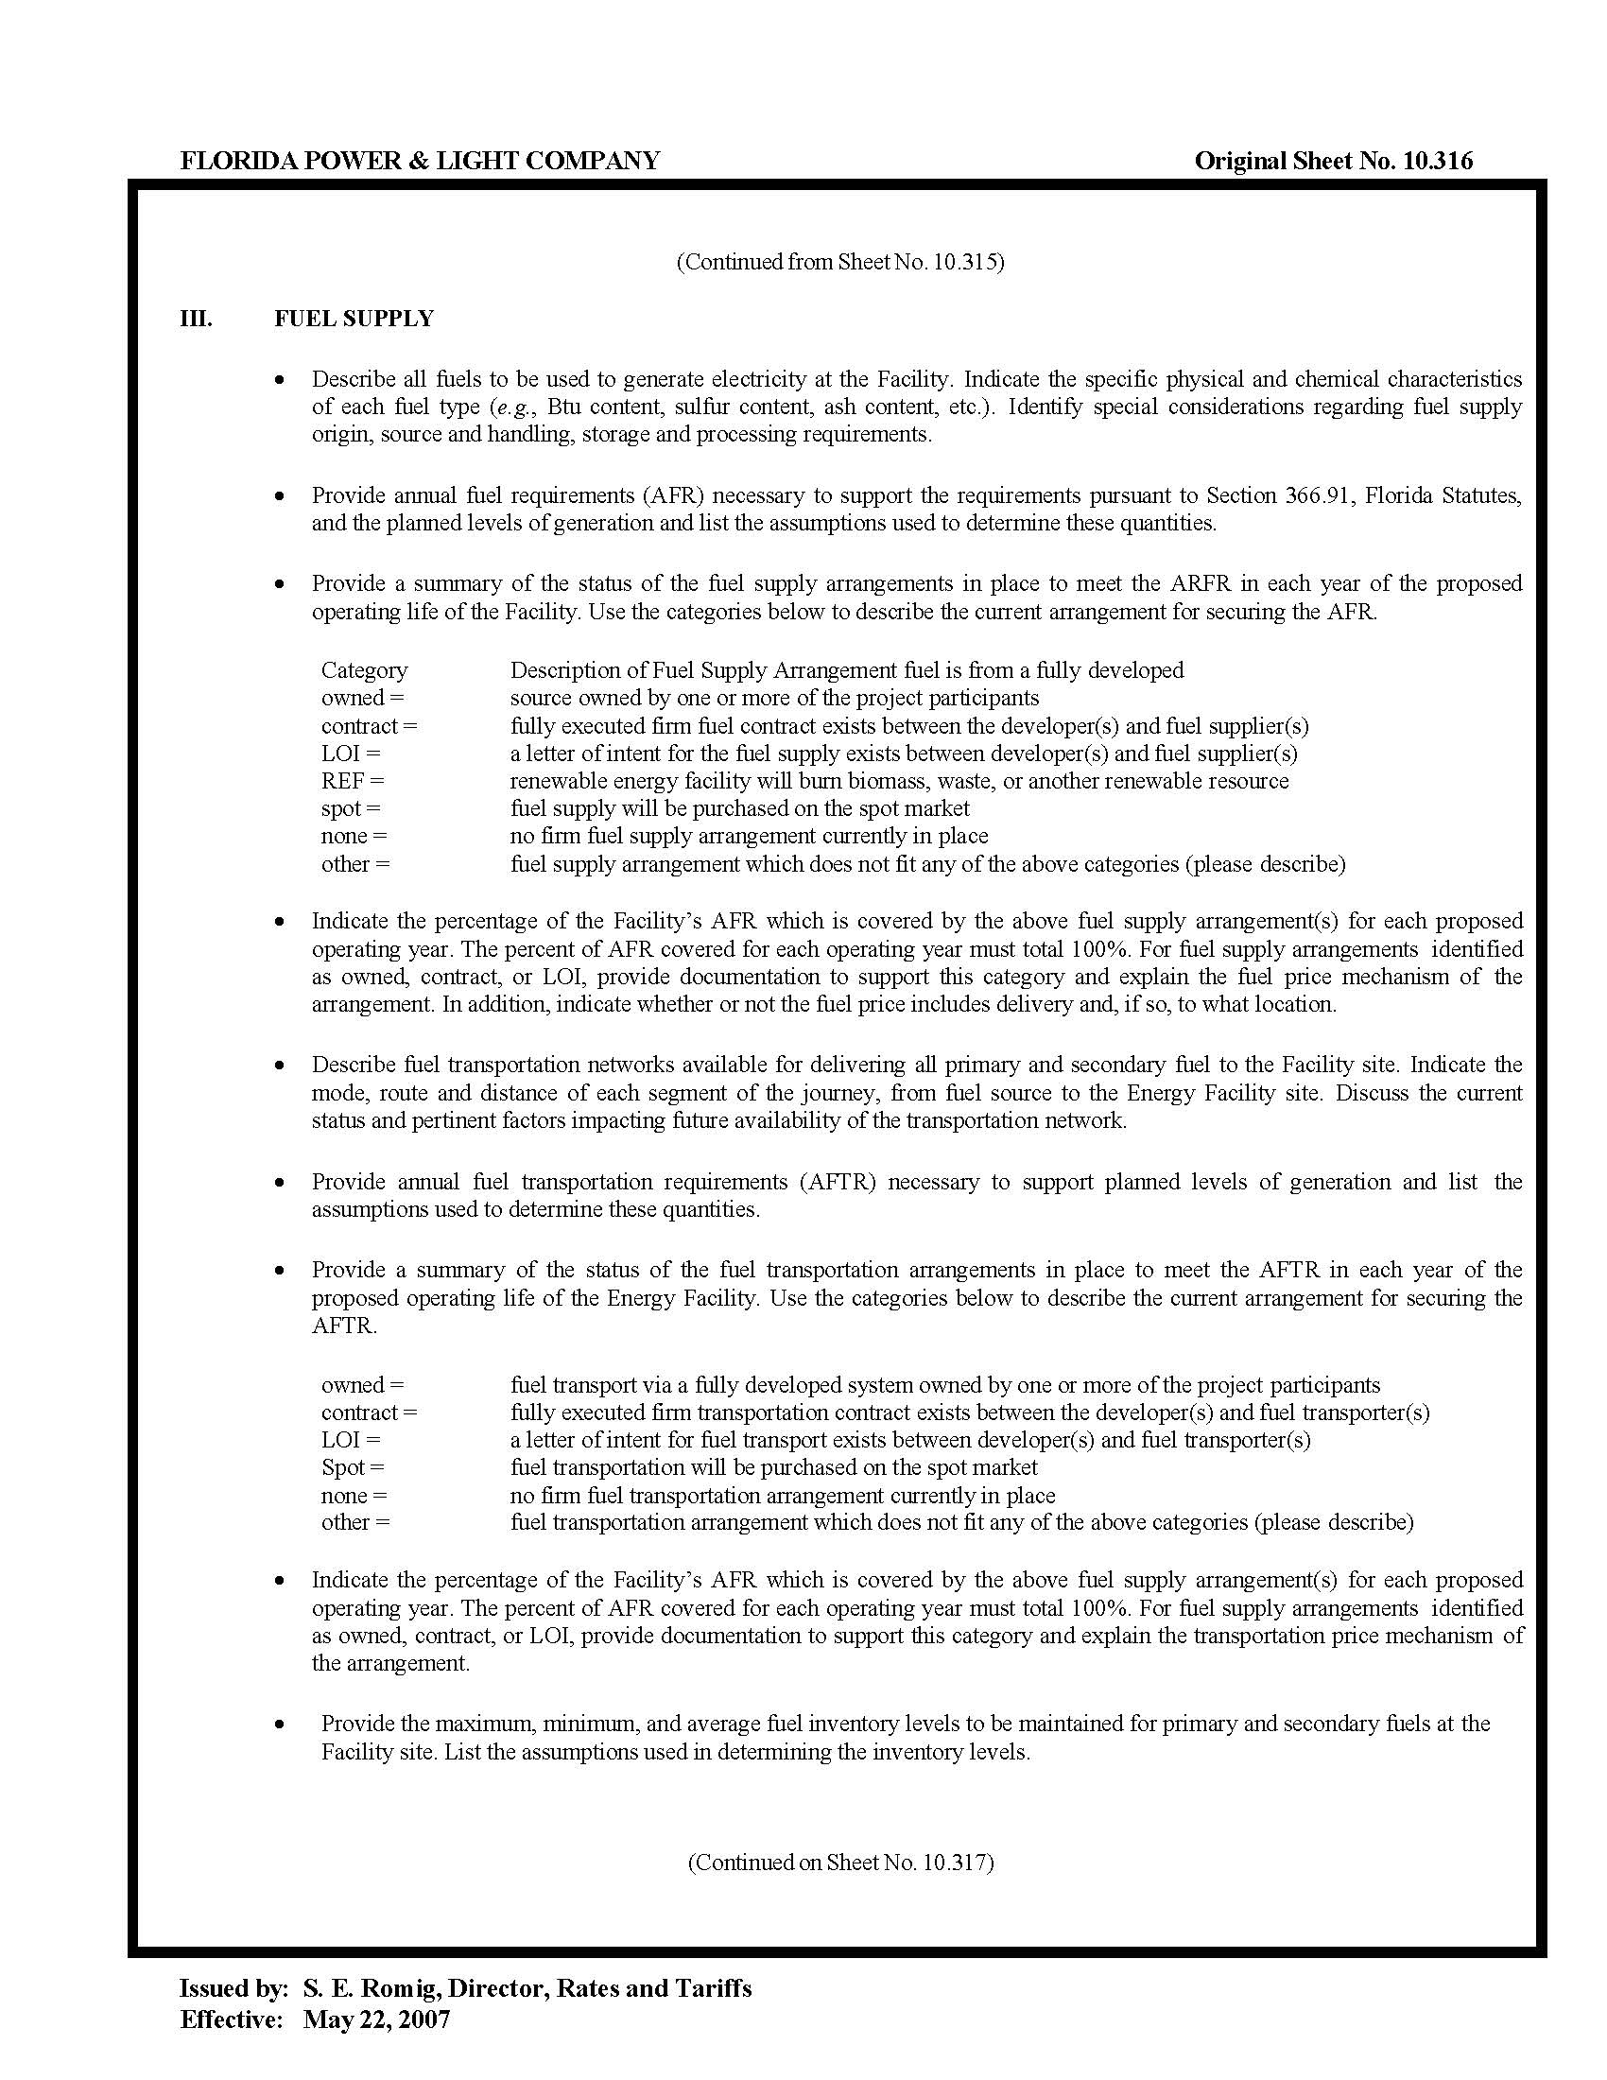
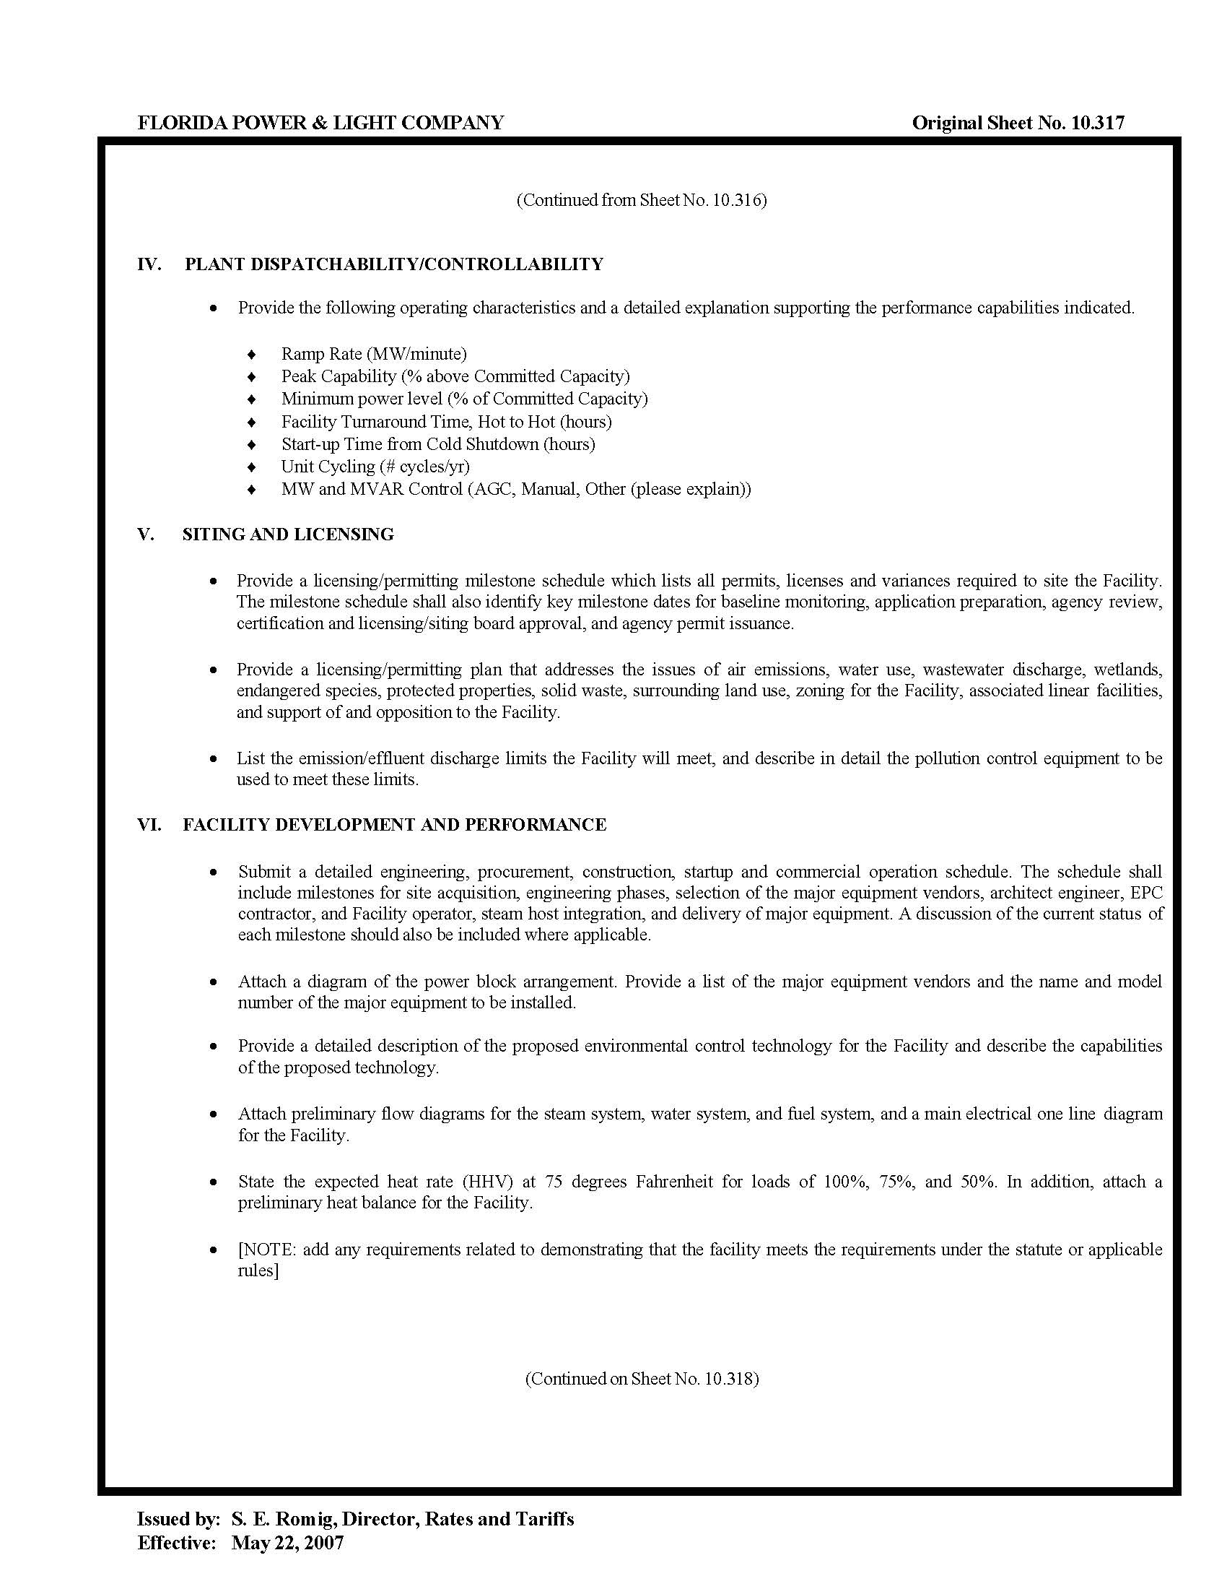
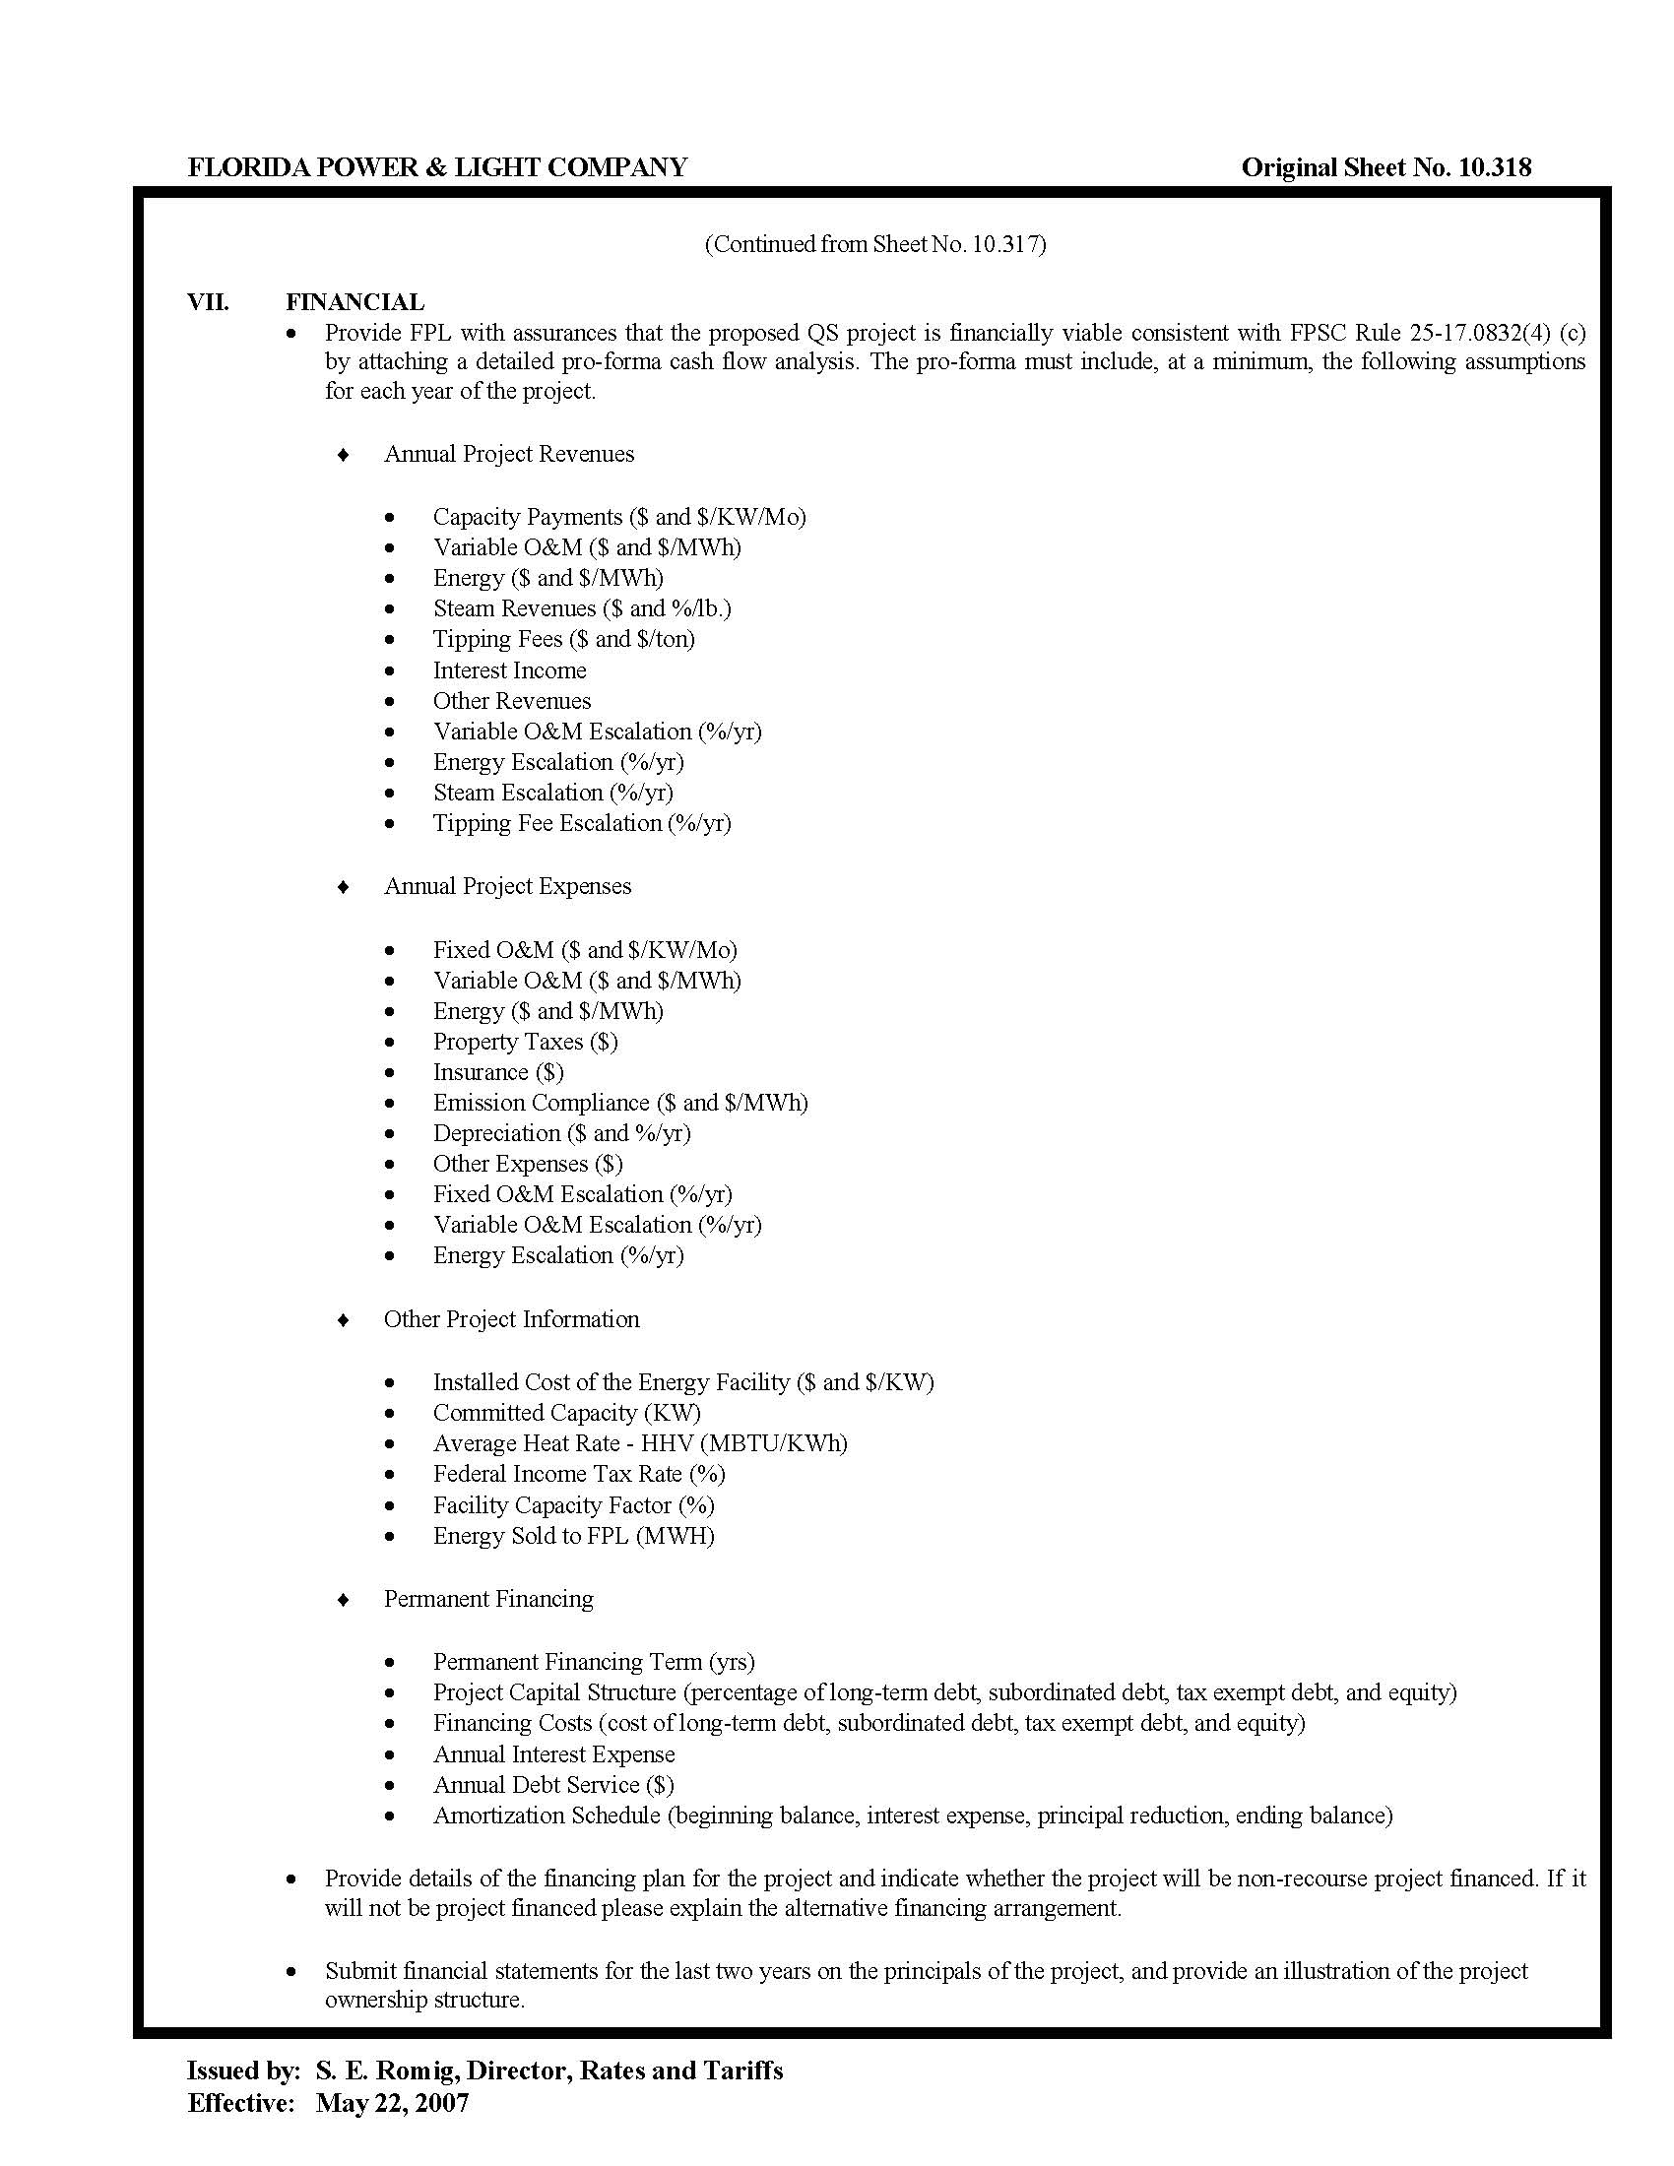
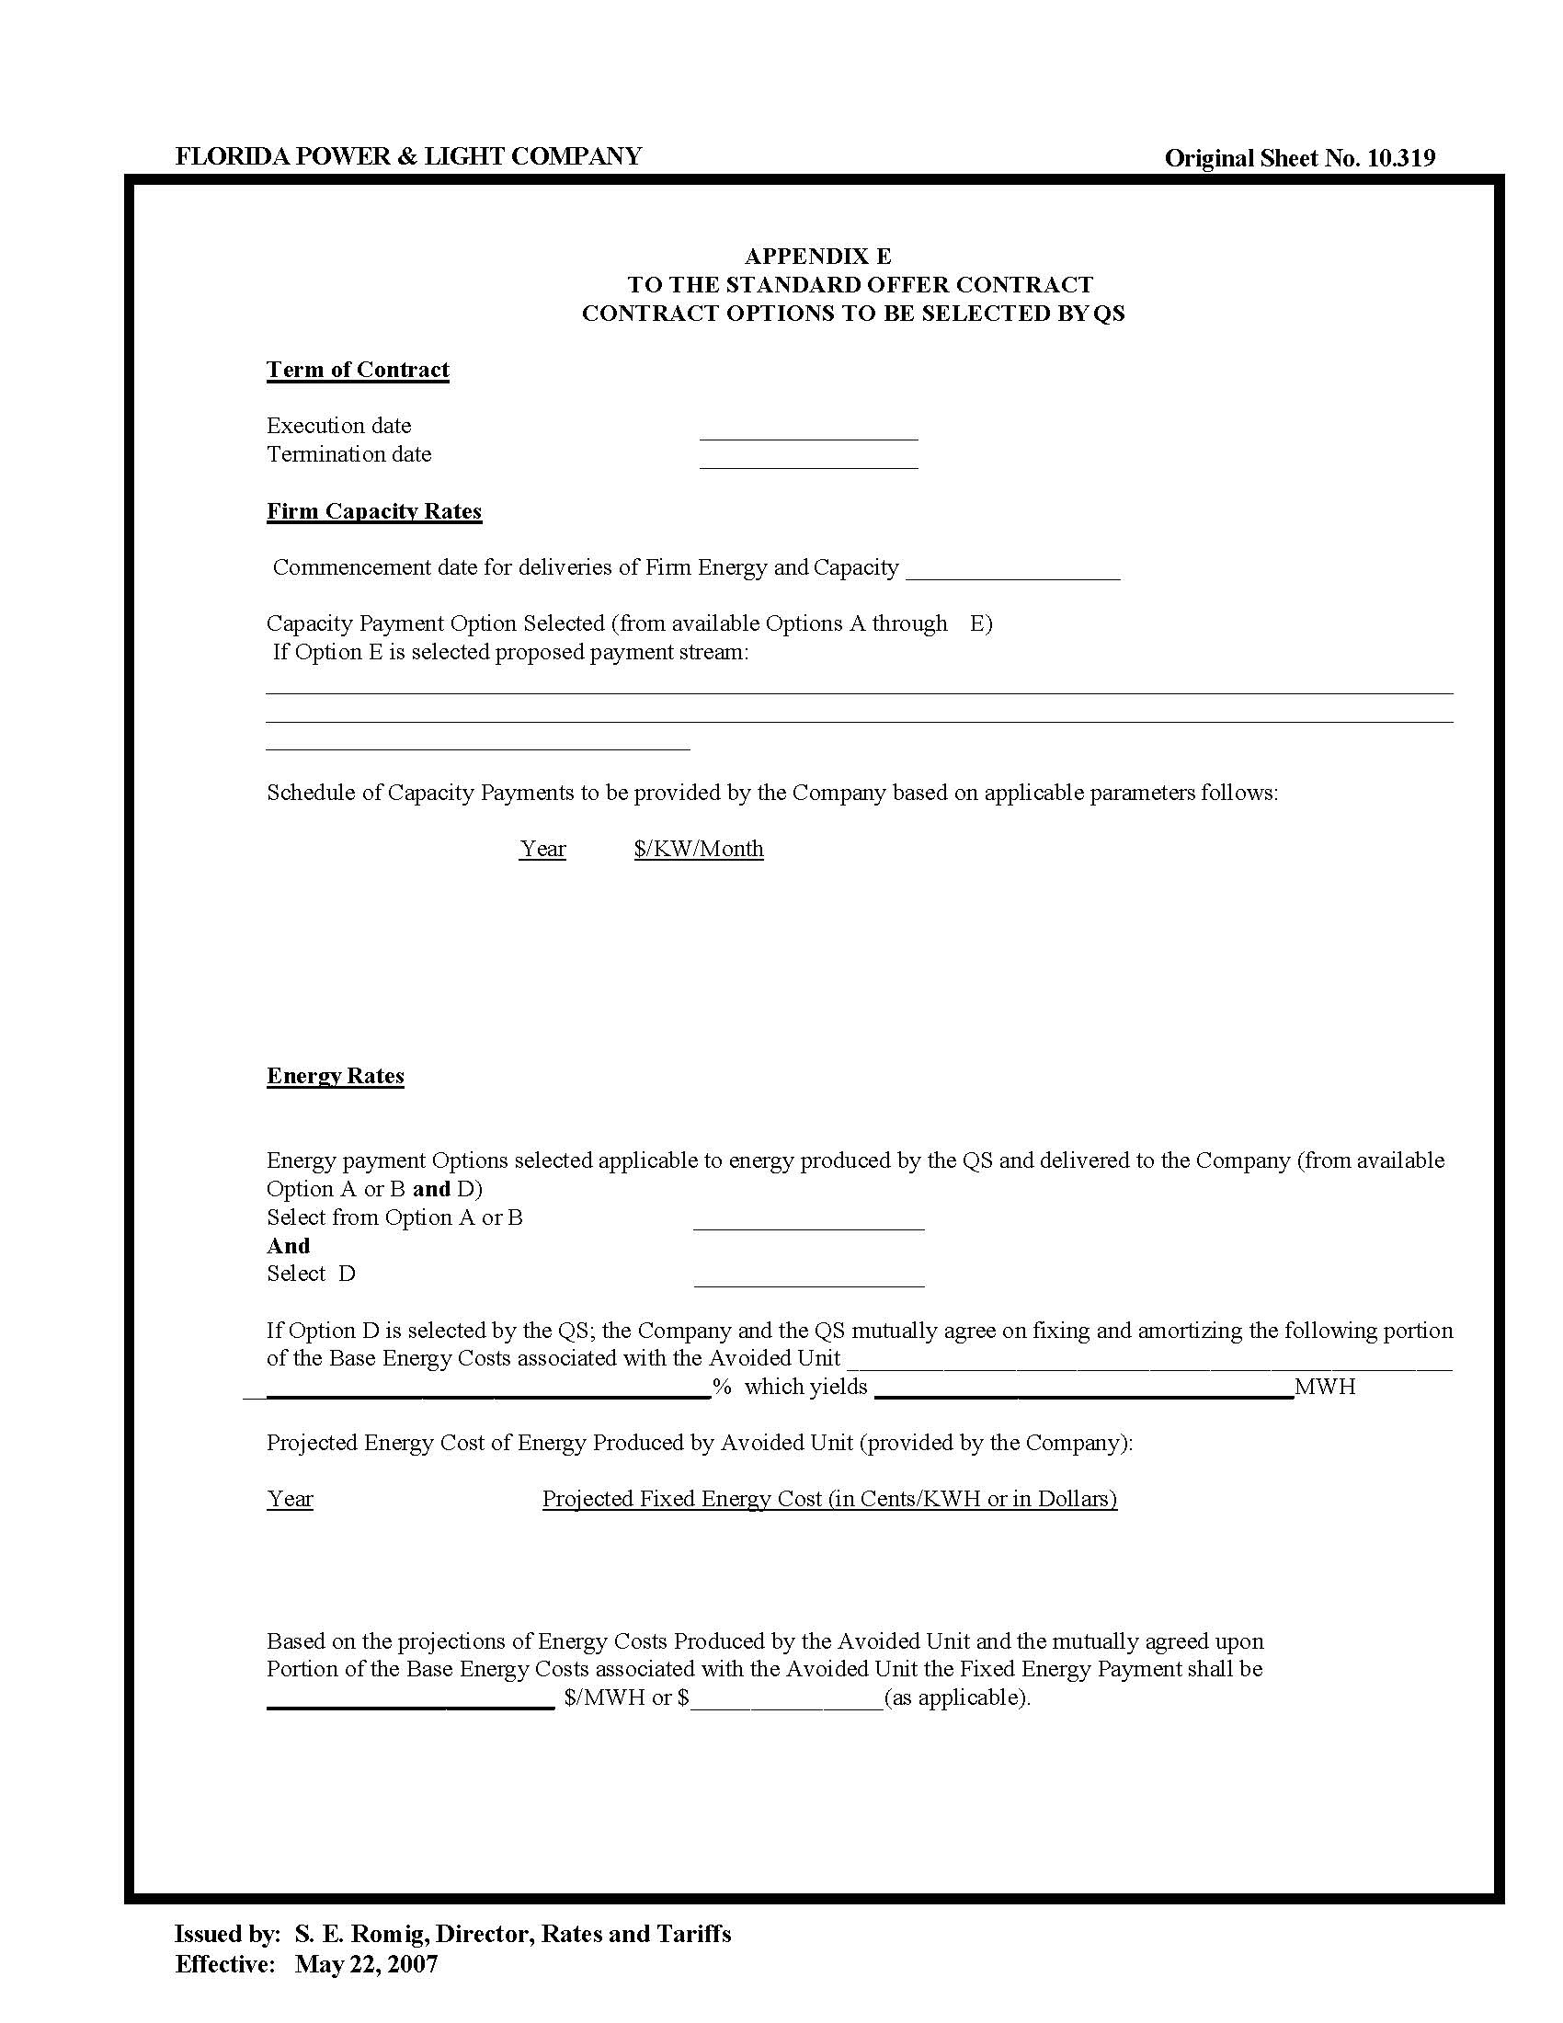

E.g., In re: Petition for approval of renewable energy tariff & standard offer contract, by Fla. Power & Light Co., Docket No. 20180083-EQ, Order No. PSC-2018-0316-PAA-EQ (Fla. PSC June 20, 2018); see also In re: Petition for approval of revised standard offer contract & a revised accompanying rate schedule QS-2, by Fla. Power & Light Co., Docket No. 20220072-EQ, Order No. PSC-2022-0203-PAA-EQ (Fla. PSC June 9, 2022); In re: Petition for approval of renewable energy tariff & standard offer contract, by Fla. Power & Light Co., Docket No. 20200114-EQ, Order No. PSC-2020-0212-PAA-EQ (Fla. PSC June 26, 2020); In re: Petition for approval of new standard offer for purchase of firm capacity & energy from renewable energy facilities or small qualifying facilities & rate schedule QS-2, by Gulf Power Co., Docket No. 20200115-EQ, Order No. PSC-2020-0213-PAA-EQ (Fla. PSC June 26, 2020).
In re: Petition for approval of renewable energy tariff & standard offer contract, by Fla. Power & Light Co., Docket No. 20240055-EQ, Document No. 02229-2024 (filed Apr. 22, 2024).

