BEFORE THE FLORIDA PUBLIC SERVICE COMMISSION

|  |  |
| --- | --- |
| In re: Petition for approval of transportation service agreement with Florida Public Utilities Company by Peninsula Pipeline Company, Inc. | DOCKET NO. 20240050-GU  ORDER NO. PSC-2024-0270-PAA-GU  ISSUED: July 26, 2024 |

The following Commissioners participated in the disposition of this matter:

MIKE LA ROSA, Chairman

ART GRAHAM

GARY F. CLARK

ANDREW GILES FAY

GABRIELLA PASSIDOMO

NOTICE OF PROPOSED AGENCY ACTION

ORDER APPROVING FIRM TRANSPORTATION SERVICE AGREEMENT

BY THE COMMISSION:

NOTICE is hereby given by the Florida Public Service Commission that the action discussed herein is preliminary in nature and will become final unless a person whose interests are substantially affected files a petition for a formal proceeding, pursuant to Rule 25-22.029, Florida Administrative Code.

Background

On March 28, 2024, Peninsula Pipeline Company, Inc. (Peninsula) filed a petition for approval of a firm transportation service agreement between Peninsula and Florida Public Utilities Company (FPUC) (jointly, the parties). The transportation agreement will permit Peninsula to provide transportation service for FPUC along the Pioneer Supply Header Pipeline (Pioneer Header), therefore allowing FPUC to continue serving customers in Palm Beach County, provide reinforcement, and allow for future expansion. FPUC is a local distribution company (LDC) subject to our regulatory jurisdiction pursuant to Chapter 366, Florida Statutes (F.S.). Peninsula operates as an intrastate natural gas transmission company as defined by Section 368.103(4), F.S.[1]

Peninsula provides gas transportation service only; it does not engage in the sale of natural gas to customers. By Order No. PSC-07-1012-TRF-GP (2007 Order), Peninsula received our approval for an intrastate gas pipeline tariff that allows it to construct and operate intrastate pipeline facilities and to actively pursue agreements with natural gas customers.[2] Pursuant to the 2007 Order, Peninsula is allowed to enter into gas transmission agreements that meet certain criteria without our prior approval.[3] However Peninsula is requesting our approval of this proposed agreement as it does not fit any of the enumerated criteria.[4] Additionally, Peninsula and FPUC are subsidiaries of Chesapeake Utility Corporation, and agreements between affiliated companies must be approved by us pursuant to Section 368.105, F.S., and the 2007 Order.

The Pioneer Header was constructed by Florida City Gas (FCG) to provide itself and other local distribution companies (LDC) and industrial customers with natural gas supply in the area in and around Palm Beach County. Currently, pursuant to a transportation agreement between FCG and FPUC, FCG provides transportation service on the Pioneer Header pipeline to FPUC.

The Pioneer Header is being transferred from FCG to Peninsula. This sale of the asset does not require our review; however, the sale will not take place until after our approval of the transportation service agreement between FCG and Peninsula addressed in Docket No. 20240051-GU. Following the transfer of the Pioneer Header from FCG to Peninsula, Peninsula would own the pipeline. Pursuant to the petition in this docket, Peninsula is seeking our approval of a transportation agreement with FPUC to provide natural gas transportation service along the Pioneer Header to FPUC. The proposed transportation agreement and project map are shown as Attachments A and B to this Order.

During the evaluation of the petition, our staff issued a data request to the parties for which responses were received on June 14 and on June 19, 2024. We have jurisdiction over this matter pursuant to Sections 366.05(1), 366.06, and 368.105, F.S.

Decision

The parties have proposed a firm transportation agreement that is the subject of this docket to maintain and enhance service to the West Palm Beach area currently provided by FCG. The parties state that the proposed agreement will allow Peninsula to serve FPUC with 900 dekatherms per day of firm transportation at three delivery points. The parties further assert that this level of service is needed for FPUC to serve current customers and expand into serving potential new customers with the addition of two delivery points.

The proposed firm transportation agreement between FPUC and Peninsula is contingent on the transfer of the Pioneer Header from FCG to Peninsula. This transfer will be completed following our review and approval of the transportation service agreement between FCG and Peninsula addressed in Docket No. 20240051-GU.

Paragraph 11 of the petition in this docket states that the proposed monthly reservation charge that FPUC would pay to Peninsula is similar to the rate FPUC is currently paying to FCG. In the parties’ joint responses to our staff’s first data request, the parties clarified that the rates have been calculated using the same methodology. However, the proposed monthly reservation charge is higher than the current rate because Peninsula has factored in activation of two additional delivery points to provide service to FPUC.

The proposed agreement would be effective for 20 years after its date of execution, and extended on a year-to-year basis after this initial term, unless either party chooses to terminate via written notice submitted 90 days prior to the expiration of the current term. Either party may request modification of the rates or terms of the agreement, to be made effective in the next renewed term, no less than 120 days before the expiration of the current term. However, the parties acknowledge that any amendments to the proposed agreements would require our approval.

FPUC would recover its monthly reservation charge payments to Peninsula through the purchased gas adjustment[5] (PGA) and swing service rider. The PGA allows FPUC to periodically adjust the price of natural gas supplied to its customers to reflect the actual cost of gas purchased and delivered on behalf of the customers. The swing service rider allows FPUC to recover intrastate capacity costs from their transportation customers and is a cents per therm charge that is included in the monthly customer gas bill of transportation customers. In a bill calculation provided by FPUC, a residential RES-3 customer using 21 therms would see an increase of $0.07.

Based on the parties’ representations, we hereby approve Peninsula’s transportation service agreement with FPUC, dated March 18, 2024, included as Attachment A to this Order. The agreement is reasonable and meets the requirements of Section 368.105, F.S. Furthermore, the agreement benefits FPUC’s current and potential future customers through the activation of two additional delivery points.

Based on the foregoing, it is

ORDERED by the Florida Public Service Commission that Peninsula Pipeline Company, Inc.’s transportation service agreement with Florida Public Utilities Company, dated March 18, 2024, is hereby approved. It is further

ORDERED that the provisions of this Order, issued as proposed agency action, shall become final and effective upon the issuance of a Consummating Order unless an appropriate petition, in the form provided by Rule 28-106.201, Florida Administrative Code, is received by the Commission Clerk, 2540 Shumard Oak Boulevard, Tallahassee, Florida 32399-0850, by the close of business on the date set forth in the “Notice of Further Proceedings” attached hereto. It is further

ORDERED that in the event this Order becomes final, this docket shall be closed.

By ORDER of the Florida Public Service Commission this 26th day of July, 2024.

|  |  |
| --- | --- |
|  | /s/ Adam J. Teitzman |
|  | ADAM J. TEITZMAN  Commission Clerk |

Florida Public Service Commission

2540 Shumard Oak Boulevard

Tallahassee, Florida 32399

(850) 413‑6770

www.floridapsc.com

Copies furnished: A copy of this document is provided to the parties of record at the time of issuance and, if applicable, interested persons.

RPS

NOTICE OF FURTHER PROCEEDINGS OR JUDICIAL REVIEW

The Florida Public Service Commission is required by Section 120.569(1), Florida Statutes, to notify parties of any administrative hearing that is available under Section 120.57, Florida Statutes, as well as the procedures and time limits that apply. This notice should not be construed to mean all requests for an administrative hearing will be granted or result in the relief sought.

Mediation may be available on a case-by-case basis. If mediation is conducted, it does not affect a substantially interested person's right to a hearing.

The action proposed herein is preliminary in nature. Any person whose substantial interests are affected by the action proposed by this order may file a petition for a formal proceeding, in the form provided by Rule 28-106.201, Florida Administrative Code. This petition must be received by the Office of Commission Clerk, 2540 Shumard Oak Boulevard, Tallahassee, Florida 32399-0850, by the close of business on August 16, 2024.

In the absence of such a petition, this order shall become final and effective upon the issuance of a Consummating Order.

Any objection or protest filed in this/these docket(s) before the issuance date of this order is considered abandoned unless it satisfies the foregoing conditions and is renewed within the specified protest period.

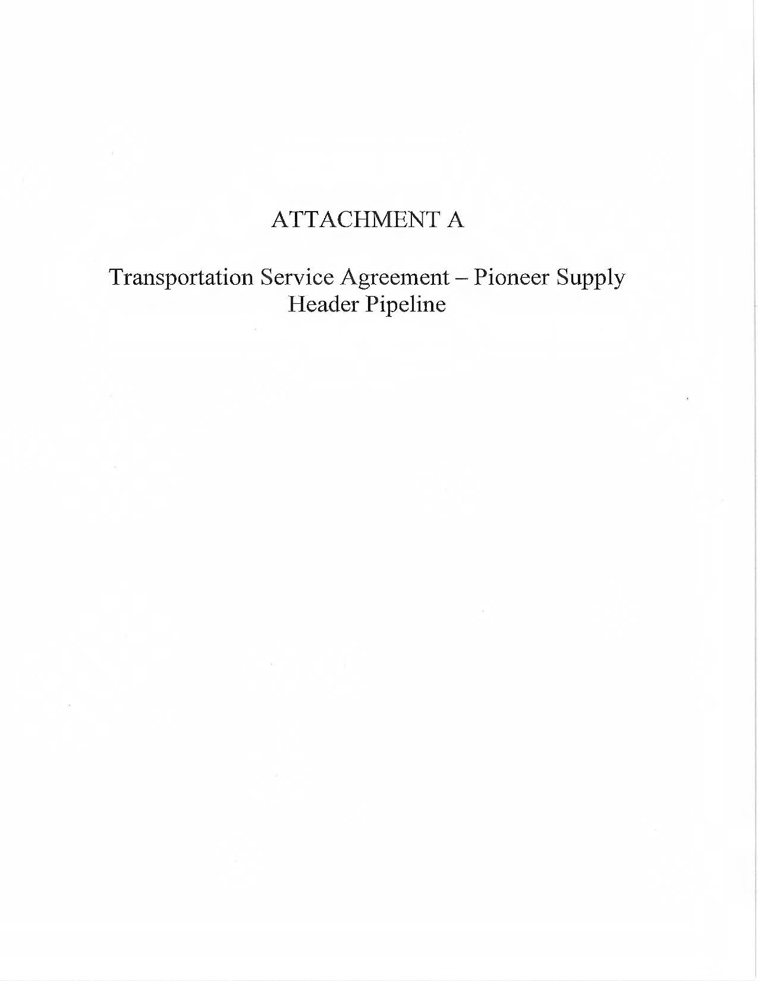

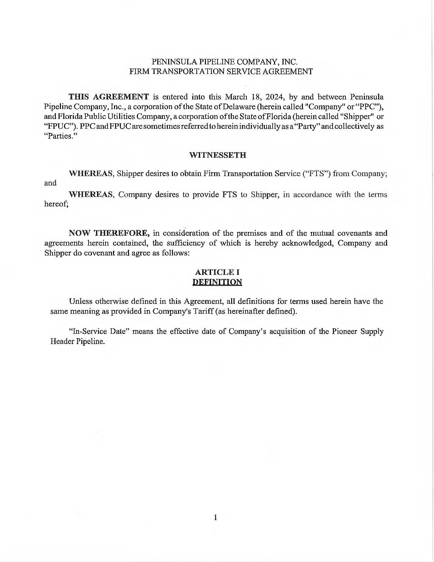

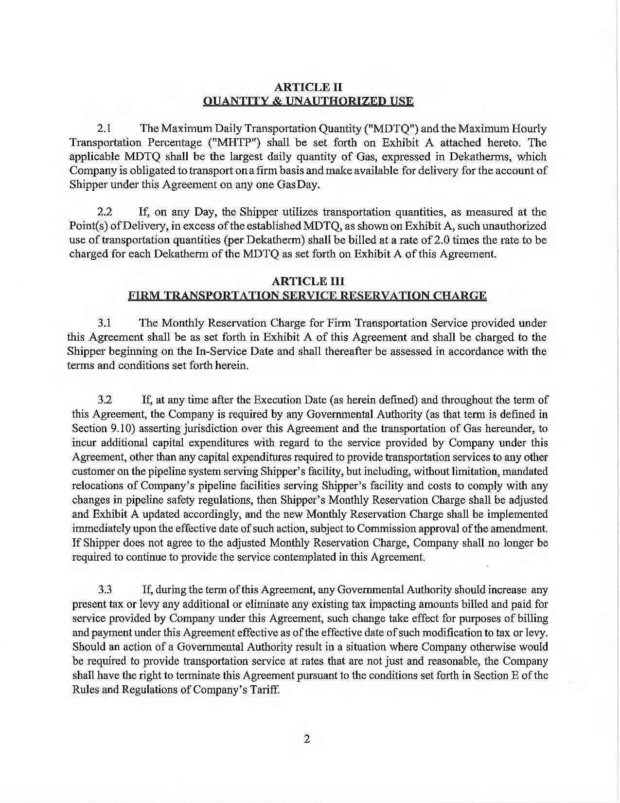

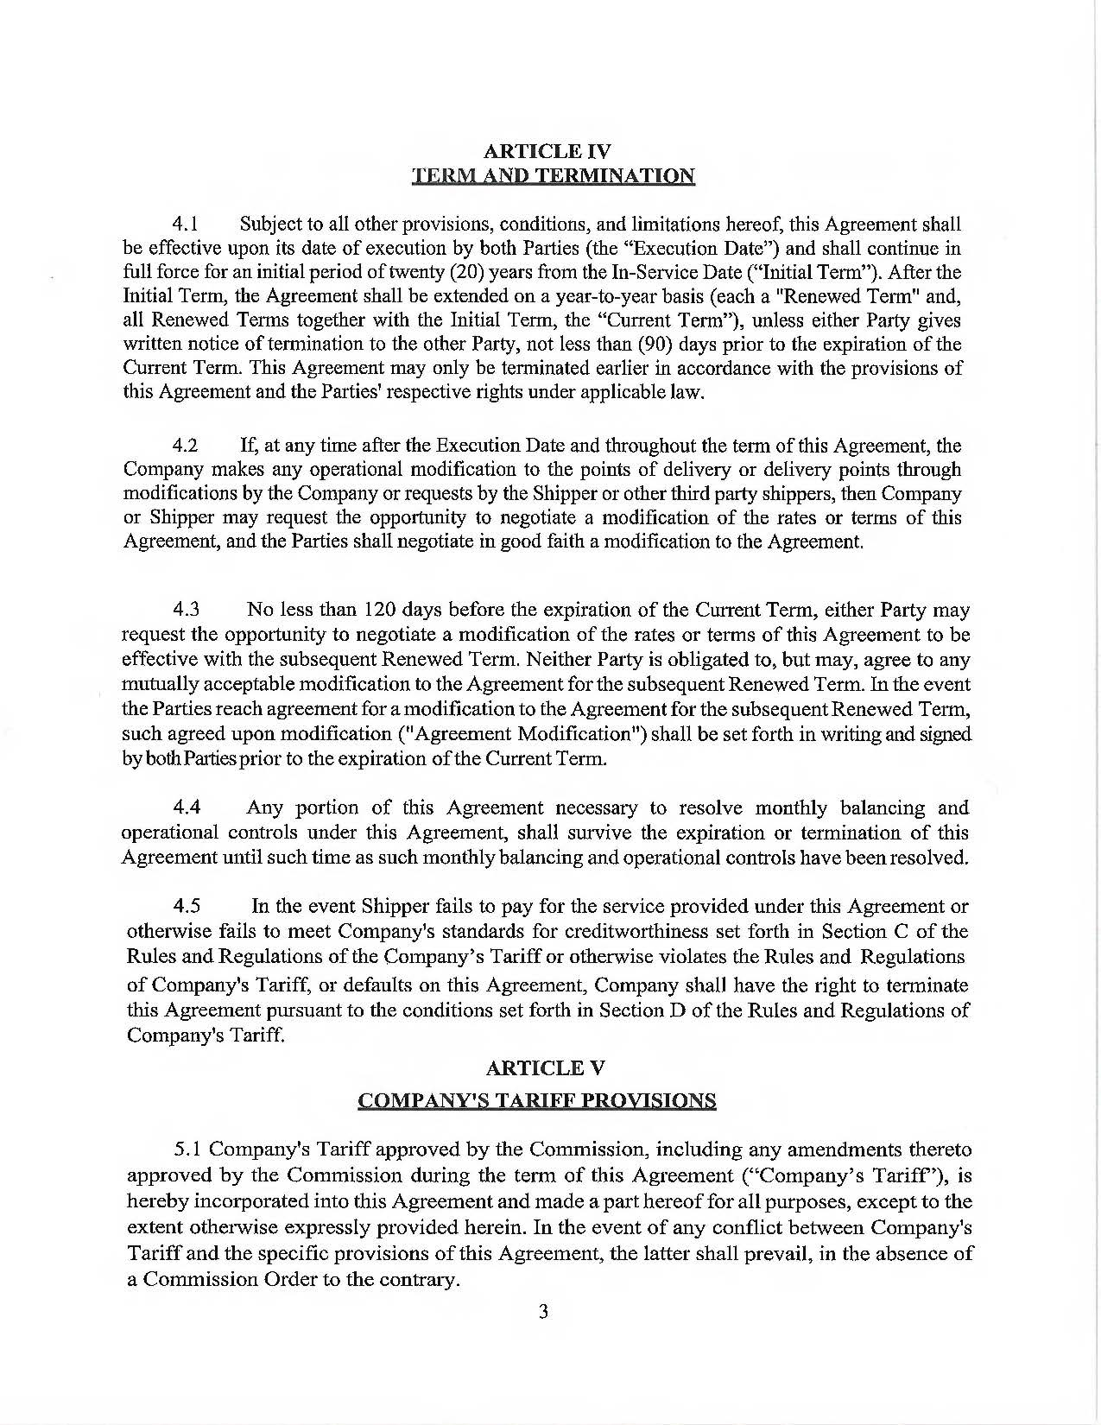

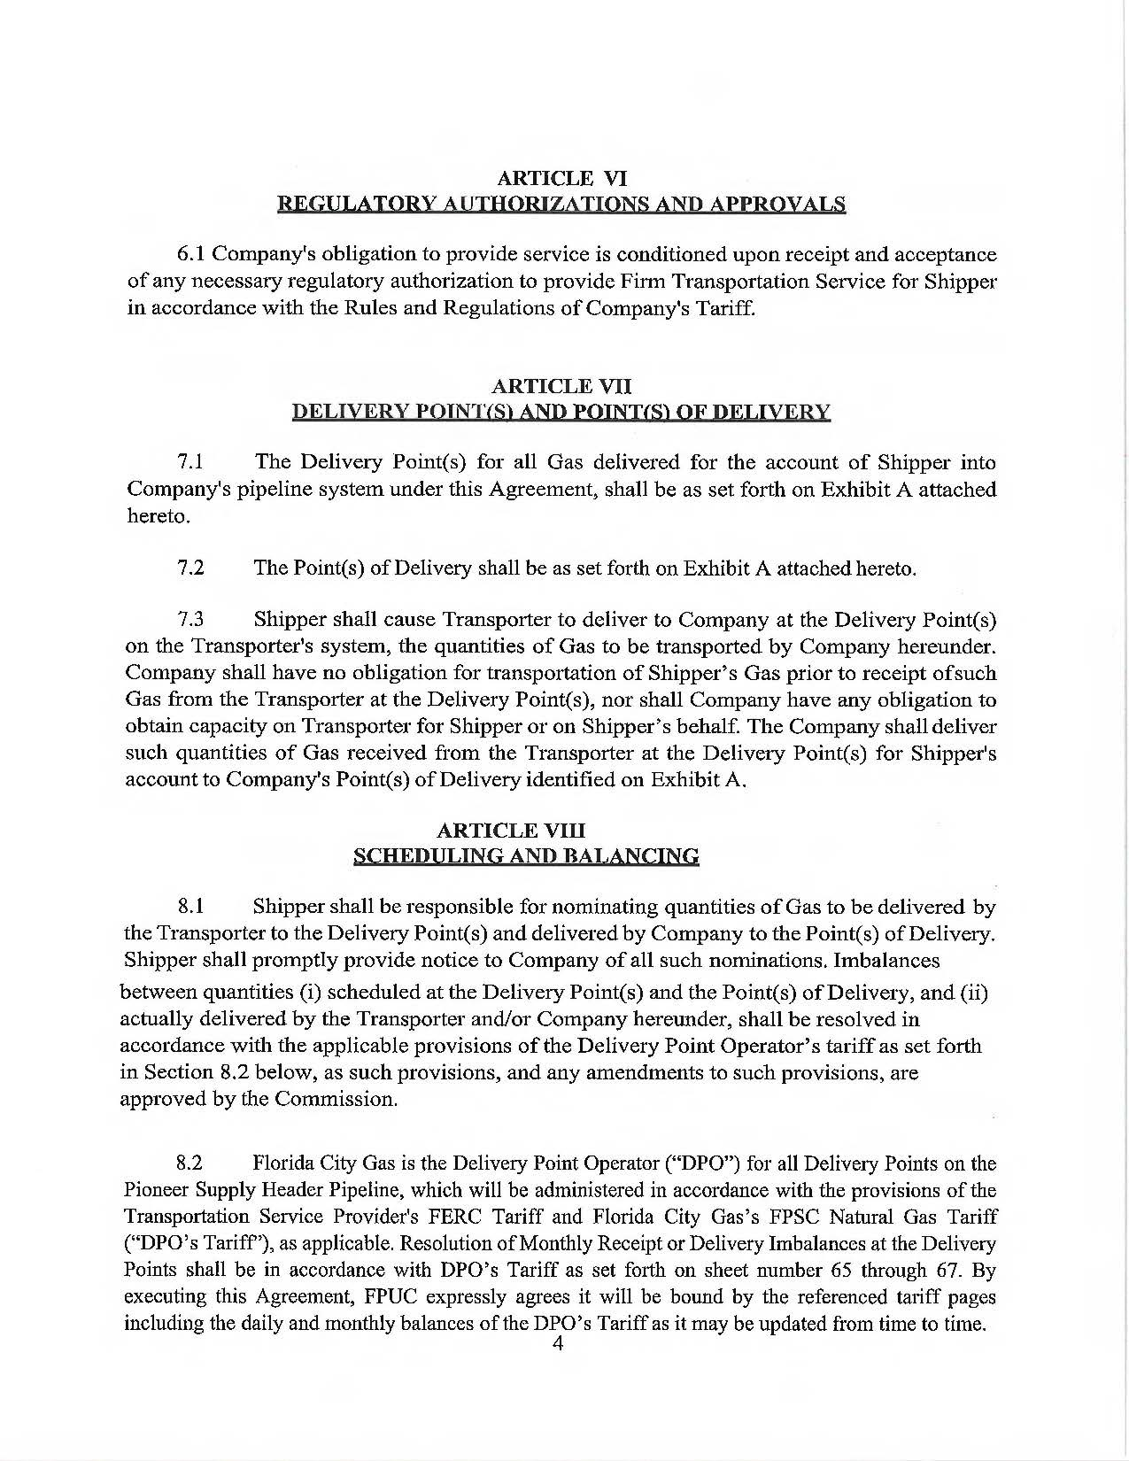

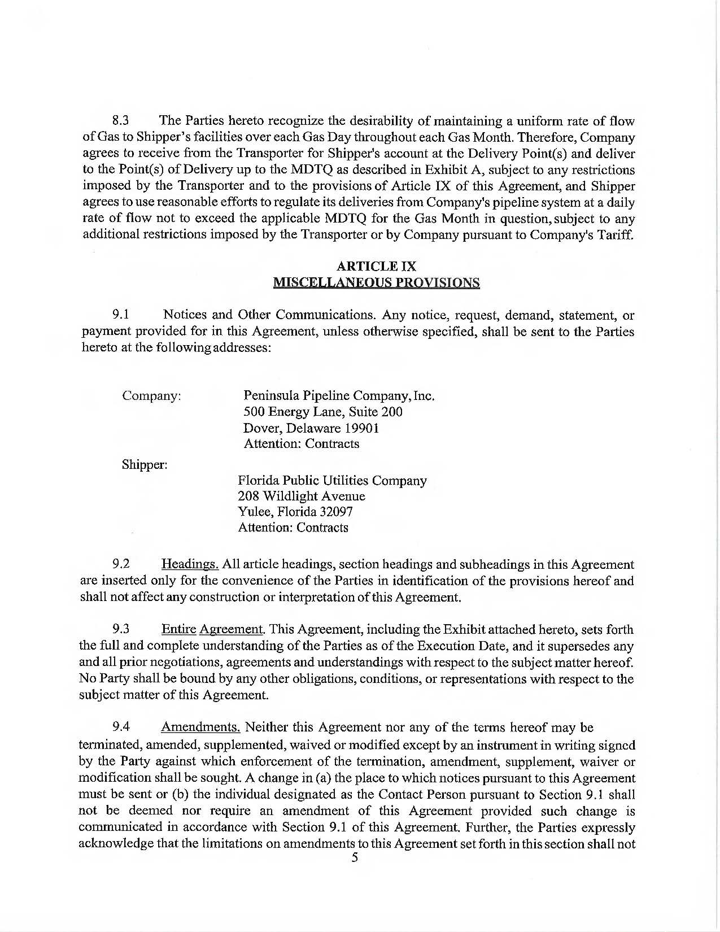

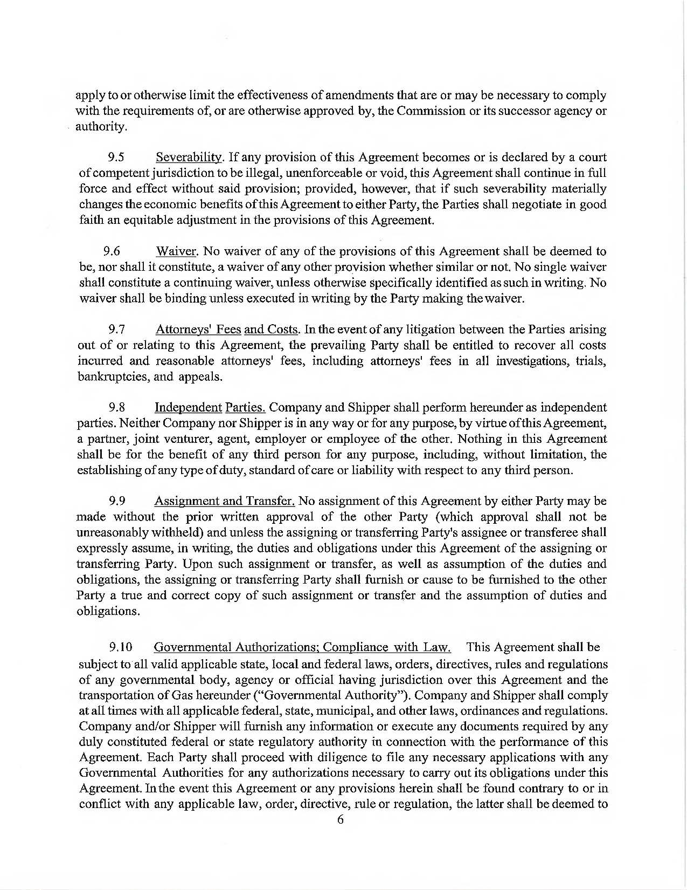

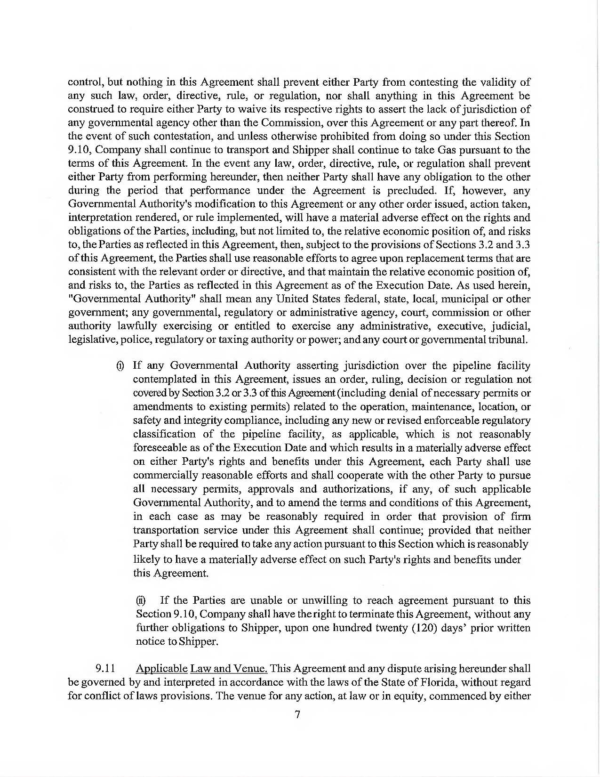



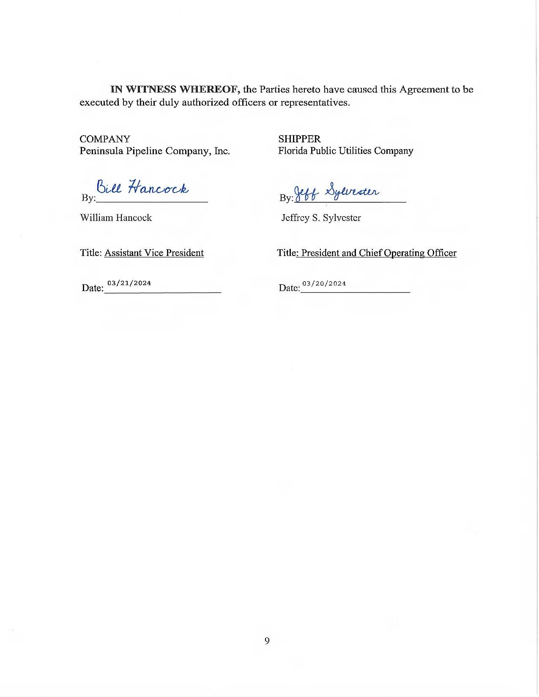

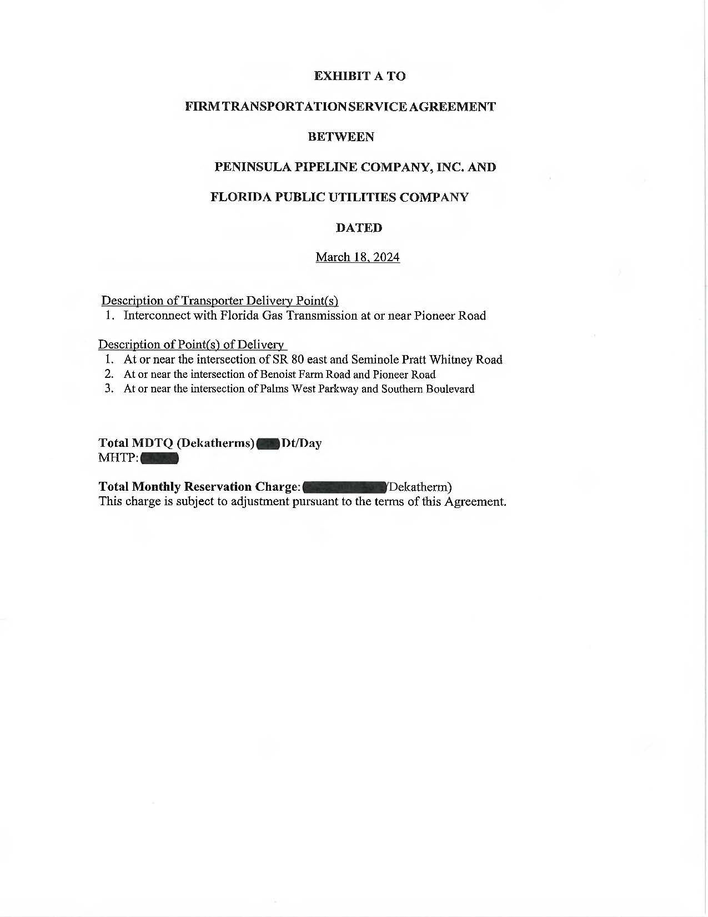



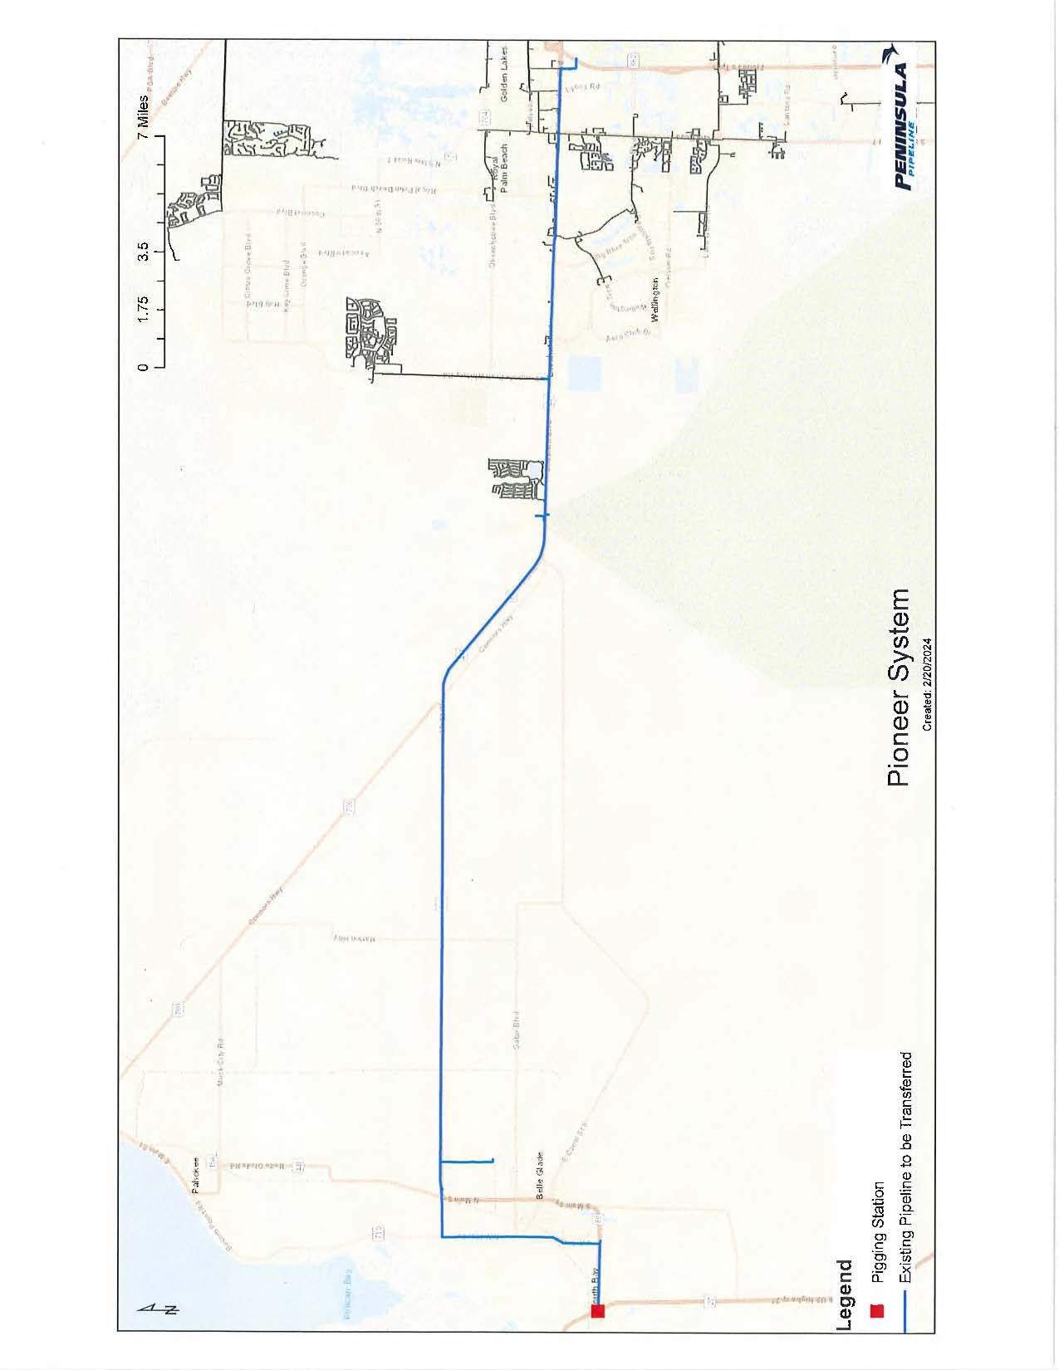

1. Order No. PSC-06-0023-DS-GP, issued January 9, 2006, in Docket No. 20050584-GP, *In re: Petition for declaratory statement by Peninsula Pipeline Company, Inc. concerning recognition as a natural gas transmission company under Section 368.101, F.S., et seq.* 
2. Order No. PSC-07-1012-TRF-GP, issued December 21, 2007, in Docket No. 070570-GP, *In re: Petition for approval of natural gas transmission pipeline tariff by Peninsula Pipeline Company, Inc.*
3. Peninsula Pipeline Company, Inc., Intrastate Pipeline Tariff, Original Vol. 1, Original Sheet No. 11, Section 3.
4. Peninsula Pipeline Company, Inc., Intrastate Pipeline Tariff, Original Vol. 1, Original Sheet No. 12, Section 4.
5. Docket No. 2024003-GU, *In re: Purchased gas adjustment (PGA) true-up.*