BEFORE THE FLORIDA PUBLIC SERVICE COMMISSION

|  |  |
| --- | --- |
| In re: Petition for approval to implement a temporary storm cost recovery surcharge, by St. Joe Natural Gas Company. | DOCKET NO. 20200039-GU  ORDER NO. PSC-2024-0272-TRF-GU  ISSUED: July 26, 2024 |

The following Commissioners participated in the disposition of this matter:

MIKE LA ROSA, Chairman

ART GRAHAM

GARY F. CLARK

ANDREW GILES FAY

GABRIELLA PASSIDOMO

ORDER APPROVING TARIFF MODIFICATIONS FOR

ST. JOE NATURAL GAS COMPANY

BY THE COMMISSION:

Background

On January 24, 2020, St. Joe Natural Gas Company (SJNG or Company) filed its petition to recover incremental storm restoration costs related to Hurricane Michael through a temporary storm cost recovery surcharge. SJNG’s service area includes Mexico Beach and Port St. Joe, and its natural gas distribution system sustained significant damage as a result of Hurricane Michael. The Company requested the recovery of $381,512 in incremental storm costs, as it had incurred incremental costs of $321,012 and projected $60,500 in remaining costs to complete the restoration of its gas system. The Office of Public Counsel (OPC) subsequently filed a notice of intervention in the docket, as acknowledged by Order No. PSC-2020-0066-GU, issued March 2, 2020.

On April 20, 2020, we issued an order approving the collection of an interim storm cost recovery surcharge over a period of 48 months.[1] On February 19, 2021, SJNG filed a request to approve final costs based on an actual amount of $402,720 in incremental storm restoration costs. Shortly thereafter, the Company and OPC filed a Joint Petition for Approval of Stipulation and Settlement (Settlement Agreement), which we approved by Order No. PSC-2021-0196-AS-GU.[2]

The Settlement Agreement permitted the Company to recover a total of $330,115 in storm costs through the surcharge that had been previously approved on an interim basis, by Order No. PSC-2020-0117-PCU-GU. The surcharge was to extend through December 2024, at which time it would cease, with any under or over-recovery handled through the Natural Gas Conservation Cost Recovery Clause. At the conclusion of the surcharge, SJNG would record $77,761 associated with the remaining life value of lost capital assets in a regulatory asset and recover the amount over a period of 10 years through an increase to the Company’s base rates, with an anticipated implementation of January 1, 2025.

On May 30, 2024, SJNG filed a letter stating that as of May 2024 the Company has recovered more than the amount permitted in the Settlement Agreement. SJNG is requesting to terminate the storm cost recovery surcharge early, as it has collected the agreed-upon amount, and will handle any over or under-recovery consistent with the Settlement Agreement. The Company subsequently also provided an update of the current and projected over-recovery amounts.[3] The Company has also filed a Fourth Revised Sheet No. 83 reflecting termination of the surcharge, which is included as Attachment A to this Order.

This docket was closed June 2, 2021, when we entered Order No. PSC-2021-0196-AS-GU approving the Settlement Agreement. On June 4, 2024, Commission staff requested that this docket be reopened for us to consider the requests made in the Company’s May 30, 2024 letter.

On June 12, 2024, the Company’s legal counsel provided clarification on the process to increase base rates for the recovery of the remaining $77,762 through a regulatory asset. Counsel confirmed that the regulatory asset would be addressed as a base rate increase to be implemented in January 2025 as set forth in the Settlement Agreement, and would remain separate and apart from SJNG’s pending base rate proceeding in Docket No. 20240046-GU. Accordingly, this Order addresses only the Company’s request for early termination of the surcharge tariff.

We have jurisdiction over this matter pursuant to Sections 366.04, 366.05, and 366.06, Florida Statutes (F.S.).

Decision

The Settlement Agreement permitted the Company to recover a total of $330,115 in storm costs through the surcharge that had been previously approved on an interim basis, by Order No. PSC-2020-0117-PCU-GU. SJNG has recovered more than the amount of storm costs permitted in the Settlement Agreement. Per the Company’s update on June 12, 2024, SJNG has collected $338,259.71 as of May 31, 2024, and expects to recover $12,600 in June and July. Termination of the surcharge will prevent further over-recovery. As stated in the Settlement Agreement, the over-recovery amount will be handled through the Natural Gas Conservation Cost Recovery Charge.

We have reviewed the Fourth Revised Sheet No. 83 and find that it is appropriate. Clean and legislative copies of the tariff are included as Attachment A to this Order.

Conclusion

Based on the information provided, we approve the proposed tariff modifications to terminate the temporary storm cost recovery surcharge, effective on the date of our vote, July 9, 2024.

Based on the foregoing, it is

ORDERED by the Florida Public Service Commission that the proposed tariff modifications to terminate the temporary storm cost recovery surcharge by St. Joe Natural Gas Company, as show on Fourth Revised Sheet No. 83 appended hereto, are approved, effective the date of our vote, July 9, 2024. It is further

ORDERED that if a protest is filed within 21 days of issuance of the Order, the tariff shall remain in effect with any charges held subject to refund pending resolution of the protest. It is further

ORDERED that if no timely protest is filed, this docket shall be closed upon the issuance of a Consummating Order.

By ORDER of the Florida Public Service Commission this 26th day of July, 2024.

|  |  |
| --- | --- |
|  | /s/ Adam J. Teitzman |
|  | ADAM J. TEITZMAN  Commission Clerk |

Florida Public Service Commission

2540 Shumard Oak Boulevard

Tallahassee, Florida 32399

(850) 413‑6770

www.floridapsc.com

Copies furnished: A copy of this document is provided to the parties of record at the time of issuance and, if applicable, interested persons.

SPS

NOTICE OF FURTHER PROCEEDINGS

The Florida Public Service Commission is required by Section 120.569(1), Florida Statutes, to notify parties of any administrative hearing or judicial review of Commission orders that is available under Sections 120.57 or 120.68, Florida Statutes, as well as the procedures and time limits that apply. This notice should not be construed to mean all requests for an administrative hearing or judicial review will be granted or result in the relief sought.

Mediation may be available on a case-by-case basis. If mediation is conducted, it does not affect a substantially interested person's right to a hearing.

The Commission's decision on this tariff is interim in nature and will become final, unless a person whose substantial interests are affected by the proposed action files a petition for a formal proceeding, in the form provided by Rule 28-106.201, Florida Administrative Code. This petition must be received by the Office of Commission Clerk, 2540 Shumard Oak Boulevard, Tallahassee, Florida 32399-0850, by the close of business on August 16, 2024.

In the absence of such a petition, this Order shall become final and effective upon the issuance of a Consummating Order.

Any objection or protest filed in this docket before the issuance date of this order is considered abandoned unless it satisfies the foregoing conditions and is renewed within the specified protest period.

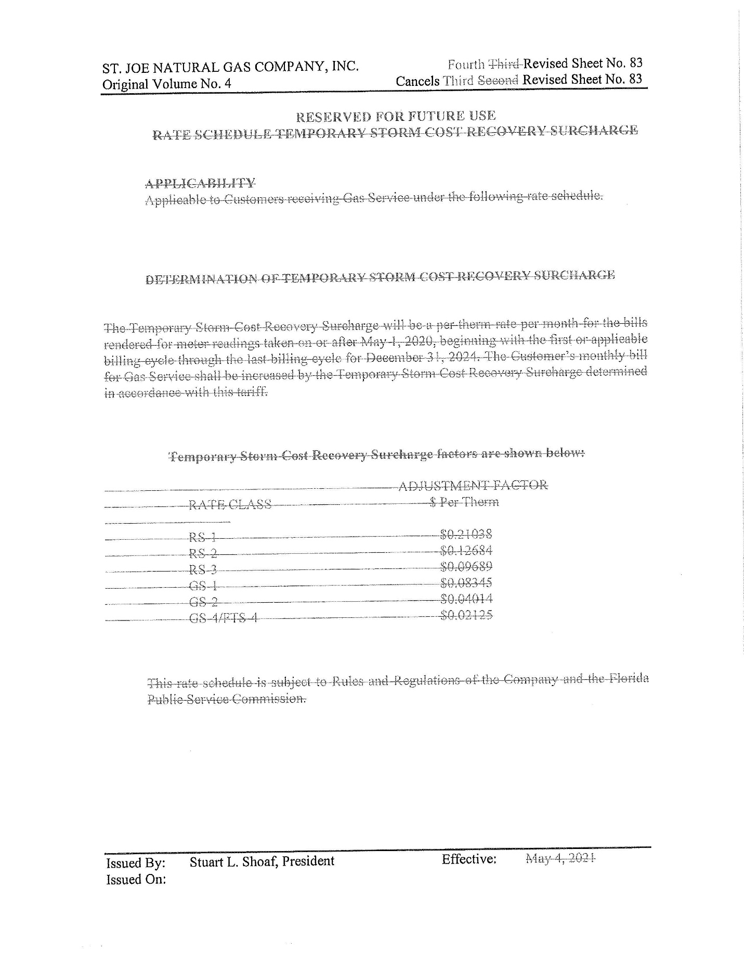

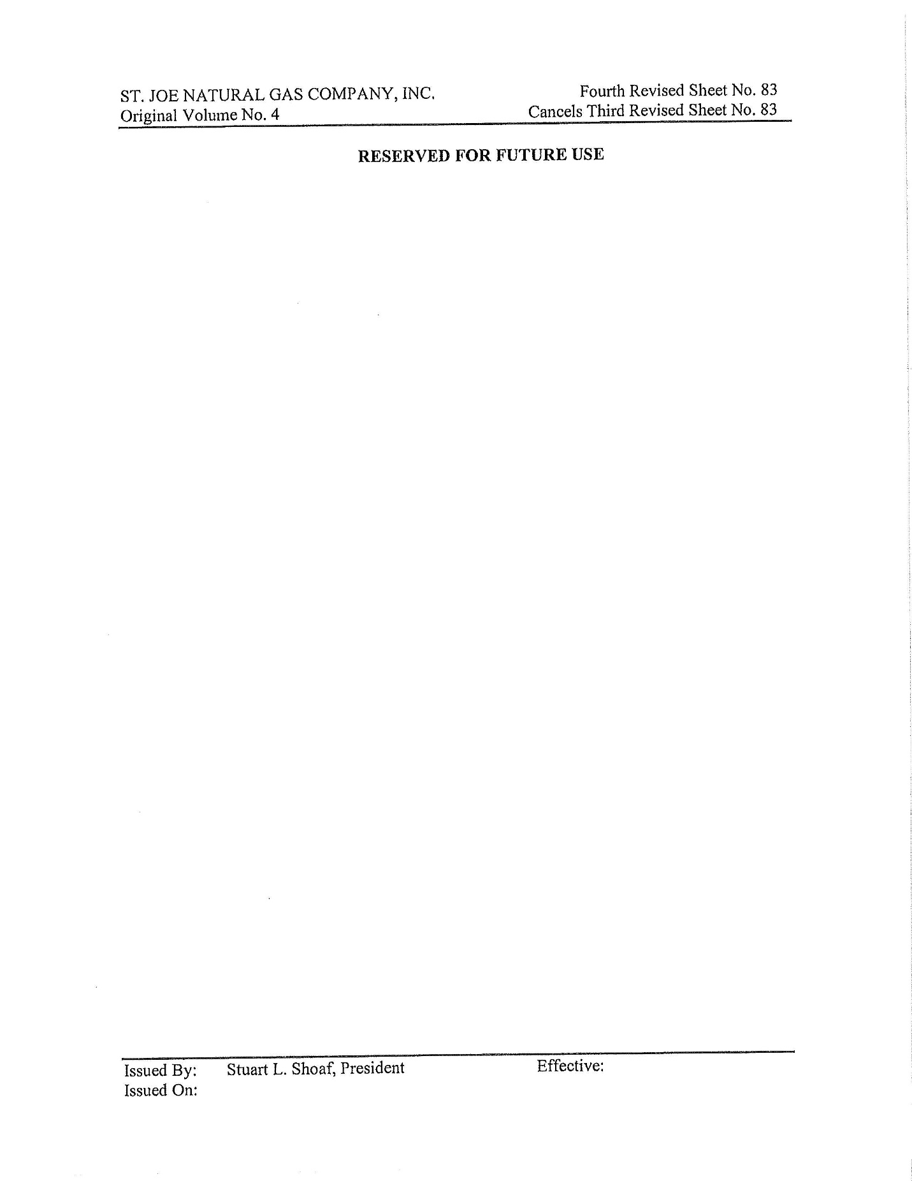

1. Order No. PSC-2020-0117-PCO-GU, issued April 20, 2020, in Docket No. 20200039-GU, *In re: Petition for approval to implement a temporary storm cost recovery surcharge, by St. Joe Natural Gas Company*.
2. Order No. PSC-2021-0196-AS-GU, issued June 3, 2021, in Docket No. 20200039-GU, *In re: Petition for approval to implement a temporary storm cost recovery surcharge, by St. Joe Natural Gas Company*.
3. Document No. 06898-2024