BEFORE THE FLORIDA PUBLIC SERVICE COMMISSION

In re: Storm protection plan cost recovery clause. | DOCKET NO. 20240010-EI  ORDER NO. PSC-2024-0426-PHO-EI  ISSUED: September 17, 2024

PREHEARING ORDER

Pursuant to Notice and in accordance with Rule 28-106.209, Florida Administrative Code (F.A.C.), Commissioner Gabriella Passidomo, as Prehearing Officer, conducted a Prehearing Conference in this docket on September 9, 2024, in Tallahassee, Florida.

APPEARANCES:

J. JEFFRY WAHLEN, MALCOLM N. MEANS and VIRGINIA L. PONDER, ESQUIRES, Ausley McMullen, Post Office Box 391, Tallahassee, Florida 32302
On behalf of Tampa Electric Company (TECO).

BETH KEATING, ESQUIRE, Gunster, Yoakley & Stewart, P.A., 215 South Monroe Street, Suite 601, Tallahassee, Florida 32301
On behalf of Florida Public Utilities Company (FPUC).

CHRISTOPHER T. WRIGHT and DAVID M. LEE, ESQUIRES, Florida Power & Light Company, 700 Universe Boulevard, Juno Beach, Florida 33408-0420
On behalf of Florida Power & Light Company (FPL).

MATTHEW R. BERNIER and STEPHANIE A. CUELLO, ESQUIRES, 106 East College Avenue, Suite 800, Tallahassee, Florida 32301
DIANNE M. TRIPLETT, ESQUIRE, Deputy General Counsel, 299 1st Avenue North, St. Petersburg, Florida 33701
On behalf of Duke Energy Florida, LLC (DEF).

WALT TRIERWEILER, CHARLES REHWINKEL, PATRICIA A. CHRISTENSEN, MARY A. WESSLING, OCTAVIO SIMOES-PONCE, and AUSTIN A. WATROUS, ESQUIRES, Office of the Public Counsel, c/o The Florida Legislature, 111 West Madison Street, Suite 812, Tallahassee, Florida 32399-1400
On behalf of Office of Public Counsel (OPC).

JON C. MOYLE, JR. and KAREN A. PUTNAL, ESQUIRES, Moyle Law Firm, P.A., 118 North Gadsden Street, Tallahassee, Florida 32301
On behalf of Florida Industrial Power Users Group (FIPUG).

PETER J. MATTHEIS, MICHAEL K. LAVANGA, and JOSEPH R. BRISCAR, ESQUIRES, Stone, Mattheis, Xenopoulos & Brew, PC, 1025 Thomas Jefferson Street, NW, Eighth Floor, West Tower, Washington, DC 20007
On behalf of Nucor Steel Florida, Inc. (Nucor).

JAMES W. BREW, LAURA WYNN BAKER and SARAH B. NEWMAN, ESQUIRES, Stone, Mattheis, Xenopoulos & Brew, PC, 1025 Thomas Jefferson Street, NW, Suite 800 West, Washington, DC 20007
On behalf of White Springs Agricultural Chemicals, Inc. d/b/a PCS Phosphate – White Springs (PCS Phosphate).

SHAW STILLER and DANIEL DOSE, ESQUIRES, Florida Public Service Commission, 2540 Shumard Oak Boulevard, Tallahassee, Florida 32399-0850
On behalf of the Florida Public Service Commission (Staff).

MARY ANNE HELTON, ESQUIRE, Deputy General Counsel, Florida Public Service Commission, 2540 Shumard Oak Boulevard, Tallahassee, Florida 32399-0850
Advisor to the Florida Public Service Commission.

KEITH C. HETRICK, ESQUIRE, General Counsel, Florida Public Service Commission, 2540 Shumard Oak Boulevard, Tallahassee, Florida 32399-0850
Florida Public Service Commission General Counsel.

I. CASE BACKGROUND

The 2019 Florida Legislature enacted Section 366.96, Florida Statutes (F.S.), entitled “Storm protection plan cost recovery.” Section 366.96(3), F.S., established a new requirement that each public utility file a transmission and distribution storm protection plan (SPP) covering the immediate 10-year planning period, and explaining the systematic approach the utility will follow to achieve the objectives of reducing restoration costs and outage times associated with extreme weather events and enhancing reliability. Pursuant to Sections 366.96(5) and 366.96(6), F.S., the Florida Public Service Commission (Commission) is required every three years to determine whether it is in the public interest to approve, approve with modification, or deny each utility’s SPP.

In addition to reviewing SPPs at least every three years, the Commission must conduct an annual proceeding pursuant to Section 366.96(7), F.S., to determine a utility’s prudently incurred transmission and distribution storm protection plan costs and allow the utility to recover such costs through a charge separate and apart from its base rates, to be referred to as the storm protection plan cost recovery clause (SPPCRC). The annual SPPCRC proceeding is a rolling three-year review that includes a true-up of costs for the prior year, the calculation of actual/estimated costs for the year of the filing, and projected factors for the following year. If the Commission determines that costs were prudently incurred, those costs will not be subject to disallowance or further prudence review except for fraud, perjury, or intentional withholding of key information by the public utility.

This docket was opened by Order No. PSC-2024-0010-PCO-EI, issued January 3, 2024, under the authority of Sections 366.96(5), 366.96(6), and 366.96(7), F.S. The purpose of this 2024 annual proceeding is for the Commission to establish the amount of prudently incurred costs each utility shall be allowed to recover through the SPPCRC and the specific terms of that recovery. Tampa Electric Company, Duke Energy Florida, Florida Industrial Power Users Group, Florida Power & Light, PCS Phosphate – White Springs, Nucor Steel Florida, Inc., Office of Public Counsel, and Florida Public Utilities Company each filed a Notice of Intent to Retain Party Status. No additional parties filed for intervention.

This matter has been scheduled for an evidentiary hearing September 25-27, 2024.

II. CONDUCT OF PROCEEDINGS

Pursuant to Rule 28-106.211, F.A.C., this Prehearing Order is issued to prevent delay and to promote the just, speedy, and inexpensive determination of all aspects of this case.

III. JURISDICTION

This Commission is vested with jurisdiction over the subject matter by the provisions of Chapter 366, F.S. This hearing will be governed by Chapters 120 and 366, F.S., and Chapters 25-6, 25-22, and 28-106, F.A.C., as well as any other applicable provisions of law.

IV. PROCEDURE FOR HANDLING CONFIDENTIAL INFORMATION

Information for which proprietary confidential business information status is requested pursuant to Section 366.093, F.S., F.S., and Rule 25-22.006, F.A.C., shall be treated by the Commission as confidential. The information shall be exempt from Section 119.07(1), F.S., pending a formal ruling on such request by the Commission or pending return of the information to the person providing the information. If no determination of confidentiality has been made and the information has not been made a part of the evidentiary record in this proceeding, it shall be returned to the person providing the information. If a determination of confidentiality has been made and the information was not entered into the record of this proceeding, it shall be returned to the person providing the information within the time period set forth in Section 366.093, F.S., F.S. The Commission may determine that continued possession of the information is necessary for the Commission to conduct its business.

It is the policy of this Commission that all Commission hearings be open to the public at all times. The Commission also recognizes its obligation pursuant to Section 366.093, F.S., F.S., to protect proprietary confidential business information from disclosure outside the proceeding. Therefore, any party wishing to use any proprietary confidential business information, as that term is defined in Section 366.093, F.S., F.S., at the hearing shall adhere to the following:

  - When confidential information is used in the hearing that has not been filed as prefiled testimony or prefiled exhibits, parties must have copies for the Commissioners, necessary staff, and the court reporter, in red envelopes clearly marked with the nature of the contents and with the confidential information highlighted. Any party wishing to examine the confidential material that is not subject to an order granting confidentiality shall be provided a copy in the same fashion as provided to the Commissioners, subject to execution of any appropriate protective agreement with the owner of the material.

  - Counsel and witnesses are cautioned to avoid verbalizing confidential information in such a way that would compromise confidentiality. Therefore, confidential information should be presented by written exhibit when reasonably possible.

At the conclusion of that portion of the hearing that involves confidential information, all copies of confidential exhibits shall be returned to the proffering party. If a confidential exhibit has been admitted into evidence, the copy provided to the court reporter shall be retained in the Office of Commission Clerk’s confidential files. If such material is admitted into the evidentiary record at hearing and is not otherwise subject to a request for confidential classification filed with the Commission, the source of the information must file a request for confidential classification of the information within 21 days of the conclusion of the hearing, as set forth in Rule 25-22.006(8)(b), F.A.C., if continued confidentiality of the information is to be maintained.

V. PREFILED TESTIMONY AND EXHIBITS; WITNESSES

Testimony of all witnesses to be sponsored by the parties and Staff has been prefiled and will be inserted into the record as though read after the witness has taken the stand and affirmed the correctness of the testimony and associated exhibits. All testimony remains subject to timely and appropriate objections. Upon insertion of a witness’ testimony, exhibits appended thereto may be marked for identification. Each witness will have the opportunity to orally summarize his or her testimony at the time he or she takes the stand. Summaries of testimony shall be limited to three minutes.

Witnesses are reminded that, on cross-examination, responses to questions calling for a simple yes or no answer shall be so answered first, after which the witness may explain his or her answer. After all parties and Staff have had the opportunity to cross-examine the witness, the exhibit may be moved into the record. All other exhibits may be similarly identified and entered into the record at the appropriate time during the hearing.

The Commission frequently administers the testimonial oath to more than one witness at a time. Therefore, when a witness takes the stand to testify, the attorney calling the witness is directed to ask the witness to affirm whether he or she has been sworn.

The parties shall avoid duplicative or repetitious cross-examination. Further, friendly cross-examination will not be allowed. Cross-examination shall be limited to witnesses whose testimony is adverse to the party desiring to cross-examine. Any party conducting what appears to be a friendly cross-examination of a witness should be prepared to indicate why that witness's direct testimony is adverse to its interests.

VI. PROVISION OF EXHIBITS FOR HEARING

With the exception of deposition transcripts used for impeachment exhibits, which will be discussed further below, all cross-examination, demonstrative, and impeachment exhibits, except for deposition transcripts, shall be exchanged between the parties and Staff by the close of business on September 13, 2024, using the process set out in Order No. PSC-2024-0216-PCO-EI.

Deposition transcripts used for impeachment purposes only are not required to be exchanged between the parties and Staff. Deposition transcripts that are used for impeachment purposes will not be loaded into Case Center. Section VI, Part G, of Order No. PSC-2024-0032-PCO-EI, still applies to those deposition transcripts that parties seek to admit into the record.

By Section VI, Part H, of Order No. PSC-2024-0216-PCO-EI, the Commission intended to require all parties and Staff to exchange exhibits prior to the hearing so that all hearing participants are on notice of all exhibits to be used during the hearing. Notice prior to the hearing remains the intent and is the reason for the Exhibit List required by Section VI, Part H, of the Order.

The following clarifications are offered to assist the parties in preparing for the final hearing:

- Parties may use the exhibits identified by Staff on the Comprehensive Exhibit List (CEL) for cross-examination purposes without listing them on the party’s exhibit list or exchanging the exhibit with the other parties. Thus, for example, a Staff Exhibit on the CEL may be used by any party, and should not be duplicated on another party’s exhibit list or provided in the exchange if the party intends to use that previously identified exhibit.
- All hearing participants are already on notice of all prefiled testimony and exhibits. Thus, no prefiled testimony or prefiled exhibits should be listed on any party’s exhibit list or exchanged.
- Parties are not required to submit an exhibit in Excel format if you are satisfied that a witness can view the PDF conversion of the spreadsheet; please check the PDF version to ensure legibility. However, if an Excel spreadsheet is submitted in native format, the party must also submit a PDF conversion of the exhibit using the same exhibit name. (i.e., OPC-1 Short Title.pdf and OPC-1 Short Title.xls).
- Parties are not required to create a separate PDF file or exhibit for each Interrogatory response. Several responses and attachments can be combined into one PDF document and submitted as one composite exhibit. If a party submits an attachment separately, the attachment must be numbered as a separate exhibit.
- The exchange of cross-examination exhibits prior to hearing is consistent with Florida law and is to afford due process to all parties by avoiding “trial by surprise.” The Commission expects all parties to respect the process by being judicious about the cross-examination exhibits provided. Parties should have a reasonable, good faith expectation of using the exhibit during the hearing.

VII. ORDER OF WITNESSES

Each witness whose name is followed by an asterisk (*) has been excused from the final hearing. Their prefiled testimonies will be inserted into the record as though read.

Witness | Proffered By | Issues #
Direct
M. Ashley Sizemore* | TECO | 1-10
C. David Sweat* | TECO | 1-10
Phuong T. Nguyen*  (adopted by Michelle Napier) | FPUC | 1C
Mark Cutshaw* | FPUC | 1C, 2C-3C
Michelle Napier* | FPUC | 2C-9C
Michael Jarro* | FPL | 1-4
Richard L. Hume* | FPL | 1-10
Christopher A. Menendez* | DEF | 1D-9D
Robert E. McCabe* | DEF | 1D-3D
Robert E. Brong* | DEF | 1D-3D
Tomer Kopelovich* | Staff | 1A
Ron Mavrides* | Staff | 1B
Donna D. Brown* | Staff | 1C and 1D

VIII. BASIC POSITIONS

TECO: In Order No. PSC-2022-0386-FOF-EI, issued November 10, 2022, the Commission found that Tampa Electric’s 2022-2031 Storm Protection Plan (“2022 SPP”) is in the public interest and approved that plan with one modification – elimination of the company’s existing Transmission Access Enhancement Program as of December 31, 2022.

The Commission is currently scheduled to conduct a hearing regarding the Storm Protection Cost Recovery Clause on September 25, 2024, to review and approve the proposed cost recovery factors to be used for the January 2025 through December 2025 period.

The Commission should determine that Tampa Electric has properly calculated its Storm Protection Plan cost recovery true-up and projections and the Storm Protection Plan cost recovery factors set forth in the testimony and exhibits of witness M. Ashley Sizemore during the period January 2025 through December 2025. These calculations were performed in accordance with the requirements of Section 366.96 of the Florida Statutes and Rule 25-6.031 of the Florida Administrative Code. No party has challenged or made any other recommended adjustments to the company’s calculations. The company’s true-up, projections, and factors should accordingly be approved. The Commission should also find that Tampa Electric’s actual 2023 Storm Protection Plan costs were prudently incurred. No party has challenged the prudence of Tampa Electric’s actual incurred costs or made any recommended adjustments to any of the projects or costs included in the 2023 final true-up.

FPUC: The factors proposed by the Company have been developed through projections and calculations made in accordance with Rule 25-6.031, F.A.C., and the associated depreciation expense has been calculated in accordance with the rates approved in the Company’s last approved depreciation study. The factors are based upon actual, prudently incurred costs associated with the implementation of those aspects of FPUC’s Storm Protection Plan (“SPP”) approved by Order No. PSC-2022-0387-FOF-EI, issued November 10, 2022, as well as reasonable estimates of costs to be incurred in the remainder of 2024 and in 2025. In addition, the Company has applied an allocation methodology consistent with the stipulation between FPUC and Walmart approved by Order No. PSC-2022-0418-FOF-EI, issued in last year’s SPPCRC proceeding. As such, the Company asks that it be allowed to implement its proposed SPPCRC Factors for the January – December, 2025 period.

FPL: FPL’s final true-up of its 2023 SPP costs is consistent with the actual/estimated 2023 SPP costs approved by Commission Order No. PSC-2023-0364-FOF-EI in Docket No. 20230010-EI, consistent with the 2023 SPP approved by Commission Order No. PSC-2022-0389-FOF-EI in Docket No. 20220051-EI, applies the methodology and prescribed schedules contained in Commission Forms 1A through 8A, and meets the requirements of Section 366.96, Florida Statutes, and Rule 25-6.031(7)(a), Florida Administrative Code. No parties challenged or made any recommended adjustments to any of the SPP projects, costs, or revenue requirements included in FPL’s 2023 SPPCRC final true-up. Therefore, the Commission should approve FPL’s net final true-up under-recovery amount of $5,648,042, including interest, for the period of January 2023 through December 2023.

FPL’s actual/estimated true-up of its 2024 SPP costs is consistent with the projected 2024 SPP costs approved by Commission Order No. PSC-2023-0364-FOF-EI in Docket No. 20230010-EI, consistent with the 2023 SPP approved by Commission Order No. PSC-2022-0389-FOF-EI in Docket No. 20220051-EI, applies the methodology and prescribed schedules contained in Commission Forms 1E through 8E, and meets the requirements of Section 366.96, Florida Statutes, and Rule 25-6.031(7)(b), Florida Administrative Code. No parties challenged or made any recommended adjustments to any of the SPP projects, costs, or revenue requirements included in FPL’s 2024 SPPCRC actual/estimated true-up. Therefore, the Commission should approve FPL’s actual/estimated true-up under-recovery amount of $59,670,684, including interest, for the period of January 2024 through December 2024.

FPL’s projected 2025 SPP costs are consistent with the 2023 SPP approved Commission Order No. PSC-2022-0389-FOF-EI in Docket No. 20220051-EI, apply the methodology and prescribed schedules contained in Commission Forms 1P through 7P, and meet the requirements of Section 366.96, Florida Statutes, and Rule 25-6.031(2) and (7)(c), Florida Administrative Code. No parties challenged or made any recommended adjustments to any of the individual 2025 SPP projects or associated costs. Therefore, the Commission should approve the $721,264,550 of revenue requirements associated with the SPP programs projected to be incurred between January 1, 2025, and December 31, 2025.

For these reasons, as further explained in FPL’s direct, supplemental, and rebuttal testimonies, the Commission should approve the total jurisdictional revenue requirement of $ 786,583,276, including true-up amounts, for recovery through FPL’s 2025 SPPCRC Factors for the period of January 2025 through December 2025.

DEF: As required by the OEP, on April 1 and May 1, DEF made its 2023 True-Up and 2024 Actual/Estimated and 2025 Projection filings, respectively. Subsequently, in Docket No. 20240025-EI, DEF filed the Joint Motion for Approval of 2024 Settlement Agreement. See doc. no. 07553-2024. The 2024 Settlement Agreement, if approved by the Commission, would authorize DEF to earn a mid-point 10.3% ROE (9.3%-11.3% authorized range). See id. at Attachment 1, Par. 2. However, DEF’s May 1 Projection filing incorporated the ROE DEF requested in its as-filed Rate Case Petition of 11.15%. The Commission is currently scheduled to hold a hearing to consider the 2024 Settlement Agreement beginning on August 21. Therefore, because DEF cannot know at this time whether the Settlement Agreement will be approved, and while it urges the Commission to do so, concurrent with this prehearing statement, DEF is also filing an Updated 2024 Actual/Estimated and 2025 Projection Petition, Updated Testimony of Christopher Menendez, and an Updated Exhibit CAM-3. The purpose of these Updated filings is to recalculate applicable projected capital recovery amounts and revenue requirements for 2025 based on the reduction in ROE as agreed in the 2024 Settlement Agreement versus as originally filed on May 1 in this docket. This results in lower capital revenue requirements and SPPCRC recovery factors in 2025. Below, in the applicable individual issues, DEF will provide its positions based on the original May 1 filing as well as an “Alternative” position that should be approved if the Commission approves the 2024 Settlement Agreement.

OPC: The Storm Protection Plan Cost Recovery Clause (SPPCRC) is the step in the ratemaking process where the Commission sets the factors necessary for recovery for the annual costs for implementing the Companies’ approved Storm Protection Plan. The process of reviewing and implementing an SPP is an indispensable and necessary step in the ratemaking process within the meaning and intent of Section 366.06(1) and 366.96, Florida Statutes. Section 366.06(1), Florida Statutes, establishes the Commission’s rate-making procedure for public utilities in the State of Florida. Upon application for a change in rates by a utility,

The commission shall investigate and determine the actual legitimate costs of the property of each utility company, actually used and useful in the public service, and shall keep a current record of the net investment of each public utility company in such property which value, as determined by the commission, shall be used for ratemaking purposes and shall be the money honestly and prudently invested by the public utility company in such property used and useful in serving the public, less accrued depreciation, and shall not include any goodwill or going-concern value or franchise value in excess of payment made therefor.

Id. (emphasis added).

The requirement that the Commission evaluate the prudence of investments in all ratemaking requests before the Commission is embedded in the Commission’s legislative mandate. The statute does not specify that the Commission must only consider prudence of investments in base rate cases, cost recovery dockets, or any other specified type of rate-setting case before the Commission. If the Commission is setting rates, it must consider, among other things, the prudence of making the investment at issue (including the decisions behind the timing, amount and locations of the investment(s)), regardless of whether that requirement is explicitly stated in the other provisions of chapter 366, Florida Statutes, or the Commission’s rules. Section 366.96, Florida Statutes, sets forth the process for review and approval of and implementation of the prudent costs for the SPP. Furthermore, it is worth noting that section 366.96(2)(c), Florida Statutes defines “transmission and distribution storm protection plan costs” as “the reasonable and prudent costs to implement an approved transmission and distribution storm protection plan.”

The positions taken by the Public Counsel in this docket are consistent with and informed to the greatest extent possible by the unresolved statutory interpretation issues currently pending before the Florida Supreme Court in Case No. SC 2022-1733 (consolidated).

FIPUG: The petitioners have the burden of proof to establish that expenditures for which cost recovery is sought are prudent. The Commission should reduce the monies sought by the utilities by the amounts for which it finds insufficient proof or for costs not properly within the scope of the state’s storm protection plan statute, section 366.96, Florida Statutes, or the Commission’s rule, Rule 25-6.030, Florida Administrative Code.

Nucor: Rule 25-6.031, F.A.C, details the specific recoverable costs that Duke Energy Florida, LLC (“DEF”) may collect through the SPPCRC and provides that such costs must be consistent with the Company’s approved Storm Protection Plan. Nucor’s basic position is that DEF bears the burden of proof to justify the amount of costs it seeks to recover through the SPPCRC and show that such costs are eligible recovery costs under 25-6.031(6) and are consistent with DEF’s approved Storm Protection Plan. Finally, Nucor notes that DEF over-recovered and/or projects to over-recover its eligible costs through the SPPCRC for 2023 and 2024. The Commission should carefully review DEF’s projected 2025 SPPCRC rates to ensure that the rates are properly designed to recover the Company’s forecast 2025 costs.

PCS
Phosphate: Only costs prudently incurred and legally authorized may be recovered through the fuel clause. Florida electric utilities, including in particular Duke Energy Florida, LLC (“DEF”), must satisfy the burden of proving the reasonableness of any expenditures for which recovery or other relief is sought in this proceeding. DEF has filed for recovery of costs of its Storm Protection Plan (“SPP”), which was approved in 2022. DEF’s approved SPPCRC revenue requirement for 2024 was $201.3 million before accounting for prior year true-ups, and its projected period 2025 SPPCRC revenue requirement for 2025 is $301.1 million before accounting for prior year true-ups. This is a 50% overall revenue requirement increase. According to DEF’s approved Storm Protection Plan, the utility’s SPP investments are supposed to begin generating substantial system benefits in the form of reduced outage times and restoration costs. The Commission should begin requiring DEF to include in its annual SPPCRC filings an assessment of system benefits realized by program.

STAFF: Staff's positions are preliminary and based on materials filed by the parties and on discovery. The preliminary positions are offered to assist the parties in preparing for the hearing. Staff's final positions will be based upon all the evidence in the record and may differ from the preliminary positions stated herein.

IX. ISSUES AND POSITIONS

ISSUE 1A: What jurisdictional amounts should the Commission approve as FPL’s final 2023 prudently incurred costs and final true-up revenue requirement amounts for the Storm Protection Plan Cost Recovery Clause?

TECO: No position.

FPUC: No position.

FPL: FPL’s final total SPPCRC cost incurred for 2023 is $1,371,442,934, which includes a total operations and maintenance (“O&M”) expense of $96,591,030 and a total capital expenditure of $1,274,851,904. FPL’s SPPCRC final jurisdictional revenue requirement true-up for the period January 2023 through December 2023, including interest, is an under-recovery of $5,648,042.

DEF: No position.

OPC: OPC takes no position on FPL’s proposed Storm Protection Plan Cost Recovery Clause Factors, nor does it have the burden of proof related to them. As such, OPC further represents that it takes no position on, and thus will not contest or oppose the Commission taking action approving a proposed stipulation between the Company and another party or Staff as to a final resolution of, Issue Nos. 1A, 2A, 3A, 4A, 5A, 6A, 7A, 8A, 9A, and 10. No person is authorized to state that the OPC is a participant in, or party to, a stipulation on these issues, either in this docket, in an order of the Commission or in a representation to a Court.
FIPUG: Agree with OPC.

NUCOR: No position.

PCS
Phosphate: No position.

STAFF: Staff has no position at this time.

ISSUE 1B: What jurisdictional amounts should the Commission approve as TECO’s final 2023 prudently incurred costs and final true-up revenue requirement amounts for the Storm Protection Plan Cost Recovery Clause?

TECO: Tampa Electric’s final Storm Protection Plan Cost Recovery Clause jurisdictional revenue requirements are $70,079,782 and jurisdictional cost recovery true-up under-recovery amount is $459,097 for the period January 2023 through December 2023 including interest.

FPUC: No position.

FPL: No position.

DEF: No position.

OPC: OPC takes no position on Tampa Electric’s proposed Storm Protection Plan Cost Recovery Clause Factors, nor does it have the burden of proof related to them. As such, OPC further represents that it takes no position on, and thus will not contest or oppose the Commission taking action approving a proposed stipulation between the Company and another party or Staff as to a final resolution of, Issue Nos. 1B, 2B, 3B, 4B, 5B, 6B, 7B, 8B, 9B, and 10. No person is authorized to state that the OPC is a participant in, or party to, a stipulation on these issues, either in this docket, in an order of the Commission or in a representation to a Court.
FIPUG: Agree with OPC.

NUCOR: No position.

PCS
Phosphate: No position.

STAFF: Staff has no position at this time.

ISSUE 1C: What jurisdictional amounts should the Commission approve as the FPUC’s final 2023 prudently incurred costs and final true-up revenue requirement amounts for the Storm Protection Plan Cost Recovery Clause?

TECO: No position.

FPUC: The final, end of period true up amount to be included in the calculation of the 2023 cost recovery factors is an under-recovery of $388,983, which reflects the difference between the actual, end of period revenue requirement of $246,889 based on actual expenditures, and the projected 2023 over-recovery of $142,094.

FPL: No position.

DEF: No position.

OPC: OPC takes no position on FPUC’s proposed Storm Protection Plan Cost Recovery Clause Factors, nor does it have the burden of proof related to them. As such, OPC further represents that it takes no position on, and thus will not contest or oppose the Commission taking action approving a proposed stipulation between the Company and another party or Staff as to a final resolution of, Issue Nos. 1C, 2C, 3C, 4C, 5C, 6C, 7C, 8C, 9C, and 10. No person is authorized to state that the OPC is a participant in, or party to, a stipulation on these issues, either in this docket, in an order of the Commission or in a representation to a Court.

FIPUG: Agree with OPC.

NUCOR: No position.

PCS
Phosphate: No position.

STAFF: Staff has no position at this time.

ISSUE 1D: What jurisdictional amounts should the Commission approve as the DEF’s final 2023 prudently incurred costs and final true-up revenue requirement amounts for the Storm Protection Plan Cost Recovery Clause?

TECO: No position.

FPUC: No position.

FPL: No position.

DEF: DEF’s total SPPCRC investments for 2024 is $684,389,980. DEF’s SPPCRC final jurisdictional revenue requirement true-up for the period January 2023 through December 2023, including interest, is an over-recovery of $5,364,450.

OPC: OPC takes no position on DEF’s proposed Storm Protection Plan Cost Recovery Clause Factors, nor does it have the burden of proof related to them. As such, OPC further represents that it takes no position on, and thus will not contest or oppose the Commission taking action approving a proposed stipulation between the Company and another party or Staff as to a final resolution of, Issue Nos. 1D, 2D, 3D, 4D, 5D, 6D, 7D, 8D, 9D, and 10. No person is authorized to state that the OPC is a participant in, or party to, a stipulation on these issues, either in this docket, in an order of the Commission or in a representation to a Court.

FIPUG: Agree with OPC.

NUCOR: Agree with OPC.

PCS
Phosphate: Agree with OPC.

STAFF: Staff has no position at this time.

ISSUE 2A: What jurisdictional amounts should the Commission approve as the FPL’s reasonably estimated 2024 costs and estimated true-up revenue requirement amounts for the Storm Protection Plan Cost Recovery Clause?

TECO: No position.

FPUC: No position.

FPL: FPL’s total SPPCRC cost estimated for 2024 is $1,540,725,072, which includes a total O&M expense of $126,982,092 and a total capital expenditure of $1,413,742,980. FPL’s SPPCRC actual/estimated jurisdictional revenue requirement true-up for the period January 2024 through December 2024, including interest, is an under-recovery of $59,670,684.

DEF: No position.

OPC: Same as Issue 1A.

FIPUG: Agree with OPC.

NUCOR: No position.

PCS
Phosphate: No position.

STAFF: Staff has no position at this time.

ISSUE 2B: What jurisdictional amounts should the Commission approve as TECO’s reasonably estimated 2024 costs and estimated true-up revenue requirement amounts for the Storm Protection Plan Cost Recovery Clause?

TECO: Tampa Electric’s actual/estimated Storm Protection Plan Cost Recovery Clause jurisdictional revenue requirements are $90,297,357 and jurisdictional estimated cost recovery true-up under-recovery amount is $606,964 for the period January 2024 through December 2024 including interest.

FPUC: No position.

FPL: No position.

DEF: No position.

OPC: Same as Issue 1B.

FIPUG: Agree with OPC.

NUCOR: No position.

PCS
Phosphate: No position.

STAFF: Staff has no position at this time.

ISSUE 2C: What jurisdictional amounts should the Commission approve as FPUC’s reasonably estimated 2024 costs and estimated true-up revenue requirement amounts for the Storm Protection Plan Cost Recovery Clause?

TECO: No position.

FPUC: FPUC projects an end of period 2024 under-recovery of $1,120,304, based on a revised 2024 revenue requirement of $3,481,578, which is net of $975,504 already recovered through base rates.

FPL: No position.

DEF: No position.

OPC: Same as Issue 1C.

FIPUG: Agree with OPC.

NUCOR: No position.

PCS
Phosphate: No position.

STAFF: Staff has no position at this time.

ISSUE 2D: What jurisdictional amounts should the Commission approve as DEF’s reasonably estimated 2024 costs and estimated true-up revenue requirement amounts for the Storm Protection Plan Cost Recovery Clause?

TECO: No position.

FPUC: No position.

FPL: No position.

DEF: DEF’s total SPPCRC investments for 2024 is $771,943,413. DEF’s SPPCRC actual/estimated jurisdictional revenue requirement true-up for the period January 2024 through December 2024, including interest, is an over-recovery of $10,259,107.

OPC: Same as Issue 1D.

FIPUG: Agree with OPC.

NUCOR: Agree with OPC.

PCS
Phosphate: Agree with OPC.

STAFF: Staff has no position at this time.

ISSUE 3A: What jurisdictional amounts should the Commission approve as FPL’s reasonably projected 2025 costs and projected revenue requirement amounts for the Storm Protection Plan Cost Recovery Clause?

TECO: No position.

FPUC: No position.

FPL: FPL’s total SPPCRC cost projected for 2025 is $1,471,820,854, which includes a total O&M expense of $134,563,013 and a total capital expenditure of $1,337,257,841. FPL’s projected SPPCRC jurisdictional revenue requirement for the period January 2025 through December 2025 is $721,264,550.

DEF: No position.

OPC: Same as Issue 1A.

FIPUG: Agree with OPC.

NUCOR: No position.

PCS
Phosphate: No position.

STAFF: Staff has no position at this time.

ISSUE 3B: What jurisdictional amounts should the Commission approve as TECO’s reasonably projected 2025 costs and projected revenue requirement amounts for the Storm Protection Plan Cost Recovery Clause?

TECO: The Commission should approve reasonably projected Storm Protection Plan Cost Recovery Clause jurisdictional revenue requirements are $116,458,022 for the period January 2025 through December 2025.

Tampa Electric has certain proposals pending in its current base rate case in Docket No. 20240026-EI that may affect the company’s storm protection plan cost recovery charges and associated tariffs. The above revenue requirement may be amended to reflect revisions ordered by the Commission in that docket.

FPUC: No position.

FPL: No position.

DEF: No position.

OPC: Same as Issue 1B.

FIPUG: Agree with OPC.

NUCOR: No position.

PCS
Phosphate: No position.

STAFF: Staff has no position at this time.

ISSUE 3C: What jurisdictional amounts should the Commission approve as FPUC’s reasonably projected 2025 costs and projected revenue requirement amounts for the Storm Protection Plan Cost Recovery Clause?

TECO: No position.

FPUC: FPUC projects total expenditures of $20.44 million, with a revenue requirement of $4,153,106, which is net of $975,504 already recovered through base rates.

FPL: No position.

DEF: No position.

OPC: Same as Issue 1C.

FIPUG: Agree with OPC.

NUCOR: No position.

PCS
Phosphate: No position.

STAFF: Staff has no position at this time.

ISSUE 3D: What jurisdictional amounts should the Commission approve as DEF’s reasonably projected 2025 costs and projected revenue requirement amounts for the Storm Protection Plan Cost Recovery Clause?

TECO: No position.

FPUC: No position.

FPL: No position.

DEF: DEF’s total SPPCRC projected investments for 2025 is $845,476,201. DEF’s projected SPPCRC jurisdictional revenue requirement for the period January 2025 through December 2025 is $285,580,616, based on the updated 2025 testimony of Christopher A. Menendez and updated Exhibit CAM-3.

OPC: Same as Issue 1D.

FIPUG: Agree with OPC.

NUCOR: Agree with OPC.

PCS
Phosphate: Agree with OPC.

STAFF: Staff has no position at this time.

ISSUE 4A: What are the Storm Protection Plan Cost Recovery Clause total jurisdictional cost recovery amounts, including true-ups, to be included in establishing 2025 Storm Protection Plan Cost Recovery factors for FPL?

TECO: No position.

FPUC: No position.

FPL: The projected total SPPCRC jurisdictional revenue requirement for the period January 2025 through December 2025, including true-up amounts, is $786,583,276.

DEF: No position.

OPC: Same as Issue 1A.

FIPUG: Agree with OPC.

NUCOR: No position.

PCS
Phosphate: No position.

STAFF: Staff has no position at this time.

ISSUE 4B: What are the Storm Protection Plan Cost Recovery Clause total jurisdictional cost recovery amounts, including true-ups, to be included in establishing 2025 Storm Protection Plan Cost Recovery factors for TECO?

TECO: The Storm Protection Plan Cost Recovery Clause total jurisdictional cost recovery amounts, including true-ups, to be included in establishing Storm Protection Plan Cost Recovery factors for the period January 2025 through December 2025 is $117,623,744 .

Tampa Electric has certain proposals pending in its current base rate case in Docket No. 20240026-EI that may affect the company’s storm protection plan cost recovery charges and associated tariffs. The above jurisdictional cost recovery amount may be amended to reflect revisions ordered by the Commission in that docket.

FPUC: No position.

FPL: No position.

DEF: No position.

OPC: Same as Issue 1B.

FIPUG: Agree with OPC.

NUCOR: No position.

PCS
Phosphate: No position.

STAFF: Staff has no position at this time.

ISSUE 4C: What are the Storm Protection Plan Cost Recovery Clause total jurisdictional cost recovery amounts, including true-ups, to be included in establishing 2025 Storm Protection Plan Cost Recovery factors for FPUC?

TECO: No position.

FPUC: The total amount upon which FPUC’s proposed factors are calculated is $5,667,195, which is adjusted for taxes.

FPL: No position.

DEF: No position.

OPC: Same as Issue 1C.

FIPUG: Agree with OPC.

NUCOR: No position.

PCS
Phosphate: No position.

STAFF: Staff has no position at this time.

ISSUE 4D: What are the Storm Protection Plan Cost Recovery Clause total jurisdictional cost recovery amounts, including true-ups, to be included in establishing 2025 Storm Protection Plan Cost Recovery factors for DEF?

TECO: No position.

FPUC: No position.

FPL: No position.

DEF: The projected total SPPCRC jurisdictional revenue requirement for the period January 2025 through December 2025, including true-up amounts, is $269,957,058, based on the updated 2025 testimony of Christopher A. Menendez and updated Exhibit CAM-3.

OPC: Same as Issue 1D.

FIPUG: Agree with OPC.

NUCOR: Agree with OPC.

PCS
Phosphate: Agree with OPC.

STAFF: Staff has no position at this time.

ISSUE 5A: What depreciation rates should be used to develop the depreciation expense included in the total 2025 Storm Protection Plan Cost Recovery Clause amounts for FPL?

TECO: No position.

FPUC: No position.

FPL: The depreciation rates used to calculate the depreciation expense should be the Commission-approved depreciation rates that are in effect during the period the allowed capital investment is in service. For the period January 2025 through December 2025, FPL’s depreciation rates are those approved by Commission Order Nos. PSC-2021-0446-S-EI and PSC-2021-0446A-S-EI in Docket No. 20210015-EI.

DEF: No position.

OPC: Same as Issue 1A.

FIPUG: Agree with OPC.

NUCOR: No position.

PCS
Phosphate: No position.

STAFF: Staff has no position at this time.

ISSUE 5B: What depreciation rates should be used to develop the depreciation expense included in the total 2025 Storm Protection Plan Cost Recovery Clause amounts for TECO?

TECO: The depreciation rates from Tampa Electric’s most current Depreciation Study, approved by Order No. PSC-2021-0423-S-EI issued November 10, 2021, within Docket No. 20210034-EI, should be and were used to develop the depreciation expense included in the total Storm Protection Plan Cost Recovery Clause amounts for 2025.

Tampa Electric has certain proposals pending in Docket No. 20240026-EI that may affect the company’s storm protection plan cost recovery charges and associated tariffs. The company’s cost recovery clause factors may be amended to reflect any changes to depreciation rates and depreciation expense ordered by the Commission in Docket Nos. 20230139-EI and 20240026-EI.

FPUC: No position.

FPL: No position.

DEF: No position.

OPC: Same as Issue 1B.

FIPUG: Agree with OPC.

NUCOR: No position.

PCS
Phosphate: No position.

STAFF: Staff has no position at this time.

ISSUE 5C: What depreciation rates should be used to develop the depreciation expense included in the total 2025 Storm Protection Plan Cost Recovery Clause amounts for FPUC?

TECO: No position.

FPUC: The appropriate depreciation rates are those approved in, Order No. PSC-2023-0384-PAA-EI, issued December 21, 2023, in Docket No. 20230079-EI.

FPL: No Position.

DEF: No position.

OPC: Same as Issue 1C.

FIPUG: Agree with OPC.

NUCOR: No position.

PCS
Phosphate: No position.

STAFF: Staff has no position at this time.

ISSUE 5D: What depreciation rates should be used to develop the depreciation expense included in the total 2025 Storm Protection Plan Cost Recovery Clause amounts for DEF?

TECO: No position.

FPUC: No position.

FPL: No position.

DEF: For the period January 2025 through December 2025, DEF should use the depreciation rates that were approved in Final Order No. PSC-2021-0202A-AS-EI, consistent with DEF’s settlement agreement filed on July 15, 2024, in Docket No. 20240025-EI and reflected in the updated 2025 testimony of Christopher A. Menendez and updated Exhibit CAM-3.

OPC: Same as Issue 1D.

FIPUG: Agree with OPC.

NUCOR: Agree with OPC.

PCS
Phosphate: Agree with OPC.

STAFF: Staff has no position at this time.

ISSUE 6A: What are the appropriate 2025 jurisdictional separation factors for FPL?

TECO: No position.

FPUC: No position.

FPL: As shown on page 1 of Exhibit RLH-4, FPL’s retail jurisdictional separation factors for the period January 2025 through December 2025 are:

DEMAND
Transmission 0.887807
Non-Stratified Production 0.960110
Intermediate Strata Production 0.954157
Peaking Strata Production 0.949428
Distribution 1.000000
ENERGY
Total Sales 0.938401
Non-Stratified Sales 0.957062
Intermediate Strata Sales 0.939405
Peaking Strata Sales 0.956020
GENERAL PLANT
Labor 0.969425

DEF: No position.

OPC: Same as Issue 1A.

FIPUG: Agree with OPC.

NUCOR: No position.

PCS
Phosphate: No position.

STAFF: Staff has no position at this time.

ISSUE 6B: What are the appropriate 2025 jurisdictional separation factors for TECO?

TECO: The appropriate jurisdictional separation factors are as follows:
FPSC Jurisdictional Factor: 93.5213%
FERC Jurisdictional Factor: 6.4787%

FPUC: No position.

FPL: No position.

DEF: No position.

OPC: Same as Issue 1B.

FIPUG: Agree with OPC.

NUCOR: No position.

PCS
Phosphate: No position.

STAFF: Staff has no position at this time.

ISSUE 6C: What are the appropriate 2025 jurisdictional separation factors for FPUC?

TECO: No position.

FPUC: There is no jurisdictional separation applicable to FPUC.

FPL: No position.

DEF: No position.

OPC: Same as Issue 1C.

FIPUG: Agree with OPC.

NUCOR: No position.

PCS
Phosphate: No position.

STAFF: Staff has no position at this time.

ISSUE 6D: What are the appropriate 2025 jurisdictional separation factors for DEF?

TECO: No position.

FPUC: No position.

FPL: No position.

DEF: As shown in updated Exhibit CAM-3, DEF’s retail jurisdictional separation factors for the period January 2025 through December 2025 are:

DEMAND

Transmission: 0.703692
Distribution: 1.000000

OPC: Same as Issue 1D.

FIPUG: Agree with OPC.

NUCOR: Agree with OPC.

PCS
Phosphate: Agree with OPC.

STAFF: Staff has no position at this time.

ISSUE 7A: What are the appropriate 2025 Storm Protection Plan Cost Recovery Clause factors for each rate class for FPL?

TECO: No position.

FPUC: No position.

FPL: As shown on Form 5P of Exhibit RLH-3, p. 15, the appropriate FPL 2025 SPPCRC factors for each rate class are as follows:

Rate Class | SPP Factor ($/kW) | SPP Factor ($/kWh) | RDC ($/KW) | SDD ($/KW)
RS1/RTR1 |  | 0.00810
GS1/GST1 |  | 0.00730
GSD1/GSDT1/HLFT1/GSD1-EV | 1.42
OS2 |  | 0.02199
GSLD1/GSLDT1/CS1/CST1/HLFT2/GSLD1-EV | 1.44
GSLD2/GSLDT2/CS2/CST2/HLFT3 | 1.32
GSLD3/GSLDT3/CS3/CST3 | 0.16
SST1T |  |  | 0.02 | 0.01
SST1D1/SST1D2/SST1D3 |  |  | 0.23 | 0.10
CILC D/CILC G | 1.34
CILC T | 0.17
MET | 1.60
OL1/SL1/SL1M/PL1/OSI/II |  | 0.00558
SL2/SL2M/GSCU1 |  | 0.00683

DEF: No position.

OPC: Same as Issue 1A.

FIPUG: Agree with OPC.

NUCOR: No position.

PCS
Phosphate: No position.

STAFF: Staff has no position at this time.

ISSUE 7B: What are the appropriate 2025 Storm Protection Plan Cost Recovery Clause factors for each rate class for TECO?

TECO: The appropriate January 2025 through December 2025 cost recovery clause factors utilizing the appropriate recognition of Federal Energy Regulatory Commission transmission jurisdictional separation, revenue tax factors and the rate design and cost allocation as put forth in Docket No. 20210034-EI are as follows:
Cost Recovery Factors
Rate Schedule (cents per kWh)
RS 0.838
GS and CS 1.040
GSD Optional – Secondary 0.188
GSD Optional – Primary 0.186
GSD Optional – Subtransmission 0.184
LS-1, LS-2 5.246

Cost Recovery Factors
Rate Schedule (dollars per kW)
GSD – Secondary 0.77
GSD – Primary 0.76
GSD – Subtransmission 0.76
SBD – Secondary 0.77
SBD – Primary 0.76
SBD – Subtransmission 0.76
GSLD - Primary 0.64
GSLD - Subtransmission 0.15

Tampa Electric has certain proposals pending in its current base rate case in Docket No. 20240026-EI that may affect the company’s storm protection plan cost recovery charges and associated tariffs. The above cost recovery clause factors may be amended to reflect revisions ordered by the Commission in that docket.

FPUC: No position.

FPL: No position.

DEF: No position.

OPC: Same as Issue 1B.

FIPUG: Agree with OPC.

NUCOR: No position.

PCS
Phosphate: No position.

STAFF: Staff has no position at this time.

ISSUE 7C: What are the appropriate 2025 Storm Protection Plan Cost Recovery Clause factors for each rate class for FPUC?

TECO: No position.

FPUC:
Rate Schedule | SPP  FACTORS  PER KWH
Residential | $0.00997
General Service | $0.01100
General Service Demand | $0.00594
General Service Large Demand | $0.00508
Industrial/Standby | $0.01402
Lighting Service | $0.06177

FPL: No position.

DEF: No position.

OPC: Same as Issue 1C.

FIPUG: Agree with OPC.

NUCOR: No position.

PCS
Phosphate: No position.

STAFF: Staff has no position at this time.

ISSUE 7D: What are the appropriate 2025 Storm Protection Plan Cost Recovery Clause factors for each rate class for DEF?

TECO: No position.

FPUC: No position.

FPL: No position.

DEF: As shown in Form 6P of updated Exhibit CAM-3, the appropriate DEF 2025 SPPCRC factors for each rate class are as follows:

Customer Class SPPCRC Factor

Residential 0.801 cents/kWh
General Service Non-Demand 0.694 cents/kWh
@ Primary Voltage 0.687 cents/kWh
@ Transmission Voltage 0.680 cents/kWh
General Service 100% Load Factor 0.355 cents/kWh
General Service Demand 1.92 $/kW
@ Primary Voltage 1.90 $/kW
@ Transmission Voltage 0.33 $/kW
Curtailable 1.15 $/kW
@ Primary Voltage 1.14 $/kW
@ Transmission Voltage 1.13 $/kW
Interruptible 1.54 $/kW
@ Primary Voltage 1.26 $/kW
@ Transmission Voltage 0.25 $/kW
Standby Monthly 0.170 $/kW
@ Primary Voltage 0.168 $/kW
@ Transmission Voltage 0.167 $/kW
Standby Daily 0.081 $/kW
@ Primary Voltage 0.080 $/kW
@ Transmission Voltage 0.079 $/kW
Lighting 0.586 cents/kWh

OPC: Same as Issue 1D.

FIPUG: Agree with OPC.

NUCOR: Agree with OPC.

PCS
Phosphate: Agree with OPC.

STAFF: Staff has no position at this time.

ISSUE 8A: What should be the effective date of the 2025 Storm Protection Plan Cost Recovery Clause factors for billing purposes for FPL?

TECO: No position.

FPUC: No position.

FPL: The 2025 SPPCRC Factors should become effective for application to bills beginning the first billing cycle in January 2025 through the last billing cycle December 2025 and continuing until modified by subsequent order of this Commission.

DEF: No position.

OPC: Same as Issue 1A.

FIPUG: Agree with OPC.

NUCOR: No position.

PCS
Phosphate: No position.

STAFF: Staff has no position at this time.

ISSUE 8B: What should be the effective date of the 2025 Storm Protection Plan Cost Recovery Clause factors for billing purposes for TECO?

TECO: The effective date of the new Storm Protection Plan Cost Recovery Clause factors should be January 1, 2025.

FPUC: No position.

FPL: No position.

DEF: No position.

OPC: Same as Issue 1B.

FIPUG: Agree with OPC.

NUCOR: No position.

PCS
Phosphate: No position.

STAFF: Staff has no position at this time.

ISSUE 8C: What should be the effective date of the 2025 Storm Protection Plan Cost Recovery Clause factors for billing purposes for FPUC?

TECO: No position.

FPUC: The effective date for FPUC's cost recovery factors should be the first billing cycle for January 1, 2025, which could include some consumption from the prior month. Thereafter, customers should be billed the approved factors for a full 12 months, unless the factors are otherwise modified by the Commission.

FPL: No position.

DEF: No position.

OPC: Same as Issue 1C.

FIPUG: Agree with OPC.

NUCOR: No position.

PCS
Phosphate: No position.

STAFF: Staff has no position at this time.

ISSUE 8D: What should be the effective date of the 2025 Storm Protection Plan Cost Recovery Clause factors for billing purposes for DEF?

TECO: No position.

FPUC: No position.

FPL: No position.

DEF: The factors shall be effective beginning with the specified Storm Protection Plan Cost Recovery Clause cycle and thereafter for the period January 2025 through December 2025. Billing cycles may start before January 1, 2025, and the last cycle may be read after December 31, 2025, so that each customer is billed for twelve months, regardless of when the adjustment factor became effective. These charges shall continue in effect until modified by subsequent order of this Commission.

OPC: Same as Issue 1D.

FIPUG: Agree with OPC.

NUCOR: Agree with OPC.

PCS
Phosphate: Agree with OPC.

STAFF: Staff has no position at this time.

ISSUE 9A: Should the Commission approve revised tariffs reflecting the 2025 Storm Protection Plan Cost Recovery Clause factors determined to be appropriate in this proceeding for FPL?

TECO: No position.

FPUC: No position.

FPL: Yes. FPL will submit to Staff for administrative approval revised tariffs reflecting the SPPCRC amounts and SPPCRC Factors approved in this proceeding.

DEF: No position.

OPC: Same as Issue 1A.

FIPUG: Agree with OPC.

NUCOR: No position.

PCS
Phosphate: No position.

STAFF: Staff has no position at this time.

ISSUE 9B: Should the Commission approve revised tariffs reflecting the 2025 Storm Protection Plan Cost Recovery Clause factors determined to be appropriate in this proceeding for TECO?

TECO: Yes, the Commission should approve revised tariffs reflecting the new Storm Protection Plan Cost Recovery Clause factors determined to be appropriate in this proceeding.

The Commission should also grant Staff administrative authority to approve revised tariffs reflecting amended cost recovery clause factors that incorporate any revisions that are necessary as a result of the Commission’s decision in Tampa Electric’s current base rate case in Docket No. 20240026-EI.

FPUC: No position.

FPL: No position.

DEF: No position.

OPC: Same as Issue 1B.

FIPUG: Agree with OPC.

NUCOR: No position.

PCS
Phosphate: No position.

STAFF: Staff has no position at this time.

ISSUE 9C: Should the Commission approve revised tariffs reflecting the 2025 Storm Protection Plan Cost Recovery Clause factors determined to be appropriate in this proceeding for FPUC?

TECO: No position.

FPUC: The Company will submit, and the Commission should authorize its staff to approve administratively, revised tariffs reflecting the SPPCRC factors determined to be appropriate in this proceeding. The Commission should direct staff to verify that the revised tariffs are consistent with the Commission’s decision.

FPL: No position.

DEF: No position.

OPC: Same as Issue 1C.

FIPUG: Agree with OPC.

NUCOR: No position.

PCS
Phosphate: No position.

STAFF: Staff has no position at this time.

ISSUE 9D: Should the Commission approve revised tariffs reflecting the 2025 Storm Protection Plan Cost Recovery Clause factors determined to be appropriate in this proceeding for DEF?

TECO: No position.

FPUC: No position.

FPL: No position.

DEF: Yes. The Commission should approve DEF’s revised tariffs reflecting the Storm Protection Plan Cost Recovery Clause factors determined to be appropriate in this proceeding. The Commission should direct Staff to verify that the revised tariffs are consistent with the Commission’s decision. The Commission should grant Staff Administrative authority to approve revised tariffs reflecting the new Storm Protection Plan Cost Recovery Clause factors determined to be appropriate in this proceeding.

OPC: Same as Issue 1D.

FIPUG: Agree with OPC.

NUCOR: Agree with OPC.

PCS
Phosphate: Agree with OPC.

STAFF: Staff has no position at this time.

ISSUE 10: Should this docket be closed?

TECO: No. The storm protection plan cost recovery clause is a continuing docket and should remain open until a new docket number is assigned next year.

FPUC: This is a continuing docket and should remain open.

FPL: No. While a separate docket number is assigned each year for administrative convenience, this is a continuing docket and should remain open.

DEF: No, this is an on-going docket and should remain open until a subsequent year’s docket is established.

OPC: Same as Issues 1A-1D.

FIPUG: Agree with OPC.

NUCOR: Agree with OPC.

PCS
Phosphate: Agree with OPC.

STAFF: Staff has no position at this time.

X. EXHIBIT LIST

Witness | Proffered By |  | Description
Direct
M. Ashley Sizemore | TECO | MAS-1 | A-Schedules, filed April 1, 2024 - Schedules Supporting Storm Protection Cost Recovery Factor, Actual for the period January 2023 – December 2023
M. Ashley Sizemore | TECO | MAS-2 | E-Schedules, filed May 1, 2024; revised July 26, 2024 - Schedules supporting cost recovery amount, projected January 2024-December 2024  P-Schedules, filed May 1, 2024; revised July 26, 2024 - Schedules supporting costs recovery amount, projected for the period January 2025–December 2025, Projected - Current
M. Ashley Sizemore | TECO | MAS-3 | P-Schedules, filed May 1, 2024; revised July 26, 2024 - Schedules supporting costs recovery amount, projected for the period January 2025–December 2025, Projected - Proposed
C. David Sweat | TECO | CDS-1 | Tampa Electric Company, 2023 Storm Protection Plan Accomplishments
C. David Sweat | TECO | CDS-2 | Project List and Summary of Costs
Michelle D. Napier  C. David Cutshaw  (Schedule 8A only) | FPUC | PTN-1  (Exhibit of Phuong Nguyen adopted by Napier) | SPPCRC Schedules 1A-9A
Michelle D. Napier | FPUC | MDN-2 | SPPCRC Schedules E and P
Michael Jarro | FPL | MJ-1 | FPL Actual Storm Protection Plan Work Completed in 2023 (Project Level Detail)
Michael Jarro | FPL | MJ-2 | List of Explanations of Drivers for Variances in Storm Protection Plan Programs and Projects
Michael Jarro | FPL | MJ-3 | Form 6P – Program Description and Progress Report
Michael Jarro | FPL | MJ-4 | FPL Actual/Estimated Storm Protection Plan Work to be Completed in 2024 (Project Level Detail)
Michael Jarro | FPL | MJ-5 | FPL Storm Protection Plan Work Projected to be Completed in 2025 (Project Level Detail)
Richard L. Hume | FPL | RLH-1  (corrected by Errata filed on May 17, 2024) | Forms 1A through 8A for the FPL 2023 SPPCRC Final True-Up
Richard L. Hume | FPL | RLH-2 | Forms 1E through 8E for the FPL 2024 SPPCRC Actual/Estimated True-Up
Richard L. Hume | FPL | RLH-3 | Forms 1P through 5P and 7P for FPL’s Proposed 2025 SPPCRC Factors
Richard L. Hume | FPL | RLH-4 | Retail Separation Factors
Christopher A. Menendez  Robert E. McCabe  Robert E. Brong | DEF | CAM-1 | True-up costs associated with the SPPCRC activities for the period January 2023 through December 2023  Distribution-related costs associated with DEF’s Storm Protection Plan (“SPP”) proposed for recovery through the Storm Protection Plan Cost Recovery Clause (“SPPCRC”) for 2023  Transmission-related costs associated with DEF’s Storm Protection Plan (“SPP”) proposed for recovery through the Storm Protection Plan Cost Recovery Clause (“SPPCRC”) for 2023
Christopher A. Menendez  Robert E. McCabe  Robert E. Brong | DEF | CAM-2 | Actual/estimated true-up for the period January 2024 through December 2024  Distribution-related costs associated with DEF’s Storm Protection Plan (“SPP”) proposed for recovery through the Storm Protection Plan Cost Recovery Clause (“SPPCRC”) for 2024  Transmission-related costs associated with DEF’s Storm Protection Plan (“SPP”) proposed for recovery through the Storm Protection Plan Cost Recovery Clause (“SPPCRC”) for 2024.
Christopher A. Menendez  Robert E. McCabe  Robert E. Brong | DEF | CAM-3  (Revised 7.31.24) | Projected costs for the SPPCRC for the period January 2025 through December 2025, and DEF’s Storm Protection Plan cost recovery factors for the period January 2025 through December 2025  Distribution-related costs associated with DEF’s Storm Protection Plan (“SPP”) proposed for recovery through the Storm Protection Plan Cost Recovery Clause (“SPPCRC”) for 2025  Transmission-related costs associated with DEF’s Storm Protection Plan (“SPP”) proposed for recovery through the Storm Protection Plan Cost Recovery Clause (“SPPCRC”) for 2025
Tomer Kopelovich | Staff | TK-1 | Auditor’s Report - FPL
Ron Mavrides | Staff | RM-1 | Auditor’s Report – TECO
Donna D. Brown | Staff | DDB-1 | Auditor’s Report - DEF
Donna D. Brown | Staff | DDB-2 | Auditor’s Report – FPUC

XI. PROPOSED STIPULATIONS

On September 5, 2024, FPL filed a set of proposed stipulations that would fully resolve all FPL issues in this docket. A true and correct copy of those stipulations is appended to this order as Attachment A.

On September 9, 2024, TECO filed a set of proposed stipulations that would fully resolve all TECO issues in this docket. A true and correct copy of those stipulations is appended to this order as Attachment B.

On September 9, 2024, FPUC filed a set of proposed stipulations that would fully resolve all FPUC issues in this docket. A true and correct copy of those stipulations is appended to this order as Attachment C.

On September 6, 2024, DEF filed a set of proposed stipulations that would fully resolve all DEF issues in this docket. A true and correct copy of those stipulations is appended to this order as Attachment D.

XII. PENDING MOTIONS

There are no pending motions at this time.

XIII. PENDING CONFIDENTIALITY MATTERS

There are no pending confidentiality matters at this time.

XIV. POST-HEARING PROCEDURES

If no bench decision is made, each party shall file a post-hearing statement of issues and positions. A summary of each position, set off with asterisks, shall be included in that statement. If a party's position has not changed since the issuance of this Prehearing Order, the post-hearing statement may simply restate the prehearing position. If a party fails to file a post-hearing statement, that party shall have waived all issues and may be dismissed from the proceeding.

Pursuant to Rule 28-106.215, F.A.C., a party's proposed findings of fact and conclusions of law, if any, statement of issues and positions, and brief, shall together total no more than 40 pages and shall be filed at the same time.

XV. RULINGS

Opening statements, if any, shall not exceed three minutes per party.

It is therefore,

ORDERED by Commissioner Gabriella Passidomo, as Prehearing Officer, that this Prehearing Order shall govern the conduct of these proceedings as set forth above unless modified by the Commission.

By ORDER of Commissioner Gabriella Passidomo, as Prehearing Officer, this 17th day of September, 2024.

/s/ Gabriella Passidomo
Gabriella Passidomo
Commissioner and Prehearing Officer
Florida Public Service Commission
2540 Shumard Oak Boulevard
Tallahassee, Florida 32399
(850) 413-6770
www.floridapsc.com

Copies furnished: A copy of this document is provided to the parties of record at the time of issuance and, if applicable, interested persons.

SPS

NOTICE OF FURTHER PROCEEDINGS OR JUDICIAL REVIEW

The Florida Public Service Commission is required by Section 120.569(1), Florida Statutes, to notify parties of any administrative hearing or judicial review of Commission orders that is available under Sections 120.57 or 120.68, Florida Statutes, as well as the procedures and time limits that apply. This notice should not be construed to mean all requests for an administrative hearing or judicial review will be granted or result in the relief sought.

Mediation may be available on a case-by-case basis. If mediation is conducted, it does not affect a substantially interested person's right to a hearing.

Any party adversely affected by this order, which is preliminary, procedural or intermediate in nature, may request: (1) reconsideration within 10 days pursuant to Rule 25-22.0376, Florida Administrative Code; or (2) judicial review by the Florida Supreme Court, in the case of an electric, gas or telephone utility, or the First District Court of Appeal, in the case of a water or wastewater utility. A motion for reconsideration shall be filed with the Office of Commission Clerk, in the form prescribed by Rule 25-22.0376, Florida Administrative Code. Judicial review of a preliminary, procedural or intermediate ruling or order is available if review of the final action will not provide an adequate remedy. Such review may be requested from the appropriate court, as described above, pursuant to Rule 9.100, Florida Rules of Appellate Procedure.
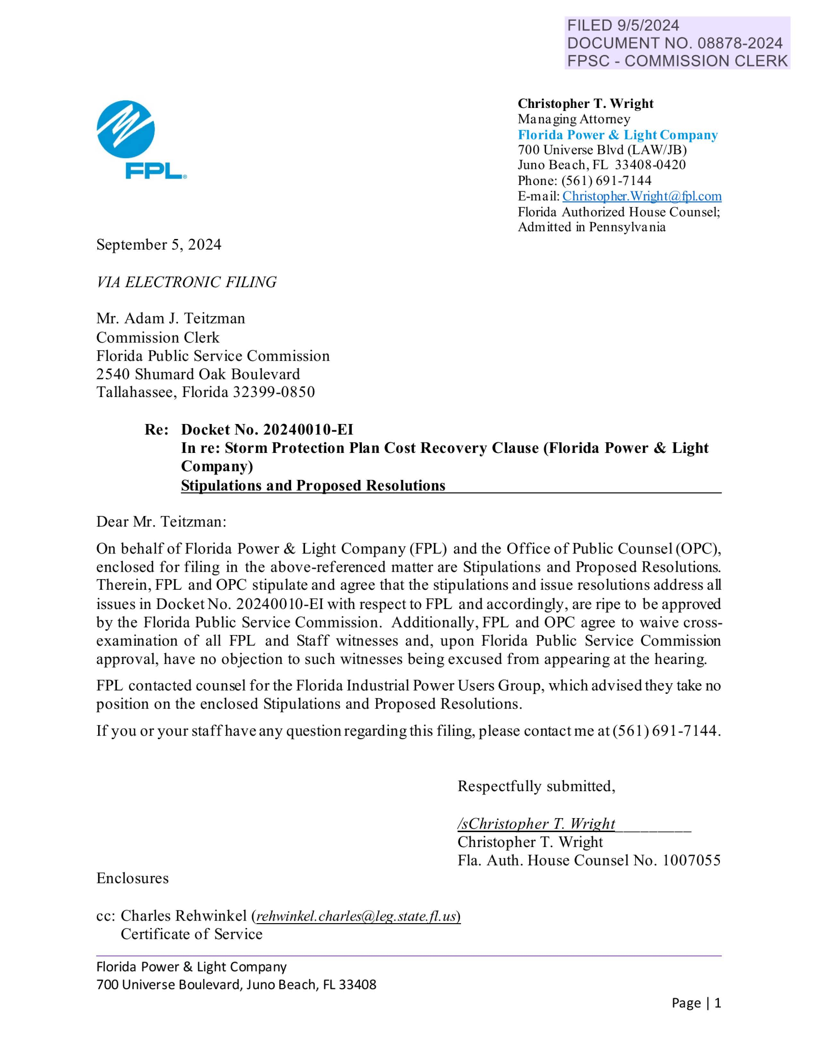
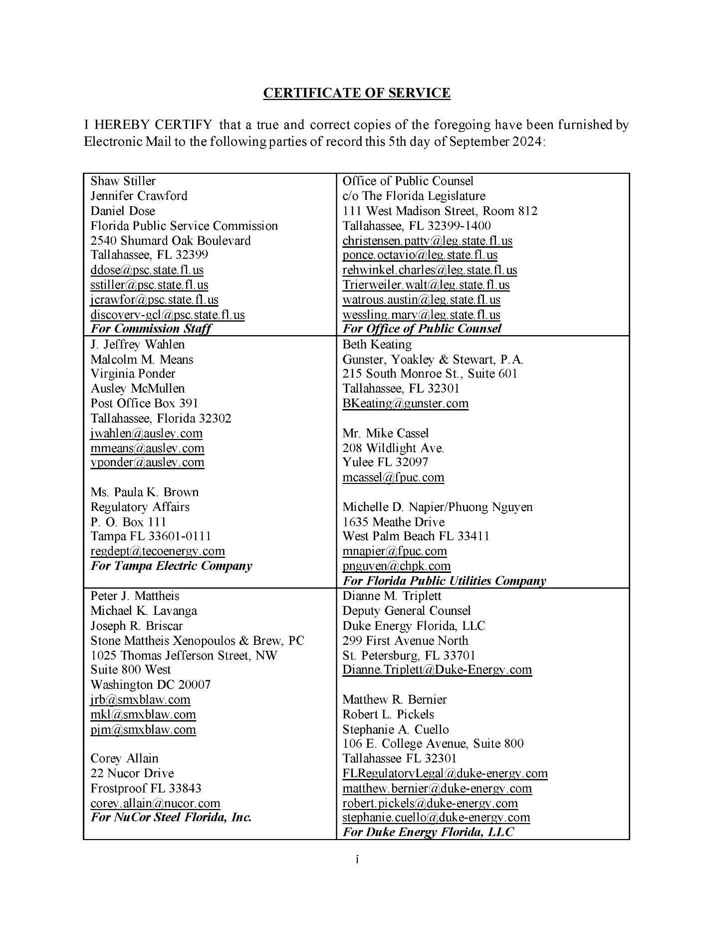
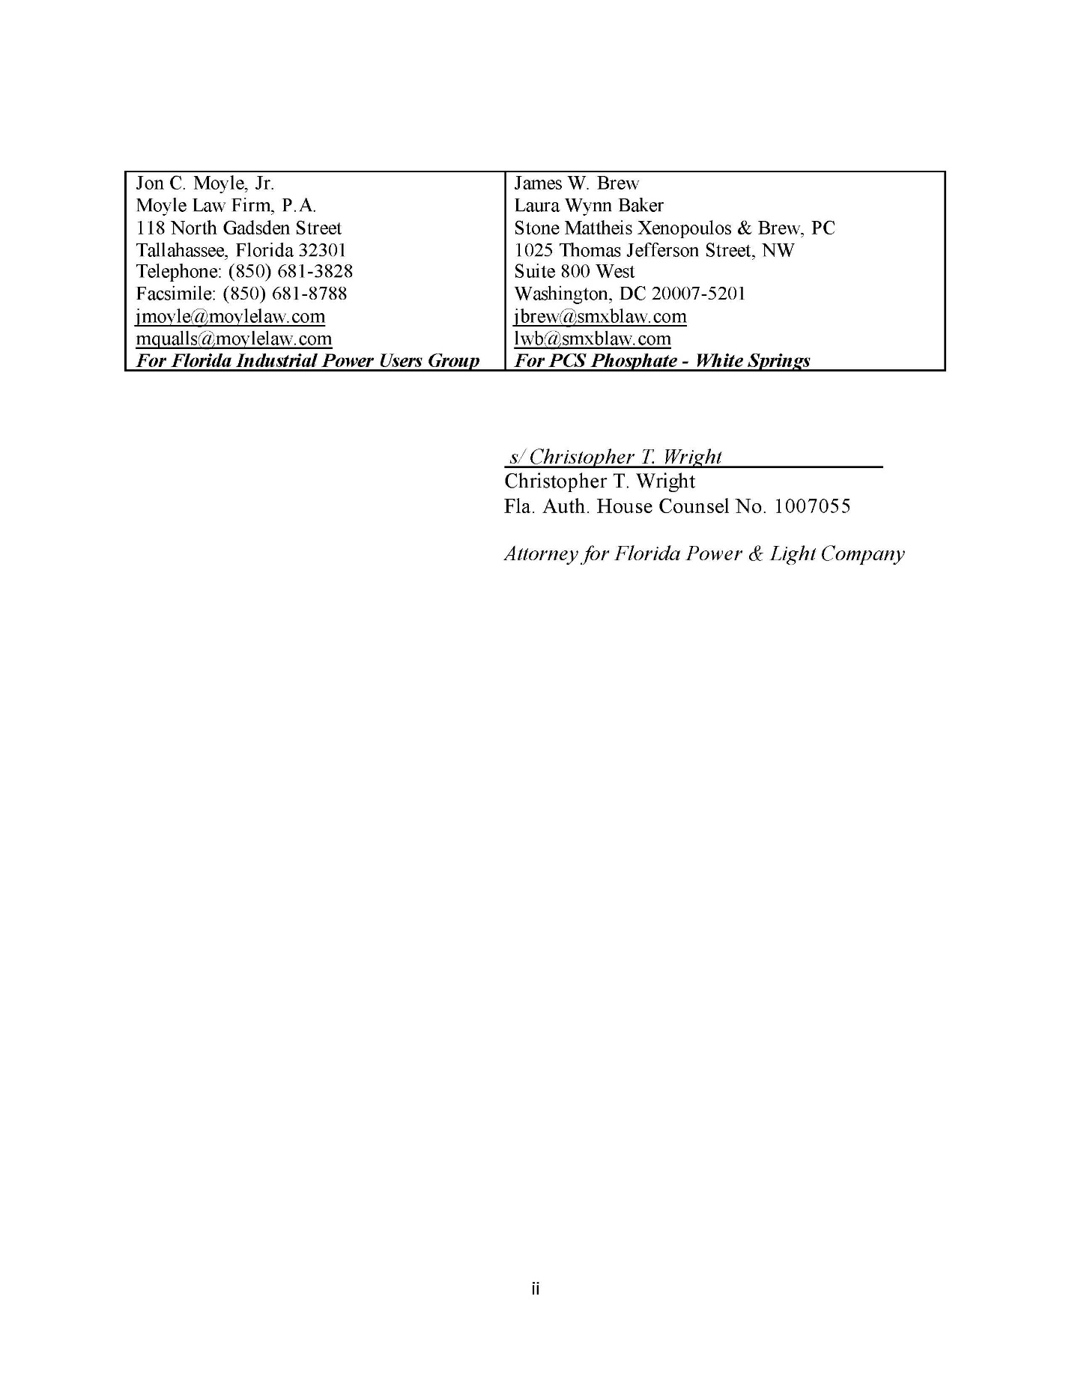

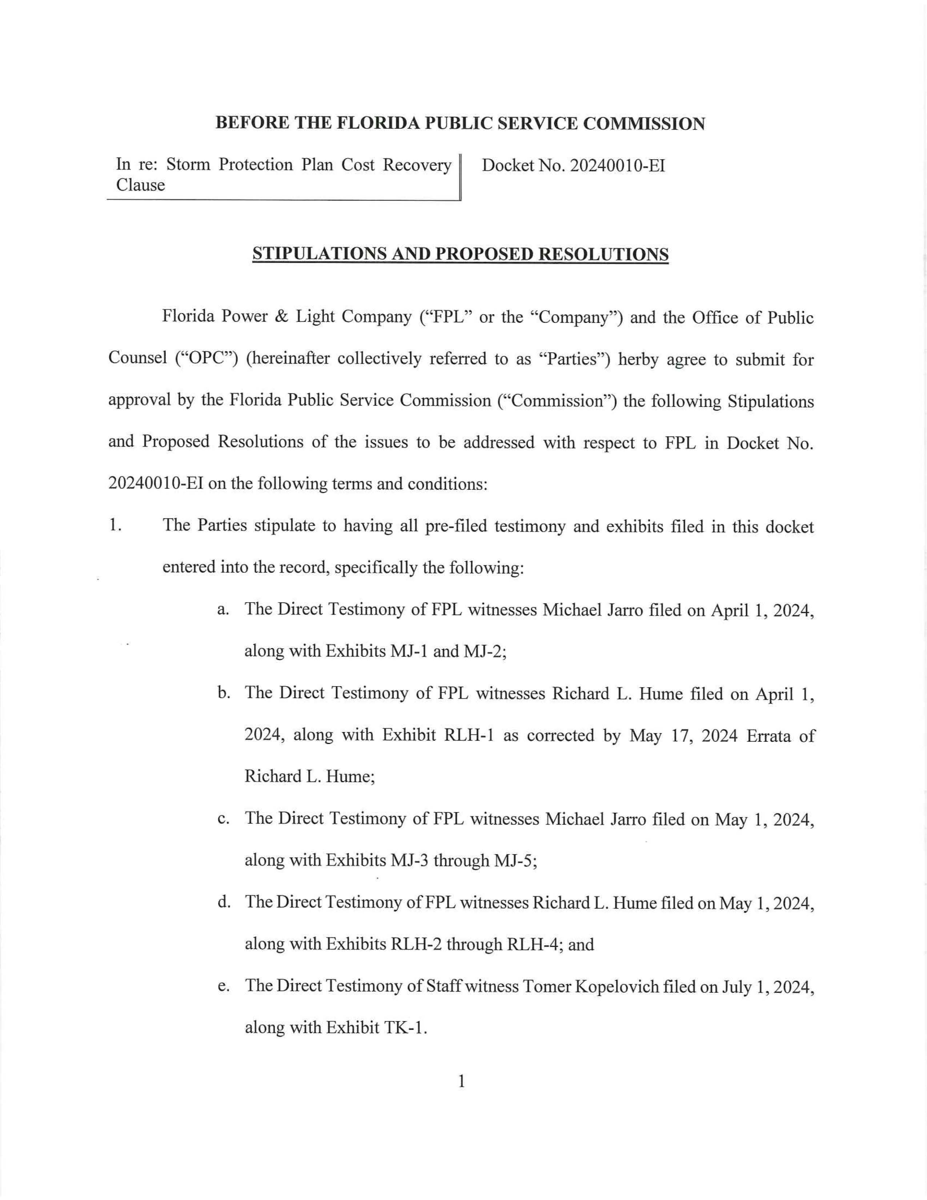

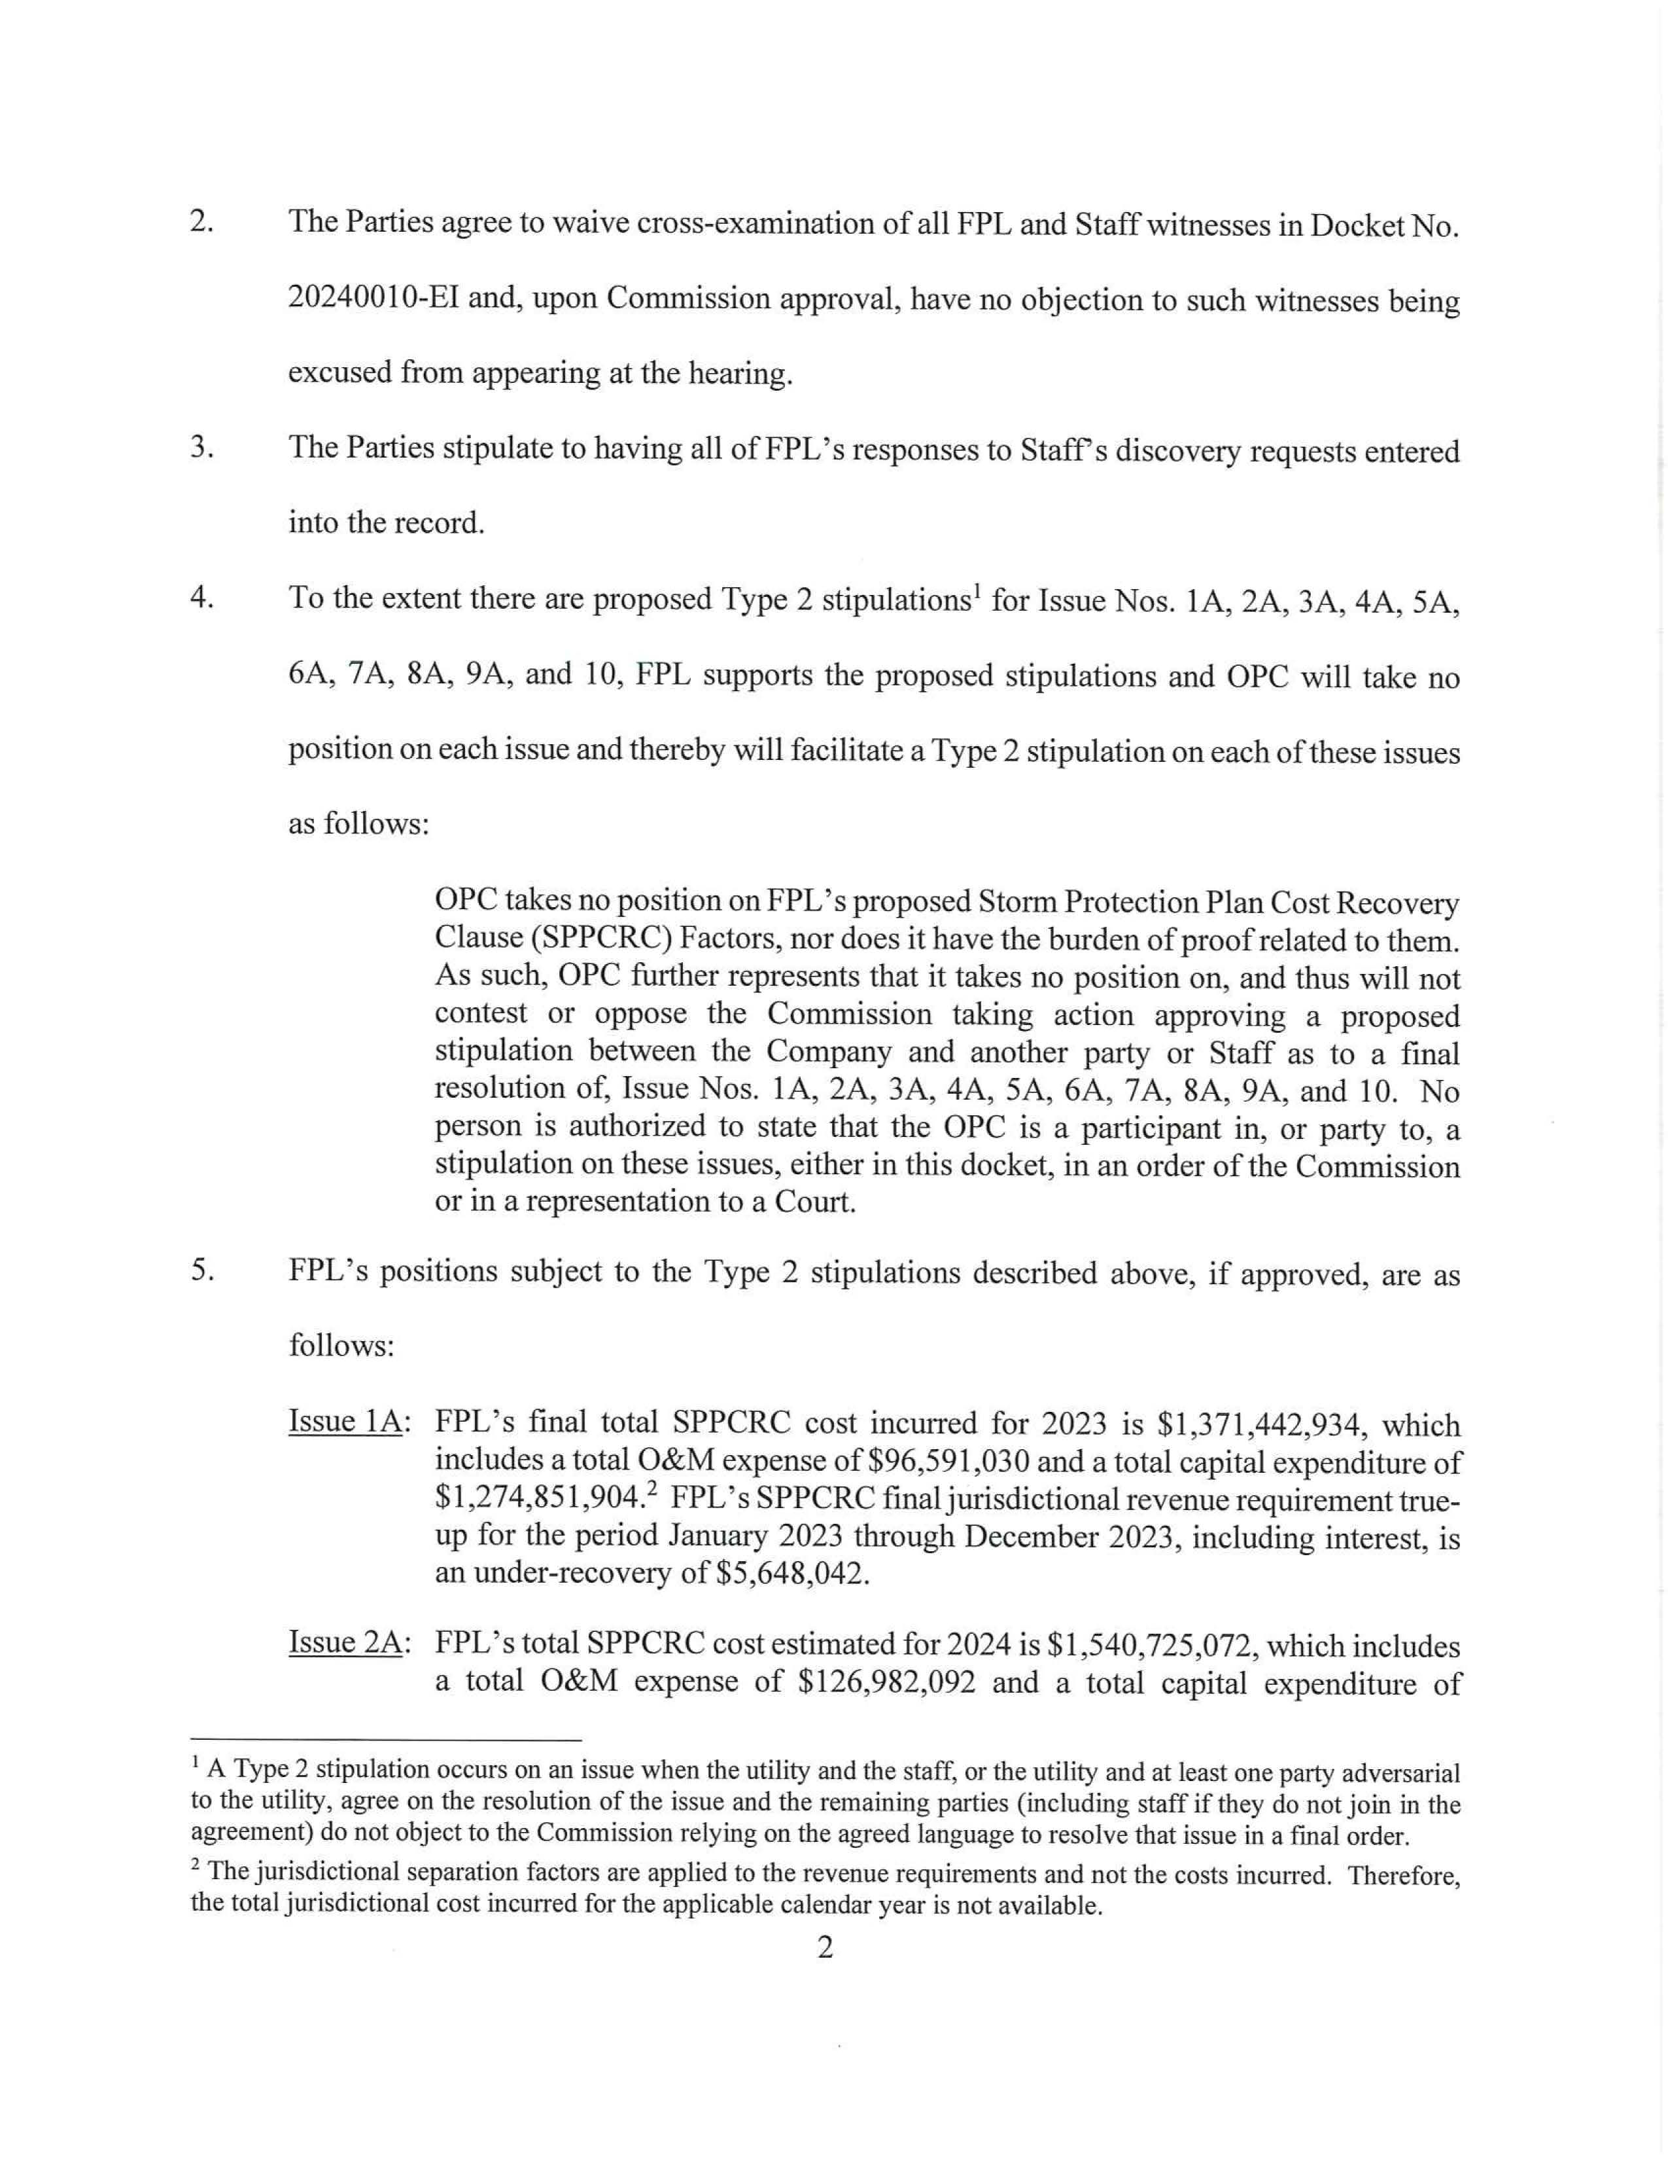

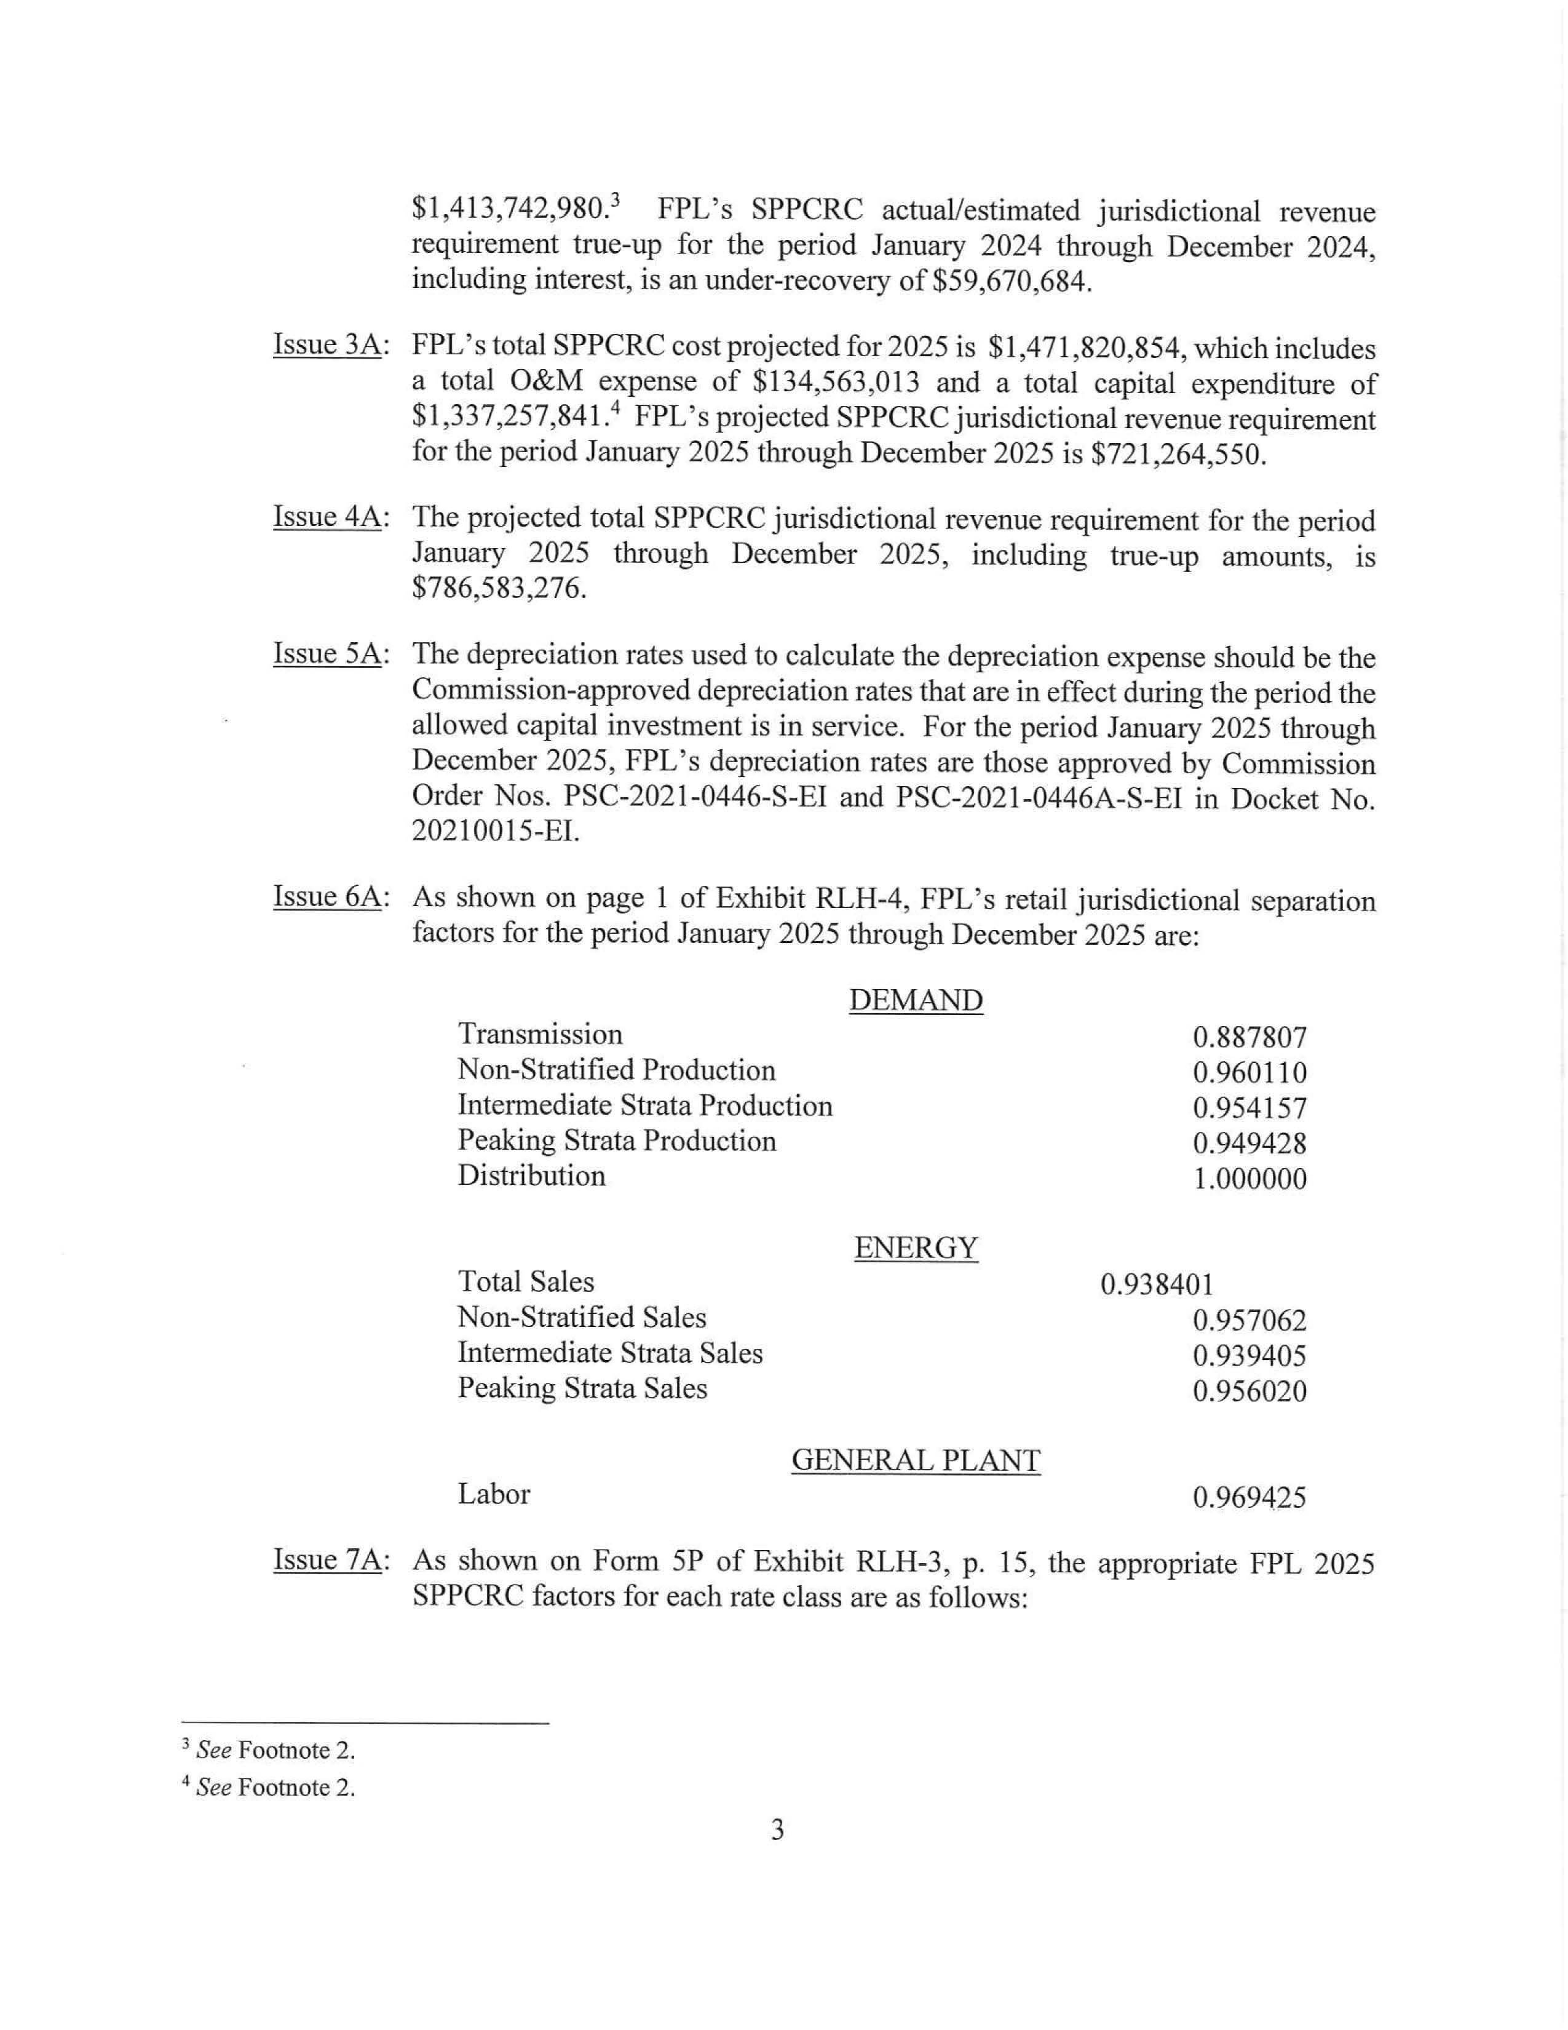

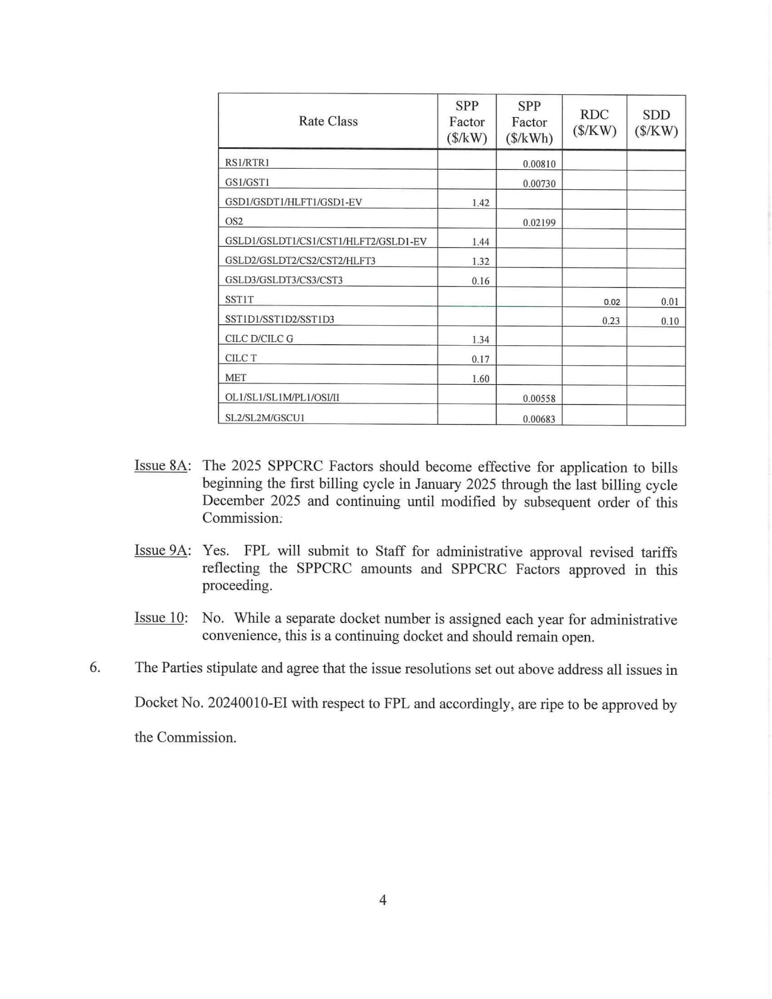

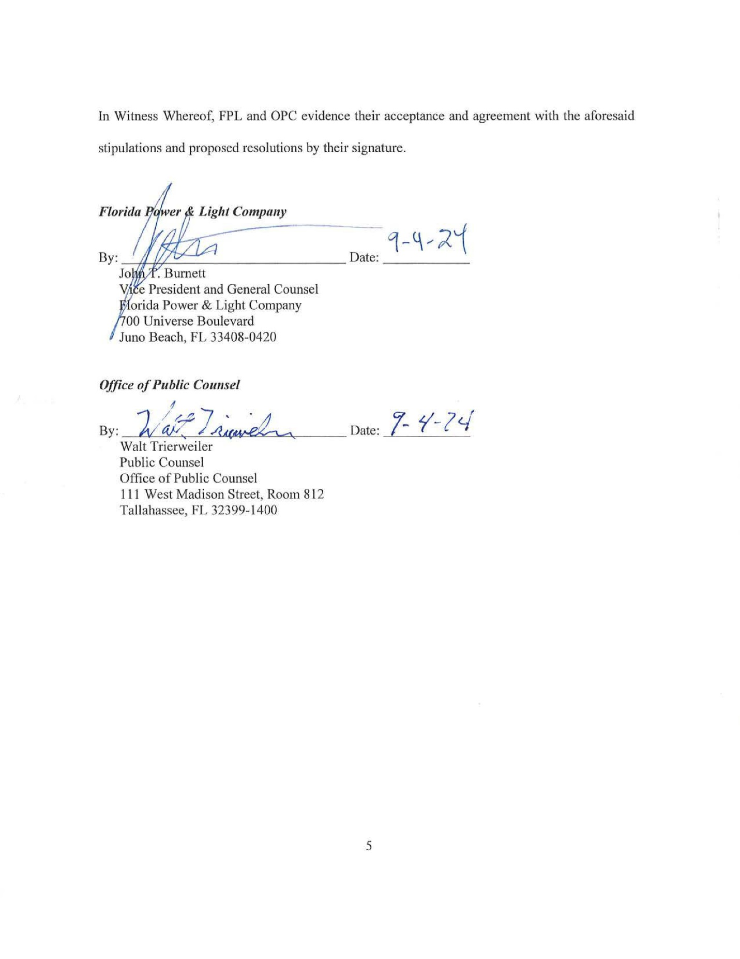

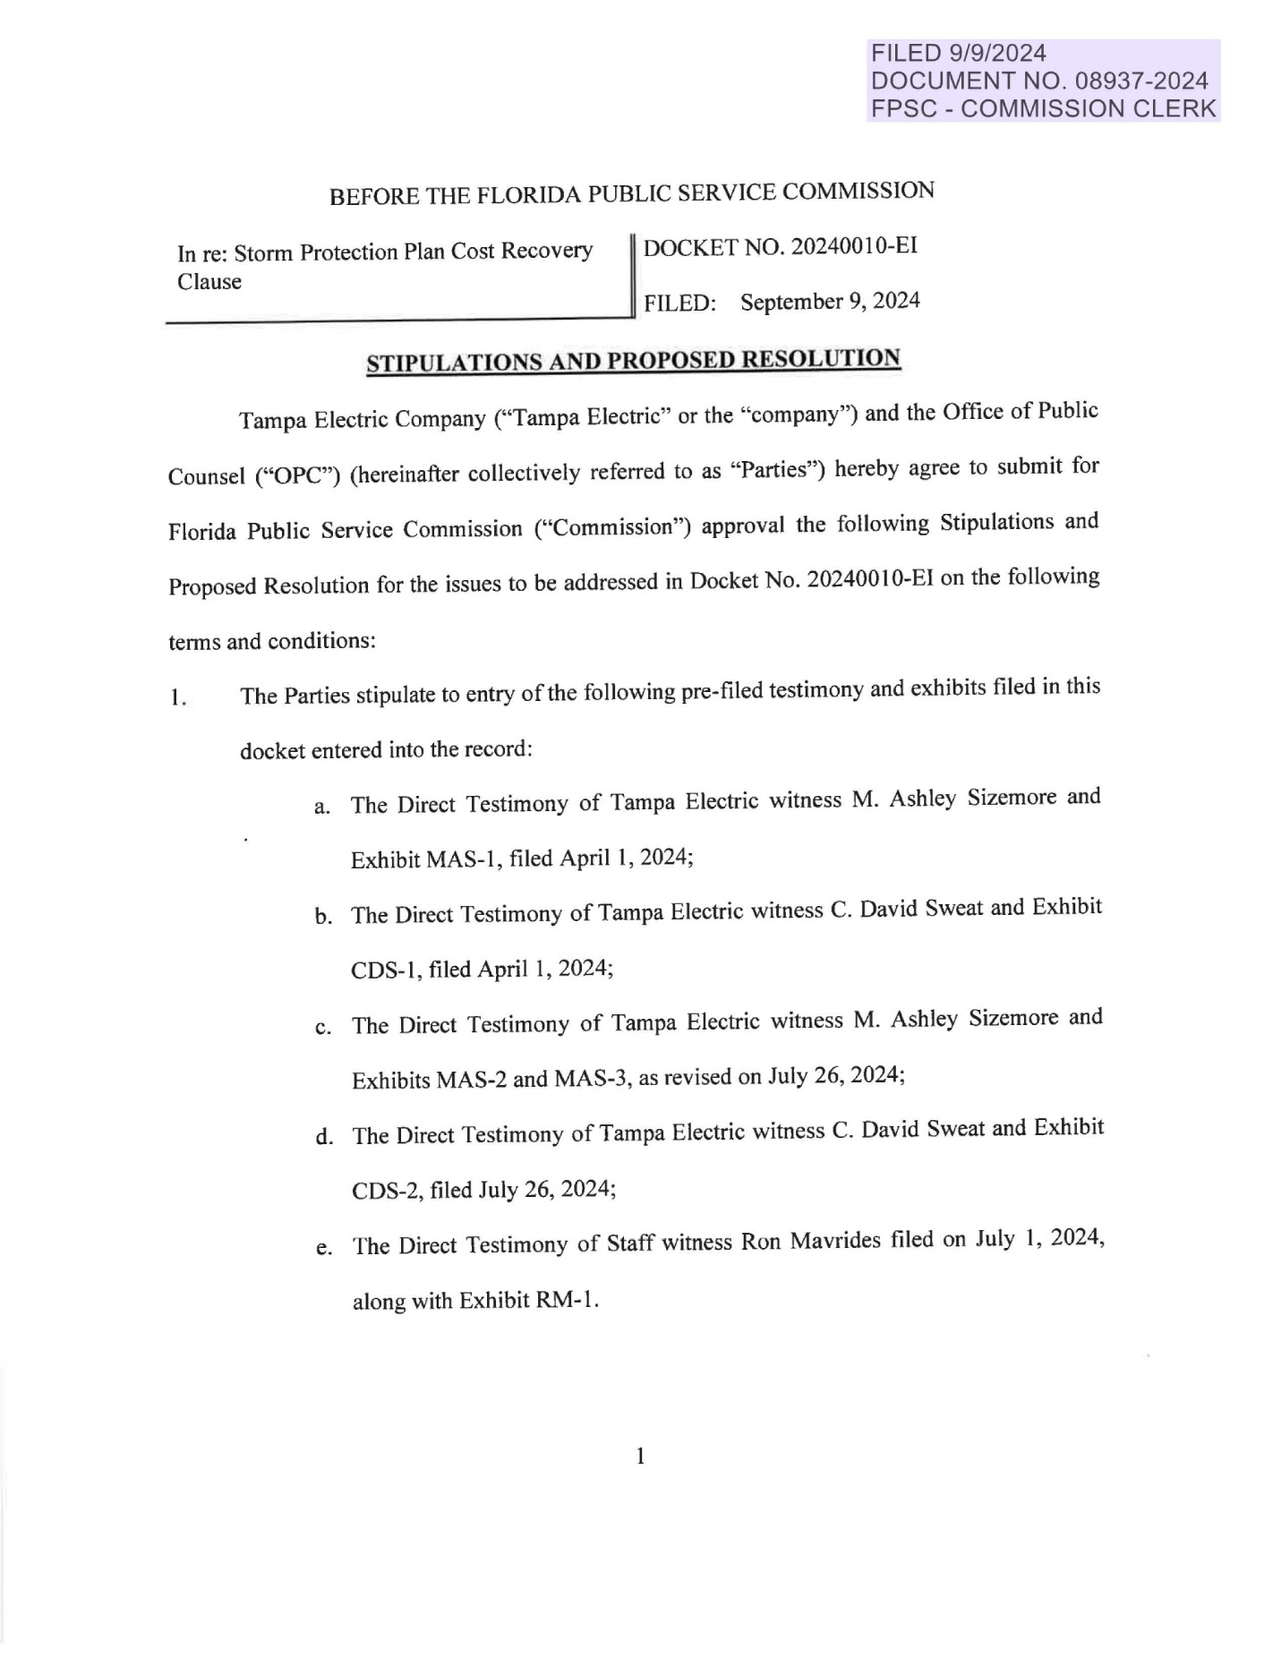

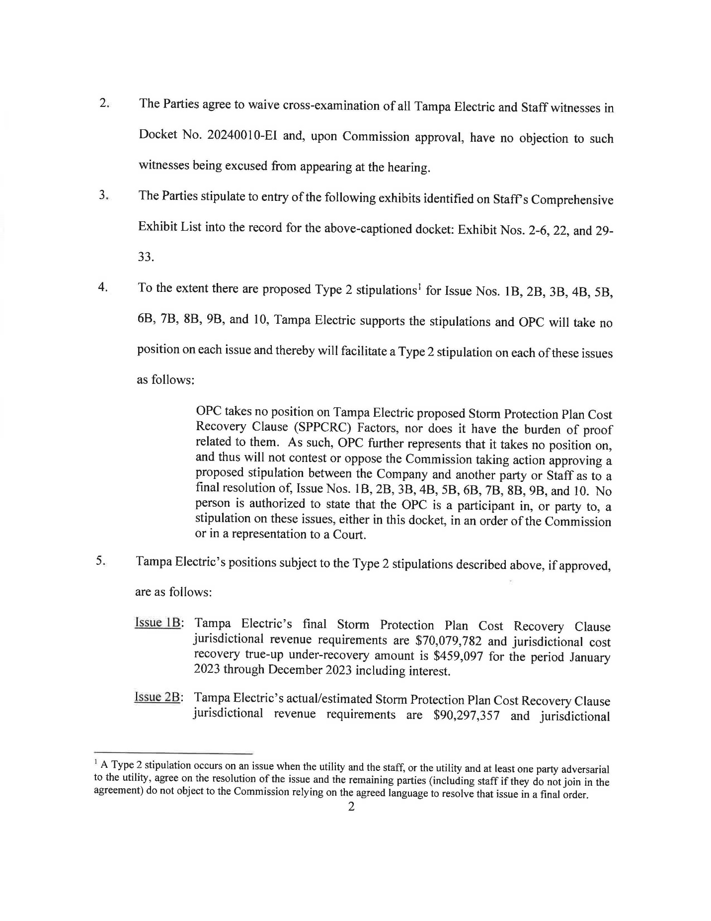

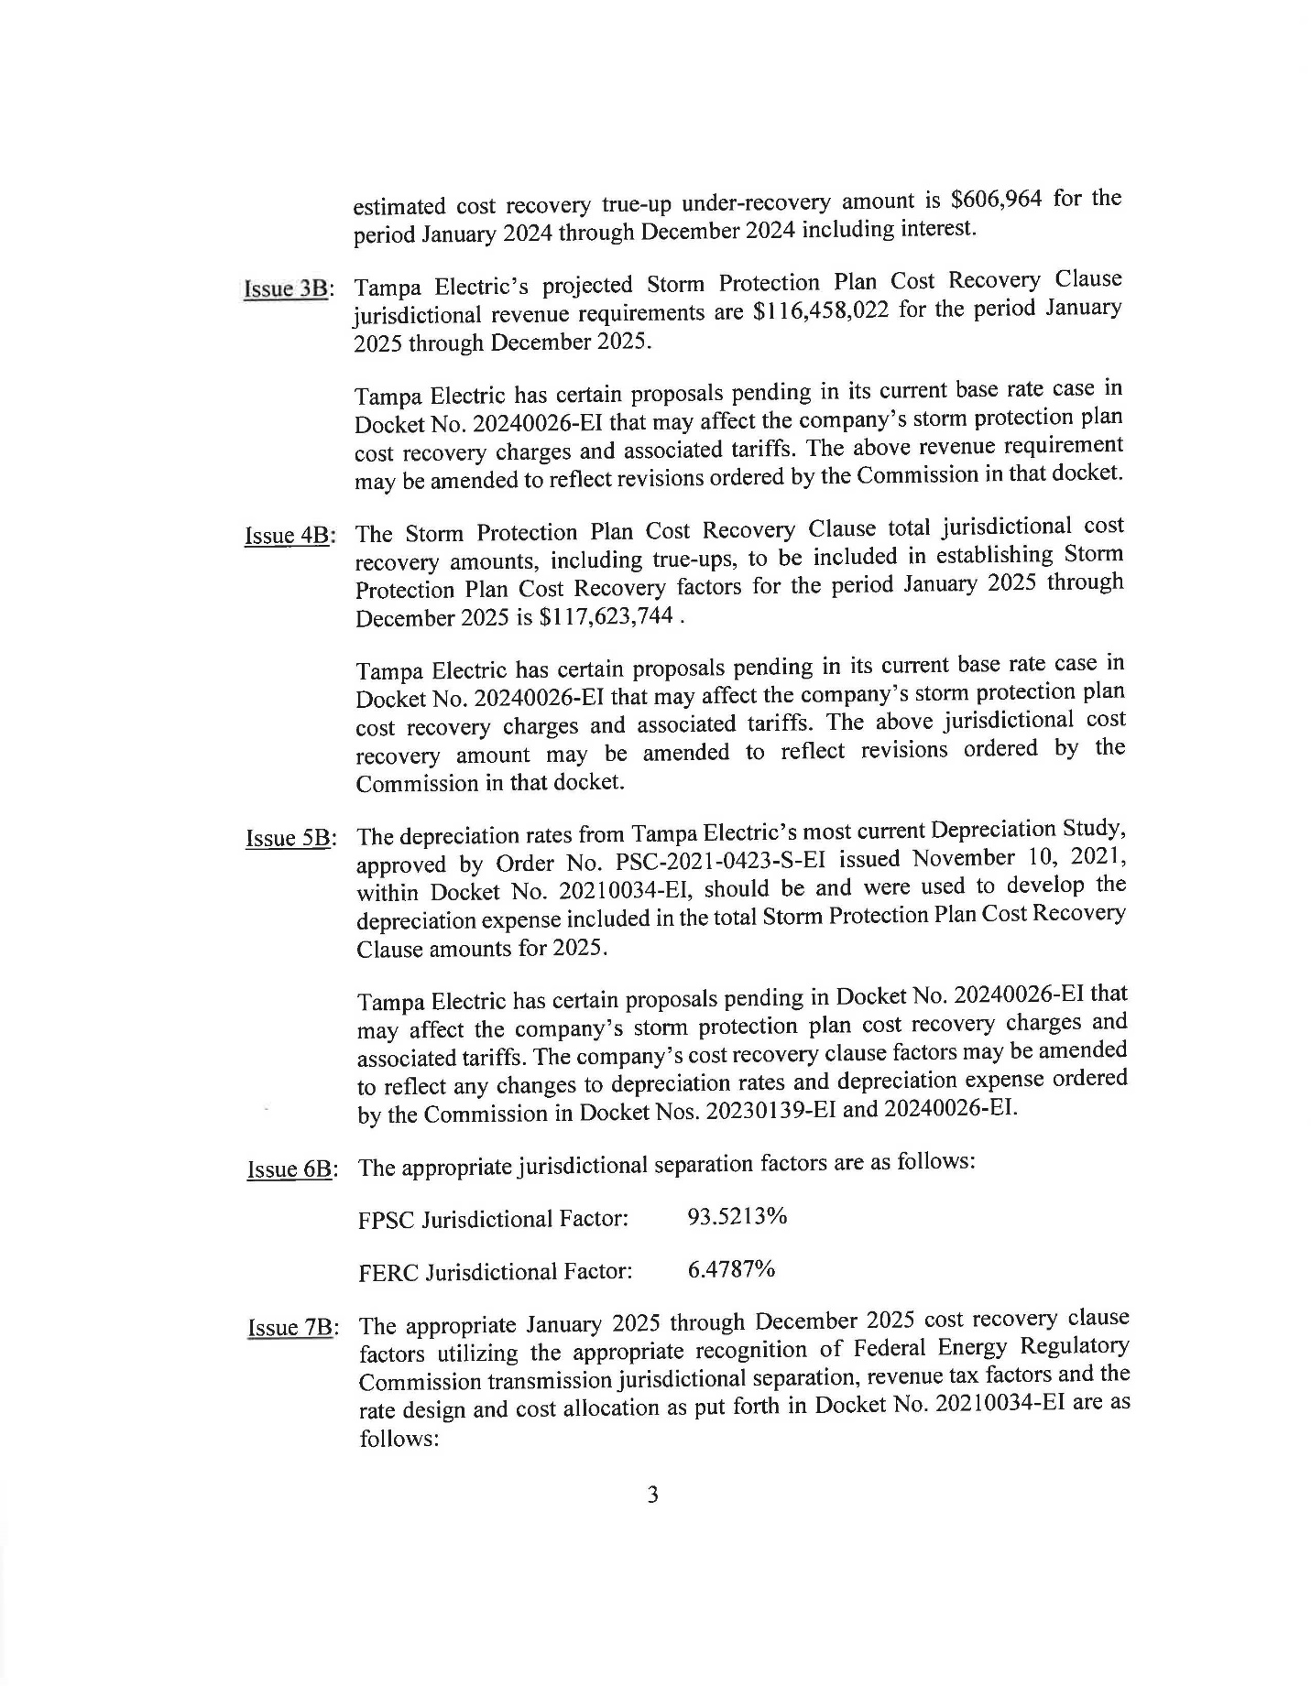

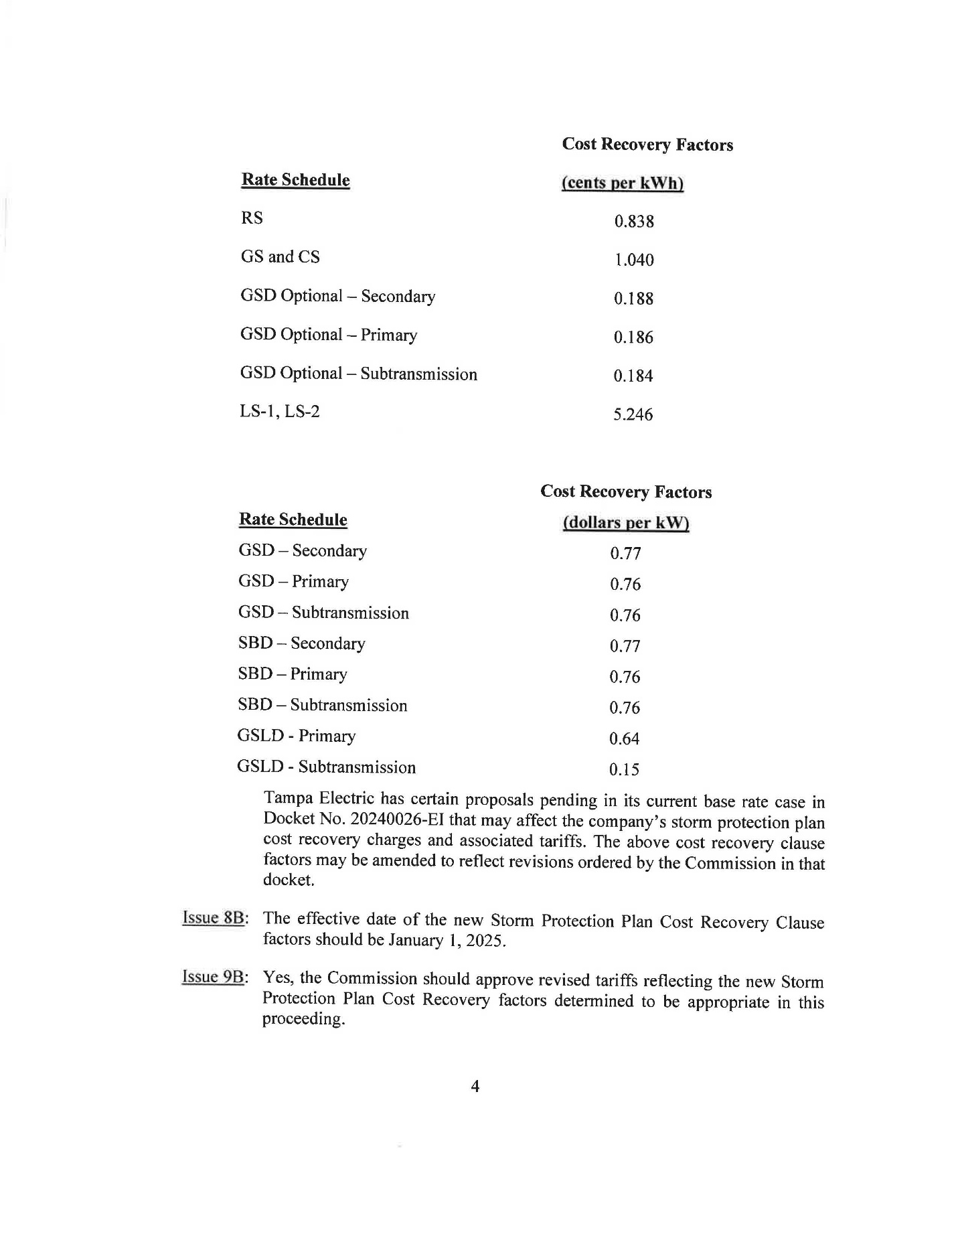

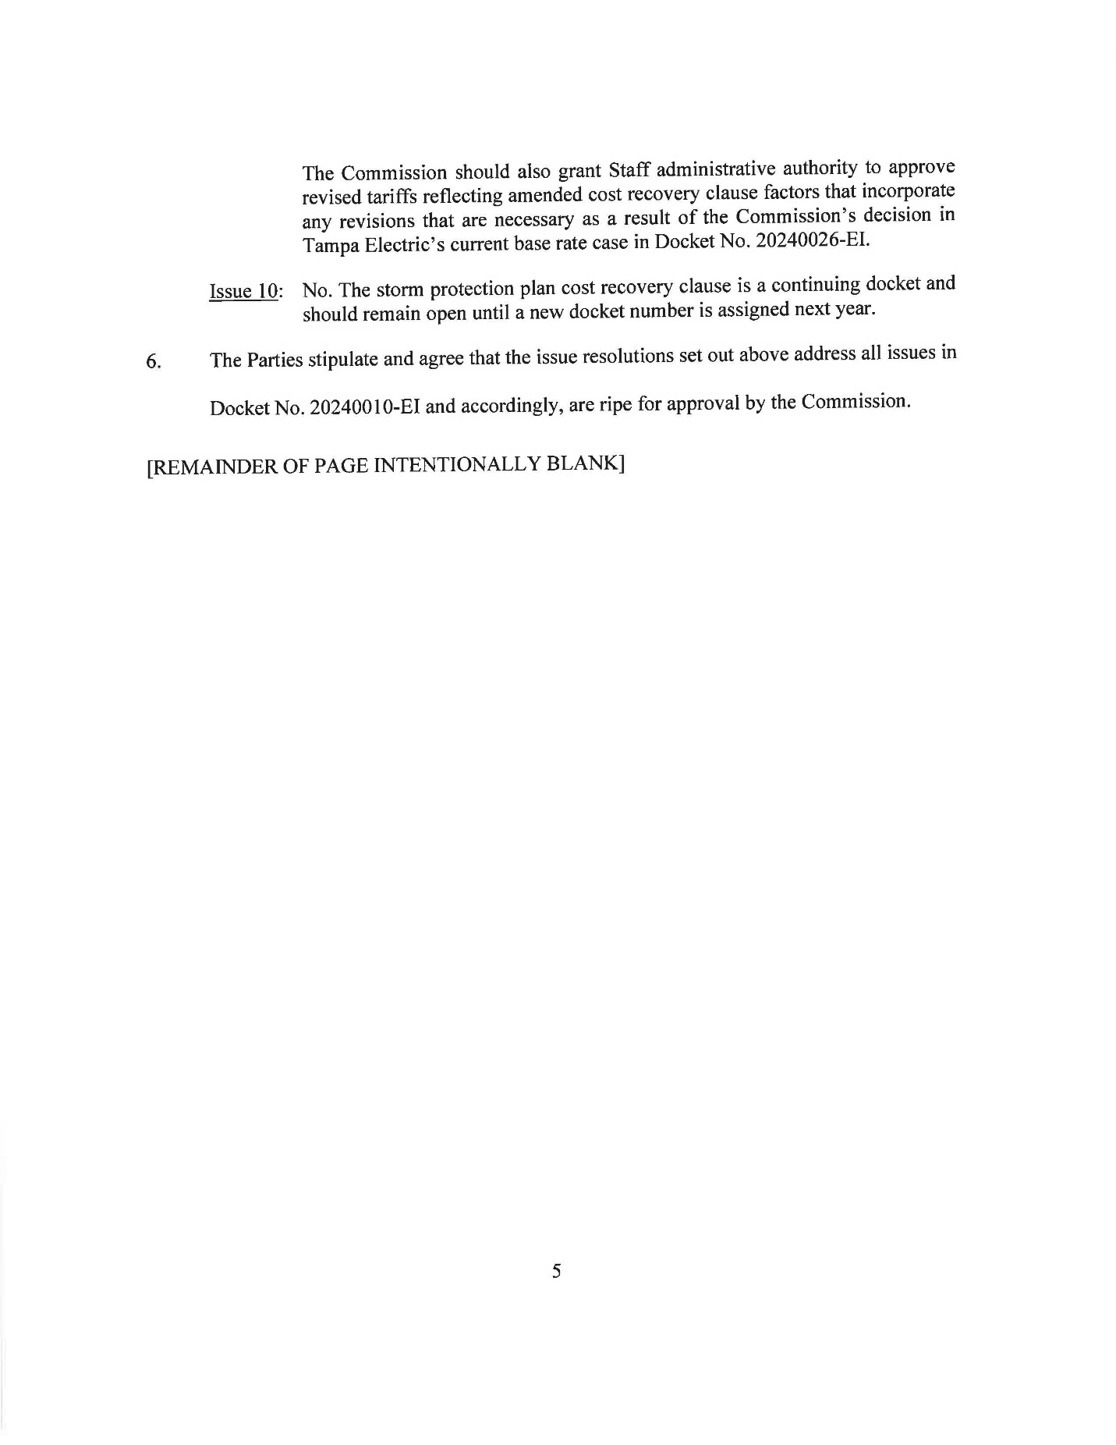

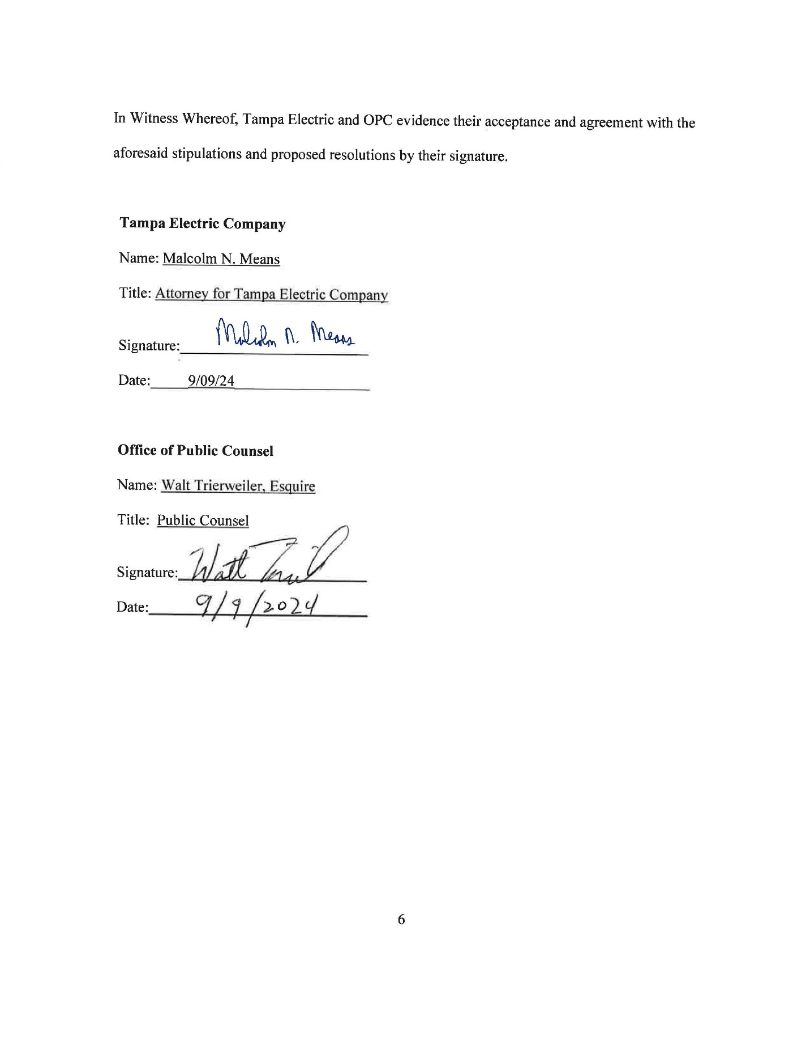

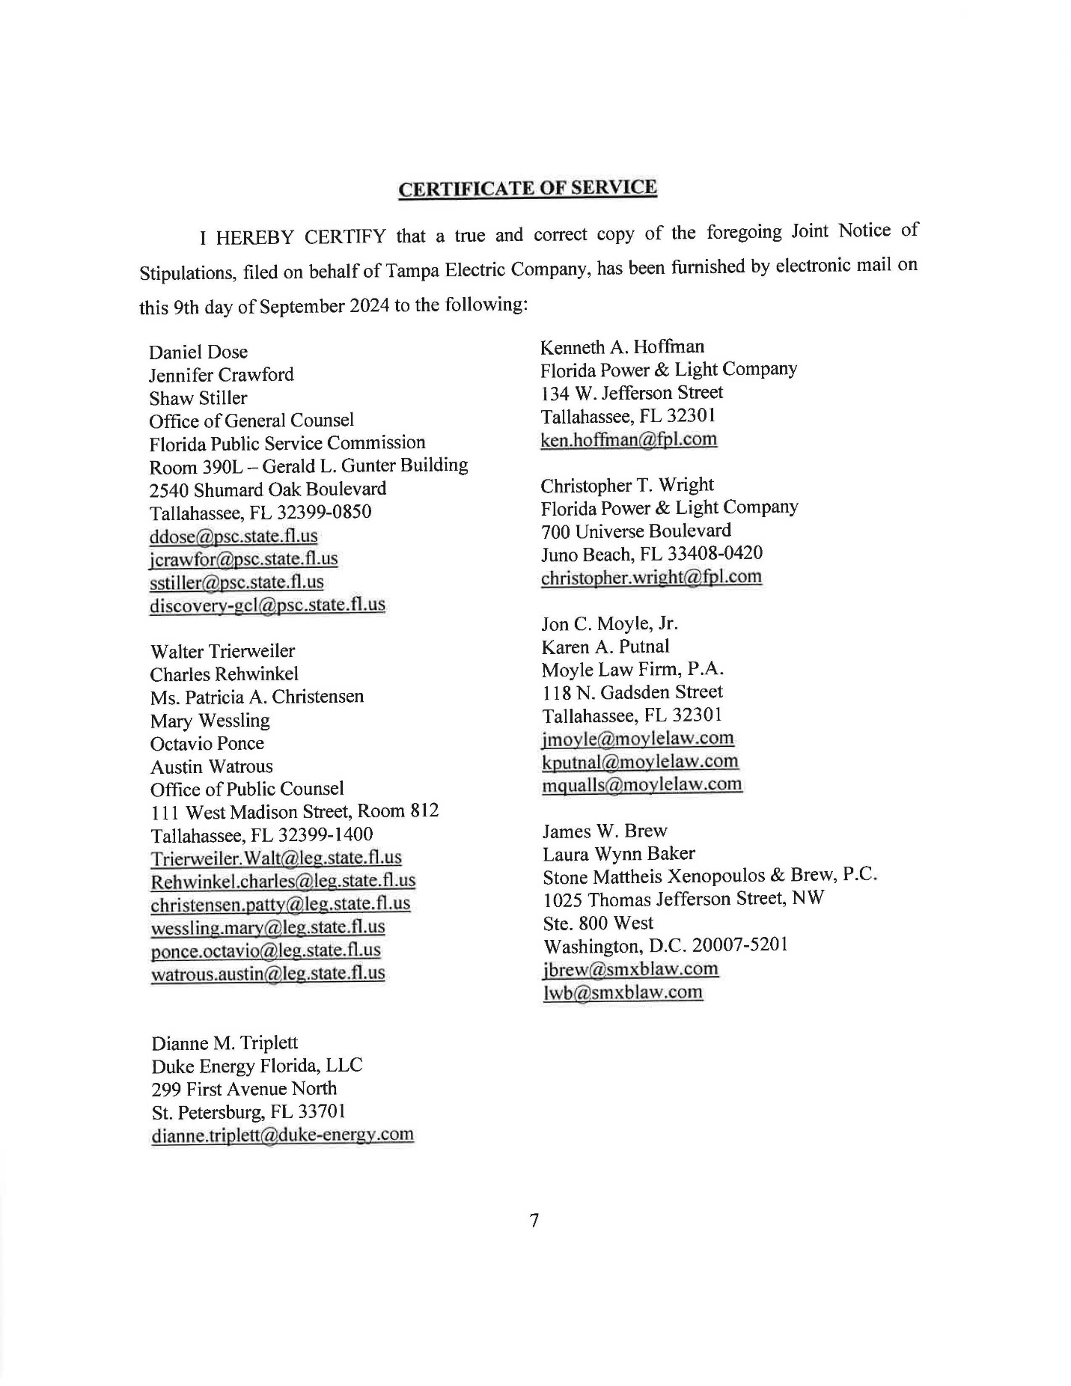

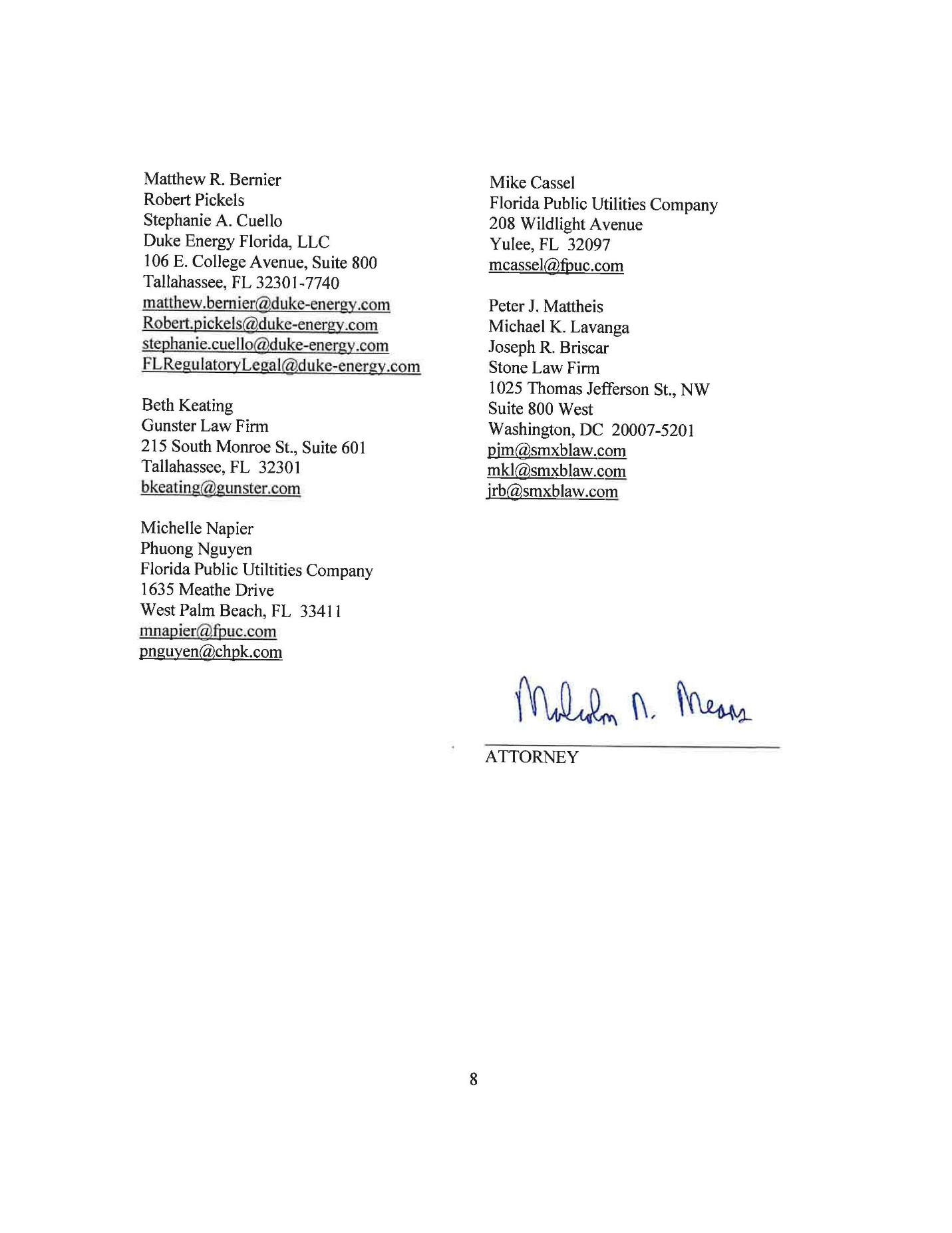

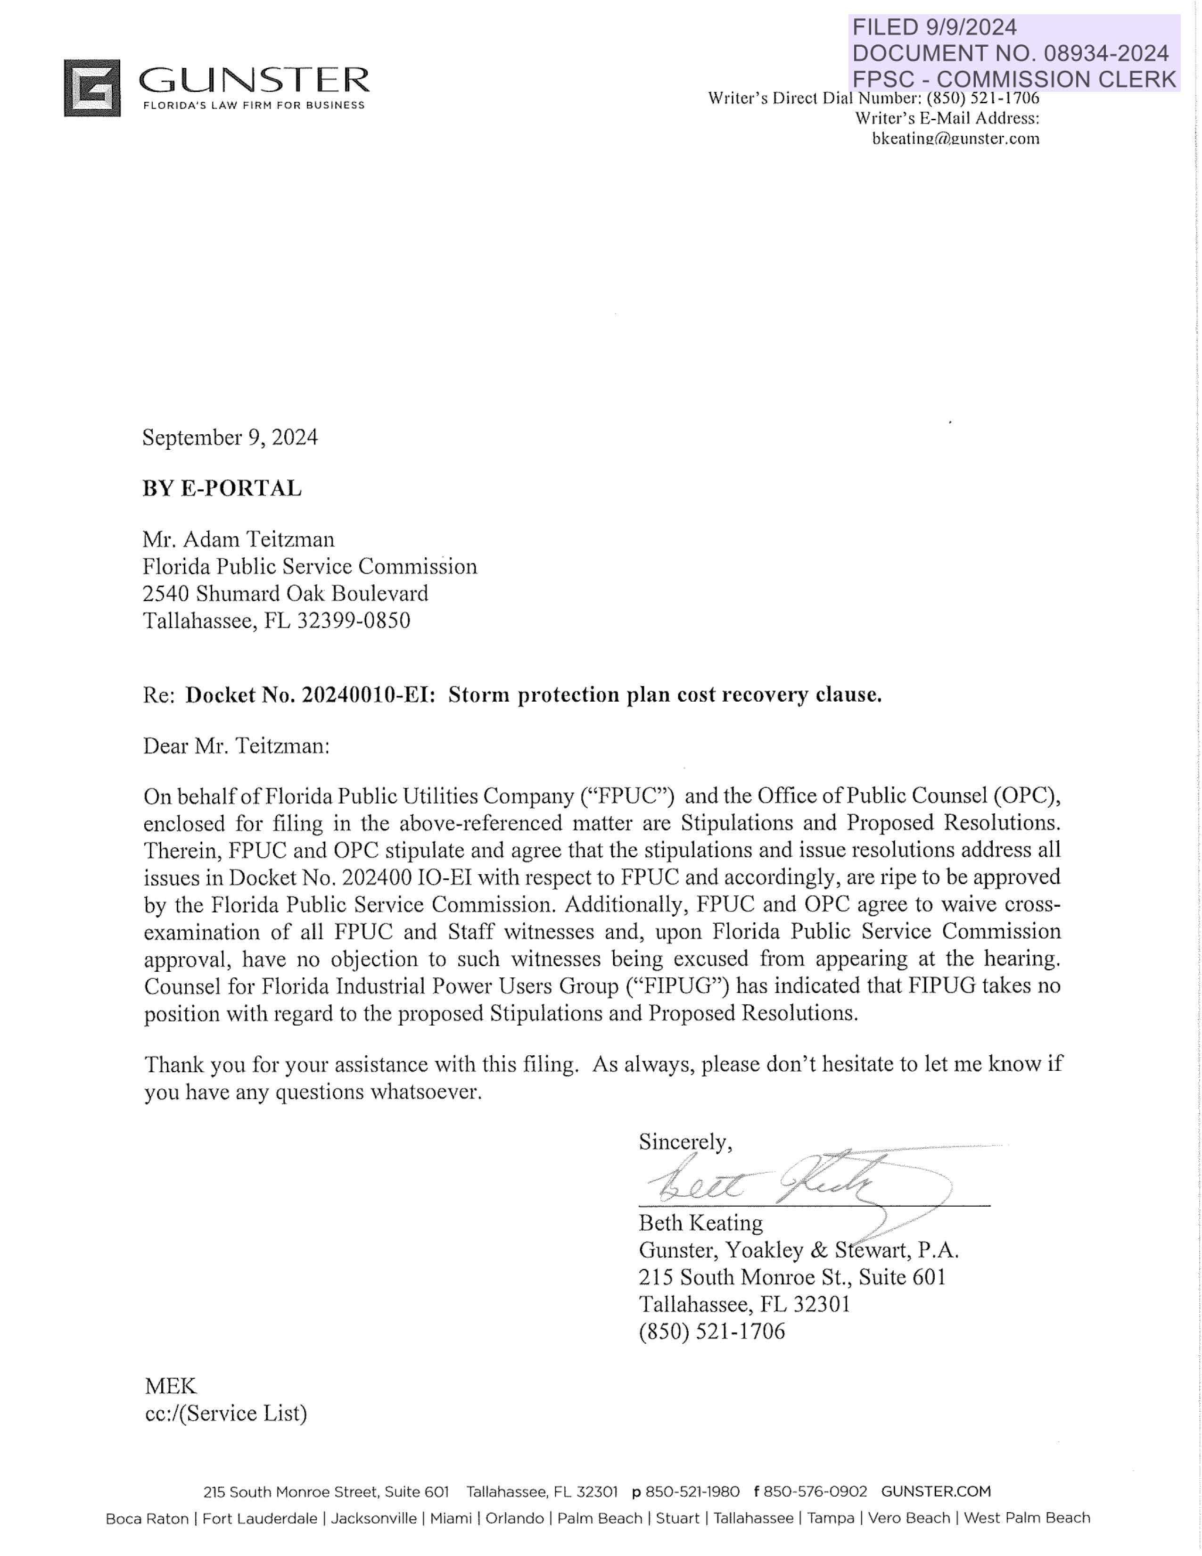

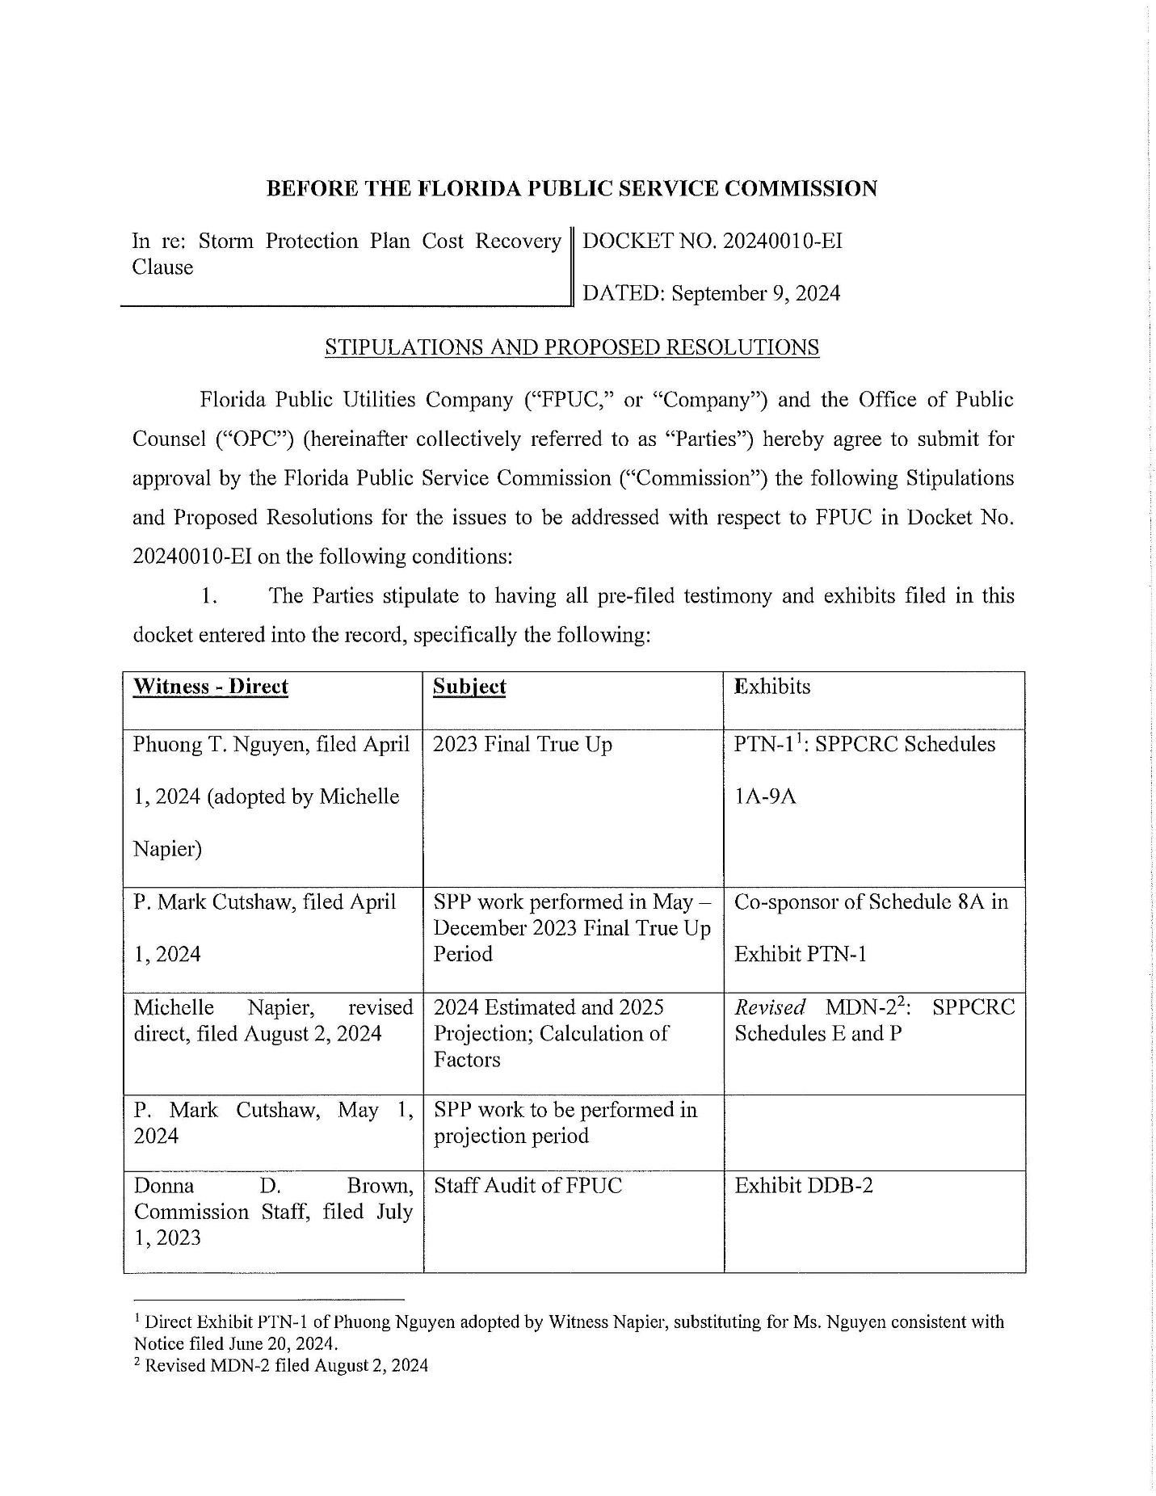

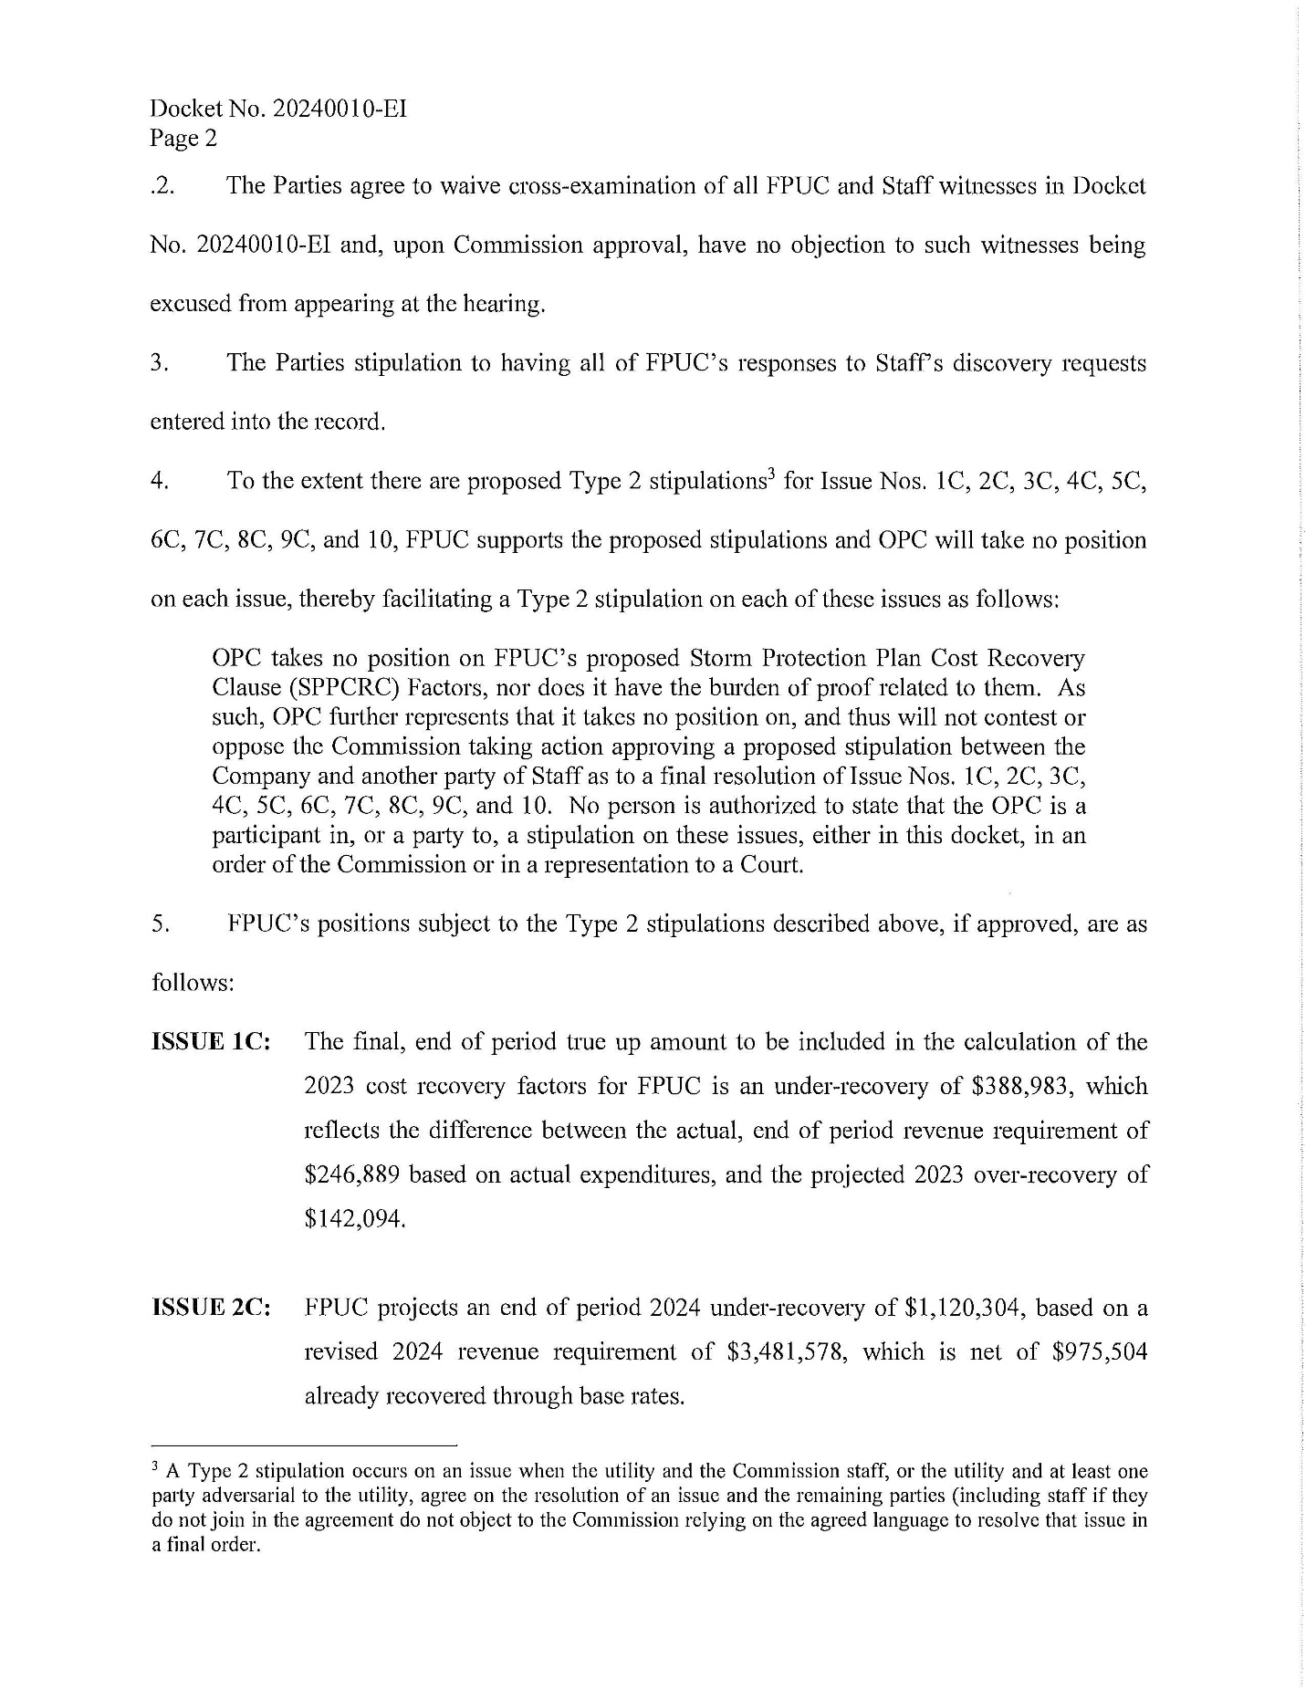

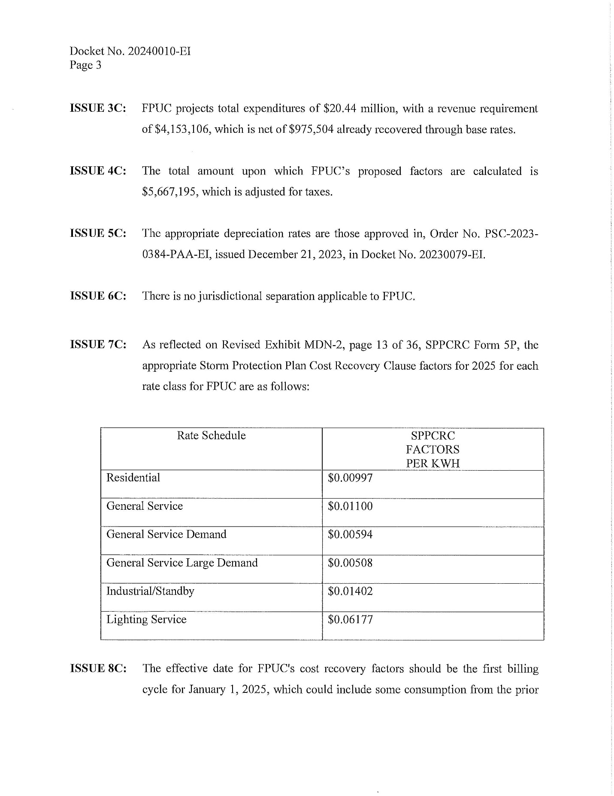

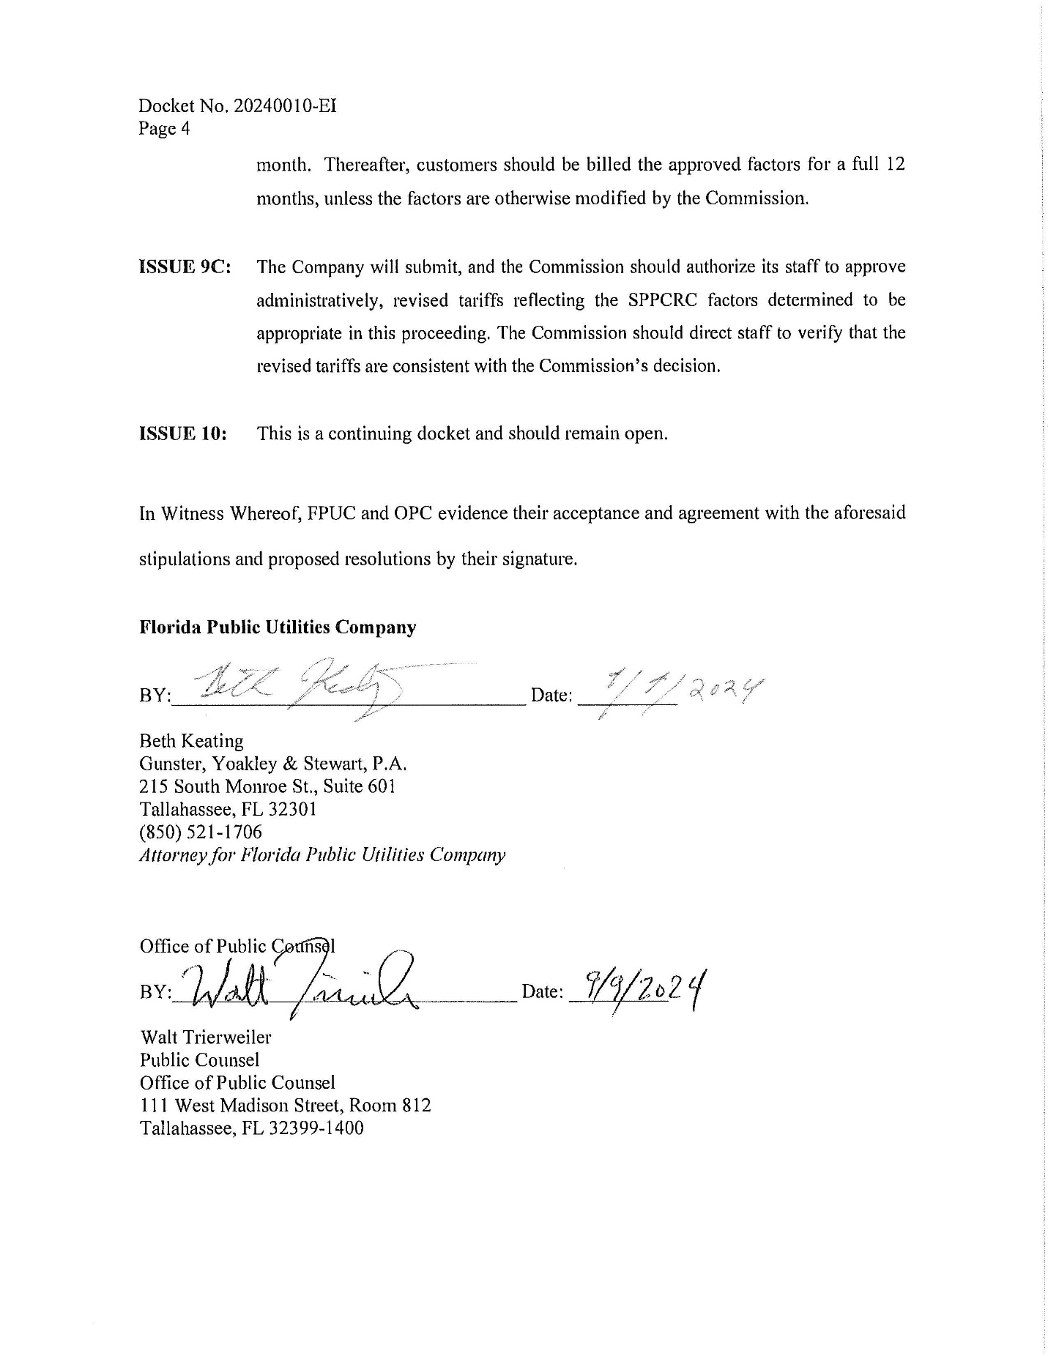

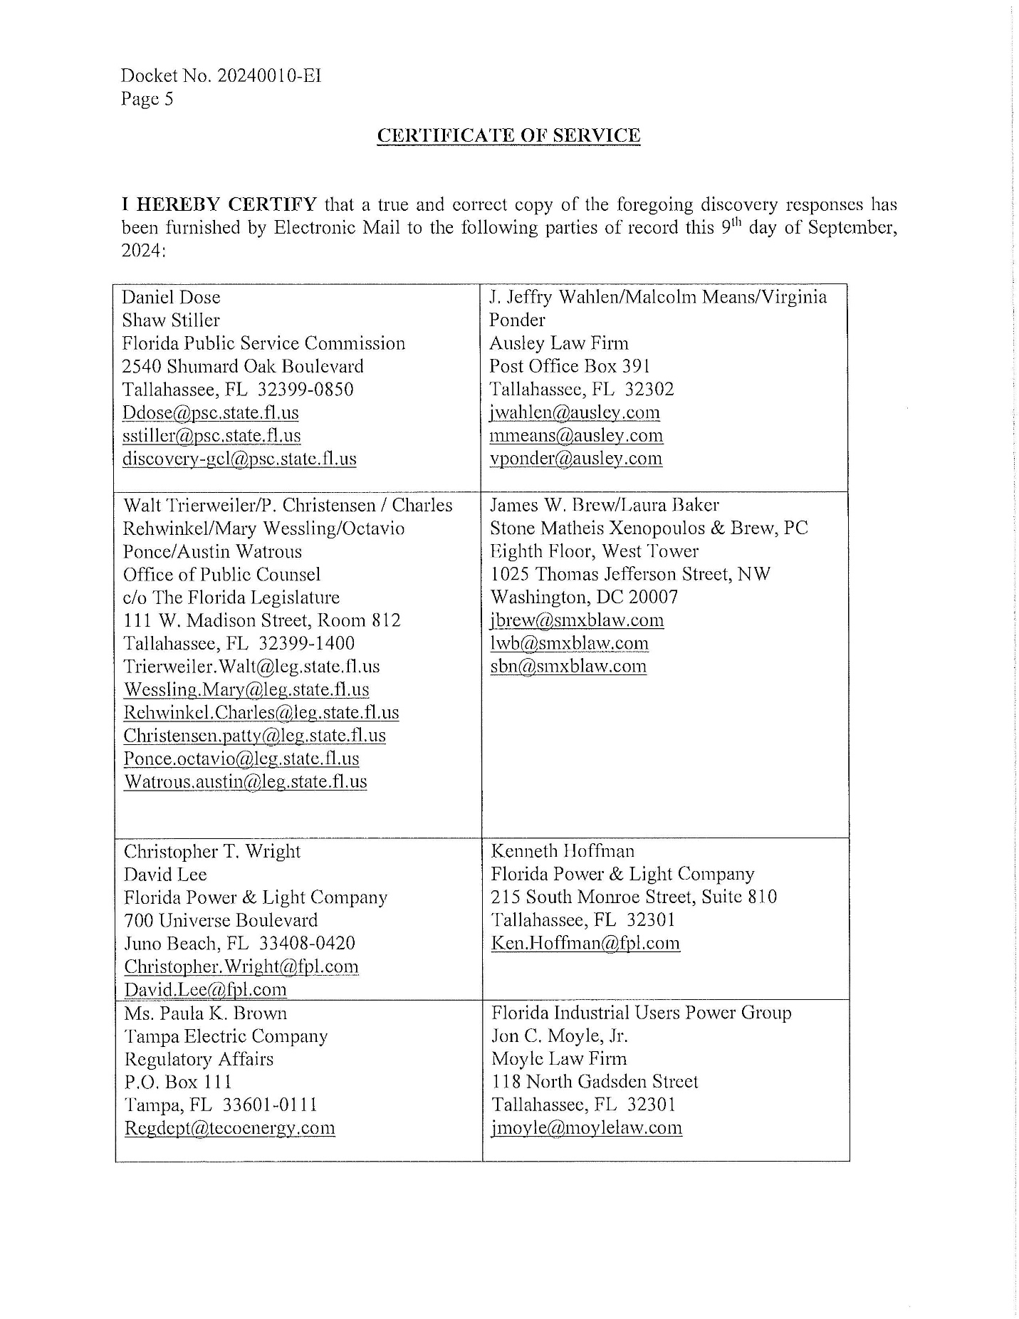

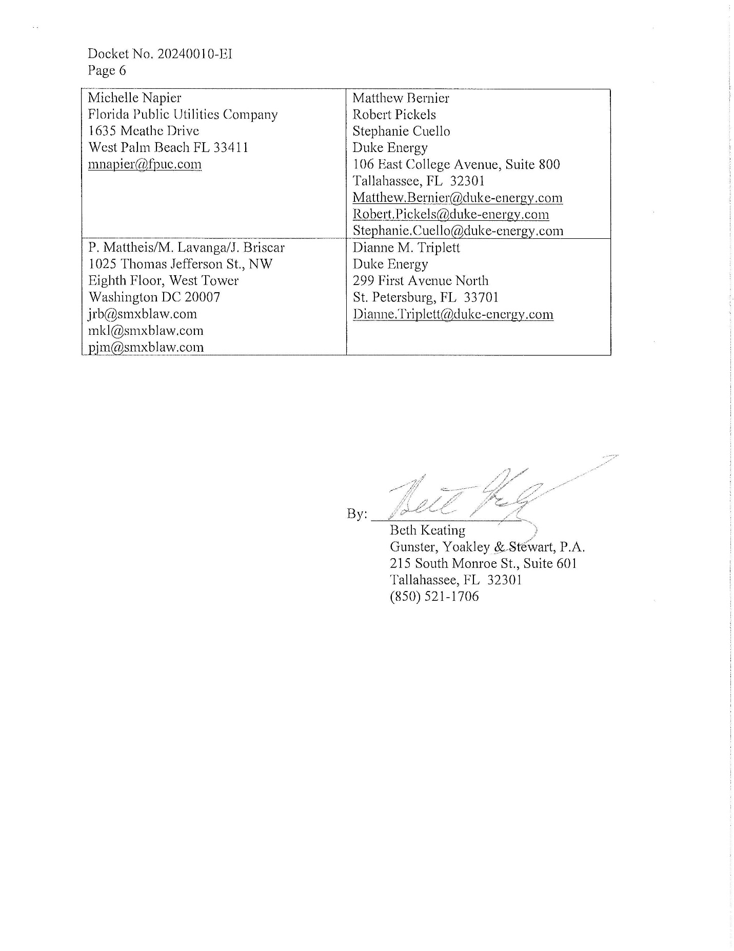

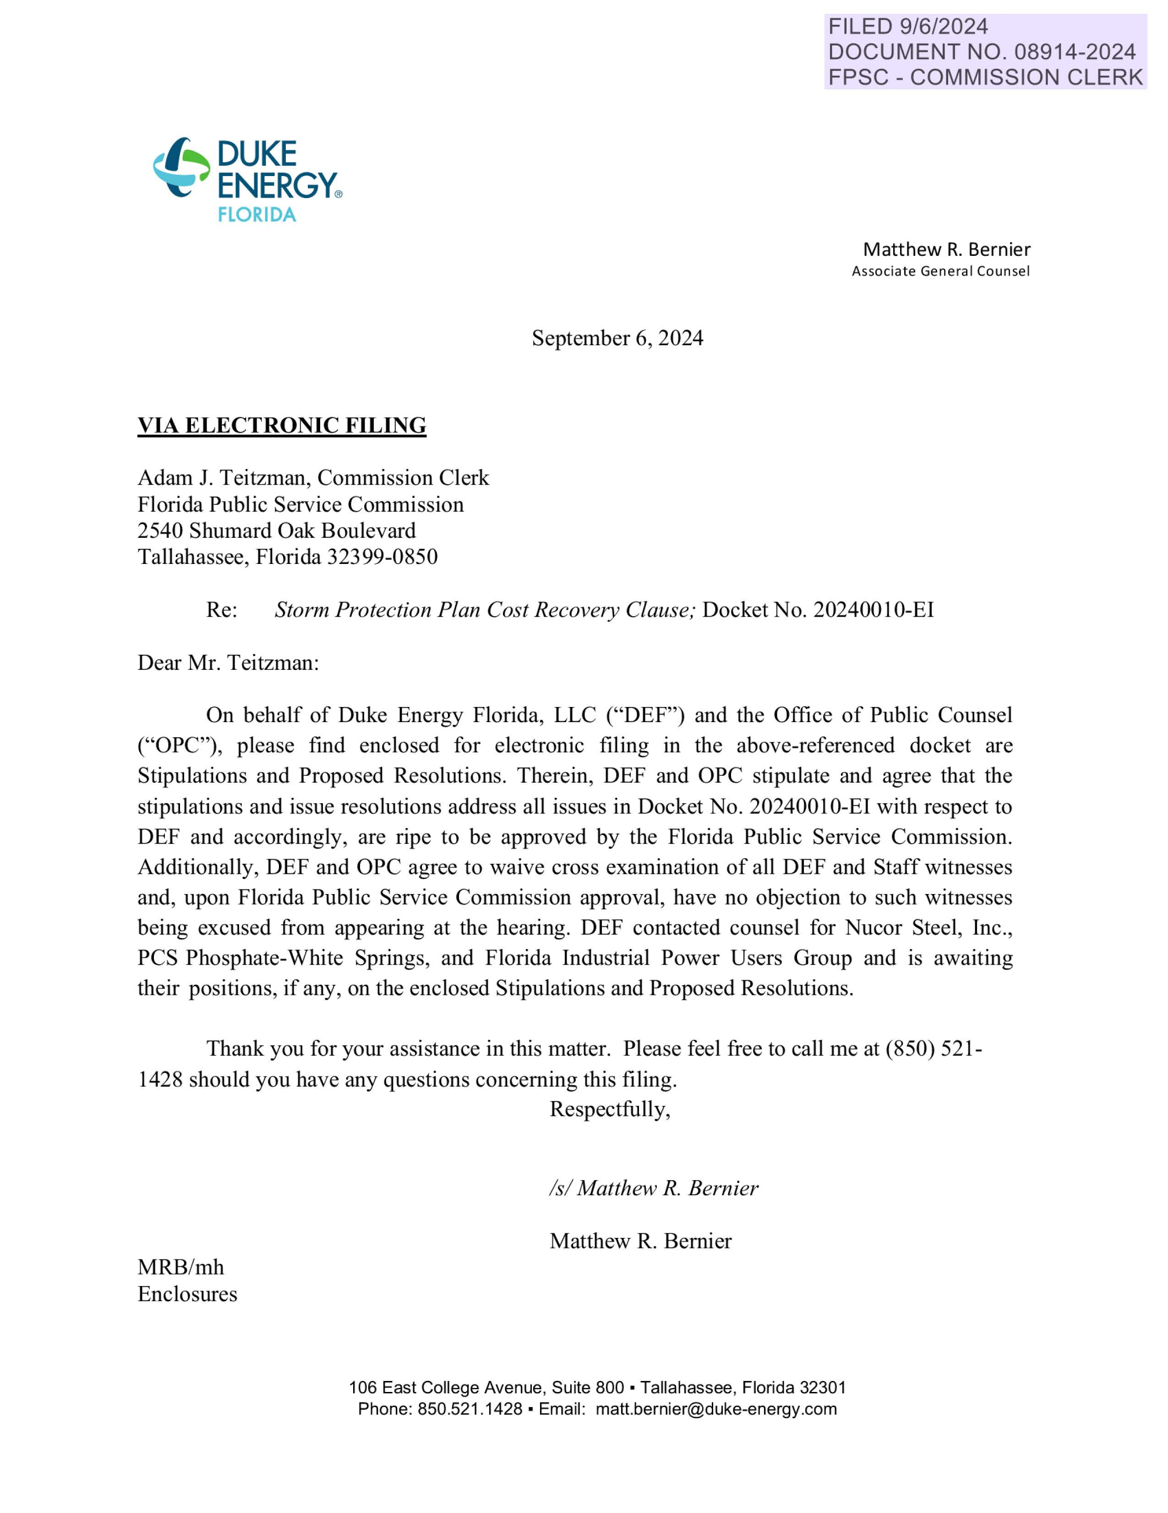

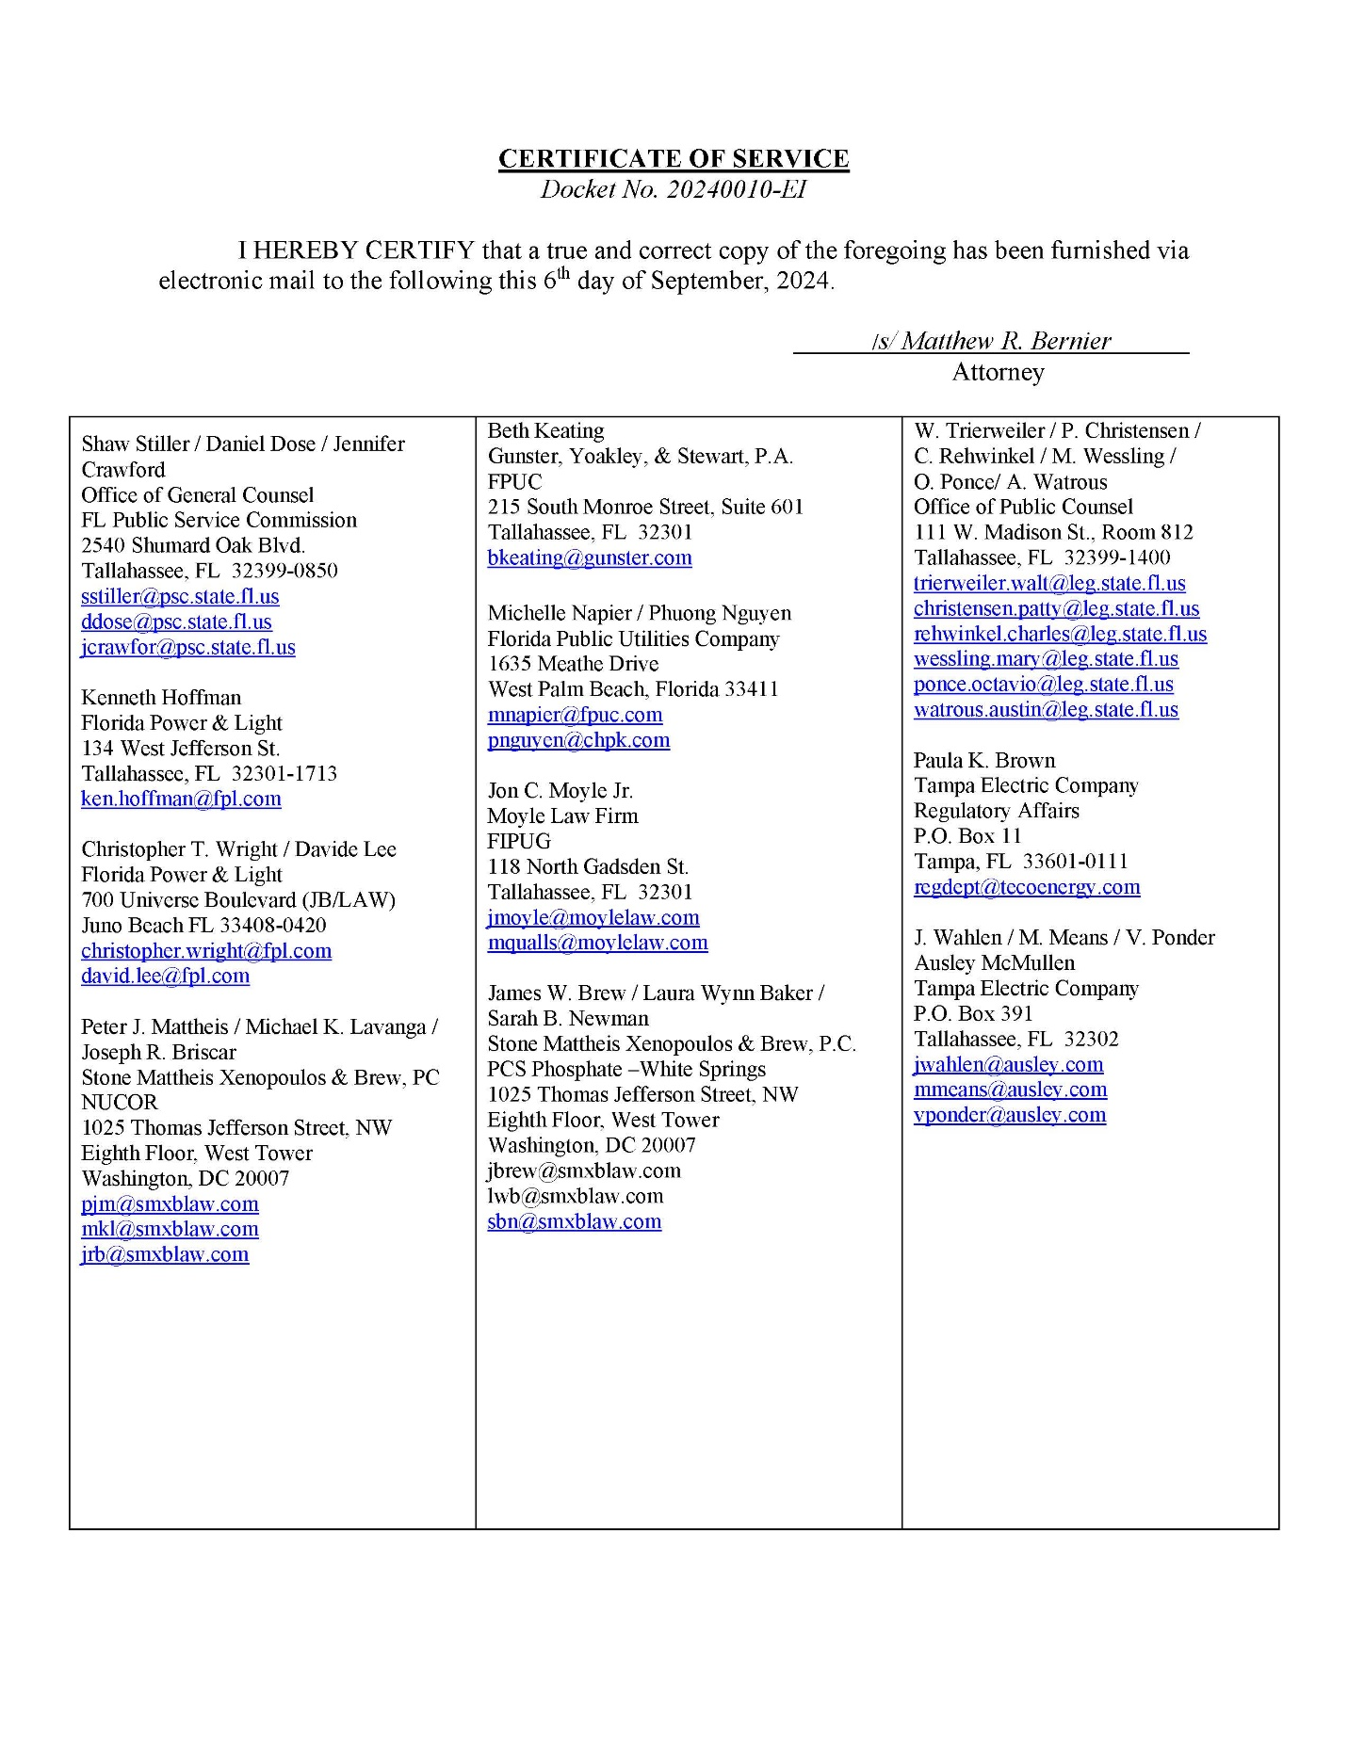

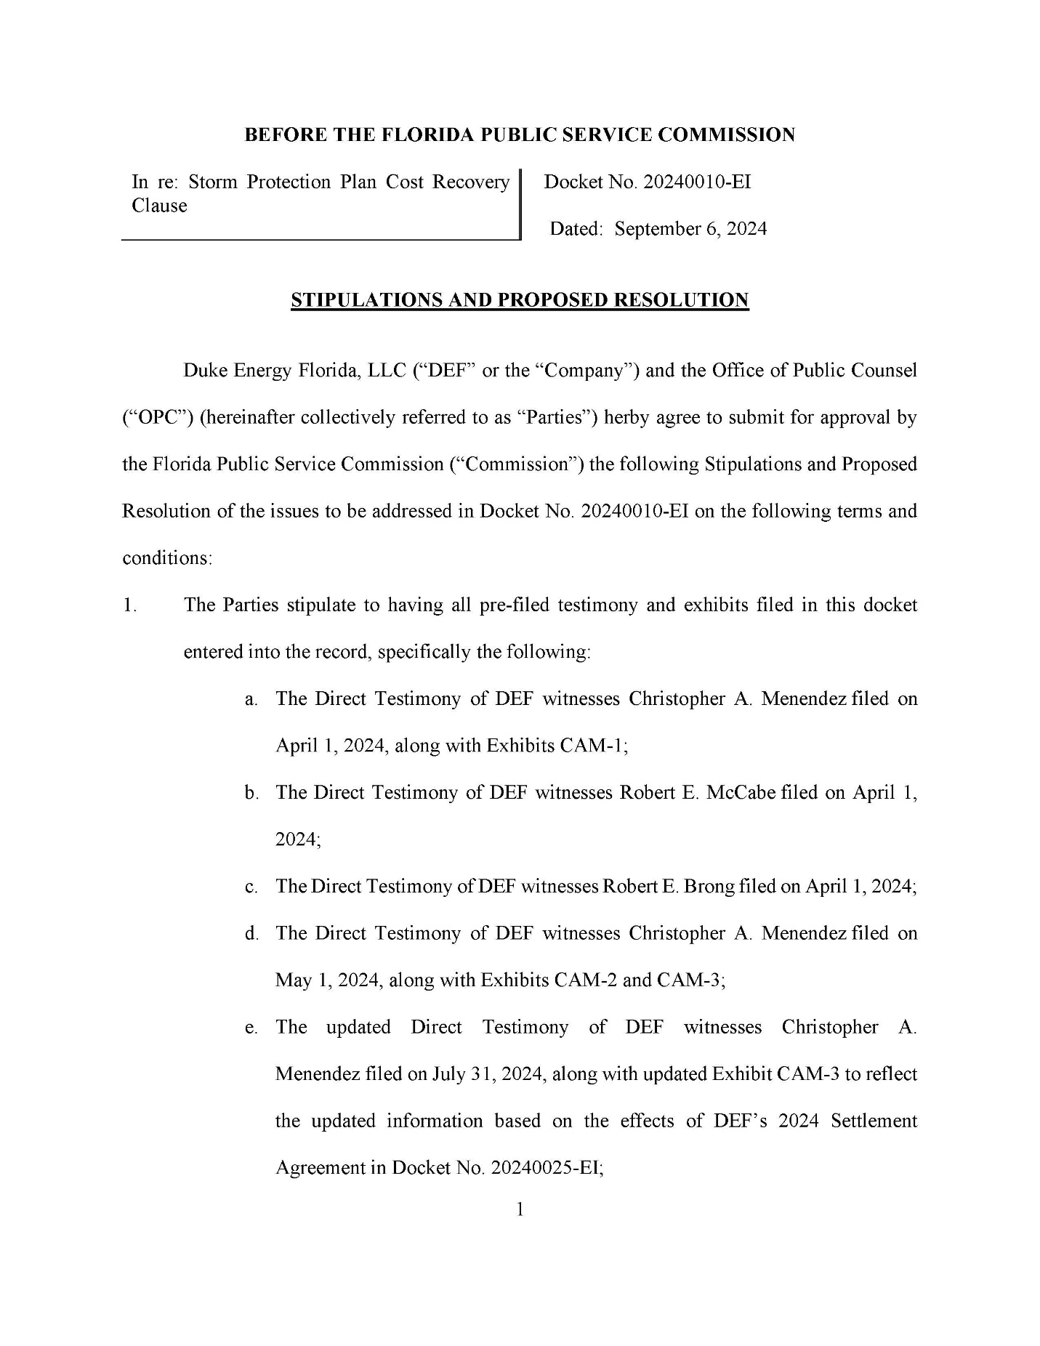

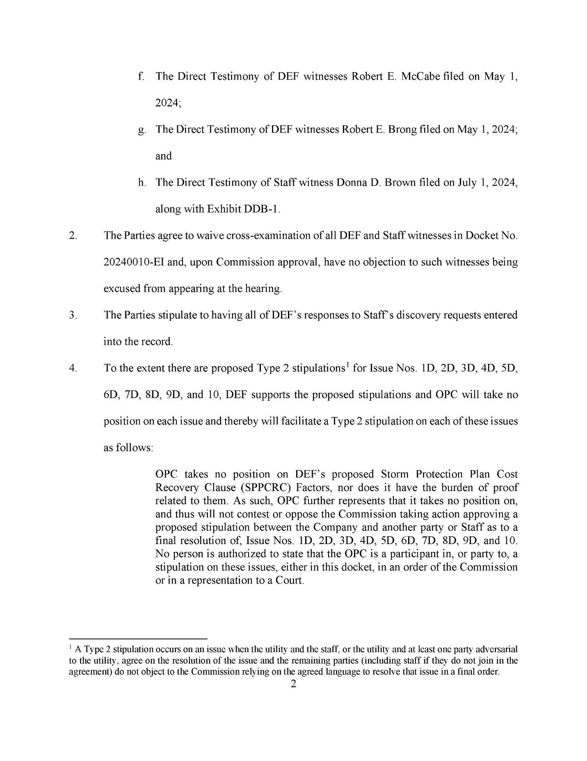

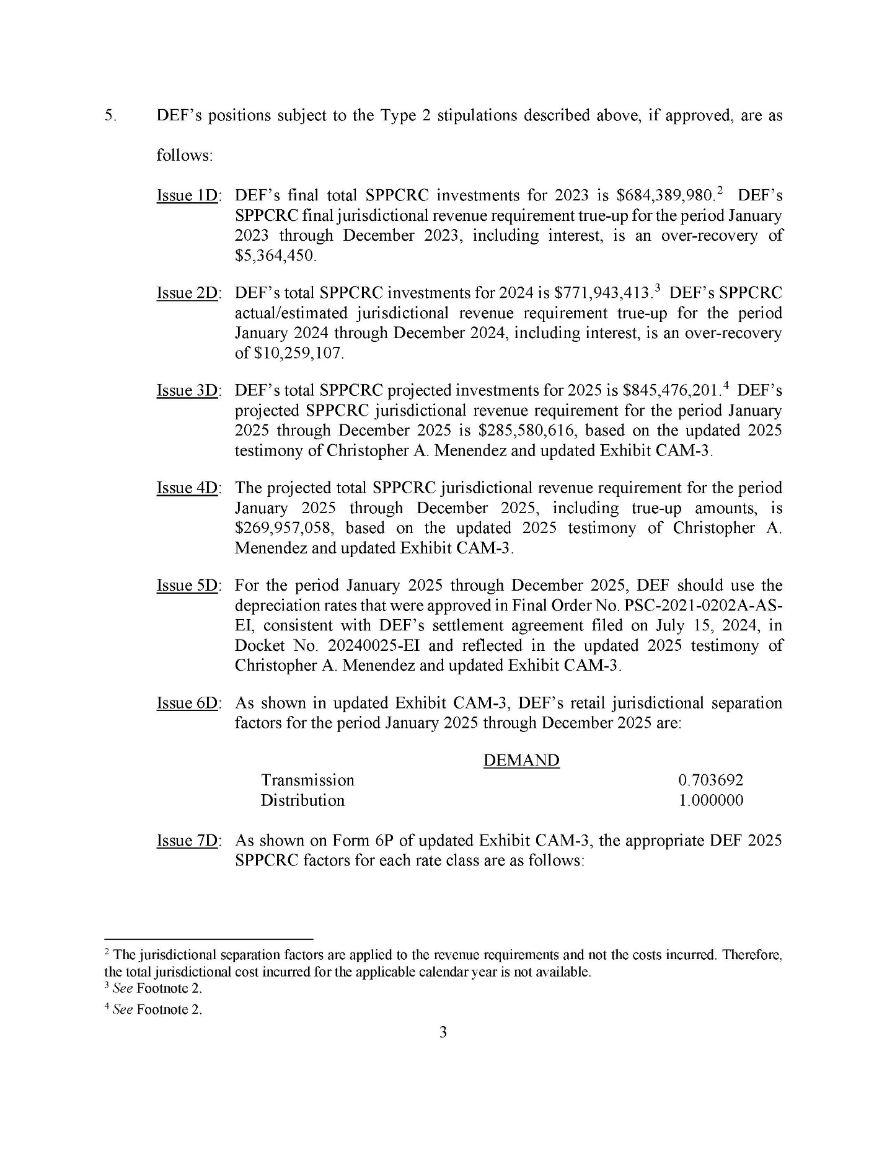

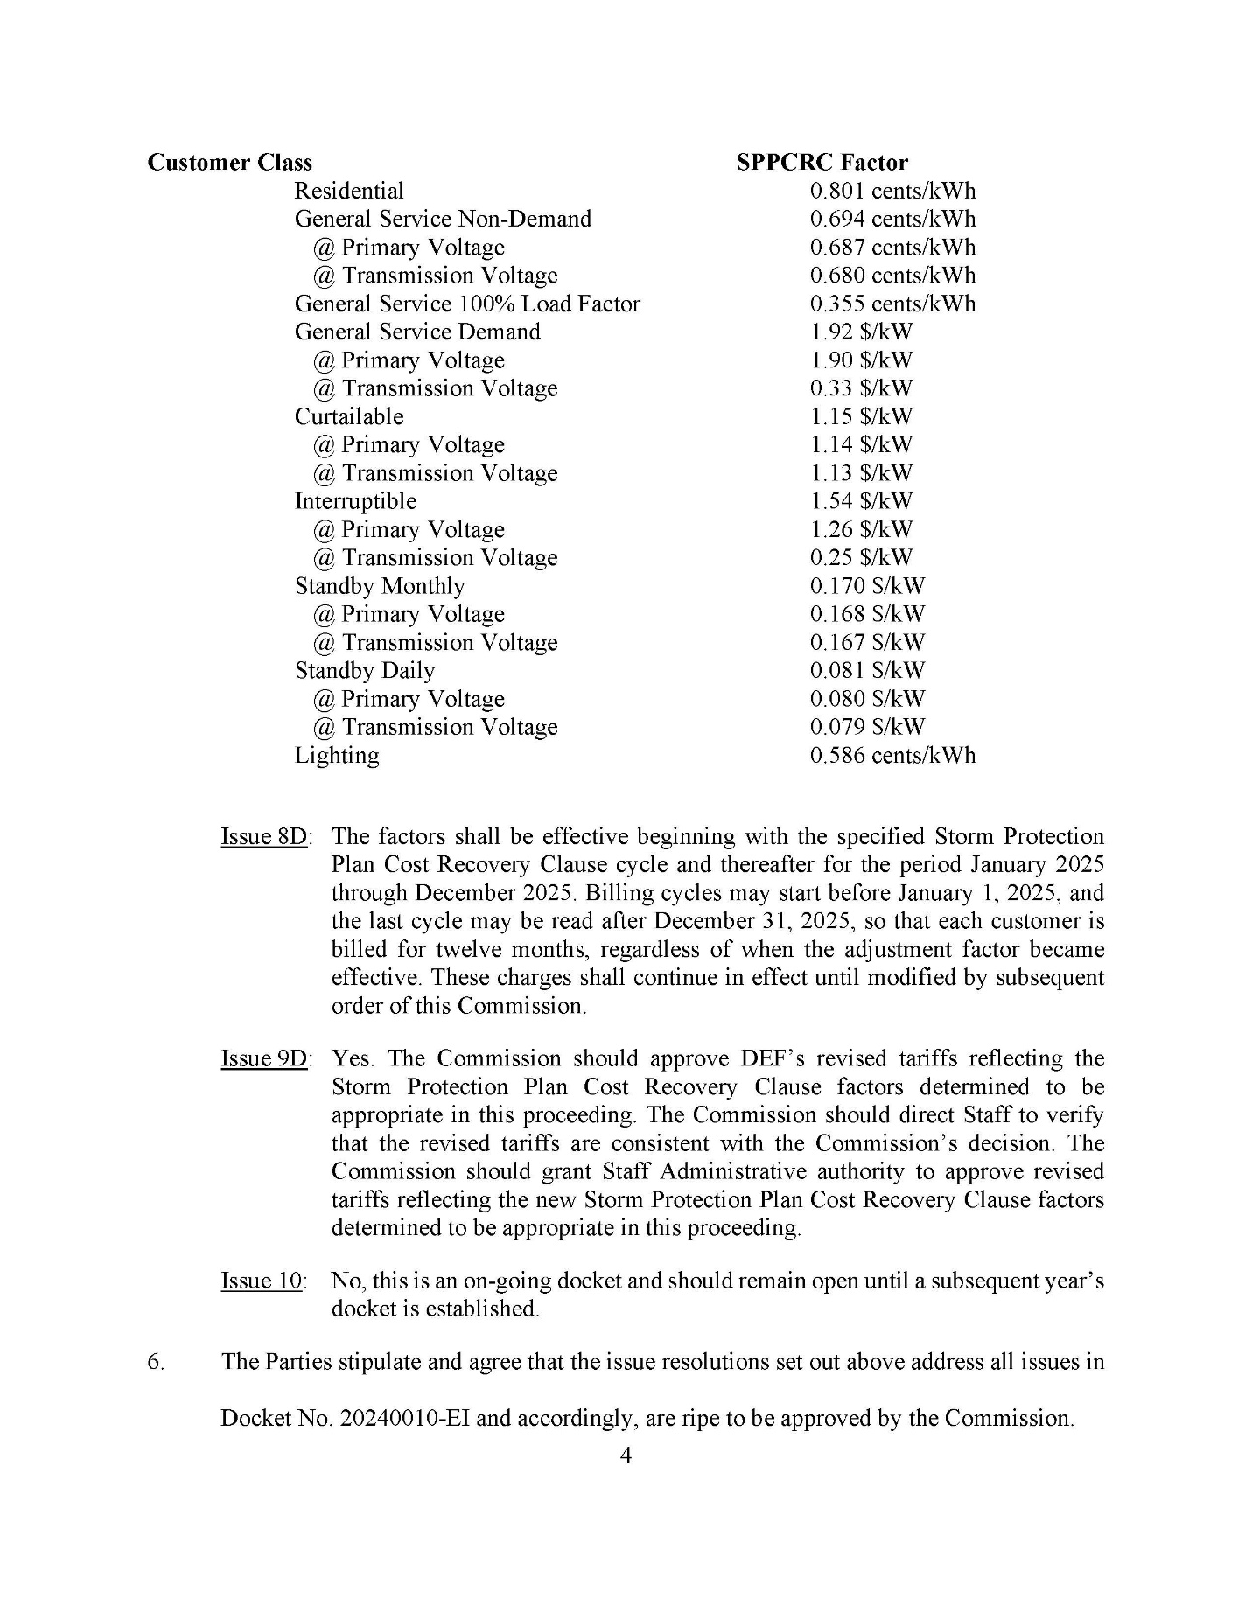

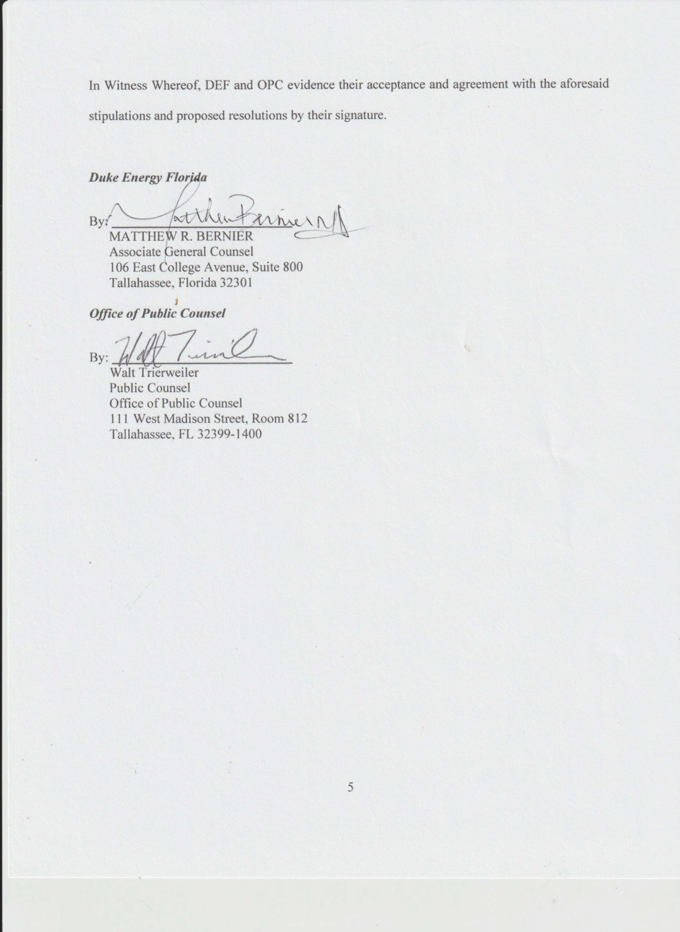

Docket 20220050-EI, Amended Final Order Approving, With Modifications, Duke Energy Florida’s Storm Protection Plan, Order No. PSC-2022-0388A-FOF-EI (Nov. 14, 2022) (“2022 SPP Approval Order”).
See Docket No. 20230010-EI, In re: Storm protection plan cost recovery clause, Final Order Approving Storm Cost Recovery Amounts and Related Tariffs and Establishing Storm Cost Recovery Factors for the Period January 2024 through December 2024, Order No. PSC-2023-0364-FOF-EI at 17.
See Exh. No. __ (CAM-3), Form 1P at page 1 of 118.
See 2022 SPP Approval Order.
All issues in this docket are the subject of proposed Type 2 stipulations. See Attachments A – D to this Order. A Type 2 stipulation occurs on an issue when the utility and the staff, or the utility and at least one party adversarial to the utility, agree on the resolution of the issue and the remaining parties (including staff if they do not join in the agreement) do not object to the Commission relying on the agreed language to resolve that issue in a final order.
The jurisdictional separation factors are applied to the revenue requirements and not the costs incurred. Therefore, the total jurisdictional cost incurred for the applicable calendar year is not available.
The jurisdictional separation factors are applied to the revenue requirements and not the costs incurred. Therefore, the total jurisdictional cost incurred for the applicable calendar year is not available.
See Footnote 3.
See Footnote 7.
See Footnote 3.
See Footnote 7.

