BEFORE THE FLORIDA PUBLIC SERVICE COMMISSION

|  |  |
| --- | --- |
| In re: Petition for rate increase by Florida Public Utilities Company. | DOCKET NO. 20240099-EI  ORDER NO. PSC-2024-0441-PCO-EI  ISSUED: October 14, 2024 |

The following Commissioners participated in the disposition of this matter:

MIKE LA ROSA, Chairman

GARY F. CLARK

ANDREW GILES FAY

GABRIELLA PASSIDOMO

ORDER SUSPENDING FINAL RATES AND APPROVING INTERIM RATES

BY THE COMMISSION:

BACKGROUND

Florida Public Utilities Company (FPUC or Company) filed a test year notification letter with the Commission on June 18, 2024, in which the Company indicated its intent to seek a permanent increase in its rates and charges based on a test year ending December 31, 2025, and a request for an interim rate increase. On August 22, 2024, FPUC filed its petition for an increase in base rates, as well as minimum filing requirements schedules (MFRs) and the direct testimony of 10 witnesses. The Company is engaged in business as a public utility providing electric service as defined in Section 366.02, Florida Statutes (F.S.), and is subject to our jurisdiction. FPUC serves approximately 18,100 retail customers in Calhoun, Liberty, and Jackson counties in the Company’s Northwest Division and approximately 15,000 retail customers in Nassau County in its Northeast Division.

FPUC has requested an increase in base rates to generate an additional $12,593,450 in annual revenues. The requested increase, according to FPUC, will provide the Company with an opportunity to earn a rate of return of 6.89 percent on its plant and property used to serve its customers and a return on equity (ROE) of 11.30 percent. The Company based its request on a 13-month average rate base of $150,053,096 for the projected test year ending December 2025.

FPUC stated in its petition that the requested test year period ending December 31, 2025, is the most relevant period upon which the Company’s operations should be analyzed for purposes of establishing rates for the period in which the new rates will be in effect. The Company further stated that this period will be indicative of its actual revenues, expenses, and investment during the first 12 months that the new rates will be in effect. We last granted FPUC an approximately $3.75 million rate increase by Order No. PSC-14-0517-S-EI.[1]

In its petition, FPUC also requested an interim rate increase in its base rates and charges to generate $1,812,869 in additional gross revenues until the permanent rates become effective. The Company has based its interim request on a historical test year ended December 31, 2023. In its petition, FPUC stated that it will hold any revenues collected, subject to refund, with interest at a rate determined pursuant to Rule 25-6.0435(3), Florida Administrative Code (F.A.C.) and that it be allowed to collect the interim increase subject to a corporate undertaking.

On September 4, 2024, the Office of Public Counsel (OPC) filed its notice of intervention in this docket and the Order acknowledging the intervention was issued on September 5, 2024.[2] On September 4, 2024, FPUC filed revisions to MFR Schedules B-2 and G-3 to correct a reference to the prior rate case order. No numeric values were changed.

This order addresses FPUC’s interim rate increase request and the suspension of the requested permanent rate increase. We have jurisdiction over this request for a rate increase and interim rate increase under Sections 366.06 and 366.071, F.S.

DECISION

I. Suspension of Permanent Rates

We find that the requested permanent increase in rates and charges requested by FPUC shall be suspended in order to allow our staff time to appropriately analyze the case. Staff issued its first data request to FPUC on September 12, 2024, and FPUC provided its responses on September 26, 2024. Our staff will be issuing additional data requests to the Company during the review process. On August 27, 2024, the Company was advised that the Commission will conduct an audit with the formal review report expected to be issued on November 13, 2024. Staff reviewed FPUC’s Minimum Filing Requirements and on September 20, 2024 found them to be in compliance with Rule 25-6.043, F.A.C.

In light of the ongoing activities in this rate case and pursuant to Section 366.06(3), F.S., we may withhold consent to the operation of all or any portion of a new rate schedule, delivering to the utility requesting such a change a reason or written statement of good cause for doing so within 60 days. We find that the reasons stated above are good cause, consistent with the requirements of Section 366.06(3), F.S., to suspend FPUC’s request for permanent rate increase.

II. Granting Interim Rates

Interim Rate Base

In its filing, the Company proposed an interim 13-month average rate base of $116,666,956 for the period ended December 31, 2023. Pursuant to Section 366.071(5)(a), F.S., the Company is permitted to elect either an average or year-end rate base to calculate its interim revenue request. We have reviewed the rate base adjustments made in the current interim filing for consistency with the rulings made in the Company’s last rate case order.[3] Based on our preliminary review, FPUC has made the applicable and appropriate adjustments consistent with the previous rate case. Therefore, we find that $116,666,956 is the appropriate amount of rate base for the 2023 interim historical test year ended December 31, 2023. The associated calculations are shown on Attachment A attached hereto.

Interim Return on Equity and Overall Rate of Return

Pursuant to Section 366.07(2)(a), F.S., the appropriate ROE for purposes of determining an interim rate increase is the minimum of the Company’s currently authorized ROE range. FPUC’s authorized ROE and range is 10.25 percent plus or minus 100 basis points. We set the return and range by Order No. PSC-14-0517-S-EI.[4] For its interim request, the Company appropriately used an ROE of 9.25 percent.

We find that the capital structure of FPUC for the historical 13-month average test year shall reflect an ROE of 9.25 percent, resulting in an overall cost of capital of 4.95 percent. Attachment B, attached hereto, details the calculations of the overall cost of capital.

Interim Net Operating Income

The proposed interim test year net operating income (NOI) for FPUC of $4,429,839 is the 12-month amount for the historical test year ended December 31, 2023. We have reviewed the NOI adjustments made in the current interim filing for consistency with the rulings made in the Company’s last rate case.[5] Based on our preliminary review, we find that FPUC made the applicable and appropriate adjustments consistent with the previous rate case. The associated calculation is shown on Attachment A.

Interim Net Operating Income (NOI) Multiplier

On MFR Schedule G-18, the Company calculated a NOI multiplier of 1.3477. This multiplier is based on a revenue expansion factor of 74.2015 percent, formulated using a 21 percent Federal Income Tax rate, a 5.50 percent state income tax rate, a 0.5227 percent bad debt rate, and a 0.0848 percent factor for regulatory assessment fees. However, the Company’s proposed interim bad debt rate includes projected data. The proposed interim bad debt rate reflects the average of the 2023 historical test year, the 2024 prior year, and the 2025 projected test year. Only historical data should be considered for determining an interim bad debt rate. Thus, we have re-calculated an interim bad debt rate based on a three-year historical average of calendar years 2021, 2022, and 2023. This resulted in an average bad debt rate of 0.6628 percent. Therefore, we find that 1.3496 is the appropriate NOI multiplier. The NOI multiplier calculation is shown in Table 1.

Table 1

Interim NOI Multiplier

|  |  |
| --- | --- |
| **Description** |  |
| Revenue Requirement | 100.000% |
| Less Regulatory Assessment Fee | 0.0848% |
| Less Comm. Calc. Bad Debt Rate | 0.6628% |
| Net Before Income Taxes | 99.252% |
| Less State Income Tax @ 5.5% | 5.459% |
| Net Before Federal Income Tax | 93.794% |
| Less Federal Income Tax @ 21% | 19.697% |
| Revenue Expansion Factor | 74.097% |
| NOI Multiplier (100/74.097) | 1.3496 |

Interim Revenue Increase Request

FPUC requested interim rate relief in the amount of $1,812,869. As discussed above, we have approved an adjustment to the NOI multiplier. The application of the revised NOI multiplier results in a new interim revenue increase of $1,815,448, for a difference of $2,579. However, we find it appropriate to limit the increase to only the Company’s requested interim amount of $1,812,869.

The Company’s requested revenue increase will allow FPUC an opportunity to earn an overall rate of return of 4.95 percent. The overall rate of return of 4.95 percent is calculated using a return on equity of 9.25 percent which is the bottom of FPUC’s currently authorized range.[6]

After a determination on the permanent rate increase has been made, the interim revenue will be reviewed to determine if any portion should be refunded to customers. The calculation of the interim revenue increase is shown in Table 2.

Table 2

Interim Revenue Increase

|  |  |
| --- | --- |
| **Description** |  |
| Jurisdictional Adjusted Rate Base | $116,666,956 |
| Overall Rate of Return | 4.95% |
| Jurisdictional Net Operating Income Requested | $5,775,014 |
| Jurisdictional Adjusted Net Operating Income | $4,429,839 |
| Revenue Deficiency | $1,345,175 |
| As-Filed Net Operating Income Multiplier | 1.3477 |
| Interim Revenue Increase | $1,812,869 |
| Base Rate Revenues | $24,525,209 |
| Approved Percentage Increase | 7.39% |

Interim Rates and Associated Tariffs

The appropriate interim revenue increase is $1,812,869. The interim rates shall be effective for all meter readings occurring on or after 30 days from the date of our vote. MFR Schedule G-20 demonstrates that the proposed interim revenue increase was applied uniformly to all existing rate classes, as required by Rule 25-6.0435, F.A.C. Attachment C, attached hereto, contains the proposed interim tariff sheet Nos. 40, 43, 45, 47, 50, 52, 56, 57, and 61. Pursuant to Rule 25-22.0406(8), F.A.C., the Company shall provide notice to customers of the revised rates. The notice must be approved in advance by our staff and provided to the customers with the first bill containing the new rates.

Security Guarantee Subject to Refund

All funds collected subject to refund shall be secured by a corporate undertaking. The criteria for a corporate undertaking include sufficient liquidity, ownership equity, profitability, and interest coverage to guarantee any potential refund. FPUC requested an interim revenue increase of $1,812,869. Based on an estimated eight-month collection period of interim rates, the estimated amount of revenues that would be collected is estimated to be $1,208,579. Pursuant to Rule 25-6.0435, F.A.C., Interim Rate Relief, interim rate relief collected is subject to refund pending final order in the permanent rate relief request. Such increase shall be subject to a corporate undertaking or under bond as authorized by this Commission and any refund shall be made with an interest factor determined by using the 30-day commercial paper rate.

The interest on the estimated amount that will be collected is estimated to be $21,580. The estimated amount that shall be protected and guaranteed is $1,230,159. FPUC’s three most recent annual reports filed with this Commission (2023, 2022, and 2021) have been reviewed to determine if the Company can support a corporate undertaking to guarantee the funds collected during the interim collection period. FPUC’s financial information demonstrates that the Company has acceptable levels of liquidity, ownership equity, and interest coverage to support a potential refund of $1,230,159.

For these reasons, we find that FPUC has adequate resources to support a corporate undertaking in the amount of $1,230,159 and that this amount is acceptable. This brief financial analysis is only appropriate for deciding if the Company can support a corporate undertaking in the amount requested and should not be considered a finding regarding our position on other issues in this proceeding.

Based on the foregoing, it is

ORDERED by the Florida Public Service Commission that Florida Public Utilities Company’s requested permanent rate increase is suspended pending further review. It is further

ORDERED that the appropriate interim rate base for the Florida Public Utilities Company is $116,666,956 for the interim historical test year ended December 31, 2023. It is further

ORDERED that the appropriate return on equity for the Florida Public Utilities Company is 9.25 percent and overall rate of return is 4.95 percent for purposes of determining interim rates. It is further

ORDERED that for the interim test year ended December 31, 2023, the net operating income for the Florida Public Utilities Company is $4,429,839. It is further

ORDERED that the appropriate interim net operating income multiplier is 1.3496. It is further

ORDERED that the appropriate interim revenue increase for the Florida Public Utilities Company is $1,812,869. It is further

ORDERED that the proposed interim rates and associated tariffs shown on Attachment C are hereby approved. The interim rates shall be effective for all meter reading occurring on or after 30 days from the date of our vote. In addition, pursuant to Rule 25-22.0406(8), F.A.C., the Company shall provide notice to customers of the revised rates. The notice must be approved in advance by our staff and provided to customers with the first bill containing the new rates. It is further

ORDERED that the Florida Public Utilities Company shall furnish a corporate undertaking subject to refund in the amount of $1,230,159. It is further

ORDERED that this docket shall remain open pending our final resolution of the Florida Public Utilities Company’s rate increase request.

By ORDER of the Florida Public Service Commission this 14th day of October, 2024.

|  |  |
| --- | --- |
|  |  |
|  | ADAM J. TEITZMAN  Commission Clerk |

Florida Public Service Commission

2540 Shumard Oak Boulevard

Tallahassee, Florida 32399

(850) 413‑6770

www.floridapsc.com

Copies furnished: A copy of this document is provided to the parties of record at the time of issuance and, if applicable, interested persons.

SBr

NOTICE OF FURTHER PROCEEDINGS OR JUDICIAL REVIEW

The Florida Public Service Commission is required by Section 120.569(1), Florida Statutes, to notify parties of any administrative hearing or judicial review of Commission orders that is available under Sections 120.57 or 120.68, Florida Statutes, as well as the procedures and time limits that apply. This notice should not be construed to mean all requests for an administrative hearing or judicial review will be granted or result in the relief sought.

Mediation may be available on a case-by-case basis. If mediation is conducted, it does not affect a substantially interested person's right to a hearing.

Any party adversely affected by the portion of this order suspending the utility’s requested final rates, which is preliminary, procedural or intermediate in nature, may request: (1) reconsideration within 10 days pursuant to Rule 25-22.0376, Florida Administrative Code; or (2) judicial review by the Florida Supreme Court, in the case of an electric, gas or telephone utility, or the First District Court of Appeal, in the case of a water or wastewater utility. A motion for reconsideration shall be filed with the Office of Commission Clerk, in the form prescribed by Rule 25-22.0376, Florida Administrative Code. Judicial review of a preliminary, procedural or intermediate ruling or order is available if review of the final action will not provide an adequate remedy. Such review may be requested from the appropriate court, as described above, pursuant to Rule 9.100, Florida Rules of Appellate Procedure.

Any party adversely affected by the portion of this order granting interim rates, which is non-final in nature, may request (1) reconsideration within 10 days pursuant to Rule 25-22.0376, Florida Administrative Code, or (2) judicial review by the Florida Supreme Court, in the case of an electric, gas or telephone utility, or the First District Court of Appeal, in the case of a water or wastewater utility. A motion for reconsideration shall be filed with the Office of Commission Clerk, in the form prescribed by Rule 25-22.0376, Florida Administrative Code. Citizens of the State of Florida v. Mayo, 316 So.2d 262 (Fla. 1975), states that an order on interim rates is not final or reviewable until a final order is issued. Such review may be requested from the appropriate court, as described above, pursuant to Rule 9.100, Florida Rules of Appellate Procedure.

**FLORIDA PUBLIC UTILITIES COMPANY**

**Docket No. 20240099-EI**

**Interim Historical Test Year**

**December 31, 2023**

|  |  |  |  |  |  |
| --- | --- | --- | --- | --- | --- |
|  |  | **Historical Test** | **Comm** | **Adjusted Historical Test** |  |
|  |  | **Year Per Company** | **Adjustments** | **Year Per Comm** |  |
|  | Rate Base |  |  |  |  |
|  | Plant in Service | $171,501,015 | - | $171,501,015 |  |
|  | Accumulated Depreciation | (78,861,742) | - -- | (78,861,742) |  |
|  | Net Plant in Service | $92,639,273 | - -- | $92,639,273 |  |
|  | Construction Work In Progress | 4,190,317 | - -- | 4,190,317 |  |
|  | Net Utility Plant | $96,829,590 | - -- | $96,829,590 |  |
|  | Working Capital Allowance | 19,837,366 | - - | 19,837,366 |  |
|  | Total Rate Base | $116,666,956 | - | $116,666,956 |  |
|  |  |  |  |  |  |
|  |  |  |  |  |  |
|  | Income Statement |  |  |  |  |
|  | Total Operating Revenues | $26,190,489 | - | $26,190,489 |  |
|  | Operating Expenses: |  |  |  |  |
|  | Operation & Maintenance – Fuel | - | - | - |  |
|  | Operation & Maintenance - Other | 13,822,103 |  | 13,822,103 |  |
|  | Depreciation & Amortization | 5,304,884 | - | 5,304,884 |  |
|  | Taxes Other Than Income | 1,705,369 | - | 1,705,369 |  |
|  | Income Taxes | 5,868,734 | - | 5,868,734 |  |
|  | Deferred Income Taxes - Net | (4,940,440) | - | (4,940,440) |  |
|  | (Gain)/Loss on Disposition | - | - | - |  |
|  | Total Operating Expenses | $21,760,649 | - | $21,760,649 |  |
|  | Net Operating Income | $4,429,839 | - | $4,429,839 |  |
|  | Overall Rate of Return | 3.80% |  | 3.80% |  |
|  |  |  |  |  |  |

**FLORIDA PUBLIC UTILITIES COMPANY**

**Docket No. 20240099-EI**

**Interim Historical Test Year**

**December 31, 2023**

|  |  |  |  |  |  |
| --- | --- | --- | --- | --- | --- |
|  |  | **Jurisdictional** |  |  |  |
|  |  | **Capital** |  |  | **Weighted** |
|  | **Capital Component** | **Structure** | **Ratio** | **Rate** | **Cost Rate** |
|  | Long-Term Debt | $34,811,456 | 0.2984 | 3.64% | 1.09% |
|  | Short-Term Debt | $6,376,054 | 0.0547 | 5.35% | 0.29% |
|  | Customer Deposits | $3,930,084 | 0.0337 | 2.22% | 0.07% |
|  | Common Equity | $44,148,564 | 0.3784 | 9.25% | 3.50% |
|  | Deferred Income Taxes | $22,517,273 | 0.1930 | 0.00% | 0.00% |
|  | Regulatory Tax Liability | $4,883,526 | 0.0419 | 0.00% | 0.00% |
|  | Total | $116,666,956 | 1.0000 |  | 4.95% |

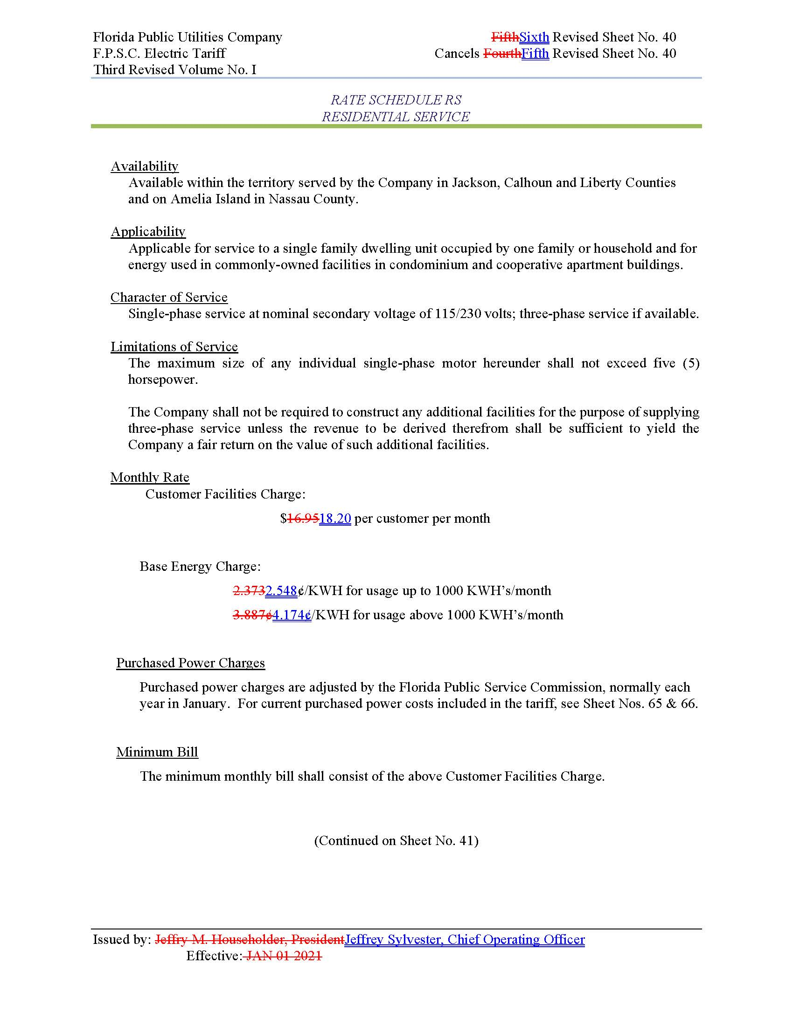

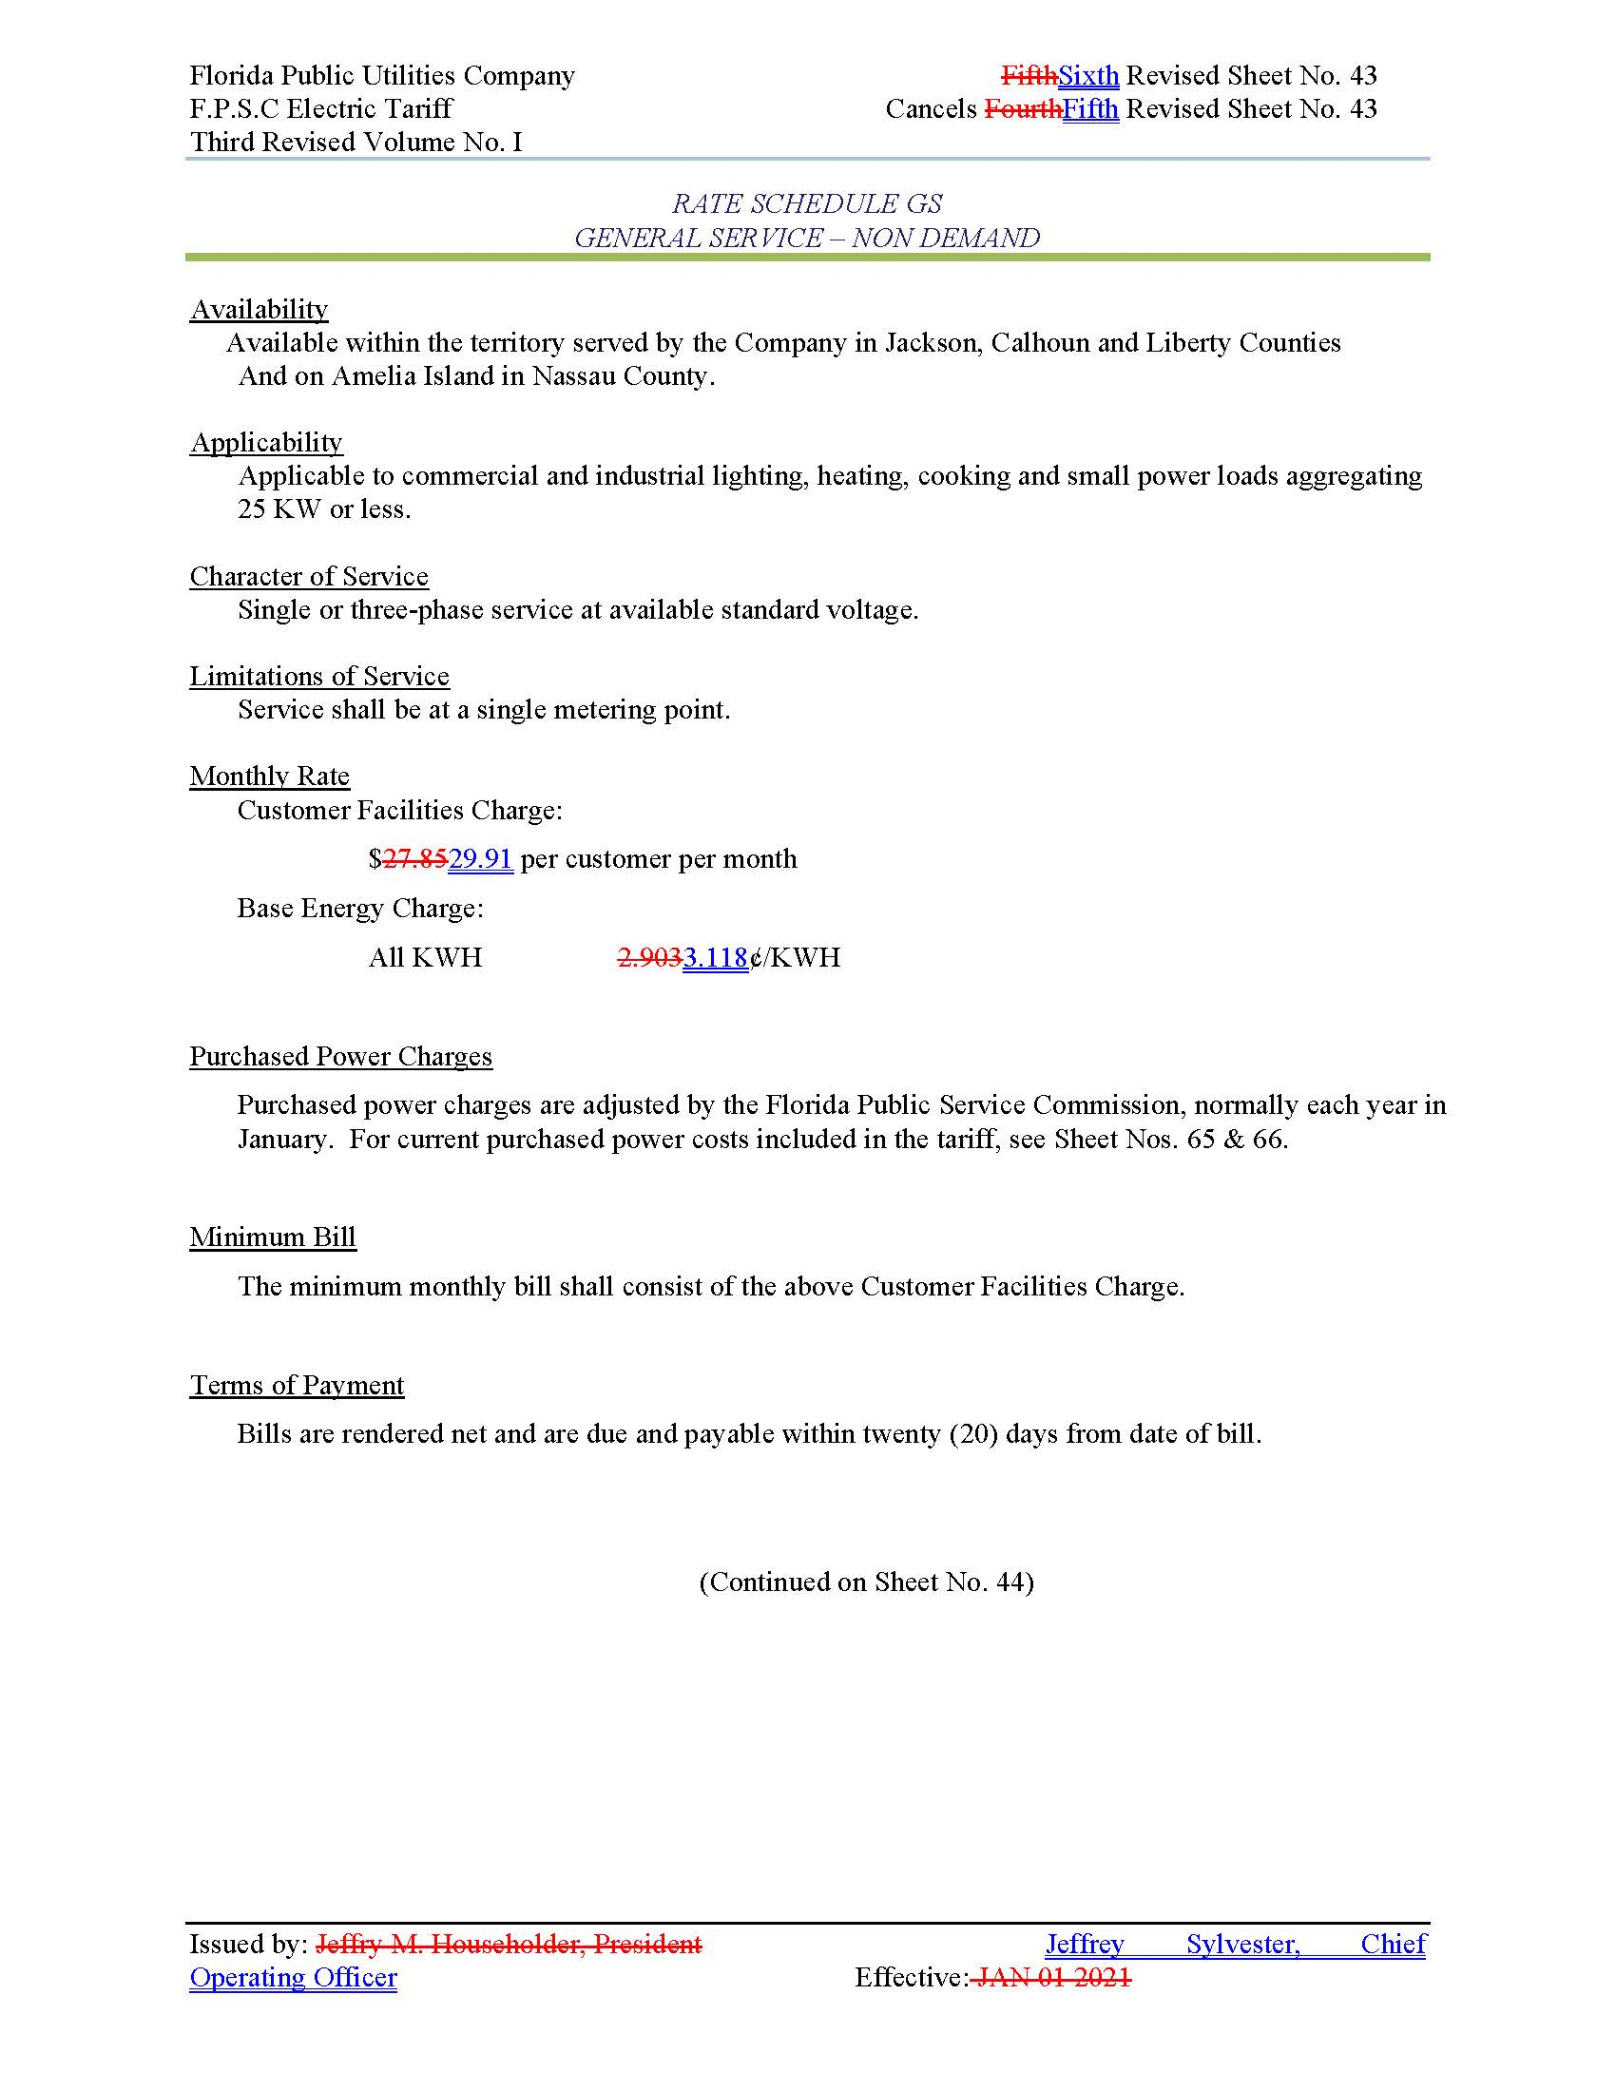

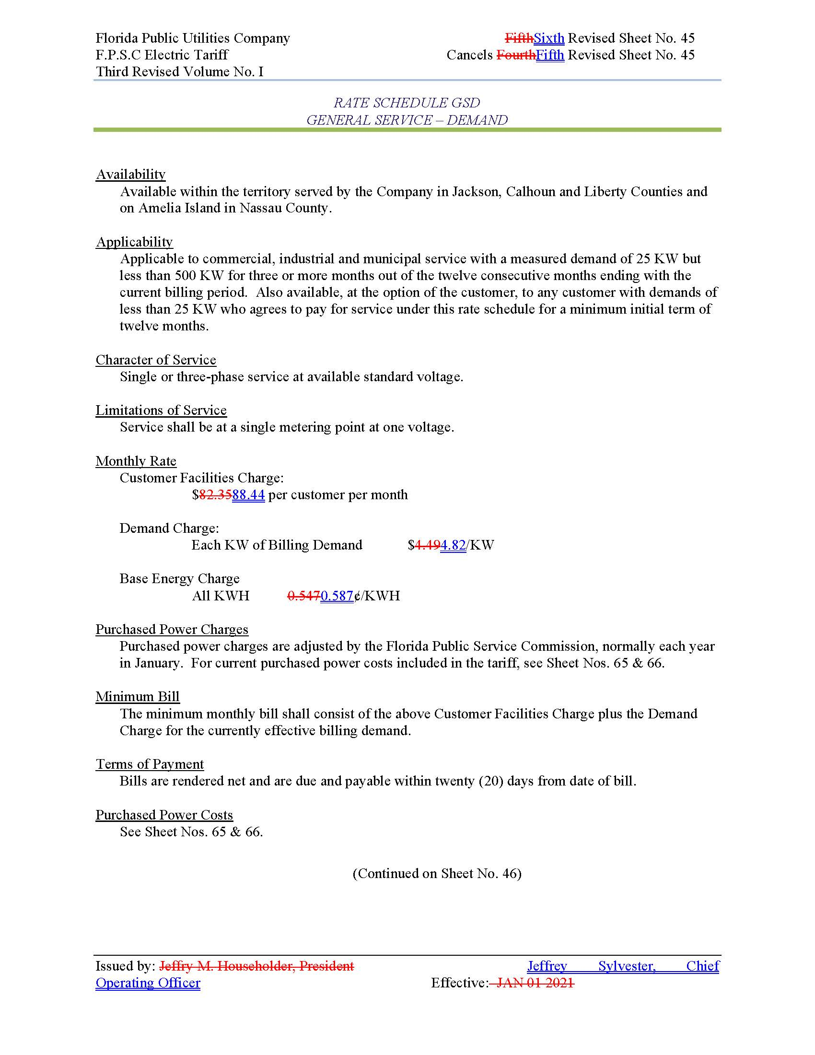

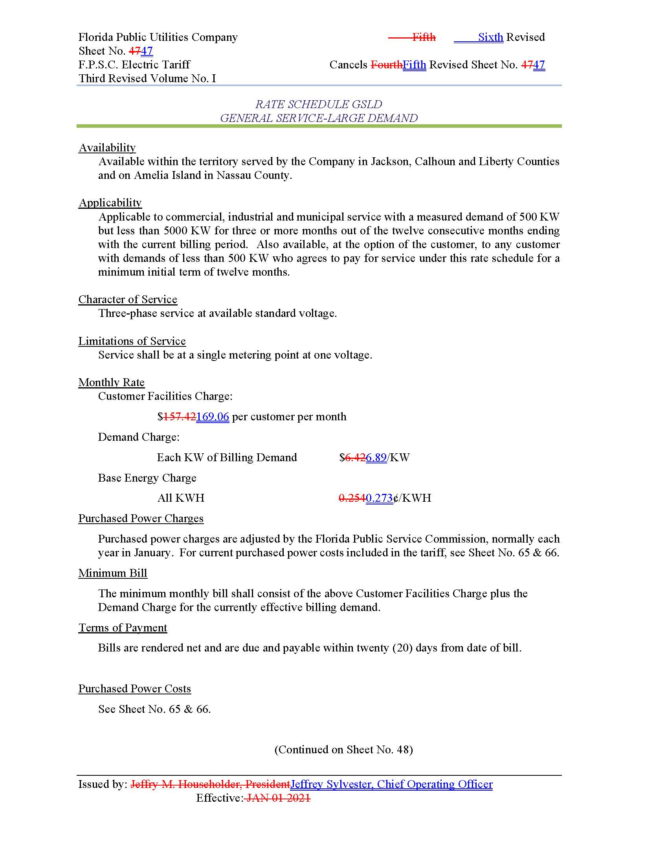

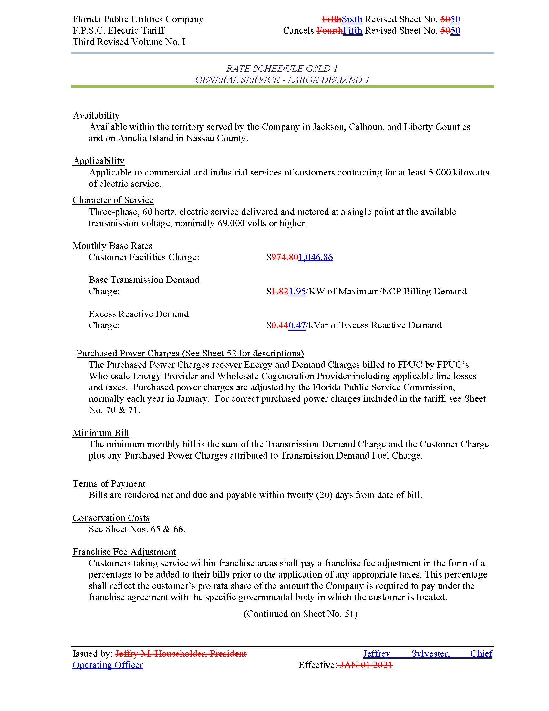

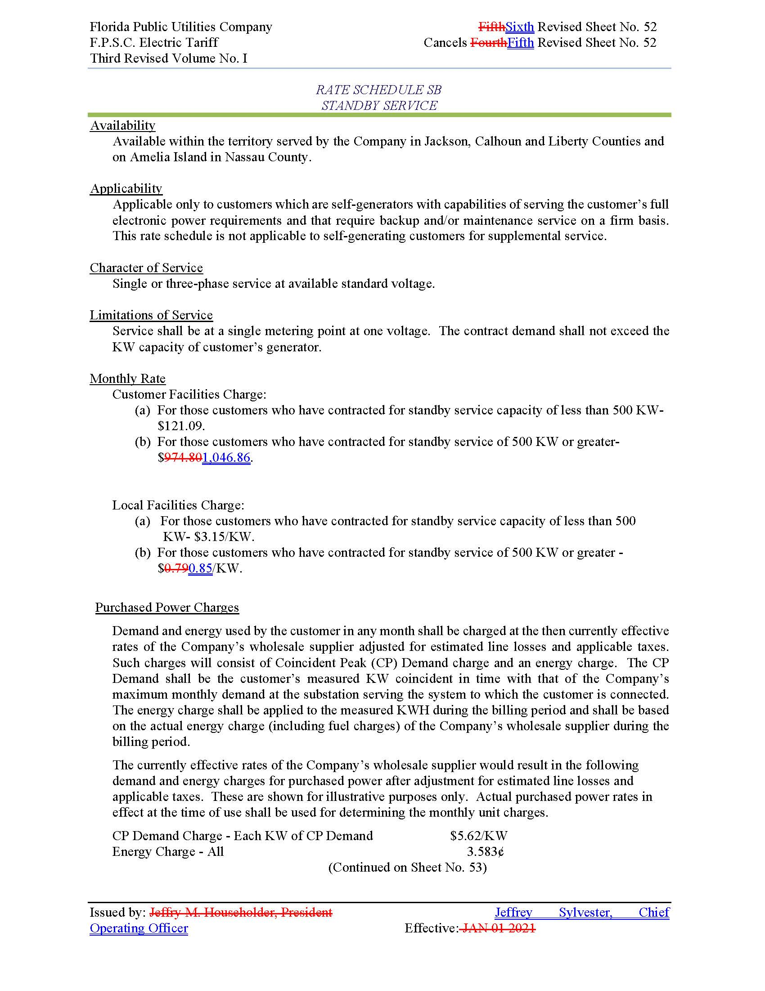

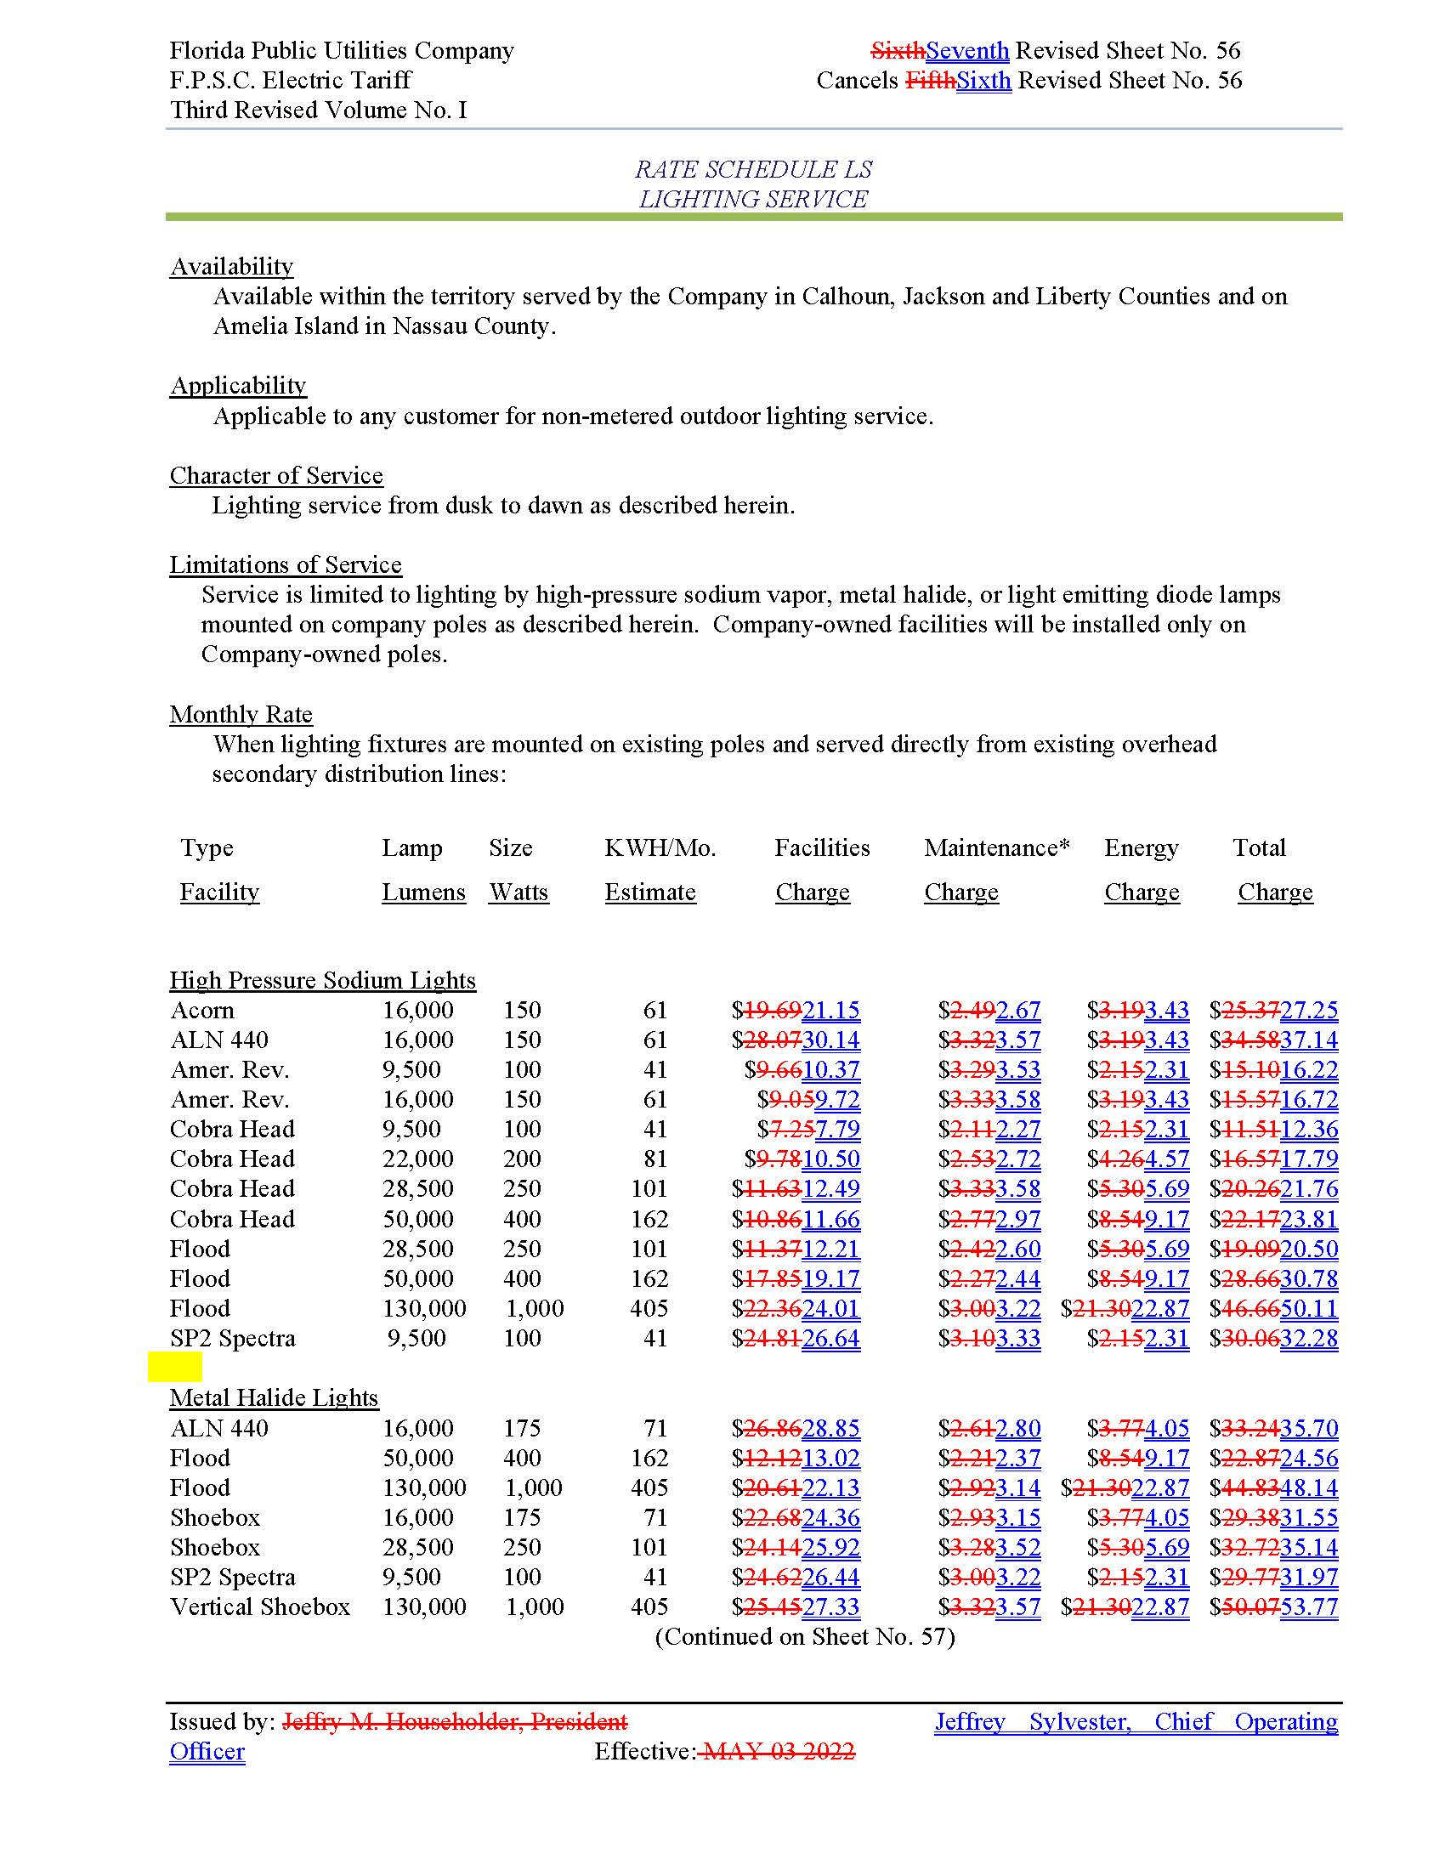

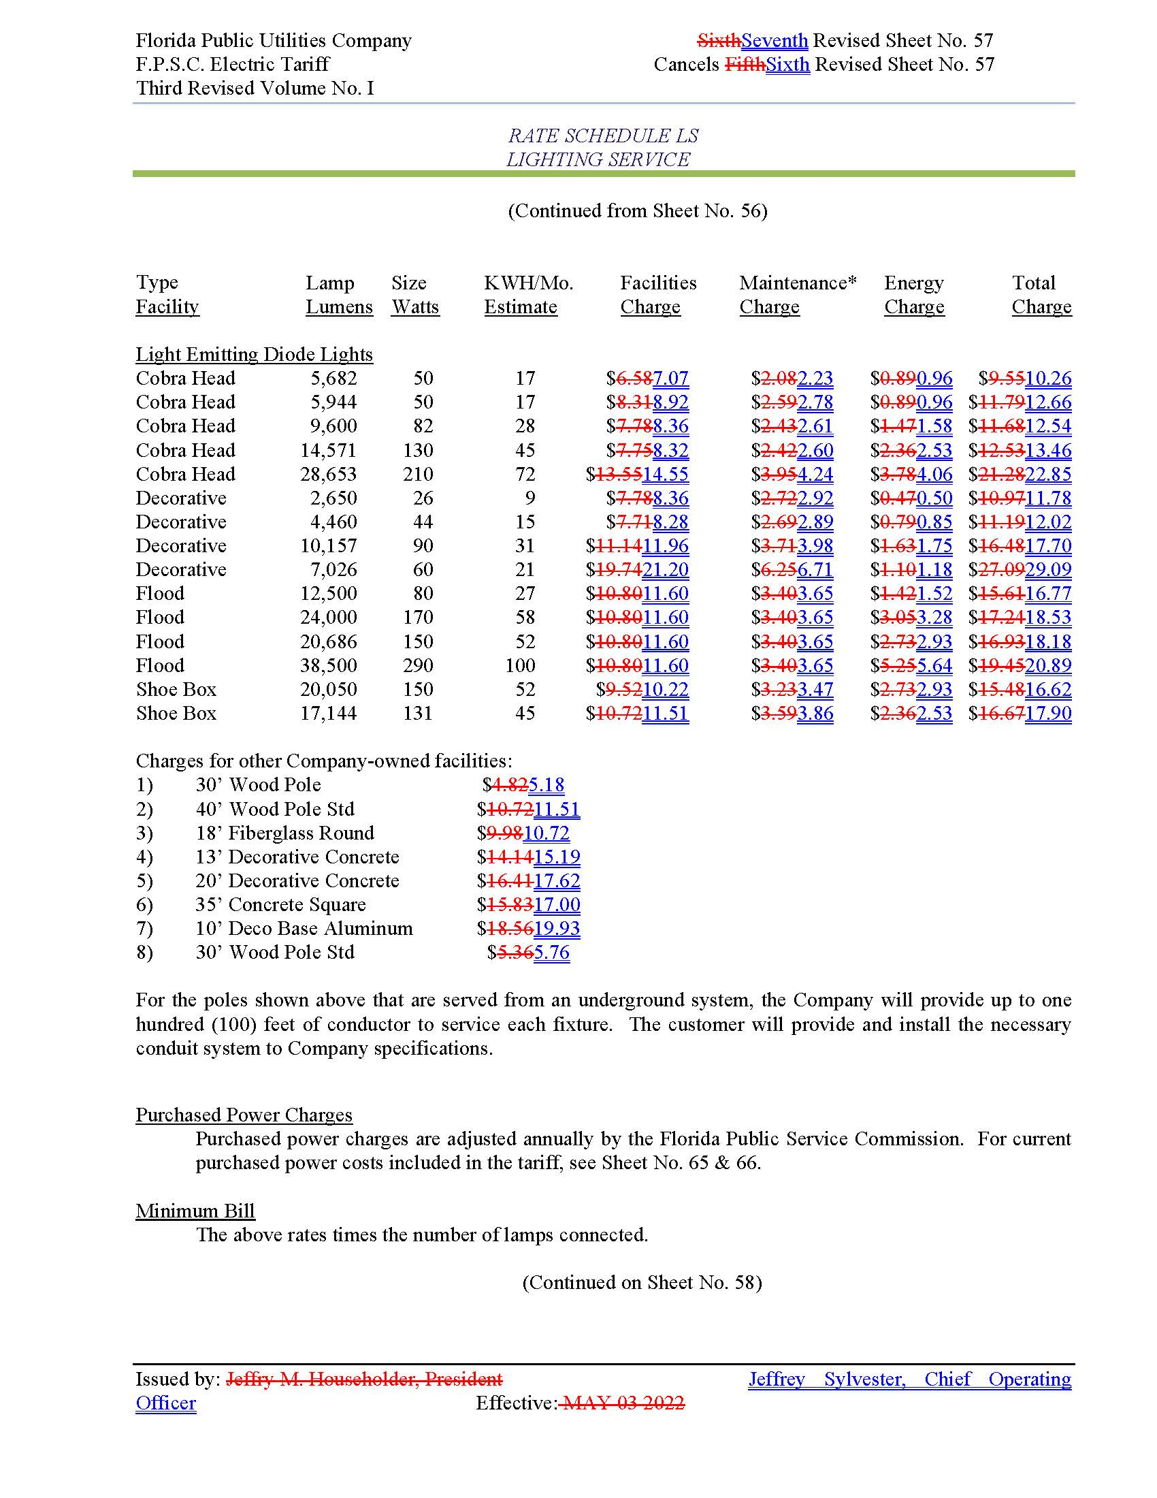

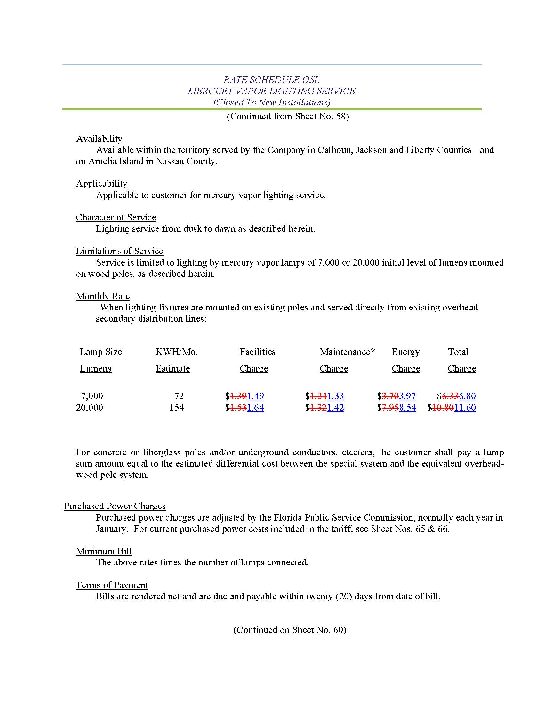

1. Order No. PSC-2014-0517-S-EI, issued September 29, 2014, in Docket No. 20140025-EI, *In re: Application for rate increase by Florida Public Utilities Company*.
2. Order No. PSC-2024-0408-PCO-EI, issued September 5, 2024, in Docket No. 20240099-EI, *In re: Petition for rate increase by Florida Public Utilities Company*.
3. Order No. PSC-2014-0517-S-EI, issued September 29, 2014, in Docket No. 140025-EI, *In re: Application for rate increase by Florida Public Utilities Company.*
4. *Id* at Page 2*.*
5. Order No. PSC-2014-0517-S-EI, issued September 29, 2014, in Docket No. 140025-EI, *In re: Application for rate increase by Florida Public Utilities Company.*
6. *Id* at Page 2*.*