|  |  |  |  |
| --- | --- | --- | --- |
| State of Florida  pscSEAL | | Public Service Commission  Capital Circle Office Center ● 2540 Shumard Oak Boulevard Tallahassee, Florida 32399-0850  -M-E-M-O-R-A-N-D-U-M- | |
| DATE: | November 21, 2024 | | |
| TO: | Office of Commission Clerk (Teitzman) | | |
| FROM: | Division of Economics (Ward, Hampson)  Division of Accounting and Finance (D. Buys, Souchik)  Office of the General Counsel (Sandy) | | |
| RE: | Docket No. 20240133-GU – Petition for approval of 2023 true-up, projected 2024 true-up, and 2025 revenue requirements and surcharges associated with cast iron/bare steel pipe replacement rider, by Peoples Gas System, Inc. | | |
| AGENDA: | 12/03/24 – Regular Agenda – Tariff Filing – Interested Persons May Participate | | |
| COMMISSIONERS ASSIGNED: | | | All Commissioners |
| PREHEARING OFFICER: | | | Administrative |
| CRITICAL DATES: | | | 04/30/25 (8-Month Effective Date) |
| SPECIAL INSTRUCTIONS: | | | None |

Case Background

On August 30, 2024, Peoples Gas System, Inc. (Peoples or utility) filed a petition for approval of its final 2023 true-up, projected 2024 true-up, and 2025 revenue requirement and surcharges associated with the cast iron/bare steel replacement rider (CI/BSR Rider or rider). The rider was originally approved by Order No. PSC-12-0476-TRF-GU (2012 Order) to recover the cost of accelerating the replacement of cast iron and bare steel pipes through a surcharge on customers’ bills.[1] In the 2012 Order, the Commission found that, “replacement of these types of pipelines is in the public interest to improve the safety of Florida’s natural gas infrastructure, and reduce the possibility of loss of life and destruction of property should an incident occur.” Peoples’ current surcharges were approved by Order No. PSC-2023-0363-TRF-GU.[2]

In Order No. PSC-17-0066-AS-GU, the Commission approved a comprehensive settlement agreement between Peoples and the Office of Public Counsel.[3] The settlement agreement, in part, added problematic plastic pipe (PPP) installed in the company's distribution system to eligible replacements under the rider beginning in 2017 and continuing through 2028. PPP was manufactured before 1983 and has significant safety concerns. In certain areas, the PPP is interspersed with, or connected to, the cast iron/bare steel pipe that is being replaced under the rider. As provided for in the settlement agreement, PPP replacements are included in the calculation of the 2024 rider surcharges.

In December 2023, the Commission approved Peoples’ petition for rate increase, which contained two provisions that would impact the CI/BSR Rider.[4] First, Peoples moved its CI/BSR investments as of December 31, 2023, into rate base, as required by the 2012 Order approving the rider.[5] This provision had the effect of resetting the CI/BSR Rider rates to zero.

Second, the Commission approved Peoples’ request for the Long Term Debt Cost Rate (LTDR) true-up mechanism. The LTDR true-up mechanism allowed Peoples to make a one-time adjustment to the estimated cost of long-term debt for the projected test year ending December 31, 2024.[6] The purpose of the LTDR true-up mechanism was to reflect the actual embedded costs of the utility’s inaugural long-term debt issuance in its revenue requirement and rates.[7] This provision was a result of Peoples being spun off from Tampa Electric Company, because Peoples no longer obtains long-term debt capital from Tampa Electric Company and instead issues its own debt as a separate entity.

The Commission further ordered that if the impact to the incremental revenue requirement was greater than $500,000 for the period between the implementation of the base rate increase and the implementation of the LTDR true-up mechanism, then the incremental revenue requirement would be recovered through the CI/BSR rider for 2025.[8] The Commission approved the incremental revenue requirement of $874,085 associated with the LTDR true-up mechanism in May 2024.[9] The total amount associated with the LTDR true-up mechanism to be recovered through the 2025 CI/BSR rider is $476,034, as shown in Exhibit B to the petition, page 2 of 4, line No. 9a.

Currently, Peoples has an active petition for an expansion of the CI/BSR rider in Docket No. 20240107-GU.[10] Peoples has proposed to rename the CI/BSR rider to the Safety of Facilities and Infrastructure Replacement Rider (SAFIR) and expand the categories of eligible replacements under the rider. If the SAFIR program is approved, projected capital expenditures would increase for 2025. In paragraph 16 of the instant petition, Peoples stated that if the SAFIR petition remains pending on November 30, 2024, the utility would not seek approval of the revenue requirement and surcharge for the SAFIR modifications in the subject docket. Staff is still in the process of reviewing the SAFIR petition; therefore, the SAFIR modifications were not considered as part of this recommendation.

During the evaluation of the petition, staff issued a data request to the utility, for which responses were received on October 7 and October 9, 2024. By Order No. PSC-2024-0453-PCO-GU, issued October 17, 2024, the petition was suspended to allow staff a sufficient opportunity to gather and evaluate all pertinent information related to the tariff proposals in order to present the Commission with an informed recommendation.

Attachment A to this recommendation contains Table 1, which consolidates actual and projected CI/BSR and PPP miles, replaced investment, and revenue requirements for each year of the replacement program.[11] Additionally, Peoples provided tables that display the replacement progress and forecasts for the CI/BSR Rider (Table 2) and for PPP (Table 3).[12] Attachment B contains the proposed tariff. The Commission has jurisdiction over this matter pursuant to Section 366.03, 366.04, 366.05, and 366.06, Florida Statutes (F.S.).

Discussion of Issues

Issue 1:

 Should the Commission approve Peoples' proposed CI/BSR Rider surcharges for the period January through December 2025?

Recommendation:

 Yes, the Commission should approve Peoples’ proposed CI/BSR Rider surcharges to be effective for the first billing cycle of January through the last billing cycle of December 2025. Staff has reviewed Peoples’ filings and supporting documentation and believes that the calculations are consistent with the methodology approved in the 2012 Order and are reasonable and accurate. (Ward)

Staff Analysis:

 The CI/BSR Rider charges have been in effect since January 2013 and were projected to be in effect for 10 years with replacement projects completed by the end of 2022. In response to staff’s first data request, Peoples stated that the COVID-19 pandemic environment greatly contributed to replacement efforts going beyond the 10-year period.[13] Contributing factors include construction contractor labor shortages, consulting firm availability, supply chain challenges, and extensive permitting challenges. Peoples stated that it expects to have 8.11 miles of CI/BSR replacement remaining entering 2025.

In 2024, Peoples’ cast iron/bare steel and PPP replacement activity focused in the areas of Miami, Tampa, St. Pete, Orlando, Eustis, Jacksonville, Lakeland, Daytona, Avon Park, and Ocala. In 2025, Peoples states it will focus on replacement projects in Miami, Tampa, St. Pete, Orlando, Eustis, Jacksonville, Lakeland, Daytona, Jupiter, Panama City, and Ocala. A detailed description of the projects, including their address, has been provided in response to staff’s first data request.[14]

True-ups by Year

Peoples’ calculation for the 2025 revenue requirement and surcharges includes a final true-up for 2023, an actual/estimated true-up for 2024, and projected costs for 2025. Pursuant to the 2012 Order, the capital expenditures for 2024 and 2025 exclude the first $1 million of facility replacements each year because that amount is included in rate base. Peoples has included depreciation expense savings as discussed in the 2012 Order; however, the utility has not identified any operations and maintenance savings.

Final True-up for 2023

Exhibit A of the petition shows that the revenues collected for 2023 were $8,215,491 compared to a revenue requirement of $7,531,346, resulting in an over-recovery of $684,145. The final 2022 under-recovery of $787,888, 2023 over-recovery of $684,145, and interest associated with any over- and under-recoveries, results in a final 2023 under-recovery of $102,499.

Actual/Estimated 2024 True-up

In Exhibit B of the petition, Peoples provided actual revenues for January through July and forecast revenues for August through December of 2024, totaling $883,056, compared to an actual/estimated revenue requirement of $576,693, resulting in an over-recovery of $306,363. The final 2023 under-recovery of $102,499, 2024 over-recovery of $306,363, 2024 LTDR true-up mechanism adjustment of $476,034, and interest associated with any over- and under- recoveries, results in a total 2024 under-recovery of $276,028.

Projected 2025 Costs

Exhibit C, page 2 of 4, of the petition shows Peoples’ project investments of $32,120,344 for the replacement of cast iron/bare steel infrastructure and PPP in 2025, excluding the $1 million adjustment to rate base. The return on investment, depreciation expense (less savings), and property tax expense associated with that investment are $3,402,010. After adding the total 2024 under-recovery of $276,028, the total 2025 revenue requirement is $3,678,038. Table 1-1 displays the 2025 revenue requirement calculation. In response to staff’s first data request, Peoples provided updated investment and revenue requirement projections for CI/BSR and PPP which is contained in Table 1 of Attachment A.

Table 1-1

2025 CI/BSR Rider Revenue Requirement

|  |  |
| --- | --- |
| 2025 Projected Expenditures | $32,120,344 |
| Return on Investment | $2,767,833 |
| Depreciation Expense (less savings) | $405,346 |
| Property Tax Expense | $228,830 |
| 2025 Revenue Requirement | $3,402,010 |
| Plus 2024 Under-recovery | $276,028 |
| Total 2025 Revenue Requirement | $3,678,038 |

Source: Page 2 of 4 in Exhibit C in petition (Docket No. 20240133-GU).

Proposed Surcharges

As established in the 2012 Order, the total 2025 revenue requirement is allocated to rate classes using the same methodology that was used for the allocation of mains and services in the cost of service study used in Peoples’ most recent approved rate case. After calculating the percentage of total plant costs attributed to each rate class, the respective percentages were multiplied by the 2025 revenue requirement resulting in the revenue requirement by rate class. Dividing each rate class’s revenue requirement by projected therm sales provides the rider surcharge for each rate class.

If the Commission approves this recommendation, the proposed 2025 rider surcharge for residential customers would be $0.01391 per therm (compared to the current surcharge of $0.00322). The 2025 monthly bill impact would be $0.28 for a residential customer who uses 20 therms.

Conclusion

Staff recommends that the Commission should approve Peoples’ proposed CI/BSR Rider surcharges to be effective for the first billing cycle of January through the last billing cycle of December 2025. Staff has reviewed Peoples’ filings and supporting documentation and believes that the calculations are consistent with the methodology approved in the 2012 Order and are reasonable and accurate.

Issue 2:

 Should this docket be closed?

Recommendation:

 Yes. If Issue 1 is approved and a protest is filed within 21 days of the issuance of the order, the tariff should remain in effect, with any revenues held subject to refund, pending resolution of the protest. If no timely protest is filed, this docket should be closed upon the issuance of a consummating order. (Sandy)

Staff Analysis:

 Yes. If Issue 1 is approved and a protest is filed within 21 days of the issuance of the order, the tariff should remain in effect, with any revenues held subject to refund, pending resolution of the protest. If no timely protest is filed, this docket should be closed upon the issuance of a consummating order.

Table 1

Peoples’ CI/BSR Replacement Program Progress

|  |  |  |  |  |  |  |
| --- | --- | --- | --- | --- | --- | --- |
| Year | CI/BS Miles Replaced | PPP Miles Replaced | CI/BS Investmentͣ | PPP Investmentᵇ | CI/BS Revenue Requirement | PPP Revenue Requirement |
| 2017 | 51 | - | $17,588,366 | $308,227 | $6,868,302 | $74,021 |
| 2018 | 62 | 56 | $27,035,678 | $18,113,104 | $8,510,823 | $848,201 |
| 2019 | 52 | 42 | $35,821,371 | $15,349,847 | $11,075,229 | $2,706,161 |
| 2020 | 55 | 43 | $32,317,184 | $9,209,668 | $14,817,804 | $4,358,010 |
| 2021 | 14 | 38 | $23,726,642 | $21,051,938 | $1,347,321 | $(160,452) |
| 2022 | 10.4 | 29 | $13,079,280 | $6,109,870 | $3,154,597 | $1,921,940 |
| 2023 | 2.3 | 44 | $5,815,954 | $26,827,191 | $3,927,032 | $3,604,313 |
| 2024* | 5 | 31 | $4,698,860 | $14,646,431 | $217,946ͤ | $366,776ͤ |
| 2025* | 5 | 65 | $2,906,616 | $29,213,728 | $760,428 | $2,721,026 |
| 2026* | 2 | 75 | $1,104,945 | $32,951,727 | $1,043,083 | $6,227,488 |
| 2027* | 1ͨ | 90 | $874,752 | $35,028,300 | $1,151,720 | $10,103,281 |
| 2028* | 1 | 54 | $1,081,100ͩ | $20,139,383ͩ | $1,246,217 | $13,341,632 |

*Projected

ͣ CI/BS Investment includes removal of initial $1M through 2025.

ᵇ PPP Investment includes removal of initial $1M each year starting in 2026.

ͨ 5-year construction moratoriums in effect in the City of Miami preventing completion before 2027.

ͩ 2028 investment includes rollover costs to occur in 2029.

ͤ Revenue requirement based on current year investment only as investment for prior years rolled into rate base pursuant to the 2023 Rate Case.

Table 2

Peoples’ CI/BSR Replacement Progress

|  |  |  |  |  |  |  |  |
| --- | --- | --- | --- | --- | --- | --- | --- |
| Year | **Main Replacements** | | | | | **Service Line Replacements** | |
| Replaced Cast Iron (miles) | Replaced Bare Steel (miles) | Remaining Cast Iron at Year End (miles) | Remaining Bare Steel at Year End (miles) | Total Miles Remaining of CI/BS Mains | Number of Bare Steel Service Lines Replaced | Number of Remaining Bare Steel Service Lines |
| 2012 | - | - | 100 | 354 | 454 | - | 14,978 |
| 2013 | 13 | 38 | 87 | 316 | 403 | 907 | 14,071 |
| 2014 | 2 | 15 | 85 | 298 | 383 | 7,964 | 6,107 |
| 2015 | 26 | 60 | 59 | 238 | 297 | 1,019 | 5,088 |
| 2016 | 15 | 35 | 44 | 203 | 247 | 1,050 | 6,963 |
| 2017 | 15 | 36 | 29 | 178 | 207 | 1,135 | 4,279 |
| 2018 | 10 | 52 | 18 | 126 | 144 | 1,970 | 2,309 |
| 2019 | 8 | 44 | 10 | 83ͣ | 93 | 649 | 1,660 |
| 2020 | 4 | 51 | 6 | 35ͣ | 41 | 423 | 1,237 |
| 2021 | 3.5 | 10.5 | 2 | 24 | 26 | 191 | 998 |
| 2022 | 1.3 | 9.1 | 0.9 | 14.6ͣ | 15.5 | 74 | 941 |
| 2023 | 0.3 | 2.0 | 0.6 | 12.4ͣ | 12.4 | 40 | 931 |
| 2024* | <0 | 5 | 0.5 | 8.6ͣ | 8.11 | 63 | 799 |

*Projected

ͣ Additional miles of pipe added after reclassification of pipe type.

Table 3

Peoples’ PPP Replacement Program Progress

|  |  |  |  |  |
| --- | --- | --- | --- | --- |
| Year | Replaced PPP (Miles) | Total Remaining PPP Mains (Miles) | Replaced Number of PPP Service Lines | Total Number of Remaining PPP Service Lines |
| 2016 | - | 551 | - | 28,237 |
| 2017 | - | 509 | 1,396 | 26,841 |
| 2018 | 56 | 461 | 3,941 | 24,741 |
| 2019 | 42 | 418 | 2,349 | 20,420 |
| 2020 | 43 | 370 | 1,702 | 18,718 |
| 2021 | 38 | 337 | 882 | 17,683 |
| 2022 | 29 | 306 | 837 | 17,229 |
| 2023 | 44 | 281ͣ | 883 | 16,346ͣ |
| 2024* | 31 | 284ͣ | 500 | ᵇ |
| 2025* | 65 | 219 | ᵇ | ᵇ |
| 2026* | 75 | 144 | ᵇ | ᵇ |
| 2027* | 90 | 54 | ᵇ | ᵇ |
| 2028* | 54 | - | ᵇ | ᵇ |

*Projected

ͣAdditional service lines reclassified during the year.

ᵇThis will be determined during the replacement year.

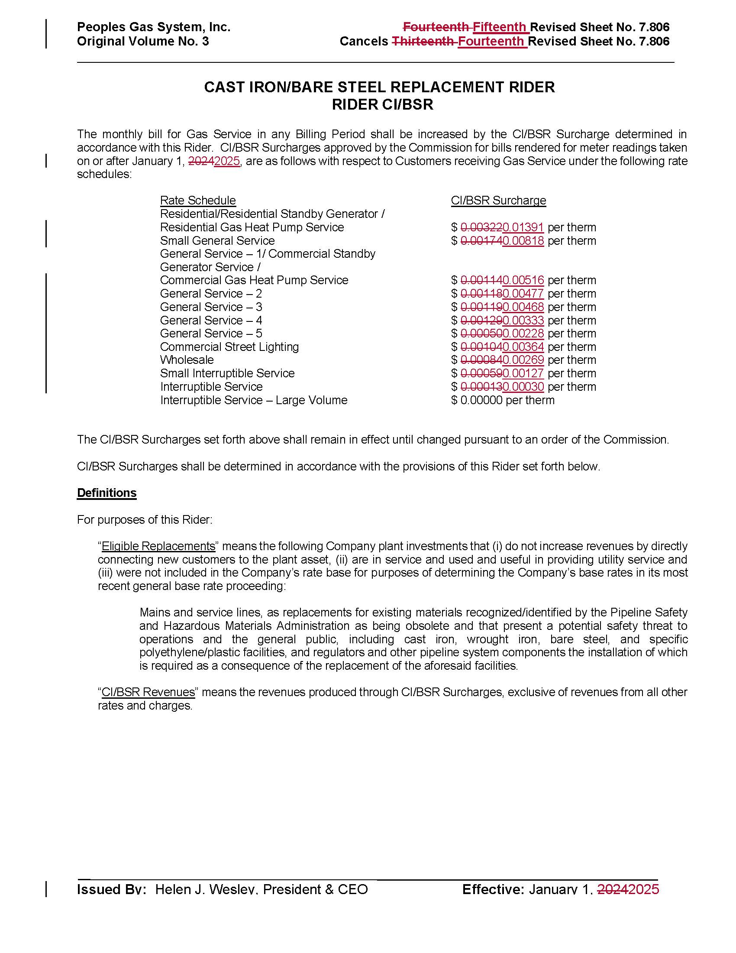

1. Order No. PSC-12-0476-TRF-GU, issued September 18, 2012, in Docket No. 20110320-GU, *In re: Petition for approval of Cast Iron/Bare Steel Pipe Replacement Rider (Rider CI/BSR), by Peoples Gas System.*
2. Order No. PSC-2023-0363-TRF-GU, issued November 29, 2023, in Docket No. 20230098-GU, *In re: Petition for approval of 2022 true-up, projected 2023 true-up, and 2024 revenue requirements and surcharges associated with cast iron/bare steel replacement rider, by Peoples Gas System.*
3. Order No. PSC-17-0066-AS-GU, issued February 28, 2017, in Docket No. 20160159-GU, *In re: Petition for approval of settlement agreement pertaining to Peoples Gas System’s 2016 depreciation study, environmental reserve account, problematic plastic pipe replacement, and authorized ROE.*
4. Order No. PSC-2023-0388-FOF-GU, issued December 27, 2023, in Docket No. 20230023-GU, *In re: Petition for rate increase by Peoples Gas System, Inc.*
5. See page 3 of Order No. PSC-12-0476-TRF-GU.
6. See pages 107-109 of Order No. PSC-2023-0388-FOF-GU.
7. *Id.*
8. See page 108 of Order No. PSC-2023-0388-FOF-GU.
9. Order No. PSC-2024-0170-TRF-GU, issued May 23, 2024, in Docket No. 20240028-GU, *In re: Petition to implement long-term debt cost true-up mechanism, by Peoples Gas System, Inc.*
10. *In re: Petition for approval of modifications to cast iron/bare steel pipe replacement rider, by Peoples Gas System, Inc.*
11. DN 09444-2024, response No. 8.
12. *Id.*
13. DN 09444-2024, response No. 4.
14. *Id.*