|  |  |  |  |
| --- | --- | --- | --- |
| State of Florida  pscSEAL | | Public Service Commission  Capital Circle Office Center ● 2540 Shumard Oak Boulevard Tallahassee, Florida 32399-0850  -M-E-M-O-R-A-N-D-U-M- | |
| DATE: | December 20, 2024 | | |
| TO: | Office of Commission Clerk (Teitzman) | | |
| FROM: | Division of Economics (P. Kelley)  Office of the General Counsel (Dose) | | |
| RE: | Docket No. 20240134-GU – Petition for approval of safety, access, and facility enhancement program true-up and 2025 cost recovery factors, by Florida City Gas. | | |
| AGENDA: | 01/07/25 – Regular Agenda – Tariff Filing – Interested Persons May Participate | | |
| COMMISSIONERS ASSIGNED: | | | All Commissioners |
| PREHEARING OFFICER: | | | Administrative |
| CRITICAL DATES: | | | 04/30/25 (8-Month Effective Date) |
| SPECIAL INSTRUCTIONS: | | | None |

Case Background

On August 30, 2024, Florida City Gas (FCG or utility) filed a petition for approval of its safety, access, and facility enhancement (SAFE) program true-up and 2025 cost recovery factors. The SAFE program was originally approved by the Commission in Order No. PSC-15-0390-TRF-GU (2015 Order) to recover the cost of relocating on an expedited basis certain existing gas mains and associated facilities from rear lot easements to the street front.[1]

On December 3, 2024, the Commission approved FCG’s proposed SAFE tariffs for the period January through December 2025. On December 5, 2024, FCG notified staff that the Seventh Revised Sheet No. 79 reflected an incorrect SAFE factor for the GS-6K customer class. After reviewing the modification to the Seventh Revised Sheet No. 79, staff believes that Commission approval of the revised tariff is required. The Commission has jurisdiction over the matter pursuant to Sections 366.04, 366.041, 366.05, and 366.06, Florida Statutes (F.S.).

Discussion of Issues

Issue 1:

 Should the Commission approve FCG's proposed modification to Seventh Revised Sheet No. 79?

Recommendation:

 Yes. The Commission should approve FCG’s proposed corrected Seventh Revised Sheet No. 79. The modification provides the correct SAFE program charge for the GS-6K customer class as calculated in FCG’s initial petition. The tariffs should be effective for the period January through December 2025. (P. Kelley)

Staff Analysis:

 The proposed modification to the Seventh Revised Sheet No. 79 would revise the SAFE program charge for the GS-6K customer class to $7.77, as opposed to $4.66, which was approved at the December 3, 2024 Agenda Conference. Staff notes that FCG calculated the charge for the GS-6K customer class correctly in its work papers included in its August 30, 2024, petition; however, the tariff contained an incorrect charge.[2]

As discussed in staff’s previous recommendation, the methodology approved for the SAFE program allocates the current cost of a 2-inch pipe to all customers on a per customer-basis and allocated the incremental cost of replacing a 4-inch pipe to customers who use over 6,000 therms per year. The GS-6K customer class is applicable to no-residential customers who use between 6,000 and 24,999 therms per year. Therefore, staff believes the correction to the Seventh Revised Sheet No. 79 is appropriate, because the correction would comply with the SAFE program cost allocation methodology approved by the Commission in the 2015 Order. The Commission’s vote from the December 3, 2024 Agenda Conference should otherwise remain unchanged.

Conclusion

The Commission should approve FCG’s proposed correction to the Seventh Revised Sheet No. 79. The modification to the Seventh Revised Sheet No. 79 provides the correct SAFE program charge for the GS-6K customer class, as calculated in FCG’s initial petition. The tariffs should be effective for the period January through December 2025.

Issue :

 Should this docket be closed?

Recommendation:

 Yes. If Issue 1 is approved and a protest is filed within 21 days of the issuance of the order, the tariffs should remain in effect, with any revenues held subject to refund, pending resolution of the protest. If no timely protest is filed, this docket should be closed upon the issuance of a consummating order. (Dose)

Staff Analysis:

 Yes. If Issue 1 is approved and a protest is filed within 21 days of the issuance of the order, the tariffs should remain in effect, with any revenues held subject to refund, pending resolution of the protest. If no timely protest is filed, this docket should be closed upon the issuance of a consummating order.

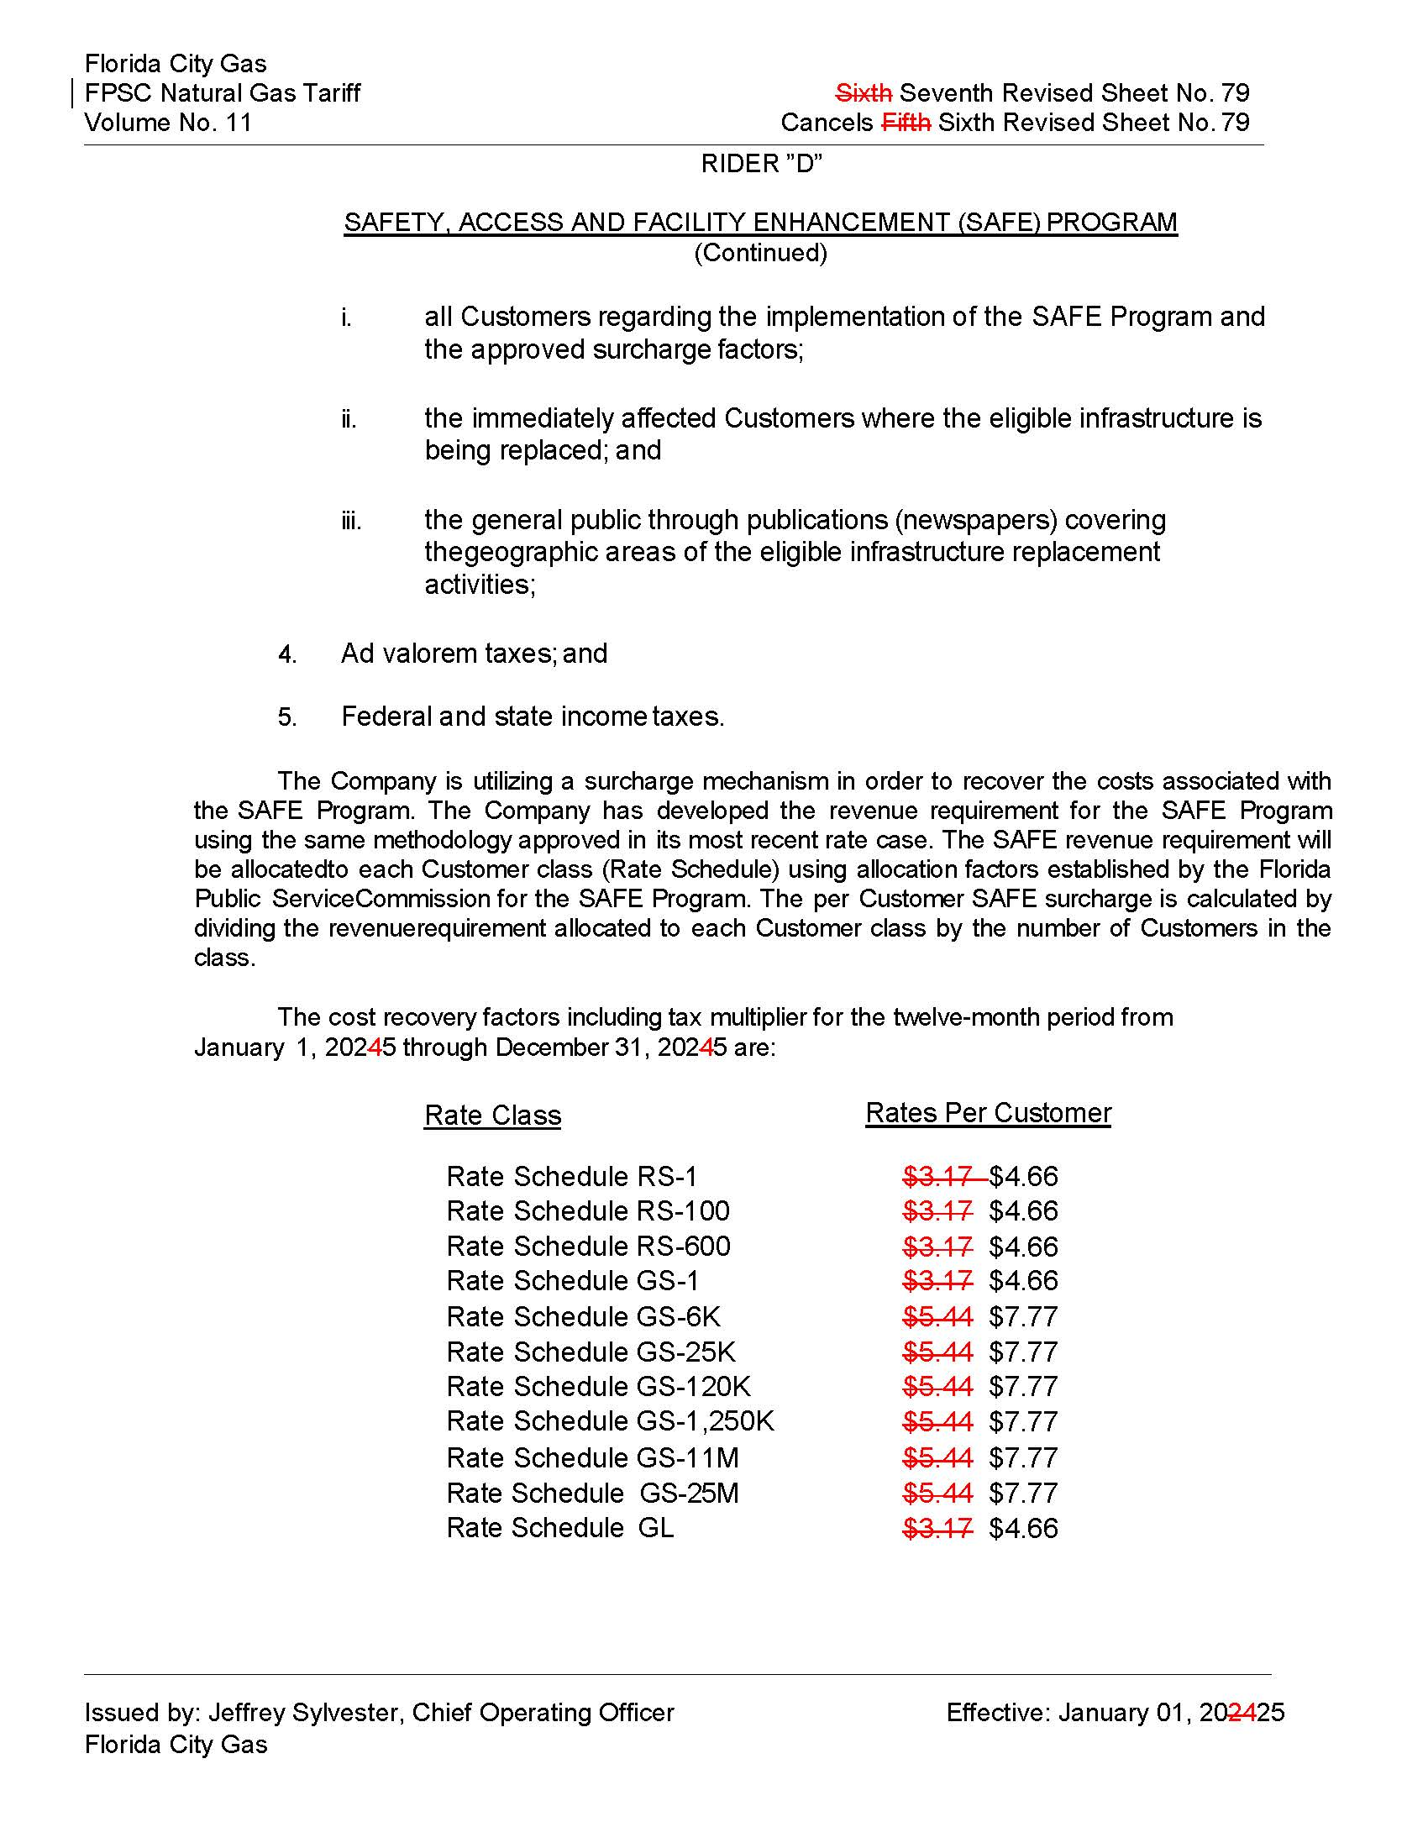

1. Order No. PSC-15-0390-TRF-GU, issued September 15, 2015, in Docket No. 20150116-GU, *In re: Petition for approval of safety, access, and facility enhancement program and associated cost recovery methodology, by Florida City Gas.*
2. See Attachment C-2, Schedule 6 to the petition (Document No. 08785-2024).