BEFORE THE FLORIDA PUBLIC SERVICE COMMISSION

|  |  |
| --- | --- |
| In re: Petition for approval of proposed demand-side management plan, by Florida Public Utilities Company. | DOCKET NO. 20240170-EG  ORDER NO. PSC-2025-0091-PAA-EG  ISSUED: March 24, 2025 |

The following Commissioners participated in the disposition of this matter:

MIKE LA ROSA, Chairman

ART GRAHAM

GARY F. CLARK

ANDREW GILES FAY

GABRIELLA PASSIDOMO SMITH

NOTICE OF PROPOSED AGENCY ACTION

ORDER APPROVING FLORIDA PUBLIC UTILITIES COMPANY’S

DEMAND-SIDE MANAGEMENT PLAN AND

SUPPLEMENTAL LED LIGHTING PROGRAM WITH MODIFICATIONS

BY THE COMMISSION:

NOTICE is hereby given by the Florida Public Service Commission that the action discussed herein is preliminary in nature and will become final unless a person whose interests are substantially affected files a petition for a formal proceeding, pursuant to Rule 25-22.029, Florida Administrative Code (F.A.C.).

Background

Sections 366.80 through 366.83, and 403.519, Florida Statutes (F.S.), known collectively as the Florida Energy Efficiency and Conservation Act (FEECA), require the Florida Public Service Commission (Commission) to adopt conservation goals to increase the efficiency of energy consumption. FEECA emphasizes reducing the growth rates of weather-sensitive peak demand, reducing and controlling the growth rates of electricity consumption, reducing the consumption of expensive resources such as petroleum fuels, and encouraging demand-side renewable energy resources. We most recently established conservation goals for Florida Public Utilities Company (FPUC or Utility) by Order No. PSC-2024-0431-FOF-EG (2024 Goalsetting Order), issued September 20, 2024, in Docket 20240015-EG.[1]

On December 19, 2024, FPUC filed a petition requesting approval of its Demand-Side Management (DSM) Plan and the associated program standards. In addition, FPUC requested to add a supplemental program to its DSM Plan through the addition of the Light Emitting Diode (LED) Lighting program, which would not count towards the DSM goals. We have jurisdiction over this matter pursuant to Sections 366.80 through 366.83, and 403.519, F.S.

Legal Standard

Section 366.82(7), F.S., requires that following the adoption of annual conservation goals, this Commission shall require each utility subject to FEECA to develop a DSM plan to meet its conservation goals. Rule 25-17.0021(4), Florida Administrative Code (F.A.C.), requires each electric utility subject to FEECA to file its DSM plan, which consists of one or more DSM programs, and program participation standards for our approval.

We consider the appropriateness of DSM programs by evaluating the following criteria, first outlined in Order No. 22176: (1) whether the program advances the policy objectives of FEECA and its implementing rules (such as reducing demand and energy usage); (2) whether the program is directly monitorable and yields measurable results; and (3) whether the program is cost-effective. Pursuant to 366.82(7), F.S., we may then approve, modify, or deny the utility’s DSM plan.

Decision and Analysis

We have reviewed FPUC’s proposed DSM Plan, including its demand and energy savings, cost-effectiveness, and rate impact. Overall, FPUC’s DSM Plan is consistent with the proposed programs used to establish the Utility’s DSM goals and is projected to meet the FEECA annual numeric conservation goals approved by this Commission in the 2024 Goalsetting Order. The programs included in FPUC’s proposed DSM Plan are also cost-effective based upon the Participants test and most programs pass the Total Resource Cost (TRC) test. In addition, the program participation standards appear to be consistent with FPUC’s DSM Plan and the programs are directly monitorable and measurable. For these reasons, as explained more fully below, we approve FPUC’s DSM Plan and associated program standards.

We have also reviewed FPUC’s proposed supplemental DSM program—the LED Lighting program—which is focused on the replacement of existing non-LED outside lighting with more efficient LED options. The program’s resulting net energy savings advance the policy objectives of FEECA and it is cost effective. In addition, the amount of savings per light fixture and number of light fixtures covered are both monitorable and measurable factors. However, we deny recovery of associated communication expenses, remove net base rate items for new LEDs, and adjust the amount to be recovered. Based on the foregoing reasons, as explained more fully below, we approve a modified supplemental LED Lighting program and program standards.

1. **Demand-Side Management Plan**
2. *Description of Demand-Side Management Plan*

FPUC’s proposed DSM Plan consists of seven programs in total, including four residential and three commercial/industrial programs. A complete list of the programs and a brief description of each can be found in Attachment A of this Order.

The DSM Plan retains the Residential HVAC program and rebrands the Residential Energy Survey program as “Efficiency 1st” with a stronger emphasis on do-it-yourself energy-saving installations. In addition, FPUC will be introducing a new web-based platform to enhance delivery of the Efficiency 1st survey program. These programs include updated rebate amounts, and a new weatherization and home energy kit. Meanwhile, FPUC is addressing limited participation in commercial programs by adding an interior lighting option and increased rebate amounts for the Commercial HVAC program.

In terms of new programs, FPUC is launching a residential low income program called “Efficiency for All.” This program will assist low income families with energy efficiencies that will benefit all customers.

We find the programs included in FPUC’s DSM Plan to be consistent with the proposed programs used to develop the Utility’s DSM goals in its 2024 goalsetting proceeding. We further find that the projected program demand and energy savings meet the goals established by us in the 2024 Goalsetting Order. These programs advance the policy objectives of FEECA.

1. *Program Participation*

FPUC’s program participation standards can be found in Attachment B of this Order. The projected program participation rates for the programs included in its DSM Plan are consistent with the participation rates provided for the proposed programs used to develop FPUC’s DSM goals. We find that the DSM Plan programs are directly monitorable and measurable. FPUC is responsible for monitoring actual participation rates and seeking Commission action, if necessary, to modify, add, or remove programs and/or standards as necessary to meet the annual conservation goals. If FPUC is unable to meet the DSM goals established by us, the Utility may be subject to appropriate action, up to and including financial penalties.

1. *Cost-Effectiveness Review*

As required by Rule 25-17.008, F.A.C., FPUC provided cost-effectiveness analyses for the programs included in its DSM Plan using the Participants, Rate Impact Measure (RIM), and TRC tests. All of FPUC’s DSM programs passed the Participants test, all but two passed the TRC test, and all failed the RIM test. “[W]e have flexibility in how we interpret and apply the cost-effectiveness tests required pursuant to Rule 25-17.008, F.A.C.”[2] Furthermore, cost-effectiveness is but one of the factors we weigh when analyzing DSM programs.[3] The results of these cost-effectiveness analyses are consistent with the cost-effectiveness analyses results provided for the proposed programs which were used to develop FPUC’s DSM goals in its 2024 goalsetting proceeding. Therefore, we find the DSM Plan programs to be cost-effective under the Participants test and all but two programs are cost-effective under the TRC test.

1. *Rate Impact*

Table 1 shows an estimate of the annual Energy Conservation Cost Recovery (ECCR) clause expenditures and monthly rate impact on a typical residential customer for FPUC’s DSM Plan.

Table 1

FPUC’s DSM Plan Annual ECCR Costs and Estimated Monthly Impact

|  |  |  |
| --- | --- | --- |
| **Year** | **Annual ECCR Costs**  **($)** | **Residential Customer**  **($/1,200 kWh-mo)** |
| **2025** | $731,191 | $1.45 |
| **2026** | $753,127 | $1.45 |
| **2027** | $775,721 | $1.45 |
| **2028** | $798,992 | $1.45 |
| **2029** | $822,962 | $1.45 |
| **2030** | $847,651 | $1.45 |
| **2031** | $873,080 | $1.45 |
| **2032** | $899,273 | $1.45 |
| **2033** | $926,251 | $1.45 |
| **2034** | $954,038 | $1.45 |
| **Total** | $8,382,285 | - |

Source: Document No. 00799-2025.

1. *Conclusion*

FPUC’s DSM Plan is consistent with the proposed programs used to establish its DSM goals and is projected to meet the FEECA annual numeric conservation goals approved by us in the 2024 Goalsetting Order. The programs included in FPUC’s proposed DSM Plan are also cost-effective based upon the Participants test and all but two programs are cost-effective based upon the TRC test. In addition, the program participation standards appear to be consistent with FPUC’s DSM Plan and the programs are directly monitorable and measurable. Therefore, we approve FPUC’s DSM Plan and program standards.

The Utility shall be allowed to file for cost recovery of the programs included in its DSM Plan in the ECCR clause. However, to recover those costs, FPUC will need to demonstrate that the expenditures to implement its DSM programs were reasonable and prudent.

1. **Light Emitting Diode Lighting Program**
2. *Utility’s Proposal*

In addition to the DSM Plan approved in Section I, FPUC requested that we authorize a supplemental new program. FPUC does not seek to have the demand and energy savings associated with this program included in the calculation of the Utility’s annual numeric conservation goals. Furthermore, unlike traditional conservation programs in which a participating customer receives a rebate or credit, here the Utility would receive a credit for each non-LED light replaced, to be recovered through the ECCR clause. For these reasons, we address this proposed program separately.

The LED Lighting program is a program focused on the replacement of existing non-LED outside lighting, such as high pressure sodium (HPS) or metal halide (MH) lights, with LED lighting options that are more efficient. The proposed program is structured as a temporary, two-year conservation initiative (to begin the first quarter of 2025) aimed at recovering depreciation and investment-related expenses through the aforementioned targeted conservation measure. Specifically, the program focuses on offsetting costs associated with converting 7,122 streetlamps to high-efficiency LEDs.

By Order No. PSC-2022-0132-TRF-EI, we closed FPUC’s Rate Schedule LS of non-LED offerings to new customers and included LED replacement options.[4] However, the Utility has not yet replaced all the existing customers’ lighting fixtures. The proposed LED Lighting program would expedite the remaining conversion process.

FPUC seeks to recover the unrecovered plant costs of the HPS and MH lights of the old non-LED lighting, incremental expenses for the new LED lighting, and additional marketing expenses associated with the program. In particular, FPUC petitions for recovery of a regulatory asset over two years based upon the projected cost of (1) unrecovered plant costs of the HPS and MH lights, (2) net rate base expenses associated with the new LED lights, such as return on investment, depreciation, and property taxes, and (3) communication expenses for customers. For purposes of cost recovery, FPUC requests recovery in the ECCR of the unamortized costs for HPS and MH lights removed both during the prior year and current year, or are expected to be removed through the projection year. The regulatory asset for the unrecovered plant associated with the HPS and MH lights would be expensed for each light replaced with the intention of resulting in a zero balance at the end of the program. FPUC plans to file a petition to address the net unrecovered cost of the new LED lights in a future tariff proceeding.

The Utility estimates the unamortized costs for the HPS and MH lighting to be $1,224,541 for 7,122 lights, or $171.94 per light, as of the end of December 2024. This value would be adjusted at the beginning of the program to reflect actual costs as of the date our decision becomes final. The net rate base expenses, an estimated $206,638 over the two-year period, and communication expenses of $15,000, brings the total program cost to $1,446,179, or $203.06 per light that would be recovered in the ECCR. This results in an annual cost of the program of $723,090, assuming approximately 300 fixtures are replaced monthly using a combination of Utility staff and contractors. This results in a rate impact of $1.44/mo. for 2025 and $1.40/mo. for 2026 for a typical residential 1,200 kWh monthly bill. Table 2 summarizes the proposed costs to be recovered under the program.

Table 2

FPUC Proposed LED Lighting Program Expenses

|  |  |  |  |  |
| --- | --- | --- | --- | --- |
| **Expense** | **2025**  **($)** | **2026**  **($)** | **Total**  **($)** | **Unit Cost\***  **($/Fixture)** |
| Non-LED Lighting Expenses |  |  |  |  |
| Unrecovered Depreciation | $612,271 | $612,271 | $1,224,542 | $171.94 |
| New LED Lighting Expenses |  |  |  |  |
| Net Return on Investment | $3,397 | $215,876 | $219,273 | $30.79 |
| Net Depreciation Expense | ($68,454) | $5,496 | ($62,958) | ($8.84) |
| Net Property Taxes | $0 | $50,322 | $50,322 | $7.07 |
| Administrative Expenses |  |  |  |  |
| Marketing/Communications | $7,500 | $7,500 | $15,000 | $2.11 |
| Total | 554,714 | $891,465 | $1,446,179 | $203.06 |

Source: Document No. 10305-2024.

1. *Program Review and Approval with Modification*

The proposed program is similar in structure to Tampa Electric Company’s (TECO’s) Street and Outdoor Lighting Conversion Program, which also featured recovery of unamortized cost of non-LED lighting.[5] In that docket, we allowed recovery of the unrecovered plant associated with the non-LED lighting but excluded recovery of advertising/communication expenses. TECO did not request recovery of incremental rate base costs associated with the new LED lighting.

Based upon the record before us, we find that the LED Lighting program is appropriate for DSM because it will result in net energy savings that serve a conservation purpose and advance the policy objectives of FEECA by replacing non-LED outside lighting with more efficient LED lighting options.

Overall, using the Utility’s requested expenses, the program has a cost-effectiveness ratio above 1.0 for both the RIM (1.075) and TRC (1.824) tests. Therefore, we also find the LED Lighting program to be a cost-effective.

Finally, we find that the amount of savings per light fixture and number of light fixtures covered are both monitorable and measurable factors, as demonstrated above in Section II(a) and Table 2. However, we deny the following requested expenses associated with FPUC’s request. First, we remove possible recovery of communication expenses. Communication expenses are not appropriate here because participation in the DSM program is non-voluntary and is done at the Utility’s discretion, not the lighting customer’s. Our removal of communication expenses in this circumstance is consistent with our decision in Order No. PSC-2018-0110-PAA-EI.

Second, we remove the requested net rate base expenses. Customers will be paying rates under FPUC’s Rate Schedule LS for the new LED lights, which is the appropriate place for recovery of new assets. Rate base expense recovery is more appropriate in a base rate case, not a cost recovery clause proceeding. Based on the values in Table 2, these two adjustments reduce FPUC’s total request by $221,637.

Third, the amount of the regulatory asset and the credit per light must be adjusted to reflect the remaining balance and number of fixtures as of the date of program approval. This is because pursuant to Section 366.82(7), F.S., any incremental lighting replaced before our approval of a DSM program is not eligible for ECCR. Prior Commission approval is a condition precedent.

In order to record and recover the unamortized portion approved by us of the HPS and MH lighting, we authorize FPUC to create a regulatory asset for the amount associated with the unrecovered plant (i.e., the non-LED lights to be converted). We find the establishment of a regulatory asset in this case to be appropriate because it will allow for FPUC to recover the associated costs over a multi-year period as contemplated in its petition. However, we find that our approval of FPUC’s regulatory asset does not limit our ability to review the amounts and recovery period for reasonableness in any future proceeding where the regulatory asset is included. In other words, any remaining balance in the regulatory asset at the end of the LED Lighting program will be evaluated in a future proceeding for recovery.

To reflect our Ordered modifications, FPUC shall file the updated unrecovered balance as adjusted above and number of fixtures based on the date our decision becomes final, and revised program standards with a per-light credit value reflecting the updated values. Our staff will have administrative authority to approve these revised program standards, provided they are consistent with the our decision.

1. *Conclusion*

FPUC’s proposed supplemental LED Lighting program falls under the umbrella of DSM. The program advances the conservation policy objectives of FEECA, is monitorable and measurable, and is cost-effective. However, any demand and energy savings associated with this program will not be included in the calculation of the Utility’s annual numeric conservation goals. Furthermore, we modify the LED Lighting program by (1) removing communication expenses, (2) removing net base rate items for new LEDs, and (3) adjusting the amount to be recovered and the credit to reflect the remaining balance and number of fixtures as of the date our decision becomes final. Consistent with our decision herein, we approve FPUC’s request to create a regulatory asset related to the unrecovered amount of the non-LED lighting as adjusted. Again, we stress that the approval to record the regulatory asset for accounting purposes does not limit this Commission’s ability to review the amounts and recovery period for reasonableness in a future proceeding in which the regulatory assets are included. Therefore, we approve the modified LED Lighting program. Staff shall have administrative authority to approve the revised program standards.

The Utility shall be allowed to file for cost recovery of the unamortized portion of the HPS and MH lighting in the ECCR clause. However, to recover those costs, FPUC will need to demonstrate that the expenditures to implement this DSM program were reasonable and prudent.

Based on the foregoing, it is

ORDERED by the Florida Public Service Commission that Florida Public Utilities Company’s Demand-Side Management Plan, as described in Attachment A, is approved. It is further

ORDERED that Florida Public Utilities Company’s program participation standards, as described in Attachment B, are consistent with the Demand-Side Management Plan and are approved. It is further

ORDERED that the Light Emitting Diode Lighting program is approved as modified herein. It is further

ORDERED that Florida Public Utilities Company shall file the updated unrecovered balance as adjusted above and number of fixtures based on the date our decision becomes final and revised program standards with a per-light credit value reflecting the updated values. Florida Public Service Commission staff shall have administrative authority to approve the revised program standards consistent with our decision herein. It is further

ORDERED that Florida Public Utilities Company is authorized to create a regulatory asset for the amount associated with the unrecovered plant (i.e., the non-LED lights to be converted) as set forth herein. The approval of this regulatory asset shall not limit the Florida Public Service Commission’s ability to review the amounts and recovery period for reasonableness in any future proceeding where the regulatory asset is included. It is further

ORDERED that Florida Public Utilities Company may file for cost recovery of the programs included in the Demand-Side Management Plan and of the Light Emitting Diode Lighting program in the Energy Conservation Cost Recovery proceeding. However, to recover those costs, Florida Public Utilities Company shall need to demonstrate that the expenditures to implement those programs were reasonable and prudent. It is further

ORDERED that Florida Public Utilities Company is responsible for monitoring actual participation rates and petitioning, if necessary, to modify, add, or remove programs and/or standards as necessary to meet the annual conservation goals. If Florida Public Utilities Company is unable to meet the goals established by us in the 2024 Goalsetting Order, then Florida Public Utilities Company may be subject to appropriate action, up to and including financial penalties. It is further

ORDERED that the provisions of this Order, issued as proposed agency action, shall become final and effective upon the issuance of a Consummating Order unless an appropriate petition, in the form provided by Rule 28-106.201, Florida Administrative Code, is received by the Office of Commission Clerk, 2540 Shumard Oak Boulevard, Tallahassee, Florida 32399-0850, by the close of business on the date set forth in the “Notice of Further Proceedings or Judicial Review” attached hereto. It is further

ORDERED that in the event this Order becomes final, this docket shall be closed.

By ORDER of the Florida Public Service Commission this 24th day of March, 2025.

|  |  |
| --- | --- |
|  | /s/ Adam J. Teitzman |
|  | ADAM J. TEITZMAN  Commission Clerk |

Florida Public Service Commission

2540 Shumard Oak Boulevard

Tallahassee, Florida 32399

(850) 413‑6770

www.floridapsc.com

Copies furnished: A copy of this document is provided to the parties of record at the time of issuance and, if applicable, interested persons.

CMM

NOTICE OF FURTHER PROCEEDINGS OR JUDICIAL REVIEW

The Florida Public Service Commission (Commission) is required by Section 120.569(1), Florida Statutes, to notify parties of any administrative hearing that is available under Section 120.57, Florida Statutes, as well as the procedures and time limits that apply. This notice should not be construed to mean all requests for an administrative hearing will be granted or result in the relief sought.

Mediation may be available on a case-by-case basis. If mediation is conducted, it does not affect a substantially interested person's right to a hearing.

The action proposed herein is preliminary in nature. Any person whose substantial interests are affected by the action proposed by this order may file a petition for a formal proceeding, in the form provided by Rule 28-106.201, Florida Administrative Code. This petition must be received by the Office of Commission Clerk, 2540 Shumard Oak Boulevard, Tallahassee, Florida 32399-0850, by the close of business on April 14, 2025.

In the absence of such a petition, this order shall become final and effective upon the issuance of a Consummating Order.

Any objection or protest filed in this/these docket(s) before the issuance date of this order is considered abandoned unless it satisfies the foregoing conditions and is renewed within the specified protest period.

**Florida Public Utility Company 2025 – 2034 DSM Programs**

**Residential Programs:**

***Residential Energy Survey Program (Efficiency First)***

The Efficiency First Program provides FPUC's residential customers with energy conservation advice that encourages the implementation of efficiency measures that result in energy savings. Once implemented, these measures also lower FPUC's energy requirements and improve operating efficiencies.

***Residential Heating and Cooling Efficiency Upgrade Program***

The Residential Heating and Cooling Upgrade Program incentivize customers operating inefficient heat pumps and air conditioners to replace them with more efficient units. This program provides incentives to install a new heat pump or replace older heat pumps or air conditioners with more efficient units.

***Low-Income Energy Outreach (Efficiency for All)***

The Efficiency for All Program is aimed at enhancing energy efficiency in low-income households and communities. Participants will complete online energy surveys and monitor their monthly energy consumption. Upon reaching specific milestones, the participants will receive tiered incentives such as weatherization kits, smart power strips, and programmable thermostats.

***Residential Small Appliance Program***

This program offers a $25 rebate to residential customers who purchase an Energy-Star certified clothes washer. These washers use approximately 20% less energy and 30% less water than standard models, leading to significant utility savings over time and reduce environmental impacts.

**Commercial Programs:**

***Commercial Heating and Cooling Efficiency Upgrade Program***

The Commercial Heating and Cooling Efficiency Upgrade Program provides rebates to small commercial customers (customers with a maximum 5 ton units) if the customers install a high-efficiency central air conditioner or heat pump with a minimum 15 SEER.

***Commercial Chiller Upgrade Program***

This program aims to mitigate the growth of peak demand and energy consumption across FPUC's commercial and industrial sectors. To achieve this, the program requires customers to replace existing chillers with more efficient systems.

***Commercial Indoor Lighting Program***

The Commercial Exterior and Interior Lighting Program is a new addition to FPUC’s energy conservation offerings. This program encourages non-residential customers to replace outdated, inefficient lighting systems with modern, energy-efficient alternatives. Incentives are based on projected annual energy savings and accommodates a wide range of end-use applications.



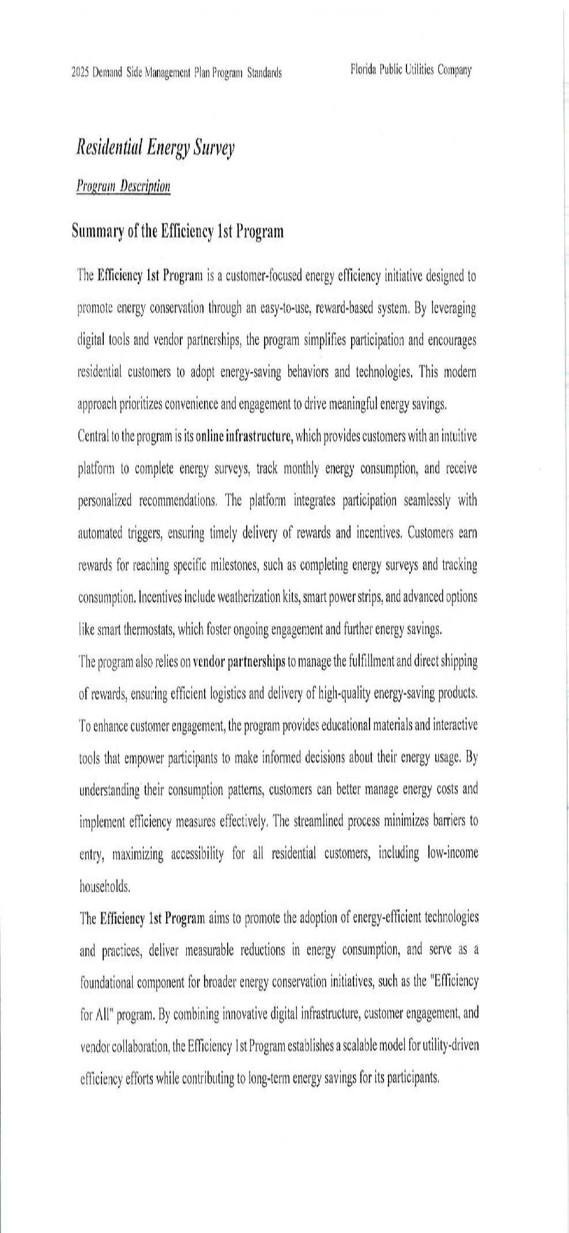

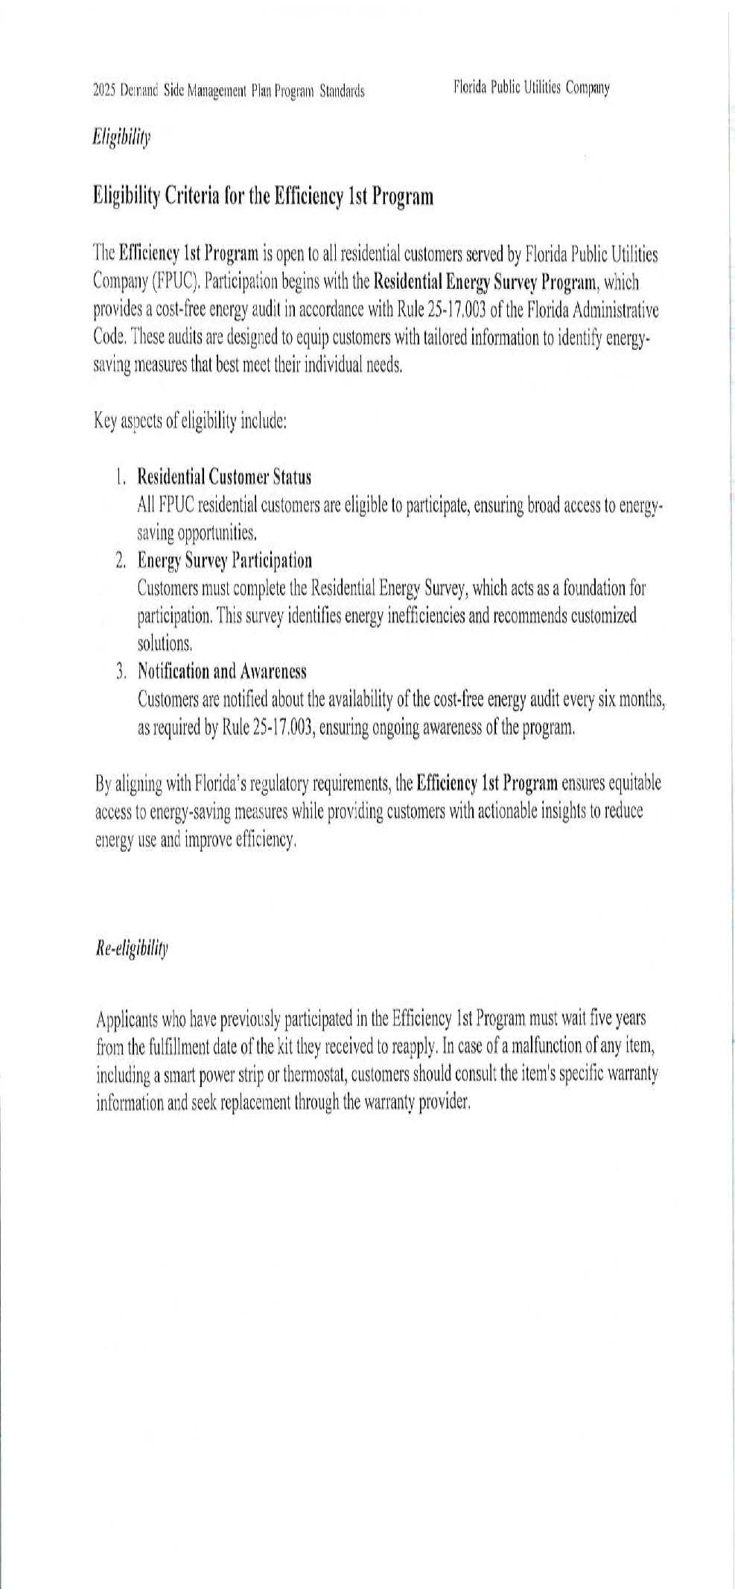

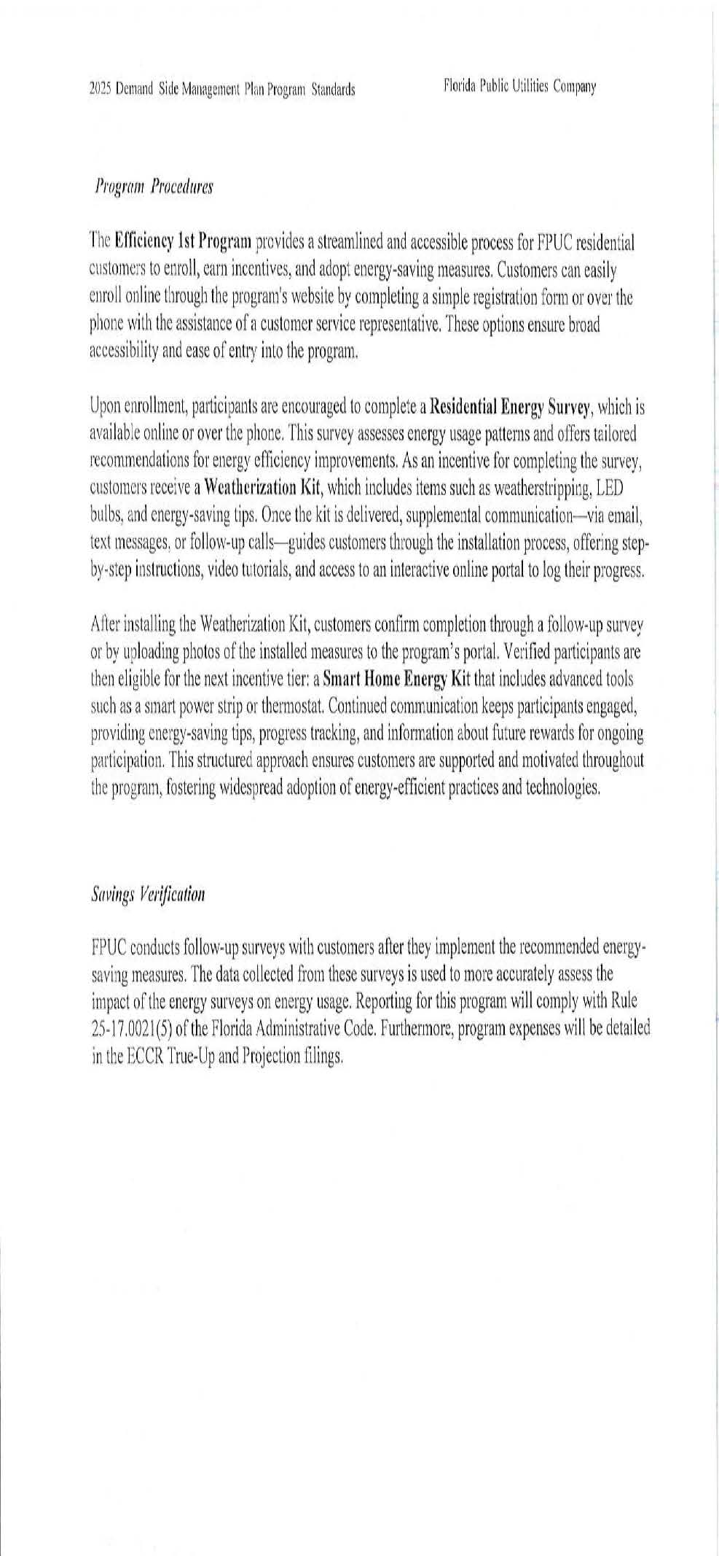

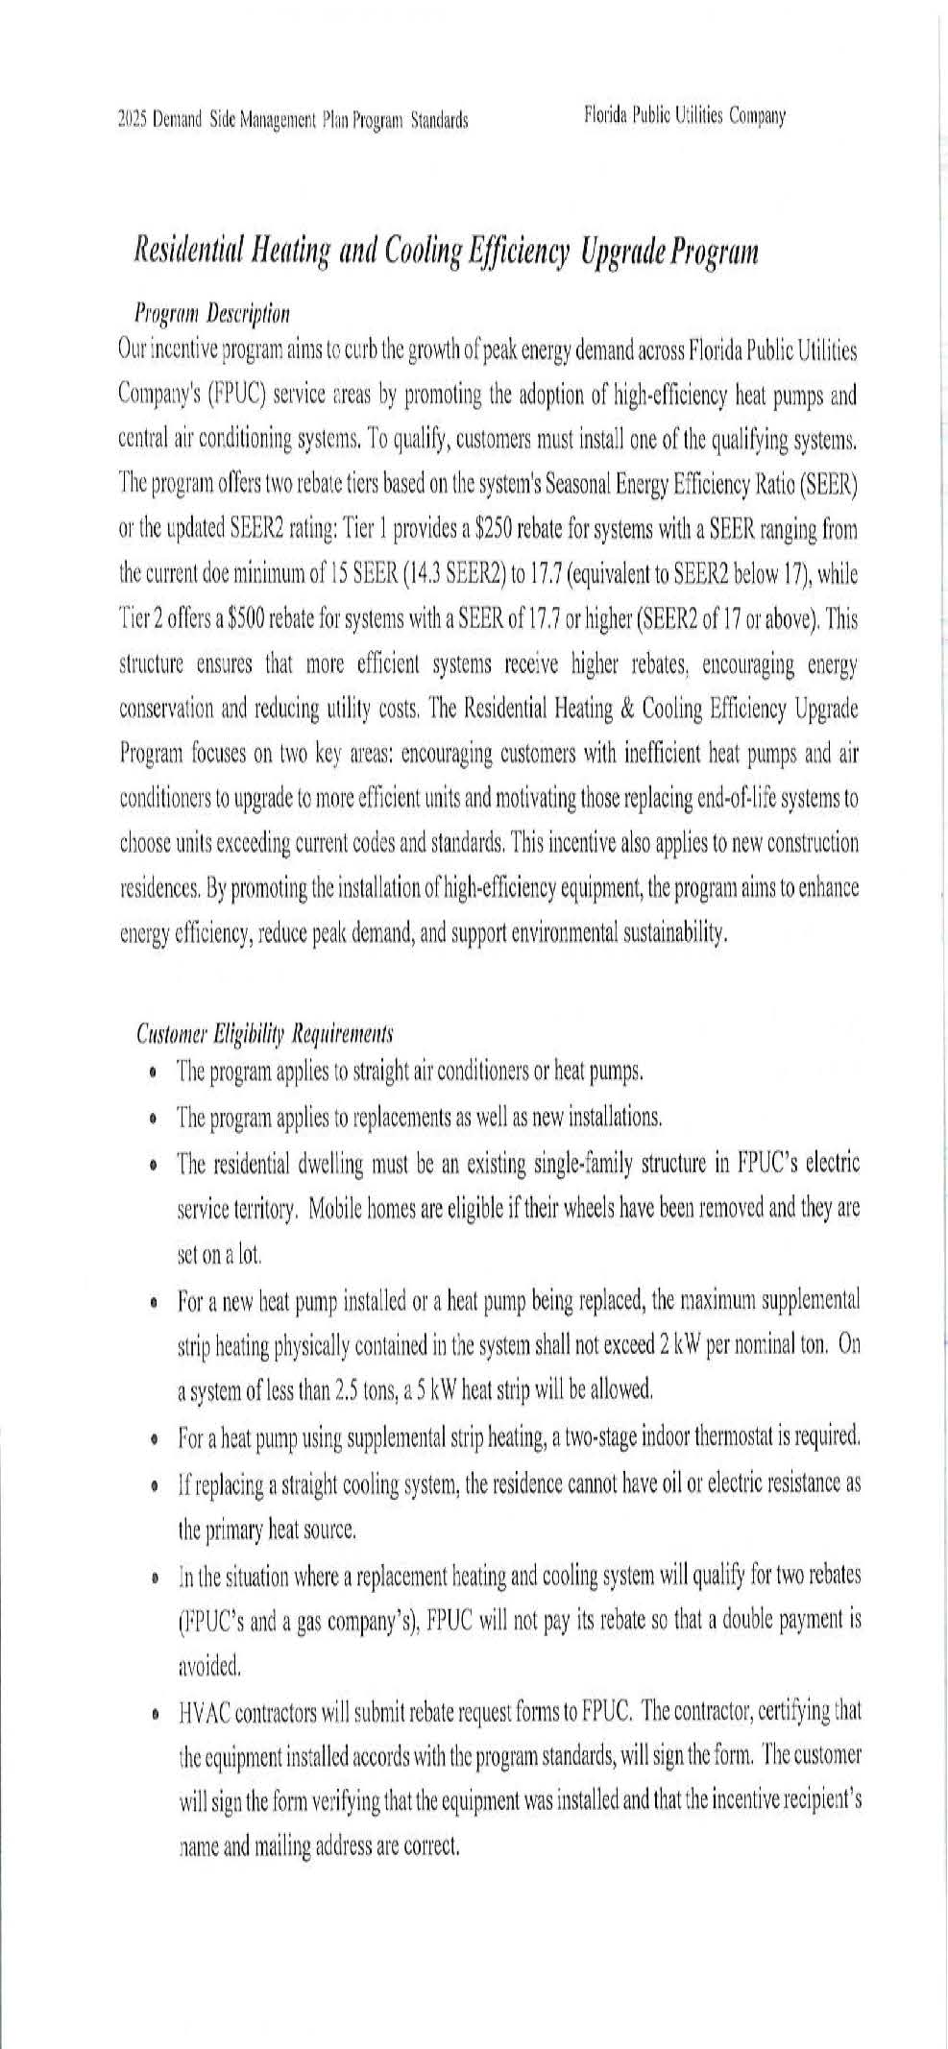

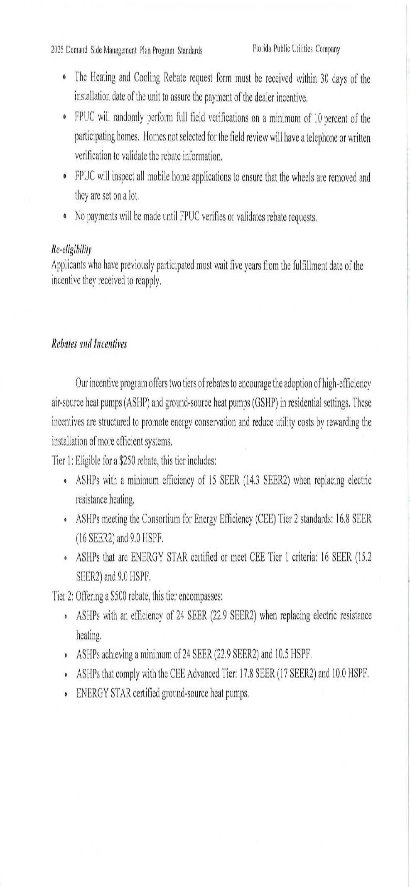

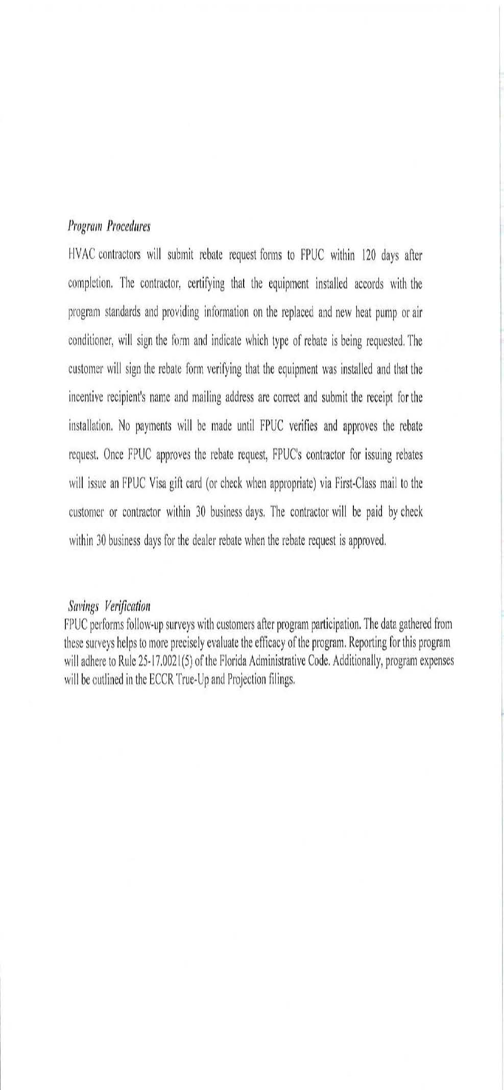

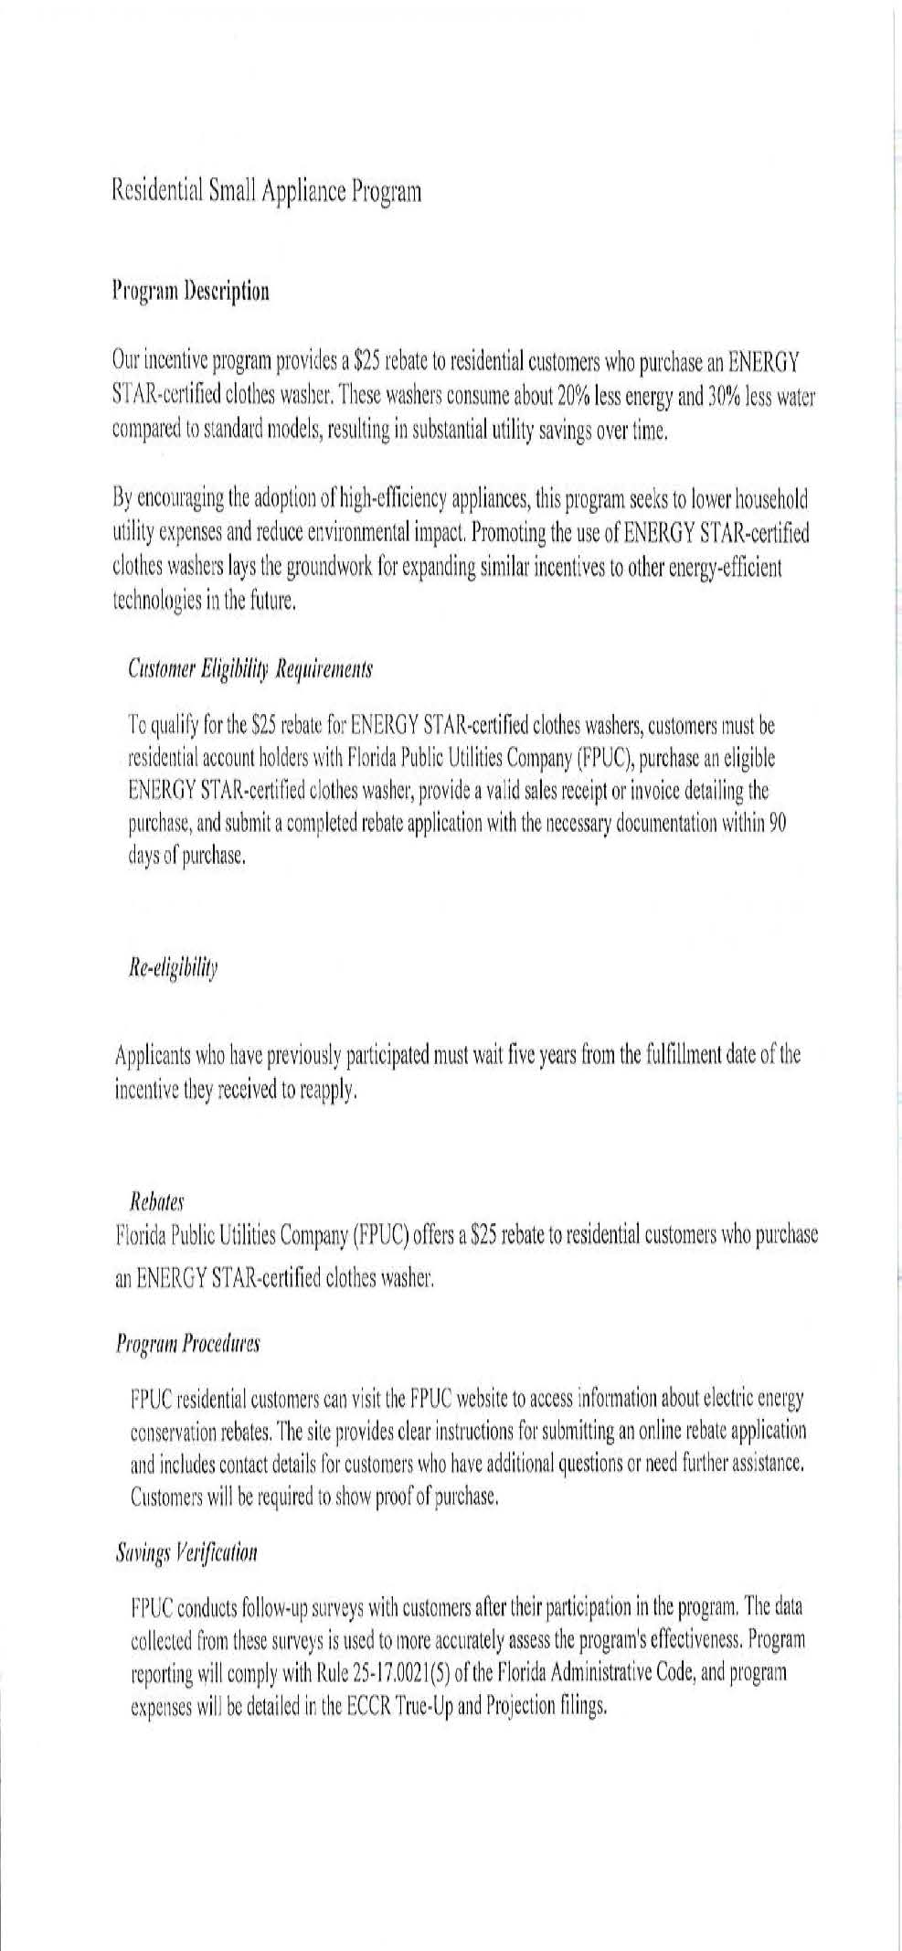

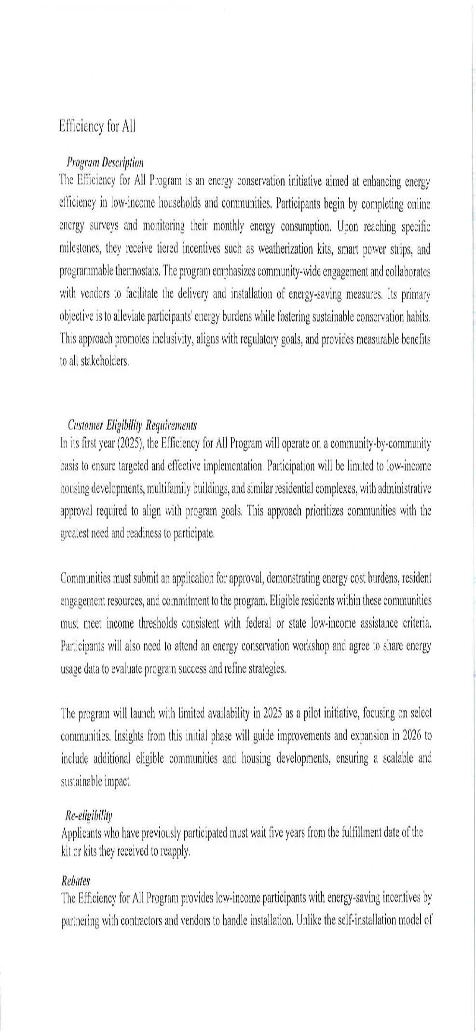

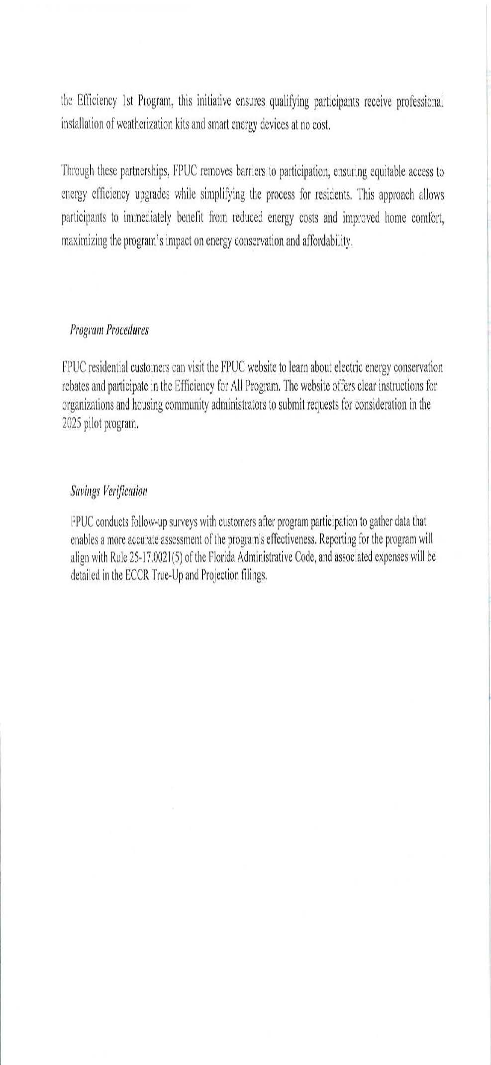

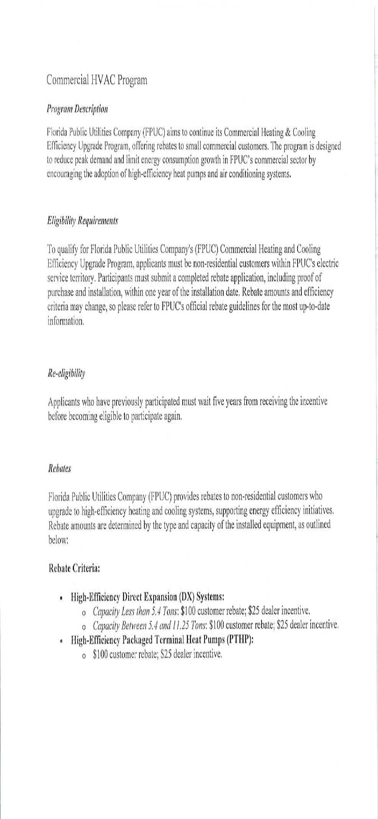



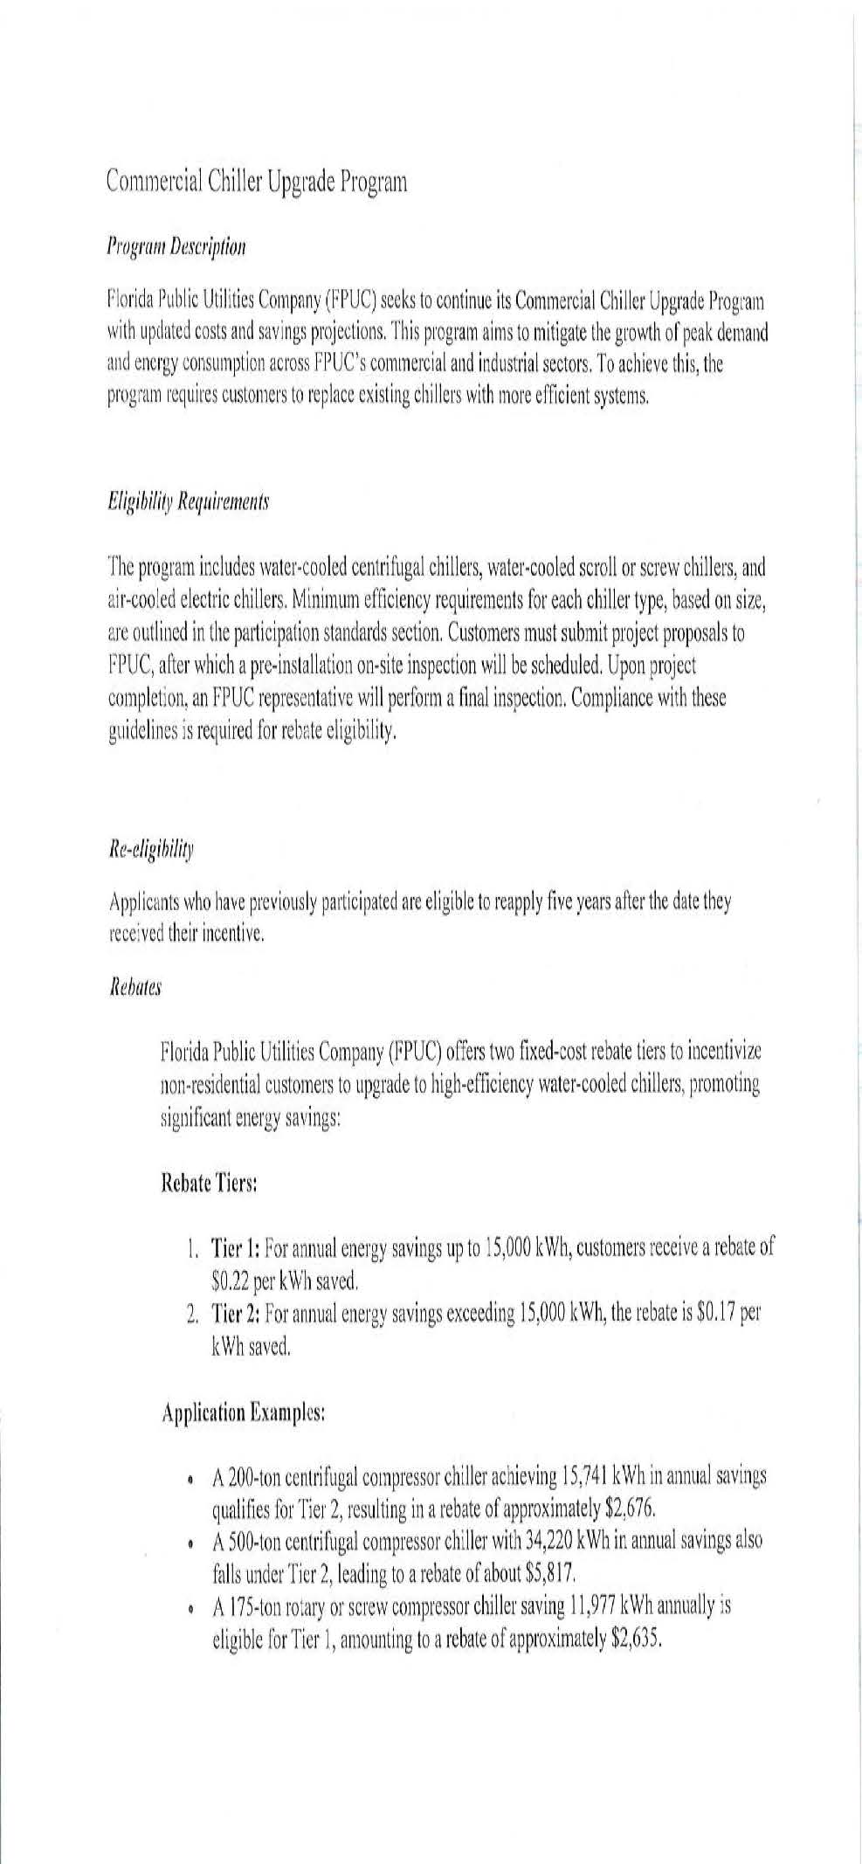

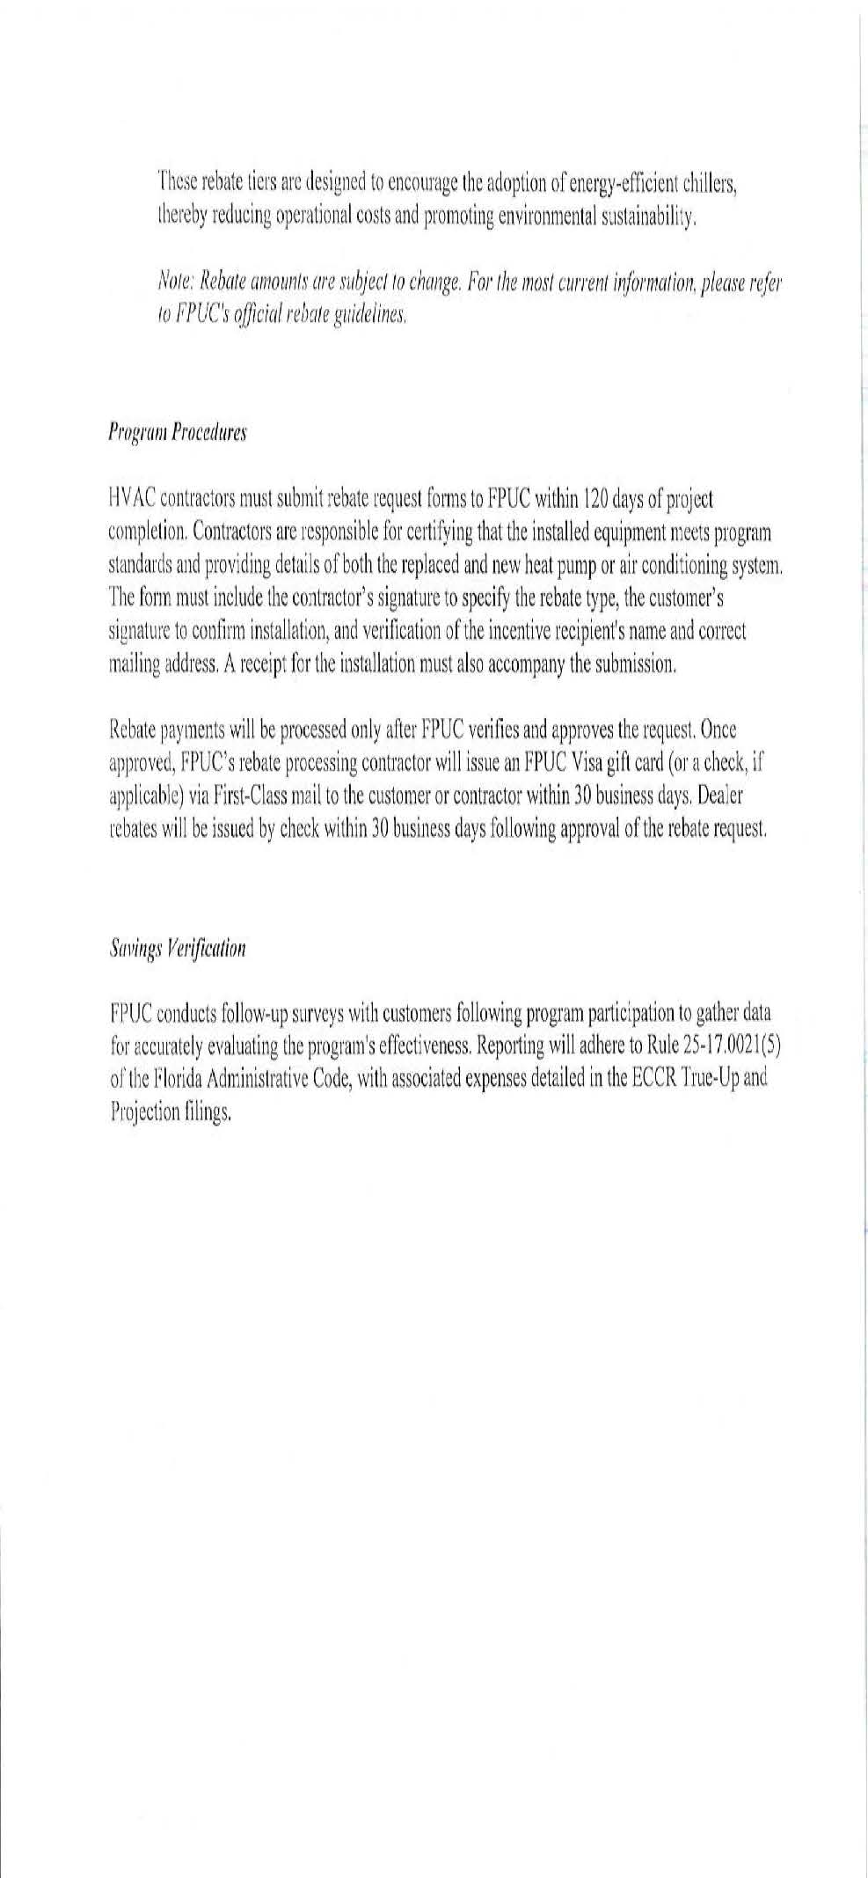

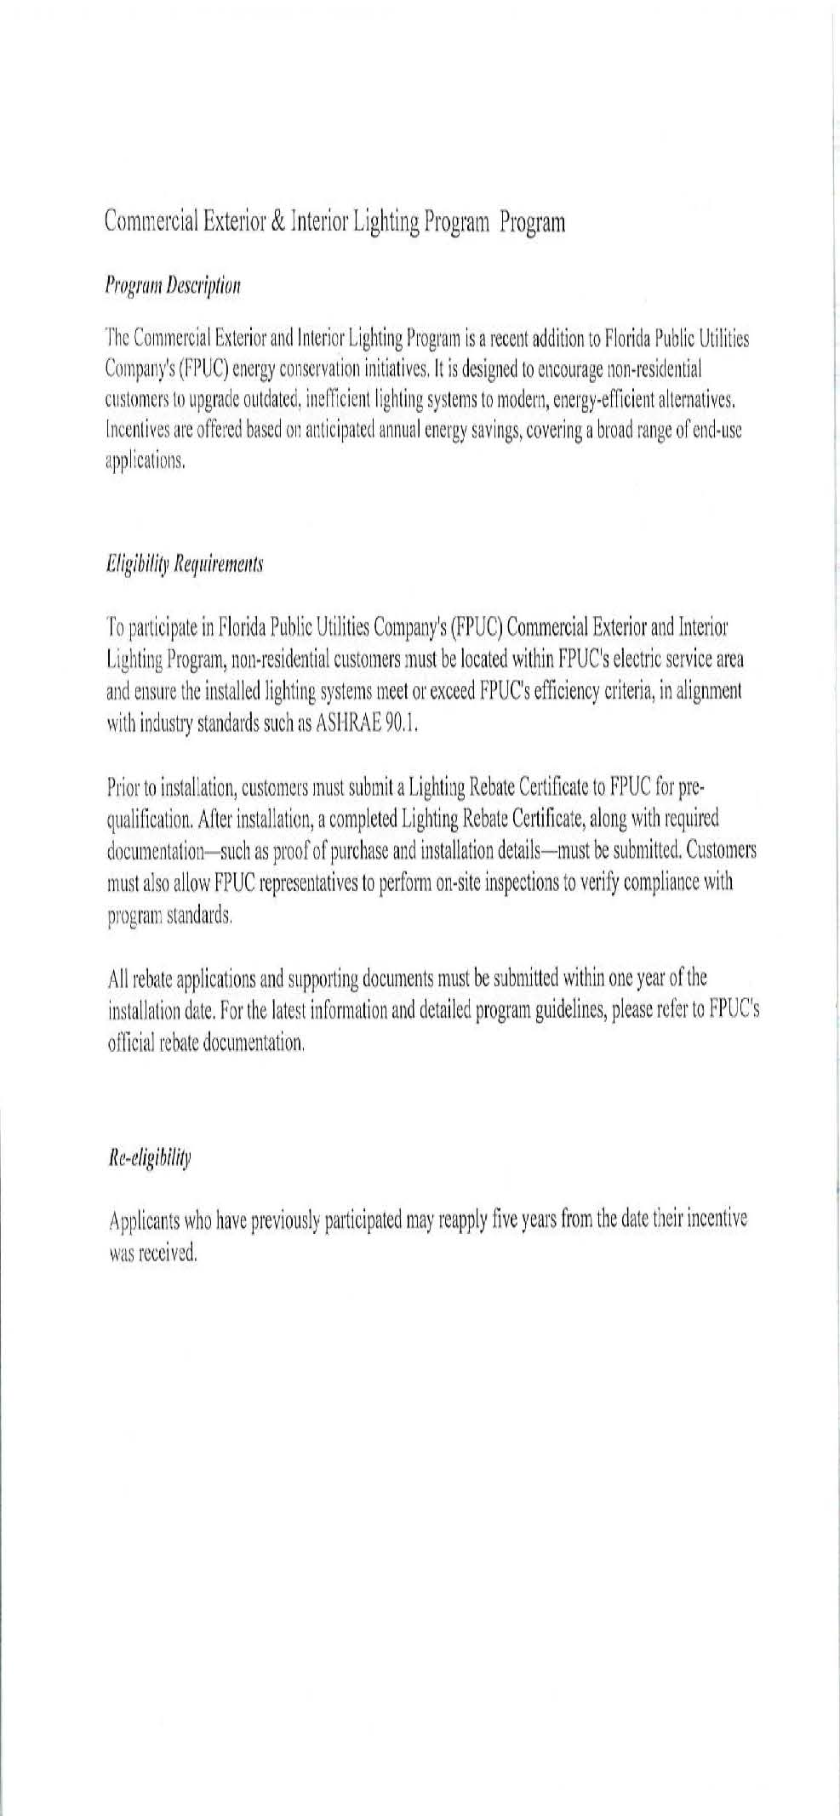

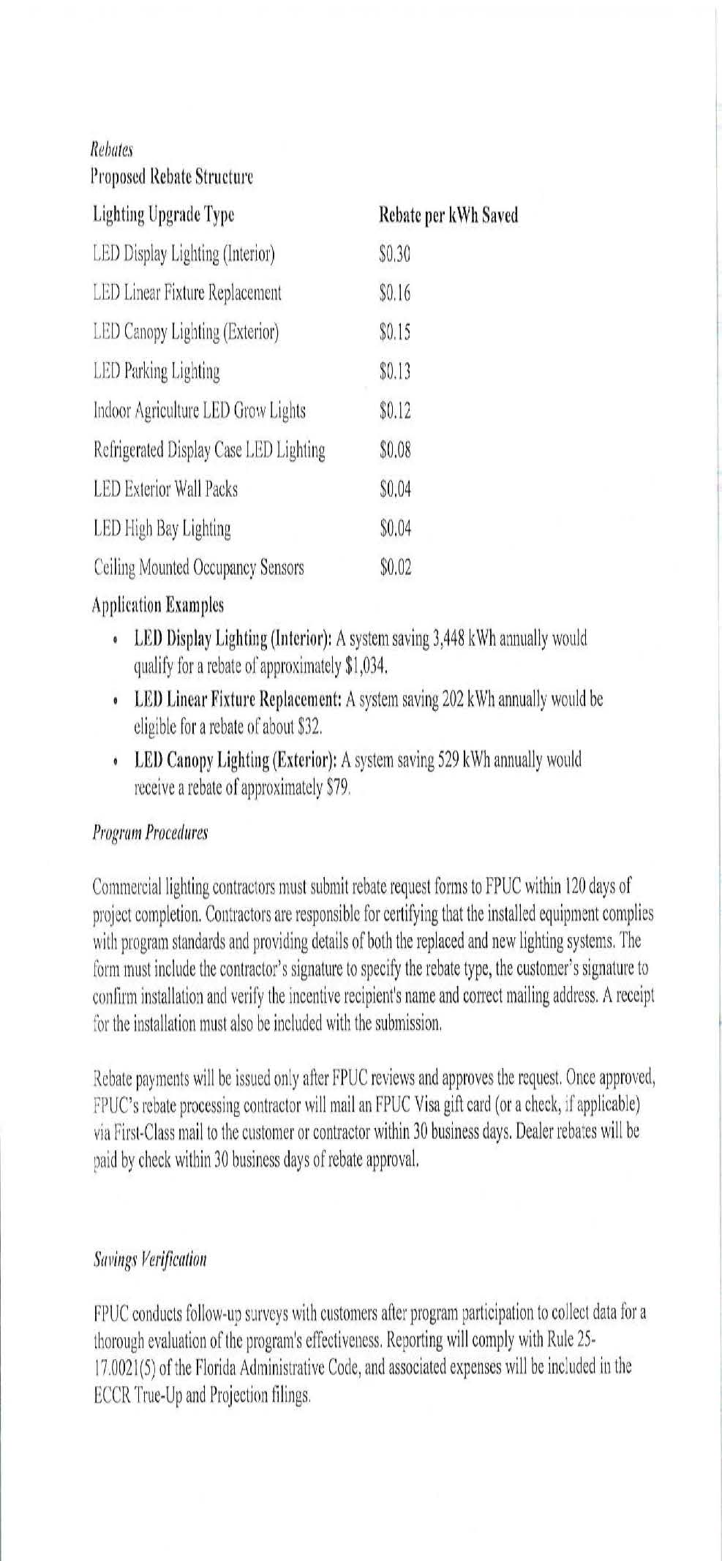

1. Order No. PSC-2024-0431-FOF-EG, issued September 20, 2024, in Docket No. 20240015-EG, *In re: Commission review of numeric conservation goals (Florida Public Utilities Company)*.
2. Order No. PSC-2020-0274-PAA-EG, issued August 3, 2020, in Docket Nos. 20200053-EG, 20200054-EG, 20200055-EG, 20200056-EG, & 20200060-EG, *In re: Petition for approval of demand-side management plan, by Tampa Electric Company*, *In re: Petition for approval of proposed demand-side management plan, by Duke Energy Florida, LLC*, *In re: Petition for approval of proposed demand-side management plan, by Gulf Power Company*, *In re: Petition for approval of demand-side management plan and request to modify residential and business on call tariff sheets, by Florida Power & Light Company*, & *In re: Petition for approval of demand-side management plan, by Florida Public Utilities Company*, p. 4.
3. *See* Order No. PSC-2019-0509-FOF-EG, issued November 26, 2019, in Docket No. 20190015-EG, *In re: Commission review of numeric conservation goals (Florida Power & Light Company)*, pp. 8–10 (finding that despite demand-side renewable energy systems not being cost-effective, continued encouragement of those systems through net metering practices nonetheless furthered FEECA); Order No. PSC-97-0528-FOF-EG, issued May 7, 1997, in Docket No. 960624-EG, *In re: Petition for approval of Green Pricing Research and Development Project by Florida Power & Light Company*, pp. 1–2 (approving not cost-effective DSM program involving photovoltaic modules when program could ultimately contribute to commercialization of renewable technologies or stimulate economic and technological growth in renewable technologies).
4. *See* Order No. PSC-2022-0132-TRF-EI, issued April 8, 2022, in Docket No. 20220011-EI, *In re: Petition to modify tariff to close existing lighting tariff to new business and introduce new LED lighting tariff by Florida Public Utilities Company*.
5. *See* Order No. PSC-2018-0110-PAA-EI, issued February 27, 2018, in Docket No. 20170199-EI, *In re: Petition for approval of conservation street and outdoor lighting conversion program, by Tampa Electric Company*.