BEFORE THE FLORIDA PUBLIC SERVICE COMMISSION

In re: Petition for approval of proposed demand-side management plan and demand-side management program standards, by Tampa Electric Company. | DOCKET NO. 20240163-EG  ORDER NO. PSC-2025-0093-PAA-EG  ISSUED: March 24, 2025

The following Commissioners participated in the disposition of this matter:

MIKE LA ROSA, Chairman
ART GRAHAM
GARY F. CLARK
ANDREW GILES FAY
GABRIELLA PASSIDOMO SMITH

NOTICE OF PROPOSED AGENCY ACTION
ORDER APPROVING TAMPA ELECTRIC COMPANY’S
DEMAND-SIDE MANAGEMENT PLAN

BY THE COMMISSION:

NOTICE is hereby given by the Florida Public Service Commission that the action discussed herein is preliminary in nature and will become final unless a person whose interests are substantially affected files a petition for a formal proceeding, pursuant to Rule 25-22.029, Florida Administrative Code (F.A.C.).

Background
Sections 366.80 through 366.83, and 403.519, Florida Statutes (F.S.), known collectively as the Florida Energy Efficiency and Conservation Act (FEECA), requires the Florida Public Service Commission (Commission) to adopt conservation goals to increase the efficiency of energy consumption. FEECA emphasizes reducing the growth rates of weather-sensitive peak demand, reducing and controlling the growth rates of electricity consumption, reducing the consumption of expensive resources such as petroleum fuels, and encouraging demand-side renewable energy resources. We most recently established conservation goals for Tampa Electric Company (TECO or Utility) by Order No. PSC-2024-0430-FOF-EG, issued September 20, 2024, (2024 Goalsetting Order) in Docket 20240014-EG.

On December 13, 2024, TECO filed a petition requesting approval of its Demand-Side Management (DSM) Plan and the associated program standards. We have jurisdiction over this matter pursuant to Sections 366.80 through 366.83 and 403.519, F.S.

Legal Standard

Section 366.82(7), F.S., requires that following the adoption of annual conservation goals, this Commission shall require each utility subject to FEECA to develop a DSM plan to meet its conservation goals. Rule 25-17.0021(4), Florida Administrative Code (F.A.C.), requires each electric utility subject to FEECA to file its DSM plan, which consists of one or more DSM programs, and program participation standards for our approval.
We consider the appropriateness of DSM programs by evaluating the following criteria, first outlined in Order No. 22176: (1) whether the program advances the policy objectives of FEECA and its implementing rules (such as reducing demand and energy usage); (2) whether the program is directly monitorable and yields measurable results; and (3) whether the program is cost-effective. Pursuant to 366.82(7), F.S., we may then approve, modify, or deny the utility’s DSM plan.

Decision and Analysis

We have reviewed TECO’s proposed DSM Plan, including its demand and energy savings, cost-effectiveness, and rate impact. Overall, TECO’s DSM Plan is consistent with the proposed programs used to establish the Utility’s DSM goals and is projected to meet the FEECA annual numeric conservation goals approved by this Commission in the 2024 Goalsetting Order. The programs included in TECO’s proposed DSM Plan are cost-effective overall based upon the Participants test, Rate Impact Measure (RIM) test, and Total Resource Cost (TRC) test. In addition, we have reviewed TECO’s administrative program standards and they appear to be consistent with the Utility’s proposed DSM Plan. For these reasons, as explained more fully below, we approve TECO’s DSM Plan and associated program standards.

Description of Demand-Side Management Plan
TECO’s proposed DSM Plan consists of 29 programs in total, including 14 residential and 15 commercial/industrial programs, as well as 1 Conservation Research and Development (R&D) program. A complete list of the programs and a brief description of each program can be found in Attachment A of this Order.

The program modifications consist of changing rebate amounts to further incentivize program participation and modifying measures to meet newer efficiency standards. TECO intends to continue the Conservation R&D program as it has led to the successful launch of DSM programs. We notes that the proposed DSM plan asserts that the Conservation R&D program has an annual estimated cost of $400,000 and that the total program cost shall not exceed $2,000,000 for the five-year period. We find that the projected program demand and energy savings meet the goals established by us in the 2024 Goalsetting Order. We further find the programs included in TECO’s DSM Plan to be consistent with the proposed programs used to develop the Utility’s DSM goals in its 2024 goalsetting proceeding.

Program Participation

TECO’s program participation standards can be found in Attachment B of this Order. TECO projected the 2025-2034 program participation levels based on historical program participation trends, except for TECO’s proposed Neighborhood Weatherization program, which reflects an increase consistent with the Utility’s commitments in the 2024 Goalsetting Order. Based on these estimates, we find that TECO’s proposed DSM Plan meets the goals set in the 2024 Goalsetting Order, and the programs included in TECO’s DSM Plan are directly monitorable and measurable. TECO is responsible for monitoring actual participation rates and seeking Commission action if necessary to modify, add, or remove programs. If TECO is unable to meet the DSM goals we have established, the Utility may be subject to appropriate action, up to and including financial penalties.

Cost-Effectiveness Review

As required by Rule 25-17.008, F.A.C., TECO provided a cost-effectiveness analysis of the proposed programs using the Participants test, RIM test, and TRC test. “[W]e have flexibility in how we interpret and apply the cost-effectiveness tests required pursuant to Rule 25-17.008, F.A.C.” Furthermore, cost-effectiveness is but one of the factors we weigh when analyzing DSM programs. All of TECO’s programs pass the TRC and Participants test, and all but two programs pass the RIM test. Overall, TECO’s DSM Plan is cost-effective and all programs maintained the same cost-effectiveness values in the Utility’s proposed DSM plan that were established in the DSM Goals proceeding. Therefore, we find the DSM Plan programs to be cost-effective.

Rate Impact

Table 1-1 is an estimate of the annual Energy Conservation Cost Recovery (ECCR) clause expenditures and monthly bill impact for a typical residential customer for TECO’s DSM Plan.
Table 0-1
TECO’s DSM Plan Annual Cost and Estimated Monthly Bill Impact
Year | Annual ECCR Costs | Residential Customer
 | ($) | $/1,200 kWh/mo
2025 | $52,680,407 | 3.61
2026 | $52,770,274 | 3.62
2027 | $53,385,991 | 3.66
2028 | $53,731,781 | 3.68
2029 | $54,252,342 | 3.72
2030 | $55,388,147 | 3.80
2031 | $56,025,631 | 3.84
2032 | $56,971,498 | 3.91
2033 | $58,077,136 | 3.98
2034 | $58,985,926 | 4.04
Total | $552,269,134
Source: Document No. 10230-2024

Conclusion

TECO’s DSM Plan is consistent with the proposed programs used to establish its DSM goals and is projected to meet the FEECA annual numeric conservation goals approved by us in the 2024 Goalsetting Order. The programs included in TECO’s proposed DSM Plan are also cost-effective based upon the Participants test, RIM test, and TRC test. In addition, TECO’s administrative program standards appear to be consistent with the TECO’s DSM Plan and the programs are directly monitorable and measurable. Therefore, we approve TECO’s DSM plan and program standards.

The Utility shall be allowed to file for cost recovery of the programs included in its DSM Plan in the ECCR clause. However, TECO must demonstrate that the expenditures to implement its DSM programs are reasonable and prudent in order to recover those expenditures.

Based on the foregoing, it is

ORDERED by the Florida Public Service Commission that Tampa Electric Company’s Demand-Side Management Plan, as described in Attachment A, is approved. It is further

ORDERED that Tampa Electric Company’s administrative program standards, as described in Attachment B, are consistent with the Demand-Side Management Plan and are approved. It is further

ORDERED that Tampa Electric Company may file for cost recovery of the programs included in the Demand-Side Management Plan in the Energy Conservation Cost Recovery proceeding. However, to recover those costs, Tampa Electric Company shall need to demonstrate that the expenditures to implement those programs were reasonable and prudent. It is further

ORDERED that Tampa Electric Company is responsible for monitoring actual participation rates and petitioning, if necessary, to modify, add, or remove programs and/or standards as necessary to meet the annual conservation goals. If Tampa Electric Company is unable to meet the goals established by us in the 2024 Goalsetting Order, then Tampa Electric Company may be subject to appropriate action, up to and including financial penalties. It is further

ORDERED that the provisions of this Order, issued as proposed agency action, shall become final and effective upon the issuance of a Consummating Order unless an appropriate petition, in the form provided by Rule 28-106.201, Florida Administrative Code, is received by the Office of Commission Clerk, 2540 Shumard Oak Boulevard, Tallahassee, Florida 32399-0850, by the close of business on the date set forth in the “Notice of Further Proceedings or Judicial Review” attached hereto. It is further

ORDERED that in the event this Order becomes final, this docket shall be closed.

By ORDER of the Florida Public Service Commission this 24th day of March, 2025.

/s/ Adam J. Teitzman
ADAM J. TEITZMAN
Commission Clerk
Florida Public Service Commission
2540 Shumard Oak Boulevard
Tallahassee, Florida 32399
(850) 413-6770
www.floridapsc.com

Copies furnished: A copy of this document is provided to the parties of record at the time of issuance and, if applicable, interested persons.

SF

NOTICE OF FURTHER PROCEEDINGS OR JUDICIAL REVIEW

The Florida Public Service Commission (Commission) is required by Section 120.569(1), Florida Statutes, to notify parties of any administrative hearing that is available under Section 120.57, Florida Statutes, as well as the procedures and time limits that apply. This notice should not be construed to mean all requests for an administrative hearing will be granted or result in the relief sought.

Mediation may be available on a case-by-case basis. If mediation is conducted, it does not affect a substantially interested person's right to a hearing.

The action proposed herein is preliminary in nature. Any person whose substantial interests are affected by the action proposed by this order may file a petition for a formal proceeding, in the form provided by Rule 28-106.201, Florida Administrative Code. This petition must be received by the Office of Commission Clerk, 2540 Shumard Oak Boulevard, Tallahassee, Florida 32399-0850, by the close of business on April 14, 2025.

In the absence of such a petition, this order shall become final and effective upon the issuance of a Consummating Order.

Any objection or protest filed in this/these docket(s) before the issuance date of this order is considered abandoned unless it satisfies the foregoing conditions and is renewed within the specified protest period.

Tampa Electric Company
Program Descriptions

RESIDENTIAL PROGRAMS

Residential Walk-Through Audit (Free Energy Check)
This is a conservation program adopted by Florida under Chapter 366.82(5), Florida Statutes, and Rule 25-17.003 F.A.C. This program is offered to all residential customers and is designed to save demand and energy by increasing customer awareness of energy use in personal residences. Savings are dependent on the customer implementing energy saving recommendations
1. Identify, note and recommend those conservation measures and practices that apply to the specific residence.
2. Encourage customer participation in available conservation programs in which the specific residence and customer will benefit.
3. Identify and communicate to the customer identified no-cost, low-cost conservation measures and practices including those that have less than a two-year payback.
Audits are kept on file with the company for three years. There is no charge to the customer for the Residential Walk-Through Audit.
Residential Customer Assisted Energy Audit (Online)
This is a conservation program designed to save demand and energy by increasing residential customer awareness of energy use in personal residences. This program allows for residential customers to engage in the energy audit either through a phone call or completing an online energy questionnaire. Savings are dependent on the customer implementing energy conservation measure and practice recommendations. Recommendations are standardized and include an estimated range of savings.
To access this free audit, customers can either call or go to Tampa Electric’s internet site to link to the audit. Customers will answer questions about their home and energy usage. Personalized audit results are either emailed, provided by the phone team or immediately displayed on the customer’s computer for review and implementation. The audit recommendations are based on the customers’ answers to the questions and their actual energy consumption.
Residential Computer-Assisted Energy Audit (RCS – Paid Audit)
This is a conservation program originally developed in response to the Energy Policy Act (1978) and adopted by Florida under Chapter 366.82(5), Florida Statutes, and Rule 25- 17.003, F.A.C. The program is designed to save demand and energy and is offered to all residential customers. Savings are achieved by increasing residential customer awareness of the energy use in personal residences. Savings are dependent on customers implementing conservation measures and practices. The audit is performed by a trained and certified residential analyst who collects

specific data about the structure of the home and the customer’s energy usage patterns. Using Energy Gauge software, the analyst will simulate different conservation measures and practices on the customer’s residence to identify potential savings that can be achieved.
Analysts identify, note and recommend only those conservation measures and practices that apply to the specific residence. The following information is then provided on the applicable conservation measures and practices:
1. Estimated cost for contractor installation
2. Estimated cost for do-it-yourself installation
3. Payback period for customer investment
4. Estimated first-year energy savings
Audit findings are kept on file with the utility for three years. The audit charge to the customer is $15.00.
Residential Ceiling Insulation
The Residential Ceiling Insulation Program is designed to encourage customers to make cost-effective improvements to existing residences. The goal is to offer customer rebates for installing ceiling insulation to help reduce their energy consumption while reducing Tampa Electric’s weather sensitive peak demand. Ceiling insulation is designed to reduce demand and energy by decreasing the load on residential air conditioning and heating equipment. Qualifying residential structures are eligible for a rebate based upon the total square footage of insulation installed over conditioned space. Customers will receive a certificate that is used as partial payment for the ceiling insulation installed.
• The Residential Ceiling Insulation rebate is set at $0.16 per square foot of qualifying insulation.
Residential Duct Repair
This program eliminates or reduces areas of HVAC air distribution losses by sealing and repairing the air distribution system (ADS). The ADS is defined as the air handler, air ducts, return plenums, supply plenums and any connecting structure. Customers call TECO to request appointments for duct repair and an HVAC contractor appointed by TECO will seal and repair all accessible components of the ADS in the residence. TECO’s rebate is included in the payment to the participating contractor performing ADS repairs.

• The Residential Duct Repair rebate is set at $270 per HVAC system that has its ADS repaired.

Energy Education, Awareness, and Agency Outreach
The Energy Education, Awareness and Agency Outreach Program is comprised of distinct initiatives:

Energy and Renewable Education and Awareness
This portion of the program is designed to establish opportunities for engaging groups of customers and students in energy-efficiency and renewable energy related discussions in an organized setting. Tampa Electric recognizes the importance of educating students and motivating customers through participation in its energy audits and raising awareness of energy conservation, energy efficiency and renewable energy efficiency. This program will provide the opportunity to accomplish these initiatives for large groups in one setting.
In order to create an awareness of this offering, the company will establish participation avenues through its Speakers’ Bureau and Community Relations teams.
By working with local civic groups, churches, government sponsored public forums, homeowners associations, trade shows, rental property management groups, etc., Tampa Electric will establish informative presentations that help educate customers on no-cost practices they can implement to reduce their energy consumption, low-cost improvements to increase the efficiency of their homes, investment type improvements with energy efficiency or renewable energy resources and rebates/incentives available which may help with these longer term investments. This type of forum will allow for dialogue with customers in such a setting that many customers will simultaneously benefit from the discussion.
Additionally, this program will focus on opportunities to promote energy efficiency education through local school systems. Students will be educated on ways to become active participants in saving energy at home and at school through the use of a variety of learning tools that support Sunshine State Standards and are approved by school authorities.
Participants will be provided with an energy efficiency kit containing the following energy saving devices and supporting information appropriate for the audience.
• LEDs: This provides four LEDs to replace incandescent bulbs with similar lumen output.
• Water Heater Temperature Check and Adjustment: This provides a temperature check of the water heater temperature setting and informs the customer of the possibility for turn-down adjustment.
• Low Flow Faucet Aerator: This provides two low flow faucet aerators to reduce the amount of hot water used.
• Wall Plate Thermometer: This provides one wall plate thermometer to check the accuracy of the installed thermostat.

• Air Filter Whistle: This provides one filter whistle to help remind to clean or change filter monthly.
• Energy Savings Education Handout: This provides the content and directions for installation for all of the measures within the kit. The handout also includes several no-cost energy conservation tips that provide an immediate payback.
Also, as part of energy education and awareness, this portion of the program will continue the focus on providing opportunities to encourage the conservation of energy and for the promotion of energy efficiency through local school systems by partnering with high schools’ driver’s education classes. This portion of the program will provide energy efficiency and electric vehicle (“EV”) training curriculum and educational materials and the incremental cost of one electric vehicle at selected high schools.
Agency Outreach
This portion of the program will allow for delivery of energy efficiency kits that will help educate agency clients on practices that help to reduce energy consumption. The suggested practices will mirror the recommendations provided to customers who participate in a free energy audit.
Customer eligibility is confirmed through the utilization of census data to identify eligible customer geographic regions of low-income customers or by referrals through direct customer contact, distributed literature and communication through key community contacts or local community assistance agencies which serve low income households.
As a means to encourage adoption of the recommendations, agency clients who are seeking energy-related assistance will be provided with the same energy efficiency kit above.

ENERGY STAR for New Multi-Family Residences
The ENERGY STAR for New Multi-Family Residences Program is a residential new construction conservation program designed to reduce the growth of peak demand and energy in the residential new construction apartment and condominium residence market. The program utilizes a rebate to encourage the construction of new multi-family residences to meet the requirements to achieve the ENERGY STAR certified apartments and condominium label. By receiving this certificate, the new residence will use less energy and demand which will help reduce the growth of Tampa Electric’s peak demand.
• The ENERGY STAR for Multi-Family Residences rebate is set at $345 for a qualifying home receiving the ENERGY STAR Certificate.

ENERGY STAR for New Homes
The ENERGY STAR for New Homes Program is a residential new construction conservation program designed to reduce the growth of peak demand and energy in the residential new construction market. The program utilizes a rebate to encourage the construction of new homes to meet the requirements to achieve the ENERGY STAR certified new home label. By receiving
this certificate, the new home will use less energy and demand which will help reduce the growth of Tampa Electric’s peak demand.
• The ENERGY STAR for New Homes rebate is set at $425 for a qualifying home receiving the ENERGY STAR Certificate.

ENERGY STAR Thermostats
The ENERGY STAR Thermostats Program is designed to encourage customers to make cost-effective improvements to existing residences. The goal is to offer customer rebates for installing an ENERGY STAR certified smart thermostat to help reduce their energy consumption while reducing Tampa Electric’s weather sensitive peak demand. Smart thermostats are designed to reduce demand and energy by decreasing the load on residential air conditioning and heating equipment and providing energy usage information regarding the heating and cooling system’s settings and usage. This program will rebate residential customers that install a qualifying thermostat.
• The ENERGY STAR Thermostats rebate is set at $22 per qualifying ENERGY STAR thermostat installed.
Residential Heating and Cooling
The Residential Heating and Cooling Program is designed to encourage customers to make cost-effective improvements to existing residences. The goal is to offer customer rebates for installing high efficiency heating and cooling systems to help reduce their energy consumption while reducing Tampa Electric’s weather sensitive peak demand. High efficiency heating and cooling systems require less demand and energy as compared to standard systems. This program will rebate residential customers that install a qualifying air conditioning system. The Residential Heating and Cooling rebate is two tiered:
• Rebate: Tier 1 - $40 per qualifying unit that meets or exceeds the current DOE energy conservation standard for residential central air conditioners and heat pumps or Florida Building Code by 1 SEER level or by 1 SEER2 level.
• Rebate: Tier 2 - $550 per qualifying unit that meets or exceeds the current DOE energy conservation standard for residential central air conditioners and heat pumps or Florida Building Code by 2 SEER levels or by 2 SEER2 levels.
Rebates tiers are not stackable.
Neighborhood Weatherization
The Neighborhood Weatherization Program is designed to assist low-income families in reducing their energy usage. The goal of the program is to provide and install a package of conservation measures at no cost to the customer. Another key component will be educating families and promoting energy conservation techniques to help customers control and reduce their energy usage.

Customer eligibility is confirmed through the utilization of census data to identify eligible customer geographic regions of low-income customers or by referrals through direct customer
contact, distributed literature and communication through key community contacts or local community assistance agencies which serve low income households. Local residents of these qualifying geographic regions will have the opportunity to enroll for participation in the program at no cost.
Tampa Electric will deliver the following applicable measures
• Duct Repair: For dwellings with a ducted central HVAC system, this will provide repair of one run of the ADS towards qualification.
• Walk-Through Energy Audit
• Duct Sealing: For qualified dwellings with a ducted central HVAC system, this will provide sealing of the ADS.
• Ceiling Insulation: For qualified dwellings where the existing ceiling insulation is below R-19, this will provide for an R-13 to be installed. Any home where roof pitch limits accessibility, a lower R-value may be installed.
• LEDs: This provides the resident with six LEDs to replace incandescent bulbs with similar lumen output.
• Hot Water Pipe Insulation: This allows for the installation of hot water insulation on un-insulated pipes.
• Water Heater Temperature Check Card and Adjustment: This provides a temperature check of the water heater temperature setting and informs the customer of the possibility for turn-down adjustment.
• Low Flow Faucet Aerator: This allows for the installation of up to three low flow faucet aerators to reduce the amount of hot water used.
• Low Flow Showerhead: This allows for the installation of up to two low flow showerheads to reduce the amount of hot water used.
• Wall Plate Thermometer: This will provide for the installation of one wall plate thermometer per home to check the accuracy of the installed thermostat.
• Refrigerator Coil Cleaning and Brush: This will provide for the cleaning of the refrigerator coil. The brush will be provided to the customer for future cleaning.
• HVAC Weather Stripping Kit: This will provide for the installation of a weather-stripping kit for window/wall HVAC units. The customer will receive or have installed up to two kits.
• Air Filter Whistle: This provides each homeowner with a filter whistle to help remind them to clean or change filter monthly.
• Weatherization Measures: This portion of the program will provide weather stripping, caulk and foam sealant which will be used to reduce or stop air infiltration around doors, windows, attic entries and where pipes enter the home. Reducing air infiltration is vital to saving energy and improving comfort.
• Energy Savings Education Handout: This provides each homeowner with the content and directions for installation for some of the measures within the kit. The handout also includes several no-cost energy conservation tips that provide an immediate payback
Residential Price Responsive Load Management (Energy Planner)
The company’s program relies on a multi-tiered rate structure combined with price signals conveyed to participating customers during the day. This price information is designed to encourage customers to make behavioral or equipment usage changes to their energy consumption thereby achieving the desired high cost period load reduction to assist in meeting system peak.
Price information from the utility is used by the customer to program a “smart” thermostat into preset actions based on the level of pricing. Equipment may be turned on, turned off or changed to a different temperature setting automatically by the smart thermostat or manually by the customer through the smart thermostat in response to either the multi- tiered rates or critical price signals.
Tampa Electric will install a communication device along with a “smart” thermostat at the customer’s home used to control the operation of selected appliances such as space heating, air conditioning, water heating, pool pumps, and Level 2 or greater EV chargers. Customers will be able to program the operation of this equipment and alter their energy consumption based the price tiers occurring at specific times of the day and year.
• The Energy Planner program incentive is approximately $131/customer annually.
Residential Prime Time Plus (Residential Load Management)
Tampa Electric’s “Prime Time Plus” is a residential load management program designed to alter the company’s system load curve by reducing summer and winter demand peaks. Residential loads such as heating, air conditioning, water heaters, level 2 EV chargers, and pool pumps are controlled via the company’s advanced metering infrastructure (“AMI”). In addition, the customer will receive a programmable “smart thermostat” and access to a mobile app. The mobile app and “smart thermostat” allow the customer to change thermostat settings from any mobile device. The program will leverage the company’s AMI to provide the communication with the installed thermostat and customer selected appliances for load control.

Customers participating in Prime Time Plus will receive monthly incentive credits on their electric bill. Air conditioning, level 2 EV chargers, and pool pump appliances can be interrupted at any time but will not exceed 134 hours of control in a single year. Water heating appliances can be interrupted at any time and may exceed 134 hours a year if needed for frequency assistance for changes to the company’s photovoltaic generation output.

The Residential Prime Time Plus program incentives are:
• $12.00 per month for central heating and air conditioning control.
• $6.00 per month for electric water heating control.
• $3.00 per month for pool pump control.
• $9.00 per month for Level 2 (or greater) EV Charger control.
Renewable Energy Program (Sun to Go)
This program provides customers with the option to purchase 200 kWh blocks of renewable energy for five dollars per block to assist in the delivery of renewable energy to the company’s grid system. This specific effort provides funding for renewable energy procurement, program administration, evaluation and market research.

Renewable energy participants will be served from the existing electrical system. Renewable energy may not be delivered to the customer but will displace energy that would have otherwise been produced from traditional fossil fuels. Tampa Electric will report program progress through the annual ECCR True-up and Projection Filings

COMMERCIAL/INDUSTRIAL PROGRAMS
Commercial/Industrial Audit (Free)
This is a conservation program designed to reduce demand and energy consumption of commercial/industrial facilities by increasing customer awareness of the energy use in their facilities. The savings are dependent upon the customer’s implementation of conservation measures and practices recommended.
The audit is conducted by a trained and certified commercial energy analyst who will perform at a minimum the following:
1. Identify, note and recommend only those conservation measures and practices that apply to the specific commercial or industrial facility.
2. Encourage customer and organization participation in available conservation programs in which the specific commercial or industrial facility will benefit.
3. Energy usage profiling and benchmarking showing the historical energy usage and forecasted usage with no changes.
4. Identify and communicate to the customer identified no-cost, low-cost and capital cost conservation measures and practices including those that have less than a two-year payback.
Recommendations are tailored to the specific commercial or industrial facility based upon the replacement of less efficient equipment and systems or modifications to operations to enhance the customer’s overall efficiency. Recommendations are primarily standardized and encourage the customer to implement measures that, if cost- effective, move the customer beyond the efficiency level typically installed in the marketplace.
Comprehensive Commercial/Industrial Audit (Paid)
This is a conservation program designed to reduce demand and energy consumption of commercial/industrial facilities by increasing customer awareness of the energy use in their facilities. The paid audit will involve monitoring specific equipment within a customer’s facility to determine its electric usage with respect to the volume of use and time of operation. Based on the results, Tampa Electric will recommend conservation measure or practice changes to save energy and/or demand within the facility. The savings are dependent upon the customer’s implementation of conservation measures and practices recommended.
The audit is conducted by a trained commercial energy analyst who will perform the following at a minimum:
1. Identify, note and recommend only those conservation measures and practices that apply to the specific commercial or industrial facility.
2. Encourage customer and organization participation in available conservation programs in which the specific commercial or industrial facility will benefit.
3. Energy usage profiling and benchmarking showing the historical energy usage and forecasted usage with no changes.
4. Set up energy and demand monitoring equipment on requested equipment.
5. Identify and communicate to the customer identified no-cost, low-cost and capital cost conservation measures and practices including those that have less than a two-year payback.
6. Provide a measurement and verification report showing the current usage and identifying the potential for energy and demand savings for the recommended conservation measures or practices recommended.
Recommendations are tailored to the specific commercial or industrial facility based upon the replacement of less efficient equipment and systems or modifications to operations to enhance the customer’s overall efficiency. Recommendations are primarily standardized and encourage the customer to implement measures that, if cost- effective, move the customer beyond the efficiency level typically installed in the marketplace.
Cogeneration
Tampa Electric’s Cogeneration program is administered by a professional team experienced in working with cogenerators. The group manages functions related to coordination with Qualifying Facilities (“QFs”) including negotiations, agreements and informational requests; functions related to governmental, regulatory and legislative bodies; research, development, data acquisition and analysis; economic evaluations of existing and proposed QFs as well as the preparation of Tampa Electric’s Annual Twenty-Year Cogeneration Forecast.
The Cogeneration team leads Tampa Electric’s involvement with prospective cogeneration projects that may be developed within the company’s retail service area. This involvement includes developing and providing interconnection cost estimates, determining appropriate relaying schemes, establishing operation and maintenance procedures and negotiating purchase power and transmission service agreement when appropriate.
A detailed description of the activities conducted under the Cogeneration program is listed below.
• Plan, develop and assist in administering and implementing corporate and Florida Public Service Commission (FPSC) policies and regulations in areas related to cogeneration activities.
• Provide consultation, data and other specific information daily to cogeneration customers, consultants, industry executives, FPSC and other governmental agencies, developers, other utilities and various media publications regarding cogeneration policies, FPSC rules, avoided cost rates and other related criteria.
• Prepare testimony and represent Tampa Electric at hearings, rulemaking and workshop sessions, and specific tariff activities before the FPSC and other governmental agencies.
• Conduct research and development, data acquisition and economic analyses that provide reliable criteria upon which to evaluate the feasibility of cogeneration and small power production facilities.
• Prepare and issue monthly correspondence to cogeneration customers which includes a payment statement, hour-by-hour energy payment rates for preliminary and final energy payments, identification of hourly differences between preliminary and final energy payments and early capacity payment accrual accounts.
• Obtain appropriate initial and subsequent renewal Certificates of Insurance for each cogeneration customer interconnected with Tampa Electric and for each cogeneration customer under contract with the company, sufficient to cover the customer’s liability with the company.
• Prepare monthly and quarterly reports of cogeneration activities, avoided costs, etc., for submittal to the FPSC.
• Review monthly O&M bills for a customer’s substation and transmission interconnections with the company.
• Determine if each customer’s monthly contract standby demand level remains appropriate, and when ratcheted, the new level does not exceed the customer’s generator capacity.
• Direct communications and develop the negotiations and final contractual language for interconnection, operating and transmission service agreements with cogeneration and small power production facilities.
• Assist the company’s engineering and maintenance personnel with cogeneration maintenance procedures and cost estimates.
• Coordinate all cogeneration-related activities with other company departments.
• Develop the company’s forecast of annual sales to cogeneration customers.
• Serve as a resource for budgeting non-fuel revenues from cogeneration customers for transmission service transactions, O&M on interconnected facilities and standby service from the company.
• Prepare and distribute the company’s Twenty-Year Cogeneration Forecast
Commercial / Industrial Custom Energy Efficiency
The Commercial / Industrial Custom Energy Efficiency (formerly Conservation Value) Program is designed to encourage commercial/industrial customers to make cost- effective improvements to existing facilities. This rebate program is designed to recognize those investments in demand shifting or demand reduction measures that reduce Tampa Electric’s peak demand. Measures

funded in this program will not be covered under any other Tampa Electric commercial/industrial conservation programs. Candidates are identified through energy audits or their engineering consultants can submit proposals for funding which offer demand and energy reduction during weather sensitive peak periods helping reduce Tampa Electric’s peak demand.
• The Commercial / Industrial Custom Energy Efficiency Program rebate value requires the cost-effectiveness to be calculated using the same inputs that establish the program at DSM goal setting to establish the rebate at the level of a two-year simple payback, or a RIM score of 1.01, whichever is more restrictive.
Demand Response
Tampa Electric’s Commercial Demand Response is a conservation and load management program intended to help alter the company’s system load curve by reducing summer and winter demand peaks. The company will contract for a turn-key program that will incent commercial/industrial customers to reduce their demand for electricity in response to market signals. Energy and demand reductions will be achieved through a mix of emergency backup generation, energy management systems, raising cooling set-points and turning off or dimming lights, signage, etc.
Tampa Electric will contract with a demand response vendor on an as needed basis for additional MW of load reduction. The vendor will market the program to potential customers and secure participants. In addition, the vendor will audit the customer’s facility to identify equipment to be utilized in demand reduction, install automated controls and provide participant with load tracking software for the customer’s use. The vendor will pay customers on a dollar per kW – month basis.
Industrial Load Management (GSLM 2&3)
The Industrial Load Management Program is a load management program for large industrial customers with interruptible loads of 500 kW or greater. The program was approved by the FPSC in Docket No. 990037-EI, FPSC Order No. PSC-99-1778-FOF-EI, issued September 10, 1999. Assessments for customer participation are conducted every six months.

Lighting Conditioned Space
The Lighting Conditioned Space Program is designed to encourage commercial/industrial customers to make cost-effective improvements to existing facilities. The goal is to offer customer rebates for installing energy efficient lighting technology and systems within conditioned space to help reduce their energy consumption and demand and reducing Tampa Electric’s peak demand. Tampa Electric will provide a rebate to customers who install qualifying conditioned space lighting system.

• The Lighting Conditioned Space rebate is $0.400 per Watt reduction.

Lighting Non-Conditioned Space
The Lighting Non-Conditioned Space Program is designed to encourage commercial/industrial customers to make cost-effective improvements to existing facilities. The goal is to offer customer rebates for installing energy efficient outdoor lighting technology and systems or in non-conditioned spaces to help reduce their energy consumption and demand and reducing Tampa Electric’s peak demand. Tampa Electric will provide a rebate to customers who install qualifying non-conditioned spaces lighting systems.

• The Lighting Non-Conditioned Space rebate is $0.350 per Watt reduction.
Lighting Occupancy Sensors
The Lighting Occupancy Sensors Program is designed to encourage commercial/industrial customers to make cost-effective improvements to existing facilities. The goal is to offer customer rebates for installing lighting occupancy sensors to efficiently control lighting systems to help reduce their energy consumption and demand and reducing Tampa Electric’s peak demand. Tampa Electric will provide a rebate to customers who install qualifying occupancy sensors for lighting systems.
• The Occupancy Sensor rebate is $26 per kW of lighting controlled up to but not to exceed 50 percent of purchase price.
Commercial Load Management (GSLM 1)
The Commercial Load Management Program is intended to help alter Tampa Electric’s system load curve by reducing summer and winter demand peaks. The goal is to offer customer incentives for allowing the installation and control of load management control equipment on specific technologies to reduce Tampa Electric’s weather sensitive peak demand. Customers that participate in this program choose whether to have the technology controlled either interrupted for the entire control period or cycled during the control period. Tampa Electric will provide a monthly incentive credit to customers participating in this program.
• Incentive: Cyclic control receives $5.00 per kW demand reduction per month during the summer; extended control receives $5.50 per kW demand reduction per month annually. Both incentives are applied to the customer’s monthly bill.
• Incentive: $265 recurring annual average per cyclic participant
• Incentive: $3,776 recurring annual average per extended participant.

Standby Generator
The Standby Generator Program is designed to utilize the emergency generation capacity of commercial/industrial facilities in order to reduce weather sensitive peak demand. Tampa Electric provides the participating customers a 30-minute notice that their generation will be required. This allows customers time to start generators and arrange for orderly transfer of load.

Tampa Electric meters and issues monthly credits for that portion of the generator’s output that could serve normal building load after the notification time. Normal building load is defined as load (type, amount and time duration) that would have been served by Tampa Electric if the emergency generator did not operate. Under no circumstances will the generator deliver power to Tampa Electric’s grid. Under the Environmental Protection Agency’s rules, Tampa Electric classifies the Standby Generator Program as a non-emergency program.

• The Standby Generator rebate is $39,107 annually based upon $6.15 per qualifying kW transferred.

VFD and Motor Controls
The Variable Frequency Drive and Motor Controls Program is designed to encourage commercial/industrial customers to make cost-effective improvements to existing facilities. The goal is to offer customer rebates for installing variable frequency drives to their new or existing cooling units, chiller systems, HVAC pumps, refrigeration systems, compressed air systems, variable air volume systems, demand circulating systems, escalator motors, or high efficiency exhaust hoods to help reduce their demand while reducing Tampa Electric’s weather sensitive peak demand. Tampa Electric will provide a rebate to customers who install a qualifying variable frequency drive.
• The VFD and Motor Controls rebate is $75 per compressor-controlled Horse Power (“HP”).
Commercial Heat Pump Water Heater and Drain Heat Recovery
The Commercial Heat Pump Water Heater and Drain Heat Recovery Program is designed to encourage commercial/industrial customers to make cost-effective improvements to existing facilities. The goal is to offer customer rebates for installing energy efficient water heating and drain heat recovery systems to help reduce their energy consumption and demand and to reduce Tampa Electric’s peak demand. Tampa Electric will provide a rebate to customers who install qualifying water heating systems.
• The Commercial Heat Pump Water Heater and Drain Heat Recovery rebate is $0.10 per Btu of qualifying water heating or drain heat recovery equipment up to 50 percent of the cost of the equipment.

Research and Development

Conservation Research and Development (R&D)
This program is in response to Rule 25-17.001 (5) (f), F.A.C., that requires aggressive R&D projects be “…an ongoing part of the practice of every well managed utility’s programs.” It is also in support of FPSC Order No. 22176 dated November 14, 1989, requiring utilities to “…pursue research, development, and demonstration projects designed to promote energy efficiency and conservation.” R&D activity will be conducted on proposed measures to determine the impact to the company and its ratepayers and may occur at customer premises, Tampa Electric facilities or at independent test sites. Tampa Electric will report program

Tampa Electric facilities or at independent test sites. Tampa Electric will report program progress through the annual ECCR True-Up filing. Program costs are estimated at $400,000 per year for a five-year period. Expenses for a given year may exceed $400,000; however, total program cost shall not exceed $2,000,000 for the five-year period.

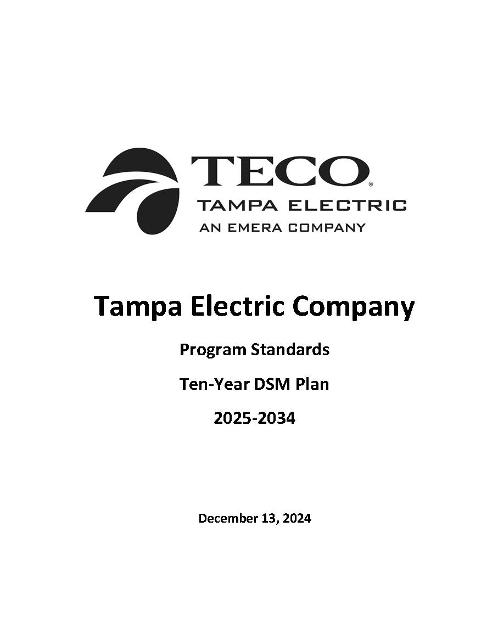

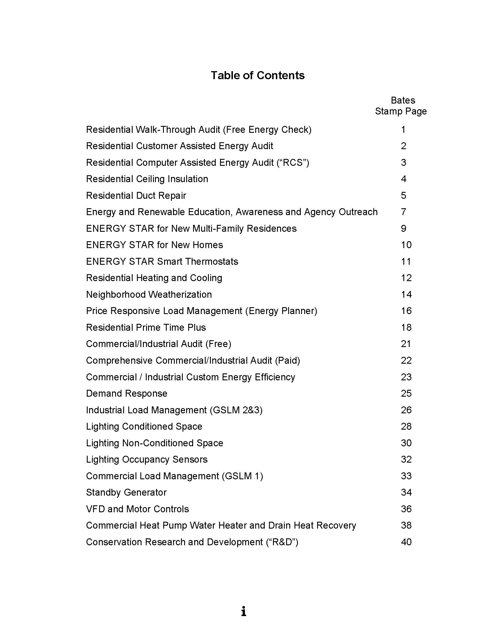

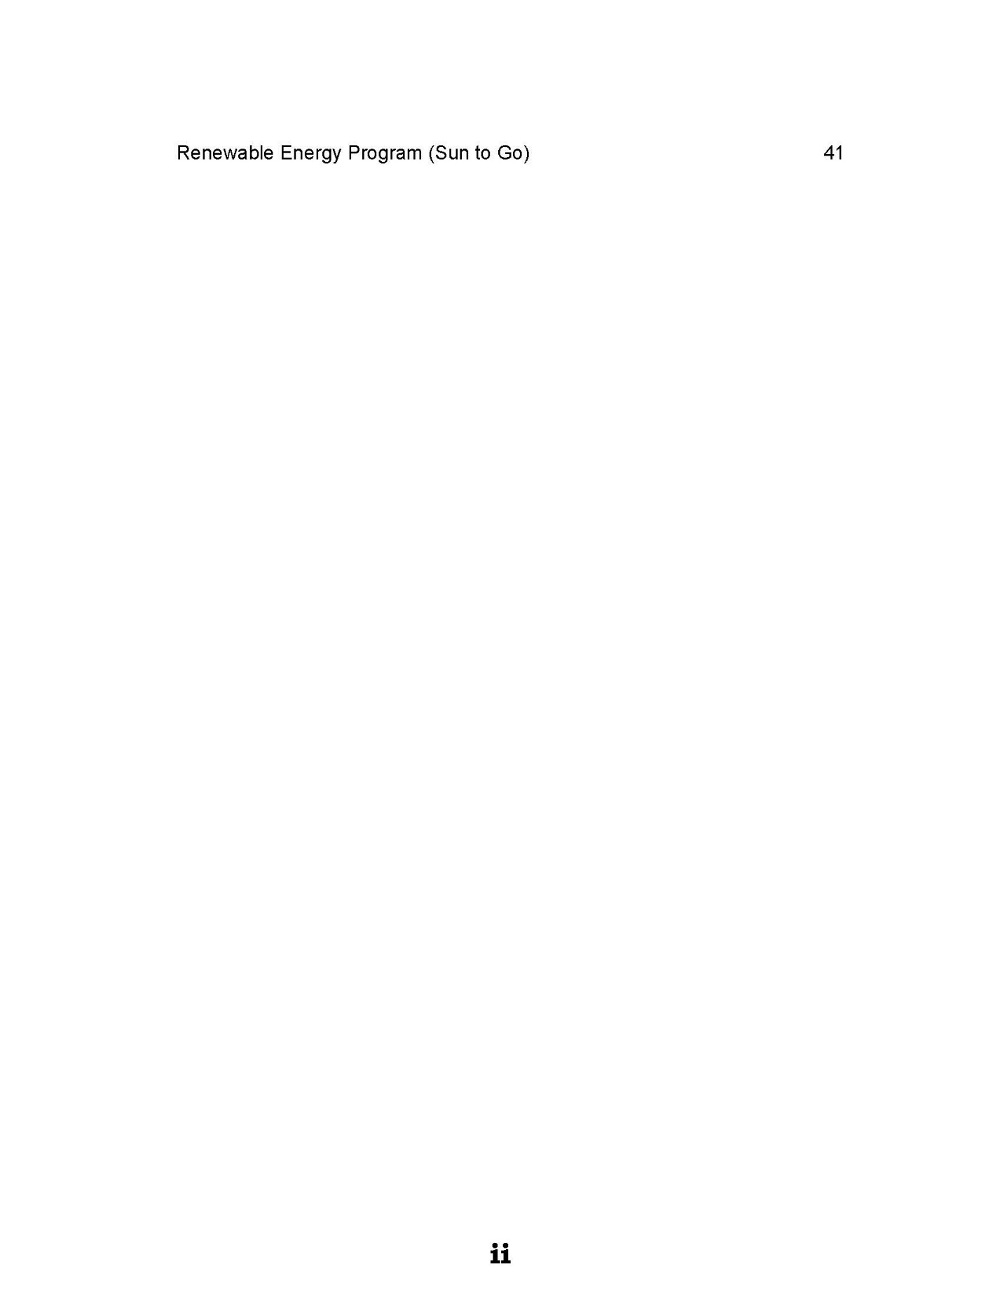

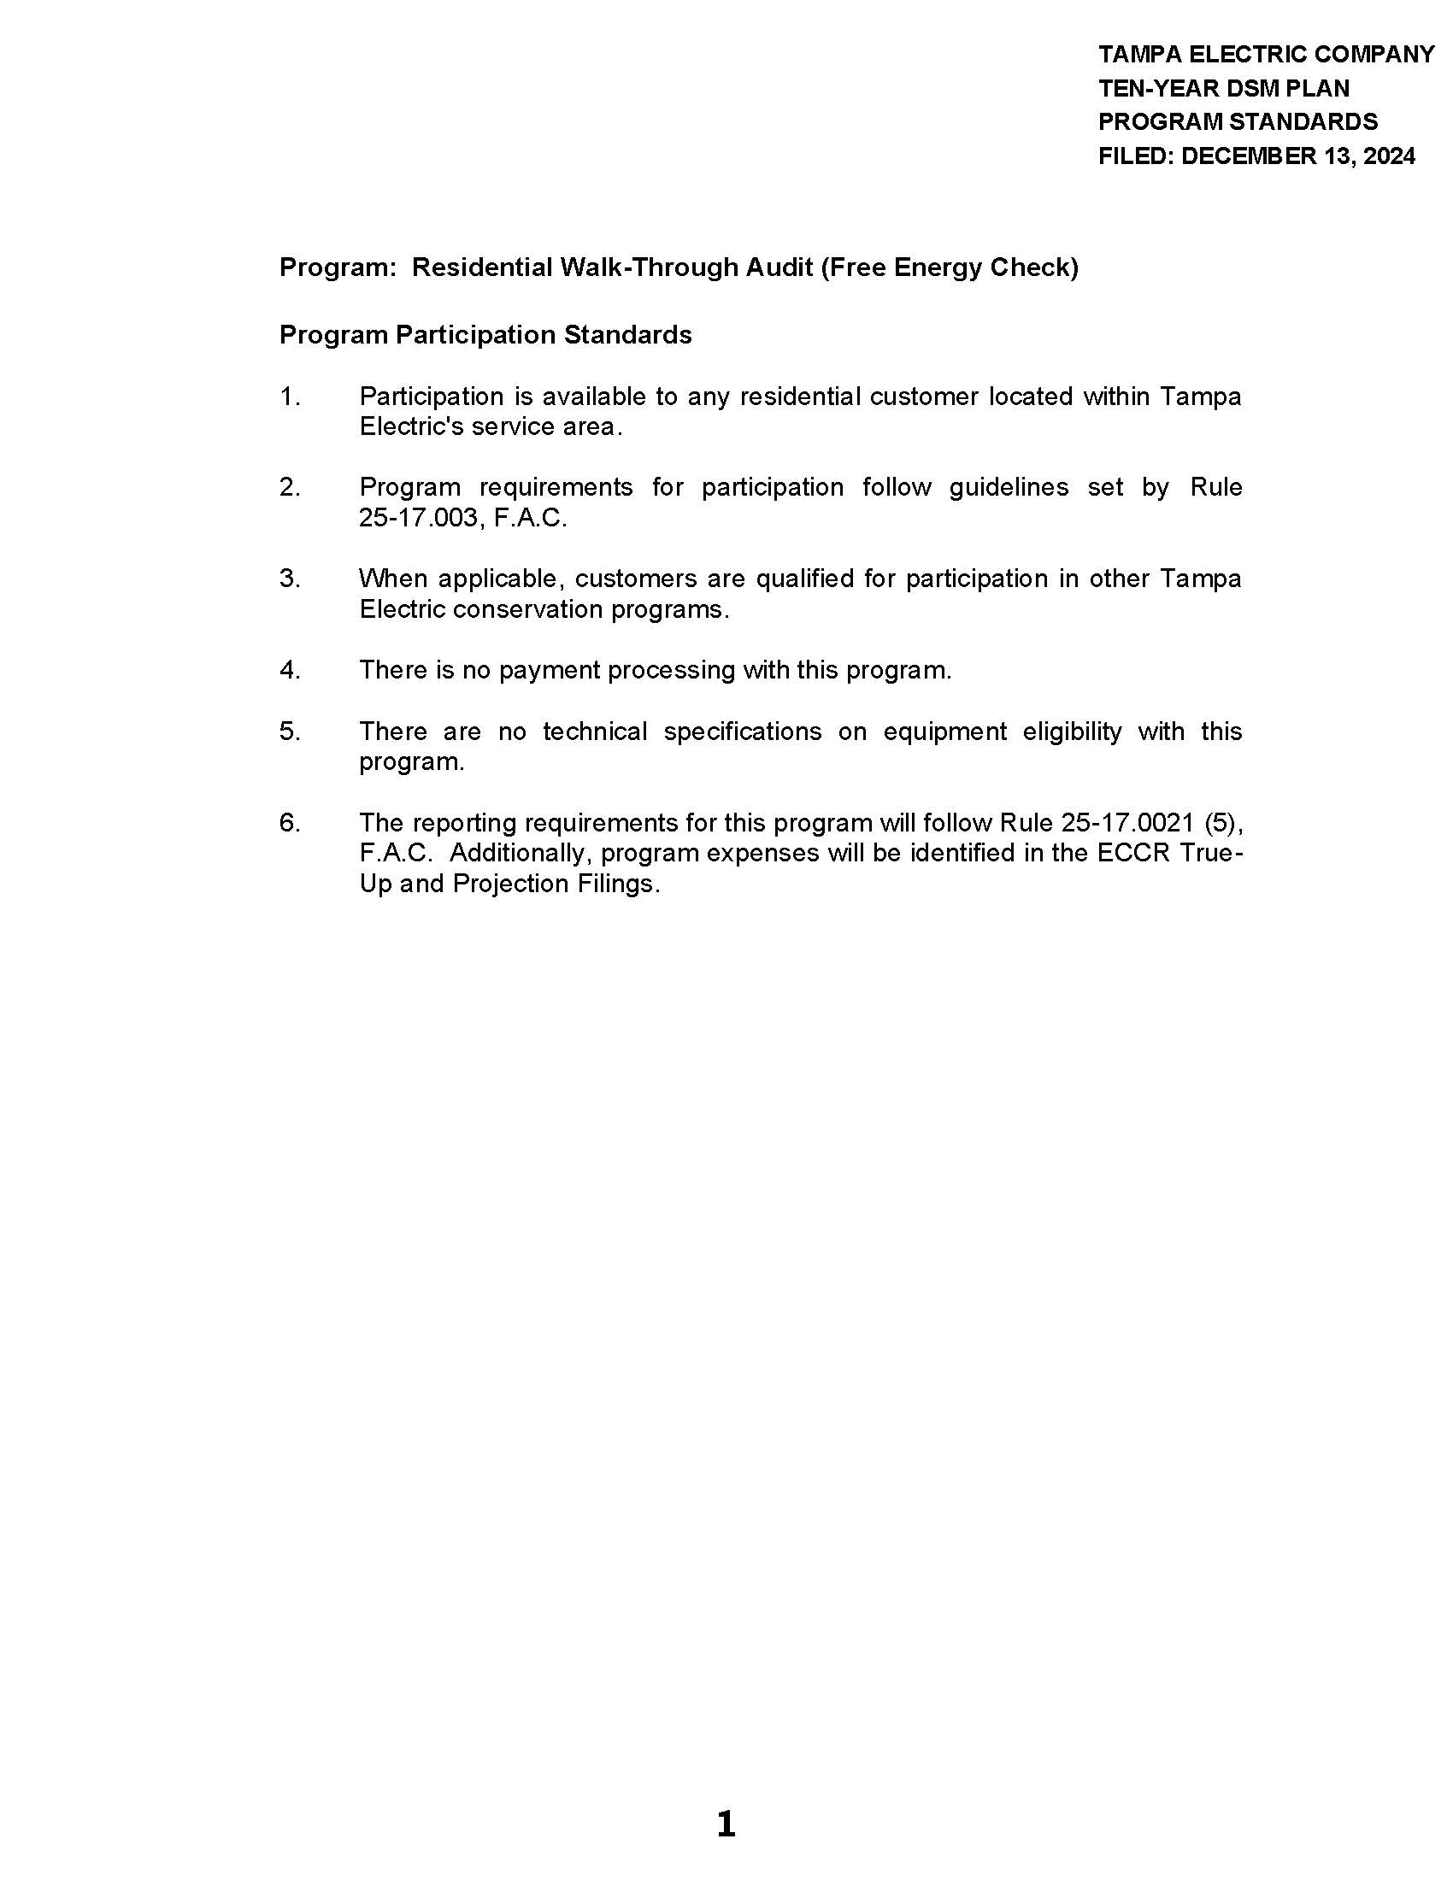

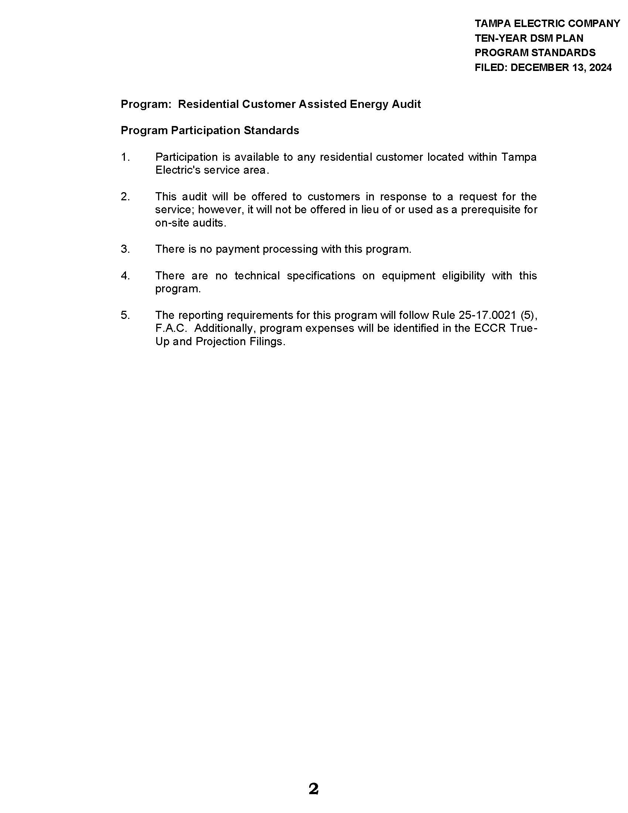

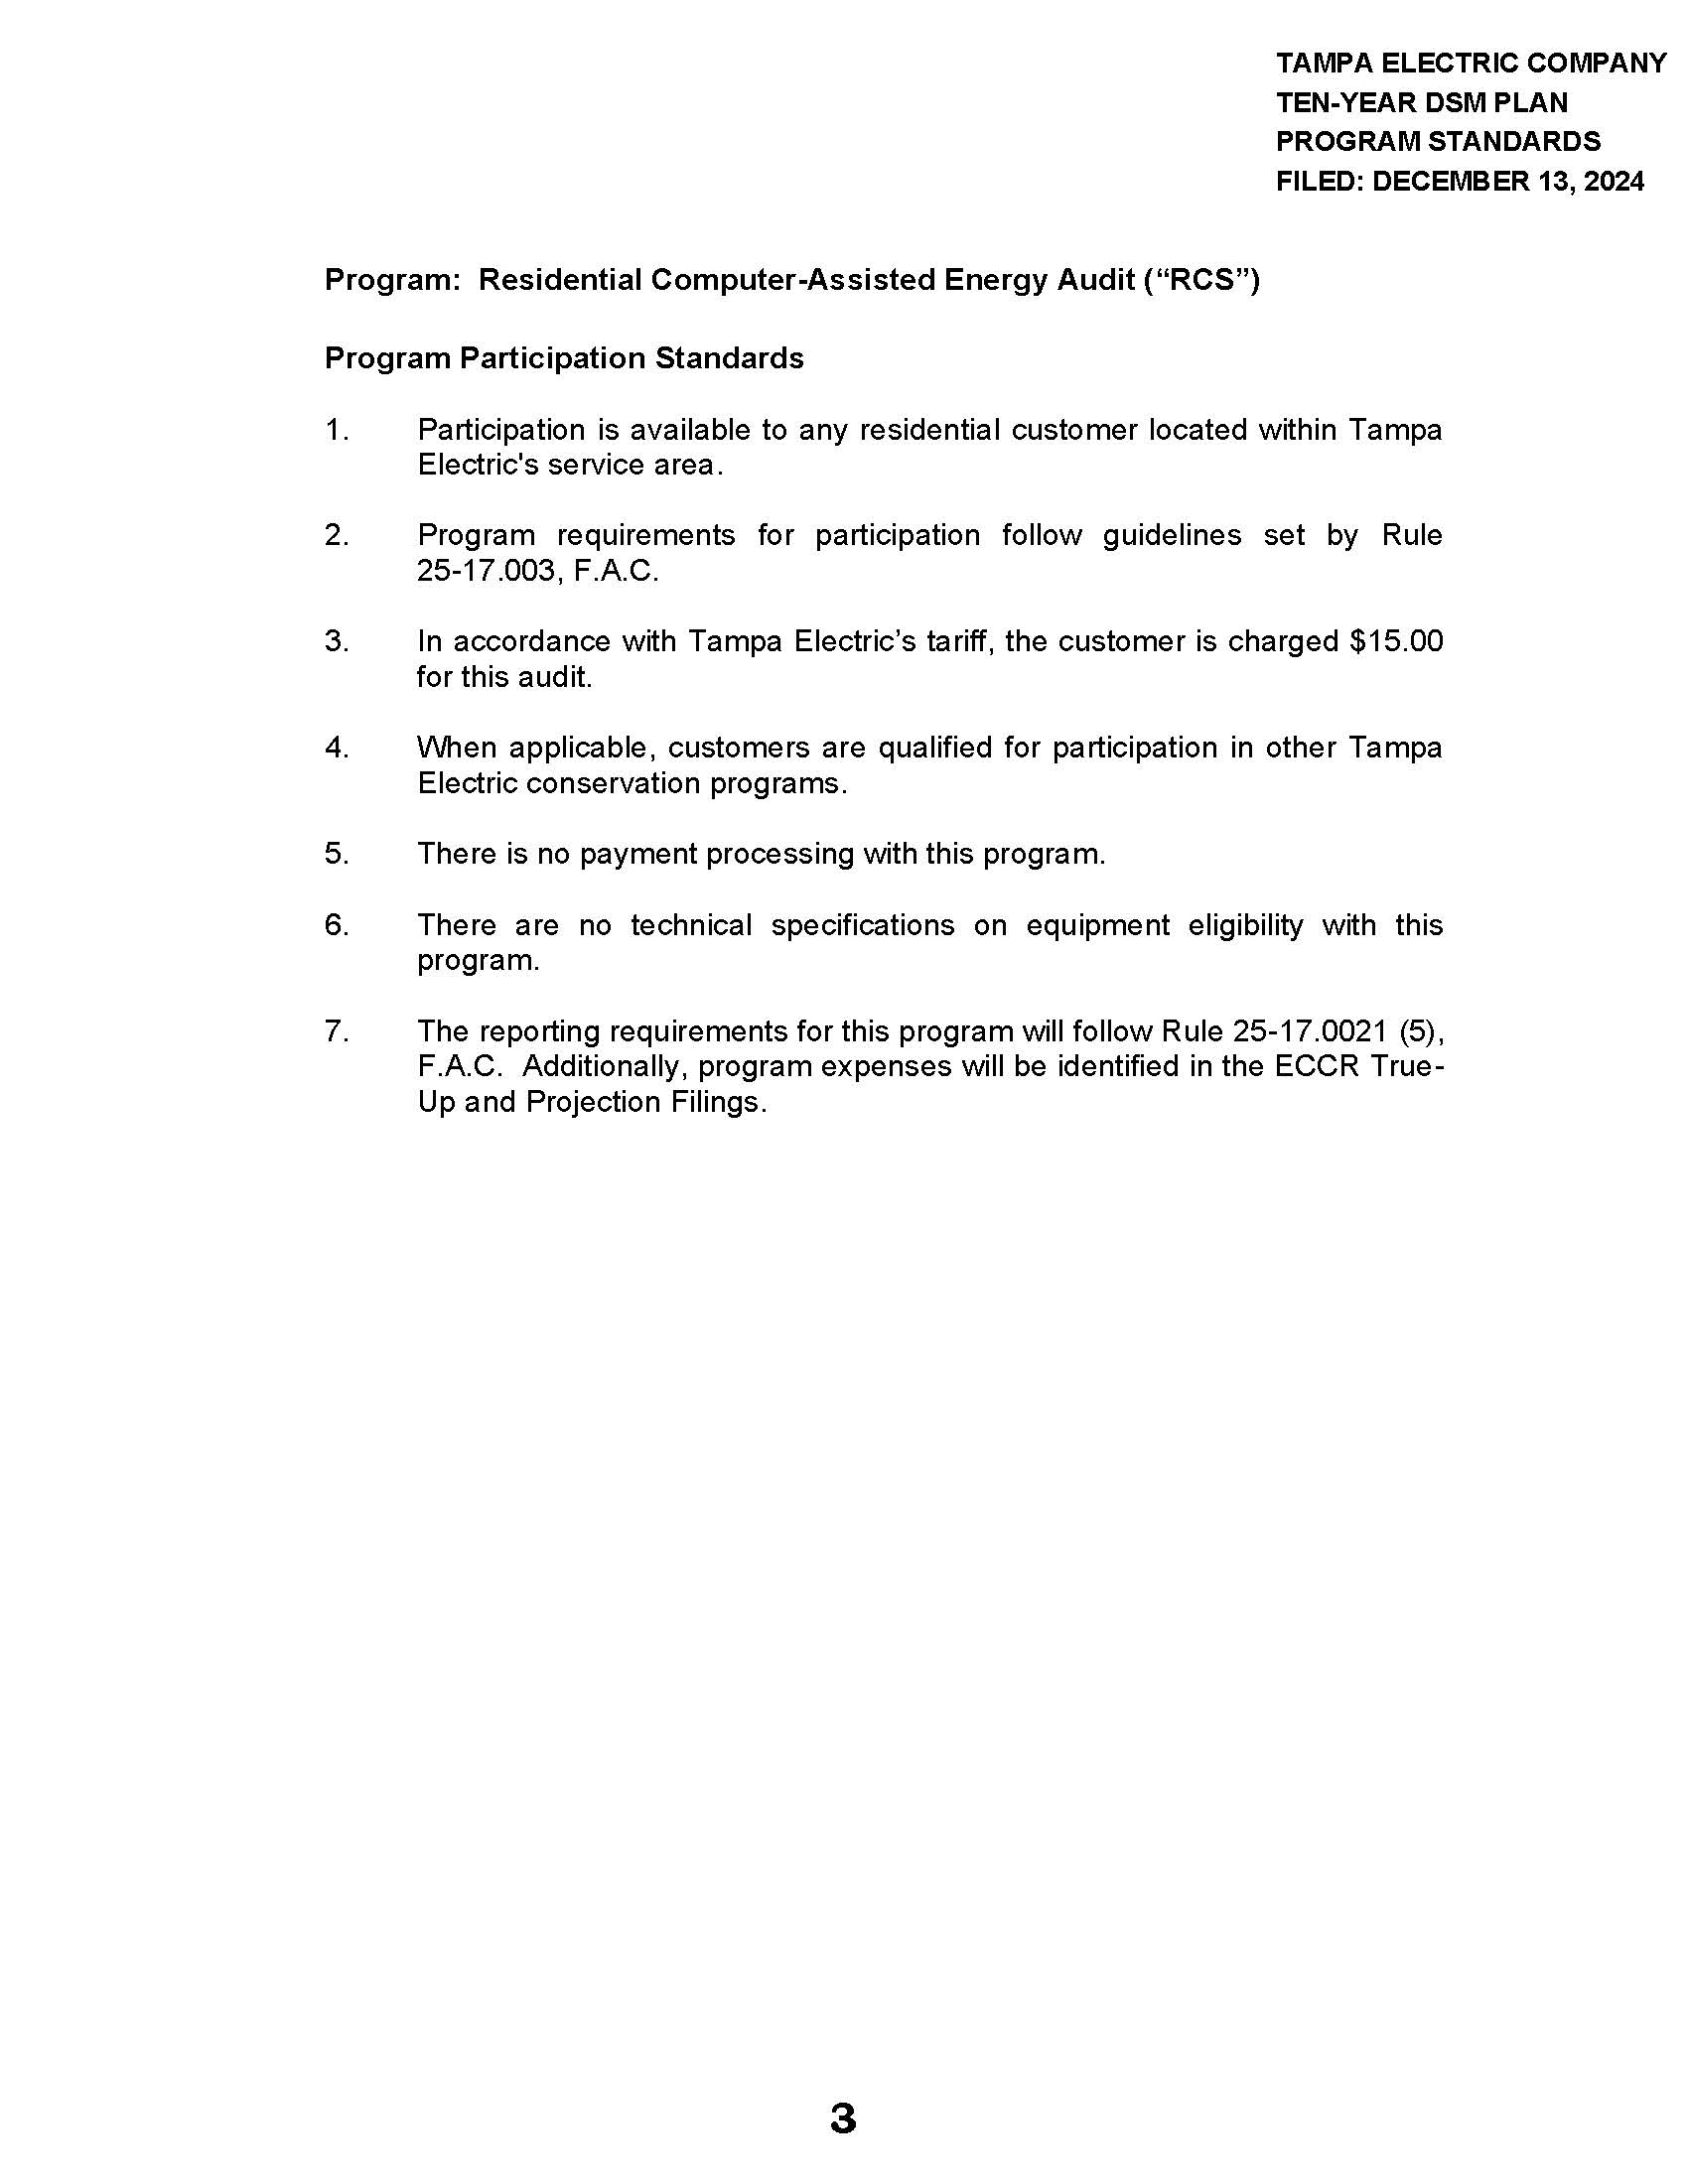

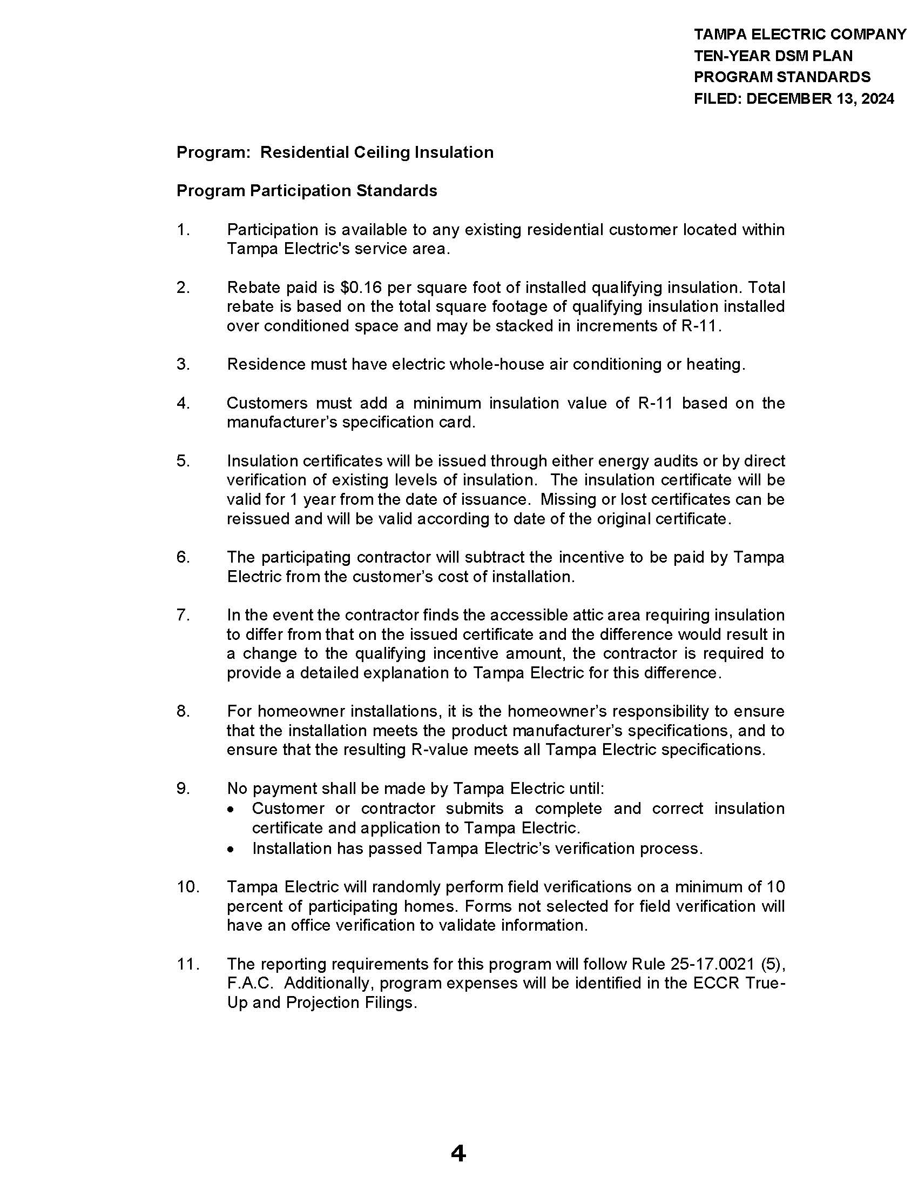

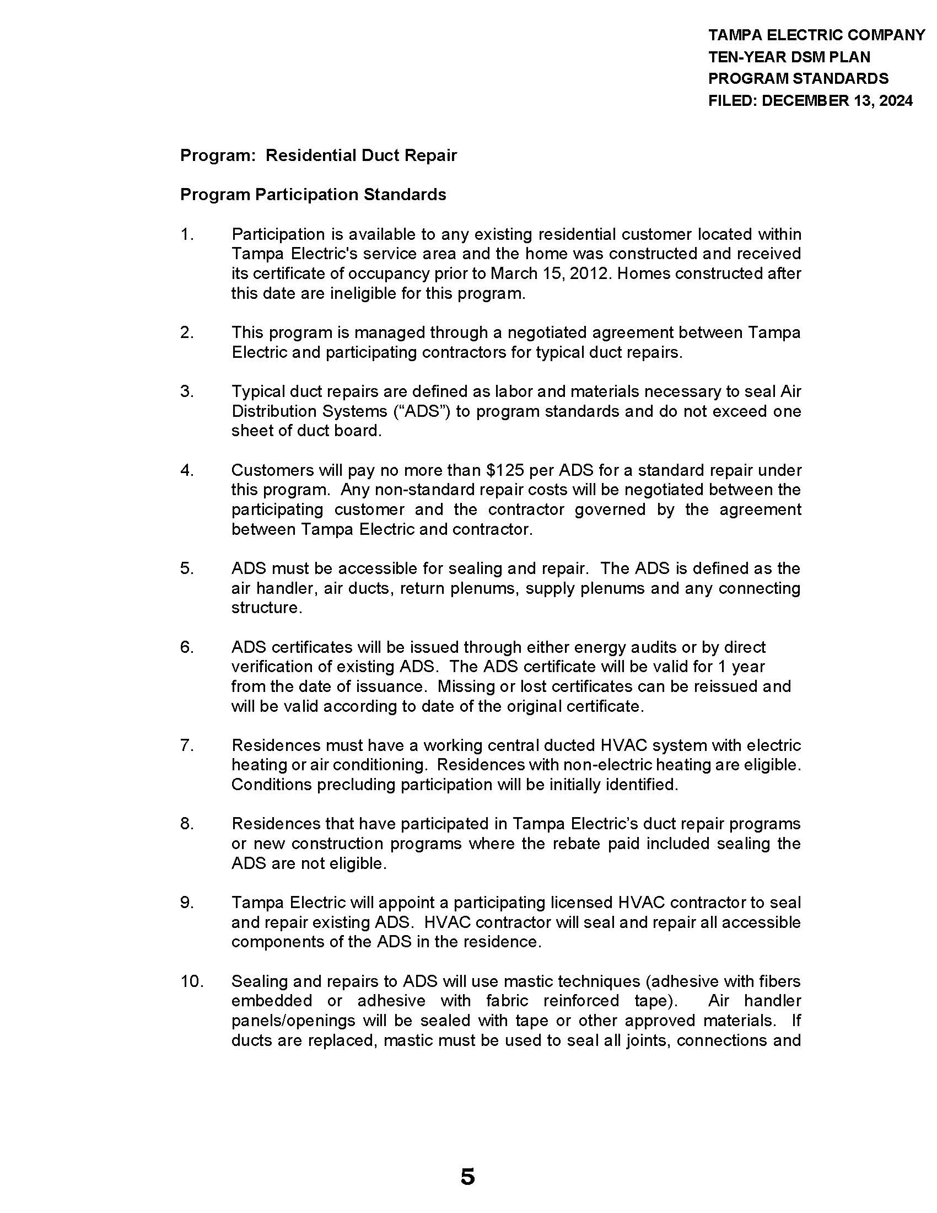

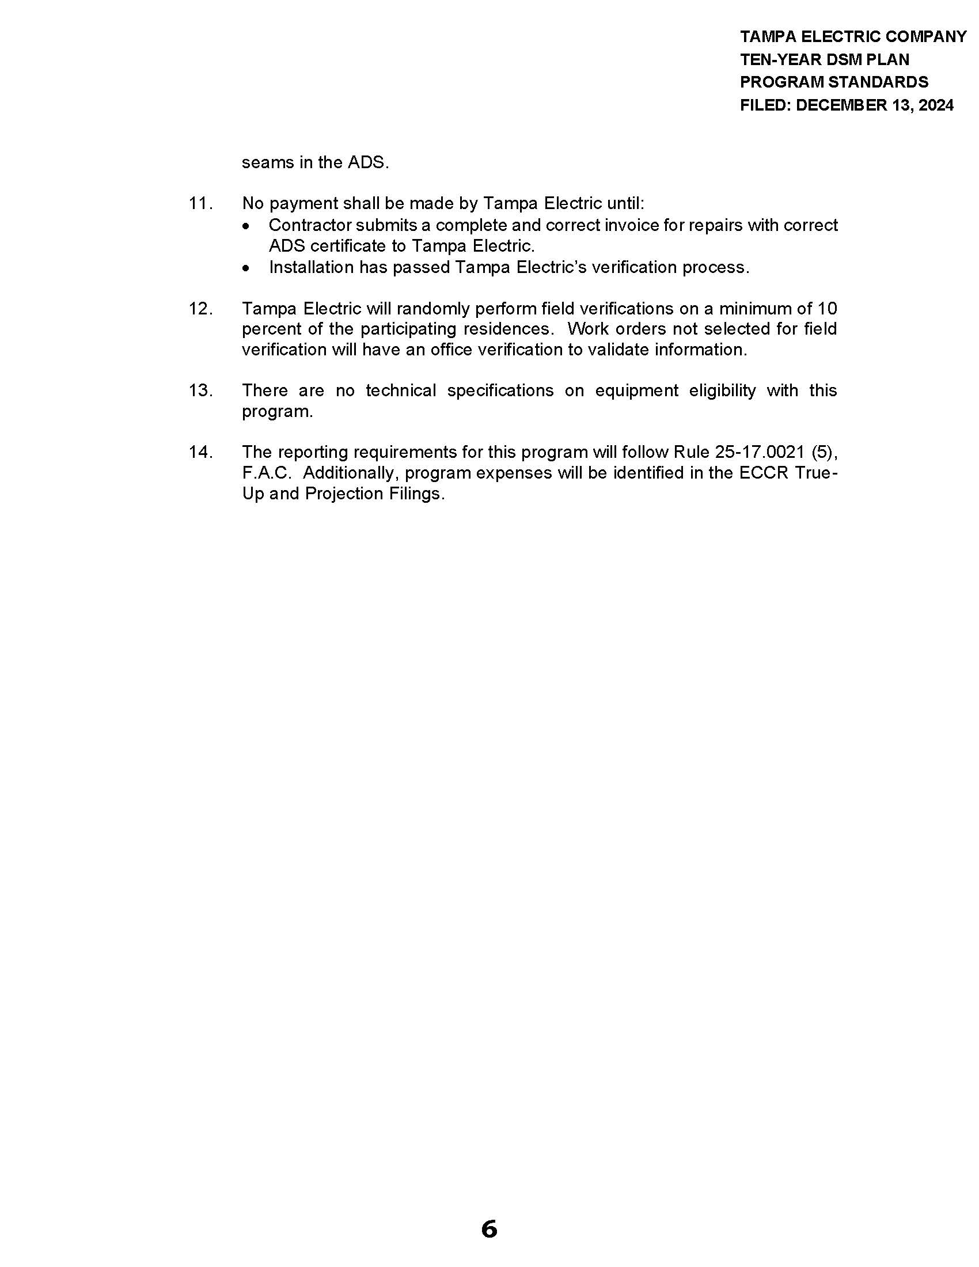

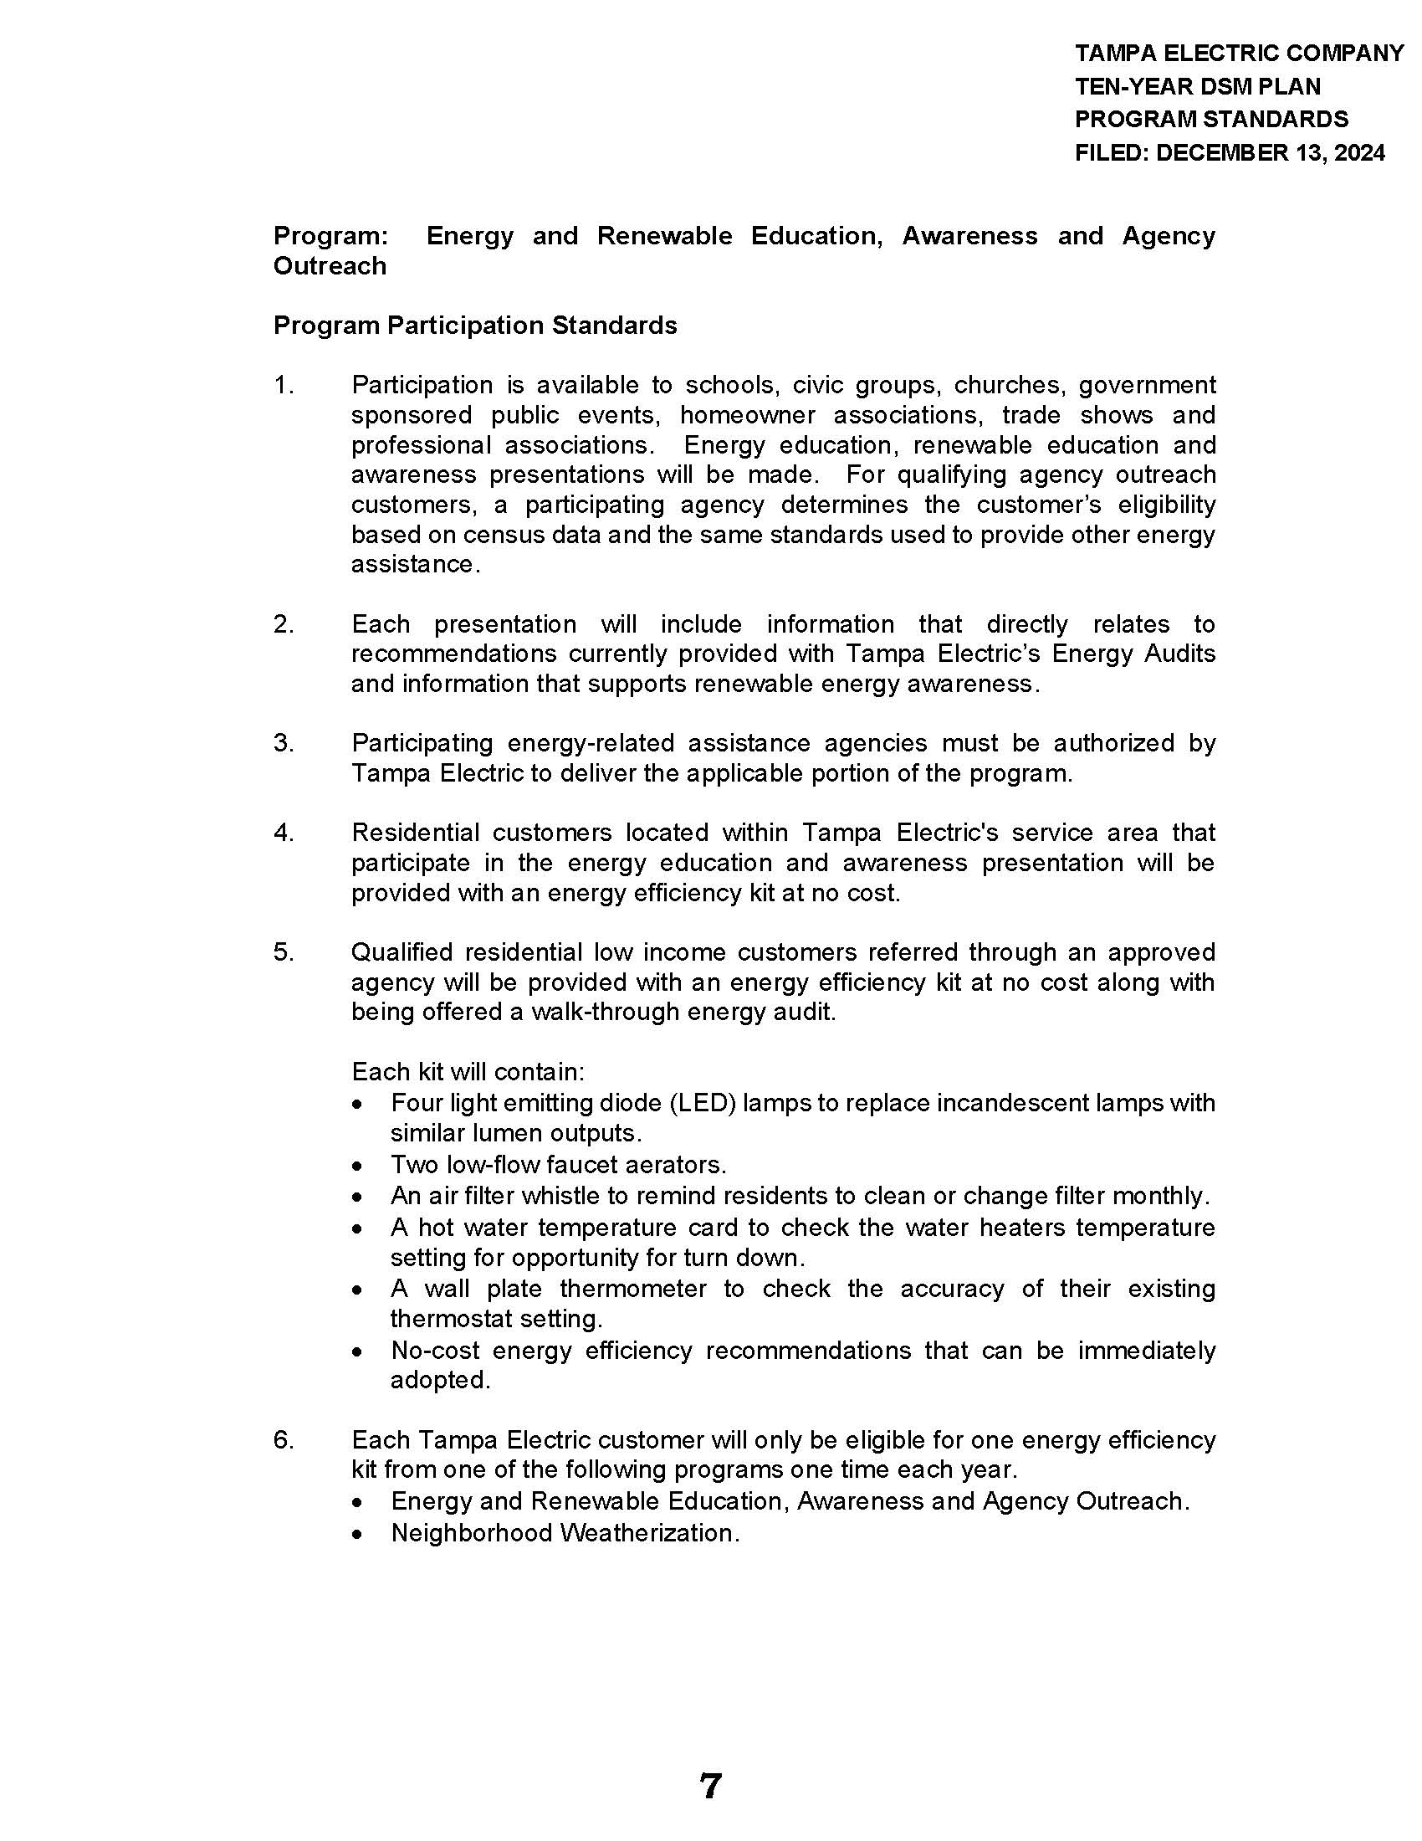

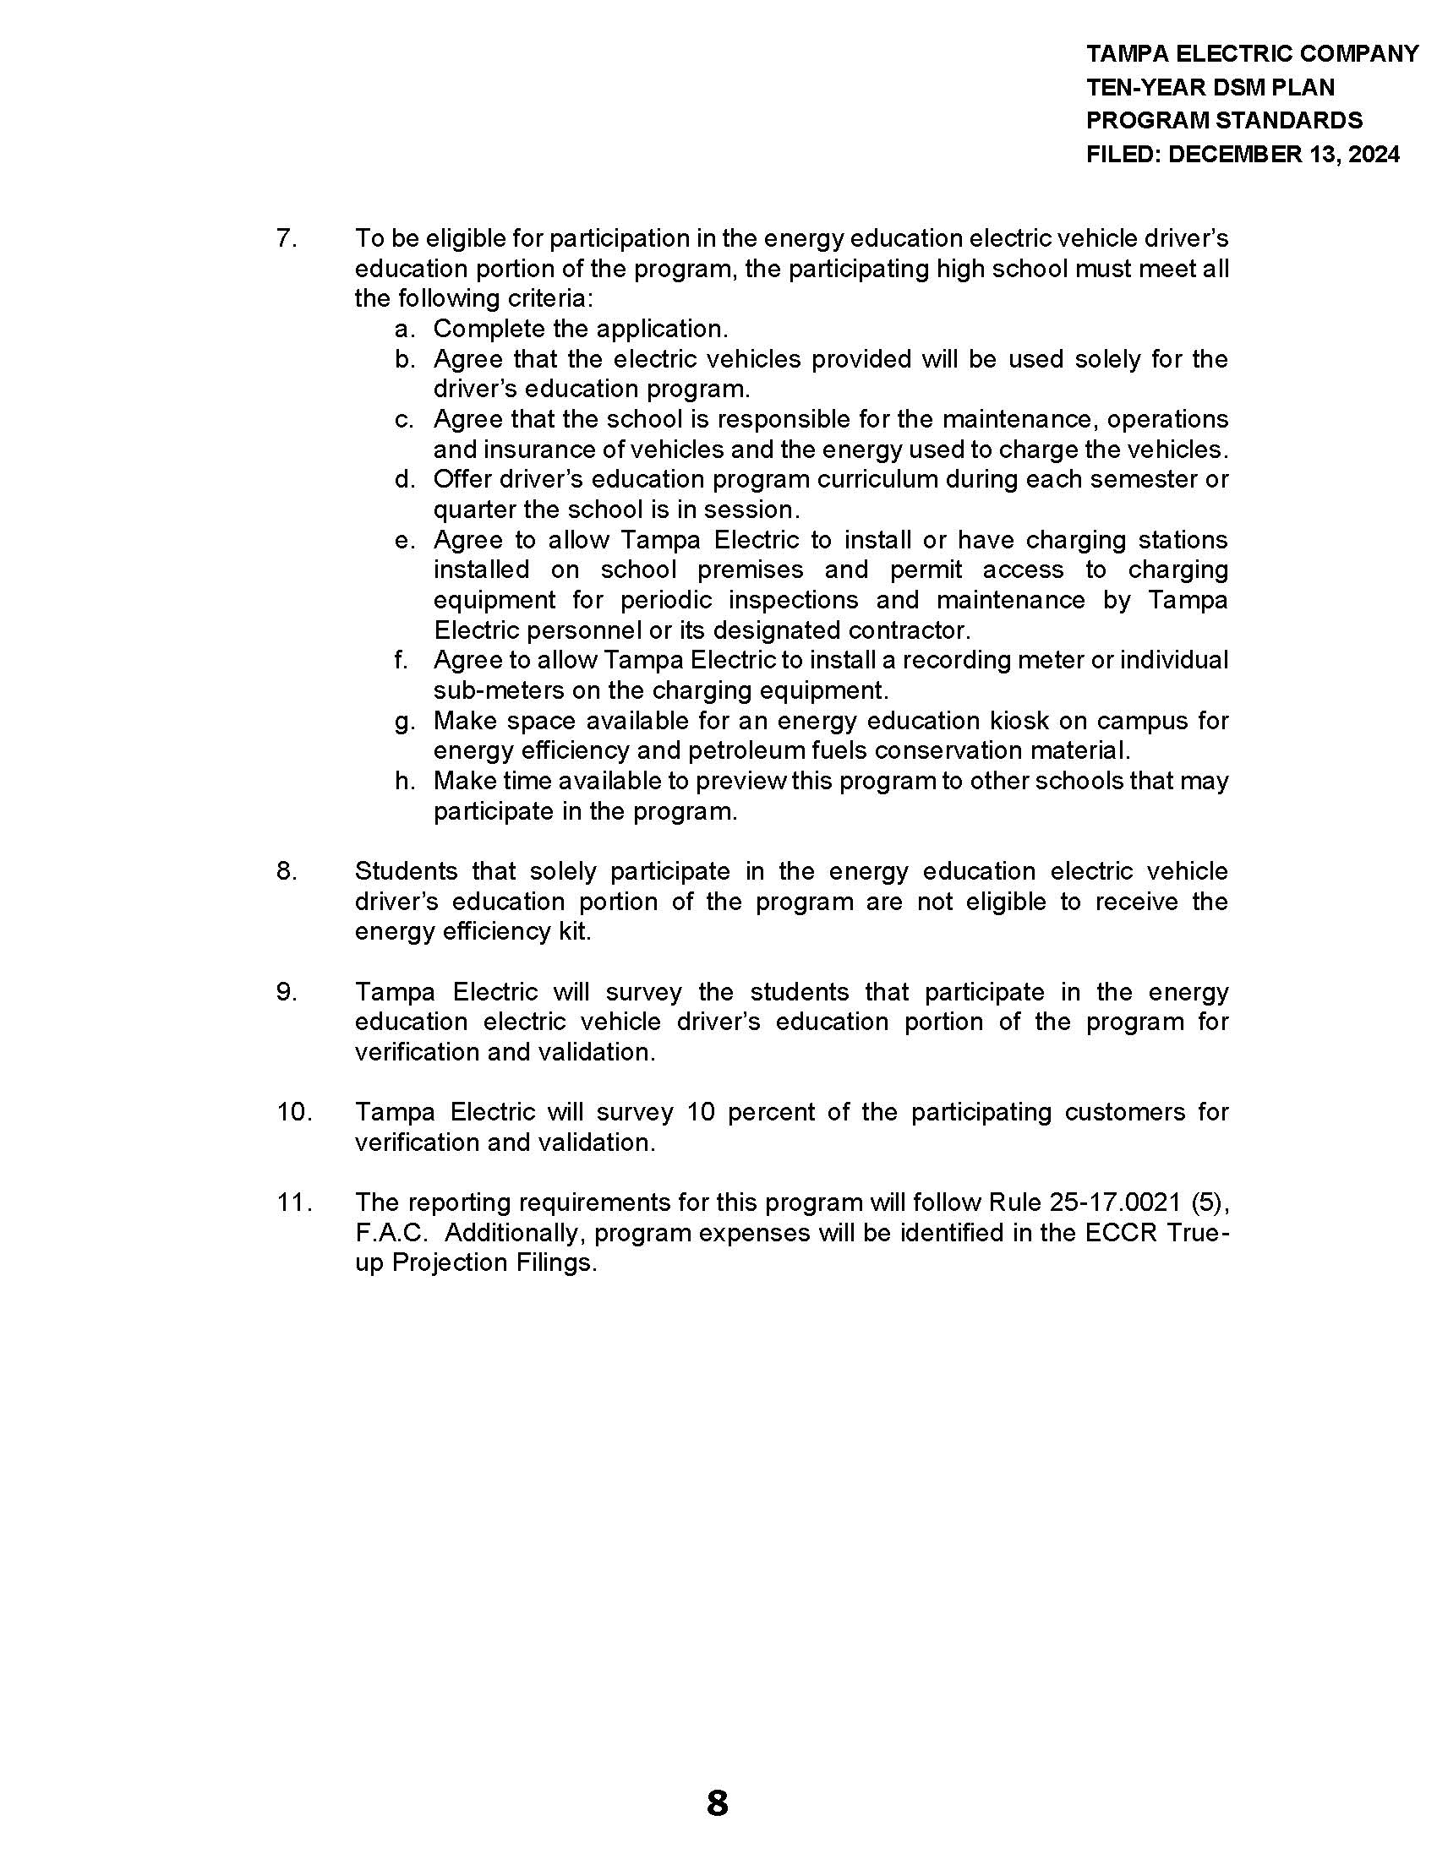

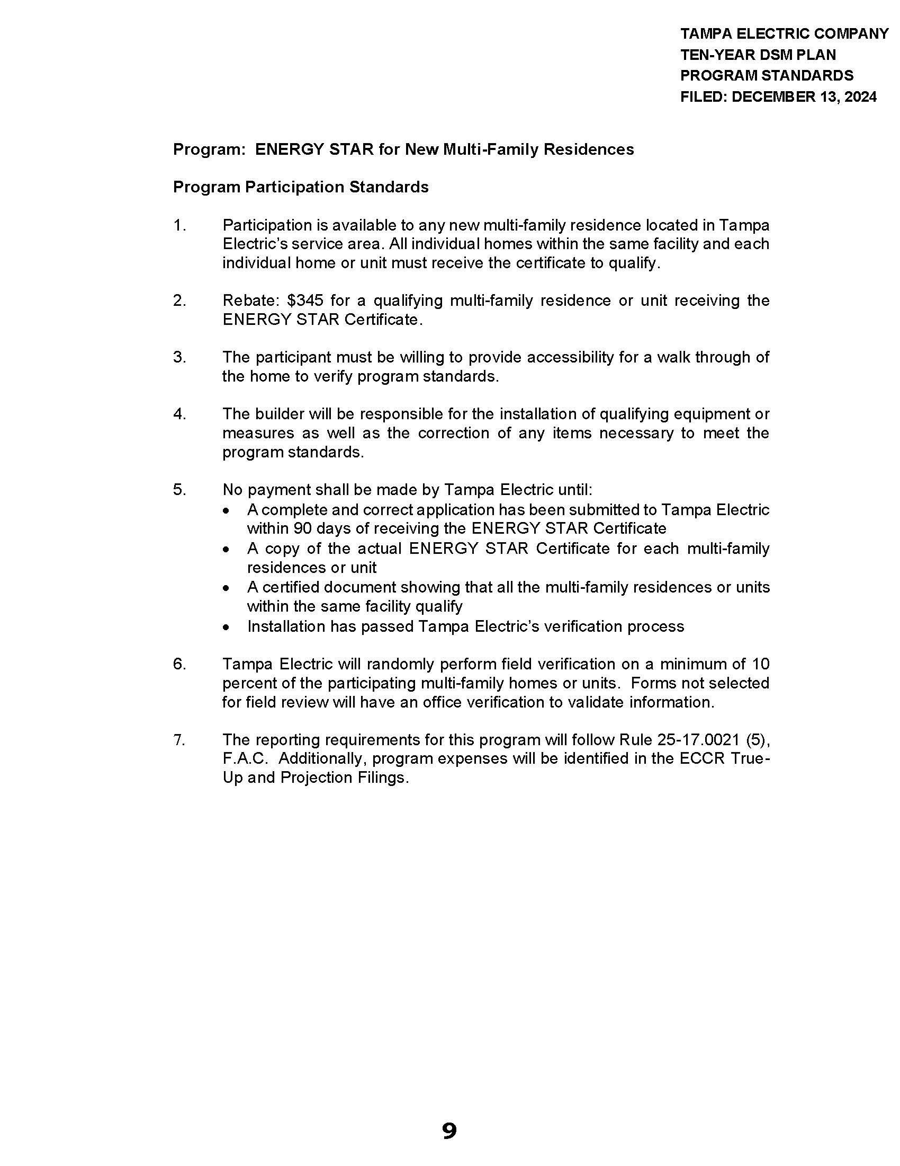

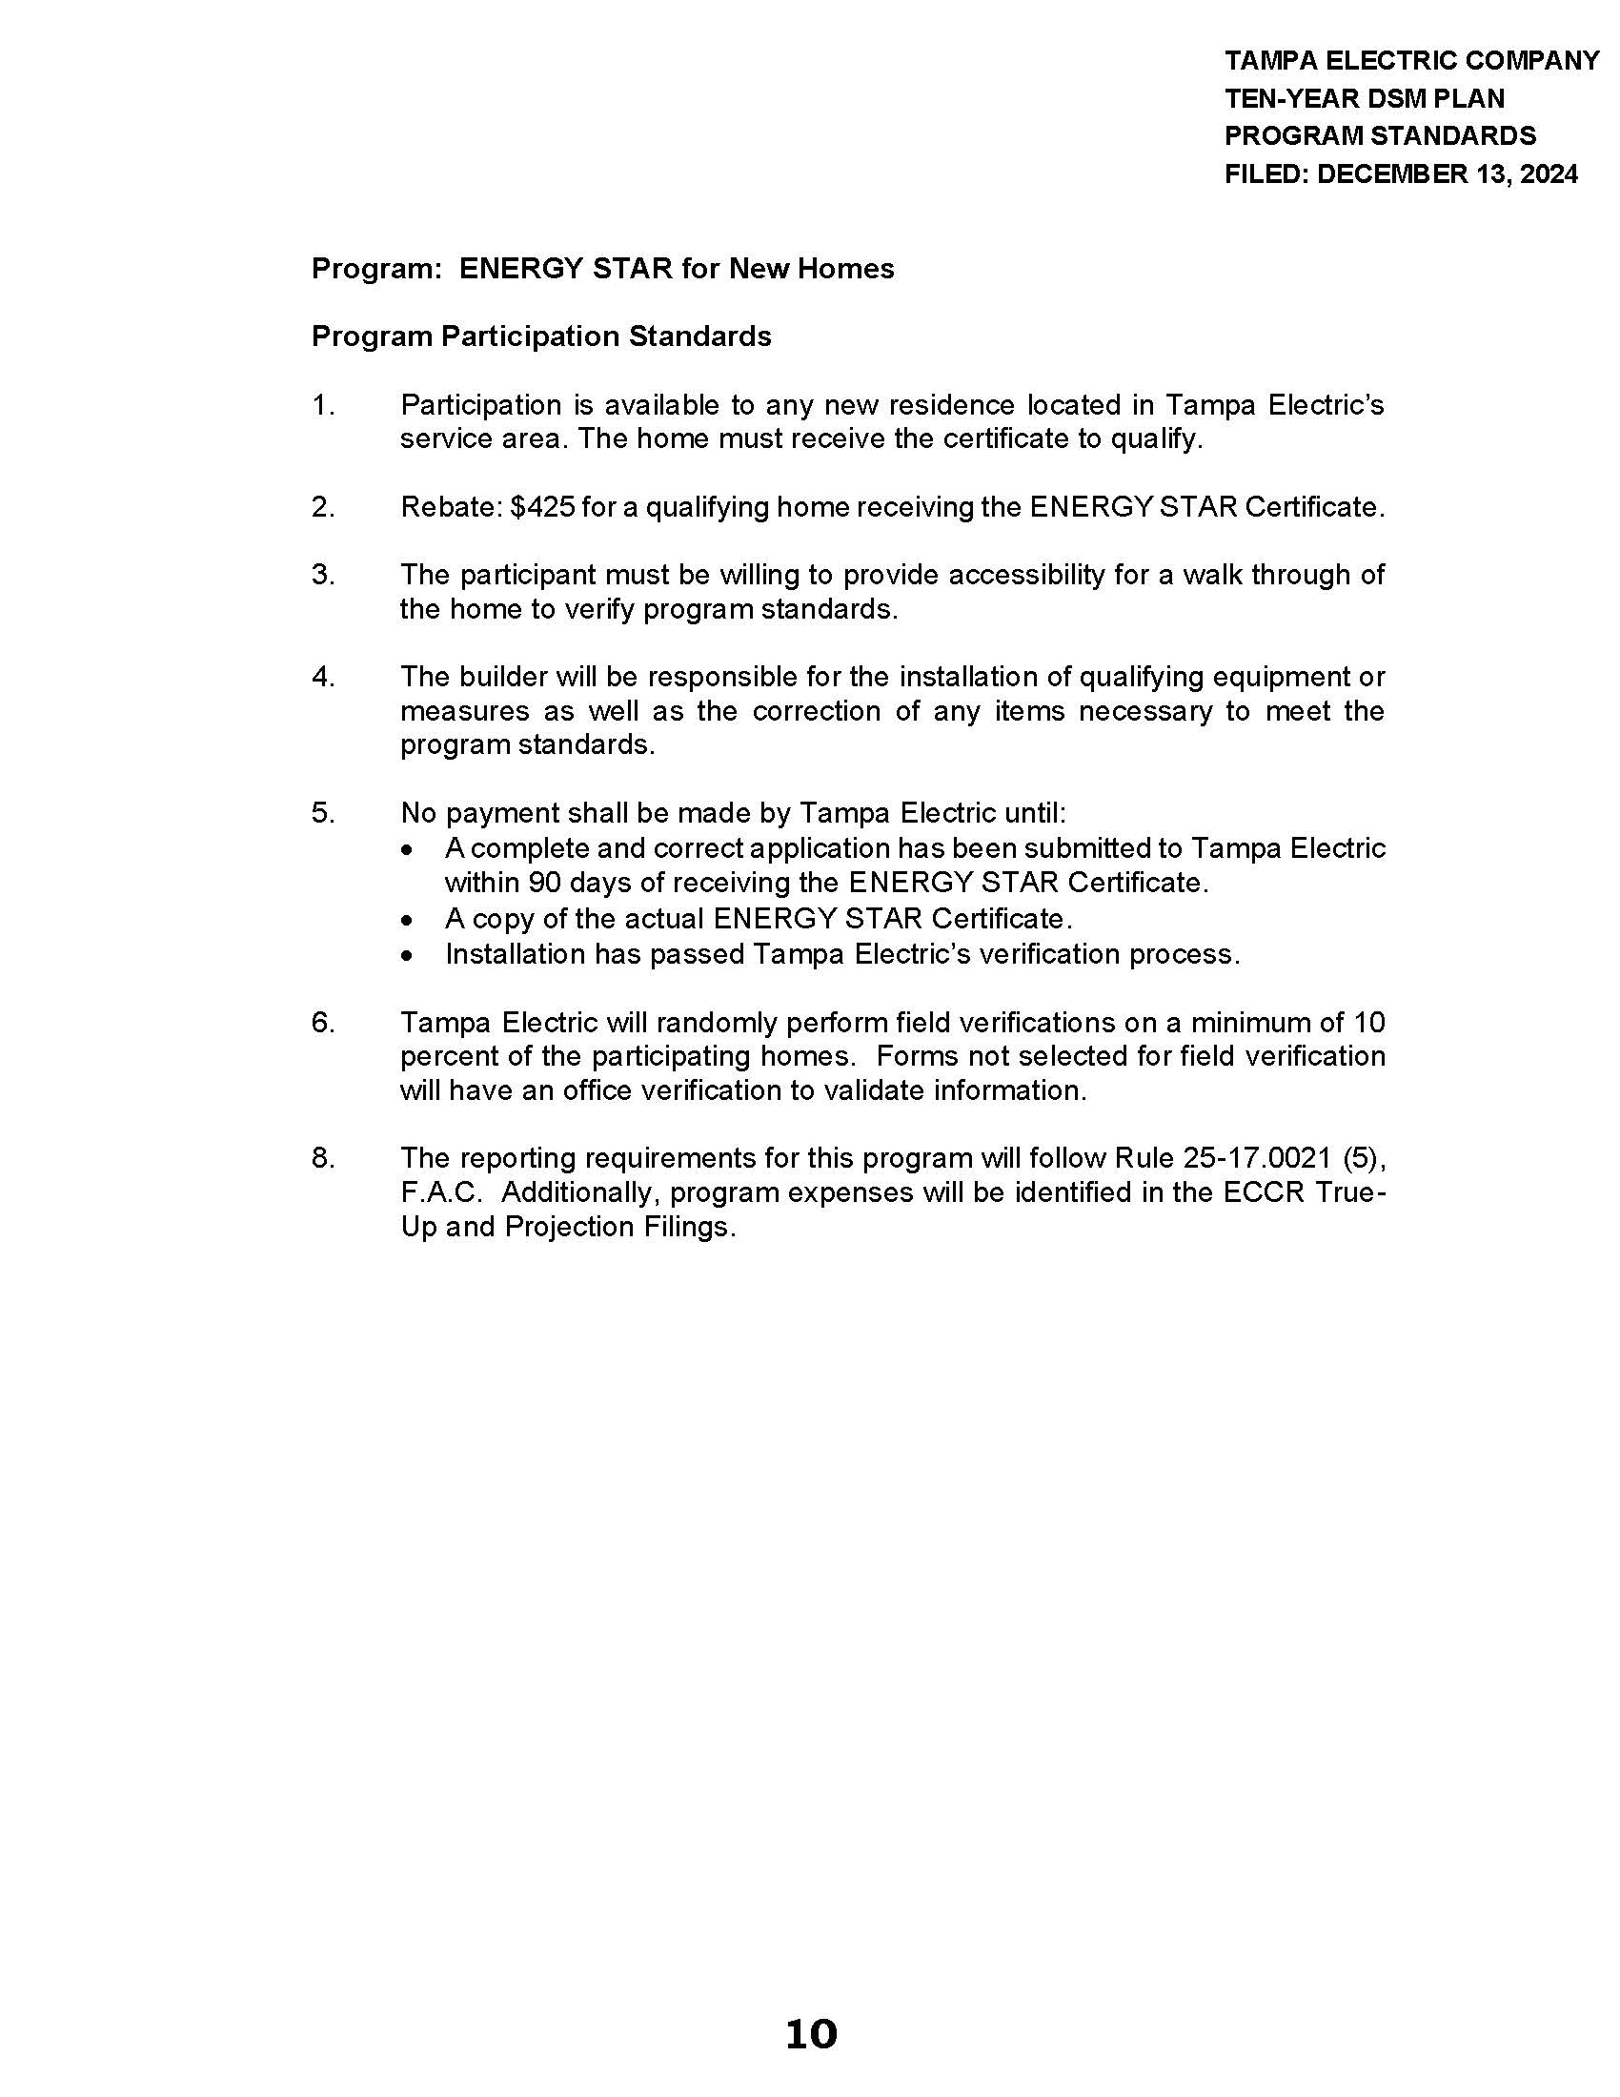

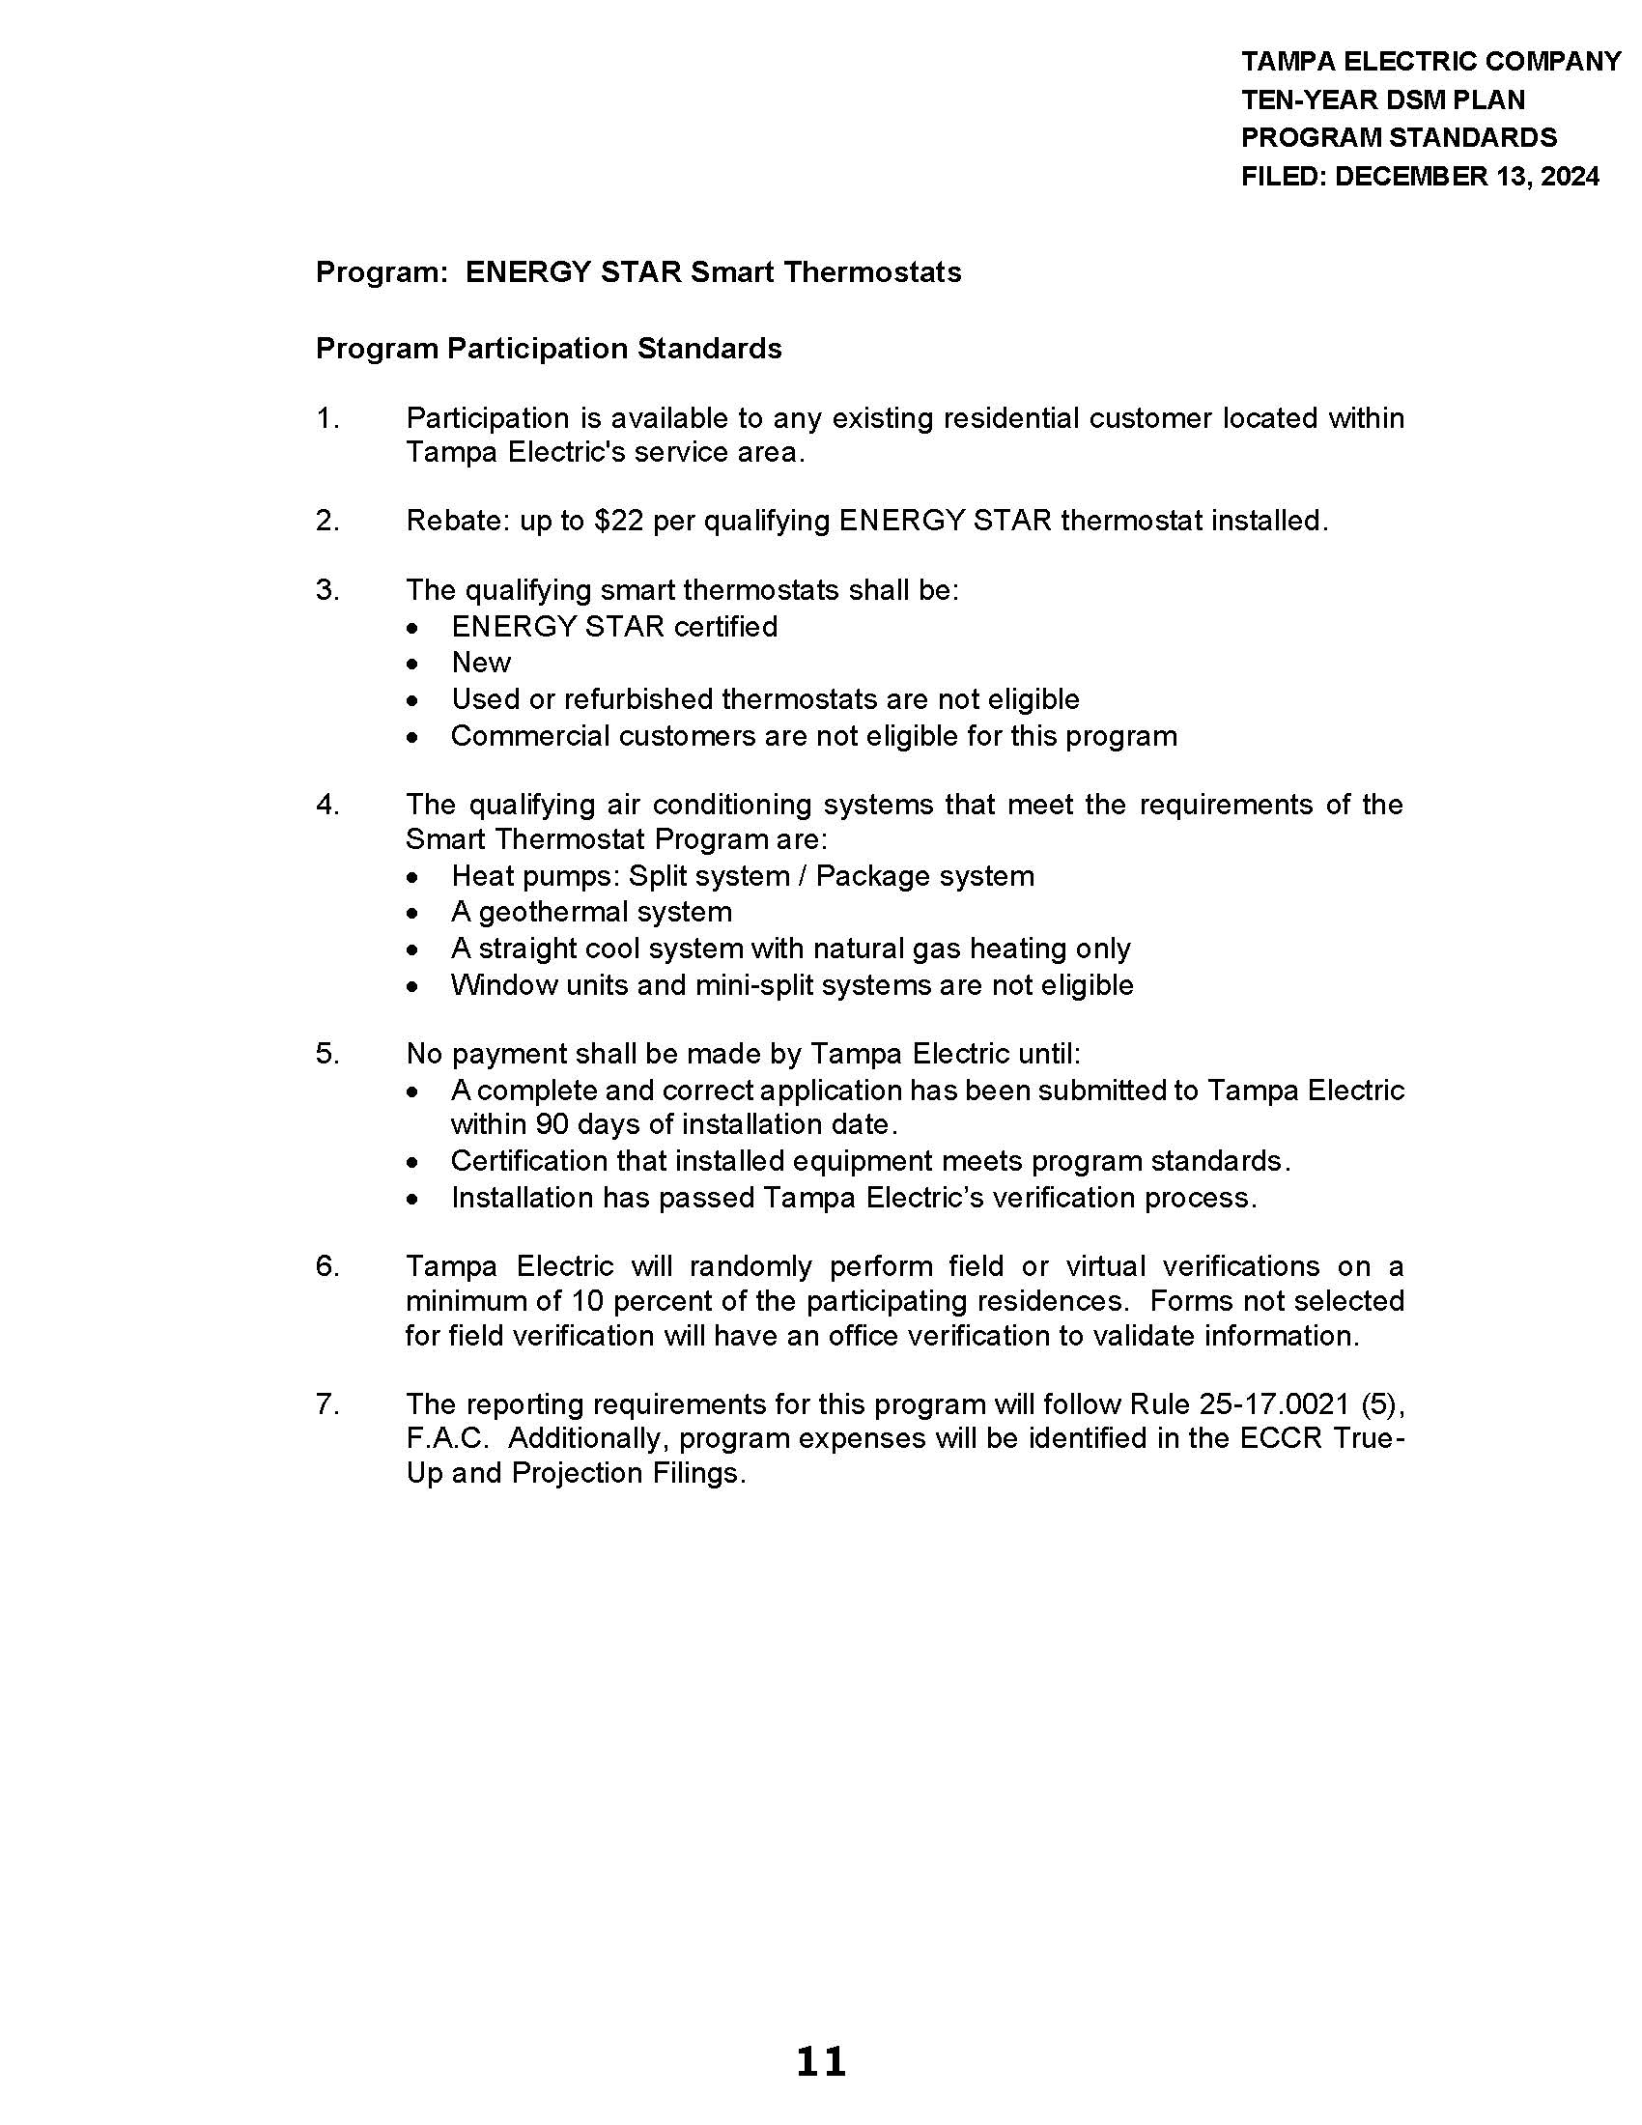

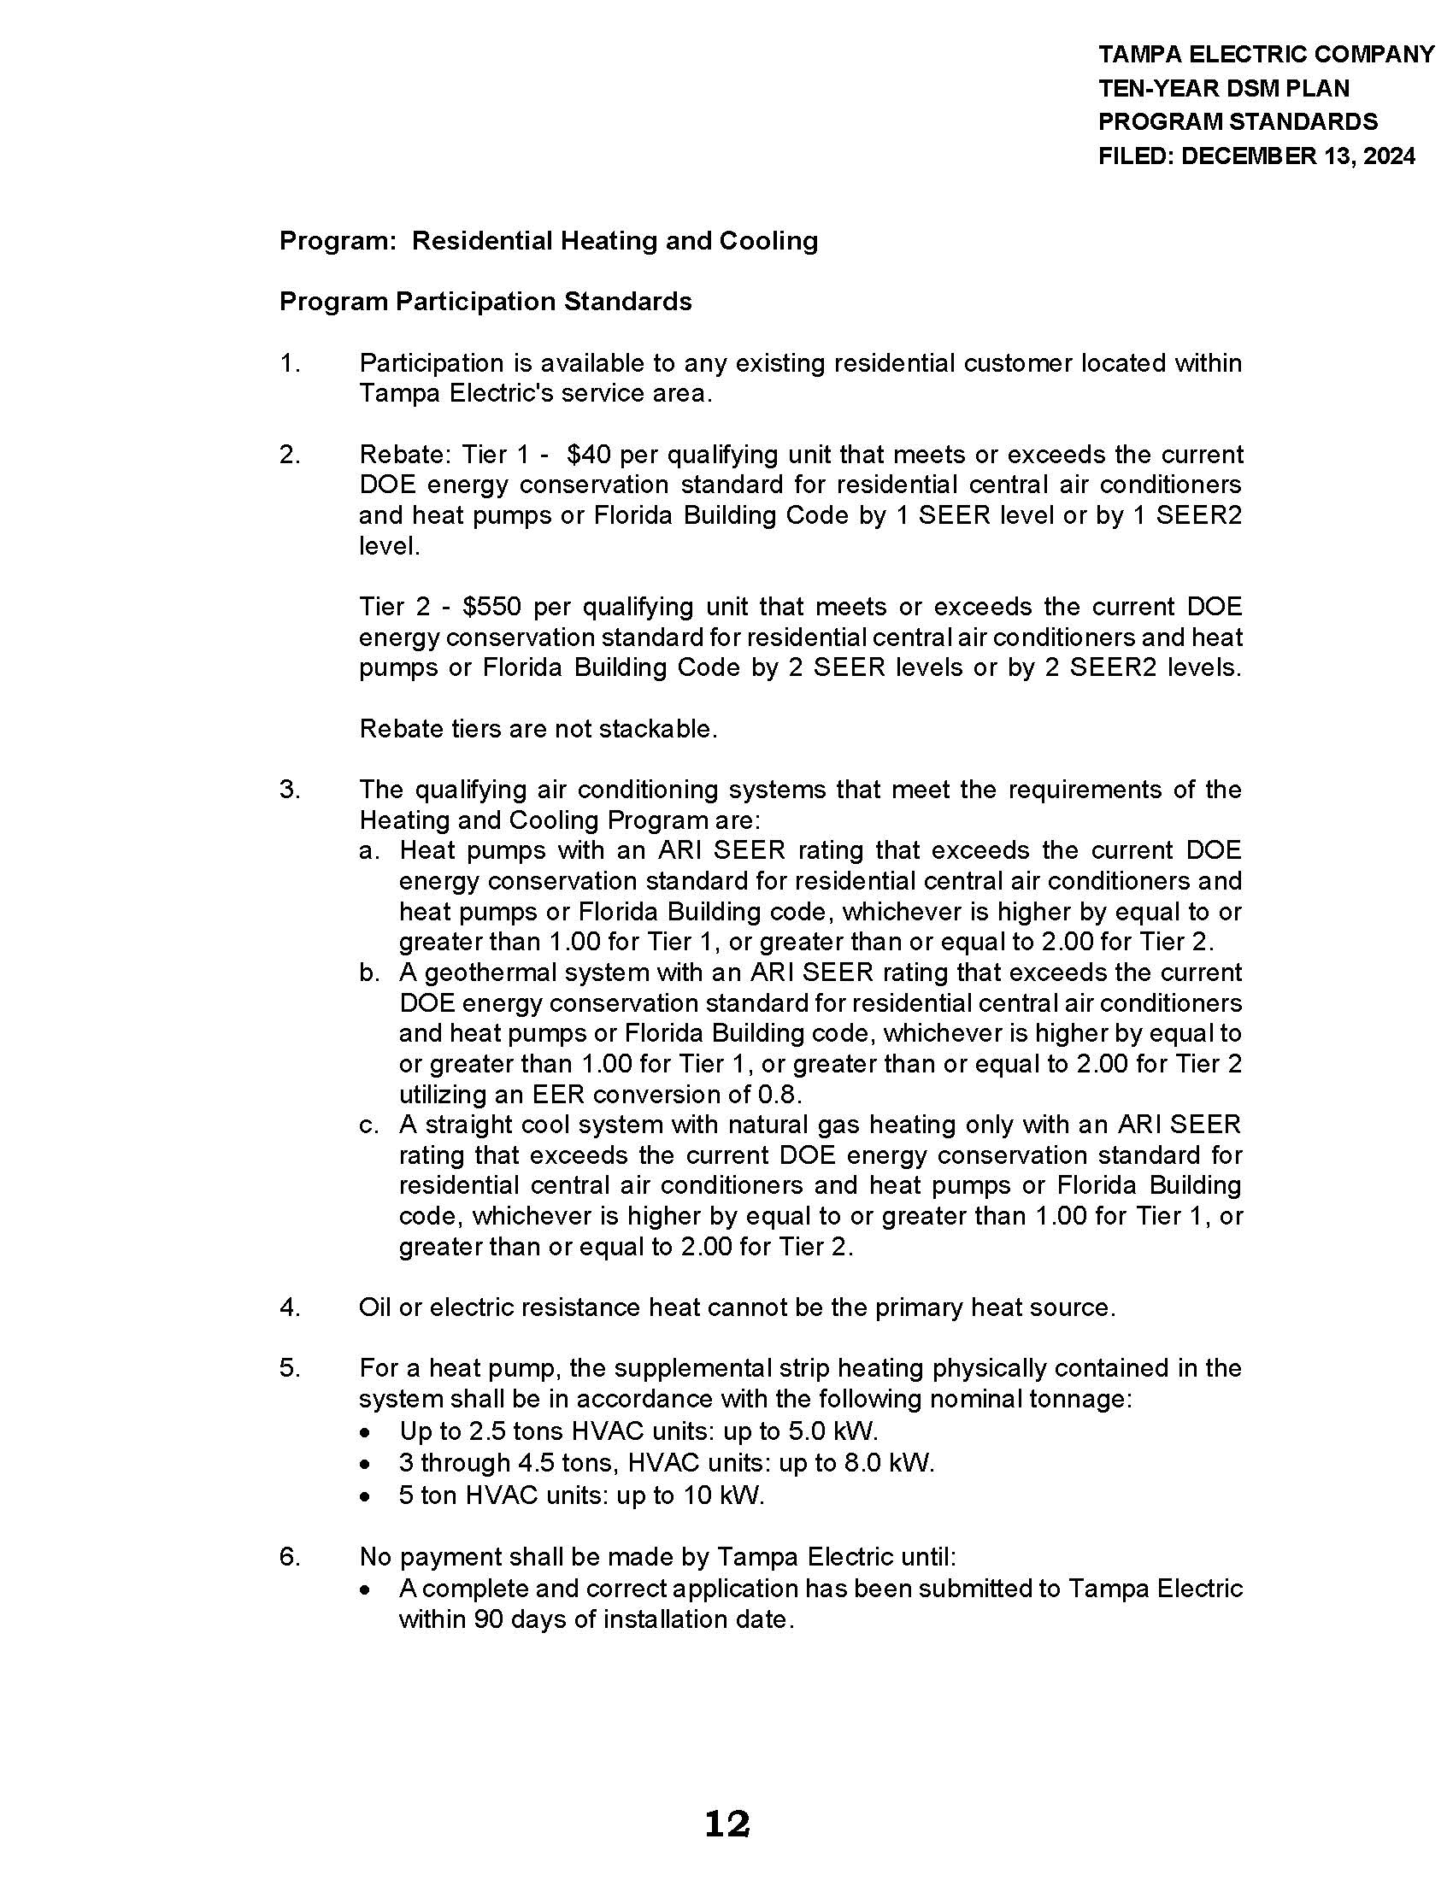

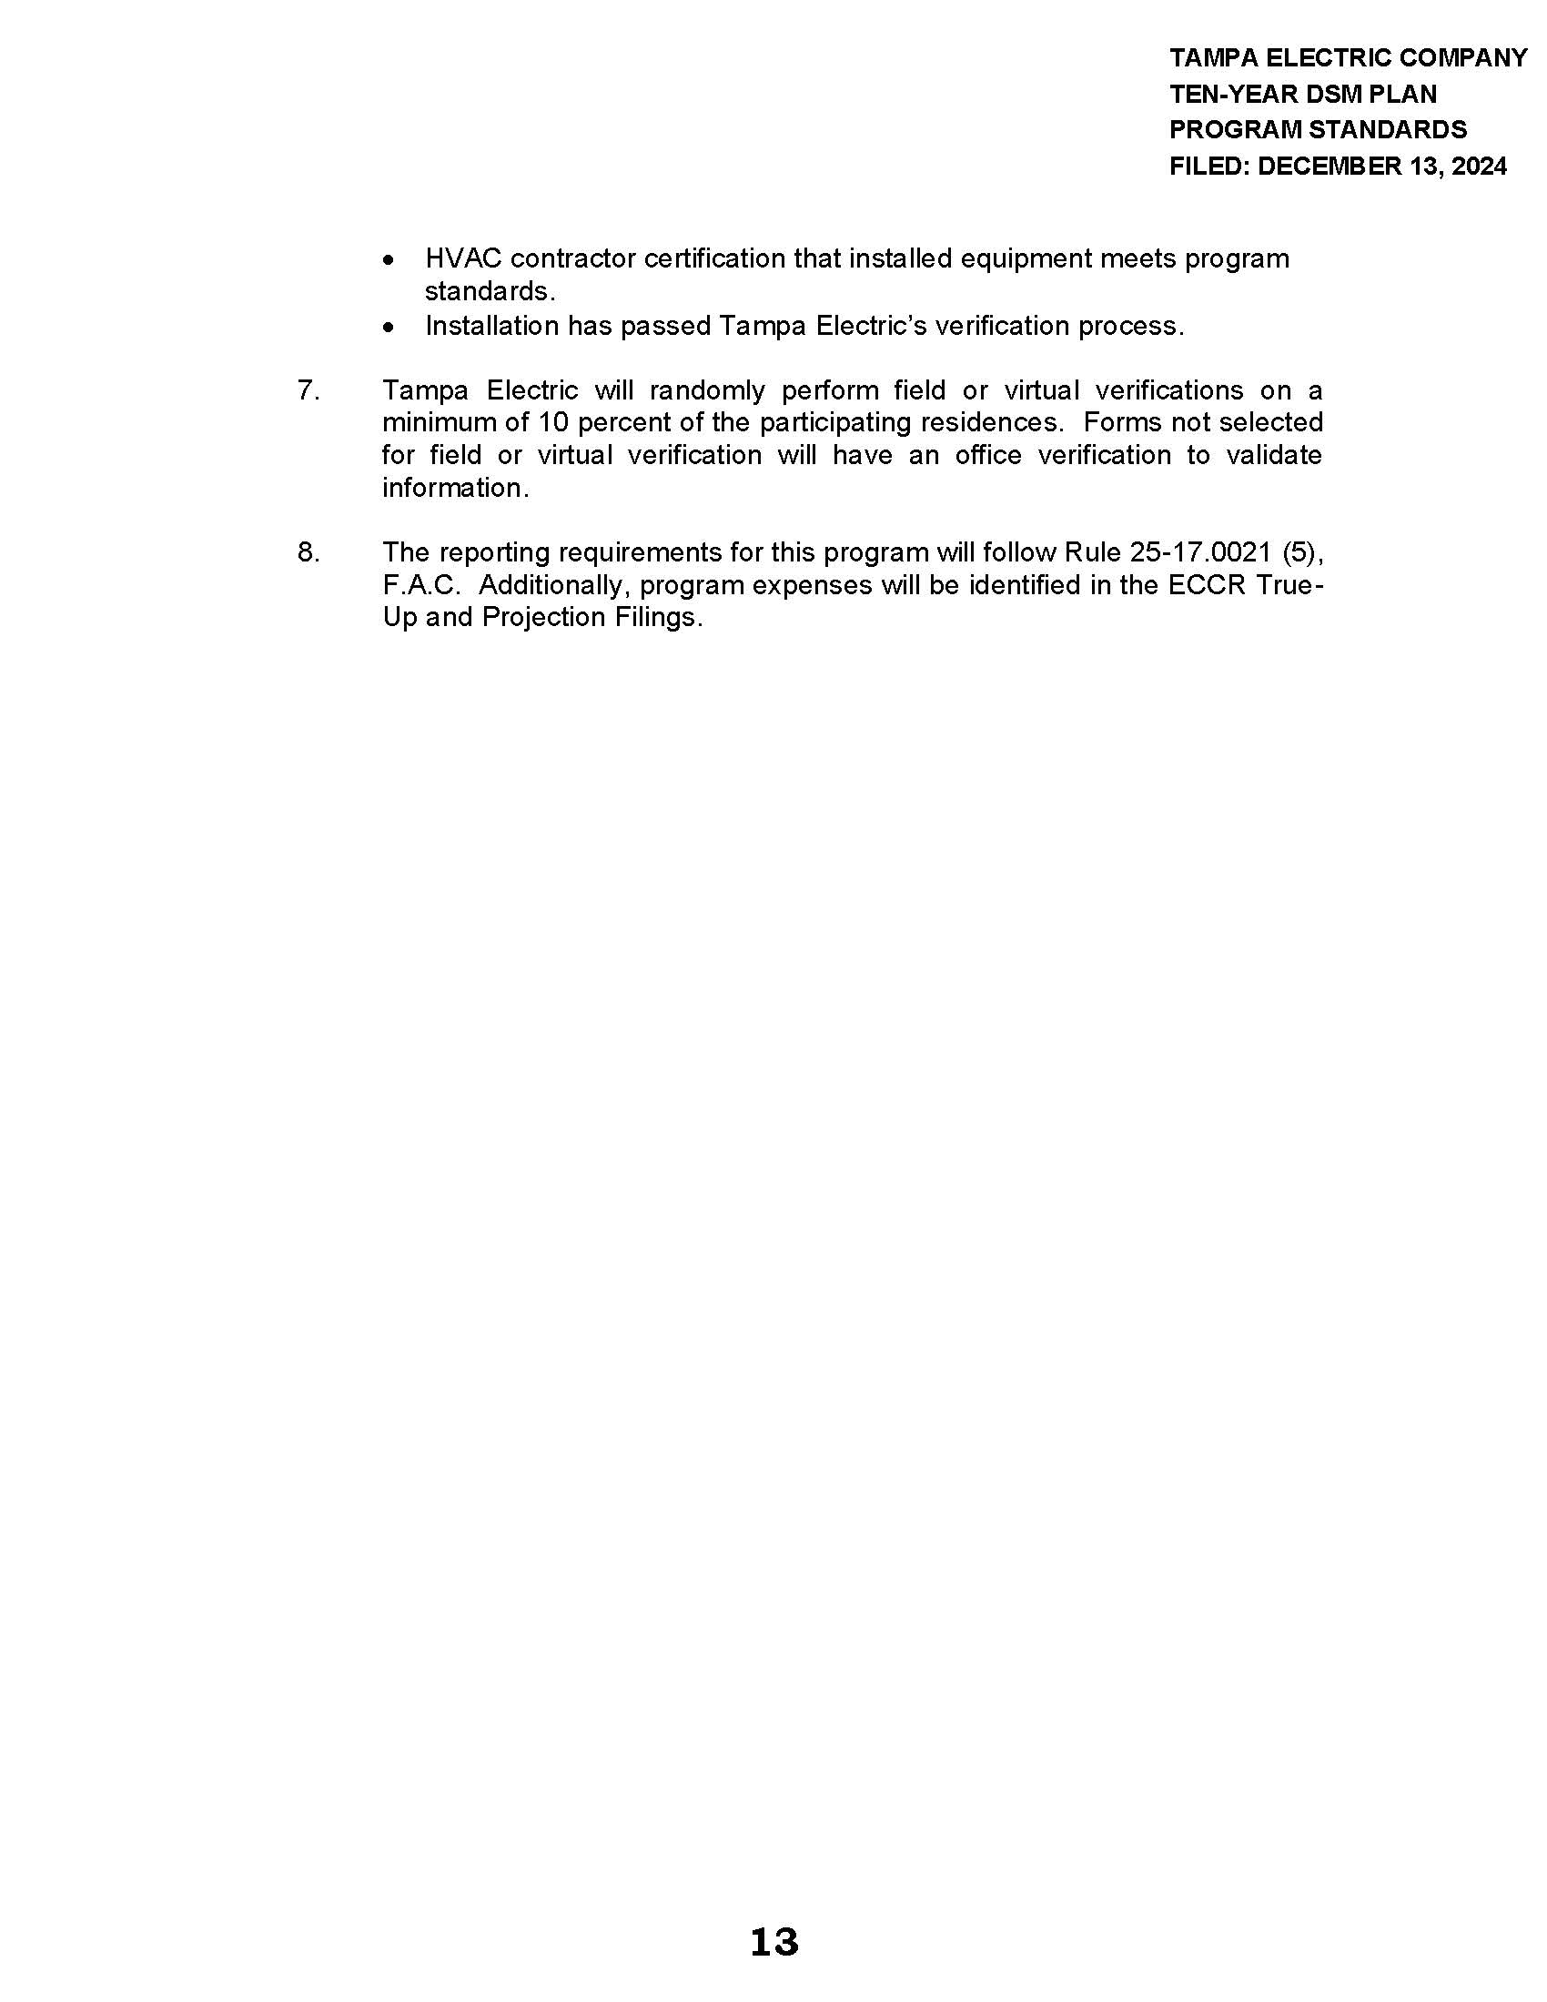

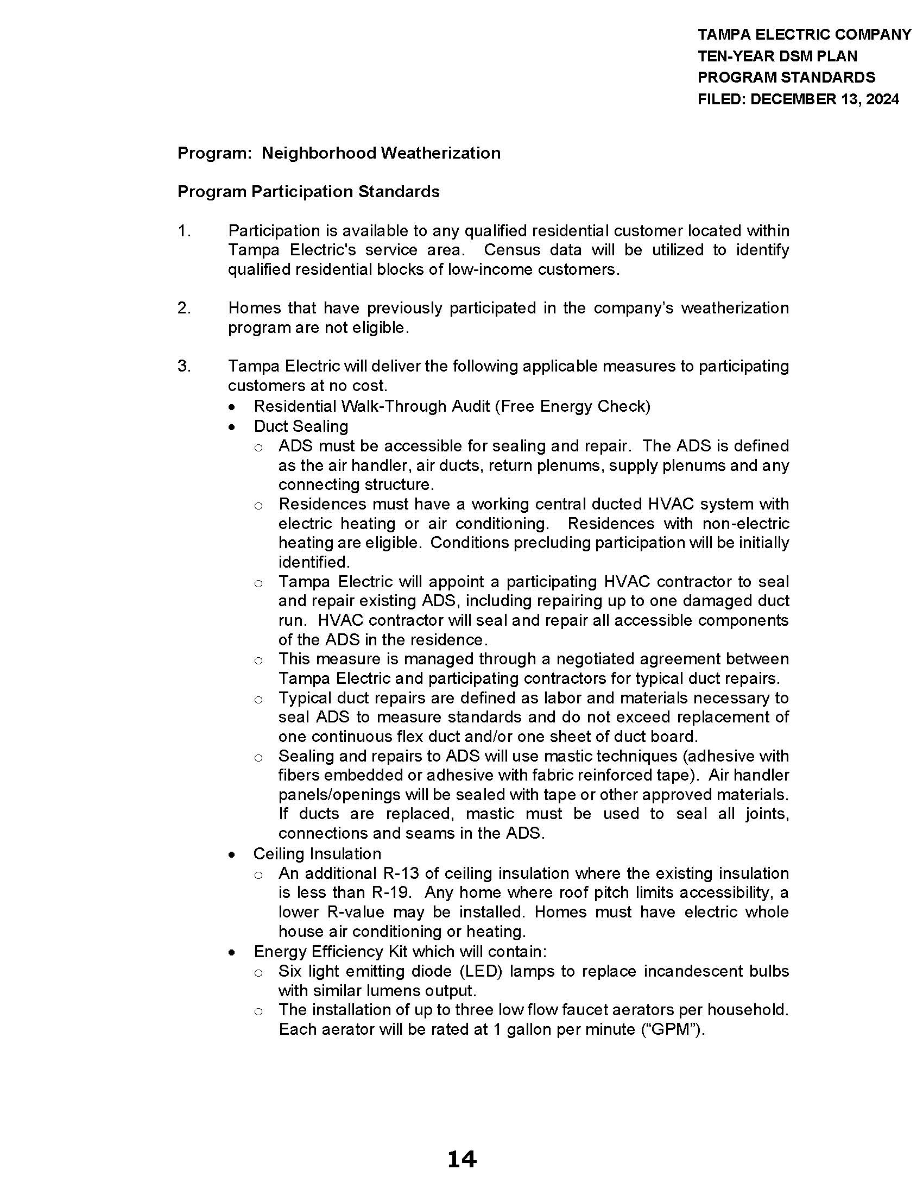

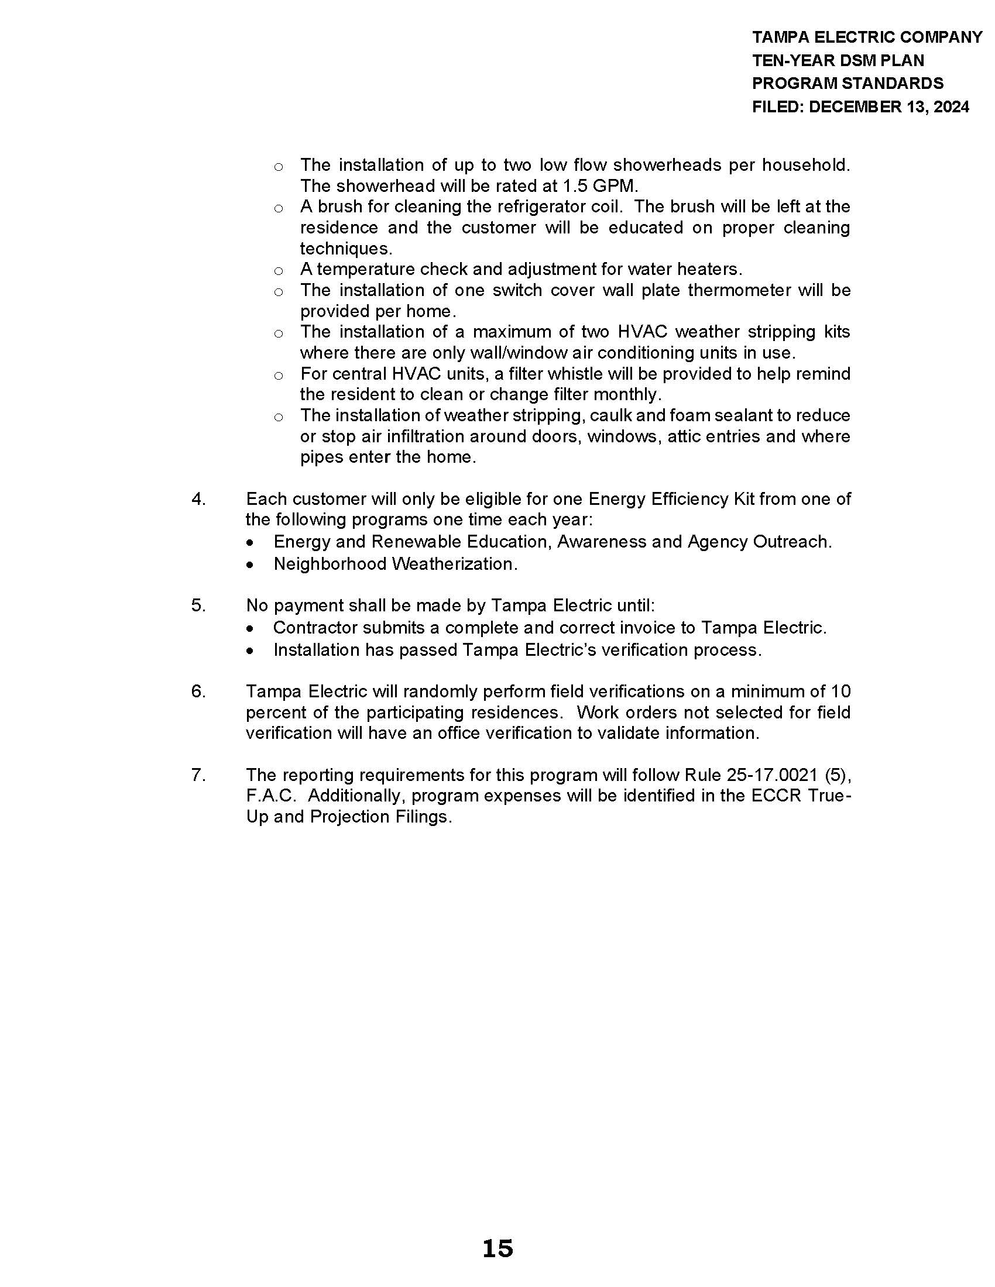

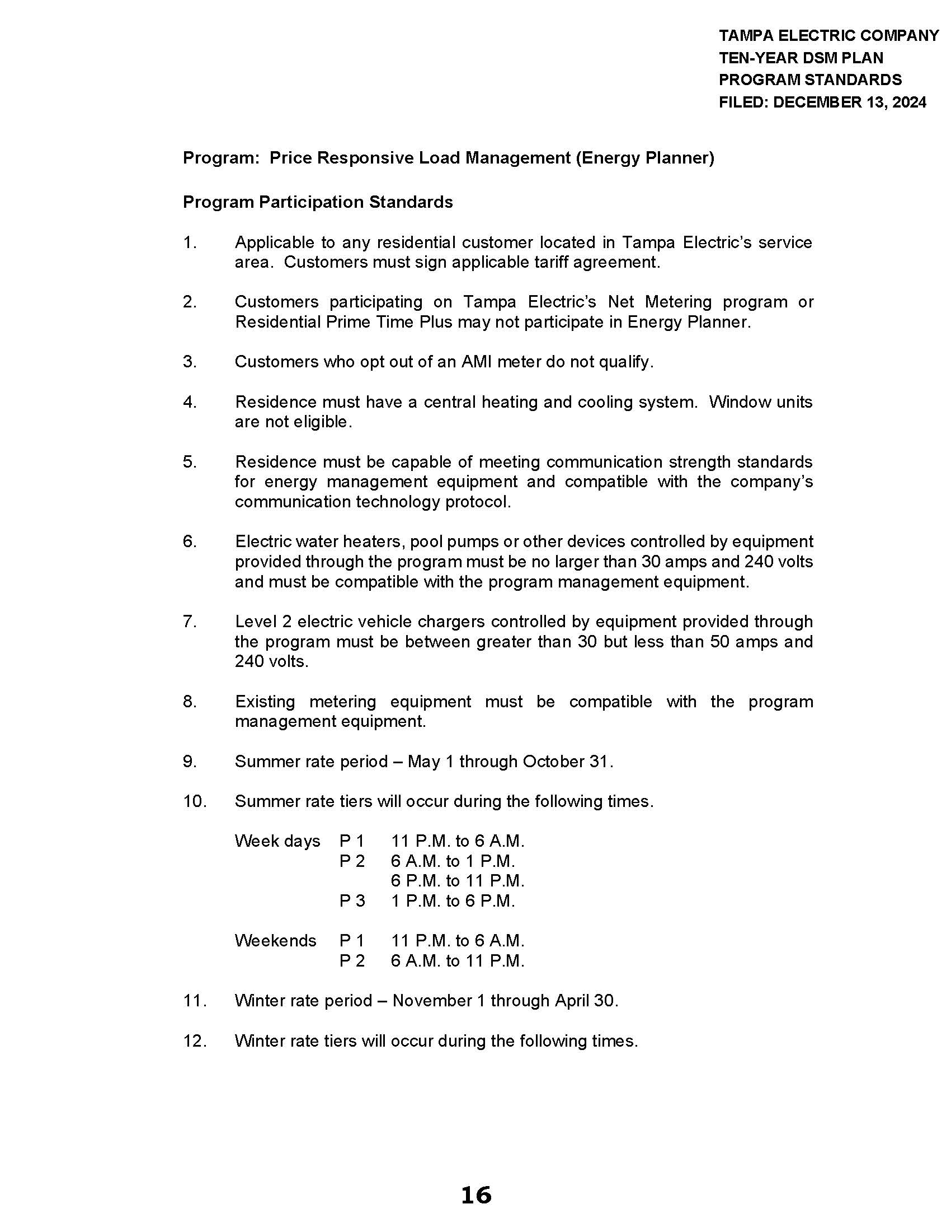

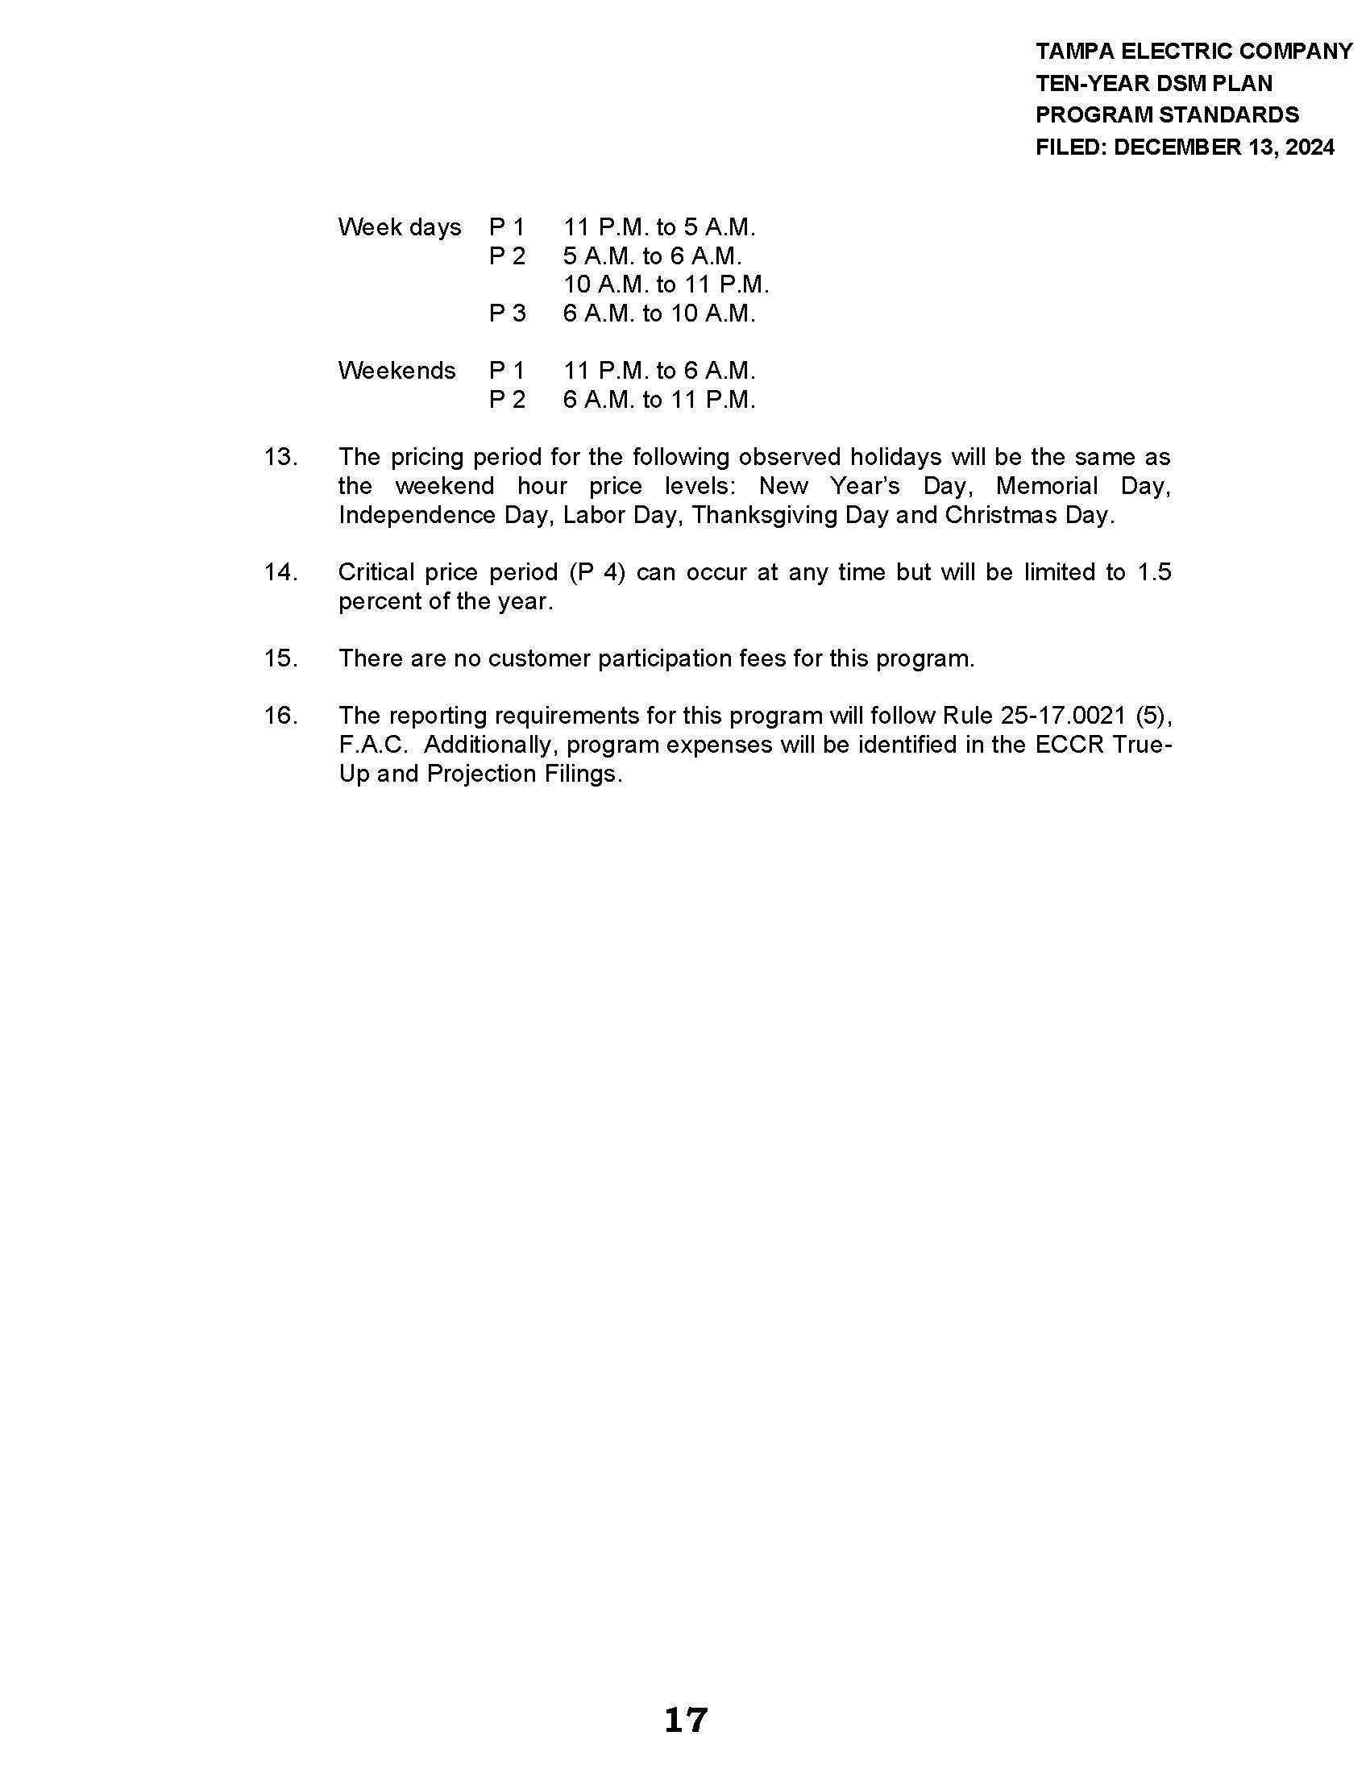

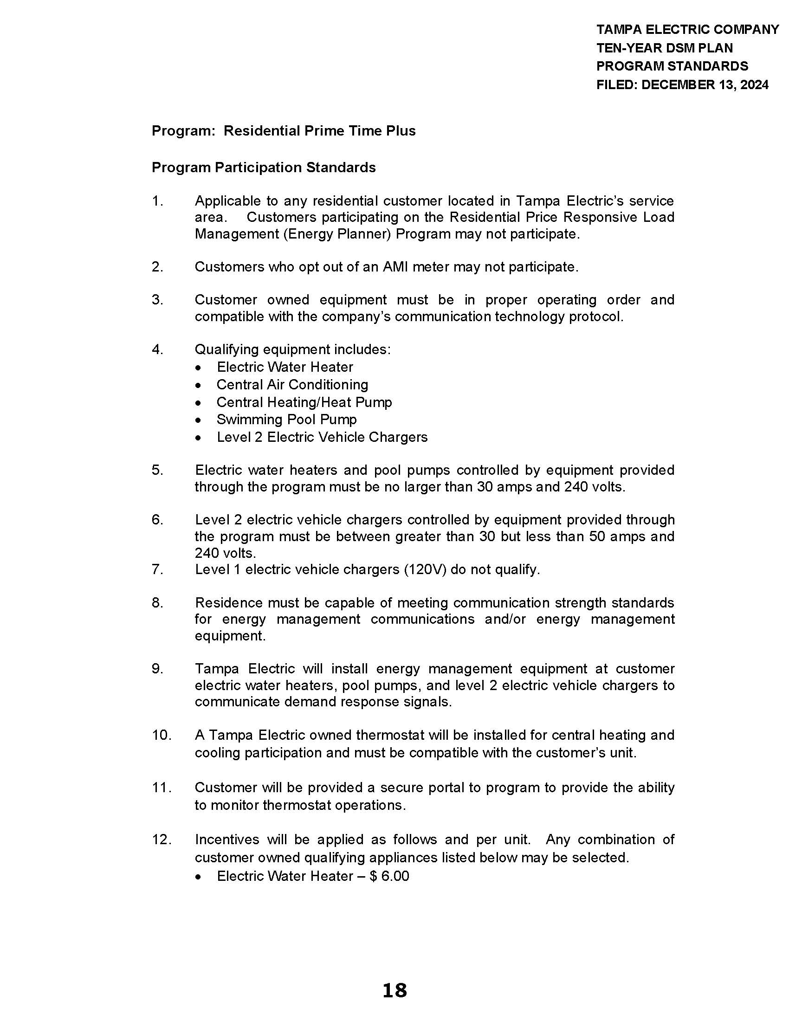

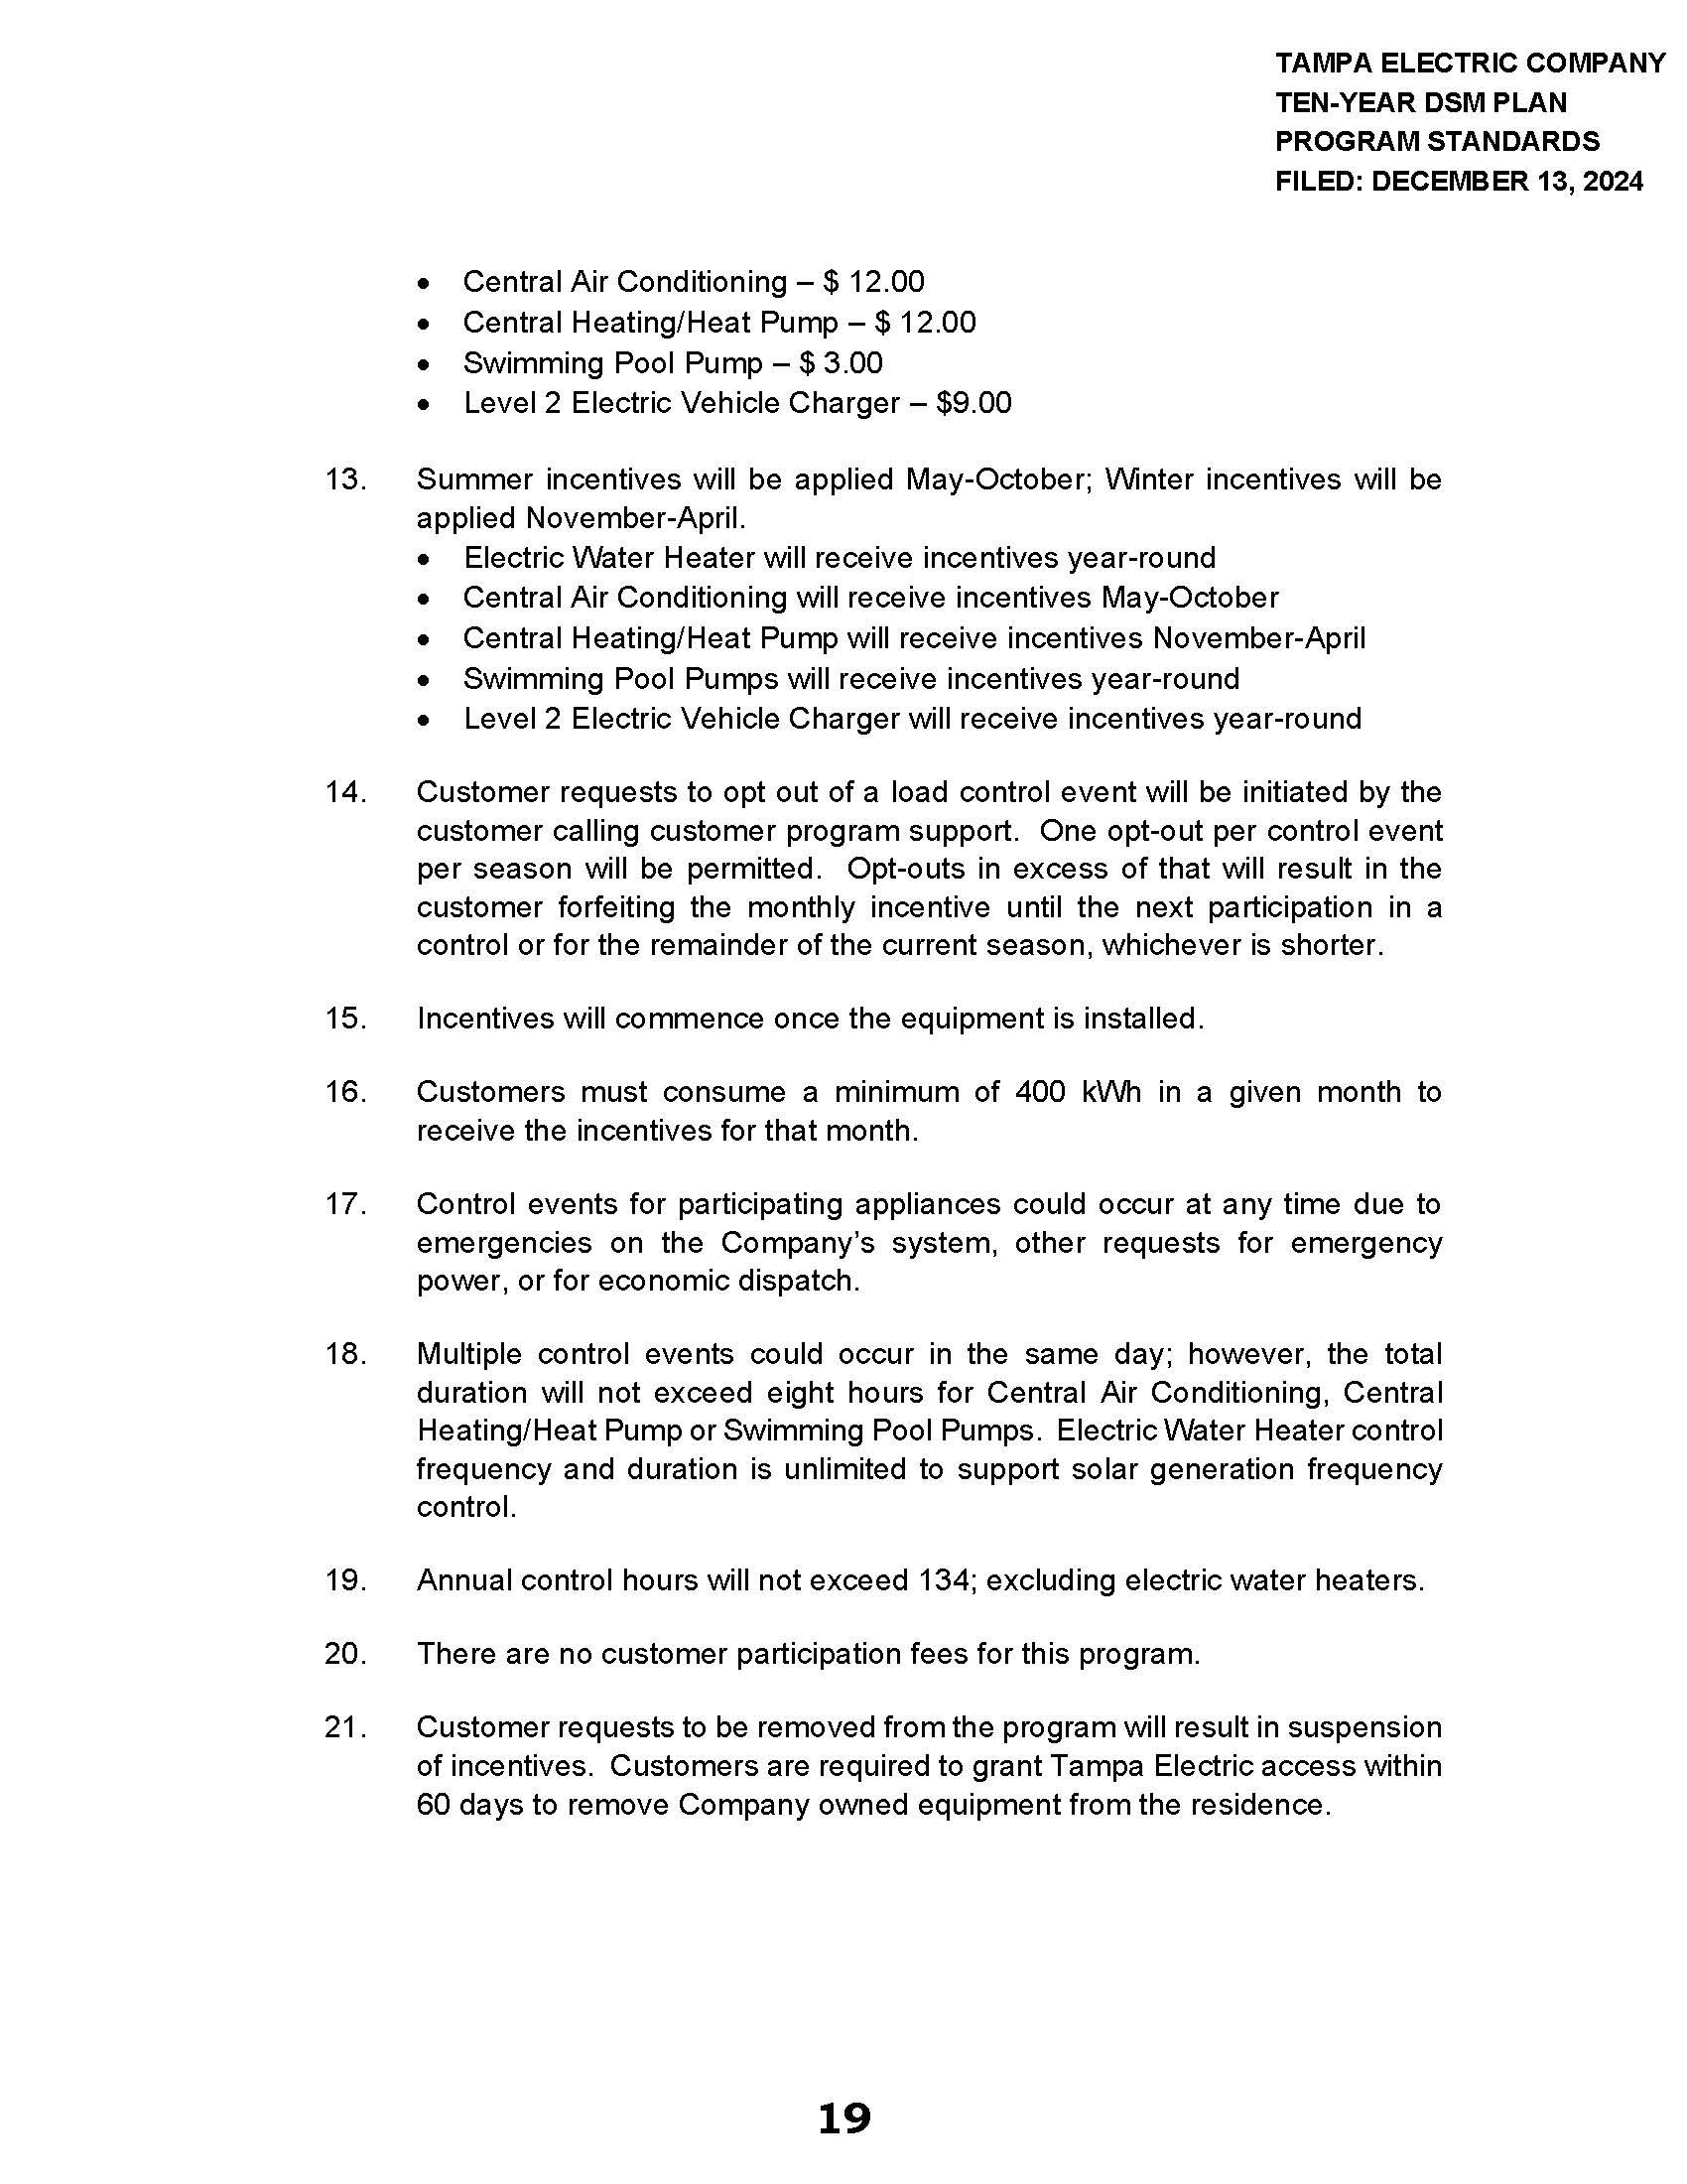

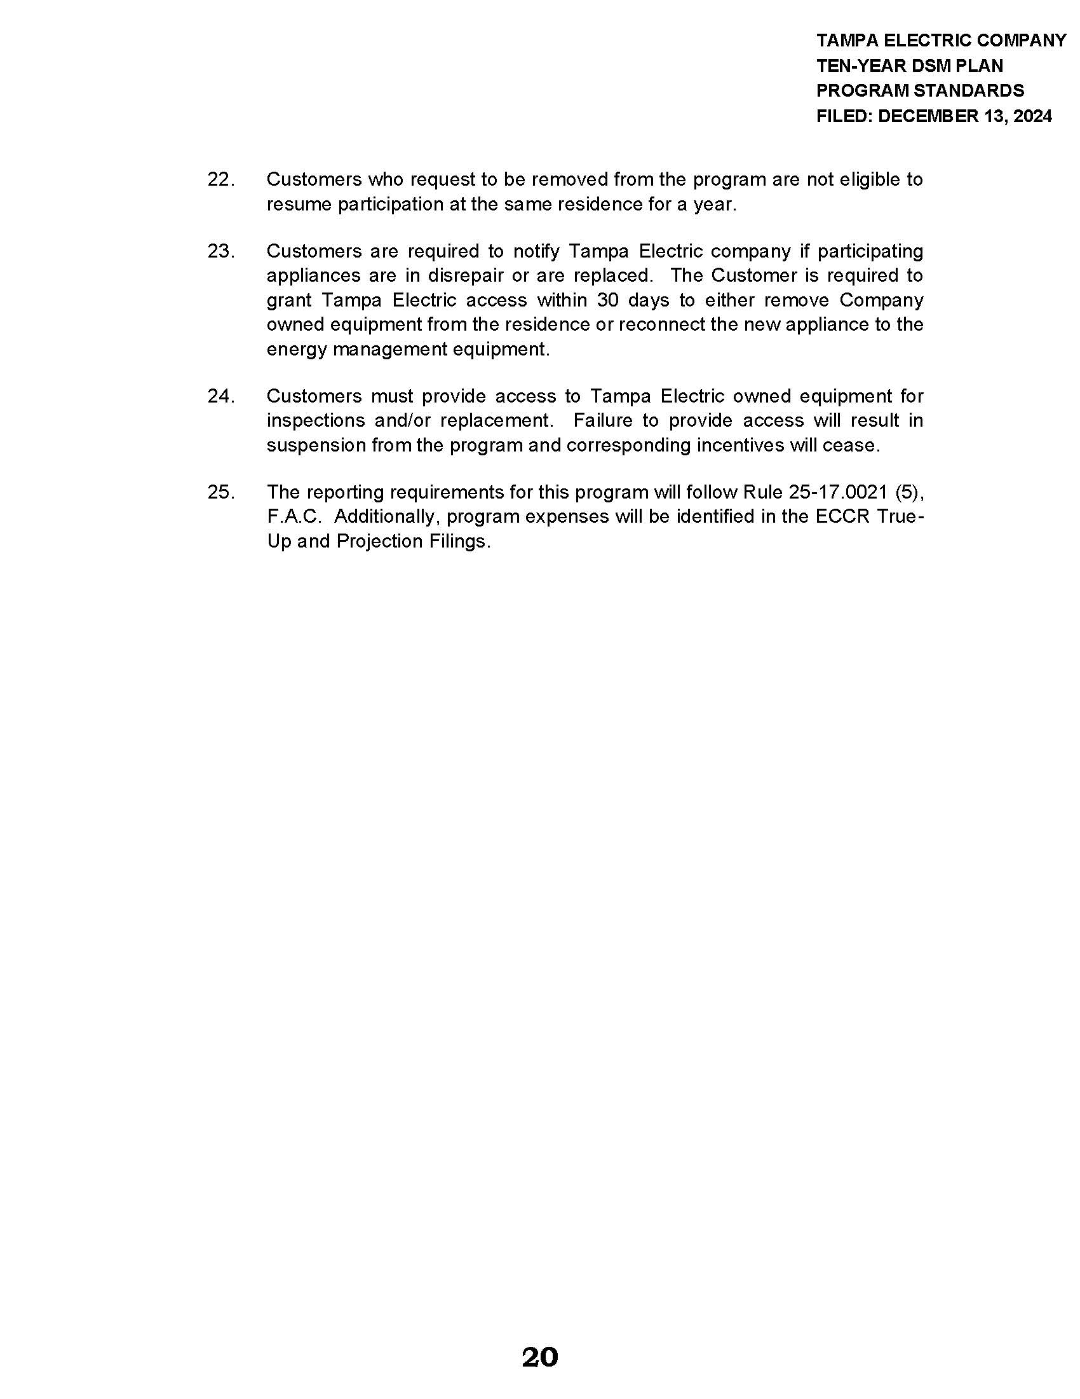

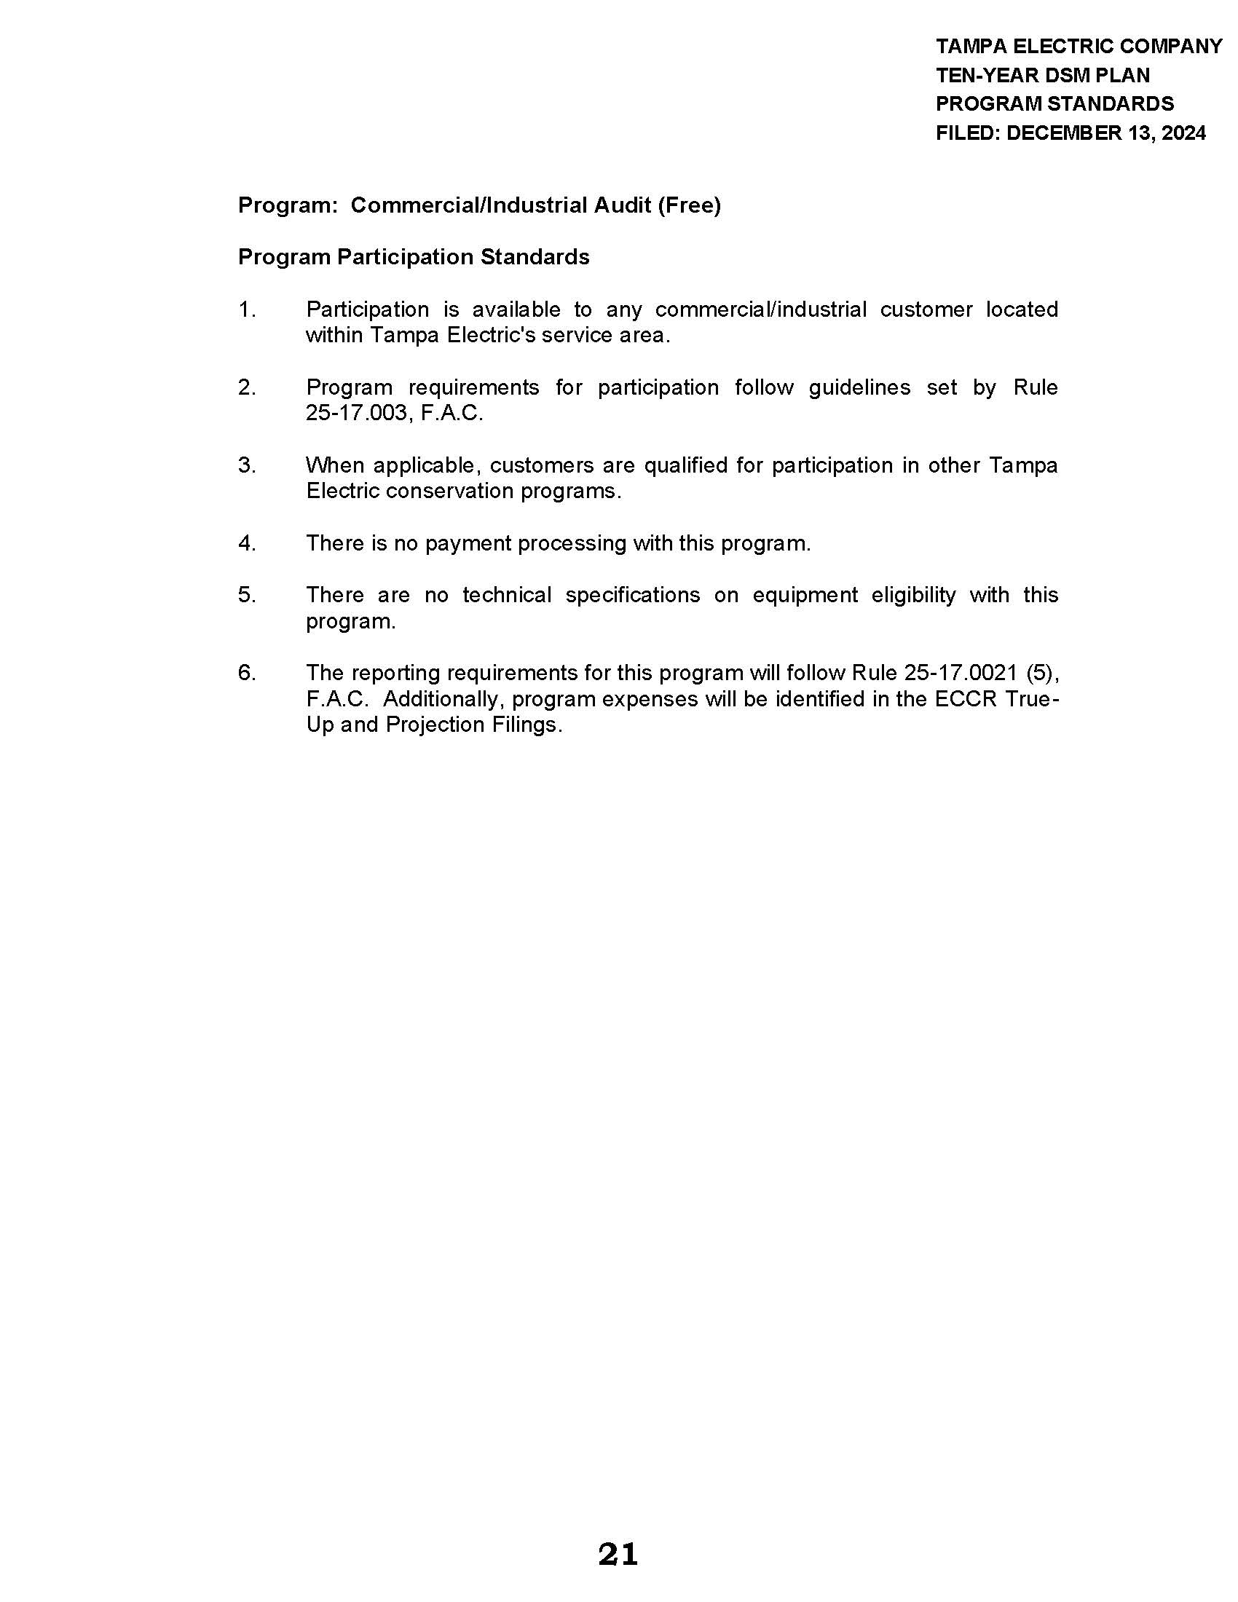

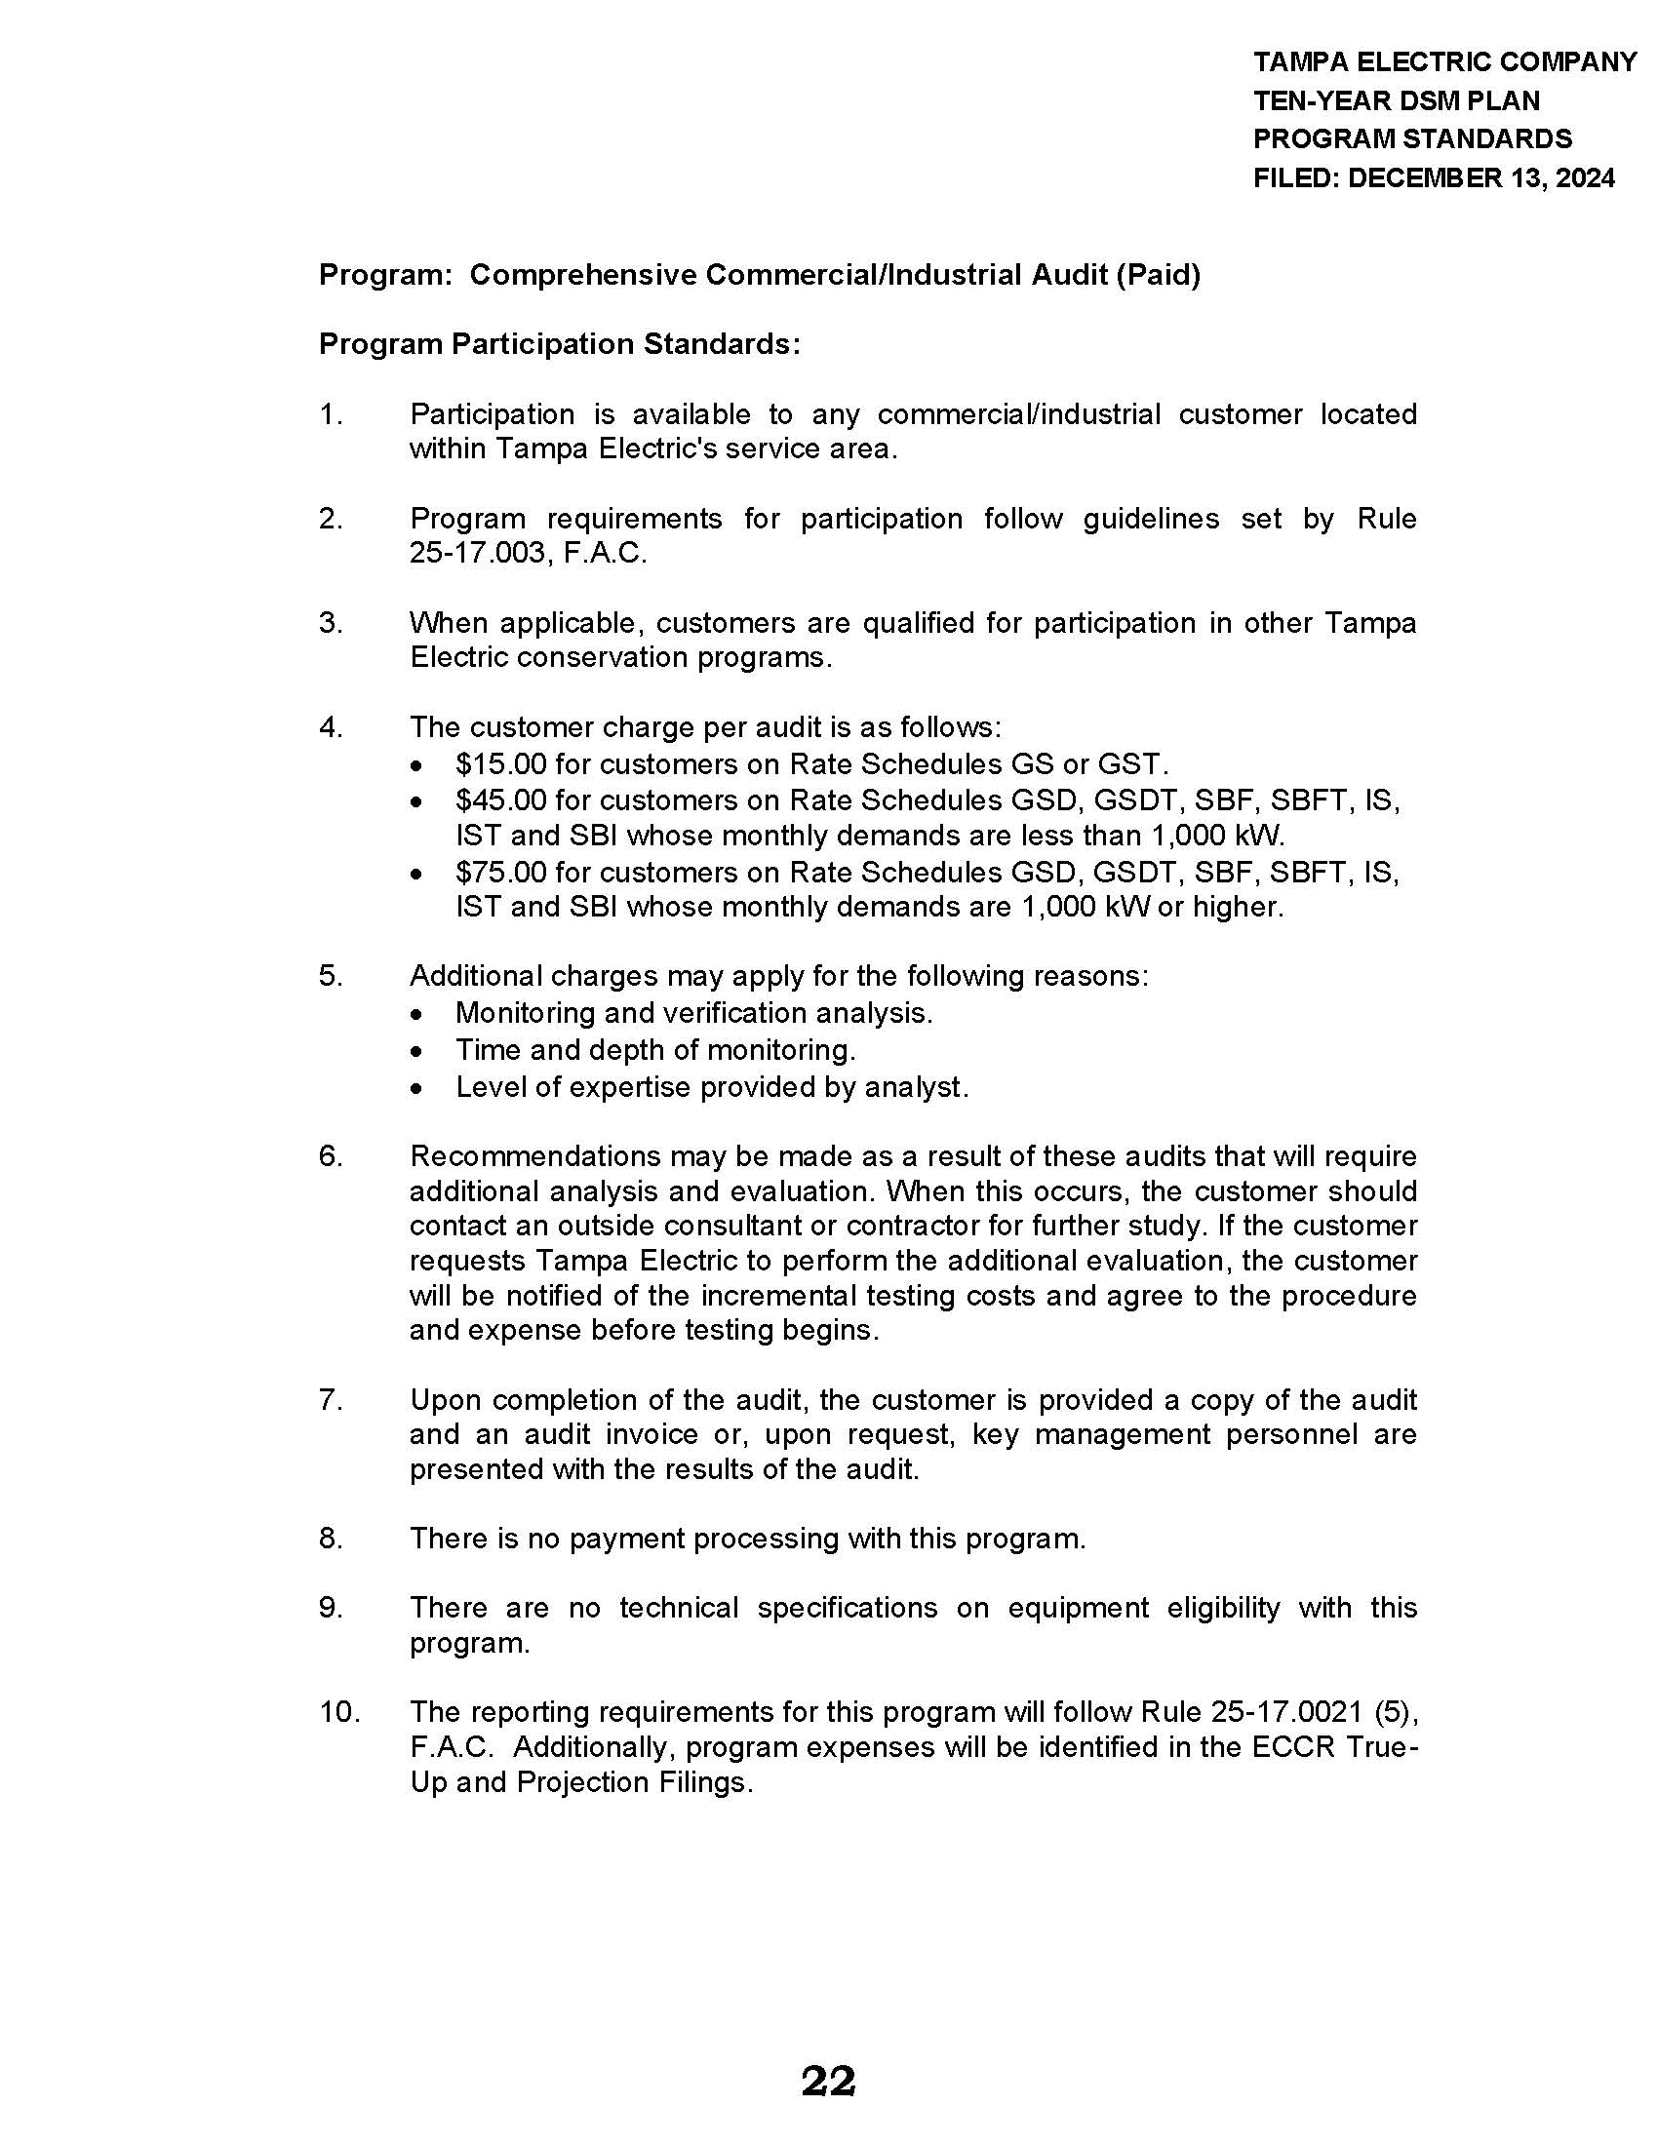

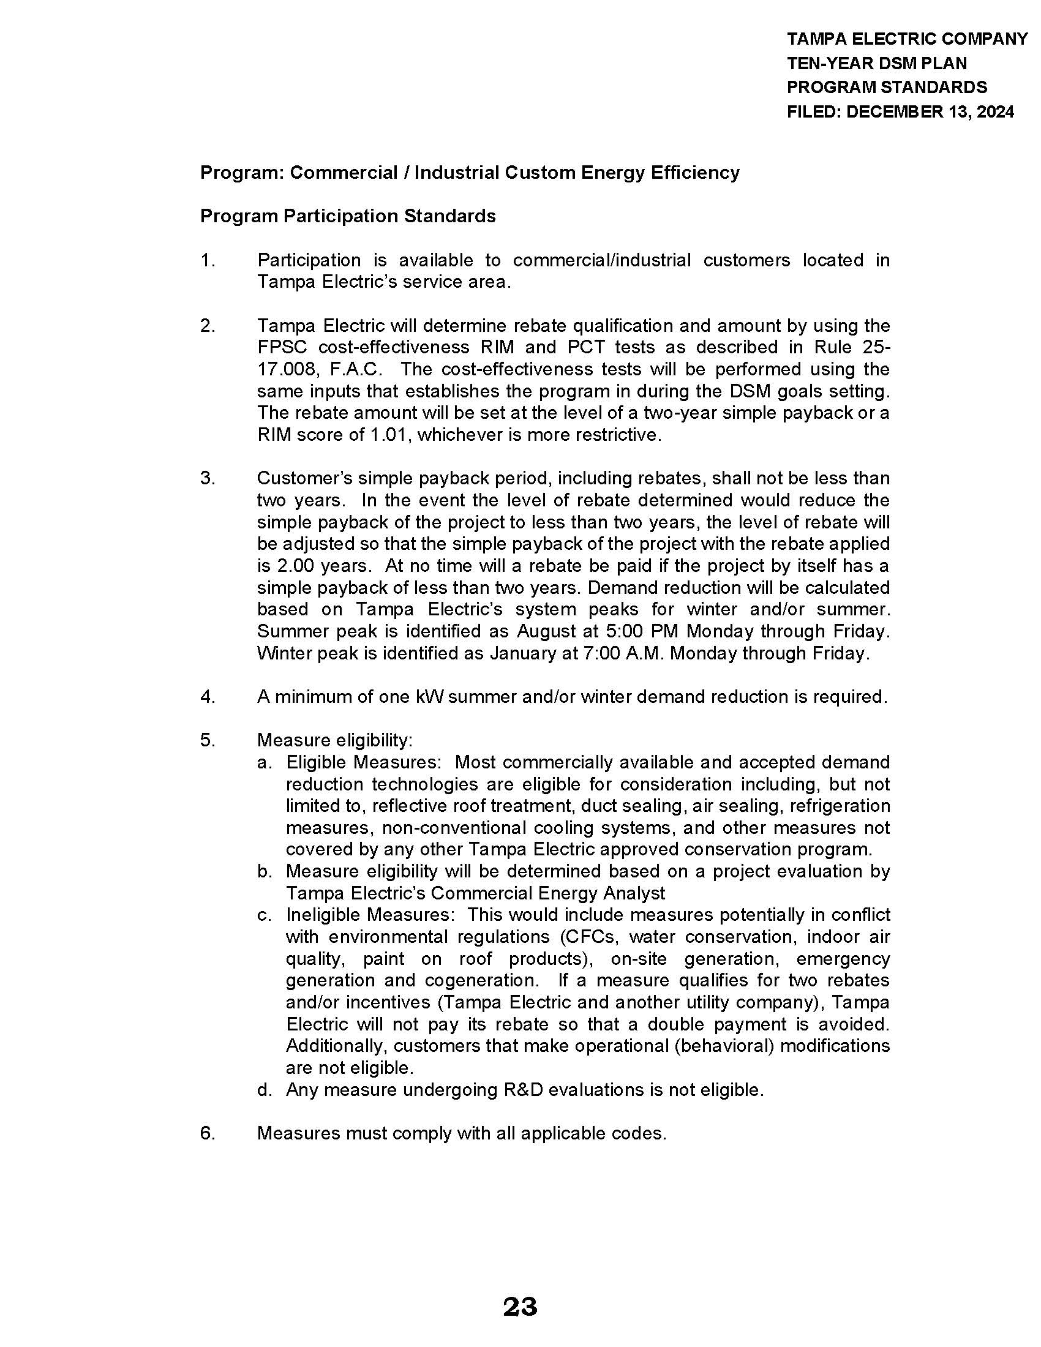

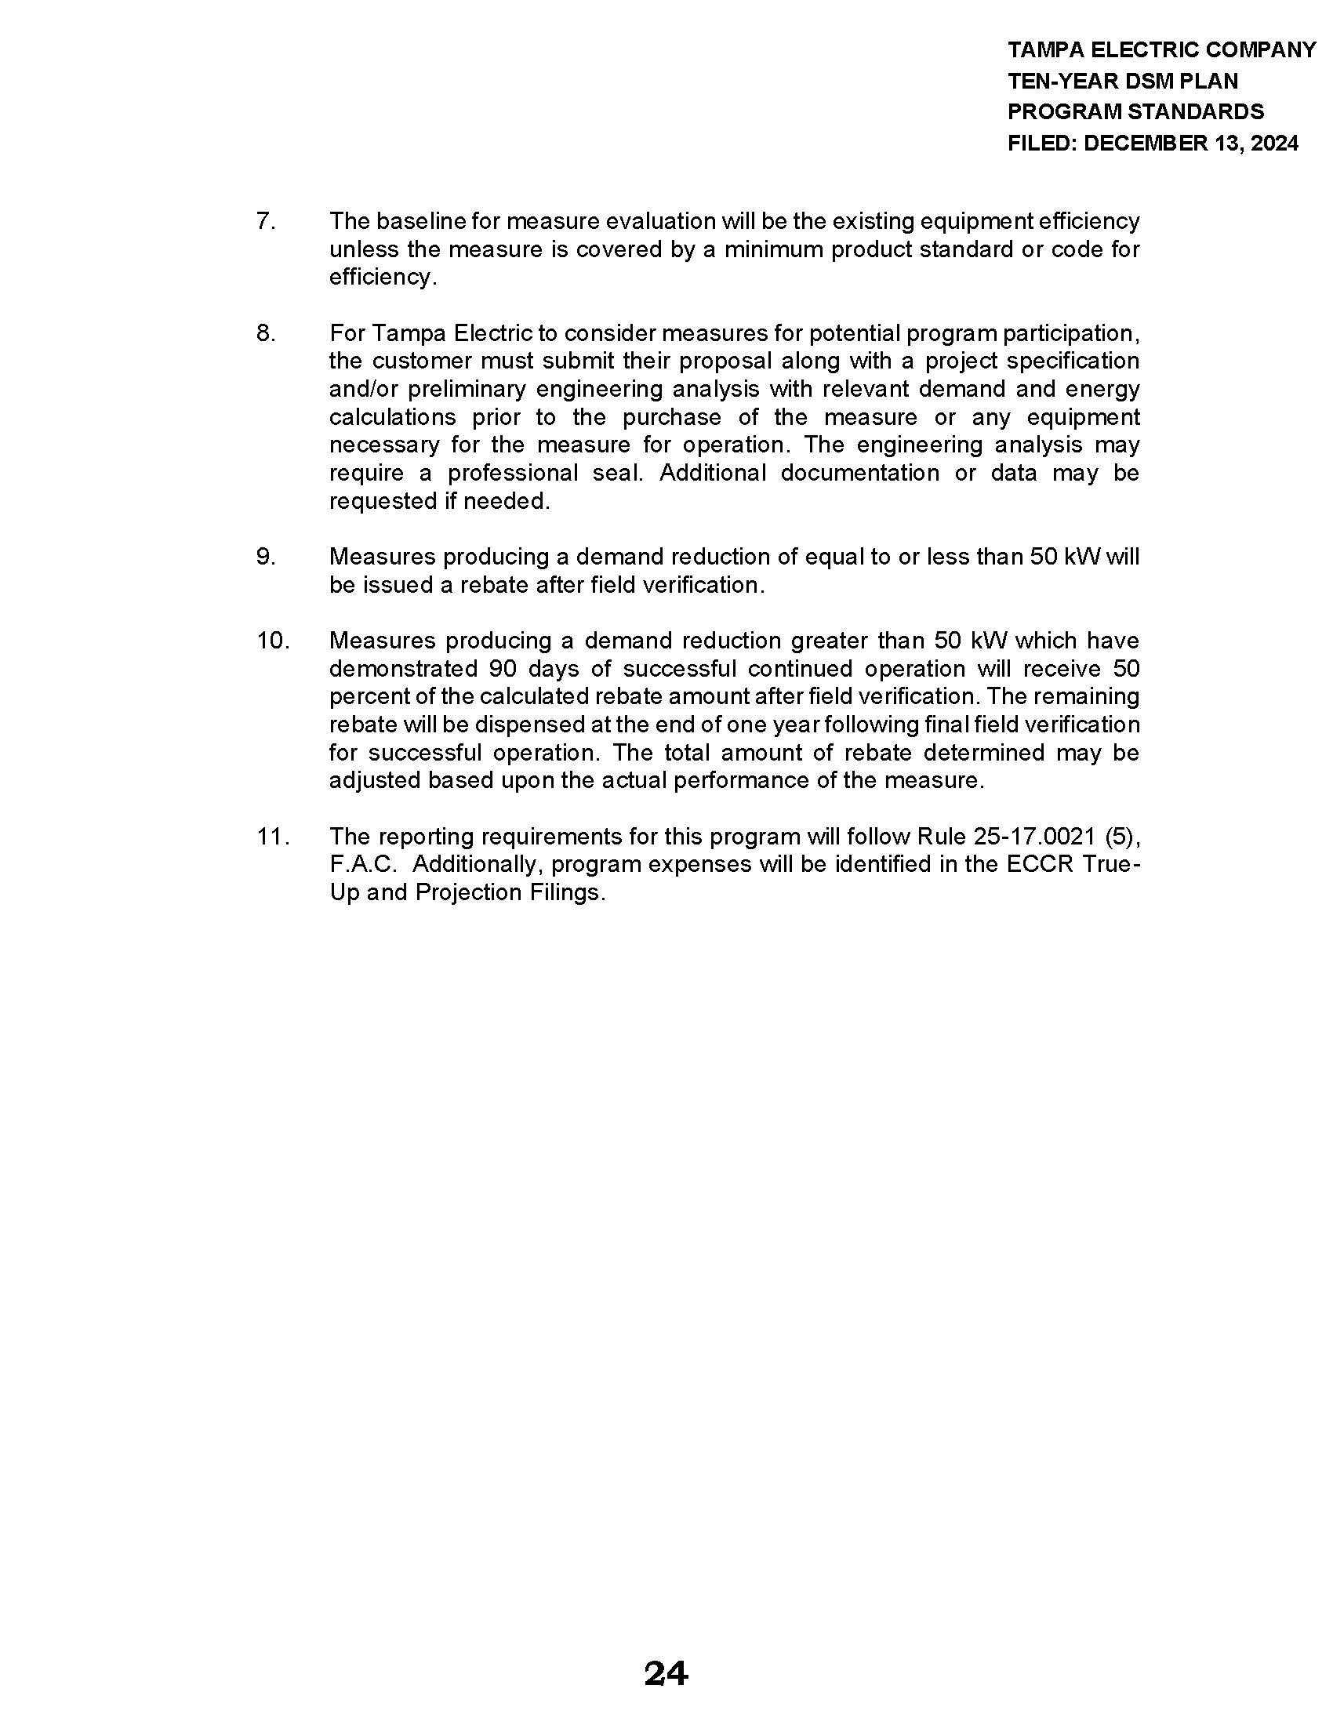

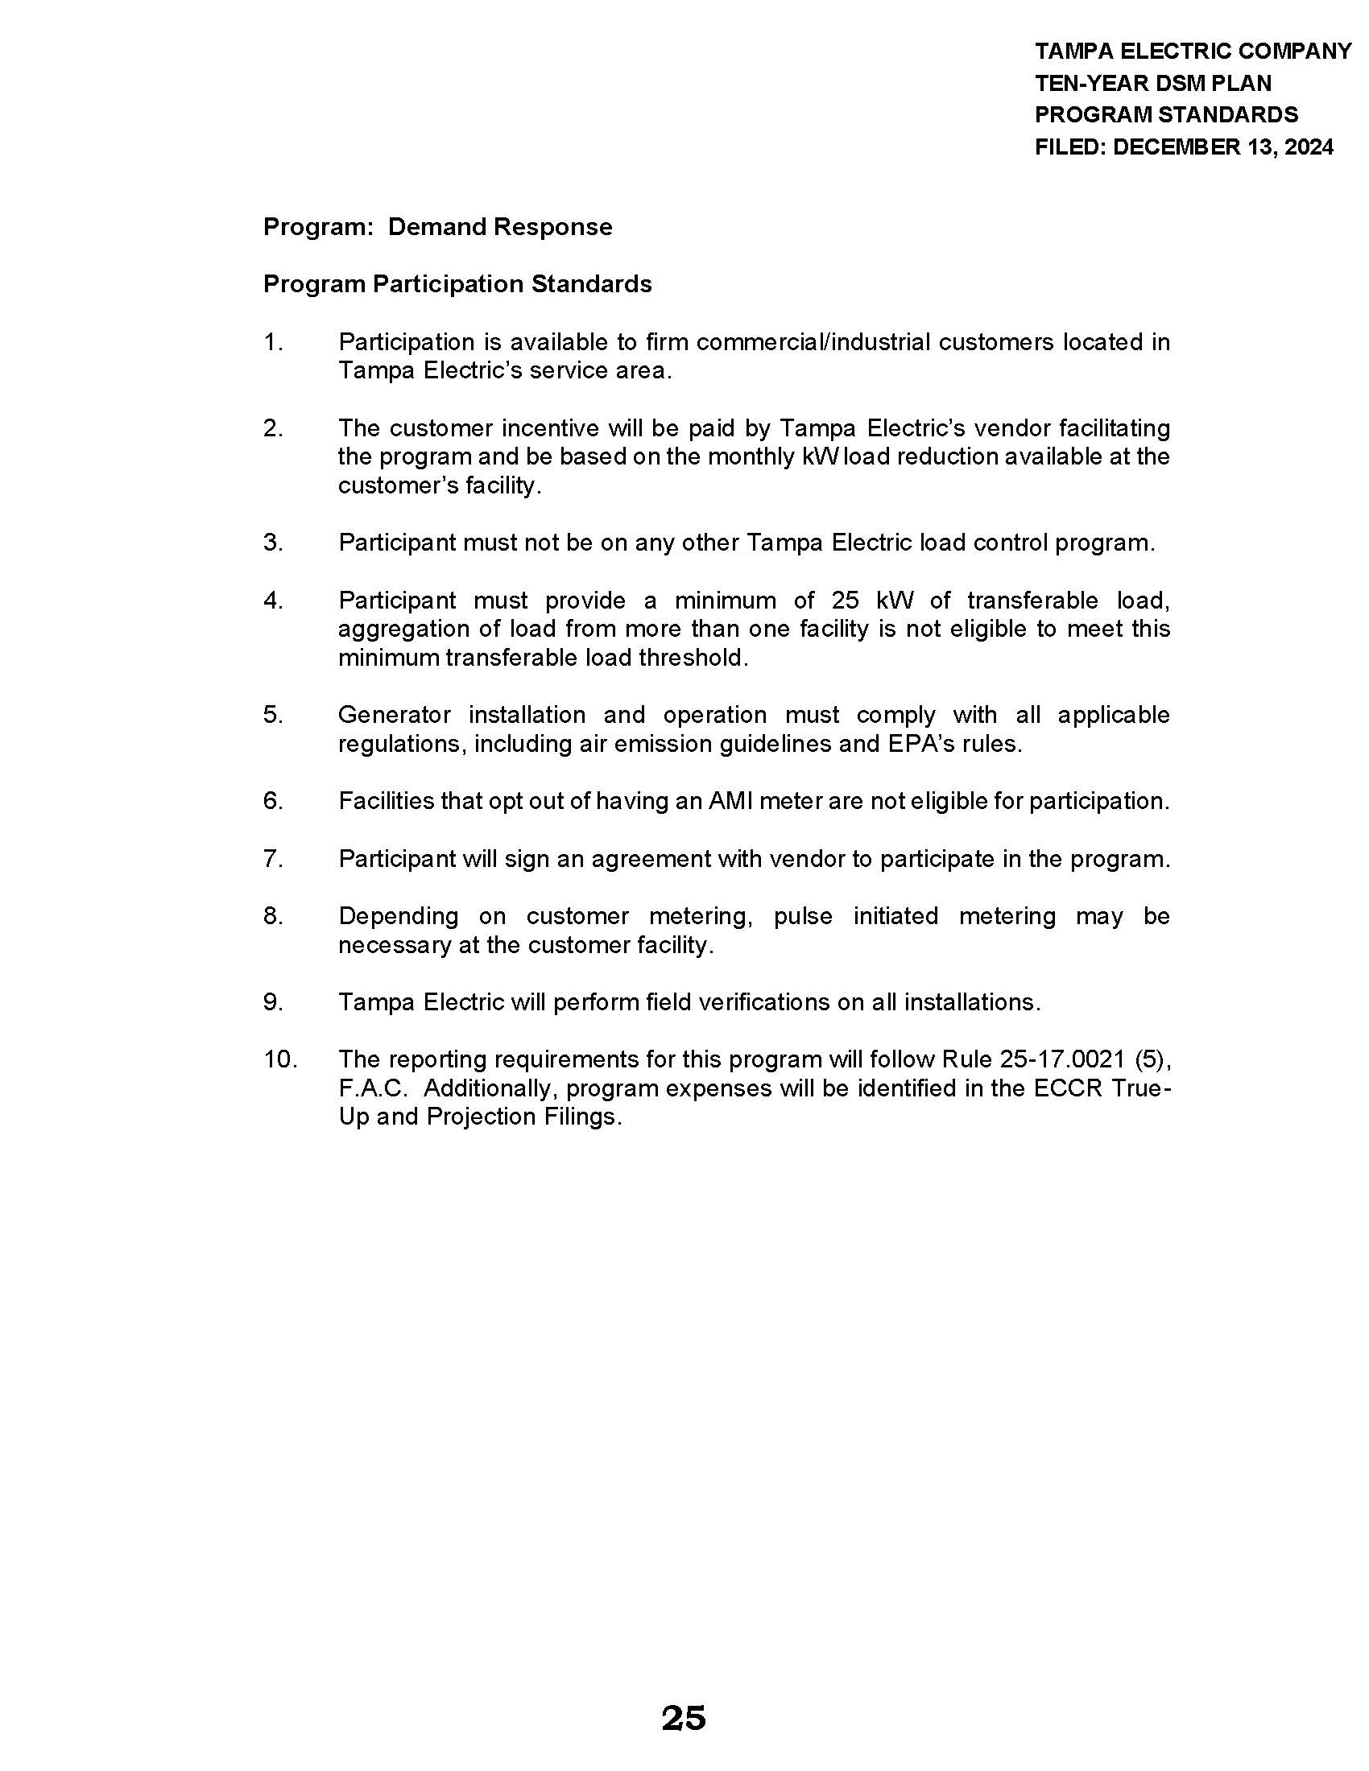

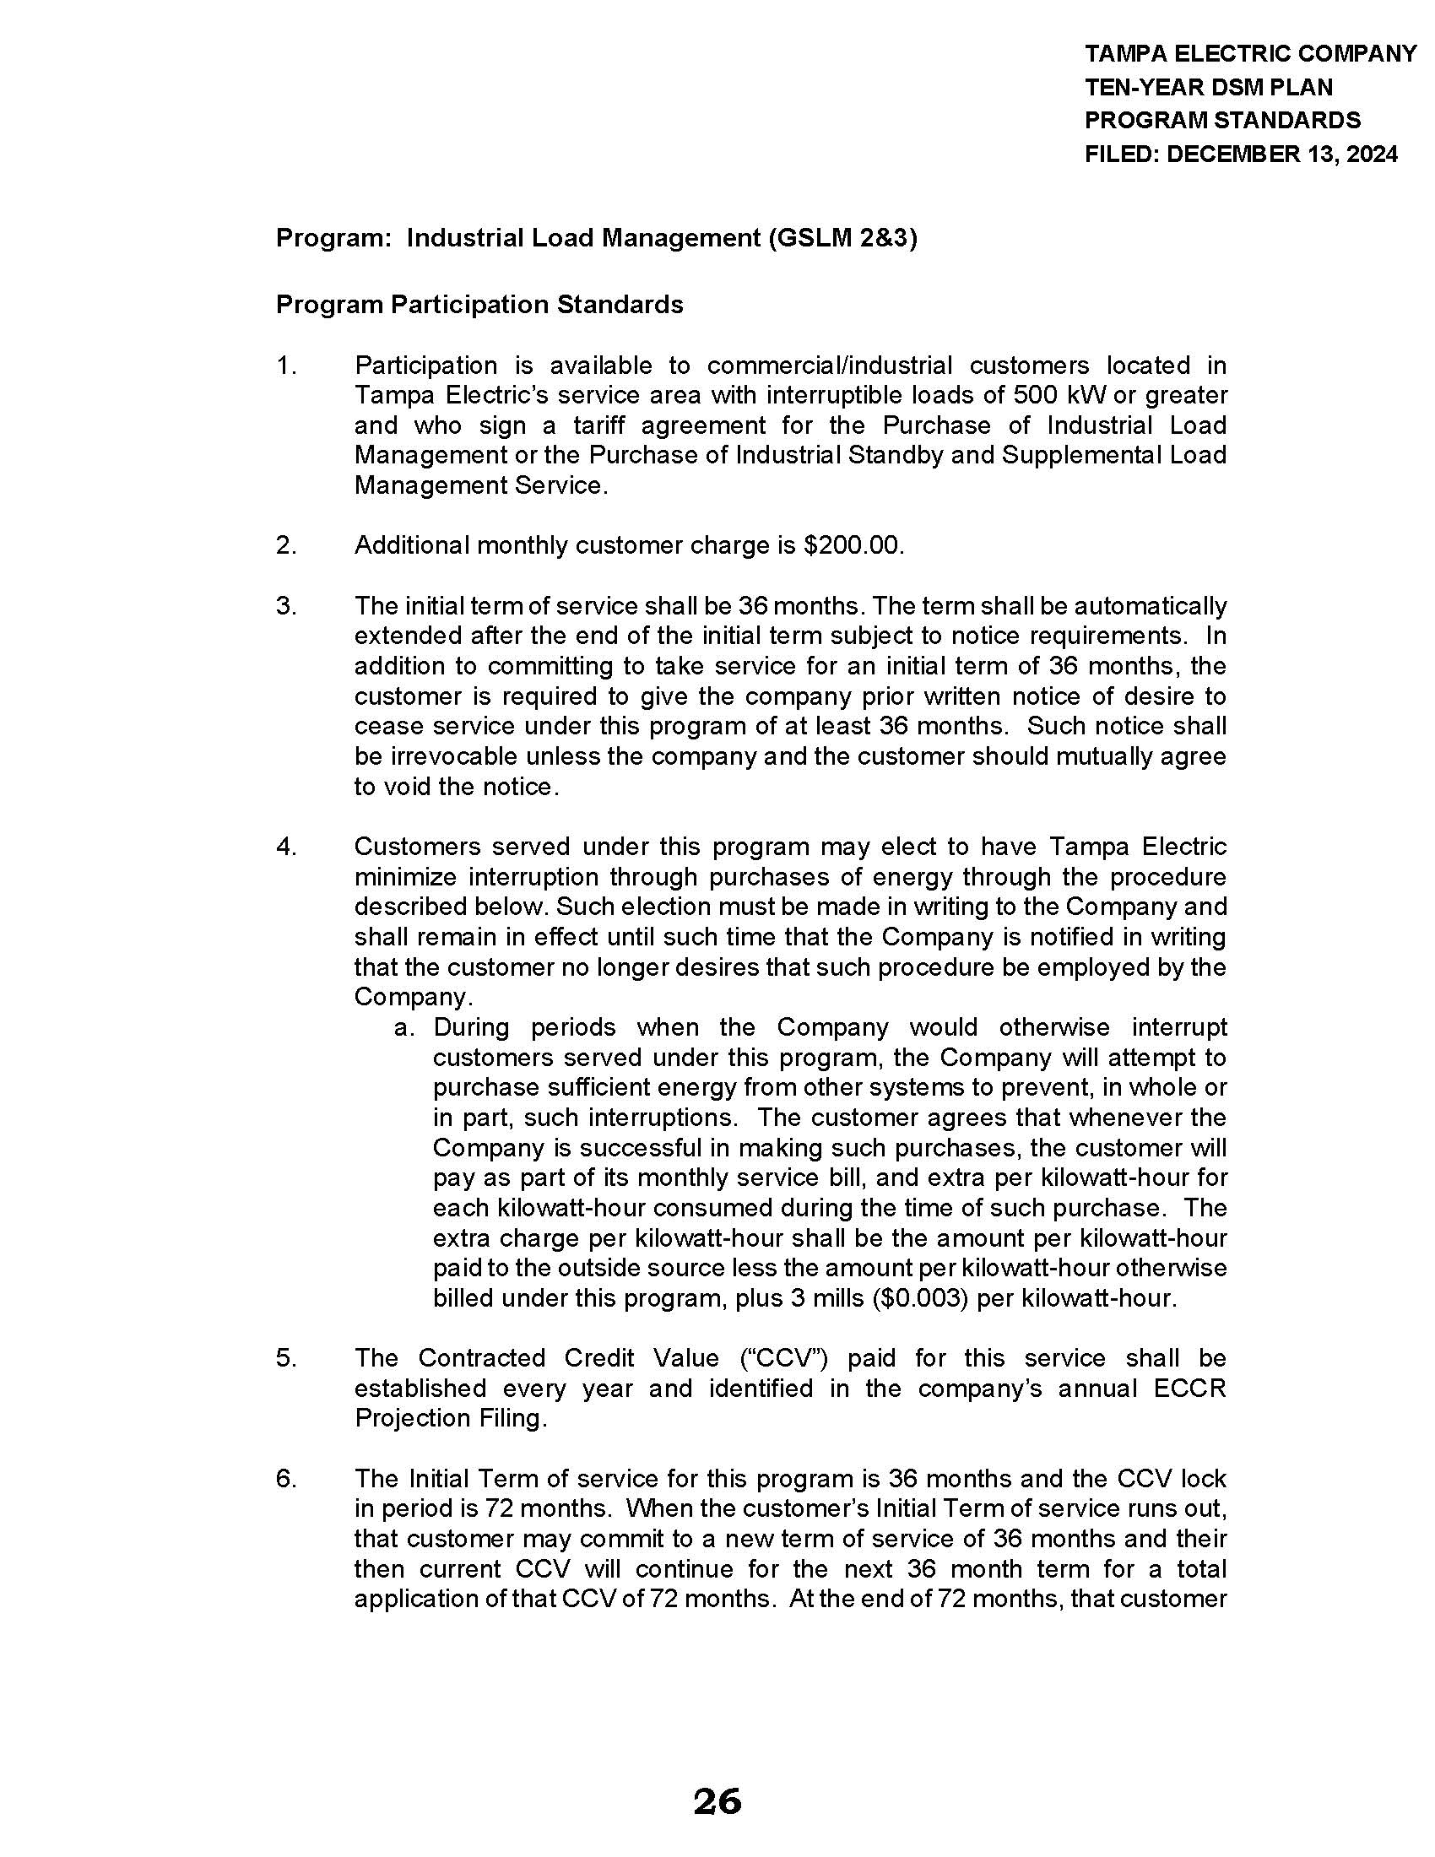

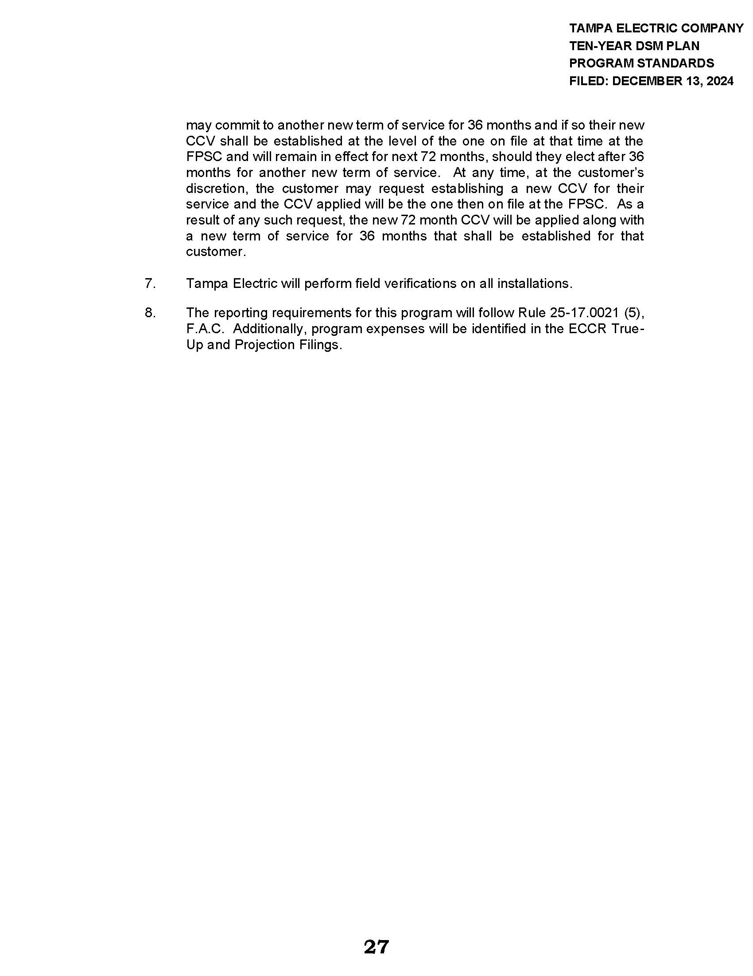

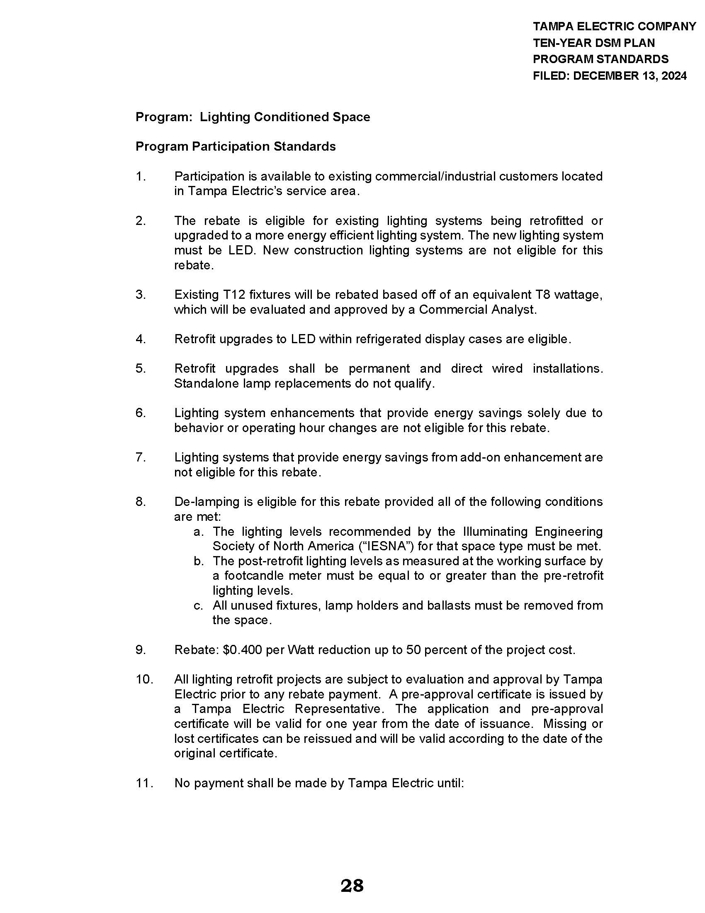

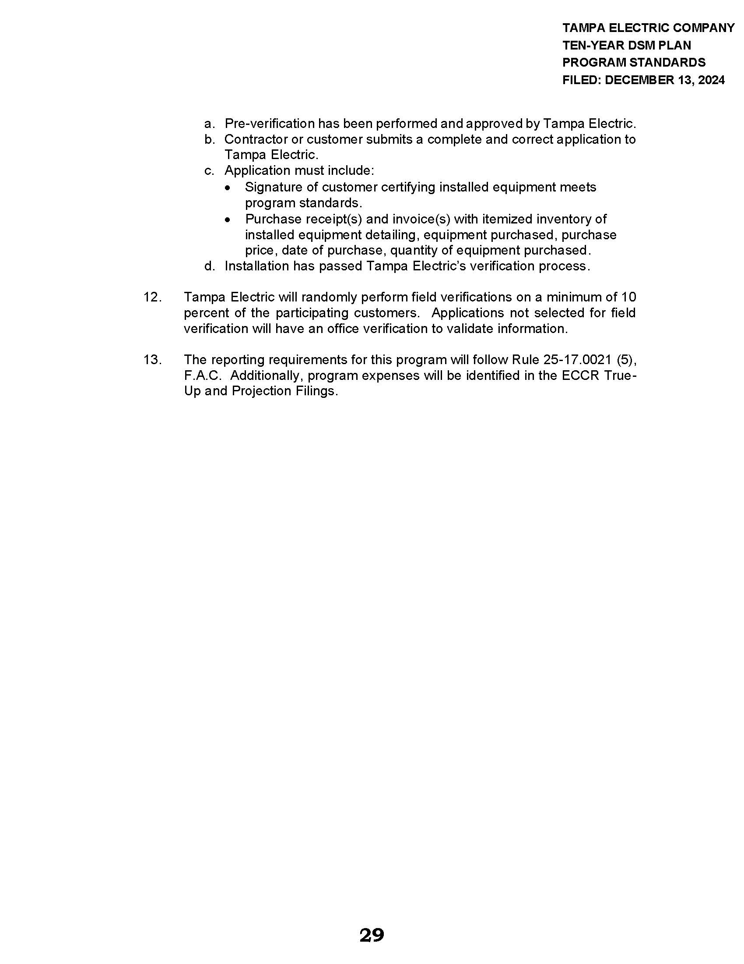

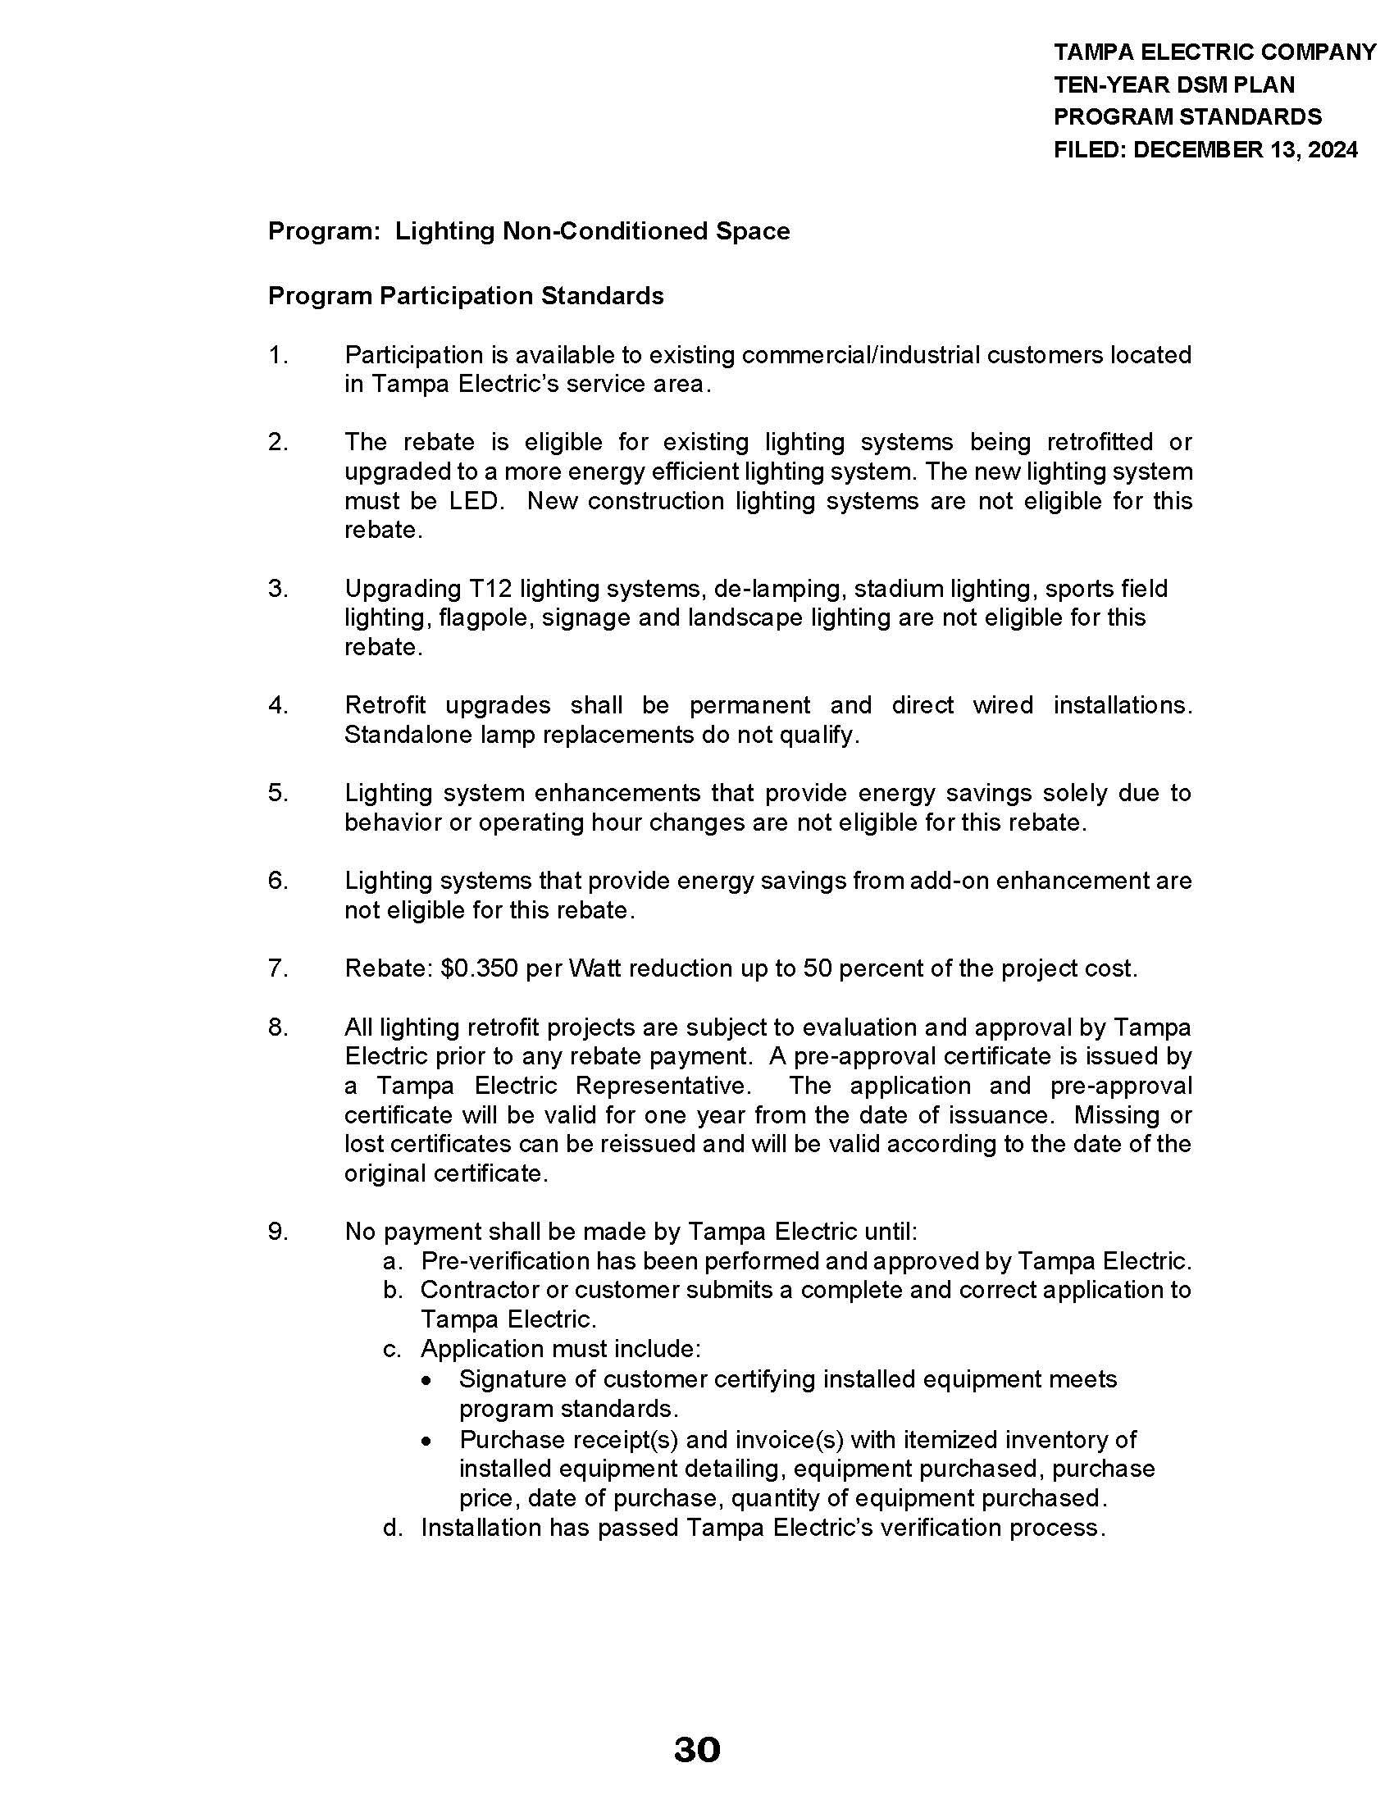

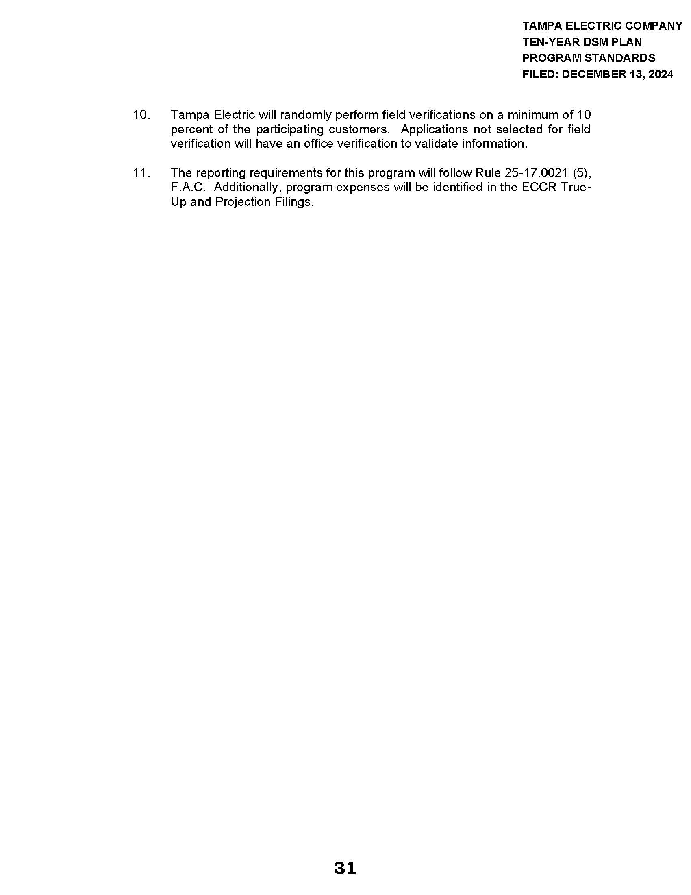

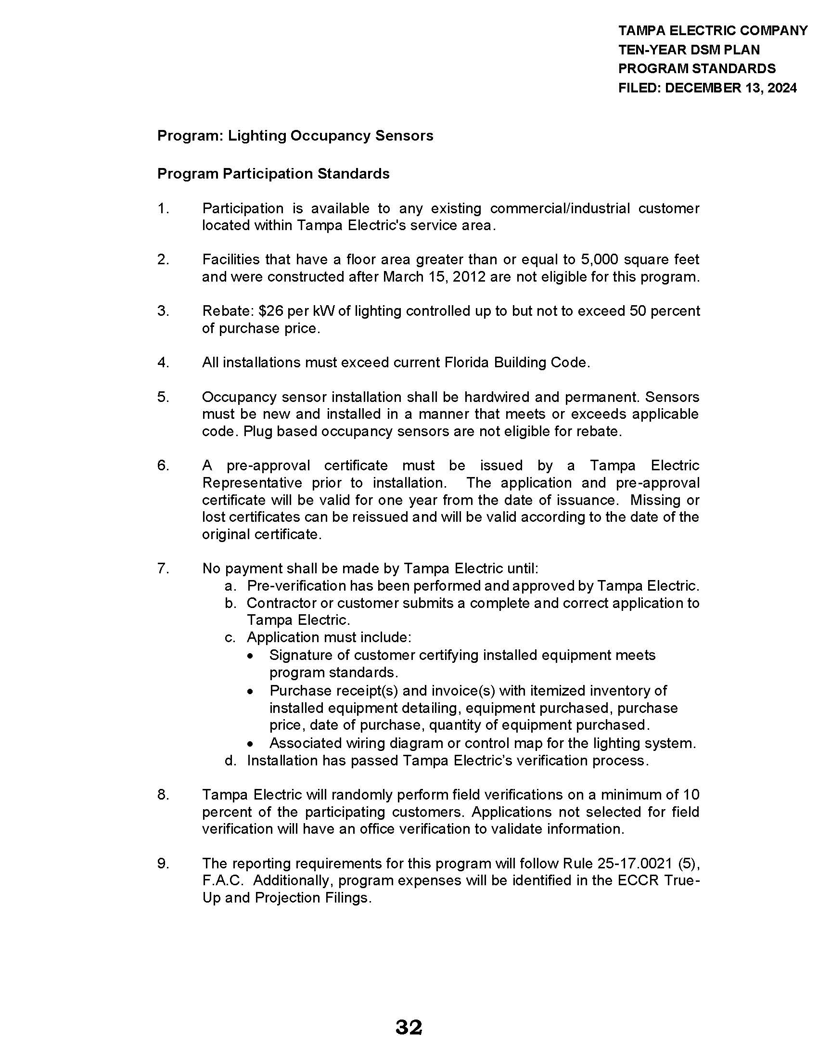

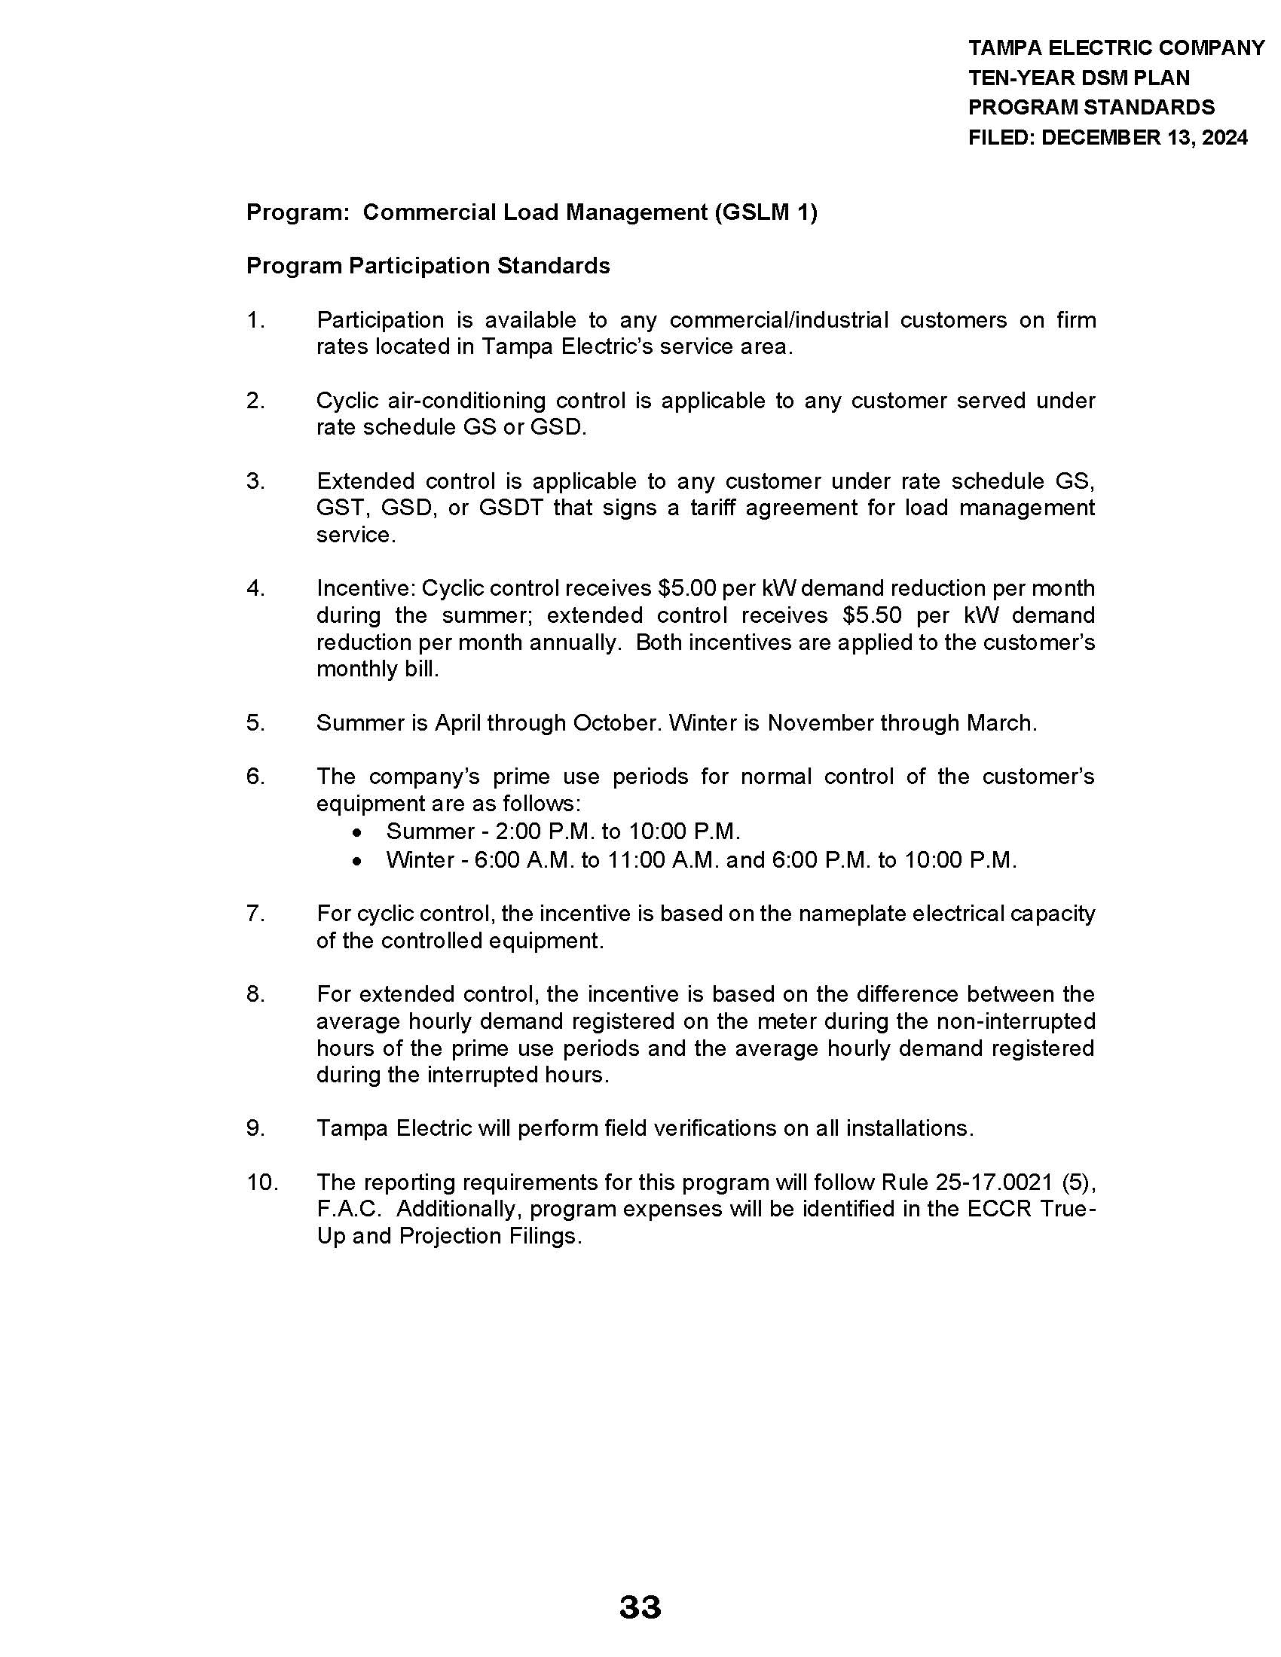

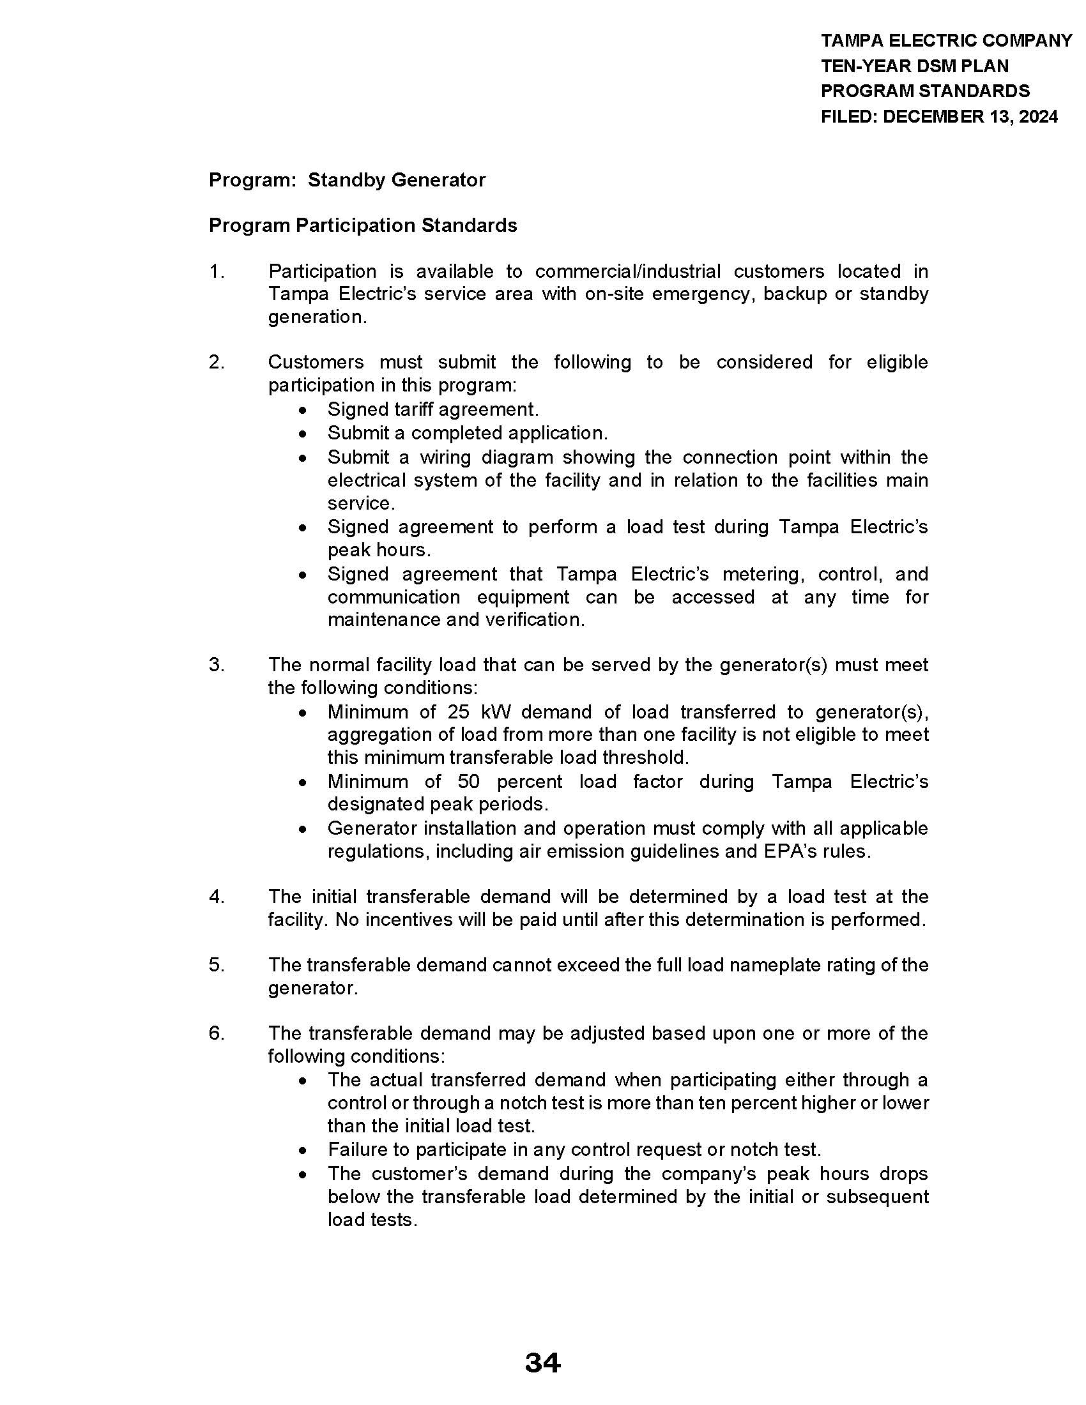

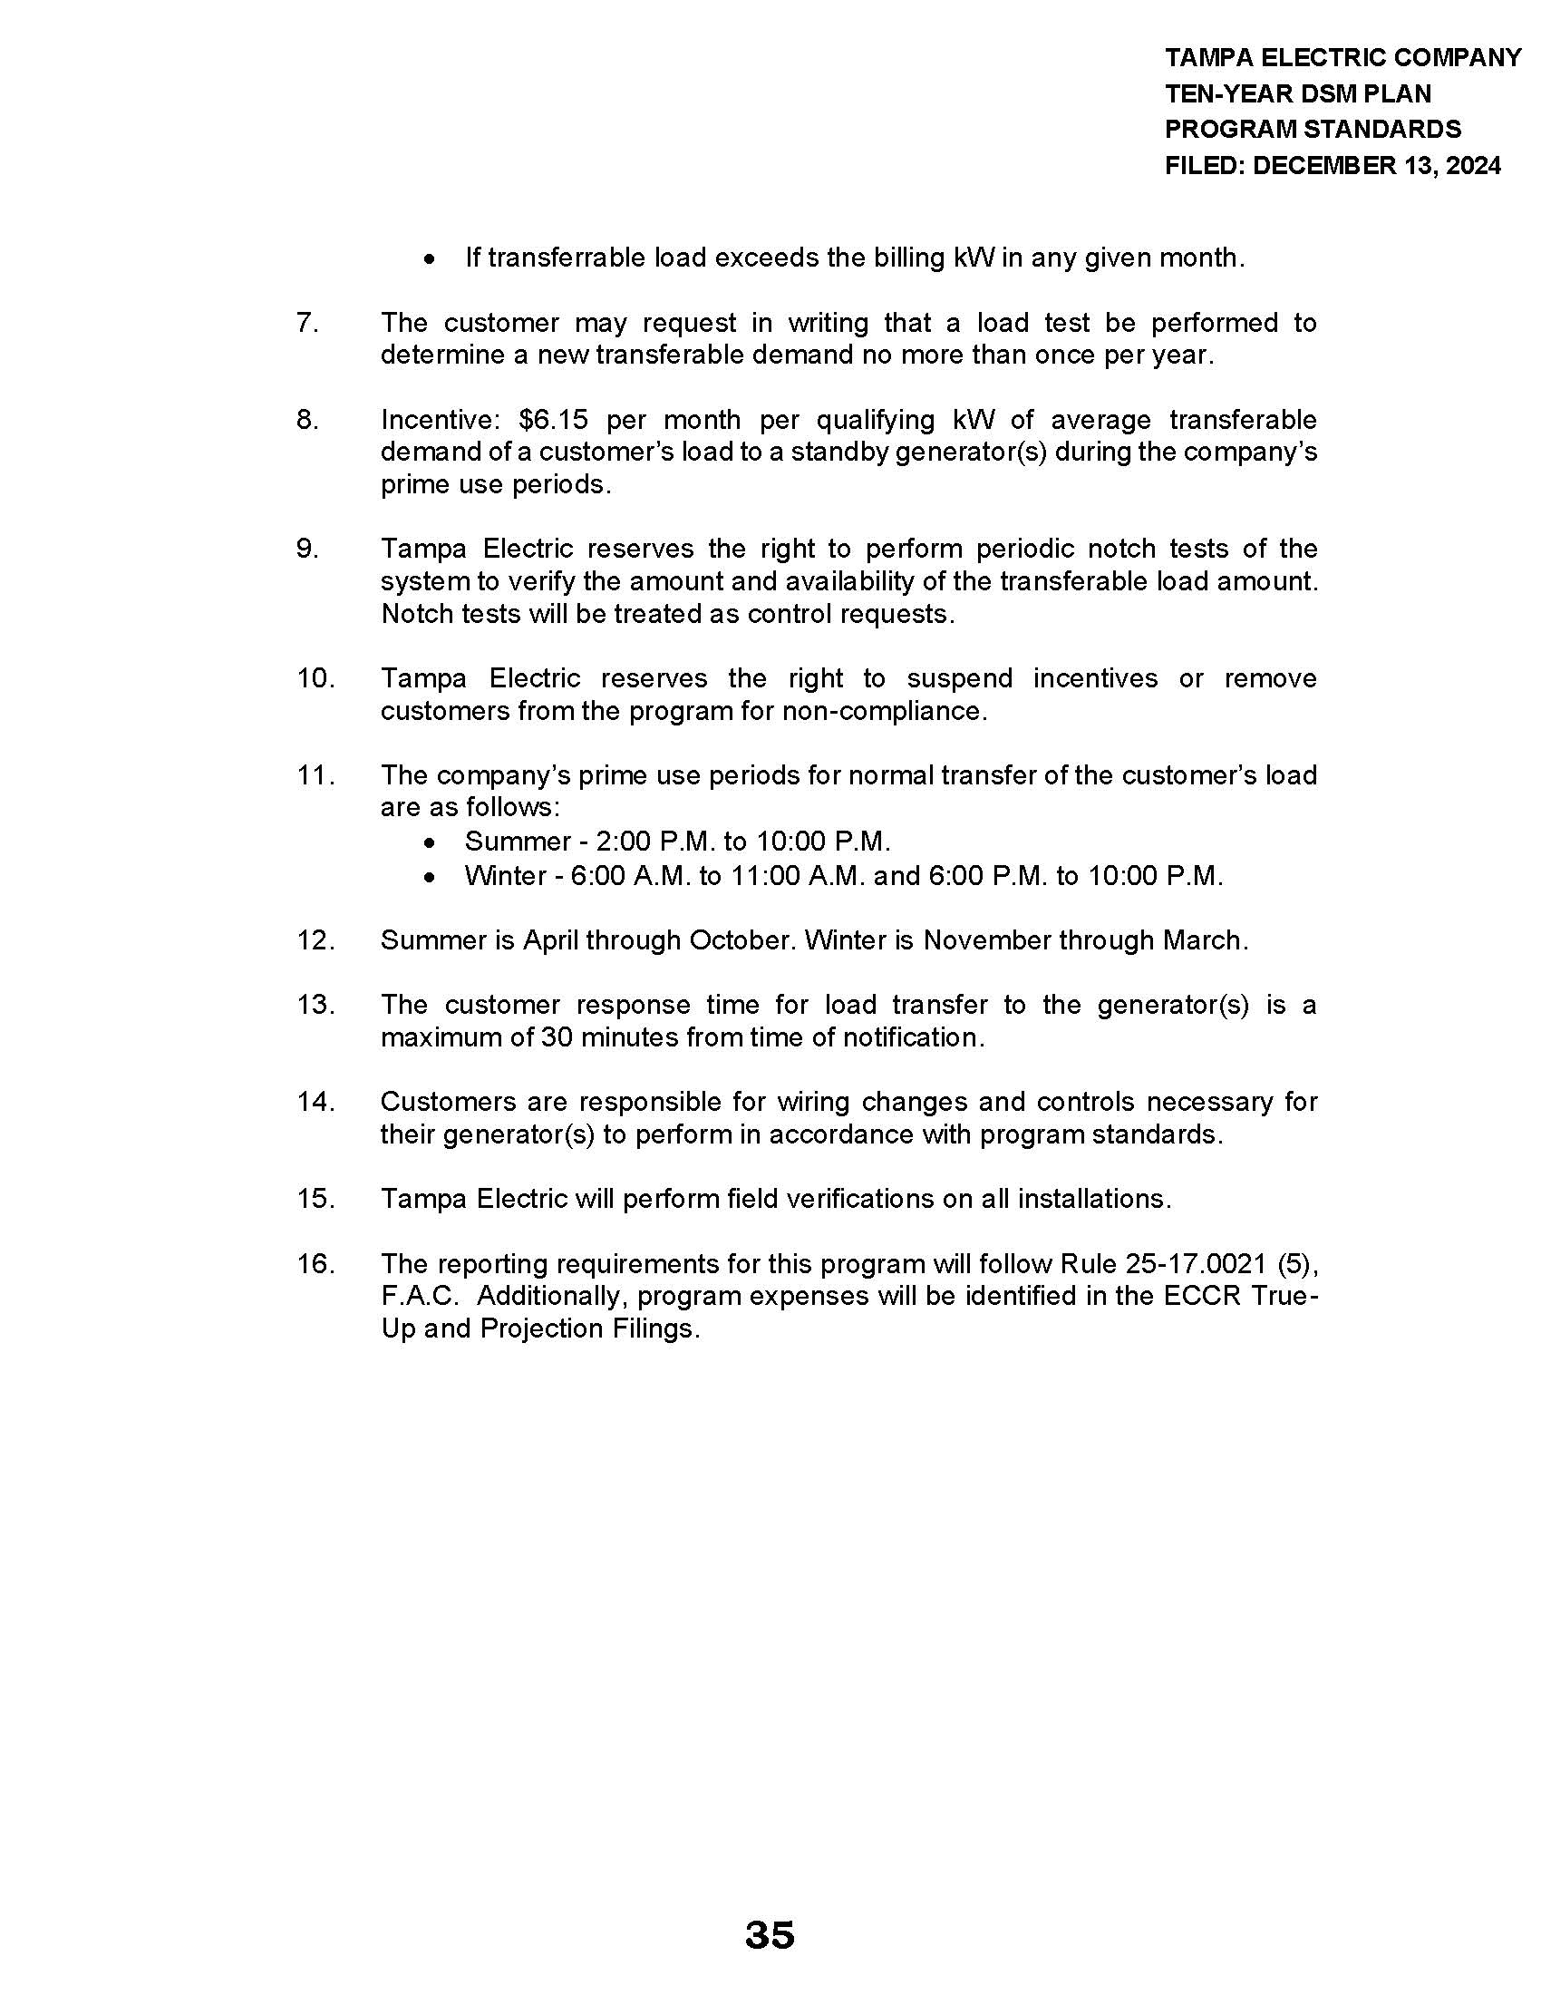

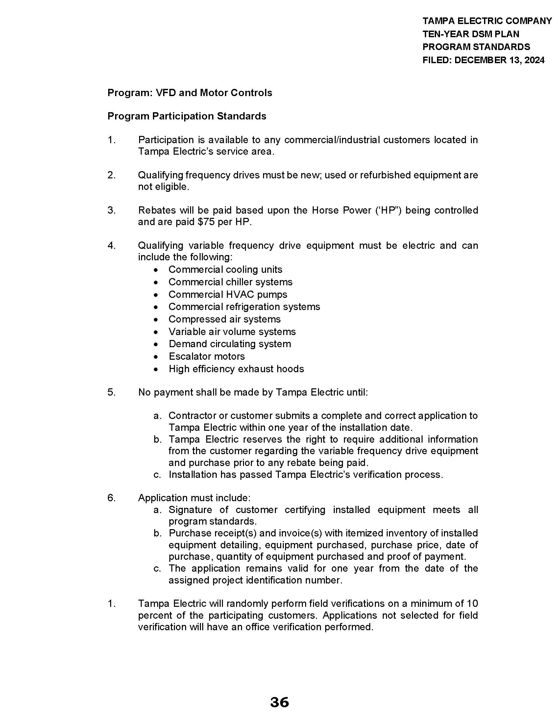

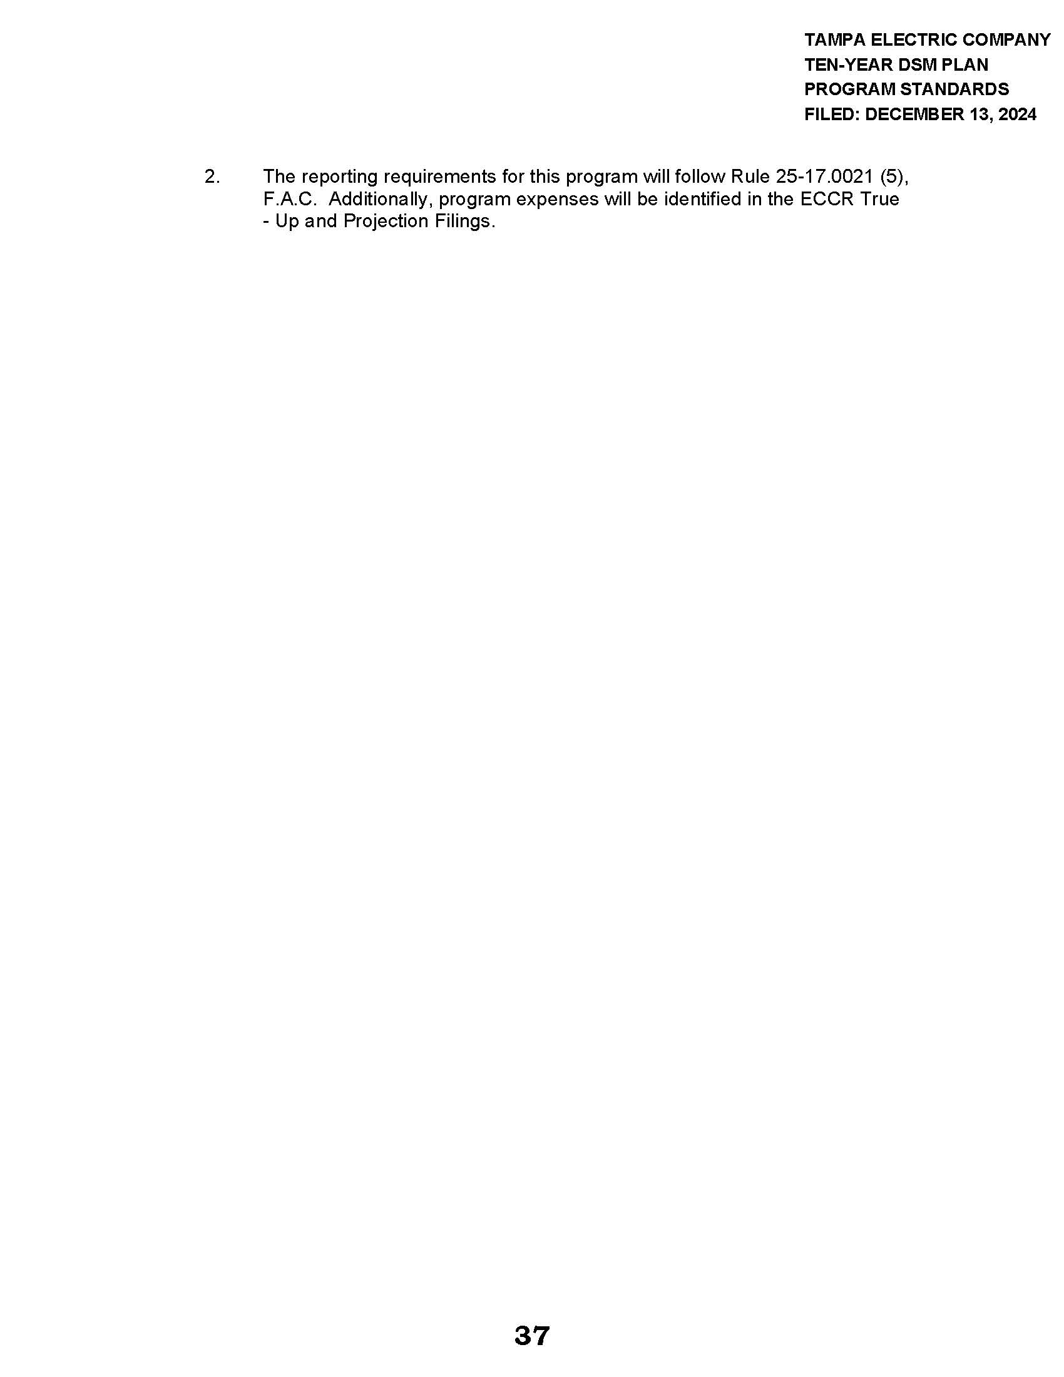

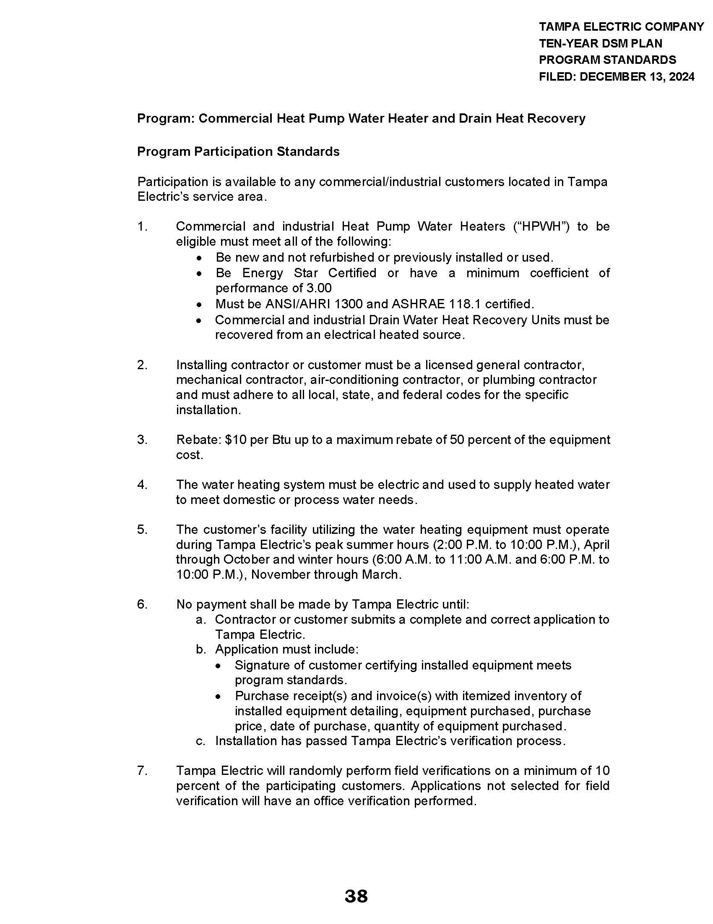

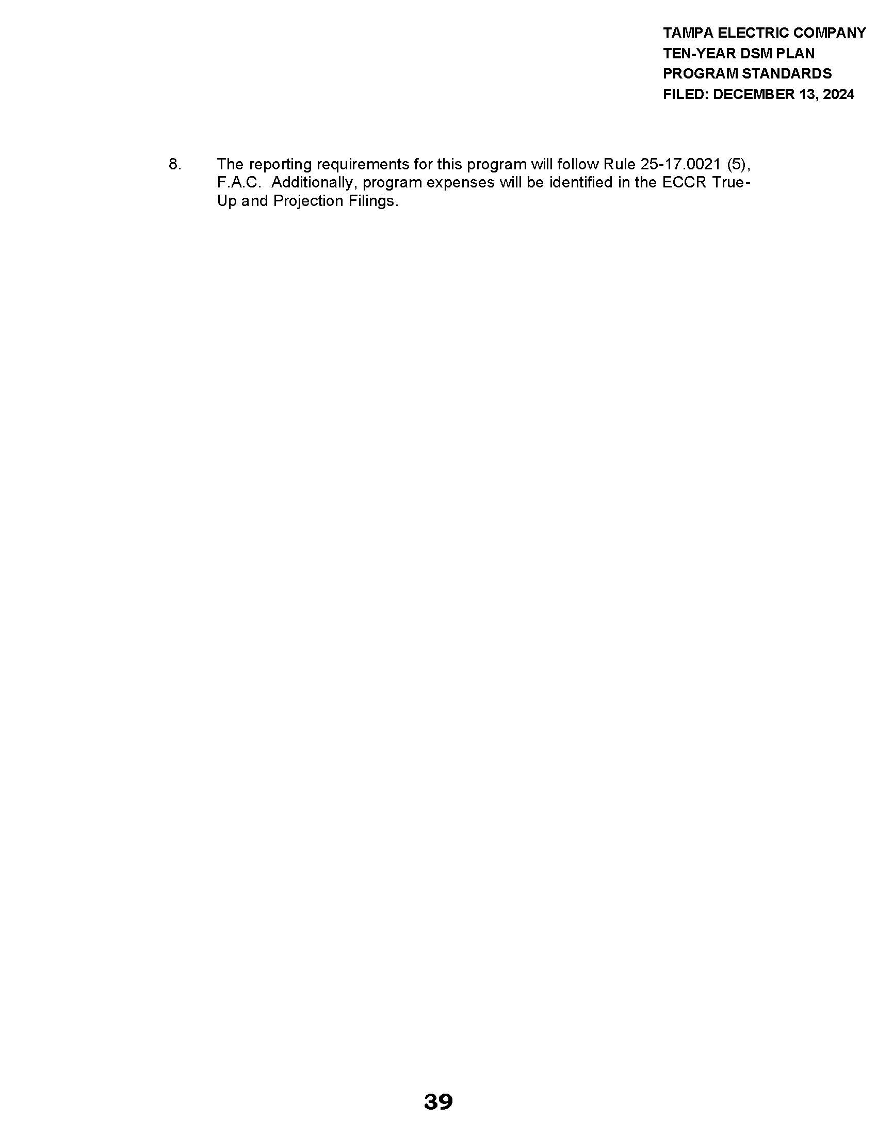

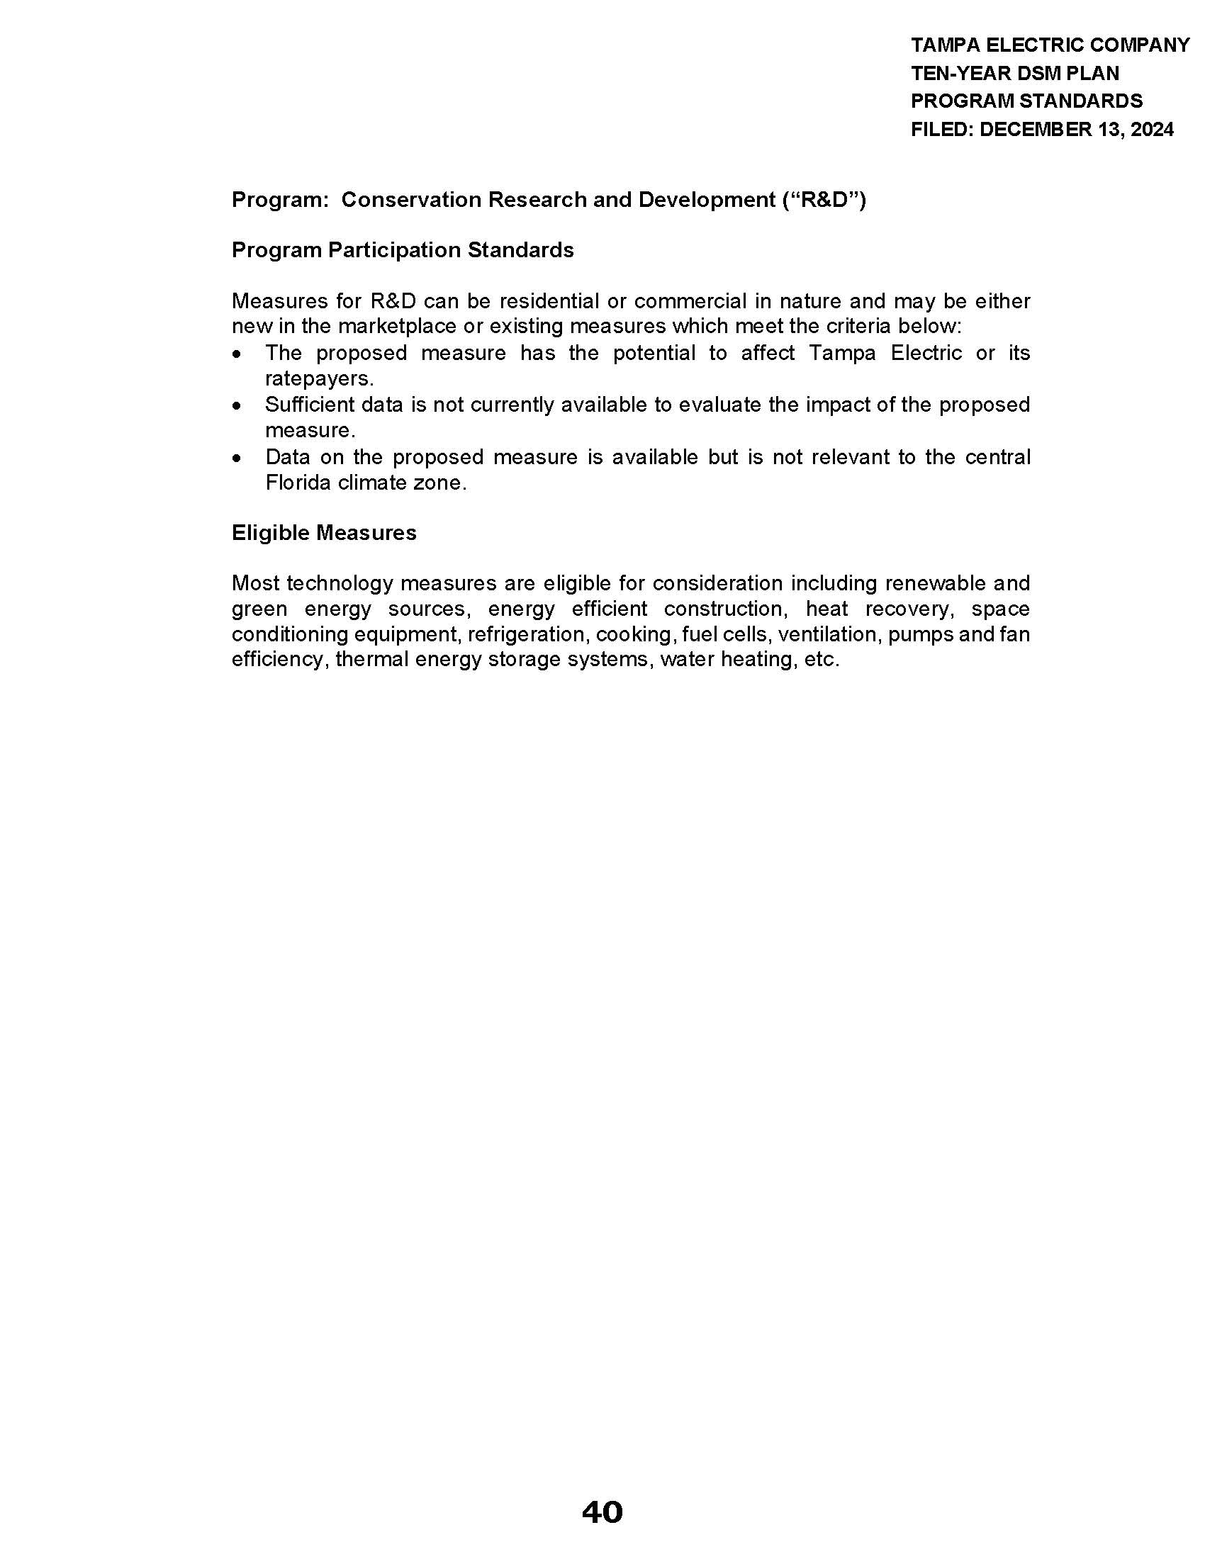

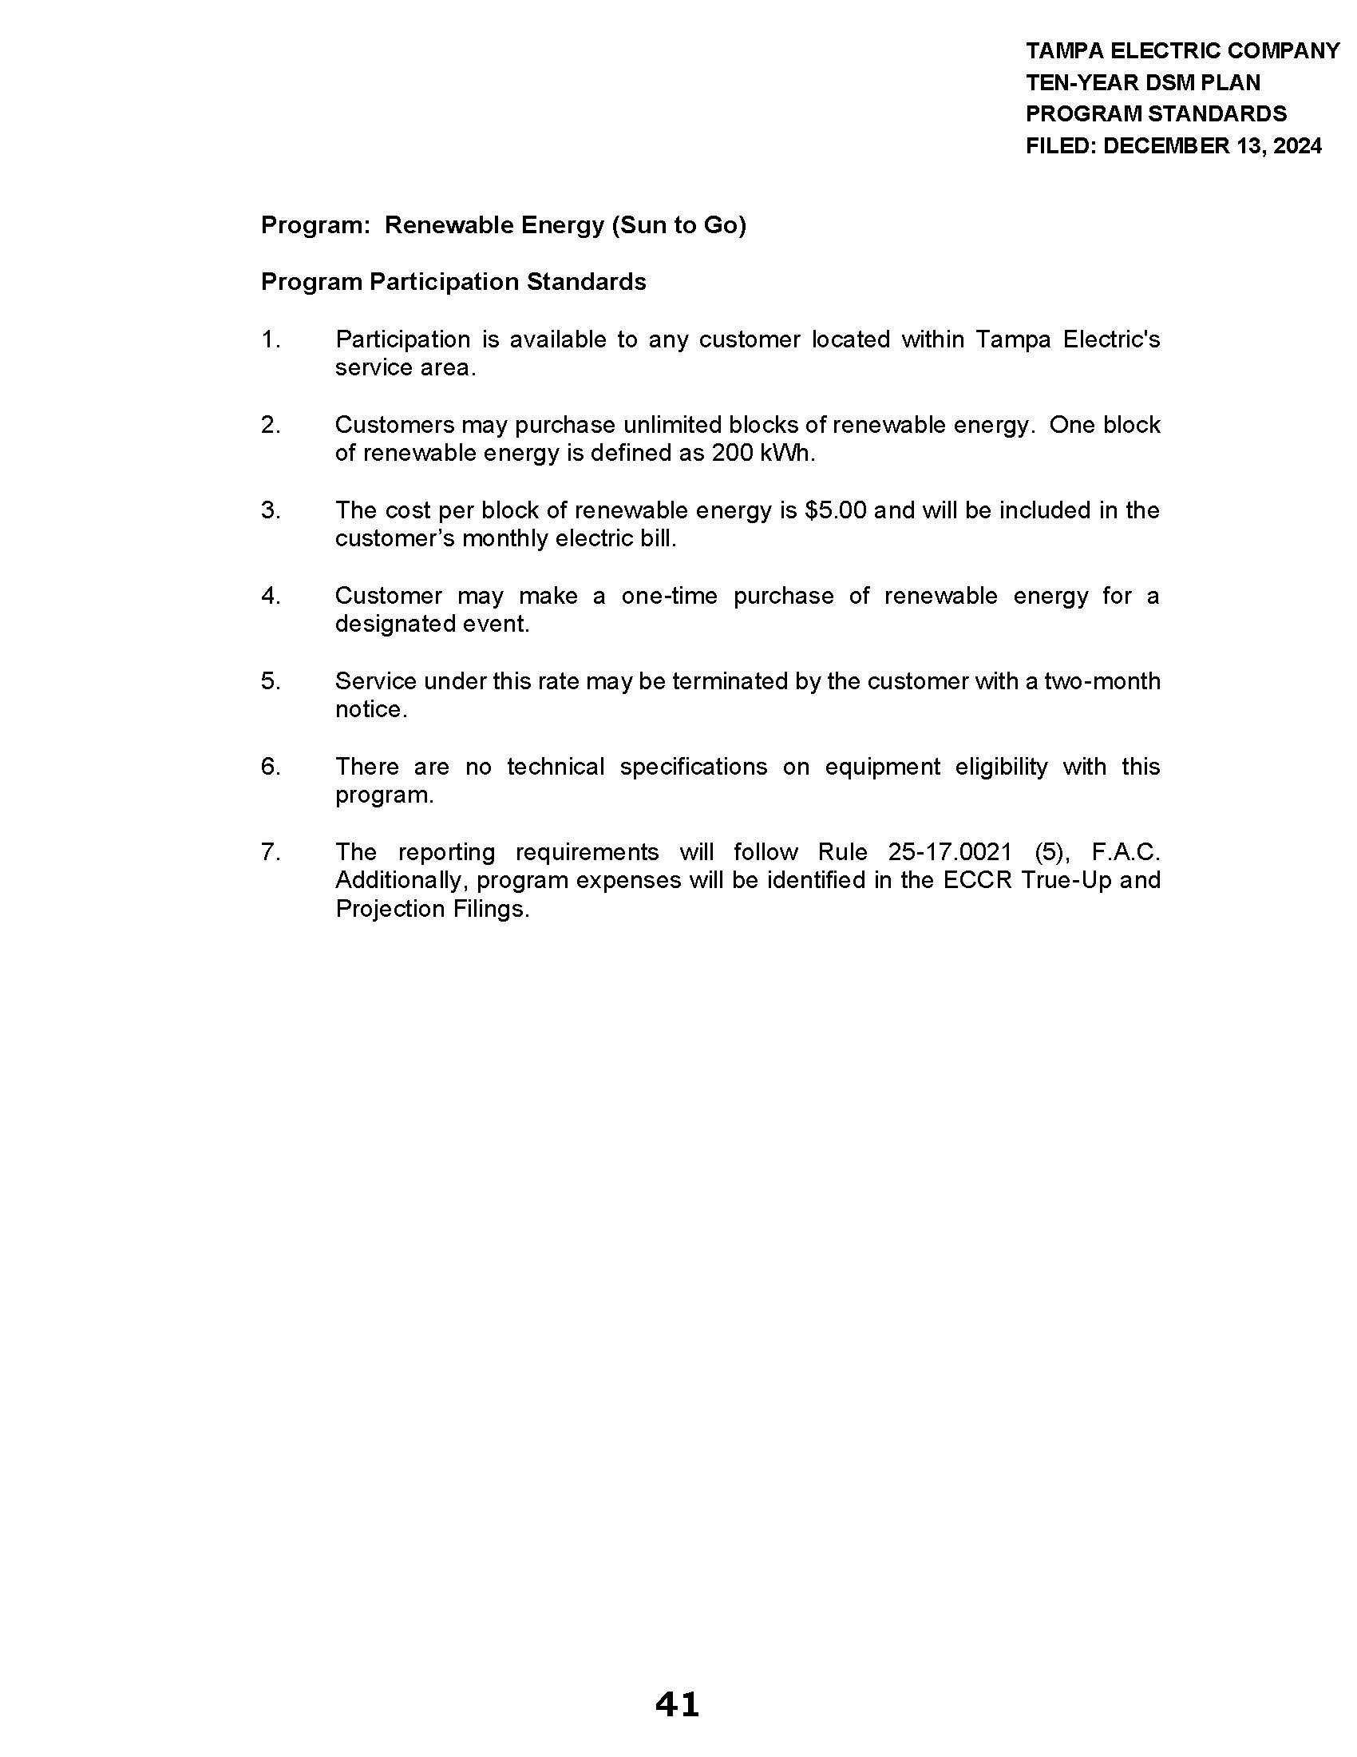

Order No. PSC-2024-0430-FOF-EG, issued September 20, 2024, in Docket No. 20240014-EG, In re: Commission review of numeric conservation goals (Tampa Electric Company).
Order No. PSC-2020-0274-PAA-EG, issued August 3, 2020, in Docket Nos. 20200053-EG, 20200054-EG, 20200055-EG, 20200056-EG, & 20200060-EG, In re: Petition for approval of demand-side management plan, by Tampa Electric Company, In re: Petition for approval of proposed demand-side management plan, by Duke Energy Florida, LLC, In re: Petition for approval of proposed demand-side management plan, by Gulf Power Company, In re: Petition for approval of demand-side management plan and request to modify residential and business on call tariff sheets, by Florida Power & Light Company, & In re: Petition for approval of demand-side management plan, by Florida Public Utilities Company, p. 4.
See Order No. PSC-2019-0509-FOF-EG, issued November 26, 2019, in Docket No. 20190015-EG, In re: Commission review of numeric conservation goals (Florida Power & Light Company), pp. 8–10 (finding that despite demand-side renewable energy systems not being cost-effective, continued encouragement of those systems through net metering practices nonetheless furthered FEECA); Order No. PSC-97-0528-FOF-EG, issued May 7, 1997, in Docket No. 960624-EG, In re: Petition for approval of Green Pricing Research and Development Project by Florida Power & Light Company, pp. 1–2 (approving not cost-effective DSM program involving photovoltaic modules when program could ultimately contribute to commercialization of renewable technologies or stimulate economic and technological growth in renewable technologies).

