BEFORE THE FLORIDA PUBLIC SERVICE COMMISSION

|  |  |
| --- | --- |
| In re: Petition for termination of my energy bill+ program with income qualified component, by Duke Energy Florida, LLC. | DOCKET NO. 20250037-EI  ORDER NO. PSC-2025-0179-PAA-EI  ISSUED: May 30, 2025 |

The following Commissioners participated in the disposition of this matter:

MIKE LA ROSA, Chairman

ART GRAHAM

GARY F. CLARK

ANDREW GILES FAY

GABRIELLA PASSIDOMO SMITH

NOTICE OF PROPOSED AGENCY ACTION

ORDER APPROVING TERMINATION OF DUKE ENERGY FLORIDA, LLC’S

MY ENERGY BILL+ PROGRAM

BY THE COMMISSION:

BACKGROUND

On March 3, 2025, Duke Energy Florida, LLC (Duke or the utility) filed a petition to close to new customers, and ultimately terminate, its optional My Energy Bill+ Program with Income Qualified Component (My Energy Bill+ Program) contained in Tariff Sheet Nos. 6.415 – 6.417. These tariff sheets are contained in Attachment A to this order. The utility states that it wants to terminate the My Energy Bill+ Program due to a lack of customer interest. The My Energy Bill+ Program is a fixed bill program that allows Duke to have limited control of a participating customer’s thermostat during specified demand response events. In exchange for this control, participating customers pay a fixed monthly bill for a year with no true-up costs. The bill calculation includes a usage adder of six percent during the first year of participation, plus a risk adder of four percent, which is lower than Duke’s FixedBill tariff. The My Energy Bill+ Program was approved by Order No. PSC-2022-0246-TRF-EI.[1]

If the petition is approved, Duke states that it would work with enrolled customers to transition them to the FixedBill program, Budget Billing, or return them to their previous standard rate schedule. Once all customers have been transitioned out of the My Energy Bill+ Program, Duke requests that we grant our staff administrative authority to approve tariff sheets to terminate the program.

Duke’s current FixedBill tariff is a flat bill program that allows participating customers to receive a fixed monthly bill for 12 months, which is calculated using the prior 12 months of actual usage data, applying weather normalization, plus an additional risk and usage adder. The FixedBill tariff was first approved by Order No. PSC-2017-0451-AS-EU and became effective on March 1, 2018.[2]

During the evaluation of the petition, our staff issued a data request for which responses were received on April 7, 2025. We have jurisdiction over this matter pursuant to Sections 366.03, 366.04, 366.05, and 366.06, Florida Statutes (F.S.).

DECISION

My Energy Bill+ Program Participation

Duke launched its first My Energy Bill+ offers to customers in November 2022. In its petition, the utility stated that additional offers were sent from March to May 2023. Duke stated that after sending 358,164 customers multiple direct marketing offers, including by mail and by email, only 142 customers enrolled in the program. Duke stated that the cost of the marketing offers was $295,695 and the costs were recovered below-the-line.[3] Currently, there are 130 customers enrolled in the program. Due to lack of customer interest in the My Energy Bill+ Program, Duke seeks to close the program to new customers and ultimately terminate the program.

For participating in the program, Duke also offered income qualified customers a free smart thermostat and installation, of which Duke completed 41 installations. The utility asserted that customers who received smart thermostat installations through the program will continue to own them if the My Energy Bill+ Program is terminated.[4]

The utility stated that the annual program costs for the My Energy Bill+ Program are $288,510 for year 1, $379,650 for year 2, and $459,275 for year 3.[5] The utility also stated that program costs are expected to increase annually based on vendor costs to support smart thermostat enrollment. All program costs are recorded below-the-line.

Closure and Termination of My Energy Bill+ Program

In its petition, Duke stated that if the program is closed it would work with enrolled customers to transition them to an alternative rate schedule. Customers would be transferred to the FixedBill program, Budget Billing, or returned to their previous standard rate schedule. Duke stated that it plans to allow customers to complete their current My Energy Bill+ 12-month service agreement.[6] Two months before the end of the agreement period, customers will receive an email from the utility informing them that the program will be terminated and other billing options are available. The utility stated that it expects all customers to be transitioned out of the My Energy Bill+ Program by October 2026.[7]

Additionally, Duke requests that we grant our staff administrative authority to approve tariffs to terminate the program after all customers have been transitioned out of the My Energy Bill+ Program. The utility stated that it will notify our staff once all customers have been removed from the My Energy Bill+ Program, including details about the new billing or payment option selected by each customer.[8]

Based on the petition and the utility’s responses to data requests, there is a clear lack of customer interest in this program. Further, there are alternative fixed bill and budget billing rate schedules available to these customers. Therefore, we hereby approve as reasonable Duke’s request to close the My Energy Bill+ Program to new customers as of August 1, 2025, and approve the tariffs contained in Attachment A to this order. Additionally, we grant our staff administrative authority to approve tariff sheets to terminate the program once all customers have been transitioned to an alternative rate schedule.

Based on the foregoing, it is

ORDERED by the Florida Public Service Commission that Duke Energy Florida LLC’s request to close the My Energy Bill+ Program to new customers and to grant staff administrative authority to approve the tariffs contained in Attachment A to this order is hereby granted. It is further

ORDERED that our staff is granted administrative authority to approve tariff sheets to terminate the program once all customers have been transitioned to an alternative rate schedule. It is further

ORDERED that if no protest is filed by a person whose substantial interests are affected within 21 days of the issuance of this order, this docket shall be closed upon the issuance of a Consummating Order. However, if a protest is timely filed in this docket, this docket shall remain open, and the current tariff remain in effect, until the resolution of the protest.

By ORDER of the Florida Public Service Commission this 30th day of May, 2025.

|  |  |
| --- | --- |
|  | /s/ Adam J. Teitzman |
|  | ADAM J. TEITZMAN  Commission Clerk |

Florida Public Service Commission

2540 Shumard Oak Boulevard

Tallahassee, Florida 32399

(850) 413‑6770

www.floridapsc.com

Copies furnished: A copy of this document is provided to the parties of record at the time of issuance and, if applicable, interested persons.

SBr

NOTICE OF FURTHER PROCEEDINGS

The Florida Public Service Commission is required by Section 120.569(1), Florida Statutes, to notify parties of any administrative hearing or judicial review of Commission orders that is available under Sections 120.57 or 120.68, Florida Statutes, as well as the procedures and time limits that apply. This notice should not be construed to mean all requests for an administrative hearing or judicial review will be granted or result in the relief sought.

Mediation may be available on a case-by-case basis. If mediation is conducted, it does not affect a substantially interested person's right to a hearing.

The Commission's decision on this tariff is interim in nature and will become final, unless a person whose substantial interests are affected by the proposed action files a petition for a formal proceeding, in the form provided by Rule 28-106.201, Florida Administrative Code. This petition must be received by the Office of Commission Clerk, 2540 Shumard Oak Boulevard, Tallahassee, Florida 32399-0850, by the close of business on June 20, 2025.

In the absence of such a petition, this Order shall become final and effective upon the issuance of a Consummating Order.

Any objection or protest filed in this docket before the issuance date of this order is considered abandoned unless it satisfies the foregoing conditions and is renewed within the specified protest period.

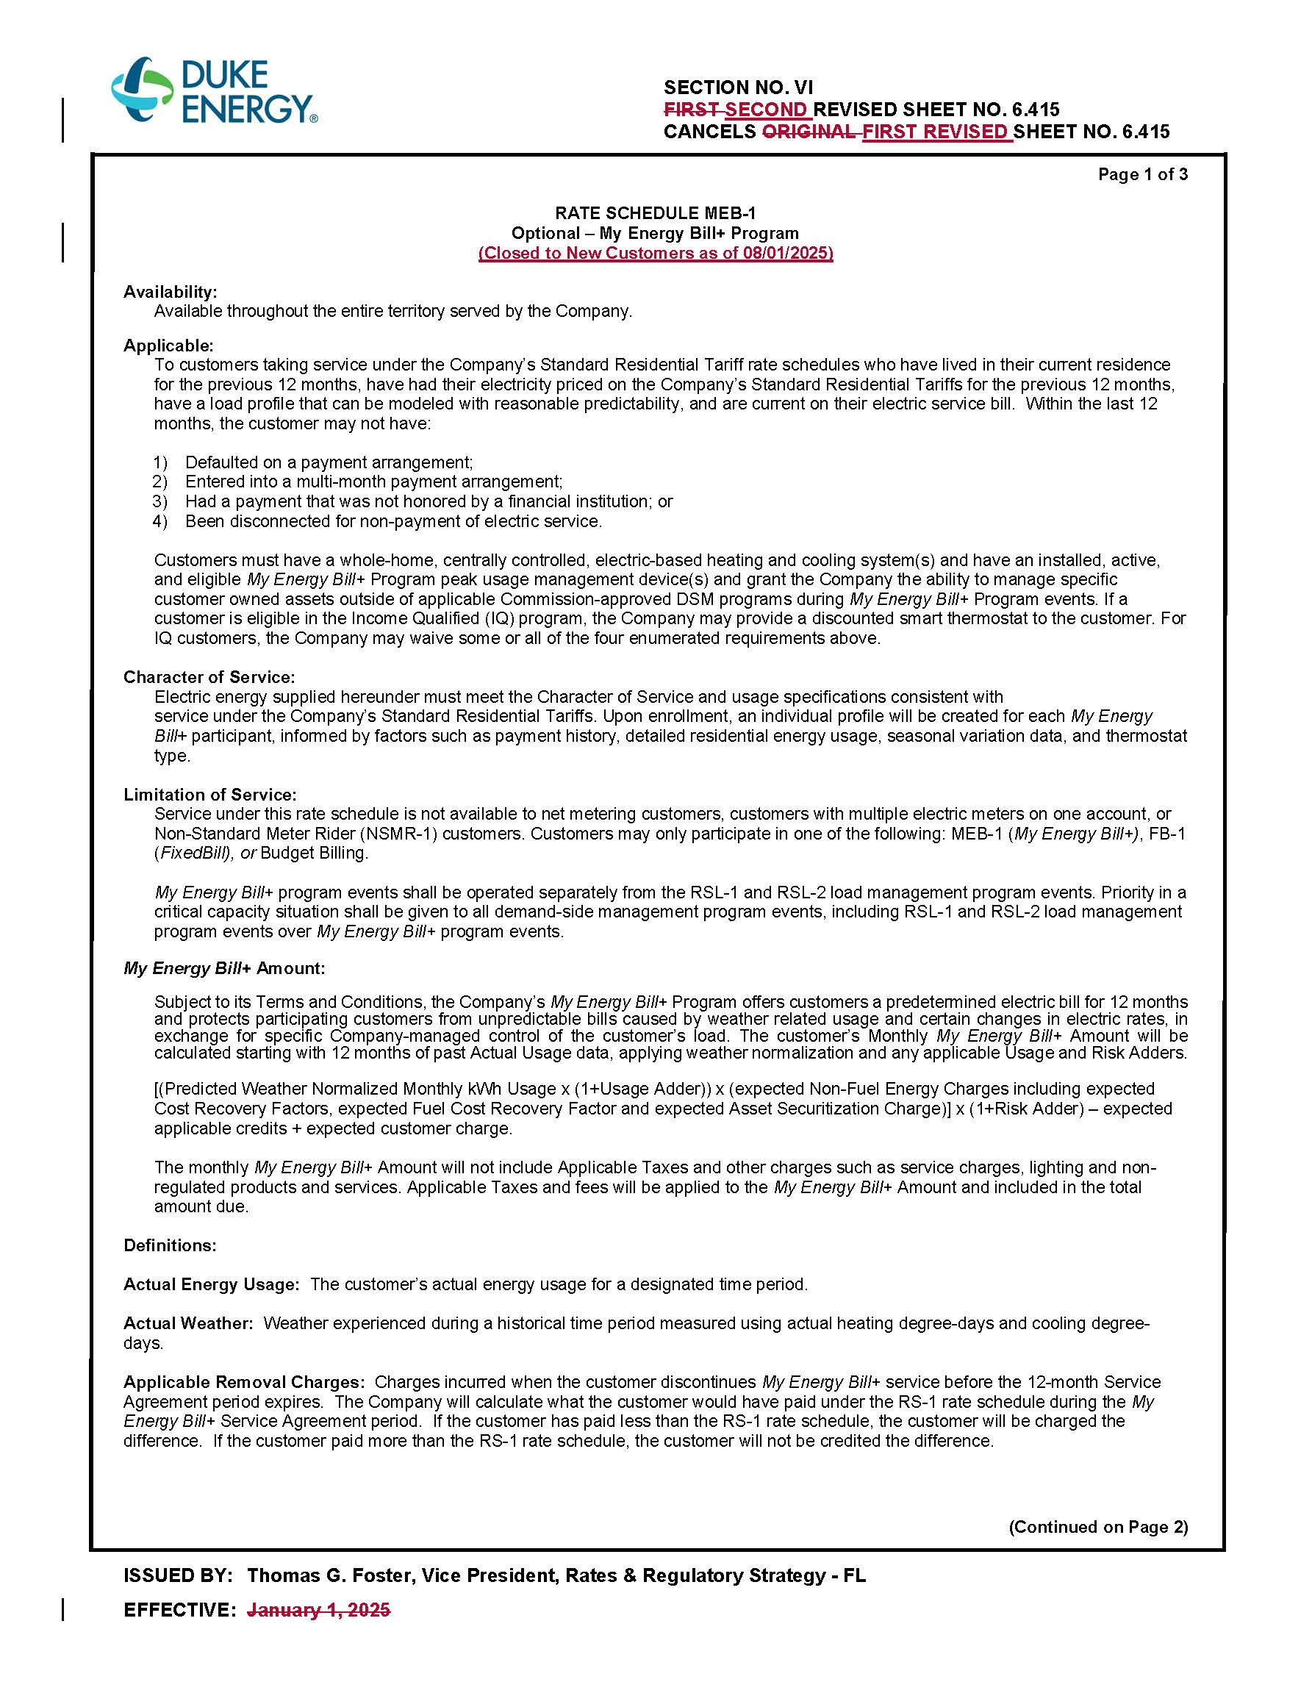

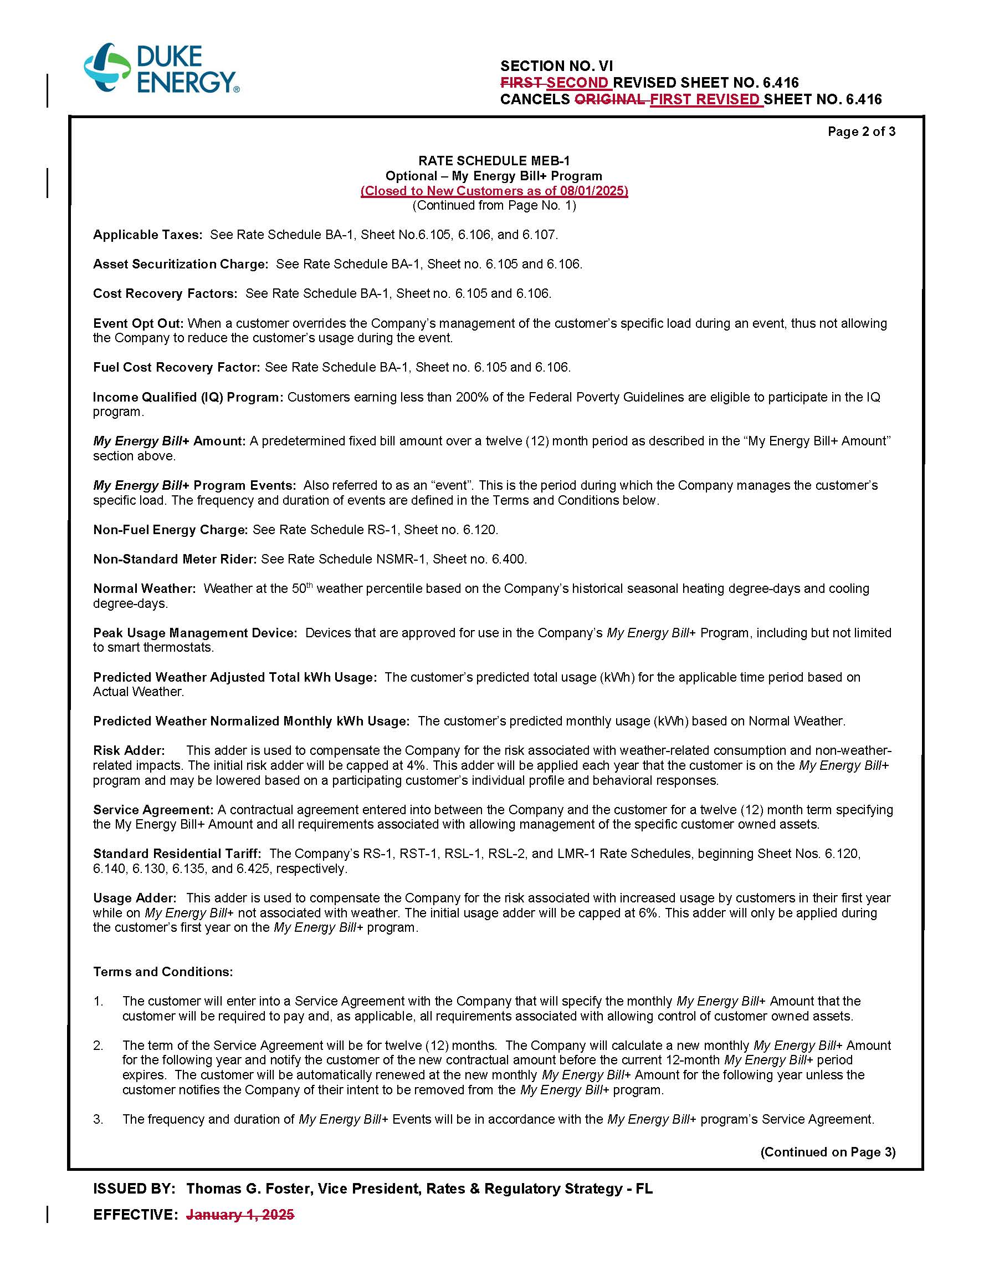

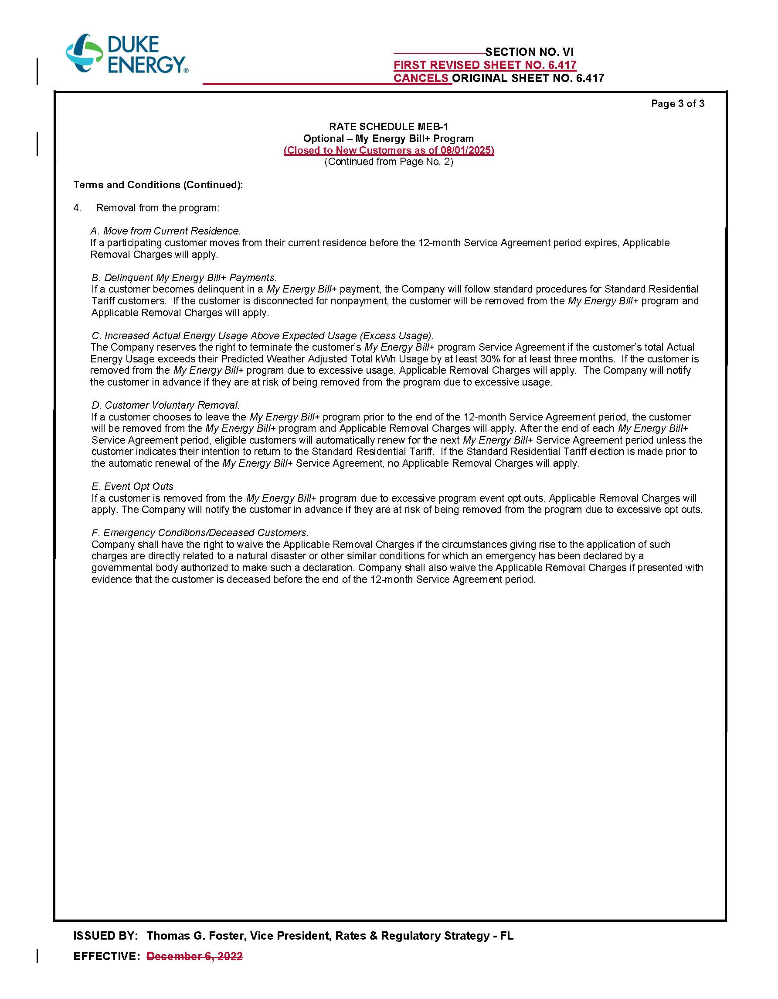

1. Order No. PSC-2022-0246-TRF-EI, issued December 14, 2022, in Docket No. 20220106-EI, *In re: Petition for approval of new my energy bill+ program with income qualified component, by Duke Energy Florida, LLC.*
2. Order No. PSC-2017-0451-AS-EU, issued November 20, 2017, in Docket No. 20170183-EI, *In re: Application for*

   *limited proceeding to approve 2017 second revised and restated settlement agreement, including certain rate*

   *adjustments, by Duke Energy Florida, LLC.*
3. Responses to Staff’s First Data Request, Response No. 7.
4. Responses to Staff’s First Data Request, Response No. 3.
5. Responses to Staff’s First Data Request, Response No. 2.
6. Responses to Staff’s First Data Request, Response No. 4.
7. Response to Staff’s First Data Request, Response No. 6.
8. Response to Staff’s First Data Request, Response No. 5.