BEFORE THE FLORIDA PUBLIC SERVICE COMMISSION

|  |  |
| --- | --- |
| In re: Petition for approval of amendment to transportation service agreement between Peninsula Pipeline Company, Inc. and Florida City Gas. | DOCKET NO. 20250042-GU  ORDER NO. PSC-2025-0225-PAA-GU  ISSUED: June 20, 2025 |

The following Commissioners participated in the disposition of this matter:

MIKE LA ROSA, Chairman

ART GRAHAM

GARY F. CLARK

ANDREW GILES FAY

GABRIELLA PASSIDOMO SMITH

NOTICE OF PROPOSED AGENCY ACTION

ORDER APPROVING AMENDMENT TO

TRANSPORTATION SERVICE AGREEMENT

BY THE COMMISSION:

NOTICE is hereby given by the Florida Public Service Commission that the action discussed herein is preliminary in nature and will become final unless a person whose interests are substantially affected files a petition for a formal proceeding, pursuant to Rule 25-22.029, Florida Administrative Code (F.A.C.).

Background

On March 14, 2025, Peninsula Pipeline Company, Inc. (Peninsula) filed its petition for approval of an amendment to a transportation service agreement between Peninsula and Florida City Gas (FCG). Peninsula states that it has received notice of a mandatory relocation by the Florida Department of Transportation (FDOT) for a road enhancement project. Peninsula has been mandated to relocate approximately 6,000 feet of 6-inch steel gas pipeline from the public right of way in Indian River County. The proposed amendment to the transportation service agreement is a result of the mandatory relocation by FDOT.

Peninsula, a wholly owned subsidiary of Chesapeake Utilities Corporation (Chesapeake), operates as an intrastate natural gas transmission company as defined by Section 368.103(4), Florida Statutes (F.S.).[1] FCG is a local distribution company, and is also a wholly owned subsidiary of Chesapeake, subject to our regulatory jurisdiction pursuant to Chapter 366, F.S. FCG provides natural gas service to residential, commercial, and industrial customers in Brevard, Indian River, and Miami-Dade Counties, and receives deliveries of natural gas to serve these customers over the interstate transmission pipelines owned by Florida Gas Transmission Company, LLC. The Parties are subsidiaries of Chesapeake, and agreements between affiliated companies must be approved by us pursuant to Section 368.105, F.S.

In July 2024, we approved Peninsula’s petition for approval of transportation service agreements between Peninsula and FCG.[2] As described on page 5 of the 2024 Order, the Indian River agreement also consolidated certain pre-existing agreements, which had been entered into before FCG was acquired by Chesapeake and therefore were not subject to our approval. The pipeline segment FDOT has now required Peninsula to relocate was initially constructed pursuant to a 2012 agreement and was consolidated in the 2024 agreement, as discussed on page 5 of the 2024 Order.

During the evaluation of the petition, our staff issued one data request to Peninsula, for which responses were received on April 28, 2025.[3] The proposed amendment to the transportation service agreement is included in this order as Attachment A. This proposed amendment also includes Exhibits A, B, and C to the transportation service agreement. We have jurisdiction over this matter pursuant to Sections 366.05(1), 366.06, and 368.105, F.S.

Decision

Peninsula initially received notice from FDOT of the road enhancement project in Indian River County on May 24, 2024.[4] As described in Peninsula’s notice to FCG, this road enhancement project requires Peninsula to relocate approximately 6,000 feet of 6-inch steel gas pipeline from the public right of way. Peninsula stated that the relocation of the pipeline segment is expected to be completed by November 2025.[5] Section 4.3 of the 2024 transportation service agreement allows Peninsula to adjust the Monthly Reservation Charge to recover the cost of mandatory relocations of pipeline facilities.[6] Section 4.3 of the 2024 agreement states:

“If, at any time after the Execution Date and throughout the term of this Agreement, [Peninsula] is required by any Governmental Authority… asserting jurisdiction over this Agreement and the transportation of Gas hereunder, to incur additional capital expenditures with regard to the service provided by [Peninsula] under this Agreement… including, without limitation, mandated relocations of [Peninsula’s] pipeline facilities serving [FCG’s] facility…, then [FCG’s] Monthly Reservation Charge shall be adjusted and Exhibit A updated accordingly, and the new Monthly Reservation Charge shall be implemented immediately upon the effective date of such action, subject to Commission approval of the amendment.”

Peninsula states the revised monthly reservation charge in the proposed amendment is appropriately modified to include the incremental costs required to relocate the pipeline segment. Peninsula provided a breakdown of the incremental capital costs to be incurred in response to our staff’s first data request.[7] In its response, Peninsula stated that the pipeline relocation would total approximately $3.1 million in capital costs, which includes $1.3 million in materials, supplies, and contingency, $940,000 in contractor labor, and $366,000 in inspections. Peninsula also provided in its responses the inputs used to calculate the incremental monthly reservation charge, which includes interest expense and return on equity, book depreciation, incremental operations and maintenance, and tax expense associated with the capital costs.

In addition to the revised Monthly Reservation Charge on Exhibits A and C to the agreement, Peninsula has also updated Exhibit B to include Pivotal Utility Holding, Inc. to Florida City Gas’s name in the title. No other modifications to Exhibit B have been proposed.

Based on the information provided in the petition and Peninsula’s responses to data requests, we approve the proposed amendment to the transportation service agreement between Peninsula and FCG, dated February 14, 2025. The proposed Total Monthly Reservation Charge for Segment I, as shown on Exhibits A and C to the transportation service agreement, is reasonable and meets the requirements of Section 368.105, F.S.

Based on the foregoing, it is

ORDERED by the Florida Public Service Commission that the proposed amendment to the transportation service agreement between Peninsula Pipeline Company, Inc. and Florida City Gas, dated February 14, 2025, is approved. The proposed Total Monthly Reservation Charge for Segment I, as shown on Exhibits A and C to the transportation service agreement, is reasonable and meets the requirements of Section 368.105, F.S. It is further

ORDERED that the provisions of this Order, issued as proposed agency action, shall become final and effective upon the issuance of a Consummating Order unless an appropriate petition, in the form provided by Rule 28-106.201, Florida Administrative Code, is received by the Commission Clerk, 2540 Shumard Oak Boulevard, Tallahassee, Florida 32399-0850, by the close of business on the date set forth in the “Notice of Further Proceedings” attached hereto. It is further

ORDERED that in the event this Order becomes final, this docket shall be closed.

By ORDER of the Florida Public Service Commission this 20th day of June, 2025.

|  |  |
| --- | --- |
|  | /s/ Adam J. Teitzman |
|  | ADAM J. TEITZMAN  Commission Clerk |

Florida Public Service Commission

2540 Shumard Oak Boulevard

Tallahassee, Florida 32399

(850) 413‑6770

www.floridapsc.com

Copies furnished: A copy of this document is provided to the parties of record at the time of issuance and, if applicable, interested persons.

DD

NOTICE OF FURTHER PROCEEDINGS OR JUDICIAL REVIEW

The Florida Public Service Commission is required by Section 120.569(1), Florida Statutes, to notify parties of any administrative hearing that is available under Section 120.57, Florida Statutes, as well as the procedures and time limits that apply. This notice should not be construed to mean all requests for an administrative hearing will be granted or result in the relief sought.

Mediation may be available on a case-by-case basis. If mediation is conducted, it does not affect a substantially interested person's right to a hearing.

The action proposed herein is preliminary in nature. Any person whose substantial interests are affected by the action proposed by this order may file a petition for a formal proceeding, in the form provided by Rule 28-106.201, Florida Administrative Code. This petition must be received by the Office of Commission Clerk, 2540 Shumard Oak Boulevard, Tallahassee, Florida 32399-0850, by the close of business on July 11, 2025.

In the absence of such a petition, this order shall become final and effective upon the issuance of a Consummating Order.

Any objection or protest filed in this/these docket(s) before the issuance date of this order is considered abandoned unless it satisfies the foregoing conditions and is renewed within the specified protest period.

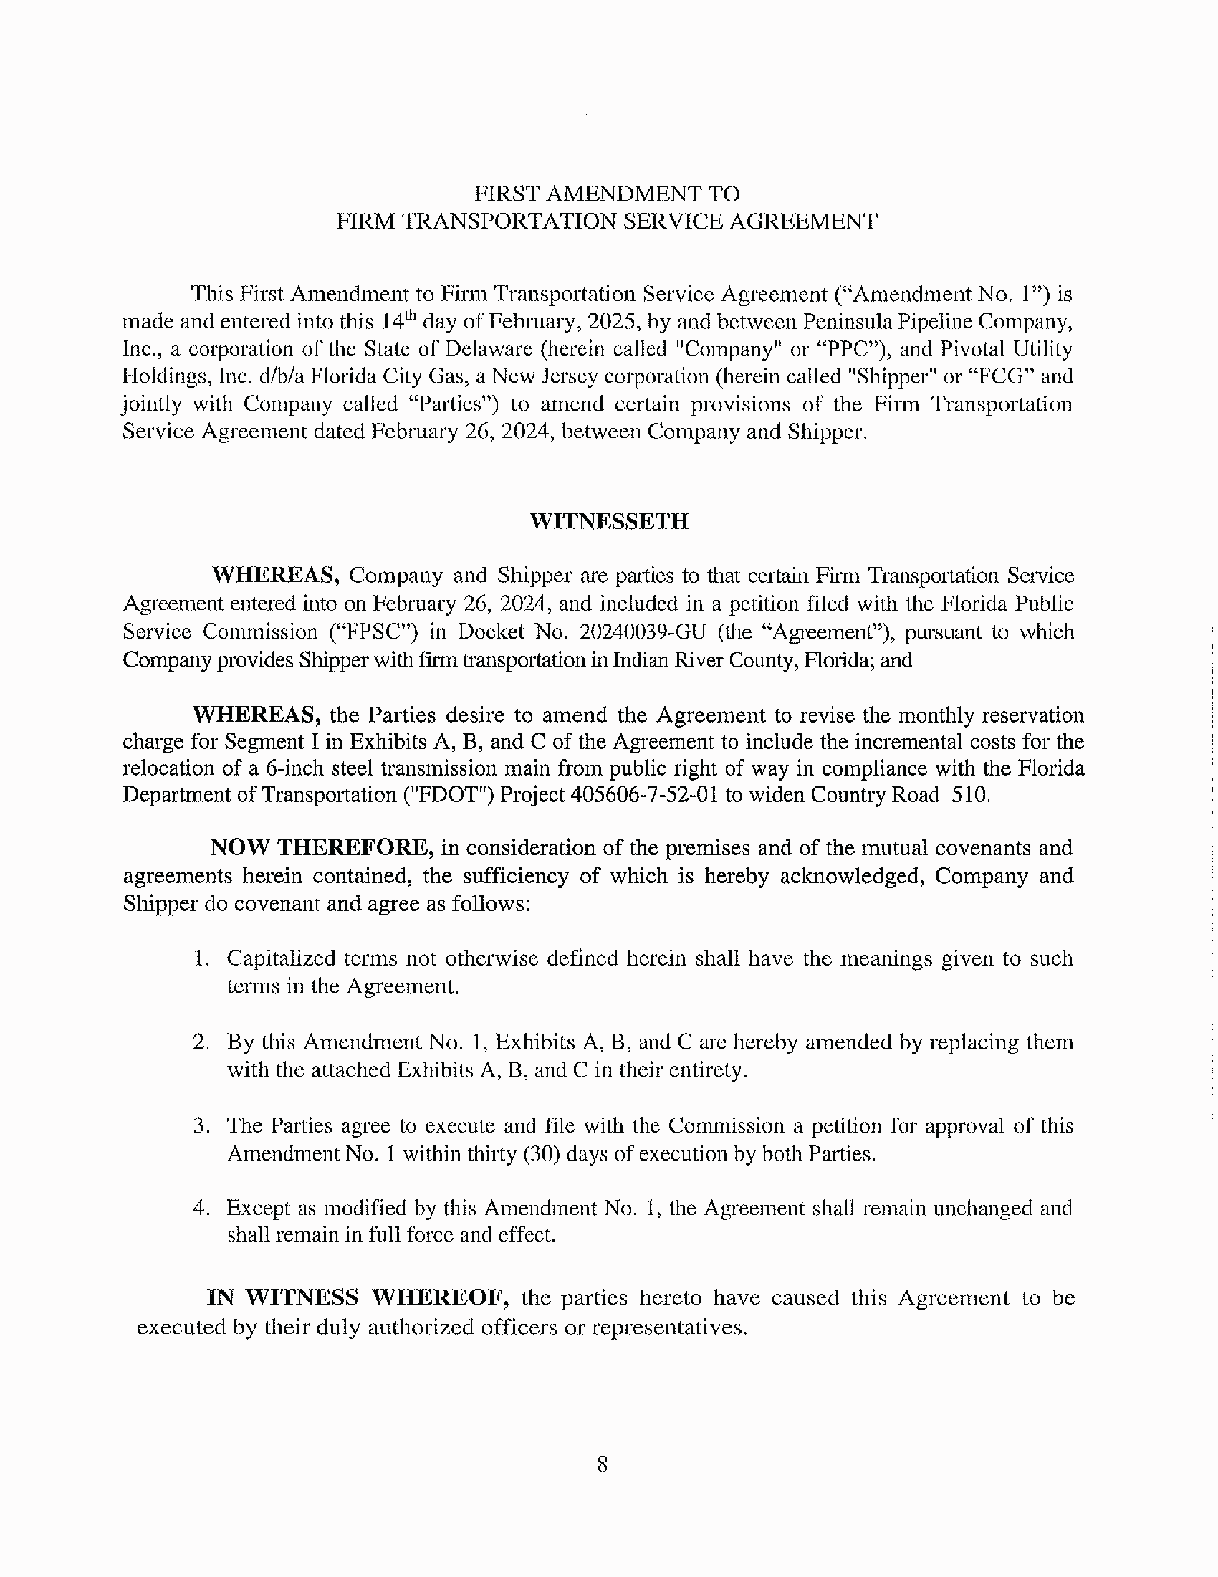

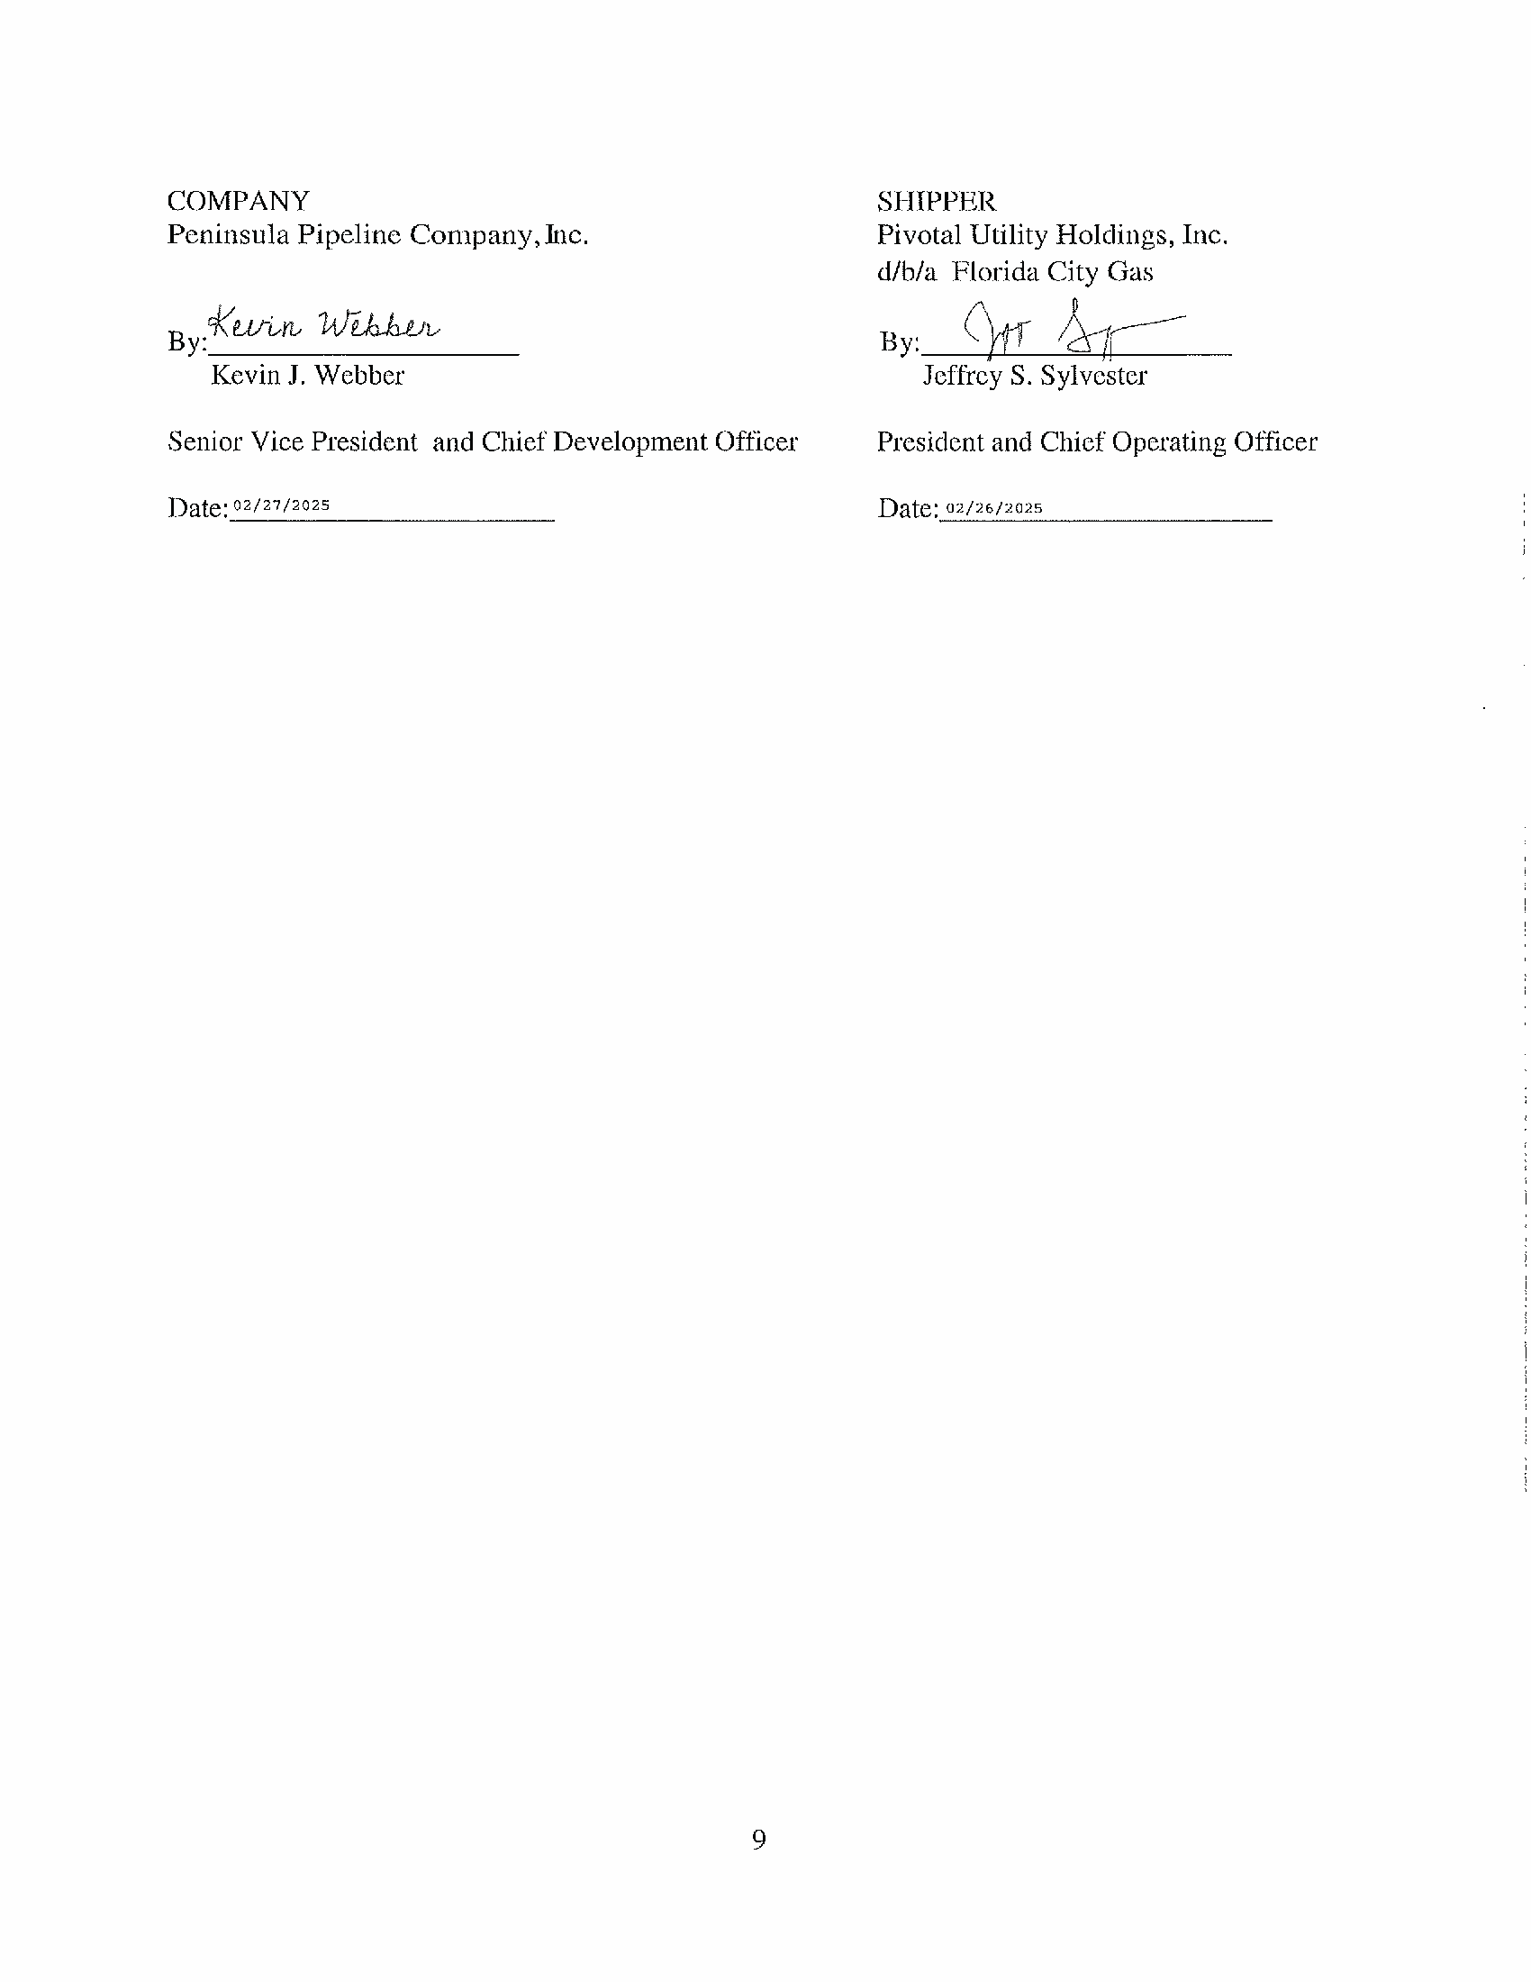

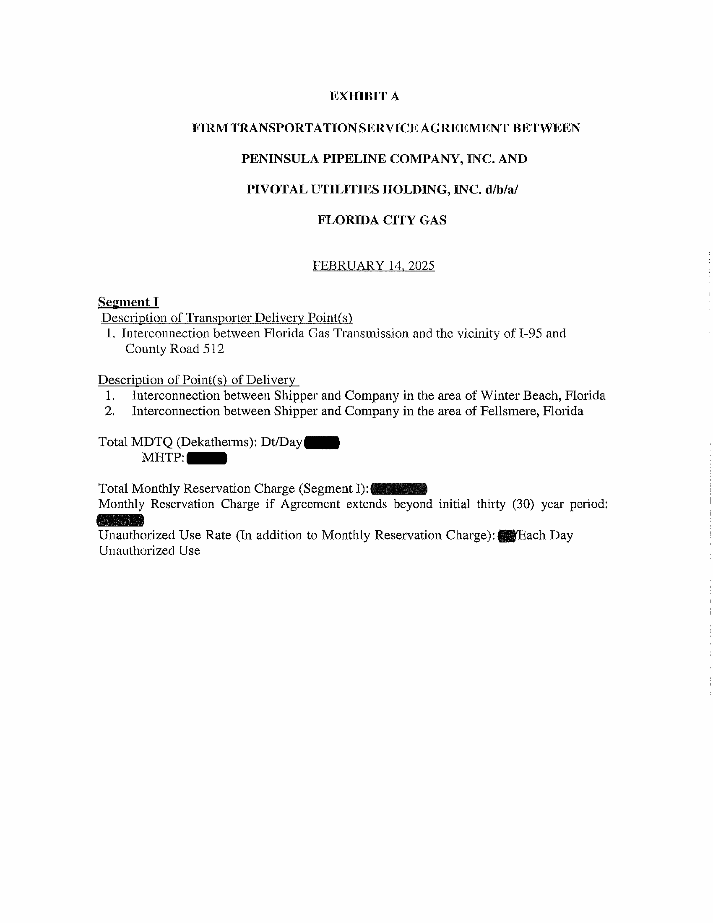

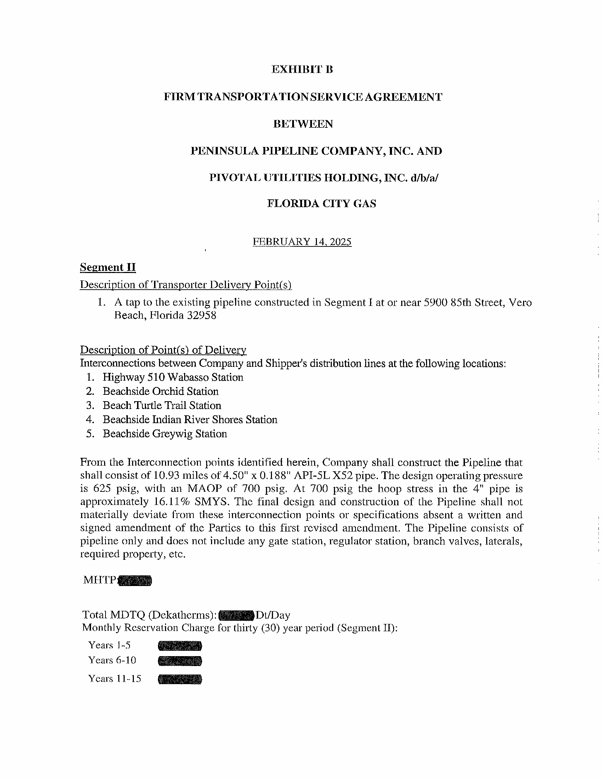



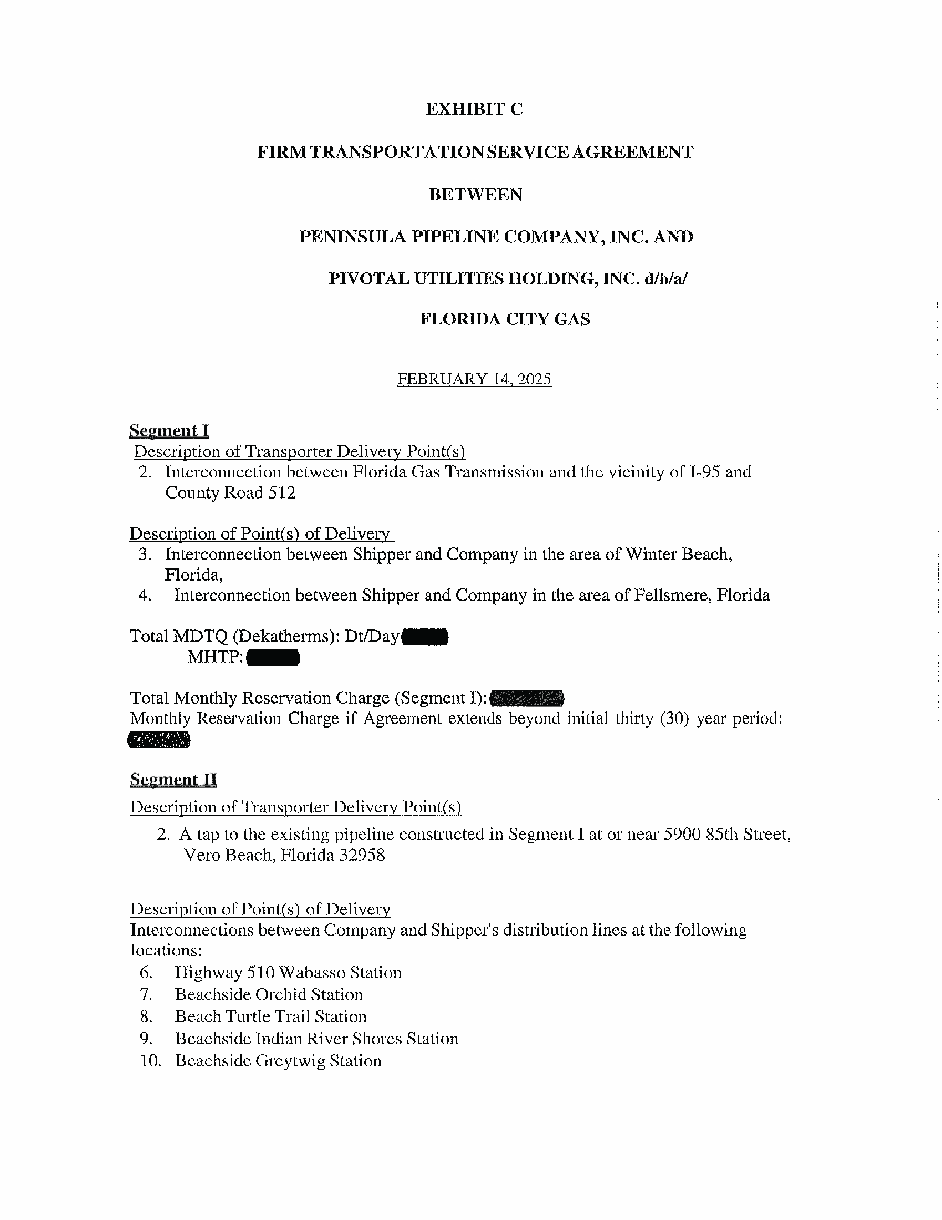

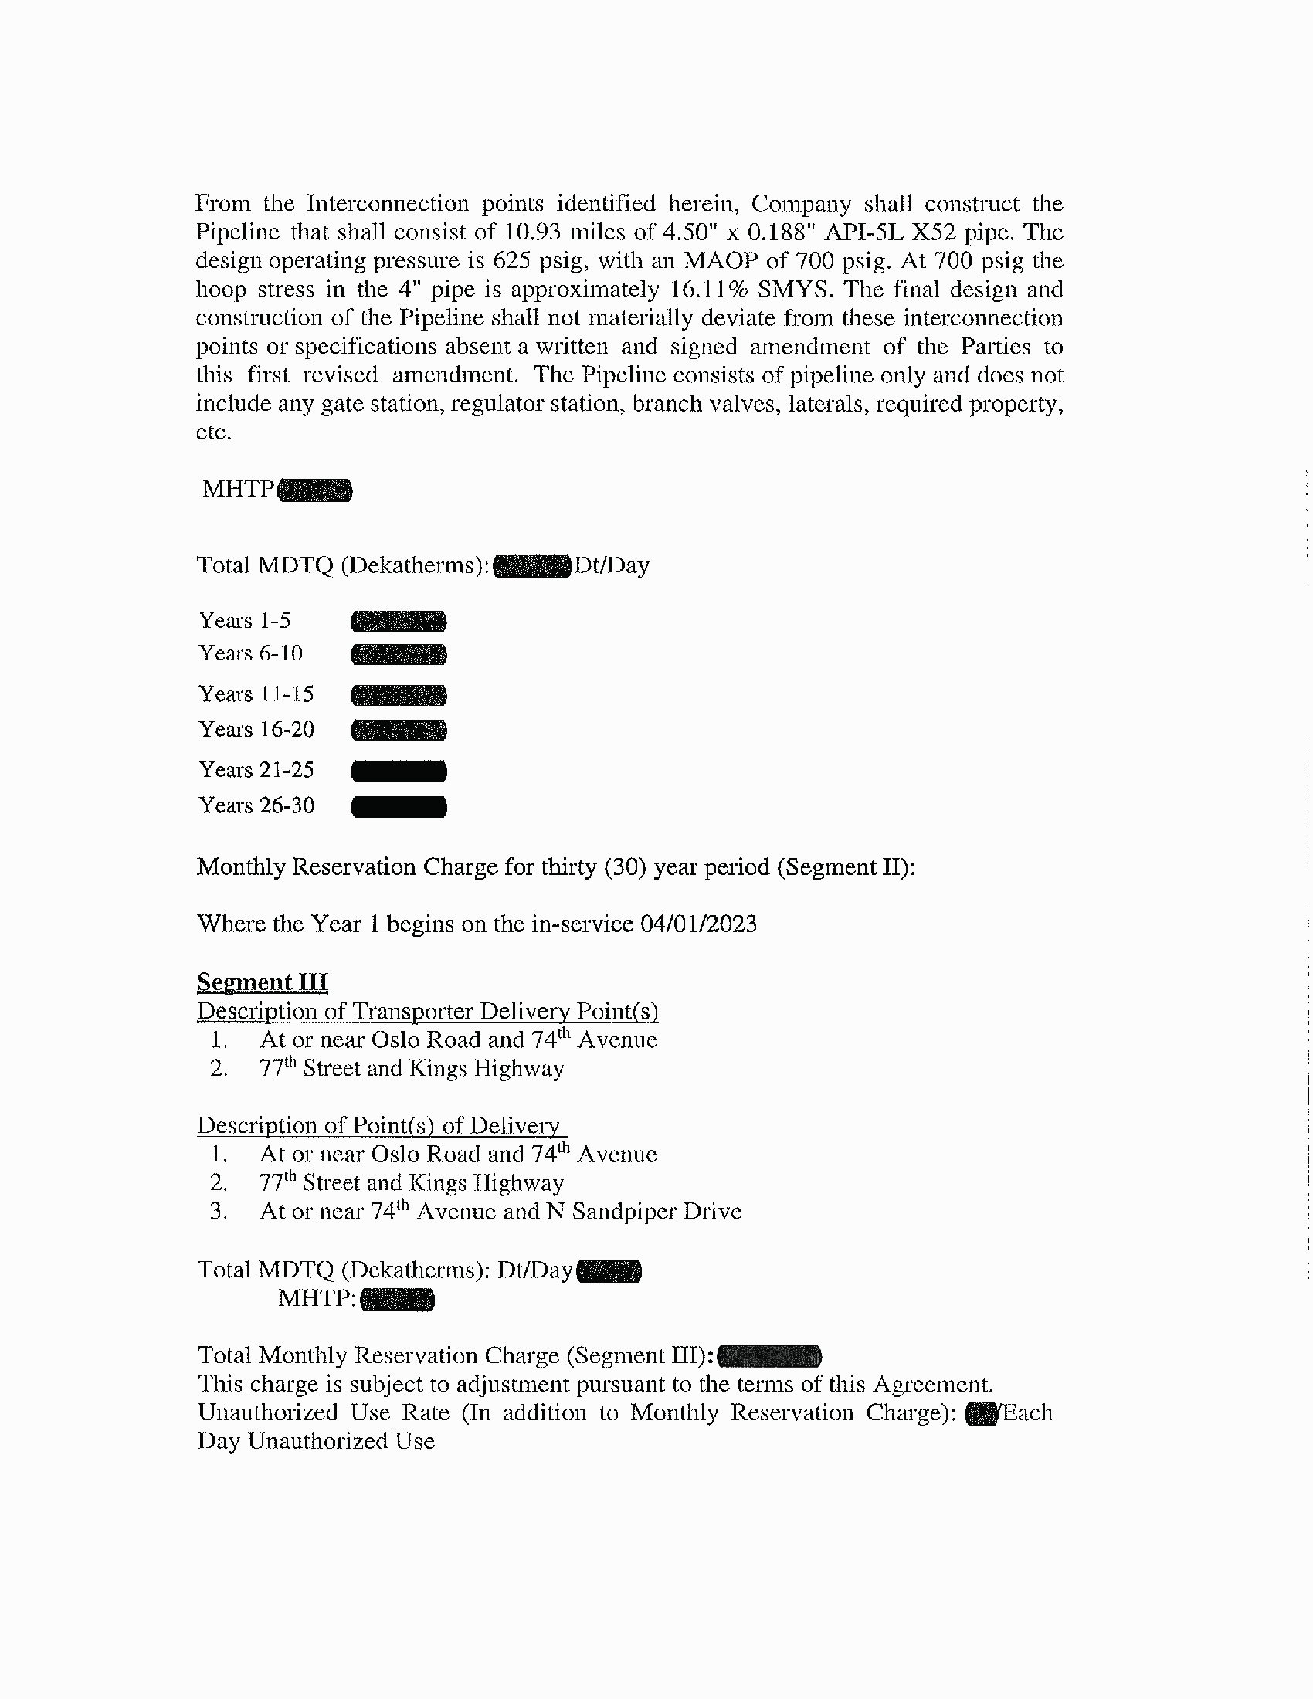

1. Order No. PSC-06-0023-DS-GP, issued January 9, 2006, in Docket No. 050584-GP, *In re: Petition for declaratory statement by Peninsula Pipeline Company, Inc. concerning recognition as a natural gas transmission company under Section 368.101, F.S., et seq.*
2. Order No. PSC-2024-0271-PAA-GU, issued July 26, 2024, in Docket No. 20240039-GU, *In re: Petition for approval of transportation service agreements between Peninsula Pipeline Company, Inc. and Pivotal Utility Holdings, Inc. d/b/a Florida City Gas.*
3. Document No. 03191-2025.
4. Responses to Staff’s First Data Request, No. 7.
5. Responses to Staff’s First Data Request, No. 8.
6. See Order No. PSC-2024-0271-PAA-GU, page 27.
7. Responses to Staff’s First Data Request, No. 1.