|  |  |  |  |
| --- | --- | --- | --- |
| State of Florida  pscSEAL | | Public Service Commission  Capital Circle Office Center ● 2540 Shumard Oak Boulevard Tallahassee, Florida 32399-0850  -M-E-M-O-R-A-N-D-U-M- | |
| DATE: | September 25, 2025 | | |
| TO: | Office of Commission Clerk (Teitzman) | | |
| FROM: | Division of Economics (Ward)  Office of the General Counsel (Bloom) | | |
| RE: | Docket No. 20250102-GU – Petition for approval of tariff modification to reflect TTS pool manager, by Florida Public Utilities Company. | | |
| AGENDA: | 10/07/25 – Regular Agenda – Tariff Filing – Interested Persons May Participate | | |
| COMMISSIONERS ASSIGNED: | | | All Commissioners |
| PREHEARING OFFICER: | | | Administrative |
| CRITICAL DATES: | | | 10/13/25 (60-Day Suspension Date) |
| SPECIAL INSTRUCTIONS: | | | None |

Case Background

On August 14, 2025, Florida Public Utilities Company (FPUC or utility) filed a petition for approval of a tariff modification reflecting the automation of FPUC’s Transitional Transportation Service (TTS) pool manager assignment process. The TTS program is designed to allow Indiantown and Central Florida Gas (CFG) Division customers to purchase natural gas from one of two TTS shippers and select from certain gas pricing options offered by the TTS shippers. The TTS tariff was originally established in 2002 to facilitate the conversion of remaining sales customers to aggregated customer pools. These customer pools are administered by qualified gas marketers (also known as pool managers) who have the capability of combining the gas supply requirements of customers in the TTS pools with other customers served by the pool managers, both on and off the utility’s distribution system. FPUC’s Indiantown and CFG Division provide transportation service only. Under the proposed tariff, FPUC would utilize its new billing system to automate the assignment of TTS pool managers. In response to staff’s data request, the utility stated that TTS pool manager A would be assigned to customers moving in on even numbered calendar days, while TTS pool manager B would be assigned to customers moving in on odd numbered calendar days.[1] Currently, this assignment is done manually.

During the evaluation of the petition, staff issued a data request for which responses were received on September 5, 2025. Proposed tariff sheet No. 6.526 is included to the recommendation as Attachment A. The Commission has jurisdiction over this matter pursuant to Sections 366.03, 366.04, 366.05, and 366.06, Florida Statutes (F.S.).

Discussion of Issues

Issue :

 Should the Commission approve FPUC's request to automatically assign TTS pool managers and the associated tariff?

Recommendation:

 Yes, the Commission should approve FPUC’s request to automatically assign TTS pool managers and the associated tariff. The new automated process will allow the utility to bill customers efficiently, while ensuring that initial pool manager assignments are made on a fair and unbiased basis. If approved, proposed tariff sheet No. 6.526 should become effective upon the issuance of a Consummating Order. (Ward)

Staff Analysis:

 Historically, if a premises had previously been assigned a particular pool manager, then any customer that subsequently moved into that premises would automatically be assigned to that same pool manager. If no pool manager had been assigned to the premises in the past, then a pool manager would be manually assigned to either TTS pool manager A or B. In response to staff’s data request, the utility stated that pool manager A is assigned to customers signing up for service on even numbered calendar days and pool manager B is assigned to customers signing up for service on odd numbered calendar days.

In its petition, FPUC states that with the utility’s new billing system, pool manager assignments can be done automatically without manual intervention, regardless of any prior history. In response to staff’s data request, the utility stated that it would utilize the new customer move-in workflow in System Analysis Program Development (SAP), its new billing system, to automate the assignment of TTS pool managers.[2] The new automated process would automatically assign new customers to TTS pool managers based upon whether the customer at that location signs up for service on an odd or even day of the week. Under the proposed tariff, this would take place regardless of any prior pool manager history at the location. In response to staff’s data request, the utility asserted that if in the future a third TTS pool manager was added, the utility would adjust the automation to assign TTS pool managers every third day, ensuring that each pool manager is provided an equal opportunity to be assigned during the move-in workflow.[3]

Additionally, in response to staff’s data request, the utility stated that a periodic review will be performed to confirm TTS pool manager assignments are distributed as expected based on move-in dates.[4] The utility asserts that the new automated process will improve the utility’s ability to bill customers efficiently and accurately, as well as further ensure that initial pool manager assignments are made on a fair and unbiased basis.

Conclusion

Staff recommends approval of FPUC’s request to automatically assign TTS pool managers and the associated tariff. The new automated process will allow the utility to bill customers efficiently, while ensuring the initial pool manager assignments are made on a fair and unbiased basis. If approved, proposed tariff sheet No. 6.526 should become effective upon the issuance of a Consummating Order.

Issue :

 Should this docket be closed?

Recommendation:

 If a timely protest is filed, the tariff should not be implemented while the protest is pending. If no protest is filed by a person whose substantial interests are affected within 21 days of the issuance of the Order, this docket should be closed upon the issuance of a Consummating Order. (Bloom)

Staff Analysis:

 If a timely protest is filed, the tariff should not be implemented while the protest is pending. If no protest is filed by a person whose substantial interests are affected within 21 days of the issuance of the Order, this docket should be closed upon the issuance of a Consummating Order.

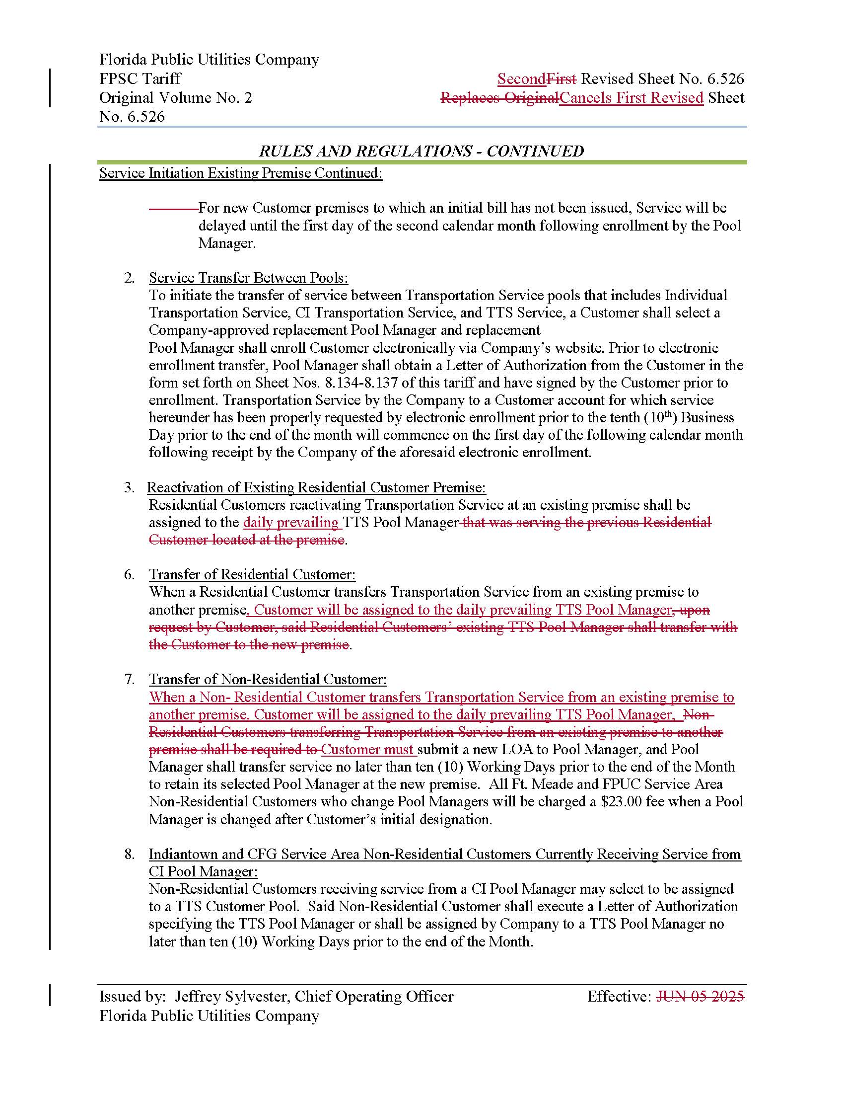

1. Document No. 09211-2025, filed September 5, 2025.
2. *Id*.
3. *Id*.
4. *Id*.