State of Florida   |  | Public Service Commission  Capital Circle Office Center ● 2540 Shumard Oak Boulevard  Tallahassee, Florida 32399-0850  -M-E-M-O-R-A-N-D-U-M-
DATE: | November 18, 2025
TO: | Office of Commission Clerk (Teitzman)
FROM: | Division of Economics (P. Kelley)  Office of the General Counsel (Sandy)
RE: | Docket No. 20250111-GU – Petition for approval of safety, access, and facility enhancement program true-up and 2026 cost recovery factors, by Florida City Gas.
AGENDA: | 12/02/25 – Regular Agenda – Tariff Filing – Interested Persons May Participate
COMMISSIONERS ASSIGNED: |  |  | All Commissioners
PREHEARING OFFICER: |  |  | Administrative
CRITICAL DATES: |  |  | 05/03/26 (8-Month Effective Date)
SPECIAL INSTRUCTIONS: |  |  | None

Case Background
On September 3, 2025, Florida City Gas (FCG or utility) filed a petition for approval of its safety, access, and facility enhancement (SAFE) program true-up and 2026 cost recovery factors. The SAFE program was originally approved by the Commission by Order No. PSC-15-0390-TRF-GU (2015 Order) to recover the cost of relocating on an expedited basis certain existing gas mains and associated facilities from rear lot easements to the street front. In the 2015 Order, the Commission found that the relocation of mains and services to the street front provides for more direct access to the facilities and will enhance the level of service provided to all customers through improved safety and reliability. The SAFE factor is a fixed surcharge on customers' bills.

In the 2015 Order, the Commission required the utility to file an annual petition, beginning in 2016, for review and resetting of the SAFE factors to true-up any prior over-or under-recovery and to set the surcharge for the coming year. The SAFE program was originally approved as a 10-year program and was planned to finish in 2025.
During the utility’s 2022 rate case, the Commission approved the continuation and expansion of the SAFE program beyond its 2025 expiration date to include the relocation of an additional approximately 150 miles of mains and services and the replacement of approximately 160 miles of orange pipe.
In 2024, the Commission approved FCG’s petition to modify its SAFE program to include replacing span pipes, burying shallow and exposed pipeline, and replacing obsolete pipe and related facilities. The total estimated cost for the program modifications is $49.8 million over a ten year period. The additional program modifications are included in this proceeding for recalculation of the SAFE surcharges. The current 2025 SAFE factors were approved by Order No. PSC-2025-0033-TRF-GU.
By Order No. PSC-2025-0396-PCO-GU, issued October 23, 2025, the Commission suspended the proposed tariffs to allow staff sufficient time to analyze the utility’s filing, pursuant to Section 366.06(3), Florida Statutes (F.S.). Commission staff issued its first data request to FCG on September 22, 2025, for which FCG provided a response on October 3, 2025.
FCG’s annual progress in the SAFE program is shown in Attachment A to the recommendation. The proposed 2026 SAFE factors are shown in Attachment B to the recommendation on Eighth Revised Sheet No. 79. The Commission has jurisdiction over the matter pursuant to Sections 366.04, 366.041, 366.05, and 366.06, F.S.

Discussion of Issues

Issue 1:
Should the Commission approve FCG's proposed SAFE tariffs for the period January through December 2026?

Recommendation:
Yes. The Commission should approve FCG’s proposed SAFE tariff for the period January through December 2026. After reviewing FCG’s filings and supporting documentation, the calculations of the 2026 SAFE factors appear consistent with the methodology approved in the 2015 Order and are reasonable and accurate. (P. Kelley)

Staff Analysis:
As required by the 2015 Order, the utility’s calculations for the 2026 revenue requirement and SAFE factors include a final true-up for 2024, an estimated/actual true-up for 2025, and projected costs for 2026. During 2025, the utility replaced 31.7 miles of mains and 1,244 services as shown in Attachment A to the petition. FCG also replaced 18 miles of mains and 1,185 services associated with orange pipe in 2025.
In Attachment B to its petition, the utility provided a description of the SAFE program projects undertaken in 2024 and 2025 and forecast for 2026. In response to staff’s data request, FCG explained that it prioritizes its replacement projects based on a risk assessment and to complete all projects in a cost-effective manner the utility uses a competitively bidding process. Work is awarded based on lowest bid, capacity to complete the work, and historical performance. FCG further explained that due to limited internal resources it utilizes contract labor the complete the replacement work.

Final True-ups for 2024
FCG stated that the revenues collected for 2024 were $4,728,363 compared to a revenue requirement of $3,691,675 resulting in an over-recovery of $1,036,688. Adding the 2023 final under-recovery of $1,852,753 and the $1,036,688 over-recovery of 2024, including interest, results in a final 2024 under-recovery of $865,219.

Actual/Estimated 2025 True-up
FCG provided actual revenues for January through June and forecasted revenues for July through
December 2025, totaling $8,308,405 as compared to a projected revenue requirement of $8,547,138, resulting in an under-recovery of $238,733. Adding the 2024 under-recovery of $865,219 to the 2025 under-recovery of $238,733, the resulting total 2025 true-up, including interest, is an under-recovery of $1,106,822.

Projected 2026 Costs
The utility’s projected investment for 2026 is $107,960,202 for its SAFE program. The revenue requirement, which includes a return on investment, depreciation, and taxes is $12,315,423. The return on investment calculation includes federal income taxes, regulatory assessment fees, and bad debt. After adding the 2025 under-recovery of $1,106,822, the total 2026 revenue requirement is $13,422,245. Table 1-1 displays the projected 2026 SAFE program revenue requirement calculation.

Table 1-1
2026 SAFE Program Revenue Requirements Calculation
2026 Projected Investment | $107,960,202
Return on Investment | $8,719,408
Depreciation Expense | $1,921,817
Property Tax Expense | $1,674,198
2026 Revenue Requirement | $12,315,423
Plus 2025 Under-recovery | $1,106,822
Total 2026 Revenue Requirement | $13,422,245
Source: Attachment C, Schedule 4 of the petition.

Proposed 2026 SAFE Factors
The SAFE factors are fixed monthly charges. FCG’s cost allocation methodology was approved in the 2015 Order and was used in the instant filing. The approved methodology allocates the current cost of a 2-inch pipe to all customers on a per customer basis and allocates the incremental cost of replacing a 4-inch pipe to customers who use over 6,000 therms per year. For customers who require 4-inch pipes, the cost takes into account that the minimum pipe is insufficient to serve their demand, and therefore, allocates an incremental per foot cost in addition to the all-customer cost. The resulting allocation factors are applied to the 2026 total revenue requirement to develop the monthly SAFE factors.
The proposed fixed monthly SAFE factor is $8.70 for customers using less than 6,000 therms per year (current factor is $4.66). The proposed fixed monthly SAFE factor for customers using more than 6,000 therms per year is $11.01 (current factor is $7.77). FCG stated that it will provide notice to customers of the approved 2026 SAFE factors through a customer bill message and update rate schedule posted online.

Conclusion

The Commission should approve FCG’s proposed SAFE tariff for the period January through December 2026. After reviewing FCG’s filings and supporting documentation, the calculations of the 2026 SAFE factors appear consistent with the methodology approved in the 2015 Order and are reasonable and accurate.
Issue 2:
Should this docket be closed?

Recommendation:
Yes. If Issue 1 is approved and a protest is filed within 21 days of the issuance of the order, the tariffs should remain in effect, with any revenues held subject to refund, pending resolution of the protest. If no timely protest is filed, this docket should be closed upon the issuance of a consummating order. (Sandy)

Staff Analysis:
Yes. If Issue 1 is approved and a protest is filed within 21 days of the issuance of the order, the tariffs should remain in effect, with any revenues held subject to refund, pending resolution of the protest. If no timely protest is filed, this docket should be closed upon the issuance of a consummating order.

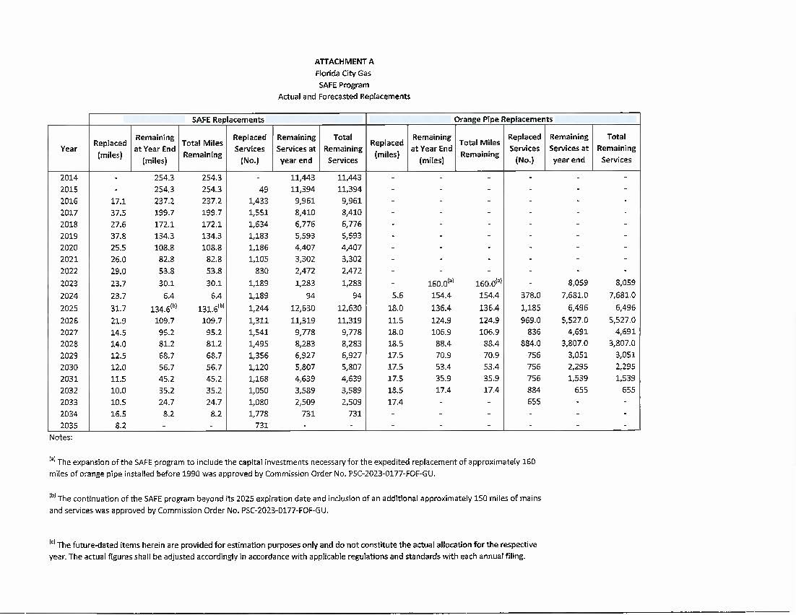

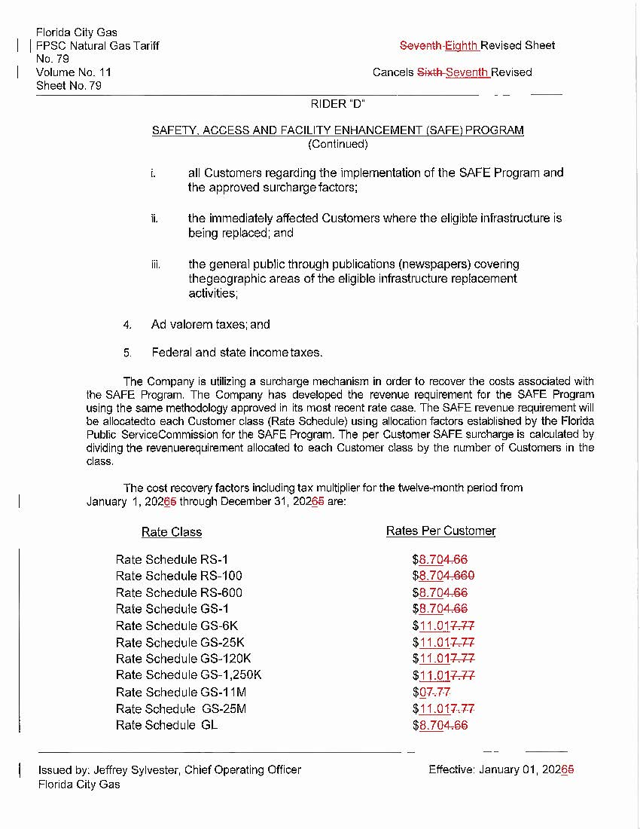

Order No. PSC-15-0390-TRF-GU, issued September 15, 2015, in Docket No. 20150116-GU, In re: Petition for approval of safety, access, and facility enhancement program and associated cost recovery methodology, by Florida City Gas.
Order No. PSC-2023-0177-FOF-GU, issued June 9, 2023, in Docket No. 20220069-GU, In re: Petition for rate increase by Florida City Gas.
Order No. PSC-2024-0438-PAA-GU, issued October 2, 2024, in Docket No. 20240071-GU, In re: Petition for approval of safety, access, and facility enhancement program modifications, by Florida City Gas.
Order No. PSC-2024-0438-PAA-GU, page 4.
Order No. PSC-2025-0033-TRF-GU, issued January 28, 2025, in Docket No. 20240134-GU, In re: Petition for approval of safety, access, and facility enhancement program true-up and 2024 cost recovery factors, by Florida City Gas.

