State of Florida   |  | Public Service Commission  Capital Circle Office Center ● 2540 Shumard Oak Boulevard  Tallahassee, Florida 32399-0850  -M-E-M-O-R-A-N-D-U-M-
DATE: | April 23, 2026
TO: | Office of Commission Clerk (Teitzman)
FROM: | Division of Engineering (Davis, Ellis)  Division of Accounting and Finance (Gatlin, Holloway)  Division of Economics (Rashawn)  Office of the General Counsel (Dose)
RE: | Docket No. 20250144-WU – Application for transfer of majority organizational control of Wildwood Water Company, holder of Certificate No. 648-W in St. Johns County.
AGENDA: | 05/05/26 – Regular Agenda – Proposed Agency Action for Issue 3 - Interested Persons May Participate
COMMISSIONERS ASSIGNED: |  |  | All Commissioners
PREHEARING OFFICER: |  |  | Clark
CRITICAL DATES: |  |  | None
SPECIAL INSTRUCTIONS: |  |  | None

Case Background
The Commission issued a Grandfather Certificate for Wildwood Water Company (Wildwood or Utility) on June 7, 2010. At the time of issuance, Gerald E. Mills and Diane N. Mills each held a 50 percent ownership interest in the Utility.
On October 16, 2025, Wildwood filed an application for a Staff-Assisted Rate Case (SARC), with the owner identified as G. Gregory Mills (51 percent) and Holy Grail, LLC (49 percent). On November 17, 2025, Wildwood’s SARC application was denied on the basis that a change in majority ownership control had occurred and not yet approved by the Commission as required by Section 367.071, Florida Statutes (F.S.). In its denial letter, staff advised the Utility to submit an application for a transfer in accordance with Rule 25-30.037, Florida Administrative Code (F.A.C.). On December 15, 2025, Wildwood filed an application for transfer of majority organizational control to G. Gregory Mills (Transferee).
The Commission has jurisdiction pursuant to Sections 367.071 and 367.091, F.S.

Discussion of Issues

Issue 1:
Should Wildwood Water Company be required to show cause why it should not be fined for an apparent violation of Section 367.071(1), F.S., and Rule 25-30.037(1)(a), F.A.C., for failing to obtain Commission approval prior to the transfer of majority organizational control, and failing to submit an application to the Commission for authority to transfer no later than 90 days after the transfer of majority organizational control?

Recommendation:
No. Staff recommends that the Utility’s apparent violation of Section 367.071(1), F.S., and Rule 25-30.037(1)(a), F.A.C., does not rise to the level which warrants the initiation of a show cause proceeding. However, Wildwood should be placed on notice that show cause proceedings may be initiated if further violations of Commission laws or rules regarding the transfer of certificates are identified. (Dose)

Staff Analysis:

Legal Standard
Section 367.071(1), F.S., provides that no utility shall transfer its certificate of authorization, facilities or any portion thereof, or majority organizational control without determination and approval of the Commission that the proposed transfer is in the public interest and that the buyer, assignee, or transferee will fulfill the commitments, obligations, and representations of the utility. However, a transfer of certificate of authorization, facilities or any portion thereof, or majority organizational control may occur prior to Commission approval if the contract for sale, assignment, or transfer is made contingent upon Commission approval.
Furthermore, Rule 25-30.037(1)(a), F.A.C., provides that if a transfer occurs prior to Commission approval, the utility shall submit an application for authority to transfer no later than 90 days after the sale closing date.
Violations of the provisions of any lawful rule or any statute administered by the Commission may result in penalties as provided by Section 367.161, F.S. In particular, violations of the provisions of Chapter 367, F.S., or any rule adopted pursuant to the Chapter, may result in a penalty for each offense of not more than $5,000. Utilities are charged with the knowledge of Commission rules and statutes. Additionally, “it is a common maxim, familiar to all minds, that ‘ignorance of the law’ will not excuse any person, either civilly or criminally.” Barlow v. United States, 32 U.S. 404, 411 (1833). The Commission considers the existence of mitigating circumstances when deciding whether to pursue show cause proceedings against utilities.

Analysis
On December 15, 2025, Wildwood submitted an application for authority to transfer majority organizational control of the Utility and Certificate No. 648-W in St. Johns County. The Transferee has been in control of and operating Wildwood since 2020, following the death of the Transferee’s parents. Notably, there was no contract of sale or transfer as the transfer occurred by inheritance.
By failing to file its transfer application within 90 days of the transfer of majority organizational control, it appears that Wildwood violated Section 367.071(1), F.S., and Rule 25-30.037(1)(a), F.A.C. On November 17, 2025, Wildwood Water Company was emailed a letter denying the Utility’s eligibility for a staff-assisted rate case because the transfer of majority organizational control was not yet approved by the Commission. Staff recommended that the Utility submit an application for a transfer of majority organizational control in accordance with Rule 25-30.037, F.A.C. Since learning of its violations, Wildwood has shown diligence in working with Commission staff to ensure the transfer of this system is in conformity with Commission laws and rules.
Staff believes that Wildwood has made a good faith effort to effect a lawful transfer of majority organizational control of this system, and that the transfer is in the best interest of its customers. Because the Utility has been responsive in coming into compliance with the applicable rules and statutes regarding transfer of certificates, staff recommends that the Utility’s apparent violation of Section 367.071(1), F.S., and Rule 25-30.037(1)(a), F.A.C., does not rise to the level which warrants the initiation of a show cause proceeding. Therefore, Wildwood should not be required to show cause for failing to obtain Commission approval prior to closing on the sale of its facilities, and failing to submit an application to the Commission for authority to transfer no later than 90 days after the transfer of majority organizational control. However, Wildwood should be placed on notice that show cause proceedings may be initiated if further violations of the Commission laws or rules regarding the transfer of certificates are identified.

Issue 2:
Should the application for transfer of majority organizational control of Wildwood Water Company in St. Johns County be approved?

Recommendation:
Yes. The transfer of majority organizational control from Gerald E. Mills and Diane N. Mills to G. Gregory Mills is in the public interest and should be approved effective the date of the Commission vote. The resultant order should serve as the water and wastewater certificates, with the territories described in Attachment A for the Utility. The Utility’s existing rates and charges should remain in effect until a change is authorized by the Commission in a subsequent proceeding. For the Utility, the tariff pages reflecting the transfer should be effective on or after the stamped approval date on the tariff sheets pursuant to Rule 25-30.475(1), F.A.C. (Davis, Rashawn, Dose)

Staff Analysis:

Legal Standard
Applications for the sale, assignment, or transfer of certificates of authorization, facilities, or control for water and wastewater utilities are governed by Section 367.071, F.S., and Rule 25-30.037, F.A.C. The statute provides that a utility may not sell, assign, or transfer its certificate of authorization, facilities, or any portion thereof, or majority organization control without a determination by the Commission that the sale, assignment, or transfer is in the public interest and that the buyer will fulfill all commitments, obligations, and representations of the utility. A sale, assignment, or transfer of a certificate of authorization may occur prior to Commission approval if the contract for sale, assignment, or transfer is made contingent upon Commission approval. The rule provides all of the requirements an applicant must provide in an application for sale, assignment, or transfer of a certificate of authorization.

Analysis
This application is for the transfer of majority organizational control of Wildwood Water Company in St. Johns County from Gerald E. Mills and Diane N. Mills to G. Gregory Mills. Based on staff’s review, the application is in compliance with the governing statute, Section 367.071, F.S., and Rule 25-30.037(4), F.A.C., concerning applications for transfer of majority organizational control. As majority organizational control was acquired through inheritance, there is no applicable contract for sale.

Noticing and Territory
Wildwood provided notice of its application pursuant to Section 367.071, F.S., and Rule 25-30.030, F.A.C. No objections to the transfer were filed with the Commission, and the time for doing so has expired. The notice contains a description of the territory for Wildwood, which is appended to this recommendation as Attachment A.

Technical and Financial Ability
The Transferee has experience in operating water systems since 1978, and has been operating the Wildwood system since 1988 through the present. Based upon a staff review, the system appears to currently be in compliance with the Department of Environmental Protection. The transfer application states that the Transferee is supported by an affiliate company, Holy Grail Holdings, LLC. Staff has reviewed the financial statements of the affiliate company and believes it has the financial capability to provide necessary funding and has established a line of credit to ensure continued operations. Based on the statement above, staff recommends the Transferee has the technical and financial capability to provide service to the existing service territory.
Rates, Charges, and Initial Customer Deposits
Wildwood Water Company’s rates, charges, and customer deposits were last approved in a grandfather certificate in 2010. Subsequently, the rates were amended by three price index rate adjustments with the last increase approved effective September 1, 2021. Rule 25-9.044(1), F.A.C., provides that, in the case of a change of ownership or control of a Utility, the rates, classifications, and regulations of the former owner must continue unless authorized to change by this Commission.
In regard to the Utility’s existing miscellaneous service charges, the violation reconnection, the late payment, and non-sufficient funds (NSF) charges are appropriate. However, the remaining miscellaneous service charges do not conform to Rule 25-30.460, F.A.C., and are discussed in Issue 3. Therefore, staff recommends that the Utility’s existing rates, initial customer deposit, violation reconnection charge, late payment charge, NSF charge, and service availability charges shown on Schedule No. 1, should remain in effect, until a change is authorized by this Commission in a subsequent proceeding. The tariff sheets reflecting the transfer should be effective on or after the stamped approval date pursuant to Rule 25-30.475(1), F.A.C.

Conclusion
Based on the above, staff recommends that the transfer of the majority organizational control from Gerald E. Mills and Diane N. Mills to G. Gregory Mills is in the public interest and should be approved effective the date of the Commission vote. The resultant order should serve as the water and wastewater certificates, with the territories described in Attachment A. The Utility’s existing rates and charges should remain in effect until a change is authorized by the Commission in a subsequent proceeding. For the Utility, the tariff pages reflecting the transfer should be effective on or after the stamped approval date on the tariff sheets pursuant to Rule 25-30.475(1), F.A.C.

Issue 3:
What are the appropriate revisions to miscellaneous service charges for Wildwood Water Company?

Recommendation:
The appropriate revisions to miscellaneous service charges for Wildwood Water Company should be the removal of initial connection and normal reconnection charges and update the definition of the premises visit charge to be consistent with Rule 25-30.460, F.A.C. The Utility should be required to file a proposed customer notice to reflect the Commission-approved charges. The approved charges should be effective on or after the stamped approval date on the tariff sheet pursuant to Rule 25-30.475(1), F.A.C. In addition, the approved charges should not be implemented until staff has approved the proposed customer notice and the notice has been received by customers. The Utility should provide proof of the date notice was given, no less than 10 days after the date of the notice. Wildwood should be required to charge the approved miscellaneous services charges until authorized to change them by the Commission in a subsequent proceeding. (Rashawn)

Staff Analysis:
The Utility did not request to revise its existing miscellaneous service charges. Section 367.091, F.S., authorizes the Commission to establish, increase, or change rates or charges other than monthly rates or service availability charges. Rule 25-30.460, F.A.C. does not allow for initial connection and normal reconnection charges. The Utility’s initial connection and normal reconnection charges are obsolete and inconsistent with the rule. The definitions for initial connection charges and normal reconnection charges were subsumed in the definition of the premises visit charge. Based on the above, staff recommends that the initial connection and normal reconnection charges be removed, and the definition for the premises visit charge be updated to comply with Rule 25-30.460, F.A.C.

Conclusion
Staff recommends that the appropriate revisions to miscellaneous service charges for Wildwood should be the removal of initial connection and normal reconnection charges and update the definition of the premises visit charge to be consistent with Rule 25-30.460, F.A.C. The Utility should be required to file a proposed customer notice to reflect the Commission-approved charges. The approved charges should be effective on or after the stamped approval date on the tariff sheet pursuant to Rule 25-30.475(1), F.A.C. In addition, the approved charges should not be implemented until staff has approved the proposed customer notice and the notice has been received by customers. The Utility should provide proof of the date notice was given, no less than 10 days after the date of the notice. Wildwood should be required to charge the approved miscellaneous services charges until authorized to change them by the Commission in a subsequent proceeding.

Issue 4:
Should this docket be closed?

Recommendation:
If no person whose substantial interests are affected by the proposed agency action portion of this recommendation files a protest within 21 days of the issuance of this order, a consummating order should be issued. (Dose)

Staff Analysis:
If no person whose substantial interests are affected by the proposed agency action portion of this recommendation files a protest within 21 days of the issuance of this order, a consummating order should be issued.

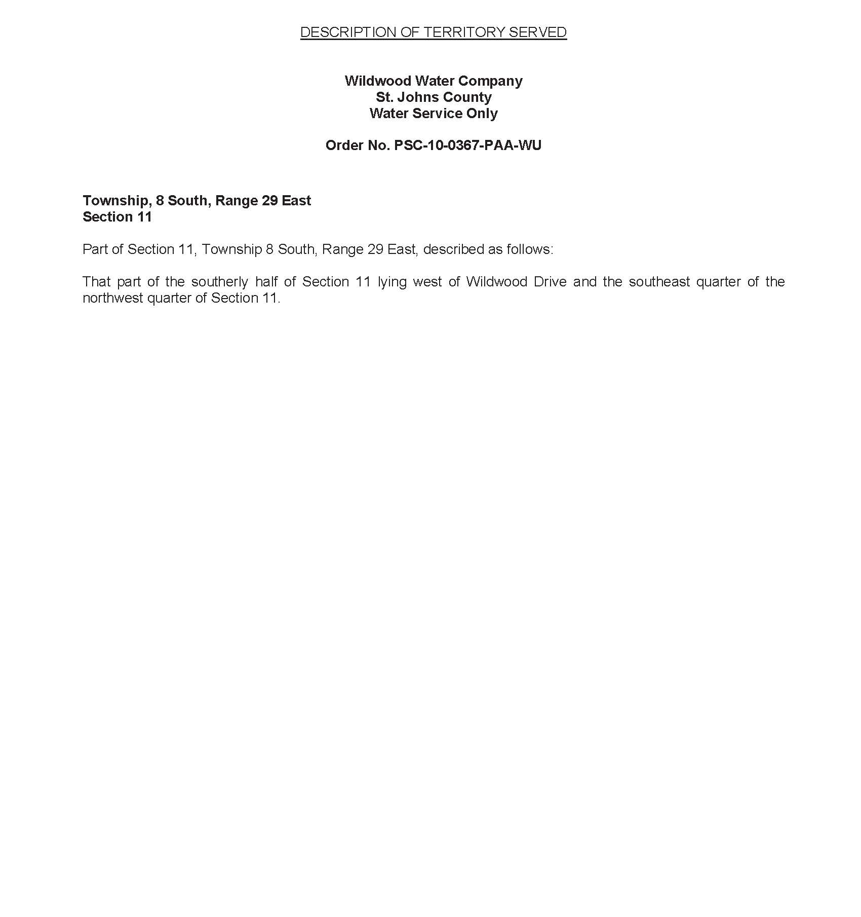

FLORIDA PUBLIC SERVICE COMMISSION
Authorizes
Wildwood Water Company
pursuant to
Certificate Number 648-W

to provide water service in St. Johns County in accordance with the provisions of Chapter 367, Florida Statutes, and the Rules, Regulations, and Orders of this Commission in the territory described by the Orders of this Commission. This authorization shall remain in force and effect until superseded, suspended, cancelled or revoked by Order of this Commission.

Order Number Date Issued Docket Number Filing Type

PSC-10-0367-PAA-WU 06/07/2010 100011-WU Grandfather Certificate

* * 20250144-WS Transfer of Majority

*Order Number and date to be provided at time of issuance.

WILDWOOD WATER COMPANY
Existing Monthly Water Rates

Residential and General Service
Base Facility Charge | $35.49
Charge Per 1,000 gallons
0 - 4,000 gallons | $0.00
4,001 - 10,000 gallons | $4.71
10,001 - 20,000 gallons | $5.77
Over 20,000 gallons | $7.01

Initial Customer Deposits
Meter Size |  |  | Residential Service
5/8” X 3/4” |  |  | $75.00

Miscellaneous Service Charges
 | Normal Hours | After Hours
Violation Reconnection Charge | $35.00 | $52.20
NSF Charge | Pursuant to Section 68.065, F.S.
Late Payment Charge | $5.00

Service Availability Charges
Meter Installation and Tap-In Charge
5/8” x 3/4" | $130.00
3/4” | $390.00
1" | $490.00
1 1/2” | $1,400.00
2” | $2,200.00
Connection Charge | $1,500.00

Order No. PSC-10-0367-PAA-WU, issued June 7, 2010, in Docket No. 20100011-WU, In re: Application for grandfather certificate to operate water utility in St. Johns County by Wildwood Water Company.
Document No. 15121-2025, issued November 17, 2025, in Docket No. 20250127-WU, In re: Application for staff-assisted rate case in St. Johns County, by Wildwood Water Company.
Order Nos. PSC-10-0367A-PAA-WU, issued August 27, 2010, in Docket No. 20100011-WU, In re: Application for grandfather certificate to operate water utility in St. Johns County by Wildwood Water Company. and PSC-10-0367-PAA-WU, issued June 7, 2010, in Docket No. 20100011-WU, In re: Application for grandfather certificate to operate water utility in St. Johns County by Wildwood Water Company.

