Commissioners:  Andrew G. Fay, Chairman  Art Graham  Gary F. Clark  Mike La Rosa  Gabriella A. Passidomo | State of Florida  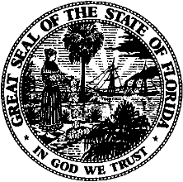 | Division of  Accounting and Finance  Andrew L. Maurey  Director  (850) 413-6900
Public Service Commission
March 18, 2022

ATTN: Lester Grooms
Northgate Properties, Inc.
3277 First Avenue
Mims, Florida 32754-3134

Re: Extension of Time to File the 2021 Annual Report for Northgate Properties, Inc. (WS172)

Dear Mr. Grooms,
Your request for an extension to file the Northgate Properties, Inc. Annual Report for the calendar year ended December 31, 2021, is granted. This is pursuant to Rule 25-30.110(3), Florida Administrative Code (F.A.C.), which automatically grants your initial request for a thirty-day extension to file the Annual Report. The report is now due on or before April 30, 2022.

Please be reminded that Rule 25-30.110(7), F.A.C., requires that a penalty be assessed against any utility that fails to timely file an Annual Report. The filing must include an original and two (2) copies of the Annual Report. If we can be of further assistance, please call Amber Norris at 850-413-6984.

Sincerely,
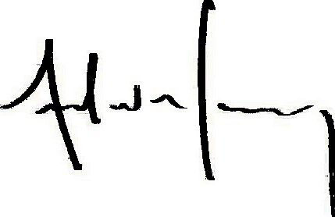
Andrew L. Maurey
Director

ALM/AN:lk

