Commissioners:  Andrew G. Fay, Chairman  Art Graham  Gary F. Clark  Mike La Rosa  Gabriella A. Passidomo | State of Florida | Division of  Accounting and Finance  Andrew L. Maurey  Director  (850) 413-6900
Public Service Commission
February 22, 2022

Mr. Gene Brown, President
Water Management Services, Inc.
250 John Knox Road, #4
Tallahassee, Florida 32303-4234

Re: Extension of Time to File the 2021 Annual Report for Water Management Services, Inc. (WS236)

Dear Mr. Brown:
Your request for an extension to file the Water Management Services, Inc. Annual Report for the calendar year ended December 31, 2021, is granted. This is pursuant to Rule 25-30.110(3), Florida Administrative Code (F.A.C.), which automatically grants your initial request for a thirty-day extension to file the Annual Report. The report is now due on or before April 30, 2022.

Please be reminded that Rule 25-30.110(7), F.A.C., requires that a penalty be assessed against any utility that fails to timely file an Annual Report. The filing must include an original and two (2) copies of the Annual Report. If we can be of further assistance, please call Amber Norris at 850-413-6984.

Sincerely,
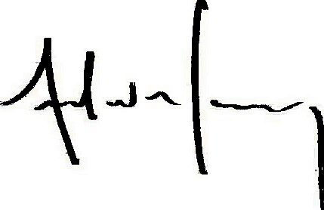
Andrew L. Maurey
Director

ALM/AN:lk

