Commissioners:  Andrew G. Fay, Chairman  Art Graham  Gary F. Clark  Mike La Rosa  Gabriella A. Passidomo | State of Florida | Division of  Accounting and Finance  Andrew L. Maurey  Director  (850) 413-6900
Public Service Commission
April 11, 2023

Mr. Gene Brown, President
Water Management Services, Inc.
250 John Knox Road, #4
Tallahassee, Florida 32303-4234

Re: Extension of Time to File the 2022 Annual Report for Water Management Services, Inc. (WS236)

Dear Utility Contact:
Your request for an additional extension to file the Water Management Services, Inc. Annual Report for the calendar year ended December 31, 2022, is granted. This is pursuant to Rule 25-30.110(3), Florida Administrative Code (F.A.C.), which grants a longer extension when accompanied by a statement of good cause with a specific date requested. The report is now due on or before May 01, 2023.

Please be reminded that Rule 25-30.110(7), F.A.C., requires that a penalty be assessed against any utility that fails to timely file an Annual Report by March 31 or within the time specified by any extension approved in writing by the Division of Accounting and Finance. If we can be of further assistance, please call Amber Norris at 850-413-6984.

Sincerely,
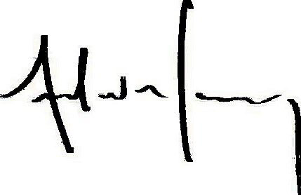
Andrew L. Maurey
Director

ALM/AN:sh

