Commissioners:  Andrew Giles Fay, Chairman  Art Graham  Gary F. Clark  Mike La Rosa  Gabriella Passidomo | State of Florida  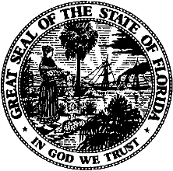 | Division of  Accounting and Finance  Andrew L. Maurey  Director  (850) 413-6900
Public Service Commission
April 5, 2022

Mr. Ben Simmons
2560 Gulf-to-Bay Blvd
Clearwater, FL 33765

Re: Extension of Time to File the 2021 Annual Report for Multiple Utilities

Dear Utility Contact:
Your request for an extension to file the 2021 Annual Report is granted for the following utilities: Coastal Income Properties-The Harbor (WS975), Coastal Income Properties-Zachary Taylor LLC (SU966), East Central Florida Services, Inc. (WU643), GCP Plantation Landings, LLC (WS983), Parkland Utilities, Inc. (WS189), River Grove Utilities, Inc. (WS979), Buttonwood Bay Utilities (WS857), Water Oak Utility (WS755), Sunlake Estates Utilities, L.L.C. (WS967). This is pursuant to Rule 25-30.110(3), Florida Administrative Code (F.A.C.), which automatically grants your initial request for a thirty-day extension to file the Annual Report. The report is now due on or before April 30, 2022.

Please be reminded that Rule 25-30.110(7), F.A.C., requires that a penalty be assessed against any utility that fails to timely file an Annual Report. The filing must include an original and two (2) copies of the Annual Report. If we can be of further assistance, please call Amber Norris at 850-413-6984.

Sincerely,
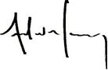
Andrew L. Maurey
Director

ALM/amn

