Commissioners:  Andrew Giles Fay, Chairman  Art Graham  Gary F. Clark  Mike La Rosa  Gabriella Passidomo | State of Florida | Division of  Accounting and Finance  Andrew L. Maurey  Director  (850) 413-6900
Public Service Commission
April 29, 2022

Mr. Ben Simmons
2560 Gulf-to-Bay Blvd
Clearwater, FL 33765

Re: 2nd Extension of Time to File the 2021 Annual Report for River Ranch Water Management, L.L.C. (WS850), Sun Communities Finance, LLC. d/b/a Water Oak Utility (WS775), and Sunlake Estates Utilities, L.L.C. (WS967)

Dear Utility Contact:
Your request for an additional extension to file the 2021 Annual Reports is granted for the following utilities: River Ranch Water Management, L.L.C. (WS850), Sun Communities Finance, LLC. d/b/a Water Oak Utility (WS775), and Sunlake Estates Utilities, L.L.C. (WS967). This is pursuant to Rule 25-30.110(3), Florida Administrative Code (F.A.C.), which grants a longer extension when accompanied by a statement of good cause with a specific date requested. The report is now due on or before May 31, 2022.

Please be reminded that Rule 25-30.110(7), F.A.C., requires that a penalty be assessed against any utility that fails to timely file an Annual Report within the time specified by any extension approved in writing by the Division of Accounting and Finance. The filing must include an unbound original and two (2) copies of the Annual Report. If we can be of further assistance, please call Amber Norris at (850) 413-6984.

Sincerely,
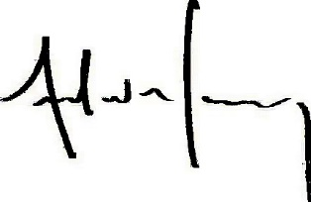
Andrew L. Maurey
Director

ALM/AN:lk

