Commissioners:  Andrew G. Fay, Chairman  Art Graham  Gary F. Clark  Mike La Rosa  Gabriella A. Passidomo | State of Florida  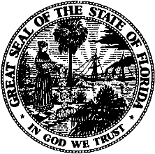 | Division of  Accounting and Finance  Andrew L. Maurey  Director  (850) 413-6900
Public Service Commission
March 22, 2022

Frank Usina, President
North Beach Utilities, Inc.
4125 Coastal Highway
St. Augustine, Florida 32084-1418

Re: Extension of Time to File the 2021 Annual Report for North Beach Utilities, Inc. (WS926)

Dear Mr. Usina:
Your request for an extension to file the North Beach Utilities, Inc. Annual Report for the calendar year ended December 31, 2021, is granted. This is pursuant to Rule 25-30.110(3), Florida Administrative Code (F.A.C.), which automatically grants a longer extension when accompanied by a statement of good cause with a specific date requested. The report is now due on or before July 29, 2022.

Please be reminded that Rule 25-30.110(7), F.A.C., requires that a penalty be assessed against any utility that fails to timely file an Annual Report. The filing must include an original and two (2) copies of the Annual Report. If we can be of further assistance, please call Amber Norris at 850-413-6984.

Sincerely,
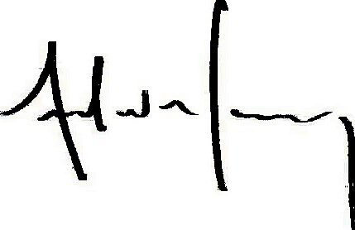
Andrew L. Maurey
Director

ALM/AN:lk

