Commissioners:  Andrew G. Fay, Chairman  Art Graham  Gary F. Clark  Mike La Rosa  Gabriella A. Passidomo | State of Florida | Division of  Accounting and Finance  Andrew L. Maurey  Director  (850) 413-6900
Public Service Commission
December 05, 2022

CERTIFIED MAIL: 70201290000072792699

Mr. Scott Middlebrooks, President
St. Johns River Estates Utilities, LLC
2000 North Orange Avenue
Orlando, Florida 32804-5533

RE: Delinquent 2021 Annual Report Penalties for St. Johns River Estates Utilities, LLC (WS978)

Dear Utility Contact:

According to our records, St. Johns River Estates Utilities, LLC failed to timely file its 2021 Annual Report by June 30, 2022. Rule 25-30.110(6) and (7), Florida Administrative Code, sets penalties for noncompliance with the annual report requirement. The applicable penalty for a Class C utility is $3.00 per day and is based on the number of calendar days elapsed from the due date until the date of filing. The 2021 Annual Report was 118 days late. Please submit a payment of $380.69 by check made payable to the Florida Public Service Commission for the amount of the penalty. The payment of the penalty should be mailed to: Division of Administrative and IT Services, Fiscal Services Section, Florida Public Service Commission, 2540 Shumard Oak Boulevard, Tallahassee, Florida 32399-0850, ATTN: Katisha Mobley.

Continued failure to comply with these requirements may result in show cause proceedings and possibly additional fines. If you have any questions concerning this matter please contact Amber Norris at 850-413-6984 as soon as possible.

Sincerely,
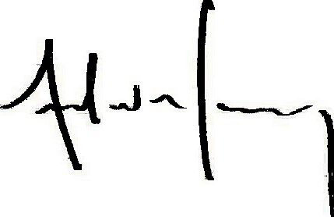
Andrew L. Maurey
Director
ALM/AN:sh

