BEFORE THE FLORIDA PUBLIC SERVICE COMMISSION

In re: Joint petition for show cause proceedings against Verizon Florida LLC for apparent violation of Rule 25-4.070, F.A.C., Customer Trouble Reports, and impose fines, by the Office of the Attorney General, Citizens of the State of Florida, and AARP. | DOCKET NO. 080278-TL  ORDER NO. PSC-09-0015-SC-TL  ISSUED: January 5, 2009

The following Commissioners participated in the disposition of this matter:

MATTHEW M. CARTER II, Chairman
LISA POLAK EDGAR
KATRINA J. McMURRIAN
NANCY ARGENZIANO
NATHAN A. SKOP

ORDER TO SHOW CAUSE

BY THE COMMISSION:

I. Case Background

In 2001 in Docket No. 991376-TL, In Re: Initiation of Show Cause Proceedings Against GTE Florida Incorporated for Violation of Service Standards, Verizon agreed to make a voluntary contribution to the General Revenue Fund in the amount of $2 million to settle the company’s apparent violation of Rule 25-4.070(3)(a), Florida Administrative Code (F.A.C.), Restoration of Interrupted Service, and Rule 25-4.066, F.A.C., Installation of Primary Service, for the years 1996 through 1999. In Order No. PSC-02-0146-AS-TL, issued February 1, 2002, we approved the company’s settlement offer. From 2001 through 2004, Verizon successfully met or exceeded the requirements of our service quality standards.
On May 15, 2008, Attorney General Bill McCollum (Attorney General), the Citizens for the State of Florida (Citizens), and the American Association of Retired Persons (AARP), (collectively, the Petitioners) filed a joint petition requesting that we issue a Show Cause Order against Verizon Florida LLC (Verizon) requiring Verizon to show cause why it should not be penalized approximately $6.5 million for the company’s apparent violation of Rule 25-4.070, F.A.C., Customer Trouble Reports. The Petitioners allege that the rate at which Verizon meets the performance standard for Rule 25-4.070, F.A.C., has declined in recent years and is below the required 95% compliance standard. The Petitioners allege that Verizon willfully violated the telephone service quality rule, Rule 25-4.070, F.A.C., two hundred and sixty-two (262) times in 2007. On June 9, 2008, Verizon filed a response and answer to the Joint Petition. Verizon requests that we deny the Petitioners’ request to issue a Show Cause Order.
Impact on Wholesale Quality of Service
By Order No. PSC-03-0761-PAA-TP, issued on June 25, 2003, in Docket No. 000121C-TP, In Re: Investigation into the establishment of operations support systems permanent performance measures for incumbent local exchange telecommunications companies. (VERIZON FLORIDA TRACK), we approved a Verizon wholesale performance measurement plan to ensure that competitive local exchange companies (CLECs) receive nondiscriminatory access to Verizon’s operations support systems (OSS), and consequently, foster the continued development of competition in Florida’s telecommunications market. Verizon’s Performance Measurement Plan (PMP) identifies and establishes performance measurements in key operational areas that CLECs and this Commission use to measure Verizon’s performance for the purpose of detecting and correcting any degradation of service provided to CLECs. A critical component of assessing the quality of service provided to CLECs is the level of performance that Verizon provides to its retail customers.

Specific performance measurement standards established within the PMP are used by CLECs and this Commission to measure the level of service Verizon provides to its wholesale customers versus the level of performance Verizon provides to its retail customers. These performance standards are known as retail analogs and are critical to the monitoring of retail-wholesale relationships. Verizon is required to provide, at a minimum, the same level of service to CLECs as Verizon provides to its retail customers. A decline in the retail quality of service may result in a decline in Verizon’s wholesale performance level obligation. Consequently, CLEC customers may also experience a decline in service quality as a result of Verizon’s decline in retail quality of service.
We are vested with jurisdiction of these matters pursuant to Sections 364.01(4), 364.03, 364.17, 364.18, and 364.285, Florida Statutes.
II. Analysis

A. Parties’ Arguments

Joint Petition

During 2007, the Petitioners allege that Verizon’s reports show that Verizon failed to achieve 95% compliance with the restoration of interrupted service interval, as required by Rule 25-4.070(3)(a), F.A.C., a total of 119 times. Verizon’s reports indicate that it failed to meet the service interval 70 times for exchanges with more than 50,000 access lines and 49 times for exchanges with less than 50,000 access lines.
The Petitioners also allege that in 2007 Verizon failed to clear 95% of service affecting trouble reports within 72 hours, as required by Rule 25-4.070(3)(b), F.A.C., a total of 143 times. In exchanges with less than 50,000 access lines, the company reported that it failed 55 times to clear 95% of the service affecting trouble reports within 72 hours. In exchanges with greater than 50,000 access lines, the company reported that it failed to meet the rule requirement 88 times.
Verizon’s Response
Verizon argues that the Petitioners’ claim that the company’s performance has been unsatisfactory is flawed for several reasons. Verizon believes that the Petitioners have drawn the wrong conclusions from the company’s performance reports based on their misunderstanding of Rule 25-4.070, F.A.C., and their failure to recognize critical information in the reports that demonstrate the company’s compliance with the rule. Verizon argues that Rule 25-4.070, F.A.C., does not authorize this Commission to impose penalties whenever the Incumbent Local Exchange Company (ILEC) does not achieve a 95% service level. Instead, Verizon argues that the rule is only designed to enable us to monitor performance rather than penalize for lack of performance.
Verizon asserts that the Petitioners have failed to take into consideration Verizon’s investment in its fiber-to-the-premises (FTTP) network in Florida. Lastly, Verizon argues that the Petitioners have failed to recognize the competitiveness of the telecommunications market and that consumers are the ultimate regulators.
B. Analysis of the Petition and the Response by Verizon
Petition
The Petitioners’ conclusions were based upon the analysis of the information that was self-reported by Verizon. Based upon our review of the reported information, for both the service interruption and service affecting measures, Verizon apparently violated Rule 25-4.070, F.A.C., 262 times in 2007.
The Petitioners note that Verizon’s performance has deteriorated over time. As reported by Verizon, the following table displays Verizon’s out-of-service (OOS) and service affecting (SA) total percentages of troubles timely cleared, by year, for all exchanges from 2001-2007. Verizon’s performance in 2007, as indicated in the table below, is significantly worse than any of the previous six years.
Year | 2001 |  | 2002 |  | 2003 |  | 2004* |  | 2005* |  | 2006 |  | 2007
 | OOS | SA | OOS | SA | OOS | SA | OOS | SA | OOS | SA | OOS | SA | OOS | SA
% Averages | 97 | 99 | 96 | 99 | 95 | 96 | 95 | 96 | 92 | 94 | 93 | 93 | 89 | 84
*Note: Years 2004 and 2005 data excludes hurricane-impacted months

Rule Interpretation: Rule 25-4.070, F.A.C., requires that each telephone company shall make all reasonable efforts to minimize the extent and duration of trouble conditions that disrupt (service interruption) or affect (service affecting) customers’ telephone service. Service interruptions occur when the customer loses dial tone, e.g., the service does not work. Trouble conditions that affect telephone service are those that do not disrupt dial tone, but affect the service. For example, a customer may have noise on the line making it difficult to conduct a conversation. We have defined the service objectives in Rule 25-4.070, F.A.C., and the rule is provided in its entirety as Attachment E.
The service objectives provided in Rule 25-4.070(3) (a) and (b), F.A.C., are:
(a) Service Interruption: Restoration of interrupted service shall be scheduled to insure at least 95 percent shall be cleared within 24 hours of report in each exchange that contains at least 50,000 lines and will be measured on a monthly basis. For exchanges that contain less than 50,000 lines, the results can be aggregated on a quarterly basis. For any exchange failing to meet this objective, the company shall provide an explanation with its periodic report to the Commission.
(b) Service Affecting: Clearing of service affecting trouble reports shall be scheduled to insure at least 95 percent of such reports are cleared within 72 hours of the report in each exchange which contains at least 50,000 lines and will be measured on a monthly basis. For exchanges which contain less than 50,000 lines, the results can be aggregated on a quarterly basis.
Verizon’s Response
In its response to the petition, Verizon argues that Rule 25-4.070, F.A.C., does not establish absolute requirements for restoring service and clearing service-affecting troubles. Rather, it provides that ILECs must make “all reasonable efforts to minimize the extent and duration of trouble conditions that disrupt or affect customer telephone service.”
While the rule does in fact state the above, Rule 25-4.070(3)(a), F.A.C., also clearly states that restoration of interrupted service shall be scheduled to insure that at least 95 percent shall be cleared within 24 hours of report in each exchange. In addition, Rule 25-4.070(3)(b), F.A.C., states in part, that clearing of service-affecting trouble reports shall be scheduled to insure that at least 95 percent of such reports are cleared within 72 hours of the report in each exchange.
Prior to 2005 incumbent local exchange companies were required to clear at least 95% of all trouble reports for service interruptions within 24 hours (or 72 hours for service affecting) on a monthly basis with no consideration for the size of the exchange, i.e., how many access lines were in each exchange. In exchanges with less than 50,000 access lines, companies often had difficulty meeting the 95% service objective on a monthly basis due to the lower number of trouble reports for small exchanges. In the smaller exchanges, missing one or two trouble reports in a month would often cause the company to miss the service objective for that month.
To address this problem with smaller exchanges, Rule 25-4.070, F.A.C., was revised in 2005 to allow the companies, for exchanges with less than 50,000 access lines, to aggregate the results on a quarterly basis instead of monthly. This change enabled the companies to manage their resources in the smaller exchanges more efficiently and made the service objectives less stringent for the company. On March 16, 2005, Order No. PSC-05-0282-FOF-TP was issued, adopting the rule amendments. The current rule became effective on April 3, 2005.
Also in 2005, Rule 25-4.085, F.A.C., Service Guarantee Program, was promulgated which allows a company to have some flexibility in quality of service plans that meet the changing needs of the companies with the caveat that we must find the plan to be beneficial to customers and in the public interest. Service guarantee plans for AT&T and Embarq include a limited waiver of Rules 25-4.066 and 25-4.070, F.A.C. Verizon has chosen to continue operation under these rules and has not sought a waiver.
Critical Information in Verizon’s Reports: On a quarterly basis, Verizon submits a report entitled “Explanation of Missed Service Standards.” The quarterly report contains Schedule 11, which addresses repair service (out-of-service trouble reports) and service-affecting trouble reports. For exchanges with greater than 50,000 access lines, Verizon explains on a monthly basis, and for exchanges less than 50,000 access lines, Verizon explains on a quarterly basis why the service standards were not met.
The schedules for 2007 were reviewed, and Verizon’s explanations for missing a service standard can be generally placed in three categories. The three categories are:
1. For service-affecting trouble reports for exchanges greater than and less than 50,000 access lines, Verizon provided the same explanation sixteen times (twelve monthly responses and four quarterly responses) for missing service standards. Verizon’s explanation was that the misses were due to manpower being reallocated from service-affecting trouble to out-of-service conditions. A conclusion may be drawn that Verizon did not have adequate personnel to address both the level of service-affecting trouble reports and the level of out-of-service trouble reports that were concurrently experienced in 2007. Verizon may have redirected its field personnel to support other objectives.
For out-of-service trouble reports for exchanges greater than and less than 50,000 access lines, Verizon provided the following statement for 29 exchanges that missed the standard during 2007: “(exchange name) experienced several outages which contributed to the missed objective by diverting manpower from other trouble to clear the outages.” Typically, there were no additional amplifying remarks included with this statement.
2. In this category, Verizon’s various explanations for missing out-of-service standards include equipment outages caused by lightning, wet splices/cables, cable cuts, vandalism, excessive rain/thunderstorms, fire, limited holiday manpower, etc. Overall, it appears that approximately 55 exchanges were affected by a combination of these causes. Verizon most likely was subjected to these same types of experiences prior to 2007, during years in which the service standard objectives were met.
3. In reviewing the reports, Verizon frequently explained that the reason for missing the out-of-service standard was an increase in the number of outages in a particular exchange as compared to the same month in the prior year. This particular explanation was provided for more than 50 exchanges during 2007.
Verizon’s FTTP Network: Verizon states that the Petitioners have failed to take into account the company’s massive investment in its FTTP network. The company believes that its investment in the FTTP network demonstrates its commitment to its consumers and exhibits the company’s more than reasonable efforts to meet the service quality objectives. Verizon also believes that as more customers move from the existing copper network to the FTTP network, the customers’ overall service quality should improve. Verizon made no mention of the FTTP network in its 2007 reports. Other than by mention in the reports that Verizon continues to utilize a fluid workforce (construction and fiber), it is unknown if Verizon’s workforce was shifted from work on the copper network to work on the FTTP network. Approximately 80% of Verizon’s customers are still served by the copper network.
Verizon has indicated that the rate of service line troubles has dropped by almost 95% where the copper network was replaced by fiber. The company also indicated that the FTTP network, in significant part, has contributed to a 34% reduction in out-of-service and service-affecting trouble reports from the fourth quarter of 2005 through 2007. Despite the reduction in out-of-service and service-affecting trouble reports due to the FTTP network, Verizon’s overall service quality declined during the same timeframe. It is our view that an investment in the FTTP network is not a justifiable reason for Verizon’s failure to maintain and support its copper network, which currently serves the vast majority of Verizon’s customers.
Competition in the Telecommunications Market: Verizon asserts that in the competitive telecommunications market the consumers are the ultimate regulators and impose the ultimate penalty by choosing another provider when they are dissatisfied with the company’s performance. In 2006 Verizon reported an eleven percent (11%) decrease in the number of residential access lines for the period June 1, 2005 through May 31, 2006. For the period June 1, 2006 through December 31, 2007, the company reported a 19% decrease in the number of residential access lines. Much of the decrease is due to customers choosing a competitor which could be due, in part, to customer dissatisfaction in Verizon’s quality of service.
C. 2007 Reported Data
1. Analysis of Verizon’s Performance for 2007
Verizon operates 24 exchanges for delivery of local exchange telecommunications services to its customers in Florida. Typically, nine exchanges serve more than 50,000 access lines and fifteen exchanges serve less than 50,000 access lines. Over time, the number of exchanges serving more or less than 50,000 access lines may vary due to the addition or loss of access lines in an exchange.
Service Interruption Performance - 2007
Exchanges with More than 50,000 Access Lines: For exchanges with access lines greater than 50,000, Verizon reported that it did not meet the restoration of service standard interval, as required by Rule 25-4.070 (3)(a), F.A.C., a total of 70 times in 2007. Table 1 shows the number of exchanges for which Verizon failed to achieve 95% compliance with the restoration of service standard interval, as required by month, for exchanges with greater than 50,000 access lines.
Table 1 – Exchanges Out-of-Service (OOS) Misses Per Month - 2007
(Greater Than 50,000 Access Lines)
Exchange | Jan | Feb | Mar | Apr | May | Jun | Jul | Aug | Sep | Oct | Nov | Dec | Times Standard Missed
Bradenton |  | X |  |  |  |  | X | X | X | X | X | X | 7
Clearwater | X | X |  | X |  | X |  | X |  | X | X |  | 7
Lakeland | X | X | X | X | X | X | X | X | X | X | X |  | 11
New Port Richey |  | X |  |  |  |  |  | X | X |  | X | X | 5
Sarasota | X | X |  |  |  | X | X | X | X | X | X | X | 9
St. Petersburg |  | X |  |  |  | X |  | X | X | X |  |  | 5
Tampa | X | X | X | X |  | X | X | X | X | X | X | X | 11
Venice | X | X |  |  |  |  | X | X | X | X | X | X | 8
Winter Haven | X | X |  |  | X | X | X | X | X |  |  |  | 7
Note: Winter Haven had less than 50,000 access lines in the 4th Quarter 2007. X - Missed Objective |  |  |  |  |  |  |  |  | Total Missed |  |  |  | 70

Our service standard rules require Verizon to restore 95% of out-of-service access lines per exchange, measured on a monthly basis. For the exchanges and time periods identified in Table 1, Verizon did not restore service within 24 hours for 24,612 access lines. To achieve 95% compliance across all exchanges and measurement periods, as required by rule, Verizon would have needed to timely restore 14,381 of these 24,612 access lines. The total number of access lines not timely restored to service and the total number of access line timely restorations required to satisfy the rule were derived from the 2007 data presented in Attachment A.
The following methodology was used to calculate the 2007 total access line numbers presented above for exchanges greater than 50,000 access lines. The relevant data are highlighted on the first page of Attachment A for the example that follows. For January 2007, the Clearwater Exchange shows 2,650 out-of-service cases reported. Verizon reported that it cleared 2,427 cases; thus, 223 access lines were not restored to service within 24 hours. To achieve 95% compliance in the Clearwater Exchange for January, Verizon should have cleared 2,518 of the 2,650 cases. Therefore, Verizon fell 91 cases short of achieving 95% compliance for the Clearwater Exchange. The monthly calculations for all exchanges were added together to determine the annual totals.
Exchanges with Less than 50,000 Access Lines: In 2007 Verizon reported that it failed to achieve 95% compliance with the restoration of service standard interval, as required by Rule 25-4.070 (3)(a), F.A.C., a total of 49 times in exchanges with less than 50,000 access lines. Table 2 identifies Verizon’s exchanges with less than 50,000 access lines and identifies each quarter, by exchange, where Verizon failed to timely restore 95% of the access lines that were out-of-service.
Table 2 – Exchanges Out-of-Service (OOS) Misses Per Quarter - 2007
(Less Than 50,000 Access Lines)
Exchange | 1st Quarter | 2nd Quarter | 3rd Quarter | 4th Quarter | Times Standard Missed
Bartow | X | X | X | X | 4
Englewood |  |  | X | X | 2
FrostProof | X |  | X | X | 3
Haines City | X | X | X | X | 4
Hudson |  |  | X | X | 2
Indian Lakes | X | X | X | X | 4
Lake Wales | X | X | X | X | 4
Mulberry | X | X | X | X | 4
Myakka | X | X | X | X | 4
North Port Charlotte |  |  |  | X | 1
Palmetto | X |  | X | X | 3
Plant City | X | X | X | X | 4
Polk City | X | X | X | X | 4
Tarpon Springs |  | X | X | X | 3
Winter Haven |  |  |  | X | 1
Zephrhills |  |  | X | X | 2
Winter Haven exceeded 50,000 access lines in the 1st, 2nd, and 3rd Quarters 2007 X - Missed Objective |  |  |  | Total Missed | 49

For the exchanges and time periods identified in Table 2, Verizon did not restore service within 24 hours for 8,948 access lines. To achieve 95% compliance across all exchanges and measurement periods, as required by rule, Verizon would have needed to timely restore 5,724 of these 8,948 access lines. See Attachment B.
Service-Affecting Performance - 2007
Exchanges with More than 50,000 Access Lines: Table 3 shows the number of exchanges in 2007 for which Verizon failed to clear 95% of the service-affecting reports within 72 hours, by month, for exchanges with greater than 50,000 access lines. Verizon reported that it did not meet the clearing of service-affecting reports standard, as required by Rule 25-4.070 (3)(b), F.A.C., a total of 88 times in 2007.

For the exchanges and time periods identified in Table 3, Verizon did not clear service-affecting trouble reports within 72 hours on 14,104 access lines. To achieve 95% compliance across all exchanges and measurement periods, as required by rule, Verizon would have needed to timely clear service-affecting trouble reports for 9,714 of these 14,104 access lines. See Attachment A.

Table 3 – Exchanges Service-Affecting (SA) Misses Per Month - 2007
(Greater Than 50,000 Access Lines)
Exchange | Jan | Feb | Mar | Apr | May | Jun | Jul | Aug | Sep | Oct | Nov | Dec | Times Standard Missed
Bradenton | X |  |  |  |  |  | X | X | X | X | X |  | 6
Clearwater | X | X | X | X | X | X | X | X | X | X | X | X | 12
Lakeland | X | X | X | X | X | X | X | X | X | X | X | X | 12
New Port Richey | X | X | X | X | X | X | X | X | X | X | X | X | 12
Sarasota | X | X | X | X |  | X | X | X | X | X | X | X | 11
St. Petersburg | X | X | X | X |  | X | X | X | X | X | X | X | 11
Tampa |  |  |  | X |  | X | X | X | X | X | X |  | 7
Venice | X |  |  | X |  |  | X | X | X | X | X | X | 8
Winter Haven | X | X | X | X | X | X | X | X | X |  |  |  | 9
Note: Winter Haven had less than 50,000 access lines in the 4th Quarter 2007. X - Missed |  |  |  |  |  |  |  |  |  | Total Missed |  |  | 88

Exchanges with Less than 50,000 Access Lines: Table 4 identifies exchanges in 2007 for which Verizon failed to clear 95% of the service affecting reports within 72 hours, by quarter, for exchanges with less than 50,000 access lines. Verizon did not meet the clearing of service-affecting reports standard, as required by Rule 25-4.070 (3)(b), F.A.C., a total of 55 times in 2007 for exchanges less than 50,000 access lines.

Table 4 – Exchanges Service-Affecting (SA) Misses Per Month - 2007
(Less Than 50,000 Access Lines)
Exchange | 1st Quarter | 2nd Quarter | 3rd Quarter | 4th Quarter | Times Standard Missed
Bartow |  |  | X | X | 2
Englewood | X |  |  | X | 2
FrostProof | X | X | X | X | 4
Haines City | X | X | X | X | 4
Hudson | X | X | X | X | 4
Indian Lakes | X | X | X | X | 4
Lake Wales | X | X | X | X | 4
Mulberry | X | X | X | X | 4
Myakka | X |  | X | X | 3
North Port Charlotte | X |  | X | X | 3
Palmetto | X | X | X | X | 4
Plant City | X | X | X | X | 4
Polk City | X | X | X | X | 4
Tarpon Springs | X | X | X | X | 4
Winter Haven |  |  |  | X | 1
Zephrhills | X | X | X | X | 4
Note: Winter Haven had greater than 50,000 access lines in 1st, 2nd, and 3rd Quarters 2007. X - Missed Objective |  |  |  | Total Missed | 55

For the exchanges and time periods identified in Table 4, Verizon did not clear service-affecting trouble reports within 72 hours on 4,329 access lines. To achieve 95% compliance across all exchanges and measurement periods, as required by rule, Verizon would have needed to timely clear service-affecting trouble reports for 3,134 of these 4,329 access lines. See Attachment B.

2007 Performance Summary: To summarize for 2007, Verizon failed to meet 95% compliance with the standard for restoration of service for 20,105 access lines on which service was interrupted and 12,848 access lines experiencing service-affecting conditions.
2. Conclusion

Based on the information that Verizon reported in 2007, Verizon has failed to comply with the provisions of Rule 25-4.070 (3)(a) and (b), F.A.C., a total of 262 times for the year 2007. Each time an exchange, by month and/or by quarter, does not meet the requirements of Rule 25-4.070 (3)(a) and (b), F.A.C., we consider each such instance to be a separate violation. If an exchange does not meet the rule requirement due to extreme weather conditions, such as a hurricane, the miss is not considered a violation. Verizon is fully aware of the quality of service rule requirements and has demonstrated its capability of meeting those requirements in the past. Verizon was previously found to be violating these rules so this is the second proceeding to deal with the quality of service rule requirements.

D. 2008 Reported Data

Verizon reported information for both service interruption and service-affecting performance. Verizon apparently violated Rule 25-4.070, F.A.C., a total of one hundred ninety-four (194) times.

For 2008, Verizon has reported that it failed to achieve 95% compliance with the restoration of service standard interval, as required by Rule 25-4.070(3)(a) F.A.C., a total of 100 times. For exchanges with less than 50,000 access lines, Verizon reported that it failed to meet the rule requirement 49 times. For exchanges with greater than 50,000 access lines, the company reported that it did not meet the rule requirement 51 times.

For 2008, Verizon has reported that it failed to achieve 95% compliance with the clearing of service-affecting trouble reports, as required by Rule 25-4.070(3)(b), F.A.C., a total of 94 times. For exchanges with less than 50,000 access lines, Verizon reported that it failed to meet the rule requirement 49 times. For exchanges with greater than 50,000 access lines, the company reported that it did not meet the rule requirement 45 times.

1. Analysis of Verizon’s Performance for 2008
Verizon operates 24 exchanges for delivery of local exchange telecommunications services to its customers in Florida. Typically, nine exchanges serve more than 50,000 access lines and fifteen exchanges serve less than 50,000 access lines. Over time, the number of exchanges serving more or less than 50,000 access lines may vary due to the addition or loss of access lines in an exchange.
Service Interruption Performance - 2008
Exchanges with More than 50,000 Access Lines: For exchanges with access lines greater than 50,000, Verizon reported that it did not meet the restoration of service standard interval, as required by Rule 25-4.070 (3)(a), F.A.C., a total of 51 times in 2008. Table 5 identifies the exchanges in 2008 for which Verizon failed to achieve 95% compliance with the restoration of service standard interval, as required by month, for exchanges with greater than 50,000 access lines.

Table 5 – Exchanges Out-of-Service (OOS) Misses Per Month - 2008
(Greater Than 50,000 Access Lines)
Exchange | Jan | Feb | Mar | Apr | May | Jun | Jul | Aug | Sep | Times Standard Missed
Bradenton | X |  | X | X | X | X |  | X |  | 6
Clearwater | X | X | X | X |  | X | X | X | X | 8
Lakeland |  | X | X | X |  | X | X | X | X | 7
New Port Richey |  | X | X |  |  |  |  |  |  | 2
Sarasota | X | X | X | X |  | X | X | X | X | 8
St. Petersburg |  | X | X | X |  |  |  |  | X | 4
Tampa |  | X | X | X |  | X | X | X | X | 7
Venice | X | X | X | X | X | X | X | X | X | 9
Note: New Port Richey had less than 50,000 access lines in the 2nd and 3rd Quarters 2008. X- Missed Objective |  |  |  |  |  | Total Missed |  |  |  | 51

For the exchanges and time periods identified in Table 5, Verizon did not restore service within 24 hours for 19,605 access lines. To achieve 95% compliance across all exchanges and measurement periods, as required by rule, Verizon would have needed to timely restore 13,531 of these 19,605 access lines. See Attachment C.
The total number of access lines not timely restored to service and the total number of access line timely restorations required to satisfy the rule were derived from the 2008 data presented in Attachment C. For example, for January 2008, the Clearwater Exchange shows 2,242 out-of-service cases reported. To meet the 95% standard, Verizon needed to clear 2,130 of the 2,242 cases. Verizon reported that it cleared 2,116 cases, which fell 14 cases short of meeting the 95% standard. The monthly calculations for all exchanges were added together to determine the annual totals.
Exchanges with Less than 50,000 Access Lines: In 2008, Verizon has reported that it failed to achieve 95% compliance with the restoration of service standard interval, as required by Rule 25-4.070 (3) (a) F.A.C., a total of 49 times for exchanges with less than 50,000 access lines. Table 6 identifies Verizon’s exchanges with less than 50,000 access lines and identifies each quarter, by exchange, where Verizon failed to timely restore 95% of the access lines that were out-of-service.

Table 6 – Exchanges Out-of-Service (OOS) Misses Per Quarter - 2008
(Less Than 50,000 Access Lines)
Exchange | 1st Quarter | 2nd Quarter | 3rd Quarter | Times Standard Missed
Bartow | X | X | X | 3
Englewood | X | X | X | 3
FrostProof | X | X | X | 3
Haines City | X | X | X | 3
Hudson | X | X | X | 3
Indian Lakes | X | X | X | 3
Lake Wales | X | X | X | 3
Mulberry | X | X | X | 3
Myakka | X | X | X | 3
New Port Richey |  | X | X | 2
North Port Charlotte | X | X | X | 3
Palmetto | X | X | X | 3
Plant City | X | X | X | 3
Polk City | X | X | X | 3
Tarpon Springs | X | X | X | 3
Winter Haven | X | X | X | 3
Zephrhills | X | X |  | 2
Note: New Port Richey had greater than 50,000 access lines in the 1st Quarter 2008. X - Missed Objective |  |  | Total Missed | 49

For the exchanges and time periods identified in Table 6, Verizon did not restore service within 24 hours for 7,910 access lines. To achieve 95% compliance across all exchanges and measurement periods, as required by rule, Verizon would have needed to timely restore 5,354 of these 7,910 access lines. See Attachment D.
Service-Affecting Performance - 2008
Exchanges with More than 50,000 Access Lines: Table 7 shows the number of exchanges in 2008 for which Verizon failed to clear 95% of the service affecting reports within 72 hours, by month, for exchanges with greater than 50,000 access lines. Verizon reported that it did not meet the clearing of service-affecting reports standard, as required by Rule 25-4.070 (3)(b), F.A.C., a total of 45 times in 2008.

For the exchanges and time periods identified in Table 7, Verizon did not clear service-affecting trouble reports within 72 hours on 6,143 access lines. To achieve 95% compliance across all exchanges and measurement periods, as required by rule, Verizon would have needed to timely clear service-affecting trouble reports for 3,725 of these 6,143 access lines. See Attachment C.

Table 7 – Exchanges Service-Affecting (SA) Misses Per Month - 2008
(Greater Than 50,000 Access Lines)
Exchange | Jan | Feb | Mar | Apr | May | Jun | Jul | Aug | Sep | Times Standard Missed
Bradenton |  |  | X | X |  |  |  | X | X | 4
Clearwater | X | X | X | X |  | X | X | X |  | 7
Lakeland |  | X | X | X |  | X | X | X | X | 7
New Port Richey | X |  | X |  |  |  |  |  |  | 2
Sarasota |  | X | X | X |  |  | X | X | X | 6
St. Petersburg |  | X | X | X |  |  |  | X | X | 5
Tampa |  | X | X | X |  | X | X | X |  | 6
Venice | X | X | X | X |  | X | X | X | X | 8
Note: New Port Richey had less than 50,000 access lines in the 2nd Quarter 2008. X - Missed Objective |  |  |  |  |  |  |  | Total Missed |  | 45

Exchanges with Less than 50,000 Access Lines: Table 8 shows the number of exchanges in 2008 for which Verizon failed to clear 95% of the service-affecting reports within 72 hours, by month, for exchanges with less than 50,000 access lines. Verizon reported that it did not meet the clearing of service-affecting reports standard, as required by Rule 25-4.070 (3)(b), F.A.C., a total of 49 times in 2008.

For the exchanges and time periods identified in Table 8, Verizon did not clear service-affecting trouble reports within 72 hours on 2,590 access lines. To achieve 95% compliance across all exchanges and measurement periods, as required by rule, Verizon would have needed to timely clear service-affecting trouble reports for 1,590 of these 2,590 access lines. See Attachment D.

Table 8 – Exchanges Service-Affecting (SA) Misses Per Quarter - 2008
(Less Than 50,000 Access Lines)
Exchange | 1st Quarter | 2nd Quarter | 3rd Quarter | Times Standard Missed
Bartow | X | X | X | 3
Englewood | X | X | X | 3
FrostProof | X | X | X | 3
Haines City | X | X | X | 3
Hudson | X | X | X | 3
Indian Lakes | X | X | X | 3
Lake Wales | X | X | X | 3
Mulberry | X | X | X | 3
Myakka | X | X | X | 3
New Port Richey |  | X | X | 2
North Port Charlotte | X | X | X | 3
Palmetto | X | X | X | 3
Plant City | X | X | X | 3
Polk City | X | X | X | 3
Tarpon Springs | X | X | X | 3
Winter Haven | X | X | X | 3
Zephrhills | X | X |  | 2
Note: New Port Richey had greater than 50,000 access lines in the 1st Quarter 2008. X - Missed Objective |  |  | Total Missed | 49

2008 Performance Summary: To summarize the first three quarters of 2008, Verizon failed to meet 95% compliance with the standard for restoration of service for 18,885 access lines on which service was interrupted and 5,315 access lines experiencing service-affecting conditions.
2. Conclusion

Based on the information that Verizon has reported, as required by Rule 25-4.070, F.A.C., we find that for the first nine months of calendar year 2008, Verizon has failed to comply with the provisions of Rule 25-4.070, F.A.C., a total of 194 times. Each time an exchange, by month and/or by quarter, does not meet the requirements of Rule 25-4.070, F.A.C., we consider each such instance to be a separate violation. Verizon is fully aware of the quality of service rule requirements and has demonstrated its capability of meeting those requirements in the past. Verizon was previously found to be violating these rules so this is the second proceeding to deal with the quality of service rule requirements.

III. Legal Analysis

Rule 25-4.070, F.A.C., establishes specific parameters for Customer Trouble Reports, and defines requirements for service restoration and service objectives. While mitigating factors can be considered by us, Rule 25-4.070, F.A.C., explicitly states that Verizon shall meet or exceed a 95% clearance rate for restoration of interrupted service and service affecting trouble reports.
Verizon has argued that Rule 25-4.070, F.A.C., is designed only to enable us to monitor performance rather than penalize for lack of performance. Verizon attempts to state that its failure to meet the parameter and service objectives is simply a conditional lack of performance rather than a failure to meet the rule’s requirements. Rule 25-4.070, F.A.C., specially addresses the responsibility of each telecommunications company to provide and maintain specific service to its customers. Looking at the rule in its entirety, the rule not only requires the company to make all reasonable efforts to minimize the extent and duration of trouble conditions that disrupt or affect customer telephone service, it also establishes an absolute requirement that the company meet the service objectives. Verizon has misinterpreted Rule 25-4.070, F.A.C., by failing to look at the rule in its entirety.
Pursuant to Section 364.285, F.S., we have the authority to impose a penalty upon any entity subject to our jurisdiction under Chapter 364 which is found to have refused to comply with or to have willfully violated any lawful rule or order of this Commission.

Section 364.285(1), F.S., authorizes us to impose upon any entity subject to our jurisdiction a penalty of not more than $25,000 for each day a violation continues, if such entity is found to have refused to comply with or to have willfully violated any lawful rule or order of this Commission, or any provision of Chapter 364, Florida Statutes, or revoke any certificate issued by us for any such violation.

Section 364.285(1), F.S., however, does not define what it is to “willfully violate” a rule or order. Nevertheless, it appears plain that the intent of the statutory language is to penalize those who affirmatively act in opposition to a Commission order or rule. See, Florida State Racing Commission v. Ponce de Leon Trotting Association, 151 So.2d 633, 634 & n.4 (Fla. 1963); c.f., McKenzie Tank Lines, Inc. v. McCauley, 418 So.2d 1177, 1181 (Fla. 1st DCA 1982) (there must be an intentional commission of an act violative of a statute with knowledge that such an act is likely to result in serious injury) [citing Smit v. Geyer Detective Agency, Inc., 130 So.2d 882, 884 (Fla. 1961)]. Thus, a “willful violation of law” at least covers an act of purposefulness.

However, “willful violation” need not be limited to acts of commission. The phrase "willful violation" can mean either an intentional act of commission or one of omission, that is failing to act. See, Nuger v. State Insurance Commissioner, 238 Md. 55, 67, 207 A.2d 619, 625 (1965)[emphasis added]. As the First District Court of Appeal stated, “willfully” can be defined as:

An act or omission is 'willfully' done, if done voluntarily and intentionally and with the specific intent to do something the law forbids, or with the specific intent to fail to do something the law requires to be done; that is to say, with bad purpose either to disobey or to disregard the law.

Metropolitan Dade County v. State Department of Environmental Protection, 714 So.2d 512, 517 (Fla. 1st DCA 1998)[emphasis added]. In other words, a willful violation of a statute, rule or order is also one done with an intentional disregard of, or a plain indifference to, the applicable statute or regulation. See, L. R. Willson & Sons, Inc. v. Donovan, 685 F.2d 664, 667 n.1 (D.C. Cir. 1982).

Thus, Verizon’s failure to meet the service quality requirements listed in Rule 25-4.070, F.A.C., meets the standard for a “refusal to comply” and a "willful violation" as contemplated by the Legislature when enacting Section 364.285, Florida Statutes. It is uncontroverted that Verizon has knowledge of both the service quality objectives and its continued failure to meet these objectives.

IV. Decision

We find it appropriate that Verizon Florida LLC show cause, in writing within 21 days from the issuance of this Order, why it should not be penalized in the amount of $10,000 per violation, for a total of $2.62 million, for a total of two hundred sixty-two apparent violations of Rule 25-4.070, F.A.C., during 2007. We also find it appropriate that Verizon Florida LLC show cause, in writing within 21 days from the issuance of this Order, why it should not be penalized in the amount of $10,000 per violation, for a total of $1.94 million, for a total of one hundred ninety-four apparent violations of Rule 25-4.070, F.A.C., during 2008.
Verizon will have 21 days from the issuance of this Order to respond in writing why it should not be penalized for its apparent violation of Rule 25-4.070, F.A.C. If the company timely responds to this Order, this docket should remain open pending resolution of the show cause proceedings. If Verizon fails to respond to this Order or request a hearing pursuant to Sections 120.569 and 120.57, Florida Statutes, within the 21-day response period, the facts shall be deemed admitted, the right to a hearing waived, and the penalties should be deemed assessed. If the company fails to respond to this Order to show cause and the penalty is not paid within ten (10) business days after the expiration of the show cause response period, the penalty shall be referred to the Department of Financial Services for collection, and this docket shall be closed administratively

Based on the foregoing, it is

ORDERED by the Florida Public Service Commission that Verizon Florida LLC shall show cause, in writing within 21 days from the issuance of this Order, why it should not be penalized in the amount of $10,000 per violation, for a total of $2.62 million, for total of two hundred sixty-two apparent violations of Rule 25-4.070, F.A.C., during 2007. It is further

ORDERED that Verizon Florida LLC shall show cause, in writing within 21 days from the issuance of this Order, why it should not be penalized in the amount of $10,000 per violation, for a total of $1.94 million, for total of one hundred ninety-four apparent violations of Rule 25-4.070, F.A.C., during 2008. It is further
ORDERED that if Verizon Florida LLC timely responds to the show cause order, this docket should remain open pending resolution of the show cause proceedings. If Verizon Florida LLC fails to respond to this Order or request a hearing pursuant to Sections 120.569 and 120.57, Florida Statutes, within the 21-day response period, the facts shall be deemed admitted, the right to a hearing waived, and the penalties should be deemed assessed. It is further
ORDERED that if Verizon Florida LLC fails to respond to the order to show cause and the penalty is not paid within ten (10) business days after the expiration of the show cause response period, the penalty shall be referred to the Department of Financial Services for collection, and this docket shall be closed administratively.
By ORDER of the Florida Public Service Commission this 5th day of January, 2009.

/s/ Ann Cole
ANN COLE
Commission Clerk

This is an electronic transmission. A copy of the original signature is available from the Commission's website, www.floridapsc.com, or by faxing a request to the Office of Commission Clerk at 1-850-413-7118.

( S E A L )

TLT

NOTICE OF FURTHER PROCEEDINGS OR JUDICIAL REVIEW

The Florida Public Service Commission is required by Section 120.569(1), Florida Statutes, to notify parties of any administrative hearing or judicial review of Commission orders that is available under Sections 120.57 or 120.68, Florida Statutes, as well as the procedures and time limits that apply. This notice should not be construed to mean all requests for an administrative hearing or judicial review will be granted or result in the relief sought.

Mediation may be available on a case-by-case basis. If mediation is conducted, it does not affect a substantially interested person's right to a hearing.

This order is preliminary, procedural or intermediate in nature. Any person whose substantial interests are affected by this show cause order may file a response within 21 days of issuance of the show cause order as set forth herein. This response must be received by the Office of Commission Clerk, 2540 Shumard Oak Boulevard, Tallahassee, Florida 32399-0850, by the close of business on January 26, 2009.

Failure to respond within the time set forth above shall constitute an admission of all facts and a waiver of the right to a hearing and a default pursuant to Rule 28-106.111(4), Florida Administrative Code. Such default shall be effective on the day subsequent to the above date.

If an adversely affected person fails to respond to this order within the time prescribed above, that party may request judicial review by the Florida Supreme Court in the case of any electric, gas or telephone utility or by the First District Court of Appeal in the case of a water or wastewater utility by filing a notice of appeal with the Office of Commission Clerk, and filing a copy of the notice of appeal and the filing fee with the appropriate court. This filing must be completed within thirty (30) days of the effective date of this order, pursuant to Rule 9.110, Florida Rules of Appellate Procedure.
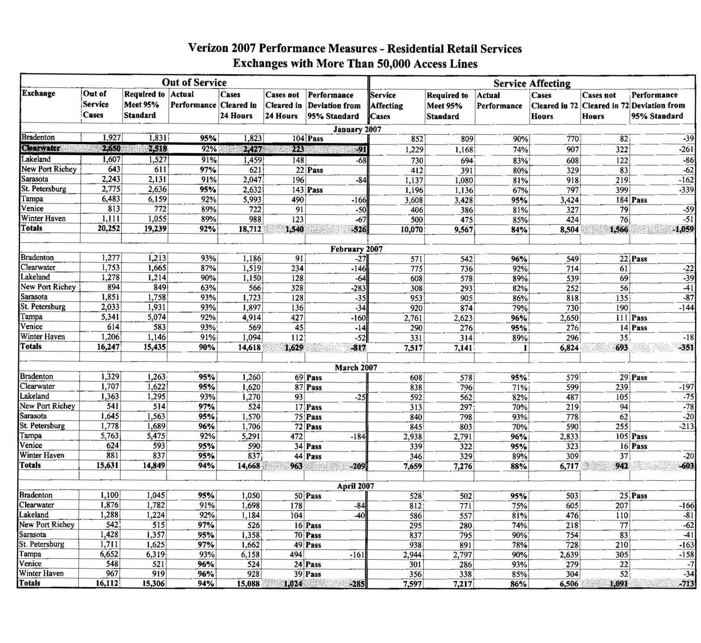
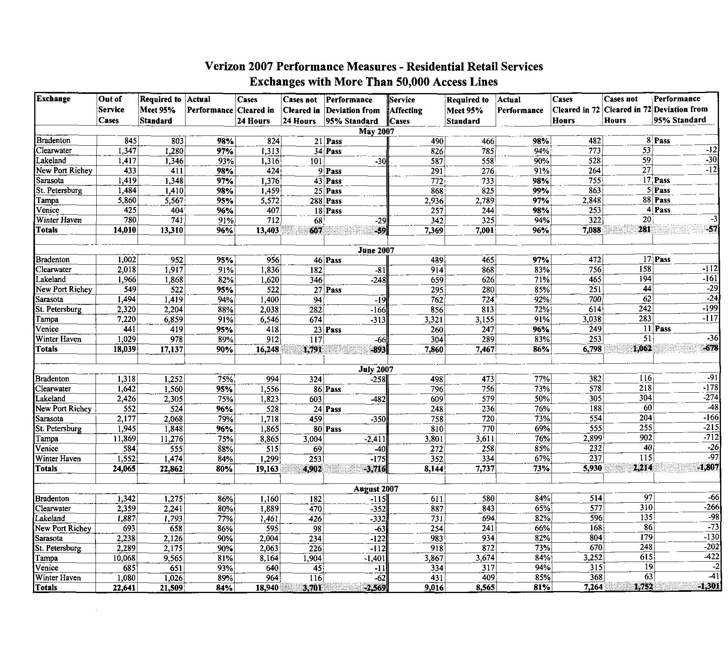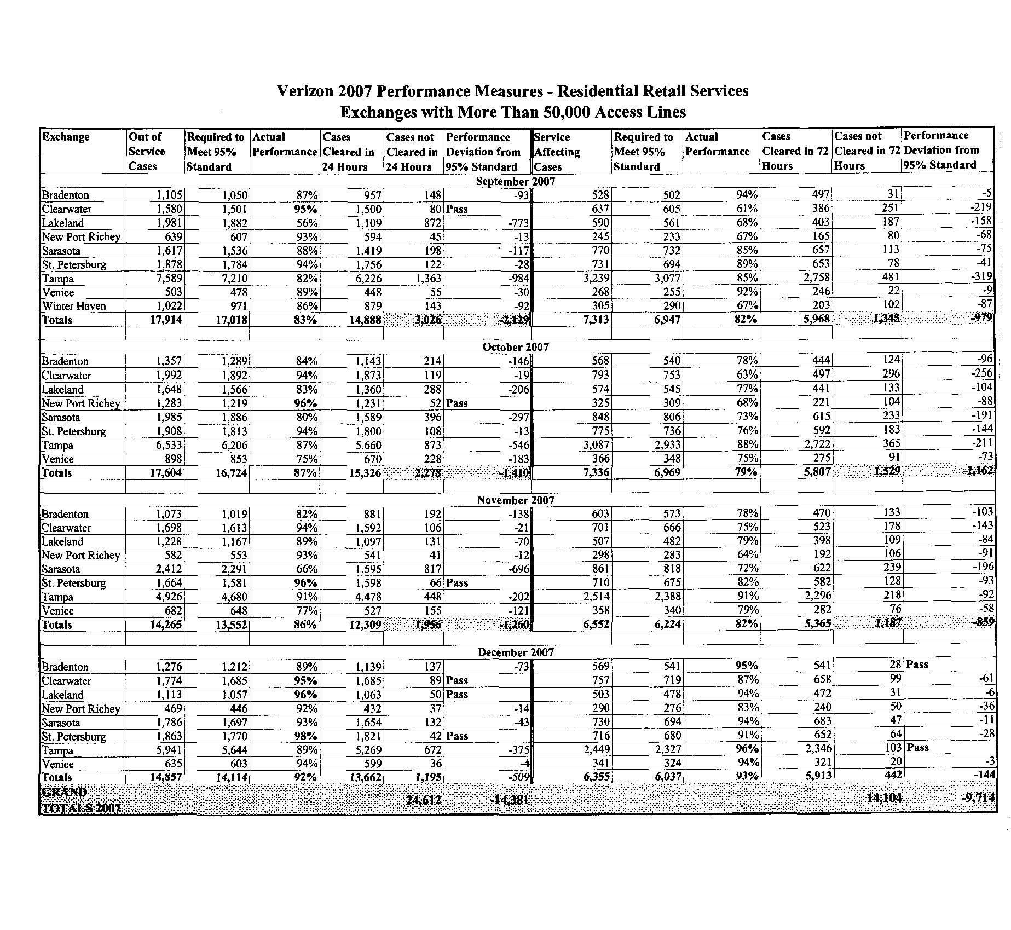
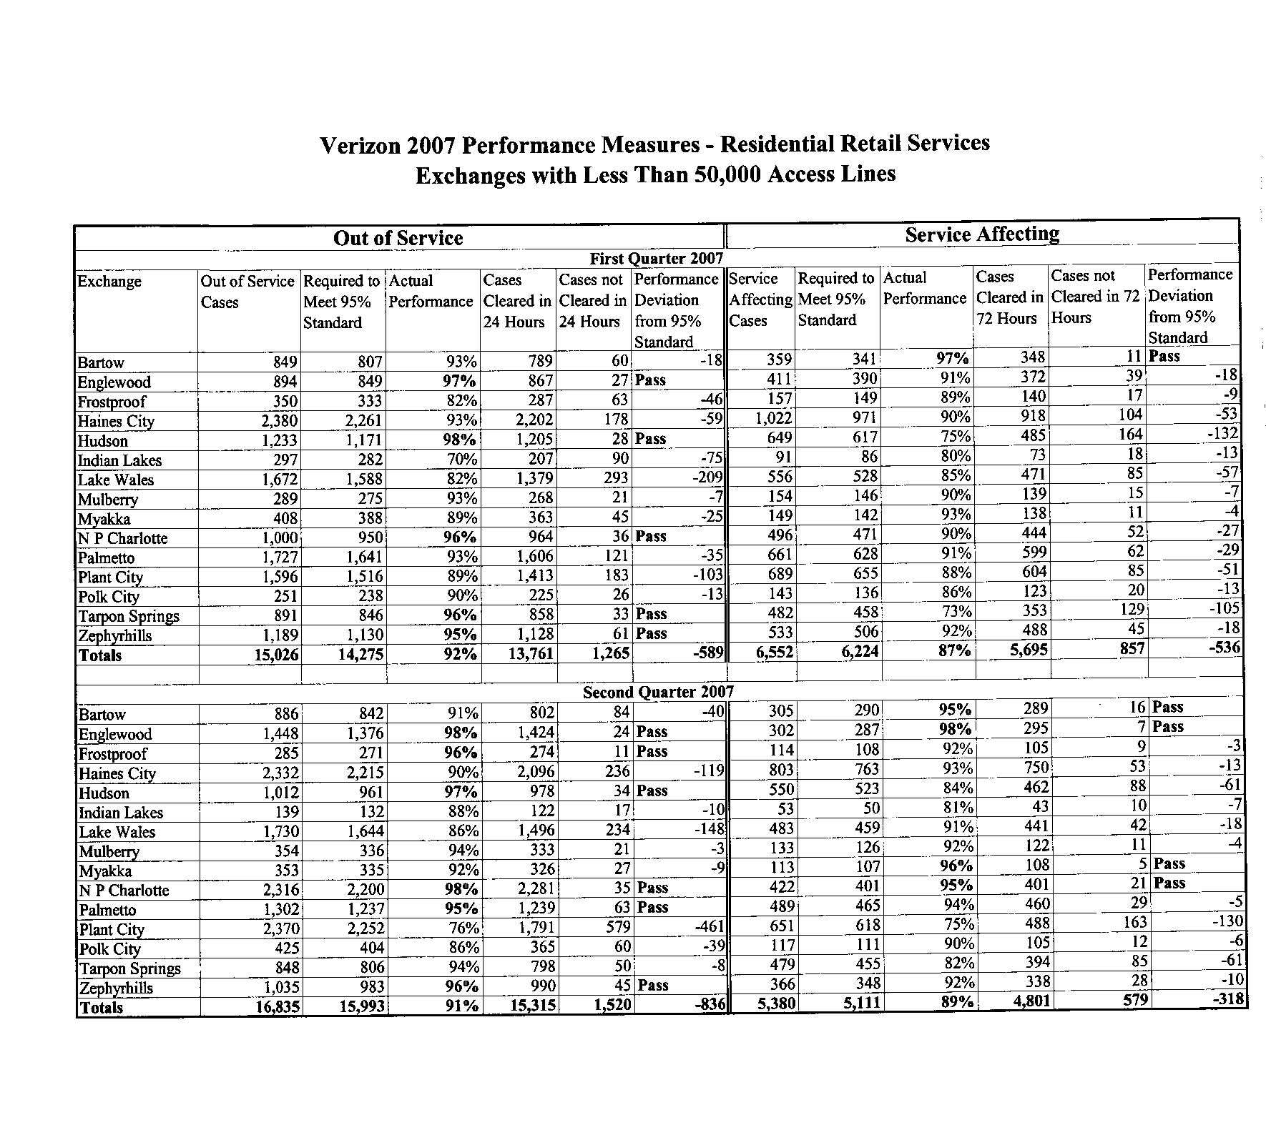
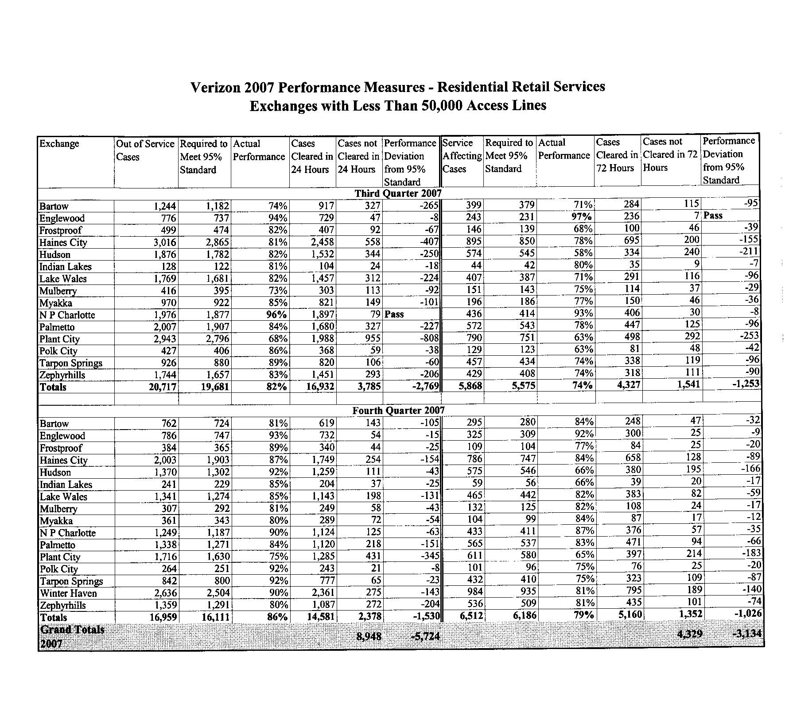
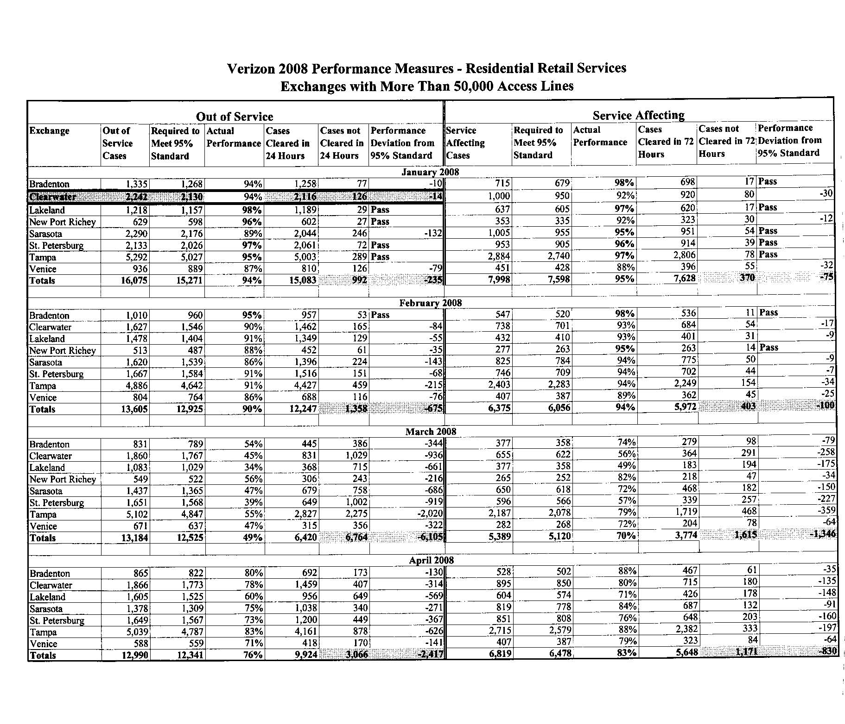
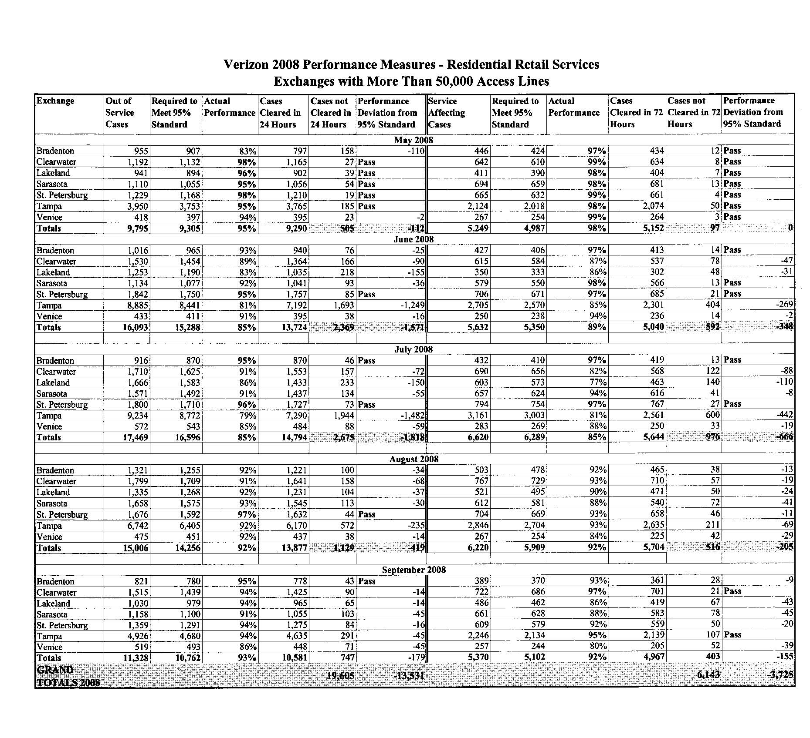
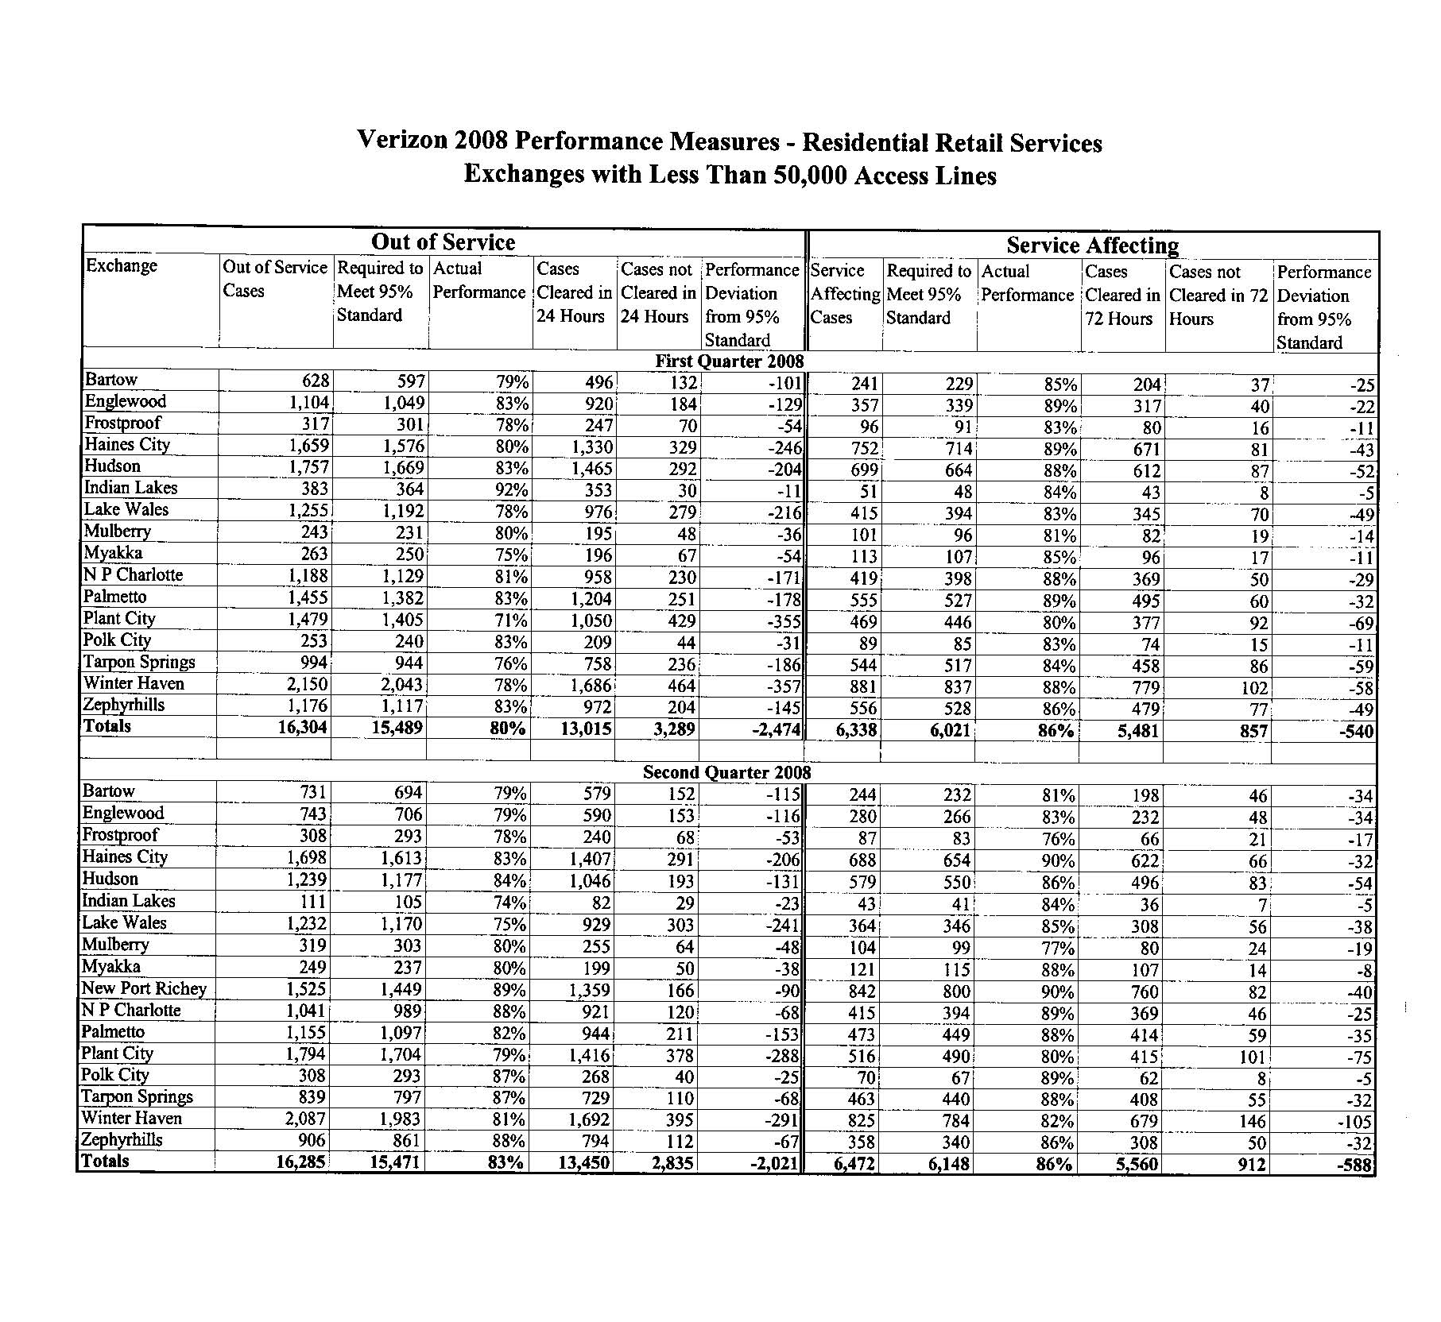
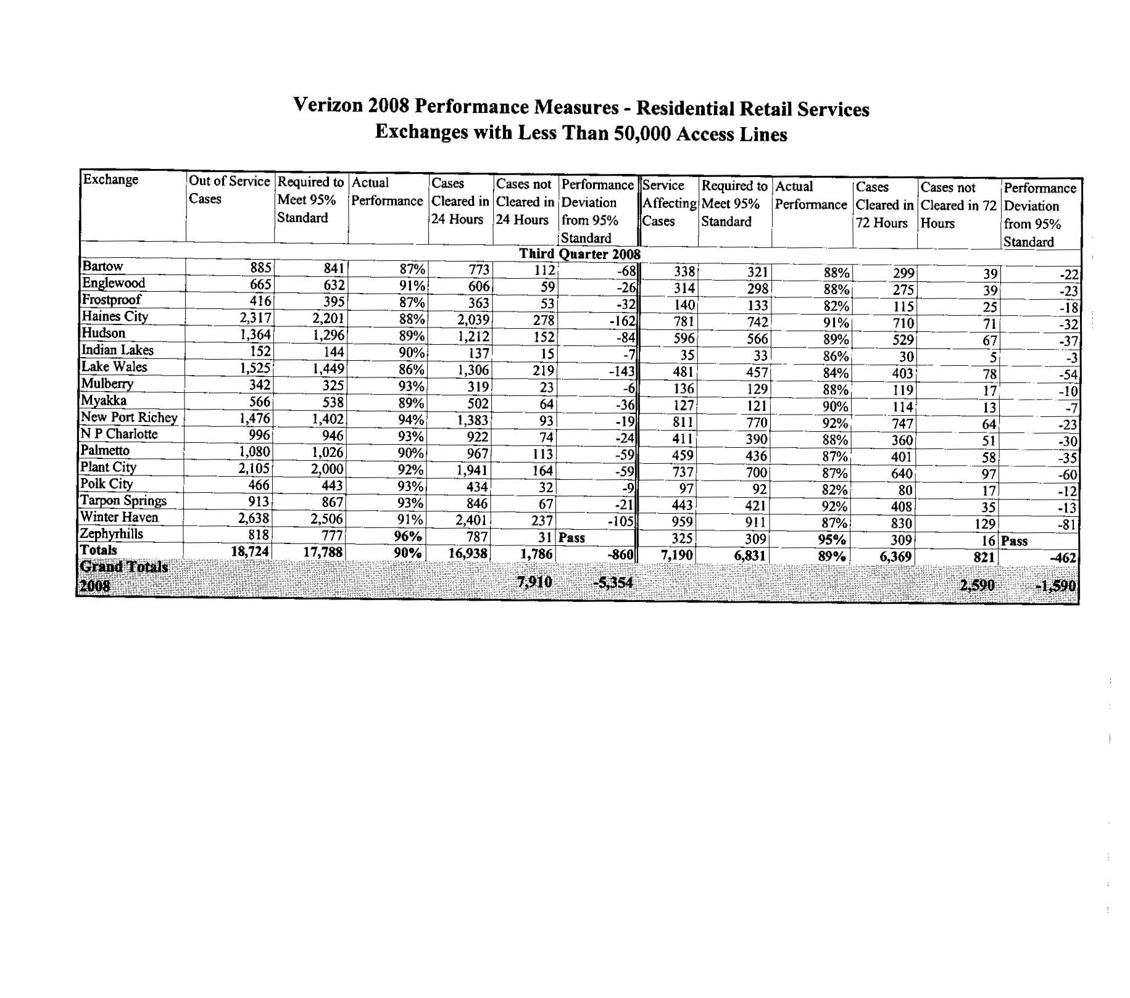

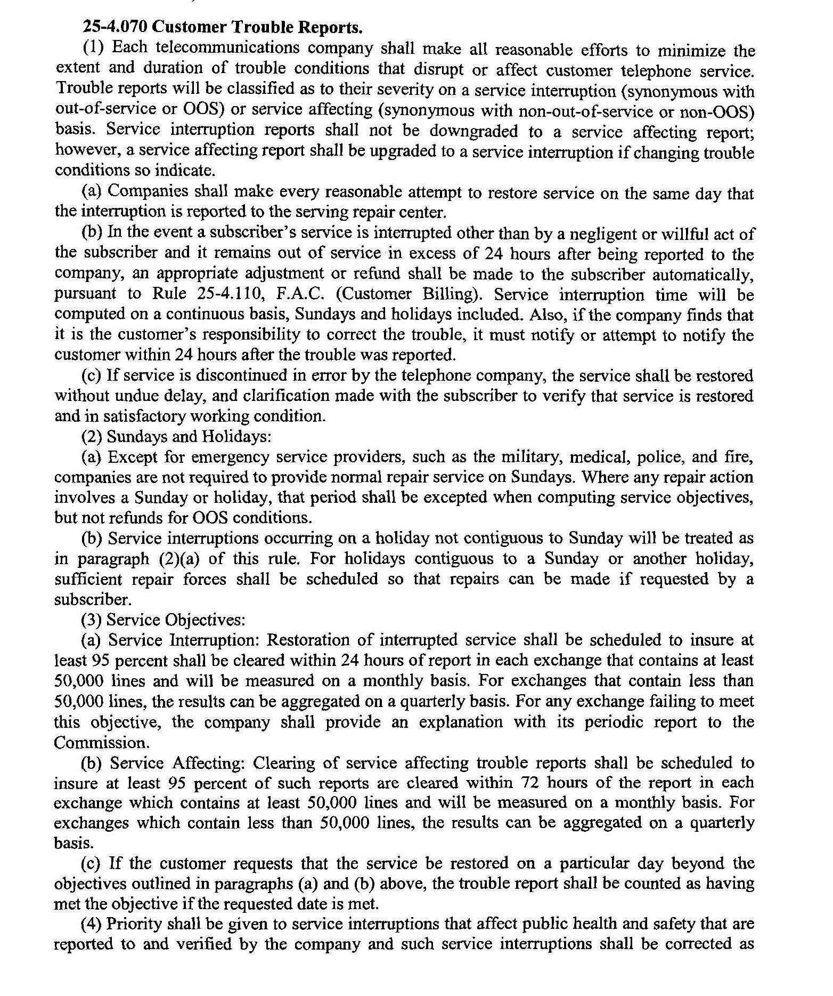
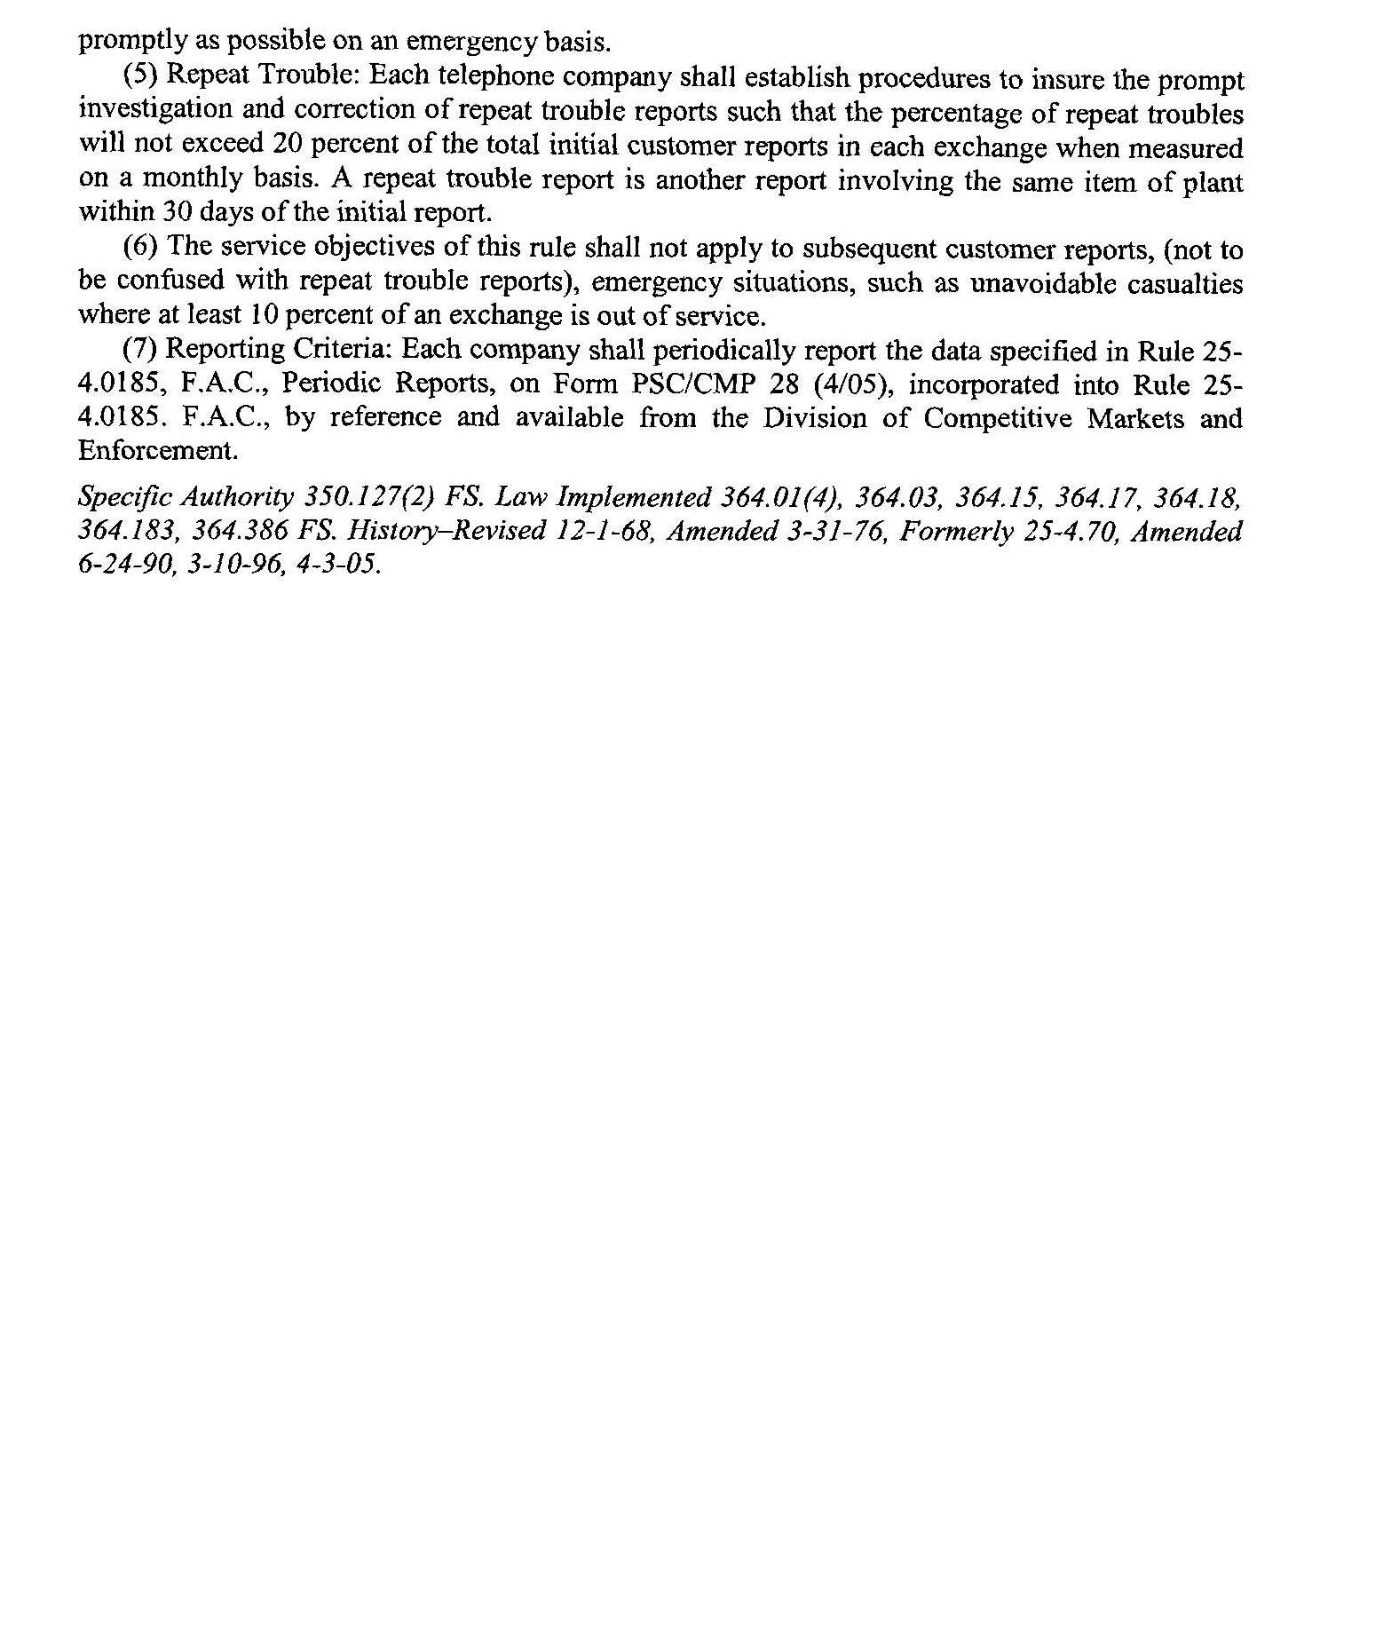

We note that in Docket Nos. 080641-TP and 080159-TP, Verizon has asked for modification or repeal of all service standard rules.
Statutory requirements set forth in Section 364.386 and Section 364.161(4), F.S., require this Commission to report “the status of competition in the telecommunications industry” to the Legislature. The information listed was submitted by the company to be included in the report to the Legislature.
The following analysis utilizes data from the first three quarters of 2008 (January –September).

