BEFORE THE FLORIDA PUBLIC SERVICE COMMISSION

In re: Petition for rate increase by Florida Public Utilities Company. | DOCKET NO. 080366-GU  ORDER NO. PSC-09-0123-PCO-GU  ISSUED: March 3, 2009

The following Commissioners participated in the disposition of this matter:

MATTHEW M. CARTER II, Chairman
LISA POLAK EDGAR
KATRINA J. McMURRIAN
NANCY ARGENZIANO
NATHAN A. SKOP

ORDER SUSPENDING PERMANENT RATES
AND APPROVING INTERIM RATE INCREASE

BY THE COMMISSION:

BACKGROUND
This proceeding commenced on December 17, 2008, with the filing of a petition for a permanent rate increase by Florida Public Utilities Company (FPUC or Company). The Company is engaged in business as a public utility providing distribution and transportation of gas as defined in Section 366.02, Florida Statutes (F.S.), and is subject to our jurisdiction. FPUC serves gas customers through two divisions: the Central Florida Division consisting of portions of Seminole, Marion and Volusia Counties and the South Florida Division consisting of portions of Palm Beach, Broward and Martin Counties. Together, FPUC provides service to over 51,000 residential and commercial customers.

FPUC requested an increase in its retail rates and charges to generate $9,917,690 in additional gross annual revenues. This increase would allow the Company to earn an overall rate of return of 8.74 percent or an 11.75 percent return on equity (range 10.75 percent to 12.75 percent). The Company based its request on a projected test year ending December 31, 2009. In its petition, FPUC stated that this test year is the appropriate period to be utilized because it best represents expected future operations for use in analyzing the request for rate relief. FPUC has elected to have its petition for rate relief processed under the PAA procedure authorized by Section 366.06(4), F.S.

FPUC has also requested an interim rate increase in its retail rates and charges to generate $984,054 in additional gross annual revenues. This increase would allow the Company to earn an overall rate of return of 7.66 percent or a 10.25 percent return on equity, which is the minimum of the currently authorized return on equity range of 10.25 percent to 12.25 percent. The Company based its interim request on a historical test year ended December 31, 2007.

We last granted FPUC a $5,865,903 rate increase by Order No. PSC-04-1110-PAA-GU. In that order, we found the Company’s jurisdictional rate base to be $59,171,674 for the projected test year ended December 31, 2005. The allowed rate of return was found to be 7.62 percent for the test year using an 11.25 percent return on equity.

We have jurisdiction pursuant to Sections 366.06(2) and (4), and 366.071, F.S.

SUSPENDING PERMANENT RATES

FPUC filed its petition, testimony, and minimum filing requirements (MFR) on December 17, 2008. The Company has requested a total permanent base rate increase of $9,917,690, based on a projected test year ending December 31, 2009.

Historically, especially when a projected test year has been involved, we have suspended the requested permanent rate schedules in order to adequately and thoroughly examine the basis for the new rates. The suspension of the rate increase is authorized by Section 366.06(3), F. S., which provides:

Pending a final order by the commission in any rate proceeding under this section, the commission may withhold consent to the operation of all or any portion of the new rate schedules, delivering to the utility requesting such increase, within 60 days, a reason or written statement of good cause for withholding its consent.

Because FPUC=s requested permanent rate relief is based on a projected test year, we find that the requested permanent rate schedules shall be suspended to allow staff and any intervenors sufficient time to adequately investigate whether the request for permanent rate relief is appropriate.

GRANTING INTERIM RATES

The proposed interim test year rate base of $59,518,973 is the thirteen-month average amount for the period ended December 31, 2007 (MFR Schedule F-1). We have reviewed the rate base adjustments made in the current interim filing for consistency with the findings made in the Company’s last rate case order. Based on our review, it appears that FPUC has made the applicable and appropriate adjustments that are consistent with the previous rate case. Therefore, we find that $59,518,973 is the appropriate amount of rate base for the 2007 interim test year. The calculation is shown on Attachment A.

It should be noted that 2007 is also the historical base year that was used to develop the 2009 projected test year for the requested permanent base rate increase. The 2007 historical test year data is currently being audited as part of the normal ratemaking review process in this docket.
Pursuant to Section 366.071(2)(a), F.S., the appropriate return on equity (ROE) for purposes of determining an interim rate increase is the minimum of the Company’s currently authorized ROE range. FPUC’s authorized ROE is 11.25 percent with a range of plus or minus 100 basis points. We set the return and range by Order No. PSC-04-1110-PAA-GU. For its interim request, FPUC used an ROE of 10.25 percent. The resulting overall cost of capital is appropriate for calculating interim rates. Attachment B details the calculation of the Company’s overall cost of capital.

The proposed interim test year net operating income of $3,950,447 is the twelve-month amount for the year ended December 31, 2007 (MFR Schedule F-4). We have reviewed the net operating income adjustments made in the current interim filing for consistency with the findings made in the Company’s last rate case. Based on our preliminary review, it appears that FPUC has not made all of the applicable and appropriate adjustments that are consistent with the previous rate case. Therefore, the following adjustments shall be made.

Adjustment 1: Franchise Fees

Franchise fees are billed as a separate line item on the customers’ bills. Franchise fees are not considered a general expense applicable to all of the Company’s customers. The appropriate franchise fee rate is applied to only those customers’ bills that reside within the franchising entity’s boundaries. Therefore, neither the revenues nor the expenses related to franchise fees should be included in the income statement for ratemaking purposes. Both operating revenues and taxes other than income should be reduced by $1,553,487. Since these amounts offset each other, there is no effect on the amount of net operating income.

Adjustment 2: Gross Receipts Tax

Although the gross receipts tax is applicable to all of the Company’s customers, it is billed as a separate line item on the customers’ bills. Therefore, neither the revenues nor the expenses related to the gross receipts tax should be included in the income statement for ratemaking purposes. Both operating revenues and taxes other than income should be reduced by $2,106,338. Since these amounts offset each other, there is no effect on the amount of net operating income.

After considering these two adjustments, we find that $3,950,447 is the appropriate amount of net operating income for the 2006 interim test year. The calculation is shown on Attachment A.

It should be noted that 2007 is also the historical base year that was utilized to develop the 2009 projected test year for the requested permanent base rate increase. The 2007 historical test year data is currently being audited as part of the normal ratemaking review process in this docket.
On MFR Schedule F-6, the Company calculated a net operating income multiplier of 1.61757 using a 34 percent federal income tax rate and a 5.5 percent state income tax rate. Additionally, the Company applied a .50 percent factor for regulatory assessment fees and a .38 percent bad debt rate. We have reviewed the Company’s calculation of the net operating income multiplier and no adjustments are needed. Therefore, 1.61757 is the appropriate net operating income multiplier. The calculation is shown below.

Line | Description
1 | Revenue Requirement | 100.000%
2 | Gross Receipts Tax | 0.000%
3 | Regulatory Assessment Fee | (0.500)%
4 | Bad Debt Rate | (0.380)%
5 | Net Before Income Taxes | 99.120%
6 | Combined State/Federal Income Tax @ 37.63% | (37.299)%
7 | Revenue Expansion Factor | 61.821%
8 | Net Operating Income Multiplier (100%/Line 7) | 1.61757

FPUC requested interim rate relief of $984,054 for the historical test year ended December 31, 2007. This would allow the Company to earn an overall rate of return of 7.66 percent and the minimum of the range on return on equity of 10.25 percent. After a determination of the permanent rate increase has been made, the interim rate increase will be reviewed to determine if any portion should be refunded to the ratepayers. The calculation of the $984,054 of interim rate relief and the percentage increase factor is shown below.

Jurisdictional Adjusted Rate Base $59,518,973
Overall Rate of Return Requested x 7.66%
Jurisdictional Net Operating Income Requested $4,558,800
Jurisdictional Adjusted Net Operating Income (3,950,447)
Income Deficiency/(Excess) $608,353
Net Operating Income Multiplier x 1.61757
Interim Revenue Increase/(Decrease) $984,054
Base Rate Revenues -:- 23,516,593
Percentage Increase Factor 4.18%
As shown on Attachments C and D, we have determined the cents-per-therm increases to be applied to each rate class based on an interim increase of $984,054. The increases were calculated using the methodology contained in Rule 25-7.040, Florida Administrative Code, which requires that any increase be applied evenly across the board to all rate classes based on their base rate revenues. A residential customer using 20 therms will see the bill increase from $33.67 to $34.39 or by $0.72. The bill includes purchased gas costs of 80 cents per therm. For additional bill comparisons, see Attachment E.

The interim rates shall be effective for all meter readings made on or after 30 days from the date of our vote approving the interim increase. FPUC shall be required to give appropriate notice to customers commencing with the first bill for service that reflects the approved interim increase that explains the nature, purpose, and effect of the increase. A copy of the notice shall be submitted for approval prior to distribution to the customers.

FPUC has requested that all funds collected subject to refund be secured by a corporate undertaking. The criteria for a corporate undertaking include sufficient liquidity, ownership equity, profitability, and interest coverage to guarantee any potential refund. We reviewed the financial statements to determine if FPUC can support a corporate undertaking for the amount of its interim rate increase of $984,054. FPUC’s 2005, 2006, and 2007 financial statements were used to determine the financial condition of the Company. This analysis shows FPUC has experienced a decline in liquidity that has remained at insufficient levels during the three-year review period. Additionally, the 2007 interest coverage ratio has declined to an insufficient level. However, FPUC’s average equity ratio over the three-year period has been relatively stable at an average of 47 percent, which is sufficient in this instance based on FPUC’s overall financial condition. Finally, net income has been on average four times greater than the requested corporate undertaking amount. FPUC’s financial performance has demonstrated adequate levels of profitability and equity capitalization to offset the decline in liquidity and interest coverage.

We find that FPUC has adequate resources to support a corporate undertaking in the amount requested. Based on this analysis, a corporate undertaking of $984,054 is acceptable. This brief financial analysis is only appropriate for deciding if the Company can support a corporate undertaking in the amount proposed and shall not be considered a finding regarding other issues in this proceeding.

Based on the foregoing, it is

ORDERED by the Florida Public Service Commission that the final rates and associated tariff revisions proposed by Florida Public Utilities Company are suspended pending a final decision in this docket. It is further

ORDERED that the request for an interim rate increase for water rates by Florida Public Utilities Company is hereby granted as set forth in the body of this Order. It is further

ORDERED that all matters contained in the schedules attached hereto are incorporated herein by reference. It is further

ORDERED that the approved interim revenue increase shall be applied evenly across the board to all rate classes based on their base rate revenues, as required by Rule 25-7.040, Florida Administrative Code, and shall be recovered on a cents-per-therm basis. It is further

ORDERED that the interim rates shall be made effective for all meter readings made on or after 30 days from the date of the vote approving the interim increase. It is further

ORDERED that Florida Public Utilities Company shall give notice to customers of the interim increase commencing with the first bill for service that reflects the increase. It is further

ORDERED that Florida Public Utilities Company shall give appropriate notice to customers commencing with the first bill for service that reflects the approved interim increase that explains the nature, purpose, and effect of the increase. A copy of the notice shall be submitted to staff for approval prior to distribution to the customers. It is further

ORDERED that the appropriate security to guarantee the funds collected subject to refund is a corporate undertaking. It is further

ORDERED that this docket shall remain open pending the Commission’s final resolution of Florida Public Utilities Company’s requested rate increase.

By ORDER of the Florida Public Service Commission this 3rd day of March, 2009.

/s/ Ann Cole
ANN COLE
Commission Clerk

This is an electronic transmission. A copy of the original signature is available from the Commission's website, www.floridapsc.com, or by faxing a request to the Office of Commission Clerk at 1-850-413-7118.

( S E A L )

JSB
NOTICE OF FURTHER PROCEEDINGS OR JUDICIAL REVIEW

The Florida Public Service Commission is required by Section 120.569(1), Florida Statutes, to notify parties of any administrative hearing or judicial review of Commission orders that is available under Sections 120.57 or 120.68, Florida Statutes, as well as the procedures and time limits that apply. This notice should not be construed to mean all requests for an administrative hearing or judicial review will be granted or result in the relief sought.

Any party adversely affected by this order, which is non-final in nature, may request (1) reconsideration within 10 days pursuant to Rule 25-22.0376, Florida Administrative Code, or (2) judicial review by the Florida Supreme Court, in the case of an electric, gas or telephone utility, or the First District Court of Appeal, in the case of a water or wastewater utility. A motion for reconsideration shall be filed with the Office of Commission Clerk, in the form prescribed by Rule 25-22.0376, Florida Administrative Code. Citizens of the State of Florida v. Mayo, 316 So.2d 262 (Fla. 1975), states that an order on interim rates is not final or reviewable until a final order is issued. Such review may be requested from the appropriate court, as described above, pursuant to Rule 9.100, Florida Rules of Appellate Procedure.

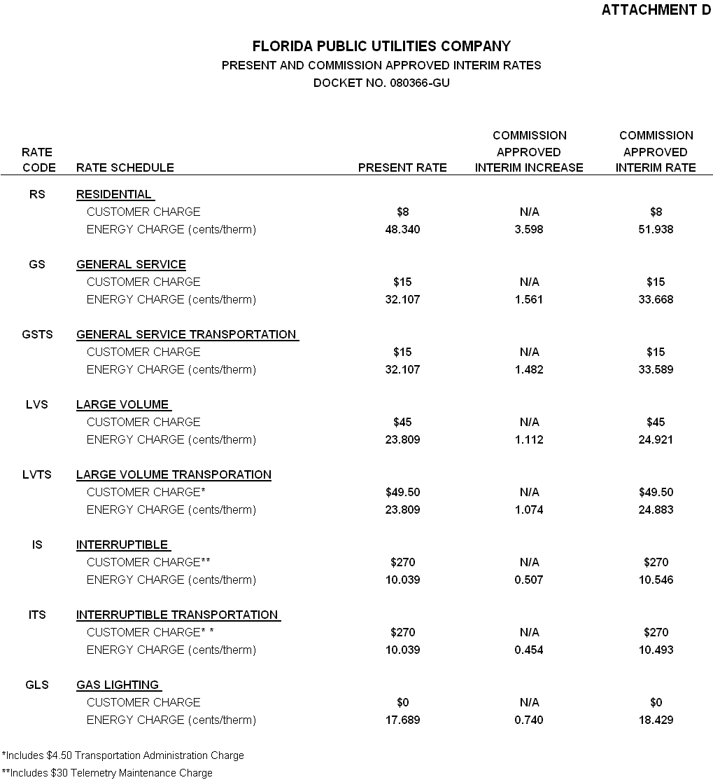
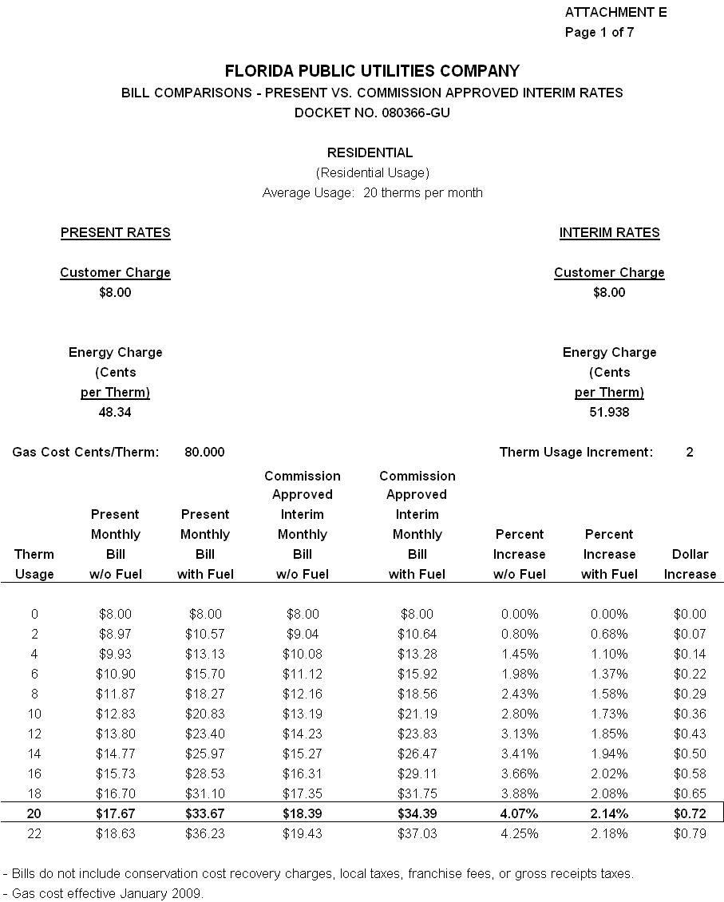
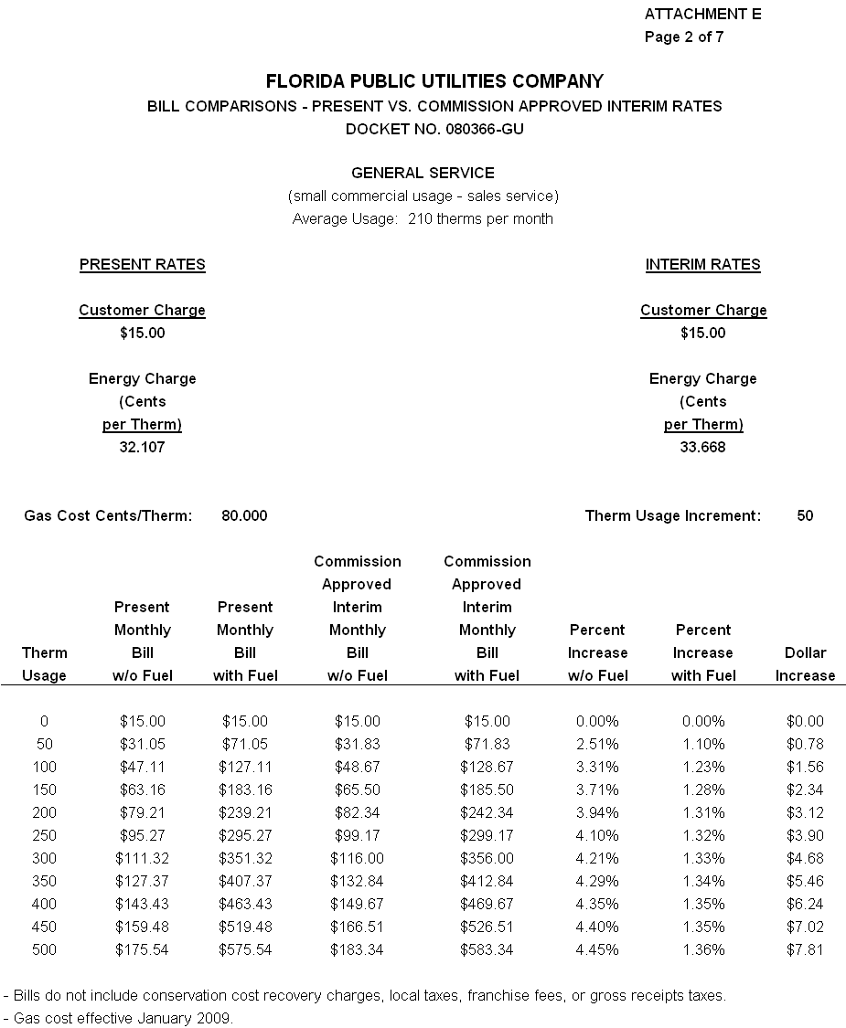
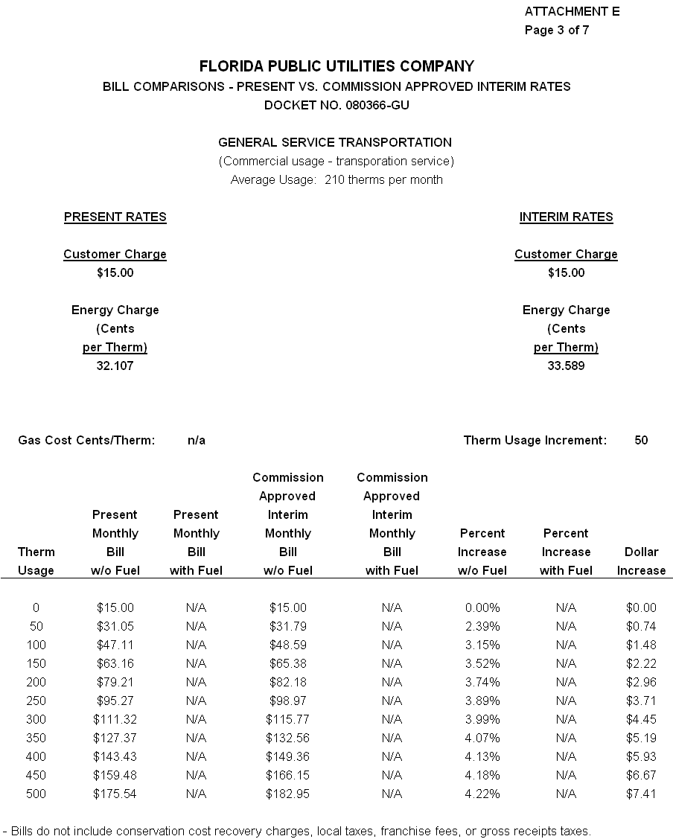
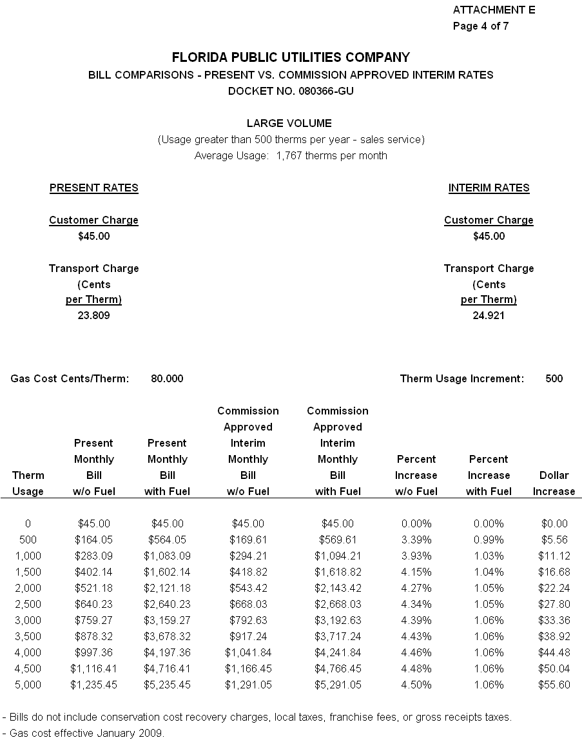
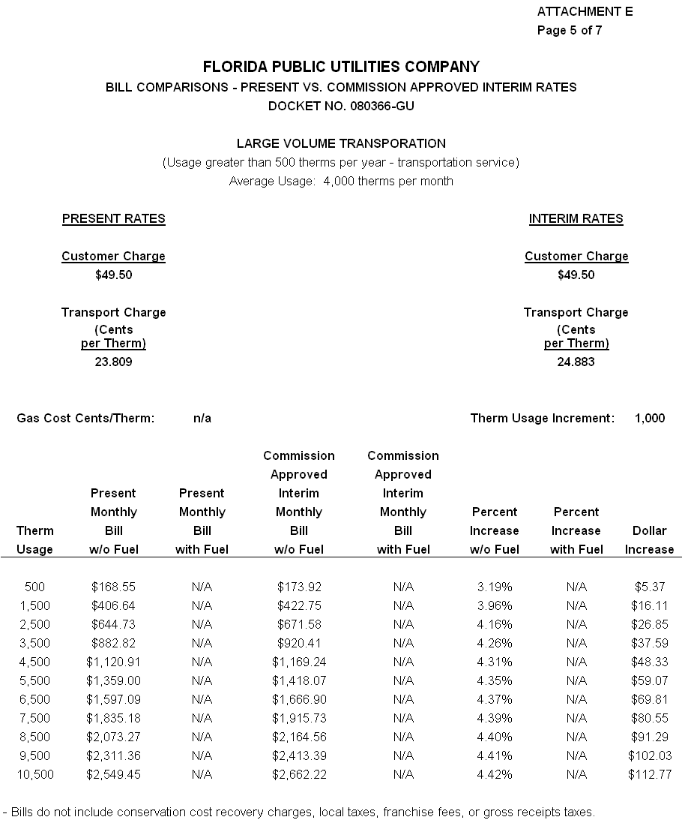
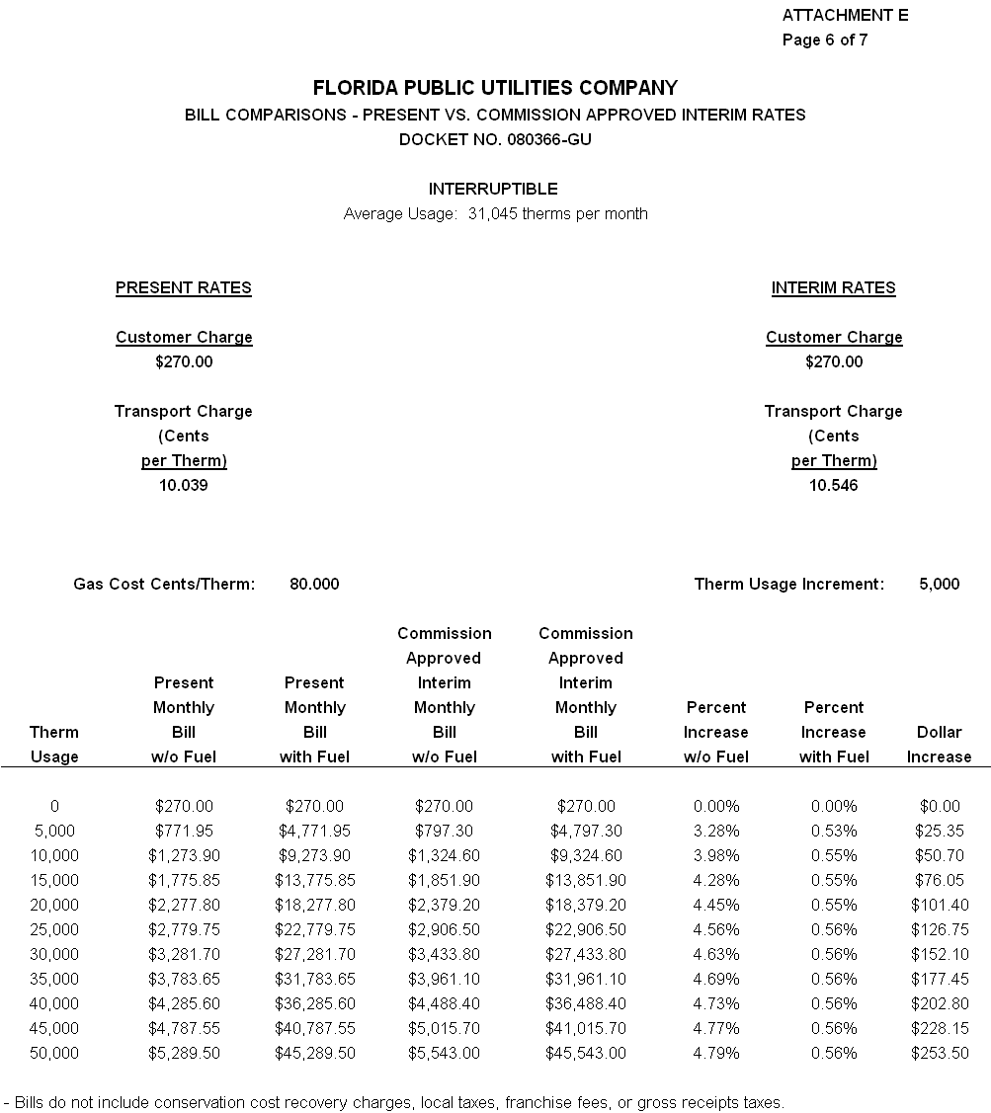
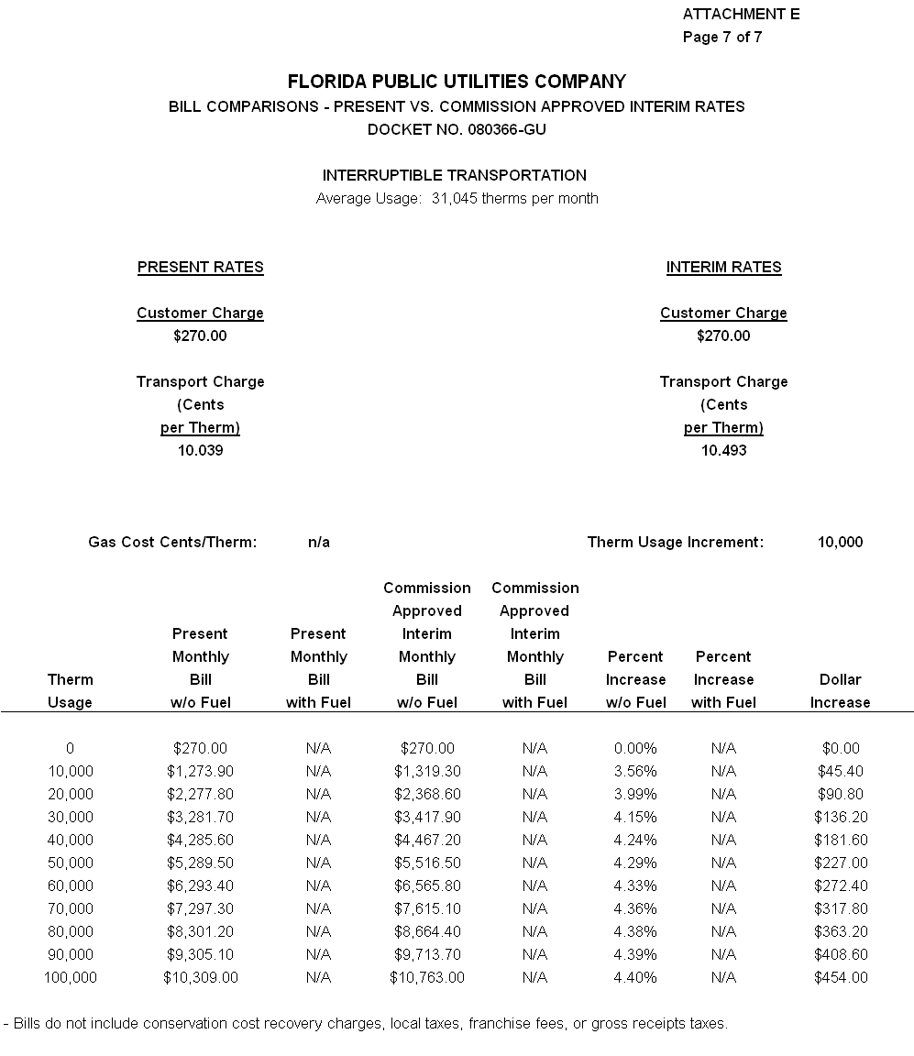

Order No. PSC-04-1110-PAA-GU, issued November 8, 2004, in Docket No. 040216-GU, In re: Application for rate increase by Florida Public Utilities Company.
Order No. PSC-04-1110-PAA-GU, issued November 8, 2004, in Docket No. 040216-GU, In re: Application for rate increase by Florida Public Utilities Company.

