BEFORE THE FLORIDA PUBLIC SERVICE COMMISSION

In re: Application for increase in water and wastewater rates in Pasco County by Labrador Utilities, Inc. | DOCKET NO. 080249-WS  ORDER NO. PSC-09-0711-AS-WS  ISSUED: October 26, 2009

The following Commissioners participated in the disposition of this matter:

LISA POLAK EDGAR
NANCY ARGENZIANO

FINAL ORDER APPROVING SETTLEMENT AGREEMENT AND CLOSING DOCKET

BY THE COMMISSION:

Background

Labrador Utilities, Inc. (Labrador or Utility) is a Class B utility providing water and wastewater service to approximately 897 water and 892 wastewater customers in Pasco County. Water and wastewater rates were last established for this Utility in 2004.
On August 28, 2008, Labrador filed its application for increased water and wastewater rates, and the application was assigned to this docket. By Order No. PSC-08-0751-PCO-WS, issued November 13, 2008, we approved interim annual revenue increases of $97,862 or 62.83 percent for water, and $29,611 or 8.17 percent for wastewater. The revenue increases are secured through a corporate undertaking by Utilities, Inc. (UI), Labrador’s parent company. By Order No. PSC-09-0462-PAA-WS (PAA Order), issued June 22, 2009, we proposed to approve rates designed to generate a water revenue requirement of $257,003 and a wastewater revenue requirement of $497,755.
On July 13, 2009, the Office of Public Counsel (OPC) timely filed a protest of the PAA Order. On July 22, 2009, Labrador timely filed a cross-petition to protest the PAA Order pursuant to Rule 25-22.029(3), Florida Administrative Code (F.A.C.).
On September 3, 2009, the Utility and OPC (collectively, Parties) filed a Joint Motion Requesting Commission Approval of Settlement Agreement (Joint Motion). The Settlement Agreement is incorporated in this Order as Attachment A. This Order addresses the Parties’ Settlement Agreement. We have jurisdiction pursuant to Sections 367.081 and 367.121, Florida Statutes (F.S.).
Settlement Agreement
In the Settlement Agreement, the Parties note that they have not agreed on certain language in the PAA Order as follows: (1) the quality of service provided by the Utility; (2) the determination of the used and usefulness of Labrador’s wastewater treatment plant; (3) the appropriate salaries and benefits expense; and (4) the appropriate amount of rate case expense. The Parties have agreed that the PAA Order is to have no precedential value as to determining the aforementioned items. We have previously approved a proposed settlement where language was stricken from a proposed agency action order. We find that the language in the PAA Order which the Parties seek to strike can be removed because each rate case is decided on its own merits.
In lieu of stipulating to the above-mentioned items, Labrador and OPC have agreed and stipulated to a total revenue requirement and rates and charges to be paid by the customers. The Parties have agreed that the water revenue requirement be reduced by $3,379 to $253,624, and the wastewater revenue requirement be reduced by $37,620 to $460,135.
The Parties have further stipulated that no refund of the interim rates is required. Further, the Parties agree that the stipulated revenue requirement shall in no way limit or estop either party from espousing whatever positions either deems appropriate for each and every issue in any subsequent proceeding. Finally, Labrador “agrees not to file the minimum filing requirements for any new rate case until at least two years after the execution of the Settlement Agreement, except for price indexes and pass-throughs pursuant to Section 367.081(4), F.S., for the recovery of government-mandated improvements, and those agreed upon between Labrador and the Citizens in the future.”
We find that the Parties’ Settlement Agreement is a reasonable resolution because it results in mutually acceptable rates. Further, we find that it is in the public interest for us to approve the Settlement Agreement because it promotes administrative efficiency and avoids the time and expense of a hearing.
The Utility shall file a proposed customer notice and revised tariff sheets by October 21, 2009, which is consistent with our decision. The approved rates shall be effective for service rendered on or after the stamped approval date of the tariff pursuant to Rule 25-30.475(1), F.A.C., and after our staff has verified that the proposed customer notice is adequate and the notice has been provided to the customers. The Utility shall provide proof that the customers have received notice within 10 days after the date of the notice.
In consideration of the above, it is
ORDERED by the Florida Public Service Commission that the Joint Motion Requesting Commission Approval of Settlement Agreement is approved, and the Settlement Agreement in its entirety is approved. It is further
ORDERED that the Settlement Agreement is attached as Attachment A, and is by reference incorporated into this Order. It is further
ORDERED that the appropriate revenue requirements are $253,624 for water and $460,135 for wastewater. It is further
ORDERED that the approved rates shall be as shown in the Settlement Agreement. It is further
ORDERED that Labrador Utilities, Inc., shall file a proposed customer notice and revised tariff sheets by October 21, 2009, which is consistent with our decision. It is further
ORDERED that the approved rates shall be effective for service rendered on or after the stamped approval date of the tariff pursuant to Rule 25-30.475(1), F.A.C., and after our staff has verified that the proposed customer notice is adequate and the notice has been provided to the customers. It is further
ORDERED that Labrador Utilities, Inc., shall provide proof that the customers have received notice within 10 days after the date of the notice. It is further
ORDERED that the corporate undertaking by Utilities, Inc., for the interim rates shall be released. It is further
ORDERED that this docket shall be closed.
By ORDER of the Florida Public Service Commission this 26th day of October, 2009.

/s/ Ann Cole
ANN COLE
Commission Clerk

This is an electronic transmission. A copy of the original signature is available from the Commission's website, www.floridapsc.com, or by faxing a request to the Office of Commission Clerk at 1-850-413-7118.

( S E A L )

RRJ

NOTICE OF FURTHER PROCEEDINGS OR JUDICIAL REVIEW

The Florida Public Service Commission is required by Section 120.569(1), Florida Statutes, to notify parties of any administrative hearing or judicial review of Commission orders that is available under Sections 120.57 or 120.68, Florida Statutes, as well as the procedures and time limits that apply. This notice should not be construed to mean all requests for an administrative hearing or judicial review will be granted or result in the relief sought.

Any party adversely affected by the Commission's final action in this matter may request: 1) reconsideration of the decision by filing a motion for reconsideration with the Office of Commission Clerk, 2540 Shumard Oak Boulevard, Tallahassee, Florida 32399-0850, within fifteen (15) days of the issuance of this order in the form prescribed by Rule 25-22.060, Florida Administrative Code; or 2) judicial review by the Florida Supreme Court in the case of an electric, gas or telephone utility or the First District Court of Appeal in the case of a water and/or wastewater utility by filing a notice of appeal with the Office of Commission Clerk, and filing a copy of the notice of appeal and the filing fee with the appropriate court. This filing must be completed within thirty (30) days after the issuance of this order, pursuant to Rule 9.110, Florida Rules of Appellate Procedure. The notice of appeal must be in the form specified in Rule 9.900(a), Florida Rules of Appellate Procedure.

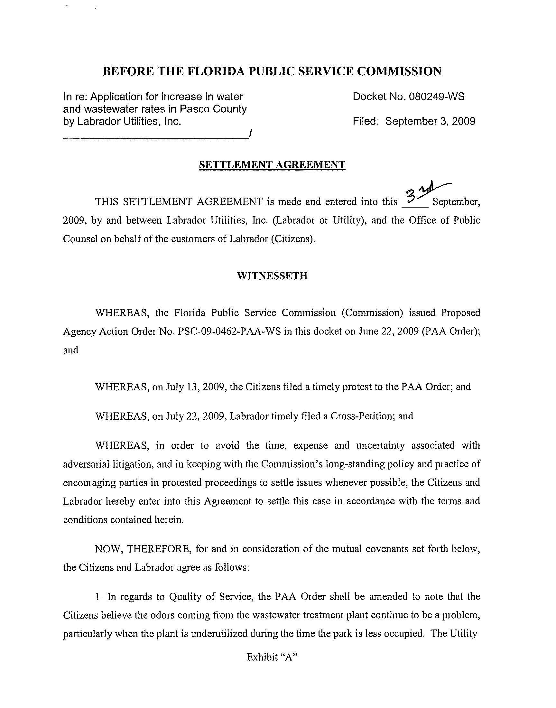
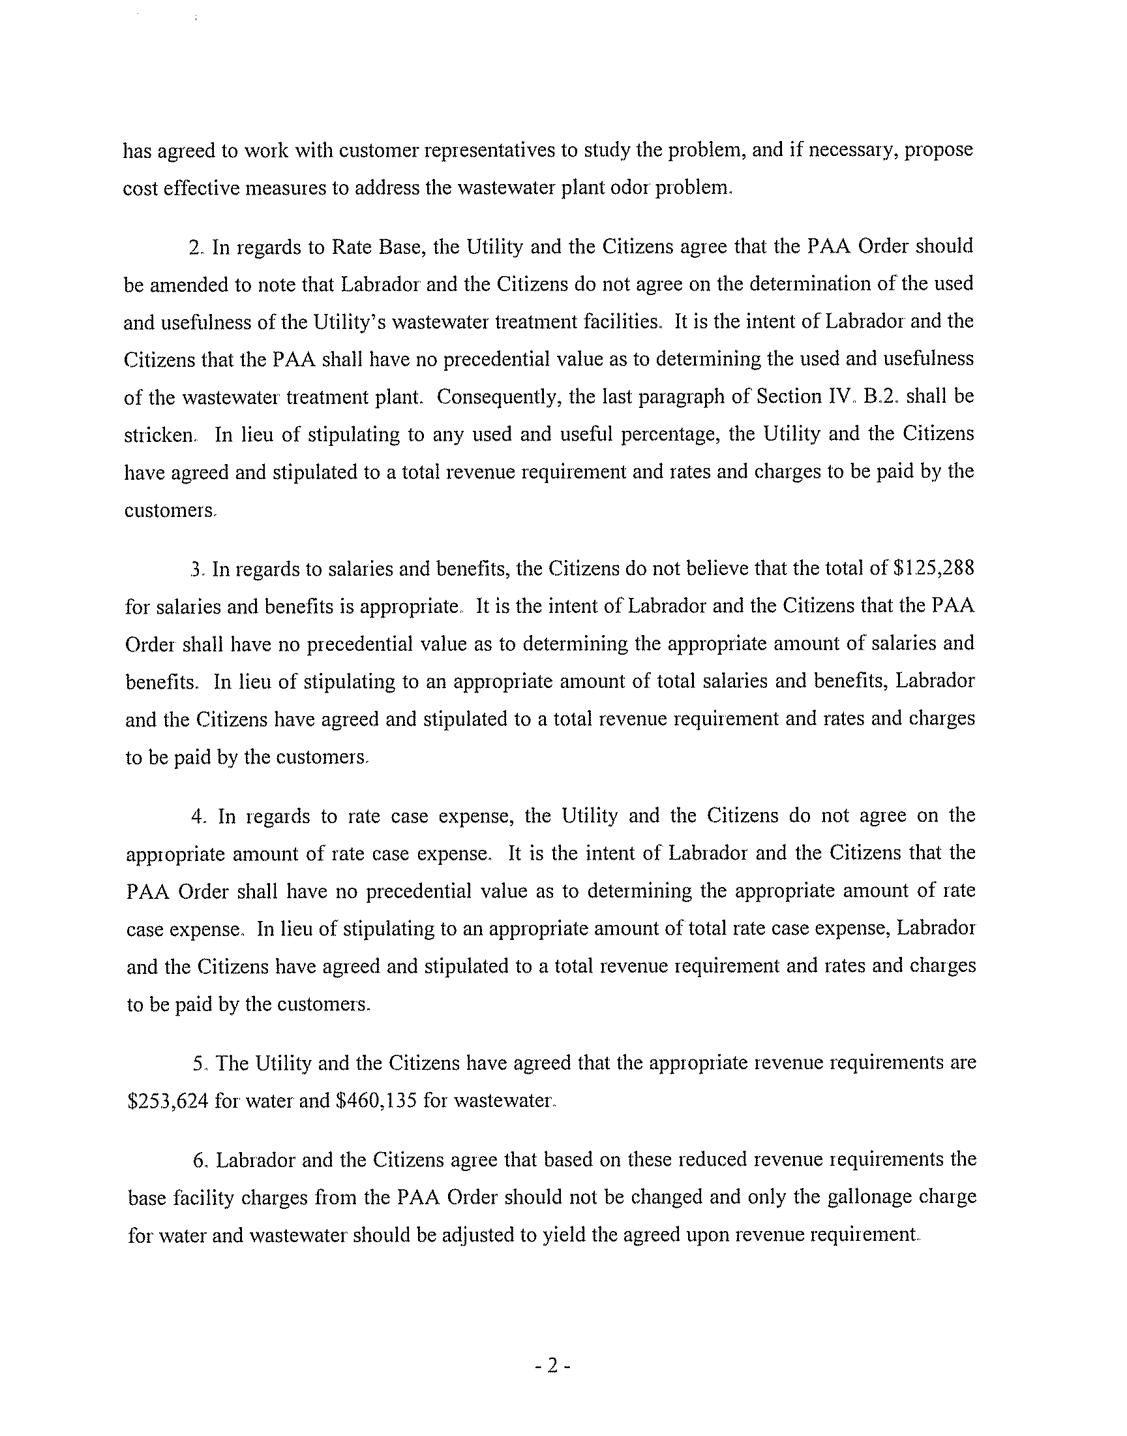
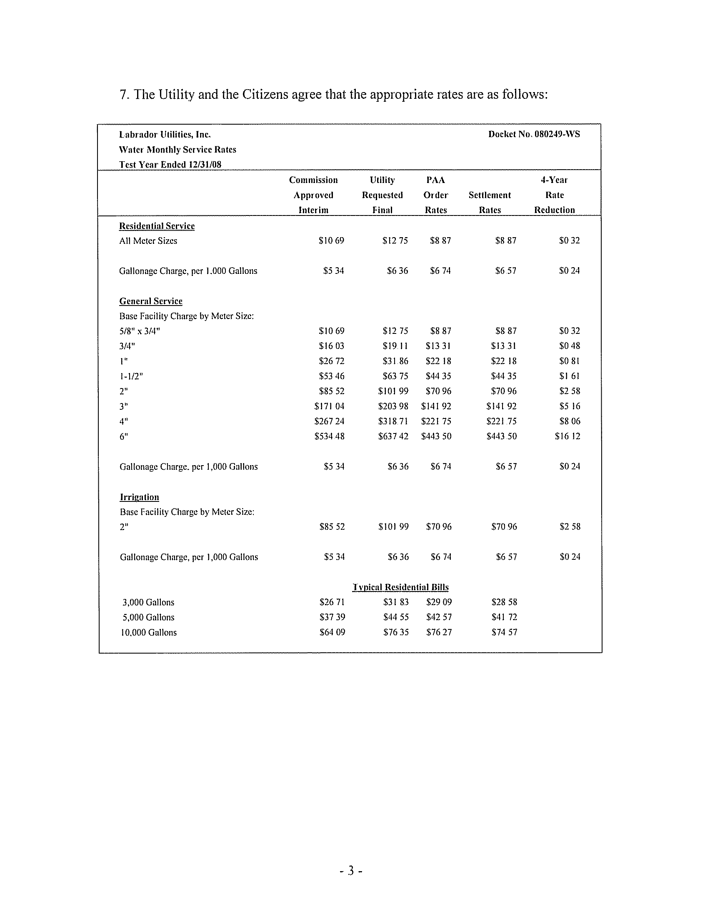
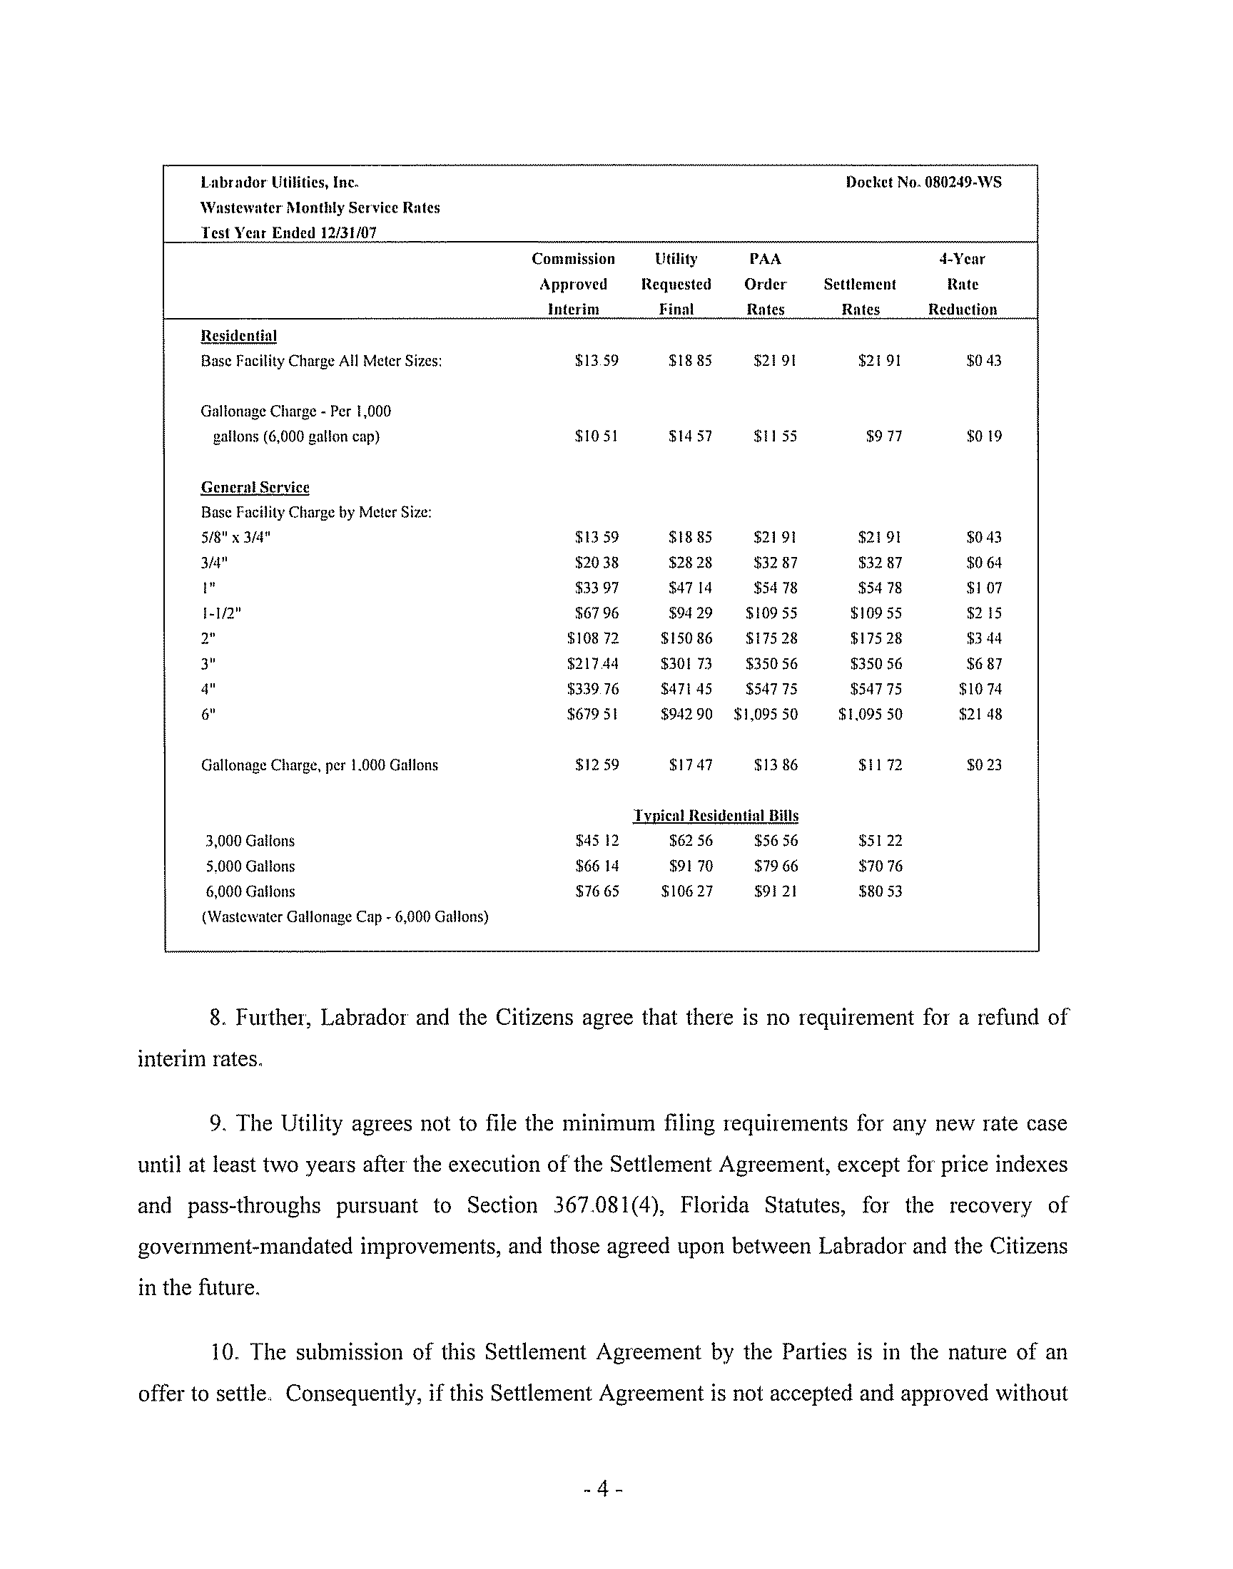
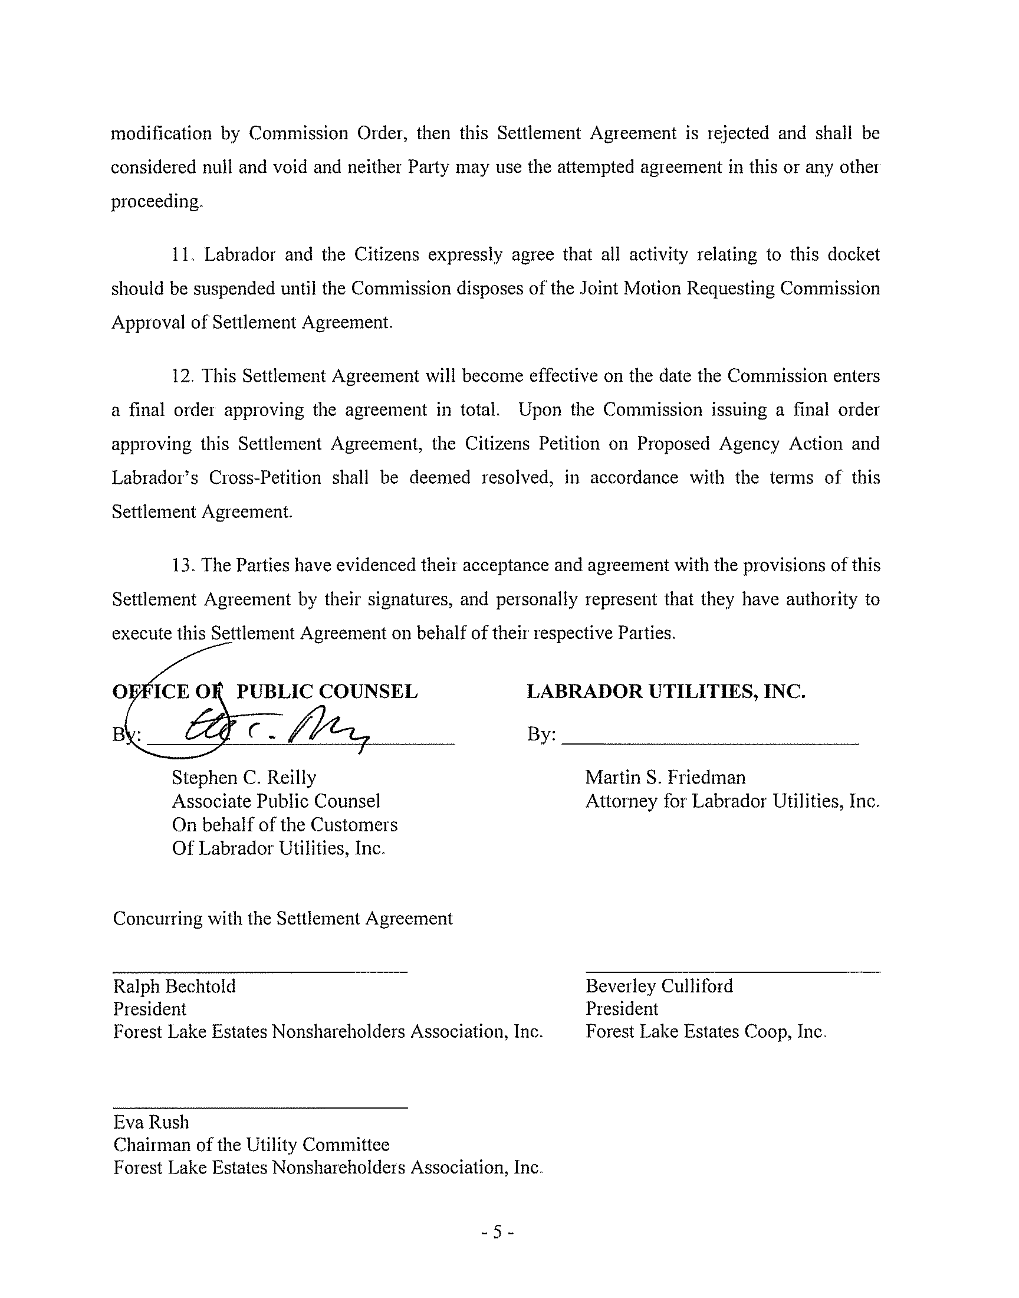

OPC believes the odors coming from the wastewater treatment plant continue to be a problem, and the Utility has agreed to work with customer representatives to study the problem and propose cost effective measures to address the problem.
The Parties do not agree on the calculation of the used and usefulness of the wastewater treatment facilities, and the last paragraph of Section IV. B. 2 of the PAA Order shall be stricken and have no precedential value.
The Parties do not agree on the calculation of the appropriate amount for salaries and benefits, and the amount of $125,288 listed in the PAA Order shall have no precedential value.
The Parties do not agree on the appropriate amount of rate case expense and the amount of rate case expense listed in the PAA Order shall have no precedential value.
See Order No. PSC-06-0665-S-WS, issued August 7, 2006, in Docket No. 050281-WS, In re: Application for increase in water and wastewater rates in Volusia County by Plantation Bay Utility Company.

