BEFORE THE FLORIDA PUBLIC SERVICE COMMISSION

In re: Petition for modification of Service Guarantee Program by Embarq Florida, Inc. d/b/a Centurylink. | DOCKET NO. 090552-TL  ORDER NO. PSC-10-0233-PAA-TL  ISSUED: April 14, 2010

The following Commissioners participated in the disposition of this matter:

NANCY ARGENZIANO, Chairman
LISA POLAK EDGAR
NATHAN A. SKOP
DAVID E. KLEMENT
BEN A. "STEVE" STEVENS III

NOTICE OF PROPOSED AGENCY ACTION
ORDER APPROVING MODIFICATION OF SERVICE GUARANTEE PLAN

BY THE COMMISSION:

NOTICE is hereby given by the Florida Public Service Commission that the action discussed herein is preliminary in nature and will become final unless a person whose interests are substantially affected files a petition for a formal proceeding, pursuant to Rule 25-22.029, Florida Administrative Code.

- Case Background

On December 20, 2000, and January 12, 2001, the Florida Public Service Commission (Commission) issued Order Nos. PSC-00-2462-PAA-TL and PSC-00-2462A-PAA-TL (Docket No. 991377-TL), respectively, approving the Settlement Agreement between the Office of Public Counsel and Sprint-Florida, Incorporated (n/k/a Embarq Florida, Inc. d/b/a CenturyLink and hereinafter referred to as CenturyLink), addressing CenturyLink’s quality of service and granting a limited waiver of certain service quality rules. This resulted in CenturyLink’s first Service Guarantee Program, which operated as an exemption from those quality of service rules for a period of two years.

On June 19, 2003, we issued Order No. PSC-03-0733-PAA-TL, modifying the first Service Guarantee Program, extending its term for another two years, and extending the rule waivers for two years or until new service rules were adopted and became effective, whichever came first. Rule 25-4.085, Florida Administrative Code (F.A.C.), which provides that a party is relieved from a set of service standard rules that is addressed in a Service Guarantee Program, became effective on June 14, 2005.

On June 9, 2005, we issued Order No. PSC-05-0630-FOF-TL (Docket No. 030430-TL) extending the time period of its Service Guarantee Program and limited rule waiver for three months to allow CenturyLink time to file a revised Service Guarantee Program in accordance with the newly adopted Rule 25-4.085, F.A.C. We then approved CenturyLink’s new Service Guarantee Program with the issuance of Order No. PSC-05-0918-PAA-TL on September 19, 2005.

On January 25, 2006, we issued Order No. PSC-06-0068-PAA-TL incorporating CenturyLink’s supplemental service quality commitments into its Service Guarantee Program. The Service Guarantee Program as modified by our 2005 and 2006 Orders is currently in effect. The current Service Guarantee Program may be terminated by either this Commission or the company at any time.

On December 30, 2009, CenturyLink filed a petition for modification of its current Service Guarantee Program. CenturyLink filed an amended petition on February 26, 2010. CenturyLink’s proposed Service Guarantee Program: 1) limits application of the service installation and repair standards of its Service Guarantee Program to basic residential customers in accordance with the 2009 legislative amendments to Section 364.02, F.S.; 2) changes answer time commitments to be consistent with the requirements of Rule 25-4.073, F.A.C.; and 3) removes the supplemental commitments approved in Order No. PSC-06-0068-PAA-TL from the Service Guarantee Program.
On February 8, 2010, a data request to CenturyLink sought clarification of what services the company believed to be basic telecommunications services. CenturyLink filed its response (Attachment A) on February 11, 2010.
CenturyLink’s initial petition proposed removing Answer Time Measurement from its Service Guarantee Program, and requested a waiver of certain reporting requirements of Rule 25-4.0185, F.A.C., pertaining to answer time. After discussions regarding the February 8, 2010 data request, CenturyLink elected to amend its original petition to remove the request for rule waiver, and leave Answer Time Measurement in its Service Guarantee Program with modifications to make it consistent with the requirements of Rule 25-4.073, F.A.C.
We are vested with jurisdiction over this matter pursuant to Sections 120.569, 364.01, 364.03, 364.035, 364.15, 364.17, and 364.183, F.S.
- Analysis

CenturyLink seeks to modify its current Service Guarantee Program. Rule 25-4.085, F.A.C., states:

A company may petition the Commission for approval of a Service Guarantee Program, which would relieve the company from the rule requirement of each service standard addressed in the approved Service Guarantee Program. When evaluating a Service Guarantee Program for approval, the Commission will consider the Program’s benefits to the customers and whether the Program is in the public interest. The Commission shall have the right to enforce the provisions of the Service Guarantee Plan.

CenturyLink’s current approved Service Guarantee Program relieves it from the requirements of Rules 25-4.066(2), 25-4.070(3)(a), 25-4.073(1)(a) and (c), and 25-4.110(6), F.A.C. These rules pertain to the establishment of primary service and repair of interrupted service within specific time frames, and the measurement of answer time for subscribers who call in to the residential business or repair office.

Rule 25-4.066(2), F.A.C., provides:

Where central office and outside plant facilities are readily available, at least 90 percent of all requests for primary service in any calendar month shall normally be satisfied in each exchange or service center within an interval of three working days after receipt of application when all tariff requirements relating thereto have been complied with, except those instances where a later installation date is requested by the applicant or where special equipment or services are involved.

Rule 25-4.070(3)(a), F.A.C., provides:

Restoration of interrupted service shall be scheduled to ensure at least 90 percent shall be cleared within 24 hours of the report.

Rule 25-4.073(1)(a) and (c), F.A.C., provides:

(a) At least 90 percent of all calls directed to business and repair offices for basic local telecommunications service shall be answered within 90 seconds after the last digit is dialed when no menu driven system is utilized.
(c) For subscribers who select the option of transferring to a live assistant, the call shall be transferred by the system to a live attendant. At least 90 percent of the calls shall be answered by the live attendant prepared to give immediate assistance within 90 seconds of being transferred to the attendant.

Rule 25-4.110(6), F.A.C., provides:

Each company shall make appropriate adjustments or refunds where the subscriber’s service is interrupted by other than the subscriber’s negligent or willful act, and remains out of order in excess of 24 hours after the subscriber notifies the company of the interruption. The refund to the subscriber shall be the pro rata part of the month’s charge for the period of days and that portion of the service and facilities rendered useless or inoperative; except that the refund shall not be applicable for the time that the company stands ready to repair the service and the subscriber does not provide access to the company for such restoration work. The refund may be accomplished by a credit on a subsequent bill for telephone service.

CenturyLink’s current Service Guarantee Program has been in effect since January 25, 2006, and meets the quality of service provisions of Chapter 364, F.S., by giving immediate and direct compensation to customers if certain quality standards are not met. Additionally, the Service Guarantee Program imposes similarly swift penalties on CenturyLink for not meeting objectives that are consistent with the Commission’s service rules. The rules and a Service Guarantee Program are not applied simultaneously, because doing so would constitute unfairness and an economic hardship by imposing duplicate penalties.

CenturyLink’s proposed modified Service Guarantee Program is similar to its existing Service Guarantee Program approved by the Commission in Order No. PSC-05-0440-PAA-TL, issued January 25, 2006, Docket No. 050918-TL, In Re: Supplemental service quality commitment by Sprint-Florida, Incorporated under Service Guarantee Program, except for the changes summarized in Table 1-1.

Table 1-1. Comparison of CenturyLink’s current vs. proposed Service Guarantee Program (SGP)

Repair – Out-of-Service (Restoration of Interrupted Service)
Existing SGP | Proposed Modified SGP
Where a customer’s service is interrupted and it remains out of service in excess of 24 hours after being reported to Sprint and where the customer is able to continue to take service, the customer will receive an automatic credit on the bill in the following amounts:  Duration of Interruption Credit  24 to 48 hours $11  2 to 5 days $15  Over 5 days $40  The SGP only applies to residential customers. | Identical except that the SGP applies only to residential basic local service (single line flat rate service).

Primary Service Installation
Existing SGP | Proposed Modified SGP
If CenturyLink fails to install primary local service on the date CenturyLink and the customer have agreed upon, a credit in the amount of $25 will be automatically applied to the customer’s account. The credit will be automatically issued if service is not installed within three work days should the customer request that service be installed within three work days from the date of the completed application. Saturdays, Sundays, and holidays are excluded for determining a commitment date. | Identical except that the SGP applies only to residential basic local service (single line flat rate service).

Term
Existing SGP | Proposed Modified SGP
Indefinite period of time. CenturyLink or this Commission may terminate the SGP at any time. | Identical. To be implemented within 30 days of our approval.

Force Majeure
Existing SGP | Proposed Modified SGP
In the event of an emergency due to major events, CenturyLink may declare a service emergency. In a service emergency, CenturyLink shall define the geographic area, may make indefinite commitments for installation and repair service within the affected areas, initiate public service announcements to inform customers, and notify the Commission at the time of implementation and termination of the emergency service period. In such cases, CenturyLink shall be relieved of its obligations to provide SGP credits. | Identical except that the SGP applies only to residential basic local service (single line flat rate service).

Answer Time
Existing SGP | Proposed Modified SGP
Answer time is measured and reported based on the Average Speed of Answer (ASA). Measurement of ASA begins when the call leaves the Integrated Voice Response Unit (IVRU) and ends when a service representative answers the call or the caller abandons the call. Where an IVRU is not used, measurement of ASA begins when the call is received at the automatic call distributor (ACD) and ends when a service representative answers the call or the caller abandons the call.  CenturyLink will credit the Community Service Fund for disposition based on the achieved monthly ASA in accordance with the following table.  ASA (seconds) Community Service Credit  ≤ 50 $ 0  > 50 ≤ 60 $ 2,000  > 60 ≤ 70 $ 5,000  > 70 $ 7,500  CenturyLink will maintain 100% accessibility to the ACD queue.  CenturyLink agreed not to deflect calls to a recording. Previously, CenturyLink would route a percentage of calls to a recording requesting that the customer leave his/her telephone number and a service representative would return the call. | Changed to reflect the answer time standard in Rule 25-4.073, F.A.C. The answer time standard will continue to apply to all residential customers because CenturyLink’s systems for answer time measurement cannot distinguish between basic and nonbasic customers.  Greater than 90% within 90 seconds - $0  Less than 90%, but greater or equal to 80% - $2,000  Less than 80%, but greater or equal to 70% - $5,000  Less than 70% - $7,000

Supplemental Commitments
Existing SGP | Proposed Modified SGP
Repair 90% of out-of-service conditions for basic residential service within 24 hours each calendar quarter on a statewide level and to repair 90% of small exchanges, with no exchange missing the 90% objective for more than two consecutive months. The initial offer for installation of basic residential service would not exceed five business days. | Removed from the SGP.

Definitions
Existing SGP | Proposed Modified SGP
1. Basic Local Service: As defined in Section 364.02, F.S., 1999  2. Day: The twenty-four hour period beginning and ending at midnight.  (For example, if a trouble report is received at 2 p.m. on Monday, and the trouble is cleared at 2:01 p.m. or later on Tuesday, a credit for one day would apply. A credit for two days would apply if the repair is completed at any time during the period 12:01 a.m. through 11:59 p.m. on Wednesday; a credit for three days would apply if the repair is completed at any time during the period 12:01 a.m. through 11:59 p.m. on Thursday, and so forth.  Definitions of the following terms, items 3 through 7, are included in the existing SGP. All of them pertain to answer time requirements of the SGP, which are not included in the proposed SGP. Due to the length of the definitions, only the terms are listed here:  3. Accessibility  4. Average Speed of Answer  5. Service Representative  6. Community Service Credits  7. Community Service Fund | 1. Basic Local Telecommunications Service: As that term is defined in Section 364.02, F.S., as amended by Chapter 2009-226, Laws of Florida.  2. Day: Identical.  3. Accessibility: Identical.  4. Average Speed of Answer: Removed from the SGP.  5. Service Representative: Identical.  6. Community Service Credits: Identical.  7. Community Service Fund: Identical.

In the event that CenturyLink declares a service emergency due to a major event (Force Majeure), CenturyLink will be relieved of meeting its Service Guarantee Program obligations and the company will revert to making refunds or adjustments for customers affected by a service emergency, pursuant to Rule 25-4.110(6), F.A.C., for out-of-service conditions defined by Rule 25-4.070(1)(b), F.A.C.

CenturyLink will provide reports quarterly to the Commission within 30 days of the end of each quarter detailing the amount of credits given. Repair- and installation-related reports of credits given will be presented in a (quarterly) format at a statewide level grouping exchanges together for those having access lines of 50,000 or more and separately grouping together exchanges having fewer than 50,000 access lines.

CenturyLink concurs with the Commission’s findings in Docket No. 090461-TL, In Re: Petition for modification of Service Guarantee Program by BellSouth Telecommunications, Inc. d/b/a AT&T Florida, that basic local telecommunications service as defined in Section 364.02, F.S., does not include a primary interexchange carrier (PIC) or a local primary interexchange carrier (LPIC).

- Decision

Accordingly, we find it appropriate to approve Embarq Florida, Inc. d/b/a CenturyLink’s petition to modify its existing Service Guarantee Program, pursuant to the changes to the service quality rules necessitated by Chapter 2009-226, Laws of Florida.
Based on the foregoing, it is

ORDERED by the Florida Public Service Commission that Embarq Florida, Inc. d/b/a CenturyLink’s Petition to Modify its Existing Service Guarantee Program, pursuant to the changes to the service quality rules necessitated by Chapter 2009-226, Laws of Florida, be approved. It is further
ORDERED that the provisions of this Order, issued as proposed agency action, shall become final and effective upon the issuance of a Consummating Order unless an appropriate petition, in the form provided by Rule 28-106.201, Florida Administrative Code, is received by the Office of Commission Clerk, 2540 Shumard Oak Boulevard, Tallahassee, Florida 32399-0850, by the close of business on the date set forth in the “Notice of Further Proceedings” attached hereto. It is further

ORDERED that in the event this Order becomes final, this docket shall be closed.

By ORDER of the Florida Public Service Commission this 14th day of April, 2010.

/s/ Ann Cole
ANN COLE
Commission Clerk

This is an electronic transmission. A copy of the original signature is available from the Commission's website, www.floridapsc.com, or by faxing a request to the Office of Commission Clerk at 1-850-413-7118.

( S E A L )

TLT

NOTICE OF FURTHER PROCEEDINGS OR JUDICIAL REVIEW

The Florida Public Service Commission is required by Section 120.569(1), Florida Statutes, to notify parties of any administrative hearing that is available under Section 120.57, Florida Statutes, as well as the procedures and time limits that apply. This notice should not be construed to mean all requests for an administrative hearing will be granted or result in the relief sought.

Mediation may be available on a case-by-case basis. If mediation is conducted, it does not affect a substantially interested person's right to a hearing.

The action proposed herein is preliminary in nature. Any person whose substantial interests are affected by the action proposed by this order may file a petition for a formal proceeding, in the form provided by Rule 28-106.201, Florida Administrative Code. This petition must be received by the Office of Commission Clerk, 2540 Shumard Oak Boulevard, Tallahassee, Florida 32399-0850, by the close of business on May 5, 2010.

In the absence of such a petition, this order shall become final and effective upon the issuance of a Consummating Order.

Any objection or protest filed in this/these docket(s) before the issuance date of this order is considered abandoned unless it satisfies the foregoing conditions and is renewed within the specified protest period.

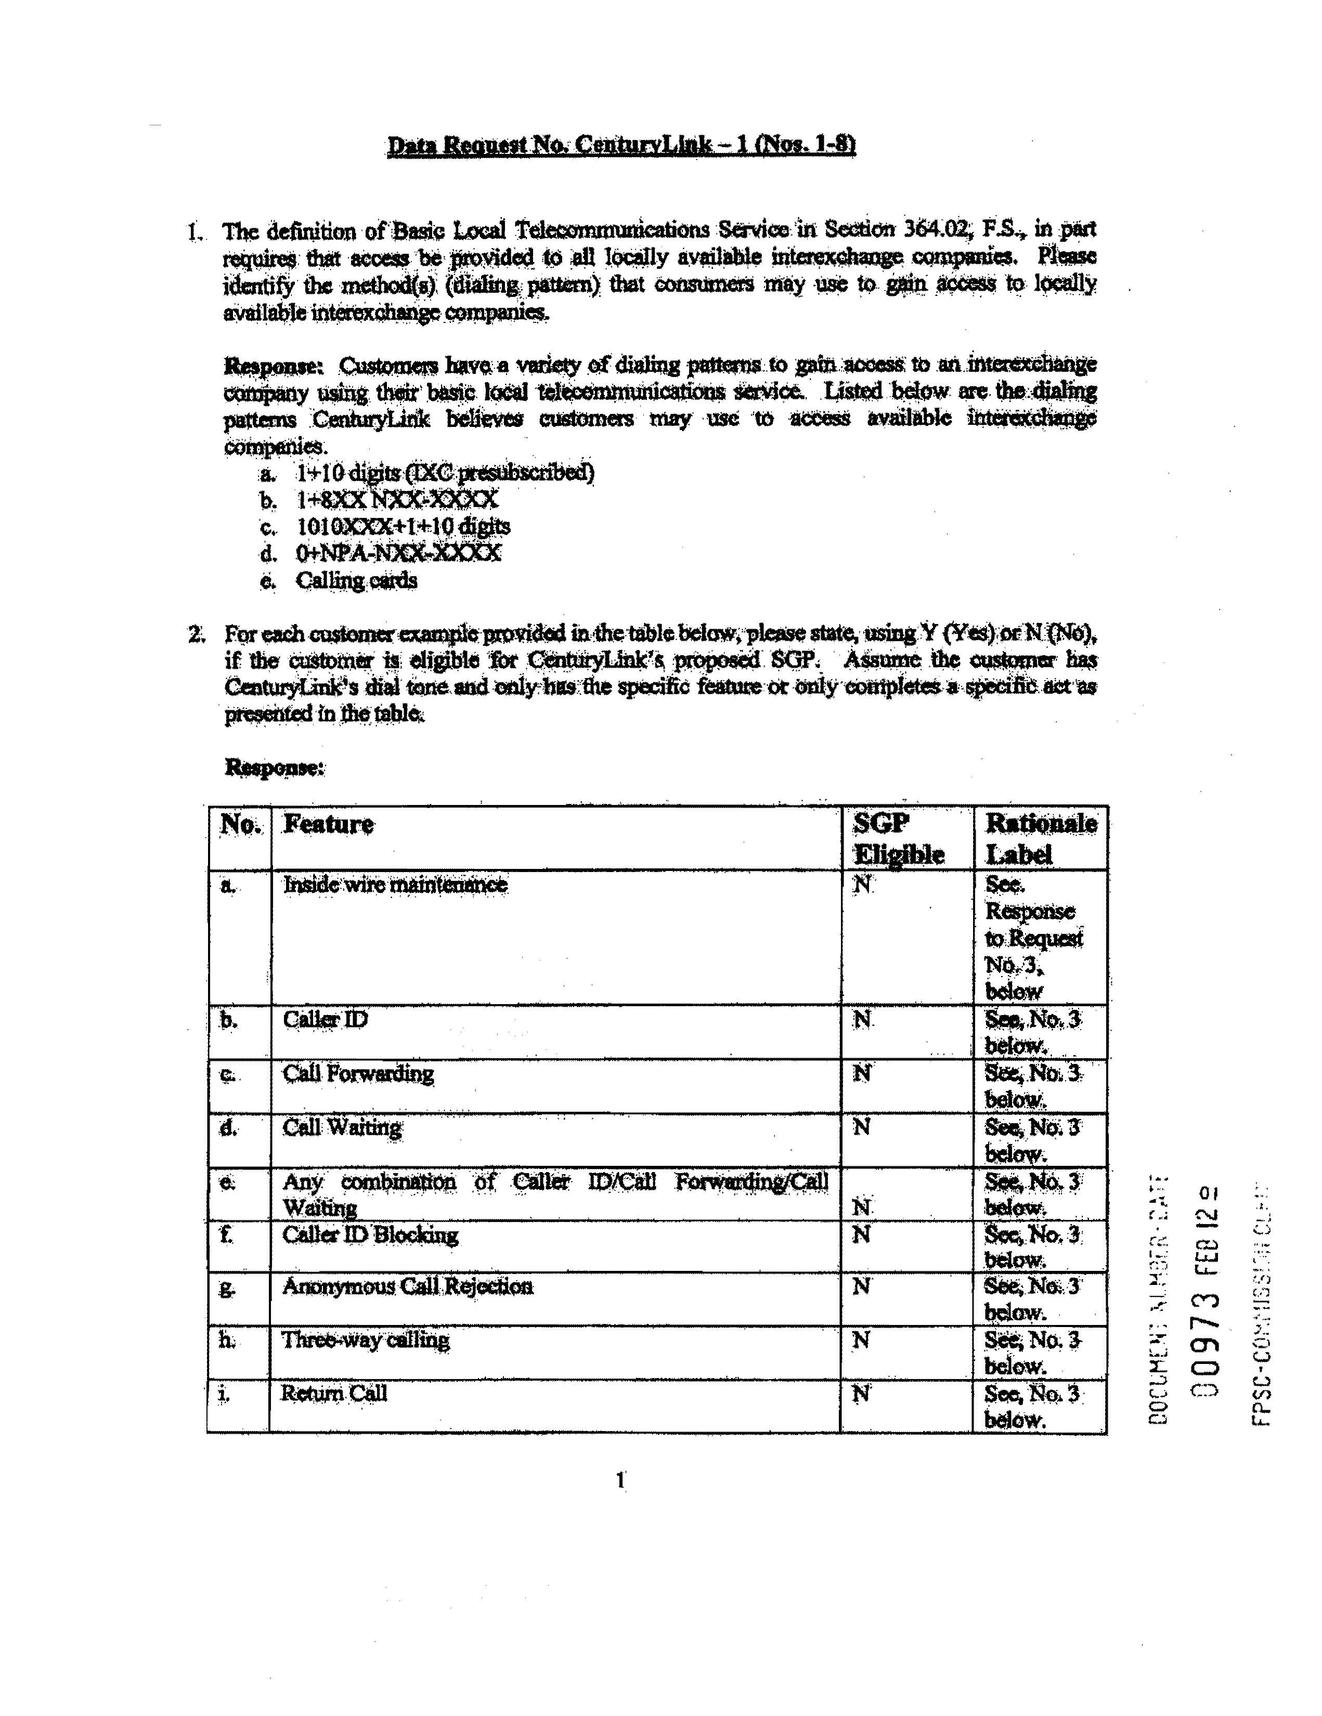

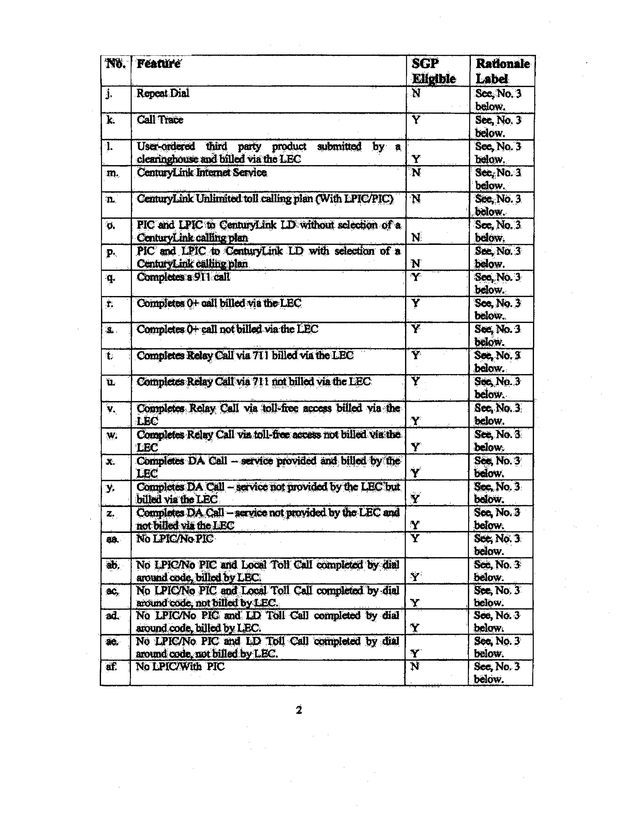

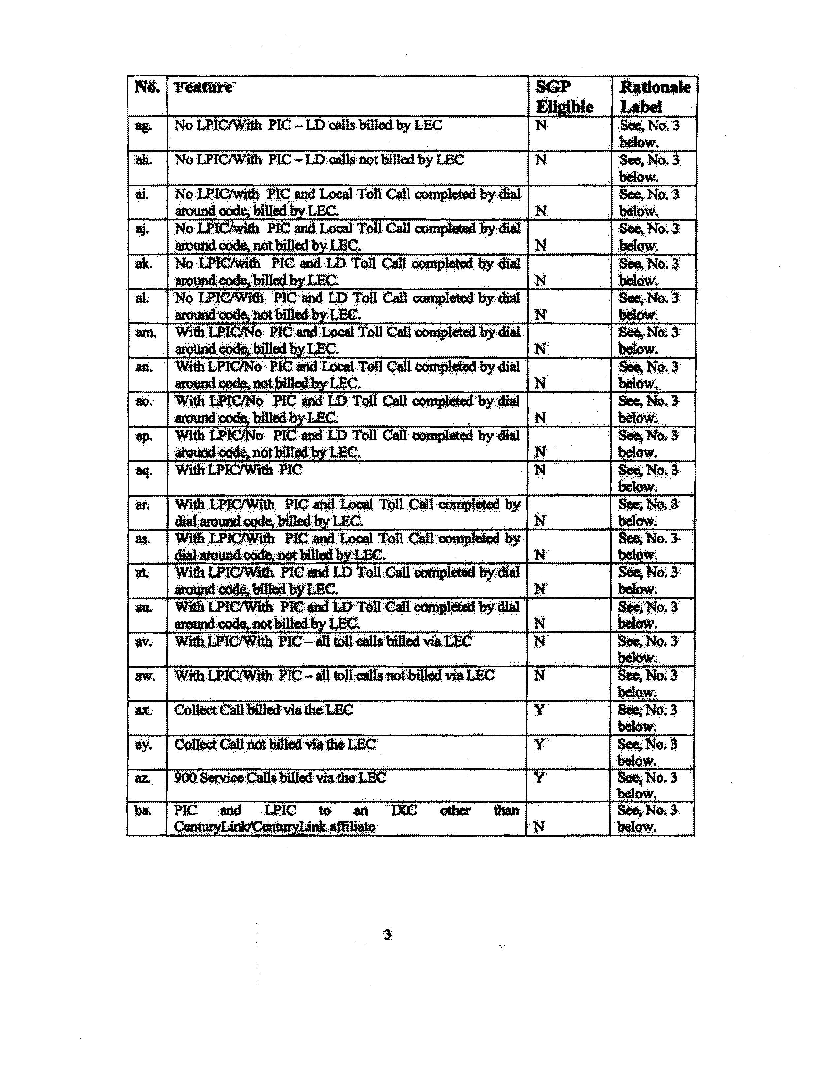

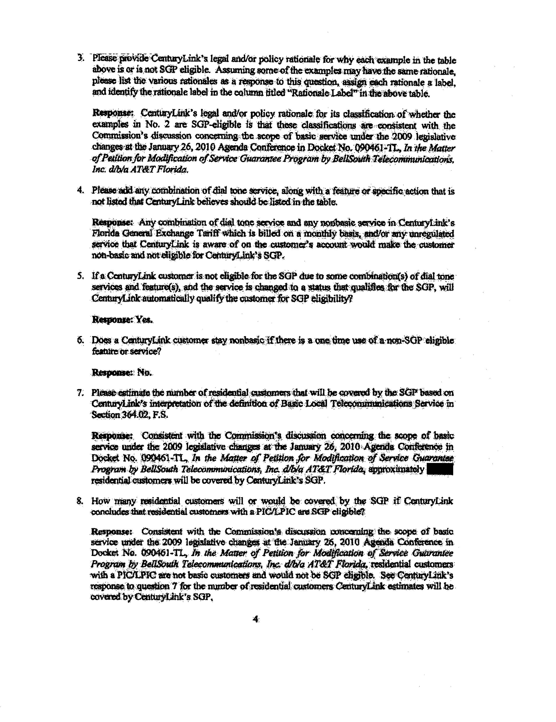

Docket No. 991377-TL - Initiation of show cause proceedings against Sprint-Florida, Incorporated for violation of service standards.
Docket No. 030430-TL – Petition for approval of limited waiver of Rules 25-4.066(2), 25-4.070(3)(a), 25-4.073(1)(c) and (1)(d), and 25-4.110(2), F.A.C.; and for approval of modification and extension of Service Guarantee Plan (SGP) approved by Order PSC-00-2462-PAA-TL, by Sprint-Florida, Incorporated.
Docket No. 050490-TL – Petition for approval of Service Guarantee Program, with relief from requirements of Rules 25-4.066(2), 25-4.070(3)(a), 25-4.073(1)(a) and (c), and 25-4.110(6), F.A.C., by Sprint-Florida, Incorporated.
Docket No. 050918-TL – Supplemental service quality commitment by Sprint-Florida, Incorporated under Service Guarantee Program. CenturyLink committed to repair 90% of out-of-service conditions for basic residential service within 24 hours each calendar quarter on a statewide level and to repair 90% of small exchanges, with no exchange missing the 90% objective for more than two consecutive months. It also committed that its initial offer for installation of basic residential service would not exceed five business days.
CenturyLink believes the supplemental commitments are no longer practicable in light of the narrowed scope of the service quality requirements.
See Attachment A.

