BEFORE THE FLORIDA PUBLIC SERVICE COMMISSION

In re: Joint petition of Peoples Gas System and Office of Public Counsel for approval of stipulation and settlement agreement for possible overearnings for calendar year ending December 31, 2010. | DOCKET NO. 100462-GU  ORDER NO. PSC-11-0111-PAA-GU  ISSUED: February 10, 2011

The following Commissioners participated in the disposition of this matter:

ART GRAHAM, Chairman
LISA POLAK EDGAR
RONALD A. BRISÉ
EDUARDO E. BALBIS
JULIE I. BROWN

NOTICE OF PROPOSED AGENCY ACTION
ORDER APPROVING STIPULATION
REGARDING 2010 OVEREARNINGS

BY THE COMMISSION:

NOTICE is hereby given by the Florida Public Service Commission that the action discussed herein is preliminary in nature and will become final unless a person whose interests are substantially affected files a petition for a formal proceeding, pursuant to Rule 25-22.029, Florida Administrative Code.

BACKGROUND
Through our continuing earnings surveillance program, Commission staff noted that Peoples Gas System (PGS or Company) had reported an achieved return on equity (ROE) of 13.73 percent on its March 2010 Earnings Surveillance Report (ESR). This reported ROE exceeded the 11.75 percent maximum ROE authorized in Docket No. 080318-GU. Our staff subsequently contacted PGS concerning the reported overearnings. On June 9, 2010, PGS submitted a letter in which it agreed to cap its earnings at an 11.75 percent ROE for calendar year 2010. In the letter, PGS proposed applying any overearnings to increase the storm damage reserve up to the $1 million target level, and that the remainder (if any) of such overearnings be used to increase the environmental reserve, and/or other purposes benefitting both the Company and its customers before any customer refunds are ordered.
On December 16, 2010, a Joint Petition for Approval of Stipulation and Settlement Agreement was filed by PGS and the Office of Public Counsel (OPC). The Stipulation and Settlement Agreement (Stipulation), attached hereto as Attachment A, is intended to resolve all of the issues relating to the Company’s overearnings for the calendar year ended December 31, 2010.
This order addresses the proposed Stipulation. We are vested with jurisdiction over this matter by several provisions of Chapter 366, including Sections 366.04, 366.05 and 366.06, Florida Statutes.
DECISION APPROVING PROPOSED STIPULATION

The major elements contained in the Stipulation are:
- 2010 earnings capped at an 11.75 percent ROE (Paragraph 2)
- $3 million refund as a one-time credit to customers’ bills (Paragraph 1)
- Overearnings in excess of $3 million to be used to correct or mitigate deficiencies in the depreciation reserve (Paragraph 3)
The proposed Stipulation consists of 8 paragraphs of agreement between PGS and OPC. We find that several of the paragraphs merit comment or clarification. These are as follows:
Paragraph 1: Paragraph 1 provides that PGS will refund $3 million to its customers in the form of a one-time credit on customer bills. Refunds will be applied only to active bills at the time the refunds are being made, and the refund amount will be based on each customer’s cents-per-therm consumption during the month the refund is made. The refund will be made one month following the date this Order becomes final. PGS states that assuming the refund is made in March 2011, a residential customer using 20 therms would receive a one-time refund of $3.74.
Paragraph 2: PGS’ 2010 earnings are capped at an ROE of 11.75 percent. Per its September 2010 ESR, PGS reported an achieved ROE of 15.96 percent on an FPSC Adjusted Basis which exceeds the 11.75 percent ROE cap by 4.21 percent. However, the actual amount of any overearnings will be based on the 12-month period ended December 31, 2010. The December 2010 ESR is not due to be filed until February 15, 2011. In response to a staff data request, dated January 5, 2011, PGS estimates that the total overearnings will be approximately $11.5 million for 2010. Once the December 2010 ESR is received, an audit will be conducted to determine the actual amount of the 2010 overearnings.
Paragraph 3: PGS proposes to use any overearnings in excess of $3 million to correct or mitigate any deficiencies subsequently identified by PGS and Commission staff. PGS indicates that in its last depreciation study filed with this Commission, where new depreciation rates were implemented on January 1, 2007, there was a $46.5 million deficiency between the actual depreciation reserve balance and the theoretical reserve balance. Although not known with certainty, PGS anticipates that the study it files this year will show a reserve deficiency in excess of $25 million. PGS’ next depreciation study is presently scheduled to be filed with this Commission on July 13, 2011.
We have reviewed the terms of the Stipulation, and believe that it provides a reasonable resolution for the disposition of any 2010 overearnings and is in the public interest. Therefore, the proposed Stipulation is hereby approved.
Based on the foregoing, it is

ORDERED by the Florida Public Service Commission that the proposed Stipulation filed by Peoples Gas System and the Office of Public Counsel regarding possible 2010 overearnings, attached hereto as Attachment A, is approved as set forth herein. It is further

ORDERED that the provisions of this Order, issued as proposed agency action, shall become final and effective upon the issuance of a Consummating Order unless an appropriate petition, in the form provided by Rule 28-106.201, Florida Administrative Code, is received by the Commission Clerk, 2540 Shumard Oak Boulevard, Tallahassee, Florida 32399-0850, by the close of business on the date set forth in the "Notice of Further Proceedings" attached hereto. It is further

ORDERED that this docket shall remain open until Peoples Gas System files a refund report indicating that the entire $3 million refund has been completed. After the refund has been verified by Commission staff, this docket shall be closed administratively.
By ORDER of the Florida Public Service Commission this 10th day of February, 2011.

/s/ Ann Cole
ANN COLE
Commission Clerk

This is an electronic transmission. A copy of the original signature is available from the Commission's website, www.floridapsc.com, or by faxing a request to the Office of Commission Clerk at 1-850-413-7118.

( S E A L )

JSC
NOTICE OF FURTHER PROCEEDINGS OR JUDICIAL REVIEW

The Florida Public Service Commission is required by Section 120.569(1), Florida Statutes, to notify parties of any administrative hearing that is available under Section 120.57, Florida Statutes, as well as the procedures and time limits that apply. This notice should not be construed to mean all requests for an administrative hearing will be granted or result in the relief sought.

Mediation may be available on a case-by-case basis. If mediation is conducted, it does not affect a substantially interested person's right to a hearing.

The action proposed herein is preliminary in nature. Any person whose substantial interests are affected by the action proposed by this order may file a petition for a formal proceeding, in the form provided by Rule 28-106.201, Florida Administrative Code. This petition must be received by the Office of Commission Clerk, 2540 Shumard Oak Boulevard, Tallahassee, Florida 32399-0850, by the close of business on March 3, 2011.

In the absence of such a petition, this order shall become final and effective upon the issuance of a Consummating Order.

Any objection or protest filed in this/these docket(s) before the issuance date of this order is considered abandoned unless it satisfies the foregoing conditions and is renewed within the specified protest period.

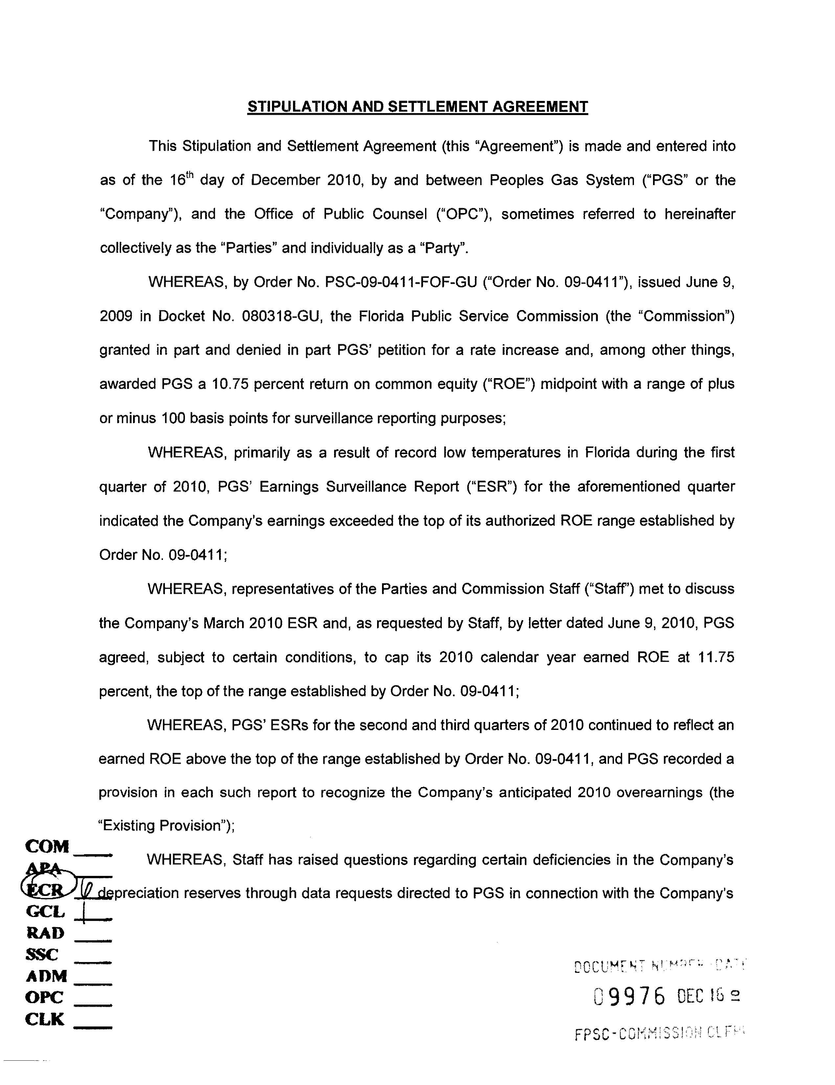
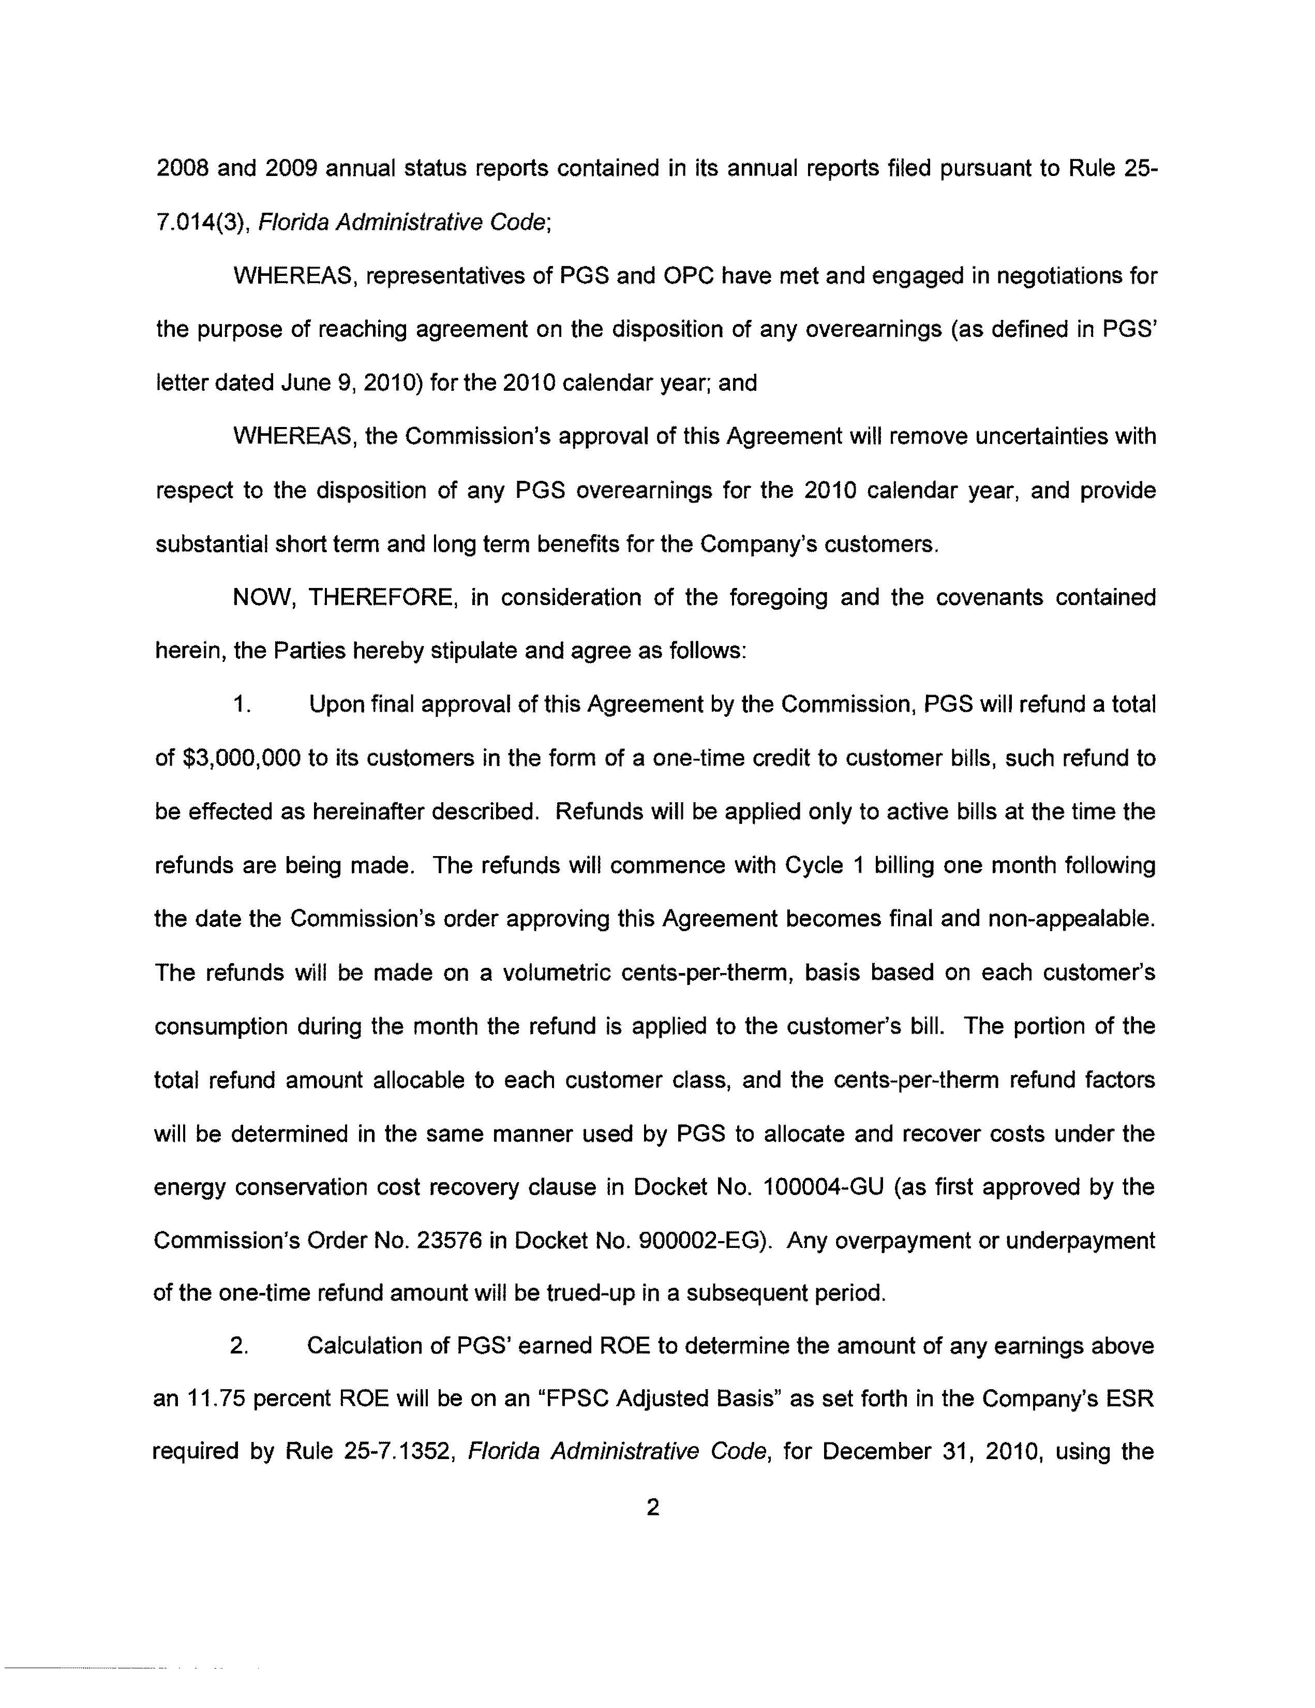
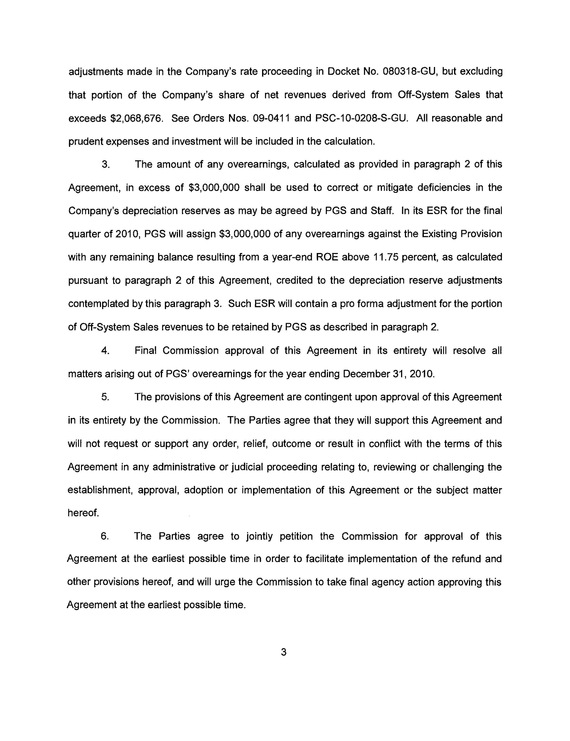
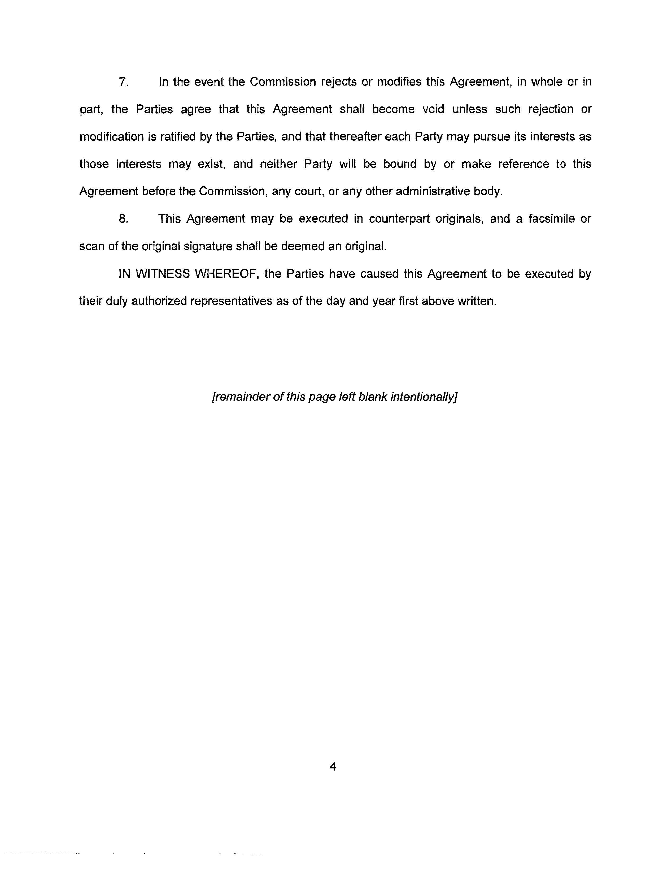
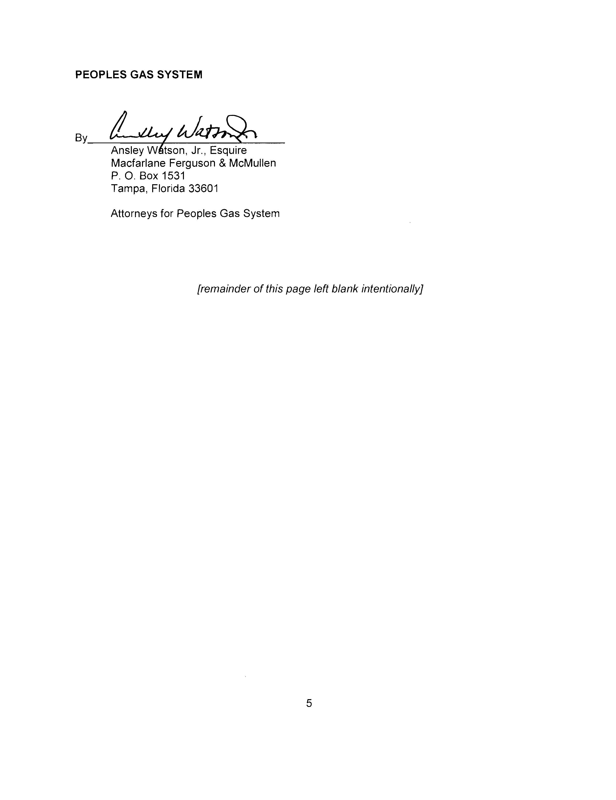
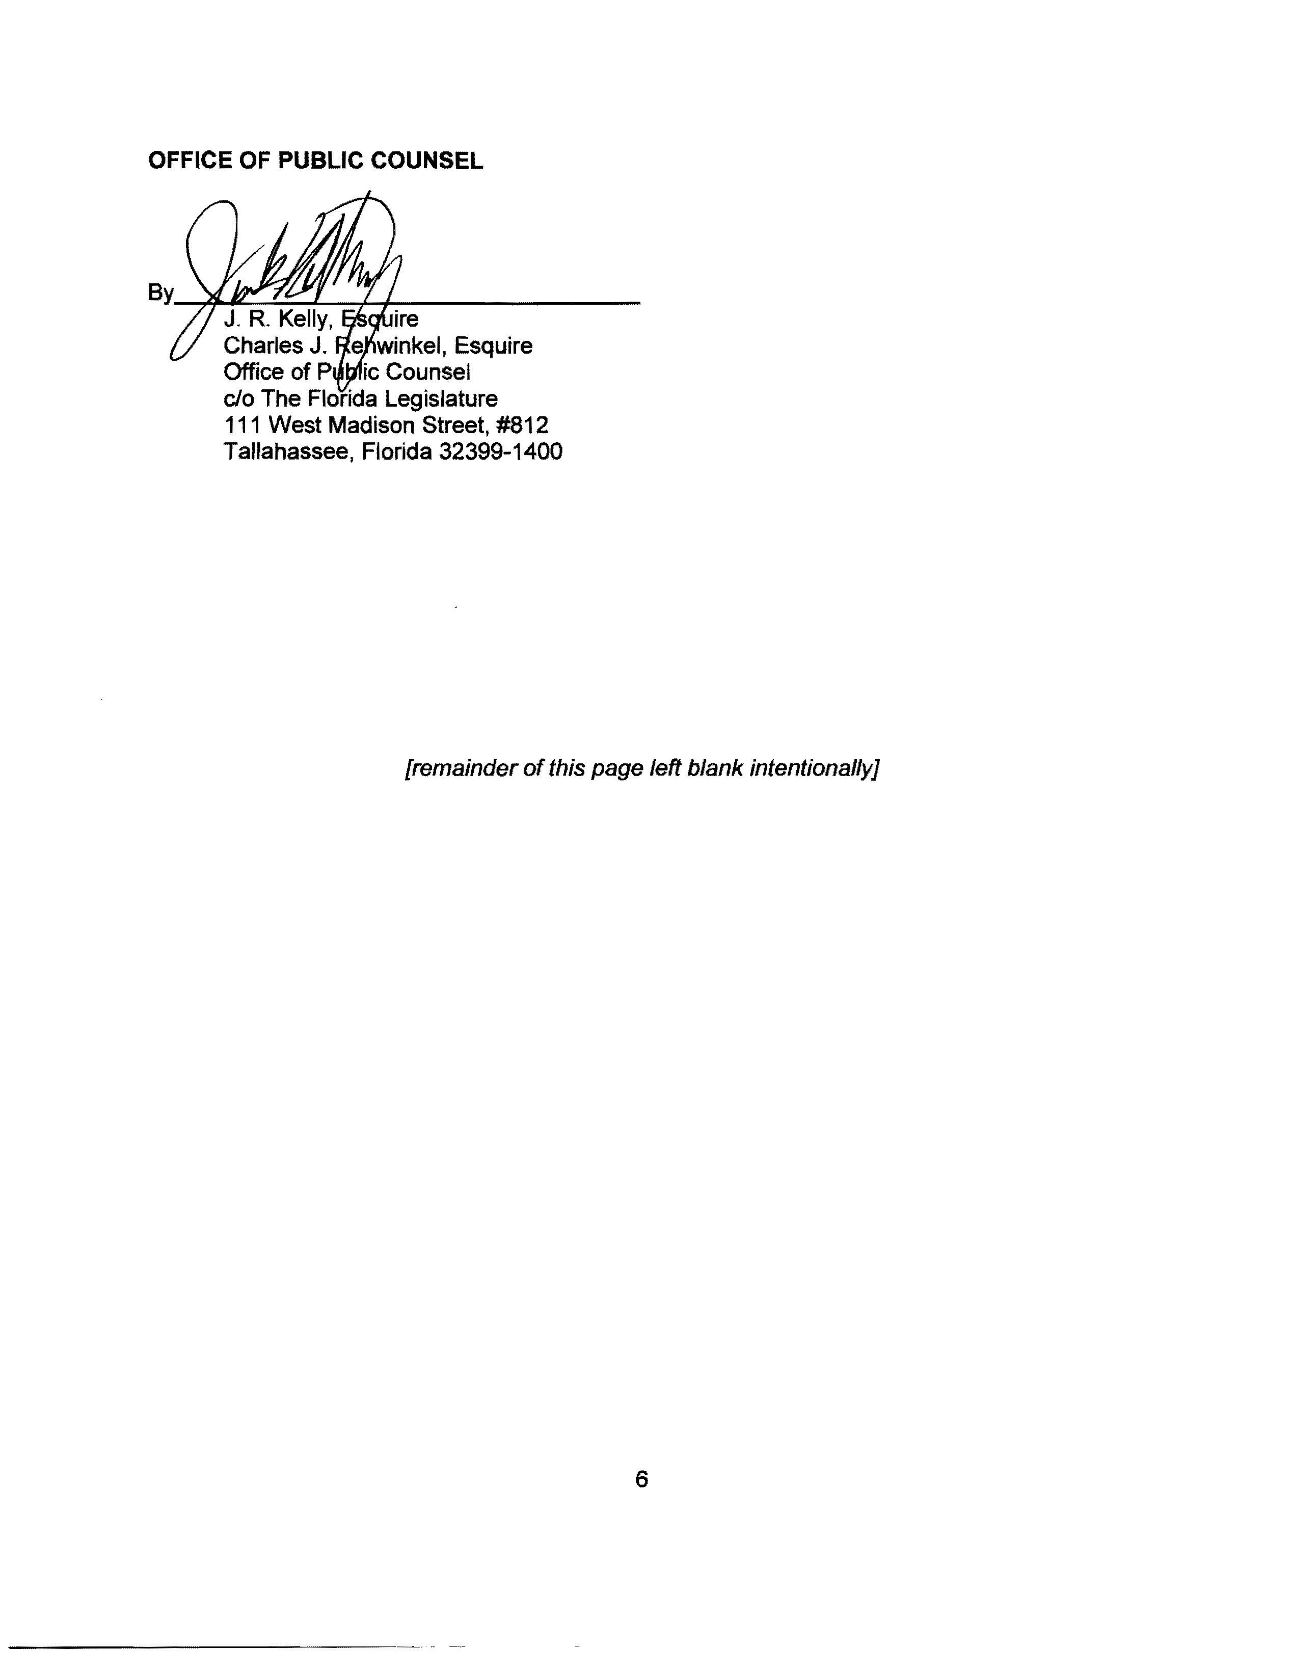

Order No. PSC-09-0411-FOF-GU, issued June 9, 2009, in Docket No. 080318-GU, In re: Petition for Rate Increase by Peoples Gas System.
Document No. 10088-10 in Docket No. 100462-GU.

