BEFORE THE FLORIDA PUBLIC SERVICE COMMISSION

In re: Investigation of Associated Telecommunications Management Services, LLC (ATMS) companies for compliance with Chapter 25-24, F.A.C., and applicable lifeline, eligible telecommunication carrier, and universal service requirements. | DOCKET NO. 100340-TP
In re: Initiation of show cause proceedings against American Dial Tone, Inc., All American Telecom, Inc., Bellerud Communications, LLC, BLC Management LLC d/b/a Angles Communication Solutions, and LifeConnex Telecom, LLC for apparent violations of Chapter 364, F.S., Chapters 25-4 and 25-24, F.A.C., and FPSC Orders. | DOCKET NO. 110082-TP  ORDER NO. PSC-11-0259-AS-TP  ISSUED: June 16, 2011

The following Commissioners participated in the disposition of this matter:

ART GRAHAM, Chairman
LISA POLAK EDGAR
RONALD A. BRISÉ
EDUARDO E. BALBIS
JULIE I. BROWN

ORDER APPROVING SETTLEMENT AGREEMENT

BY THE COMMISSION:

Case Background
In 2009, as in past years, Florida was the number one net contributor to the Federal universal service fund (“USF”), contributing $495,839,000 into the USF while receiving only $221,903,000 from the fund. Florida consumer contributions account for approximately seven percent of the USF monies contributed nationally. In accordance with our desire for accountability in the federal universal service program, and elimination of fraud, waste, and abuse in the USF, we have directed our staff to monitor all eligible telecommunications carriers (“ETC”) in Florida. On June 28, 2010, our staff opened Docket No. 100340-TP to evaluate Associated Telecommunications Management Services’ (“ATMS”) compliance with Chapter 25-24, Florida Administrative Code, and applicable Lifeline, ETC, and universal service requirements applicable to ATMS companies doing business in Florida. As a result of its investigation, on March 24, 2011, our staff opened Docket Number 110082-TP in order to recommend the initiation of a show cause proceeding against ATMS.

Florida Lifeline and Link Up

Lifeline was originally implemented in 1985 to ensure that the increase in local rates that occurred in the aftermath of the breakup of AT&T would not put local phone service out of reach for low-income households. Support for low-income households has long been a partnership between the states and the federal government, and the universal service program historically was administered in cooperation with states. Under authority of Chapter 364.10, Florida Statutes, the Florida PSC adopted the requirements of the federal Lifeline and Link Up programs for Florida’s Lifeline and Link Up programs.

The Lifeline, Link-Up, and Toll Limitation Services (“TLS”) programs allow an ETC providing services to qualifying low-income consumers to seek and receive reimbursement through the Universal Service Administrative Company (“USAC”) for revenues it forgoes each month for providing these services. The program was never intended to provide a profit for service providers. In order for a carrier to receive low-income support from USAC, the carrier must first be designated as an ETC. Currently, the Commission has the authority to approve or deny ETC designation for all telecommunications companies, including wireless in Florida.

Investigation Background and Overview

Associated Telecommunications Management Services is a Delaware limited liability company (“LLC”). On April 26, 2010, in answer to a staff data request, ATMS provided its organizational structure showing ATMS-owned companies, including American Dial Tone, Inc. (“ADT”), All American Telecom, Inc. (“All American Telecom”), Bellerud Communications, LLC (“Bellerud”), BLC Management LLC d/b/a Angles Communication Solutions (“BLC”), and LifeConnex Telecom, LLC (“LifeConnex”). ATMS companies received approximately $37 million in universal service low-income program monies from the USF on a national basis for the year 2010. Our staff noticed the atypical growth in federal universal service low-income program disbursements for some companies under this ownership and management structure, and also received information from multiple anonymous sources that ATMS’ business practices may not be in compliance with state and federal Lifeline and Link-Up regulations.

The following nine ATMS companies were the initial subject of our staff’s investigation in Docket No. 100340-TP.

Company | CLEC Certificate Number | IXC Registration Number
Bellerud Communications, LLC | TX 464 | TK 293
LifeConnex Telecom, LLC, f/k/a Swiftel LLC | TX 922 | TK 290
TriArch Marketing, Inc. | N/A (Withdrew application 9/14/10) | N/A (Withdrew application 9/14/10)
American Dial Tone Inc., f/k/a Ganoco, Inc. | TX 274 | TK 292
BLC Management, LLC, d/b/a Angles Communications Solutions | TX 840 (Cancelled by PSC)  TX997(Withdrew application 9/27/10) | TK 070 (Cancelled by PSC)  TK 251 (Withdrew application 9/27/10)
DialTone & More, Inc. | TX 939 (Cancelled by PSC) | TK 155 (Cancelled by PSC)
Ren-Tel Communications, Inc. | N/A | N/A
SCTXLink, LLC | N/A | N/A
All American Telecom, Inc. | TX 996 | N/A

Bellerud, LifeConnex, BLC, and All American Telecom have all previously applied for ETC status in Florida. The Bellerud and All American Telecom petitions for ETC designation were withdrawn by the companies after staff sent data requests to them. The BLC docket was closed administratively by our staff because BLC’s competitive local exchange certificate (CLEC) was cancelled and CLEC certification in Florida is a condition for receiving landline ETC designation in Florida. LifeConnex withdrew its petition for ETC designation after our staff filed a recommendation to deny ETC status to LifeConnex and prior to our consideration. American Dial Tone had already received its ETC designation at the time it was purchased by ATMS on September 30, 2009.

The following chart reflects low-income USF monies received nationally by five ATMS companies from January 2009 through May 2010: LifeConnex; American Dial Tone; Bellerud; TriArch Marketing, Inc. (Triarch); and BLC. ATMS purchased these companies between September 1, 2009, and November 30, 2009. Each of these five companies received ETC designation in at least one state which allows each to file for reimbursement from the USF for revenues it forgoes providing service to Lifeline customers in states where such companies have been designated as an ETC. American Dial Tone is the only ATMS company which presently has ETC designation in Florida.

On September 7, 2010, our staff met with ATMS to discuss our staff’s specific concerns related to ATMS companies appearing to provide inaccurate information to regulators and engaging in questionable activities; we understand our staff also discussed allegations which had been received from other third parties about ATMS companies. On January 31, 2011, we understand our staff again met with ATMS and presented concerns raised by its investigation. ATMS declined the opportunity to review each of our staff’s concerns and instead chose to focus on how the matter might be settled. While initially agreeing to submit a proposed settlement by Friday, February 3, 2011, ATMS sought additional time and clarification of what was needed. We understand our staff agreed to additional time and to ATMS providing a framework for a possible settlement. On February 8, 2011, ATMS timely filed a framework for settlement. On that date, pursuant to Section 120.573, Florida Statutes, ATMS companies also filed a Request for Settlement Discussions, Mediation and to Hold Docket in Abeyance. Our staff met with ATMS to discuss a possible settlement on February 18, 2011, February 28, 2011, March 7, 2011, March 16, 2011, and March 23, 2011, and conducted a telephone conference with ATMS on March 9, 2011.

The company insisted that any negotiation discussions during these meetings with our staff remain confidential and anything discussed during the negotiations could not be used against the company in possible future prosecutory proceedings. On February 21, 2011, after the first meeting, ATMS withdrew, without prejudice, its Request for Settlement Discussions, Mediation and to Hold Docket in Abeyance, noting that settlement discussions were currently on-going. Although ATMS representatives and our staff had a total of seven meetings and a conference call during February and March, those discussions failed to produce a workable resolution of the issues, and on March 25, 2011, ATMS filed a “Petition for Mediation and to Hold Docket in Abeyance,” along with a “Request for Oral Argument.”

On March 29, 2011, our staff filed a combined Recommendation in Dockets 100340-TP and 110082-TP, recommending we deny ATMS’ Petition for Mediation and initiating show cause proceedings against ADT, Bellerud, LifeConnex, BLC, and All American Telecom. Our staff’s investigation concluded that American Dial Tone apparently misrepresented the number of certified Florida Lifeline, Link-Up, and TLS customers it was serving when it filed its 497 forms with USAC. This appeared to result in an overpayment by USAC to American Dial Tone of $1,945,866 from the USF for January 2010, through May 2010.

The March 29, 2011 staff recommendation concluded that American Dial Tone, Bellerud, LifeConnex, All American Telecom, BLC Management, and American Dial Tone were each in apparent willful violation of one or more of the following statutes, rules and orders: Section 364.10(2)(a), Florida Statutes, Section 364.10(2)(e)1, Florida Statutes, Section 364.10(2)(f), Florida Statutes, Section 364.107(3)(a), Florida Statutes, Section 364.24(2), Florida Statutes, Section 364.183(1), Florida Statutes, Rule 25-4.0161, Florida Administrative Code, Rule 25-4.0665(1), Florida Administrative Code, Rule 25-4.118, Florida Administrative Code, Rule 25-24.825(1), Florida Administrative Code, Order No. PSC-06-0298-PAA-TX, Order No. PSC-06-0680-PAA-TL, and Order No. PSC-07-0417-PAA-TL. As a result, our staff recommended the show cause proceedings include the cancellation of all companies’ CLEC certificates; the revocation of ADT’s ETC designation; and the imposition of over $16.4 Million in fines. The Recommendation was deferred from our April 5, 2011, Agenda Conference.

Following the filing of the Recommendation, we understand our staff continued to work with ATMS in an attempt to reach a settlement of this matter, including a conference call on April 13, 2011, and an in-person meeting on April 27, 2011. As a result of both ATMS’ and our staff’s continued efforts to reach a settlement, both our staff and ATMS were able to agree on a Framework for Settlement (“Settlement Agreement”) which both represent meet the goal of a show cause, which is to ensure compliance with Florida Statutes and our Rules. Following the agreement on the Framework, on May 6, 2011, ATMS filed a Motion for Approval of Offer of Settlement Agreement, included in its entirety as Attachment One.

Jurisdiction

Pursuant to Section 364.285(1), F.S., we are authorized to impose upon any entity subject to our jurisdiction a penalty of not more than $25,000 for each day a violation continues, if such entity is found to have refused to comply with or to have willfully violated any lawful rule or order, or any provision of Chapter 364, F.S.

A willful violation of a statute, rule or order is one done with an intentional disregard of, or a plain indifference to, the applicable statute or regulation. See, L. R. Willson & Sons, Inc. v. Donovan, 685 F.2d 664, 667 n.1 (D.C. Cir. 1982). Utilities are charged with knowledge of our orders, rules, and statutes, and the intent of Section 364.285(1) is to penalize those who affirmatively act in opposition to those orders, rules, or statutes. See, Florida State Racing Commission v. Ponce de Leon Trotting Association, 151 So.2d 633, 634 (Fla. 1963), and. Commercial Ventures, Inc. v. Beard, 595 So.2d 47, 48 (Fla. 1992) (utilities are subject to the rules published in the Florida Administrative Code).

In Order No. 24306, issued April 1, 1991, in Docket No. 890216-TL, In Re: Investigation Into The Proper Application of Rule 25-14.003, F.A.C., Relating To Tax Savings Refund for 1988 and 1989 For GTE Florida, Inc., having found that the company had not intended to violate the rule, we nevertheless found it appropriate to order it to show cause why it should not be fined, stating that “‘willful’ implies an intent to do an act, and this is distinct from an intent to violate a statute or rule.” Additionally, “[i]t is a common maxim, familiar to all minds that ‘ignorance of the law’ will not excuse any person, either civilly or criminally.” Barlow v. United States, 32 U.S. 404, 411 (1833); see also, Perez v. Marti, 770 So.2d 284, 289 (Fla. 3rd DCA 2000) (ignorance of the law is never a defense). Thus, we find that any intentional act, such as the acts described in this docket, would meet the standard for a “willful violation.”

Federal law recognizes that individual states and territories play an important role in accomplishing universal service goals. The FCC also has recognized the important role of the states. Courts have also previously determined that the Telecom Act “plainly contemplates a partnership between the federal and state governments to support universal service,” and that “it is appropriate—even necessary—for the FCC to rely on state action.” We have Florida jurisdiction and authority to impose penalties on the ATMS companies pursuant to the following: Chapter 364, Florida Statutes; Sections 120.80(13)(d) and 364.285, Florida Statutes; Rules 25-24.820 and 25-24.474, Florida Administrative Code.

Acceptance of Settlement Agreement0

On May 6, 2011, ATMS filed the attached Framework for Settlement (Settlement Agreement) in an effort to fully resolve all apparent violations identified by our staff in both Dockets 100340-TP and 110082-TP. We understand that from the onset of this investigation, our staff’s goal, as is the goal of any investigation or show cause proceeding before us, was to ensure the companies’ compliance with Florida law and our rules and orders. It appears that the Settlement Offer accomplishes this goal, as well as providing a remedy for apparent past violations.

After careful consideration we find that, taken in its entirety, the Settlement Agreement, provides a reasonable resolution of the outstanding issues in Docket Nos. 100340-TP and 110082-TP. We further find that approval of the Settlement Agreement is in the public interest, as it provides for future compliance with Florida Statutes and our Rules and provides a voluntary contribution to the State’s General Revenue fund as a remedy for any apparent past violations. We find that approval of the Settlement Agreement will promote administrative efficiency and will avoid the time and expense of a hearing, and therefore, approve the Revised Settlement Agreement submitted by ATMS.

Closure of Dockets

Since we have approved staff’s recommendation to accept the Settlement Agreement proposed by ATMS, Docket Number 100340-TP shall be closed. However, Docket Number 110082-TP shall remain open to process the quarterly settlement payments as well as to monitor ongoing compliance with the Settlement Agreement during the four year period of the agreement.

Based on the foregoing, it is

ORDERED by the Florida Public Service Commission that the Revised Settlement Agreement submitted by Associated Telecommunications Management Services, attached hereto as Attachment A, is approved. It is further

ORDERED that within fourteen days of this order becoming final and non-appealable, Associated Telecommunications Management Services shall make the first payment of $250,000 to the general revenue fund, with additional payments of $250,000 to be made quarterly thereafter. It is further

ORDERED that Docket Number 100340-TP shall be closed. It is further

ORDERED that Docket Number 110082-TP shall remain open to process the quarterly settlement payments as well as to monitor ongoing compliance with the Settlement Agreement during the four year period of the agreement.

By ORDER of the Florida Public Service Commission this 16th day of June, 2011.

/s/ Ann Cole
ANN COLE
Commission Clerk
Florida Public Service Commission
2540 Shumard Oak Boulevard
Tallahassee, Florida 32399
(850) 413-6770
www.floridapsc.com

( S E A L )

LDH

NOTICE OF FURTHER PROCEEDINGS OR JUDICIAL REVIEW

The Florida Public Service Commission is required by Section 120.569(1), Florida Statutes, to notify parties of any administrative hearing or judicial review of Commission orders that is available under Sections 120.57 or 120.68, Florida Statutes, as well as the procedures and time limits that apply. This notice should not be construed to mean all requests for an administrative hearing or judicial review will be granted or result in the relief sought.

Any party adversely affected by the Commission's final action in this matter may request: 1) reconsideration of the decision by filing a motion for reconsideration with the Office of Commission Clerk, 2540 Shumard Oak Boulevard, Tallahassee, Florida 32399-0850, within fifteen (15) days of the issuance of this order in the form prescribed by Rule 25-22.060, Florida Administrative Code; or 2) judicial review by the Florida Supreme Court in the case of an electric, gas or telephone utility or the First District Court of Appeal in the case of a water and/or wastewater utility by filing a notice of appeal with the Office of Commission Clerk, and filing a copy of the notice of appeal and the filing fee with the appropriate court. This filing must be completed within thirty (30) days after the issuance of this order, pursuant to Rule 9.110, Florida Rules of Appellate Procedure. The notice of appeal must be in the form specified in Rule 9.900(a), Florida Rules of Appellate Procedure.

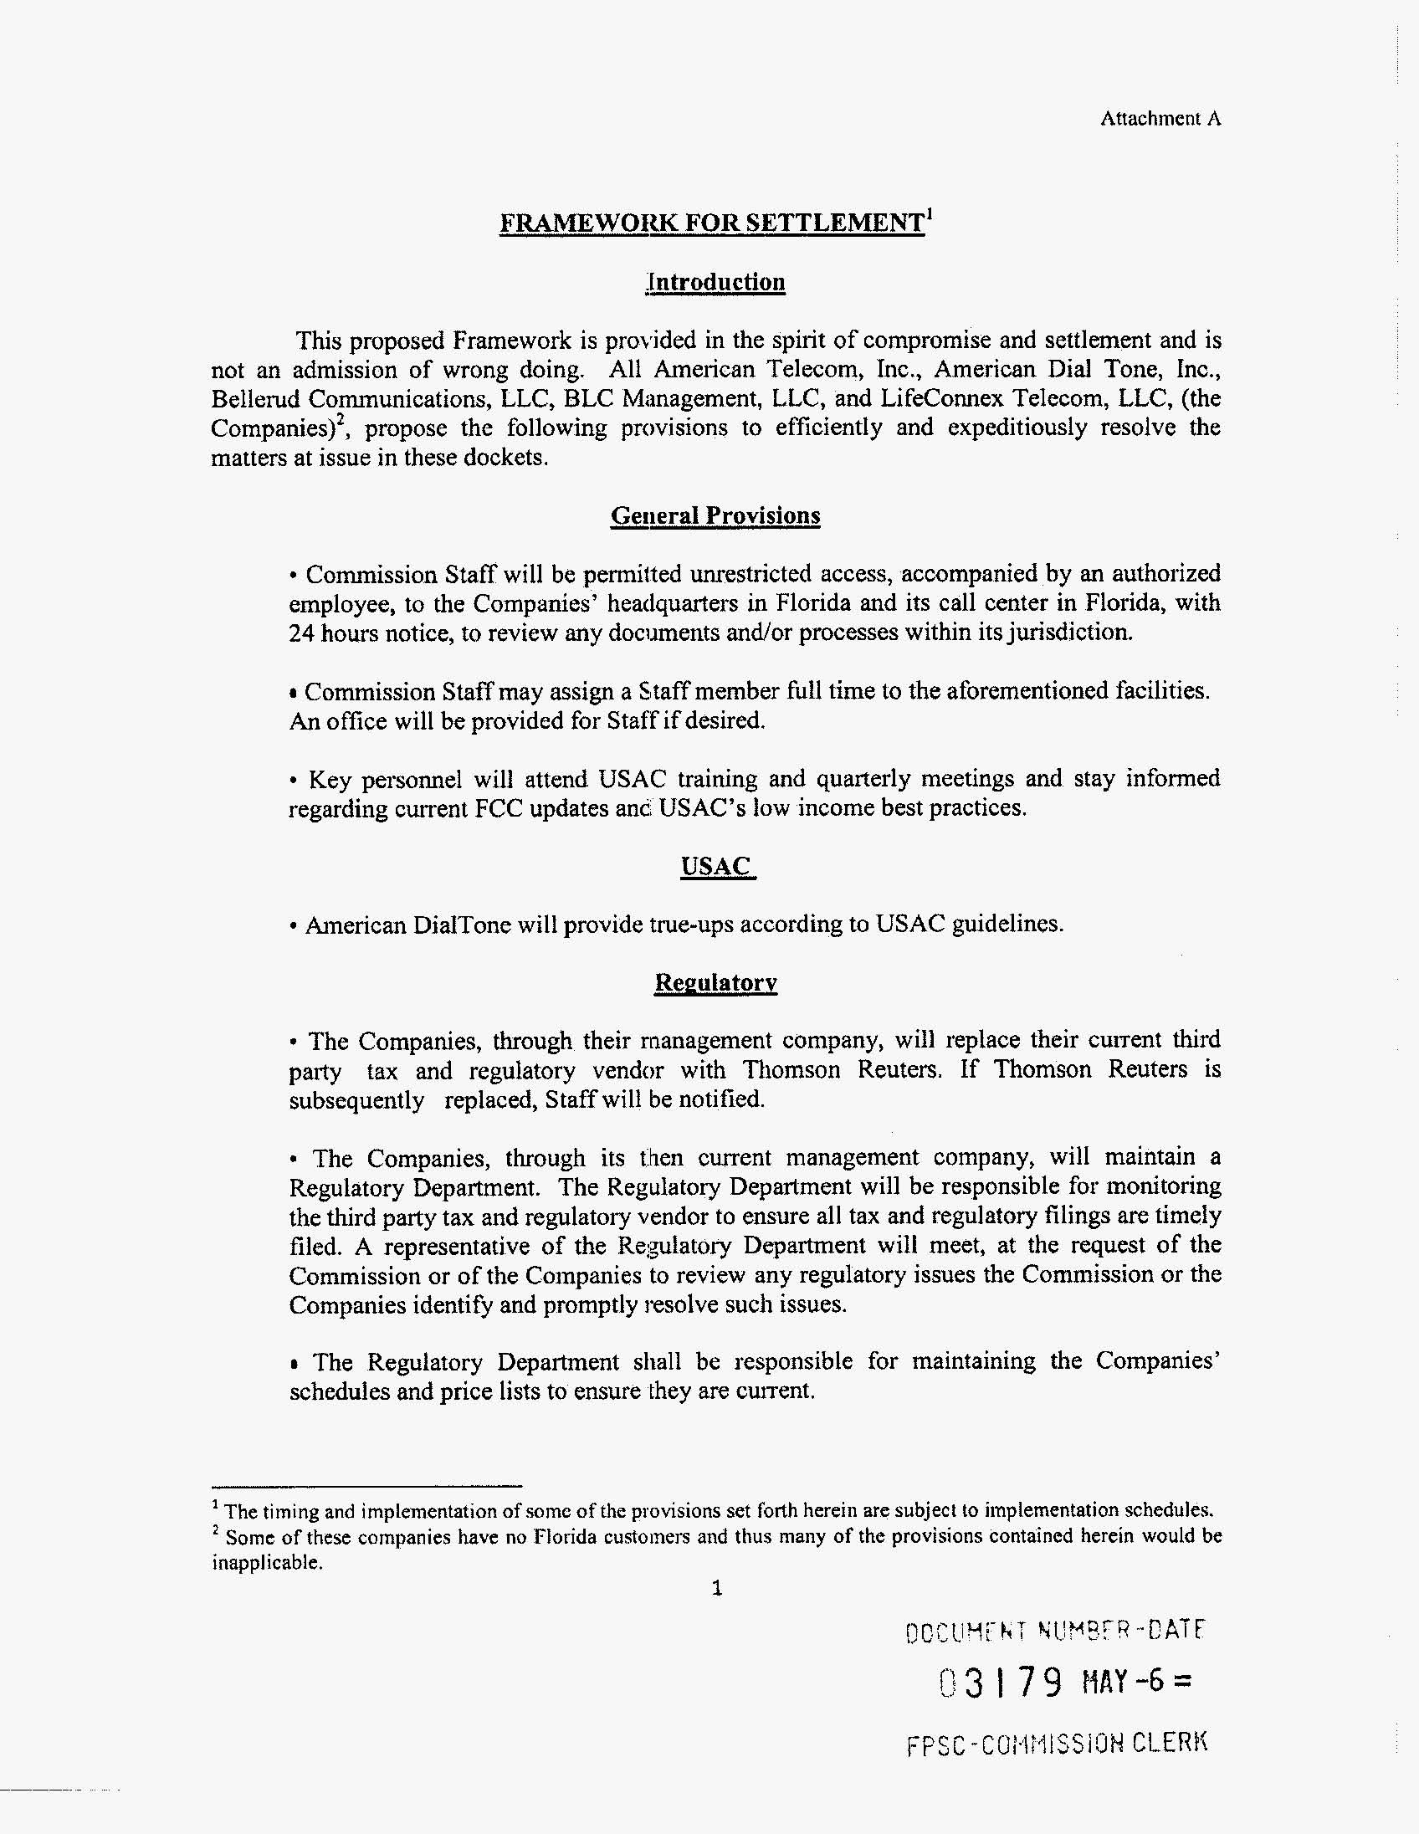
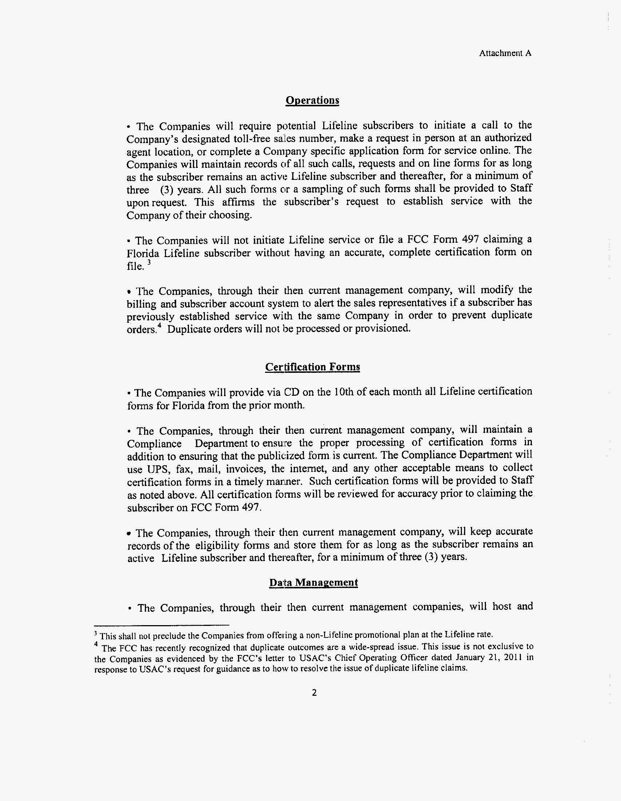
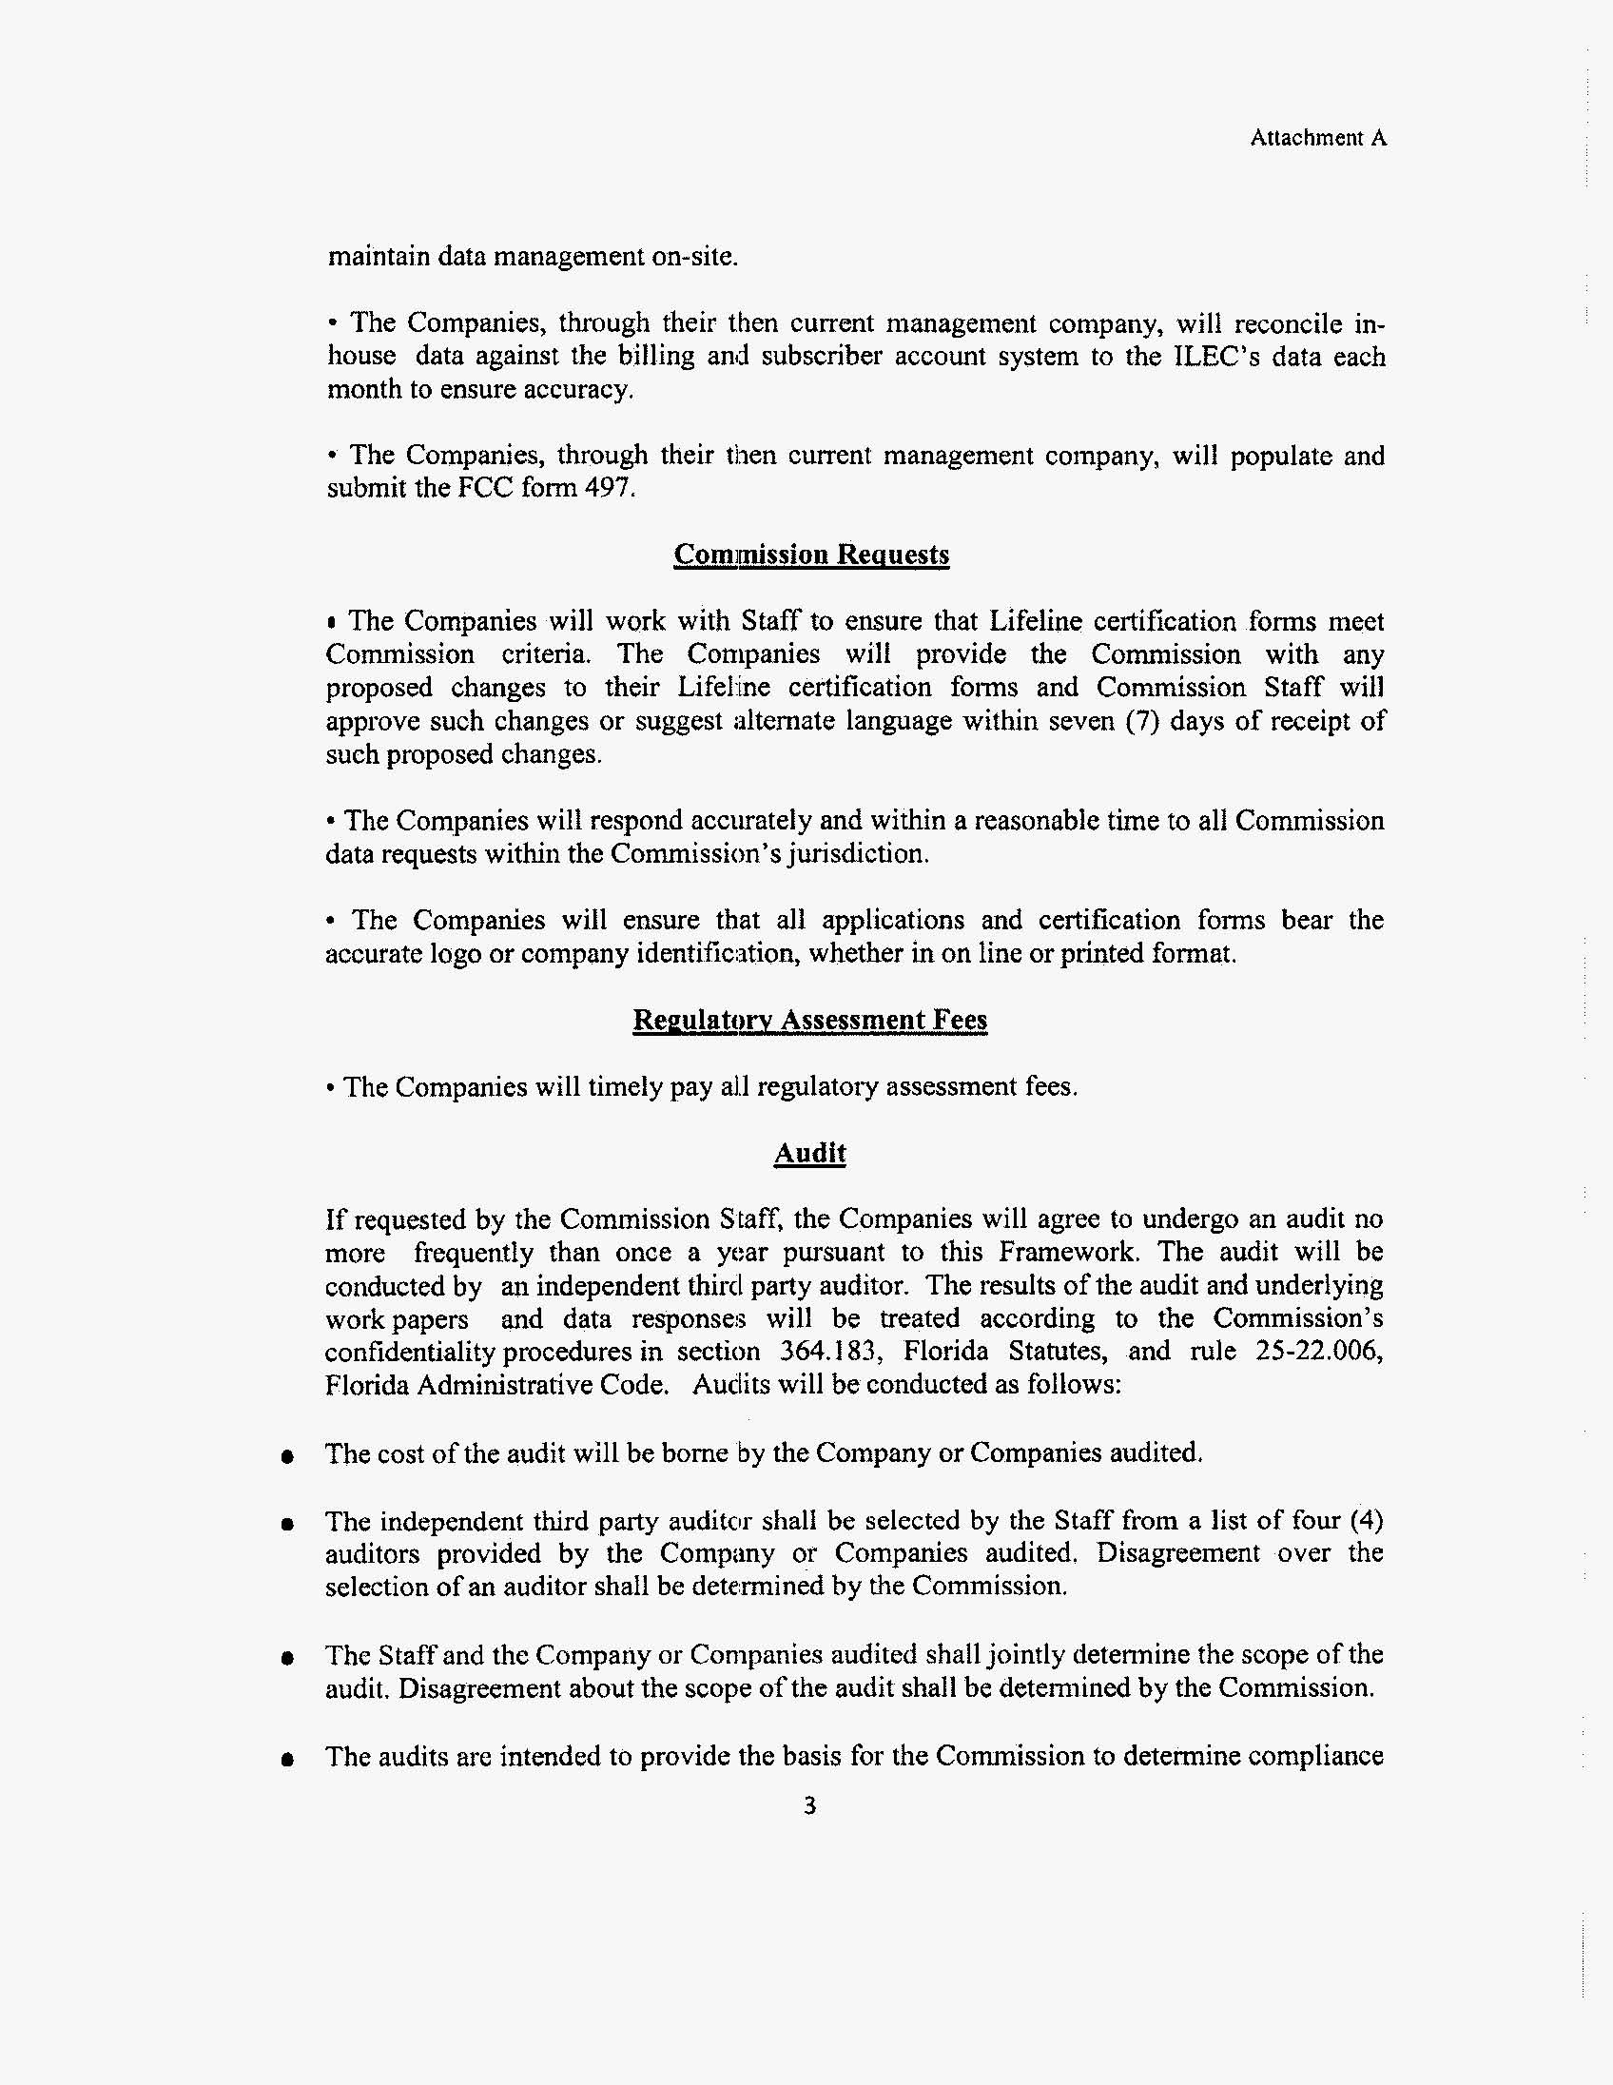
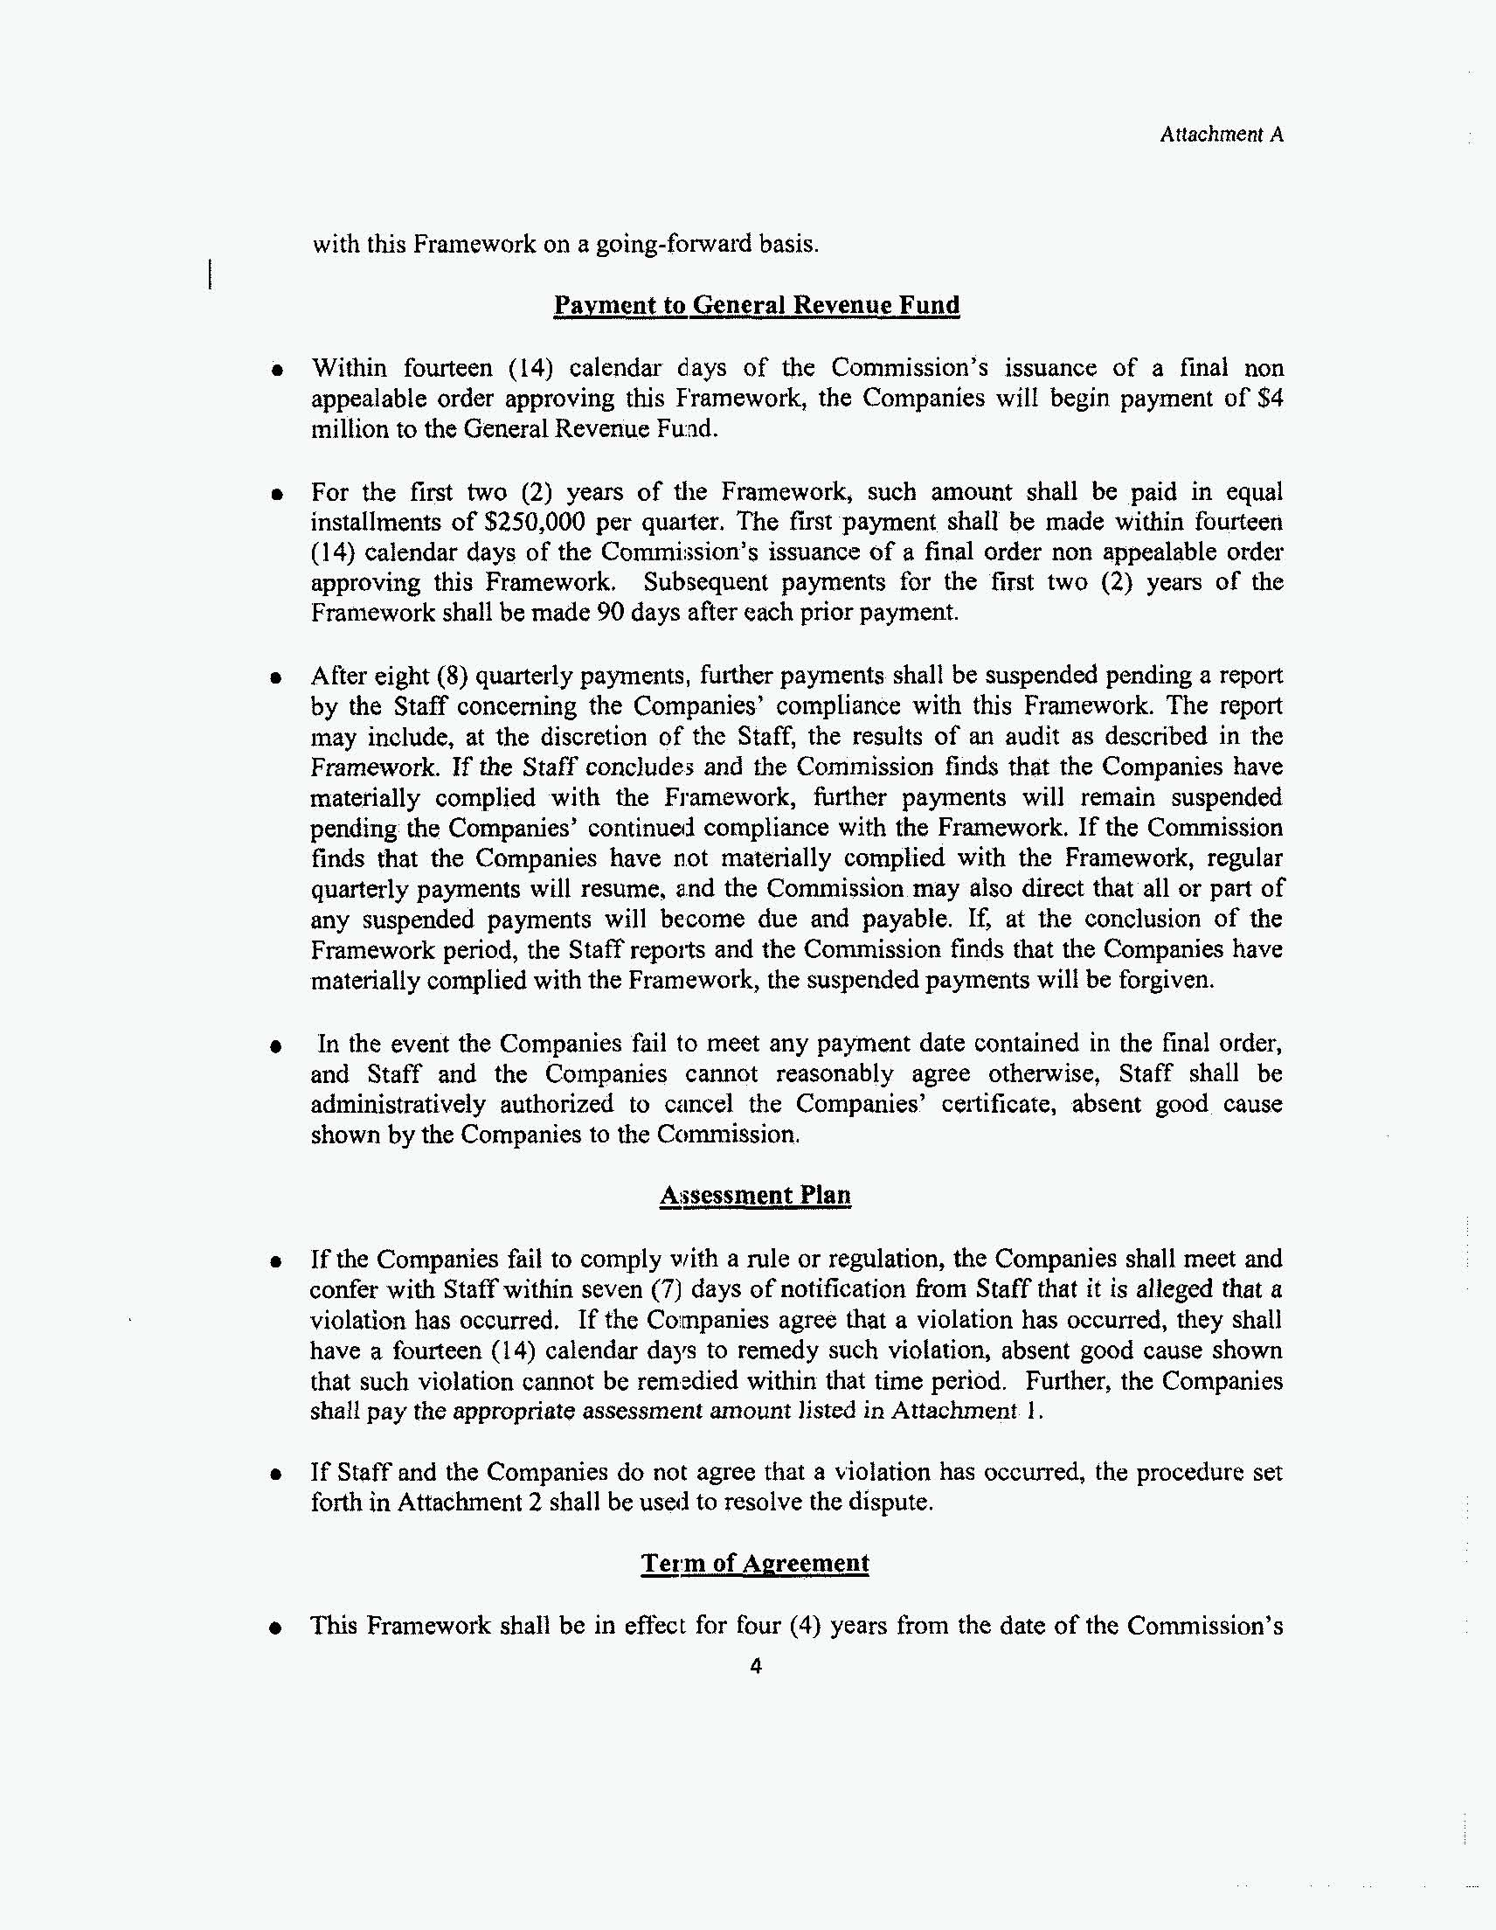
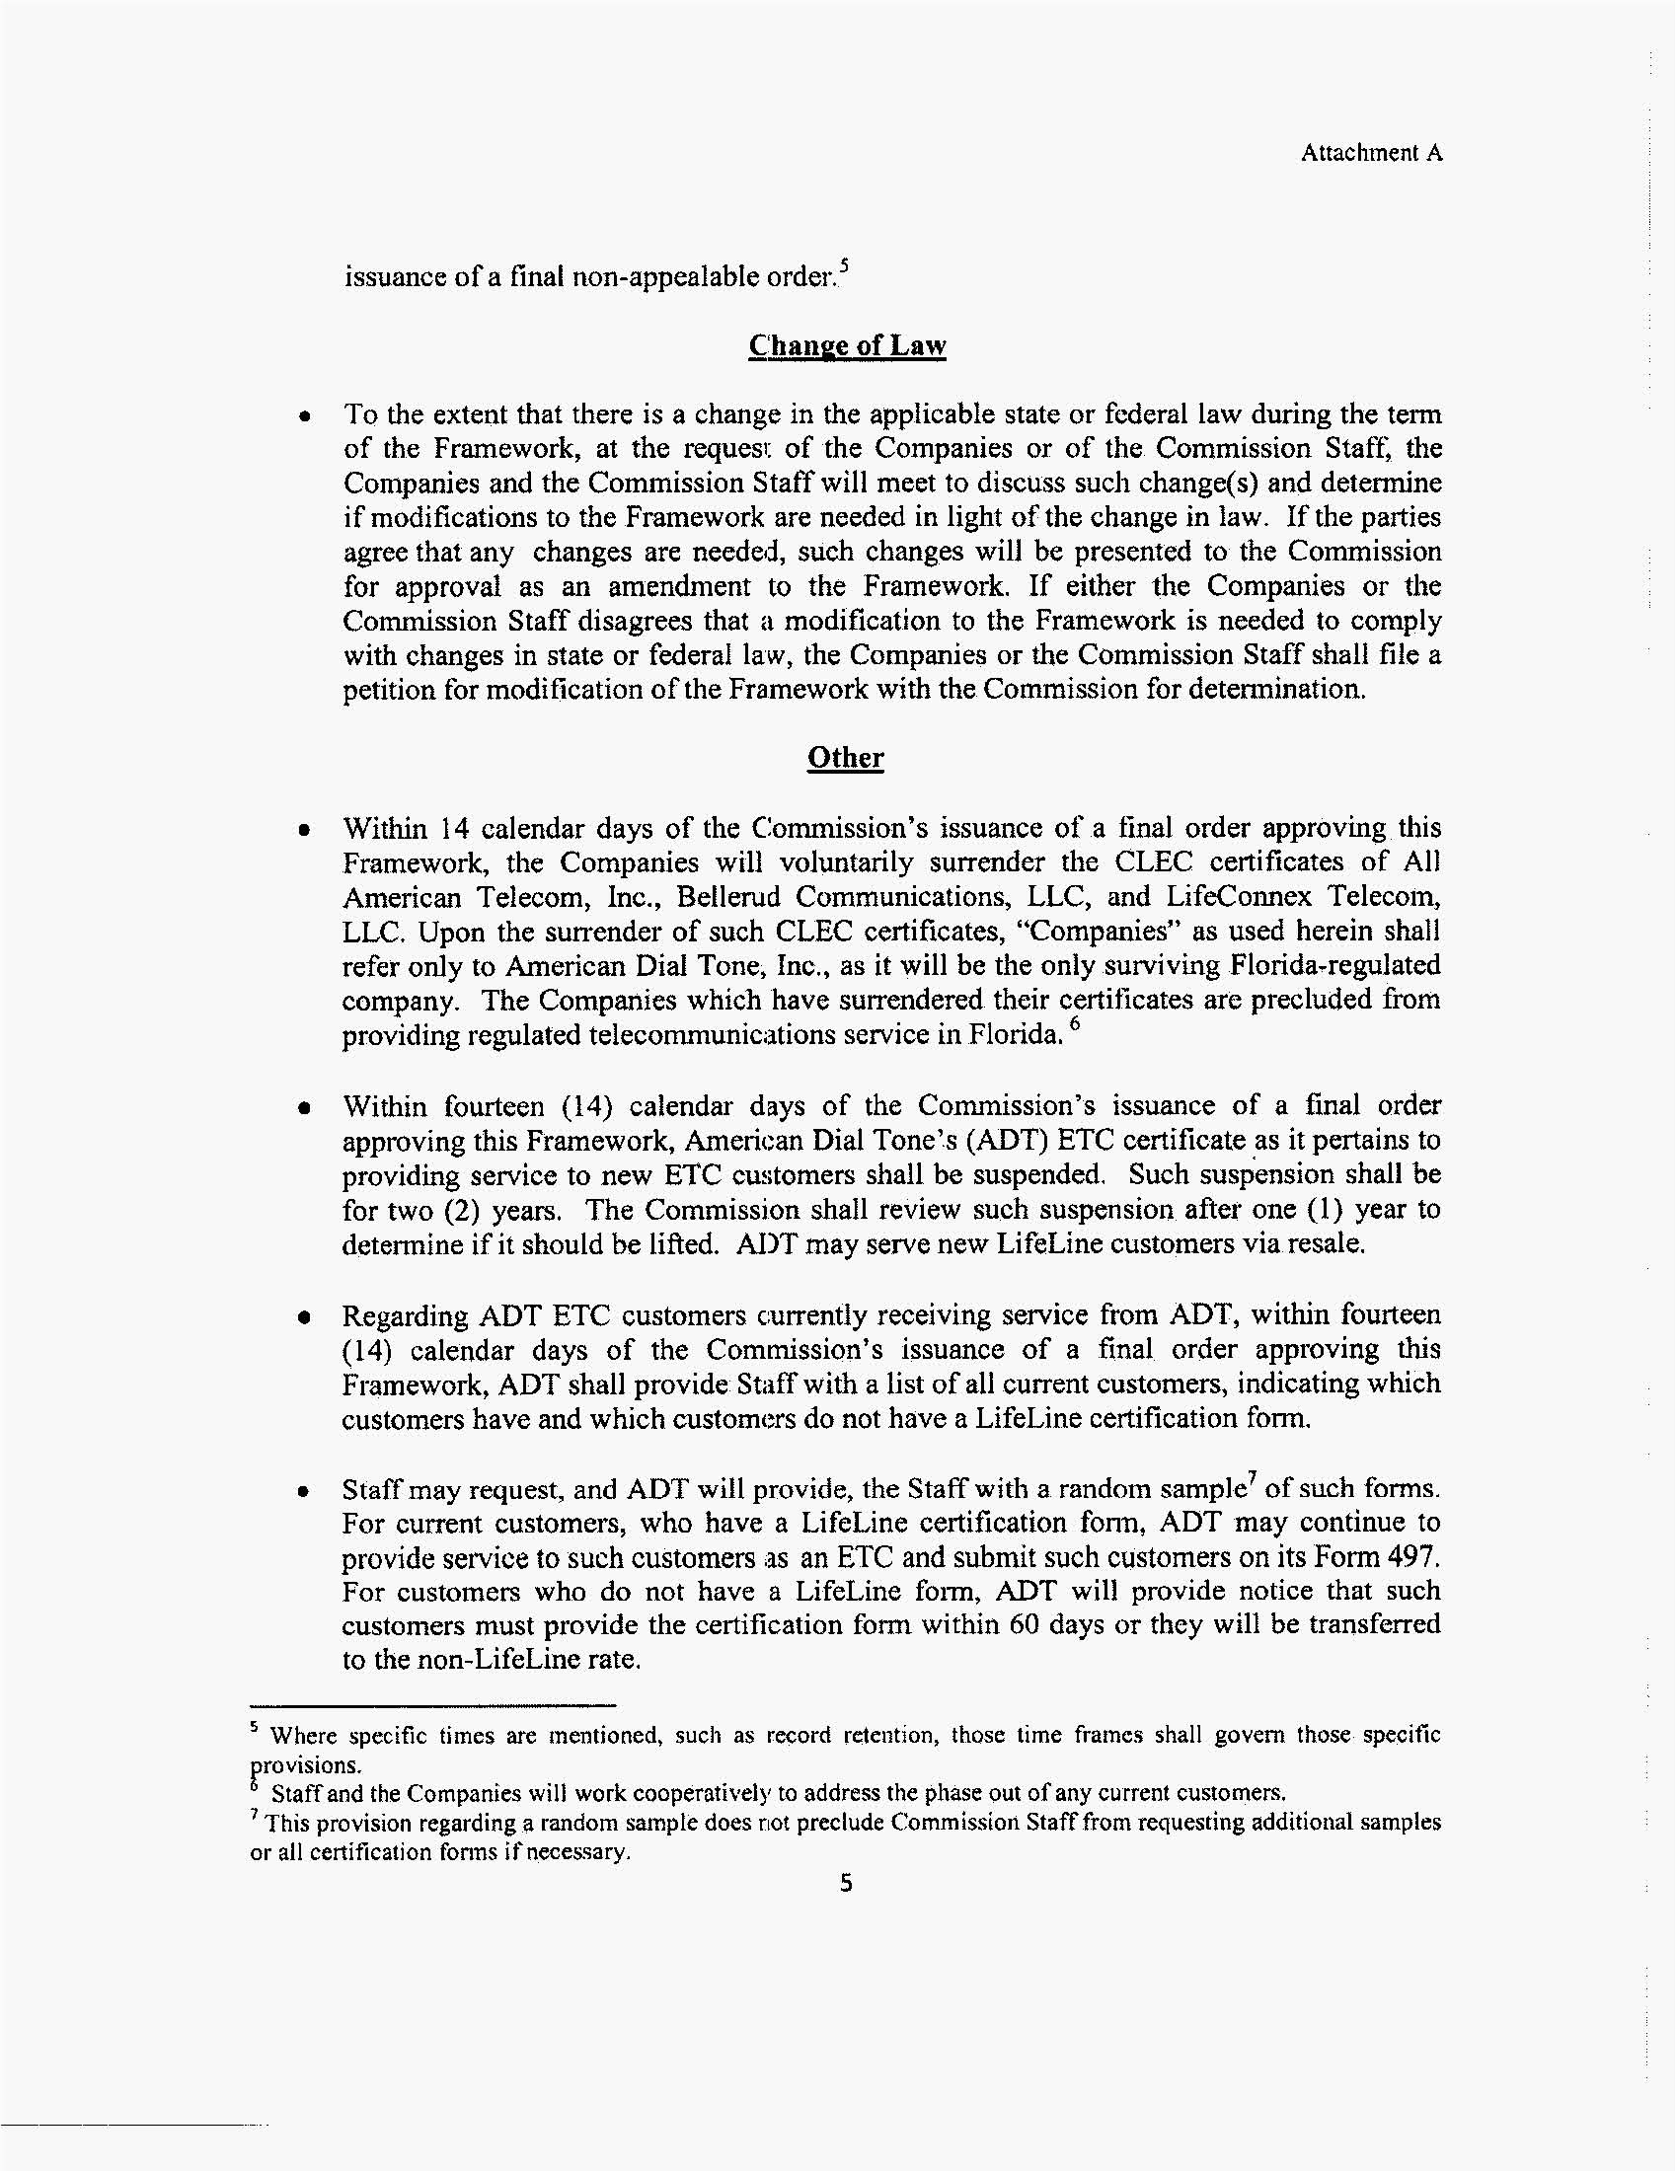
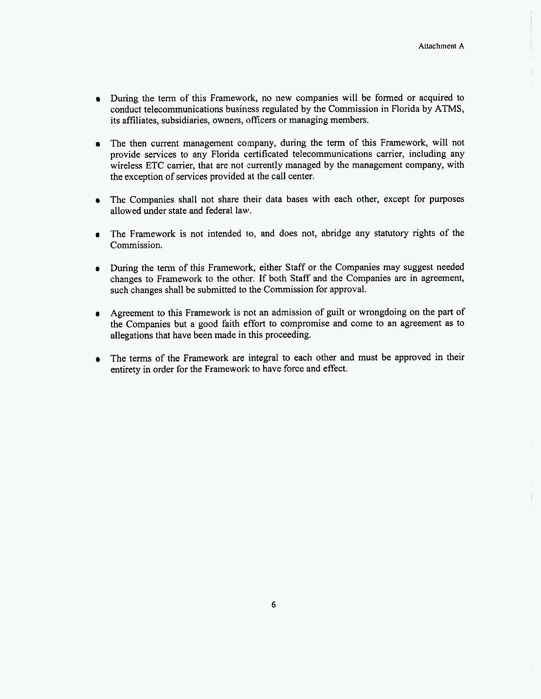
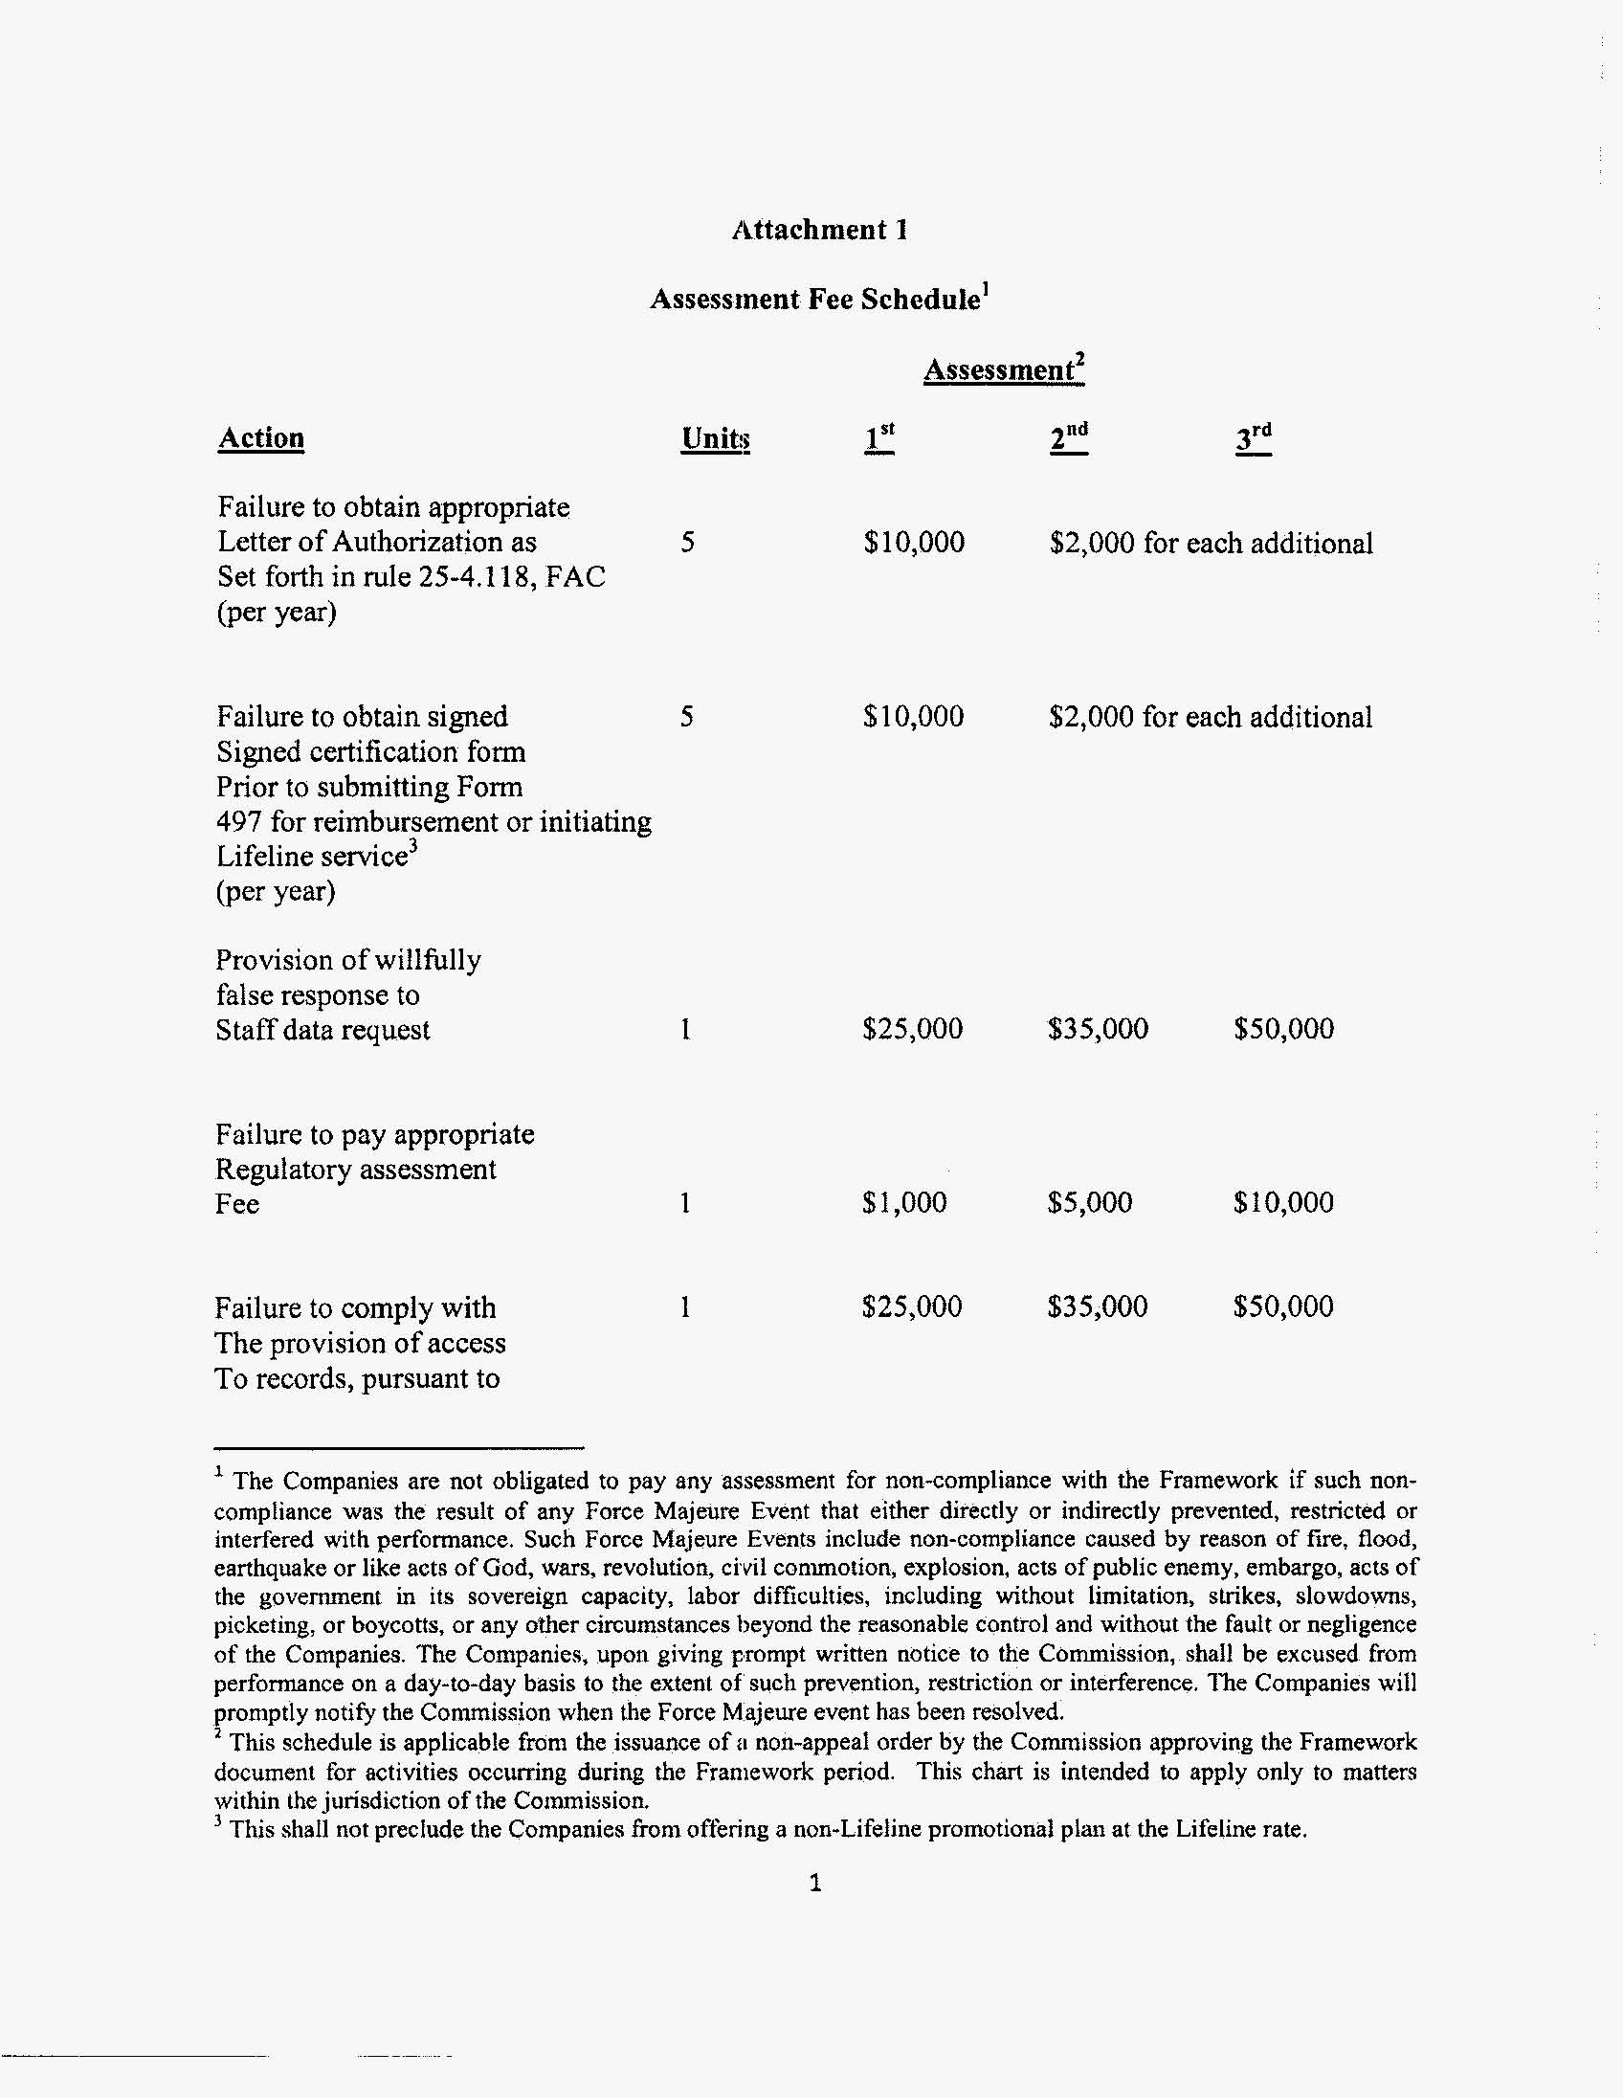
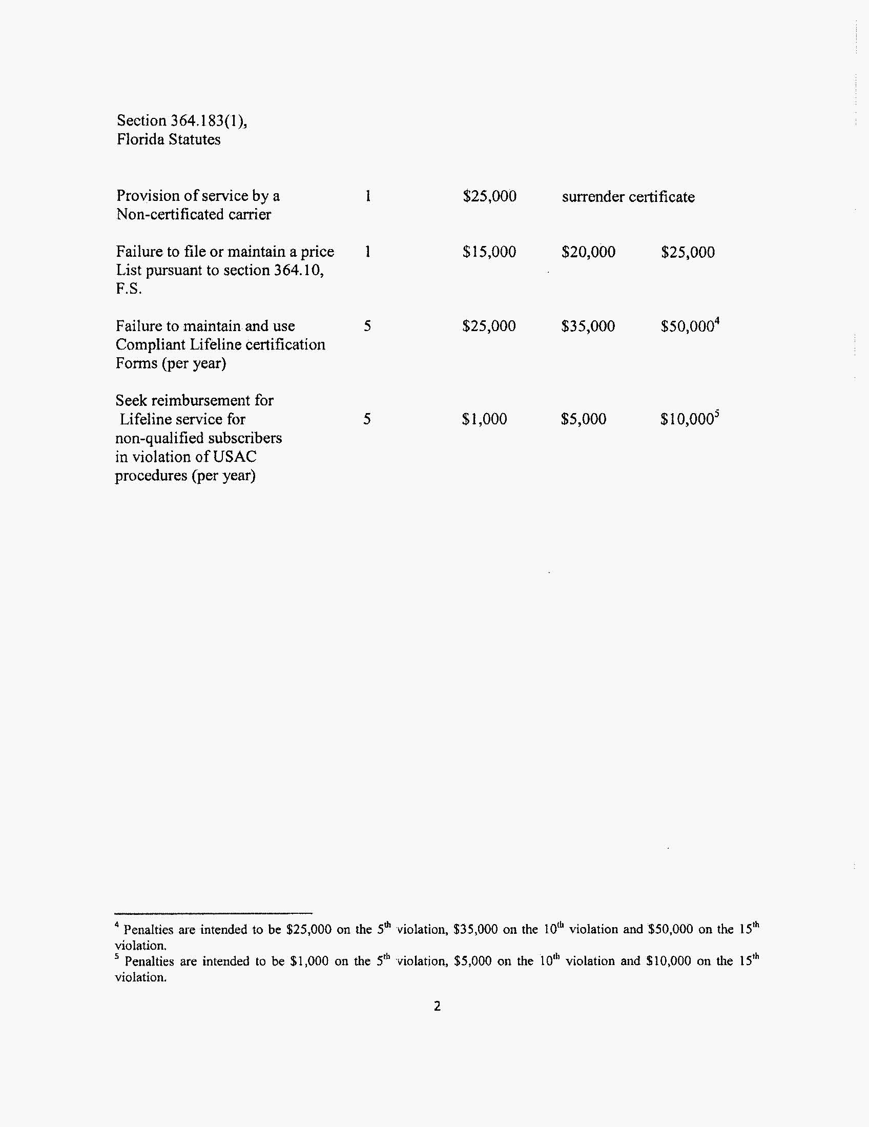
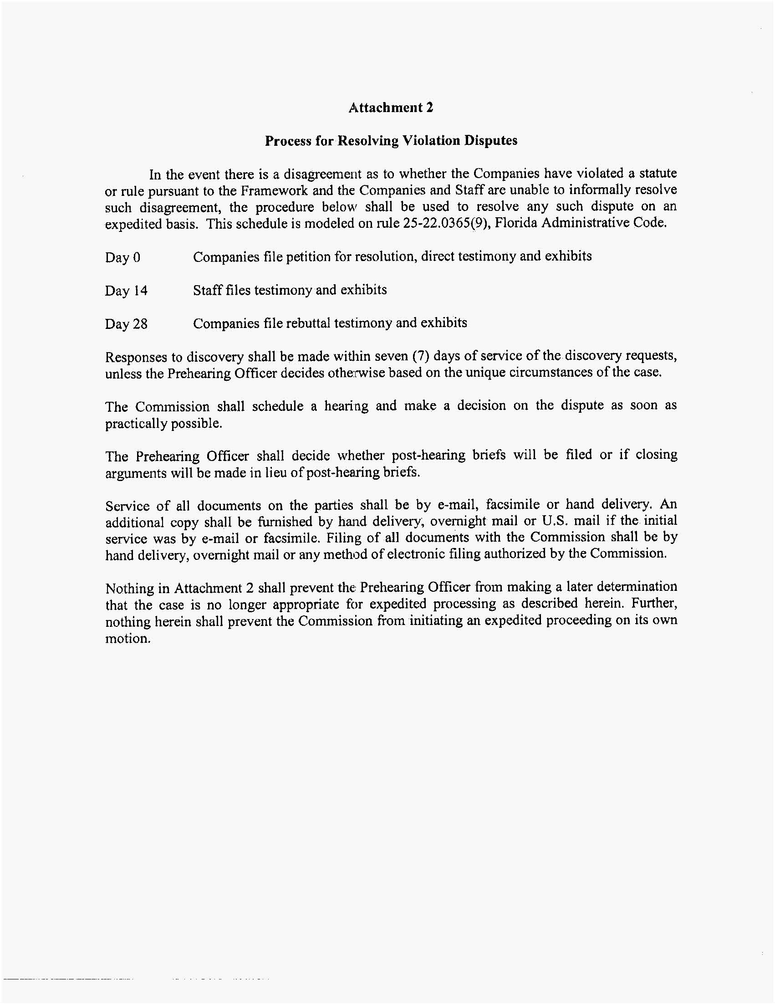

Summary of Staff’s Recommended Show Cause Penalties, by Company.
Violation | American Dial Tone | LifeConnex | BLC Management | Bellerud | All American Telecom | Total
Unauthorized customer moves | $610,000 | $150,000 | $1,160,000 | $0 | $0 | $1,920,000
Multiple ATMS companies providing service to same customer | $2,220,000 | $1,340,000 | $1,270,000 | $20,000 | $0 | $4,850,000
Missing Lifeline certification forms | $3,643,000 | $828,500 | $2,702,000 | $25,000 | $0 | $7,198,500
Senior Citizen Low-Income Discount Plan Qualifier | $1,500 | $2,500 | $500 | $0 | $0 | $4,500
USAC Form 497 | $125,000 | $0 | $0 | $0 | $0 | $125,000
Access to company records | $100,000 | $50,000 | $25,000 | $25,000 | $25,000 | $225,000
Failure to file price list | $25,000 | $25,000 | $25,000 | $25,000 | $0 | $100,000
Providing CLEC service in Florida without a certificate | $0 | $0 | $25,000 | $0 | $0 | $25,000
CPNI | $500,000 | $500,000 | $500,000 | $500,000 | $0 | $2,000,000
 | $7,224,500 | $2,896,000 | $5,707,500 | $595,000 | $25,000 | $16,448,000

2010 Universal Service Monitoring Report, CC Docket No. 98-202.
FCC 11-32, ¶14.
The Universal Service Administrative Company is an independent, not-for-profit corporation designated as the administrator of the federal Universal Service Fund by the Federal Communications Commission.
FCC 11-32, ¶ 14.
Through discovery, our staff learned that Triarch Marketing, Inc., Dialtone & More, Inc., Ren-Tel Communications, Inc, and SCTXLink were not conducting business in Florida.
Docket No. 090457-TX, In Re: Petition for designation as an ETC by Bellerud Communications, LLC. Petition withdrawn March 3, 2010. Docket No. 070348-TX, In Re: Amended petition for designation as eligible telecommunications carrier by Swiftel, LLC. Petition withdrawn July 21, 2009. Docket No. 080157-TX, In Re: Application for designation as an eligible telecommunications carrier by BLC Management LLC d/b/a Angles Communications Solutions. Docket closed administratively December 10, 2008. Docket No. 090437-TX, In Re: Petition for designation as eligible telecommunications carrier by All American Telecom, Inc. Petition withdrawn August 5, 2010.
Docket No. 080475-TX, In Re: Compliance investigation of CLEC Certificate No. 8579, issued to BLC Management LLC d/b/a Angles Communication Solutions, for apparent first-time violation of Rule 25-4.0161, F.A.C., Regulatory Assessment Fees; Telecommunications Companies. Order No. PSC-08-0617-CO-TX, issued September 23, 2008.
Recommendation filed June 4, 2009, Document No. 05570-09, Docket No. 070348-TX, Amended petition for designation as eligible telecommunications carrier by Swiftel, LLC n/k/a LifeConnex Telecom, LLC.
As noted in Footnote 6, Ren-Tel Communications and SCTXLink have never been certificated in Florida, and Triarch Marketing withdrew its certificate application in September, 2010.
A complete breakdown of staff’s recommendations regarding apparent violations by company is contained in Attachment 2.
Qwest I, 258 F.3d at 1203; Qwest II, 398 F.3d at 1232.
Qwest I, at 1203.

