BEFORE THE FLORIDA PUBLIC SERVICE COMMISSION

In re: Joint petition for approval of territorial agreement in Bradford County by Florida Power & Light Company and City of Starke. | DOCKET NO. 110099-EU  ORDER NO. PSC-11-0472-PAA-EU  ISSUED: October 18, 2011

The following Commissioners participated in the disposition of this matter:

ART GRAHAM, Chairman
LISA POLAK EDGAR
RONALD A. BRISÉ
EDUARDO E. BALBIS
JULIE I. BROWN

NOTICE OF PROPOSED AGENCY ACTION
ORDER APPROVING TERRITORIAL AGREEMENT

BY THE COMMISSION:

NOTICE is hereby given by the Florida Public Service Commission that the action discussed herein is preliminary in nature and will become final unless a person whose interests are substantially affected files a petition for a formal proceeding, pursuant to Rule 25-22.029, Florida Administrative Code (F.A.C.).

BACKGROUND
On April 12, 2011, Florida Power & Light Company (FPL) and the City of Starke, Florida (City) filed a joint petition for approval of a territorial agreement. The petition requests the establishment of a service territory boundary between the two utilities in Bradford County. The agreement will result in the transfer of 86 customer accounts and related distribution facilities between the parties. This is the first territorial agreement between these utilities.
As explained below, we approve the territorial agreement. We have jurisdiction over the matter pursuant to Section 366.04, Florida Statutes (F.S.).
DECISION
The joint petition states that the parties initially entered into an agreement on February 27, 2009, but did not seek Commission approval of the initial agreement until all necessary filing requirements, including obtaining a legal description of the territorial boundaries, were satisfied. By the time those requirements were satisfied, the list of affected customers referenced in the initial agreement needed to be updated to reflect the fact that customers had relocated in and out of the respective service territories. As a result, the parties decided to enter into a restated agreement instead of creating an addendum to the original agreement. FPL and the City entered into a restated territorial agreement on March 21, 2011. The restated territorial agreement was attached to the petition as Exhibit 1, and is attached hereto as Attachment A, and incorporated herein.
The agreement establishes a geographic boundary between the two utilities that is depicted on the map attached to the agreement as Composite Appendix A. The map also includes a legal description of the proposed boundary line.
As mentioned above, the proposed territorial agreement addresses the transfer of a total of 86 customer accounts between the parties. Under the agreement, 20 customer accounts (15 residential and 5 commercial) will be transferred from the City to FPL and 66 accounts (54 residential and 12 commercial) will be transferred from FPL to the City. Written notice to all affected customers has been made, as required by Rule 25-6.0440(1)(d), F.A.C. The petition states that 6 City customers responded that they were not opposed to the transfer, while 12 FPL customers responded to the proposal, 11 of whom were opposed to the transfer.
The petition states that the transfer of customers will be completed within two years of our approval of the agreement. The parties have indicated that a transfer schedule will be established once we make a ruling on the petition. The parties also indicated that they will work with all affected customers regarding deposits, so applicable deposit policies are followed and the customers will not suffer any hardship as a result of the transfer.
Pursuant to Section 366.04(2)(d), F.S., we have the jurisdiction to approve territorial agreements between and among rural electric cooperatives, municipal electric utilities, and other electric utilities. Pursuant to Rule 25-6.0440(2), F.A.C., in approving territorial agreements, we may consider the reasonableness of the purchase price of any facilities being transferred, the likelihood that the agreement will not cause a decrease in the reliability of electric service to existing or future ratepayers, and the likelihood that the agreement will eliminate existing or potential uneconomic duplication of facilities. Unless we determine that the agreement will cause a detriment to the public interest, the agreement should be approved. Utilities Commission of the City of New Smyrna v. Florida Public Service Commission, 469 So. 2d 731 (Fla. 1985).
According to the parties, the proposed territorial agreement eliminates existing or potential uneconomic duplication of facilities, does not cause a decrease in the reliability of electric service to existing or future ratepayers, will not occur at any significant cost, and prevents wasteful expenditures by the parties. Based on all of the above, we find that the proposed territorial agreement is in the public interest and we approve it. Since the agreement contemplates the transfer of customers over a two year period, we direct the parties to file status reports on the transfers every six months until the transfers are complete.
Based on the foregoing, it is

ORDERED by the Florida Public Service Commission that the Joint petition for approval of a territorial agreement in Bradford County by Florida Power & Light Company and the City of Starke is approved. It is further

ORDERED that the territorial agreement attached to the petition, and all related maps, are incorporated by reference into this Order as Attachment A. It is further

ORDERED that the parties to the territorial agreement shall file status reports on the customer transfers identified in the territorial agreement every six months until the transfers are complete. It is further

ORDERED that the provisions of this Order, issued as proposed agency action, shall become final and effective upon the issuance of a Consummating Order unless an appropriate petition, in the form provided by Rule 28-106.201, Florida Administrative Code, is received by the Commission Clerk, 2540 Shumard Oak Boulevard, Tallahassee, Florida 32399-0850, by the close of business on the date set forth in the “Notice of Further Proceedings” attached hereto. It is further

ORDERED that in the event this Order becomes final, this docket shall be closed.

By ORDER of the Florida Public Service Commission this 18th day of October, 2011.

/s/ Ann Cole
ANN COLE
Commission Clerk
Florida Public Service Commission
2540 Shumard Oak Boulevard
Tallahassee, Florida 32399
(850) 413-6770
www.floridapsc.com

MCB

NOTICE OF FURTHER PROCEEDINGS OR JUDICIAL REVIEW

The Florida Public Service Commission is required by Section 120.569(1), Florida Statutes, to notify parties of any administrative hearing that is available under Section 120.57, Florida Statutes, as well as the procedures and time limits that apply. This notice should not be construed to mean all requests for an administrative hearing will be granted or result in the relief sought.

Mediation may be available on a case-by-case basis. If mediation is conducted, it does not affect a substantially interested person's right to a hearing.

The action proposed herein is preliminary in nature. Any person whose substantial interests are affected by the action proposed by this order may file a petition for a formal proceeding, in the form provided by Rule 28-106.201, Florida Administrative Code. This petition must be received by the Office of Commission Clerk, 2540 Shumard Oak Boulevard, Tallahassee, Florida 32399-0850, by the close of business on November 8, 2011.

In the absence of such a petition, this order shall become final and effective upon the issuance of a Consummating Order.

Any objection or protest filed in this/these docket(s) before the issuance date of this order is considered abandoned unless it satisfies the foregoing conditions and is renewed within the specified protest period.
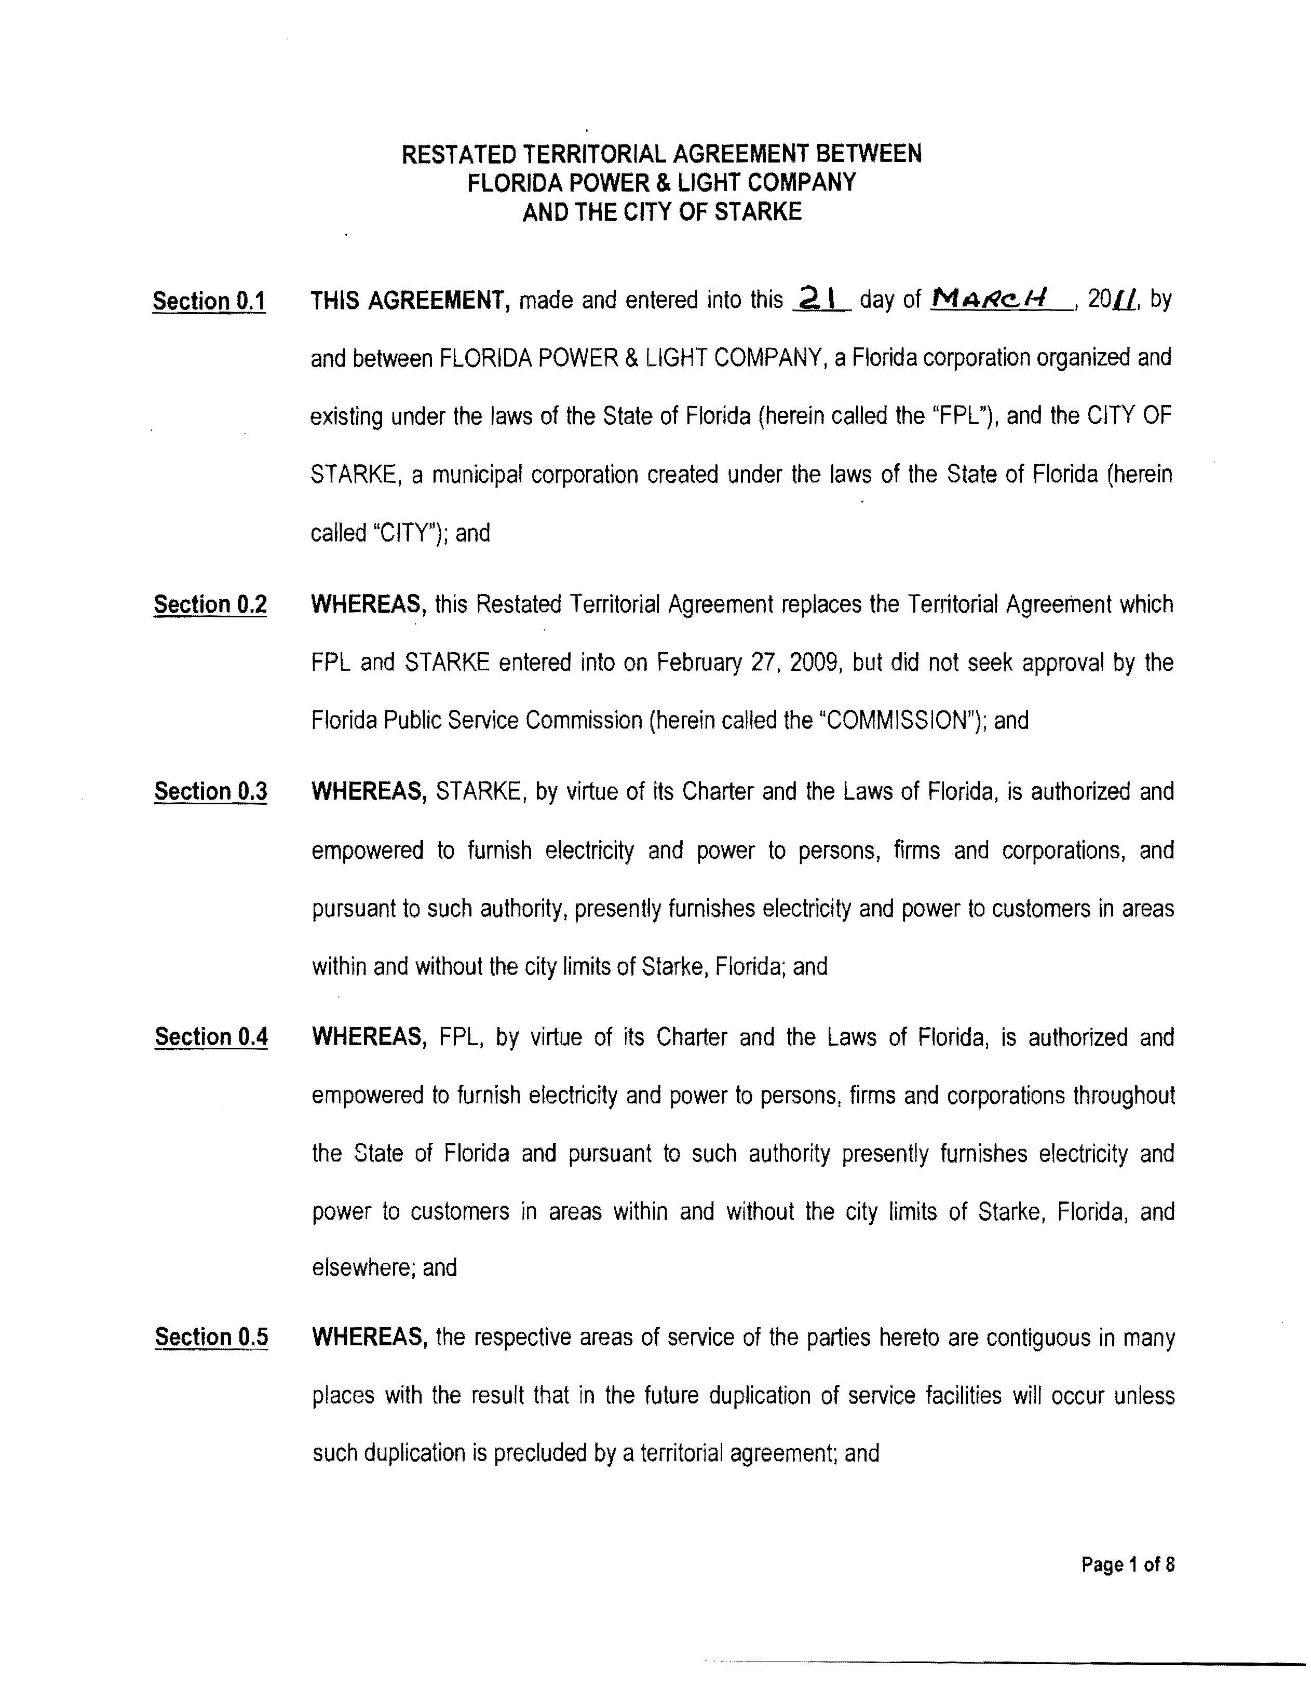
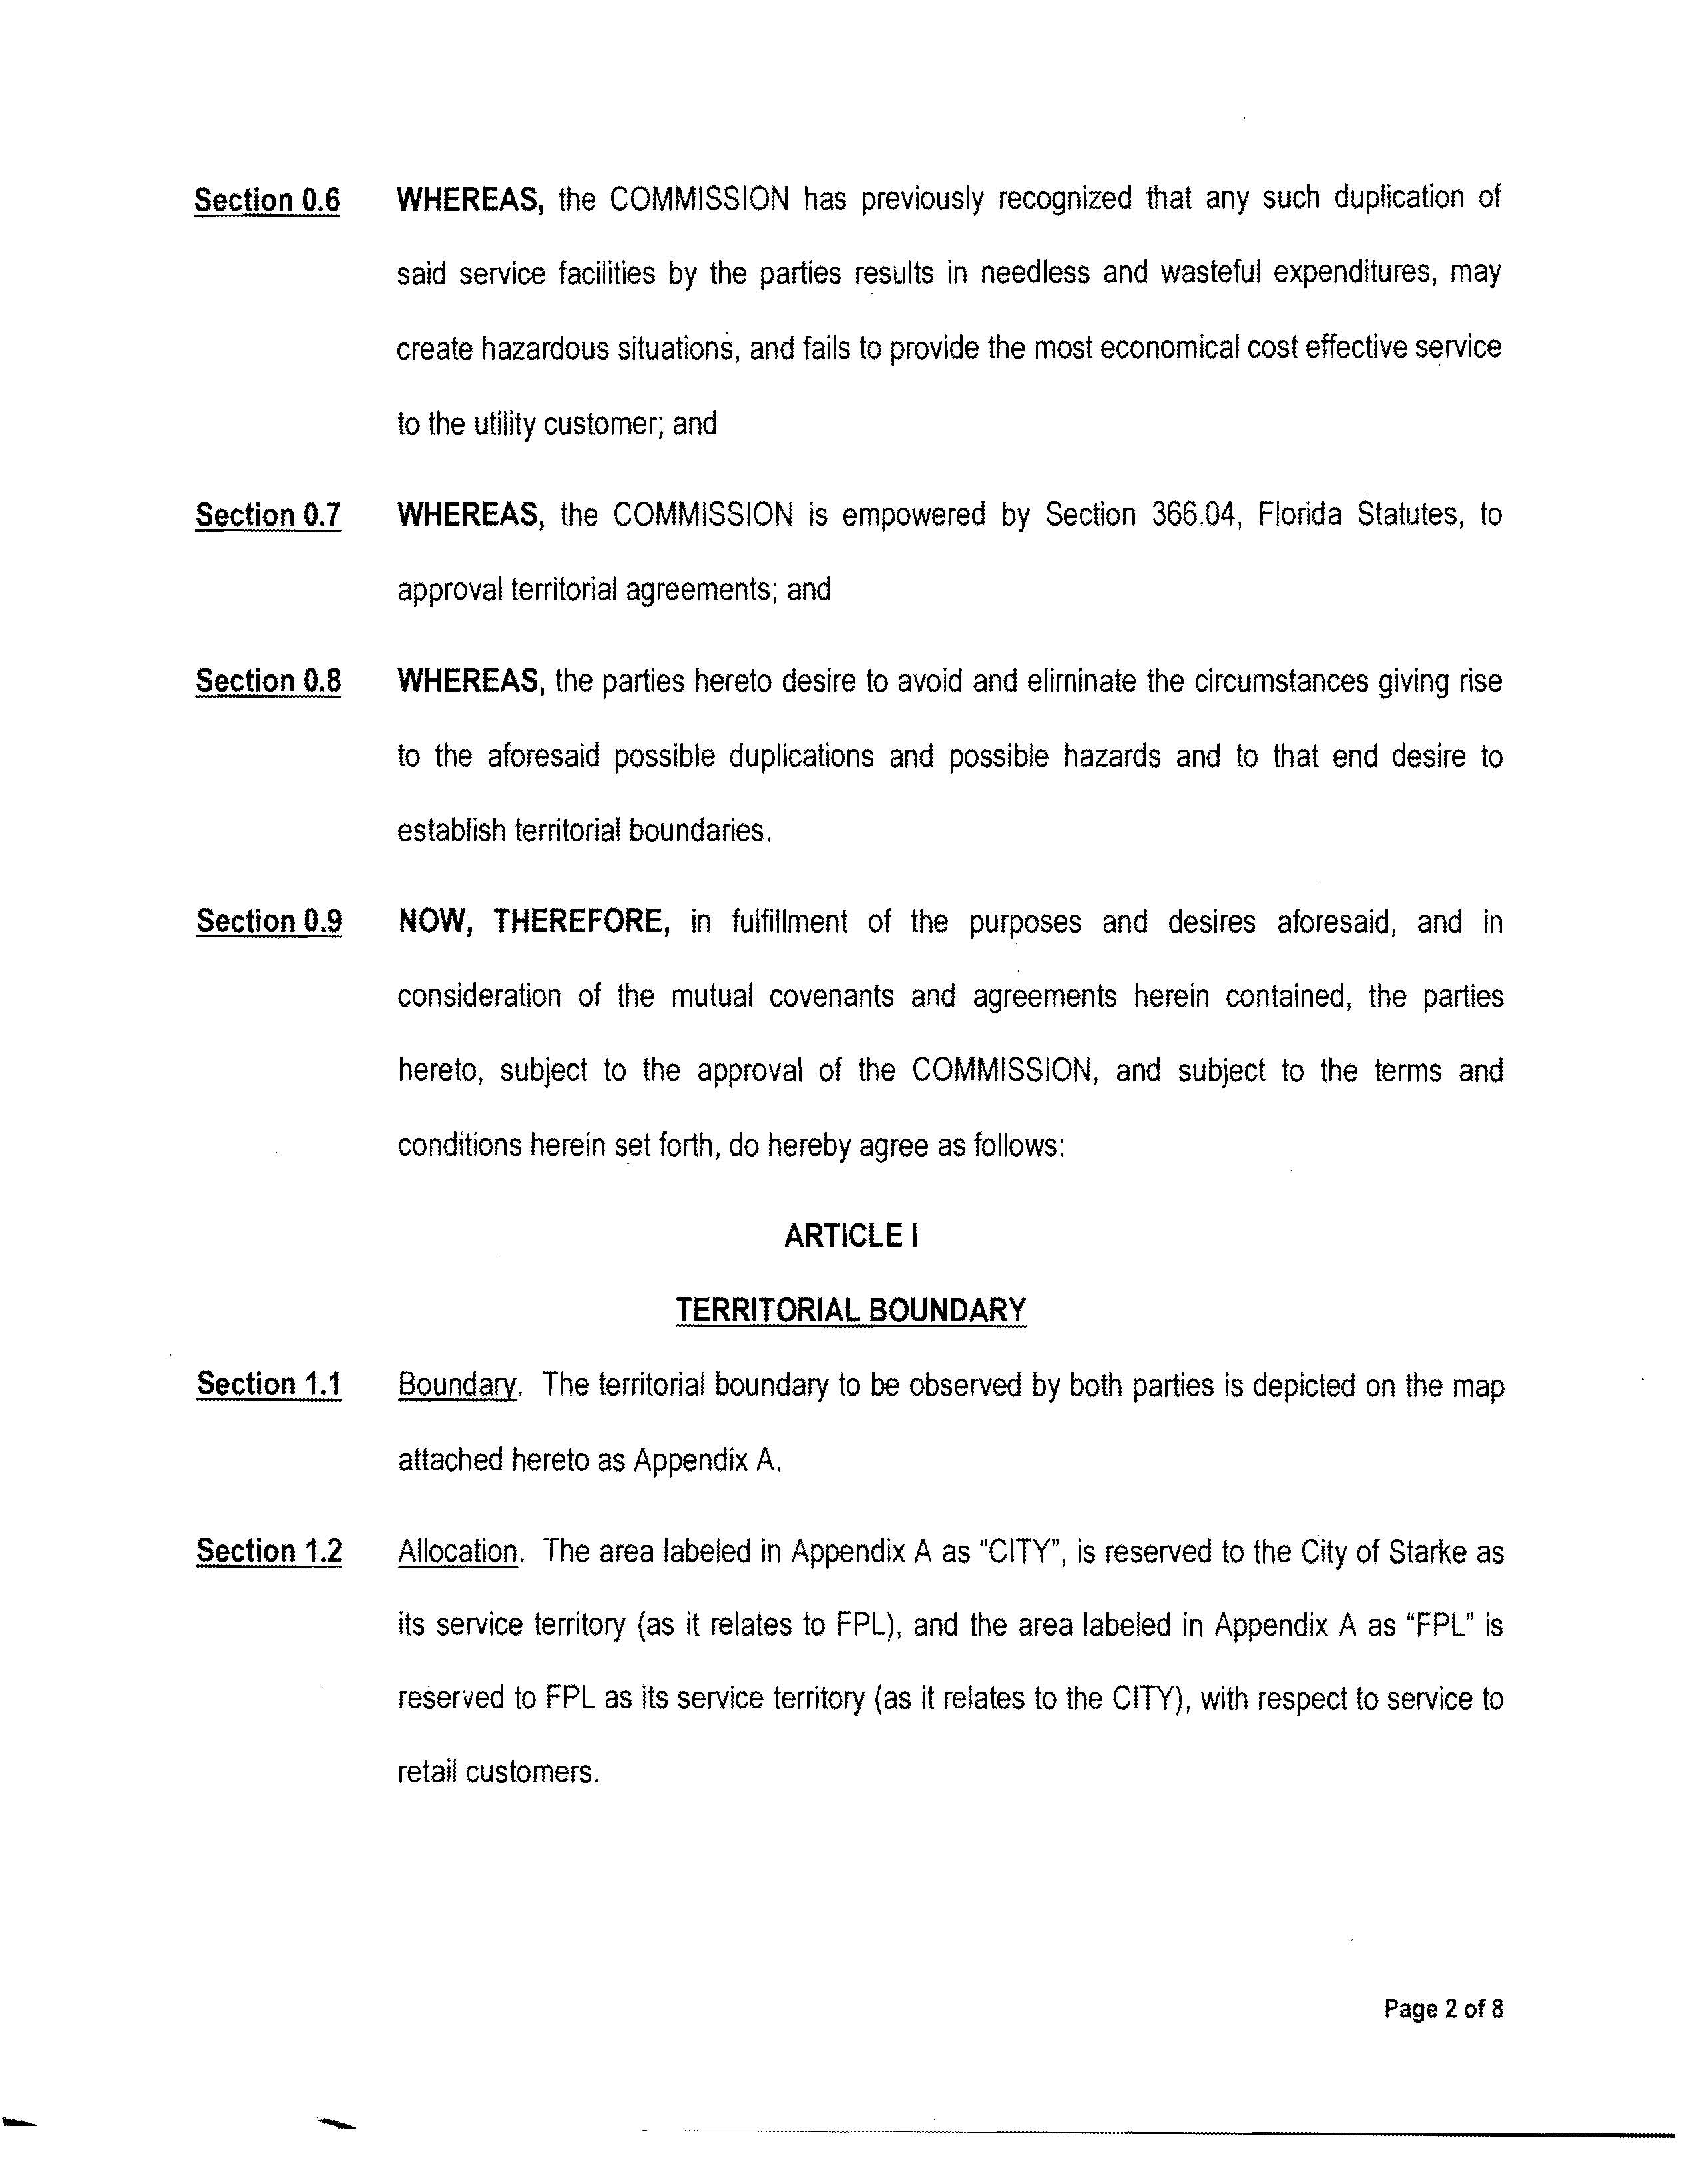
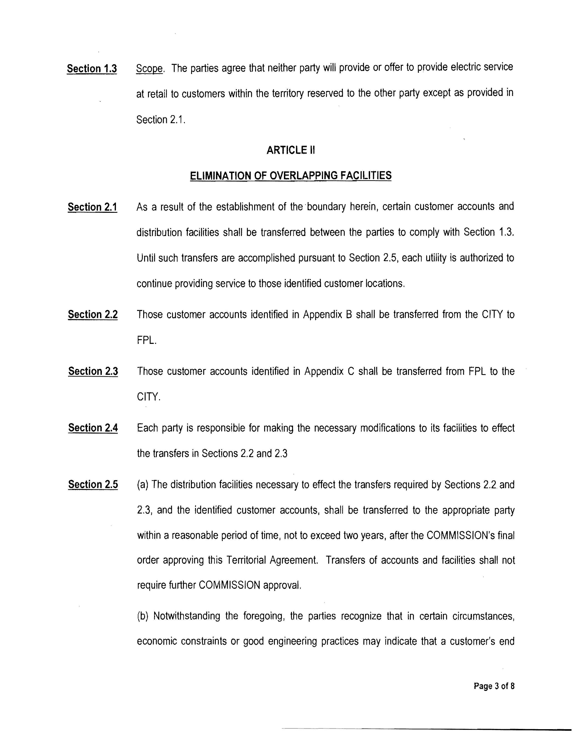
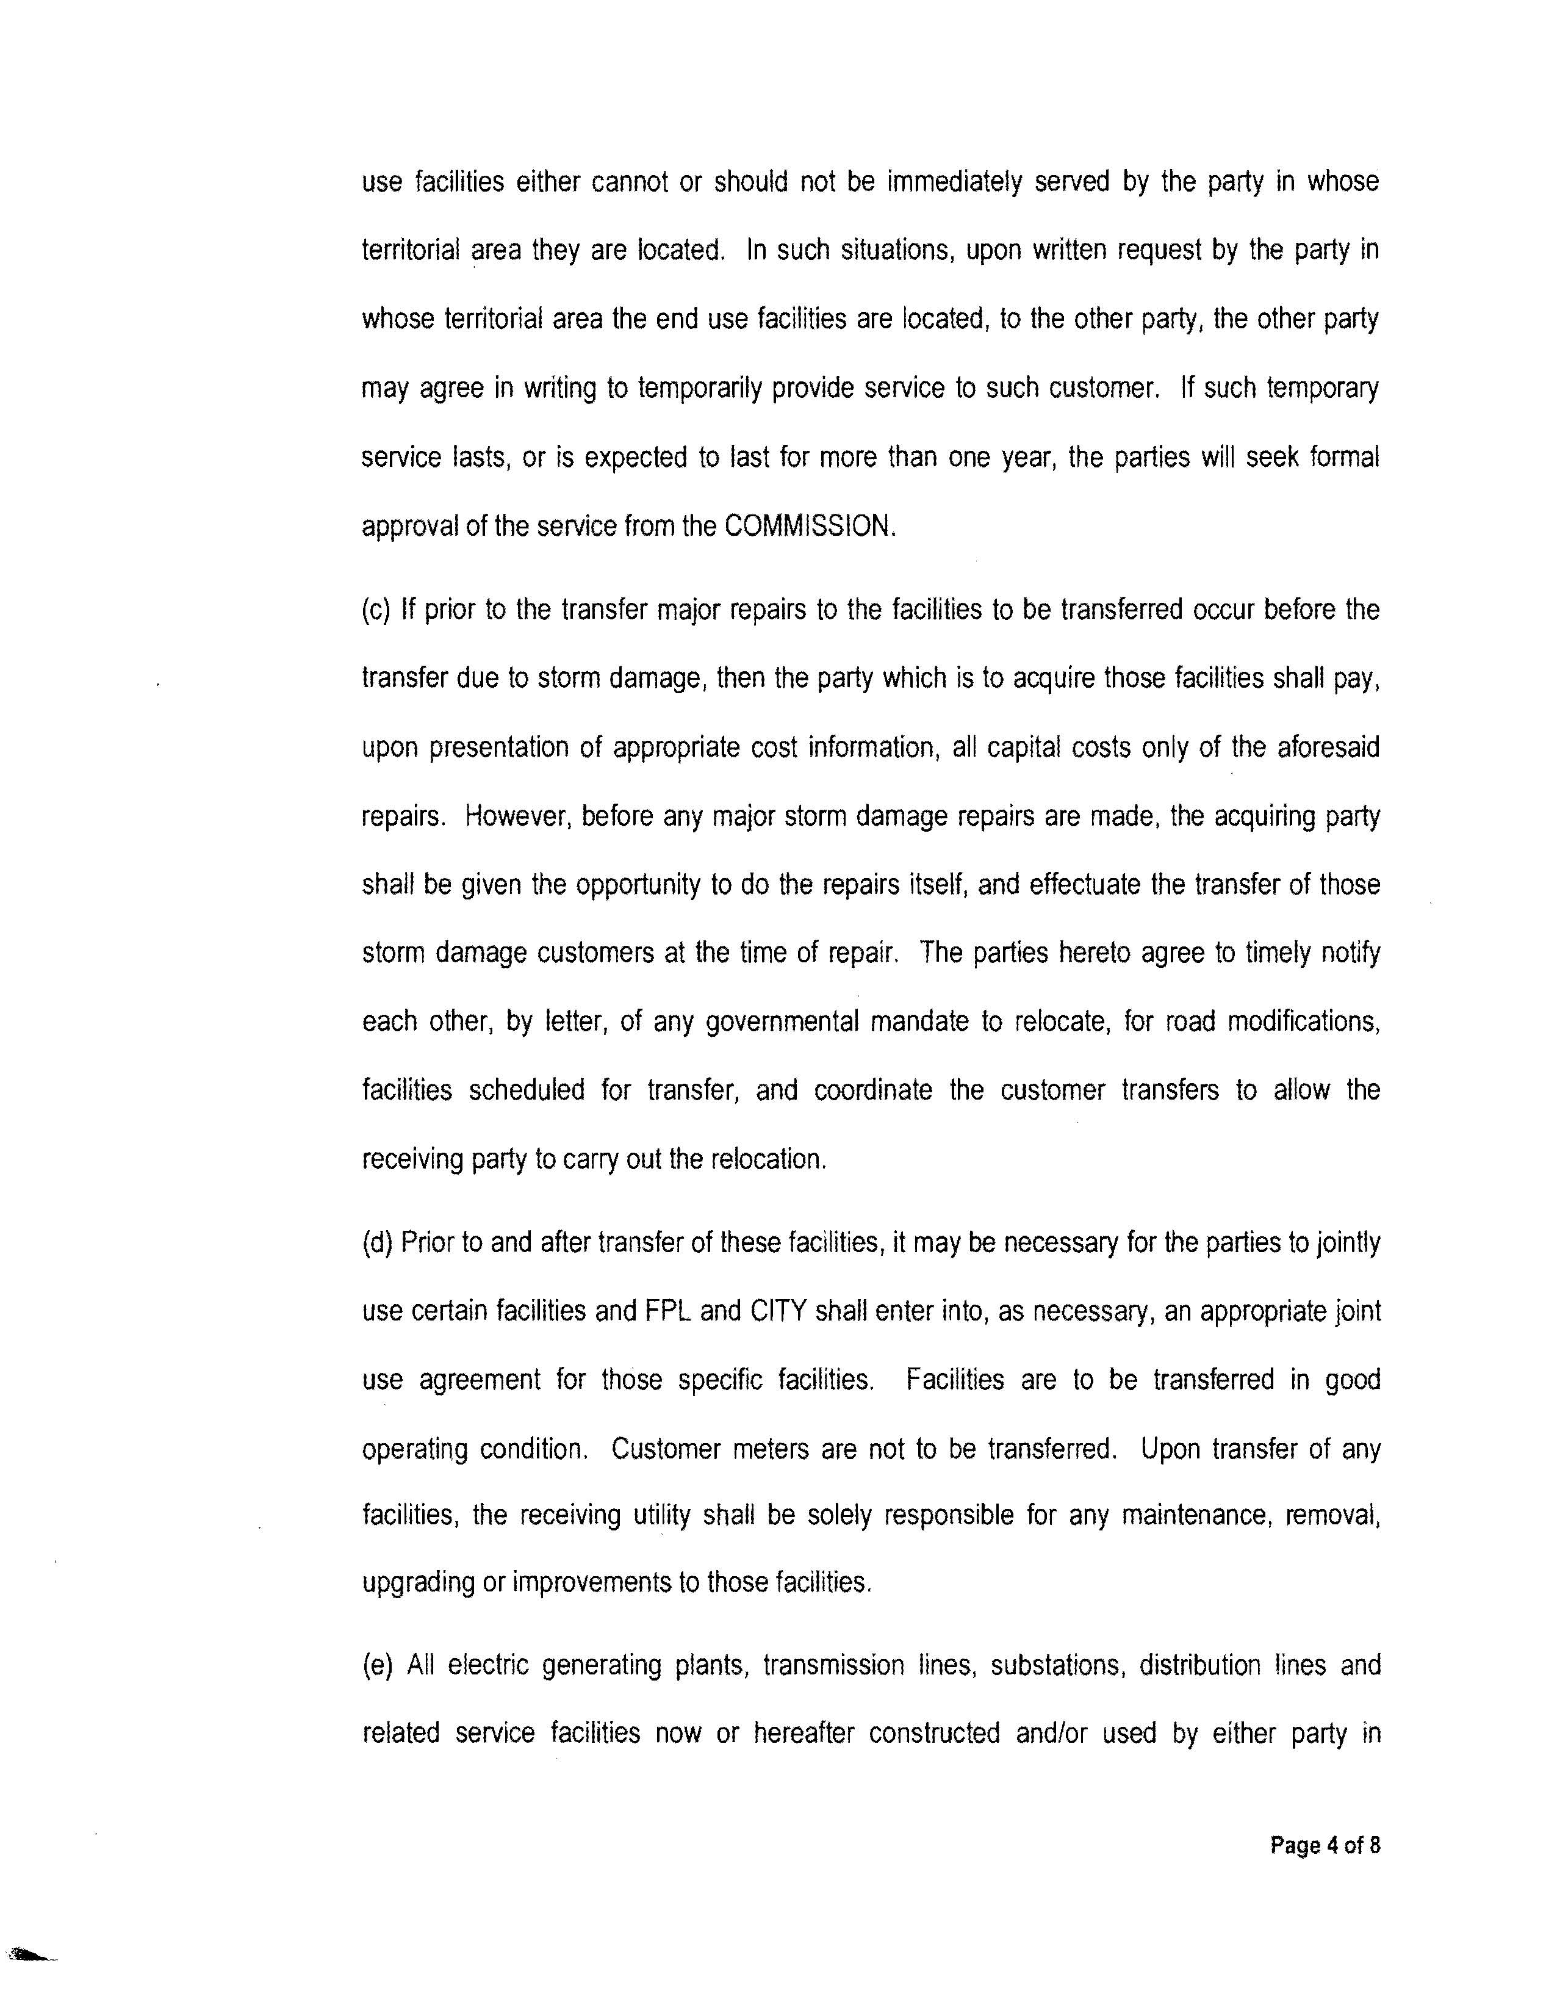
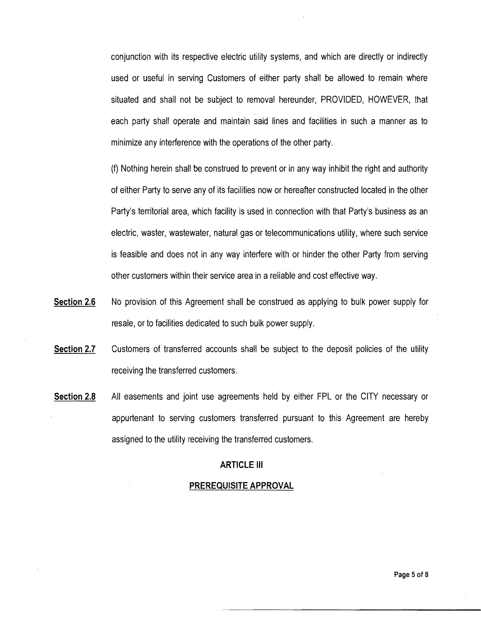
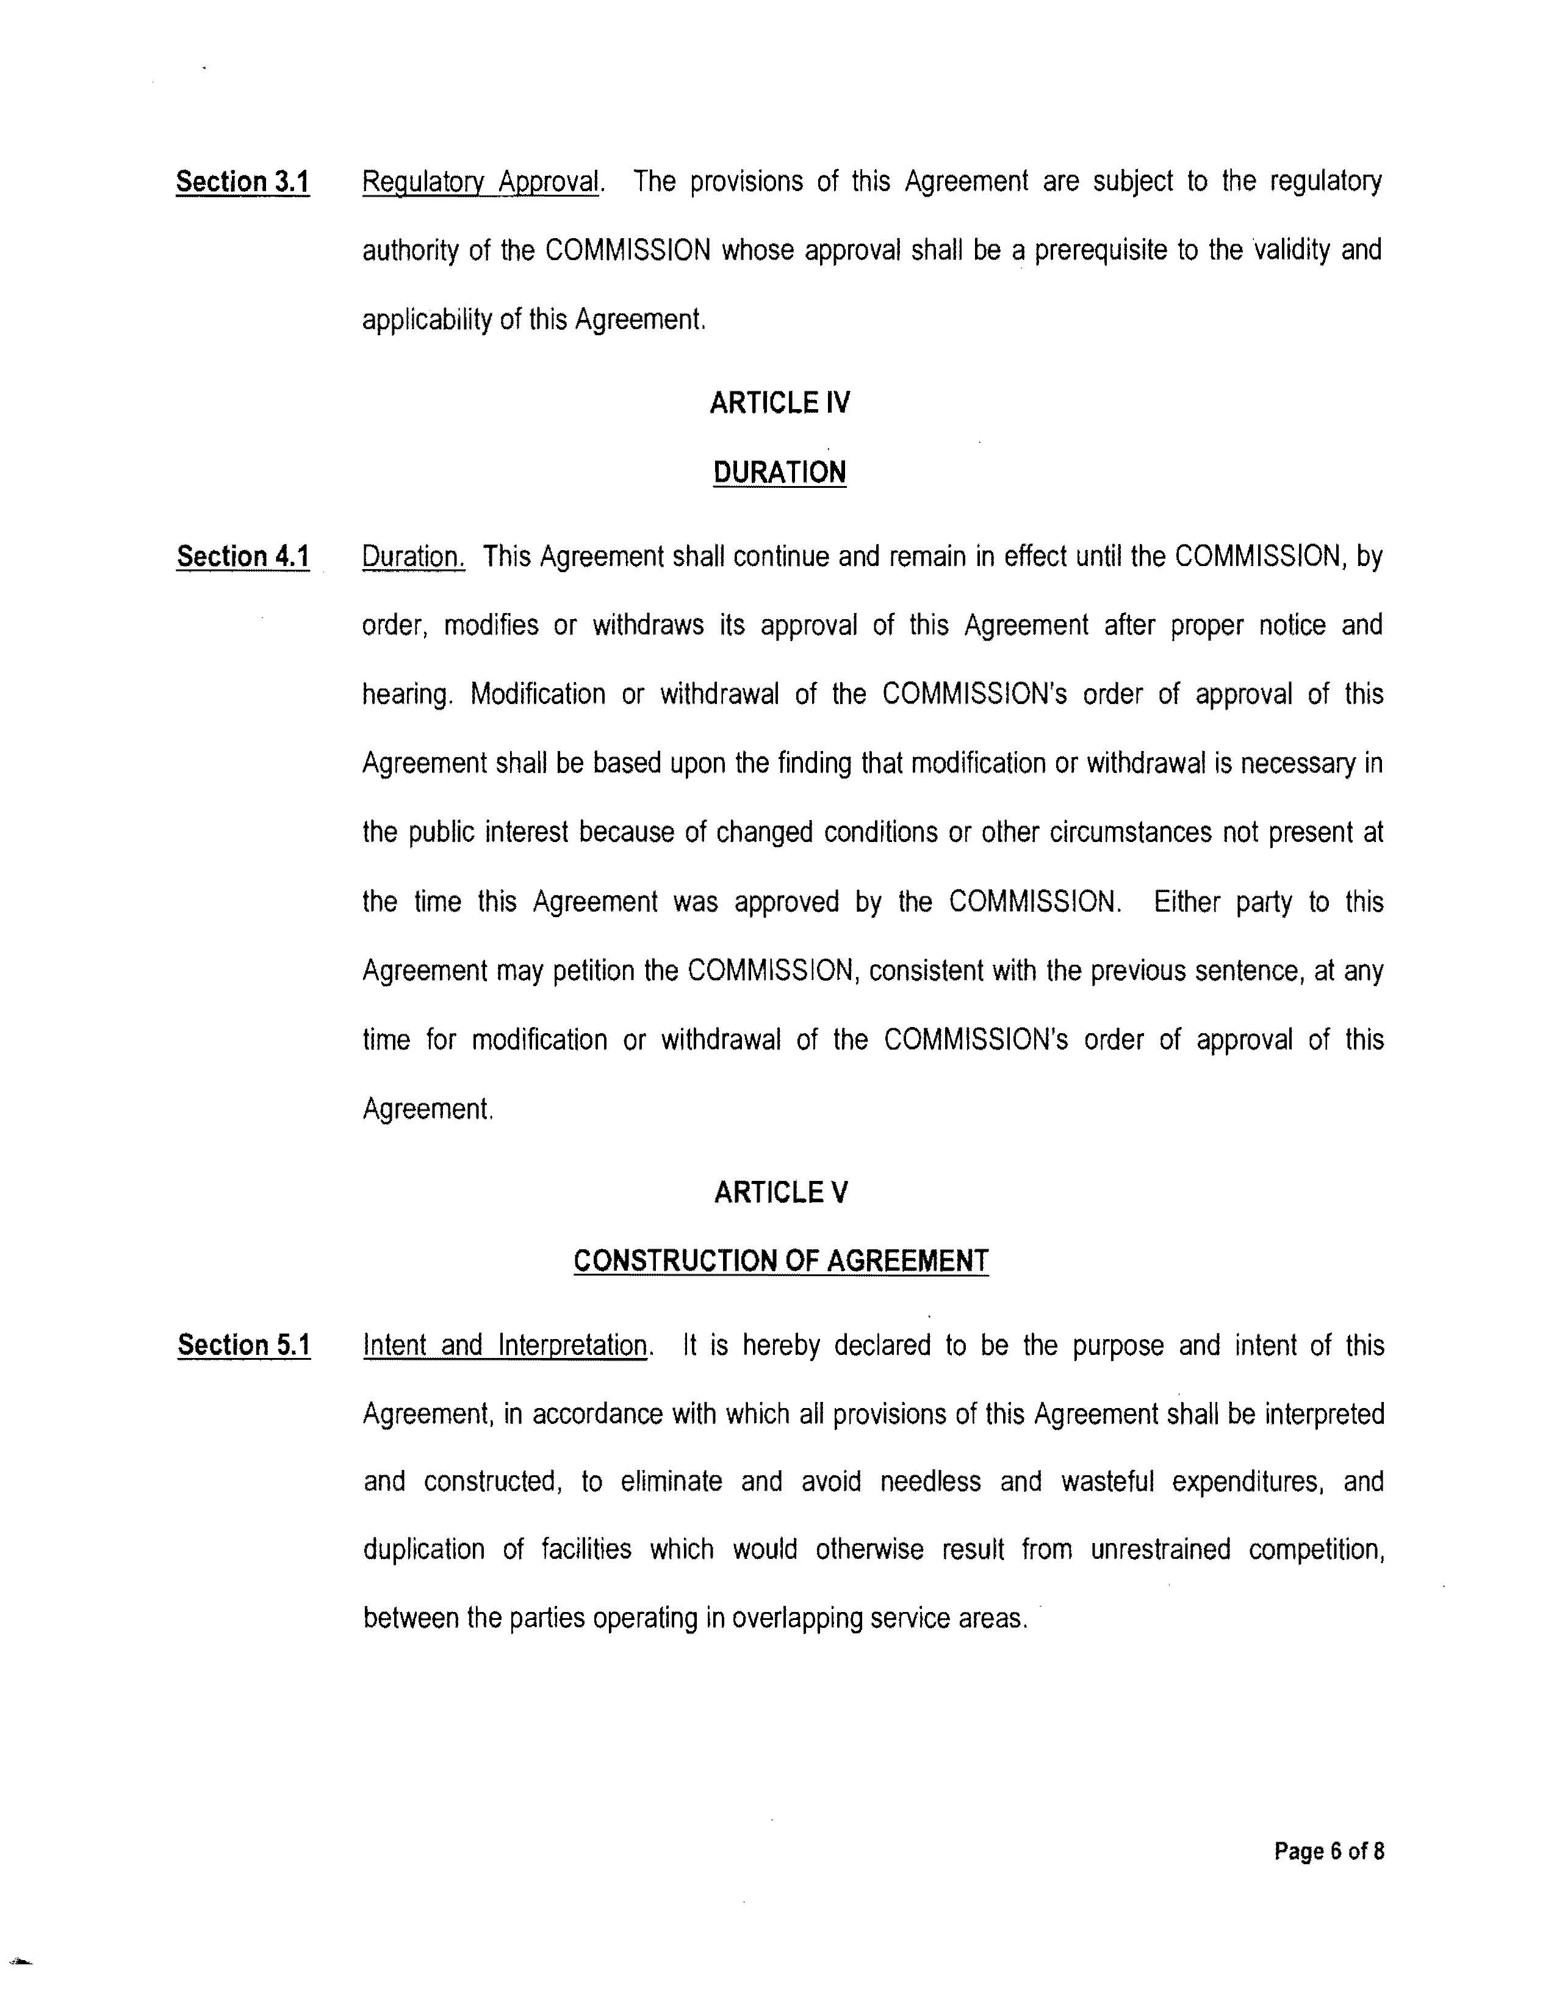
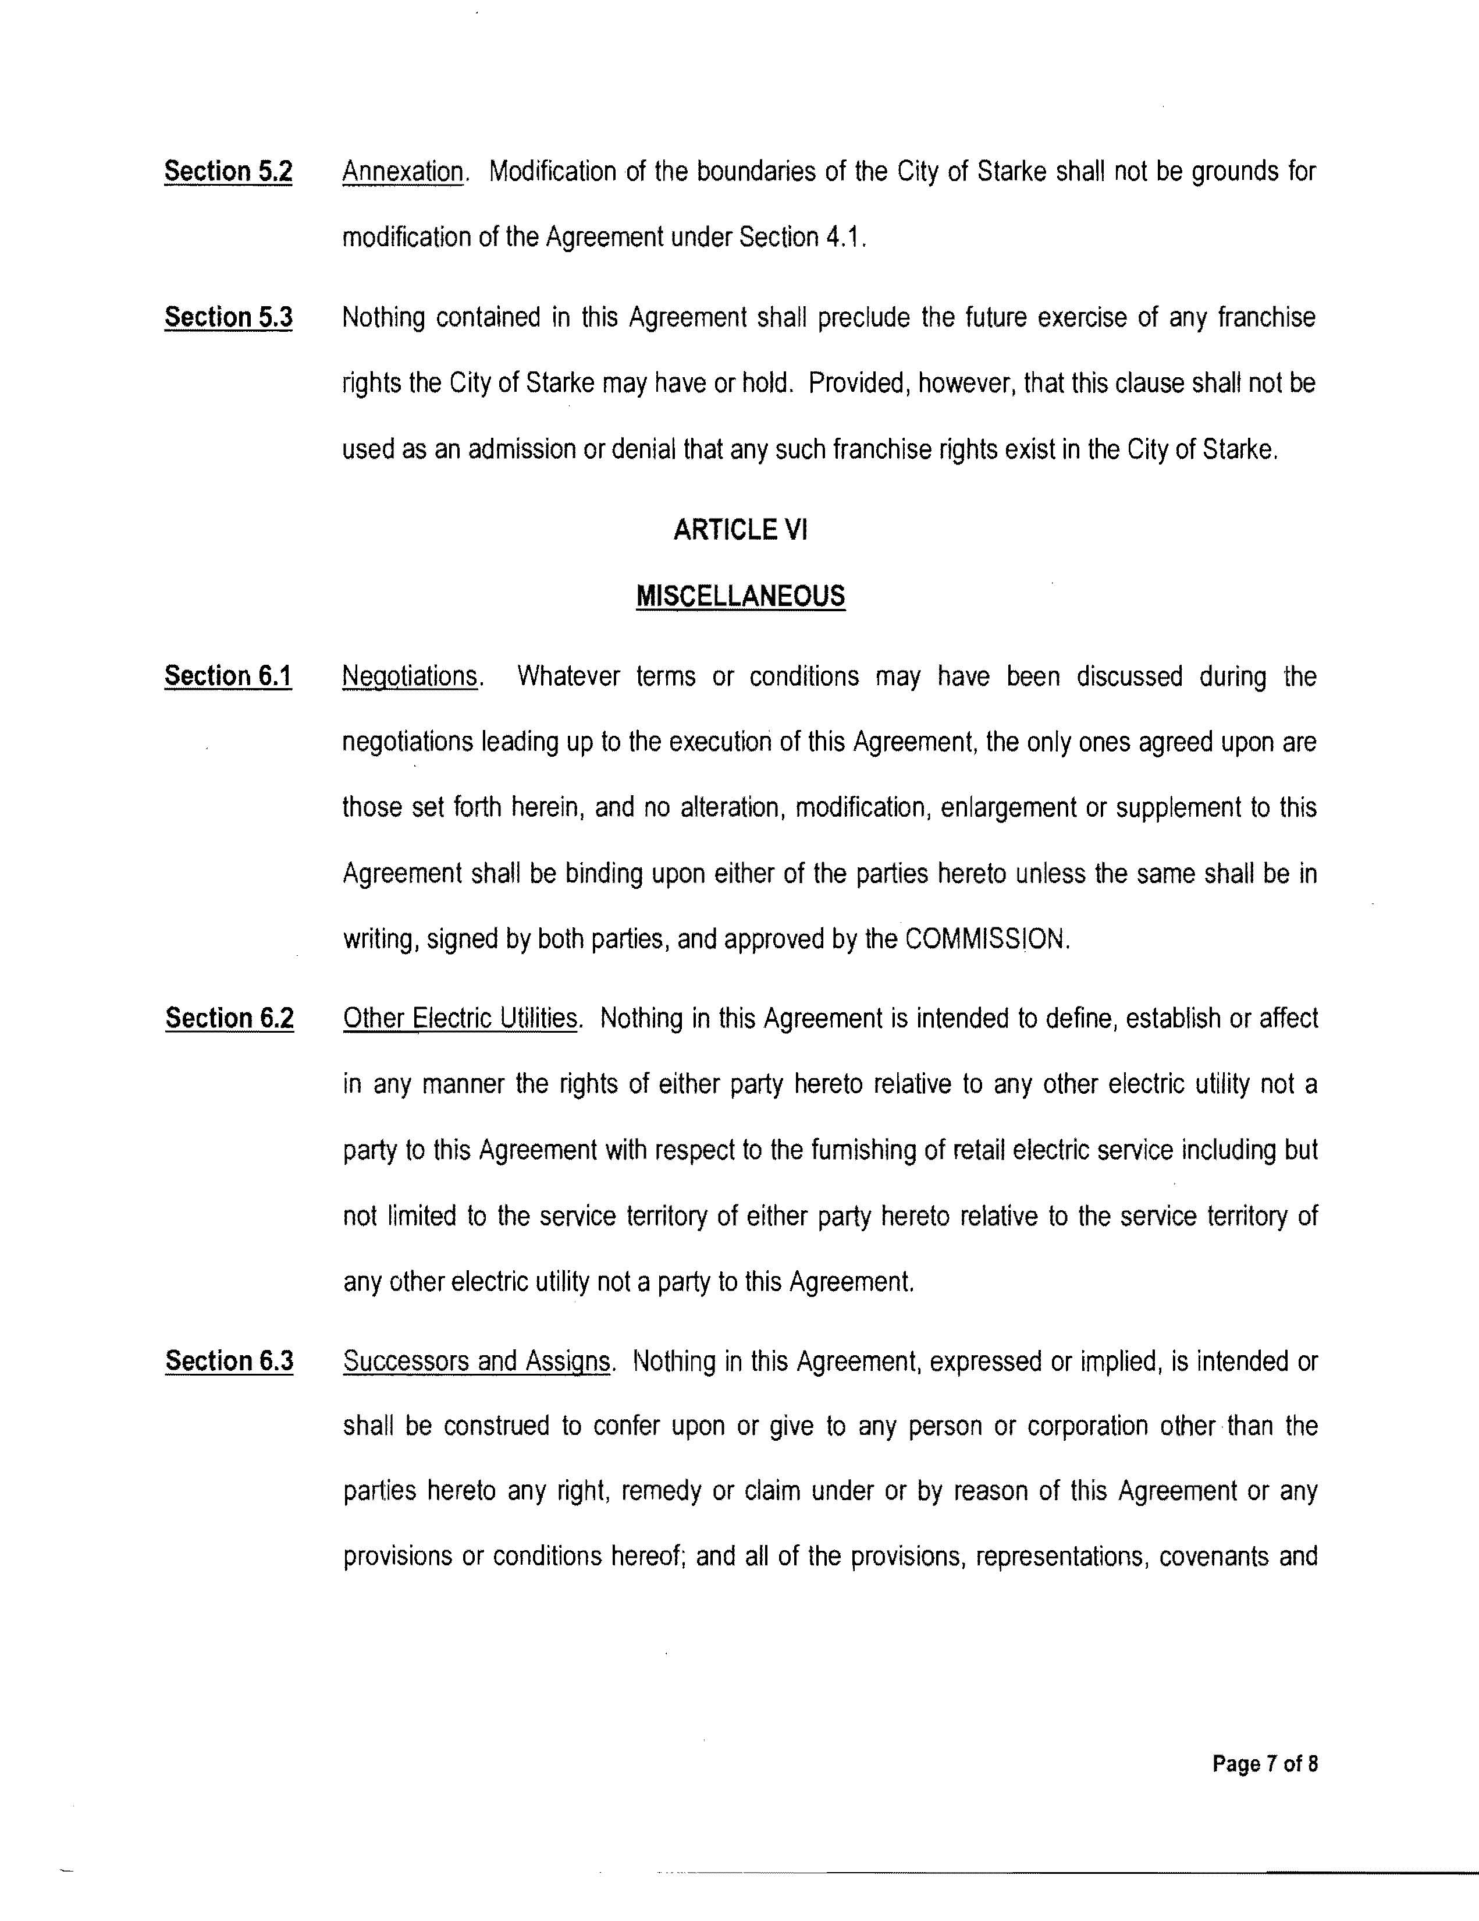
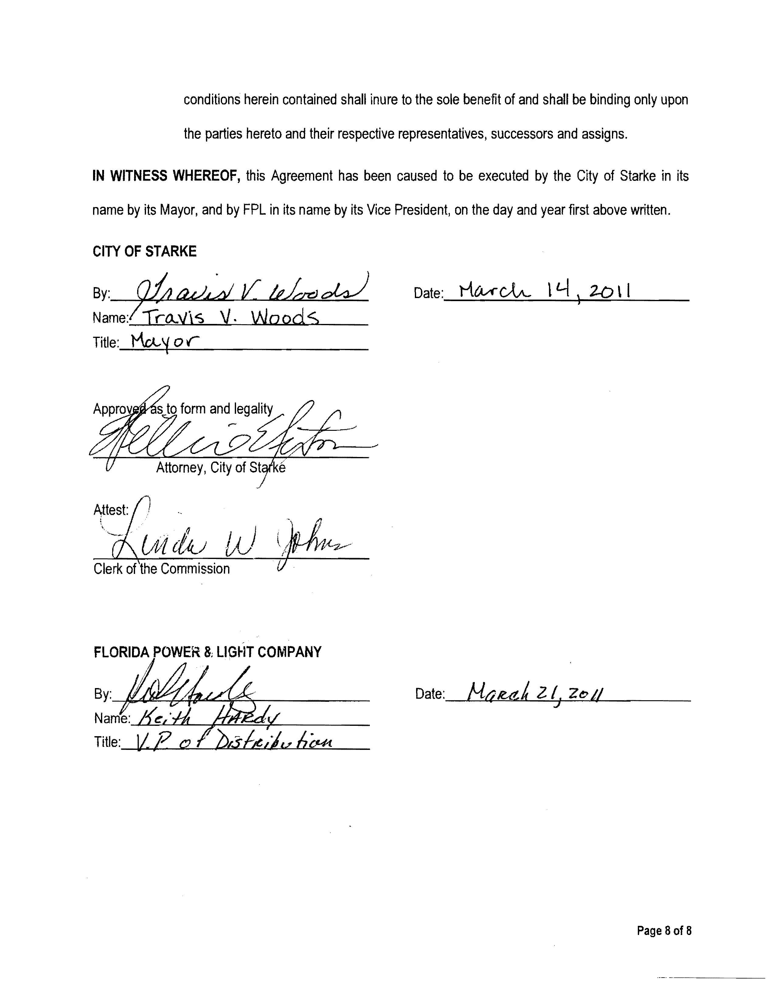

City and Clay Electric Cooperative (Clay) also have a territorial agreement that encompasses some of the same geographical areas. See Order No. PSC-08-0105-PAA-EU, issued February 18, 2008, in Docket No. 070669-EU, In re: Joint petition for approval of territorial agreement in Bradford County by Clay Electric Cooperative, Inc. and City of Starke, Florida. Clay has been apprised of this territorial agreement, and it does not have any objections to it.

