BEFORE THE FLORIDA PUBLIC SERVICE COMMISSION

In re: Petition to determine need for Polk 2-5 combined cycle conversion, by Tampa Electric Company. | DOCKET NO. 120234-EI  ORDER NO. PSC-12-0628-CFO-EI  ISSUED: November 21, 2012

ORDER GRANTING TAMPA ELECTRIC COMPANY’S REQUESTS FOR CONFIDENTIAL CLASSIFICATION AND MOTIONS FOR TEMPORARY PROTECTIVE ORDERS (DOCUMENT NOS. 07114-12, 07212-12, & 07526-12 - CROSS-REFERENCE DOCUMENT NO. 07210-12.)

On October 18, 2012 pursuant to Section 366.093, Florida Statutes, and Rule 25-22.006, Florida Administrative Code, Tampa Electric Company (TECO or Company) filed a Request for Confidential Classification and a Motion for Temporary Protective Orders regarding portions of its response to Commission Staff’s First Request for Production of Documents (Nos. 2 and 6) contained in Document No. 07114-12. On October 23, 2012, TECO filed a second Request for Confidential Classification and a Motion for Temporary Protective Order for information contained in TECO’s response to Commission Staff’s Second Request for Production of Documents (No. 20 on a separate CD and No. 25) contained in Document No. 07212-12. On October 23, 2012, TECO filed a third Request for Confidential Classification and a Temporary Protective Order for its answers to Commission Staff’s Second Set of Interrogatories (No. 50) contained in Document No. 07526-12.

In its requests, TECO asserted that the confidential information contained in Document Nos. 07114-12, 07212-12, and 07526-12 meet the statutory definition of and constitute proprietary confidential business information entitled to protection as outlined in Section 366.093, Florida Statutes (F.S.), and Rule 25-22.006, Florida Administrative Code (F.A.C.). TECO stated that: (1) the information pertains to competitive interests and/or bids and other contractual data, the disclosure of which would impair TECO’s efforts to contract favorably; and (2) the information has been treated by TECO as private and has not been publicly disclosed. TECO requested confidential classification and temporary protective orders for the information for a period of at least 18 months. TECO’s justifications for the confidential classification and temporary protective orders for the relevant information contained in Document Nos. 07114-12, 07212-12, and 07526-12 are attached hereto and incorporated herein as Attachment A.

Pursuant to Section 366.093(1), F.S., information that this Commission finds to be proprietary confidential business information must be kept confidential and exempt from Section 119.07(1), F.S., [the Public Records Act]. Proprietary confidential business information is defined as information that: (1) is intended to be and is treated by the company as private, in that disclosure of the information would cause harm to the company’s ratepayers or business operations; and (2) has not been voluntarily disclosed to the public. Pursuant to Section 366.093 F.S., proprietary confidential business information includes, but is not limited to, information relating to bids, other contractual data, or competitive interests, the disclosure of which will cause harm to the utility’s business operations or ratepayers.

After careful review, I find that the information contained in Document Nos. 07114-12, 07212-12, and 07526-12 satisfies the criteria set forth in Section 366.093, F.S., for classification as proprietary confidential business information. The information relates to competitive interests and/or bids and other contractual data, and public disclosure of this information will cause harm to TECO, its affiliates’ business operations, and its ratepayers. Therefore, I find it appropriate to grant TECO’s Requests for Confidential Classification and Motions for Temporary Protective Orders of the information as justified in Attachment A, which is attached hereto and incorporated herein.

Based on the foregoing, it is

ORDERED by Commissioner Art Graham, as Prehearing Officer, that Tampa Electric Company’s Request for Confidential Classification of information contained in Document Nos. 07114-12, 07212-12, and 07526-12 (cross-reference Document No. 07210-12), is granted. It is further

ORDERED that Tampa Electric Company’s Motions for Temporary Protective Orders for the information contained in Document Nos. 07114-12, 07212-12, and 07526-12 (cross-reference Document No. 07210-12), are granted. It is further

ORDERED that the information contained in Document Nos. 07114-12, 07212-12, and 07526-12 (cross-reference Document No. 07210-12), for which confidential classification and temporary protective orders have been granted shall, subject to the requirements of Rule 25-22.006(6)(c), Florida Administrative Code, remain protected from disclosure for a period of 18 months from the date of issuance of this Order. It is further

ORDERED that at the conclusion of the 18-month period, the confidential information will no longer be exempt from Section 119.07(1), Florida Statutes, unless Tampa Electric Company or another affected person shows, and the Commission finds, that the records continue to contain proprietary confidential business information. It is further

ORDERED that this Order shall be the only notification by the Commission to the parties of the date of declassification of the materials discussed herein.

By ORDER of Commissioner Art Graham, as Prehearing Officer, this 21st day of November, 2012.

/s/ Art Graham
ART GRAHAM
Commissioner and Prehearing Officer
Florida Public Service Commission
2540 Shumard Oak Boulevard
Tallahassee, Florida 32399
(850) 413-6770
www.floridapsc.com

Copies furnished: A copy of this document is provided to the parties of record at the time of issuance and, if applicable, interested persons.

PER

NOTICE OF FURTHER PROCEEDINGS OR JUDICIAL REVIEW

The Florida Public Service Commission is required by Section 120.569(1), Florida Statutes, to notify parties of any administrative hearing or judicial review of Commission orders that is available under Sections 120.57 or 120.68, Florida Statutes, as well as the procedures and time limits that apply. This notice should not be construed to mean all requests for an administrative hearing or judicial review will be granted or result in the relief sought.

Mediation may be available on a case-by-case basis. If mediation is conducted, it does not affect a substantially interested person's right to a hearing.

Any party adversely affected by this order, which is preliminary, procedural or intermediate in nature, may request: (1) reconsideration within 10 days pursuant to Rule 25-22.0376, Florida Administrative Code; or (2) judicial review by the Florida Supreme Court, in the case of an electric, gas or telephone utility, or the First District Court of Appeal, in the case of a water or wastewater utility. A motion for reconsideration shall be filed with the Office of Commission Clerk, in the form prescribed by Rule 25-22.0376, Florida Administrative Code. Judicial review of a preliminary, procedural or intermediate ruling or order is available if review of the final action will not provide an adequate remedy. Such review may be requested from the appropriate court, as described above, pursuant to Rule 9.100, Florida Rules of Appellate Procedure.

TECO’s Justification for Document No. 07114-12

TECO’s Justification and Supplemental Justification for Document No. 07526-12 (cross-referenced as 07210-12)

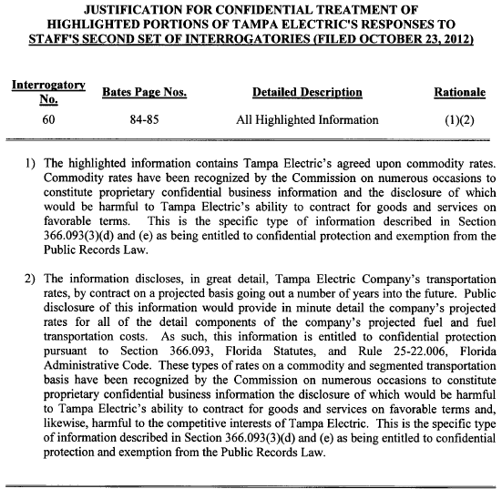

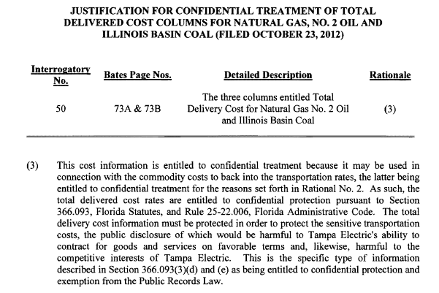
TECO’S JUSTIFICATION FOR DOCUMENT NO. 07212-12
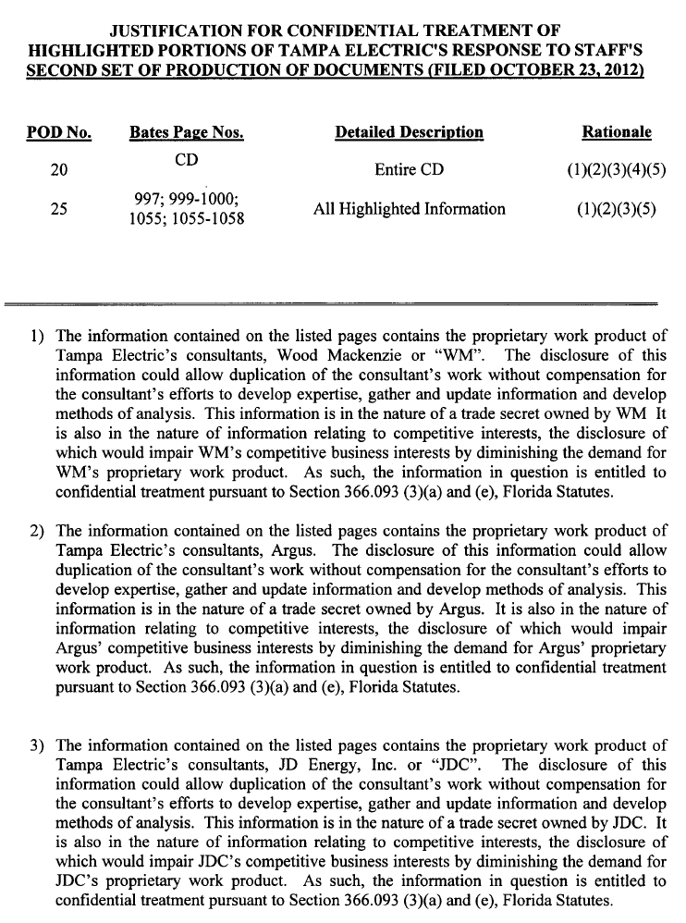

TECO is requesting confidential classification and a temporary protective order for its response to Commission Staff’s Interrogatory No. 50, not No. 60 as inadvertently listed in its justification for the request.
The justification is for TECO’s request for confidential classification for its response to Staff’s Interrogatory No. 50, not No. 60 as inadvertently listed on justification. TECO revised its request in the supplemental justification below.

