BEFORE THE FLORIDA PUBLIC SERVICE COMMISSION

In re: Complaint of Frederick Smallakoff against Progress Energy Florida, Inc. concerning alleged improper bills, Case No. 1059336E. | DOCKET NO. 120176-EI  ORDER NO. PSC-13-0124-PAA-EI  ISSUED: March 13, 2013

The following Commissioners participated in the disposition of this matter:

RONALD A. BRISÉ, Chairman
LISA POLAK EDGAR
ART GRAHAM
EDUARDO E. BALBIS
JULIE I. BROWN

NOTICE OF PROPOSED AGENCY ACTION
ORDER DENYING COMPLAINT

BY THE COMMISSION:

NOTICE is hereby given by the Florida Public Service Commission that the action discussed herein is preliminary in nature and will become final unless a person whose interests are substantially affected files a petition for a formal proceeding, pursuant to Rule 25-22.029, Florida Administrative Code.

Background
This consumer complaint was initially filed with this Commission’s Office of Consumer Assistance and Outreach (CAO) on April 4, 2012. In the complaint, Mr. Smallakoff alleged that his electric bills for his account with Progress Energy Florida, Inc. (PEF) were unusually high. Mr. Smallakoff claimed his February, March and April 2012 bills were excessive. Mr. Smallakoff further complained of an improper additional deposit being levied against him, an improper disconnection of electrical service, and disputed the subsequent reconnection fee. The total amount in dispute is $320. Commission staff’s informal investigations regarding Mr. Smallakoff’s complaint found that the meter tests and voltage studies that PEF conducted at Mr. Smallakoff’s residence were correctly performed, and that the equipment was operating within the limits specified by this Commission. Furthermore Commission staff has reviewed Mr. Smallakoff’s billing history, and we find from the information provided that the account has been billed consistently with PEF’s tariff and our rules and statutes. The following list is a summary of all of the activity that has been performed on behalf of Mr. Smallakoff in an effort to address his complaint.
- March 23, 2010 – PEF visited Mr. Smallakoff’s residence and tested meter number 001438327. The results of the meter test were: full load - 100.10%, light load - 100.11%, which yielded a weighted average of 100.10%. These results confirmed that the subject meter was recording electric consumption accurately in accordance with Rule 25-6.052(2), Florida Administrative Code (F.A.C.), which requires that a meter, when tested, must not register less than 98% or no more that 102%. Although conducted prior to the initiation of this complaint the results of this test were used in the evaluation of the complaint.
- March 20, 2012 – PEF records show Mr. Smallakoff’s service was interrupted for an alleged past due balance in the amount of $265.90. Mr. Smallakoff stated he would pay the balance under duress and made the payment in person at a pay station later that day. Mr. Smallakoff’s service was restored several hours later. PEF also imposed an additional security deposit of $280.00, which represented two months’ average billing. Subsequently, PEF agreed to break the requested deposit into six monthly installments of $46.67.
- March 28, 2012 - PEF visited Mr. Smallakoff’s residence a second time and tested meter number 001438327. The results of the meter test were: full load- 100.13%, light load - 100.13%, which yielded a weighted average of 100.13%. These results confirmed that the subject meter was recording electric consumption accurately in accordance with Rule 25-6.052(2), F.A.C.
- March 29, 2012 – At the request of Mr. Smallakoff, PEF removed meter number 001438327 and replaced it with a new meter identified as meter number 006292750.
- April 3, 2012 – PEF completed a shop test of meter number 001438327, the results of this third meter test were: full load - 100.09%, light load - 100.09%, which yielded a weighted average of 100.09%. These results confirmed that the subject meter was recording electric consumption accurately in accordance with Rule 25-6.052(2), F.A.C.
- April 5, 2012 – A PEF Senior Consumer Affairs Associate assigned to Mr. Smallakoff’s case recommended and offered to organize a Home Energy Audit of Mr. Smallakoff’s residence to identify any inefficiencies which may have an adverse impact on Mr. Smallakoff’s utility bills. Mr. Smallakoff declined this offer.
- April 23, 2012 – CAO staff reviewed PEF’s response to Mr. Smallakoff’s complaint. Upon reporting its findings back to Mr. Smallakoff, he stated that CAO’s response was incorrect with regards to its review of his account and the meter tests.
- April 24, 2012 – Based on Mr. Smallakoff’s continued dissatisfaction the complaint was forwarded to this Commission’s Process Review Group for escalation to the process review phase of the complaint progression in accordance with Rule 25-22.032(7), F.A.C.
- April 24, 2012 – Pursuant to Rule 25-22.032(3), F.A.C., PEF was sent notice that PEF must notify us of all communications it has with Mr. Smallakoff and that PEF could not disconnect Mr. Smallakoff for nonpayment of the disputed amount. On numerous occasions, Commission staff has informed Mr. Smallakoff that he is not obligated to pay the disputed amount ($320) until this complaint is resolved.
- May 4, 2012 – PEF conducted a second shop test of meter number 001438327 in the presence of Commission engineering safety staff. The results of this test were full load: 100.12%, light load: 100.12%, which yielded a weighted average of 100.12%. Commission engineering safety staff subsequently conducted its own test using a Commission-owned Probewell portable meter tester. The results of the Commission staff meter test were full load: 100.14%, light load: 100.16%, which yielded a weighted average of 100.26%. Commission engineering safety staff reported that an inspection of meter number 00143827 found no conditions indicative of meter tampering. Commission engineering safety staff also stated that the minor variations between the five tests of the meter were well within the expected variations of tests conducted on different days, under variable conditions and with different kinds of equipment.
- May 15, 2012 – The Process Review Group sent a letter to Mr. Smallakoff summarizing its review of his account activity and electrical consumption from April 2010 to March 2012. The Process Review Group found PEF has complied with all applicable statutes, rules, tariffs and orders of this Commission. As a result of Mr. Smallakoff’s continued dissatisfaction and his objection to the Process Review Group’s findings, the Consumer Affairs Office referred this complaint for Administrative Review to determine if informal complaint action was necessary or if the complaint should become the subject of a formal proceeding.
- June 4, 2012 – After a review of the complaint file, Commission legal staff sent Mr. Smallakoff another letter presenting Commission staff’s analysis and conclusions and included copies of an account audit summary and account energy consumption summary prepared by Commission staff. Commission legal staff concurred with the Process Review Group’s conclusion that it found PEF had complied with all applicable statutes, rules, tariffs and orders of this Commission.
- June 19, 2012 – The Commission Clerk received a written request from Mr. Smallakoff to open a formal complaint against PEF. This docket was subsequently opened.
- July 18, 2012 – Mr. Smallakoff contacted Commission legal staff to complain about a disconnection notice he had received. Subsequently PEF indicated it had sent out an automated notice, possibly in error, and promptly sent a notice to the customer to disregard the cutoff notice.
- On September 20, 2012 Commission staff agreed to provide Mr. Smallakoff additional time to provide documentation and to bring this matter and a separate complaint by Mr. Smallakoff regarding Florida Power & Light Company in Docket No. 060774-EI before this Commission simultaneously. Mr. Smallakoff was notified by mail of this extension.
- September 26, 2012 –A letter was sent to Mr. Smallakoff requesting that he furnish any information he may have in support of his complaint.
- On November 20, 2012 – Commission staff had not received a response to its September 26, 2012 letter; therefore, a second request was sent via certified mail. The certified letter was returned as unclaimed and the letter was resent via first class mail.
Decision
Alleged Excessive Usage and Billing

The focus of the complaint has been an assertion of excessive billing. Mr. Smallakoff maintains that his bills for February, March, and April 2012 were abnormally high and that his electric usage could not have legitimately increased by such a large percentage.

In order to more clearly understand this claim, we reviewed PEF's electric consumption history for Mr. Smallakoff’s service address for the 24-month period of April 28, 2010, through March 27, 2012, which encompassed 729 days. For analytical purposes, Commission staff prepared the attached Account Energy Consumption Comparison Summary (CCS) for that period of time (Attachment A).

Comparison Chart 1 reflects a side-by-side comparison of kilowatt hour (kWh) usage for the 729-day period from April 28, 2010, through March 27, 2012. As reflected on Chart 1, during the 364-day period from April 28, 2010, through March 28, 2011, Mr. Smallakoff consumed 15,581 kWh, an average daily usage of 43 kWh (line 13, column G). For the corresponding 365-day period from April 27, 2011, through March 27, 2012, Mr. Smallakoff consumed 13,701 kWh, an average daily usage of 38 kWh (line 13, column N), which is a moderate decrease of 11.6 percent from the previous year. Highlighted lines 9 through 12, columns A through G and columns H through N indicate the typical expected seasonal usage spike that occurs during the winter and early spring season, which occurs due to lower temperatures. Comparison Chart 1 does not reflect any unusual trends or extraordinary anomalies that would indicate skewed or disproportionate kWh consumption; in fact, as noted, Mr. Smallakoff’s kWh usage actually decreased from the previous year. We find the comparison chart reflects rather consistent usage from one year to the next.

Comparison Chart 2 represents Mr. Smallakoff’s kWh usage for 2010 and 2011 for the eight-month period immediately preceding the seasonal spike periods identified on lines 9 through 12. Comparison Chart 2 does not reflect any unusual trends or extraordinary anomalies that would indicate skewed or disproportionate kWh consumption; in fact, as noted previously, Mr. Smallakoff’s kWh usage actually decreased from the previous year. We find the comparison chart shows remarkably consistent usage from one year to the next.

Comparison Chart 3 compares Mr. Smallakoff’s kWh consumption during the seasonal winter spike period of December 23, 2010, through March 28, 2011, and for the same period of December 27, 2011, through March 27, 2012, which is the period of time of the disputed billing statements. Compared to the 2010/2011 period, Mr. Smallakoff’s 2011/2012 billed kWh usage decreased significantly. Average daily kWh usage decreased by 20.3 percent from 59 (line 27, column G) to 47 (line 27, column N). However, according to the National Weather Service, the winter of 2011/2012 was exceptionally mild; subsequently, it would be expected that Mr. Smallakoff’s electric consumption would decrease from the previous year. We also note that winter peak period kWh consumption was the lowest it has been in three years.

Meter Testing

On rare occasions, a defective or malfunctioning electric meter can contribute to unusually high or low electric bills. As a result, PEF conducted a meter test at Mr. Smallakoff’s residence on March 28, 2012. The results of the test confirmed the meter was functioning properly within guidelines established by this Commission. On March 29, 2012, meter number 001438327 was removed from the Smallakoff residence (at his request) and replaced with meter number 006292750. On April 3, 2012, PEF performed a bench test of meter number 001438327 at its facilities. For a second time, the results of the test confirmed that the meter was functioning properly within guidelines established by this Commission.

In accordance with Rule 25-6.060, F.A.C., Meter Test – Referee, at the request of Commission staff, on May 4, 2012, a witnessed inspection and meter test was performed on meter number 001438327, the meter previously removed from the Smallakoff residence on March 29, 2012. Commission staff witnessed the test at PEF's facilities. For a third time, the results of the test confirmed that the meter was functioning properly within Commission guidelines. This confirmation was further validated by an independent test conducted by Commission staff with a Commission-owned Probewell Portable Meter Tester, which obtained the same results. Furthermore, there was no evidence of meter tampering.

We note that on March 23, 2010, prior to the events in this complaint, PEF had conducted a test of meter number 001438327 at the Smallakoff residence, and at that time the results indicated the meter was functioning properly within guidelines established by this Commission.

Account Audit Summary

Commission staff prepared a chronological summary of actions taken by PEF in order to investigate and address any concerns raised by Mr. Smallakoff. Commission staff also prepared the attached Account Audit Summary (Attachment B), which reflects all transactions applied to Mr. Smallakoff’s account for the period of April 6, 2010, through April 28, 2012.

The chronological summary and Account Audit Summary shows that Mr. Smallakoff’s account history, over time, has been relatively consistent in terms of power consumption and billing assessments. It also illustrates considerable interaction between Mr. Smallakoff and PEF involving disputes over billing amounts, late fees and other service fees. Regardless of the outcome of these disputes, the Account Audit Summary shows that PEF has promptly applied the relevant credits or debits to Mr. Smallakoff’s account and has followed all relevant Commission rules, statutes and tariffs. Several significant facts are emphasized in the following chronology in reference to data on the Account Audit Summary which demonstrate both the interaction between the utility and the customer, as well the manner in which PEF managed Mr. Smallakoff’s account:

- March 29, 2010 - As reflected on line 1, column K of the Account Audit Summary, the account balance as of March 29, 2010, was $496.36.

- April 6, 2010 - As reflected on line 2, column H, the account was assessed a reconnection charge in the amount of $40.00. This yielded an account balance of $536.35 (line 2, column K).

- April 26, 2010 - The reconnection charge billed to the Smallakoff account on April 6, 2010, was waived and the account was issued a credit adjustment of $40.00 as reflected on line 4, column J. This yielded a new account balance of $503.80 (line 4, column K).

- April 28, 2010 - July 27, 2010 - Specific identified electric account debits and credits during this period of time are reflected on lines 5 - 52. The audit indicates that these debits and credits were properly applied to the account and that the account balance of $446.17 as of July 27, 2010, is accurate.

- August 1, 2011 - As reflected on line 53, column G, the account was assessed a reconnection fee in the amount of $50.00, which yielded a new account balance of $496.17 (line 53, column K).

- August 3, 2011 - February 27, 2012 - Specific identified electric account debits and credits during this period of time are reflected on lines 54 - 71. The audit indicates that these debits and credits were properly applied to the account and that the account balance of $451.87 as of February 27, 2012, is accurate (line 71, column K).

- March 20, 2012 - As reflected on line 72, column G, the account was assessed a reconnection charge in the amount of $40.00. This yielded an account balance in the amount of $491.87 as of March 20, 2012 (line 73, column K).

- March 21, 2012 - March 27, 2012 - Specific identified electric account debits and credits during this period of time are reflected on lines 73 - 75. The audit indicates that these debits and credits were properly applied to the account and that the account balance of $334.52 as of March 27, 2012, is accurate (line 75, column K).

- March 27, 2012 - A deposit assessment in the amount of $280.00 was assessed to the account on March 20, 2012. On March 26, 2012, PEF agreed to break payment of the deposit into six payments of $46.67 each. The first deposit assessment payment of $46.67 was posted to the account on March 27, 2012 (line 76, column G). This resulted in a new account balance in the amount of $381.19 (line 76, column K).

- April 26, 2012 - The account balance as of this date is $285.94 as reflected on line 79, column K.

Alleged Improper Disconnection

When the complaint was filed on April 4, 2012, Mr. Smallakoff indicated that his electric service was improperly disconnected without notice. As stated in Rule 25-6.105(5)(g), F.A.C., PEF or any other regulated electric utility may discontinue or refuse service for non-payment after a diligent attempt has been made to collect the unpaid amount, including at least five working days' written notice to the customer. PEF reported that on February 17, 2012, it sent a late notice that the account was past due by $265.90 (an undisputed amount which is not subject to this complaint). PEF further reported that Mr. Smallakoff contacted the company on March 14, 2012, attempting to obtain a payment extension for the past due amount. The payment extension request was denied. Additionally, a March 2012, billing statement for the billing period of January 26, 2010, through February 27, 2012, provided a statement: "Your account has a past due amount of $265.90 and electric service may be disconnected. Please pay immediately." Subsequently, in accordance with Rule 25-6.105, F.A.C., service was disconnected on March 20, 2012. Therefore, we find that service was properly disconnected at that time in compliance with the rule.

Disputed Reconnection Fee

Mr. Smallakoff disputed a reconnection fee of $40.00 that was billed to his account in association with the disconnection referenced above. It is his belief that he should not have been charged a reconnection fee, since he claimed he received no notice of disconnection. As previously explained, we find that he was given proper notice of disconnection. Furthermore, in accordance with PEF's Tariff, Section No VI, Eighteenth Revised Sheet No. 6.110, Establishment of Service, section 4, PEF is allowed to bill his account a charge of $40.00 for the reconnection of service after the service was disconnected for non-payment. We find that PEF did not violate any Commission rule or its tariff in assessing his account a reconnection fee of $40.00.

Alleged Unjustified and Excessive Deposit

Mr. Smallakoff complained that he was improperly assessed an additional deposit in the amount of $280.00. On March 20, 2012, Mr. Smallakoff’s service was interrupted due to alleged non-payment. Upon receipt of $265.90 later that day, Mr. Smallakoff’s service was restored and he was mailed a notice advising him that a security deposit in the amount of $280.00 would be required. This new deposit was in addition to an earlier deposit that was required at the time service commenced. The assessed deposit of $280.00 was calculated consistent with PEF’s tariff, by adding the previous 12 months billing yielding total charges of $1,694.11. PEF then divided that amount by 12 months yielding an average monthly billing in the amount of $141.18. PEF then multiplied $141.18 by two for a total of $282.36. PEF’s policy is to round down the deposit index to the nearest multiple of five, yielding a deposit index of $280.00.

In accordance with Rule 25-6.097(3), F.A.C., Customer Deposits, a utility may at any time require a new or additional deposit in order to secure payment of current bills. In doing so, the utility must provide at least 30 days’ written notice separate and apart from any bill for service and shall explain the reason for the new or additional deposit. Furthermore, the new or additional deposit may not exceed an amount equal to twice the average charges for actual electric usage for the twelve month period immediately prior to the date of notice. PEF's Tariff Section No. IV, Third Revised Sheet No. 4.070, section 7.03, reflects Rule 25-6.097(3), F.A.C., by stating that “The Company (PEF) may require upon written notice of not less than thirty (30) days a new deposit, where previously waived or returned, or additional deposit in order to secure payment of current bills.”

The utility sent a separate notice to Mr. Smallakoff assessing an additional deposit of $280.00 based on its statement that his payment history warranted an additional deposit to secure payment for current services. Payment of the deposit was not due for thirty days after the delivery of the notice and at the request of Mr. Smallakoff, payment of the deposit was broken into six monthly installments of $46.67. The method used to calculate the additional deposit yields an amount that is slightly less than twice the average charges for actual electric usage for the twelve month period immediately prior to the date of notice as specified by Rule 25-6.097(3), F.A.C., Therefore, we find that PEF was not in violation of Rule 25-6.097(3), F.A.C., or its tariff in assessing Mr. Smallakoff’s account a deposit of $280.00.

Conclusion

We find that Mr. Smallakoff’s account was properly billed in accordance with Commission rules, statutes, and PEF's tariffs. Mr. Smallakoff has presented no documentation or evidence that supports his contention that he was improperly billed or that his electric consumption is excessive; in fact, the available information shows his usage is the lowest it has been in three years. We find the additional deposit assessment has been accurately calculated and assessed. Furthermore, we find that PEF has not violated any jurisdictionally applicable provision of the Florida Statutes, the Florida Administrative Code, or its tariff in the handling of Mr. Smallakoff’s account. Therefore, we find that Mr. Smallakoff’s complaint shall be denied and the utility is entitled to collect the outstanding amount of $320.00 as previously billed.

Based on the foregoing, it is

ORDERED by the Florida Public Service Commission that Mr. Smallakoff’s complaint is denied. We find the disputed amount of $320 was properly billed in accordance with Commission statutes, rules, and PEF's tariffs. It is further

ORDERED that the provisions of this Order, issued as proposed agency action, shall become final and effective upon the issuance of a Consummating Order unless an appropriate petition, in the form provided by Rule 28-106.201, Florida Administrative Code, is received by the Commission Clerk, 2540 Shumard Oak Boulevard, Tallahassee, Florida 32399-0850, by the close of business on the date set forth in the “Notice of Further Proceedings” attached hereto. It is further

ORDERED that in the event this Order becomes final, this docket shall be closed.

By ORDER of the Florida Public Service Commission this 13th day of March, 2013.

HONG WANG
Chief Deputy Commission Clerk
Florida Public Service Commission
2540 Shumard Oak Boulevard
Tallahassee, Florida 32399
(850) 413-6770
www.floridapsc.com

Copies furnished: A copy of this document is provided to the parties of record at the time of issuance and, if applicable, interested persons.

MTL

NOTICE OF FURTHER PROCEEDINGS OR JUDICIAL REVIEW

The Florida Public Service Commission is required by Section 120.569(1), Florida Statutes, to notify parties of any administrative hearing that is available under Section 120.57, Florida Statutes, as well as the procedures and time limits that apply. This notice should not be construed to mean all requests for an administrative hearing will be granted or result in the relief sought.

Mediation may be available on a case-by-case basis. If mediation is conducted, it does not affect a substantially interested person's right to a hearing.

The action proposed herein is preliminary in nature. Any person whose substantial interests are affected by the action proposed by this order may file a petition for a formal proceeding, in the form provided by Rule 28-106.201, Florida Administrative Code. This petition must be received by the Office of Commission Clerk, 2540 Shumard Oak Boulevard, Tallahassee, Florida 32399-0850, by the close of business on April 3, 2013.

In the absence of such a petition, this order shall become final and effective upon the issuance of a Consummating Order.

Any objection or protest filed in this/these docket(s) before the issuance date of this order is considered abandoned unless it satisfies the foregoing conditions and is renewed within the specified protest period.

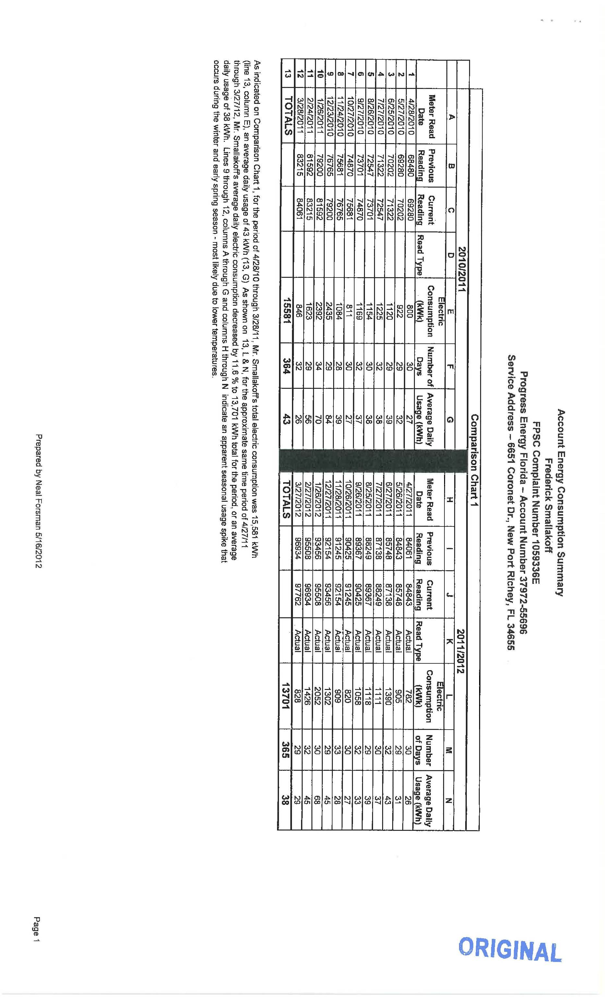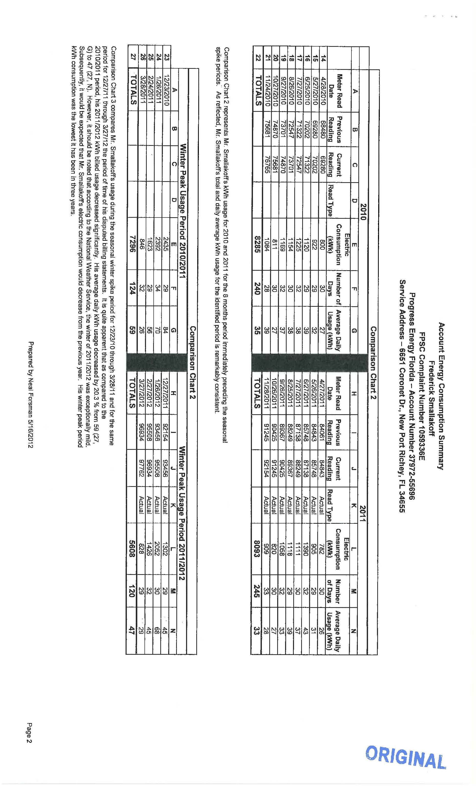

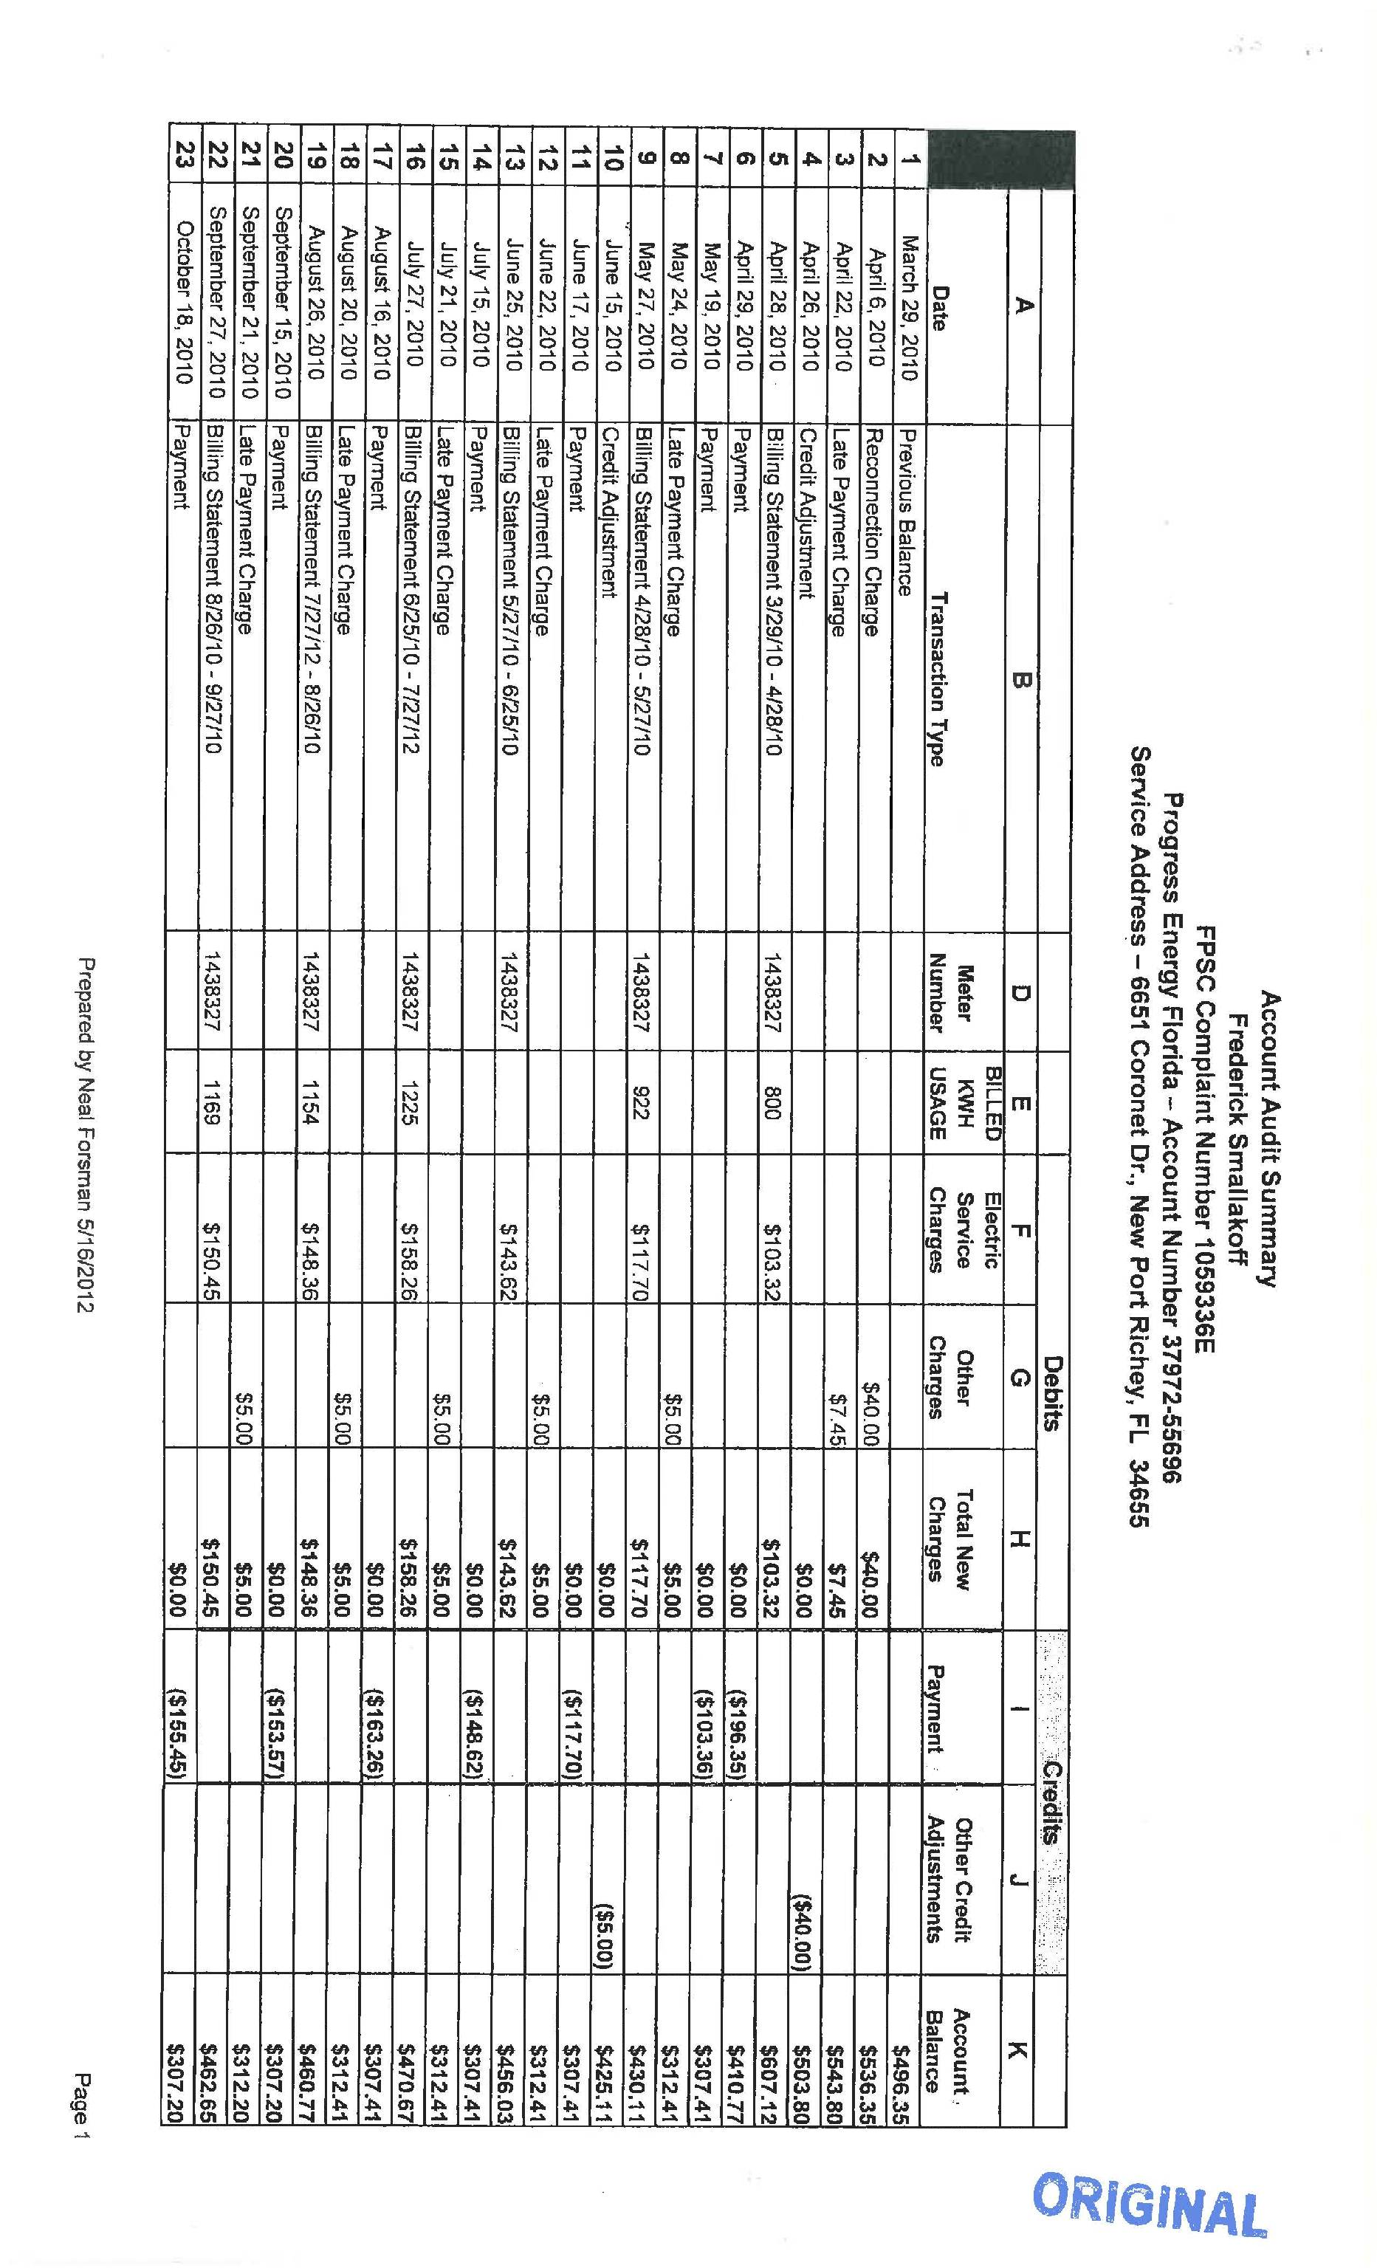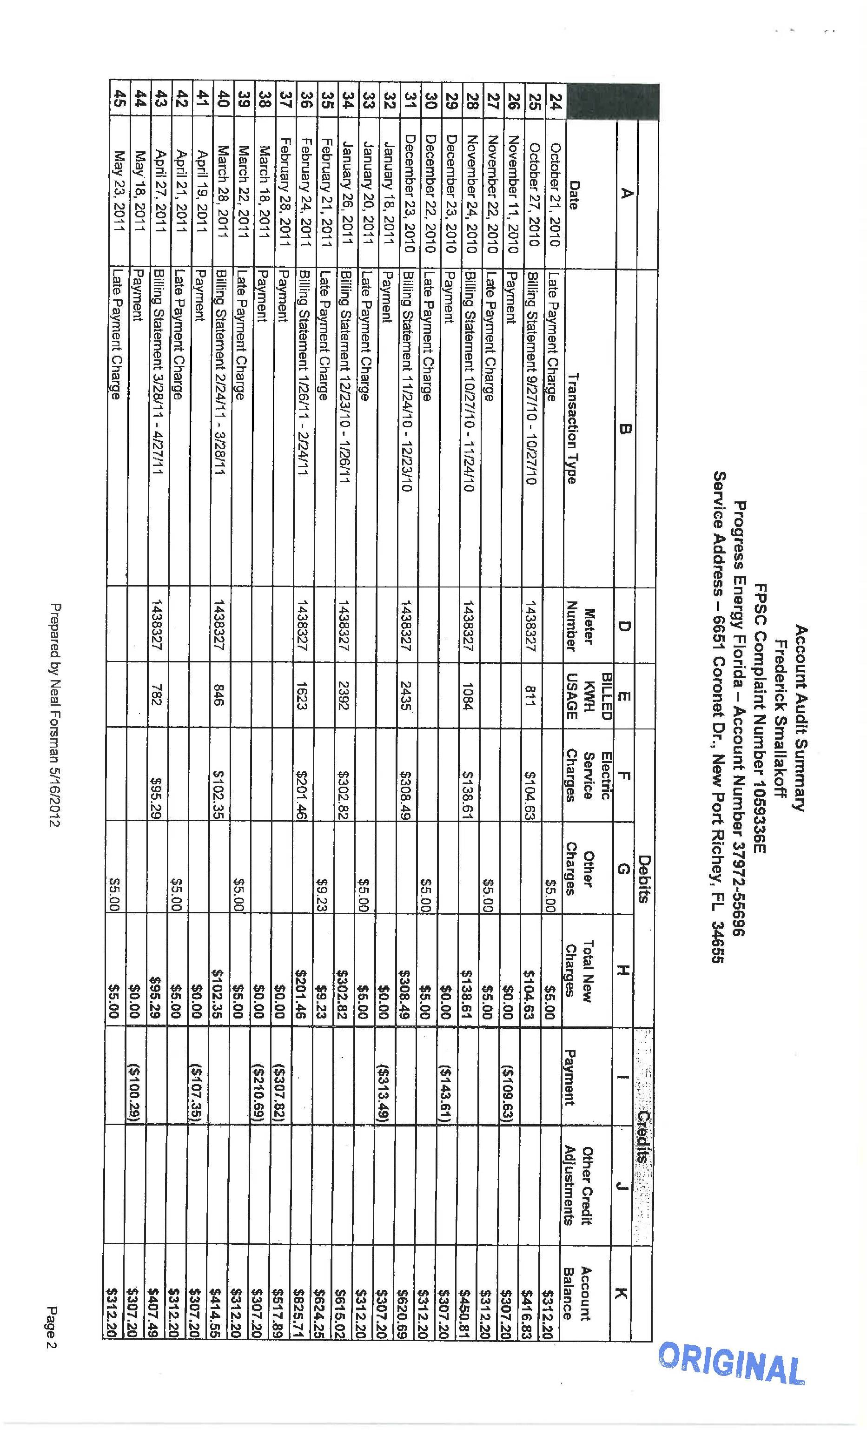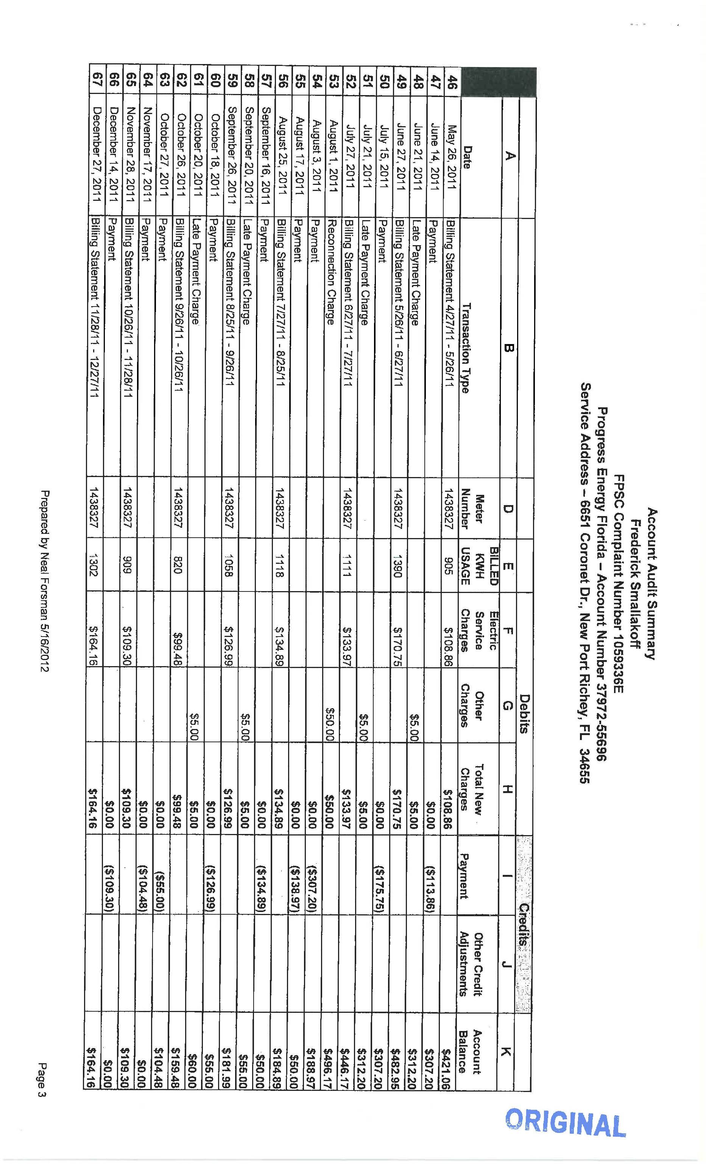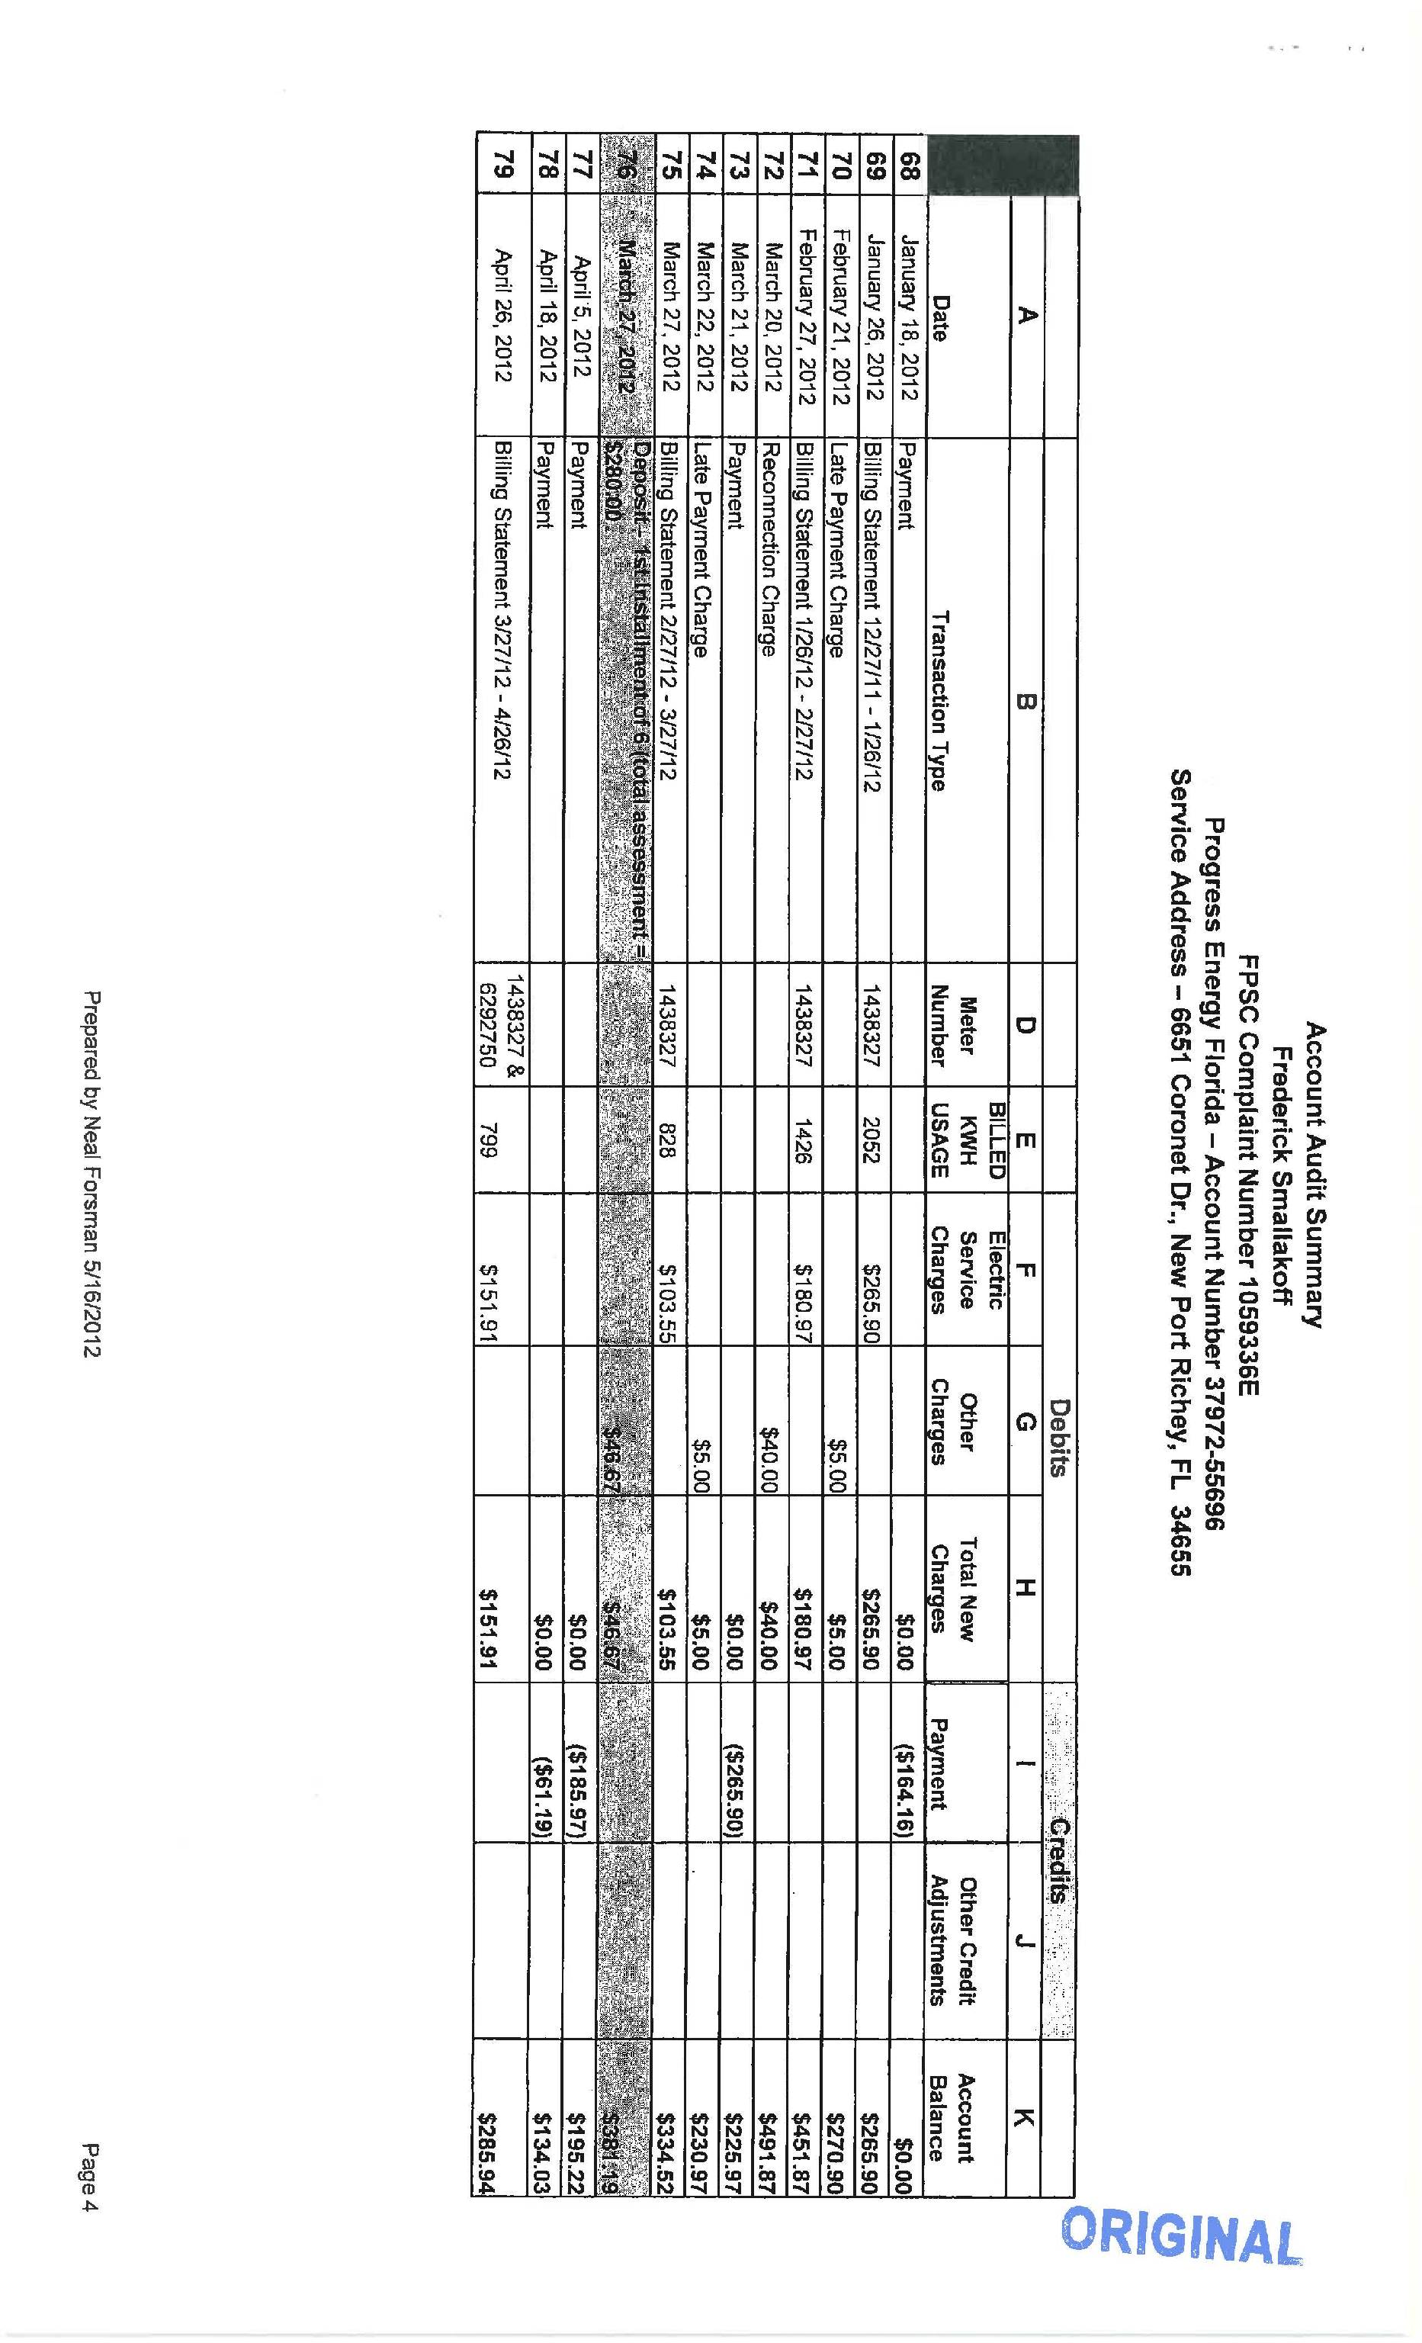

Complaint Number 1059336E

