BEFORE THE FLORIDA PUBLIC SERVICE COMMISSION

In re: Joint petition for approval of Gas Reliability Infrastructure Program (GRIP) by Florida Public Utilities Company and the Florida Division of Chesapeake Utilities Corporation. | DOCKET NO. 140166-GU  ORDER NO. PSC-14-0693-TRF-GU  ISSUED: December 15, 2014

The following Commissioners participated in the disposition of this matter:

ART GRAHAM, Chairman
LISA POLAK EDGAR
RONALD A. BRISÉ
EDUARDO E. BALBIS
JULIE I. BROWN

ORDER APPROVING TARIFFS

BY THE COMMISSION:

Background
On August 28, 2014, Florida Public Utilities Company (FPUC) and the Florida Division of Chesapeake Utilities Corporation (Chesapeake), collectively the Company, filed a petition seeking approval of 2015 Gas Reliability Infrastructure Program (GRIP) surcharges for their cast iron and bare steel pipe replacement programs. The GRIP program was approved in Order No. PSC-12-0490-TRF-GU (2012 order) to recover the cost of accelerated replacement of cast iron and bare steel distribution mains and services through a surcharge on customers’ bills. The Company’s currently effective surcharges were approved in Order No. PSC-13-0601-GU.
The 2012 Order addressed the reliability and safety rationale for pipeline replacement, the scope of the program, similar actions in other states, and the procedure for annually setting the GRIP surcharge to recover the costs of the program. The procedure requires an annual filing with three components:
- A final true-up showing the actual replacement costs, actual surcharge revenues, and over- or under-recovery amount for the 12-month historical period from January 1 through December 31 of the year prior to FPUC’s/Chesapeake’s annual GRIP petition.
- An actual/estimated true-up showing seven months of actual and five months of projected replacement costs, surcharge revenues, and over- or under-recovery amount.
- A revenue requirement projection showing 12 months of projected GRIP revenue requirement for the period beginning January 1 following FPUC’s/Chesapeake/s annual GRIP petition filing.
We concluded the 2012 Order by stating:
Replacement of bare steel pipelines is in the public interest to improve the safety of Florida’s natural gas infrastructure, thereby reducing the risk to life and property. Given the length of time these pipelines have been installed and the leak history due to corrosion, we find that it is appropriate to approve the proposed replacement program. Without the GRIP surcharge, it is reasonable to expect that FPUC/Chesapeake will have to file for more frequent base rate proceedings to recover the expenses of an accelerated replacement program. The annual filings will provide us with the oversight to ensure that projected expenses are trued-up and only actual costs are recovered. FPUC’s/Chesapeake’s GRIP and its associated surcharges will terminate when all replacements have been made and the revenue requirement rolled into rate base.
On October 15, 2014, the Company filed its responses to Commission staff’s First Data Request. On October 17, 2014, the Company filed an amended response to Commission staff’s First Data Request, No. 5. On October 21, 2014, the Company filed its responses to the Office of Public Counsel’s First Set of Interrogatories and First Request for Production of Documents. We have jurisdiction over this matter pursuant to Sections 366.03, 366.04, 366.05, and 366.06, Florida Statutes (F.S.).

Decision

The GRIP surcharges have been in effect since January 2013. In response to Commission staff’s data request, the Company explained that it is accelerating its infrastructure replacement. FPUC’s original projection was to replace 34 percent of the eligible infrastructure in the first two years. By the end of 2015 (the third year), FPUC forecasts that it will have completed 50 percent of the mains and 63 percent of the services. Similarly, Chesapeake’s original projection was to replace 20 percent of the infrastructure in the first two years; however, by the end of 2015, Chesapeake forecasts that it will have replaced 39 percent of the mains and 46 percent of the services. Attachments 1 and 2 show the progress for the 10-year main and service replacement programs for FPUC and Chesapeake, respectively.
According to the Company costs have increased in recent years. The weighted average cost per mile of main for FPUC and Chesapeake used in calculating the 2015 GRIP surcharge is $193,796. The 2009-2011 replacement cost per mile was $174,258. Similarly, the cost to replace a service has increased. According to the Company, factors that contribute to increased costs include the type of replacement project, inflation, cost of outside contractors, requirements of city and county officials, and population density.
The 2012 Order required FPUC and Chesapeake to report any depreciation and operations and maintenance expense savings in their annual petitions for recovery of the GRIP surcharge, beginning with the second annual petition. FPUC’s and Chesapeake’s 2013 depreciation expenses were reduced by $29,944 and $13,262, respectively, due to savings from the GRIP program. FPUC and Chesapeake have not yet determined whether there are fewer leak surveys; thus, no operations and maintenance savings have been included in this filing.
FPUC’S GRIP SURCHARGE FACTORS FOR 2015
FPUC has had a bare steel replacement and recovery program in place since 2005. In FPUC’s 2008 rate case, we approved an annual expense of $747,727 associated with the program to be included in base rates. The amount included in base rates is excluded from the GRIP surcharge calculation. FPUC’s calculations for the 2015 revenue requirement and surcharges include a final true-up amount for 2013, an actual/estimated true-up for 2014, and projected costs for 2015.
Final True-up for 2013. The final true-up for 2013 includes 2012’s over-recovery of $243,238. To calculate the 2013 true-up, FPUC calculated the difference between the revenue requirement in base rates, $747,727, and the 2013 actual revenue requirement, $811,114, producing a net revenue requirement of $63,387. The revenue requirement includes the return on investment, depreciation expense, customer notification, and ad valorem taxes associated with the investment. FPUC reported actual 2013 GRIP revenues of $258,936. When the revenue requirement is subtracted from 2013 revenues, there is an over-recovery of $195,550. Adding the 2012 over-recovery of $243,238, and interest of $418, results in a final true-up (over-recovery) of $439,206, as shown below:

Annual Revenue Requirement in Base Rates | $747,727
2013 GRIP Revenue Requirement | $811,114
Net Revenue Requirement | $63,387
2013 GRIP Revenues | $258,936
2013 True-up (Over-recovery) | $195,550
2012 True-up (Over-recovery) | $243,238
Interest | $418
Final True-up for 2013 (Over-recovery) | $439,206

Actual/Estimated 2014 true-up. To calculate the 2014 true-up, FPUC calculated the difference between the revenue requirement in base rates, $747,727, and the 2014 actual (January through July) and estimated (August through December) revenue requirement, $2,850,582, producing a deficit of $2,102,855. FPUC reported actual/estimated revenues for 2014 of $690,391. When the 2014 estimated revenues are subtracted from the revenue requirement, the 2014 under-recovery including interest is $1,412,567. The final 2013 over-recovery serves as a partial offset, resulting in an under-recovery for 2014 of $973,361 as shown below:

Annual Revenue Requirement in Base Rates | $747,727
2014 GRIP Revenue Requirement | $2,850,582
Net Revenue Requirement | $2,102,855
2014 GRIP Revenues | $690,391
Under-Recovery | $1,412,464
Interest Provision | $103
True-up for 2014 (Under-Recovery) | $1,412,567
Final True-up for 2013 (Over-Recovery) | $439,206
Total 2013 and 2014 Under-Recovery | $973,361

Projected 2015 Costs. FPUC projects to spend $6,139,178 for the replacement of cast iron/bare steel infrastructure in 2015. The return on investment, depreciation, customer notification, and ad valorem tax expenses associated with that investment are $3,924,377.
Subtracting the revenue requirement for bare steel replacement investment included in base rates results in a 2015 revenue requirement of $3,176,650. Finally, the total 2013 and 2014 under-recovery, $973,361, is added to the 2015 revenue requirement to produce a total 2015 revenue requirement of $4,150,011 as shown below:

2015 Projected Expenditures | $6,139,178
Return on Investment | $2,779,059
Depreciation Expense | $631,181
Tax and Customer Notice Expenses | $514,138
Revenue Requirement | 3,924,377
Less Revenue Requirement in Base Rates | ($747,727)
2015 GRIP Revenue Requirement | 3,176,650  4
Plus Prior Period Under-Recovery | $973,361
Projected 2015 GRIP Costs | $4,150,011

The calculation of the GRIP surcharges by rate class is shown in Attachment 3 to this Order. As established in the order approving the GRIP, the total 2015 revenue requirement is allocated to the rate classes using the same methodology that was used for the allocation of mains and services in the cost of service study used in FPUC’s most recent rate case. After calculating the percentage of total plant costs attributed to each rate class, the respective percentages were multiplied by the 2015 revenue requirement, resulting in the revenue requirement by rate class. Dividing each rate class’ revenue requirement by projected therm sales provides the GRIP surcharge for each rate class. The GRIP surcharge for residential customers is $0.10516 per therm. The monthly bill impact is $2.10 for a residential customer who uses 20 therms. Attachment 3 displays the rate schedule and Attachment 4 displays the proposed tariff page.
CHESAPEAKE’S GRIP SURCHARGE FACTORS FOR 2015
Chesapeake does not have a replacement recovery amount embedded in base rates and has in the past replaced its infrastructure as conditions warranted.
Final True-up for 2013. The final true-up for 2013 includes 2012’s under-recovery of $16,886. To calculate the 2013 true-up, Chesapeake calculated the difference between the revenue requirement of $446,032 and revenues of $523,677; this resulted in an over-recovery of $77,645. Adding interest of $55 and subtracting the 2012 under-recovery of $16,886 results in a final 2013 true-up (over-recovery) of $60,814, as shown below:

2013 GRIP Revenue Requirement | $446,032
2013 GRIP Revenues | $523,677
2013 True-up (Over-recovery) | $77,645
2012 True-up (Under-recovery) | $16,886
Interest | $55
Final True-up for 2013 (Over-recovery) | $60,814

Actual/Estimated 2014 true-up. To calculate the 2014 true-up, Chesapeake reported the actual/estimated revenue requirement of $949,326, actual/estimated revenues of $663,069 and interest of $20. Using the final 2013 over-recovery to offset 2014’s under-recovery results in a total under-recovery of $225,373 as shown below:

2014 GRIP Revenues | $663,069
2014 GRIP Revenue Requirement | $949,236
Under-Recovery | $286,167
Interest Provision | $20
2014 Total Under-Recovery | $286,187
Final 2013 Over-Recovery | $60,814
Total 2013 and 2014 Under-Recovery | $225,373

Projected 2015 costs. Chesapeake projects to spend $2,912,259 in 2015. The return on that amount plus investment expenses are $1,395,647. Finally, the total 2013 and 2014 under-recovery, $225,373, is added to provide the total 2015 revenue requirement of $1,621,020 as shown below.
2015 Projected Expenditures | $2,912,259
Return on Investment | $919,980
Depreciation Expense | $301,447
Tax and Customer Notice Expenses | $174,220
2015 Revenue Requirement | $1,395,647
Plus Prior Period Under-Recovery | $225,373
Projected 2015 Costs | $1,621,020

The calculation of Chesapeake’s GRIP surcharges by rate class is shown in Attachment 5 to this Order. The GRIP surcharge for residential customers on the FTS-1 rate is $0.05713 per therm. The monthly bill impact for a residential customer who uses 20 therms is $1.14. Attachment 5 displays the rate schedule and Attachments 6 and 7 display the proposed tariff pages.
Conclusion
We find that the calculation of FPUC and Chesapeake’s GRIP revenue requirement and surcharges for each rate class is reasonable and accurate. Therefore, we approve FPUC and Chesapeake’s proposed GRIP surcharges for 2015. The effective date of the tariffs shall be January 1, 2015.

Based on the foregoing, it is

ORDERED by the Florida Public Service Commission that Florida Public Utilities Company and the Florida Division of Chesapeake Utilities Corporation joint petition of Gas Reliability Infrastructure Program is approved. It is further

ORDERED that the effective date of the tariffs shall be January 1, 2015. It is futher

ORDERED that if a protest is filed within 21 days of issuance of the Order, the tariff shall remain in effect with any revenues held subject to refund, pending resolution of the protest. It is further

ORDERED that if no timely protest is filed, this docket shall be closed upon the issuance of a Consummating Order.

By ORDER of the Florida Public Service Commission this 15th day of December, 2014.

/s/ Carlotta S. Stauffer
CARLOTTA S. STAUFFER
Commission Clerk
Florida Public Service Commission
2540 Shumard Oak Boulevard
Tallahassee, Florida 32399
(850) 413-6770
www.floridapsc.com

Copies furnished: A copy of this document is provided to the parties of record at the time of issuance and, if applicable, interested persons.

KY

NOTICE OF FURTHER PROCEEDINGS

The Florida Public Service Commission is required by Section 120.569(1), Florida Statutes, to notify parties of any administrative hearing or judicial review of Commission orders that is available under Sections 120.57 or 120.68, Florida Statutes, as well as the procedures and time limits that apply. This notice should not be construed to mean all requests for an administrative hearing or judicial review will be granted or result in the relief sought.

Mediation may be available on a case-by-case basis. If mediation is conducted, it does not affect a substantially interested person's right to a hearing.

The Commission's decision on this tariff is interim in nature and will become final, unless a person whose substantial interests are affected by the proposed action files a petition for a formal proceeding, in the form provided by Rule 28-106.201, Florida Administrative Code. This petition must be received by the Office of Commission Clerk, 2540 Shumard Oak Boulevard, Tallahassee, Florida 32399-0850, by the close of business on January 5, 2015.

In the absence of such a petition, this Order shall become final and effective upon the issuance of a Consummating Order.

Any objection or protest filed in this docket before the issuance date of this order is considered abandoned unless it satisfies the foregoing conditions and is renewed within the specified protest period.
FLORIDA PUBLIC UTILITIES COMPANY
Mains (Miles)
Year | Replaced Cast Iron | Replaced Bare Steel | Remaining Cast Iron at Year-End | Remaining Bare Steel at Year-End | Total Remaining
Jul-12 |  |  | 0.9 | 197.10 | 198.00
2012 |  | 6.00 | 0.9 | 191.10 | 192.00
2013 | 0.6 | 26.40 | 0.3 | 164.70 | 165.00
2014 |  | 36.40 | 0.3 | 128.30 | 128.60
2015 |  | 25.00 | 0.3 | 103.30 | 103.60
2016 |  | 19.60 | 0.3 | 83.70 | 84.00
2017 | 0.3 | 13.70 | 0 | 70.00 | 70.00
2018 |  | 14.00 | 0 | 56.00 | 56.00
2019 |  | 14.00 | 0 | 42.00 | 42.00
2020 |  | 14.00 | 0 | 28.00 | 28.00
2021 |  | 14.00 | 0 | 14.00 | 14.00
2022 |  | 14.00 | 0 | 0.00 | 0.00
Number of Services
Year | Replaced Cast Iron | Replaced Bare Steel | Remaining Cast Iron at Year-End | Remaining Bare Steel at Year-End | Total Remaining
Jul-12 |  |  |  | 7980 | 7980
2012 |  | 91 | 0 | 7889 | 7889
2013 |  | 2071 | 0 | 5818 | 5818
2014 |  | 2111 | 0 | 3707 | 3707
2015 |  | 741 | 0 | 2966 | 2966
2016 |  | 424 | 0 | 2542 | 2542
2017 |  | 424 | 0 | 2118 | 2118
2018 |  | 424 | 0 | 1694 | 1694
2019 |  | 424 | 0 | 1270 | 1270
2020 |  | 424 | 0 | 846 | 846
2021 |  | 424 | 0 | 422 | 422
2022 |  | 422 | 0 | 0 | 0

FLORIDA DIVISION OF CHESAPEAKE UTILITIES CORPORATION
Mains (Miles)
Year | Replaced Cast Iron | Replaced Bare Steel | Remaining Cast Iron at Year-End | Remaining Bare Steel at Year-End | Total Remaining
Jul-12 |  |  |  | 152 | 152
2012 |  | 5 | 0 | 147 | 147
2013 |  | 3 | 0 | 144 | 144
2014 |  | 33 | 0 | 111 | 111
2015 |  | 14 | 0 | 97 | 97
2016 |  | 14 | 0 | 83 | 83
2017 |  | 14 | 0 | 69 | 69
2018 |  | 14 | 0 | 55 | 55
2019 |  | 14 | 0 | 41 | 41
2020 |  | 14 | 0 | 27 | 27
2021 |  | 14 | 0 | 13 | 13
2022 |  | 13 | 0 | 0 | 0
Number of Services
Year | Replaced Cast Iron | Replaced Bare Steel | Remaining Cast Iron at Year-End | Remaining Bare Steel at Year-End | Total Remaining
Jul-12 |  |  |  | 762 | 762
2012 |  | 34 | 0 | 728 | 728
2013 |  | 139 | 0 | 589 | 589
2014 |  | 97 | 0 | 492 | 492
2015 |  | 82 | 0 | 410 | 410
2016 |  | 59 | 0 | 351 | 351
2017 |  | 59 | 0 | 292 | 292
2018 |  | 59 | 0 | 233 | 233
2019 |  | 59 | 0 | 174 | 174
2020 |  | 58 | 0 | 116 | 116
2021 |  | 58 | 0 | 58 | 58
2022 |  | 58 | 0 | 0 | 0

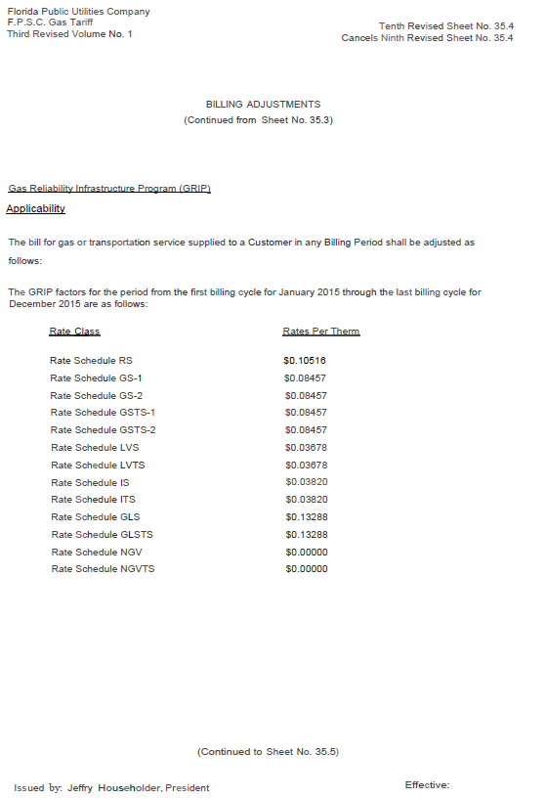
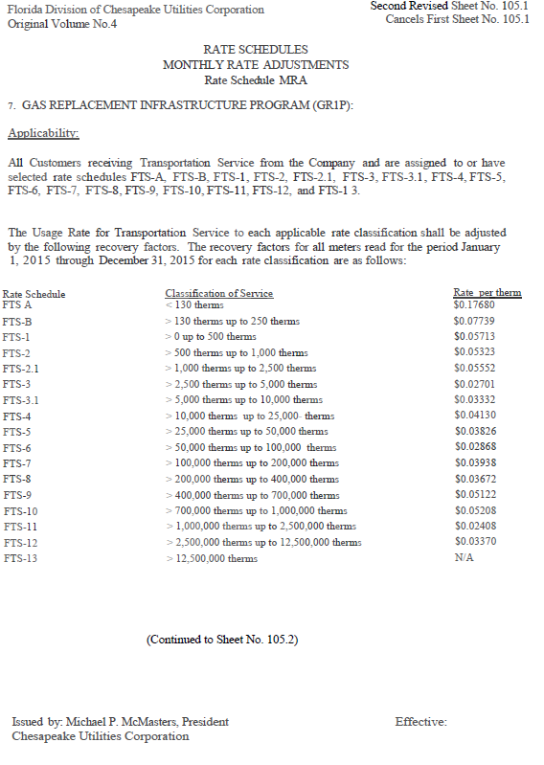
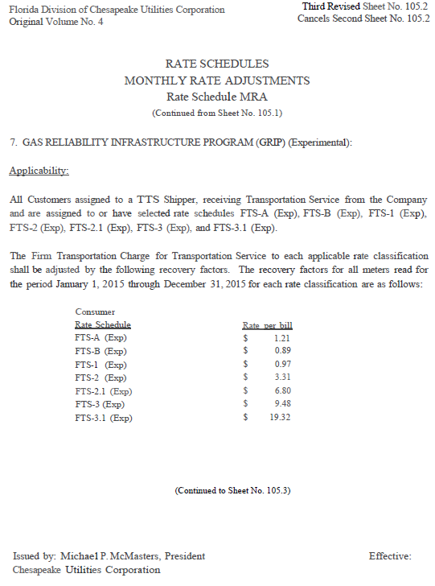

Order No. PSC-12-0490-TRF-GU, issued September 24, 2012, in Docket No. 120036-GU, In re: Joint petition for approval of Gas Reliability Infrastructure Program (GRIP) by Florida Public Utilities Company and the Florida Division of Chesapeake Utilities Corporation.
Order No. PSC-13-0601-TRF-GU, issued November 13, 2013, in Docket No. 120036-GU.
2012 order, page 19.
The 2012 Order allowed the Company to include a final true-up for pipeline replacement costs incurred for the period August 14, 2012, through December 31, 2012.

