BEFORE THE FLORIDA PUBLIC SERVICE COMMISSION

In re: Commission review of numeric conservation goals (Florida Power & Light Company). | DOCKET NO. 130199-EI
In re: Commission review of numeric conservation goals (Duke Energy Florida, Inc.). | DOCKET NO. 130200-EI
In re: Commission review of numeric conservation goals (Tampa Electric Company). | DOCKET NO. 130201-EI
In re: Commission review of numeric conservation goals (Gulf Power Company). | DOCKET NO. 130202-EI
In re: Commission review of numeric conservation goals (JEA). | DOCKET NO. 130203-EM
In re: Commission review of numeric conservation goals (Orlando Utilities Commission). | DOCKET NO. 130204-EM
In re: Commission review of numeric conservation goals (Florida Public Utilities Company). | DOCKET NO. 130205-EI  ORDER NO. PSC-14-0696-FOF-EU  ISSUED: December 16, 2014

The following Commissioners participated in the disposition of this matter:

ART GRAHAM, Chairman
LISA POLAK EDGAR
RONALD A. BRISÉ
EDUARDO E. BALBIS
JULIE I. BROWN

APPEARANCES:

JOHN T. BUTLER, JESSICA CANO, and KEVIN I. C. DONALDSON, ESQUIRES,
700 Universe Boulevard, Juno Beach Florida 33408-0420
On behalf of Florida Power & Light Company (FPL).

DIANNE TRIPLETT, JOHN BURNETT and MATTHEW R. BERNIER, ESQUIRES, 299 First Avenue N. FL-151, St. Petersburg, FL 33701
On behalf of Duke Energy Florida (DEF).
JAMES D. BEASLEY, J. JEFFRY WAHLEN, and ASHLEY M. DANIELS, ESQUIRES,
Post Office Box 391, Tallahassee, FL, 32302
On behalf of Tampa Electric Company (TECO).

RUSSELL A. BADDERS, and STEVEN R. GRIFFIN, ESQUIRES,
Post Office Box 12950, Pensacola, FL 32591-2950
On behalf of Gulf Power Company (GULF).

GARY V. PERKO and BROOKE E. LEWIS, ESQUIRES,
119 S. Monroe Street, Suite 300, Tallahassee, FL 32301
On behalf of JEA (JEA).

JOHN S. FINNIGAN, ESQUIRE,
128 Winding Brook Lane, Cincinnati, OH 45174
On behalf of Environmental Defense Fund (EDF).

JON MOYLE, JR. and KAREN A. PUTNAL, ESQUIRES,
118 North Gadsden Street, Tallahassee, FL, 32312
On behalf of Florida Industrial Power Users Group (FIPUG).

ALTON E. DREW, ESQUIRE,
667 Peeples Street, SW, #4, Atlanta, GA, 30310
On behalf of National Association for the Advancement of Colored People (NAACP).

JAMES W. BREW, ESQUIRE,
1025 Thomas Jefferson St., NW, Eighth Floor, West Tower, Washington, DC 20007
On behalf of White Springs Agricultural Chemicals, Inc., d/b/a PCS Phosphate- White Springs (PCS Phosphate).

DAVID GUEST, ALISA COE, GEORGE CAVROS, and JILL M. TAUBER, ESQUIRES
111 S. Martin Luther King Jr. Blvd, Tallahassee, FL 32301
120 E. Oakland Park Blvd., Suite 105, Fort Lauderdale, FL 33334
1625 Massachusetts Ave. NE, Suite 702, Washington, D.C. 20036
On behalf of Southern Alliance for Clean Energy (SACE).

DIANA A. CSANK, ESQUIRE,
50 F. Street NW, 8th Floor, Washington D.C., 20001
On behalf of Sierra Club (SIERRA CLUB).

ROBERT SCHEFFEL WRIGHT and JOHN T. LAVIA III, ESQUIRES,
1300 Thomaswood Drive, Tallahassee, FL 32308
On behalf of Wal-Mart Stores, East, LP and Sam’s East, Inc. (WALMART).

STEVEN L. HALL, ESQUIRE,
407 South Calhoun Street, Suite 520, Tallahassee, FL 32399
On behalf of Florida Department of Agriculture and Consumer Services (FDACS).

ERIK L. SAYLER, and J.R. KELLY, ESQUIRES
111 West Madison Street, Room 812, Tallahassee, FL 32399-1400
On behalf of Office of the Public Counsel (OPC).

CHARLES W. MURPHY, LEE ENG TAN, and KELLEY F. CORBARI, ESQUIRES, Florida Public Service Commission, 2540 Shumard Oak Boulevard, Tallahassee, Florida 32399-0850
On behalf of the Florida Public Service Commission (Staff).

MARY ANNE HELTON, ESQUIRE, Deputy General Counsel, Florida Public Service Commission, 2540 Shumard Oak Boulevard, Tallahassee, Florida 32399-0850
Advisor to the Florida Public Service Commission.

S. CURTIS KISER, ESQUIRE, General Counsel, Florida Public Service Commission, 2540 Shumard Oak Boulevard, Tallahassee, Florida 32399-0850
Advisor to the Florida Public Service Commission.

FINAL ORDER APPROVING NUMERIC CONSERVATION GOALS

BY THE COMMISSION:

Background
Sections 366.80 through 366.85, and 403.519, Florida Statutes (F.S.), are known collectively as the Florida Energy Efficiency and Conservation Act (FEECA). The seven utilities subject to FEECA, collectively known as the FEECA Utilities, are Florida Power & Light Company (FPL), Duke Energy Florida, Inc. (DEF), Tampa Electric Company (TECO), Gulf Power Company (Gulf), Florida Public Utilities Company (FPUC), JEA, and Orlando Utilities Commission (OUC). Pursuant to Section 366.82(6), F.S., we must review the conservation goals of each utility subject to FEECA at least every five years. FEECA goals were last established for these utilities by Order No. PSC-09-0855-FOF-EG, issued December 30, 2009. Therefore, new goals may be established by January 2015.
An informal meeting was held on June 17, 2013, with the FEECA Utilities and interested parties to discuss the current numeric goals proceeding. In an effort to streamline the proceeding and minimize costs, our staff recommended and the parties agreed that the Technical Potential Study used in the previous numeric goals proceeding, Docket Nos. 080407-EG through 080413-EG, should be updated, instead of performing a completely new study. Further, parties discussed minimum testimony requirements and what level of analysis could be reasonably conducted by the parties within the timeframe of the docket. Consistent with Order No. PSC-09-0855-FOF-EG in the previous goals proceeding, parties agreed that supply-side efficiencies would not be addressed in this proceeding. On July 26, 2013, seven dockets were established to set numeric conservation goals for each of the FEECA Utilities, the fifth such proceeding.
By the Order Establishing Procedure (OEP), Order No. PSC-13-0386-PCO-EU, issued August 19, 2013, the dockets for each of the affected Utilities were consolidated for purposes of hearing and controlling dates were established. The Order established minimum testimony requirements for the FEECA Utilities, including a description of how the Technical Potential Study was updated, economic and achievable potential for a base case, sensitivities on fuel prices, free-ridership periods, and carbon dioxide costs, as well as information on their Solar Pilot programs.
By Order No. PSC-14-0112-PCO-EU, issued February 26, 2014, the controlling dates were revised, moving the hearing to July 21-23, and July 30-31, 2014. Order No. PSC-14-0154-PCO-EU, issued April 7, 2014, established the issues for the dockets. Pursuant to Order No. PSC-14-0189-PCO-EU, issued April 22, 2014, the controlling dates were modified to extend the intervenor and rebuttal testimony deadlines to May 19, 2014, and June 10, 2014, respectively.
On August 23, 2013, FPUC filed a petition requesting to establish its numeric goals by use of a proxy methodology and to waive the filing requirements of Order No. PSC-13-0386-PCO-EU. On October 2, 2013, OUC filed a petition requesting to establish its numeric goals by use of a proxy methodology, similar to the request filed by FPUC.
By Order No. PSC-13-0645-PAA-EU, issued December 4, 2013, we approved the use of a proxy methodology to establish the numeric goals for both OUC and FPUC. By using a proxy methodology, OUC and FPUC were able to avoid costs associated with performing the analyses required by the minimum testimony requirements which would have represented a hardship to their customers. Both OUC and FPUC were excused from the filing and participation requirements of the July 2014 hearing. However, both OUC and FPUC will be responsible for filing numeric conservation goals based upon the proxy utilities, TECO and Gulf, respectively, within ten days of a Final Order establishing goals for those utilities. We granted our staff administrative authority to validate the calculations of the respective numeric conservation goals submitted by OUC and FPUC who shall file their respective demand side management plans within 90 days of the Final Orders establishing goals for their respective proxies.
We acknowledged the intervention of the Florida Department of Agriculture and Consumer Services (FDACS) on September 10, 2013. The Sierra Club and the Florida Industrial Power Users Group (FIPUG) were granted leave to intervene on February 7, 2014. The Southern Alliance for Clean Energy (SACE) and White Springs Agriculture Chemicals, Inc. d/b/a PCS Phosphate (PCS Phosphate) were granted leave to intervene on March 18, 2014. Wal-Mart Stores East, LP and Sam’s East, Inc. (collectively referred to as Walmart) were granted leave to intervene on April 7, 2014. The Environmental Defense Fund (EDF) was granted leave to intervene on May 16, 2014. We acknowledged the intervention of the Office of Public Counsel (OPC) on May 29, 2014. The Florida State Conference of the National Association for the Advancement of Colored People (NAACP) was granted leave to intervene by the Prehearing Order on July 11, 2014.
We held an evidentiary hearing on July 21, 22, and 23, 2014. During the hearing, we approved a stipulation to establish goals for JEA based upon the savings associated with core measures JEA intends to offer its electric customers. A copy of this stipulation is included as Attachment A. We have jurisdiction over this matter pursuant to Sections 366.80 through 366.82, F.S.

TECHNICAL POTENTIAL STUDY
FPL stated that the update to the 2009 Technical Potential Study provided an adequate assessment of the full technical potential of all measures, with collaboration among all FEECA utilities and extensive analytical work to ensure it was thoroughly comprehensive. DEF stated that it utilized the agreed-upon methodology for updating the 2009 Technical Potential Study. TECO asserted that the practice of updating a previous Technical Potential Study has been utilized in previous goal-setting proceedings when the foundational data was deemed to still be accurate, and that it is appropriate in this case. At the publicly noticed workshop meeting on June 17, 2013, Gulf asserted that the parties and our staff agreed that an update to the 2009 Technical Potential Study was appropriate, rather than undertaking an entirely new study.
FDACS asserts that all parties present at the June 17, 2013, workshop agreed to the update of the 2009 Technical Potential Study, and the resulting 2014 Technical Potential Study represents a collaborative update of the previous study which was approved by us as adequate. NAACP stated that the assessment of the full technical potential of all available demand-side and supply-side conservation and energy efficiency measures is adequate. EDF, FIPUG, PCS Phosphate, SACE, Sierra Club, Walmart and OPC did not provide arguments directly related to the information discussed.
Analysis
Chapter 366.82(3), F.S., states in relevant part that in developing Demand-Side Management (DSM) goals, we “shall evaluate the full technical potential of all available demand-side and supply-side conservation and efficiency measures . . .” In Order No. PSC-13-0386-PCO-EU, we required the FEECA Utilities to develop an updated version of the 2009 Technical Potential Study used during the last goals proceeding. This Order was based upon an agreement made during a meeting held by our staff with utility representatives and interested parties on June 17, 2013. At that meeting our staff expressed a desire to streamline the goal setting process and to build upon the work done in 2009. We had previously determined the 2009 Technical Potential Study to be an adequate assessment of the technical potential of all available demand-side conservation and efficiency measures in its final order setting conservation goals in 2009 by Order No. PSC-09-0855-FOF-EG.
The utilities worked jointly on the methodology for updating the Technical Potential Study, and each FEECA Utility employed this common methodology in developing its technical potential for the 2015-2024 goals period. The methodology employed by the Utilities began with the 2009 Technical Potential Study which identified all of the annual energy and winter and summer peak demand savings available in the state that could be implemented without regard to economic, customer acceptance, or other real-world constraints. In updating the study for the 2015-2024 goal setting period, the FEECA Utilities worked together to develop a multi-step process. The first step was simply establishing the 2009 Technical Potential Study as the common reference point from which each utility would begin, since this study was already accepted as a comprehensive list of unique conservation and efficiency measures.
The next step in updating the Technical Potential Study involved making adjustments to compensate for the increase in mandatory equipment and appliance efficiency codes and standards implemented by federal and state entities. Because the Florida building codes and the Federal equipment manufacturing standards have changed significantly in the last five years to increase the required minimum standards, the utilities found it necessary to take into consideration the subsequent decrease in incremental energy efficiency and demand reduction available through utility sponsored programs. This development led to the elimination of outdated and obsolete measures from the total technical potential.
The next step was to add new efficiency and demand savings measures that have become available since the 2009 goal-setting cycle. Each new measure identified is an existing technology that is commercially available, and for which Florida-specific pricing information is available. In this manner, emerging or non-standard technologies were not included. FPL, DEF, TECO, and Gulf all developed lists of the measures added to and eliminated from the energy savings measures included in the 2009 Technical Potential Study.
Finally, each Utility made any further adjustments to its technical potential that were necessary based on marketplace changes, such as service area growth and the effects of demand and efficiency achievements since the previous technical potential assessment.
The changes made in building codes and appliance efficiency standards associated with air conditioning equipment is especially important when considering changes to technical potential for utility programs. Because a large portion of the available technical potential comes from air conditioning equipment, the increase in codes and standards mandated by state and federal authorities leads to a large decrease in that technical potential.
Each utility provided its technical potential totals, utilizing the 2009 Technical Potential totals as a starting point and illustrating the information used to update those totals for 2014. This information is provided in the tables below.
Table 1-1: FPL Technical Potential Changes (Energy Efficiency and Demand Response)

Category | Summer Demand  (MW) | Winter Demand  (MW) | Annual Energy  (GWh)
2009 Approved  Technical Potential | 10,212 | 7,287 | 31,849
New Codes  & Standards | (1,086) | (575) | (4,183)
Marketplace  Changes | (446) | (212) | (374)
New Measures  Considered | 531 | 303 | 4,177
2014 Updated  Technical Potential | 9,212 | 6,803 | 31,468
Net Change  from 2009 | (1,001) | (484) | (380)

Table 1-2: DEF Technical Potential Changes (Energy Efficiency and Demand Response)
Category | Summer Demand  (MW) | Winter Demand  (MW) | Annual Energy  (GWh)
2009 Approved  Technical Potential | 2,943 | 1,897 | 12,351
New Codes  & Standards | (470) | (267) | (1,828)
Marketplace  Changes | (186) | (244) | (385)
New Measures  Considered | 364 | 125 | 1,935
2014 Updated  Technical Potential | 2,651 | 1,511 | 12,073
Net Change  from 2009 | (292) | (386) | (278)

Table 1-3: TECO Technical Potential Changes (Energy Efficiency and Demand Response)

Category | Summer Demand  (MW) | Winter Demand  (MW) | Annual Energy  (GWh)
2009 Approved  Technical Potential | 1,962 | 1,388 | 5,853
New Codes  & Standards | (224) | (132) | (963)
Marketplace  Changes | (67) | (84) | (26)
New Measures  Considered | 137 | 81 | 1,097
2014 Updated  Technical Potential | 1,808 | 1,253 | 5,961
Net Change  from 2009 | (154) | (125) | 108

Table 1-4: Gulf Technical Potential Changes (Energy Efficiency and Demand Response)

Category | Summer Demand  (MW) | Winter Demand  (MW) | Annual Energy  (GWh)
2009 Approved  Technical Potential | 1,091 | 743 | 3,304
New Codes  & Standards | (118) | (62) | (458)
Marketplace  Changes | (28) | (30) | (38)
New Measures  Considered | 61 | 35 | 445
2014 Updated  Technical Potential | 1,005 | 686 | 3,253
Net Change  from 2009 | (86) | (57) | (51)

Only SACE and Sierra Club took issue with the Utilities’ updated Technical Potential Study. SACE witness Mims testified that simply updating a Technical Potential Study is not appropriate. Rather, the witness cites from a Georgia case study that determined a Technical Potential Study conducted five years earlier had significant differences from the current one. In particular, the testimony cited states that measures had been added over the five-year period. We find that the Utilities have accounted for this phenomenon in their updated list of measures, which includes newly available measures as well as excluding outdated ones.

Sierra Club witness Woolf testified in his direct testimony that the 2014 update was insufficient, primarily because the 2009 Technical Potential Study did not include potential savings from several market sectors. The witness gave a detailed description of the types of measures and sectors that were omitted from the total technical potential presented by the Utilities in 2009.
FPL witness Koch notes that SACE and Sierra Club were given the opportunity following the June 2013 meeting to submit additional measures for consideration in the Technical Potential provided that Florida-specific data was provided. No such data was ever received, and therefore the measures listed by witness Woolf were not included in the Technical Potential Study update.
SACE witness Mims also discussed her opinion that the Technical Potential Study performed in 2009 was flawed by being too conservative and that the resulting estimates were too low. The witness cites testimony of NRDC/SACE witness Mosenthal from the 2009 proceeding, which addresses this opinion. SACE testified that errors in computing all technical potential in the 2009 Technical Potential Study have been carried forward, resulting in a conservative estimate of the full technical potential. Sierra Club asserted that the Utilities’ calculations of technical potential significantly understate the full value of technical potential in Florida, and ignore important technologies. These arguments were rejected in Order No. PSC-09-0855-FOF-EG, the 2009 final order setting goals, in which the 2009 Technical Potential Study was found adequate.
Decision

Consistent with Order No. PSC-13-0386-PCO-EU, the FEECA Utilities employed a common methodology wherein the Technical Potential Study utilized for the 2009 goal-setting proceeding was updated to reflect new technologies, current marketplace conditions, and appliance and efficiency standards.

REFLECTION OF COSTS AND BENEFITS
The FEECA utilities agree the Participants test is appropriate because it captures all of the relevant costs and benefits for customers who participate in DSM measures. FDACS also agrees that the Participants test is appropriate.
EDF, FIPUG, NAACP, PCS Phosphate, Walmart, and OPC did not provide arguments directly related while SACE and Sierra Club were the only parties to disagree with the appropriateness of the Participants test, though neither did so explicitly. SACE stated its opinion that the Total Resource Cost (TRC) test should be used in place of the combined Rate Impact Measure (RIM) test and Participants test. Sierra Club asserts that the RIM test does not satisfy the requirements of the FEECA statute because it does not accurately account for the costs and benefits to customers who elect to participate in measures.
Analysis
Chapter 366.82(3)(a), F.S., requires that in establishing the goals, we take into consideration the costs and benefits to customers participating in the measure. During the 2009 goals proceeding this concern was vetted by many of the same parties in this proceeding including SACE, FIPUG, and the FEECA utilities. As part of that proceeding we issued Order No. PSC-09-0855-FOF-EG, p. 12, which stated the following:
We find that the Participants Test, as used by the utilities in this proceeding, satisfies the requirements of Section 366.82(3)(a), F.S. As described in Rule 25-17.088, F.A.C., the Participants Test measures the impact of the program on the participating customers. Based on the evidence in the record, as well as existing Commission Rules, we find that the Participants Test must be considered when establishing conservation goals in order to satisfy Section 366.82(3)(a), F.S.
The goals for energy efficiency and demand savings proposed by the FEECA Utilities are based on measures which all pass the Participants test. The Participants test is designed to determine whether a measure makes economic sense for customers who choose to participate in a particular DSM measure. The economic elements accounted for by the Participants test are bill savings, incentives received, and tax credits received by the participating customer. The Participants test is a useful tool in assessing the impacts on potential participants, since this screening test fully accounts for all potential benefits received, as well as costs incurred, by a customer participating in a DSM measure.
No party took issue with the use of the Participants test, although both SACE and Sierra Club expressed the opinion that TRC was the only appropriate test, and is in fact mandated by the FEECA Statute. As discussed later, although SACE and Sierra Club advocate the usage of the TRC test, neither party suggested goals based on the TRC test
Decision

Consistent with Order No. PSC-09-0855-FOF-EG, the FEECA utilities correctly calculated the costs and benefits to the customers participating in the energy savings and demand reduction measures included in their goals by properly utilizing the Participants test. The goals proposed by the utilities adequately reflect these costs and benefits, pursuant to Section 366.82(3)(a), F.S.
COST-EFFECTIVENESS TESTS

FPL contends that only the combination of the Participants and RIM tests reflect the benefits and costs incurred by participants and by all of a utility’s customers. FPL concludes that the use of these two tests meets the statutory criteria included in Section 366.82(3)(b) F.S.
DEF asserts that using the RIM and Participants Tests ensures that goals (and subsequent programs) will result in all customers, participants and non-participants, receiving rates and bills that are no higher than they would have been without the DSM programs. DEF additionally contends that the RIM test is designed to eliminate the subsidization of participants by non-participants while the TRC test, benefits participants to the detriment of non-participants.
TECO and Gulf express similar views with respect to the use of the RIM and Participants tests to meet the requirements Section 366.82(3)(b) F.S. Gulf additionally notes that 366.82(3)(b) F.S., does not reference a specific cost-effectiveness test by name.
FIPUG contends that we must not overlook rate impact as it evaluates RIM-based goals. Similarly the NAACP opines that the RIM test accounts for the costs and benefits incurred and consistently results in the lowest rates and costs for participants and non-participants. PCS Phosphate also provides a similar argument asserting that use of the TRC test, as suggested by SACE, is dismissive of customer rate impacts.
SACE states that Section 366.82(3)(b), F.S., requires that we employ the TRC test. SACE concludes that the TRC test singularly meets the requirement of Section 366.82(3)(b) F.S., without having to use two tests (RIM and Participants), as the Utilities do. Likewise, Sierra Club states that the TRC test is the best test to indicate “costs and benefits to the general body of ratepayers as a whole” under Section 366.82(3)(b) F.S.
FDACS advocates that we consider the Participants, RIM, and TRC tests when establishing goals. EDF, Walmart, and OPC did not provide directly related arguments.
Analysis
In 2008, the Legislature amended Section 366.82(3)(b), F.S., requiring us, in establishing goals, to consider “[t]he costs and benefits to the general body of ratepayers as a whole, including utility incentives and participant contributions.” During the 2009 goals proceeding this issue was vetted by many of the same parties in this proceeding including SACE, FIPUG, and the FEECA Utilities. As part of that proceeding we issued Order No. PSC-09-0855-FOF-EG, p. 15, which stated the following:
. . . consideration of both the RIM and TRC tests is necessary to fulfill the requirements of Section 366.82(3)(b), F.S. Both the RIM and the TRC Tests address costs and benefits beyond those associated solely with the program participant. By having RIM and TRC results, we can evaluate the most cost-effective way to balance the goals of deferring capacity and capturing energy savings while minimizing rate impacts to all customers.
As part of this proceeding, Order No. PSC-13-0386-PCO-EU required the FEECA Utilities to provide, as part of their pre-filed testimony and exhibits, the achievable demand and energy savings potential for both a RIM based evaluation and a TRC based evaluation. Our staff reviewed the Utilities pre-filed testimony and exhibits and determined that they conform to the requirements of our procedural order.
Although the Utilities filings included cost and benefit information associated with RIM and TRC based goals, the utilities provided testimony supporting use of the RIM and Participants tests as the best way to adequately reflect the costs and benefits to the general body of ratepayers as a whole, including utility incentives and participant contributions. While the Utilities advocated that the RIM test, in conjunction with the Participants test, fulfilled the requirements of Section 366.82(3)(b), F.S., Sierra Club and SACE stated to the contrary. SACE witness Mims testified that FEECA mandates that utilities use the total resource cost TRC test.
While no party provided testimony supporting the use of both the RIM and TRC test, several witnesses cited Order No. PSC-09-0855-FOF-EG in supporting their arguments for use of the RIM test or TRC test. Moreover, FPL witness Deason testified that it is his belief that Section 366.82(3)(b) F.S., does not prescribe one cost-effectiveness test to the exclusion of another. DEF witness Duff similarly testified that he believes we have flexibility to consider results under the RIM and TRC tests. Lastly, Gulf witness Floyd testified that the statute does not specifically name any cost-effectiveness test as being the standard, but rather that the statute references aspects of both the RIM and TRC tests. Consideration of both the RIM and TRC is necessary to fulfill the requirements of Section 366.82(3)(b), F.S. and is consistent with Commission precedence.
Decision
We find that consideration of both the RIM and TRC is necessary to fulfill the requirements of Section 366.82(3)(b), F.S. Consistent with Order No. PSC-13-0386-PCO-EU, the Companies provided information based on the RIM and TRC tests.
INCENTIVES
FPL asserts that because its goals reflect measures that pass both the Participants and RIM tests, incentives are adequately reflected in its proposed DSM goals. FPL additionally asserts that utility incentives are not needed at this time.
Gulf contends that its use of the RIM and Participants tests provides incentives to customers through the payment of rebates. Gulf additionally opines that utility performance incentives are not needed under a RIM based goal proposal. Gulf concludes that consideration of utility performance incentives may be warranted if we were to adopt the recommendations of the SACE, Sierra Club, and EDF.
SACE suggests that utilities should be provided performance incentives for achievement of DSM goals. With respect to customer-owned energy efficiency, Sierra Club contends that incentives provided through efficiency programs are needed for customers to adopt the optimal levels of energy efficiency.) FDACS states that the additional costs associated with utility incentives will be added to customers’ bills and would therefore result in a greater burden on customers. DEF, TECO, EDF, FIPUG, NAACP, PCS Phosphate, Walmart, and OPC did not provide arguments directly related to the information discussed.
Analysis
In establishing DSM goals, Section 366.82(3), F.S., requires us to consider whether incentives are needed to promote both customer-owned and utility-owned energy efficiency and demand-side renewable energy systems.
Regarding customer incentives, each Utility’s filing included evaluations based on the Participants Test paired with the RIM and TRC test respectively. The Participants Test takes into consideration incentives to customers. We found no evidence in the record opposing the use of the Participants Test as a means to reflect the need for customer incentives. Therefore, we find that that the use of the Participants Test adequately reflects the need for customer incentives. Additionally, that customer incentives shall be considered at the programs approval phase which follows the goal setting proceeding. In Order No. PSC-09-0855-FOF-EU, p. 24, we stated the following:
With regard to customer-owned energy-efficiency and demand-side renewable energy systems, incentives are typically provided through each DSM program. Our staff evaluates each program proposed by a utility prior to making a recommendation as to whether it should be approved. Part of our staff’s evaluation process includes an analysis of the cost-effectiveness tests performed by the utility, including the appropriateness of any incentives the utility proposes to offer to customers taking advantage of a particular program as well as the cost and benefits to all customers. Therefore, in our view, a mechanism for providing customers with incentives is already in place and we should continue to make decisions about customer incentives on an individual program basis. We find that it is not necessary to establish additional incentives for customers at this time as doing so would result in higher rates for all customers.
We find it is not necessary to establish additional incentives for customers at this time.
Concerning utility-owned energy efficiency and demand-side renewable energy systems, Section 366.82(8), F.S., states:
The commission may authorize financial rewards for those utilities over which it has rate setting authority that exceed their goals and may authorize financial penalties for those utilities that fail to meet their goals, including, but not limited to, the sharing of generation, transmission, and distribution cost savings associated with conservation, energy efficiency, and demand-side renewable energy systems additions.
The Utilities take the position that there is no need to establish incentives if we approve RIM based goals. Sierra Club witness Woolf testified that we should open a generic docket to investigate opportunities to establish shareholder performance incentives to help provide positive financial incentives for the Utilities to implement successful DSM programs. SACE witness Mims testified that a lost revenue adjustment mechanism and performance incentives for utilities need to be put in place. Witness Mims testified that such incentives could be based on a percentage of customer savings. While Witness Mims advocated for utility incentives, she did not provide a methodology for which we should calculate such incentives nor did she intimate that such incentives should be established at this time. This was also discussed during the 2009 goals proceeding. By Order No. PSC-09-0855-FOF-EU, p. 24, we recognized that such incentives would be a cost to ratepayers and stated the following:
We believe establishing incentives during this proceeding would unnecessarily increase costs to ratepayers at a time when consumers are already facing financial challenges. Increasing rates in order to provide incentives to utilities is more appropriately addressed in a future proceeding after utilities have demonstrated and we have evaluated their performance.
Witness Mims did not provide evidence with respect to the potential rate impact of utility incentives. Therefore, based on the record evidence, and consistent with Order No. PSC-09-0855-FOF-EU, we find that the Utilities’ exclusion of utility incentives adequately reflects the need, at this time, for such incentives. This Order does not preclude a Utility from petitioning us for an additional return on equity based upon its performance.
Decision

We find that the Utilities’ methodology of applying customer incentives for the purpose of establishing goals in this proceeding is adequate. We further find that performance incentives for Utilities are not necessary at this time.

COSTS OF GREENHOUSE GAS REGULATIONS
The FEECA Utilities stated that since there are no current state or federal regulations on the emissions of greenhouse gases, their proposed goals appropriately reflect a zero cost for CO₂ in the base case scenario. FPL stated that it correctly followed the OEP in this docket which required the FEECA Utilities not to include CO₂ costs in the base case. FPL asserts, however, that the CO₂ compliance costs used in its sensitivity analysis are reasonable, but that it is too early to reflect compliance costs associated with the draft Environmental Protection Agency (EPA) regulation in the base case. DEF stated that the form of carbon regulation, and resulting value of CO₂ compliance costs, is becoming more “speculative” than in the last goal-setting process. As a result of the uncertainty surrounding future carbon regulation, DEF asserted there was no need to include a cost of CO₂ emissions in the current goal-setting process. TECO contended that the future of Greenhouse gas regulation is anything but settled, and although EPA issued proposed CO₂ regulations, the rule has not yet been adopted. TECO asserted that it is still not known: (a) whether or when the CO₂ reduction-related requirements will become final; or (b) what the final requirements may be. Similarly, Gulf states that it is not incurring costs associated with existing state or federal regulations on the emissions of greenhouse gases. Therefore, Gulf asserts it has appropriately not included assumptions of costs of CO₂ emissions in the development of proposed goals.

Sierra Club asserted that we should require the cost of recent federal regulations in the base case analysis. Witness Woolf opined that all of the FEECA Utilities should have included the reasonable estimates of greenhouse gas compliance costs. Witness Woolf also asserted that we should “give no weight” to the results of DEF’s and FPL’s CO₂ sensitivity analyses as the Utilities’ forecasted CO₂ costs were understated. Moreover, Sierra Club stated that since there is an overlap in the timeline for compliance with EPA’s proposal to regulate CO₂ from existing sources and that proposal includes an energy efficiency target for the state we should not wait to address the proposed rule. Therefore, Sierra Club asserted that we should re-open the FEECA docket to revisit the goals to account for the provisions in the proposal by summer of 2015.

SACE stated that the FEECA Utilities did not accurately consider the future cost of CO₂ regulation and the ability to use energy efficiency as a compliance mechanism for future EPA regulations. EDF notes that renewable energy resources can be used to comply with the EPA’s Clean Power Plan.
OPC, FDACS, and FIPUG all agreed that there are no currently imposed costs resulting from state or federal regulations on the emission of greenhouse gases. FDACS also stated that it would be premature to include a cost of compliance with regulations that are not currently in their final form. Further, FDACS asserted that if the proposed EPA rule becomes final and compliance costs are established, we have the ability to modify FEECA plans. Walmart, PCS Phosphate and NAACP did not specifically address this concern.

Analysis

When establishing conservation goals, Section 366.82(3)(d), F.S., requires us to consider the costs imposed by state and federal regulations on the emission of greenhouse gases. The statute neither defines “greenhouse gases,” nor requires us to actually develop costs or require their inclusion as part of its findings. The FEECA Utilities have viewed any costs imposed for the regulation of CO₂, one of the greenhouse gases, as satisfying this statutory requirement. Of the greenhouse gases, CO₂ has been regarded as the most likely to be regulated because of prior proposed legislation.

In June 2014, the Environmental Protection Agency (EPA) published a proposal to regulate CO₂ from existing electric utility generating units. That rule is not expected to be finalized until June 2015, with an initial proposed compliance date of 2020. FPL outlined the timeline, as shown below, for the implementation of the EPA’s proposal, barring any delays from legal challenges. DEF further explained that under the current proposal, there is a ten year glide path from the interim emission goals for 2020 and the final emission goals in 2030. We note that following the statutory timeframe contained in Section 366.82(6), F.S., we are required to establish new FEECA goals in 2019, prior to the first interim EPA goals.
The following timeline summarizes the EPA schedule:
- June 2014: proposed regulations are issued and comments are requested
- June 2015: final regulations are to be issued
- June 2016: state implementation plans are to be filed
- June 2017: possible one-year extension to filing of state implementation plans
- June 2018: multi-state implementation plans to be filed
- 2020: first year that interim average emission goals are to be met
- 2030: first year that final emission goals are to be met

According to the minimum filing requirements outlined in Order No. PSC-13-0386-PCO-EU, the FEECA Utilities were required to propose goals that exclude costs associated with CO₂ emissions. The FEECA Utilities were permitted to include a sensitivity analysis that included a cost for CO₂ emissions, provided it was consistent across all utilities and each utility included a detailed description of how the sensitivity was developed. Accordingly, none of the FEECA Utilities included a cost of CO₂ compliance in the base case when developing their respective proposed goals. Additionally, DEF and FPL chose to include a CO₂ sensitivity analysis, whereas TECO and Gulf did not.

Prior Inclusion of CO₂ Cost Estimates

In the 2009 goals proceeding, TECO and DEF both explained that all of the FEECA Utilities believed that the cost of carbon regulation would be incurred by the Utilities relatively close to the prior goal-setting. As a result, each Utility in that proceeding added a cost impact of CO₂ regulation in its base case analysis, and subsequently we approved goals that included cost estimates for future greenhouse gas emissions. As CO₂ legislation did not become effective, witness Bryant estimated that the rate impact on TECO’s customers from including cost estimates over the past five years totaled approximately $37 million. Witness Bryant’s testimony implies that the current goals set for TECO are higher than they should be, and that TECO customers are funding programs that would not have been implemented, except for the inclusion in the prior goal-setting process of CO₂ cost, that did not materialize.
Utilities with CO₂ Sensitivity

DEF and FPL included a CO₂ sensitivity analysis that was consistent across the two Utilities. The Utilities provided additional information describing how those costs were developed as instructed by the OEP. FPL and DEF both individually developed a CO₂ compliance cost forecast, and averaged their individual Utility’s forecasted CO₂ costs to arrive at a “composite” CO₂ cost forecast to include in their sensitivity analyses. FPL’s projected annual CO₂ compliance costs were developed by an external consulting firm; whereas, DEF’s annual CO₂ compliance costs were developed internally.

As seen in Table 2-1, compliance costs are forecasted to be zero until 2022 and increase yearly thereafter. However, given that there are no currently imposed CO₂ regulations, forecasted compliance costs remain highly speculative. Additionally, as described in the following section, FPL and DEF concluded that the impact of their sensitivity analyses did not materially change the results of either Utility’s proposed goals. Further, although EDF, SACE, and Sierra Club testified that the Utilities’ forecasted CO₂ compliance costs were not accurate, no party offered an alternative CO₂ cost forecast.

Table 2-1: FPL & DEF Compliance CO₂ Costs Forecast

CO₂ Costs Forecast
(Nominal $/Ton)
2014 | $0.00
2015 | $0.00
2016 | $0.00
2017 | $0.00
2018 | $0.00
2019 | $0.00
2020 | $0.00
2021 | $0.00
2022 | $10.25
2023 | $15.35
2024 | $16.61
2025 | $18.62

Impact of CO₂ Sensitivity

FPL and DEF both concluded that the impact of the CO₂ costs sensitivity analysis was relatively small. DEF explained that the impact of including a CO₂ compliance cost increased the avoided production costs and lost revenue that resulted in a decrease of 208 gigawatt-hours in the RIM portfolio. DEF concluded its CO₂ cost sensitivity analysis did not significantly increase the amount of programs the Utility could offer.

FPL testified that the achievable summer values without CO₂ were 526 MW under the RIM screening path and 576 MW under the TRC screening path. The achievable values with CO₂ were 508 MW under the RIM screening path and 577 MW under the TRC screening path. FPL concluded that since the OEP instructed the FEECA Utilities not to include CO₂ compliance cost in the base case and because there were only nominal impacts resulting from the CO₂ sensitivities, it was sufficient to evaluate DSM measures without the inclusion of CO₂ costs for its remaining analyses.
Utilities without CO₂ Sensitivity

TECO and Gulf did not include a CO₂ sensitivity analysis in their filings. TECO believes whether or when the carbon reduction-related requirements will become final, and what the final requirements may be, remain unknown. In addition, witness Bryant testified that there is significant opposition to the proposed regulation, and it would be premature to burden ratepayers by speculating about carbon costs associated with a proposed regulation that may or may not come into being. Additionally, although Gulf included CO₂ compliance costs in its base case for the prior goal-setting docket, Gulf believes inclusion of such costs was not consistent with its Ten-Year Site Plan at that time. In this docket, to be consistent with their 2013 Ten-Year Site Plan, Gulf did not believe it should include a sensitivity analysis for CO₂ since CO₂ assumptions were not included in the determination of the avoided unit used in the development of their proposed goals. Although TECO and Gulf did not include a CO₂ sensitivity analysis in their filings, TECO and Gulf correctly followed the provisions of Order No. PSC-13-0386-PCO-EU, regarding this issue.

Proposed CO₂ Regulation

At the hearing, some discussion was held regarding the overlap of this goal setting docket and whether utilities would be required to increase their DSM offerings to meet EPA’s proposed requirements. Although the Utilities indicated that they are currently reviewing the proposal, exact details of its requirements cannot be known until the state files, and gets EPA approval on, an implementation plan to address the proposed CO₂ emissions limits. FPL witness Sim also testified that it is too early to conclude what effect the proposed draft regulation could have on CO₂ compliance costs. Under the current proposal, the exact requirements may not be known until after EPA approves Florida’s state implementation plan, which can be submitted as late as June 2018. Section 366.82(3)(d), F.S., requires us to consider actual compliance costs, rather than proposed or future costs when setting DSM goals. Therefore, we disagree with SACE and Sierra Club’s position that we should set goals based, in part, on the proposed EPA regulations since the ultimate compliance requirements, including the timing of compliance and the role energy efficiency may play, have yet to be finalized at this time.
Witness Bryant pointed out that pursuant to Section 366.82(6), F.S., we can open a new goal-setting docket at any point (but not later than every five years). When asked about the FEECA Utilities’ abilities to add new programs, witness Bryant pointed to the 2004-2005 hurricane season as an example of how quickly we and utilities can respond to changing regulations. Further, FPL pointed out that the schedule outlined in EPA’s proposal does not require compliance towards goals until 2020, which is a year after we are scheduled to review DSM goals. Therefore, once the costs of compliance with EPA’s proposed regulations become effective, if at all, we can require a reevaluation and re-establishment of FEECA goals with the accommodating new programs.
Decision

Currently, there are no costs imposed by state and federal regulations on the emissions of greenhouse gases. Therefore, consistent with Order No. PSC-13-0386-PCO-EU, the Utilities filed base case goals assuming a cost of zero dollars for CO₂. Pursuant to Section 366.82(6), F.S., we may change the goals for a reasonable cause. Once the compliance costs associated with any regulations on the emission of Greenhouse gases are known, including CO₂, we have the authority to review and, if appropriate, modify goals.

COST-EFFECTIVENESS TESTS
The FEECA Utilities universally propose the usage of a combination of the Participants test and the RIM test to set goals. The FEECA Utilities also state that the RIM test addresses cross-subsidization between DSM program participants and non-participants.
FPL, DEF, and TECO state the selection of the RIM test is consistent with previous Commission precedent, and refer to the 1994 Goals Order, Order No. PSC-94-1313-FOF-EG, which opted to select goals based upon the RIM test. DEF and TECO note that while we elected to base goals on the Enhanced TRC test in the 2009 Goals Order, Order No. 09-0855-FOF-EG, we ultimately rejected plans proposed to meet those goals due to adverse rate impacts to customers.
NAACP asserts that we should use the RIM test to address concerns of cross-subsidization and minimize rates, particularly for low income and minority ratepayers. NAACP also refers to the 1994 Goals Order, and suggests that RIM test will produce the lowest rates.
FIPUG and PCS Phosphate state that we should establish goals based upon the RIM test. PCS Phosphate states that rates are highly important to its members, and that the TRC test does not adequately address rate concerns.
OPC elected to take no position with regards to the appropriate cost-effectiveness test, but states that if we elect to base goals on the RIM test then the FEECA Utilities should not be eligible to receive rewards for exceeding the goals. OPC asserts that whichever cost-effectiveness test or tests we select should protect the general body of ratepayers from undue rate impacts.
FDACS contends that we should consider both the RIM test and the TRC test when establishing goals. FDACS states that by considering multiple tests, we would have a better perspective of the cost-effectiveness of conservation measures and potential rate impacts.
Walmart recommends that we, in addition to the three tests already utilized, should establish a new methodology for determining the cost-effectiveness of solar measures that includes benefits associated with risk reduction for fuel price volatility, construction costs, and environmental regulations. Walmart states that we should engage in workshops or other proceedings to evaluate such a methodology.
EDF asserts that the FEECA Utilities have not accurately calculated the potential benefits of solar measures, and therefore the cost-effectiveness analysis conducted is incomplete. EDF identifies several potential benefits not considered in any of the three tests utilized by us, and recommends that we should seek to quantify these benefits through studies of distributed solar systems.
Sierra Club states that we should specify that a robust TRC test be used in future studies, and that it should include customer incentives, non-energy benefits, and greenhouse gas compliance costs. Sierra Club also recommends the Utility Cost test should be required, which Sierra Club states is the optimum test for determining utility revenue requirements and impacts on average customer bills. Sierra Club asserts that the TRC test currently used by us incorrectly omits customer incentive payments and non-energy benefits, thereby undervaluing the test.
SACE asserts that the FEECA Utilities support the RIM test because it provides a financial benefit to the utilities, not out of concerns for low income ratepayers. SACE suggests that the TRC test meets the statutory requirements of FEECA for reduction in energy consumption and peak demand and should be used by us to set goals. SACE acknowledges that rate increases could result from goals based on TRC, but that programs could be designed to allow wide participation. SACE also recommends that regulatory policies such as lost revenue recovery and performance incentives could be implemented to fully support energy efficiency as a resource.
Analysis
By Rule 25-17.008(3), Florida Administrative Code (F.A.C.), we adopted a cost-effectiveness manual that outlines the Participants test, RIM test, and the TRC test for use when evaluating the cost-effectiveness of conservation programs. By providing achievable potential based on the Participants test, RIM test, and TRC test, the Utilities have provided us with adequate information to consider the impact to all utility customers. As such, Order No. PSC 13-0386-FOF-EG, required all utilities to provide achievable potentials for both RIM and TRC portfolios.
Rule 25-17.008(3), F.A.C. does not specify preference for any one test. The FEECA statute also does not specify preference for any one test. In the 2009 goals proceeding, we interpreted Section 366.82(3), F.S., to require use of multiple tests.
Specifically, Order No. PSC-09-0855-FOF-EG, p.15, states that:

. . . consideration of both the RIM and TRC tests is necessary to fulfill the requirements of Section 366.82(3)(b), F.S. Both the RIM and the TRC Tests address costs and benefits beyond those associated solely with the program participant. By having the RIM and TRC results, we can evaluate the most cost-effective way to balance the goals of deferring capacity and capturing energy savings while minimizing rate impacts to all customers.
DEF witness Duff asserts that we have the flexibility to consider all three cost-effectiveness tests, but suggests that the RIM test and Participants test should be relied upon to set goals. We find it appropriate to consider all three cost-effectiveness tests to set goals.
While SACE and Sierra Club propose we use the TRC test to evaluate programs, neither proposes the use of the TRC test to determine goals. Further, EDF, SACE, and Sierra Club propose adoption of alternative cost-effectiveness methodologies for some solar Photovoltaic (PV) measures.
Decision

We find that, consistent with Order No. PSC-09-0855-FOF-EG, a combination of the Participants test, the RIM test, and the TRC test shall all be used to set goals.

CONSIDERATION OF FREE RIDERS

The FEECA Utilities contend that using a two-year payback criterion is the proper method to identify and screen free-ridership as required by Rule 25-17.0021, F.A.C. Furthermore, FPL, TECO, and Gulf assert that we have properly recognized the two-year payback as the correct criterion to address free-ridership in every DSM goal-setting process since 1994. DEF states that it has used a two-year payback period to account for free riders since 1991. DEF further asserts that during the program development phase of the proceeding, the FEECA Utilities have traditionally included measures that have shorter paybacks to encourage low income participation. Gulf also states that if we adopt its proposed goals, the Utility is committed to offering a low income program that includes some two-year payback measures.

FIPUG contends that we should employ a three-year payback screen rather than a two-year payback screen to ensure that “free riders” are limited as much as possible. This would reduce the rates paid by customers and match the participating customer’s discounted rate of return to more reasonable expected returns in today’s market.

SACE believes that the two-year payback standard for free-ridership should not be used because it does not accurately capture free riders and it discriminates against low income communities. Additionally, SACE states the two-year payback standard is “a blunt instrument that assumes customers will adopt measures without incentives that payback in under two years.” Moreover, SACE asserts that we should require the FEECA Utilities to conduct surveys and studies referred to as Evaluation, Measurement, and Verification (EM&V) for all DSM programs in Florida in order to study the degree of free-ridership in all programs, especially low income communities.

The Sierra Club contends that there is no evidence to support excluding the two-year measures and that such measures are not being adopted without programs to support them. In addition, the Sierra Club believes we should reject the two-year payback criterion and use reasonable impacts from measurement and verification studies instead of the two-year payback criterion.

The FDACS asserts that the use of a two-year payback screen will not eliminate utility incentives to help low income families invest in conservation measures. The FDACS further believes that programs may need to be designed and targeted to capture the needs of low income customers while eliminating free riders from higher income groups.

The OPC takes no position on whether goals proposed by the FEECA Utilities appropriately reflect consideration of free riders or whether the two-year payback screen is appropriate. However, the OPC believes that if we decide that the two-year payback screen is appropriate, we should require the FEECA Utilities to increase educational outreach efforts to ensure that all ratepayers are aware of low cost energy efficiency measures with paybacks of two years or less. Additionally, the OPC believes that special efforts should be made to educate low income ratepayers, renters, small businesses and others about the potential cost savings associated with such measures.

The EDF, NAACP, PCS, and Walmart did not provide arguments.

Analysis

A free rider is defined as a customer who receives an incentive for a measure he/she would have installed even without receiving a financial incentive from a utility-sponsored program. Rule 25-17.0021(3), F.A.C., requires the utilities subject to FEECA to address free riders in their goals analyses during the goal setting process. In order to meet the requirements of this section of the Rule, the four FEECA Utilities screened energy efficiency measures and removed those that included participant “payback” periods of two years or less. The rationale is that it is reasonable to assume in most situations, individuals will act in an economically reasonable manner and invest in energy efficiency measures that will pay for themselves in less than two years. When utilities further incent these investment decisions by way of rebate, the costs of the program increase for all customers – those who receive the incentive and non-participants.

As a whole, the FEECA Utilities assert that the application of a two-year payback screen is appropriate for all customers. We initially recognized a two-year payback period to address the free-ridership issue in the 1994 DSM goals-setting proceeding. Since that initial decision, we have consistently approved a two-year payback criterion in our goals-setting proceedings. In an effort to streamline the process and use a consistent set of analyses, Order No. PSC-13-0386-PCO-EU required the FEECA Utilities to file a baseline and shorter and longer payback periods to be used as sensitivities in developing the economic potential level of the analysis.

Methods for addressing free riders

FPL witness Sim asserts that the intent of the years-to-payback test is to address the “free rider” issue so that the utility and all of its ratepayers are not making incentive payments, and incurring administrative costs, for DSM measures that customers would likely purchase on their own without an incentive. DEF witness Duff contends that since it is difficult to determine whether or not a participant in a DSM program would have participated in the program without a utility incentive, using a payback period proxy is a reasonable method. DEF witness Duff and FPL witness Deason testified that if an energy efficiency measure would pay for itself within two years, a customer has an economic reason to engage in that measure. DEF witness Duff and Gulf witness Floyd assert that the two-year payback methodology used by the Utilities is an accepted industry practice to screen for potential free riders.

Unlike the FEECA Utilities, FIPUG testified that a two-year payback criterion is not appropriate and that we should pursue a three-year payback criterion. Although DEF used and supports a two-year payback screen, DEF witness Duff testified that residential and commercial/industrial customers may have different economic rationales for installing an energy efficiency measure, including access to capital and longer-term decision making. In addition, DEF stated that a longer payback period screen may be appropriate for commercial/industrial customers and a shorter payback period screen for residential customers. Using a two-year payback method results in both commercial/industrial and residential measures being screened out from further analyses.

SACE asserts that Florida should replace the two-year payback methodology for screening free riders with an EM&V methodology to determine the appropriate level of free-ridership rates. SACE witness Mims testified that using an EM&V methodology would provide performance metrics for each program, account for spillover effects, and determine if changes are necessary. In addition, witness Mims contends that using the two-year payback methodology is flawed because it incorrectly applies the same free-ridership rate to every measure. DEF witness Duff disagreed with SACE’s assertion that the two-year payback proxy should be replaced with an EM&V methodology in this proceeding because each measure requires a unique analysis. When asked about how to use EM&V in the current goal-setting process, witness Mims agreed with DEF witness Duff that it is “too late” to use EM&V to calculate free-ridership. Witness Mims further stated that the EM&V methodology should be evaluated “at the program level, but not in this proceeding.”

In summary, the evidence in this docket illustrates that the two-year payback criterion remains an appropriate methodology for identifying potential free riders for the purpose of setting goals. No persuasive evidence was presented for the alternate methodologies suggested by the intervenors. We have consistently approved goals based on this methodology in our previous DSM goal setting proceedings. While the selection of the most appropriate approach to account for free riders as required by Rule 25-17.0021(3), F.A.C., is discretionary, the overwhelming evidence in this case suggests that the discretionary balance point continues to be a two-year payback period. There may be merit to a longer period for some commercial/industrial customers, due to their individual discount rates and availability of capital; however, we cannot support the position of FIPUG for a three-year period. FIPUG provided no witness or compelling evidence to support its position that moving to a three-year criterion is appropriate for all customer classes and its adoption would further lower the economic potential level of demand and energy savings thus, reducing the number of available measures. Finally, the EM&V approach, as advanced by witness Mims, is not suitable due to costs and time constraints and is more appropriate for program design. Furthermore, the current phase in this proceeding requires us to address goals, not programs.

Payback sensitivities

According to the minimum filing requirements outlined in Order No. PSC-13-0386-PCO-EU, the FEECA Utilities were required to perform shorter and longer free-ridership exclusion period sensitivities at an economic potential level. The results from the sensitivities illustrated that using a shorter payback period threshold translates into more measures being included in the achievable potential step of the goal analysis. Gulf witness Floyd also noted that using a longer payback period screen would result in lower goals.

As part of discovery, information from the Utilities was requested that would identify measures added to the economic potential when using a payback period of one year rather than two years. The results revealed that, in the residential sector, measures such as air conditioner maintenance and window tinting provide a payback period between one and two years and would therefore be included using a one-year payback screen rather than a two-year payback screen. The commercial sector also included measures that related to air conditioner maintenance along with lighting control measures.

When addressing changing the payback period screen from two years to one year, DEF testified that the increase in the amount of incentives paid to customers to motivate them to undertake energy efficiency measures would increase the program costs, resulting in a lower cost-effectiveness score of the program. Therefore, DEF believes that education is more cost-effective for measures with a quick payback period than decreasing the time of the payback period screen. TECO witness Bryant testified that the results from the sensitivity analysis should not be used to establish goals, rather, they were performed to provide us with an indication of how the respective cost-effectiveness of the goals are impacted by changing assumptions.

The selection of a payback period to account for free riders is important because it affects the level of demand and energy goals ultimately established. Shorter payback periods increase the number of measures that continue on with the achievable potential evaluation. Thus, shorter payback periods result in an increase in the potential MW and MWh savings. Conversely, longer payback periods reduce the number of measures with commensurate lower MW and MWh savings. Directly related to these are the program costs. More aggressive goals inherently require higher utility expenditures, to increase the participation rates, resulting in higher program costs and greater cross subsidies between customer classes.

Customer Education

During the hearing, we requested information from the FEECA Utilities how they reached out to educate customers on energy efficiency opportunities of measures with less than a two-year payback. In addition, some of the intervenors voiced their support for more consumer education in their briefs. Each of the FEECA Utilities currently provided educational outreach programs to their customers. For example, witness Koch explained that FPL provides information to its customers regarding water heater and air conditioner temperatures and lighting. Witness Koch further explained that the Utility provides its customers with information through a variety of media venues including radio, television, home, and on-line energy audits, which allows the Utility to provide suggestions to its customers regarding energy saving opportunities. In regards to being informed of the benefits of purchasing measures with a two-year payback, witness Koch states that there is no guarantee all customers would do so even if they were informed.

DEF states it has strong educational efforts geared at promoting awareness of efficiency measures that have a short payback period. Witness Duff explained that even with the right efficiency equipment, without the proper education, customers may not actually achieve the energy savings the measure is intended to deliver. DEF provides a number of education outreach efforts for efficiency measures that have a relatively “no cost” or “low cost” and to those customer segments that may not have access to the initial capital needed for the purchase of an energy efficiency measure. Additionally, DEF testified that when conducting an energy audit, the utility representative reviews energy efficiency measures that the customer can undertake to reduce energy usage.

TECO’s outreach programs involve directly assigning TECO employees to visit targeted communities, informing customers of efficiency measures and, when absent, installing them in those individuals’ homes. TECO also works with community centers and other agencies to inform individuals about energy efficiency opportunities.

Gulf asserts that the Utility has placed great emphasis on customer education through its audit programs and outreach activities. In doing so, Gulf provides advice and recommendations to its customers concerning energy use and equipment decisions.

Consumer education is a critical component of energy efficiency initiatives that will allow customers to get the highest available benefit from energy efficiency measures including those with short payback periods. We find that the two-year payback criterion provides sufficient economic incentive to convince a customer to participate in a given energy efficiency program while balancing the requirement to account for free riders and minimizing program costs and undue subsidies. We acknowledge that certain market imperfections, such as lack of information, or homeowner versus tenant relationship, could be impediments to some individuals investing in energy efficiency opportunities or getting the full value out of such investments. The evidence in the record shows that the Utilities endeavor to provide information to their customers about energy efficiency opportunities including those with a quick payback. We find that the Utilities should continue to educate customers regarding the benefits of energy efficiency opportunities with specific focus on outreach and educating customers on energy efficiency measures with payback periods of two years or less.

Low Income

During the hearing, we voiced our concerns regarding how the FEECA Utilities’ goals-setting analyses affected the low income customer base and questioned the FEECA Utilities regarding the types of programs each utility marketed to their low income customers. In addition, some of the intervenors noted in their briefs their concern for the low income market. The Sierra Club voiced concerns with the low number of measures available for low income communities.

DEF’s witness Duff believes when developing programs to meet their required goals, including some measures that have a short payback in a “bundle” with cost-effective programs may be appropriate. Specifically, DEF explained that the measures included in its Low Income Weatherization program consist of measures such as compact fluorescent lights, door sweeps, weather stripping, faucet aerators, showerheads, and refrigerator coil brushing, all of which have a two-year or less payback.

Using a two-year criterion to screen for potential free riders in the goals-setting stage is not so rigid as to prevent low-cost measures from being included in carefully crafted utility programs. Furthermore, while the record indicates that the FEECA Utilities have programs and measures to assist their low income customers, the Utilities should continue to evaluate and develop measures that will assist and educate such groups. The FEECA Utilities shall be required to address measures targeted for this customer segment in their proposed plans during the program development stage of this proceeding. The FEECA Utilities shall continue to use a portfolio approach of information coupled with cost-effective incentives to address this market.

Decision

In response to Rule 25-17.0021(3), F.A.C., and Order No. PSC-13-0386-PCO-EU, the FEECA Utilities filed a base case with a two-year payback to account for free riders. We approved goals based on a two-year payback criterion to identify free riders since 1994 and we find it appropriate to continue this policy. Each Utility should continue to broadly educate all customer groups on energy efficiency opportunities. When the FEECA Utilities file their DSM implementation plans, each plan should address how the Utilities will assist and educate their low income customers, specifically with respect to the measures with a two-year or less payback.

COMMISSION APPROVED GOALS

RESIDENTIAL
The FEECA Utilities all propose goals based upon a combination of those measures which pass both the RIM test and the Participant’s test. The FEECA Utilities acknowledge that the proposed goals are lower than those established in the 2009 Goals Proceeding, but state that this is expected due to lower costs and changes in codes and standards. The FEECA Utilities further suggest that goals based upon the RIM and Participants test address concerns regarding cross-subsidization between participants and non-participants and limits rates to all customers. The FEECA Utilities state that the goals proposed by Sierra Club and SACE are arbitrary, as they are based upon other state’s achievements and not upon a cost-effectiveness analysis. FPL asserts that its proposed goals should be limited based upon its forecasted resource need, and that the full achievable potential does not comply with FPL’s proposed planning process.

NAACP does not propose goals, but states that goals should ensure low rates and not allow cross-subsidization. NAACP recommends that we should utilize the RIM test, as it results in lower rates for low-income customers. FIPUG recommends that goals based upon the RIM test should be adopted, as they result in low rates. PCS Phosphate, addressing DEF specifically, recommends that we should approve the Utility’s proposed goals, utilizing the RIM test and Participants test.
OPC takes no position as to the goals, but recommends that for residential goals, we should approve goals that benefit both participants and non-participants. OPC states that if we approve goals based upon the RIM test, then the FEECA Utilities should not be eligible for a reward for exceeding them. FDACS takes no position as to the goals, but recommends that we should balance concerns regarding rates with the goals to be established. Walmart and EDF took no position regarding the goals to be established.
Sierra Club proposes that the goals should be set to ramp up energy savings to at least 1 percent of retail energy sales by 2019, or earlier as proposed by SACE. Sierra Club asserts that these goals would result in lower total costs and average bills. SACE further encourages us to reopen the goals docket in 2015 to establish goals based upon compliance obligations with the proposed federal greenhouse gas regulations. Sierra Club recommends that we should reject the FEECA Utility’s proposals as too low compared to the accomplishments of other states.
SACE proposes that a one percent of annual energy savings goal be established for the investor-owned utilities. SACE asserts that the investor-owned utilities have a disincentive to establish meaningful goals due to a loss in return on power plants that would be deferred or eliminated. SACE states that it did not base its proposed goals on the FEECA Utilities’ economic studies due to multiple fundamental flaws that limited the studies’ value in establishing goals. SACE asserts that the FEECA Utilities are capable of meeting a 1 percent annual sales goal because other states have achieved similar results.
Analysis
We must consider multiple factors when determining the FEECA Utilities’ annual numeric conservation goals, including those explicitly outlined in Section 366.82(3), F.S. We must also consider other concerns within our statutory jurisdiction, such as rates, to determine the amount of conservation that is cost-effective and reasonably achievable.
Demand-side management is an alternate resource to generation driven by economic and reliability considerations for Florida’s electric utilities. The economics of demand-side management are similar to generation, with a focus on fixed capacity and avoidable fossil fuel cost. The reliability considerations of demand-side management are significantly different, however, as measures tend to be implemented in small increments over time, rely upon voluntary participation of customers, and are typically not dispatchable by the utility.
Changes in market conditions are addressed by each of the utility witnesses, asserting that since the 2009 goals proceeding the cost-effectiveness and availability of demand-side management measures have decreased. Specific areas addressed include load forecasts, building codes and appliance efficiency standards, and lastly, avoided costs for both fuel and generation.
Load Forecast
The FEECA Utilities have experienced a notable decline in growth rates in terms of net energy for load since the last goals proceeding. On a combined basis, the remaining FEECA Utilities project net energy for load in 2024 to be approximately equal to the level forecasted for 2015 during the 2009 Goals Proceeding. Figure 3-1, compares the 2009 Goals Proceeding forecast and the current goals proceeding forecasts for net energy for load. The current 2014 Goals Proceeding forecast for DEF, TECO, and Gulf all begin significantly below the 2009 value of the 2009 Goals forecast, with DEF not anticipated to exceed this value during the goals period. Only FPL shows growth in comparison to the 2009 Goals Proceeding forecast, but the rate of growth is projected to be considerably lower over the goals period. As noted by TECO witness Bryant, this decrease in load also impacts deferring the next avoidable unit.
Figure 3-1: Net Energy for Load Comparisons
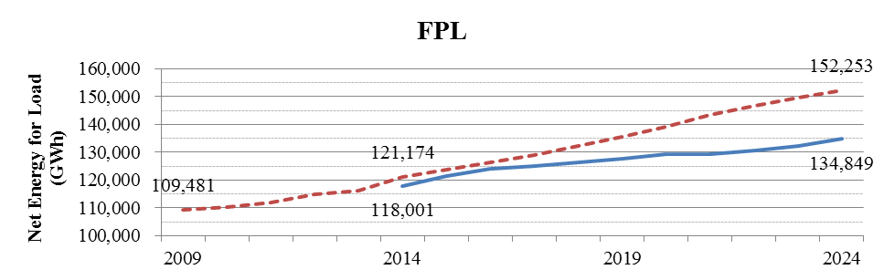
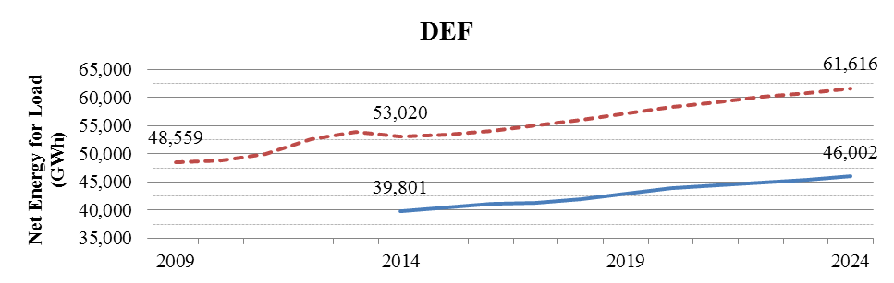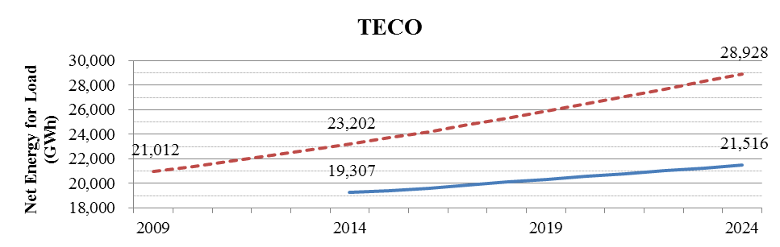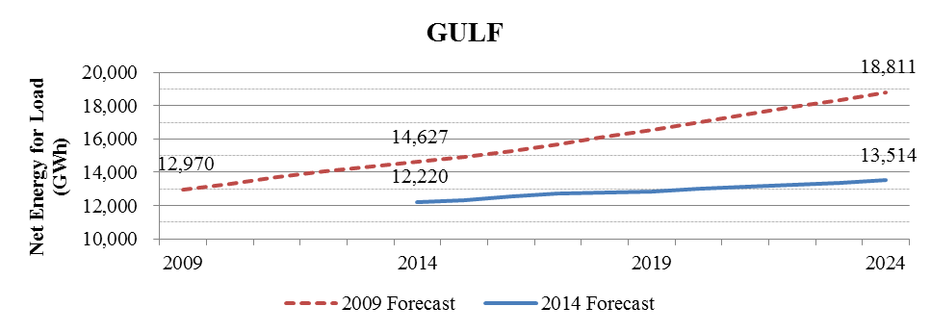
DEF witness Duff explains that the decline in usage and projection of lower growth is attributable to multiple factors, including increased customer awareness of conservation to reduce bills, new building codes, and appliance efficiency standards. Whatever the factors, these actions are occurring without the intervention of the FEECA Utilities. As a consequence the FEECA Utilities have less growth in electric peak demand and annual energy consumption to reduce, thereby lowering potential DSM goals.

Building Code & Efficiency Standards
Rule 25-17.0021(3), F.A.C., in relevant part, requires consideration of “interactions with building codes and appliance efficiency standards.” The FEECA Utilities identified multiple changes that have or will occur to the Florida Building Code and the Federal appliance standards. DEF witness Duff notes that two main programs affected are heating, ventilation, and air-conditioning (HVAC) and lighting. Several measures relating to air-conditioning will be considered minimum standards, such as right-sizing of residential air conditioning as of 2012 and the seasonal energy efficiency ratio (SEER) increasing from 13 to 14 for heat pumps beginning in 2015. Similar standards improvements impact commercial/industrial customers. Lighting standards have been phased in since 2012, with many common lamp sizes (45, 60, 75, and 100 watt for residential) now required to meet higher energy efficiency standards. Other appliances such as water heaters and clothes dryers also have improved efficiency standards effective in 2015.
Each of these standards represents a decline from previously available demand and energy goals potential. FPL witness Koch notes that with increases in codes and standards, there is less incremental energy efficiency available to the FEECA Utilities, which in turn reduces the cost-effectiveness of measures.
Avoided Costs
Rule 25-17.0021(3), F.A.C., requires that each utility’s proposed goals must be based upon the utility’s most recent planning process. By using up to date economic data for the cost of avoided generation and fuel, a determination of cost-effectiveness can be made for potential demand-side management measures.
The FEECA Utilities note a significant decline in fuel costs, primarily associated with a decline in natural gas prices. FPL witness Sim notes that while a decline in fuel prices is beneficial to ratepayers, it reduces the fuel savings associated with reduced energy consumption. As a result, demand-side management measures focusing on energy consumption are less cost-effective, reducing potential goals.
Figure 3-2, is the average natural gas price forecasts from the 2009 Goals Proceeding and the current goals proceeding for FPL, DEF, and TECO. Due to confidentiality, Gulf’s forecast was not included in Figure 8-2, but the results of the comparison would be similar. As illustrated below, natural gas prices have declined more than 50 percent as of 2014, and are anticipated to remain below any point along the forecast used in the 2009 goals proceeding for the entirety of the ten-year goal setting period.
Figure 3-2: Natural Gas Price Forecast Comparisons for FPL, DEF, and TECO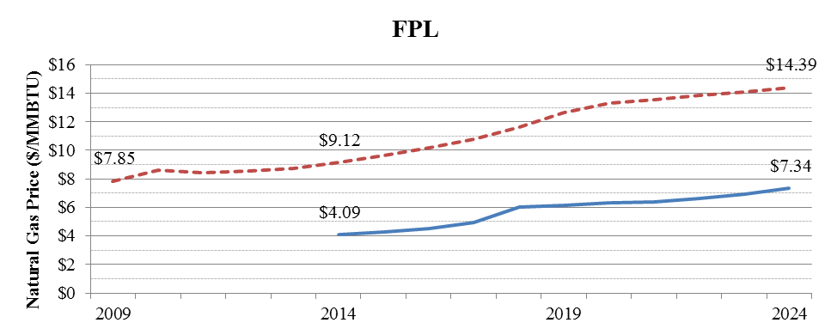 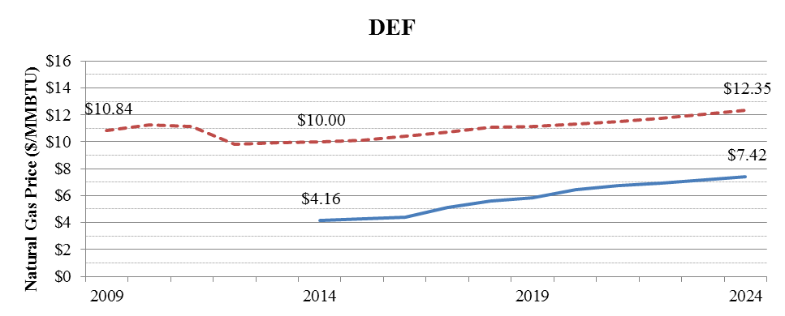 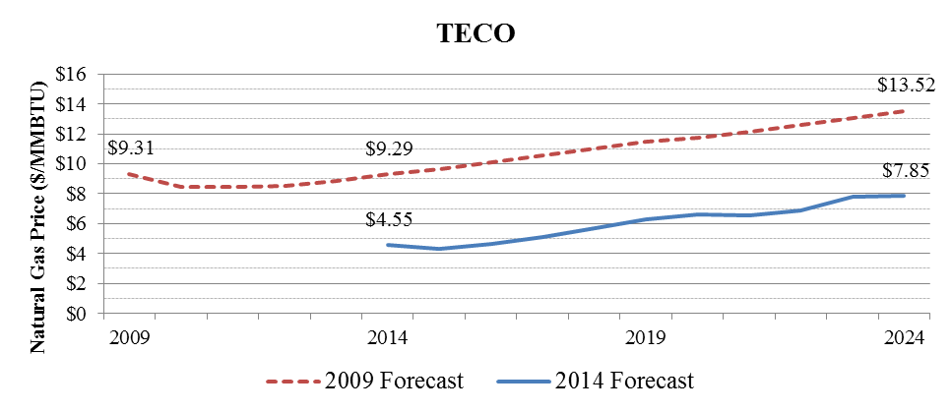

As discussed above, load forecasts have delayed potential avoided generation. Gulf witness Floyd notes that the later the in-service date of an avoided unit, the less benefit in being deferred or avoided it provides. Table 3-1, illustrates the in-service date, type, and capacity of the avoided units used in the 2009 Goals Proceeding and the current dockets. Since the type of avoided capacity did not change, the benefits of avoided capacity are only impacted by the timing of the capacity.

Table 4-1: Avoided Unit Comparison for FPL, DEF, TECO, and Gulf

Company | FPL | DEF | TECO | Gulf
2009 Goals  Proceeding  (2010-2019) | 2019 CC (1,219 MW) | 2013 CT (205 MW) | 2012 CT (56 MW) | 2014 CC (840 MW)
2014 Goals  Proceeding  (2015-2024) | 2019 CC (1,269 MW) | 2018 CT (214 MW) | 2019 CT (190 MW) | 2023 CC (750 MW)

While fuel prices were uniformly down for the FEECA utilities, avoided generation varies by utility. TECO and Gulf have avoided units, coming in later in the goals period, by two and five years respectively. DEF’s initial unit is three years from the start of the analysis period for both cases, while later units are delayed further in the current proceeding. For these utilities, avoided generation benefits are reduced because capacity requirements are later in time. FPL’s avoided unit, despite having the same in-service date, advances from nine years into the goals period to only four, which increases the benefits of avoided generation. As a consequence of delayed avoided units, demand-side management measures focusing on avoiding capacity are less cost-effective for three of the four Utilities, reducing potential goals.

Market Conditions Combined
The potential for demand-side management in Florida has decreased since the 2009 goals proceeding due to changes in market conditions as outlined above. Lower fuel costs reduce the cost-effectiveness of demand-side management measures, as measures offer smaller incentives per unit of energy savings. Lower load forecasts delay anticipated generation, further reducing avoidable costs. Finally, building codes and appliance efficiency standards reduce the amount of incremental savings available. Therefore, several factors beyond the control of the Utilities have the affect of reducing the amount of cost-effective demand-side management available to all customers at this time. We note that while these factors may reduce the incentives offered, it does not limit customers from participating in utility demand-side management programs.
Cost-Effectiveness Evaluations
Rule 25-17.008, F.A.C., and the “Cost-Effectiveness Manual for Demand Side Management Programs and Self Service Wheeling Proposals” (Cost-Effectiveness Manual) were adopted as part of the implementation of Section 366.82, F.S., prior to the 2008 amendments. Rule 25-17.008(3), F.A.C., directs us to evaluate the cost-effectiveness of conservation and direct load control programs utilizing the following three tests.
- Participants Test: Measures the impact of the program on the participating customers.
- Total Resource Cost Test (TRC): Measures the net costs of a demand-side management program as a resource option.
- Rate Impact Measure Test (RIM): Measures the impact on customer rates caused by the program.
Table 4-2, provides an illustration of the costs and benefits, as presented in Rule 25-17.008, F.A.C., assessed under each test. As illustrated in Table 4-2, the benefits associated with the TRC and RIM tests are the same.

Table 4-2: Summary of Cost-Effectiveness Test Components

 | Participant | Total Resource Cost | Rate Impact Measure
Benefits
Bill Savings | Yes | - | -
Incentives | Yes | - | -
Tax Credits | Yes | - | -
Avoided Generation | - | Yes | Yes
Avoided Energy | - | Yes | Yes
Costs
Participant Contributions | Yes | Yes | -
Equipment | - | Yes | Yes
Administrative | - | Yes | Yes
Incentives | - | - | Yes
Lost Revenues | - | - | Yes

Based on Order No. PSC-13-0386-PCO-EU, the FEECA Utilities provided both economic potential and achievable potential evaluations using both the RIM test and the TRC test. The economic potential was developed using the technical potential discussed and then applying multiple economic tests and screenings. While technical potential represents the state of all possible improvements being made, economic potential reflects only those improvements that make economic sense using a cost-effectiveness test. Each cost-effectiveness test, RIM and TRC, is combined with the Participants test so that measures pass both to be included. The achievable potential is derived from the economic potential and includes an assumed participation rate based upon factors such as availability and customer acceptance. The results from all three tests (Participants, RIM, and TRC) are useful when establishing DSM goals.

FEECA Utility Proposals
The FEECA Utilities propose to establish annual numeric conservation goals based upon a combination of the RIM and Participants tests, and provided testimony that the RIM and Participants tests alone adequately reflect the costs and benefits to the general body of ratepayers as a whole. DEF, TECO, and Gulf propose that goals be based upon the RIM achievable potential.
FPL witness Sim suggests that goals should be limited by resource needs, and that the achievable potential exceeded the minimum required to meet FPL’s reliability requirements. As a result, FPL’s proposed goals are less than its achievable potential by approximately 36 percent for summer peak, 42 percent for winter peak, and 89 percent for annual energy consumption.
FPL initially analyzed the 2015 through 2024 goals period, and based upon an avoided unit in 2021, found that no DSM additions were necessary past 2021 for summer peak demand. FPL witness Sim testified that FPL elected to include an additional year in its analysis, 2025, which increased the need for DSM additions by 31 percent for summer peak demand. FPL witness Koch testified that FPL, to determine proposed goals for winter peak demand and annual energy, combined only those measures necessary to meet its summer peak demand determination, primarily load management.
FPL witness Sim testified that FPL’s resource analysis included the usage of a generation-only reserve margin that excludes the benefits of demand response resources and incremental energy efficiency. While FPL has noted its use of this metric in this docket, we have not ruled on the use of this methodology based upon this review. We will have an opportunity to review FPL’s proposed third reliability criterion if it becomes a factor in a determination of need for a new electrical power plant under the Power Plant Siting Act.
We do not find it appropriate to use constraints for establishing goals based upon the RIM Achievable Potential. By definition, any participation in a measure that passes the Participants Test and the RIM Test is beneficial both to participants and the non-participants. The unconstrained RIM Achievable Potential allows for a larger amount of cost-effective demand-side management with more potential participants while minimizing cross-subsidization. As discussed previously, the reliability considerations of demand-side management are significantly different, however, as measures tend to be implemented in small increments over time, rely upon voluntary participation of customers, and are typically not dispatchable by the utility. Utilizing an unconstrained version of the Test would also be consistent with Order No. PSC-09-0855-FOF-EG in the 2009 Goals Proceeding, which also rejected the use of constrained goals.
Other Parties Proposals
SACE and Sierra Club propose goals based upon a percentage of retail energy sales. SACE witness Mims recommends that the FEECA Utilities meet a goal of 0.75 percent of retail energy sales in 2015, ramping up to 1.0 percent by 2017. Sierra Club witness Woolf recommends ramping up to a goal of 1.0 percent of retail energy sales by 2019. Our staff requested annual numeric conservation goals from both Sierra Club and SACE. Sierra Club’s response was incomplete, and the annual values provided do not comply with Rule 25-17.0021(1), F.A.C., in that they include only values for 2015 through 2019 for three utilities, include only values for 2015 through 2018 for one utility, fail to include separate goals for residential and commercial/industrial customers, and include only one season for peak demand goals. SACE and Sierra Club used the TRC test to determine cost-effectiveness, but the goals proposed by both are not based on any cost-effectiveness test. SACE and Sierra Club base the reasonableness of the proposed goals upon experiences in other states. FPL witness Deason, DEF witness Duff, and Gulf witness Floyd testify it is inappropriate to make comparisons with other states without regard to the differences in legislation and other factors. We find that there is no competent or substantial evidence in the record to support the goals proffered by either SACE or the Sierra Club.
Sensitivities
Based on Order No. PSC-13-0386-PCO-EU, the FEECA Utilities provided sensitivities of fuel forecasts and free-ridership screening periods for the RIM test and TRC test. In general, the free-ridership sensitivities produced a greater magnitude of change than fuel price sensitivities. The average change in the economic potential of each of the sensitivities is outlined in Table 4-3.
Table 4-3: Average Economic Potential Sensitivity Analysis by Test

Test | Goal | Fuel |  | Payback
Test | Goal | High | Low | 1 Year | 3 Year
RIM | Summer | 6.6% | (11.9)% | 12.8% | (20.6)%
RIM | Winter | 3.4% | (13.0)% | 1.2% | (10.2)%
RIM | Annual | 10.7% | (17.6)% | 13.1% | (20.5)%
TRC | Summer | 3.8% | (6.1)% | 24.7% | (20.6)%
TRC | Winter | 3.8% | (6.1)% | 21.4% | (10.2)%
TRC | Annual | 2.6% | (4.5)% | 30.4% | (20.5)%

In the 2009 Goals Proceeding, each FEECA Utility used an individual forecast for costs associated with CO₂ emissions that had significantly different values and start dates. Based on Order No. PSC-13-0386-PCO-EU the FEECA Utilities did not include costs associated with CO₂ emissions in the base case of the cost-effectiveness screening presented above. To prevent confusion, Order No. PSC-13-0386-PCO-EU directed the FEECA Utilities that wished to include a CO₂ sensitivity to use a common CO₂ price forecast in the current proceeding. Only FPL and DEF provided a CO₂ price sensitivity, and the results show a minor negative effect, as new generation tends to be more efficient and therefore produce less emissions. Should future costs for CO₂ emissions be implemented, it is within our authority to revisit the FEECA goals at that time.

The sensitivities discussed above were conducted on the economic potential, not the achievable potential. In data request responses, the FEECA Utilities suggested that the application of a linear extrapolation was not appropriate, as the sensitivities were conducted at the economic potential level. However, no alternative method is included in the record for applying the sensitivities to calculate an achievable potential. Without an alternative, we find that a linear approach, while not ideal, is an available option.
Rate Impact
We have direct rate-setting authority over the investor-owned utilities subject to FEECA for which goals are to be established. Based on Order No. PSC-13-0386-PCO-EU, the FEECA Utilities provided the rate impact of the utility’s proposal, the RIM achievable potential, and the TRC achievable potential. In previous FEECA goals proceedings, we have considered the impact on rates when determining goals for the FEECA Utilities.
As required by our Rules, the FEECA Utilities will submit programs based upon the goals established in this proceeding, and those program costs will be recovered from the ratepayers through the Energy Conservation Cost Recovery Clause. As incentives are paid based upon participation, cost recovery will vary over time.
Excluding Gulf, the FEECA Utilities estimate monthly bills would remain approximately the same or decline with the adoption of goals based upon the utilities’ proposals, the RIM achievable potential, or the TRC achievable potential. Table 4-4, lists the FEECA Utility’s current Energy Conservation Cost Recovery (ECCR) monthly bill impact for 2014 and the average monthly bill impact of these scenarios. While no party provided a monthly ECCR bill impact for all years for the goals recommended by SACE or Sierra Club, it is reasonable to suggest that they would be significantly higher than the scenarios presented below due to the higher goal levels.

Table 4-4: Average Monthly ECCR Bill Impact by Test

Utility | 2014  ECCR | Average Monthly Bill Impact ($/1,200-kWh)
Utility | 2014  ECCR | Utilities  Proposal | RIM  Achievable | TRC  Achievable
FPL | $3.37 | $1.86 | $2.06 | $2.32
DEF | $4.82 | $4.04 | $4.04 | $4.54
TECO | $3.54 | $3.22 | $3.22 | $3.59
Gulf | $2.71 | $0.91 | $0.91 | $3.97

The discussion above reflects primarily upon the impact of the ECCR Clause, and does not consider the impact of increased energy conservation on the FEECA Utility’s base rates. A utility’s base rates are established by us in a rate case, and represent the recovery of fixed costs for items such as power plants and operations. Base rates are recovered based upon customer’s consumption of energy, which is variable. As a result, if energy consumption decreases, the FEECA Utilities would have fewer units of consumption over which to spread these fixed costs. Such an outcome is often referenced to as lost revenues. SACE witness Mims notes that if sales decline for any reason, rates may increase. The reduction in sales due to participation in demand-side management measures would have the same effect as a sales forecast that did not materialize. We note that decline in sales was the primary factor in the last several electric rate cases before us. If consumption is reduced enough, a utility may file a petition with us for a rate increase.

While lost revenues associated with demand-side management programs are not the only cause for a decrease in a utility’s return on equity, should a utility’s return on equity be decreased by more than 100 basis points, the utility may file a petition with us for a rate increase. Table 4-5, provides the basis point impact of the RIM and TRC achievable potential goals outlined above, based upon each utility’s lost revenues, for the five-year period before goals must be reset. As illustrated below, no utility would be impacted in excess of 100 basis points during the five-year period, with the highest impact of 42.1 for FPL’s TRC achievable potential. As a result, it is unlikely that an increase in base rates would be entirely driven by a decline in sales due to conservation during the next five-year period. While no formal analysis was conducted, given the 20 to 40 times higher energy savings associated with Sierra Club and SACE’s proposed goals, it is reasonable to conclude that an increase in base rates would be likely if these intervenors’ goals were adopted.

Table 4-5: Basis Point by Cost-Effectiveness
Year | RIM Achievable Potential
Year | FPL | DEF | TECO | Gulf
2015 | 2.2 | 2.9 | 1.0 | 4.0
2016 | 6.8 | 5.6 | 2.6 | 6.0
2017 | 12.2 | 8.1 | 4.0 | 7.0
2018 | 18.4 | 10.3 | 6.2 | 8.0
2019 | 25.8 | 12.0 | 8.5 | 10.0
Year | TRC Achievable Potential
Year | FPL | DEF | TECO | Gulf
2015 | 2.9 | 5.2 | 1.6 | 7.0
2016 | 9.8 | 10.3 | 4.2 | 9.0
2017 | 18.6 | 15.5 | 6.6 | 10.0
2018 | 29.2 | 21.0 | 10.2 | 13.0
2019 | 42.1 | 26.8 | 14.3 | 15.0

Our decision must be based upon the evidence within the consolidated record of these dockets. Through prior meetings, our staff attempted to streamline the process and ensure we were provided with all available information to make a decision. The procedural orders in this proceeding provided a guideline for all parties to follow. The goals proposed by SACE and Sierra Club are not based on any cost-effectiveness test and are contrary to the previous positions taken by these parties.

As previously discussed, demand-side management is an alternative resource to generation plants and should be evaluated similarly for reliability and economic impacts. The current market conditions adequately explain why the utilities’ proposed goals are lower than those proposed in 2009.

The cumulative results of the utility’s proposal, the achievable potential based upon the RIM and TRC tests, the proposed goals of Sierra Club and SACE, and our approved goals are provided in Table 4-6. Tables outlining the approved residential annual goals are shown in Attachment B for each utility.

Table 4-6: Residential Cumulative Goals

Summer Peak Demand (MW)
Utility | Utility  Proposed | RIM  Achievable | TRC  Achievable | Sierra  Club* | SACE | Commission  Approved
FPL | 175.8 | 267.8 | 220.2 | 2,467.0 | 3,575.6 | 267.8
DEF | 173.7 | 173.7 | 198.1 | n/a | 1,206.2 | 173.7
TECO | 25.7 | 25.7 | 36.2 | 317.0 | 539.8 | 25.7
Gulf | 60.9 | 60.9 | 82.8 | 137.0 | 322.6 | 60.9
Winter Peak Demand (MW)
Utility | Utility  Proposed | RIM  Achievable | TRC  Achievable | Sierra  Club* | SACE | Commission  Approved
FPL | 122.8 | 166.0 | 203.8 | n/a | 2,859.9 | 166.0
DEF | 368.6 | 368.6 | 390.0 | 1,170.0 | 964.8 | 368.6
TECO | 61.9 | 61.9 | 71.0 | n/a | 431.7 | 61.9
Gulf | 34.7 | 34.7 | 50.7 | n/a | 258.0 | 34.7
Annual Energy (GWh)
Utility | Utility  Proposed | RIM  Achievable | TRC  Achievable | Sierra  Club* | SACE | Commission  Approved
FPL | 54.0 | 247.2 | 239.8 | 4,161.0 | 8,259.5 | 247.2
DEF | 122.6 | 122.6 | 269.3 | 1,425.0 | 2,786.3 | 122.6
TECO | 56.9 | 56.9 | 93.4 | 717.0 | 1,246.9 | 56.9
Gulf | 61.9 | 61.9 | 158.8 | 430.0 | 745.2 | 61.9
* Sierra Club’s proposed goals are incomplete despite our staff’s data request asking for goals for the full ten-year period. Sierra Club’s proposed goals are for the period 2015-2019 only, except for Gulf, which is for the period 2015-2018 only.

Decision

We find appropriate to establish goals for the FEECA Utilities based upon a cost-effectiveness analysis that allows all ratepayers, participants and non-participants, to benefit from the Utilities’ demand-side management programs. Therefore, we find annual goals based upon the unconstrained RIM achievable potential be adopted. As the RIM test eliminates cross-subsidies, using an unconstrained RIM allows for maximum participation by customers while keeping rates equitable. We find the use of two-year payback as a free-ridership screen and no inclusion of potential CO₂ costs to establish goals to be appropriate. A breakdown of annual goals for each of the utilities is included in Attachment B.

COMMERCIAL/INDUSTRIAL
The FEECA Utilities all propose goals based upon a combination of those measures which pass both the RIM test and the Participants test. The FEECA Utilities acknowledge that the proposed goals are lower than those established in the 2009 Goals Proceeding, but that this is expected due to lower costs and changes in codes and standards. The FEECA Utilities further suggest that goals based upon the RIM and Participants test address concerns regarding cross-subsidization between participants and non-participants, and limits rates to all customers. The FEECA Utilities contend that the goals proposed by Sierra Club and SACE are arbitrary, as they are based upon other state’s achievements and not upon a cost-effectiveness analysis. FPL asserts that its proposed goals should be limited based upon its forecast resource need, and that the full achievable potential does not comply with FPL’s proposed planning process.
NAACP does not propose goals, but recommends that goals should ensure low rates and not allow cross-subsidization. NAACP states that we should utilize the RIM test, as it results in lower rates for low-income customers.
FIPUG recommends that goals based upon the RIM test should be adopted, as they result in low rates.
PCS Phosphate, addressing DEF specifically, recommends we should approve the Utility’s proposed goals, utilizing the RIM test and Participants test.
OPC takes no position as to the goals, but recommends that for commercial/industrial goals, we should approve goals that benefit both participants and non-participants. OPC states that if we approve goals based upon the RIM test, then the FEECA Utilities should not be eligible for a reward for exceeding them.
FDACS takes no position as to the goals, but recommends that we should balance concerns regarding rates with the goals to be established.
Walmart and EDF took no position regarding the goals to be established.
Sierra Club proposes that the goals should be set to ramp up energy savings to at least 1 percent of retail energy sales by 2019, or earlier as proposed by SACE. Sierra Club states that these goals would result in lower total costs and average bills. SACE further encourages us to reopen the goals docket in 2015 to establish goals based upon compliance obligations with the proposed federal greenhouse gas regulations. Sierra Club recommends that we should reject the FEECA Utilities’ proposals as too low compared to the accomplishments of other states.
SACE proposes that a 1 percent of annual energy savings goal be established for the investor-owned utilities. SACE asserts that the investor-owned utilities have a disincentive to establish meaning goals due to a loss in return on power plants that would be deferred or eliminated. SACE states that it did not base its proposed goals on the FEECA Utilities’ economic studies due to multiple fundamental flaws that limited the studies’ value in establishing goals. SACE asserts that the FEECA Utilities are capable of meeting a 1 percent annual sales goal because other states have achieved similar results.

Analysis

The same factors for residential goals influence the FEECA Utility’s commercial/industrial customers and potential conservation goals. We find that the commercial/industrial conservation goals should be based on an unconstrained RIM Test with a two-year payback free-ridership screen and no CO₂ costs included.

Table 5-1, summarizes the Utility’s proposed goals, the Achievable Potential for the RIM and TRC Tests, the proposed goals from Sierra Club and SACE, and our approved goals. Tables outlining the potential commercial/industrial annual goals are shown in Attachment C for each utility. As previously discussed, Sierra Club’s proposed goals are incomplete, including only values for 2015 through 2019, failing to include separate goals for residential and commercial/industrial customers, and including only summer peak demand goals for three of the utilities and winter peak demand goals for one utility.

Table 5-1: Commercial/Industrial Cumulative Goals
Summer Peak Demand (MW)
Utility | Utility  Proposed | RIM  Achievable | TRC  Achievable | Sierra  Club* | SACE | Commission  Approved
FPL | 160.9 | 258.3 | 356.1 | 2,467.0 | 2,601.0 | 258.3
DEF | 85.4 | 85.4 | 137.1 | n/a | 917.3 | 85.4
TECO | 30.6 | 30.6 | 50.0 | 317.0 | 480.2 | 30.6
Gulf | 7.2 | 7.2 | 21.5 | 137.0 | 289.0 | 7.2
Winter Peak Demand (MW)
Utility | Utility  Proposed | RIM  Achievable | TRC  Achievable | Sierra  Club* | SACE | Commission  Approved
FPL | 66.2 | 158.2 | 264.6 | n/a | 1,245.6 | 158.2
DEF | 50.7 | 50.7 | 67.8 | 1,170.0 | 439.3 | 50.7
TECO | 16.4 | 16.4 | 26.5 | n/a | 230.0 | 16.4
Gulf | 2.0 | 2.0 | 7.3 | n/a | 138.4 | 2.0
Annual Energy (GWh)
Utility | Utility  Proposed | RIM  Achievable | TRC  Achievable | Sierra  Club* | SACE | Commission  Approved
FPL | 5.2 | 279.1 | 855.8 | 4,161.0 | 7,565.2 | 279.1
DEF | 72.4 | 72.4 | 229.7 | 1,425.0 | 2,667.9 | 72.4
TECO | 87.4 | 87.4 | 175.6 | 717.0 | 1,396.7 | 87.4
Gulf | 22.3 | 22.3 | 109.4 | 430.0 | 840.5 | 22.3

* Sierra Club’s proposed goals are incomplete despite our staff’s data request asking for goals for the full ten-year period. Sierra Club’s proposed goals are for the period 2015-2019 only, except for Gulf, which is for the period 2015-2018 only.

Decision

We find that annual goals based upon the unconstrained RIM achievable potential are appropriate. We find that the use of two-year payback as a free-ridership screen and no inclusion of potential CO₂ costs to establish goals is also appropriate. A breakdown of annual goals for each of the utilities is included in Attachment C.

DEMAND-SIDE ENERGY RENEWABLE ENERGY GOALS
The four Investor-Owned Utilities (IOUs), FPL, DEF, TECO and Gulf, assert that goals should not be established because the solar pilot programs were not cost-effective and not an equitable way to encourage demand-side solar development. The lack of cost-effectiveness places upward pressure on rates. Intervenors NAACP and FDACS concur that rates should be kept as low as possible and cross-subsidization should be avoided. TECO, Gulf, and NAACP contend that it is appropriate for us to set a goal of zero when there are no cost-effective options.
DEF contends in its brief that a goal does not have to be numeric. If we establish a goal, DEF suggests that we approve a utility-owned conceptual community solar pilot program that would resolve issues of cross-subsidization and benefit all customers.
In its brief, FPL explains a solar Research & Demonstration project would involve collecting data from existing solar PV installations and installing solar PV panels that would be metered and instrumented at various locations and on various circuits across the FPL territory. These panels would provide valuable data on customers’ electric consumption and energy output of panels based on size, location and configuration. FPL, TECO, and Gulf assert that the Value of Solar (VOS) methodology is not a true cost-effectiveness test, because it only focuses on the benefits of solar.
Walmart and SACE assert that a goal of zero will not encourage the development of demand-side renewable energy systems. EDF, Sierra Club, and Walmart agree that a study is needed, but contend that the topic of the study should be determining the true costs and benefits of solar to Florida utilities. These intervenors also believe that the VOS methodology must be fully evaluated to determine the cost-effectiveness of solar energy. Walmart contends solar energy has values that are not reflected in the standard cost-effectiveness tests, such as reduced exposure to fuel price volatility, reduced transmission and distribution costs, and reduced construction cost risk due to declining cost of installed PV.
FIPUG and Walmart believe we should establish appropriate goals for the development of demand-side renewable energy systems as required by FEECA.
While OPC did not take a position on what goals should be established for the development of demand-side renewable energy systems, it asserted that any goals established by us should comply with the intent of FEECA and safeguard against undue rate impacts.
In its brief, FDACS contends any goals established by us should be for cost-effective demand-side renewable systems. In addition, we should determine how to comply with FEECA directives without placing an undue financial burden on non-participating customers. PCS Phosphate states in its brief that goals proposed by DEF represent a reasonable balance of FEECA’s requirements and the cost and rate impacts to Florida consumers.
Analysis

Section 366.81, F.S., states, “. . . the Legislature finds and declares that it is critical to utilize the most efficient and cost-effective demand-side renewable energy systems and conservation systems in order to protect the health, prosperity, and general welfare of the state and its citizens.” Later in this same Section it states, “Since solutions to our energy problems are complex, the Legislature intends that the use of solar energy, renewable energy sources, highly efficient systems, cogeneration, and load-control systems be encouraged.”

Section 366.82, F.S., requires us to adopt appropriate goals for increasing the development of demand-side renewable energy systems. In developing the goals we shall take into account the benefits and costs to the consumer participating in the measure and the benefits and costs to the general body of ratepayers.

We found in the 2009 goal setting proceeding that solar measures did not pass the cost-effectiveness tests. However, we ordered the IOUs and FPUC to offer solar pilot programs in order to address the intent of the Legislature to place added emphasis on demand-side renewable resources. We established a spending cap in order to protect ratepayers from undue rate increases. The spending cap was established at 10 percent of the ECCR expenditures the last five years, and amounted to $24,483,051 a year for the five IOUs combined.

Solar PV have been steadily growing in Florida. As seen in Table 6-1, from 2011-2013, 2,824 new solar installations have been added by the four largest IOUs. These new solar installations are from residential and business customers. This amount includes both systems installed that received a rebate and those systems for which no rebate was received.

Table 6-1 - Number of Solar PV Installations

Utility | 2011 | 2012 | 2013 | Total
FPL | 531 | 553 | 467 | 1551
DEF | 233 | 309 | 323 | 865
TECO | 71 | 117 | 109 | 297
Gulf | n/a | 69 | 42 | 111
Total | 835 | 1048 | 941 | 2,824

In addition to the solar pilot programs discussed, it appears that at least three factors have contributed to the growth of solar PV in the state over the past few years: Federal income tax incentives, the decreasing cost of installed solar PV, and our Rule 25-6.065, F.A.C., Interconnection and Net Metering of Customer-Owned Renewable Generation.

Federal Income Tax Incentives
The Federal Government has enacted laws that provide tax credits for solar installations made by residential and business customers. Current Federal tax law provides a 30 percent tax credit for personal and corporate solar systems installed by December 31, 2016. There is no maximum credit for the personal or corporate tax credit. Recipients of the personal tax credit may carry forward the tax credit to the next year if they do not have a tax liability.
Decreasing Cost of Installed Solar Photovoltaic Systems
DEF witness Duff testified that the cost of installed solar PV dropped for residential installations from $5.01/watt_{dc} in 2011 to $4.13/watt_{dc} in 2013. The cost of commercial installations dropped even more, from $5.33/watt_{dc} in 2011 to $3.89 in 2013. FPL and TECO report similar decreases in the cost of installed solar PV. Gulf reports the installed cost of PV systems (residential and commercial) has dropped from an average of $5.54/watt_{dc} in 2011 to $3.42 per watt for systems being installed in 2014. Gulf witness Floyd contends this price drop reflects a national trend of declining solar PV prices.
According to DEF witness Duff, “Over the course of the five years since that Commission order, the costs of solar technology has decreased and the subscription rates for solar devices have increased, mainly because solar technology has advanced since that time.”
Rule 25-6.065, F.A.C., Interconnection and Net Metering of Customer-Owned Renewable Generation

The Florida Legislature has established policies to require utilities to facilitate customer-owned renewable energy resources. Sections 366.91(5) and (6), F.S., require electric utilities to develop a standardized interconnection agreement and net metering program for customer-owned renewable generation. The purpose of Rule 25-6.065, F.A.C., is to promote the development of small customer-owned renewable generation, particularly solar and wind energy systems.

A customer primarily benefits from a renewable energy system by using the energy for his own purposes and thus reducing electricity purchases from the utility. Our rule requires each IOU to file for approval a Standard Interconnection Agreement for expedited interconnection of customer-owned renewable generation for systems up to 2 MW. The agreements specify nationally recognized standards for interconnection and safety for renewable systems to be interconnected with the utility.

In addition, the rule provides direction for the application and interconnection process, detailing specific due dates for action by the utility and the customer. The rule also requires the IOUs to submit for Commission approval all fees and charges related to the interconnection of customer-owned renewable generation. The rule acts to minimize costs associated with fees and liability insurance that customers might otherwise experience when attempting to interconnect renewable systems to their utility.

The rule recognizes the seasonal nature of some renewable energy resources and allows for a billing adjustment through net metering. During times when the customer’s system produces more energy than is consumed on-site, the excess energy is delivered to the utility’s grid and the excess energy is credited to the next month’s utility bill. At the end of the calendar year, any excess energy is credited on the bill at the utility’s cost of producing energy (fuel). DEF witness Duff testified that the rule will continue to be available to customers.

Community Solar

FPL witness Koch recommended a community solar program that is voluntary and community-based. Witness Koch testified that the program would be an efficient way to promote solar to customers who cannot afford to install panels on their own property and would not rely upon subsidies from non-participants. The system would be grid-tied on utility owned property and not be a demand-side renewable.

DEF witness Duff testified that DEF would recommend a community solar program that:
. . . would involve DEF using the existing solar set aside dollars to build utility-owned solar generation to initially serve all customers that could eventually be used as a community solar offering allowing individual customers to meet their renewable energy goals.

EDF witness Fine testified that utilities should establish a utility-owned commercial PV program to allow utilities to make more investments in PV. SACE witness Rabago testified that community solar programs provide an opportunity to allow more customers to participate in the benefits that distributed solar provides.
However, in its brief, SACE contends:
A utility owned solar system is a supply-side renewable. Nothing about the proposed solar conceptual programs proposed by FPL and DEF are demand-side in nature. A supply-side resource is not typically placed on the premise of a customer, and it certainly cannot assist that customer in offsetting the customer’s electricity requirements. As such, the conceptual programs, such as these, are not consistent with the FEECA statute.
We find that community solar does not promote the development of demand-side renewables. While the development of utility scale solar may have many benefits, it does not comply with Section 366.82, F.S., because it is a supply-side source, not demand-side.

Research and Development
FPL witness Koch recommends a solar research and development project. Witness Koch testified that FPL could benefit from additional research with a variety of PV installations located through their service territory. Each of these installations would be metered and instrumented to gather more information. In addition, FPL would rely upon data gathered at the Desoto and Space Coast installations.
Witness Koch testified that the use of a utility research and development project would be more useful due to the utility’s ability to obtain more information. He opined that FPL has learned little from the current pilots other than that, “. . . people will rush to get in line for giveaways.”

EDF, Sierra Club, and Walmart also suggest that a Research & Development (R&D) program be conducted; however, they think the study should focus on the true costs and benefits of solar to the Florida utilities. SACE witness Rabago recommends a workshop with our staff, utilities, and stakeholders to create a VOS methodology similar to that now in place in Minnesota.

There is not sufficient value for ratepayers to warrant establishing new research and development PV programs at this time. Both FPL and DEF currently have solar R&D programs. FPL also has accumulated data from the 110 MWs of installed solar that were installed due to 2008 Legislation, and has conducted research similar to their proposed R&D program at these sites. Accordingly, we find that no additional solar R&D be approved at this time.

Decision

Each of the IOUs should continue to implement the provisions of Rule 25-6.065, F.A.C., Interconnection and Net Metering of Customer-Owned Renewable Generation. The rule is an appropriate means to encourage the development of demand-side renewable energy, as it expedites the interconnection of customer-owned renewable energy systems and benefits participating customers through net metering.

EXISTING SOLAR PILOT PROGRAMS
The IOUs and the NAACP believe that the existing solar pilot programs should be allowed to expire. The solar pilot programs were not cost-effective when established in 2009, and continue not to be cost-effective. The solar pilot programs failed the RIM and TRC cost-effectiveness tests and created a cross-subsidy from non-participants to participants that caused upward pressure on rates. The NAACP contends that “cross subsidization can result in rates that are higher than otherwise fair and equitable.” Gulf asserted that these programs reflect the worse type of cross-subsidization -- from low-income customers to high-income customers.
Conversely, EDF, SACE and Walmart contend the solar pilot programs should be extended. EDF recommends an independently supervised study of the costs and benefits of distributed solar and a redesign of the incentives to enhance cost-effectiveness. The Sierra Club believes a study should be conducted to investigate the effectiveness of the rebate programs and the role of utility-owned solar PV. Sierra Club also advocated an update of the marketing and incentive approaches for PV programs, to minimize the amount of incentives paid while installing as much PV as possible.
SACE asserts we would benefit from a Value of Solar analysis to determine the appropriate costs and benefits of distributed solar on a utility’s system. Extending the current solar programs would provide an opportunity for a thorough examination of the costs and benefits of solar energy, and to develop a Value of Solar methodology.
FIPUG believes the solar pilot programs should not be extended in their present forms without a thorough review and appropriate modifications.
OPC does not take a position on extending the solar pilot programs. However, if extended, the programs should comply with provisions of FEECA and protect the general body of ratepayers from undue impact on rates.
FDACS believes any goals set by us to meet FEECA directives should be cost-effective and avoid subsidization by the general body of ratepayers. Placing an undue financial burden on non-participants should be avoided. PCS Phosphate did not offer argument.
Analysis
In 2008, the Legislature amended Section 366.82, F.S., such that when DSM goals are established, we are required to establish appropriate goals to encourage the development of demand-side renewable energy systems. “Demand-side renewable energy” is defined as a system located on a customer’s premises using Florida renewable energy resources with a capacity that does not exceed 2 MWs. The system must be designed to offset part or all of a customer’s energy needs.
Because of the revisions to the statute, we requested that the utilities address demand-side renewables in the 2009 goals proceeding. Demand-side renewables were not found to be cost-effective in the analyses conducted by the utilities. However, based on evidence presented during the proceeding, we ordered that the IOUs develop and offer pilot programs in order to encourage such resources. In order to minimize the rate impacts to all customers, we ordered the cost for these programs be limited to 10 percent of each utility’s five-year average for costs recovered through the ECCR Clause.
We directed the IOUs to file pilot programs focusing on encouraging solar water heating and solar PV technologies in the DSM program approval process. Each of the IOUs filed for approval of their Solar Rebate programs. Each utility provided rebates for residential and commercial PV with rebates up to $2.00 a watt. Rebate programs were also established for solar water heating. Residential customers installing a water heating system received a rebate of $550 to $1,000, depending on their utility. FPL offered a business water heating program that provided a rebate of $30 per 1,000 Btu/day. Each of the Utilities provided systems to qualifying schools at no charge under the Solar for Schools PV program and offered free low-income water heating programs. The IOUs were directed to collect information relating to customer acceptance rates, energy production, and other data to refine potential future program offerings for solar technologies.
Table 7-1: Pilot Program Rebates
Utility | Program | Amount of Rebate
FPL
 | Residential PV | $2.00/watt $20,000 max
 | Business PV | $2.00/watt first 10kW,  $1.50/Watt 10-25KW,  $1.00/watt >25kW $50,000 max
 | Residential Water Heating | $1,000
 | Business Water Heating | $30 per 1,000 Btu/day $50,000 max
TECO
 | Residential PV | $2.00/watt $20,000 max
 | Commercial PV | $2.00/watt $20,000 max
 | Residential Water Heating | $1,000
Gulf
 | Residential PV | $2.00/watt $10,000 max
 | Commercial PV | $2.00/watt $10,000 max
 | Solar Thermal Water Heating -Residential | $1,000
DEF
 | Residential PV | $2.00/watt $20,000 max
 | Commercial PV | $2.00/watt first 10KW,  $1.50/Watt 11-50KW,  $1.00/watt 51-100kW
 | Residential (SWH)w/ Energy Management | $550

Results of Solar Pilot Programs

FPL
FPL has implemented three types of solar pilot programs: solar water heating; photovoltaic; and research and demonstration. The solar water heating programs included special programs for residential, business, and low-income, new construction customers. Photovoltaic programs were designed for residential and business customers. The business program included a special carve out program to install PV on schools at no charge.
These programs were implemented on a first-come first-served basis and helped approximately 4,000 customers during 2011-2013 at a cost of $30 million, as seen on Table 7-2. FPL expended approximately $7,500 on the average installation. FPL reports some installations for 2013 are still pending.
Table 7-2: FPL Solar Pilot Programs (2011-2013)

Program Name | Number of Participants
Solar Water Heating - Residential &  Low Income New Construction | 2,968
Solar Water Heating - Business | 38
Photovoltaic (PV) - Residential | 774
Photovoltaic (PV) - Business | 153
Photovoltaic (PV) - Business PV for Schools | 29
Research & Demonstration | n/a
Non-program Specific | n/a
TOTAL PARTICIPANTS | 3,962
TOTAL EXPENDITURES | $29,853,514
AVG. EXPENDITURE PER PARTICIPANT | $7,535

The photovoltaic pilot programs had high participation. Residential and business customers quickly submitted requests for reservations each time an offering was announced. However, an average of 75 percent of the residential customers who received a pilot program reservation, actually installed solar PV equipment. The business customers had a lower average completion rate of 50 percent.

The Residential and Low-Income Solar Water Heating pilot program was initially popular. The 2011 and 2012 offerings had a high number of reservations and installations. However, in 2013 the number of reservations dropped by almost 73 percent, from 1,491 to 428. Only 47 residential and low-income solar water heaters were installed in 2013.
FPL partnered with Habitat for Humanity to provide solar water heaters for low-income customers at no cost to the customer. FPL retained ownership of the solar arrays installed under the Solar for Schools program for the first five years. FPL provided maintenance during that time.
The Research and Demonstration pilot largely consisted of the installation of solar panels on science museums in FPL’s service territory. These museums are dedicated to education and provided an appropriate venue for demonstrating renewable energy. FPL also conducted research on solar-powered swimming pool pumps.
FPL states that these solar pilot programs are not cost-effective, failing both the RIM and TRC cost-effectiveness tests. Table 8-3, reflects that these solar pilot programs also failed the Participants test, with the exception of the Low-Income New Construction Solar Hot Water Heater and the Solar PV for Schools pilots. However, FPL provided these two solar programs at no charge to the recipients.
Table 8-3: FPL Solar Pilot Programs: Cost-Effectiveness Test Results
Solar Pilot Program | Benefit Cost Ratio
Solar Pilot Program | RIM | TRC | Participant
Solar Water Heating - Residential | 0.51 | 0.18 | 0.50
Solar Water Heating - Low Income New Construction | 0.21 | 0.28 | 1.52
Solar Water Heating - Business | 0.34 | 0.19 | 0.58
Photovoltaic (PV) - Residential | 0.46 | 0.27 | 0.74
Photovoltaic (PV) - Business | 0.64 | 0.33 | 0.67
Photovoltaic (PV) - Business PV for Schools | 0.13 | 0.15 | 1.19

FPL witness Koch testified that these solar pilot programs are not an efficient and equitable way to encourage the development of demand-side solar energy and should be allowed to expire.

DEF
DEF implemented six solar pilot programs: Solar Water Heating for Low Income Residential Customers, Solar Water Heating with Energy Management, Residential Solar Photovoltaic, Commercial Photovoltaic, Photovoltaic for Schools, and a Research and Demonstration Project.
As seen in Table 8-4, there were 1,318 DEF customers that participated in a solar pilot program at a total cost of $13,788,013 during 2011-2013. The average incentive cost approximately $10,461 per installation.

Table 8-4: DEF Solar Pilot Programs (2011-2013)

Program Name | Number of  Participants
Solar Water Heating Low Income - Residential | 63
Solar Water Heating Energy Mgmt. - Residential | 847
Photovoltaic (PV) - Residential | 346
Photovoltaic (PV) - Commercial | 39
Photovoltaic (PV) for Schools | 23
Research and Demonstration | n/a
TOTAL PARTICIPANTS | 1,318
TOTAL EXPENDITURES | $13,788,013
AVG. EXPENDITURE PER PARTICIPANT | $10,461

Like FPL, DEF’s residential and commercial solar PV pilot programs were popular and had high participation. As seen on Table 8-4, there were 346 residential customers and 39 commercial customers that participated in the photovoltaic pilot programs.
DEF’s average 2011-2013 completion rate for residential PV systems was 64 percent, while it was 45 percent for business systems. For this same period, the average completion rate for solar water heating with load management was 87 percent.

DEF worked with Habitat for Humanity to provide solar hot water heaters to low-income customers in new construction. DEF fully funded the cost of installation and the equipment costs.

The DEF Solar Water Heating with Energy Management program is unique because it combines the hot water heating program with a demand response program. The participating customers receive an up-front rebate of $550 and a monthly bill credit for participating in the load management program.

The Research and Demonstration Pilot consisted of DEF working with the Electric Power Research Institute (EPRI), the University of Central Florida, and the University of South Florida to study various applications of wind and solar renewable energy. Some of the projects included: a study of small-scale wind energy potential, data collection for a distributed photovoltaic study, and a study of a PV array and energy storage system.
As seen in Table 8-5, all programs failed the RIM and TRC cost-effectiveness tests. DEF witness Duff asserted that most solar pilot programs passed the participant test due to the availability of Federal tax credits and the DEF subsidy.

Table 8-5: DEF Solar Pilot Programs: Cost-Effectiveness Test Results

Solar Pilot Program | Benefit Cost Ratio
Solar Pilot Program | RIM | TRC | Participant
Solar Water Heating for Low-income Residential | 0.274 | 0.454 | 1.83
Solar Water Heating with Energy Management | 0.596 | 0.580 | 0.79
Photovoltaic - Residential | 0.376 | 0.547 | 1.23
Photovoltaic - Commercial | 0.422 | 0.628 | 1.35
Photovoltaic for Schools | 0.141 | 0.163 | 1.18

DEF witness Duff believes the solar pilot programs should not be continued because they are not cost-effective and the market for customer-owned photovoltaic has matured over the past five years.

TECO

Tampa Electric Company implemented the following solar pilot programs: Photovoltaic – Residential and Commercial; PV Systems for Schools; Solar Water Heating – Residential; and, Solar Water Heating - Low Income.

Table 8-6: TECO Solar Pilot Programs (2011-2013)

Program Name | Number of  Participants
Photovoltaic (PV) - Residential | 168
Photovoltaic (PV) - Commercial | 24
PV Systems for Schools | 3
Solar Water Heating - Residential | 120
Solar Water Heating - Low Income | 10
TOTAL PARTICIPANTS | 325
TOTAL EXPENDITURES | $3,793,723
AVG. EXPENDITURE PER PARTICIPANT | $11,673

Table 8-6, reflects that during 2011-2013, TECO distributed $3,793,723 to fund 325 solar pilot installations. This resulted in an average incentive of $11,673 per installation. During the period 2011-2013, TECO’s completion rate (installations divided by reservations) for residential PV systems was 62 percent, while the rate for business PV was 46 percent. During this same period the average completion rate for residential solar water heating was lower, at 24 percent.

The photovoltaic pilot programs were very popular with residential and commercial customers and were fully subscribed and quickly reserved each year. Customers had less interest than expected in the solar water heating pilot. Unused funds were redistributed from the solar hot water heating pilot to the photovoltaic pilots.

TECO offered five low-income water heating systems per year. Like FPL and DEF, TECO worked with Habitat for Humanity and other non-profit organizations to provide solar water heating on newly constructed homes.
The PV Systems for Schools program was in collaboration with the Florida Solar Energy Center Sunsmart/E-Shelter program. The Sunsmart/E-Shelter program involved installing photovoltaic panels on schools that were also being used as emergency shelters. TECO installed one PV system per year. The installed systems were up to 10kW and included battery backups.
As shown on Table 8-7, the solar pilot programs were not cost-effective:

Table 8-7: TECO Solar Pilot Programs: Cost-Effectiveness Test Results

Solar Pilot Program | Benefit Cost Ratio
Solar Pilot Program | RIM | TRC | Participant
Residential PV | 0.38 | 0.41 | 1.20
Commercial PV | 0.40 | 0.39 | 1.10
Residential Solar Water Heating | 0.56 | 0.28 | 0.71

TECO witness Bryant contends that the solar pilot programs should not be continued. According to witness Bryant “cross-subsidies are flowing from non-participants to the participants without sufficient, cost-effective benefits being received by the non-participants.” The TECO witness also stated, “It is simply not a responsible use of ratepayer dollars to promote these programs under any cost-effectiveness test.”

Gulf
Gulf Power Company’s solar pilot programs included photovoltaic for residential and commercial customers, PV systems for schools, and solar thermal water heating systems for residential and low-income customers. The photovoltaic pilot was popular and fully subscribed every year. However, customer interest in the solar thermal water heating pilot was less than Gulf had projected. Unlike FPL, TECO, or DEF, Gulf reported that its installations equaled its reservations, thus yielding a 100 percent completion rate.

As shown on Table 8-8, from 2011 through 2013, Gulf provided incentives to a total of 240 customers at a total cost of $2,300,000. The average incentive per installation was $9,583.

Table 8-8: Gulf Solar Pilot Programs (2011-2013)

Program Name | Number of  Participants
Photovoltaic (PV) - Residential & Commercial | 132
PV Systems for Schools | 2
Solar Water Heating - Residential | 76
Solar Water Heating - Low Income | 30
Administrative Expenses | n/a
TOTAL PARTICIPANTS | 240
TOTAL EXPENDITURES | $2,300,000
AVG. EXPENDITURE PER PARTICIPANT | $9,583

The PV for schools program was designed to install a PV system on one school per year in collaboration with the Florida Solar Energy Center E-Shelter program. Each system was up to 10 kW. No school was selected in 2011, but in 2012 and 2013, one PV system was installed each year to a school.

Solar thermal water heaters were offered to low-income customers at no expense to the customer. Gulf offered up to 15 solar thermal water heaters each year. Participation in this program was below Gulf’s projections due to an increase in the installed cost of solar water heating systems from 2011-2013, and there being more cost-effective alternatives. In addition, many low-income customers could not afford to pay the long-term maintenance of the systems.

Like FPL, DEF and TECO, the Gulf solar programs were not cost-effective as shown on Table 8-9.

Table 8-9: Gulf Solar Pilot Programs: Cost-Effectiveness Test Results (2011-2013)

Solar Pilot Program | Benefit Cost Ratio*
Solar Pilot Program | RIM | TRC | Participant
Solar PV (combined residential and commercial) | 0.88 | 0.67 | 1.005 – 1.05
Solar Thermal Water Heating (Single Family) | 0.74 | 0.56 | 0.98
* Results shown above did not include incentive payments

Gulf witness Floyd opined, “Cost-effectiveness is an important consideration in this docket, and it’s the primary means of protecting the interests of Gulf’s customers. Despite the well-publicized decreases in the cost of distributed PV systems, incenting these systems actually costs our customers more than the benefits they provide to the utility system.”

Solar Trends: Costs and Installations

Photovoltaic Pilot Programs

The photovoltaic pilot programs of all four IOUs were fully subscribed each year shortly after the program reservations were made available. According to DEF witness Duff, “Over the course of the five years since that Commission order, the costs of solar technology has decreased and the subscription rates for solar devices have increased, mainly because solar technology has advanced since that time.”

DEF reported that the installed cost of solar PV dropped for residential installations from $5.01/watt in 2011 to $4.13/watt in 2013. The installed cost of commercial installations dropped even more, from $5.33/watt in 2011 to $3.89 in 2013. FPL and TECO reported similar decreases in the installed cost of solar PV. Gulf reported the installed cost of PV systems (residential and commercial) has dropped from an average of $5.54/watt in 2011 to $4.27 per watt for systems being installed in 2013. Gulf witness Floyd contended that this price drop reflects a national trend.
During the period 2011 to 2013, the cost of installed PV throughout the nation had been decreasing. According to DEF witness Duff, the “. . . broader U. S. residential market has seen significant declines from about $5.03/watt from Q4 2012 to $4.59/watt in Q4 2013.” (TR 529) TECO witness Bryant contended the existence of the Florida incentive program did not cause the price decrease.

The number of Florida customers (residential and commercial) installing solar PV has been growing. Table 8–10 shows that over 2,800 new solar PV installations were made from 2011 to 2013.
Table 8-10: Number of Solar PV Installations

Utility | 2011 | 2012 | 2013 | Total
FPL | 531 | 553 | 467 | 1,551
DEF | 233 | 309 | 323 | 865
TECO | 71 | 117 | 109 | 297
Gulf | n/a | 69 | 42 | 111
Total | 835 | 1,048 | 941 | 2,824

However, not everyone in Florida who installed solar PV on their home or business received a rebate or incentive from his/her utility. For example, DEF reported that of its customer PV installations made during 2011-2013, 46 percent of residential and 83 percent of commercial installations were made without receiving a DEF rebate or incentive. The other FEECA Utilities reported similar results.

Solar Thermal Water Heating Programs
FPL witness Koch testified that the Residential Solar Hot Water Program actually experienced an increase in its installed cost. He asserted that the average installed cost increased from $5,700 per installation in 2011 to $7,200 in 2013.
TECO witness Bryant testified that the average cost for a solar hot water heating systems had seen a modest increase in price. Witness Bryant testified that this was due to inflationary impacts and changes to the system size being installed.
Gulf witness Floyd testified that the installed cost for solar water heating increased between 2011 and 2013. Witness Floyd opined that customers are unwilling to make such a significant investment when alternatives, such as a heat pump water heater, are more cost-effective.
In contrast to the PV pilot programs, participation in the solar water heating programs for the IOUs was less than expected. TECO witness Bryant testified that its solar water heater pilot had moderate success, with 49 participants in the pilot. Unused funds were transferred to the more popular solar PV pilot program. Similarly, DEF witness Duff asserted that customers did not respond as well as expected to the solar water heater program. From 2011-2013, DEF reallocated $1,959,940 from the solar water heater programs to the solar PV programs to meet the soaring demands for PV. None of the intervenor or utility witnesses has recommended the continuation of the solar thermal programs.
Summary of Solar PV Customers and Incentives
The IOUs all agree that the solar pilot programs were not cost-effective and the general body of ratepayers - in particular, non-participants - have been subsidizing the incentives provided to participants installing solar PV. According to FPL witness Koch, the FPL average incentive from 2011-2013 for installing solar PV was about $16,500, while the average incentive from DEF for installing residential PV was $15,962 and TECO was $14,028. The average Gulf incentive for residential and business solar PV was $9,765. As testified by TECO witness Bryant, “. . . cross-subsidies are flowing from non-participants to the participants without sufficient, cost-effective benefits being received by the non-participants.”
DEF witness Duff testified that the average household income for solar PV customers in its service territory was $100,926, and the average size home on which solar PV was installed was 3,133 sq. feet, with an estimated value of $350,903. Gulf witness Floyd also stated that its solar PV customers were more affluent, with 76 percent of solar pilot participants having an annual income greater than the northwest Florida median income of $47,800. Gulf witness Floyd further provided that housing values for 63 percent of solar PV participants exceeded the northwest Florida median value of $170,000.
During the hearing, alternatives were discussed relating to the continuation of the solar pilot programs. EDF witness Fine recommended that we “ratchet down” the amount of the utility rebates. Witness Fine proposed that the total dollars allocated to the rebate programs remain unchanged and the individual rebates be reduced as the cost of installed systems falls. Witness Fine made no specific recommendations on rebate levels. In discussing cost trends of solar, witness Fine testified, “It is no wonder the Utilities have experienced very strong customer interest in the incentive program. It is also obvious that the amount of incentive for average or above-average electricity consuming homes can be ratcheted downward over time.” Lowering the rebate level would generally improve the RIM cost-effectiveness results, but would lower the Participants test results.
Value of Solar
A VOS analysis identifies and characterizes the attributes of solar generation by characterizing and quantifying the costs avoided by solar generation. SACE witness Rabago testified that a VOS analysis is an expansion on a full avoided cost approach that adds a long term value perspective that includes societal costs and benefits.
SACE witness Rabago and EDF witness Fine recommended that we adopt a VOS methodology, specifically the Minnesota Model. EDF witness Fine testifies that under a VOS methodology we could identify all the costs and benefits associated with a PV installation.
Witness Rabago asserted that renewable generation is undervalued by the utilities. He testified that the cost-effectiveness tests employed by the IOUs do not account for the full value of solar. Witness Rabago testified that:
VOS analysis is an expansion on a full avoided cost approach that adds a long term valuation perspective, including, as appropriate and quantifiable, social costs and benefits. There are two basic steps: first, benefits and costs are identified and grouped, then, second, the benefits are quantified. These steps are essentially the same as traditional ratemaking functions inherent in cost of service analysis. The focus is on the net value that distributed resources bring to utility and grid finances and operations.
FPL witness Sim countered that the VOS methodology is not a cost-effectiveness test, ignores well-known system cost impacts, and thus overstates DSM PV benefits, and takes a one-sided view of DSM PV. He testified that the proposed VOS methodology only examines the benefits of solar. For example, the FPL witness testified that the VOS methodology does not appear to account for administrative costs or examine whether a proposed solar program would have any impact on future rates. Witness Sim concluded that the VOS methodology only examines system benefits and ignores system costs.
Witness Sim recommended that we continue using the RIM test and disregard the VOS methodology. Witness Sim testified that the VOS methodology is an incomplete and one-sided compilation of benefits. Florida’s approach of looking at actual costs is more appropriate than using the projections in the VOS methodology. FPL witness Deason testified that, “The Commission has had a long history of implementing FEECA in a manner that works to minimize rate impacts on all customers and prevent cross-subsidizations among customers.” FPL witness Sim testified that “Using the VOS approach may be fine for someone who wished to promote any type of PV use regardless of whether it is cost-effective for a utility’s customers.”
We do not find it appropriate to adopt a VOS methodology as it is not a cost-effectiveness test and there is not sufficient evidence in the record to support further efforts to explore this option. Since the VOS methodology is not a true cost-effectiveness test, it therefore shall not be relied upon to evaluate programs in a DSM portfolio. Moreover, the VOS methodology does not provide any information about the potential effect of solar on rates.
Record evidence indicates that reducing the rebate levels will not make the Solar PV programs cost-effective. Even if we eliminated all rebates, the programs would continue to fail the RIM and TRC tests.
TECO witness Bryant summed up why these solar pilots should be terminated:
These subsidizing payments made through the collection of pilot program costs in the ECCR Clause are being levied against the non-participating general body of ratepayers who are not receiving their commensurate level of benefits. It is simply not a responsible use of ratepayer dollars to promote these programs under any cost-effectiveness test.
Moreover, lessons learned from the pilots cast doubt on the extent to which primary driver contributed to the development of solar demand-side renewable energy systems. Instead, continuing to promote the provisions of Rule 25-6.065, F.A.C., is an appropriate way to encourage the development of demand-side renewables. Accordingly, we find it appropriate that the solar pilots shall be allowed to expire December 31, 2015.
Decision

The existing solar pilot programs shall continue through December 31, 2015. The programs are not cost-effective and experience gained since the last goals proceeding indicates that consumers have continued to install systems without any rebates. The current solar rebates represent a large subsidy from the general body of ratepayers to a very small segment of each utility’s customers. However, we direct our staff to move forward with a workshop to thoroughly address the solar issues discussed during the November 25, 2014, Commission Agenda Conference.

Based on the foregoing, it is

ORDERED by the Florida Public Service Commission that Florida Power & Light Company’s residential winter demand, summer demand, and annual energy conservation goals for the period 2015-2024 are hereby approved as set forth herein. It is further

ORDERED that Florida Power & Light Company's commercial/industrial winter demand, summer demand, and annual energy conservation goals for the period 2015-2024 are hereby approved as set forth herein. It is further

ORDERED that Duke Energy Florida, Inc.’s residential winter demand, summer demand, and annual energy conservation goals for the period 2015-2024 are hereby approved as set forth herein. It is further

ORDERED that Duke Energy Florida, Inc.’s commercial/industrial winter demand, summer demand, and annual energy conservation goals for the period 2015-2024 are hereby approved as set forth herein. It is further

ORDERED that Gulf Power Company's residential winter demand, summer demand, and annual energy conservation goals for the period 2015-2024 are hereby approved as set forth herein. It is further

ORDERED that Gulf Power Company's commercial/industrial winter demand, summer demand, and annual energy conservation goals for the period 2015-2024 are hereby approved as set forth herein. It is further

ORDERED that Tampa Electric Company's residential winter demand, summer demand, and annual energy conservation goals for the period 2015-2024 are hereby approved as set forth herein. It is further

ORDERED that Tampa Electric Company's commercial/industrial winter demand, summer demand, and annual energy conservation goals for the period 2015-2024 are hereby approved as set forth herein. It is further

ORDERED that JEA’s Settlement Agreement is attached as Attachment A and is by reference incorporated into this Order. It is further

ORDERED that Orlando Utilities Commission and Florida Public Utilities Company shall file numeric conservation goals based upon the proxy utilities, TECO and Gulf, respectively, within ten days of this Order. It is further

ORDERED that within 90 days of the issuance of this Order, each utility shall file a demand-side management plan designed to meet the utility’s approved goals. It is further

ORDERED that the existing solar pilot programs shall continue through December 31, 2015 as set forth herein. It is further

ORDERED that our staff is directed to move forward with a workshop to thoroughly address the solar issues discussed at the November 25, 2014, Commission Agenda Conference. It is further

ORDERED that these dockets shall be closed if no appeal is filed within the time period permitted for filing an appeal of this Order.

By ORDER of the Florida Public Service Commission this 16th day of December, 2014.

/s/ Carlotta S. Stauffer
CARLOTTA S. STAUFFER
Commission Clerk
Florida Public Service Commission
2540 Shumard Oak Boulevard
Tallahassee, Florida 32399
(850) 413-6770
www.floridapsc.com

Copies furnished: A copy of this document is provided to the parties of record at the time of issuance and, if applicable, interested persons.

TLT

COMMISSIONERS LISA POLAK EDGAR AND JULIE I. BROWN, DISSENT ON ISSUES 1-9 , AS IDENTIFIED IN ORDER NO. PSC-14-0356-PHO-EU, WITHOUT OPINION.

NOTICE OF FURTHER PROCEEDINGS OR JUDICIAL REVIEW

The Florida Public Service Commission is required by Section 120.569(1), Florida Statutes, to notify parties of any administrative hearing or judicial review of Commission orders that is available under Sections 120.57 or 120.68, Florida Statutes, as well as the procedures and time limits that apply. This notice should not be construed to mean all requests for an administrative hearing or judicial review will be granted or result in the relief sought.

Any party adversely affected by the Commission's final action in this matter may request: 1) reconsideration of the decision by filing a motion for reconsideration with the Office of Commission Clerk, 2540 Shumard Oak Boulevard, Tallahassee, Florida 32399-0850, within fifteen (15) days of the issuance of this order in the form prescribed by Rule 25-22.060, Florida Administrative Code; or 2) judicial review by the Florida Supreme Court in the case of an electric, gas or telephone utility or the First District Court of Appeal in the case of a water and/or wastewater utility by filing a notice of appeal with the Office of Commission Clerk, and filing a copy of the notice of appeal and the filing fee with the appropriate court. This filing must be completed within thirty (30) days after the issuance of this order, pursuant to Rule 9.110, Florida Rules of Appellate Procedure. The notice of appeal must be in the form specified in Rule 9.900(a), Florida Rules of Appellate Procedure.

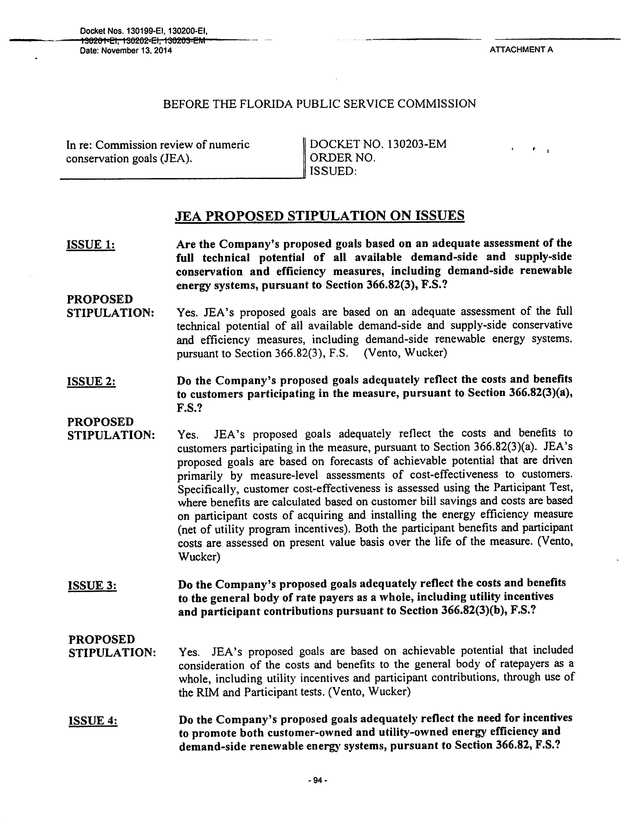
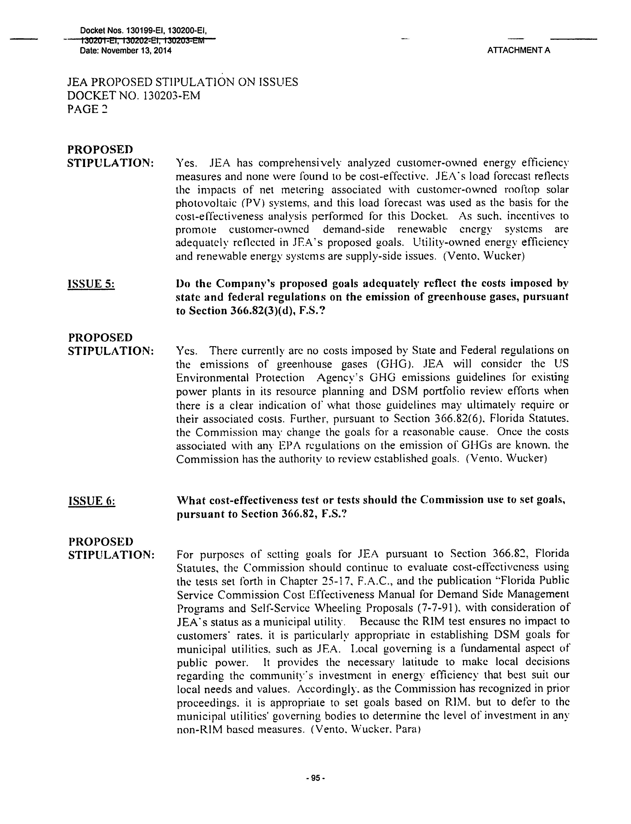
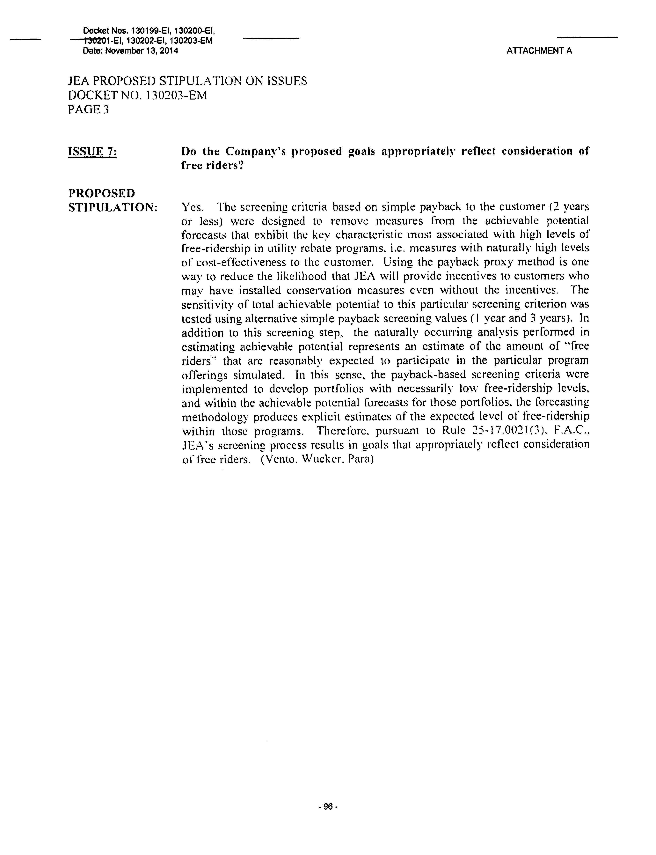
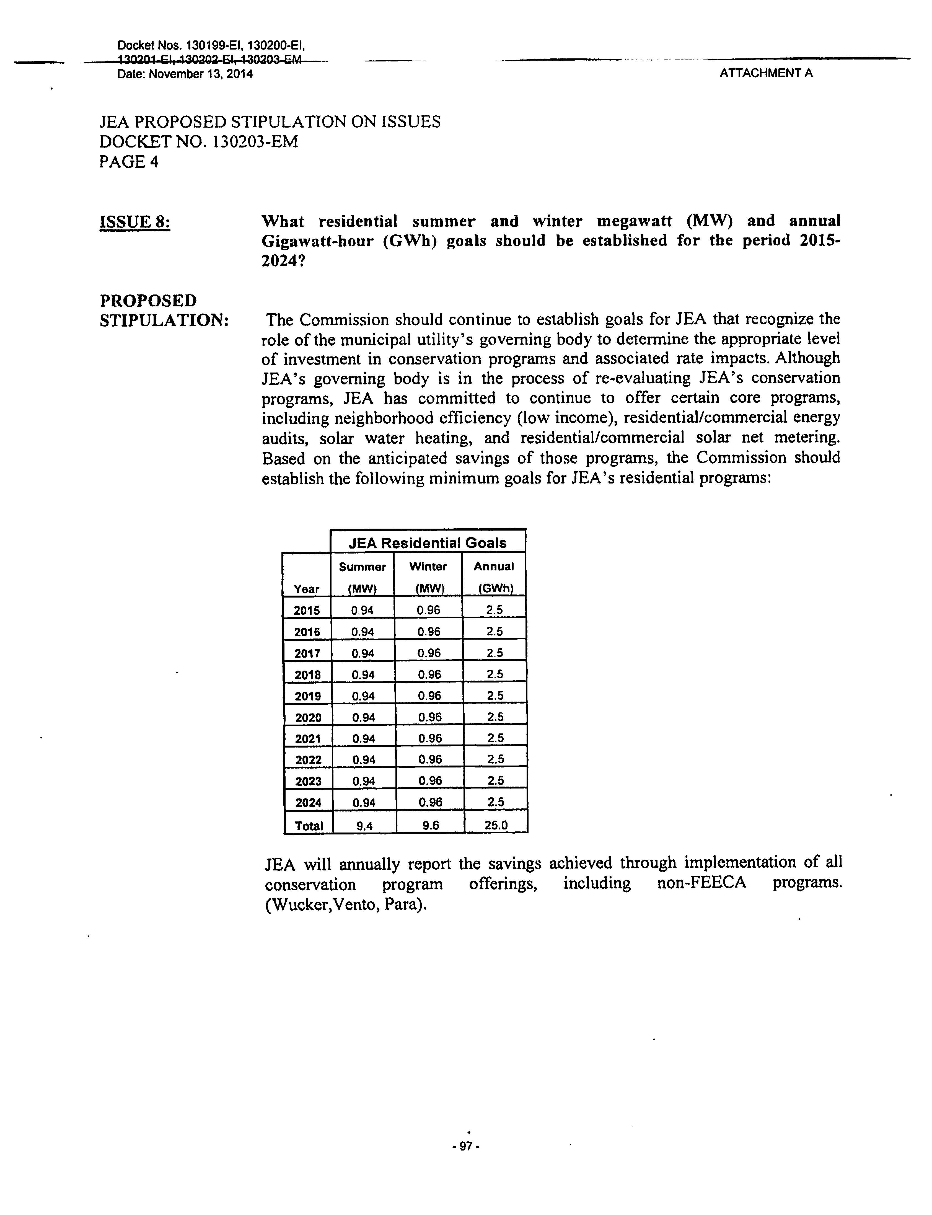
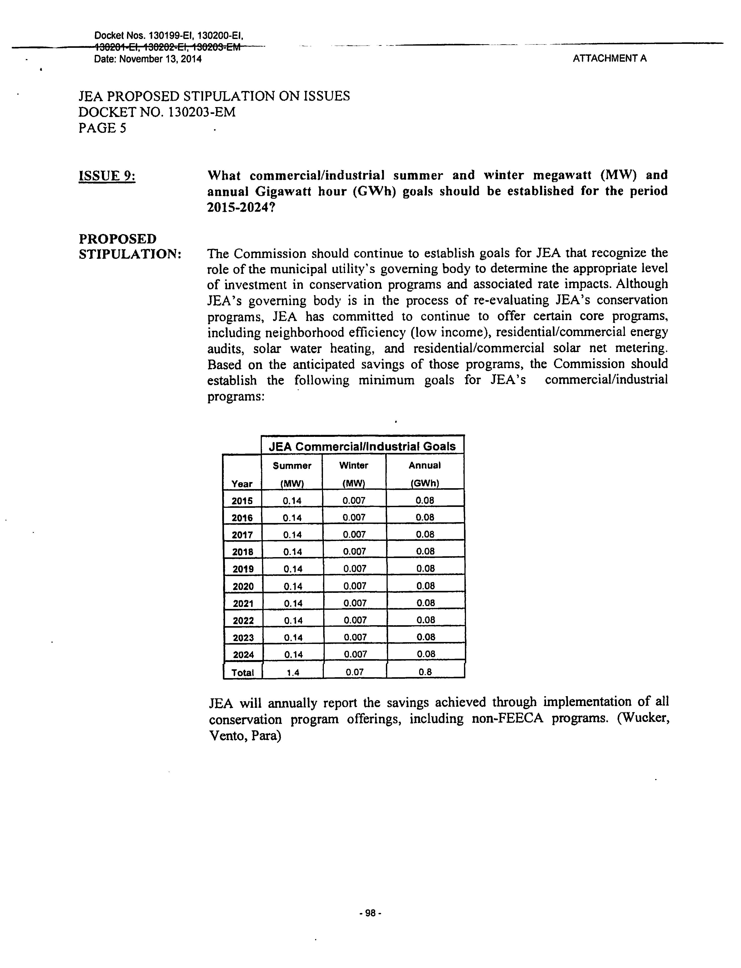
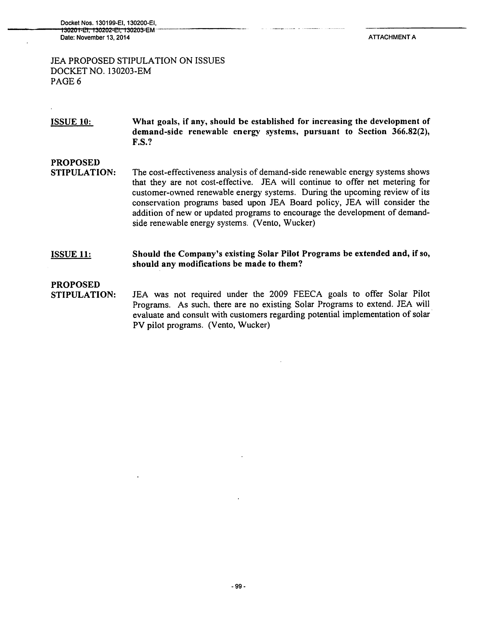
Table B-5: FPL Residential Annual Goals
Summer Peak Demand (MW)
Year | Utility  Proposed | RIM  Achievable | TRC  Achievable | Sierra  Club* | SACE | Commission Approved
2015 | 15.7 | 25.3 | 17.5 | 306.0 | 196.0 | 25.3
2016 | 15.9 | 25.6 | 20.0 | 399.0 | 266.0 | 25.6
2017 | 16.2 | 25.9 | 20.5 | 492.0 | 268.7 | 25.9
2018 | 16.5 | 26.2 | 21.1 | 587.0 | 326.4 | 26.2
2019 | 16.9 | 26.5 | 21.7 | 683.0 | 384.8 | 26.5
2020 | 17.4 | 26.9 | 22.3 | n/a | 417.5 | 26.9
2021 | 18.0 | 27.3 | 23.0 | n/a | 420.3 | 27.3
2022 | 18.7 | 27.6 | 23.8 | n/a | 425.4 | 27.6
2023 | 19.7 | 28.0 | 24.7 | n/a | 431.9 | 28.0
2024 | 20.8 | 28.5 | 25.6 | n/a | 438.5 | 28.5
Total | 175.8 | 267.8 | 220.2 | 2,467.0 | 3,575.6 | 267.8
Winter Peak Demand (MW)
Year | Utility  Proposed | RIM  Achievable | TRC  Achievable | Sierra  Club* | SACE | Commission Approved
2015 | 12.3 | 15.6 | 16.6 | n/a | 156.8 | 15.6
2016 | 12.3 | 15.8 | 18.4 | n/a | 212.8 | 15.8
2017 | 12.3 | 16.0 | 18.9 | n/a | 214.9 | 16.0
2018 | 12.3 | 16.2 | 19.4 | n/a | 261.1 | 16.2
2019 | 12.3 | 16.4 | 20.0 | n/a | 307.8 | 16.4
2020 | 12.3 | 16.7 | 20.6 | n/a | 333.9 | 16.7
2021 | 12.3 | 16.9 | 21.3 | n/a | 336.2 | 16.9
2022 | 12.3 | 17.2 | 22.1 | n/a | 340.2 | 17.2
2023 | 12.3 | 17.5 | 22.9 | n/a | 345.4 | 17.5
2024 | 12.3 | 17.8 | 23.7 | n/a | 350.7 | 17.8
Total | 122.8 | 166.0 | 203.8 | n/a | 2,859.9 | 166.0
Annual Energy Consumption (GWh)
Year | Utility  Proposed | RIM  Achievable | TRC  Achievable | Sierra  Club* | SACE | Commission Approved
2015 | 1.8 | 21.6 | 6.3 | 516.0 | 452.8 | 21.6
2016 | 2.2 | 22.2 | 17.2 | 673.0 | 614.6 | 22.2
2017 | 2.7 | 22.8 | 18.9 | 830.0 | 620.8 | 22.8
2018 | 3.3 | 23.5 | 20.8 | 990.0 | 754.0 | 23.5
2019 | 4.1 | 24.2 | 22.9 | 1,152.0 | 889.0 | 24.2
2020 | 5.0 | 25.0 | 25.2 | n/a | 964.4 | 25.0
2021 | 6.2 | 25.7 | 27.7 | n/a | 970.9 | 25.7
2022 | 7.7 | 26.5 | 30.5 | n/a | 982.6 | 26.5
2023 | 9.5 | 27.4 | 33.5 | n/a | 997.6 | 27.4
2024 | 11.7 | 28.3 | 36.7 | n/a | 1,012.9 | 28.3
Total | 54.0 | 247.2 | 239.8 | 4,161.0 | 8,259.5 | 247.2
* Sierra Club’s proposed goals are for both Residential & Commercial/Industrial and for the period 2015-2019 only
Table B-6: DEF Residential Annual Goals
Summer Peak Demand (MW)
Year | Utility  Proposed | RIM  Achievable | TRC  Achievable | Sierra  Club* | SACE | Commission Approved
2015 | 26.4 | 26.4 | 26.2 | n/a | 65.3 | 26.4
2016 | 24.0 | 24.0 | 24.4 | n/a | 88.4 | 24.0
2017 | 22.2 | 22.2 | 23.7 | n/a | 89.8 | 22.2
2018 | 20.0 | 20.0 | 23.4 | n/a | 109.8 | 20.0
2019 | 17.7 | 17.7 | 23.1 | n/a | 129.6 | 17.7
2020 | 15.5 | 15.5 | 21.1 | n/a | 140.9 | 15.5
2021 | 13.7 | 13.7 | 17.6 | n/a | 142.7 | 13.7
2022 | 12.2 | 12.2 | 14.5 | n/a | 144.2 | 12.2
2023 | 11.3 | 11.3 | 12.7 | n/a | 146.5 | 11.3
2024 | 10.7 | 10.7 | 11.5 | n/a | 148.8 | 10.7
Total | 173.7 | 173.7 | 198.1 | n/a | 1,206.2 | 173.7
Winter Peak Demand (MW)
Year | Utility  Proposed | RIM  Achievable | TRC  Achievable | Sierra  Club* | SACE | Commission Approved
2015 | 58.4 | 58.4 | 59.2 | 148.0 | 52.2 | 58.4
2016 | 53.1 | 53.1 | 54.3 | 190.0 | 70.7 | 53.1
2017 | 48.7 | 48.7 | 50.5 | 232.0 | 71.9 | 48.7
2018 | 43.2 | 43.2 | 46.2 | 277.0 | 87.9 | 43.2
2019 | 37.5 | 37.5 | 41.7 | 323.0 | 103.7 | 37.5
2020 | 32.2 | 32.2 | 36.3 | n/a | 112.7 | 32.2
2021 | 27.8 | 27.8 | 30.7 | n/a | 114.1 | 27.8
2022 | 24.5 | 24.5 | 26.2 | n/a | 115.4 | 24.5
2023 | 22.3 | 22.3 | 23.3 | n/a | 117.2 | 22.3
2024 | 20.9 | 20.9 | 21.5 | n/a | 119.0 | 20.9
Total | 368.6 | 368.6 | 390.0 | 1,170.0 | 964.8 | 368.6
Annual Energy Consumption (GWh)
Year | Utility  Proposed | RIM  Achievable | TRC  Achievable | Sierra  Club* | SACE | Commission Approved
2015 | 25.5 | 25.5 | 27.0 | 180.0 | 150.9 | 25.5
2016 | 23.8 | 23.8 | 28.8 | 231.0 | 204.2 | 23.8
2017 | 20.8 | 20.8 | 31.1 | 283.0 | 207.5 | 20.8
2018 | 17.0 | 17.0 | 37.6 | 337.0 | 253.7 | 17.0
2019 | 13.0 | 13.0 | 43.9 | 394.0 | 299.4 | 13.0
2020 | 9.3 | 9.3 | 40.6 | n/a | 325.6 | 9.3
2021 | 6.2 | 6.2 | 28.1 | n/a | 329.6 | 6.2
2022 | 3.8 | 3.8 | 16.3 | n/a | 333.2 | 3.8
2023 | 2.2 | 2.2 | 10.0 | n/a | 338.4 | 2.2
2024 | 1.2 | 1.2 | 5.9 | n/a | 343.8 | 1.2
Total | 122.6 | 122.6 | 269.3 | 1,425.0 | 2,786.3 | 122.6
* Sierra Club’s proposed goals are for both Residential & Commercial/Industrial and for the period 2015-2019 only
Table B-7: TECO Residential Annual Goals
Summer Peak Demand (MW)
Year | Utility  Proposed | RIM  Achievable | TRC  Achievable | Sierra  Club* | SACE | Commission Approved
2015 | 1.1 | 1.1 | 1.5 | 42.0 | 29.5 | 1.1
2016 | 1.6 | 1.6 | 2.5 | 52.0 | 39.8 | 1.6
2017 | 2.2 | 2.2 | 3.5 | 63.0 | 40.4 | 2.2
2018 | 2.7 | 2.7 | 4.3 | 74.0 | 49.1 | 2.7
2019 | 3.1 | 3.1 | 4.8 | 86.0 | 58.1 | 3.1
2020 | 3.3 | 3.3 | 4.8 | n/a | 62.9 | 3.3
2021 | 3.3 | 3.3 | 4.3 | n/a | 63.7 | 3.3
2022 | 3.0 | 3.0 | 3.8 | n/a | 64.5 | 3.0
2023 | 2.9 | 2.9 | 3.5 | n/a | 65.4 | 2.9
2024 | 2.5 | 2.5 | 3.2 | n/a | 66.3 | 2.5
Total | 25.7 | 25.7 | 36.2 | 317.0 | 539.8 | 25.7
Winter Peak Demand (MW)
Year | Utility  Proposed | RIM  Achievable | TRC  Achievable | Sierra  Club* | SACE | Commission Approved
2015 | 2.6 | 2.6 | 3.4 | n/a | 23.6 | 2.6
2016 | 4.1 | 4.1 | 5.9 | n/a | 31.9 | 4.1
2017 | 5.2 | 5.2 | 8.0 | n/a | 32.3 | 5.2
2018 | 6.5 | 6.5 | 9.6 | n/a | 39.3 | 6.5
2019 | 7.6 | 7.6 | 10.3 | n/a | 46.4 | 7.6
2020 | 7.6 | 7.6 | 9.7 | n/a | 50.3 | 7.6
2021 | 8.0 | 8.0 | 7.9 | n/a | 51.0 | 8.0
2022 | 7.4 | 7.4 | 6.3 | n/a | 51.6 | 7.4
2023 | 6.8 | 6.8 | 5.3 | n/a | 52.3 | 6.8
2024 | 6.1 | 6.1 | 4.6 | n/a | 53.0 | 6.1
Total | 61.9 | 61.9 | 71.0 | n/a | 431.7 | 61.9
Annual Energy Consumption (GWh)
Year | Utility  Proposed | RIM  Achievable | TRC  Achievable | Sierra  Club* | SACE | Commission Approved
2015 | 1.8 | 1.8 | 3.3 | 95.0 | 68.2 | 1.8
2016 | 3.5 | 3.5 | 6.3 | 118.0 | 92.0 | 3.5
2017 | 4.8 | 4.8 | 8.8 | 143.0 | 93.3 | 4.8
2018 | 6.1 | 6.1 | 10.9 | 168.0 | 113.4 | 6.1
2019 | 6.9 | 6.9 | 12.3 | 193.0 | 134.1 | 6.9
2020 | 7.4 | 7.4 | 12.5 | n/a | 145.3 | 7.4
2021 | 7.7 | 7.7 | 11.4 | n/a | 147.2 | 7.7
2022 | 6.9 | 6.9 | 10.0 | n/a | 149.1 | 6.9
2023 | 6.3 | 6.3 | 9.3 | n/a | 151.1 | 6.3
2024 | 5.5 | 5.5 | 8.6 | n/a | 153.2 | 5.5
Total | 56.9 | 56.9 | 93.4 | 717.0 | 1,246.9 | 56.9
* Sierra Club’s proposed goals are for both Residential & Commercial/Industrial and for the period 2015-2019 only
Table B-8: GULF Residential Annual Goals
Summer Peak Demand (MW)
Year | Utility  Proposed | RIM  Achievable | TRC  Achievable | Sierra  Club* | SACE | Commission Approved
2015 | 2.3 | 2.3 | 3.1 | 33.0 | 18.0 | 2.3
2016 | 3.2 | 3.2 | 4.3 | 34.0 | 24.2 | 3.2
2017 | 4.1 | 4.1 | 5.6 | 35.0 | 24.3 | 4.1
2018 | 5.0 | 5.0 | 6.8 | 35.0 | 29.3 | 5.0
2019 | 5.9 | 5.9 | 8.0 | n/a | 34.4 | 5.9
2020 | 6.7 | 6.7 | 9.1 | n/a | 37.5 | 6.7
2021 | 7.5 | 7.5 | 10.2 | n/a | 38.0 | 7.5
2022 | 8.1 | 8.1 | 11.1 | n/a | 38.5 | 8.1
2023 | 8.8 | 8.8 | 11.9 | n/a | 39.0 | 8.8
2024 | 9.3 | 9.3 | 12.7 | n/a | 39.4 | 9.3
Total | 60.9 | 60.9 | 82.8 | 137.0 | 322.6 | 60.9
Winter Peak Demand (MW)
Year | Utility  Proposed | RIM  Achievable | TRC  Achievable | Sierra  Club* | SACE | Commission Approved
2015 | 1.3 | 1.3 | 1.9 | n/a | 14.4 | 1.3
2016 | 1.8 | 1.8 | 2.6 | n/a | 19.4 | 1.8
2017 | 2.3 | 2.3 | 3.4 | n/a | 19.5 | 2.3
2018 | 2.9 | 2.9 | 4.2 | n/a | 23.4 | 2.9
2019 | 3.4 | 3.4 | 4.9 | n/a | 27.5 | 3.4
2020 | 3.8 | 3.8 | 5.6 | n/a | 30.0 | 3.8
2021 | 4.3 | 4.3 | 6.2 | n/a | 30.4 | 4.3
2022 | 4.6 | 4.6 | 6.8 | n/a | 30.8 | 4.6
2023 | 5.0 | 5.0 | 7.3 | n/a | 31.2 | 5.0
2024 | 5.3 | 5.3 | 7.8 | n/a | 31.5 | 5.3
Total | 34.7 | 34.7 | 50.7 | n/a | 258.0 | 34.7
Annual Energy Consumption (GWh)
Year | Utility  Proposed | RIM  Achievable | TRC  Achievable | Sierra  Club* | SACE | Commission Approved
2015 | 2.3 | 2.3 | 6.0 | 103.0 | 41.5 | 2.3
2016 | 3.2 | 3.2 | 8.2 | 106.0 | 56.0 | 3.2
2017 | 4.2 | 4.2 | 10.6 | 109.0 | 56.2 | 4.2
2018 | 5.1 | 5.1 | 13.1 | 112.0 | 67.7 | 5.1
2019 | 6.0 | 6.0 | 15.4 | n/a | 79.5 | 6.0
2020 | 6.8 | 6.8 | 17.5 | n/a | 86.6 | 6.8
2021 | 7.6 | 7.6 | 19.5 | n/a | 87.7 | 7.6
2022 | 8.3 | 8.3 | 21.2 | n/a | 88.9 | 8.3
2023 | 8.9 | 8.9 | 22.9 | n/a | 90.0 | 8.9
2024 | 9.5 | 9.5 | 24.4 | n/a | 91.1 | 9.5
Total | 61.9 | 61.9 | 158.8 | 430.0 | 745.2 | 61.9
* Sierra Club’s proposed goals are for both Residential & Commercial/Industrial and for the period 2015-2018 only
Table 9: FPL Commercial/Industrial Annual Goals
Summer Peak Demand (MW)
Year | Utility  Proposed | RIM  Achievable | TRC  Achievable | Sierra  Club* | SACE | Commission Approved
2015 | 10.5 | 22.8 | 29.9 | 306.0 | 142.5 | 22.8
2016 | 13.8 | 24.0 | 32.2 | 399.0 | 194.1 | 24.0
2017 | 15.0 | 24.9 | 33.7 | 492.0 | 196.3 | 24.9
2018 | 16.0 | 25.3 | 34.5 | 587.0 | 238.5 | 25.3
2019 | 17.5 | 25.8 | 35.4 | 683.0 | 280.9 | 25.8
2020 | 17.5 | 26.2 | 36.3 | n/a | 304.4 | 26.2
2021 | 17.6 | 26.6 | 37.2 | n/a | 305.8 | 26.6
2022 | 17.6 | 27.1 | 38.1 | n/a | 308.8 | 27.1
2023 | 17.7 | 27.5 | 39.0 | n/a | 312.8 | 27.5
2024 | 17.7 | 28.0 | 39.9 | n/a | 316.8 | 28.0
Total | 160.9 | 258.3 | 356.1 | 2,467.0 | 2,601.0 | 258.3
Winter Peak Demand (MW)
Year | Utility  Proposed | RIM  Achievable | TRC  Achievable | Sierra  Club* | SACE | Commission Approved
2015 | 4.1 | 13.6 | 21.4 | n/a | 68.2 | 13.6
2016 | 5.9 | 14.3 | 23.1 | n/a | 92.9 | 14.3
2017 | 6.4 | 14.9 | 24.3 | n/a | 94.0 | 14.9
2018 | 6.7 | 15.3 | 25.2 | n/a | 114.2 | 15.3
2019 | 7.1 | 15.7 | 26.1 | n/a | 134.5 | 15.7
2020 | 7.1 | 16.1 | 27.0 | n/a | 145.8 | 16.1
2021 | 7.2 | 16.5 | 27.9 | n/a | 146.5 | 16.5
2022 | 7.2 | 16.9 | 28.9 | n/a | 147.9 | 16.9
2023 | 7.2 | 17.3 | 29.9 | n/a | 149.8 | 17.3
2024 | 7.2 | 17.7 | 30.8 | n/a | 151.7 | 17.7
Total | 66.2 | 158.2 | 264.6 | n/a | 1,245.6 | 158.2
Annual Energy Consumption (GWh)
Year | Utility  Proposed | RIM  Achievable | TRC  Achievable | Sierra  Club* | SACE | Commission Approved
2015 | 0.6 | 19.6 | 57.7 | 516.0 | 414.3 | 19.6
2016 | 0.6 | 23.4 | 70.0 | 673.0 | 564.5 | 23.4
2017 | 0.5 | 24.7 | 74.5 | 830.0 | 571.0 | 24.7
2018 | 0.4 | 26.0 | 79.1 | 990.0 | 693.8 | 26.0
2019 | 0.1 | 27.3 | 83.7 | 1,152.0 | 817.1 | 27.3
2020 | 0.3 | 28.7 | 88.5 | n/a | 885.2 | 28.7
2021 | 0.5 | 30.1 | 93.2 | n/a | 889.5 | 30.1
2022 | 0.7 | 31.6 | 98.1 | n/a | 898.3 | 31.6
2023 | 0.8 | 33.1 | 103.0 | n/a | 909.9 | 33.1
2024 | 0.8 | 34.7 | 108.0 | n/a | 921.6 | 34.7
Total | 5.2 | 279.1 | 855.8 | 4,161.0 | 7,565.2 | 279.1
* Sierra Club’s proposed goals are for both Residential & Commercial/Industrial and for the period 2015-2019 only
Table 10: DEF Commercial/Industrial Annual Goals
Summer Peak Demand (MW)
Year | Utility  Proposed | RIM  Achievable | TRC  Achievable | Sierra  Club* | SACE | Commission Approved
2015 | 12.0 | 12.0 | 23.5 | n/a | 49.9 | 12.0
2016 | 11.6 | 11.6 | 22.3 | n/a | 67.4 | 11.6
2017 | 11.0 | 11.0 | 20.2 | n/a | 68.0 | 11.0
2018 | 10.0 | 10.0 | 17.1 | n/a | 82.7 | 10.0
2019 | 9.1 | 9.1 | 14.2 | n/a | 98.7 | 9.1
2020 | 8.2 | 8.2 | 11.6 | n/a | 108.0 | 8.2
2021 | 6.9 | 6.9 | 9.1 | n/a | 108.9 | 6.9
2022 | 6.0 | 6.0 | 7.4 | n/a | 110.0 | 6.0
2023 | 5.6 | 5.6 | 6.4 | n/a | 111.3 | 5.6
2024 | 5.0 | 5.0 | 5.4 | n/a | 112.5 | 5.0
Total | 85.4 | 85.4 | 137.1 | n/a | 917.3 | 85.4
Winter Peak Demand (MW)
Year | Utility  Proposed | RIM  Achievable | TRC  Achievable | Sierra  Club* | SACE | Commission Approved
2015 | 5.4 | 5.4 | 9.0 | 148.0 | 23.9 | 5.4
2016 | 5.4 | 5.4 | 8.7 | 190.0 | 32.3 | 5.4
2017 | 5.6 | 5.6 | 8.5 | 232.0 | 32.6 | 5.6
2018 | 5.1 | 5.1 | 7.5 | 277.0 | 39.6 | 5.1
2019 | 5.0 | 5.0 | 6.8 | 323.0 | 47.3 | 5.0
2020 | 5.2 | 5.2 | 6.5 | n/a | 51.7 | 5.2
2021 | 4.8 | 4.8 | 5.7 | n/a | 52.2 | 4.8
2022 | 4.7 | 4.7 | 5.2 | n/a | 52.7 | 4.7
2023 | 5.0 | 5.0 | 5.3 | n/a | 53.3 | 5.0
2024 | 4.6 | 4.6 | 4.8 | n/a | 53.9 | 4.6
Total | 50.7 | 50.7 | 67.8 | 1,170.0 | 439.3 | 50.7
Annual Energy Consumption (GWh)
Year | Utility  Proposed | RIM  Achievable | TRC  Achievable | Sierra  Club* | SACE | Commission Approved
2015 | 14.5 | 14.5 | 47.6 | 180.0 | 145.0 | 14.5
2016 | 13.6 | 13.6 | 44.5 | 231.0 | 195.9 | 13.6
2017 | 12.0 | 12.0 | 38.9 | 283.0 | 197.8 | 12.0
2018 | 10.0 | 10.0 | 31.8 | 337.0 | 240.4 | 10.0
2019 | 8.0 | 8.0 | 24.4 | 394.0 | 287.2 | 8.0
2020 | 5.9 | 5.9 | 17.5 | n/a | 314.1 | 5.9
2021 | 3.9 | 3.9 | 11.6 | n/a | 316.8 | 3.9
2022 | 2.4 | 2.4 | 7.1 | n/a | 320.1 | 2.4
2023 | 1.4 | 1.4 | 4.1 | n/a | 323.6 | 1.4
2024 | 0.8 | 0.8 | 2.2 | n/a | 327.2 | 0.8
Total | 72.4 | 72.4 | 229.7 | 1,425.0 | 2667.9 | 72.4
* Sierra Club’s proposed goals are for both Residential & Commercial/Industrial and for the period 2015-2019 only
Table 11: TECO Commercial/Industrial Annual Goals
Summer Peak Demand (MW)
Year | Utility  Proposed | RIM  Achievable | TRC  Achievable | Sierra  Club* | SACE | Commission Approved
2015 | 1.7 | 1.7 | 2.4 | 42.0 | 26.6 | 1.7
2016 | 2.5 | 2.5 | 3.5 | 52.0 | 35.8 | 2.5
2017 | 2.7 | 2.7 | 4.1 | 63.0 | 36.2 | 2.7
2018 | 3.3 | 3.3 | 4.9 | 74.0 | 43.9 | 3.3
2019 | 3.3 | 3.3 | 5.2 | 86.0 | 51.8 | 3.3
2020 | 3.5 | 3.5 | 5.8 | n/a | 56.1 | 3.5
2021 | 3.6 | 3.6 | 6.0 | n/a | 56.6 | 3.6
2022 | 3.3 | 3.3 | 6.0 | n/a | 57.2 | 3.3
2023 | 3.5 | 3.5 | 6.1 | n/a | 57.7 | 3.5
2024 | 3.2 | 3.2 | 6.0 | n/a | 58.2 | 3.2
Total | 30.6 | 30.6 | 50.0 | 317.0 | 480.2 | 30.6
Winter Peak Demand (MW)
Year | Utility  Proposed | RIM  Achievable | TRC  Achievable | Sierra  Club* | SACE | Commission Approved
2015 | 1.2 | 1.2 | 1.6 | n/a | 12.7 | 1.2
2016 | 1.3 | 1.3 | 2.0 | n/a | 17.1 | 1.3
2017 | 1.6 | 1.6 | 2.6 | n/a | 17.3 | 1.6
2018 | 1.7 | 1.7 | 2.4 | n/a | 21.0 | 1.7
2019 | 1.6 | 1.6 | 2.7 | n/a | 24.8 | 1.6
2020 | 1.7 | 1.7 | 3.2 | n/a | 26.9 | 1.7
2021 | 1.9 | 1.9 | 2.9 | n/a | 27.1 | 1.9
2022 | 1.9 | 1.9 | 2.9 | n/a | 27.4 | 1.9
2023 | 1.8 | 1.8 | 3.1 | n/a | 27.6 | 1.8
2024 | 1.7 | 1.7 | 3.1 | n/a | 27.9 | 1.7
Total | 16.4 | 16.4 | 26.5 | n/a | 230.0 | 16.4
Annual Energy Consumption (GWh)
Year | Utility  Proposed | RIM  Achievable | TRC  Achievable | Sierra  Club* | SACE | Commission Approved
2015 | 3.9 | 3.9 | 6.5 | 95.0 | 77.4 | 3.9
2016 | 6.0 | 6.0 | 10.6 | 118.0 | 104.1 | 6.0
2017 | 8.0 | 8.0 | 15.3 | 143.0 | 105.3 | 8.0
2018 | 9.2 | 9.2 | 16.1 | 168.0 | 127.8 | 9.2
2019 | 9.9 | 9.9 | 19.4 | 193.0 | 150.7 | 9.9
2020 | 10.3 | 10.3 | 20.8 | n/a | 163.2 | 10.3
2021 | 10.4 | 10.4 | 21.5 | n/a | 164.7 | 10.4
2022 | 10.2 | 10.2 | 21.8 | n/a | 166.3 | 10.2
2023 | 9.9 | 9.9 | 22.0 | n/a | 167.8 | 9.9
2024 | 9.6 | 9.6 | 21.6 | n/a | 169.4 | 9.6
Total | 87.4 | 87.4 | 175.6 | 717.0 | 1396.7 | 87.4
* Sierra Club’s proposed goals are for both Residential & Commercial/Industrial and for the period 2015-2019 only
Table 12: Gulf Commercial/Industrial Annual Goals
Summer Peak Demand (MW)
Year | Utility  Proposed | RIM  Achievable | TRC  Achievable | Sierra  Club* | SACE | Commission Approved
2015 | 0.3 | 0.3 | 0.8 | 33.0 | 16.0 | 0.3
2016 | 0.4 | 0.4 | 1.1 | 34.0 | 21.7 | 0.4
2017 | 0.5 | 0.5 | 1.4 | 35.0 | 21.9 | 0.5
2018 | 0.6 | 0.6 | 1.8 | 35.0 | 26.4 | 0.6
2019 | 0.7 | 0.7 | 2.1 | n/a | 31.1 | 0.7
2020 | 0.8 | 0.8 | 2.4 | n/a | 33.7 | 0.8
2021 | 0.9 | 0.9 | 2.6 | n/a | 34.0 | 0.9
2022 | 0.9 | 0.9 | 2.9 | n/a | 34.4 | 0.9
2023 | 1.0 | 1.0 | 3.1 | n/a | 34.7 | 1.0
2024 | 1.1 | 1.1 | 3.3 | n/a | 35.0 | 1.1
Total | 7.2 | 7.2 | 21.5 | 137.0 | 289.0 | 7.2
Winter Peak Demand (MW)
Year | Utility  Proposed | RIM  Achievable | TRC  Achievable | Sierra  Club* | SACE | Commission Approved
2015 | 0.1 | 0.1 | 0.3 | n/a | 7.7 | 0.1
2016 | 0.1 | 0.1 | 0.4 | n/a | 10.4 | 0.1
2017 | 0.1 | 0.1 | 0.5 | n/a | 10.5 | 0.1
2018 | 0.2 | 0.2 | 0.6 | n/a | 12.7 | 0.2
2019 | 0.2 | 0.2 | 0.7 | n/a | 14.9 | 0.2
2020 | 0.2 | 0.2 | 0.8 | n/a | 16.1 | 0.2
2021 | 0.2 | 0.2 | 0.9 | n/a | 16.3 | 0.2
2022 | 0.3 | 0.3 | 1.0 | n/a | 16.5 | 0.3
2023 | 0.3 | 0.3 | 1.0 | n/a | 16.6 | 0.3
2024 | 0.3 | 0.3 | 1.1 | n/a | 16.8 | 0.3
Total | 2.0 | 2.0 | 7.3 | n/a | 138.4 | 2.0
Annual Energy Consumption (GWh)
Year | Utility  Proposed | RIM  Achievable | TRC  Achievable | Sierra  Club* | SACE | Commission Approved
2015 | 0.8 | 0.8 | 4.1 | 103.0 | 46.6 | 0.8
2016 | 1.2 | 1.2 | 5.7 | 106.0 | 63.0 | 1.2
2017 | 1.5 | 1.5 | 7.3 | 109.0 | 63.6 | 1.5
2018 | 1.8 | 1.8 | 9.0 | 112.0 | 76.9 | 1.8
2019 | 2.2 | 2.2 | 10.6 | n/a | 90.5 | 2.2
2020 | 2.5 | 2.5 | 12.1 | n/a | 98.1 | 2.5
2021 | 2.7 | 2.7 | 13.4 | n/a | 99.0 | 2.7
2022 | 3.0 | 3.0 | 14.6 | n/a | 100.0 | 3.0
2023 | 3.2 | 3.2 | 15.8 | n/a | 100.9 | 3.2
2024 | 3.4 | 3.4 | 16.8 | n/a | 101.8 | 3.4
Total | 22.3 | 22.3 | 109.4 | 430.0 | 840.5 | 22.3
* Sierra Club’s proposed goals are for both Residential & Commercial/Industrial and for the period 2015-2018 only

See DN 080407-EG, In re: Commission review of numeric conservation goals (Florida Power & Light Company); DN 080408-EG, In re: Commission review of numeric conservation goals (Progress Energy Florida, Inc.); DN 080409-EG, In re: Commission review of numeric conservation goals (Tampa Electric Company); DN 0804010-EG, In re: Commission review of numeric conservation goals (Gulf Power Company); DN 080411-EG, In re: Commission review of numeric conservation goals (Florida Public Utilities Company); DN 080412-EG, In re: Commission review of numeric conservation goals (Orlando Utilities Commission); DN 080413-EG, In re: Commission review of numeric conservation goals (JEA).
See Order No. PSC-13-0420-PCO-EU, issued September 10, 2013, (FDACS).
See Order Nos. PSC-14-0097-PCO-EU (Sierra Club) and PSC-14-0097-PCO-EI (FIPUG), issued February, 7, 2014.
See Order Nos. PSC-14-0135-PCO-EI (SACE) and PSC-14-0136-PCO-EI (PCS Phosphate), issued March 18, 2014.
See Order No. PSC-14-0153-PCO-EU (Walmart), issued April 7, 2014.
See Order No. PSC-14-0239-PCO-EI (EDF), issued May 16, 2014.
See Order No. PSC-14-0269-FOF-EU (OPC), issued May 29, 2014.
See Order No. PSC-14-0356-PHO-EU (NAACP), issued July 11, 2014.
See Order No. PSC-13-0386-PCO-EU, Issued August 19, 2013, Order Consolidating Dockets and Establishing Procedure, in Docket Nos. 130199-EI, 130200-EI, 130201-EI, 130202-EI, 130203-EM, 130204-EM, and 130205-EI.
See Order No. PSC-09-0855-FOF-EG, Issued December 30, 2009, Final Order Approving Numeric Conservation Goals, in Docket Nos. 080407-EG, 080408-EG, 080409-EG, 080410-EG, 080411-EG, 080412-EG, and 080413-EG.
See Carbon Pollution Emission Guidelines for Existing Stationary Sources: Electric Utility Generating Units,” 79 Fed. Reg., pp. 34830-01 (June 18, 2014), http://www.gpo.gov/fdsys/pkg/FR-2014-06-18/pdf/2014-13726.pdf.
See Order No. PSC-13-0386-PCO-EU, Attachment A.
See Order No. PSC-09-0855-FOF-EG, issued December 30, 2009, in Docket Nos. 080407-EG, 080408-EG, 080409-EG, 080410-EG, 080411-EG, 080412-EG, 080413-EG, In re: Commission review of numeric conservation goals (Florida Power & Light Company, Progress Energy Florida, Inc., Tampa Electric Company, Gulf Power Company, Florida Public Utilities Company, Orlando Utilities Commission, and JEA), pp. 15-16.
See Order No. PSC-14-0356-PHO-EU.
See Carbon Pollution Emission Guidelines for Existing Stationary Sources: Electric Utility Generating Units,” 79 Fed. Reg., p. 34900 (June 18, 2014), http://www.gpo.gov/fdsys/pkg/FR-2014-06-18/pdf/2014-13726.pdf.
See Order No. PSC-94-1313-FOF-EG, issued October 25, 1994, Docket No. 93-0548-EG, In re: Adoption of Numeric Conservation Goals and Consideration of National Energy Policy Act Standards (Section 111) by Florida Power and Light Company; Docket No. 93-0549-EG, In re: Adoption of Numeric Conservation Goals and Consideration of National Energy Policy Act Standards (Section 111) by Florida Power Corporation; Docket No. 93-0550-EG, In re: Adoption of Numeric Conservation Goals and Consideration of National Energy Policy Act Standards (Section 111) by Gulf Power Company; Docket No. 93-0551-EG, In re: Adoption of Numeric Conservation Goals and Consideration of National Energy Policy Act Standards (Section 111) by Tampa Electric Company.
See Order No. 09-0855-FOF-EG, issued December 30, 2009, Docket No. 080407-EG, In re: Commission Review of numeric conservation goals (Florida Power & Light Company); Docket No. 080408-EG, In re: Commission Review of numeric conservation goals (Progress Energy Florida, Inc.); Docket No. 080409-EG, In re: Commission Review of numeric conservation goals (Tampa Electric Company); Docket No. 080410-EG, In re: Commission Review of numeric conservation goals (Gulf Power Company); Docket No. 080411-EG, In re: Commission Review of numeric conservation goals (Florida Public Utilities Company); Docket No. 080412-EG, In re: Commission Review of numeric conservation goals (Orlando Utilities Commission); Docket No. 080413-EG, In re: Commission Review of numeric conservation goals (JEA).
We have exclusive jurisdiction to determine the need for new electric power plants based on Section 403.519, F.S.
See Order No. PSC-09-0855-FOF-EG, issued December 30, 2009, Docket No. 080407-EG, In re: Commission Review of numeric conservation goals (Florida Power & Light Company); Docket No. 080408-EG, In re: Commission Review of numeric conservation goals (Progress Energy Florida, Inc.); Docket No. 080409-EG, In re: Commission Review of numeric conservation goals (Tampa Electric Company); Docket No. 080410-EG, In re: Commission Review of numeric conservation goals (Gulf Power Company); Docket No. 080411-EG, In re: Commission Review of numeric conservation goals (Florida Public Utilities Company); Docket No. 080412-EG, In re: Commission Review of numeric conservation goals (Orlando Utilities Commission); Docket No. 080413-EG, In re: Commission Review of numeric conservation goals (JEA).
Rules 25-17.0021(4) and 25-17.015(1), F.A.C., respectively.
See Order No. PSC-09-0855-FOF-EG, issued December 30, 2009, in Docket Nos. 080408-EG, 080409-EG, 080410-EG, 080412-EG, 080413-EG, In re: Commission Review of numeric Conservation Goals.
Ibid.
Ibid.
See Section 366.82(1)(b), F.S.
See Order No. PSC-09-0855-FOF-EG, issued December 30, 2009, in Docket Nos. 080408-EG, 080409-EG, 080410-EG, 080412-EG, 080413-EG, In re: Commission Review of numeric Conservation Goals.
Ibid.
Ibid.
FPL - See Order No. PSC-11-0079-PAA-EG, issued January 31, 2011 in Docket No. 100155-EG, In re: Petition for approval of demand-side management plan of Florida Power & Light Company. DEF - See Order No. PSC-10-0605-PAA-EG, issued October 4, 2012 in Docket No. 100160-EG, In re: Petition for approval of demand-side management plan of Progress Energy Florida, Inc. TECO - See Order No. PSC-10-0607-PAA-EG, issued October 4, 2012 in Docket No. 100159-EG, In re: Petition for approval of demand-side management plan of Tampa Electric Company. Gulf - See Order No. PSC-10-0608-PAA-EG, issued October 4, 2012 in Docket No. 100154-EG, In re: Petition for approval of demand-side management plan of Gulf Power Company.
Ibid.

