BEFORE THE FLORIDA PUBLIC SERVICE COMMISSION

In re: Initiation of show cause proceedings against Florida Public Telephone Company for apparent violation of Section 364.335(2), F.S., Application for Certificate of Authority, Section 364.3375(2), F.S., Pay Telephone Service Providers, Rule 25-4.0051, F.A.C., Current Certificate Holder Information, and Rule 25-22.032(6)(b), F.A.C., Customer Complaints. | DOCKET NO. 140223-TC  ORDER NO. PSC-15-0048-SC-TC  ISSUED: January 14, 2015

The following Commissioners participated in the disposition of this matter:

ART GRAHAM, Chairman
LISA POLAK EDGAR
RONALD A. BRISÉ
JULIE I. BROWN
JIMMY PATRONIS

ORDER TO SHOW CAUSE

BY THE COMMISSION:

BACKGROUND AND FACTUAL ALLEGATIONS

By Order PSC-97-0271-FOF-TC, issued March 11, 1997, this Commission granted Florida Public Telephone Company (Company) Payphone Certificate Number 5108, authorizing the Company to provide pay telephone service in the State of Florida. The Order specified that pay telephone providers are required to comply with all applicable provisions of Chapter 364, Florida Statutes (F.S.), and Chapters 25-24 and 25-4, Florida Administrative Code (F.A.C.).

This matter addresses two complaints received by this Commission involving payphones operated by Florida Public Telephone Company and its apparent violations of Section 364.335(2) and 364.3375(2), F.S., as well as, Rules 25-4.0051 and 25-22.032(6)(b), F.A.C.

We have jurisdiction pursuant to Chapter 364, F.S., Rule 25-4.0051, F.A.C., and Rule 25-22.032, F.A.C.
Factual Allegations

Section 364.3375(2), F.S., requires that each pay telephone station shall:

- Receive and permit coin-free access to the universal emergency telephone number “911” where operable or to a local exchange company toll operator;
- Receive and provide coin-free or coin-return access to local directory assistance and the telephone number of the person responsible for repair service; and
- Be eligible to subscribe to flat-rate, single-line business local exchange services.

Rule 25-4.0051, F.A.C., (Current Certificate Holder Information) requires each certificated company to file updated information for the following items with the Office of Commission Clerk within 10 days after any changes to the following:

- The address of the certificate holder’s main corporate and Florida offices (if any) including street name and address and post office box, city, state and zip code; or
- Telephone number, name, and address of the individual who is to serve as primary liaison with the Commission in regard to the ongoing Florida operations of the certificated company.

In addition, Section 364.335(2), F.S., provides that certificated companies are required to ensure continued compliance with applicable business formation, registration, and taxation provisions of law.

Finally, Rule 25-22.032(6)(b), F.A.C., (Customer Complaints), requires a company to provide the Commission with a written response to a customer complaint, within 15 working days after the complaint is sent to the company by Commission staff.

In 2014, the Company paid its 2013 Regulatory Assessment Fees and indicated on its Regulatory Assessment Fee Return that it had 42 payphones in operation at the end of 2013.
Complaint No. 1139237T

On February 18, 2014, our Office of Consumer Assistance & Outreach received a complaint that the payphone at 10696 Biscayne Boulevard, Jacksonville, Florida was out of order. The complainant stated that neither the payphone number nor the repair number was working. Our Office of Consumer Assistance & Outreach attempted to contact Florida Public Telephone Company via telephone and facsimile, however, both lines were out of service. On February 19, 2014, our Office of Consumer Assistance & Outreach mailed a copy of the complaint to the Company. No response was received.

On March 21, 2014, our Office of Consumer Assistance & Outreach forwarded the complaint to our Office of Telecommunications for further action. Our Office of Telecommunications attempted to call the payphone number and received a recording that the payphones were disconnected. On June 25, 2014, our Office of Telecommunications sent a certified letter to Florida Public Telephone Company notifying it of the payphone complaint and that our staff had attempted to contact the Company numerous times regarding the payphone located at 10696 Biscayne Boulevard, with no success. Our staff requested Florida Public Telephone Company submit a plan, within 15 days of the date of the letter, outlining when the payphone would be operational. In addition, our staff advised the Company that failure to comply with staff’s request may result in cancellation of its payphone certificate and penalties of up to $25,000 per day, pursuant to Section 364.285, F.S. On July 25, 2014, the certified letter was returned by the United States Postal Service as “unclaimed, unable to forward.”

Complaint No. 1142992T

On March 27, 2014, our Office of Consumer Assistance & Outreach received a complaint from the City of Jacksonville stating the payphone operated by Florida Public Telephone Company, located at 1245 West 8th Street in Jacksonville, Florida, was not working and should be removed. The complaint stated that the payphone was located in a known drug area, has not been working for a very long time, and the Jacksonville Sheriff’s Office would like the payphone removed due to illegal activity in the area. On March 28, 2014, our staff with the Office of Consumer Assistance & Outreach sent a copy of the complaint to the Company, via certified mail. On April 4, 2014, a Certified, Return Receipt postcard was received, signed by David Swearingen, the registered owner of Florida Public Telephone Company, evidencing receipt of the complaint by Florida Public Telephone Company.

After receiving no response from the Company to the complaint, our Office of Consumer Assistance & Outreach attempted to call and fax the Company regarding the complaint, however, the Company’s fax number was “out of order” and the telephone number was “disconnected.” On May 1, 2014, our Office of Consumer Assistance & Outreach sent another copy of the complaint to the Company via certified mail. On May 9, 2014, a signed Certified, Return Receipt postcard was received, evidencing receipt of the complaint by Florida Public Telephone Company.

Upon receiving no response from the Company, our Office of Consumer Assistance & Outreach forwarded the complaint to our Office of Telecommunications for further action. On July 3, 2014, our Office of Telecommunications, again, sent a certified letter to Florida Public Telephone Company notifying it of the payphone complaint and that our staff had attempted to contact the Company numerous times regarding the payphone located at 1245 West 8th, with no success. Our staff requested Florida Public Telephone Company submit a plan, within 15 days of the date of the letter, outlining when the payphone would be operational. In addition, our staff advised the Company that failure to comply with our staff’s request may result in cancellation of its payphone certificate and penalties of up to $25,000 per day pursuant to Section 364.285, F.S. On August 9, 2014, the certified letter was returned by the United States Postal Service as “unclaimed, unable to forward.”

Finally, our staff’s review of the Florida Secretary of State Corporation database revealed that Florida Public Telephone Company does not have a current Florida Corporate Registration, as required by Section 364.335, F.S.

DECISION

Show Cause Standard

Certificated companies are charged with the knowledge of this Commission's rules and statutes. Additionally, "[i]t is a common maxim, familiar to all minds that ‘ignorance of the law’ will not excuse any person, either civilly or criminally." Barlow v. United States, 32 U.S. 404, 411 (1833). In making similar decisions, we have repeatedly held that certificated companies are charged with the knowledge of our Rules and Statutes, and the intent of Section 364.285(1) is to penalize those who affirmatively act in opposition to those orders, rules, or statutes.

The procedure followed by this Commission in dockets such as this, is to consider our staff’s recommendation and determine whether or not the facts warrant requiring the company to respond. If we approve our staff’s recommendation, we issue an Order to Show Cause. A show cause order is considered an administrative complaint by this Commission against the company. If a show cause order is issued, the company is required to file a written response. The response must contain specific allegations of disputed fact. If there are no disputed factual issues, the company’s response should so indicate. The response must be filed within 21 days of service of the show cause order on the respondent company.

The company has two options if a show cause order is issued. The company may respond and request a hearing pursuant to Sections 120.569 and 120.57, F.S. If the company requests a hearing, a hearing will be scheduled to take place before the Commission, after which a final determination will be made. Alternatively, the company may respond to the show cause order by remitting the penalty. If the company pays the penalty and resolves the complaint, this show cause matter will be considered resolved, and the docket closed.

In the event the company fails to timely respond to the show cause order, the company is deemed to have admitted the factual allegations contained in the show cause order. The company’s failure to timely respond is also a waiver of its right to a hearing. Additionally, a final order will be issued imposing the sanctions set out in the show cause order.

Pursuant to Section 364.285, F.S., this Commission is authorized to impose upon any entity subject to its jurisdiction a penalty of not more than $25,000 for each offense, if such entity is found to have refused to comply with or to have willfully violated any lawful rule or order of the Commission, or any provision of Chapter 364. Each day a violation continues is treated as a separate offense. Each penalty is a lien upon the real and personal property of the company and is enforceable by this Commission as a statutory lien.

Willfulness is a question of fact. Therefore, part of the determination we must make in evaluating whether to penalize a company is whether the company willfully violated the rule, statute, or order. Section 364.285, F.S., does not define what it is to “willfully violate” a rule or order. In Commission Order No. 24306, issued April 1, 1991, in Docket No. 890216-TL titled In Re: Investigation Into The Proper Application of Rule 25-14.003, F.A.C., Relating To Tax Savings Refund for 1988 and 1989 For GTE Florida, Inc., we stated that “willful implies an intent to do an act, and this is distinct from an intent to violate a statute or rule." The plain meaning of "willful" typically applied by the Courts in the absence of a statutory definition, is an act or omission that is done “voluntarily and intentionally” with specific intent and “purpose to violate or disregard the requirements of the law.” Fugate v. Fla. Elections Comm’n, 924 So. at 76.

Ruling

We find that the facts outlined above demonstrate that Florida Public Telephone Company knowingly failed to comply with the provisions of Sections 364.335(2) and 364.3375(2), F.S., and Rules 25-4.0051 and 25-22.032(6)(b), F.A.C., and, as a result, the Company’s acts were “willful” in the sense intended by Section 364.285, F.S., and Fugate. Therefore, we order Florida Public Telephone Company to show cause, in writing within 21 days, why it should not be penalized $2,000 or its Certificate No. 5108 cancelled for violating Sections 364.335(2) and 364.3375(2), F.S., and Rules 25-4.0051 and 25-22.032(6)(b), F.A.C.

ORDER TO SHOW CAUSE, RESPONSE, AND CLOSING THE DOCKET

This show cause order is an administrative complaint by the Florida Public Service Commission, as petitioner, against Florida Public Telephone Company, as respondent. Florida Public Telephone Company shall respond to this Order within 21 days of service on the Utility, and the response shall reference Docket No. 140223-TC, In re: Initiation of show cause proceedings against Florida Public Telephone Company for apparent violation of Section 364.335(2), F.S., Application for Certificate of Authority, Section 364.3375(2), F.S., Pay Telephone Service Providers, Rule 25-4.0051, F.A.C., Current Certificate Holder Information, and Rule 25-22.032(6)(b), F.A.C., Customer Complaints.

Florida Public Telephone Company has the right to request a hearing to be conducted in accordance with Sections 120.569 and 120.57, F.S., and to be represented by counsel or other qualified representative. A request for hearing must comply with Rule 28-106.2015, F.A.C.

Any response to this Order must contain specific allegations of fact and law and shall identify those material facts that are in dispute. If there are no material facts in dispute, the response must so indicate. Should Florida Public Telephone Company file a timely, written response that raises material questions of fact and request a hearing pursuant to Sections 120.569 and 120.57, F.S., a further proceeding shall be scheduled before a final determination of this matter is made.

A failure to file a timely, written response to this Order shall constitute an admission of the facts herein alleged and a waiver of the right to a hearing on this issue. In the event that Florida Public Telephone Company fails to file a timely written response to this Order, the penalties will be deemed assessed, Florida Public Telephone Company’s Certificate No. 5108 will be cancelled, and a Final Order will be issued.

Should Florida Public Telephone Company respond to this Order by remitting the penalty, resolving the complaints, updating its contact information with the Commission Clerk, and updating its Corporate Registration with the Florida Secretary of State, this show cause matter will be considered resolved, and the docket closed administratively.

Based on the foregoing, it is

ORDERED by the Florida Public Service Commission that Florida Public Telephone Company show cause, in writing, within 21 days why it should not be penalized $2,000 or its Certificate No. 5108 cancelled for violating Sections 364.335(2) and 364.3375(2), F.S., and Rules 25-4.0051 and 25-22.032(6)(b), F.A.C. Florida Public Telephone Company’s response shall reference Docket No. 140223-TC, In re: Initiation of show cause proceedings against Florida Public Telephone Company for apparent violation of Section 364.335(2), F.S., Application for Certificate of Authority, Section 364.3375(2), F.S., Pay Telephone Service Providers, Rule 25-4.0051, F.A.C., Current Certificate Holder Information, and Rule 25-22.032(6)(b), F.A.C., Customer Complaints. It is further,

ORDERED that Florida Public Telephone Company’s response to this Order to Show Cause shall contain specific allegations of fact and law and shall identify those material facts that are in dispute. If there are no material facts in dispute, the response must so indicate. It is further,

ORDERED that, should Florida Public Telephone Company file a timely, written response that raises material questions of fact and make a request for a hearing pursuant to Sections 120.569 and 120.57, F.S., a further proceeding shall be scheduled before a final determination of this matter is made. It is further,

ORDERED that, a failure to file a timely, written response to this Order to Show Cause shall constitute an admission of the facts herein alleged and a waiver of the right to a hearing on this matter. It is further,

ORDERED that, in the event that Florida Public Telephone Company fails to file a timely response to this Order to Show Cause, the penalties will be deemed assessed, its Certificate No. 5108 will be cancelled, and a Final Order will be issued. It is further,

ORDERED that, in the event Florida Public Telephone Company responds to this Order to Show Cause by remitting the $2,000 penalty, resolving the complaints, updating its contact information with the Commission Clerk, and updating its Corporate Registration with the Florida Secretary of State, this show cause matter will be considered resolved, and this docket closed administratively. It is further,

ORDERED that, any penalty amount collected by this Commission from Florida Public Telephone Company in connection with this matter, shall be deposited in the Florida General Revenue Fund, pursuant to Section 364.285(1), F.S.

By ORDER of the Florida Public Service Commission this 14th day of January, 2015.

/s/ Carlotta S. Stauffer
CARLOTTA S. STAUFFER
Commission Clerk
Florida Public Service Commission
2540 Shumard Oak Boulevard
Tallahassee, Florida 32399
(850) 413-6770
www.floridapsc.com

Copies furnished: A copy of this document is provided to the parties of record at the time of issuance and, if applicable, interested persons.

KFC

NOTICE OF FURTHER PROCEEDINGS OR JUDICIAL REVIEW

The Florida Public Service Commission is required by Section 120.569(1), Florida Statutes, to notify parties of any administrative hearing or judicial review of Commission orders that is available under Sections 120.57 or 120.68, Florida Statutes, as well as the procedures and time limits that apply. This notice should not be construed to mean all requests for an administrative hearing or judicial review will be granted or result in the relief sought.

Mediation may be available on a case-by-case basis. If mediation is conducted, it does not affect a substantially interested person's right to a hearing.

This order is preliminary, procedural or intermediate in nature. Any person whose substantial interests are affected by this show cause order may file a response within 21 days of issuance of the show cause order as set forth herein. This response must be received by the Office of Commission Clerk, 2540 Shumard Oak Boulevard, Tallahassee, Florida 32399-0850, by the close of business on February 4, 2015.

Failure to respond within the time set forth above shall constitute an admission of all facts and a waiver of the right to a hearing and a default pursuant to Rule 28-106.111(4), Florida Administrative Code. Such default shall be effective on the day subsequent to the above date.

If an adversely affected person fails to respond to this order within the time prescribed above, that party may request judicial review by the Florida Supreme Court in the case of any electric, gas or telephone utility or by the First District Court of Appeal in the case of a water or wastewater utility by filing a notice of appeal with the Office of Commission Clerk, and filing a copy of the notice of appeal and the filing fee with the appropriate court. This filing must be completed within thirty (30) days of the effective date of this order, pursuant to Rule 9.110, Florida Rules of Appellate Procedure.

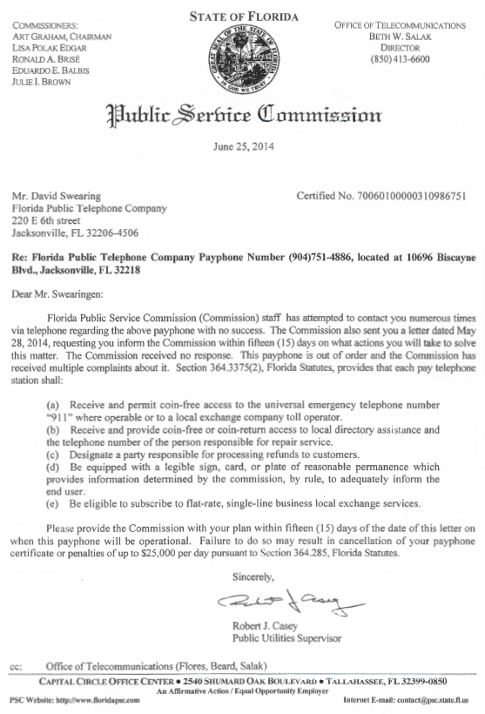

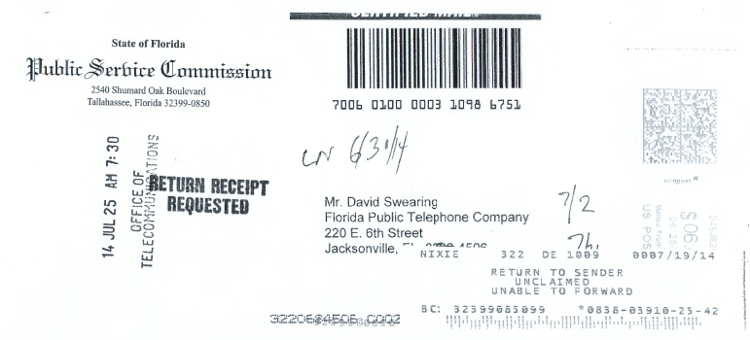
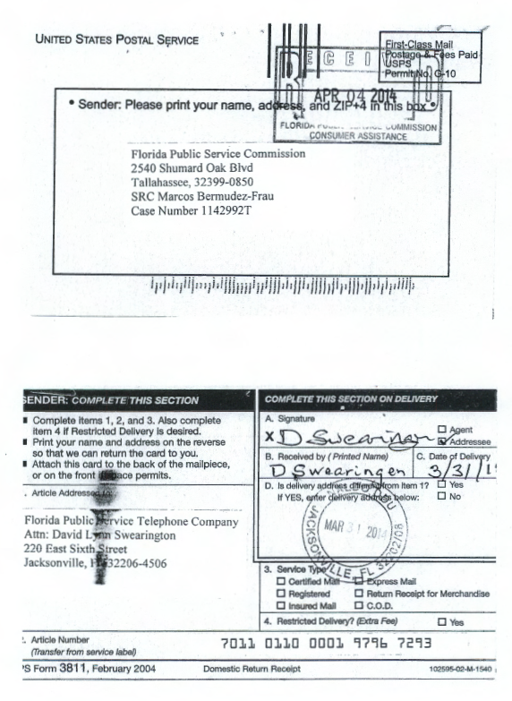
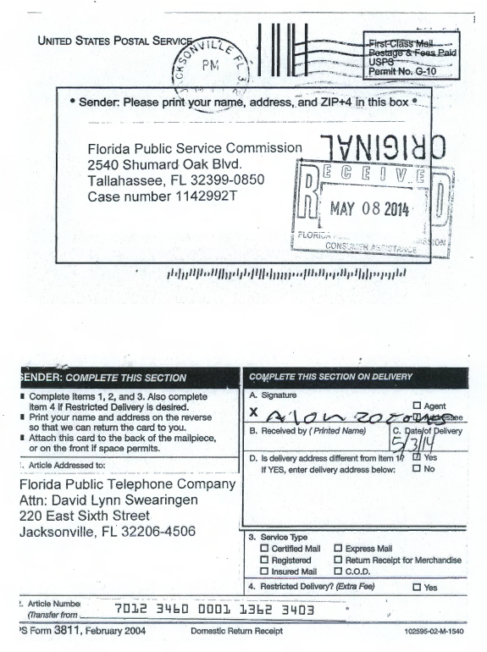
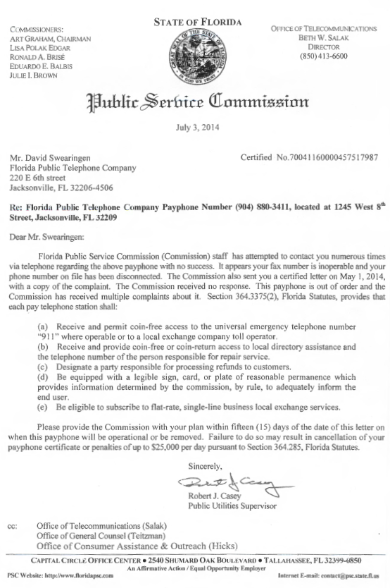

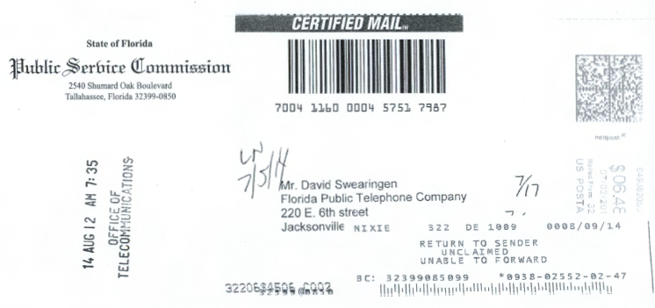
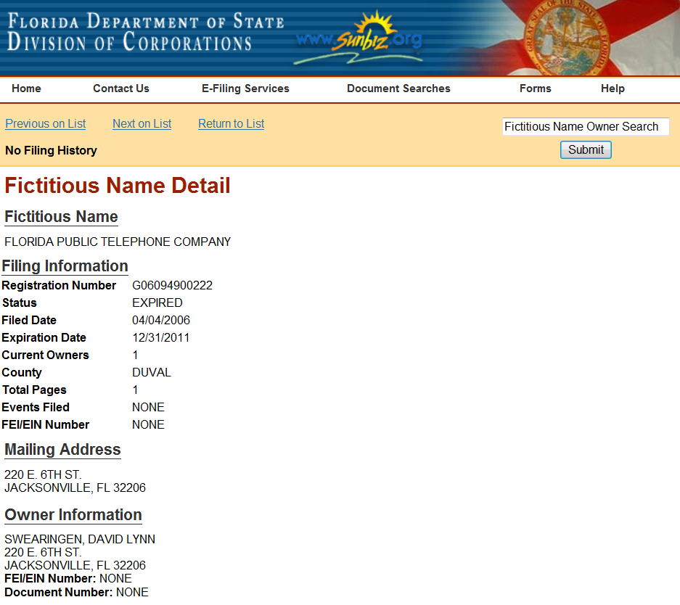

See, Section 364.3375(2), F.S.
See, Rule 25-4.0051, F.A.C.
See, Section 364.335(2), F.S.
See, Rule 25-22.032(6)(b), F.A.C.
See, Attachment A – Copy of Florida Public Telephone Company’s 2013 Pay Telephone Service Provider Regulatory Assessment Fee Return, received February 5, 2014.
See, Attachment B – Copy of Commission staff’s June 25, 2014, certified letter to Florida Public Telephone Company, returned by the U.S. Postal Service on July 25, 2014.
See, Attachment C – Copy of Certified Return Receipt signed by David Swearingen on March 31, 2014.
See, Attachment D – Copy of Certified Return Receipt signed on May 3, 2014.
See, Attachment E – Copy of Commission staff’s July 3, 2014, certified letter to Florida Public Telephone Company, returned by the U.S. Postal Service on August 9, 2014.
See, Attachment F – Screenshot of Florida Secretary of State Corporation online database, evidencing Florida Public Telephone Company’s Expired Corporate Registration.
See, Order No. PSC-11-0250-FOF-WU, issued June 13, 2011, in Docket No. 100104-WU, In re: Application for increase in water rates in Franklin County by Water Management Services, Inc.; Order No. PSC-07-0275-SC-SU, issued April 2, 2007, in Docket No. 060406-SU, In re: Application for staff-assisted rate case in Polk County by Crooked Lake Park Sewerage Company; and Order No. PSC-05-0104-SC-SU, issued January 26, 2005 in Docket Nos. 020439-SU and 020331-SU; In re: Application for staff-assisted rate case in Lee County by Sanibel Bayous Utility Corporation; In re: Investigation into alleged improper billing by Sanibel Bayous Utility Corporation in Lee County in violation of Section 367.091(4), Florida Statutes. See also, Florida State Racing Commission v. Ponce de Leon Trotting Association, 151 So.2d 633, 634 (Fla. 1963), and Commercial Ventures, Inc. v. Beard, 595 So.2d 47, 48 (Fla. 1992) (utilities are subject to the rules published in the Florida Administrative Code).
See, Section 364.285(1), F.S.
Id.
Fugate v. Fla. Elections Comm’n, 924 So. 2d 74, 75 (Fla. 1st DCA 2006), citing, Metro. Dade County v. State Dep't of Envtl. Prot., 714 So. 2d 512, 517 (Fla. 3d DCA 1998).
Penalty assessed is $500 per violation, which is consistent with amounts imposed by this Commission for similar violations.

