BEFORE THE FLORIDA PUBLIC SERVICE COMMISSION

|  |  |
| --- | --- |
| In re: Petition for recovery of costs associated with named tropical systems during the 2018-2022 hurricane seasons and replenishment of storm reserve, by Tampa Electric Company. | DOCKET NO. 20230019-EI  ORDER NO. PSC-2023-0351-PCO-EI  ISSUED: November 20, 2023 |

The following Commissioners participated in the disposition of this matter:

ANDREW GILES FAY, Chairman

ART GRAHAM

GARY F. CLARK

MIKE LA ROSA

GABRIELLA PASSIDOMO

ORDER APPROVING AMENDED INTERIM STORM RESTORATION RECOVERY CHARGE AND MODIFIED RECOVERY PERIOD

BY THE COMMISSION:

Background

On January 23, 2023, Tampa Electric Company (TECO or Company) filed a petition for a limited proceeding seeking authority to implement a storm restoration recovery charge to recover $130.9 million for the incremental restoration costs related to Tropical Storms Alberto, Nestor, and Eta, and Hurricanes Dorian, Elsa, Ian, and Nicole (collectively, "the Storms"), the implementation of the GPS software ARCOS, as well as the replenishment of its storm reserve. Included in the $130.9 million is interest charged for Hurricanes Ian and Nicole. TECO filed its petition pursuant to the provisions of the 2021 Stipulation and Settlement Agreement (2021 Settlement).[1]

By order issued March 27, 2023, we approved TECO’s tariff revisions and an interim storm restoration recovery charge, effective with the first billing cycle of April 2023 through March 2024, subject to a final true-up.[2]

On August 16, 2023, the Company filed a supplemental petition requesting an amended interim storm surcharge to reflect an increase of $3.6 million in incremental storm costs, for a total of $134.5 million, based on updated actual and accrued costs. TECO also requested to modify the 12-month recovery period we initially approved to extend cost recovery through the last billing cycle of December 2024. The current recovery period approved in Order No. PSC-2023-0116-PCO-EI was for the period from April 2023 through the last billing cycle of March 2024.

On September 29, 2023, TECO filed a petition for approval of final/actual storm restoration costs and the associated true-up process related to the Storms. A formal evidentiary hearing has been scheduled for May 1-2, 2024.

We have jurisdiction over this matter pursuant to Sections 366.04, 366.05, 366.06, and 366.076, Florida Statutes.

Decision

1. Amended Interim Storm Restoration Recovery Charge and Recovery Period

As stated in the Background, TECO filed a supplemental petition requesting an amended interim storm surcharge to reflect an increase of $3.6 million in incremental storm costs, for a total of $134.5 million, based on updated actual and accrued costs. TECO also requested to modify the 12-month recovery period we initially approved, to extend cost recovery through the last billing cycle of December 2024.

The initial interim petition was filed pursuant to the provisions of the 2021 Settlement. Pursuant to Section II.B of the Process Improvements portion of the 2019 Storm Cost Settlement Agreement, the Company commissioned an external audit to review the incremental storm restoration costs for Hurricane Ian. In its amended petition, TECO asserted that the total, actual incremental storm restoration costs for Hurricane Ian were $120,851,632, an increase of $1,635,341, as affirmed by the PricewaterhouseCoopers audit.

The Company also received additional invoices through July 31, 2023, for a total of $122,727,694 in costs associated with Hurricane Ian. TECO additionally updated its final costs for Hurricane Nicole, which results in an increase of $78,753. All other costs remained the same. The Company’s updated costs result in a total increase of $3.6 million in incremental storm costs, for a total of $134.5 million. TECO requested a modified recovery period to spread cost recovery for the remaining unrecovered incremental storm costs over an additional nine months to reduce the impact of the increase on monthly customer bills.

Pursuant to Paragraph 8b of the 2021 Settlement, the Company may petition us to increase the initial 12-month recovery at rates greater than $4.00 per 1,000 kWh if the total costs are in excess of $100 million in a given calendar year, inclusive of the amount needed to replenish the storm reserve. Based on the total recovery requested in its initial petition, $130.9 million or $10.22 per 1,000 kWh, TECO met the threshold for requesting a recovery period longer than the 12 months it initially petitioned. The amended interim storm surcharge falls below $4.00 per 1,000 kWh, but that is a function of spreading the remaining total costs, which increased from the initial petition, over an additional 9 months.

The approval of an interim storm restoration recovery charge is preliminary in nature and is subject to refund pending further review of the Company’s total actual storm restoration costs reflected in its petition filed on September 29, 2023. After the actual costs are reviewed for prudence and reasonableness, and compared to the actual amount recovered through the interim storm restoration recovery charge, a determination will be made whether any over or under recovery has occurred. The disposition of any over or under recovery, and associated interest, will be considered by us at a later date.

Based on a review of the information provided by TECO in its supplemental petition, we hereby authorize TECO to implement an amended interim storm restoration recovery charge, subject to refund, and a modified recovery period. This enables the interim storm surcharge originally approved by Order No. PSC-2023-0116-PCO-EI to reflect the known and measurable changes identified by the Company and modify the recovery period to spread the cost recovery over a longer period.

1. Security to Guarantee Funds Collected Subject to Refund

All funds collected subject to refund shall be secured by a corporate undertaking. The criteria for a corporate undertaking include sufficient liquidity, ownership equity, profitability, and interest coverage to guarantee any potential refund. TECO requested a modified 12-month collection period from January 2024 through December 2024 for Interim Storm Cost Recovery Charges of $134,471,119 related to the Storms, including the ARCOS cost. Staff reviewed TECO’s three most recent annual reports filed with us (2022, 2021, and 2020) to determine if the Company can support a corporate undertaking to guarantee the funds collected for recovery of incremental storm restoration costs related to all the weather events. TECO’s financial information demonstrates the Company has deficient levels of liquidity; that is, current assets are less than current liabilities. However, the Company has sufficient levels of ownership equity, profitability, and interest coverage to support a potential refund of $134.5 million. TECO’s average net income for the three years 2022, 2021, and 2020 is almost three times the requested corporate undertaking amount ($399.6 million vs. $134.5 million). Moreover, it is improbable TECO will be required to refund the entire requested amount.

TECO has adequate resources to support a corporate undertaking in the amount requested. Based on this analysis, we find that a corporate undertaking of $134.5 million is acceptable. This brief financial analysis is only appropriate for deciding if the Company can support a corporate undertaking in the amount proposed and shall not be considered a finding regarding any other issues in this proceeding.

1. Storm Surcharge Factors and Revised Tariff

TECO has proposed to decrease the currently effective storm surcharge factors, as discussed in Section I, *supra*. TECO stated that the updated surcharges were developed using the cost-of-service allocation methodology approved in the Company’s most recent rate case. We have reviewed the allocation to rate classes and find that the allocations provided in the petition are consistent with those approved in TECO’s most recent rate case. Furthermore, we have reviewed the derivation of the surcharges in the petition and find that the surcharges have been calculated correctly, using projected kilowatt hour (kWh) sales for January through December 2024.

The proposed storm surcharge factors are shown on First Revised Tariff Sheet No. 6.024. For residential customers, the proposed surcharge would be 0.219 cents per kWh, which equates to a total surcharge of $2.19 for a 1,000 kWh monthly bill. The current surcharge is 1.022 cents per kWh, which equates to a total surcharge of $10.22 for a 1,000 kWh monthly bill. The proposed storm surcharge factors will be included in the non-fuel energy charge on customer bills.

We hereby approve TECO’s proposal to revise the storm surcharge factors and associated tariff, as shown in Attachment A to this order. The tariff shall become effective the first billing cycle of January 2024 and conclude with the last billing cycle of December 2024. The interim storm restoration surcharge factors shall be subject to final true-up once the final total actual storm-related costs are known and filed.

Based on the foregoing, it is

ORDERED by the Florida Public Service Commission that Tampa Electric Company is authorized to implement an amended interim storm restoration recovery charge, subject to refund, and a modified recovery period. After the actual costs are reviewed for prudence and reasonableness, and compared to the actual amount recovered through the interim storm restoration recovery charge, a determination will be made whether any over or under recovery has occurred. The disposition of any over or under recovery, and associated interest, will be considered by us at a later date. It is further

ORDERED that the appropriate security to guarantee the funds collected subject to refund is a corporate undertaking. It is further

ORDERED that TECO’s proposal to revise the storm surcharge factors and associated tariff, as shown in Attachment A to this order, is approved. The tariff shall become effective the first billing cycle of January 2024 and conclude with the last billing cycle of December 2024. The proposed storm surcharge factors shall be subject to final true-up once the final total actual storm-related costs are known and filed. It is further

ORDERED that this docket shall remain open pending final reconciliation of actual recoverable storm costs with the amount collected pursuant to the interim storm restoration recovery charge and the calculation of a refund or additional charge if warranted.

By ORDER of the Florida Public Service Commission this 20th day of November, 2023.

|  |  |
| --- | --- |
|  | /s/ Adam J. Teitzman |
|  | ADAM J. TEITZMAN  Commission Clerk |

Florida Public Service Commission

2540 Shumard Oak Boulevard

Tallahassee, Florida 32399

(850) 413‑6770

www.floridapsc.com

Copies furnished: A copy of this document is provided to the parties of record at the time of issuance and, if applicable, interested persons.

MRT

NOTICE OF FURTHER PROCEEDINGS OR JUDICIAL REVIEW

The Florida Public Service Commission is required by Section 120.569(1), Florida Statutes, to notify parties of any administrative hearing or judicial review of Commission orders that is available under Sections 120.57 or 120.68, Florida Statutes, as well as the procedures and time limits that apply. This notice should not be construed to mean all requests for an administrative hearing or judicial review will be granted or result in the relief sought.

Mediation may be available on a case-by-case basis. If mediation is conducted, it does not affect a substantially interested person's right to a hearing.

Any party adversely affected by this order, which is preliminary, procedural or intermediate in nature, may request: (1) reconsideration within 10 days pursuant to Rule 25-22.0376, Florida Administrative Code; or (2) judicial review by the Florida Supreme Court, in the case of an electric, gas or telephone utility, or the First District Court of Appeal, in the case of a water or wastewater utility. A motion for reconsideration shall be filed with the Office of Commission Clerk, in the form prescribed by Rule 25-22.0376, Florida Administrative Code. Judicial review of a preliminary, procedural or intermediate ruling or order is available if review of the final action will not provide an adequate remedy. Such review may be requested from the appropriate court, as described above, pursuant to Rule 9.100, Florida Rules of Appellate Procedure.

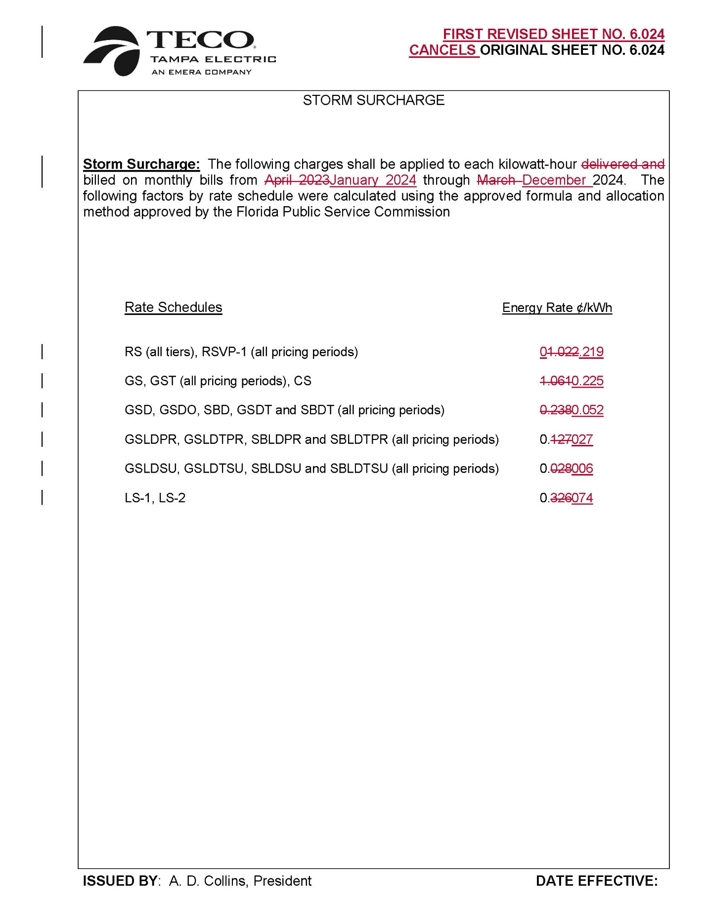

1. *See* Order No. PSC-2021-0423-S-EI, issued on November 10, 2021, in Docket Nos. 20210034-EI, *In re: Petition for rate increase by Tampa Electric Company*, and 20200264-EI*, In re: Petition for approval of 2020 depreciation and dismantlement study and capital recovery schedules, by Tampa Electric Company*. Pursuant to the Future Process Improvements in the Storm Cost Settlement Agreement, TECO was required to establish a policy under which vendor crews would be tracked “to the maximum extent possible” using GPS software such as ARCOS. TECO began implementation of the ARCOS application in 2019.
2. Order No. PSC-2023-0116-PCO-EI issued on March 27, 2023, in Docket No. 20230019-EI.