BEFORE THE FLORIDA PUBLIC SERVICE COMMISSION

|  |  |
| --- | --- |
| In re: Petition for approval of safety, access, and facility enhancement program true-up and 2025 cost recovery factors, by Florida City Gas. | DOCKET NO. 20240134-GU  ORDER NO. PSC-2025-0033-TRF-GU  ISSUED: January 28, 2025 |

The following Commissioners participated in the disposition of this matter:

MIKE LA ROSA, Chairman

ART GRAHAM

GARY F. CLARK

ANDREW GILES FAY

GABRIELLA PASSIDOMO SMITH

ORDER APPROVING SAFETY, ACCESS, AND

FACILITY ENHANCEMENT TRUE-UP AND

2025 COST RECOVERY FACTORS

BY THE COMMISSION:

Background

On August 30, 2024, Florida City Gas (FCG or utility) filed a petition for approval of its safety, access, and facility enhancement (SAFE) program true-up and 2025 cost recovery factors. The SAFE program was originally approved by us in Order No. PSC-15-0390-TRF-GU (2015 Order) to recover the cost of relocating on an expedited basis certain existing gas mains and associated facilities from rear lot easements to the street front.[1] In the 2015 Order, we found that the relocation of mains and services to the street front provides for more direct access to the facilities and will enhance the level of service provided to all customers through improved safety and reliability. We ordered FCG to relocate or replace 254.3 miles of mains and 11,443 associated service lines from rear property easements to the street over a 10-year period.

In the 2015 Order, we also required the utility to file an annual petition to review and reset the SAFE factors to true-up any prior over-or under-recovery and to set the surcharge for the coming year. The SAFE program was originally approved as a 10-year program and was planned to finish in 2025.

During the utility’s 2022 rate case, we approved a stipulation for the expansion of the SAFE program.[2] The parties agreed that the continuation of the SAFE program beyond its original 2025 expiration date and the relocation of an additional approximately 150 miles of mains and 13,874 services was reasonable.[3] We further approved a stipulation for the replacement of approximately 160 miles and 8,059 associated services of “orange pipe,” through the SAFE program.[4]

In October 2024, we approved FCG’s petition to modify the SAFE program to include replacing span pipes, burying shallow and exposed pipeline, and replacing obsolete pipe and related facilities.[5] The total estimated cost for the program modifications is $49.8 million over a 10-year period.[6] As described in paragraphs 10 and 11 of the instant petition, FCG prepared two versions of its annual SAFE true-up, one including the SAFE modifications and one without any modifications. As a result of our approval of the SAFE program modifications in Docket No. 20240071-GU, we relied upon Attachments A-2, B-2, C-2, and D-2 to the instant petition for analysis of the proposed SAFE program rates.

By Order No. PSC-2024-0451-PCO-GU, issued October 16, 2024, we suspended the proposed tariffs to allow our staff sufficient time to analyze the utility’s filing, pursuant to Section 366.06(3), Florida Statutes (F.S.). Our staff issued its first data request to FCG on September 17, 2024, for which FCG provided a response on October 1, 2023.

On December 3, 2024, we approved FCG’s proposed SAFE tariffs for the period January through December 2025. On December 5, 2024, FCG notified our staff that the Seventh Revised Sheet No. 79 reflected an incorrect SAFE factor for the GS-6K customer class. After reviewing the modification to the Seventh Revised Sheet No. 79, our approval of the revised tariff is required. FCG’s annual progress in the SAFE program is shown in Attachment A to this order. The proposed 2025 SAFE factors updated with the correct SAFE factor for the GS-6K customer class are shown in Attachment B to this order on Seventh Revised Sheet No. 79.

We have jurisdiction over the matter pursuant to Sections 366.04, 366.041, 366.05, and 366.06, Florida Statutes (F.S.).

Decision

As required by the 2015 Order, the utility’s calculations for the 2025 revenue requirement and SAFE factors include a final true-up for 2023, an estimated/actual true-up for 2024, and projected costs for 2025. During 2024, the utility replaced 28.5 miles of mains and 1,283 services.[7]

Final True-ups for 2023

FCG stated that the revenues collected for 2023 were $694,998, compared to a revenue requirement of $2,436,443 resulting in an under-recovery $1,741,445. Adding the 2022 final under-recovery of $37,236 and the $1,741,445 under-recovery of 2023, including interest, results in a final 2023 under-recovery of $1,842,805.[8]

Actual/Estimated 2024 True-up

FCG provided actual revenues for January through June and forecasted revenues for July through December 2024, totaling $4,695,456 as compared to a projected revenue requirement of $3,733,272, resulting in an over-recovery of $962,183. Adding the 2023 under-recovery of $1,852,753 to the 2024 over-recovery of $962,183, the resulting total 2024 true-up, including interest, is an under-recovery of $973,939.

Projected 2025 Costs

The utility’s projected investment for 2025 is $61,149,679 for its projects located in Miami-Dade and Brevard counties. The revenue requirement, which includes a return on investment, depreciation, and taxes is $6,538,096. The return on investment calculation includes federal income taxes, regulatory assessment fees, and bad debt. After adding the 2024 over-recovery of $973,939, the total 2025 revenue requirement is $7,512,034. Table 1 displays the projected 2025 SAFE program revenue requirement calculation.

Table 1

2025 SAFE Program Revenue Requirements Calculation

|  |  |
| --- | --- |
| 2025 Projected Investment | $61,149,679 |
| Return on Investment | $4,611,042 |
| Depreciation Expense | $1,043,316 |
| Property Tax Expense | $883,738 |
| 2025 Revenue Requirement | $6,538,096 |
| Plus 2024 Under-recovery | $973,939 |
| Total 2025 Revenue Requirement | $7,512,034 |

Source: Page 5 of Attachment C of the petition.

Proposed 2025 SAFE Factors

The SAFE factors are fixed monthly charges. FCG’s cost allocation methodology was approved in the 2015 Order and was used in the instant filing. The approved methodology allocates the current cost of a 2-inch pipe to all customers on a per customer basis and allocates the incremental cost of replacing a 4-inch pipe to customers who use over 6,000 therms per year. For customers who require 4-inch pipes, the cost takes into account that the minimum pipe is insufficient to serve their demand, and therefore, allocates an incremental per foot cost in addition to the all-customer cost. The resulting allocation factors are applied to the 2025 total revenue requirement to develop the monthly SAFE factors.

The proposed fixed monthly SAFE factor is $4.66 for customers using less than 6,000 therms per year (current factor is $3.17). The proposed fixed monthly SAFE factor for customers using more than 6,000 therms per year is $7.77 (current factor is $5.44).

The modification to the Seventh Revised Sheet No. 79 revises the SAFE program charge for the GS-6K customer class to $7.77, as opposed to $4.66, which was approved at the December 3, 2024 Agenda Conference. We note that FCG calculated the charge for the GS-6K customer class correctly in its work papers included in its August 30, 2024, petition; however, the tariff contained an incorrect charge.[9]

The methodology approved for the SAFE program allocates the current cost of a 2-inch pipe to all customers on a per customer-basis and allocates the incremental cost of replacing a 4-inch pipe to customers who use over 6,000 therms per year. The GS-6K customer class is applicable to non-residential customers who use between 6,000 and 24,999 therms per year. Therefore, the correction to the Seventh Revised Sheet No. 79 is appropriate, because the correction complies with the SAFE program cost allocation methodology that we approved in the 2015 Order. Our vote from the December 3, 2024 Agenda Conference otherwise remains unchanged.

Conclusion

We approve FCG’s proposed SAFE tariff for the period January through December 2025. After reviewing FCG’s filings and supporting documentation, the calculations of the 2025 SAFE factors appear consistent with the methodology approved in the 2015 order and are reasonable and accurate. In addition, we approve FCG’s correction to the Seventh Revised Sheet No. 79. The modification to the Seventh Revised Sheet No. 79 provides the correct SAFE program charge for the GS-6K customer class, as calculated in FCG’s initial petition. The tariffs shall be effective for the period January through December 2025.

Based on the foregoing, it is

ORDERED by the Florida Public Service Commission that Florida City Gas’s proposed Safety, Access, and Facility Enhancement tariff for the period January through December 2025 is approved as set forth herein. It is further

ORDERED that Florida City Gas’s proposed modification to Seventh Revised Sheet No. 79 as shown in Attachment B to this order is approved. It is further

ORDERED that if a protest is filed within 21 days of issuance of the Order, the tariff shall remain in effect with any charges held subject to refund pending resolution of the protest. It is further

ORDERED that if no timely protest is filed, this docket shall be closed upon the issuance of a Consummating Order.

By ORDER of the Florida Public Service Commission this 28th day of January, 2025.

|  |  |
| --- | --- |
|  | /s/ Adam J. Teitzman |
|  | ADAM J. TEITZMAN  Commission Clerk |

Florida Public Service Commission

2540 Shumard Oak Boulevard

Tallahassee, Florida 32399

(850) 413‑6770

www.floridapsc.com

Copies furnished: A copy of this document is provided to the parties of record at the time of issuance and, if applicable, interested persons.

DD

NOTICE OF FURTHER PROCEEDINGS

The Florida Public Service Commission is required by Section 120.569(1), Florida Statutes, to notify parties of any administrative hearing or judicial review of Commission orders that is available under Sections 120.57 or 120.68, Florida Statutes, as well as the procedures and time limits that apply. This notice should not be construed to mean all requests for an administrative hearing or judicial review will be granted or result in the relief sought.

Mediation may be available on a case-by-case basis. If mediation is conducted, it does not affect a substantially interested person's right to a hearing.

The Commission's decision on this tariff is interim in nature and will become final, unless a person whose substantial interests are affected by the proposed action files a petition for a formal proceeding, in the form provided by Rule 28-106.201, Florida Administrative Code. This petition must be received by the Office of Commission Clerk, 2540 Shumard Oak Boulevard, Tallahassee, Florida 32399-0850, by the close of business on February 18, 2025.

In the absence of such a petition, this Order shall become final and effective upon the issuance of a Consummating Order.

Any objection or protest filed in this docket before the issuance date of this order is considered abandoned unless it satisfies the foregoing conditions and is renewed within the specified protest period.

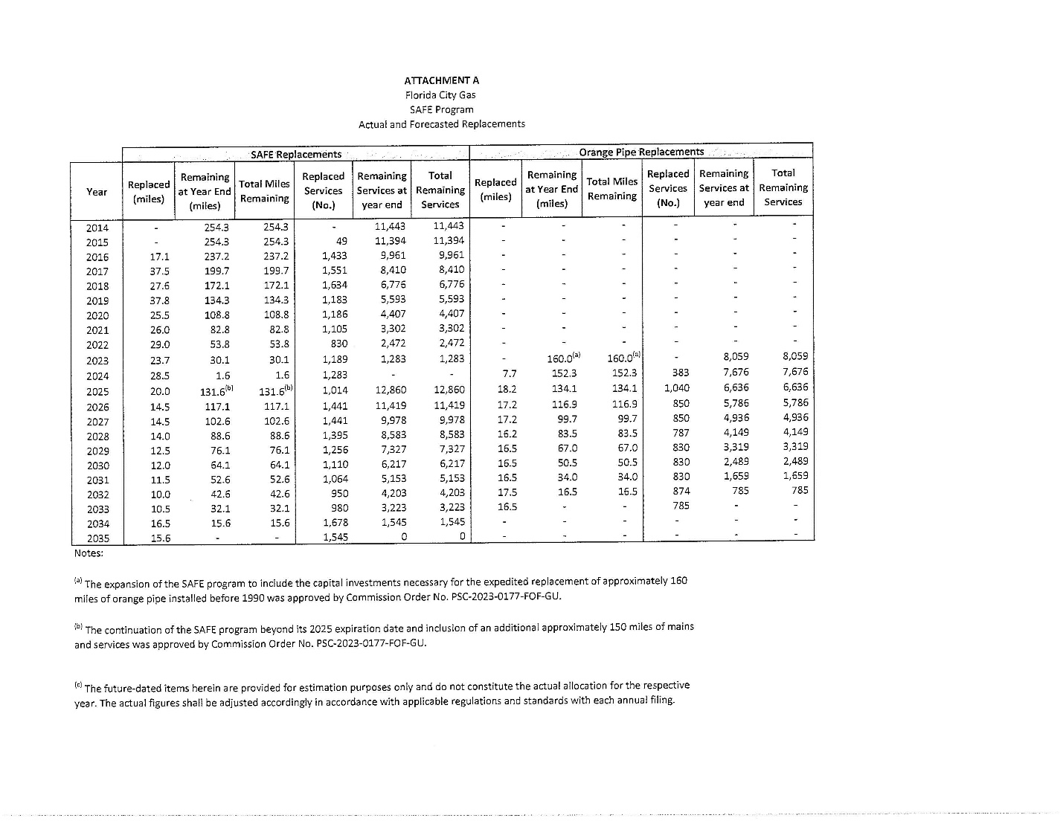

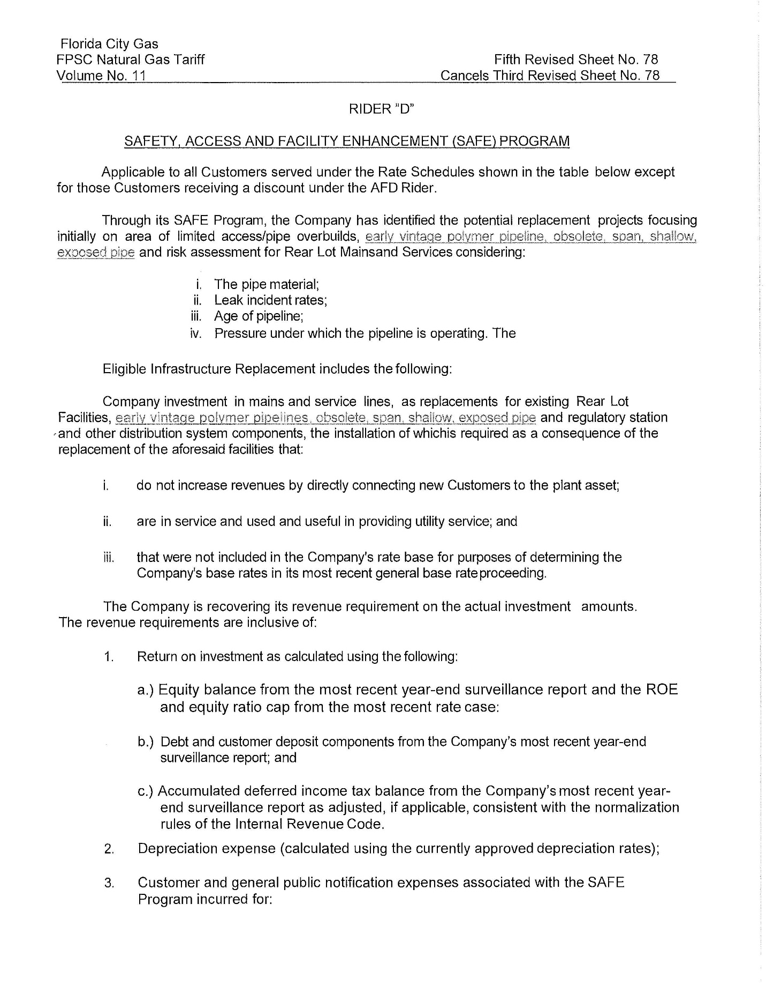

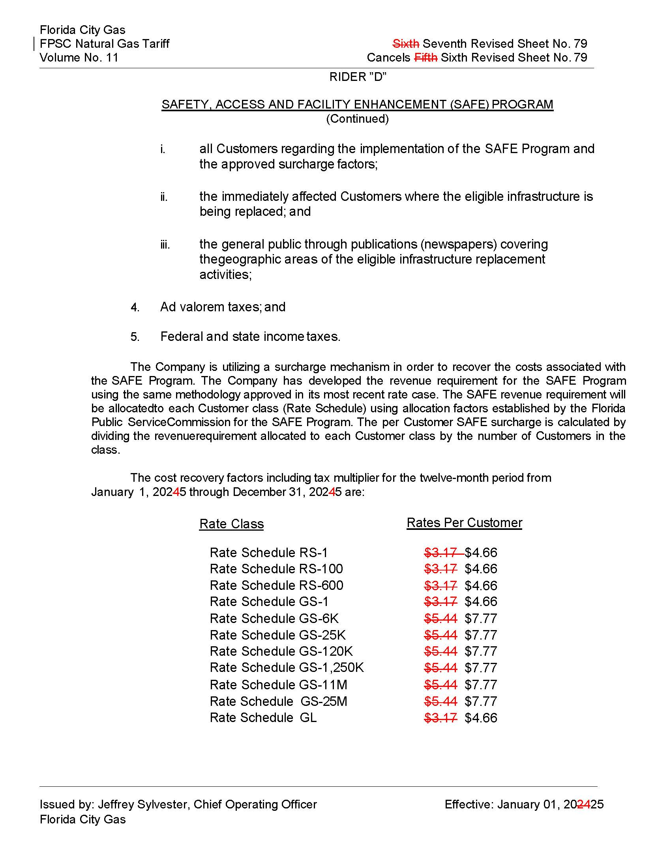

1. Order No. PSC-15-0390-TRF-GU, issued September 15, 2015, in Docket No. 20150116-GU, *In re: Petition for approval of safety, access, and facility enhancement program and associated cost recovery methodology, by Florida City Gas.*
2. Order No. PSC-2023-0177-FOF-GU, issued June 9, 2023, in Docket No. 20220069-GU, *In re: Petition for rate increase by Florida City Gas.*
3. See page 72, Section X, B. of Order No. PSC-2023-0177-FOF-GU.
4. See page 72, Section X, C. of Order No. PSC-2023-0177-FOF-GU.
5. Order No. PSC-2024-0438-PAA-GU, issued October 2, 2024, in Docket No. 20240071-GU, *In re: Petition for approval of safety, access, and facility enhancement program modifications, by Florida City Gas.*
6. See Attachment B to Document No. 04172-2024.
7. See page 1 of Attachment A to Document No. 08785-2024.
8. The calculation also includes a December 2022 true-up of $26,525 booked in January 2023.
9. See Attachment C-2, Schedule 6 to the petition (Document No. 08785-2024).